Complexes of Schiff Bases with Pendant Azaoxa-Crown Ether; Synthesis and Some Noteworthy Results
Partha Pratim Das
Dept. of Chemistry, Magadh University, Bodh-Gaya, Bihar-824234
Abstract:
Considering the importance and extensive applications in numerous domains, fascination with the preparation of Schiff Bases having pendant azaoxa-Crown ether as well as related compounds has surged in recent times. Aza-oxa crown ether macrocycles have exciting potential to create supramolecular assemblies that are suitable for carrying out highly specific atomic functions. To change the ion binding potential, sensitivity, and specificity of the original aza-oxa crown ethers, ligands with an additional donor atom in the side chain were synthesised in a systematic manner by researchers around the globe. There are numerous applications for Schiff bases with attached azaoxa-crown ethers in catalytic processes. Coordination chemists are intrigued by Aza-oxa crown ethers having pendant Schiff bases because they behave as an ambis-dentate chelating framework. Through the Schiff base component, it can coordinate with transition metal ions of intermediary hardness (Co²⁺, Fe²⁺, Mn²⁺, Ni²⁺, Zn²⁺, Cu²⁺ etc.), but the crown ether part complexes with alkali/ alkaline earth metal ions (Li⁺, K⁺, Na⁺, Ba²⁺ etc.). Preparation of these modified crown ethers and their metal complexation primarily with transition metals, were thoroughly discussed in this chapter, with a focus upon their catalytic capabilities. Three key catalytic characteristics were addressed. These types of compounds nearly always have higher catalytic activity than the comparable regular Schiff base compounds, thus emphasises their significance.

Introduction

Since the accidental discovery of crown ethers by Pedersen¹, supramolecular chemistry has grown by leaps and bounds, as their host-guest chemistry has been utilized in several practical applications². Due to the importance and wide range of applications of complexes of Schiff bases with pendant azaoxa-crown ethers in diverse fields, demand of their synthesis has grown in recent years. Azaoxa-crown ether ligands with an additional donor atoms in their side chain framework are primarily synthesized to modify initial molecule' ion binding potential, sensitivity, and selectivity. Schiff bases along with crown ethers in one single backbone, provides the possibility of binding alkali/alkaline earth metal and transition metal ions together. In the disciplines of analytical chemistry³, coordination chemistry⁴, liquid crystals and photochromism⁵, catalytic chemistry⁶, Schiff bases and their metal complexes have found extensive use. Transition metal complexes of Salicylaldimine Schiff bases have attracted a lot of attention recently for their potential applications as enzyme catalysis mimics⁷ as well as oxygen carriers⁸.
Synthesis of Ligands [Schiff Bases with Pendant Azaoxa-Crown Ether]
A number of azaoxa-crown ether-containing mono- and di-Schiff bases [Scheme 1] were produced in order to study the impact of an azaoxa-crown ether ring with a unique stereo configuration and function on a number of significant characteristics, including the capacity for chelation with metal ions and bioinspired efficiency⁹.
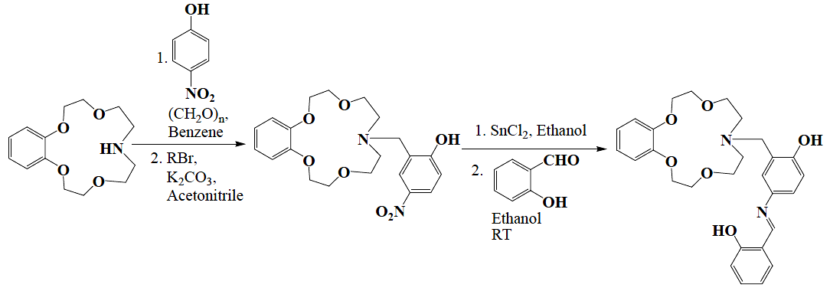
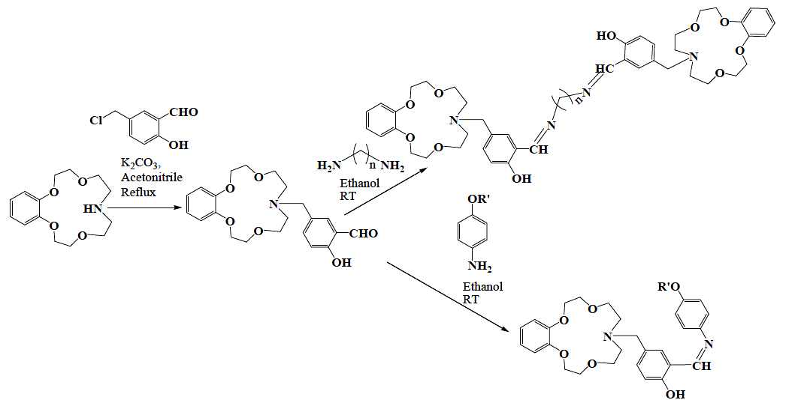
Scheme 1
Lu et al. reported on the synthesis and investigation of numerous azaoxa-crown [12-crown-4/15-crown-5]-containing mono-/di-schiff base ligands¹⁰ [Scheme 2]. They synthesized a series of Co(II) complexes with these ligands. Cation chelating properties and steadiness constants of these complexes were studied.
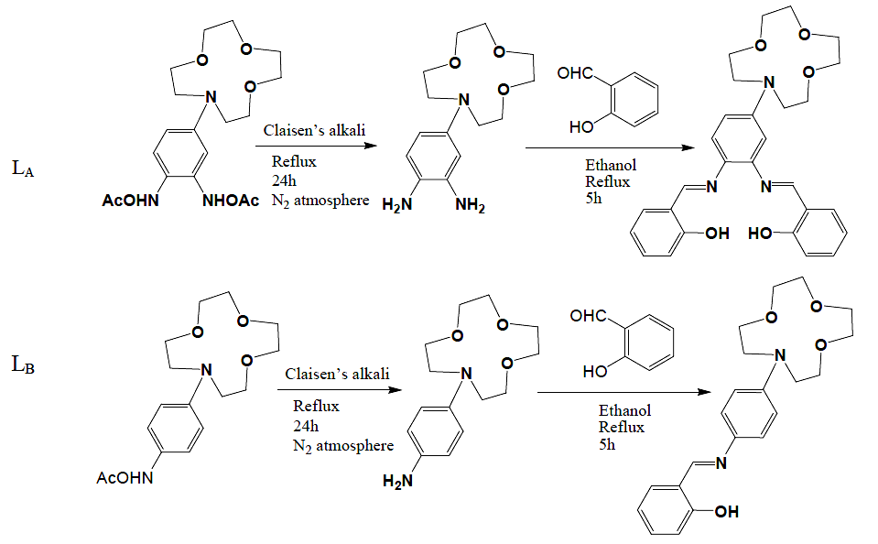
L_{C} | 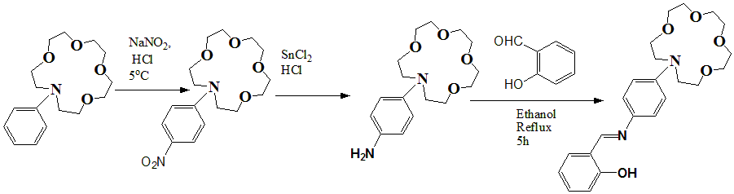  Scheme 2
Series of unique azaoxa crowned salicylaldimine mono-Schiff bases¹¹ [Scheme 3] were developed in order to examine the influence of the connected azaoxa crown ether ring's unique stereo configuration and activity on a number of significant characteristics, including their capacity to complex with metal ions and their bioinspired catalytic efficiency.
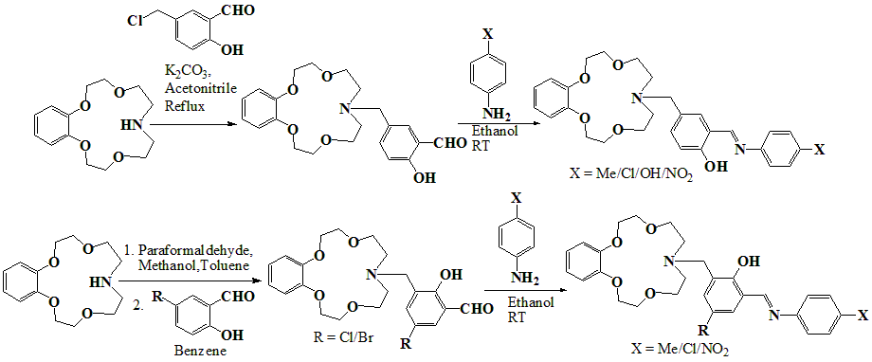
Scheme 3
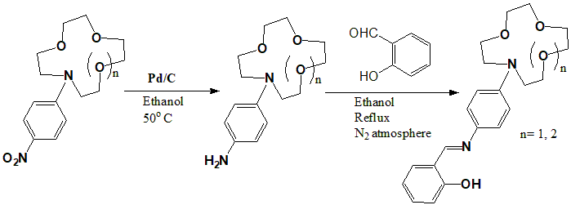
In the similar line, mono azaoxo appended with 12-crown-4 and 15-crown-5 moieties [Scheme 4] were synthesized by Zeng et. al.¹². Their Co(II) complexes have enhanced capacity to form dioxygen adducts with O₂, compared to uncrowned Schiff base complexes. In addition, better biomimetic catalytic activity too was seen for such complexes.
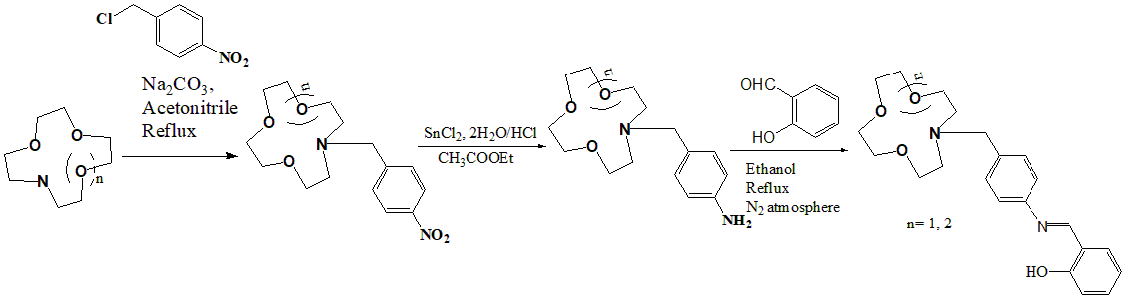
Scheme 4
More such works showing similar properties in the same field were reported by wei et. al.¹³. Data comparisons were also reported. Similar synthetic methodologies were employed for their synthesis as shown previously.
There have been studies on the chemical kinetics and mechanism of the hydrolysis of PNPP [p-nitrophenyl picolinate] catalysed using mono-Schiff base metal complexes containing benzo-azaoxa-crown ether pendants. These are used as hydrolase enzyme models. Scheme 5 displays the related ligand systems and their synthetic methodologies¹⁴.
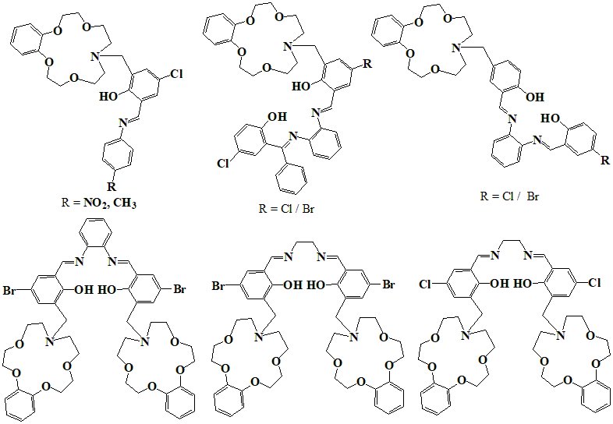
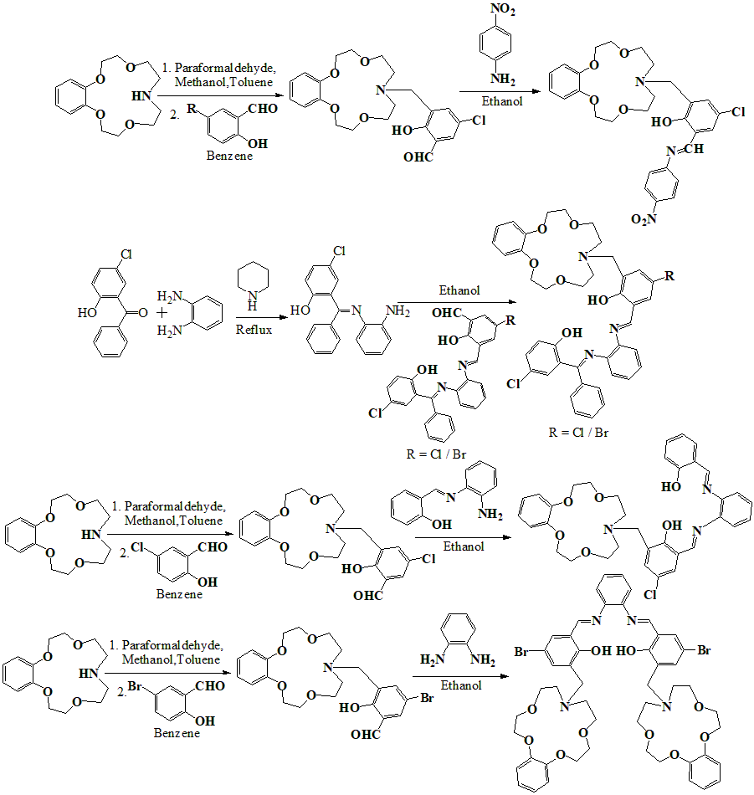
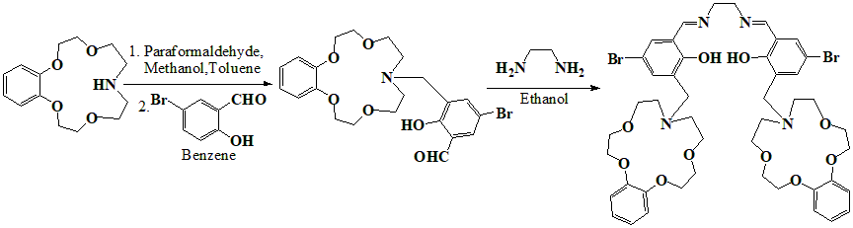
Scheme 5
UV-Vis spectroscopy is used to investigate the complex formation of a number of novel Schiff bases with the N-phenylaza-15-crown-5 structure with Group I and Group II metal ions (mainly Beryllium and Magnesium ions). The position of the N-phenylaza-15-crown-5 group in the ligand framework and the nature of the cation, are taken into consideration in order to estimate and analyze the associated stabilization constants. Related ligands¹⁵ are depicted in Scheme 6.
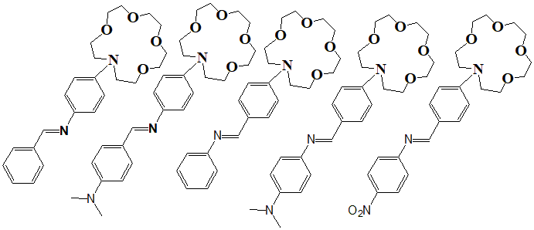
Scheme 6
Several other similar types of ligands are reported in literature. In the next section, some noteworthy metal complexes of these types of ligands will be discussed.

Noteworthy complexes of Schiff Bases with Pendant Azaoxa-Crown Ether ligands:
Co^{II} complexes containing azaoxa-crown ether-based salicylaldimine Schiff base ligands were effectively synthesised as [Co(L_{A})], [Co(L_{B})₂], and [Co(L_{C})₂]¹⁰. L_{A}, L_{B} and L_{C} are depicted earlier in scheme 2. The complexes' cation-binding characteristics were investigated, and stability constants for Group I and Group II metal ions have been established. Meaningful correlation of the cation-binding characteristics between both the mono- and bis-Schiff base frameworks, and also with the molecule containing the monoaza-15-crown-5 pendant, ([Co(L_{C})₂]), that has a dissimilar crown size, is made possible by the synthesising of the compounds of monoaza-12-crown-4, ([Co(L_{A})] and [Co(L_{B})₂]. Complex structures and their synthetic routes are shown in Scheme 7.
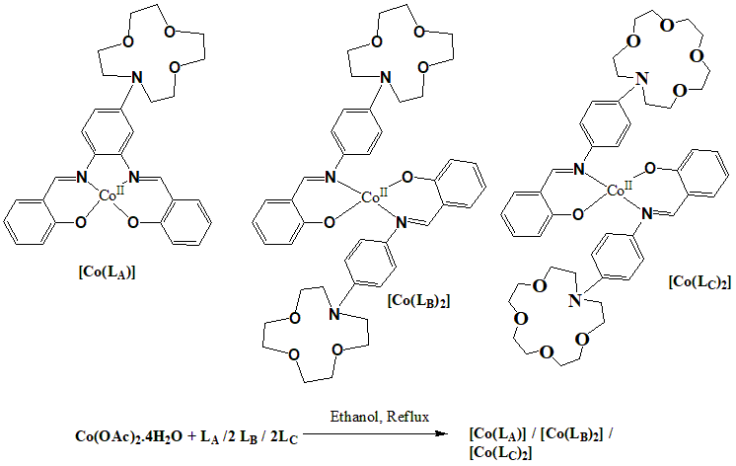
Scheme 7
In 1,2-dimethoxyethane solution, oxygenation constants (K_{O2}) Co^{II} complexes, [Scheme 8] with azaoxa-crown pendants were evaluated over the range of temperature of -5º-25ºC. According on these K_{O2} values, ΔH₀ and ΔS₀ for oxygenation were derived. With regard to the regulation of O₂-binding capacities, the impacts of various substituent groups on the Schiff base ligand were investigated. The findings show that azaoxa-crown pendants significantly improve the dioxygen affinities of Co^{II} complexes more than their comparable morpholino pendants do, and that sodium ion can also improve the azaoxa-crown pendant complexes' ability to bind oxygen.
A | 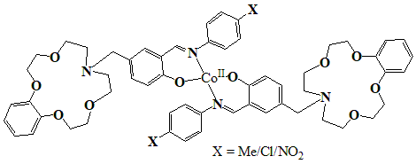
B | 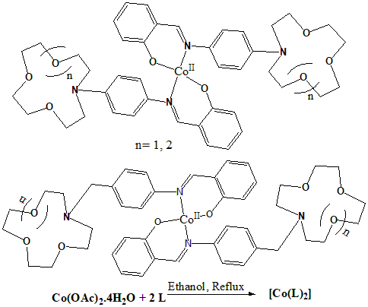
C
Scheme 8
In order to catalyse the hydrolysis of p-nitrophenyl picolinate (PNPP), many mono-/bis-schiff base ligands with attached azaoxa crown-ether and their metal complexes [Co^{II} and Mn^{III}] were developed¹⁴. The kinetics and mechanism of the catalytic hydrolysis in buffer solution were also studied. Fe of such complexes and their synthetic routes are shown below [Scheme 9]. Synthesis of complexes are generally done by refluxing Co(OAc)₂.4H₂O or MnCl₂.4H₂O with corresponding ligand in ethanol in refluxing condition under nitrogen atmosphere. A hypothesised kinetic paradigm for the p-nitrophenyl picolinate breakdown mediated by such complexes. On the kinetics of p-nitrophenyl picolinate hydrolysis, the impact of complex system and solution temperature has been studied. With pH, the rate rises. Mechanistic detail of hydrolysis is shown in scheme 10.
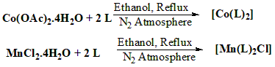
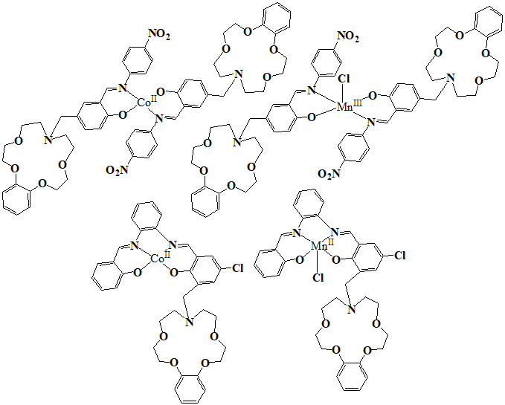
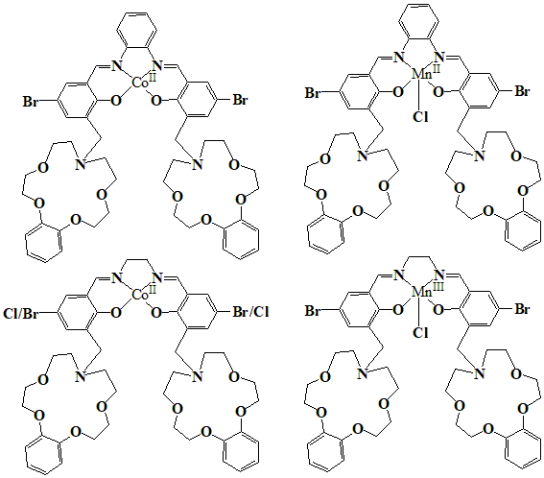
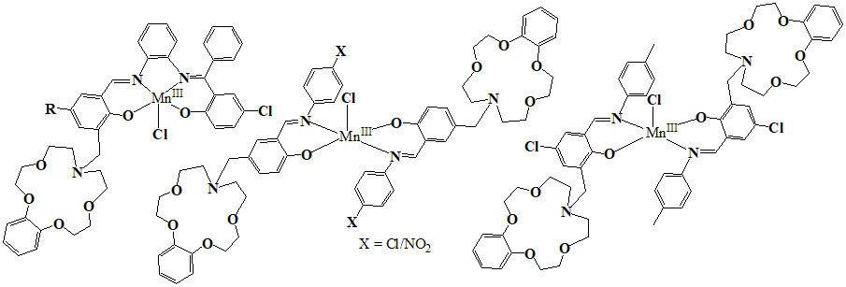
Scheme 9
All the above complexes show similar mechanistic pathway for hydrolysis of PNPP. The proposed mechanism is shown in Scheme 10 for catalytic hydrolysis of PNPP by one of Schiff-base complexes having attached azaoxa crown ether in buffer solution. The formation of the hydrated complex happens when H₂O is linked to the complex's metal ion. This hydrated complex might serve as the catalytic hydrolysis of PNPP's actual active species. The metal ion and crown ring work together to activate H₂O, resulting in the formation of the intramolecular hydrated complex (ML). The intermediary MLS is then produced by PNPP coordinating to this complex (Step I). The coordinated hydroxide then targets the PNPP carbonyl group with a first-order rate constant (k) in Step II, which is the rds (rate determining step) of the entire process. Eventually, H₂O quickly rebinds, releasing the coordinated picolinic acid from the metal (Step III). When the pseudo-first-order rate constant for the catalytic hydrolysis of PNPP is relatively independent of concentration of substrate, free hydroxyl ion (OH⁻) may operate as a nucleophile. Hence, the hydrated complex (MLS⁻) may represent the actual active species for the catalytic hydrolysis of PNPP if the pseudo-first-order rate constants for PNPP hydrolysis rise linearly with substrate concentration at any pH.
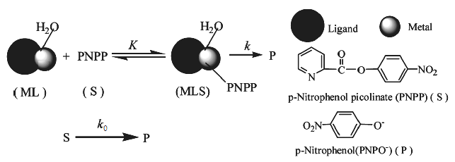
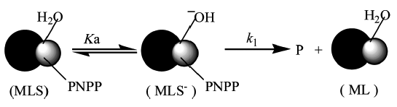
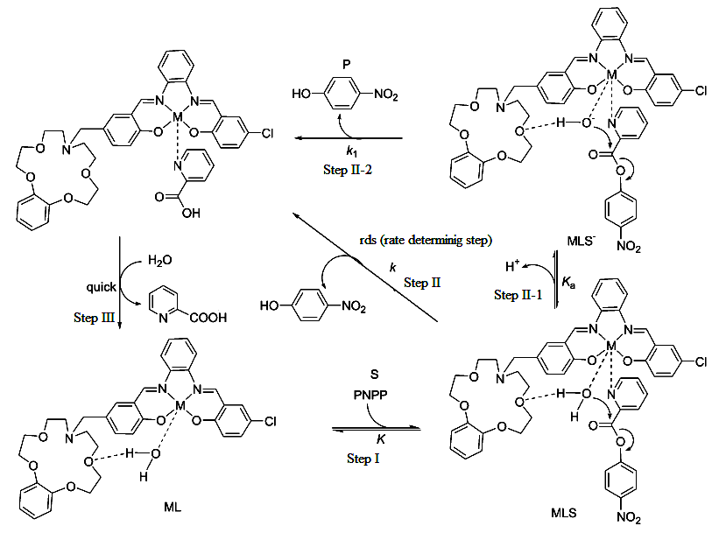
Scheme 10
Different metal complexes of Schiff bases with pendant azooxa crown ether moiety are found to exibit catalytic activity. Mainly, three types of catalysis reactions are reported; (1) oxidation of styrene to benzaldehyde¹⁶, (2) epoxidation of styrene¹⁷ and (3) oxidation of p-xylene to p-toluic acid¹⁸. The metal complexes listed in Scheme 11, Scheme 12 and Scheme 13, show catalytic oxidation of styrene to benzaldehyde, epoxidation of styrene and oxidation of p-xylene to p-toluic acid, respectively. Using Mn^{III} complexes of Scheme 11, styrene can be selectively oxidised into benzaldehyde with molecular dioxygen at room tempature and normal atmospheric O₂ pressure. Alkali metal salt addition can increase conversion and turn over frequency (TOF).
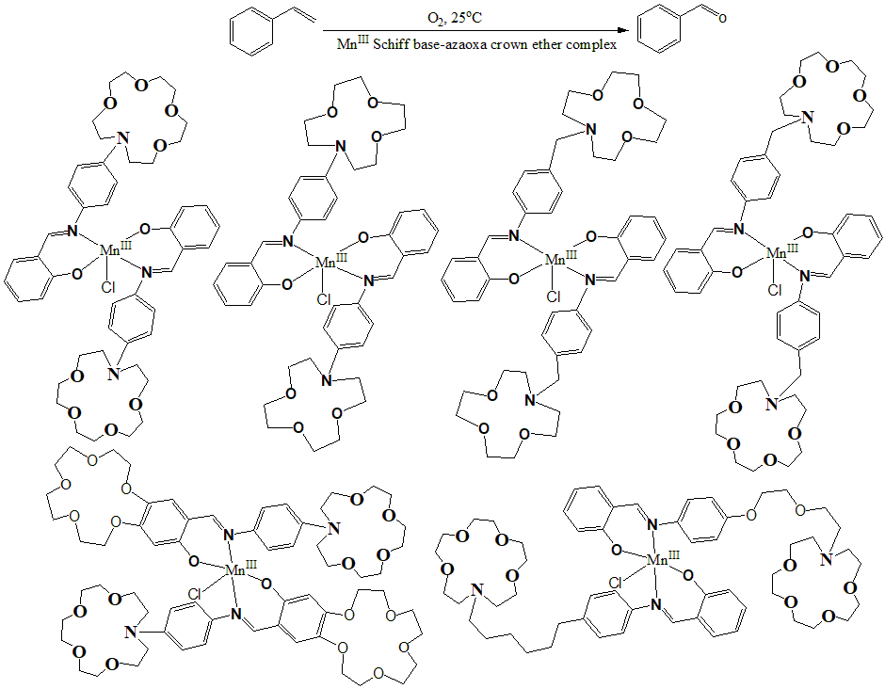
Scheme 11
Using excess imidazole as the axial ligand and iodosylbenzene as the catalyst, Mn^{III} compounds of Scheme 12 were used to catalyse the epoxidation of styrene (serving as analogues for monooxygenases) at standard pressure and 20°C. PhIO serves as the single-oxygen donor and no reaction occurs without PhIO, indicating no aerial oxidation.
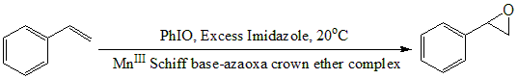
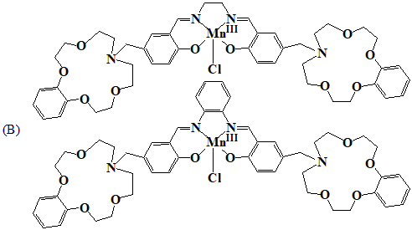
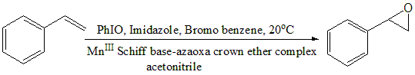
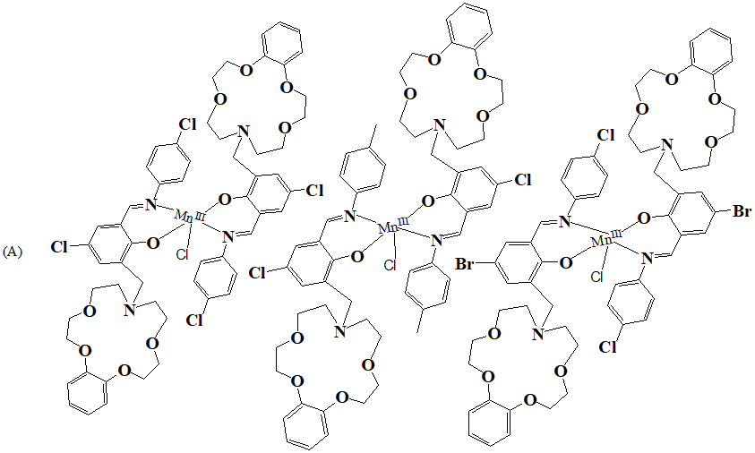
Similar type of epoxidation reaction occurs when acetonitrile solution of styrene, bromobenzene (internal stander), imidazole (axial ligand), PhIO as oxidation donor stirred for one hours in presence of below MnIII Schiff base complexes with pendant azaoxa crown ether as catalyst.

Scheme 12
When mono-Schiff base Mn^{III} complexes with azaoxa-crown ether substitution [A, Scheme 12 & Scheme 13] were present, air was effectively used to oxidise p-xylene to p-toluic acid at 120ºC and standard air pressure. Significant levels of conversion and selectivity were attained. By comparing the complexes of morpholino pendant analogues with the azaoxa-crown ether pendant ligands, the impact of these compounds on the oxidation of p-xylene was also examined. Alkali metal ions were added to speed up the conversion.
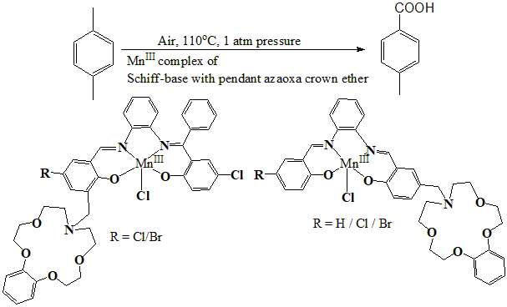
Scheme 13

Conclusion
Schiff base with pendant azaoxa-crown ethers have found variety of importance in catalysis. In this chapter, their synthesis and metal complexation with transition metals mainly, were described extensively, along with emphasis on catalytic properties. Three major catalytic properties were discussed. In almost all cases, these type of complexes got greater catalytic activity than corresponding normal Schiff base complexes, which indicates their importance.
References
- C. J. Pedersen, “Cyclic polyethers and their complexes with metal salts”, J. Am. Chem. Soc., Vol. 89, pp. 7017–7036, 1967.
- (a) K Kimura E. Hayara and T. Shono, “Convenient, efficient crown ether-containing stationary phases for chromatographic separation of alkali metal ions: dynamic coating of highly lipophilic crown ethers on octadecylsilanized silica”, J. Chem. Soc., Chem. Commun., Issue 5, pp. 271-272, 1984. (b) T. Imato, M. Katahira and N. Ishibashi, “Effects of concentration of neutral carrier and addition of organophosphorus compounds on alkali metal ion-selectivity of the dibenzo-14-crown-4 liquid-membrane electrode”, Anal Chim Acta, vol. 165, pp. 285-289, 1984. (c) T. Shono, M. Okahara, I. Ikeda, K. Kimura and H. Tamura, “Sodium-selective PVC membrane electrodes based on bis(12-crowns-4)s”, J. Electroanal. Chem., Vol. 132, pp. 99-105, 1982. (d) H. Nakamura, M. Takagi and K Ueno, “Complexation and extraction of alkali metal ions by 4'-picrylaminobenzo-18-crown-6 derivatives”, Anal. Chem., Vol. 52, pp. 1668-1671, 1980. (e) H. Nishida, M. Tazaki, M. Takagi and K Ueno, “Photometric reagents based on crown ether complex formation. VII”, Mikrochim Acta., Vol. 75, pp. 281-287, 1981. (f) F. Hu and T. Song, “Application of functionalized ether in lithium ion batteries”, RSC Adv., 2017, Vol. 7, pp. 54203-54212, 2017. (g) S. D. Jagadale, A. M. Teli, S. V. Kalake, A. D. Sawant, A. A. Yadav and P. S. Patil, “Functionalized crown ether assisted morphological tuning of CuO nanosheets for electrochemical supercapacitors”, J. Electroanal. Chem., Vol. 816, pp. 99-106, 2008. (h) M. G. Mohamed and S. -W. Kuo, “Crown Ether-Functionalized Polybenzoxazine for Metal Ion Adsorption”, Macromolecules, Vol. 53, pp. 2420–2429, 2020.
- Z. Cimernan, N. Galic and B. Bosner, “The Schiff bases of salicylaldehyde and aminopyridines as highly sensitive analytical reagents”, Anal. Chim. Acta, 1997, Vol. 343, pp. 145-153, 1997.
- S. Yamada, “Advancement in stereochemical aspects of Schiff base metal complexes”, Coord. Chem. Rev., Vol. 190, pp. 537-555, 1999.
- M. G. Xie, M. S. Peng, Q. Jiang, Z. L. Hu and X. L. Wang, “Synthesis of Schiff's base and azo liquid crystalline crown ethers”, Liq. Cryst., Vol. 21, pp. 461-467, 1996.

T. Panniyamurthy, B. Bhatia, M.M. Reddy, G.C. Maikap and J. Iqbal, “A versatile cobalt (II)-Schiff base catalyzed oxidation of organic substrates with dioxygen: Scope and mechanism”, Tetrahedron, Vol. 53, pp. 7649-7670, 1997.

N. Kim and J. Suh, “Artificial Metallophosphoesterases Built on Poly(ethylenimine)”, J. Org. Chem., Vol. 59, 1561-1571, 1994.

D. Chen, A.E. Martell and Y. Sun, “New synthetic cobalt Schiff base complexes as oxygen carriers”, Inorg. Chem., Vol. 28, pp. 2647-2652, 1989.
- X. Wei, Z. Mao, J. Li and S. Qin, “Synthesis of Salicylaldimine Schiff Bases with Benzo‐10‐aza‐15‐crown‐5 Pendant”, Synth. Commun., Vol. 34(7), 1237-1246, 2004.
- X. -X. Lu, S. -Y. Qin, Z. -Y. Zhou and V. W. -W. Yam, “Synthesis, structure, and ion-binding studies of cobalt(II) complexes with aza-crown substituted salicylaldimine Schiff base ligand” Inorg. Chim. Acta., Vol. 346, pp. 49-56, 2003.
- (a) J. Z. Li, J. Yan, X. Wei, B. Zhou and S. -Y. Qin, “Synthesis of Novel Salicylaldimine Schiff Bases with a Pendant Benzo-10-Aza-15-Crown”, J. Chem. Res., Vol. 7, pp. 467-469, 2006. (b) J. -Z. Li, L. Wei, F. M. Feng, J. Zeng and S. –Y.Qin, “Dioxygen affinities of Schiff base cobalt(II) complexes with aza-crown or morpholino pendants”, Transition Met. Chem., Vol. 35, pp. 463-468, 2010.
- Z. Wei, H. -B. Li, X. Y. Wei, S. –Y, Qin and R. -Li. Xiang, “Synthesis of N-(4-Salicylideneiminoaryl) monoaza Crown Ethers and Dioxygen Affinities of Their Cobalt (II) Complexes”, Chin. J. Chem., Vol. 21, pp. 510-514, 2003.
- X. Y. Wei, Z. H. Mao, J. -Z. Li and S. -Y. Qin, “Synthesis of Azacrown Ether-substituted Mono-Schiff Bases and Dioxygen Affinities of Their Co(Ⅱ) Complexes”, Acta Chim. Sin., Vol. 62(10), pp. 969-974, 2004.
- (a) J. Z. Li, Y. Lu, L. Wei, W. Hu and S. -Y. Qin, “Synthesis and Kinetic Studies of Mono-Schiff Base Manganese(III) and Cobalt(II) Complexes with Aza-Crown Ether or Morpholino Pendants as Synthetic Hydrolases for P-Nitrophenyl Picolinate”, Prog. React. Kinet. Mech., Vol. 35, pp. 368–386, 2010. (b) Z. Xiang, J. Z. Li, S. Huang, Z. Yang and W. Hu, “Studies on Hydrolysis of P-Nitrophenyl Picolinate by Unsymmetrical Bis-Schiff Base Manganese Complexes with Aza-Crown Ether or Morpholino Pendants”, Appl. Mech. Mater., Vol. 343, pp. 65-68, 2013. (c) J. Z. Li, X. He, Y. Wang, J. Zhang, W. Hu and S. Qin, “p-Nitrophenyl Picolinate Cleavage by Unsymmetrical Bis-Schiff Base Manganese(III) and Cobalt(II) Complexes with Aza-Crown Ether or Morpholino Pendants”, Chin. J. Chem., Vol. 29, pp. 1894-1900, 2011. (d) Li, J. z.; Xu, B.; wang, y. and Li, S. X.; “Studies on the Kinetics and Mechanism of Hydrolysis of p-nitrophenyl Picolinate (PNPP) by Unsymmetrical bis-Schiff Base Complexes with Aza-crown Ether or Morpholino Pendants”, Transit. Met. Chem., Vol. 31, 487-494, 2006. (e) J. Z. Li, W. Hu, X. Chen, L. Yang, S. -Y. Sun, and S. -Y. Qin, “Studies on Schiff Base Complexes with Aza-Crown Ether Pendants as Synthetic Hydrolases for p-Nitrophenyl Picolinate in Brij35 Surfactant Micellar Solution”, J. Dispers. Sci. Technol., Vol. 36, pp. 595–603, 2015.
- L. Antonova, M. Vladimirova, E. Stanoeva, W. M. F. Fabian, L. Balleste and M. Mitewa, “Complexation Properties of Schiff Bases Containing the N-Phenylaza-15-crown-5 Moiety”, J. Incl. Phenom. Macrocycl. Chem., Vol. 40, pp. 23-28, 2011.
- (a) W. Zeng, Z. Mao, X. Wei, J. Li, Z. Hong and S. Qin, “Synthesis, Dioxygen Affinities and Biomimetic Catalytic Oxidation Performance of Crown Ether-tethered Schiff Base Transition-Metal Complexes”, J. Supramol. Chem., Vol. 2, pp. 501-507, 2002. (b) W. Zeng, J. Li and S. Qin, “The effect of aza crown ring bearing salicylaldimine Schiff bases Mn(III) complexes as catalysts in the presence of molecular oxygen on the catalytic oxidation of styrene”, Inorg. Chem. commun., Vol. 9, pp. 10-12, 2006. (c) W. Zeng, J. Li, Z. Mao, Z. Hong and S. Qin, “Synthesis, Oxygenation and Catalytic Oxidation Performance of Crown Ether-Containing Schiff Base-Transition Metal Complexes”, Adv. Synth. Catal., Vol. 346, 1385-1391, 2004.
- (a) J. Z. Li, S. -X. Li, F. Xie, B. Zhou, W. Zeng and S. –Y. Qin, “Dioxygen affinities and catalytic epoxidation performance of mono-Schiff base transition-metal complexes with aza-crown or morpholino pendants”, Transit. Met. Chem., Vol. 31, pp. 1066-1070, 2006. (b) X. Wei, J. Li, B. Zhou and S. Qin, “Synthesis, Oxygenation and Catalytic Epoxidation Performance of Salen and Salophen Transition-Metal Complexes with Aza-Crown or Morpholino Pendants”, Transit. Met. Chem., Vol. 29, pp. 457-462, 2004.
- (a) J. -Z. Li, Y. Wang, W. Zeng and S. -Y. Qin, “Synthesis and Study of Unsymmetrical Schiff Base Mn(III) Complexes with Pendant Aza-crown or Morpholino Groups as Catalyst in Aerobic Oxidation for p-Xylene to p-Toluic Acid”, Supramol. Chem., Vol. 20(3), pp. 249-254, 2008. (b) J. Yan, J. -Z. Li, K. -B. Li, B. Zhou, W. Zeng and S. -Y. Qin, “Synthesis and Study of Mono-Schiff Base Mn^{III} Complexes with Aza-crown or Morpholino Pendant as Catalyst in Aerobic Oxidation of p-xylene to p-toluic Acid”, Transit. Met. Chem., Vol. 31, pp. 286-292, 2006. (c) J. -Z. Li, Z. -Z. Yang, X. -Y. He, J. Zeng and J. Zhang, “Synthesis of transition metal complexes with aza-crown substituted unsymmetrical salicylaldimine bis-Schiff base ligands and metal Schiff base complex catalysed oxidation of p-xylene to p-toluic acid”, J. Chem. Res., Vol. 36(7), pp. 425-428, 2012.

