TITLE: A COMPREHENSIVE CLINICAL STUDY ON KOTTAMCHUKKADI LEPA IN THE MANAGEMENT OF BREAST FIBROADINOMA
Dr Shweta C Dindur, Associate Professor, Department of Prasooti Tantra and Stree Roga, S D M I A H, Bengaluru

ABSTRACT
Background: Fibro adenomas are one of the most common benign tumors of the breast accounting to 46.6% to 55.6% ^{[8]} of all breast masses found in the active reproductive phase of Indian women population. The contemporary system of medicine uses analgesia and surgery as the line of management for breast fibro adenoma. Cosmetologically, surgery being less accepted by women, medical management of it is need of the hour.
Objective: To Assess the Efficacy of KottamchukkadiLepa in Fibroadenoma of the Breast.
Study Design: The present study was an Exploratory Single arm, Open label clinical trial conducted on 10 patients attending the OPD &IPD of SDMIAH, Bengaluru C/O movable rubbery mass, pain, tenderness & heaviness, in either unilateral or bilateral breasts were randomly selected for the trial.
Material & Methods: patients were treated with Kottamchukkadichurna mixed with required quantity of Gomutraarka, to get lepa like consistency. It was applied over the breast for 20 minutes, avoiding the area of nipple and later washed with warm water. It was applied for 7 days with follow ups on 15, 30, 45 days.
Result: the collected data was evaluated and statistically analyzed, where 100% of patients observed reduction in heaviness, pain and tenderness whereas no significant effect was observed on the size of the fibro adenoma.
Conclusion: Breasts being the most important external identification of femininity, any abnormality in the breast contour can have devastating psychological effects on women. Kottamchukkadilepa which is non-invasive easily available, cost effective and easy administration at OPD level, having better patient acceptance proves to be a new ray of hope in the management of Fibroedenoma of the breasts.

Keywords: Fibroadenoma, Kottamchukkadi Churna, Gomutra Arka, Lepa

INTRODUCTION:
Health comprises of both body and mind. Ayurveda aims at maintaining the health of the healthy person and to treat the disease. Although Ayurveda being one of the ancient sciences has never lagged in diagnosing and curing the diseases seen in women though there were sparse clinical and diagnostic tools available.
Ayurveda is a science of life; it includes comprehensive information on diverse modalities of treatments to prevent and eradicate ailments. One such category of treatment mode explained is bahir-parimarjana where the drugs are applied externally.
In day-to-day clinical practices, there are a number of breast fibro adenoma ^{[1]} cases seen in OPD levels. It is difficult and frustrating for patients & doctors to face the same even after surgery. There is no exact etiology found in contemporary science till date, but several factors such as hormones, hereditary factors, etc. influence their development and growth. Surgical excision is the only option, but it has a higher recurrence rate. Hence it has led to a strong emphasis on identifying alternative techniques for kaphajagranthi in sthana with special reference to fibro adenoma of breasts.
Various medicines have been mentioned under the context of SthanaRoga by different Acharyas. Local application and massaging the site of granthi with the lepa of Vikantaka, Aragwadha, Kakananti, Kakadani, roots of Taapasavriksha, Pindaphala, Arka, Karanjain the medium of water^{[2]}has been explained in the classics.Lepahasthe properties of Snehana (oleation), Shodhana (cleansing), Ropana (healing), Lekhana (scraping) and Varnya (beautifying), depending on the drugs used and their permutations and combinations in any formulation.
In the present study, kottamchukkadilepa, mainly indicated for shotha and vedana in local area is taken up for further evaluation on the lines of management of Fibroadenoma of breast.

AIMS AND OBJECTIVES
- To assess the efficacy of Kottamchukkadilepa in Breast Fibroadenoma.

MATERIALS AND METHODS
The present study was carried out under- Clinical Study
Place of study: Clinical assessment was done in the patients attending the OPD, IPD of department ofPrasutiTantra&StreeRoga and through screening in medical camps.
Materials: Market available Kottamchukkadichurna and Gomutraarka products from pharmacy were utilized.
Kottamchukkadichurna^{[3]}
Table 1: Showing ingredients of Kottamchukkadichurna
Sl.no | Drug Name | Botanical Name | Family
1 | Kusta–Kottam | Saussurealappa | Asteraceae
2 | Shunthi | Zingiber officinalis | Zingiberaceae
3 | Vacha | Acorus calamus | Acoraceae
4 | Shigru | Moringaolifera | Moringaceae
5 | Lashuna | Allium sativum | Liliaceae
6 | Karttootti | Capparis spinosa | Capparaceae
7 | Devdaru | Cedrusdeodara | Coniferae
8 | Sarshapa | Brassica alba | Brassicaceae
9 | Rasna–Suvacha | Pluchealanceolata | Asteraceae
10 | Pushkarmoola | Inula racemose | Asteraceae
11 | Chinchapatra | Tamarindus indicus | Fabaceae

Gomutraarka^{[4]}:Distilled cow’s urine.

Kusta–Kottam  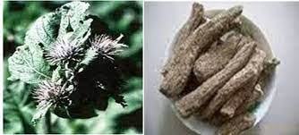 | Shunthi  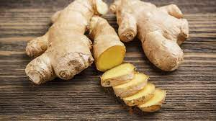
Vacha  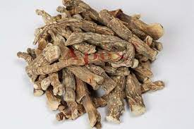 | Shigru  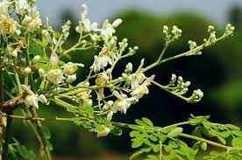
Lashuna  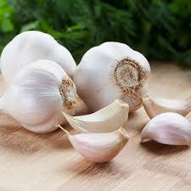 | Karttootti  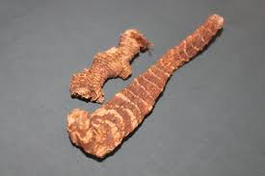
Devdaru  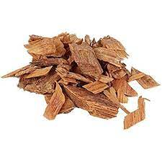 | Sarshapa  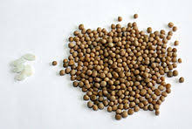
Rasna–Suvacha  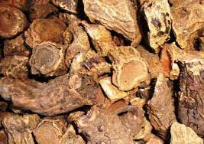 | Pushkarmoola  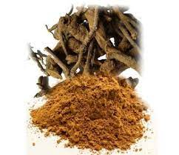
Chinchapatra  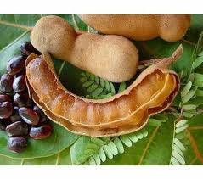 | Gomutraarka  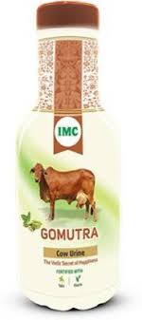

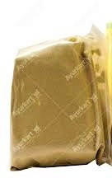  Kottamchukkadichurna | Gomutraarka

Clinical study:
As this research involved human participants, ethical approval was taken from Institutional Ethics Committee (IEC) on 03-05-2022with IEC no.: SDMIAH/IEC/46/2022 (Annexure 1). For clinical trial, 30 subjects with breast fibro adenoma were screened and selected from OPD, IPD of department of PrasutiTantraevamStreeRoga and from the camps conducted, as per the inclusion and exclusion criteria. Information sheet was provided to each subject, purpose of clinical trial was explained and written consent was taken for participation in the study. All 30 subjects participated successfully till the completion of study period.

Study design:
It is a clinical interventional open label, single arm study with evaluation of data in single group.
Sample size: 30
Study period: 7 days
1st follow up – 15th day after the treatment
2nd follow up – 15th day after the 1st follow up
3rd follow up – 45th day
Total duration –2 months
The subjects willing to participate in the study were screened according to the inclusion and exclusion criteria by a screening form. They were explained about the purpose of study, significance of their participation and participant information sheet was provided to each subject, purpose of the trial was explained and consent was taken for participation in the study, followed by which a detailed case sheet was filled for data collection and diagnosis was concluded as Breast Fibroadenoma based on clinical assessment and reports of USG. An Adverse Drug Reaction ^{[6]} form was utilized to document any adverse drug reactions during the study. Subjects were dispensed with the churna and arka, and given guidelines over application procedure. They were informed about the method of application and removal. Kottamchukkadichurna was mixed with gomutraarka to obtain a paste ^{[5]} like consistency. It was applied over the breasts except the area of nipples and was kept for 20 minutes. Later it was removed using a wet cotton pad. The lepa was applied continuously for 7 days, and follow up was carried out on Day 0, Day 7, Day 15, Day 30 and Day 45. This whole period of treatment and follow ups were observed for the reduction in pain, pricking sensation, tenderness and inflammation of the breast.
Target Population

Potential Participants

Subjects evaluated n=30
(Based on inclusion & exclusion criteria)

Eligible subjects randomized n_{i} =30
Assessment of the condition on Day 0 done based on the subjective criteria

Subjects were dispensed with Kottamchukkadichurna Gomutraarka

Assessment and follow up of the condition on Day 0, Day 7, Day 15, Day 30 and Day 45 was observed and noted

Completed study n_{f} =30
Inclusion Criteria:
- Women aged between 18-25 years, complaining of lump in the breast.
- Individuals willing to sign the assigned consent form.

Exclusion criteria:
- Pregnant and nursing mothers.
- Women with giant and juvenile fibro adenoma, with the history of breast malignancy/ surgery.
- Women with breast implants.
- Individuals participating in any other clinical trials involving investigational drugs, device etc.

Assessment Criteria:
Fibroadenoma of breast assessment can be done, in terms of –
• Visual Analogue Scale ^{[7]}

Figure 1: Showing Visual Analogue Scale
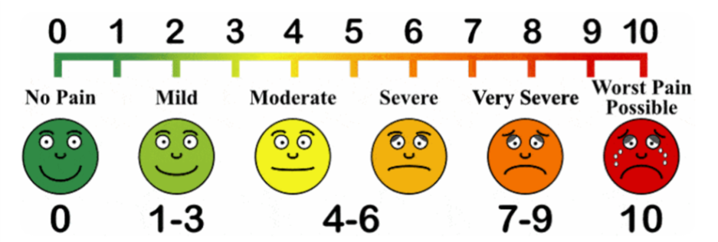
• Pain
0 - No pain
1 - Localized pain during movement but tolerable
2 - Localized pain during movement which effects the movement
3 - Localized pain at rest but not disturbing the sleep

• Pricking sensation
Pricking sensation (Yes/ No)

• Tenderness
0 – No tenderness
1 – Tenderness on applying pressure
2 – Tenderness on gentle touch over the lump
3 - Tenderness on touching the lump and surrounding area

• Inflammation
0 – No inflammation
1 – Slight inflammation
2 – Inflammation with tenderness and painful during movements
3 - Inflammation with painful movements with local rise in temperature
Assessment and follow up for the signs and symptoms will be done on day 0, day 7, day 15, day 30 and day 45 based on gradations. The information gathered will be subjected for statistical analysis.

Observations & Results:
Literature review conducted over the formulation evaluated the subsequent findings about efficacy of Kottamchukkadichurna and Gomutraarka.Lepa is a form of bahir-parimarjanachikitsa (external treatment) used to get equilibrium between sthanikadosha (localized dosha) and dhatusamyata (tissue maintenance). It is absorbed through the surface of body which promotes optimum drug delivery and action.
After obtaining a complete history as per the special proforma, observations were made with regard to age, socio-economic status, marital status, parity, pain pricking sensation, tenderness, inflammation etc.

Incidence of Age: Age wise distribution of 30 patients shows that 43.3% patients were belonging to the age group 18-21 years, 33.33% of 22-25 years and 23.33% of patients were from more than 25 years, as shownin the table below.

Table 2: ShowingIncidence of Age

Age (years) | Trial group | %
18-21 | 13 | 43.33
22-25 | 10 | 33.33
>25 | 7 | 23.33

Figure 1: Showing Incidence of Age

Incidence of Socio-economic Status: out of 30 patients, 20% were of lower middle class, 33.33% of middle class and 46.66% of upper middle class.

Table 3: Showing Incidence Socio-economic Status
Socio-economic status | Trial group | %
Lower middle class | 6 | 20
Middle class | 10 | 33.33
Upper middle class | 14 | 46.66

Figure 2: Showing Incidence Socio-economic Status

Incidence of Dietary Habits: out of 30 patients, 70% were vegetarians and 30% eat mixed diet.
Table 4: Showing Incidence of Dietary Habits
Dietary habits | Trial group | %
Vegetarian | 21 | 70
Mixed | 9 | 30

Figure 3: Showing Incidence of Dietary Habits

Incidence of Dysmenorrhea: out of 30 patients, it was observed that 80% had painful menstruation (dysmenorrhea) and 20% with absence of dysmenorrhea.

Table 5: Showing Incidence of Dysmenorrhea
Dysmenorrhea | Trial group | %
Present | 24 | 80
Absent | 6 | 20

Figure 4: Showing Incidence of Dysmenorrhea

Incidence of Marital Status: out of 30 patients, 50% of them were married and other 50% were not married.

Table 6: Showing Incidence of Marital Status
Marital Status | Trial group | %
Married | 15 | 50
Unmarried | 15 | 50

Figure 5: Showing Incidence of Marital Status

Incidence of Parity: the data shows 53.33% nulliparity, 33.33% monoparus and 13.33% 2 parous.

Table 7: Showing Incidence of Parity
Parity | Trial group | %
Nulliparous | 16 | 53.33
P – 1 | 10 | 33.33
P – 2 | 4 | 13.33

Figure 6: Showing Incidence of Marital Status

Prakruti: according to the study, 50% of the patients were of Vata-Kaphajaprakruti, 20% of them were of Vata-Pittajaprakruti and rest 30% belonged to Pitta-Kaphajaprakruti.

Table 8: Showing Incidence of Prakruti
Prakruti | Trial group | %
Vata-Kapha | 15 | 50
Vata-Pitta | 6 | 20
Pitta-Kapha | 9 | 30

Figure 7: Showing Incidence of Prakruti

Saara: among 30 patients, 20% belonged to Pravara, 46.66% to Madhyama and 33.33% to Avarasaara.
Table 9: Showing Incidence of Saara
Sara | Trial group | %
Pravara | 6 | 20
Madhyama | 14 | 46.66
Avara | 10 | 33.33

Figure 7: Showing Incidence of Saara

- Satva: among 30 patients, 33.33% were of Pravarasatva, 46.66% of Madhyamasatva and 20% of Avarasatva.

Table 9: Showing Incidence of Satva
Satva | Trial group | %
Pravara | 10 | 33.33
Madhyama | 14 | 46.66
Avara | 6 | 20

Figure 8: Showing Incidence of Satva

- Samhanana: according to the case study, 20% were Pravara, 56.66% Madhyama and 23.33% Avara.
Table 10: Showing Incidence of Samhanana
Samhanana | Trial group | %
Pravara | 6 | 20
Madhyama | 17 | 56.66
Avara | 7 | 23.33

Figure 9: Showing Incidence of Samhanana

- Abhyavarana Shakti: out of 30 patients, 13.33% had Pravarashakti, 70% were of Madhyama shakti and 23.33% of Avarashakti.
Table 11: Showing Incidence of Abhyavarana Shakti
Abhyavaranashakti | Trial group | %
Pravara | 4 | 13.33
Madhyama | 21 | 70
Avara | 5 | 16.66

Figure 10: Showing Incidence ofAbhyavarana Shakti

- Jarana Shakti: among the 30 patients, 26.66% of them had Pravarashakti, 66.66% had Madhyama shakti and 6.66% had Avarashakti.
Jaranashakti | Trial group | %
Pravara | 8 | 26.66
Madhyama | 20 | 66.66
Avara | 2 | 6.66
Table 12: Showing Incidence of Jarana Shakti

Figure 11: Showing Incidence ofJarana Shakti

DETAILED STATISTICAL ANALYSIS OF RESULTS
Results of the treatment were tabulated and analyzed statistically for data of 30 patients using GraphPad Prism 9.0. Unpaired ‘t’ test and Wilcoxon signed rank test were done to interpret the significant changes and improvement. Results having p<0.01 is considered as statistically significant in this study.

Table 13: Pain Parameter
Showing ‘t’ test results in reduction of Pain before and after the treatment
Group | Mean | Pair t test
 |  | SD | Difference  (95% confidence interval) | SEM | T | P
BT | 2.067 | 1.015 | 2.033 ± 0.1883 | 0.1853 | 10.80 | <0.0001
AT | 0.03333 | 0.1826 |  | 0.03333

Table 14: Pain Parameter (VAS)
Visual Analouge Scale
Pain | Trial group | %
0 | 0 | 0
1-3 | 10 | 33.33
4-6 | 10 | 33.33
7-9 | 10 | 33.33
10 | 0 | 0

Figure 12: Visual Analogue Scale

Table 15
Showing ‘t’ test results in reduction of Pricking sensation before and after the treatment
Group | Mean | Pair t test
 |  | SD | Difference  (95% confidence interval) | SEM | T | P
BT | 0.7333 | 0.4498 | -0.7333 ± 0.08212 | 0.08212 | 8.930 | <0.0001
AT | 0 | 0 |  | 0

Table 16: Tenderness Parameter
Showing ‘t’ test results in reduction of Tenderness before and after the treatment
Group | Mean | Pair t test
 |  | SD | Difference  (95% confidence interval) | SEM | T | P
BT | 1.767 | 1.104 | -1.667 ± 0.2092 | 0.2016 | 7.968 | <0.0001
AT | 0.1 | 0.3051 |  | 0.05571

Table 16: Tenderness Parameter
Showing ‘t’ test results in reduction of Inflammation before and after the treatment
Group | Mean | Pair t test
 |  | SD | Difference  (95% confidence interval) | SEM | T | P
BT | 1.7 | 1.055 | -1.700 ± 0.1927 | 0.1927 | 80823 | <0.0001
AT | 0 | 0 |  | 0

Interpretation of statistical analysis:
Results of the treatment were tabulated and analyzed statistically for data of 30 patients using GraphPad Prism 9.0. Unpaired ‘t’ test and Wilcoxon signed rank test were done to interpret the significant changes, before and after the treatment. Results having p<0.01 is considered as statistically significant in this study.All the test parameters were said to be statistically highly significant.

CONTRIBUTIONS MADE TOWARDS INCREASING THE STATE OF KNOWLEDGE IN THE SUBJECT
Breast fibroadenomacan be understood in terms of Kaphajasthanagranthi with their respective cardinal features.
Kottamchukkadichurna having kushta,shunti,vachaetc having ushnaveerya, vedanashamana (reduces pain) and shophahara (reduces inflammation) properties helps in reducing the heaviness, pain and tenderness of the fibroadenoma.
Gomutraarka is mainly beneficial in edema and tumors, acts as the best medicine in association with kottamchukkadichurna as an external application in treating breast fibroadenoma.
In combination kottamchukkadichurna and gomutraarka act on the vata and kapha by virtue of their vedanahara and shophahara properties there by reducing the pain, heaviness and tenderness.
Kottamchukkadilepa which is non-invasive, easily available, cost effective and easy administration at OPD level, having better patient acceptance proves to be a new ray of hope in the management of Fibroadenoma of the breasts.

CONCLUSION SUMMARIZING THE ACHIEVEMENTS AND INDICATION OF SCOPE FOR FUTURE WORK

Breasts being the most important external identification of femininity, any abnormality in the breast contour can have devastating psychological effects on women.
The contemporary system of medicine uses analgesia and surgery as the line of management for breast fibroadenoma. Cosmetologically, surgery being less accepted by women, medical management is need of the hour.
As per the study, it is proved that Ayurvedic treatment in fibroadenoma of the breast is very effective, wherein there was a remarkable reduction in heaviness, pain and tenderness.
The present study was carried on a small group of sample size n=30, showed statistically significant results, which paves the way for further research on a larger population amongst varied age groups of women.
Being a non – invasive, easily available, cost effective and easy administration having better patient acceptance proves to be a new ray of hope in the management of Fibroadenoma of the breasts.

REFERENCES
- Sabaratnam A, V Sivasenesaratnam, A Chatterjee, Pratap K, Editors. Essentials of Gynecology.3rd ed. New Delhi: Jaypee Brothers Medical Publishers, 2019. p.454- 218

- Jadavji TA, Narayan R A, Editors. Nibandhasangraha Commentary by Sri Dalhanacharya, SushrutaSamhita of AcharyaSushruta, ChikitsaSthana, Granthyaparchyarbudachikitsitam: Chapter 18, Verse:12-14. Varanasi: ChaukambaOrientalia, 2018, p.784- 471.

- K Nishteswar, R Vidyanath.Sahasrayogam. Chapter- ParisisthtaPrakaranaTaila, Varanasi: Chaukamba Orientalia,2017. p.540-405

- V Revashankar, KamdhenuChikitsa, Editors. 2011, p.16

- Ravindra Angadi, A Textbook of BhaishajyaKalpanaVijnana- Pharmaceutical Science, 2 ndedi. Varanasi: ChaukambaSurbharatiPrakashan.LepaKalpana. 2016, p.560- 349

- Central Drug Standard Control Organization, Directorate General of Health Services, Ministry of Health & Family Welfare, Government of India, https://cdsco.gov.in/opencms/opencms/en/Search/index.html/ accessed date 04/05/2022.

- Visual analogue scales (VAS): Measuring instruments for the documentation of symptoms and therapy monitoring in cases of allergic rhinitis in everyday health care, https://www.ncbi.nlm.nih.gov/pmc/articles/PMC5288410/ accessed date 04/05/2022.

- Breast Fibroadenoma, StatPearls, National Library of Medicine, last updated date 06/10/2022, https://www.ncbi.nlm.nih.gov/books/NBK535345/

