ECHOCARDIOGRAPHIC ASSESSMENT IN PATIENTS WITH MITRAL VALVE DISEASES

AUTHORS
M.GLORY MERLIN,ASSISTANT PROFESSOR IN DEPARTMENT OF CARDIAC TECHNOLOGY,
SCHOOL OF ALLIED HEALTH SCIENCES,VINAYAKA MISSIONS RESEARCH FOUNDATION -DU,AVMC & H CAMPUS,PUDUCHERRY
glorymerlinsahs@gmail.com

ABSTRACT
Mitral valve plays a key role in the heart,as it controls the flow of blood moving in one direction from the lungs to the body.[1]A life-threatening heart condition may result if the mitral valve, which is situated between the left upper chamber (left atrium) and the left lower chamber (left ventricle) of the heart, does not close properly or opens completely.The most effective and non-invasive method for evaluating mitral valve diseases is echocardiography.Transthoracic echocardiography is sufficient for the majority of conditions [2,3]. This topic will examine the evaluation of the severity of valve dysfunction using echocardiography and to study the common morphological features of mitral valve disease and to recognize the severity of mitral stenosis and regurgitation by using Echocardiography.
KEY WORDS: Left Atrium,Left Ventricle,Transthoracic Echocardiography,Mitral Stenosis,Mitral Regurgitation.

I.INTRODUCTION

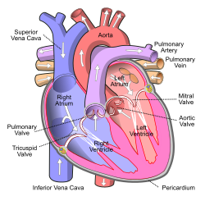
The typical mitral valve apparatus is a dynamic, three-dimensional system that assures unidirectional cardiac pump performance by closing the left atrium from the LV during systole and allowing rapid left ventricular (LV) blood inflow during diastole. The mitral annulus, the mitral valve leaflets, the chordae tendineae, and the left ventricle wall with its connected papillary muscles (PMs) are important parts. An imbalance can cause a leaky (regurgitant, inadequate, incompetent), stenotic, or mixed regurgitant and stenotic valve dysfunction. Proper valve function depends on the integrity and harmonic interaction of these components. Under normal circumstances, the left atrium contracts during diastole, allowing blood to flow through an open mitral valve, while the left ventricle contracts during systole, causing the valve to close. Pressure differences cause the valve to open and close, opening when the left atrium has a higher pressure than the ventricle and closing when the ventricle has a higher pressure than the atrium.In abnormal circumstances, the mitral valve may narrow (mitral stenosis) or blood may flow backward through it (mitral regurgitation). The mitral valve is frequently impacted by rheumatic heart disease; it can also prolapse with aging and be harmed by infective endocarditis. The bishop's mitre, which mimics the flaps of the mitral valve, inspired its name.

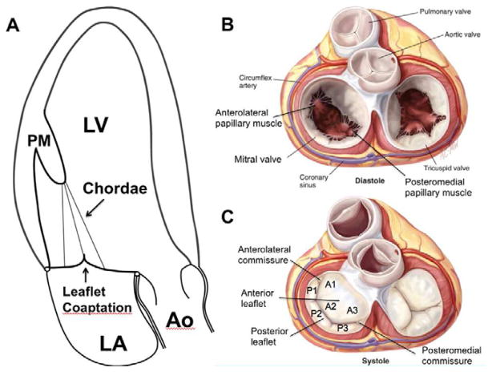
FIGURE.1.MITRAL VALVE

II.ANATOMY OF MITRAL VALVE

MITRAL VALVE APPARATUS:

LEAFLETS: The MV is made up of two leaflets, an annular connection at the atrioventricular junction, tendinous cords, and papillary muscles (PMS).The two leaflets of the mv are structurally distinct and are known as the Anterior and Posterior leaflets.

ANNULUS: It is not a rigid fibrous ring but pliable, changing shape during the cardiac cycle.Instead, it incorporates several structures along its hinge point. Fibrous continuity exists between the aortic mitral leaflet (anterior) and the right and left fibrous trigones.This portion of the annulus is thus fibrous and less prone to dilatation; the other two-thirds of the annulus is primarily muscular.In severe mitral regurgitation, this area frequently dilates and is more prone to calcification.
- CHORDAE TENDINAE: In the typical valve, fan-shaped cords flow from the papillary muscles into the leaflets. There are three kinds of chordae tendinae, depending on where they attach.Primary chords are connected to the free edge of both rough zones.Secondary chords adhere to the ventricular surface in the rough zone (i.e. the leaflet's body). Only the mural (posterior) leaflet bears tertiary chords.These cords are attached to the ventricular wall directly.Posteromedial PM chords the medial half of both leaflets (i.e. Posteromedial commissure, P3, A3, and half of P2 and A2).Similarly, the Anterolateral PM chords connect to the lateral half of the MV leaflets (i.e. Anterolateral commissure, A1,P1, and half of P2 and A2).The aortic (anterior) leaflet's secondary chords are the biggest and thickest. The strongest strut cords are assumed to come from the apex of each papillary muscle.
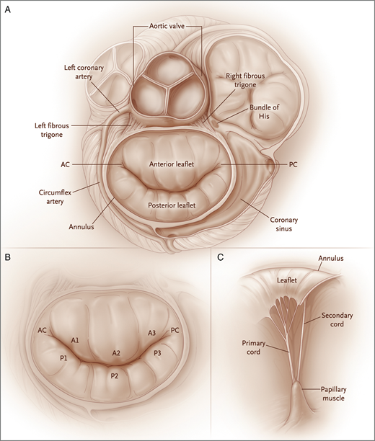
- PAPILLARY MUSCLES:The PM bundles are typically located in the anterolateral and posteromedial positions and run along the mid to apical segments of the left ventricle; the former is typically seen to attach at the border of the anterolateral (lateral) and inferolateral (posterior) walls, and the latter over the inferior wall; in most adults, the pm can have up to three heads.Our research has shown that this distribution, particularly in people with myxomatous-type leaflets (degenerative mv disease), can vary greatly. In a few instances, one or both PMs lack definition and are replaced by a number of thin muscle bundles that are attached to the ventricular wall.

FIGURE:2.MV APPARATUS
III. MITRAL VALVE DISEASES
The mitral valve's primary issues are:
- Mitral valve prolapse: the valve becomes overly floppy.
- The valve leaks in mitral regurgitation, causing blood to flow the opposite direction.
- Mitral stenosis causes the valve to not open as widely as it should.

III.A.MITRAL VALVE REGURGITATION
- MITRAL REGURGITATION: Mitral valve regurgitation can be caused by problems with the mitral valve, also called primary mitral valve regurgitation. Diseases of the left ventricle can lead to secondary or functional mitral valve regurgitation[3].
- PROLAPSE Leaflet billowing of more than 2 mm over the annular "plane" during systole is referred to as Prolapse.The parasternal longaxis view, which shows the highest points of the saddle-shaped annulus, is often used to make this judgment. The apical four-chamber view, which reveals lower (more apical) spots on the annulus, should not be used only to diagnose prolapse.The severity of MV prolapse ranges from little leaflet prolapse into the left atrium to widespread leaflet thickness and redundancy[4].
- FLAIL LEAFLET is a kind of MV prolapse that is characterized by the leaflet becoming everted, losing its typical convex form, and having its tip visible within the left atrium.Disruption of the principal (marginal) chordae results in a flail leaflet because efficient coaptation is no longer possible.Clinically significant MV Barlow disease and fibroelastic deficit are the two most common ways that prolapse/flail manifests.
- MYXOMATOUS DEGENERATION OF MITRAL VALVE:In cases of mitral valve prolapse, myxomatous degeneration is the most frequent underlying disease.It mostly affects women, and it occurs more frequently as people become older.As a result, the Chordae Tendinae and the valve leaflet are stretched out.The leaflets of the mitral valve ballooning.Annular dilatation, elongated, thinning tendinous cords, and thickened, rubbery leaflets are signs of the disease.Mitral valve prolapse is shown on echocardiography.[5,6]Mitral regurgitation is caused by the valve leaflets prolapsing into the left atrium as a result of the chordae and valve leaflets' elongation preventing the valve leaflets from fully coapting when the valve is closed.One or both leaflets are prolapsed back into the left atrium and one or both are enlarged, hooded, reduntant, or floppy.A minority of people experience serious complications.

III.B. MITRAL STENOSIS:

The narrowing of the mitral valve aperture causes mitral stenosis. It cannot receive enough blood because of this.There are several problems that mitral valve stenosis can cause, such as exhaustion, breathing problems, blood clots, and heart failure.The primary cause of mitral valve stenosis is scarring brought on by rheumatic fever.Despite being widespread in other nations, rheumatic fever is now uncommon in the United States as a result of early diagnosis and treatment of streptococcal infections. The evaluation of the mitral valve using echocardiography should include the following:
  - A diagnosis based on the pattern of valve involvement and calcification.
  - The degree of mitral stenosis; the presence of associated mitral regurgitation; and any further coexisting valve abnormalities[7]
  - The purpose and enlargement of the chamber.
  - M-mode tracing, several two-dimensional images, and doppler flow analysis are all necessary for a thorough echocardiographic study of the mitral valve.

IV. ECHOCARDIOGRAPHIC FEATURES OF PATIENTS WITH MITRAL VALVE DISEASES :

When evaluating the mitral valve using echocardiography, the following should be done:
- Diagnosis based on the pattern of valve involvement and calcification.
- The degree of mitral stenosis, the presence of mitral regurgitation, and any further coexisting valve diseases.
- The dilation and operation of chambers

The following echocardiographic procedures are required for a thorough evaluation of the mitral valve:
- M-mode tracing,
- several two-dimensional images, and
- Doppler flow analysis.

IV.1.ECHOCARDIOGRAPHIC FEATURES IN MR:

A.COLOR FLOW MAPPING:

• A flow recruitment's size is indicated.

• The valve level jet base width.

• If it is a central jet, the intra-atrial jet region.

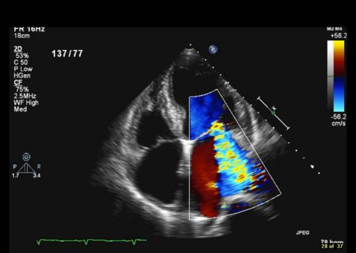
• The direction of the jet is typically behind a confined leaflet and away from a prolapsing leaflet.

FIGURE.3: COLOUR DOPPLER IN MR

- CONTINUOUS WAVE DOPPLER:

• Signal density and shape – in severe mitral regurgitation, the flow is triangular and dense.

• It is Severe if as Dense as Forward flow.

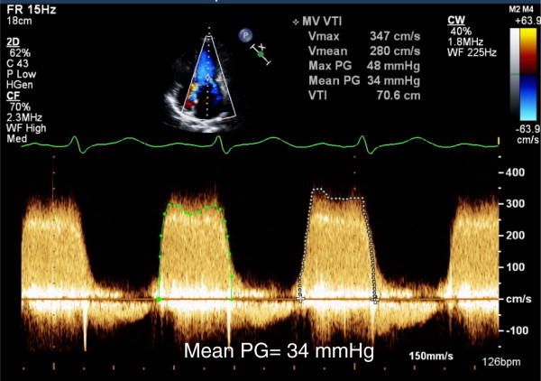

FIGURE.4: CONTINUOUS WAVE DOPPLER IN MR

- PULSE WAVE DOPPLER(PW) :
- Apical 4-chamber view is used to capture PW tracings.
- Severe mr is indicated by an E wave greater than 1.2 m/s.[8]
- Hyperdynamic circulation or even mild mitral stenosis might augment the E wave.
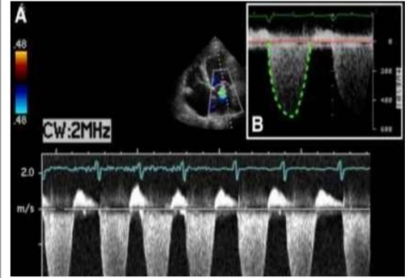
    - Severe MR is essentially ruled out if A-wave is dominating.

FIGURE.5: PULSE WAVE DOPPLER IN MR

PULMONARY VENOUS FLOW:
  - Usually moving ahead during the cycle.
- dominating in the systole.
- Systolic flow becomes blunted as MR deteriorates.
- Systolic Flow Reversal if MR is Serious.
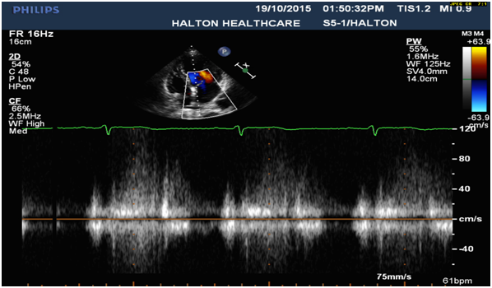

FIGURE.6: PULMONARY VENOUS FLOW OF MR

IV.2. FEATURES OF MITRAL VALVE PROLAPSE IN ECHOCARDIOGRAPHY:
A. CRITERIA FOR MVP:
- >3mm late systolic buckling.
- Pan Systolic Hammocking 5mm or more.
- Very Specific,Not Sensitive.
- M-Mode echo is useful when 2D echo is equivocal.
- Colour M Mode-whether Pan Systolic or Late Systolic.

- 2D ECHO FEATURES:

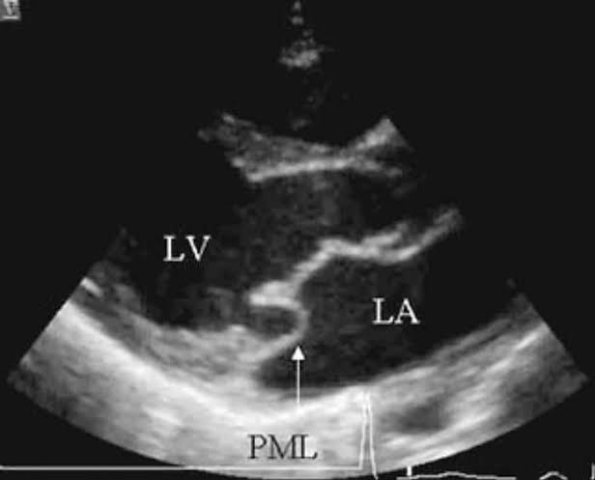
If any leaflet moves more than 2 mm superiorly into the left atrium during systole in the parasternal long axis view with a leaflet thickness of at least 5 mm, or if the site of coaptation moves away from the annular plane in the apical 4 chamber view, these are the signs that something is wrong.Chordal elongation, annular dilatation, and expanded la size thick and superfluous leaflets and chordae are additional findings on echo.[9]

FIGURE.7. 2-D ECHOCARDIOGRAPHIC IMAGE OF MV PROLAPSE

Lessened tensile strength causes chordae, which often take the form of flail segments, to progressively elongate or break.
- PARASTERNAL LONG AXIS VIEW:
- Systolic displacement of a mitral valve that seems normal or myxomatously swollen, or a part of it, beyond the plane of the mitral annulus.
- Mitral annulus plane: a line that connects the intersection of the posterior left atrial and left ventricular walls with the posterior aortic wall and the AML.
- The regurgitant jet will be extremely eccentric and either posteriorly or anteriorly oriented, less sensitive and specific.Therefore, it will be extremely challenging to gauge the degree of regurgitation in such jets.
- M MODE IN MITRAL VALVE PROLAPSE:
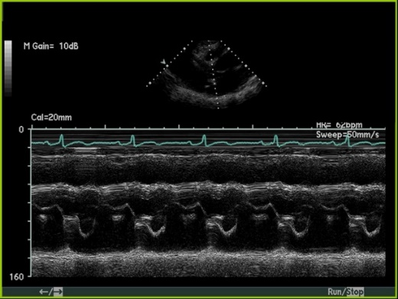
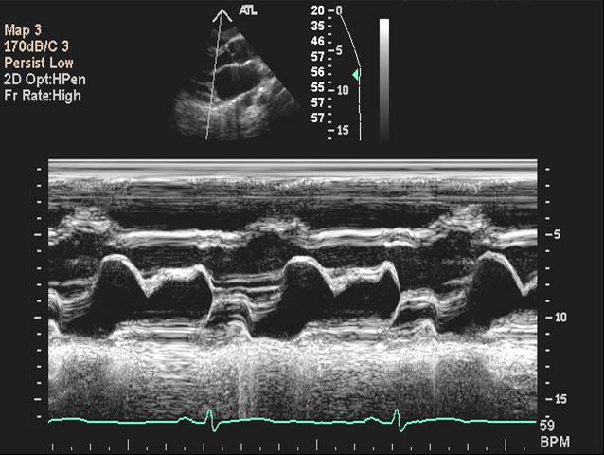
- The Posterior Mitral Valve Leaflet shows Systolic Bowing.

8.A. 8.B.
FIGURE.8. A.shows the Systolic bowing of Anterior MV and FIGURE 8.B. represents Prolapse of PMV

- APICAL 4C VIEW:
- The Regurgitant jet is very eccentric,molding the Lateral Wall of the Left Atrium.

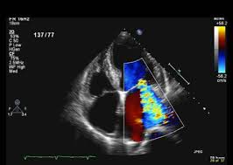
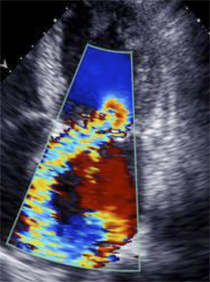
    - B.
FIGURE.9.A.Shows Eccentric Jet of MR and FIGURE.9.B. shows Centralized Jet flowing inside LA.

IV.2.1.ECHO CARDIOGRAPHIC FEATURES OF FLAIL LEAFLET INCLUDES:
• A leaflet tip that does not have systolic coaptation and points to LA.
• Torn chordae, parallel sign between flail and regular leaflets, and double contour.
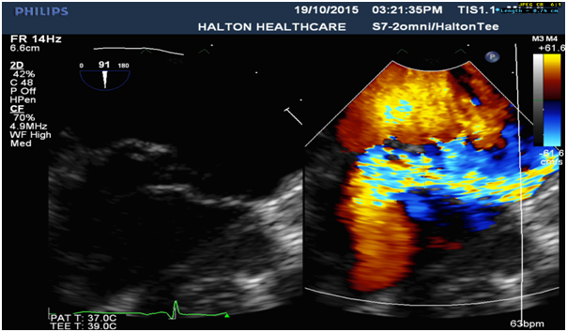
• Eccentric MR jet direction opposing the flail leaflet's position.
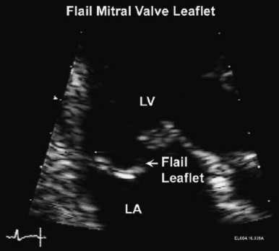

FIGURE.10.A.Shows anteriorly directed flail leaflet with eccentric jet towards the Posterior side.

- DOPPLER ECHOCARDIOGRAPHY:
According to ASE guidelines, it is crucial in determining the severity of MR.
• A Vena Contracta Jet width of ≥ 0.7 cm
• Large central Mitral Regurgitation jet (area >40% of left atrium),
• Systolic pulmonary venous flow reversal, Effective Regurgitant Orifice >40 mm²
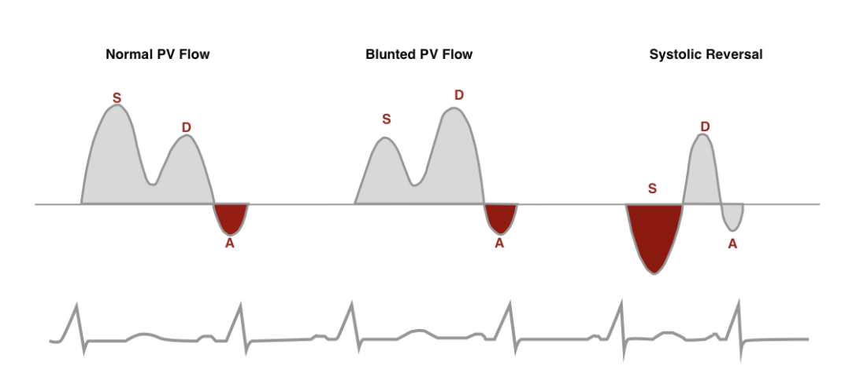

FIGURE.11. Systolic Pulmonary Venous Flow Reversal of Mitral Regurgitation.

IV.2.2.MYXOMATOUS DEGENERATION OF MITRAL VALVE:
- DOPPLER ECHO:
- Color Flow Mapping is the greatest tool for determining the extent of MR, and the MR jet is frequently oriented posteriorly.
- The degree of regurgitation is determined by comparing the regurgitant jet area to the total left atrial area.
- It's critical to distinguish between mild pathogenic MR and physiologic MR, which can occasionally be noticed in healthy people.
- A pathological MR is visible in at least two views, has a regurgitant jet length of at least 2 cm, a peak velocity of at least 3 m/s, and at least one beat of pansystolic Doppler signal.

- CONTINUOUS WAVE DOPPLER:
- A qualitative method of assessing MR.
- As opposed to a feeble signal, a dense MR signal with a complete envelop suggests more severe MR.
- Severe MR may cause the CW Doppler to be truncated (notched), with a triangle contour, an early Peak Velocity-Elevated pressure, and a noticeable Regurgitant pressure wave in the Left Atrium. It can also be challenging when there is an eccentric jet.

IV.3. ECHOCARDIOGRAPHIC ASSESSMENT IN MITRAL STENOSIS:
IV.3.1. RHEUMATIC HEART DISEASE- ECHOCARDIOGRAPHIC ASSESSMENT IN MITRAL STENOSIS:
- In the great majority of instances, MS is secondary to RHD.
- The valve thickens and fibrosis, as well as commissural fusion, are effects of the chronic rheumatic process.
- In several poor nations, severe MS strikes at a young age.
- The leaflets of the mitral valve are thick and have small apertures, and subvalvular apparatuses that have undergone chordal shortening and fusion may be implicated.
- The preferred form of therapy for MS patients is balloon valve replacement, and echocardiography is a critical tool in determining a patient's potential for balloon valve replacement and the severity of their MS.
- 2D ECHO:
- The mobility of the mitral valve is limited, resulting in doming and the distinctive dog leg deformity. • The mitral valve is thickened, and frequently the anterior mitral leaflet measures >5 mm in thickness.
- The Parasternal Short-Axis view offers the finest opportunity to observe commissural fusion, the defining feature of the rheumatic etiology.
- By using planimetry in the parasternal short-axis view at the leaflet tips, the mitral valve area may be determined.
- A two-dimensional echo allows for a thorough assessment of the subvalvular deformity.
- Chronic pressure overload causes the Left Atrium to expand.
- Left atrial thrombosis is a frequent complication of MS, particularly in patients with atrial fibrillation and/or very large left atrium(>50 mm).
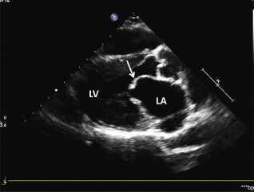
- The Left Atrial Appendage is where the Clot is frequently seen, and unless the appendage is explicitly observed in short-axis view, it can go undetected.

FIGURE.12.Indicates Typical RHD with MS showing features of AML Doming,PML Restricted,LA dilatation,Thickening and Calcification of MV Leaflets

- M-MODE
- The M-mode echo results are pretty normal.
- Mitral valve leaflets are thickened.
- A decrease in the E-F slope of the anterior mitral leaflet.
- The posterior mitral valve leaflet moves anteriorly or paradoxically.
- A-wave of the mitral leaflet is absent or reduced.
- The left atrium is enlarged, but the left ventricular size and systolic function are normally intact.
- Patients with severe pulmonary hypertension may also have an enlarged right atrium and right ventricle.
- In these cases, the interventricular septal motion is paradoxical.
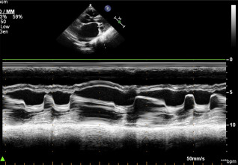
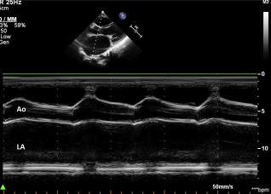
- The function may be decreased in some circumstances due to acute rheumatic carditis or persistent atrial fibrillation.
- B

FIGURE:13.A.Shows Dilatation of Left Atrium.FIGURE.13.B. Shows mitral valve leaflets Thickening,Decreased E-F slope of the AML,Anterior or Paradoxical motion of the PML,Diminished or Absence of A-wave in the mitral leaflet.
C . DOPPLER ECHOCARDIOGRAPHY:
- Mitral valve area may be measured using pressure half-time technique or continuity method, and will be discussed in detail later.
- The flow over the mitral orifice is turbulent with decreasing E-F slope of the mitral inflow doppler trace.
- The primary reason for catheterizing these patients today is to perform balloon mitral valvotomy.
- The Doppler trace across the mitral valve is used to derive mean and end-diastolic gradients, and echocardiography has replaced cardiac catheterization as the gold standard for assessing the severity of MS.
- The diastolic jet might be eccentric due to subvalvular involvement, hence color flow imaging in the apical 4-chamber view is quite helpful to locate it.
- Color jet-derived gradients have higher levels of dependability.
- Depending on heart rate, the gradients might change.
- To compute the mean gradient in atrial fibrillation, an average of five or more cardiac cycles should be employed.
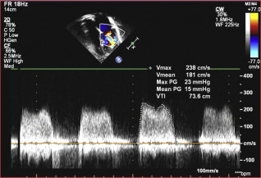
- Because it is influenced by heart rate, cardiac output, and concurrent MR, the mean gradient could not correspond with the severity of MS.

FIGURE:14.Measurement of Mean Pressure gradient using CW Doppler

- COLOR DOPPLER ACROSS MITRAL VALVE IN A PATIENT WITH MITRAL STENOSIS:
- Using the Bernoulli Equation (gradient = 4 velocity2), the TR jet velocity is measured in order to determine the degree of pulmonary hypertension.
- In all patients with MS, it is important to check for concurrent MR, and additional valves must be thoroughly inspected for any signs of RHD involvement.
- The balloon dilation operation was effective when the transmitral gradients decreased and the degree of pulmonary hypertension decreased.
- In the event that the patient gets mr, its mechanism is immediately discernible, allowing for proper patient management.
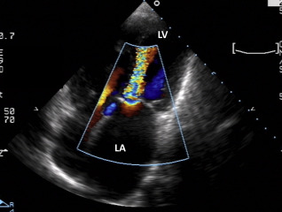
- While commissural MR, which is not severe, can be closely monitored conservatively, MR caused by a valve rupture or chordal avulsion sometimes necessitates immediate surgery for mitral valve repair or replacement[10].

FIGURE:15. COLOUR DOPPLER SHOWING SEVERE MS IN APICAL 4 CHAMBER VIEW.

V. REFERENCE

1) Rheumatic fever and rheumatic heart disease World Health Organ Tech Rep Ser, 923 (2004),

2)J.R. Carapetis Rheumatic heart disease in developing countries N Engl J Med,357 (2007), pp. 439-441

3)M. Enriquez-Sarano, C.W. Akins, A. Vahanian Mitral regurgitationLancet, 373 (2009), pp. 1382-1394 ArticleDownloadPDFView.

4)R.H. Marcus, P. Sareli, W.A. Pocock, et al. Functional anatomy of severe mitral regurgitation in active rheumatic carditis Am J Cardiol, 63 (1989), pp. 577-584 ArticleDownloadPDFView.

5) hayek e, gringcn and griffin bp (2005) mitral valve prolapse. lancet 365(9458): 507-518.

6)guy ts, hill ac (2012) mitral valve prolapse. annu rev med 63: 277-292.

7)S.B. Roy, M.L. Bhatia, E.J. Lazaro, V. Ramalingaswami Juvenile mitral stenosis in India Lancet, 2 (1963), pp. 1193-1195

8)zoghbiwa, enriquez-sarano m, foster e, grayburn pa, kraft cd, et al. (2003) recommendations for evaluation of the severity of native valvular regurgitation with two-dimensional and doppler echocardiography. j am socechocardiogr 16(7): 777-802.

9)shah pm (2010) current concepts in mitral valve prolapse – diagnosis and management. jcardiol 56(2): 125-133.

10) H. Baumgartner, J. Hung, J. Bermejo, et al.Echocardiographic assessment of valve stenosis: EAE/ASE recommendations for clinical practice Eur J Echocardiogr, 10 (2009), pp. 1-25 CrossRefView Record.

