AI-POWERED HEALTHCARE TECHNOLOGY: A POST PANDEMIC CRITICAL REVIEW

DR. S. SAROJINI M.Com., M.Phil., Ph.D.
Assistant Professor, Commerce, Dr. G.R. Damodaran College of Science, CBE-14
DR. J. NITHYA M.Com., M.Phil., M.B.A., Ph.D.
Associate Professor, Commerce, Dr. N.G. P Arts and Science College, CBE-48
MS. SWATHY S
B. Com BPS, Dr. N.G. P Arts and Science College, Coimbatore-48
MR. SARAN R
B. Com BPS, Dr. N.G. P Arts and Science College, Coimbatore-48

ABSTRACT

The complication and escalation of information in healthcare means that (Artificial intelligence) will increasingly be tried within the field. Several types of AI are already being empowered by customers and providers of care, and life sciences corporations. The predominant areas include application involved in diagnosis and treatment, in and out patient information, official activities in hospital. Though there are many instances in which Artificial Intelligence can perform healthcare job as well or better than human beings, execution element will prevent extensive automation of healthcare expert jobs for a significant period. ChatGPT help reducing efforts to understand patients’ symptoms by providing alternative ways solving their problems. Ethical issues while using the application of AI in health care sector is also discussed. AI is being used to improve the accuracy of cancer diagnosis, to create new drugs and treatments. AI chatbots are used to provide information related to the patient support and education. Key Words: Artificial intelligence, life sciences, diagnosis, automation, ChatGPT
Key Words: Artificial intelligence, life sciences, diagnosis, automation, ChatGPT

INTRODUCTION:

Artificial intelligence (AI) and equivalent knowledges are rising in predominant business and society, and are commencement to be adopted to healthcare. These technologies have the capacity to transmute many features of patient care, as well as managerial processes within provider, payer and medicinal organizations. There are previously a number of research studies signifying that AI can execute as well as or better than humans at key healthcare jobs, such as identifying disease. Today, structured programs are by now performing radiologists at noticing malignant tumors, and administrating the researchers that how to build cohorts for expensive clinical trials. Humankind believes that AI replaces humans or doctors in wider medical process domains. In this paper, we discuss both the potential that Artificial Intelligence offers to automate aspects of care that is provided to the patients.
AI-POWERED CHATBOTS IN HEALTHCARE
AI chatbots are being used to provide information related to patient support and education. For example, Babylon Health's chatbot has been used by over 2 million patients in the UK, and it has been shown to be effective in reducing wait times and improving patient satisfaction.
AI IN DRUG DISCOVERY
AI is being used to create new drugs and treatments. For example, Insilico Medicine uses AI to predict the effects of new drug candidates on human cells, and it has already identified several promising new drug targets.
AI IN CANCER DIAGNOSIS
AI is being used to improve the accuracy of cancer diagnosis. For example, Google AI has developed an AI system that can detect breast cancer with 99% accuracy, and it is currently being used in clinical trials.
AI IN PERSONALIZED MEDICINE
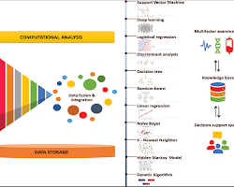
AI is being used to personalize medicine. For example, IBM Watson Health's Oncology Suite used AI to scrutinize patient data and recommend the best treatment plan for each individual patient.
These are lot of peculiar examples that AI is used in hospital industries. As AI technology endures to develop, so we can expect to see even more innovative and effective application of AI in the healthcare Industry.
Here are some additional figures and facts about AI in healthcare:
- According to the report by Grand View Research, the global market for AI in the healthcare field is expected to reach $6.6 billion by 2026.
- In 2020, there were over 1,000 AI-powered healthcare startups.
- AI is being used in over 200 different healthcare applications.
- AI is being used to improve patient care in over 50 countries.
These figures and facts show that AI is rapidly becoming a mainstream technology in the healthcare industry. As AI technology follows to develop, so we can expect to see even more widespread adoption of AI in healthcare in the forth coming year.
There are a few real-world examples of AI in healthcare:
- Google AI has developed an AI system that can detect breast cancer with 99% accuracy. The system, called DeepVariant, analyzes medical images to identify cancer cells. It is currently being used in clinical trials, and it has the potential to revolutionize the early detection of breast cancer.
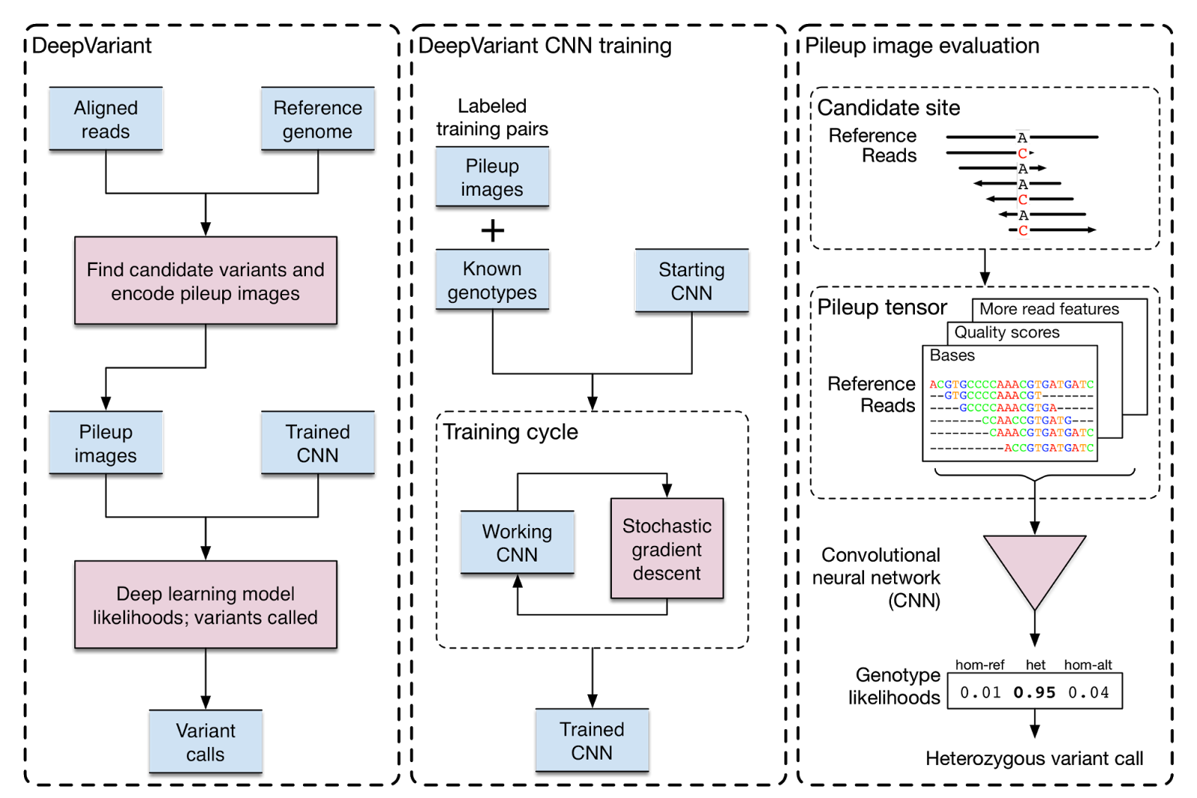 Source:ai.googleblog.com
Google AI DeepVariant
IBM Watson Health Oncology Suite
IBM Watson Health's Oncology Suite use AI to interpret patients data and recommend the best treatment plan for each individual patient. The system takes into account a patient's medical history, genetic information, and other factors to create a personalized treatment plan. It is currently being used in hospitals around the world, and it has the potential to improve the outcomes of cancer treatment.
Babylon Health chatbot
Babylon Health's chatbot has been used by over 2 million patients in the UK. The chatbot can answer patient questions, provide education on health topics, and even help patients book appointments. It has been shown to be effective in reducing wait times and improving patient satisfaction.
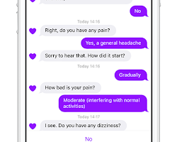techcrunch.com:
INSILICO MEDICINE USES AI TO PREDICT THE EFFECTS OF NEW DRUG CANDIDATES ON HUMAN CELLS:
The company's AI platform, called Genotype-Tissue Expression (GTEx), analyzes large datasets of medical data to identify new drug targets and develop new treatments.
. It has already identified several promising new drug targets, and it is currently working with pharmaceutical companies to develop new drugs.
These are lot of examples that provide live witnesses about the AI usage in healthcare today. As AI technology remains to develop, we can expect to see even more innovative and effective application of AI in the healthcare industry in the years to come.

TYPES OF ARTIFICIAL INTELLIGENCE OF SIGNIFICANCE TO HEALTHCARE

AI is a complex technology, but as a group. Most of the technology have instant implication to the medical field, but the particular process and task, they support vary extensively. Some weird AI technologies of extraordinary standing to healthcare are also elaborate and mentioned as down.

MACHINE LEARNING – PECULIAR NETWORKS AND DEEP LEARNING

Machine learning is a analytical method for attaching model to data and to ‘learn’ by teaching model with data. Machine learning is one among the supreme usual forms of AI.

Fig: 1 Machine learning in Healthcare

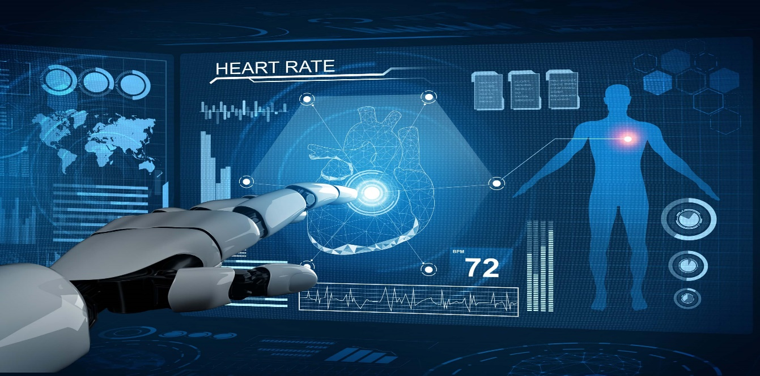

According to Deloitte survey in 2018 by 1,100 US manager whose establishments were previously handling with AI, 63% of companies were engaging machine learning in their industries. It is a wider technique at the core of many approaches to AI and there has many versions of it.

PHYSICAL ROBOTS

Physical robots are identified by this point, given that more than 2 lakhs industrial robots are installed each year around the world. They pre -progrmmed tasks like lifting, keeping back in the previous positions, welding or assembling objects in places like working place and warehouses, and delivery in hospitals. Further , robots have become engaged with humans and are more conveniently trained by moving them through a desired task.

Fig: 2 Corporeal Robots in Healthcare

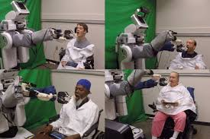

They are also becoming more knowledgeable, as other AI capabilities are being used in their ‘brains’ (really their operating systems). Over time, it seems likely that the same improvements in innovation that we've seen in other areas of AI would be included into physical robots, which could be the future so the robots could easily viewed on the nook and corner of the world. Many companies started to invest billions of dollar into the installation process of the robots. But we cannot say the result of the robots will be 100 percent.

THE FUTURE OF AI IN HEALTHCARE

We believe that AI has a main role to play in the healthcare offerings of the future. In the form of machine learning, it is the initial capability behind the development of precision medicine, widely agreed to be a sorely needed advance in care. Although early efforts at providing diagnosis and treatment endorse have proven challenging, we expect that AI will eventually leading that department also. Provided the simultaneous advances in Artificial Intelligence for image scrutiny, it looks likely that most radiology and pathology images will be patterned at some point by a machine. Speech and text acknowledged are already put in place for task patient statement and seizure of clinical notes, and their usage will improved.

Fig: 3 Applications of AI in Healthcare

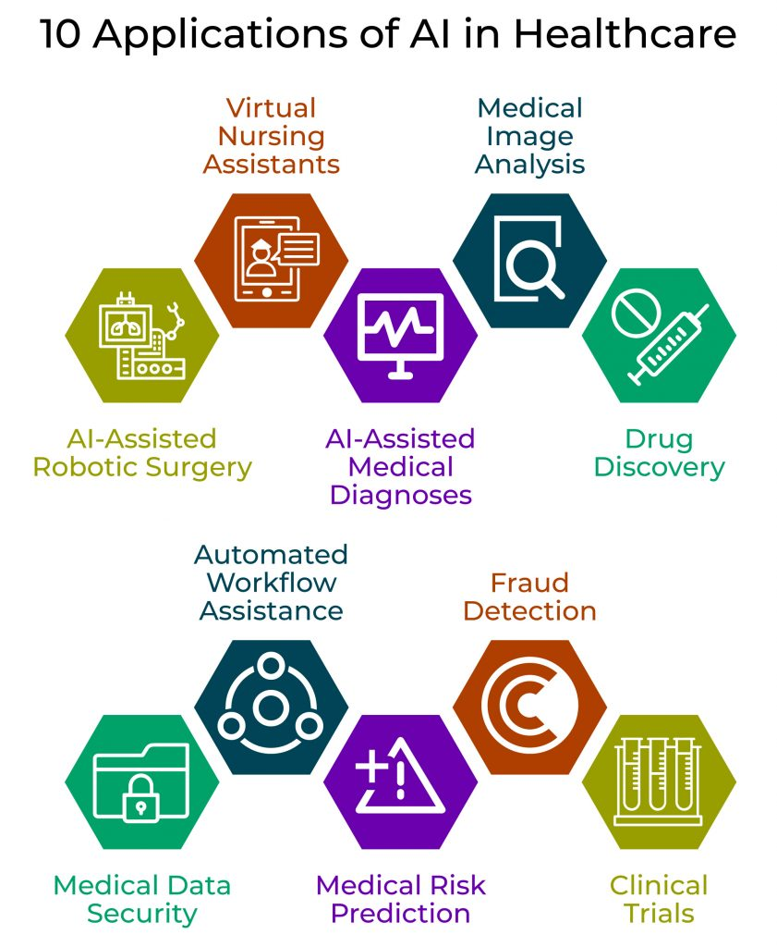

ChatGPT

Our research is also aimed at the Chat-GPT. For instance, people are occupied to improve give response to people who use our conclusion aid on antidepressants (http://MeAgainMeds.com). Today, when ChatGPT gives antidepressants, it narrates very universal advice. We need to type it very specific to be definite. Google Brain has equipped ChatGPT more specific by keeping fit further. The specific version of Google Brain also approved the U.S. Medical Licensing Exam. Thus, it has more information and is more specific to the assessment. The system we are planning will be skilled to do so.

CONCLUSION:
There are previously a number of research studies signifying that AI can execute as well as or better than humans at key healthcare jobs, such as identifying disease. Today, structured programs are by now performing radiologists at noticing malignant tumors, and administrating the researchers that how to build cohorts for expensive clinical trials. Humankind believes that AI replaces humans or doctors in wider medical process domains. It also seems vibrant that AI systems will not swap human doctors on a huge scale, but rather will upsurge their exertions to care for patients. Over time, human doctors may move in on responsibilities and job designs that draw on idiosyncratic human skills like compassion, reliance and big-picture integration.

REFERENCES:

Deloitte Insights State of AI in the enterprise. Deloitte, 2018
Lee SI, Celik S, Logsdon BA, et al. A machine learning approach to integrate big data for precision medicine in acute myeloid leukemia. Nat Commun 2018;9:42.
Ross C, Swetlitz I. IBM pitched its Watson supercomputer as a revolution in cancer care. It's nowhere close. Stat 2017.
www.statnews.com/2017/09/05/watson-ibm-cancer.

