Energy - Energy efficient routing and Mobility Prediction in Vehicular Ad-Hoc Network Using Optimal Recurrent Neural Network

T. Vetrivel
1Research scholar, Department of Computer and Information Science,
Annamalai University, Annamalainagar-608002, Tamil Nadu, India
Email: The.vetrivel@gmail.com

T. Rathimala
2Assistant Professor/Programmer, Department of Computer and Information Science, Faculty of Science, Annamalai University, Annamalainagar-608002, Tamil Nadu, India
Email: rathimalat@gmail.com

ABSTRACT
The main aim of the research is to develop energy efficient routing method and mobility prediction for VANET. The proposed technique is an Optimal Recurrent Neural Network (ORNN). The ORNN is a combination of Recurrent Neural Network (RNN) and Dingo Optimizer (DO). In the RNN, the optimal weighting factor is selected with the help of DO. The RNN is perform efficient prediction with the assistance of DO. Based on the mobility prediction, the average delay and efficient transmission probability of each vehicle is computed based on their base station and roadside units. The computation of the delay and transmission probability is computed with the base of Poisson procedure. With the consideration of the above parameters, the optimal routing is selected by proposed technique. In the analysis, the destination vehicle and source vehicle are presented in the similar location. With the optimal routing process, the delay of the vehicle is reduced. The proposed system is implemented in the NS2 platform and also performance is evaluated based on the performance metrics. The proposed technique is compared to conventional technique.
Keywords— routing technique, mobility prediction, VANET, recurrent Neural Network and Dingo optimizer.

INTRODUCTION

These days, the tremendous development of sophisticated inventions and modern arrangements applied to Intelligent transport systems (ITS) is being observed. For example, the Internet of Vehicle (IoV) will be a core part of the future ITS, allowing both infotainment frameworks and traffic involving executives [1]’ applications that require Internet access. For vehicle collaboration, the short-distance correspondence innovation that integrates the stationary roadside units (RSUs) of GPS-made vehicles and road units is commonly used, which is classified as a VANET. VANET transforms Inter Vehicle Communication (IVC) traditions into an important part of Co-op-ITS [2]. Likewise, with the advancement of remote correspondence innovation, the idea of an organized vehicle has received enormous consideration everywhere. This kind of importance was felt by significant government associations, modern producers, and academic studies [3].
In VANET, each vehicle that goes to the center of the company speaks to another vehicle and has a larger precursor system. Taking into account the large number of vehicles (expected to reach 2 billion on the world's streets by 2035), the market and benefits of VANET will then increase dramatically. For example, VANET [4] can be used to classify current traffic information for both welfare and non-security applications, notification creation, high-level path adjustment, area-based administration, data suspension, infotainment applications, and Internet access. Since then, V2X correspondence, including vehicle-to-vehicle (V2V) and vehicle-to-vehicle infrastructure (V2I), has become increasingly popular for solid and efficient data transfer [5] (e.g., automotive data, traffic conditions, contract messages). And intuitive messages) sometimes.
Nevertheless, in the contemporary urban traffic scenario, high-speed vehicles can trigger regular variations in network geography, thus causing confusion over correspondence links which is a difficult issue for conventional geographically based operating plans [6]. Numerous studies are zero in providing efficient connection reliability / immovable quality arrangements, including connectivity-focused link reserve time expectation, integration-based static operation, artificial intelligence-supported security, and implementation identification. In a wide range of arrangements [7,8], AI-based plot shows great benefits in guaranteeing reliable communication. In automotive companies, AI enjoys the benefits that come with it. (1) In many transports, it is challenging to estimate with clear limits, as these components can be demonstrated and collected by clarification contact. (2) Dynamic changes in organizational geography represent a major test of course implementation. Hence, the efficient technique is introduced in this paper for enabling energy efficient routing and mobility prediction in VANET [9,10].

LITERATURE REVIEW

Different techniques are introduced by authors for empowering the mobility prediction and energy efficient routing techniques in VANET. Few research is reviewed in this section. M.Ye et al. [11] introduced the novel target-driven and mobility prediction (TDMP) based steering conference for vehicles with fast portability and dynamic geography, fluctuating traffic stream, and various street designs on VANET. To implement a potential operating conference, DDMP basically includes the driver's scope for diversity expectation and the Received Signal Strength Indicator (RSSI) for vehicle connectivity status assessment.
Shaik Shafi et al., [12] have introduced the Energy and Mobility Aware Routing Protocol (EM-ARP) to further enhance infotainment management by reducing procrastination and power consumption on VANETs. The proposed process involves two calculations using a cross-layer worldview. The proposed EM-ARP is, first and foremost, a gradual selection of Cooperative Relay Vehicles (CRVs) in light of battery power and the portability of the hubs towards the target. In this way, the new steering calculator improves the nature of streaming and data scattering, balancing high portability, header and power difference. Besides, a better way between the source and the objectives was assessed by the confidence value and determined by considering three basic variables such as Link Expiration Time (LET), hop number and congestion.
Liang Zhao et al. [13] have introduced an intelligent fuzzy-based redirection program for the Metropolitan Software Defined Network (SDN). Initially, a large metropolitan area was divided into several subdivisions, each of which focused on a crossroads. Second, the focal regulator has a directing table that transmits the needs of the bundles from one region to another, and all the properties in the steering table are established using ambiguous logic. For a long time, according to the directing table, various standardized ravenous directing with greedy routing with link stability (GLS) was introduced to calculate the steering path with the highest interface strength.
Xiaobo Wang et al. [15] have introduced a nonhomogeneous Poisson process to separate the network availability and adopt one of the selection criteria that drive the system network. Thus, using fuzzy logic to address routing choices under a number of rigorous standards, LENC developed a new operating conference called (Low Inactivity and Energy-Efficient Movement in the View of the System Network). The old-fashioned AODV and LENC have been recreated in contrast. The results indicate that LENC is an extraordinary improvement in operating rigidity and, in some respects, better than AOTV.

PROPOSED SYSTEM MODEL
In this section, we present the system model of the integrated V2I and V2V correspondence framework for VANET in the metropolitan area, in which global content can be executed by cell companies, i.e., BS, as shown in Figure 1. The rotation and diversity of the modified proposed regulator current overlay networks are taken into account in this work. Each controller will be responsible for the proposed location representing urban communities or networks. There is a standard TCP / IP connection between the dispatched controllers, which controls ineffective transmission and miscommunication. Each proposed regulator interfaces all BS and RSU within its charged area, and BS and RSU are considered interchangeable switches. RSUs are located in every integration because reporting RSUs at crossing points reduces the need for non-line-of-sight (NLOS) transactions to add better support. RSUs serve vehicles within the RSU enrolment area, while BS serves vehicles outside the coverage area of any RSU. Vehicles forward their requests and their IP locations and their objections to RSU / BS. Following that, the RSU/BS informs the data regulator. The proposed then converts the IP locations to the vehicle registers and continues the drive selection, as indicated in both the original vehicle and the object vehicle [16].

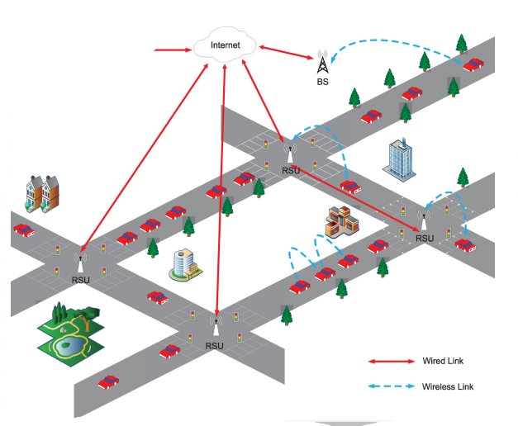
Figure 1: VANET model
Table 1: VANET description
S. No | Description | Parameters
1 | Number of vehicles | 150
2 | Vehicle speed | 12-30 m/s
3 | Data generation | Poisson distribution
4 | Packet Size | 512 Bytes
5 | Traffic constant | 0.25
6 | Road configuration | 1 lane in each direction
7 | Channel model | Nakagami m fading model
8 | Signal to Noise ratio | 20dB
9 | Number of Access point | 8
10 | Simulation Area | 1000m *1000m
11 | Road length | 5 km
12 | Short time period | 5 seconds
13 | Road Side unit | 10
14 | Radio Range | 300m

In the VANET, the mobility prediction and energy efficient routing is enhanced with the consideration of the RNN and DN. In the RNN, the weight parameter is optimized with the assistance of the DN optimizer. The detailed explanation of the projected technique is explained in the below section.

Recurrent Neural Network
In the RNN, the ROA is utilized to select optimal weighting parameters for enabling efficient weather forecasting. The detailed description of the RNN and DO is presented in this section. The proposed RNN is developed by six fully connected layers. Normally, the RNN model trained with the help of back propagation. In this proposed RNN, it is achieved with the assistance of DO. The proposed RNN consist of five neurons in the input layers, 1024 neurons in every four hidden layers in addition one neuron in the output layer. From datasets, the attributes are sent to the RNN input section. RNN is a variation of general feed-forward neural networks with their hidden layers. In the RNN, each hidden layer achieves input not only from the previous layer but also from initiations of itself for preceding input. The recurrent neural network is designed with the MLP [17] and consists of hidden unit activations feeding back in the system which considered with the inputs. In this RNN, the time T can be discretized with the initial updating process at every time period. The time period may be varied to the function of real neurons or intended for reproduction methods. In the proposed RNN function, two activation functions are utilized such as exponential linear unit (ELU) and rectified linear activation unit (ReLU). The ELU function is mathematically formulated as follows,
F(x)=α(e^X-1),X<0,otherwise F(x)=X (1)
Where, α can be described as a parameter and x can be described as input to a neuron.
The RLU function can be mathematically formulated as follows,
F(x)=max (0, x) (2)
Where x can be described as input to the neuron.
to mitigate the overfitting, dingo optimizer is utilized in the RNN network for training process. Additionally, dropout layer is utilized in among fully connected layers to mitigate overfitting. Normally, the dropout ratio is 0.5. The RNN training is contains two parts such as training objective and a dingo optimizer to reduce this objective function. In this research, utilized a dingo optimizer to reduce the Mean Square Error (MSE). In this proposed approach, the learning rate is considered as 0.001. The proposed RNN structure is illustrated in figure 2.
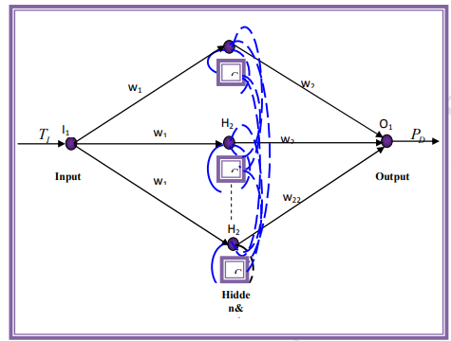
Figure 2: RNN architecture of the proposed methodology
The neuron in the output layer is related to and differentiated from the expected human activity recognition and the pre-defined human activity recognition (target data). The evaluation of the model performance depends on the rail-clearance test (80/10/10) plot. The actual product of the method was completed in the product database, while the approved database was used to adjust the hyper-boundaries. The general presentation of the model was evaluated in the experimental dataset. Teachable loads were introduced by the dingo optimizer. Weight updates were performed in small clusters, and the size of the experiments for a group was set to 20. Production ends when the company does not work on its exhibition, subject to approval for a pre-defined number of ages. The figure was set at 80, and the execution was rated as unlucky and accurate [18]. The misfortune is the MSE, which is the difference in the approximate output distribution from the actual distribution of the names.

Dingo optimizer
The weighting parameter is selected with the help of dingo optimizer. Dingos have a precise sense of correspondence. They talk to each other by detecting unique sound forces in the air. In DOX, dingo generates sound input so that dingo’s can trade their intelligence with others to create normal local area nuances. Adequate amount of vibration is changed by the strength of the individual as the dingo moves from one area to another [19].
Group hunting is an intriguing social behavior of dingos. Hunting practices are classified into their stages as follows:
❖ Chasing and approaching
❖ Encircling and harassing
❖ Attack
Encircling: Dingos are capable of detecting the area of prey, following the area and following the alpha, circling the prey. To demonstrate dingo's social progressive structure, the current best professional approach is expected to be objective or point prey, which is best because the mission area is unknown. Meanwhile, other task systems are still trying to update their algorithms in the following imaginary algorithms. The behavior of dingos is shown by the accompanying numerical conditions (3) - (7).
$$\vec{D_{d}}=\left|\vec{A}.\vec{P_{P}}\left(X\right)-\vec{P}(i)\right| (3)$$
$$\vec{P}\left(i+1\right)=\vec{P_{P}}\left(X\right)-\vec{B}.\vec{D}\left(d\right) (4)$$
$$\vec{A}=2.\vec{a_{1}} (5)$$
$$\vec{B}=2\vec{b}.\vec{a_{2}}-\vec{b} (6)$$
$$\vec{b}=3-\left(1*\left(\frac{3}{I_{max}}\right)\right) \left(7\right)$$
Positions of neighboring dingoes addressed using a two-tier level vector. As mentioned by the location of the prey $(P*, Q*),$ a dingo (P, Q) can update its position in place. By changing the value of the vectors $\vec{A}$ and $\vec{B}$ for the current area, each of the possible areas is arranged individually on the map around the best expert.
Table 2: Parameters of dingo optimizer
Elements | Description
$$\vec{D_{d}}$$ | Distance among the dingo and prey
$$\vec{P_{P}}\left(X\right)$$ | Position vector (prey)
$$\vec{P}(i)$$ | Position vector (dingo)
$$\vec{A}$$ | Coefficient vector
$$\vec{B}$$ | Coefficient vector
$$\vec{a_{1}}$$ | Random vector in [0,1]
$$\vec{a_{2}}$$ | Random vector in [0,1]
$$\vec{b}$$ | Linearly decreased from 3 to 0 at every iteration
$$I_{max}$$ | Maximum number of iterations
It's useful to look at the optimism side by side. Following the part of a dingo that arbitrarily maintains the value of the prey [20], it is important not to bend the dingo or encounter the past. Deliberately, we used $\vec{A}$ to give a random trial value from base to last importance. This strategy is possible in protecting the arrangement from nearby Optima. In the long run, DOX ends up at the point where it meets the final steps. Based on the dingo optimizer, the optimal weighting parameter is selected. Finally, the proposed methodology is utilized to air pollution detection for monitoring health effects of human lives.

Outcome Evaluation
In this section, the projected technique performances are validated by performance and comparison analysis. To validate the presence of the projected Encryption and data access, the proposed method is implemented in an Intel Core i5-2450M CPU 2.50GHz laptop and 6GB RAM. This method is implemented in MATLAB software R2016b. To validate the performance to be presented in the proposed method, the messages are considered which contains the normal text content. The projected method implementation parameters are given in table 3.
Table 3: Proposed method parameters
S. No | Method | Description | Value
1 | Proposed method | Number of decision parameters | 3
2 |  | Upper bound | 10
3 |  | Lower bound | -10
4 |  | Number of Populations | 50
5 |  | Iteration | 100

The computation of performance metrics is presented in the given formula.
$$Delay=\frac{TD}{PR}=\frac{Total delivery time}{Packets received} (8)$$
$$packet loss=Packet received\left(\right)-packet send\left(PS\right) (9)$$
$$Delivery ratio DR=\frac{PR}{PS}×100\%=\frac{Packet ratio}{packet send}×100\% (10)$$
$$Throughput=\frac{PR}{SE}×SZ=\frac{Packet received}{Simulation end time}×packet size (11)$$

Arrival rate-based outcomes
In this section, the arrival rate-based outcomes are considered for validating the proposed technique. The delay of the projected technique is illustrated in figure 3. The projected technique is achieved the 16. The conventional technique of RNN-PSO and RNN is attained the 17 and 18. Related to the analysis, the projected technique achieved efficient incomes of delay because a low delay value is an efficient outcome.
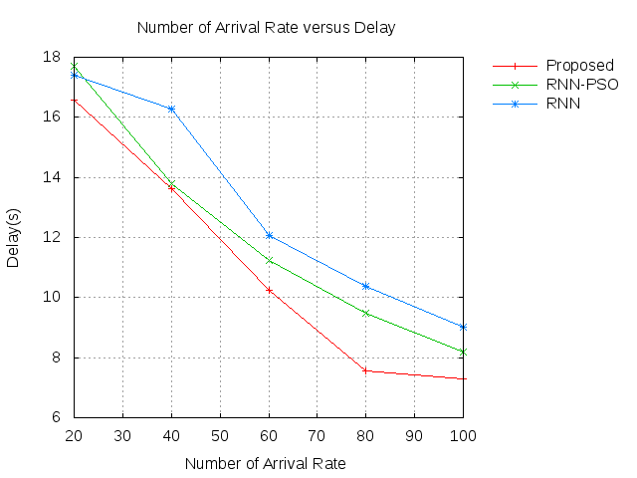
Figure 3: Delay
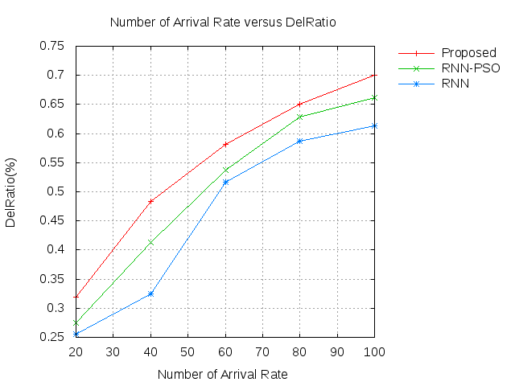
Figure 4: Delivery ratio
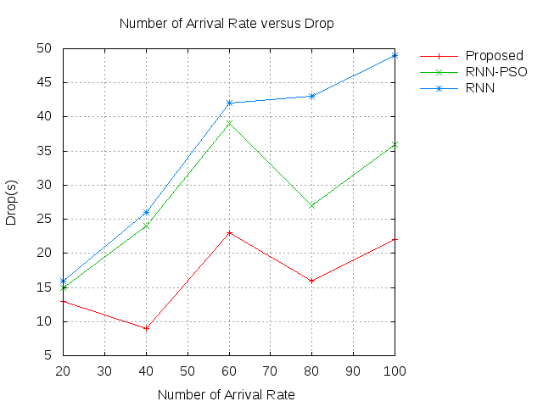
Figure 5: Drop
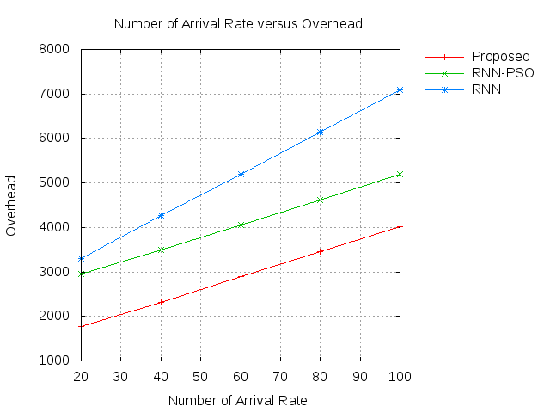
Figure 6: Overhead
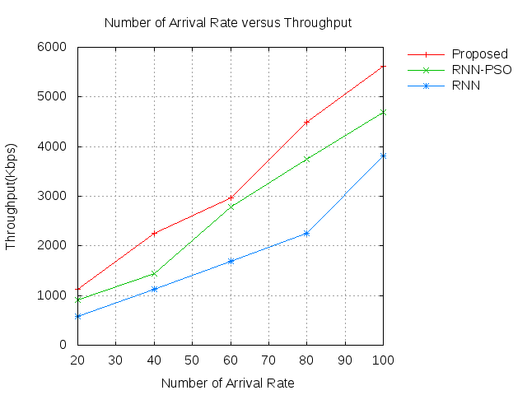
Figure 7: Throughput

The delivery ratio of the projected technique is illustrated in figure 4. The projected technique is achieved the 0.35. The conventional technique of RNN-PSO and RNN is attained the 0.3 and 0.25. Related with the analysis, the projected technique is achieved efficient incomes of delivery ratio. The drop of the projected technique is illustrated in figure 5. The projected technique is achieved in the 10s. The conventional technique of RNN-PSO and RNN is attained the 15s and 16s. Related with the analysis, the projected technique is achieved efficient incomes of drop. The overhead of the projected technique is illustrated in figure 6. The projected technique is achieved the 1800. The conventional technique of RNN-PSO and RNN is attained the 3000 and 3200. Related with the analysis, the projected technique is achieved efficient incomes of overhead. The throughput of the projected technique is illustrated in figure 7. The projected technique is achieved the 800. The conventional technique of RNN-PSO and RNN is attained the 1000 and 1200. Related with the analysis, the projected technique is achieved efficient incomes of throughput.

Time based outcomes
In this section, the time-based outcomes are considered for validating the proposed technique. The delay of the projected technique is illustrated in figure 8. The projected technique is achieved the 1.5. The conventional technique of RNN-PSO and RNN is attained the 1.8 and 2.1. Related to the analysis, the projected technique achieved efficient incomes of delay because a low delay value is an efficient outcome.
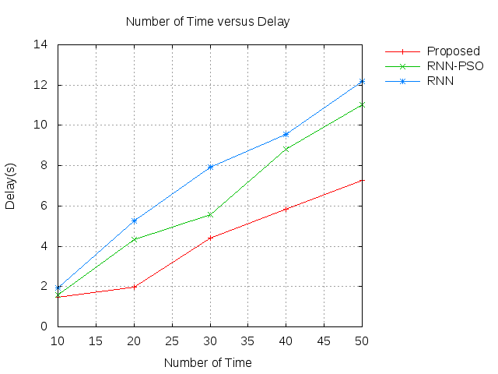
Figure 8: Delay
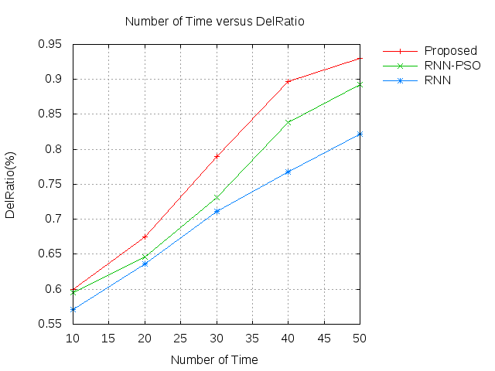
Figure 9: Delivery ratio
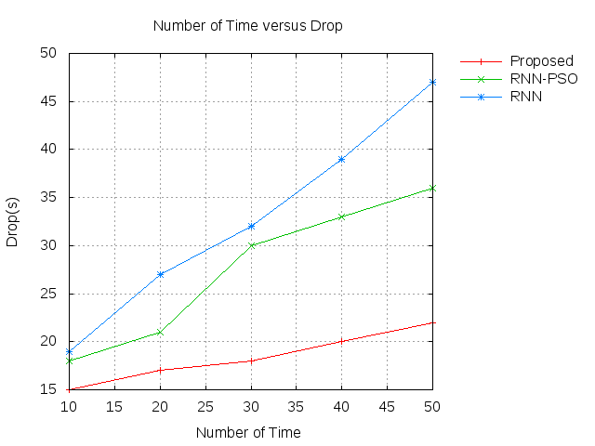
Figure 10: Drop
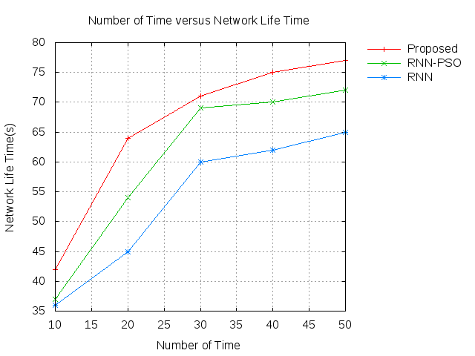
Figure 11: network life time
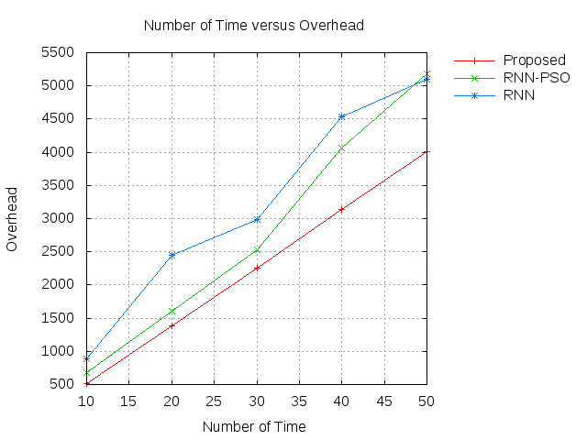
Figure 12: Overhead
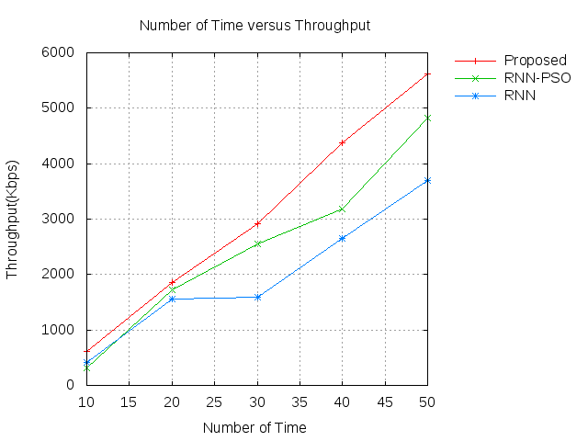
Figure 13: throughput
The delivery ratio of the projected technique is illustrated in figure 9. The projected technique is achieved the 0.55. The conventional technique of RNN-PSO and RNN is attained the 0.58 and 0.66. Related with the analysis, the projected technique is achieved efficient incomes of delivery ratio. The drop of the projected technique is illustrated in figure 10. The projected technique is achieved in the 15s. The conventional technique of RNN-PSO and RNN is attained the 18s and 20s. Related with the analysis, the projected technique is achieved efficient incomes of drop. The network lifetime of the projected technique is illustrated in figure 11. The projected technique is achieved in the 43s. The conventional technique of RNN-PSO and RNN is attained the 38 and 35. Related with the analysis, the projected technique is achieved efficient incomes of network lifetime. The overhead of the projected technique is illustrated in figure 12. The projected technique is achieved the 450. The conventional technique of RNN-PSO and RNN is attained the 800 and 900. Related with the analysis, the projected technique is achieved efficient incomes of overhead. The throughput of the projected technique is illustrated in figure 13. The projected technique is achieved the 700. The conventional technique of RNN-PSO and RNN is attained the 500 and 300. Related with the analysis, the projected technique is achieved efficient incomes of throughput.

CONCLUSION

The main aim of the research has been to develop energy efficient routing method and mobility prediction for VANET. The proposed technique has been an ORNN. The ORNN has been a combination of RNN and DO. In the RNN, the optimal weighting factor has been selected with the help of DO. The RNN has been perform efficient prediction with the assistance of DO. Based on the mobility prediction, the average delay and efficient transmission probability of each vehicle is computed based on their base station and roadside units. The computation of the delay and transmission probability has been computed with the base of Poisson procedure. With the consideration of the above parameters, the optimal routing has been selected by proposed technique. In the analysis, the destination vehicle and source vehicle are presented in the similar location. With the optimal routing process, the delay of the vehicle has been reduced. The proposed technique has been implemented in the NS2 platform, and performance has been evaluated based on the performance metrics. The proposed technique has been compared with the conventional technique.

REFERENCES

- Azzoug, Youcef, and Abdelmadjid Boukra. "Bio-inspired VANET routing optimization: an overview." Artificial Intelligence Review 54, no. 2 (2021): 1005-1062.
- Kudva, Sowmya, Shahriar Badsha, Shamik Sengupta, Hung La, Ibrahim Khalil, and Mohammed Atiquzzaman. "A scalable blockchain based trust management in VANET routing protocol." Journal of Parallel and Distributed Computing 152 (2021): 144-156.
- Abdeen, Mohammad AR, Abdurrahman Beg, Saud Mohammad Mostafa, AbdulAziz AbdulGhaffar, Tarek R. Sheltami, and Ansar Yasar. "Performance Evaluation of VANET Routing Protocols in Madinah City." Electronics 11, no. 5 (2022): 777.
- Belamri, Fatima, Samra Boulfekhar, and Djamil Aissani. "A survey on QoS routing protocols in Vehicular Ad Hoc Network (VANET)." Telecommunication Systems 78, no. 1 (2021): 117-153.
- Dhaya, R., and R. Kanthavel. "Bus-based VANET using ACO multipath routing algorithm." Journal of Trends in Computer Science and Smart Technology (TCSST) 3, no. 01 (2021): 40-48.
- Aljabry, Israa A., and Ghaida A. Al-Suhail. "A simulation of AODV and GPSR routing protocols in VANET based on multimetrices." communications 7 (2021): 9.
- Gnanasekar, Tony Santhosh, and Dhandapani Samiappan. "Impact of hybridized rider optimization with cuckoo search algorithm on optimal VANET routing." International Journal of Communication Systems 34, no. 16 (2021): e4954.
- Shrivastava, Prashant Kumar, and L. K. Vishwamitra. "Comparative analysis of proactive and reactive routing protocols in VANET environment." Measurement: Sensors 16 (2021): 100051.
- Paul, Bijan, Md Ibrahim, Md Bikas, and Abu Naser. "Vanet routing protocols: Pros and cons." arXiv preprint arXiv:1204.1201 (2012).
- Debnath, Arindam, Habila Basumatary, Mili Dhar, Mrinal Kanti Debbarma, and Bidyut K. Bhattacharyya. "Fuzzy logic-based VANET routing method to increase the QoS by considering the dynamic nature of vehicles." Computing 103, no. 7 (2021): 1391-1415.
- Ye, Mao, Lin Guan, and Mohammed Quddus. "TDMP: Reliable Target Driven and Mobility Prediction based routing protocol in complex Vehicular Ad-hoc Network." Vehicular Communications 31 (2021): 100361.
- Shafi, Shaik, and D. Venkata Ratnam. "A trust-based energy and mobility aware routing protocol to improve infotainment services in VANETs." Peer-to-Peer Networking and Applications (2022): 1-16.
- Liang Zhao, Zhenguo Bi, Mingwei Lin, Ammar Hawbani, Junling Shi, and Yunchong Guan. "An intelligent fuzzy-based routing scheme for software-defined vehicular networks." Computer Networks 187 (2021): 107837.
- He, Chenguang, Guanqiao Qu, Liang Ye, and Shouming Wei. "A Two-Level Communication Routing Algorithm Based on Vehicle Attribute Information for Vehicular Ad Hoc Network." Wireless Communications and Mobile Computing 2021 (2021).
- Wang, Xiaobo, Yu Weng, and Honghao Gao. "A Low-Latency and Energy-Efficient Multimetric Routing Protocol Based on Network Connectivity in VANET Communication." IEEE Transactions on Green Communications and Networking 5, no. 4 (2021): 1761-1776.
- Tang, Yujie, Nan Cheng, Wen Wu, Miao Wang, Yanpeng Dai, and Xuemin Shen. "Delay-minimization routing for heterogeneous VANETs with machine learning based mobility prediction." IEEE Transactions on Vehicular Technology 68, no. 4 (2019): 3967-3979.

