Exploring the Potential role of Biomedical Imaging and Bio-signalling in the Field of Biomedicine
Akhiya A R
(https://orcid.org/0000-0003-2939-5643)
Post Graduate
Department of Computational Biology and Bioinformatics
Trivandrum, Kerala India
akhiya96@gmail.com
Neenu Mohan (https://orcid.org/0009-0009-4142-0259)
Research Scholar
Department of Computational Biology and Bioinformatics
Trivandrum, Kerala India
neenuusha1998@gmail.com
Vinod M. P. (https://orcid.org/0000-0002-5242-7394)
Research Scholar
Department of Computational Biology and Bioinformatics
Trivandrum, Kerala India
mpvinod625@gmail.com

Abstract

The human body, a wonder puzzle, continues to tantalize the depths of scientific exploration and the complexities yet to be fully unveiled. Like a vast and infinite tapestry, it weaves together a serpentine harmony of biological wonders, with each thread holding the potential to unravel intense mysteries. As researchers dive deeper into cellular and molecular complications, they find themselves captivated by the rhythm of the heart, snapshots of view within the eyes, muscle contraction and release, lungs inflating and deflating, the maestro of dreams in the brain, etc., thus capturing these symphonies as information that can be collected using physiological instruments that measure beat, circulatory strain, oxygen drenching levels, blood glucose, nerve conduction, and mental activity. In this chapter, we will discuss various methods by which we have succumbed to newer technologies and modalities in biomedical imaging and signal-based diagnosis that have had a huge impact on improving patients' health. In addition, we briefly discuss some imaging techniques and signal-based diagnostic approaches that have gained importance over time and have gained significance in the field of biomedicine. Pointing out the potential application of Machine learning in areas that may present opportunities and challenges also it is essential to explain the ethical concerns and challenges associated with these technologies.

Keywords : Biomedicine, Biomedical imaging, Biomedical signalling and sensors, Machine learning

Introduction : From invention to innovation

Let us travel through a sequence of inventions from imaging, signalling and sensors that made diagnosis easier and viable as a part of technological inventions and advancements.

A mark of serendipity in the year 1895, where Wilhelm Conrad Roentgen, a visionary German physicist, stood amidst the swirling mist of scientific exploration. What emerged from this quest was something extraordinary - a revelation that defied the boundaries of human perception. Roentgen discovered the hidden wonders of X-rays, a form of ethereal radiation capable of traversing solid matter, peering into the very essence of life itself. With a stroke of genius, he unveiled a breathtaking new dimension, one that would forever change the way we see the intricacies of the human body. From the discovery of fractures that eluded the eye, to detecting hidden tumours lurking beneath the surface, the power of X-rays transformed the realm of medicine and its allied field. In a blink of an eye, the invisible became visible, transforming life into diagnosis and guiding the hands of healers with greater precision. The ripple effect of Roentgen's serendipitous encounter resonated throughout the corridors of science and medicine, sparking a fervour of innovation and advancement [1].

Yet another historic event, marked in the year 1887, was made by physiologist Augustus Desire Waller who recorded the first electrical activity of the human heart using electrocardiogram (ECG). The invention of electrocardiogram is a groundbreaking invention in cardiology that influenced the development of new therapies including pacing. Electrocardiogram records the electrical activity resulting from the heart. Including the heart, the human body is a masterpiece composition of organs and tissues that work in harmony by generating electrical and chemical signals. The rhythm produced by such signals reflects their health status. Abnormality in the electrical or chemical signals acts similar to the appearance of a wrong note in well-composed music. It makes us think something is wrong with the composition. Similarly, such signal imbalance reflects an unhealthy organ or tissue [2]. Considering this concept as base, a new area emerged with numerous innovations of various signal detection. A combinational analysis of such signals wide open new realms in biomedical science. The concept of self-monitoring was made revolutionary in the field of biomedical science. All thanks to Leland C. Clark Jr. and Champ Lyons who invented the first oxygen sensor. The concept then resulted in the creation of the modern glucose sensors that are still helping millions and millions of diabetic patients in monitoring blood glucose level and regulating their diet. Leland C. Clark, Jr is known as the “father of biosensors”.

There are rapid detection tools available alongside sensors. Rapid detection kits that work on agglutination or immunochromatographic or immuno-filtration or other techniques are popular due to their simplicity, portability and affordability. Biosensors offer the same but are different from them. Since sensors combine physico chemical detection equipment with biologically sensitive components [3].

From these very basic inventions to technological advancement, the field of biomedical science is improving day by day. And some technologies are not only used in the field of biomedical science but also coexist with other fields such as physical sciences, chemical sciences and so on. We will outline the various classification of biomedicine in terms of biomedical imaging and signalling in the first section, starting with the imaging techniques. Similarly we will discuss the advancements in signalling along with the ethical, technical and research perspectives.

Biomedical imaging : A perspective view from basics to advanced

At a very nascent stage, doctors were required to check the body and recognize the disease by performing exploratory surgeries, which resulted due to the lack of technology that could address or look into the body for further diagnosis and prognosis of the disease. The previously used process that was involved in the checking of internal body parts is by inspection (the practitioner will look to the external body features like illness, abnormalities etc), Palpation (the doctor will check the abnormalities in the body by checking and feeling the changes using the hands), Percussion ( Here the doctors will tap the body with hands, fingers or small instruments to identify the abnormalities), Auscultation (the doctor will be listening to the various sounds from the body organs by using stethoscope), Pulse diagnosis (It is the old technique which will retrieve the detail information of the body by analysing the signals present in the radial pulse) etc. All these techniques mentioned above strictly need the consultation individually. The techniques used at that time limited the scope of identifying new conditions very quickly. In fact a combination of experience of the medical practitioner and effective usage of techniques available at that time were required to identify any emerging disease or novel medical conditions. Sometimes a decision was made after consulting multiple experienced practitioners. These consultations result in consuming critical time is enough for the disease/condition to progress into the next stage. Thanks to science and technology for making our modern days very dynamic. Now it is possible to identify the disease and make comments without consulting many medical practitioners. The technology is so advanced that the person and pathologist in different places can communicate with each other virtually and analyse the disease, this has improved and accepted through the biomedical imaging techniques. Biomedical imaging has improved the accuracy of predicting the actual disease and the time and effort is reduced greatly. If someone asks about what Biomedical Imaging is then a simple definition is that it is a technique which can be used to inspect the physical body internally or externally by taking the images without harming the body. Now we can have a look upon various types of Biomedical Imaging available in the current scenario [4-7].
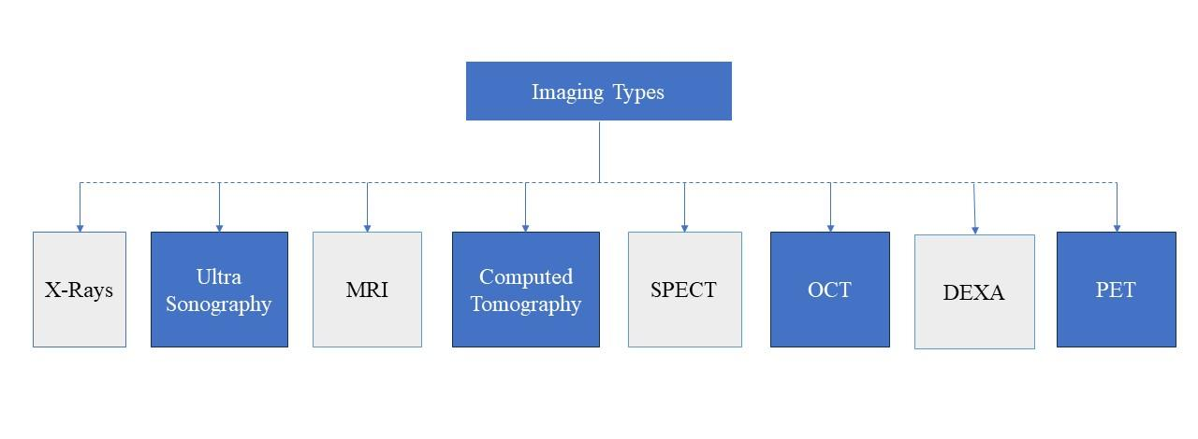
Figure 1 : Flow chart representing the types of imaging techniques available in medical health care.
We will now discuss the concepts, principles and applications of few imaging types, which are mentioned in Figure 1 and to examine the principle underlying in the operation of various imaging techniques and their pertinent applications in the field of biomedicine.
X-Rays: These are a form of electromagnetic radiation just like our visible spectrum but with a wavelength range between 0.01 nm to 10 nm. These radiations have more energy making them penetrable through different objects. The penetration depends upon the density of the subject. These rays are penetrable through living organisms. The master piece work of arrangement of various organs inside a living thing can be visualised using x-ray, thanks to the density difference. The rays when passed through such density different subjects result in absorption of the rays. These losses in absorption can be traced in a surface. The absorption difference is identified by contrast changes in the surface made by the resulting rays. X rays can harm human tissue since they are ionizing radiation. Therefore longer exposure is not recommended. But the rays can be used to detect bone fracture, tumours, abnormal masses, pneumonia, injuries, calcification, foreign objects such as sharp objects that are pierced through the body, or indigestible objects in gut or intestines, dental problems etc [8-11].
Figure 2 : Shows the working of X-ray
Ultrasonography : Like the light spectrum there are a range of sound waves that exist in our nature. Humans can detect the sound waves between 20 Hz to 20 KHz. But there are waves inaudible to humans but can be applied for other things. Ultrasounds are inaudible sound waves whose frequency lies between 30KHz to 500 MHz. These waves can be essentially used in therapeutics. Consider the waves range between 30 kHz to 3 MHz. These ranges are low frequency waves that are used for therapeutics. The range 2MHz to 40 MHz are higher range waves that are used for diagnosis purposes. One of the applications of these higher waves is doppler effect based analysis which can be used to visualize blood flow based on the frequency difference measured in the receiver. Based on the number of transducers and how they are used, there are four different modes in ultrasonography. Other than doppler mode, usage of a single transducer (A-Mode) plot based on function of depth. A two dimensional image can be constructed by the usage of a linear array of transducers (B-Mode). If the two dimensional images constructed from the linear array of transducers follow one by one rapidly under motion (M-Mode), deeper insights can be produced. For obtaining microscopic images much higher frequencies ranging from 50MHz to 500 MHz are used. The application of ultrasonography includes Detection of cracks, Echocardiography, Sound Navigation and Ranging. These waves help in consequent healing and remodelling of bone wounds similar to bone remodelling caused by orthodontic tooth movement. It can identify early-stage abnormal healing or non-healing in the soft tissues and that can become potential in assessing topological features of bone tissue as well as the onset of bone formation and identification of other morphological features of bone [12-16].
MRI : Magnetic fields can also be used in diagnostic investigation. Living cells contain water molecules. A powerful uniform magnetic field can be used to align these water molecules. Introducing a radio frequency over this alignment could perturb or disrupt magnetization and induce resonance. While introducing this radio frequency if a gradient (spatially dependent magnetic field) is applied then spatial localization can be obtained. After the initial alignment, various relaxation processes occur to achieve a restive alignment. These processes emit radio frequency proportional to their initial state. The emitted radio frequency is measured and using fourier transformation, this received radio frequency data is converted to images. These are non ionizing electromagnetic radiation. MRI has a great potential that has become the primary diagnostic investigation for many clinical problems [17-18]. It can identify anomalies of the brain and spinal cord, Identifies tumors, cysts, and other anomalies in various parts of the body. MRI can be used to identify injuries or abnormalities of the joints, types of heart problems and diseases of the liver and other abdominal organs.
Computed Tomography (CT) scans : Consider several x-ray beams passing through a body. The beams and its detectors revolve around the body detecting the amount of radiation being absorbed. An associated computer device and software could produce a 3D image of the body. Not limited to 3D but a multidimensional view of the body and its interior. That is being achieved though Computed Tomography. The main advantage of using Computed Tomography is its ability to be non-destructive while revealing the internal details of the objects in 3D. Computed tomography (CT) of the body uses sophisticated x-ray technology to help detect a variety of diseases and conditions. CT scanning is fast, painless, noninvasive and accurate. In emergency cases, it can reveal internal injuries and bleeding quickly enough to help save lives [19-20].

Other than X-ray and its detectors, gamma cameras can be used to compute tomography. This is being achieved with Single Photon Emission Computed Tomography (SPECT). In SPECT, gamma cameras are rotating around the body. Using more than one camera will increase efficiency. The obtained data from multiple cameras are woven using softwares to create a three-dimensional image. SPECT provides spatial information and including more cameras will increase the spatial resolution. This technique is a flexible imaging technique that is capable of visualizing and quantifying changes in cerebral blood flow and neurotransmitter systems [21-22].

- Other Imaging Techniques
Optical Coherence Tomography (OCT) is a non-invasive technique that can be used to inspect the retina inside the eye [23]. This technique can give a high resolution cross-section image that is constructed using near-infrared spectrum. This technique is very much useful for diagnosing valuable organs where biopsy is not an option.
Positron Emission Tomography (PET) utilises radioactive tracers that are injected to the peripheral vein. The tracers can be oxygen-15, fluorine-18, carbon-11 or nitrogen-13. This technique allows diagnosing or monitoring changes that are happening over a time period as a medical condition progresses or responds to a stimulus that is given as part of treatment procedure [25]. The application of such monitoring will help us understand the blood flow and oxygen consumption in areas of interest. This technique will also help us distinguish recurrent tumours from radiation necrosis.
DEXA scans can be used to analyse bone density. Not limited to density analysis but can also be used to determine body composition including fat. With this technique, low density bones and fragile areas in bones can be identified. This helps physicians in diagnosing and assessing osteoporosis, which causes the bones to thin and become more fragile [24].
The above are some glimpses of imaging techniques used in biomedical imaging. The recent advances in biomedical images have grown more evidently with increasing amounts of imaging data. Further, in recent times the available data could be interpreted using machine learning to predict a given condition even in the absence of a medical practitioner.
- Significance of Biomedical imaging
The significant impact of biomedical imaging lies in its transformative power on modern medicine and healthcare. The field plays a crucial role in improving personalised treatments, advancing medical knowledge and shaping the future of healthcare practices. The below mentioned are the key impacts of biomedical imaging in medical healthcare systems:
- Early and Accurate Diagnosis: Enabling the early detection and precise diagnosis of diseased medical conditions, including cancer, heart disease, neurological disorders and musculoskeletal injuries. Allowing to accurately prescribe the diagnosis and prognosis of the disease.

- Medicine and allied field: Facilitating personalized medicine by availing treatments to individuals based on their unique anatomy, disease characteristics and responses to therapies. Thus optimizes treatment efficacy and reduces critical effects.

- Monitoring Disease Progression and Surgical Planning: Imaging modalities enable pathologists/physicians to monitor disease progression, response to treatments, and the effectiveness. Also assisting surgeons in planning complex disease conditions by providing detailed, three-dimensional views of anatomical structures, improving surgical precision and patient safety.

- Guiding in Treatment Decisions: Imaging findings provide critical information that guides healthcare professionals in making informed treatment decisions. It helps determine the most suitable treatment approach and allows for real-time monitoring of treatment progress.

- Theragnostic: Integrating imaging with therapeutic approaches (theragnostic) allows for targeted treatments, delivering therapies directly to affected areas, and assessing treatment responses in real-time.

- Scientific Research: Serving as a powerful tool in medical research, contributing to a deeper understanding of the mechanisms, drug interactions and human anatomy. Driving the advancements and inventions in medical technology.

- Public Health Initiatives: Helps clinicians to clearly communicate with an effective understanding of the disease with the patient's/general public. This would create a communicating medium that would potentially help in conducting public health initiatives, such as self-awareness of the initial stages of particular diseases. This potentially helps in early detection and diagnosis of emerging diseases [26,27].

Biomedical Signalling and Sensors : An advancing technological masterpiece

Now the modern society is gradually changing with the entry of electronic wearable gadgets. People can themselves plan their daily activities based on these readings from gadgets, such as smart watches, specifically for monitoring various health parameters such as sleep monitoring, heart rate, temperature activity tracking and much more. These gadgets are using electronic components to obtain signals from the body and provide users with valuable and real time health-related information [28].

A few years ago, the main focus of biomedical signal processing was on inspecting and enhancing biosignals, such as by removing noise and interference from power lines; spectral analysis and modelling of these signals for feature representation and parameterization. Today, however, biomedical signal processing is moving beyond signal analysis to a wide range of applications. One of the applications is the creation of complex medical imaging systems like ultrasound scanners. Computational analysis of these signals by employing potential algorithms for biomedical signal analysis has improved the diagnostic power. Numerous methods, including filtering, adaptive noise cancellation, pattern recognition, medical image registration, etc., are utilised for the analysis of biosignals. Hence acquiring these biomedical signals and processing it in combination with biomedical systems help improve the treatment quality and living standard of patients [29].

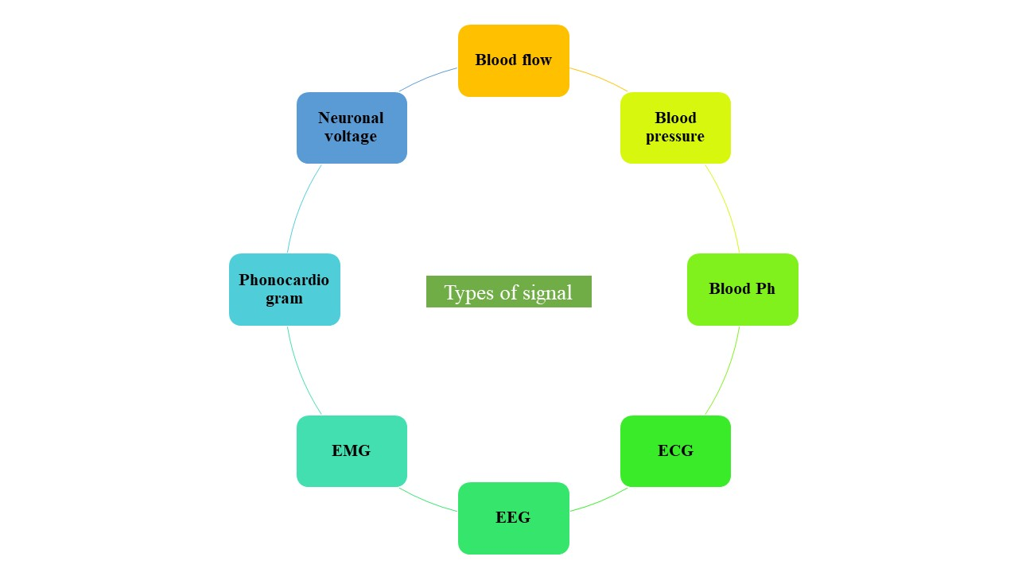
Figure 3 : Representation of various type of biomedical signals

Based on the above represented types of biomedical signals, the enlisted below are the common types [30]

Electrocardiogram (ECG/EKG) : For analyzing the electrical activity of the heart as recorded in an ECG. It helps in identifying variations in ECG waveform, such as P-waves, QRS complexes, and T-waves, which are essential for diagnosing arrhythmias and other cardiac conditions.

Electroencephalogram (EEG): Represents the electrical activity of the brain. These can be detected and can be processed to identify specific brain wave patterns, such as alpha, beta, theta, and delta waves, assisting in diagnosing neurological disorders, monitoring brain activity during sleep studies, and evaluating brain function in research.

Electromyogram (EMG): These signals from muscles are analysed to identify and measure patterns of muscle activation, which could aid medical professionals in identifying neuromuscular diseases, evaluating muscle health, and monitoring muscle activity during physical therapy or sports performance analysis.

Blood Pressure Signals: These signal extraction is important to find parameters like systolic and diastolic pressures and calculate mean arterial pressure, aiding in the diagnosis of hypertension and assessing cardiovascular health.

Respiratory Signals: Giving insights into respiratory rate and patterns. It is crucial in monitoring patients with respiratory conditions, detecting sleep-related, breathing disorders, and evaluating respiratory function for clinical studies.

Glucose Monitoring: Continuous glucose monitoring (CGM) is very much important for individuals with the condition of diabetes and helps in monitoring and managing diabetes, detecting glucose fluctuations, and adjusting insulin therapy accordingly.

Other Biomedical signal analysis include: Electrooculography (EOG) that helps diagnose and identify eye movement including rapid eye movements (REM) during sleep studies and evaluate eye movements in neurological assessments. Photoplethysmogram (PPG) signals, that are obtained from devices like pulse oximeters, help to measure oxygen saturation levels and assess blood flow changes. Intracranial Pressure Monitoring is used in neurocritical care to analyze intracranial pressure signals that help in detection of elevated pressure levels and early intervention in patients with brain injuries or intracranial hypertension [30].

- Detection of Biomedical signals
The non-invasive biomedical signal detection requires sensors that detect electrical, chemical or optical information from the body. Implementation of biomedical sensors in the field of medical science has received immense attention. Use of sensors help identify potential signals that can be used for disease identification, prevention, rehabilitation, patients’ health surveillance and human health management. Biomedical sensors can be used to detect bacterial, pathogens and virus microorganisms [31].
Biosensors are devices equipped with a sensor system and transducers. The sensor system contains a part that is specifically designed to conduct a biological reaction which is then detected by the electronic component.such as enzyme, a nucleic acid otherwise an antibody. The bio-element communicates through the analyte being checked & the biological reply can be changed into an electrical signal using the transducer. In the medical field, glucose biosensors have historically been concerned with the regulation of diabetes. Biosensors are also used to streamline blood glucose levels, which remain a vital diabetes predictor. In addition to health care and treatment, biosensors can diagnose diseases faster and monitor patients' status [32--34].

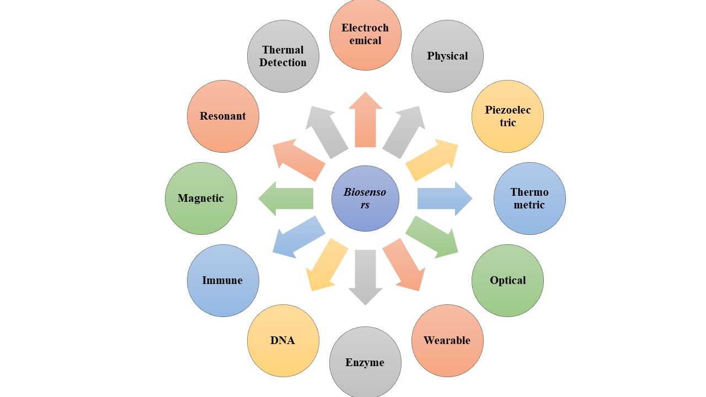
Figure 4 : Flow chart representing various types of biomedical sensors in the area of biomedicine and its allied field

- Components and Working of a Biosensor

Figure 3 represents the main components in a biosensor. This includes three main segments; a sensor, transducer and associated electrons. The sensor will be the responsive biological part, transducer is the detecting part that changes the resulting signal from the contact of the analyte and an amplifier known as a signal conditioning circuit, with a display unit and a processor [35].

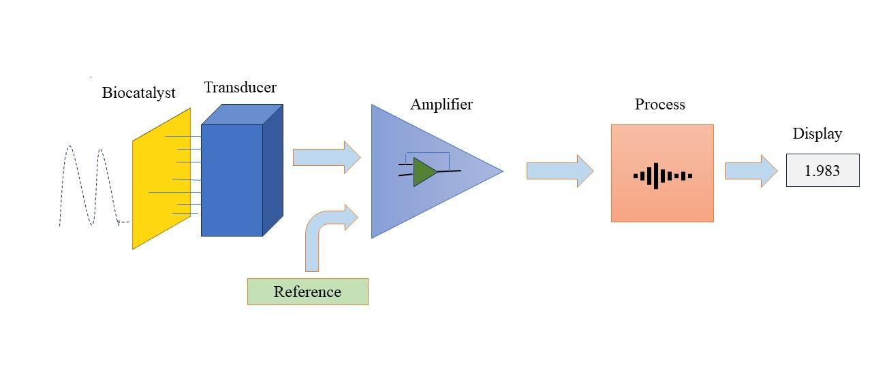
Figure 5 : Represents the main components required for the working of a biosensor

When a particular enzyme or chosen biological entity is in touch with the sensor's transducer after being deactivated by some procedure. The biological entity and the analyte work together to create a clear analyte, which in turn produces a calculable electronic reaction. The transducer in a biosensor can change the connected device and transform it into electrical signals that can be adjusted and calculated accordingly [36]. The transducer's electrical signal is typically considered weak and lies on top of a pretty high baseline. Typical part of signal processing is deducting a baseline signal from a related transducer without any biocatalyst coating. The direct output at this point will be an analog signal, but it is converted to digital form and sent to a microprocessor phase where it is advanced, converted to its preferred units and stored output to a data store [37-38].

Biomedical sensors classified based on transducing elements and biorecognition elements [39]

Transducing elements | Principle
Electrochemical | Measuring the electrical potential difference caused by an interaction between an analyte and the membrane/sensor surface.  Further categorised as :  - Amperometric Biosensors : detect electroactive species present in biological test samples  - Potentiometric Biosensors : measure changes in pH and ion concentrations resulting from antigen/antibody interactions  - Impedimetric Biosensors : monitor changes in impedances upon antigen/antibody interaction  - Voltammetric Biosensors : electrical conductivity of the solution in the course of a biochemical reaction
Optical | Principle of interaction of a sensing element with electromagnetic radiation.  Characterised into three types :  - Fluorescence  - Chemiluminescence  - Surface plasmon resonance
Mass based | Group of analytical devices working on a principle of affinity interaction recording.
Biorecognition element | Group of analytical devices working on a principle of affinity interaction recording.  - DNA : These use nucleic acids as their biological receptors, detecting proteins and other non-macromolecular compounds that can interact with certain DNA fragments.  - Enzyme : Used for monitoring speedy changes in the metabolite levels, including pure enzyme preparations or biological processes.  - Antibody  - phage  - Biomimetic
Table 1 : Representing the transducing and bio recognition elements used in biosensors
C. Significance of Biomedical signalling and biosensors in the field of medicine
Biosignals and biosensors play a very crucial role in the field of biomedicine which enables the monitoring, diagnosis, and prognosis of various diseases and other medical conditions. These technologies have significantly impacted healthcare facilities and have improved the treatment outcomes as well [40-41]. Considering conventional on site analysis requires the samples to be sent/present to a laboratory for further analysis. These methods are expensive, time consuming and require the use of highly trained personnels. Mentioned above drawbacks, there has been a great interest in the technological advancement of biosignals and biosensors. The field has seen phenomenal growth in the field of biosignals and biosensor development in recent years with emerging applications in a wide range of disciplines [42].
- Non conventional mode of Treatment : Biosensors and biosignal monitoring devices allow healthcare professionals to gather important physiological data without the need of conventional mode of analysis. Help in remote monitoring of patients, monitoring vital signs and other relevant health data even when patients are not in a clinical setting. This is particularly beneficial for patients with chronic conditions or those in remote areas who may have limited access to healthcare facilities.

- Early detection and diagnosis: By providing valuable insights into a person's health status, enabling the early detection and diagnosis of various medical conditions. By detecting patterns that are indicative of specific diseases, thus healthcare providers can initiate timely interventions, potentially improving patient outcomes. Contributing to the development of personalized medicine. By tracking an individual's unique physiological responses and biomarkers, thus increasing treatment efficacy.

- Continuous monitoring in critical care: Biosensors play a crucial role in the critical care settings by continuously monitoring patients' vital signs, such as heart rate, blood pressure, respiratory rate, and oxygen saturation. This allows healthcare providers to respond promptly to any changes in a patient's condition, improving patient outcomes.

- Wearable health devices: Recent developments of wearable biosensors have revolutionized healthcare by empowering individuals to take charge of their own health. These devices can track various parameters such as heart rate, blood pressure, glucose levels, and more, providing users with real-time feedback and encouraging healthier lifestyle choices.

- Drug development and clinical trials: Regarded as a valuable tool in drug development and clinical trials. They can help researchers assess the effects of medications, study drug interactions, and evaluate the safety and efficacy of new treatments.

- Brain-computer interfaces (BCIs): These use biosignals, such as electroencephalography (EEG), to establish a direct communication pathway between the brain and external devices, also in assisting individuals with neurological conditions or disabilities, enabling them to control prosthetics or computers using their thoughts.

IV. Applying Machine Learning over Biomedical data

Through previous sections we had discussed some of the procedures to collect biomedical data. The data generated from such procedures is too huge. These big data open new possibilities. With availability of such huge data, we could potentially create a virtual doctor and use it for the preliminary diagnosis of any given condition. This is possible with Artificial Intelligence. We can use this data for machines to learn something that we humans can't see. In Machine learning, the availability of huge quantities of data is very much appreciated. But this is not the case, as much as quantity, quality of training data play a crucial role in the output that was generated. In this section we will see practical applications in which Machine Learning was implemented for biomedical analysis. Medical data is increasing day by day. Most of the data are available in some of the open source repositories. One such source of data is Kaggle. Kaggle is a website where we can find biomedical data in the form of images and tabular data. Biomedical images are available as image inputs where signalling images can be seen as tabular data having values such as pressure, heart beat etc. Some audio based data may be available from online sources including the sound or voice from patients. Each type of data requires different methods to solve the problem. For analysing the images we have Convolutional Neural Network (CNN), for analysing the tabular data we have Artificial Neural Network (ANN), for analysing the textual data we have Recurrent Neural Network (RNN) [43-45].

Let's go through some of the Interesting datasets that are present in Kaggle.

Cancer Dataset: Cancer is a condition that can be detected by various biomedical images such as the images taken by X-rays, CT scan etc. The image dataset collected includes different types of cancers that are detected by various machines. Some of the imaging modalities that are represented in the dataset are computed tomography (CT), magnetic resonance (MR), mammography (MG), computed radiography (CR), nuclear medicine (NM), digital radiography (DX), positron emission tomography (PT) etc.

Diabetes Healthcare: These dataset was prepared for finding the diabetes affected and unaffected population in a tabular format which contains the details such as Pregnancy count, Glucose Plasma glucose concentration in an oral glucose tolerance test, BloodPressure Diastolic blood pressure (mm Hg), Insulin Two hour serum insulin, BMI Body Mass Index, Skin Thickness Triceps skinfold thickness (mm), Diabetes Pedigree Function Diabetes pedigree function, Age in years etc. By looking at these many values we can conclude whether the person is suffering from diabetes or not.

Reproductive Child-Health Care: This is used mainly to prevent child or maternal mortality. This dataset was prepared by taking the results from the Cardiotocogram test which is mainly done during the trimester of pregnancy. This test can help to check the health condition of the body by simply hearing the sound of the body. By using this data a dataset was prepared which will check whether the baby or mother is having any problem [46-49].

V. Limitations and Ethical Considerations : From Innovations to Implosions

Science has its own pros and cons; it depends how carefully we use it for the advancement of mankind. Considering imaging, despite its numerous advantages a critical number of limitations and challenges are also notable. Exposure to ionizing radiation, such as X-rays and CT scans, raise ethical concerns due to potential health risks. Balancing the benefits of diagnosis and treatment with the potential risks of radiation exposure becomes a delicate ethical consideration. Most of the imaging techniques are non-invasive, certain procedures that involve contrasting agents or invasive imaging (e.g., endoscopy) may carry risks of adverse reactions or complications. Some advanced imaging technologies can be expensive to acquire, operate and maintain. The high costs associated with these sophisticated equipment, availing specialized training for healthcare professionals and ongoing upgrades may limit access to these technologies in some healthcare settings, particularly in resource-constrained regions. The accuracy of imaging interpretation heavily relies on the expertise of the radiologist or a pathologist. False positives (diagnosing a condition that is not present) and false negatives (missing a condition that is actually present) potentially leading to unnecessary interventions.[50]

- Virtual Doctor

Just the results are not enough for diagnosing a not so common disease or condition. The experience of the medical practitioner comes in handy to identify the disease. Just think about creating an experienced virtual doctor. This automated, virtual doctor could potentially help us identify whether a condition results due to something we are unaware of. This virtual doctor alone may analyse the biomedical data and tell the disease which we are suffering from. In fact it is not replacing the duty of doctors, it is only making the job of the doctors easier than before. Humans have a limitation to keep every detail in mind and detect diseases. Doctors can detect the common diseases that they are looking into but most of the time they will fail to detect the rare diseases on time and may make the situation worse due to this delayed finding. This can be prevented by using virtual doctors. Virtual doctors are machines that can store much knowledge that can be used in disease diagnosis. When the disease is diagnosed properly then the doctors can give the patients correct treatment and this causes the early detection and cure of diseases.

IBM-Watson, a virtual doctor consists of knowledge about various diseases and it is expert in predicting even if it is a rare disease. IBM revolutionized healthcare only after defeating two human champions in the game of Jeopardy, which is an American game show of quiz competition. IBM Watson is now trying to use its NLP skill in structuring the doctor’s notes, hospital discharge summaries, lab reports etc and use them to predict the diseases and make the treatment easy [51].

- Reporting Theranos Scam : A case study

Elizabeth Holmes, founded Theranos with the vision of revolutionizing blood testing. After working in the dark for a decade, she introduced Theranos to the world via press appearances and unveiled its website. In 2014, Theranos gained immense attention and popularity due to its revolutionary technology, claiming to conduct over 240 diagnostic tests with only a single pinprick of blood, promising automation, speed, and cost-effectiveness. With more than $400 million in funding, Theranos was valued at nearly $9 billion. Holmes effectively became a multimillionaire and was referred to as lady Steve Jobs. Despite her company's hefty valuation, Holmes remained tight-lipped on how Theranos’s technology worked. However, the “Edison” – the device supposed to carry out the tests did not deliver what Theranos promised right to the very end, providing unreliable or false results. In addition, it was found that the technology has never been submitted for peer review in medical journals. What went wrong with this technology? In fact, the technology did not work. The shortcomings and inaccuracies of Theranos's technology were exposed to the world, along with the role that Holmes played in covering it all up. Theranos and Holmes were charged with massive fraud, and the company was forced to close its laboratories and testing centres. Seemingly, John Carreyrou publicized Theranos fraud in the Wall Street Journal and wrote a book entitled “Bad Blood: Secrets and Lies in a Silicon Valley Startup '' about the case.
[52]

VII. Conclusion

Biomedicine, at the forefront of modern healthcare, encompasses a diverse array of methodologies and disciplines that revolutionize our understanding of human health and pave the way for innovative medical practices. Among its multifaceted components, three prominent pillars stand out: biomedical imaging, biomedical signalling, and biomedical sensors. Through the lens of biomedical imaging, the medical community has witnessed a remarkable evolution, transcending the rudimentary use of X-rays to an impressive repertoire of powerful techniques. These methods not only aid in patient care but also provide invaluable insights into biological structures and functions, unravelling fundamental questions in biomedicine. As the field advances, biomedical imaging holds the promise of identifying new imaging endpoints that can reshape patient therapy and establish correlations with clinical outcomes, thereby transforming the landscape of medical diagnostics and treatment. Concurrently, biomedical signalling delves into the intricate communication mechanisms governing physiological functions within the human body. By deciphering the language of signalling molecules and electrical signals, researchers gain invaluable knowledge about the coordination of various bodily processes, from hormone signalling and neurotransmission to immune responses and intracellular pathways. The comprehensive understanding of these signaling networks brings forth new opportunities for therapeutic interventions and the development of personalized treatment strategies, ushering in a new era of precision medicine. Moreover, biomedical sensors, designed to detect and measure physiological parameters and biomolecules, play a pivotal role in medical monitoring, research, and diagnosis. From heart rate monitoring and blood glucose meters to DNA microarrays and pH sensors, these specialized devices empower healthcare professionals with real-time data, shaping the future of medical care and catalyzing groundbreaking advancements. The amalgamation of these three realms of biomedicine fosters a comprehensive and unparalleled comprehension of human health, propelling us towards enhanced diagnostic accuracy, targeted therapeutic approaches, and uncharted horizons in medical research. [53-55]
References
- Tubiana M. Wilhelm Conrad Röntgen et la découverte des rayons X [Wilhelm Conrad Röntgen and the discovery of X-rays]. Bull Acad Natl Med. 1996 Jan;180(1):97-108. French. PMID: 8696882.
- Mishra, S., Khatwani, G., Patil, R. et al. ECG Paper Record Digitization and Diagnosis Using Deep Learning. J. Med. Biol. Eng. 41, 422–432 (2021). https://doi.org/10.1007/s40846-021-00632-0
- Kundu, B. K. (2023). Introduction to sensors and types of biosensors. In Multifaceted Bio-Sensing Technology (pp. 1-12). Academic Press.
- Goecks, J., Jalili, V., Heiser, L. M., & Gray, J. W. (2020). How machine learning will transform biomedicine. Cell, 181(1), 92-101.
- Sun Z, Ng KH, Ramli N. Biomedical imaging research: a fast-emerging area for interdisciplinary collaboration. Biomed Imaging Interv J. 2011 Jul-Sep;7(3):e21. doi: 10.2349/biij.7.3.e21. Epub 2011 Jul 1. PMID: 22279498; PMCID: PMC3265193.
- Weissleder, R., & Nahrendorf, M. (2015). Advancing biomedical imaging. Proceedings of the National Academy of Sciences, 112(47), 14424-14428.
- Tempany, C. M., & McNeil, B. J. (2001). Advances in biomedical imaging. Jama, 285(5), 562-567.
- https://www.ncbi.nlm.nih.gov/books/NBK546155
- https://www.fda.gov/radiation-emitting-products/medical-imaging/medical-x-ray-imaging
- https://www.nibib.nih.gov/science-education/science-topics/x-rays#pid-1111
- https://www.javatpoint.com/advantages-and-disadvantages-of-x-ray
- Elbarbary, M., Sgro, A., Khazaei, S. et al. The applications of ultrasound, and ultrasonography in dentistry: a scoping review of the literature. Clin Oral Invest 26, 2299–2316 (2022). https://doi.org/10.1007/s00784-021-04340-6
- BASIC PRINCIPLES OF ULTRASOUND, Physics for Medical Imaging Applications, 2007, Volume 240, ISBN : 978-1-4020-5649-9, TERESA M. ROBINSON
- Carovac A, Smajlovic F, Junuzovic D. Application of ultrasound in medicine. Acta Inform Med. 2011 Sep;19(3):168-71. doi: 10.5455/aim.2011.19.168-171. PMID: 23408755; PMCID: PMC3564184.
- Evirgen Ş, Kamburoğlu K. Review on the applications of ultrasonography in the dentomaxillofacial region. World J Radiol. 2016 Jan 28;8(1):50-8. doi: 10.4329/wjr.v8.i1.50. PMID: 26834943; PMCID: PMC4731348.
- https://www.embibe.com/exams/applications-of-ultrasound/
- Katti, Girish & Ara, Syeda & Shireen, Dr. (2011). Magnetic resonance imaging (MRI) - A review. Intl J Dental Clin. 3.
- https://www.medicalnewstoday.com/articles/146309#uses
- Withers, P.J., Bouman, C., Carmignato, S. et al. X-ray computed tomography. Nat Rev Methods Primers 1, 18 (2021). https://doi.org/10.1038/s43586-021-00015-4
- https://www.radiologyinfo.org/en/info/bodyct
- Andrew B. Newberg, Abass Alavi, Single Photon Emission Computed Tomography☆, Reference Module in Neuroscience and Biobehavioral Psychology, Elsevier, 2017, ISBN 9780128093245, https://doi.org/10.1016/B978-0-12-809324-5.02487-1
- https://radiopaedia.org/articles/single-photon-emission-computed-tomography-spect?lang=us
- Aumann S, Donner S, Fischer J, Müller F. Optical Coherence Tomography (OCT): Principle and Technical Realization. 2019 Aug 14. In: Bille JF, editor. High Resolution Imaging in Microscopy and Ophthalmology: New Frontiers in Biomedical Optics [Internet]. Cham (CH): Springer; 2019. Chapter 3. PMID: 32091846.
- https://www.medicalnewstoday.com/articles/324553
- Berger A. How does it work? Positron emission tomography. BMJ. 2003 Jun 28;326(7404):1449. doi: 10.1136/bmj.326.7404.1449. PMID: 12829560; PMCID: PMC1126321.
- Lahoti HS, Jogdand SD. Bioimaging: Evolution, Significance, and Deficit. Cureus. 2022 Sep 8;14(9):e28923. doi: 10.7759/cureus.28923. PMID: 36225412; PMCID: PMC9541884.
- William Hsu and others, Biomedical imaging informatics in the era of precision medicine: progress, challenges, and opportunities, Journal of the American Medical Informatics Association, Volume 20, Issue 6, November 2013, Pages 1010–1013, https://doi.org/10.1136/amiajnl-2013-002315
- Haleem, A., Javaid, M., Singh, R. P., Suman, R., & Rab, S. (2021). Biosensors applications in the medical field: A brief review. Sensors International, 2, 100100.
- Cohen, A. (2006). Biomedical signals: Origin and dynamic characteristics; frequency-domain analysis. In Medical devices and systems (pp. 1-1). CRC Press.
- CHEŢAN, M., & Morega, A. M. (2008). Personal data network for outpatient medical monitoring devices.
- M. K. Jalagam and V. K. Mittal, "Recent Studies on Applications Using Biomedical Signal Processing: A Review," 2021 2nd Global Conference for Advancement in Technology (GCAT), Bangalore, India, 2021, pp. 1-11, doi: 10.1109/GCAT52182.2021.9587456.
- Tewari, A., Jain, B., Brar, B., Prasad, G., & Prasad, M. (2021). Biosensors: modern tools for disease diagnosis and animal health monitoring. Biosensors in agriculture: recent trends and future perspectives, 387-414.
- Karunakaran, C., Rajkumar, R., & Bhargava, K. (2015). Introduction to biosensors. In Biosensors and bioelectronics (pp. 1-68). Elsevier.
- Tetyana, P., Shumbula, P. M., & Njengele-Tetyana, Z. (2021). Biosensors: design, development and applications. In Nanopores. IntechOpen.
- https://www.elprocus.com/what-is-a-biosensor-types-of-biosensors-and-applications
- Vigneshvar, S., Sudhakumari, C. C., Senthilkumaran, B., & Prakash, H. (2016). Recent advances in biosensor technology for potential applications–an overview. Frontiers in bioengineering and biotechnology, 4, 11.
- https://www.elprocus.com/what-is-a-biosensor-types-of-biosensors-and-applications/
- Chadha, U., Bhardwaj, P., Agarwal, R., Rawat, P., Agarwal, R., Gupta, I., ... & Chakravorty, A. (2022). Recent progress and growth in biosensors technology: A critical review. Journal of Industrial and Engineering Chemistry, 109, 21-51.
- Situ, C., Mooney, M. H., Elliott, C. T., & Buijs, J. (2010). Advances in surface plasmon resonance biosensor technology towards high-throughput, food-safety analysis. TrAC Trends in Analytical Chemistry, 29(11), 1305-1315.
- Tetyana, P., Morgan Shumbula, P., & Njengele-Tetyana, Z. (2021). Biosensors: Design, Development and Applications. IntechOpen. doi: 10.5772/intechopen.97576
- Mehrotra P. Biosensors and their applications - A review. J Oral Biol Craniofac Res. 2016 May-Aug;6(2):153-9. doi: 10.1016/j.jobcr.2015.12.002. Epub 2016 Jan 6. PMID: 27195214; PMCID: PMC4862100.
- Monošík, R., Stred'anský, M., & Šturdík, E. (2012). Application of electrochemical biosensors in clinical diagnosis. Journal of clinical laboratory analysis, 26(1), 22-34.
- Goecks, J., Jalili, V., Heiser, L. M., & Gray, J. W. (2020). How machine learning will transform biomedicine. Cell, 181(1), 92-101.
- Sun, W., Lee, J., Zhang, S., Benyshek, C., Dokmeci, M. R., & Khademhosseini, A. (2019). Engineering precision medicine. Advanced Science, 6(1), 1801039.
- Gujar R, Panwar B, Dhanda SK. Bioinformatics drives discovery in Biomedicine. Bioinformation. 2020 Jan 1;16(1):13-16. doi: 10.6026/97320630016013. PMID: 32025155; PMCID: PMC6986933.
- Clark K, Vendt B, Smith K, Freymann J, Kirby J, Koppel P, Moore S, Phillips S, Maffitt D, Pringle M, Tarbox L, Prior F. The Cancer Imaging Archive (TCIA): Maintaining and Operating a Public Information Repository, Journal of Digital Imaging, Volume 26, Number 6, December, 2013, pp 1045-1057. (paper)
- https://www.kaggle.com/datasets/shivan118/healthcare-analytics
- https://www.kaggle.com/datasets/deependraverma13/diabetes-healthcare-comprehensive-dataset
- https://www.kaggle.com/datasets/gauravduttakiit/reproductive-childhealthcare-classification
- https://spectrum.ieee.org/how-ibm-watson-overpromised-and-underdelivered-on-ai-health-care
- Nazarian, S., Lam, K., Darzi, A., & Ashrafian, H. (2021). Diagnostic accuracy of smartwatches for the detection of cardiac arrhythmia: systematic review and meta-analysis. Journal of medical Internet research, 23(8), e28974.
- https://www.investopedia.com/articles/investing/020116/theranos-fallen-unicorn.asp
- Quirke V, Gaudillière JP. The era of biomedicine: science, medicine, and public health in Britain and France after the Second World War. Med Hist. 2008 Oct;52(4):441-52. doi: 10.1017/s002572730000017x. PMID: 18958248; PMCID: PMC2570449.
- Cao, C., Liu, F., Tan, H., Song, D., Shu, W., Li, W., ... & Xie, Z. (2018). Deep learning and its applications in biomedicine. Genomics, proteomics & bioinformatics, 16(1), 17-32.
- Palaniappan, M., & Annamalai, M. (2019). Advances in Signal and Image Processing in Biomedical Applications. In Coding Theory (p. 131). IntechOpen.

