Environmental Impact Assessment Report
Safeguard Policies for Environment
With
Environmental Checklist, Management and Monitoring Plan
EIA/ IEE for Chandigarh – IT City Chowk to Kurali Chandigarh Road, UT and Punjab State
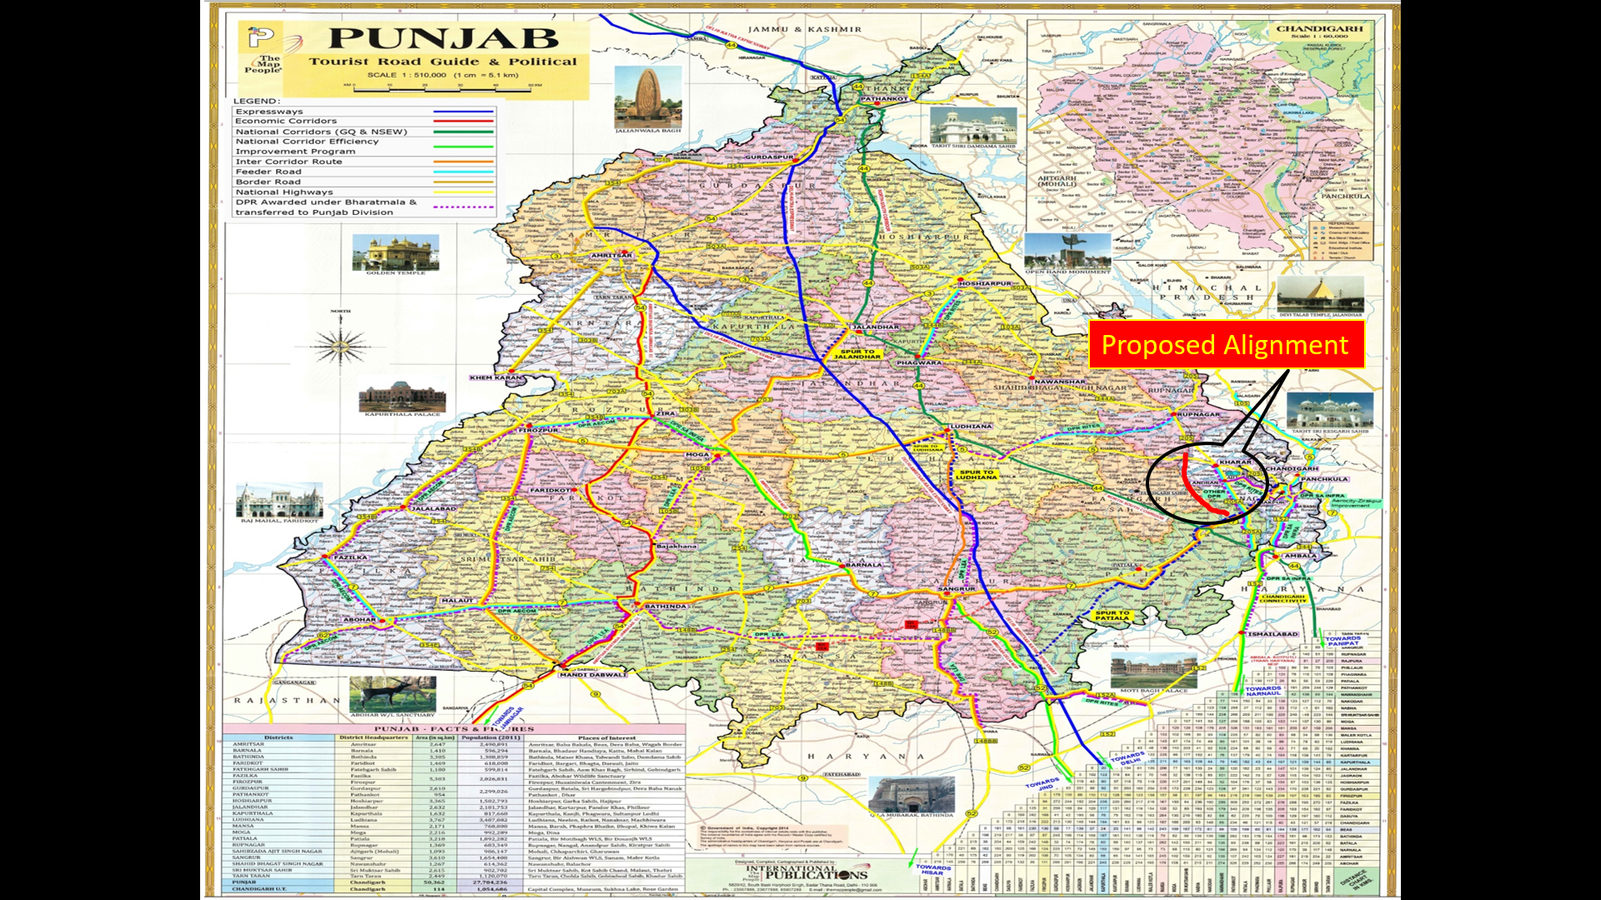

NHAI: National Highway Authority of India,
Submission On: March – 2022
TABLE OF CONTENTS

Sr. Nos. | Description of Item | Page Nos.
CHAPTER – 1: ENVIRONMENTAL IMPACT ASSESSMENT AND EMP FOR PUNJAB STATE
1. | INTRODUCTION AND BACKGROUND OF THE PROJECT | 10
2. | BACKGROUND – Scope and Study | 17
3. | PROJECT DESCRIPTION AND ALIGNMENT | 30
4. | OBJECTIVE OF CONSULTANCY SERVICES | 32
5. | PROPOSED APPROACH AND METHODOLOGY: Eco – Friendly OR Environmental Friendly Road Construction Methods and Materials | 35
6. | ENVIRONMENTAL INDEX OR FEATURES OF THE PROJECT | 38
7. | DEMOGRAPHIC INFRASTRUCTURE INDEX OF THE PROJECT DISTRICT/ STATE | 48
8. | ENVIRONMENTAL CHECKLIST (EC) | 59 – 60
9. | STATUTORY CLEARANCES REQUIRED | 60
10. | ENVIRONMENTAL IMPACT ASSESSMENT OF THE PROJECT | 79
11. | BASELINE ENVIRONMENTAL INDEX AND STATUS | 79
12. | AIR, WATER AND NOISE LEVEL | 85
13. | INSTITUTIONAL REQUIREMENTS AND ENVIRONMENTAL MONITORING PLANS | 146
14. | Principal Component Analysis (PCA) Indicators | 148 – 150
15. | ENVIRONMENTAL MANAGEMENT PLAN (EMP) for IT City Chowk to Kurali Chandigarh Road in the State of Punjab | 175 – 185
16. | CONCLUSIONS AND BUDGET | 186
17. | CONCLUSIONS AND RECOMMONDATIONS | 189
18. | - Environmentally Expected Natural Resources and Policies for Chandigarh and Punjab State…!!! | 191

Sr. Nos. | LIST OF TABLES | Page Nos.
CHAPTER – 1: ENVIRONMENTAL IMPACT ASSESSMENT AND EMP FOR PUNJAB STATE
Table 1: | The Route Plan of IT City Chowk to Kurali Chandigarh Road. | 16
Table 2: | Climate Data for Chandigarh (1961 – 1990, Extremes 1954 – 2010). | 27 – 28
Table 3: | Estimated Gross Expenses under Various Sectors for UT Chandigarh Climate Change Action Plan. | 29
Table 4: | Extra Widening/ Improvement and Land Acquisition Index. | 30
Table 5: | List of Districts and Talukas along the Projected Highway. | 30
Table 6: | The Inventory of IT City Chowk to Kurali Chandigarh Project Road. | 31
Table 7: | Zone Influence Factor at Chainage 00 + 000 Km and 31 + 230 Km. | 35
Table 8: | Current Pollutants’ Air Quality Scale and Status in Chandigarh. | 44
Table 9: | Air Quality Status in Kurali. | 44
Table 10: | Average Respirable Suspended Particulate Matter and Suspended Particulate Matter during Last 5 Years (in ppm). | 45
Table 11: | Forecast by Class of Vehicle Populations in India (In Millions). | 45
Table 12: | Homogeneous Section based on Traffic Volume Tehsil/ District Wise Villages. | 48
Table 13: | Existing – Proposed Chainage Wise Villages. | 48
Table 14: | POPULATION GROWTH (1951 to 2011). | 48
Table 15: | DENSITY FOR PHASE I, II AND III BASED ON CENSUS 2001 AND HOLDING CAPACITY. | 50
Table 16: | POPULATION PROJECTION OF CHANDIGARH UT BY VARIOUS METHODS. | 52
Table 17: | HOLDING CAPACITY OF UT CHANDIGARH BASED ON MASTER PLAN RECOMMENDATIONS. | 53
Table 18: | ADJUSTMENT OF PROPOSED POPULATION IN CHANDIGARH CITY. | 53
Table 19 (a): | CORONA VIRUS OR COVID – 19 Figure Cases Updates. | 55
Table 19 (b): | COVID – 19 Digital Catalogue Apprise in Punjab, Haryana, Himachal Pradesh and Other States. | 55
Table 19 (c): | Current CORONA Virus Infected Patients Count in Rupnagar District. | 56
Table 19 (d): | Current CORONA Virus Infected Patients Count in Chandigarh District. | 56
Table 20: | List of Village with Length and Chainages. | 57
Table 21: | As per IRC: SP: 48 – 1998; IRC: SP: 87 – 2019 Curve Detail “ROAD INVENTORY”. | 58
Table 22: | Classification of Design Standards for Geometrics of Highway. | 58 – 59
Table 23: | Rapid Environmental Assessment Checklist. | 59 – 60
Table 24: | Required Statutory (EIA/ S) Clearances. | 61
Table 25: | Environmental Impact and Clearances Required. | 62
Table 26: | Land Acquisition Requirements and Status. | 62
Table 27: | Pavement Crust Thickness for Widening and New Construction. | 63
Table 28: | Chainage References of Village Community/ Town (IT City Chowk to Kurali Chandigarh Road). | 63
Table 29: | Details of Existing DESIGN PARAMETERS for Proposed Structures. | 63 – 64
Table 30: | Land Use Pattern of Existing Road. | 64 – 65
Table 31: | Plain Terrain All Most Stretch/ Normal/ Rolling Gradient. | 65
Table 32 (a): | Crust/ Pavement Composition IT City Chowk to Kurali Chandigarh Road. | 67
Table 32 (b): | Soil Classification IT City Chowk to Kurali Chandigarh Road. | 67 – 68
Table 32 (c): | List of Junctions’/ Cross Roads Composition IT City Chowk to Kurali Chandigarh Road. | 68 – 69
Table 32 (d): | Existing Bridges, Cross Drainage and Culverts Structures. | 70
Table 32 (e): | Details of Major Bridge Structures (Bailey Bridge). | 70
Table 32 (f): | Details of Minor Bridge Structures (Bailey Bridge). | 70
Table 32 (g): | Details of Railway Over Bridge (ROB). | 70
Table 32 (h): | Details of Crossing Culverts. | 70 – 71
Table 32 (i): | Details of Small Vehicular Underpasses (SVUP’s). | 71
Table 32 (j): | Details of Light Vehicular Underpasses (LVUPs). | 72
Table 32 (k): | Details of Vehicular Underpasses (VUP). | 72
Table 32 (l): | Details of VOP at Start Point Towards Airport Side. | 72
Table 32 (m): | Details of Flyover IT City Kurali Road to Banur. | 72
Table 33: | Classified Different Average Daily Traffic (ADT) Surveys, Schedules and Dates of Commencement at Two Locations | 73 – 74
Table 34: | Categorized Average Daily Traffic (ADT) Inventory Reviews and Periods of Instigation at Two Locations. | 74
Table 35: | Capacity; Level of Service and Design Service Volume. | 75
Table 36: | Classified Summary “Variable Frequency Drive” (VFD) Surveys of Commencement at Two Locations. | 76
Table 37: | Classified Summary “Million Standard Axle” (MSA) Surveys of Commencement at Two Locations. | 76
Table 38: | Details of Vehicle Category. | 77
Table 39: | Projected Traffic Volume, Vehicle/ Day and PCU/ Day IT City Chowk – Kurali Chandigarh Road. | 77
Table 40: | Design of Existing – Proposed Chainage for Homogenous Section. | 78
Table 41: | Design of Flexible Pavement for Homogenous Section. | 78
Table 42: | Design of Proposed Better Crust Thickness for Ridge Pavement Composition. | 78
Table 43: | Design of Curve Improvement Details Section. | 78
Table 44: | Summary of Flexible Pavement, Breast Wall, Hill Side Drain, Valley Side Crash Barrier for Structure Configuration. | 78
Table 45: | Maintenance Labour and Crew Costs Details. | 79
Table 46: | AAQ Monitoring Result of Project Road. | 85
Table 47: | National Ambient Noise Standards. | 85
Table 48: | Equivalent Noise Level Data. | 86
Table 49: | CPCB Best Use Classification for Surface Water Bodies. | 86
Table 50 (a): | Ground Water and Surface Water Quality along the Projected Road. | 87
Table 50 (b): | Ground Water and Surface Water Quality along the Projected Road. | 88
Table 51: | Frequency of Sulphur Dioxide in Air. | 100
Table 52: | Frequency of Permissible Noise Limit in the Environment. | 104
Table 53: | Category of Domestic Appliances/ Construction Equipments in the Environment. | 105
Table 54: | Peak Sound Pressure Level (PSPL) in the Environment. | 105
Table 55: | Total Time Exposure of Peak Sound Pressure Level in the Environment. | 105
Table 56: | Potential Environmental Impacts. | 112
Table 57: | Activity – Impact Identification Matrix. | 128 – 129
Table 58: | Environmental Issues and Measurements. | 131 – 132
Table 59: | Impacts during Design Phase. | 142
Table 60: | Environmental Management Plan during Construction Period. | 142 – 143
Table 61: | Environmental Management during Operation Phase. | 143
Table 62: | Institutional Responsibility of Remedial Measures. | 146 – 148
Table 63: | Principal Component Analysis as Significant Indicators of Remedial Measures. | 148 – 150
Table 64: | Proposed Typical Cross Section Lengthwise for Projected Road Sections. | 151
Table 65: | Environmental Management Plan (EMP). | 175 – 185
Table 66: | Environmental Mitigation and Monitoring Requirements. | 186 – 187
Table 67 (a): | Details of IT City Chowk to Kurali Chandigarh Road. | 187 – 188
Table 67 (b): | Tentative Cost of IT City Chowk to Kurali Chandigarh Road. | 188

Sr. Nos. | LIST OF FIGURES | Page Nos.
CHAPTER – 1: ENVIRONMENTAL IMPACT ASSESSMENT AND EMP FOR PUNJAB STATE
Figure 1 (a): | Chandigarh “Union Territory” Birds, Animals and Cumulative Impact Assessment (CIA) Supporting Wealthy and Rich Diversity OR Species. | 14
Figure 1 (b): | Foothills, Meandering Rivers and Miles of Forests Supporting Wealthy and Rich Biodiversity. | 15
Figure 2: | Detailed Project Description Process (Schematic Diagram OR Flowchart Showing Project Layouts and Concluding Components). | 18
Figure 3: | Index Map Showing Projected Road. | 23
Figure 4: | The Tentative Prototype – Paradigm – Digital Sample/ Example of Digital Terrain Model (DTM)/ DEM Generation of Geo – Tiff – Format of IT City Chowk to Kurali Chandigarh Road, Village (31.230 Km) Projected New Road at IT City Chowk Latitude of 30°36’58” (North) and Longitude of 76°41’37” (East); Kurali Chandigarh Latitude of 30°49’59” (North) and Longitude of 76°38’57” (East). Vetting/ Geology and Slope Stability are observed by IIT Delhi/ Roorkee Team Experts. (Part – I) | 26
Figure 5: | Approved Project Alignment of IT City Chowk to Kurali Chandigarh Road Projected as per Inception Report by Environmental Team Experts. | 32
Figure 6: | Project Execution Objectives and Decision Making Work – Life Cycle. | 34
Figure 7: | Methodological Perspective Over – View of Road Date Base Construction Photographs. | 37
Figure 8: | Inauguration/ Opening Ceremony of “Energy Efficient Green Building” by Minister of Paryavaran Bhawan Sector 19 – B, Chandigarh. | 41
Figure 9: | Live Air Quality Index (AQI) Isopleths’ Forecast and Statement in Chandigarh. | 43
Figure 10: | Live Graphical Weather Representation (GWR) with Temperature, Precipitation and Air Pressure Profile for Kurali, Punjab State India. | 44
Figure 11: | Weekly Live Graphical Weather Representation (GWR) with Sun Shine, Temperature, Wind Speed and Humidity Profile for Kurali, Punjab State India. | 45
Figure 12: | Rural – Urban Composition of Chandigarh and Manimajra Occupying a Major Part of Population. | 49
Figure 13 (a): | PLAN D1 – DENSITY PATTERN IN SECTORS (AS PER ORIGINAL PLAN). | 50
Figure 13 (b): | PLAN D2 – DENSITY PLAN OF CHANDIGARH – YEAR 2001. | 51
Figure 13 (c): | PLAN D3 – DENSITY PLAN OF CHANDIGARH (AS PER HOLDING CAPACITY). | 51
Figure 14: | The Kharar – Banur – Tepla Road with an Alternate “Green Field” Alignment of 32 Km Road from IT Chowk (PR – 7) near Airport to Kurali – Chandigarh Road from Villages of Nagiari and Devi Nagar. | 56
Figure 15: | Prototype – Paradigm of Land Use Pattern of Existing Road. | 64
Figure 16: | Existing Forest Cover along the Projected Road in Chandigarh U. T. | 65
Figure 17 (a): | Daily Variations of Traffic Volume at IT City Chowk (Chainage 00 + 000) to Kurali Chandigarh (Chainage 31 + 230) on Projected Road. | 66
Figure 17 (b): | Catalogue for Pavement with Bituminous Surface with CTSB, CTB and SAMI – Effective CBR 10% (Plate – 22). | 67
Figure 17 (c): | Kurali Chandigarh Road Distance around 26.9 Km (34 minutes). | 68
Figure 18: | Three Columns of Sustainability Development – Environmental, Economic and Social. | 84
Figure 19: | Chandigarh Master Plan – 2031 (Source: Management Plan for Sukhna Wildlife Sanctuary and Survey of India Map of the Lake’s Catchment Area/ Zone). | 89
Figure 20: | Isopleths/ Graphics of Dispersed Pollutants from Volume Source. | 99
Figure 21: | Graphical Representation of Air Pollutants from Volume Source. | 100
Figure 22: | Increase in Levels of Pollutant – Emissions – Impact on Future Generated Aspects/ Prospects from Various Sources. | 104
Figure 23: | Comparison of Noise Level Separated by Component. | 107
Figure 24: | Noise Levels Impact Must Not Exceed the Permissible Limits in Sensitive Zones along Road Side. | 109
Figure 25: | Mitigatory Measures Plans Generated; Initialized and Finalized to Avoid Contamination Impact on Water Resources and Quality. | 110
Figure 26: | Plan Mitigatory Measures to Avoid Soil Contamination Impact on Agricultural Land and Other Sensitive Zones in Environmental/ Natural/ Ecological Vicinity/ Area/ Site. | 111
Figure 27: | Proposed/ Recommended/ Optional/ Suggested Area Method of Land Filing Solid Wastes at Projected Site. | 118
Figure 28: | Proposed/ Recommended/ Optional/ Suggested Trench Method of Land Filing Solid Wastes for Small Landfills at Projected Site. | 119
Figure 29: | Proposed/ Recommended/ Optional/ Suggested Pit Method of Land Filing Solid Wastes for Large Landfills at Projected Site. | 120
Figure 30 (a): | Mitigation Enhancement as per Alignment Design Phase to Reduce Tree Cutting and Compensatory Plantation Relevance. | 123
Figure 30 (b): | Anticipated Refined Enhancement Measures of Road Design Phase as per Alignment to Reduce Tree Cutting and Compensatory Plantation Relevance for ZERO Pollution Level. | 125
Figure 30 (c): | Recommended Refined Enhancement Measures of Road Design Phase as per Alignment to Reduce Tree Cutting and Compensatory Plantation Relevance for ZERO Pollution Level. | 126
Figure 30 (d): | Road Designing Phase as per Alignment to Reduce Tree Cutting and Compensatory Plantation Relevance for ZERO Pollution Level. | 128
Figure 31: | Proposed/ Recommended/ Optional/ Suggested Plant of Bitumen Disposal Pit. | 134
Figure 32: | Proposed/ Recommended/ Optional/ Suggested Ground Water Recharge Pit. | 138
Figure 33: | Process of Pyrolysis in Solid and Waste Water Treatment. | 144
Figure 34: | Solid Waste Handling Pyrolysis Technique. | 145
Figure 35: | Sewage Treatment Process (STP) of Wastewater Layout. | 146
Figure 36 (a): | TCS: TYPICAL CROSS SECTION: FOR 6 AND 4 – LANE TOWARDS BANUR AND AIR PORT ROAD. TYPICAL CROSS SECTION – I AND I (A) | 152
Figure 36 (b): | TCS: TYPICAL CROSS SECTION: FOR 6 – LANE WITH PAVED SHOULDER & RAISED MEDIAN. TYPICAL CROSS SECTION – II AND III (RHS) | 153
Figure 36 (c): | TCS: TYPICAL CROSS SECTION: FOR 6 – LANE WITH PAVED SHOULDER & RAISED MEDIAN. TYPICAL CROSS SECTION – IV (LHS) AND V | 154
Figure 36 (d): | TCS: TYPICAL CROSS SECTION: FOR 6 – LANE WITH PAVED SHOULDER VUP/ LVUP/ SVUP/ FLYOVER. TYPICAL CROSS SECTION – VI AND VII (BHS) | 155
Figure 36 (e): | TCS: TYPICAL CROSS SECTION: FOR 2 – LANE CARRIAGEWAY.  TYPICAL CROSS SECTION – V | 156
Figure 36 (f): | TCS: TYPICAL CROSS SECTION: FOR 6 – LANE BY MAJOR BRIDGE AND RAILWAY OVER BRIDGE. TYPICAL CROSS SECTION – X AND X (A) | 157
Figure 36 (g): | TCS: TYPICAL CROSS SECTION: FOR 6, 8 – LANE WITH PAVED SHOULDER VUP/ LVUP/ SVUP/ FLYOVER. TYPICAL CROSS SECTION – XI (BHS) AND XII | 158
Figure 36 (h): | TCS: TYPICAL CROSS SECTION: FOR 6 – LANE WITH SERVICE ROAD & RAISED MEDIAN (TOWARDS BADDI ROAD). TYPICAL CROSS SECTION – XIII | 159
Figure 37: | BOTHER... SAFEGUARD; PROTECT; CONSERVE AND PRESERVE OUR PLANET EARTH’S NATURAL – MOTHER... (ECO – NATURAL – GREEN – ENVIRONMENT)...!!! | 160
Figure 38 (a): | Stream Illustration of Prior Environmental Clearance Process for Category “A” Projects. | 168
Figure 38 (b): | Stream Illustration of Prior Environmental Clearance Process for Category “B” Projects. | 169
Figure 39: | Existing and New/ Expansion Highway Projects are an Integral Part during Planning, Construction and Operational Stage for Road Safety Management System Audit Frame Work in India*. | 170
Figure 40 (a): | Overview of the Environment and Social Framework. | 171
Figure 40 (b): | Core Principles of the Environmental and Social Framework. | 172
Figure 40 (c): | The Environmental Objectives; Application Scope; Policy Approach of the Environmental and Social Framework. | 173
Figure 40 (d): | The Policy Requirements; Roles and Responsibilities of the Environment and Social Framework. | 174

Sr. Nos. | LIST OF EQUATIONS AND NABL Accreditation, TESTING and Calibration | Page Nos.
CHAPTER – 1: ENVIRONMENTAL IMPACT ASSESSMENT AND EMP FOR PUNJAB STATE
Equation (1): | “Zone Influence Factors” (ZIF) At Chainage 00 + 000 Km and 31 + 230 Km. | 35
Equation (2): | “Fourth – Generation Line Source Gaussian Plume Dispersion Model” (GPDM) “CALINE – 4 Model”. | 101
Equation (3): | Frequency of Permissible Noise Limit in the Environment “Empirical Formula” (Inverse Square Law). | 104
Equation (4): | Prediction of Impacts “7 – CRTN Model” Comparison of Noise Level Separated by Component. | 107
Laboratory Monitoring: | NABL Accreditation, TESTING and Calibration Laboratories Sample Format. (Laboratory Monitoring Results are under Practice). | 141

ABBREVIATIONS AND ACRONYMS

AADT | Annual Average Daily Traffic |  | MOEF | Ministry of Environment and Forests
AC | Asphaltic Concrete |  | MORT & H | Ministry of Road Transport & Highways
ADT | Average Daily Traffic |  | BRO | Border Road Organisation
BBD | Benkelman Beam Deflection |  | MSA | Million Standard Axles
BC | Bituminous Concrete |  | MSL | Mean Sea Level
BM | Bituminous Macadam |  | NH | National Highway
BOQ | Bill of Quantities |  | NMT | Non – Motorized Traffic
BOT | Build Operate Transfer |  | NPV | Net Present Value
BSNL | Bharat Sanchar Nigam Limited |  | NSDP | Net State Domestic Product
BT | Bituminous Track |  | NTPC | National Thermal Power Corporation
CBR | California Bearing Ratio |  | O&M | Operation & Maintenance
CD | Cross Drainage |  | O – D | Origin Destination
CGWB | Central Ground Water Board |  | OFC | Optical Fiber Cable
CMSA | Cumulative Million Standard Axles |  | OMC | Optimum Moisture Content
COI | Corridor of Impact |  | PCC | Plain Cement Concrete
CRRI | Central Road Research Institute (India) |  | PCU | Passenger Car Unit
CVPD | Commercial Vehicle Per Day |  | PIU | Project Implementation Unit
DBFOT | Design, Build, Finance, Operate & Transfer |  | PPM | Parts Per Million
DBM | Dense Bituminous Macadam |  | PPP | Public Private Partnership
DLC | Dry Lean Concrete |  | PPR | Preliminary Project Report
DTM | Digital Terrain Model |  | PQ | Pre – Qualification
EA | Environmental Assessment |  | PQC | Pavement Quality Control
EASL | Equivalent Standard Axle Load |  | PWD | Public Works Department
EIA | Environment Impact Assessment |  | QAP | Quality Assurance Plan
EIRR | Economic Internal Rate of Return |  | QC | Quality Control
FFR | Final Feasibility Report |  | R&R | Resettlement and Rehabilitation
FIRR | Financial Internal Rate of Return |  | RAP | Resettlement Action Plans
GAD | General Arrangement Drawing |  | RCC | Reinforced Cement Concrete
GDP | Gross Domestic Product |  | RHS | Right Hand Side
GOI | Government of India |  | RL | Reduced Level
GPS | Global Positioning System |  | ROB/ RUB | Road Over Bridge/ Road Under Bridge
GSB | Granular Sub – Base |  | ROW | Right of Way
GTS | Geodetic Triangulation Survey |  | ₹/ Rs. | Rupees
Ha | Hectare |  | SH | State Highway
HDMM – 4 | Highway Design and Maintenance Model (Series – 4) |  | SIA | Social Impact Assessment
HDMMQ CA | Highway Design and Maintenance Model with Congestion Analysis |  | Sq. Km. | Square Kilometers
HFL | High Flood Level |  | TBM | Temporary Bench Mark
IRC | Indian Road Congress |  | Temp | Temperature
IRR | Internal Rate of Return |  | TOR | Terms of Reference
Km | Kilometre |  | TRL | Transportation Research Laboratory
KMPH | Kilometre Per Hour |  | UG | Under Ground
LA | Land Acquisition |  | VDF | Vehicles Damage Factor
LT/ HT | Low Tension/ High Tension Electric Lines |  | Veh. | Vehicles
m | Meters |  | VGF | Viability Gap Funding
MDR | Major District Road |  | WB | World Bank
mm | Millimetre |  | WBM | Water Bound Macadam
Dia. | Diameters |  | WMM | Wet Mix Macadam
EPC | Engineering, Procurement, and Construction |  | PPE | Personal Protective Equipment
PPR | Peste – des Petits Ruminants |  | GAD | General Administration Department
LMI | Labour Market Information |  | MSE | Mean Squared Error
SARA | Saturates, Aromatics, Resins and Asphaltenes |  | ACZ | Agro – Climatic Zone
PET | Poly – Ethylene Tere – phthalate |  | SEDP | Sustainable Environmental Development Practices
FRC | Fibre Reinforced Concrete |  | PCM | Public Consultation Method
PCM | Public Consultation Meeting |  | FGD | Focus Group Discussion
UTC | Universal Time Coordinated |  | GPS | Global Positioning System
DEM | Digital Elevation Model |  | DTM | Digital Terrain Model
FCW | Flush Cause Way |  | CRRI | Central Road Research Institute
CVPD | Commercial Vehicles Per Day |  | ATTC | Advanced Technical Training Centre
CCCT | Centre for Computers and Communication Technology |  | CRPF | Central Reserve Police Force
NWL | Normal Water Level |  | TAR | Tibet Autonomous Region
CCP | CIVIL CONSTRUCTION PRACTICES |  | NSSDA | National Standard for Spatial Data Accuracy
GSD | Ground Sample Distance |  | DGPS | Differential Global Positioning System
NRSC | National Remote Sensing Centre |  | GIS | Geographical Information System
DEM | Digital Elevation Model |  | RL | Reduced Level
NHAI | National Highway Authority of India |  | CPWD | Central Public Works Department

This is a Draft Report on “Louis Berger Pattern” for Environmental and Social Management Framework (ESMF) for the proposed Enhancing Land, Air, Water, Noise and Road Construction Resource Efficiency (ELAWNRCRE) Project with financial assistance from the BRO/ NHAI/ ITBP/ CPWD/ PWD/ MPRDC/ MSRDC/ ADB/ NDB OR World Bank etc. This is hereby disclosed with a view to soliciting comments/ suggestions on or before December 2019. In this regard, please send your comments/ suggestions by email to h.g@rediffmail.com or by WhatsApp Number 09329213257 to Dr. Harish Kumar Gupta, Environment Expert, L. N. M. Infra Projects Pvt. Ltd., Bhopal (M.P.).

“I am not interested in building a bridge just because someone says one is needed. I want to know if it is needed, and why, and where is the best place to put it. I want to know how the building of that bridge will change the lives of the people who use it.”
Dr. Louis Berger | Founder

Chapter – 1: ENVIRONMENTAL IMPACT ASSESSMENT AND EMP FOR PUNJAB STATE

1. INTRODUCTION AND BACKGROUND OF THE PROJECT

“Chandigarh”, city and union territory of India. Located about 165 miles (265 Km) North of New Delhi, the territory is bounded by the state of Haryana on the East and by the State of Punjab on all other sides. It is situated on the Indo – Gangetic Plain a short distance South West of the Siwalik Range (Shiwalik Range), between two seasonal hill torrents, the “Sukhna and Patiali Rivers”. The land is a flat and fertile tract of alluvial soils, and its rural farmland produces such crops as wheat, corn (maize), and rice. In the summer months (April to June) temperatures may rise above 120°F (about 50°C), while in the winter months (November to February) temperatures may dip into the mid – 30s F (about 2°C), with frequent rain showers. The monsoon season (July to September) is hot and humid.
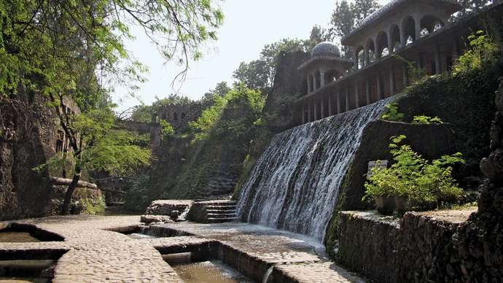

Chandigarh Rock Garden:
Waterfall in the Rock Garden of Nek Chand, Chandigarh, North Western India.

“Punjab” State of India, located in the North Western part of the subcontinent. It is bounded by the Indian states of Jammu and Kashmir to the North, Himachal Pradesh to the Northeast, Haryana to the South and Southeast, and Rajasthan to the Southwest and by the country of Pakistan to the West. Punjab in its present form came into existence on November 1st, 1966, when most of its predominantly Hindi – speaking areas were separated to form the new state of Haryana. The city of Chandigarh, within the Chandigarh union territory, is the joint capital of Punjab and Haryana.

Amritsar, India: Harmandir Sahib:
The Harmandir Sahib (Golden Temple; Right) Amritsar, Punjab, India.

The word Punjab is a compound of two Persian words, panj (“Five”) and āb (“Water”), thus signifying the land of five waters, or rivers (the Beas, Chenab, Jhelum, Ravi, and Sutlej). The word’s origin can perhaps be traced to panca nada, Sanskrit for “Five Rivers” and the name of a region mentioned in the ancient epic the Mahabharata. As applied to the present Indian state of Punjab, however, it is a misnomer: since the partition of India in 1947, only two of those rivers, the Sutlej and the Beas, lie within Punjab’s Territory, while the Ravi flows only along part of its Western border. Area 19,445 Square Miles (50,362 Square Km). Population is around (2011) 27,704,236.

Land: Relief, Drainage and Soils

Punjab spans three physiographic regions, the smallest being the Siwalik Range in the Northeast, where elevations reach about 3,000 Feet (900 Metres). Farther South, the narrow, undulating foothill region is dissected by closely spaced seasonal torrents, locally known as chos, several of which terminate in the plain below without joining any stream. To the South and West of the foothills lies the broad flat tract, with low – lying floodplains separated by slightly elevated uplands. This region, with its fertile alluvial soils, slopes gently from an elevation of about 900 Feet (275 Metres) in the Northeast to about 550 Feet (170 Metres) in the Southwest. The South Western part of the plains, formerly strewn with sand dunes, has mostly been levelled off with the expansion of irrigation projects. Lying within the territory of Chandigarh are the city of Chandigarh, several towns, and a number of adjoining villages. Administration of the territory’s government is provided by the governor of Punjab, who is assisted by a senior officer; both are appointed by the national government. Chandigarh city is the capital of the territory and of the states of Haryana and Punjab. Chandigarh’s name, meaning “Stronghold of the Goddess Chandi,” is derived from the Chandi Mandir, a temple dedicated to the goddess that is located near the town of Mani Majra. Area union territory, 44 Square Miles (114 Square Km). Population of the city (2001) 808,515; Union Territory (2001) 1,063,000; City (2011) 960,787; Union Territory (2011) 1,054,686.

History

With the partition of India in 1947, the old British province of Punjab was divided into two parts. The larger Western part, including the Punjabi capital of Lahore, went to Pakistan. The Eastern part was granted to India, but it was without an administrative, commercial, or cultural centre. Consequently, plans to find a suitable site for the capital of the new Indian Punjab were undertaken soon after partition. The Indian government considered several options – including Amritsar, Jalandhar (Jullundur), Phillaur, Ludhiana, Shimla (Simla), Ambala, and Karnal – and selected the present site of Chandigarh in 1948. It was hoped that a magnificent new state capital, scenically located at the foot of the Himalayas, would become a symbol of modernity, would heal the wounded pride of Indian Punjabis, and would house thousands of mostly Hindu and Sikh refugees who had fled from Muslim – dominated Pakistan. The city was planned by the Swiss – born architect Le Corbusier, assisted by Maxwell Fry, Jane Drew, and several Indian architects and town planners. Construction began in the early 1950s, and most of the city was completed in the early 1960s. The project ultimately required the relocation of some 21,000 people from 58 villages.

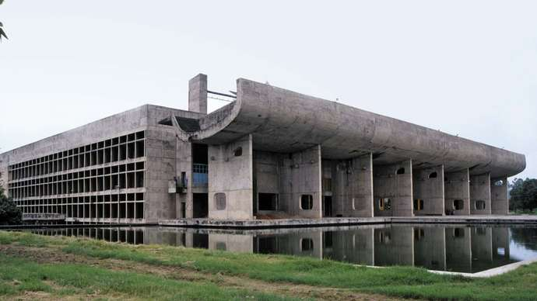
Chandigarh, India: Palace of Assembly

The Palace of Assembly in Chandigarh, India, Designed by Le Corbusier.

The Chandigarh union territory was constituted on November 1st, 1966, when the Indian Punjab was reorganized along linguistic lines into two new states – predominantly Hindi – speaking Haryana and Punjabi – speaking Punjab. Straddled between Haryana and Punjab, the city of Chandigarh was made the shared capital of the two states and of the union territory itself. Under the terms of the 1986 Punjab Accord, the entire union territory was to become part of Punjab, whereas the agriculturally productive, mostly Hindi – speaking areas of Fazilka and Abohar, both in Punjab, were to be transferred to Haryana; by the early 21st century, however, this plan had yet to come to fruition.

The Contemporary City and Territory

The city of Chandigarh, with its well – developed infrastructure and relatively low population density, covers more than half of the union territory. It consists of more than 50 rectangular sectors, which are separated from one another by broad streets carrying the city’s fast – moving arterial traffic. The main government buildings are in the Northern part of the city. In the Southeast are the industrial areas, separated from the residential sectors by a greenbelt planted with mango trees. Among the city’s principal industries are electronics, pharmaceuticals, ceramic plumbing fixtures and electrical appliances.

Chandigarh: Sculpture by Le Corbusier, Chandigarh, Northwestern India.

Most of the population of the territory is concentrated in the Southern sector of Chandigarh city. Hindus constitute by far the predominant religious group, although Sikhs form a significant minority. There also is a sprinkling of Muslims, Christians and Jains. Hindi and Punjabi are the most widely spoken languages in the territory. The territory has many notable educational and cultural institutions, including “Panjab University” (founded 1947), the “Postgraduate Institute of Medical Education and Research” (PIGMER), the Punjab Engineering College, the Government College of Art, and the Government Medical College and Hospital. There also are several specialized arts academies. Chandigarh’s local museum houses a rich collection of Gandhara Sculptures and Pahari and Sikh paintings, while archaeological digs in the area have yielded ancient Indus civilization (c. 2500 – 1700 BCE) artifacts, particularly pottery. The city also is known for its extensive rose garden and for its unusual rock garden, which contains numerous statues created from broken objects by the self – taught artist “Nek Chand”.

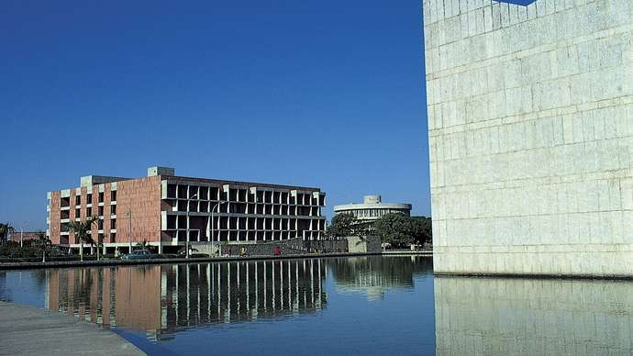

Library Building (Left) of Panjab University, Chandigarh.
Chandigarh has a multitude of sports and recreation facilities. In the Northeast is the large, artificial Lake Sukhna, which has become the main spot in the city for promenading and evening recreation. There also are many government – supported sports complexes and community centres. These have served as the training grounds for numerous nationally and internationally competitive athletes in field hockey, cricket, rowing, and other sports.

The consultancy services for carrying out preparation of “Environmental Impact Assessment/ Initial Environmental Examination” (EIA/ IEE)/ Detailed Project Report (DPR) and bid documents. In order to fulfil the traffic needs and road safety requirement, “National Highway Authority of India” (NHAI) has appointed the M/s. L. N. Malviya Infra Projects Pvt. Ltd. BHOPAL (MP), for Survey, Investigation and Preparation of Detailed Project Report for improvement of faster, economical and quality Road Construction work throughout India. NHAI Aims at provisioning and maintaining the national highways network to meet user expectations in the most time – bound and cost – effective manner within the strategic policy framework. The “National Highways Authority of India” (NHAI) is the nodal agency of “Ministry of Road Transport and Highways” (MORT&H), Government of India and has been entrusted with the Development of Memmadpur (Ambala) – Banur (IT City Chowk) – Kharar – Kurali Chandigarh Road in the State of Punjab using “Satellite Imagery” and “Geographical Information System” (GIS). The report brings out the project background, mobilization and staffing, approach and methodology relating to surveys/ investigations and detailed design. A broad conceptualization of the project essentially based on study of available data/ reports and a detailed reconnaissance survey has been provided. “National Highway Authority of India” (NHAI) Division has been entrusted preparation of “Environmental Impact Assessment/ Initial Environmental Examination” (EIA/ IEE) of IT City Chowk to Kurali Chandigarh from 00.000 Km to 31.230 Km (31.23 Kms) in Punjab”. Through Consultancy Services As Specified By MORT & H and Provisions of IRC – SP – 19 for Improvement/ Development of Road IT City Chowk to Kurali Chandigarh from 00.000 Km to 31.230 Km to the assignment for “Consultancy Letter No.: NHAI/ RO/ CHD/ 11011/ PD – MHL/ Raj – Kha/ DPR/ RFP/ 50 – 6754 Dated 7th March 2020”.

As part of the development, Consultancy services for Preparation of DPR for Development of Memmadpur (Ambala) – Banur (IT City Chowk) – Kharar – Kurali Chandigarh Road Corridor under Bharatmala Pariyojana for Package – II: IT City Chowk to Kurali Chandigarh Road having length 31.23 Km. As per topographic survey which are given below.

- Part – I: Starts from IT City Chowk (Chainage 00 + 000) and Ends at Kurali Chandigarh (Chainage 31 + 230).

The report covers the following major aspects and prospects are as discussed below one by one:

Project Background;

Mobilization and Progress;

Project Appreciation and Conceptualization;

Proposed Approach and Methodology;

Alignment Deciding Criteria and Significant Factors

Stable Side of Hilly Areas;

Avoiding of S – Bends to the Extent Possible;

Gradient Limits;

Availability of Road Construction Materials;

Minimum Number of Cross Drainage Structures;

Connectivity to Intermediate Village, If Any;

Avoiding Acquisition of Private Land;

Keeping the Alignment 25 – 30 m above “Normal Water Level” (NWL) of River, If Any;

The consultancy services for the same have included design of best possible alignment and pavement composition, culverts and other structures in addition to analysis of costs, determining project feasibility and “Environmental Impact Assessment/ Initial Environmental Examination” (EIA/ IEE) Report for the Project IT City Chowk to Kurali Chandigarh Road Starts from IT City Chowk Road and Terminates at Kurali Chandigarh Road in the “Union Territory” as shown in the Figures 1 (a) and (b).

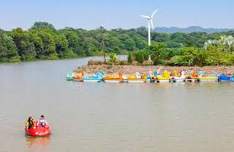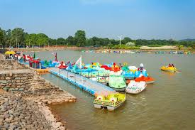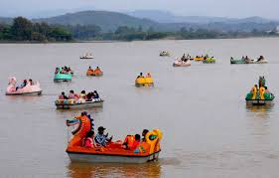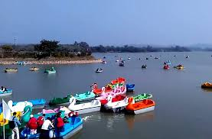

Figure 1 (a): Chandigarh “Union Territory” Birds, Animals and Cumulative Impact Assessment (CIA) Supporting Wealthy and Rich Diversity OR Species.
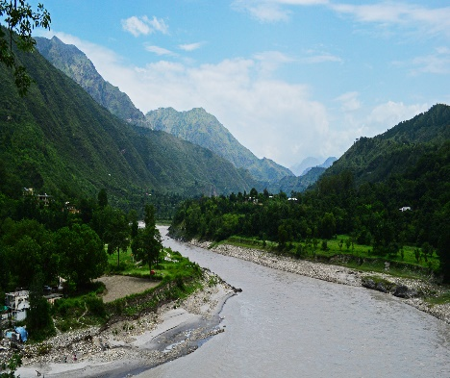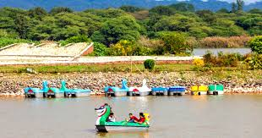
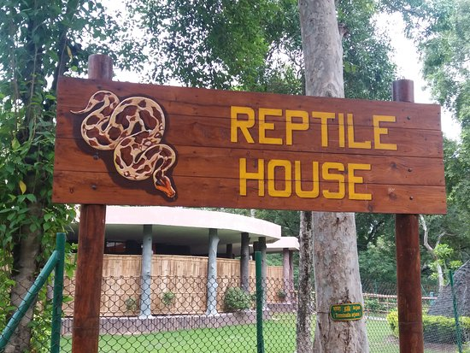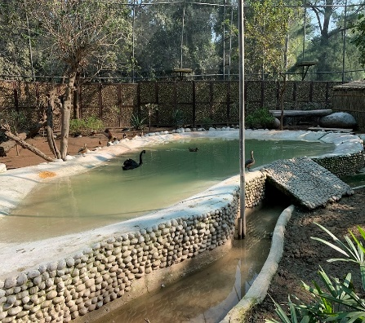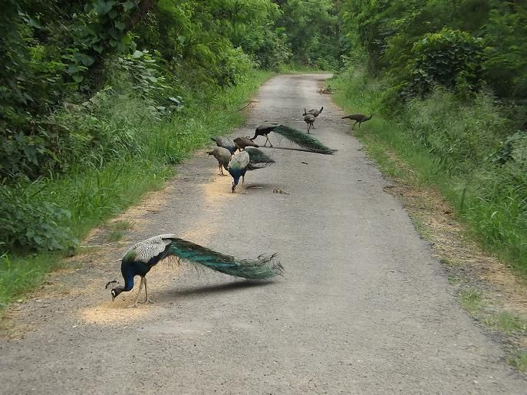
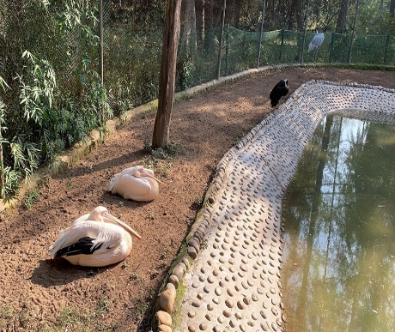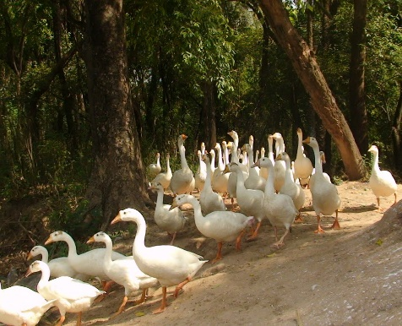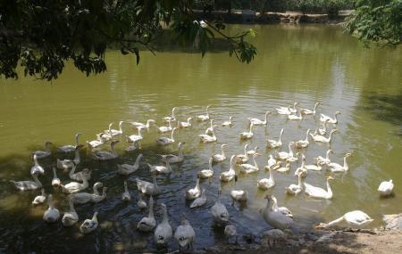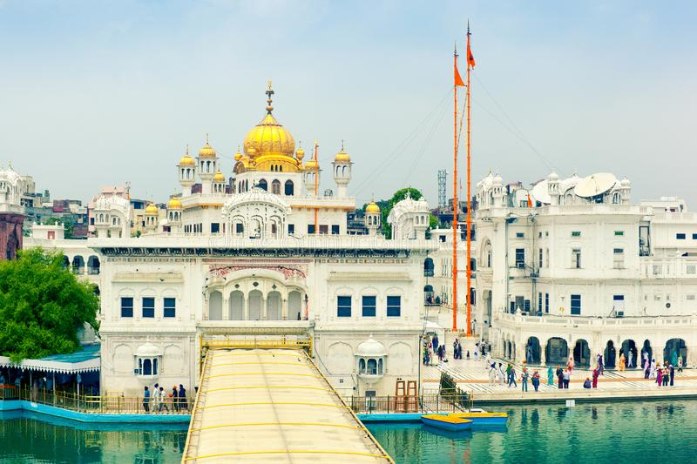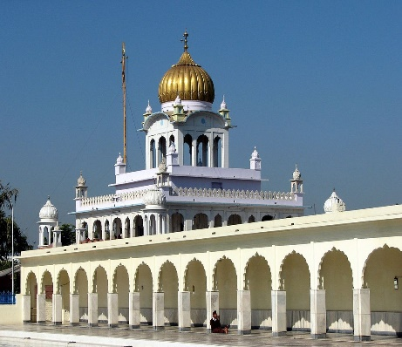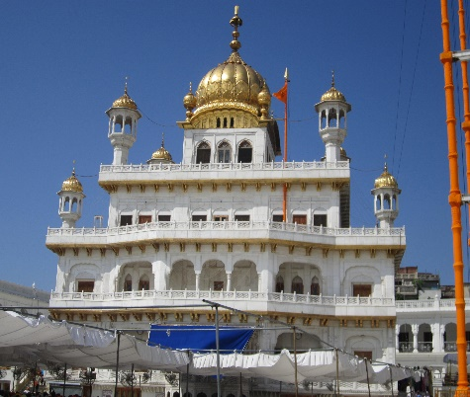

Figure 1 (b): Foothills, Meandering Rivers and Miles of Forests Supporting Wealthy and Rich Biodiversity.
Chandigarh (ਚੰਡੀਗੜ੍ਹ) is a City, District and Union Territory in India that serves as the capital of the two neighbouring States of Punjab and Haryana. Chandigarh is bordered by the state of Punjab to the North, the West and the South, and by the State of Haryana to the East. It is considered to be a part of the Chandigarh Capital Region or Greater Chandigarh, which includes Chandigarh, and the city of Panchkula (in Haryana) and Cities of Kharar, Kurali, Mohali, Zirakpur (in Punjab). It is located 260 Km (162 Miles) North of New Delhi and 229 Km (143 Miles) Southeast of Amritsar. Chandigarh has a “Humid Subtropical Climate” (Köppen: CWA) characterized by a seasonal rhythm: very hot summers, mild winters, unreliable rainfall and great variation in temperature (−1°C to 46°C OR 30.2°F to 114°F). The average annual rainfall is 1110.7 mm. It lies between “Latitude 30.7333° N and Longitude 76.7794° E”. Chandigarh is located near the foothills of the Sivalik Range of the Himalayas in Northwest India. It covers an area of approximately 114 Km². It borders the states of Haryana and Punjab. The exact geographic coordinates of Chandigarh are 30.74°N and 76.79°E. It has an average elevation of 321 Metres (1053 Feet). The city, lying in the Northern plains, includes a vast area of flat, fertile land. Its northeast covers sections of Bhabar and while the remainder of its terrain is part of the Terai. The surrounding cities are Mohali, New Chandigarh, Patiala, Zirakpur and Rupnagar in Punjab and Panchkula and Ambala in Haryana. Chandigarh is situated 44 Km (28 Miles) Northeast of Ambala, 229 Km (143 Miles) Southeast of Amritsar, and 250 Km (156 Miles) North of Delhi. The beautiful foothills and the biodiversity makes Chandigarh and Punjab a favourite spot for tourists like Foothills, Meandering Rivers and Miles of Forests Supporting Wealthy and Rich Biodiversity as shown above in Figures 1 (a) and (b). The “National Highway Authority of India” (NHAI) Division has been entrusted preparation of “Environmental Impact Assessment/ Initial Environmental Examination” (EIA/ IEE) of IT City Chowk to Kurali Chandigarh from 00.000 Km to 31.230 Km (31.23 Kms) in Punjab”. Through Consultancy Services As Specified By MORT & H and Provisions of IRC – SP – 19 for Improvement/ Development of Road IT City Chowk to Kurali Chandigarh from 00.000 Km to 31.230 to the assignment for “Consultancy Letter No.: NHAI/ RO/ CHD/ 11011/ PD – MHL/ Raj – Kha/ DPR/ RFP/ 50 – 6754 Dated 7th March, 2020”. The Projected Road IT City Chowk to Kurali Chandigarh Starts at IT City Chowk and Terminates at Kurali Chandigarh. The design length of proposed alignment is 191.00 Km and the route plan of IT City Chowk to Kurali Chandigarh Road is given in Table 1.

Table 1: The Route Plan of IT City Chowk to Kurali Chandigarh Road.

Road Direction and Route Plan

Place Name |  | Distance | Approximate Time for Journey | Mode of Vehicle
From | To
IT City Chowk | Kurali Chandigarh | 31.230 Km. | 00.35 Hrs | By Road with 4 Wheeler Drive
Total |  | 31.230 Km.

Physiographic Index

Chandigarh is geographically located at “Latitude 30.7333° N and Longitude 76.7794° E. The Western disturbances usually bring rain predominantly from mid – December till the end of April which can be heavier sometimes with strong winds and hails if the weather turns colder (during March – April months) which usually proves disastrous to the crops. Cold winds usually tend to come from the North near Shimla, capital of Himachal Pradesh and from the state of Jammu and Kashmir, both of which receive their share of snowfall during winter time. The city experiences the following seasons and the respective average temperatures. The weather condition of the state is mainly divided into 5 seasons, which are depicted below:

- Spring;
- Summer;
- Autumn;
- Monsoon;
- Winter.

- Spring: In the spring season (from February – end to early – April), temperatures vary between (maximum) 13°C to 20°C and (minimum) 5°C to 12°C;

- Autumn: In autumn (from September – end to mid – November), the temperature may rise to a maximum of 30°C. Temperatures usually remain between 10°C to 22°C in autumn. The minimum temperature is around 6°C;
- Summer: The temperature in summer (from mid – April to June – end) may rise to 44°C. The temperatures might sometime rise to 44°C in mid – June. Temperatures generally vary between 40°C and 42°C;

- Monsoon: During the monsoon (from early – July to mid – September), Chandigarh receives moderate to heavy rainfall and sometimes heavy to very heavy rainfall (generally during the month of August or September). Usually, the rain – bearing monsoon winds blow from South – West/ South – East. Mostly, the city receives heavy rain from the South (which is mainly a persistent rain) but it generally receives most of its rain during monsoon either from Northwest or Northeast. The maximum amount of rain received by the city of Chandigarh during the monsoon season is 195.5 mm in a single day;

- Winter: Winters (November – end to February – end) are mild but they can sometimes get quite chilly in Chandigarh. Average temperatures in the winter remain at (maximum) 5°C to 14°C and (minimum) 1°C to 5°C. Rain usually comes from the West during winters and it is usually a persistent rain for 2 – 3 days with sometimes hailstorms. The city witnessed bone – numbing chill as the maximum temperature on Monday, 7th January, 2013 plunged to a 30 – Year low to settle at 6.1 Degrees Celsius.

2. BACKGROUND – Scope and Study

The construction of plain/ rolling terrain under package – II in the state of Punjab has been entrusted to “National Highway Authority of India” (NHAI) Government of India. The work is of National importance having strategic in nature from Border security aspect. The consultancy work for Preparation of Detailed Project Report has been awarded to M/s. L. N. Malviya Infra Projects Pvt. Ltd. BHOPAL (MP). The “National Highway Authority of India” (NHAI) has been entrusted with the assignment of Consultancy Services for preparation of Detailed Project Report of National Highways/ State Roads (approved as National Highway) in many States for up gradation to Two/ Four Lanes with paved shoulder configuration. NHAI now invites proposal from Technical Consultants for carrying out detailed project report for proper structuring and implementation of projects on Engineering, Procurement, and Construction (EPC)/ Public Private Partnership (PPP) mode on IT City Chowk to Kurali Chandigarh Road in the North Punjab. In order to fulfill the traffic needs and road safety requirement, NHAI has appointed the M/s. L. N. Malviya Infra Projects Pvt. Ltd. BHOPAL (MP) as consultants to Providing Consultancy Services for Preparation of Detailed Project Report of IT City Chowk to Kurali Chandigarh Road for Management and Construction in the State of Punjab, Package No.: 2nd, using “Satellite Imagery/ Global Positioning System”.

This project section is from IT City Chowk to Kurali Chandigarh in the State of Punjab and the “Total Length of Proposed Road is 31.230 Km”. The Coordinates of Project roads at Starting Point, IT City Chowk are Latitude of 30°36’58” (North) and Longitude of 76°41’37” (East). Coordinates at the End Point, Kurali Chandigarh are Latitude of 30°49’59” (North) and Longitude of 76°38’57” (East) of S. A. S. Nagar District in the State of Punjab.

The project study consists of preparation of the following as shown in Figure 2:

Stage 1 –: Inception Report and Quality Assurance Plan;
Stage 2 –: Reconnaissance/ Feasibility/ Strip Plan / Investigation/ Survey Report;
Stage 3 –: Land Acquisition and Clearances: Ist – Report;
Stage 4 –: Detailed Project Report (DPR);
Stage 5 –: Technical Schedules and Strategies (TSS);
Stage 6 –: Land Acquisition and Clearances: IInd – Report;
Stage 7 –: Final Detailed Project Report (FDPR);

Figure 2: Detailed Project Description Process (Schematic Diagram OR Flowchart Showing Project Layouts and Concluding Components).

Consultancy Services for preparation of feasibility study and detailed project report of INITIAL ENVIRONMENTAL EXAMINATION (IEE) assessED – controlled… areas like super communication expressway...!!!

Operations and Maintenances

Standards/ Policies/ Essential Environmental Clearances

CS/ CC/ Bituminous Road Construction
Clearing Sites/ Places/ Areas
Road/ Bridge Construction Network/ Activities
Construction of Roads/ Bridges and Pertinent/ Applicable Structures

FINAL PLANS/ DPR
Project Planning’s (Alternative Considerations)
Sanction from NHAI and State/ Local/ Regional Government Agencies
Leveling/ Laying Foundation on Coat
Preliminary Engineering Applications
(Preferred Plans/ Locations/ IEE REPORT)
Route Inspection/ Innovations and Inventory
Project Development Concepts/ Baselines

Natural Resources

Forest Resources: Chandigarh had a forest spread in an area of 33.3515 Sq. Km. in the year 2006 – 07 of which 30.686 Sq. Km. is reserved forest. There are two ranges viz., the “Chandigarh Forest Range” and the “Nepali Forest Range”. The department of space has sanctioned the creation of a State wide digital database of natural resources in Haryana under a “Geographic Information System” by the “Haryana State Remote Sensing Centre” (HSRSC). Large number of water holes, grazing grounds and good plantations including natural regeneration of indigenous species provide an ideal habitat for the wildlife in the Sanctuary. The flora and fauna found in Sukhna Wildlife Sanctuary are: Flora: There are wide variety of trees, shrubs, herbs, grasses and climbers. Chandigarh Golf Club is an environmentalist’s dream. The serenity of the surroundings, pollution free locale and a concerted drive by the Course management to preserve and enhance flora and fauna deserve kudos. This is indeed a one – stop nursery and aviary to all the plants and the birds that are peculiar to the region. The uniqueness of nature lies in the fact that at no time of the year is the Golf Club bereft of bloom and bird chatter. Following are some of the flora and fauna that one can expect to witness during a round of golf. The Sukhna Wildlife Sanctuary is a protected wildlife sanctuary and it is just 2 Kilometers from the Sukhna Lake. It has been spread over an area of 26 Square Kilometres (2,600 Hectares) of forest land spanning the plains at the foot of the Shivalik Hills. The rain – fed catchment region of the Sukhna Lake partly falls in the area designated for the Wildlife Sanctuary. Although the “Sukhna Wildlife Sanctuary” (SWS) was formally declared as a protected wildlife sanctuary in March 1998 yet this semi hilly area was already under adequate forest cover. After 1998 more systematic and a large scale afforestation program was taken up in the catchment areas that resulted in a further better forest cover developed in the catchment area.

The deep forest area that grew in size over five decades became the home to a large variety of animals and plants. This forest was then designated as a protected sanctuary; Sukhna Wildlife Sanctuary has a rich variety of flora and fauna. It is known to have the most number of sambar found in a group or cluster than anywhere else in the country. It is home of a large number of birds and reptiles also which include jungle fowl, various sparrows. The sanctuary contains various variety of trees, shrubs, herbs, grasses and climbers which include Acacia Catechu (Khair), Acacia Arabica (Kikar), Dalbergia Sisoo (Shisham), Anogeissus Latifolia (Chhal), Azadirachta Indica (Neem), Butea Frondosa (Dhakk). The state is gifted with abundant natural resources and the resources can be grouped into biotic or a – biotic, both of which can be renewable. Biotic resources include agriculture crops fodder and forests. “The entire “Shivalik Foothills of Chandigarh” is endowed with natural “Flora and Fauna”, and is a “Natural Paradise” for nature lovers, conservationists, botanists, zoologists and environmentalists etc.” Most of Chandigarh is covered by dense banyan, and eucalyptus plantations. Ashoka, cassia, mulberry and other trees flourish in the forested ecosystem. The city has forests surrounding that sustain many animal and plant species.

Desert Vegetation: These forests grow in areas where the precipitation is between 50 cm and 100 cm. It mostly consists of bushes, acacia, cacti and date trees and these are mainly seen in the areas of the Central Deccan Plateau, Punjab, and Haryana, parts of Uttar Pradesh, Madhya Pradesh and South – East of Rajasthan.

Semi – Deserts and Deserts Vegetation: Vegetation grow in areas where rainfall is less than 50 cm and mostly thorny bushes, acacia, babul and sand binding grasses. The Indian wild date, known as “Khejur” is common in these deserts. They have long roots and thick fleshy stems in which they store water to survive during the long drought and found in Rajasthan and parts of Gujarat, Punjab and Karnataka.

Desert/ Arid Soil:

- Seen under Arid and Semi – Arid conditions;
- Deposited mainly by wind activities;
- High salt content;
- Lack of moisture and Humus;
- Kankar or Impure Calcium carbonate content is high which restricts the infiltration of water;
- Nitrogen is insufficient and Phosphate is normal;
- Texture: Sandy;
- Colour: Red to Brown;
- Areas: Rajasthan, Saurashtra, Kachch, Haryana, South Punjab.

Socio – Economic Profile Index

The Government of India also established the “Northern Regional Disease Diagnostic Laboratory” (NRDDL) at the State Animal Health Institute in 2000 – 2001, which serves as a referral laboratory in the field of disease diagnosis, monitoring and surveillance for Punjab, Haryana, Rajasthan, Himachal Pradesh, Jammu and Kashmir, Delhi and Chandigarh. The “Rashtriya Bal Swasthya Karyakaram” (RBSK) is an initiative aimed at early identification and early intervention for children from birth to 18 years to cover 4 Ds i.e., “Defect at Birth, Deficiencies, Diseases and Development Delays” including disability for selected 31 diseases. Any child suffering from any one of selected 31 diseases under 4Ds and referred by Mobile Health Team is treated free of cost at all Government, Government medical colleges in the Punjab State and PGI Chandigarh. Children suffering from “Rheumatic Heart Disease” and “Congenital Heart Disease” (RHD/ CHD) are also treated free of cost at super specialty hospitals. Punjab has immense potential to emerge as one of the most economically developed state in India. The state offers wide range of subsidies, fiscal and policy incentives and excellent infrastructure, to provide conducive milieu to foster investments and development for industries. The state has emerged as a key hub for textile based industries including yarn, readymade garments and hosiery. The state has successfully established “Food Park” at Fatehgarh District, “Electronics Township” (ELTOP) at Mohali for promotion and growth of IT and electronics industry in the State and “Biotech Park” in Chandigarh.

To facilitate biotech industries, state has provided special package of incentives under its Biotech Policy, 2006. Provision for setting up new biotechnology institutes for research and development, creation of “Punjab Biotech Promotion Board” (PBPB) to attract investments are the key initiatives taken up by the state. The state has established “Biotech Park” situated in Chandigarh to provide favourable environment. Industrial policy of the state offers a gamut of incentives to the industries. Punjab has emerged as a key hub for textile based industries including yarn, readymade garments and hosiery. Special economic zones have been set up for IT and pharmaceuticals industries. In addition to this, “Apparel Park” is situated at Ludhiana and “Biotech Park” in Chandigarh. With its base in the National Capital, Delhi, the Chamber has Regional offices in States of Haryana, Himachal Pradesh, Jammu & Kashmir, Madhya Pradesh, Punjab, Rajasthan, Uttar Pradesh, Uttarakhand, Chhattisgarh and the Union Territory of Chandigarh.

Kurali (कुराली: ਕੁਰਾਲੀ) is a Village, Village Council in the Ambala District of the Indian State of Haryana, Located 8 Km South to Naraingarh. Kurali is basically a Rajput Village and it is established by Rana Ranta Singh Chauhan. The current Rajput families of Kurali is considered to be of the direct lineage of Prithviraj Chauhan.

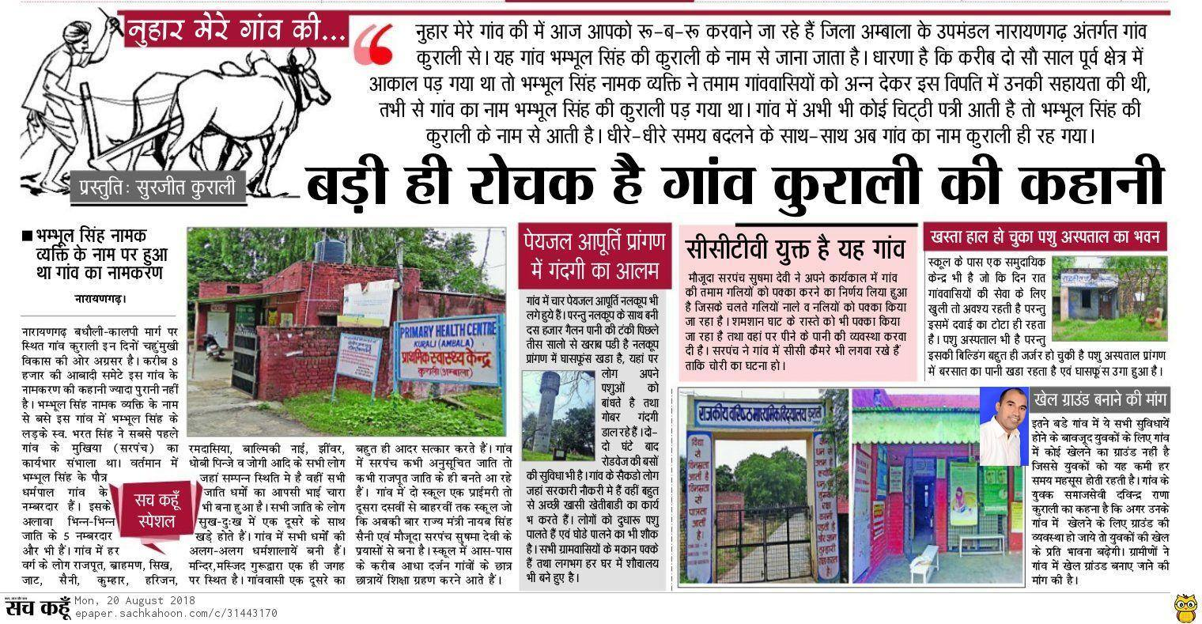
Demographics

Population: Kurali is a Village located in Ambala District of Haryana. As per the Census India 2011, Kurali Village has 770 households, population of 4,222 of which 2,278 are males and 1,944 are females. The population of children between ages 0 – 6 is 620, which is 14.68% of total population. The sex – ratio of Kurali Village is around 853 compared to 879, which is average of Haryana State. The literacy rate of Kurali is 71.4% out of which 76.53% males are literate and 65.38% females are literate. The total area of Kurali is 9 Km² with population density of 470 per Km².

Religion

Hinduism is the prominent religion of Kurali followed by 93.36% of the population. Sikhism is the second most popular religion in the city followed 4.64% of the people. In Kurali Islam is followed by 1.75% and those that didn't state a religion are 0.25%.

Languages

Hindi is the official language of Kurali. English and Punjabi are additional official languages. Government schools use English and Hindi Text Books.

“Animal Husbandry (Piglets)” is an integral part of the house hold economy of the region and there are certain house hold industries also, which substantially adds to house hold incomes. The past one and half decade has witnessed a tremendous upward swing in various development programmes giving a new thrust to the Punjab and Chandigarh Economy. Government Pig Breeding Farm Chhaju Majra is located at Village Chhaju Majra, 1 Km away from “Chandigarh – Ludhiana Highway” (near Nijjer Chowk). This Farm is made on 8 acres of land. The farm consists of 3 working sheds, having 65 sows, 14 boars and 155 piglets at present. The rear animals on dry feed and green fodder and the farm is based on the intensive farming system, having both open and closed area in sheds. The mission of this farm is to bring excellence in pig production, pig health and to generate employment and reduce poverty among socially and economically weaker section through the medium of pig husbandry.

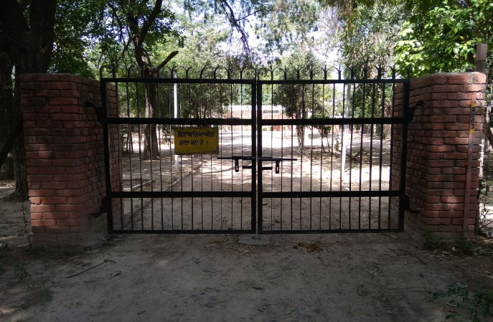 | 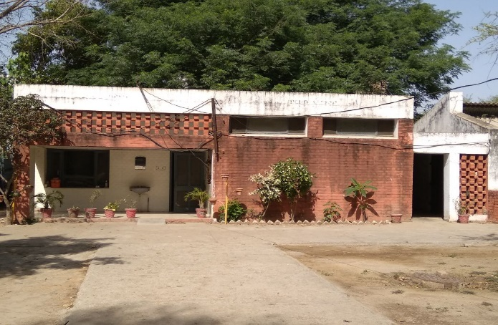
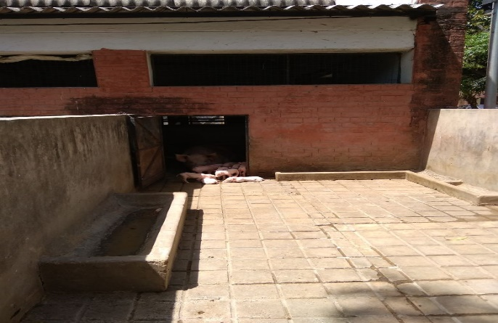 | 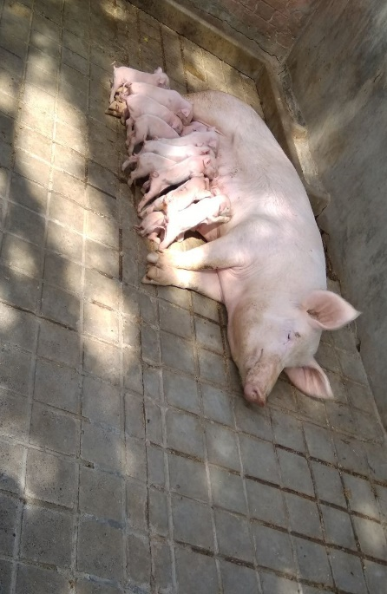
View Point at Kurali Chhaju Majra Village around 1 Km Away from Chandigarh – Ludhiana Highway (near Nijjer Chowk).

Providing necessary training to farmers every month at farm and help them in establishing piggery units. Accordingly train farmers about profitable and disease free pig farming, integrated farming system and motivate farmers in achieving household, nutritional and economic security. There is also sell piglets (approximately 2 months of age) to farmers at subsidy rate. This process has increased wage employment opportunities and though most of the inhabitants are basically agriculture, they have diversified into tertiary jobs such as Government Services.

Bharatmala Pariyojana

The development of any nation depends on the transportation networks and the ways in which they are being maintained. The same holds true for the development of a huge and populous nation like India. For connecting the areas and maintaining smooth flow of traffic, the construction of new and developed roads are a must. The same will be achieved with the implementation of the Bharatmala Project. Under the scheme, a host of new roads will be laid down in the nation.

Bharatmala Pariyojana is a new umbrella program for the highways sector that focuses on optimizing efficiency of freight and passenger movement across the country by bridging critical infrastructure gaps through effective interventions like development of Economic Corridors, Inter Corridors and Feeder Routes, National Corridor Efficiency Improvement, Border and International connectivity roads, Coastal and Port connectivity roads and “Green – Field Expressways”. A total of around 24,800 Kms are being considered in Phase – I. In addition, Phase – I also includes 10,000 Kms of balance road works under NHDP. Estimated outlay for Phase – I is ₹ 5, 35,000 crores spread over 5 years. The objective of the program is optimal resource allocation for a holistic highway development/ improvement initiative.

Bharatmala Pariyojana (Project): is a centrally – sponsored and funded Road and Highways project of the Government of India. The total investment for 83,677 Km (51,994 Mi) committed new highways is estimated at ₹ 5.35 lakh crore (US$ 75 Billion), making it the single largest outlay for a government road construction scheme (as of December 2017). The project will build highways from Gujarat, Rajasthan, Punjab, Haryana and then cover the entire string of Himalayan States – Jammu and Kashmir, Himachal Pradesh, Uttarakhand – and then portions of borders of Uttar Pradesh and Bihar alongside Terai, and move to West Bengal, Sikkim, Assam, Arunachal Pradesh, and right up to the Indo – Myanmar border in Manipur and Mizoram. Special emphasis will be given on providing connectivity to far – flung border and rural areas including the tribal and backward areas. Bharatmala Project will interconnect 550 District Headquarters (from current 300) through a minimum 4 – Lane highway by raising the number of corridors to 50 (from current 6) and move 80% freight traffic (40% currently) to National Highways by interconnecting 24 logistics parks, 66 “Inter – Corridors” (IC) of total 8,000 Km (5,000 Mi), 116 Feeder Routes (FR) of total 7,500/ Km (4,700 Mi) and 7 North East Multi – Modal Waterway Ports. The ambitious umbrella programme will subsume all existing Highway Projects including the flagship “National Highways Development Project” (NHDP), launched by the Atal Bihari Vajpayee Government in 1998.

Context: India's 54, 82,000 Km (3,406,000 Mi) road network is second largest in the world, of which only 2% (~1, 10, 000 Km) are “National Highways” (NHs) carrying 40% road traffic. Bharatmala Phase – I will raise the NH connection to a total of 80% or 550 districts out of total 716 districts from the current 42% or 300 districts connected to NH (December 2017). Mapping of Shortest Route for 12,000 routes carrying 90% of the India's freight, commodity – wise survey of freight movement across 600 Districts, automated traffic surveys over 1,500+ points across the country and satellite mapping of corridors to identify upgradation requirements for Bharatmala.

Impact: Bharatmala will significantly boost highway infrastructure:

- Raise 6 NC corridors to 50 corridors (6 NC and 44 EC);
- Raise 40% freight to 80% freight on National Highways;
- Raise 300 districts to 550 districts connected by minimum 4 – lane highways;

The Figure 3 Showing Index Map of Projected Road.

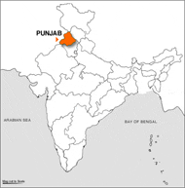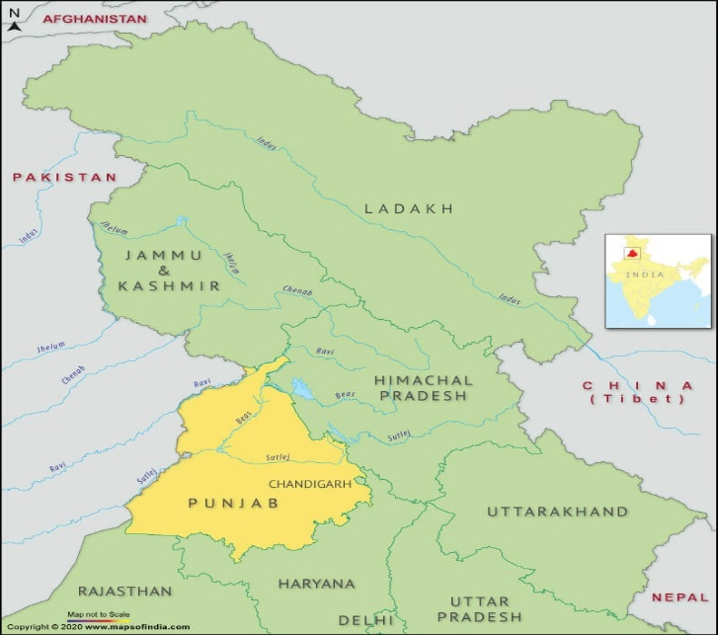

Figure 3: Index Map Showing Projected Road.

Chandigarh and Punjab Demographic Index

The “District Census Handbook” (DCHB) is an important publication of the Census Organization since 1951. It contains both Census and Non – Census data of urban and rural areas for each District. The Census data provide information on demographic and socioeconomic characteristics of population at the lowest administrative unit i.e., of each Village and Town and Ward of the District. A change takes place in administrative divisions of a State during the decade. Declassification, de – notification, merging and notification of new towns and outgrowths depends on the specified demographic and economic criteria. The Census of India 2011 is the 5th for Chandigarh (U. T.) after it came into existence. Since formation, Chandigarh has seen urban spread over the decades; it has one district and one tehsil only. No area/ urban unit in Chandigarh emerged as new Statutory Town in 2011 Census. Inclusion of new Census Towns shows that in 2001 Census these were villages and in 2011 Census while satisfying the demographic and economic criteria have been treated as Census Towns. They are dominant ethnic group in the state and the people from the plain mostly involved in trade and services represent a marginal group. The Digital Terrain Model (DTM)/ DEM Generation of Geo – Tiff – Format of Projected Road, Vetting/ Geology and Slope Stability by Environmental Team Experts is as shown in the Figure 4. As of 2011 India census, Chandigarh had a population of 1,055,450, making for a density of about 9,252 (7,900 in 2001) persons per Square Kilometre. Males constitute 55% of the population and females 45%. The sex ratio is 818 females for every 1,000 males. The child sex ratio is 880 females per thousand males. As of 2011 India census, Punjab had a population of 27,743,338 making for a density of about 550 (484 in 2001) persons per Square Kilometre. The overall density of population in the “Punjab and Chandigarh is 7,900 and 484 Km²” and population rank/ position is found to be 16th and 10th respectively. Figure 4: The Tentative Prototype – Paradigm – Digital Sample/ Example of Terrain Model (DTM)/ DEM Generation of Geo – Tiff – Format of IT City Chowk to Kurali Chandigarh (31.230 Km) Projected New Road at IT City Chowk Latitude of 30°36’58” (North) and Longitude of 76°41’37” (East); Kurali Chandigarh Latitude of 30°49’59” (North) and Longitude of 76°38’57” (East). Vetting/ Geology and Slope Stability are observed by Environmental Team Experts. (Part – I)

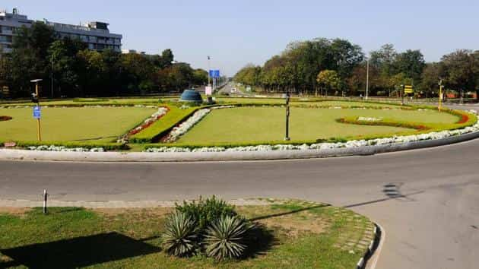

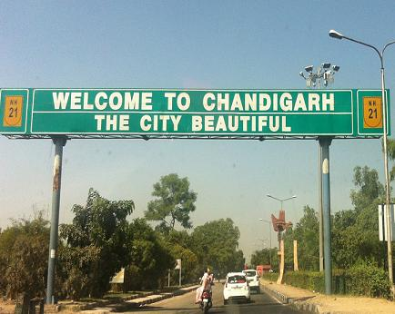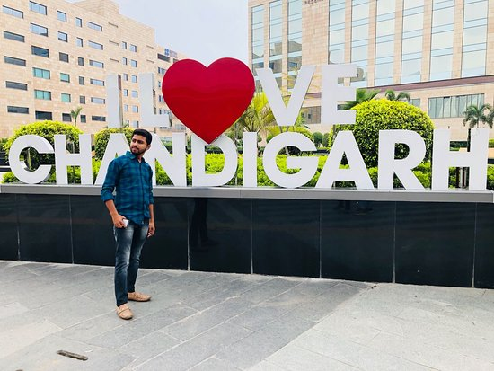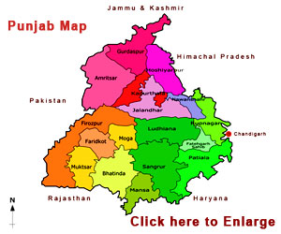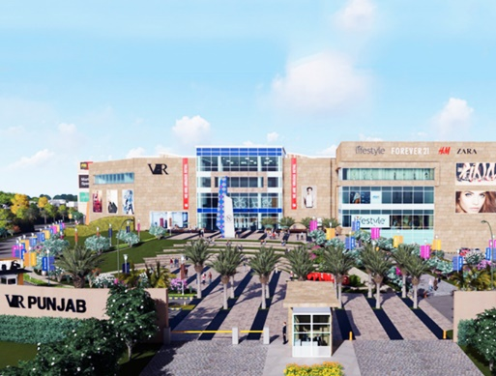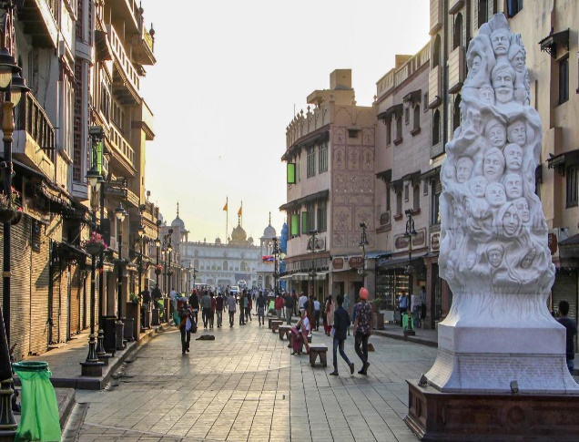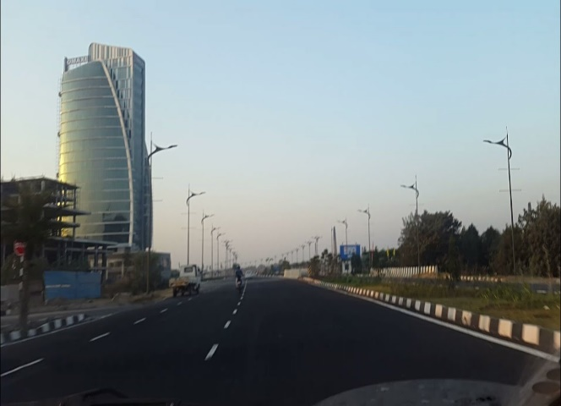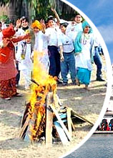
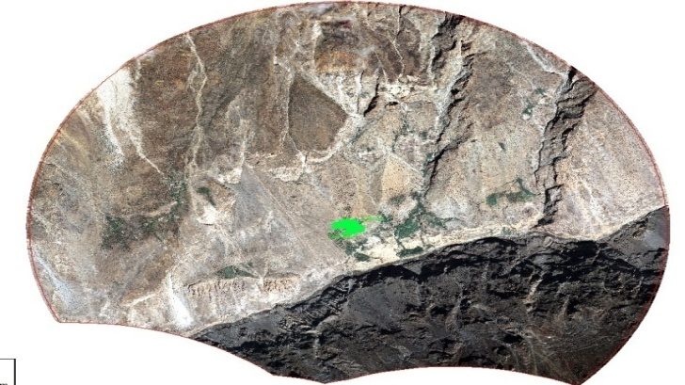 | 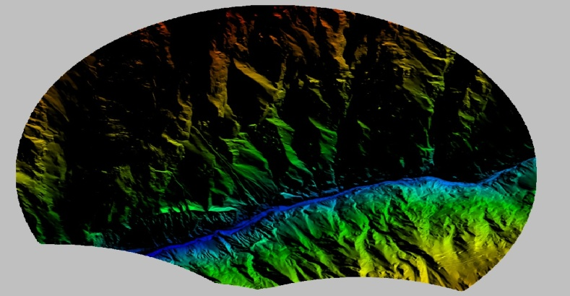
IT City Chowk to Kurali Chandigarh Road,  Village (UK) Area – 37.625 Sq. Km. Overview of the 50 cm GSD Ortho – photo. | The 5 m Grid DEM a Relief View (An Overview for the Whole Area of Interest).
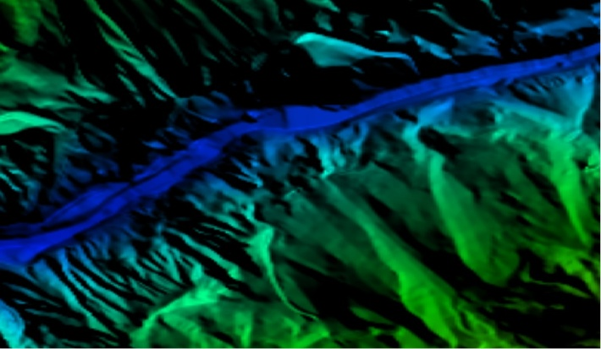 | 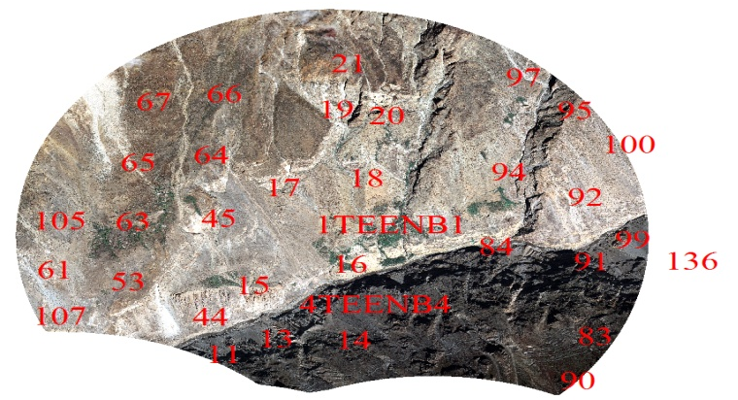
The DEM in Relief View for a Part of a River. | The Plan 3D Features Over the Ortho – photo an Overview.
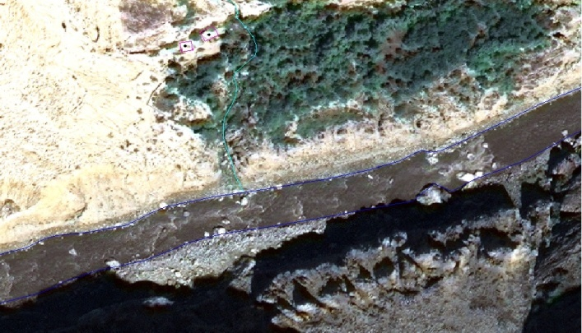 | 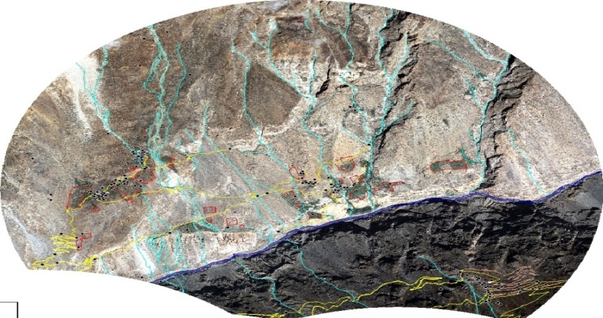
The Plan 3D Features – Part of a River; Roads and Buildings Plan Over the Ortho – photo. | Differences at Ground Scale between Measured and Adjusted Tie Photogrammetric Points.
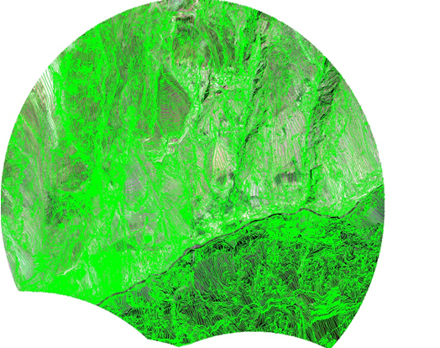
Compilation of Break Lines (A Line Portrays the Sudden Changes in the Elevation) and Mass Points Using Stereo Images.
State:  Name:  Total Length of the Road as per Remote Sensing:  Total Sq. Km. Area as per 5 Km Buffer Boundary: | Punjab  IT City Chowk to Kurali Chandigarh, Road (UT) Package – II  31.230 Km  37.625 Sq. Km.

Figure 4: The Tentative Prototype – Paradigm – Digital Sample/ Example of Digital Terrain Model (DTM)/ DEM Generation of Geo – Tiff – Format of IT City Chowk to Kurali Chandigarh Road, Village (31.230 Km) Projected New Road at IT City Chowk Latitude of 30°36’58” (North) and Longitude of 76°41’37” (East); Kurali Chandigarh Latitude of 30°49’59” (North) and Longitude of 76°38’57” (East). Vetting/ Geology and Slope Stability are observed by IIT Delhi/ Roorkee Team Experts. (Part – I)
Climatic Condition and Projection Index

The State has Five Seasons: Winter, Summer, Spring, Autumn, and a Monsoon Season between June and September. There is a straight line distance and so most of the time the actual travel distance between Kurali and Chandigarh may be higher or vary due to curvature of the road. The driving distance or the travel distance between Kurali to Chandigarh is 30 Km and 418 Meters. The Kurali lies on 301 m “Above Sea Level” (ASL). The climate here is mild and generally warm and temperate. Kurali is a city with a significant rainfall and the average annual temperature in Kurali is 24.2°C | 75.6°F. The annual rainfall is 922 mm | 36.3 inch. In current weather report with temperature, feels like, air quality, humidity, UV report and pollen forecast from TheWeatherNetwork.com. Chandigarh has a humid subtropical climate (Köppen: Cwa) characterized by a seasonal rhythm: very hot summers, mild winters, unreliable rainfall and great variation in temperature (−1°C to 46°C OR 30.2°F to 114°F). The average annual rainfall is 1110.7 mm and temperatures generally varies in between 40°C and 42°C. Punjab is one of the coldest regions in India with an average daily high temperature of only 30°C. Several months of the year it is warm to hot at temperatures continuously above 25°C, sometimes up to 40°C. Due to the warmer temperatures the best time for traveling is in May. “Fog affects many parts of the state during winter and the monsoons, making transportation perilous and precarious”.

Temperature Profile Index

Change is a feature of earth’s climate, but faster rate of change due to increased human interference is a great concern to all. According to a report of the “Intergovernmental Panel on Climate Change” (IPCC 2007a), the average rise in surface temperature in the past 100 years (1906 to 2005) was 0.74°C, but the rate of warming in the last part of 50 years (1956 – 2005) was little higher (0.13°C/ decade) than the rate of warming in the first part of 50 years (0.07°C/ decade). Global warming refers to continuing rise in the average temperature of the Earth’s atmosphere. The high maximum temperature and longer duration of sunshine during January – February may hasten maturity of crops like mustard or affect the yield of late maturing varieties.

Temperature: The average annual maximum temperature since 1981 – 2010 did not show any significant increase or decrease during the past 30 years, which is a good sign of “Environment Stability” (ES). Whereas, the average annual minimum temperature have increased 1.95°C in the past 30 years from 1981 – 2010 (or 0.06°C increase/ year) which is a matter of concern. Further, the rate of increase in the mean minimum temperature during 1991 – 2000 to 2001 – 2010 was greater i.e., 0.81°C/ decade or 0.08°C increase/ year. Increasing minimum temperature during October and November may affect germination of Rabi crops like wheat and barley. Various prediction models on global warming indicate that the global surface temperature, by the year 2030, would increase somewhere between 1.5°C and 4.5°C with an average of 3°C (WHO 1990 and IPCC 1990). This increase would be most marked in the high latitudes as well as in high altitudes. Small changes in temperature in the high altitude belt would affect drinking water supply and plant growth. Therefore, meteorological observatories may be set up at the high altitudes of Punjab so as to monitor changes in weather elements as well as to enable precautionary measures. There is an average of 46.8 days of precipitation, with the most precipitation occurring in August with 11.9 days and the least precipitation occurring in November with 0.6 days in the Table 2.

Table 2: Climate Data for Chandigarh (1961 – 1990, Extremes 1954 – 2010).

Month | Jan | Feb | Mar | Apr | May | Jun | Jul | Aug | Sep | Oct | Nov | Dec | Year
Record High °C (°F) | 27.7  (81.9) | 32.8  (91.0) | 37.8  (100.0) | 42.6  (108.7) | 44.6  (112.3) | 45.3  (113.5) | 42.0  (107.6) | 39.0  (102.2) | 37.5  (99.5) | 37.0  (98.6) | 34.0  (93.2) | 28.5  (83.3) | 45.6  (114.1)
Average High °C (°F) | 20.5  (68.9) | 23.0  (73.4) | 28.4  (83.1) | 34.6  (94.3) | 38.3  (100.9) | 38.3  (100.9) | 34.1  (93.4) | 32.8  (91.0) | 33.3  (91.9) | 32.3  (90.1) | 27.4  (81.3) | 21.9  (71.4) | 30.4  (86.7)
Average Low °C (°F) | 5.5  (41.9) | 8.1  (46.6) | 13.0  (55.4) | 18.8  (65.8) | 23.0  (73.4) | 24.9  (76.8) | 23.7  (74.7) | 23.2  (73.8) | 21.7  (71.1) | 17.2  (63.0) | 10.6  (51.1) | 6.4  (43.5) | 16.3  (61.3)
Record Low °C (°F) | 0.0  (32.0) | 0.0  (32.0) | 4.2  (39.6) | 7.8  (46.0) | 13.4  (56.1) | 14.8  (58.6) | 14.2  (57.6) | 17.2  (63.0) | 14.3  (57.7) | 9.4  (48.9) | 3.7  (38.7) | 0.0  (32.0) | 0.0  (32.0)
Average Rainfall mm (inches) | 43.3  (1.70) | 44.2  (1.74) | 30.5  (1.20) | 11.7  (0.46) | 28.9  (1.14) | 131.8  (5.19) | 278.1  (10.95) | 289.0  (11.38) | 158.2  (6.23) | 22.8  (0.90) | 6.4  (0.25) | 19.2  (0.76) | 1,064.1  (41.89)
Average Rainy Days | 2.8 | 2.7 | 2.0 | 0.8 | 1.6 | 5.5 | 10.8 | 10.9 | 4.8 | 1.4 | 0.8 | 1.4 | 45.5
Average Relative Humidity (%) (at 17:30 IST) | 47 | 42 | 34 | 23 | 23 | 39 | 62 | 70 | 59 | 40 | 40 | 46 | 44
Source: India Meteorological Department Weather Base;

CHADIGARH AND PUNJAB STRATEGIES FOR MITIGATING POSSIBLE IMPACT OF CLIMATE CHANGE ON AGRICULTURE

CHANDIGARH: While the “Global Climate Change” is “Expected” to reduce production of rice in Punjab and Haryana, at the same time it is likely to increase potato output in the two states. The committee noted that studies indicate that “Changing Climate” will decrease yields in “Major Crops” like wheat, rice and maize. “Union Territory” (UT) of Chandigarh being an urban conglomerate with adjoining states with urban centers faces a different threat than the rest of India. Chandigarh, described as “The City Beautiful” is well planned city for comfortable living, built primarily to provide the best amenities. Today Chandigarh has grown beyond expectations in terms of the populations and therefore, the problems also grew at the same proportions. Chandigarh enjoys the picturesque locale with “Shivalik Hills and Wonderful Climate”, endowed with various natural habitats and many manmade parks. Fortunately, the city also has less number of polluting industries. The domestic electricity consumption and petroleum usage for personal transport is higher in Chandigarh than many other states and therefore, the emission from domestic electricity consumption and transport is high. Given that its area is confined to 114 Km², (and 25.42 Km² as Sukhna Wild Life Sanctuary) there is no land area that can be allocated for alternative uses except rooftops. Chandigarh has excellent educational and health facilities. The growth of service industry has been remarkable in IT field. This makes the city Chandigarh a fast developing Union Territory. Furthermore, this growth pattern has increased the pressure from the neighboring states for various infrastructures such as educational institutions, hospitals and other recreational opportunities. This is letting the city beautiful with increased slums, increased traffic congestions and increased population. Thus, Chandigarh experiences a typical urban problem and the climate change action plan is to be addressing both adaptation and mitigation with equal priority.

The Vision: Based on the vision of “Le Corbusier” while building Chandigarh, the new master plan builds on accommodating the new and emerging demands and pressures maintaining the quality of life and its urban fabric while rectifying some aberrations. In line with global development on climate change the Chandigarh will strive to reduce urban carbon foot print. Chandigarh will strive to become a model for sustainable water management, use of renewable sources of energy, and protecting the local ecology and environment. The master plan also strives to reduce private vehicle use and increase public transport. As part of the Mission for Sustainable Habitat and Green Code, Chandigarh has been developing Solar City concept to harness solar energy to meet the requirements of power. In addition to address the issue of mitigation of GHG emission from municipal waste, appropriate actions are required through adoption of scientific waste management systems with options for recovery of wealth from waste, i.e., compost and energy recovery from solid waste. Improved waste management will not only provide significant GHG mitigation but will also improve public health and environment quality. Some of the frameworks for low carbon urban plan for UT Chandigarh are to build pedestrian city, introducing bicycles as a mode of transport, reducing vehicular congestion, creating awareness among public on various climate change concerns, developing integrated waste management systems and developing a comprehensive mobility plan to reduce GHG emissions and provide clean habitations for citizens of UT Chandigarh. A participatory process was followed for drafting the UT Chandigarh Climate Change Action Plan. There are many challenges ahead for India to combat impacts of climate change particularly on the natural resources and livelihoods.

Implementation of the Action Plan: The action plan will be guided and implemented by the Climate Change Advisory committee in coordination with various departments. However, the two major impacts that may cause concern to are the impact of climate change on built up environment and energy production patterns. UT Chandigarh Authorities should aim using less energy and opt for renewable energy to reduce dependence on petroleum based energy products. Overall, it appears that UT Chandigarh may not experience any major impacts due to climate change. Sustainable habitat mission in Chandigarh is the most important to combat climate change. Some of the reducing energy consumption option in the buildings and low carbon lifestyle need to be implemented as a measure of adaptation to climate change. Successful climate change management calls for a new development paradigm that integrates climate change into strategies and plans and that links policy setting with the financing of solutions. The focus of the mission is to create awareness, monitor progress and coordinate among various missions to share knowledge and implement the action plan towards combating impacts of climate change. A centre will be created to deal with strategic knowledge management towards climate change involving various institutions and reputed individuals in the respective areas (Table 3). The strategies aspires to the guide the way forward for various departments to integrate and mainstream the climate change concerns in the schemes, projects, programmes, missions and policies to make UT Chandigarh a resilient state to handle the challenges and risks of climate change by making its population to help mitigate carbon emissions and adapt to climate change through low carbon development pathway.

Table 3: Estimated Gross Expenses under Various Sectors for UT Chandigarh Climate Change Action Plan.

Sr. No. | Sectorwise Missions and Assignments | Funds Required in Crores (₹/ Rs.)
1. | Green India Mission including Agriculture, Animal Husbandry and Horticulture etc. | 58.75
2. | Energy Sector (involving Solar, Electricity and Transportation Network). | 1,714.49
3. | Water Sector Setup and Network Operation and Undertaking. | 51.76
4. | Sustainable Habitat Mission (including Health, Waste Management, Comprehensive Mobility and Biomedical Sector). | 15,641.00
5. | Knowledge Management Mission and Assignments. | 1.54
 | Total | 17,467.54

Heat Waves and Human Health: Climate change is expected to increase relative stress on human health, water resources due to the decline in rainfall, with impact on water availability (per capita water availability is expected to decrease from 1820 m³/ yr in 2001 to 1140 m³/ yr in 2050) and agriculture/ food security (60% of crop area in India is under rain – fed agriculture). They focus on promoting understanding of climate change, adaptation and mitigation, energy efficiency and natural resource conservation. Climate change concerns needs to be internalized into the policy and development planning of UT Chandigarh. Climate change impacts all walks of life and therefore the policy instruments and implementation strategies should be addressed through various sectors such as water, forests, habitats, energy, disaster risk reduction and knowledge management. This necessitates the development of a climate response strategy should be a multi – disciplinary approach with ample vertical and horizontal linkages and feedbacks across sectors, systems and people. Therefore the actions aimed at addressing climate change should not be viewed in isolation and should be an integral part of development planning, action and execution. In the context of UT Chandigarh, and “Right to Develop” (RTD) aspirations of developing societies it is important to pursue both mitigation and adaptation measures to combat climate change, considering the overall socio – economic and ecological contexts and vulnerabilities, it would be of high importance to focus on adaptation options including “Disaster Risk Reduction” (DRR). Plan to implement risk reduction of impacts of climate change through Knowledge management and with climate change, there would be increasing scarcity of water, reduction in yields of forest biomass, and increased risks to human health with children, women and the elderly in a household becoming the most vulnerable. The vegetation grids near Chandigarh such as Panchkula did not show any change due to climate change impacts. Likely Impacts of Climate Change on Agriculture projects that with short periods of exposure of wheat crops to temperatures of 28°C to 32°C result in significant decrease in yield by 20% or more. In addition to climate change adaptation, soil organic carbon and organic cultivation improves the soil water retention capacity and improves crop yield.

One of the most important contributions of livestock on “Climate Change” is enteric “Methane” (CH₄) production, which has 23 times more “Global Warming Potential” than “Carbon Dioxide” (CO₂). Several strategies have been developed to combat climate change to reduce ground water use, reduce water use and to improve infiltration of storm water in the union territory. In addition, the Mission will address the need to adapt to future climate change by improving the resilience of infrastructure, community based disaster management, and measures for improving the warning system for extreme weather events. “Climate Change” poses a serious threat to development and poverty reduction in the poorest and most vulnerable regions of the world. “Impact of Climate Change” on various sectors will alter the distribution and quality of natural resources and adversely affect the livelihood of the people dependent on the respective resources. Prepare and upgrade environmental status reports with special emphasis on climate change. Develop effective and low cost technology for pollution control. Conduct EIA of development projects critical to climate change i.e., power, housing, cement etc. Create climate change related databases and identify responses to climate change. This indicates that Chandigarh may experience frequent cold and hot waves due to climate change impacting on the health of inhabitants of Chandigarh City.
Extra Widening/ Improvement Index

- The Project road is proposed as two lanes with shoulder, drain, and extra widening (7.0 m + 2 × 0.9 m + 0.6 m + 0.6 m) as shown in the Table 4.

Table 4: Extra Widening/ Improvement and Land Acquisition Index.

Sr. No. | Feature | Description
1. | Extra Widening/ Land Acquisition  (7.0 m + 2 × 0.9 m + 0.6 m + 0.6 m) | 24 m Wide Strip of Land is Required

The aim of reconnaissance survey was to assess the scope of land acquisition and resettlement study and accordingly the detailed plan of action was prepared for the preparation of land acquisition planning and resettlement plan. The transparent process for land acquisition for industrialization, development of essential infrastructural facilities and urbanization with the least disturbance to the owners of the land and other affected families and provide just fair compensation to the affected families whose land has been acquired or proposed to be acquired or are affected by such acquisition and make adequate provisions for such affected persons for their rehabilitation and resettlement and for ensuring that the cumulative outcome of compulsory acquisition should be that affected persons become partners in development leading to an improvement in their post – acquisition social and economic status and for matters connected therewith or incidental thereto.

Methodology for Social Impact Assessment

Project Road if traverses through hilly/ mountainous and steepas well as plain terrain. The proposed alignment improvement design is based on various parameters. The design principles for alignment selection have been evolved based on discussions with the expertise in Highway Engineers, Bridge Design Specialists, Environmentalist, Transport and other key personnel. The selection of the alignment is broadly based on the following criteria:

- Technical soundness and economic viability;
- Least social and environmental adverse impact;
- Least displacements and loss of public property;
- Avoiding adverse impact to water bodies and other environmental features;
- Locations of required causeways;

3. PROJECT DESCRIPTION AND ALIGNMENT

Features of Proposed Projected Highway Description: The Project Section of IT City Chowk to Kurali Chandigarh, Road is located in the State of Punjab length as per topography survey is 31.230 Km as per design. The alignment of the project road is connecting IT City Chowk (Defence Check Post) and Kurali Chandigarh. The land use pattern of 10 Km either side of the project alignment is mainly agricultural and human habitation, besides some Forest areas (Roadside Plantations declared as Forest). Project section is passes through 1 No. of districts namely; S. A. S. Nagar Extent of the alignment length (from Km 00 + 000 to Km 31 + 230) across the districts is presented in Table 5 below. The project road IT City Chowk to Kurali Chandigarh having length of 31.230 Km and the project stretch is traversing in hilly terrain from IT City Chowk at (30°36’58” N Latitude and 76°41’37” E Longitudes) and Ends at Kurali Chandigarh Road (30°49’59” N Latitude and 76°38’57” E Longitudes) in the State of Punjab. “The Proposed designed alignment/ corridor between these stations comes out to be from 00 + 000 Km to 31 + 230 Km”.

Table 5: List of Districts and Talukas along the Projected Highway.

Sr. No. | Name of District | Name of Taluka | Approx. Length in Km
1. | S. A. S. Nagar, Mohali | Mohali | 00.000 to 31.230
 |  | Kharar

- The Existing Alignment of IT City Chowk to Kurali Chandigarh, Road is Newly Declared as NH/ SH; is connecting to Newly Declare Road. The Total Existing Length of the Projected Road is approximately 31.230 Km.
- The Actual Design Length of the Project Road is around 31.230 Km.
- The project road section between IT City Chowk to Kurali Chandigarh, Road has been divided into following homogeneous section in the Table 6:

Report Purpose

- To Identify Existing Traffic Data in the Region/ State;
- To Describe New Data Collection Requirements;
- To Presents the Findings of Data Collection Undertaken;
- To Determine if the Data Collection is Fit for Use;

Table 6: The Inventory of IT City Chowk to Kurali Chandigarh Project Road.

ROAD INVENTORY
Road Name: IT City Chowk to Kurali Chandigarh
Section : From Km 00 + 000 To 31 + 230 Km. |  |  |  |  |  |  |  |  |  |  | District: East Punjab
Chainage |  | Type of Terrain | Land Use Pattern | Name of Village/ Town | Right of Way (m) | Roadway Width (m) | Carriageway |  |  | Shoulders |  |  | Average Height of Embankment or Depth of Cutting (m) | Road Side Drainage |  | Service Road, If Any | Details of Cross Roads |  |  | Remarks
Km | Km |  |  |  |  |  | Type | Width (m) | Condition | Type |  | Width (m) |  | Exists (F/ NF) | Does not Exist |  | Location | Destination | C/W (m)
00 + 000 | 31 + 230 | Hilly Terrain | Barren and No Use of Forest Land | IT City Chowk to Kurali Chandigarh | Right of Way = 24 m | 24 m (7.0 m + 2 × 0.9 m + 0.6 m + 0.6 m) | Dense Bituminous Macadam and Bituminous Concrete | Width = 5.5 m | Very Good; But Not Found Horrific OR Dreadful | Unpaved Shoulders |  | Width = 2 × 1.25 m (7.0 m + 2 × 0.9 m + 0.6 m + 0.6 m) | Cutting = 3.75 m to 5.5 m | As per Design (Not Final) | Drainage Road Area Network Association | Kurali Chandigarh – IT City Chowk – IT City Chowk | IT City Chowk, Punjab | IT City Chowk to Kurali Chandigarh, Punjab | C/ W Width – Varying = b/ w 7 m | Foot Track

- The Existing road Starts from 00 + 000 Km IT City Chowk Village of Latitude and Longitude (30°36’58” N Latitude and 76°41’37” E Longitudes) and the road Terminates at 31 + 230 Km of Kurali Chandigarh Village with Latitude and Longitude (30°49’59” N Latitude and 76°38’57” E Longitudes). The Project Road IT City Chowk to Kurali Chandigarh is situated in the State of Punjab. Project corridor is from Km 00 + 000 to Km 31 + 230.

- The consultancy services for the same is to include design of best possible alignment and pavement composition, design of bridges, culverts and other structures in addition to analysis of costs, determining project feasibility, preparation of “Land – Acquisition – Plan” (LAP), if applicable in any area, and obtaining of all requisite clearances as per need or suitability in the projected areas.

- The index map illustrates the “Approved Project Alignment of IT City Chowk to Kurali Chandigarh Road Projected” are presented in the Figure 5 below:

Figure 5: Approved Project Alignment of IT City Chowk to Kurali Chandigarh Road Projected as per Inception Report by Environmental Team Experts.

Meticulous/ Particular TOR for Satellite Imagery

The coordinates of the origin and destination points of the proposed roads provided in the TOR were tentative. These have been checked on ground by us in concurrence of ITBP posts at the particular stations by GPS to ensure the accuracy of the coordinates.

4. OBJECTIVE OF CONSULTANCY SERVICES

Objective of Consultancy Services: The main objectives of the consultancy services are to prepare “Initial Environmental Examination” (IEE)/ DPR Report and bid documents for the length of “31.230 Km of IT City Chowk to Kurali Chandigarh Road” and to establish the techno, economical, viability of the project and prepare detailed project reports for design of roads and bridges. An important requirement with regard to improving the Project Road is that the development of work shall be within the “Right of Way” (ROW) of “24 Meters” and avoiding additional land acquisition as far as possible. All these means that the development schemes for the Project Road should be as economical as possible consistent with the functional requirements and that it should amenable for quick implementation without delays.

To serve the environmental aspects and adopt good “Road Construction Practices” (Sustainable Environmental Development Practices) under this project are being considered. The present research methodology aims to use the waste of some industries like polypropylene, polyester (as waste of backing and carpet industries respectively) in the preparation of a special type of asphalt to be used in the production of “Hot Mix Asphalt” (HMA) for roads, bridges, structures and dams construction during the civil work. The solid materials in paving mix were low quality aggregates of high absorptive type and waste marble filler with the final objective to provide added value, to reduce the production costs and keep the virgin solid materials especially aggregates for a longer period of time. The produced mixes are of similar or of better performance compared to the conventional asphalt mixtures. And there is an urgent need to address the great challenges of our times: climate change, resource depletion, pollution, and peak oil. These issues are all accelerating rapidly, and all have strong links with the road as well as building industry as shown below in Project Execution Objectives and Decision Making Work – Life Cycle (Figure 6).

- Ground Control Point Survey by using “Differential Global Positioning System” (DGPS);
- Procurement of 0.5 m Resolution of Satellite Imagery from “National Remote Sensing Centre” (NRSC), Hyderabad, India;
- Development of “Geographical Information System” (GIS) Layers and “Digital Elevation Model” (DEM) of Finalized Alignment of Border Roads;
- Contours Creation at 2.5 m Interval;
- Ortho – photo Generation at 0.5 m “Ground Sample Distance” (GSD);

Major Tasks and Scope of Consultancy Services

- Engineering Surveys and Investigations

- Topographic Surveys;
- Hydraulic and Hydrological Investigations;
- Traffic Surveys;
- Material Investigations;

- Engineering Designs

- Geometric Designs;
- Pavement and Road Designs;
- Design of Bridge and Structures;
- Drainage Designs;

- Project Cost Estimations

- Detailed Project Report; “Initial Environmental Examination” and Bid Documents

- General Topographical Features of the Area/ Region/ State

- Proposed Drainage Facilities/ Structures of the Area/ Region/ State

- Establishing the Most Suitable Alignment of the Projected Road;

- Minimal Adverse/ Unfavourable/ Unpleasant Impact on the Surrounding Environment.

HAMARA SANDESH…!!! HARA BHARA “PUNJAB” PRADESH…!!!

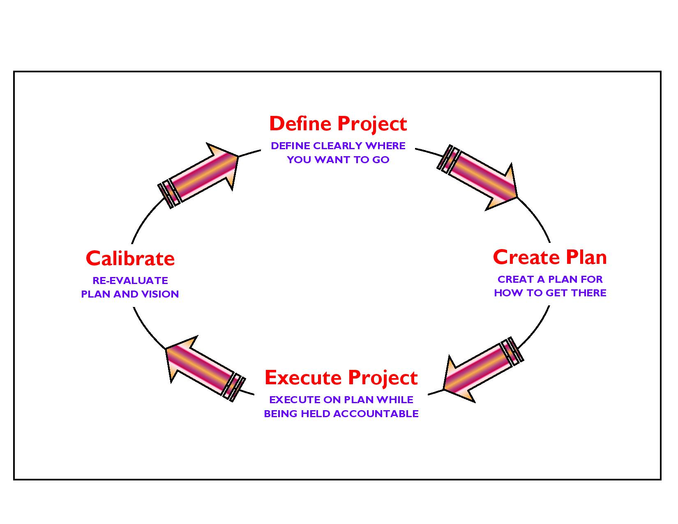
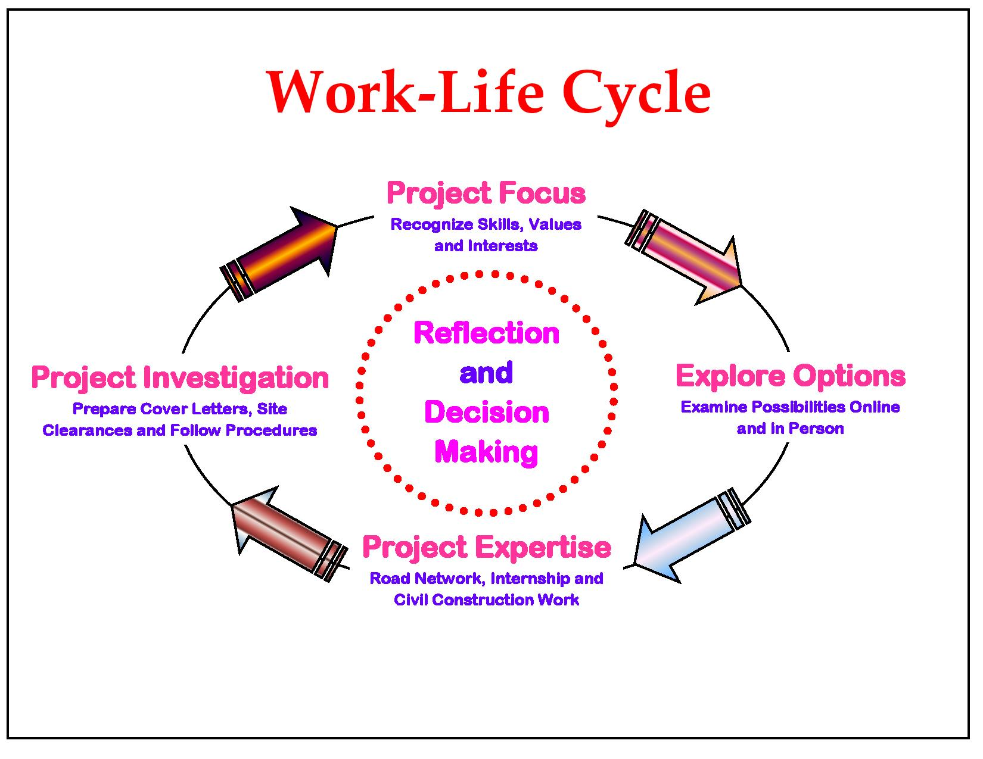

Figure 6: Project Execution Objectives and Decision Making Work – Life Cycle.

There is a growing consensus from scientists and the industry that, we are going to reach peak for construction in the next twenty years, and that we might have reached this point already. Global demand is soaring, whilst global production is declining, and oil is set to become increasingly expensive and scarce. The road and building industry is hugely dependent on cheap resources from the manufacture and transportation of its materials, to the machinery and tools used in demolition and construction. Not only in India, but also in other countries, they use vast quantities of fossil fuels, accounting for over half of total carbon emissions that lead to increase in temperature, global warming and climate change. The built environment is also responsible for significant amounts of air, soil and water pollution, and millions of tons of landfill waste and this is a situation that clearly needs to change. Strategic value of these always occur, because our roads, belongs to some very important and informative objectives, which makes our country strong against another country as whole around the “World OR Globe OR Precious Earth Sphere”.

5. PROPOSED APPROACH AND METHODOLOGY: Eco – Friendly OR Environmental Friendly Road Construction Methods and Materials

General Approach: The general approach of the Consultants would be to comprehensively address the various issues involved in the project, to carry out all the field and design office activities as set out in the Scope of Services of the “Term of Reference” (TOR) and finally to develop improvement proposals satisfying the objectives of the project.

Methodology: The project involves a series of inter – related activities, both in the field and in the design office. Methodology for carrying out these activities is described in the following paragraphs.

Zone Influence Factor

“Zone Influence Factors” (ZIF) can be explained as the relative contributions of various zones to trip generation. The ZIF are calculated as follows in the Equation (1) and Table (7):

$${ZIF}_{ i}=\frac{{O }_{i} + {D }_{i}}{2 × \sum_{ i = 1, n, j = 1, n}{{ T}_{ij}}}$$ | …Equation (1)

Where,

ZIF _{i} is the Zone Influence Factor of Zone i;
O _{i} is the Number of Trip Productions from Zone i;
D _{i} is the Number of Trip Attractions from Zone i;
T _{ij} is the Number of Trips between Zones i and j;

Table 7: Zone Influence Factor at Chainage 00 + 000 Km and 31 + 230 Km.

Sr. No. | Zone Description | Passengers Vehicles |  |  | Goods Vehicles
 |  | Trip Production | Trip Attraction | ZIF (%) | Trip Production | Trip Attraction | ZIF (%)
1. | IT City Chowk to Kurali Chandigarh Roads | 3 | 6 | 5.11 | 1 | 5 | 4.92
Total |  | 3 | 6 | 100.00 | 1 | 5 | 100.00

Topographical Surveys: The topographical surveys by means of “Global Positioning System” (GPS), for fixing of ground control points for the entire length of the corridor. Further, the survey has been completed with the 0.5 m high resolution satellite imagery.

Soil and Material Investigations: Prospective sources of construction materials have been located by the Consultants to add in list of sources of materials. To estimate the quantities of available suitable materials; the Consultants have prepared quarry/ material source charts including lead distances etc. This shall form an input in Rate Analysis of borrow/ quarry materials, following which recommendations for the use of the materials from different sources can be made. Material investigation done for engineering properties reveals that the material available at site is fit for use in protection, drainage and surfacing works aggregate and no quarry outside the site is required. The material can be used for crust layer execution by processing the available material by stone crusher and rotary screen. Only local transportation is the need for transporting the aggregates for preparation of bituminous mix preparation and laying at respective chainages.

For the completion of this environmental report the data was collected from different sources including government department and our DPR as well as “Initial Environmental Examination” (IEE) “Report, Expert/ Specialist Team”. The main aim of this report is to produce a smart; innovative/ informative/ adaptive/ applicable guideline for good construction practices. Eco – friendly design methodologies and technologies can further reduce energy consumption by minimizing energy inputs for heating, cooling and light, and incorporating energy efficient appliances and applications. Saving energy for the occupant also saves money – an issue that will become increasingly important as the cost of fossil fuels and materials for road, bridges, and structure are used inevitably rises in the near future. High absorptive aggregate and waste polymer must play a very important role in road paving to decrease the cost of construction and maintenance. With the inevitability of declining fossil fuels, and the threat of global climate change, reducing our energy consumption is an essential survival strategy. “Choosing to Build – Green...!!! And Go – Green...!!! To Save Energy Consumptions and its Valuable Resources to Achieve Significant Prospective Goals in the Projected Area Study”. The low embodied energy of green products ensures that very little energy went into their manufacture and production, with a direct reduction in carbon emissions. The best modifier of asphalt must contain high percentages of Iso and Cyclo – Paraffins and lower percentage of asphaltenes similar to asphalt composition itself and the waste polymer from other industries can be used in future work.

The report mainly contains environmental points regarding different stages of the Designing; Construction and Operational Phases like three as depicted below for IT City Chowk to Kurali Chandigarh Road, which is situated in the Northern part of Punjab to achieve projected goals and mainly these are in:

- Designing Phase;
- Construction Phase;
- Operational Phase.

Bitumen, as a residue from crude oil distillation, is the complex mixture of four main families of compounds, referred to as “SARA” Fractions (Saturates, Aromatics, Resins and Asphaltenes). The behaviour of bitumen depended on the relative concentration and the chemical features of asphaltenes and maltenes; thus, variation in its composition strongly affects its mechanical properties. Methodological Perspective Over – View of Road Date Base Construction Photographs is given in Figure 7.

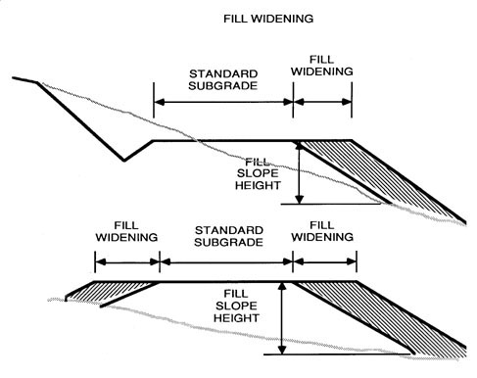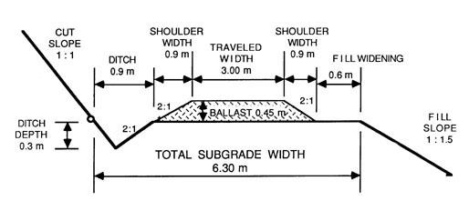
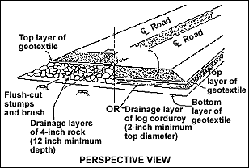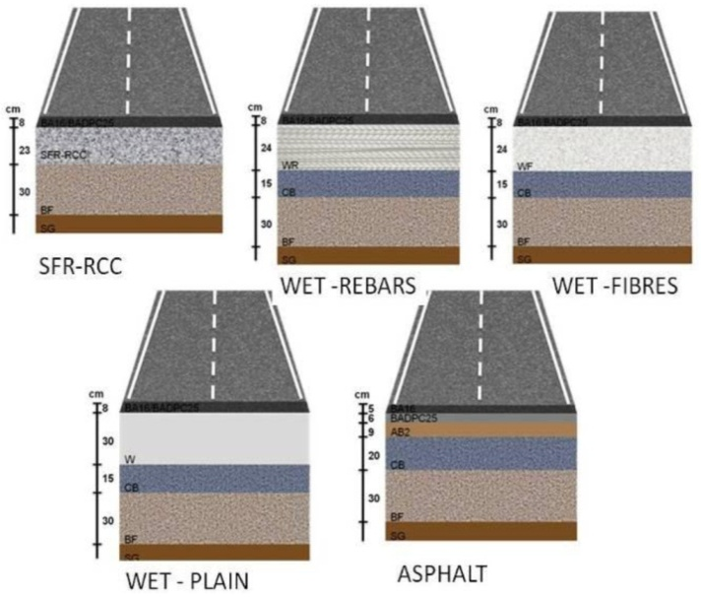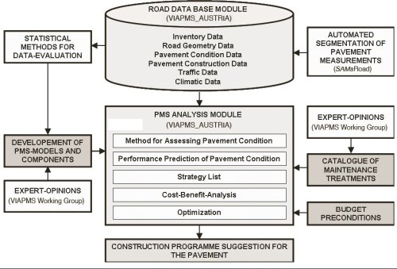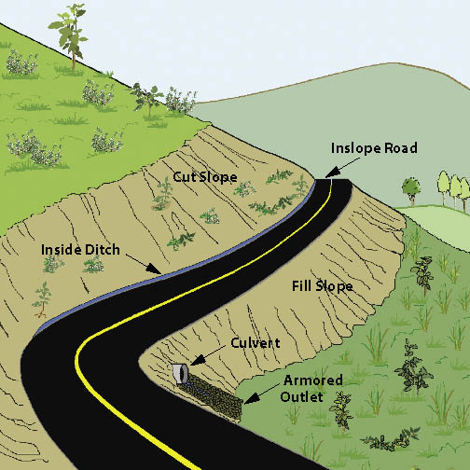

Figure 7: Methodological Perspective Over – View of Road Date Base Construction Photographs.

It presents a large set of interesting potential properties: impermeability, ductility, adhesivity and resistance to the effect of weathering and chemicals, etc. In the last 20 years, a wide spectrum of modifying polymeric materials has been tested with bitumens for their use in road construction. For a polymer to be effective it must blend with bitumen and improve its resistance at high temperatures without making the bitumen too viscous at mixing temperatures or too brittle at low temperatures. It should be capable of being processed by conventional equipment, available, not expensive and physically and chemically stable during storage, application and service. In actual modified bitumens, thermoplastic rubbers, as well as some thermoplastic polymers, were mainly used. The use of secondary (recycled) aggregates, instead of primary (virgin) materials helped in easing landfill pressures, reducing the need for extraction, protecting environment and minimizing the consumption of original resources. Polyester polymer, thermoplastic “Poly – Ethylene Tere – phthalate” (PET) and mineral fibres are the additives, which are mostly used to produce strong and durable reinforcement bitumen. Also, different industrial wastes such as waste polymers, spent toner, marble quarry waste and fibres ...etc. can be used as asphalt modifiers for civil construction work. Carpet waste fibres were used recently in asphalt mixtures and in “Fibre Reinforced Concrete” (FRC). Such reinforcement improved effectively the shatter resistance, toughness, and ductility of concrete. One of the major waste generating industries is the construction and marble production, and, it was reported that the potentials to use this type of waste in low to medium traffic urban as well as rural areas roads and as binder courses were very beneficial. There are some literatures that discussed the use of fillers such as limestone powders, rubber silica and carbon black as modifiers for asphalt mixture. In Egypt, the use of waste materials in HMA is not applied yet, in addition to the presence of a large amount of low quality aggregate not suitable for use in paving or other purposes.

Preparation of Hot Mix Asphalt and Properties

Hot mix asphalt samples were prepared using virgin asphalt and modified binders and were evaluated using the “Marshall Test Method” (ASTM: D – 6927). The mixes were designed according to the standard limits of surface (wearing) course. The job mix was formulated (% Wt.) using coarse and fine aggregates, sand and filler as 33, 30, 32 and 5 Wt. %, respectively. The mixes were tested for maximum load and flow along with density and air voids in mixes and solid materials were determined.

- HMA are hot mixes asphalt consisted of normal absorptive aggregate type, primary (virgin) asphalt samples and limestone filler;
- HMA are hot mixes asphalt consisted of high absorptive aggregate type, virgin (primary) asphalt samples and limestone filler;
- HMA are hot mixes asphalt consisted of high absorptive aggregate type, marble dust, modified asphalt through using 5% of waste polypropylene and waste polyester respectively.

Conclusion and Recommendation

This research aimed to prepare and use special types of HMA consisting of unordinary materials with the final objective of decreasing the cost of paving and maintenance, keeping the premium aggregate for the longest period of time and decreasing the land space needed for land filling of un – degradable pollutants. To achieve this aim, 5 to 15% of each of waste polypropylene and polyester were used in asphalt modifying. High absorptive aggregate and marble fillers were used in mixes preparation instead of ordering materials such as normal absorptive aggregate and limestone filler. The obtained results showed that all the types of waste polymers and solid materials used in the study are suitable in road paving and construction activities. The mixes comply with the standards and have reduced temperature susceptibility. The best modifier was polypropylene waste and the polyester waste was found to be very tough. The mix can be used as base course or other purpose in any type of construction and civil work.

6. ENVIRONMENTAL INDEX OR FEATURES OF THE PROJECT

Environment and Economy Status of Chandigarh, Kurali and Punjab State

The Vision: Based on the vision of le Corbusier while building Chandigarh, the new master plan builds on accommodating the new and emerging demands and pressures maintaining the quality of life and its urban fabric while rectifying some aberrations. In line with global development on climate change the Chandigarh will strive to reduce urban carbon foot print. Chandigarh will strive to become a model for sustainable water management, use of renewable sources of energy, and protecting the local ecology and environment. The master plan also strives to reduce private vehicle use and increase public transport. As part of the Mission for Sustainable Habitat and Green Code, Chandigarh has been developing Solar City concept to harness solar energy to meet the requirements of power. In addition to address the issue of mitigation of GHG emission from municipal waste, appropriate actions are required through adoption of scientific waste management systems with options for recovery of wealth from waste, i.e., compost and energy recovery from solid waste. Improved waste management will not only provide significant GHG mitigation, but will also improve public health and environment quality.

Climate Change Impacts on the Resources of UT Chandigarh: Analysis of weather data indicates that there is no change in temperatures particularly in the summer months, while there will be increased temperature in winter. The rainfall may not experience any change over time. Forests also may not experience any change though water could be a problem in the future. Given that there are no polluting industries, in UT Chandigarh, pollution from industries is lesser. However, the two major impacts that may cause concern to are the impact of climate change on built up environment and energy production patterns.

Strategies for Strategic Knowledge Management: Successful climate change management calls for a new development paradigm that integrates climate change into strategies and plans, and that links policy setting with the financing of solutions. The focus of the mission is to create awareness, monitor progress and coordinate among various missions to share knowledge and implement the action plan towards combating impacts of climate change. A centre will be created to deal with strategic knowledge management towards climate change involving various institutions and reputed individuals in the respective areas. The centre may Department of Environment, Science and Technology, Industries (may be 2 or 3 sectors), Municipal Corporation (1 each from Engineering, Housing, Electricity and Health), Hospitals, Universities, Punjab and Haryana Science and Technology Councils, Housing Board, and Other Appropriate Institutions. With a view to address the climate change impacts in India, India prepared an action plan. India’s “National Action Plan on Climate Change” (NAPCC) released in 2008 outlines its strategy to meet the challenge of “Climate Change”. NAPCC is guided by the principles of “Sustainable Development” (SD) and aligns the environmental and “Environment and Economic Objectives”.

Solar Mission and Enhanced Energy Efficiency: Department of Environment and Forest appointed as the Nodal Agency for the preparation of the CAPCC. UNDP’s help was solicited to help in compiling relevant information as well as for providing over all technical guidance for the preparation of the report. Missions in the CAPCC and the nodal agency for each mission are Chandigarh Renewable Energy Science and Technology, Engineering Department, Municipality Chandigarh, Chandigarh Housing Board, Environment Department etc.

Green India Mission (which includes Sustainable Agriculture): Department of Wildlife and Forest Department of Environment, Agriculture, Horticulture, Animal Husbandry and Fisheries Departments are Divisional Conservation of Forests – HQ convener member of Forests Department.

Forest and Wildlife: The Forest Department is taking up various activities for improving the green cover of UT Chandigarh, conserving and protecting the Wildlife, creating awareness among the people of Chandigarh about the protection of flora, fauna, preservation and restoration of Bio – Diversity. To increase green cover in UT Chandigarh, “Annual Greening Chandigarh Action Plan” is being prepared and released for implementation by all greening departments every year. By successful implementation of ongoing schemes like – Forest Conservation and Development, Social and Farm Forestry, Preservation of Wildlife etc. the quality and quantity of forest and wildlife has improved significantly over the years, which was acknowledged by the Ministry of Environment and Forest, Government of India by providing the prestigious Indira Priyadarshini Vriksha Mitra Award – 2010 for outstanding work in increasing forest and tree cover in the city. For Ex – Situ and In – Situ Conservation of the flora of Shiwalik region in particular and others in general department of forest is developing a Botanical Garden, spread over in 176 Acre area.

Industries: There are about 2,950 Small Scale and 15 Large and Medium Scale Units in existence in UT Chandigarh7 as on date. Growth of industry for the last few years has been limited in Chandigarh as it is not an industry led city because of the limited space ENVIS aged for industrial development at the time of original planning of the city. However, still keeping in view the fact that industry would provide crucial resource base in the city, a limited area of about 1,450 acres was planned for development as industrial area mainly for the development of small scale and pollution free industries. “As per Chandigarh Pollution Control Committee there are 193 red, 137 orange and 627 green categories of Industries as per their data during 2011 indicating Chandigarh has large number of environmental friendly industries”.

Impact on Agriculture and Food Production: A rise in atmospheric carbon dioxide to 550 ppm under controlled environment conditions [Free Air CO₂ Enrichment – FACE, “Open Top Chambers” (OTC)] enhanced the yields of wheat, chickpea, green gram, pigeon pea, soybean, tomato and potato between 14% and 27%. These enhancements were largely due to the increase in the number of storage organs. In most of the crops, this was accompanied by a small reduction (2 to 10%) in the protein content. In plantation crops like coconut, areca nut and cocoa increased CO₂ led to higher biomass. It is estimated that India loses 1.8 million tonnes of milk production at present due to climatic stresses in different parts of the country. Global warming will further negatively impact milk production by 1.6 million tonnes by 2020 and more than 15 million tonnes by 2050, as per studies conducted by scientific institutions. High producing crossbred cows and buffaloes will be more adversely affected than indigenous cattle.

Impact On and Off Built Environment: Developments in Indian economy have triggered the growth of real estate in the country. Huge investments are being committed in real estate due to increased demand and increasing capacity to invest. Buildings account for more than 60% of all energy use in most high – and middle – income countries of the world, and an increasing proportion in low – income regions. Studies have indicated that both the functionality of the existing built environment and the design of future buildings may need to be altered to cope up with environmental and weather conditions. Rainfall Pattern in Chandigarh over 40 years with the climate change impacts.

Greening of City Beautiful Scheme: Main objective of this scheme is to raise plantation in and around city to provide pollution free environment to the people of the city beautiful. Mixed plantations raised in Southern sectors along Vikas Marg are also being maintained under this scheme. Seedlings are being supplied to the institutions/ NGO’s and public free of cost from following Nurseries:

- Hallomajra Nursery on Ambala – Chandigarh National Highway;
- Nursery at Forest Rest House in front of Railway Station;
- Kishangarh Nursery at Kishangarh Village;
- Forest Nursery in Patiala – Ki – Rao Forests (behind Panjab University) Saplings are distributed during all working days;
- Forest Nursery near Boat Club;
- Medicinal Plants Nursery at Chandigarh Botanic Garden, Sarangpur;

Chain Link Fencings are being Provided Around Forest Area to Avoid Encroachment: The works like plantation in lake and Patiala – Ki – Rao forest and Sukhna choe forests, chain link fencing, removal of lantana – parthenium in forest area and environmental up gradation of Sukhna Choe etc. are being undertaken. Apart from maintaining Lake reserve forest, Sukhna choe reserve forest and Patiala – Ki – Rao forests, department is maintaining plantations over 100 Hectares of land in Southern sectors and brick kiln area. It is appropriate to mention that Chandigarh UT was bestowed with Indira Priyadarshini Vriksha Mitra Award – 2010 for outstanding work in increasing forest and tree cover in the city. The forest cover in UT Chandigarh is 43 Km² and another 10 Km² area in under tree cover. The ecological problems caused by using anti – eco – chemical has local national and global consequences, protection of environment and conservation of natural resources are the prime duty of each and every person. To provide good environment and technical guidance, the “Kitchen Garden Nursery” (KGN) be strengthened on large scale, with plenty of ornamental and fruits plants, apart from supplying pesticides, seeds and seedlings of flowers and vegetables on reasonable rates. The object of this scheme is to maintain and provide good environment to city residents.

Impact on Livestock: The environmental conditions that induce heat stress on dairy animals may exacerbate and may lead to decline in milk productivity and may impair reproductive functions and efficiency of livestock species.

Greening the City beautiful: The aim of this programme is to raise plantation in and around city to provide pollution free environment to the people of the city beautiful. Plantations are raised in various vacant places in and around the city, particularly in the education institutions, hospitals, office buildings and avenues. Chandigarh administration is undertaking large scale plantations to reduce the impacts of climate change through carbon capture. Carbon capture was calculated conservatively using the following assumptions:

- Assuming a tree density of 200 per hectare;
- Converting the number of seedlings distributed or planted into number of hectares;
- Assuming an annual biomass accumulation of 1.5 tons per ha;
- Assuming that 20% of the biomass produced is used by people or wasted. The biomass accumulated with these number of seedlings distributed or planted was calculated. The total biomass at the end of 2010 according to the above assumptions is 4,077 Tonnes.

Plantation in Schools, Colleges, Offices and Residential Houses and Other Vacant Spaces: A massive campaign for plantations on private lands, complexes of Schools, Colleges, University, Hospitals, Police Lines and Residential Complexes and offices may be undertaken in collaboration with students, Resident Welfare Associations, Market Associations, Environmental N. G. O.’s etc. Every unutilized and abandoned patch of land will thus be brought under tree plantations.

Strategy to Improve the Forest and Green Cover: Increasing pollution level and subsequent degradation of the city environment, particularly by vehicular pollution, highlights the need for immediate remedial measures to combat pollution. Though the best way to reduce pollution at source is by adoption of clean technology and clean fuel, proper maintenance of roads and vehicles, maximum use of bicycles, strict enforcement of “Air” (Prevention and Control of Pollution) Act, 1981; “Water” (Prevention and Control of Pollution) Act, 1974 and the “Environment” (Protection) Act, 1986 etc., yet another effective way to reduce air and noise pollution is through a well – planned and realistic strategy for afforestation. Apart from giving shade, aesthetic beauty, recreational spots and playing host to a wide variety of birds and insects, the forests and trees play an important role in amelioration of environment due to their tremendous potential to act as organic sponges to absorb gaseous pollutants through their leaf stomata (the tiny pores on the leaves) and breaks them down into less harmful molecules during the photosynthesis; storehouse of “Carbon Dioxide” (CO₂) by assimilating the carbon dioxide in form of sugar; supplier of much needed vital oxygen; aid in soil and water conservation.

A need based appropriate model dovetailing environmental considerations will have to be adopted by all “Greening Agencies” in their plantation drives. The selection and quality of species play most important role in the success of greening and improving the survival percentage of the plantations. Therefore, the selection of species has to be judicious for which a number of indicators have been short – listed. They are (i) Location of plantation site (ii) Site conditions like, soil, ground water table (iii) Climatic conditions like rainfall, temperature (iv) Ornamental and aesthetic requirement (v) Environmental considerations like pollution abatement and (vi) Distance of the plantation site from the residential building, public utility services etc.

Chandigarh – A Move towards Model Solar City: MNRE has identified 60 cities in the country to be developed as solar city by 2012 as part of the National Mission of Solar Energy with Chandigarh being one of them in the Northern region. This concept will prove extremely beneficial for Chandigarh, which is located in the sunny belt of the country and receives a good amount of solar radiation over the year. The Chandigarh Administration has got a Master plan for implementation of solar city program prepared from “Tata Energy Research Institute” (TERI) approved by Government of India. The underlying philosophy of the concept of the Solar City is to ensure that Chandigarh’s energy demand is met in affordable, technologically advanced, and environmentally friendly manner. It means that after cost effective efficiency and demand response, the city relies on renewable sources of power and distributed generation, to the extent possible. It is proposed that Chandigarh will generate its own power by harnessing solar energy for which the following has been proposed setting up of:

- Around 10 MW solar PV based roof top power plant;
- Near almost 5 MW solar PV based power plants in landfill site of the city (this has of late has been ruled out due to capping of site which prohibits use of the site for grass);
- Nearby 25 MW large solar PV based power plant in “Patiala Ki Rao” area of Chandigarh;

Paryavaran Bhawan: A new “Energy Efficient Green Building” name “Paryavaran Bhawan” has been constructed housing the offices of Forest Department, Environment Department, Science and Technology Department, Pollution Control Committee, the Offices of CREST and Solar City Cell in Sector 19 – B of Chandigarh (Figure 8).

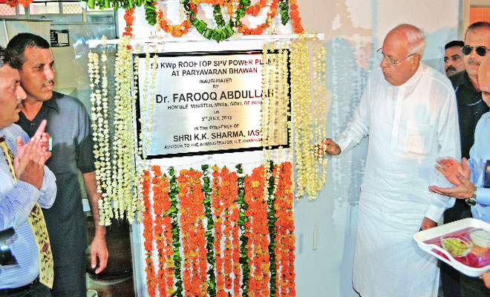 | 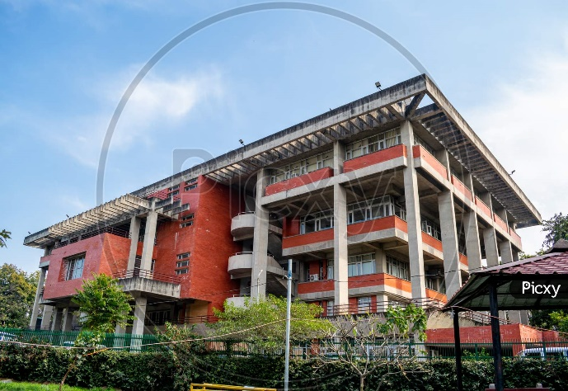
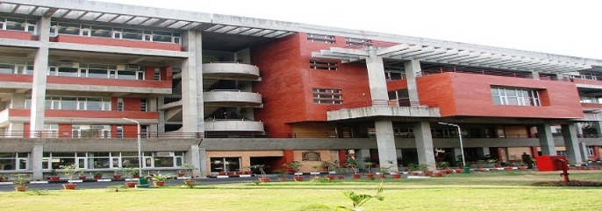 | 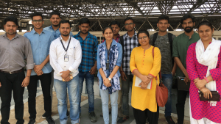
Inauguration/ Opening Ceremony of “Energy Efficient Green Building” by Minister of Paryavaran Bhawan Sector 19 – B, Chandigarh.

Figure 8: Inauguration/ Opening Ceremony of “Energy Efficient Green Building” by Minister of Paryavaran Bhawan Sector 19 – B, Chandigarh.
Chandigarh as Pedestrian City: A comprehensive proposal for making the city pedestrian friendly should be part of the “Master Plan” (MP) of Chandigarh under preparation. This concept is easily achievable in a compact city like Chandigarh, which is already consciously planned on the neighborhood concept designed with the pedestrian in mind. The predominance of vehicles on internal roads, the missing pedestrian paths and underpasses across major roads, have not made it comfortable for the pedestrian so far. Though the city may have the highest walkability index as compared to other Indian cities, there is still need to provide for well – defined comfortable, lively pedestrian environment.

Status of Storm Water Drainage in Chandigarh: Chandigarh is having a closed drainage system, therefore no prominent impact on Environment. In addition to this, the work of up – gradation/ construction of STP's are under progress to mitigate sewage treatment needs of Chandigarh. It was initially designed for a rainfall intensity of half an inch per hour. However, because of increased green areas and open spaces coming under construction, the run – of has increased tremendously. This has resulted in overloading of storm drain areas resulting in flooding of low lying areas of the city. The administration has attempted to address this problem by laying additional pipelines, constructing additional rain water harvesting structures along the storm drains, which helped the rainwater endowment of the city. The “Municipal Corporation” (MC) has undertaken a study to prepare a storm water drainage master plan to alleviate the problems of flooding by providing adequate measures. The study has recommended deepening, widening and providing retaining walls at critical sections.

Water Harvesting for Chandigarh: The demand for water is growing in direct proportion to the city’s growth. Rain water harvesting is one of the ways to protect and sustain its water resources. The Ministry of Urban Development had appointed “Centre for Science and Environment” (CSE) to prepare a plan for rain water harvesting at city level for Chandigarh. A report has been submitted titled as “Capturing Rainwater: A Way to Augment Chandigarh’s Water Resources”.

Landscape Water Conservation: Landscape forms an important part of the building environment a large amount of water is utilized for landscaping purposes and garden watering. Much of this water is used to maintain traditionally high water – demanding landscapes, or it is simply applied inefficiently.

Integrated Implementation of Sustainable Urban Drainage Systems (SUDS): Many existing cities storm water is damaging the environment and is not sustainable for long term. To reduce these effects techniques have been developed with the ideals of sustainable development and collectively referred as “Sustainable Drainage System” (SDS). Improved waste management will not only provide for significant GHG mitigation, but will also improve public health and environment quality.

Green Belt given Away to Urbanization: Le Corbusier’s concept of the green belt around the city to provide an environmental belt to control spread of urbanization besides the purpose of meeting the basic daily needs – vegetables, fruits, milk and milk products, poultry etc. has been given away to extensive urbanization in this area as a result of bifurcation. The city thus has to depend on far flung areas for its day – to – day needs resulting in additional transportation costs and thereby increase in the price of essential commodities.

Dependence of Neighborhood States on City’s Infrastructure: The development of the satellite towns of Mohali and Panchkula in the vicinity and their dependence for schools, hospitals, institutional, cultural and commercial areas has put great pressure on the city’s infrastructure, increasing regional traffic through and city, adding to noise, air, pollution thus impacting the overall environment and carbon footprints of the city.

Adoption of Green Building Concepts in the Building Designs of the City: Buildings have major environmental impact over their entire life cycle and therefore the aim of the Chandigarh Administration is to ensure that all new buildings that come within the city in future are “Green Buildings” and that the existing buildings are also retrofitted to meet the same standards. The features of the code are site selection and parameters for conservation of efficient utilization of “Resources”.

Plantation Design Consideration: Planting design consideration lays emphasis on the sensitive decisions based on various aspects, ecology, botany, horticulture, aesthetic value, growth and survival, environmental considerations. For service Utilities in Landscape areas paved surfaces with hard paving should be reduced or to be provided with shade.

The Green Building Code: A code offers a broad, subjective set of recommendations and means to achieve a certain end. The end in this case is a “Green City” or a structure that has a minimal negative impact on the environment and consumes minimal “Resources” (Water, Energy, Power etc.) during its construction, operation and demolition stages.

Green Rating Systems: There are rating systems such as the “Leadership in Energy and Environmental Design” (LEED) rating system. This system is developed by the “United States Green Building Code” (USGBC) and now adapted by “Indian Green Building Council” (IGBC). In India, TERI has developed its independent rating system called the “Green Rating for Integrated Habitat Assessment” (GRIHA) rating system, which has been endorsed by the “Ministry of New and Renewable Energy” (MNRE). MNRE has initiated schemes which offer incentives to architects, planners, who achieve a 3 star GRIHA green rating. The MNRE has also launched a set of guidelines for energy efficiency measures in commercial and residential buildings. Financial assistance is being offered by MNRE for encouraging awareness efforts, for organizing seminars and disseminating knowledge.

Climate Change Impact on Built Environment: Developments in Indian economy have triggered the growth of real estate in the country. Huge investments are being committed in real estate due to increased demand and increasing capacity to invest. Buildings account for more than 60% of all energy use in most high – and middle – income countries of the world, and an increasing proportion in low – income regions. Studies have indicated that both the functionality of the existing built environment and the design of future buildings may need to be altered to cope with the climate change impacts.

Environmental Degradation

Air Pollution: Ambient air quality of Chandigarh is under pressure. Respirable Suspended Particulate Matter in the city is crossing its permissible limits. The fleet of vehicles is over 2 per household. Chandigarh has the highest density of vehicles in India. The other major contributor of air pollution are activities like transport, industries, burning of dry leaves, litter from trees and gardens in the city, and operation of generator sets in certain areas. Pollution would be on the rise as the forecast of new vehicles in the forthcoming years in Chandigarh is high. The composite pollution index provided for over 85 countries across the world indicates that Chandigarh is one of the least polluted cities (6.3). The highly polluted city in the world Jakarta has a composite pollution index of 146, while Chandigarh has only about 12.07 (Tables 8, 9, 10, 11 and Figure 9).

Figure 9: Live Air Quality Index (AQI) Isopleths’ Forecast and Statement in Chandigarh.
Table 8: Current Pollutants’ Air Quality Scale and Status in Chandigarh.

Sr. No. | Current Pollutants | Air Quality Scale | Over the Past Hour
1. | PM₁₀: Particulate Matter are inhalable pollutant particles with a diameter less than 10 micrometers. Particles that are larger than 2.5 micrometers can be deposited in airways, resulting in health issues. Exposure can result in eye and throat irritation, coughing or difficulty breathing, and aggravated asthma. More frequent and excessive exposure can result in more serious health effects. | Unhealthy | 129  (127 µg/ m³)
2. | PM_{2.5}: Fine Particulate Matter are inhalable pollutant particles with a diameter less than 2.5 micrometers that can enter the lungs and bloodstream, resulting in serious health issues. The most severe impacts are on the lungs and heart. Exposure can result in coughing or difficulty breathing, aggravated asthma, and the development of chronic respiratory disease. | Poor | 85  (43 µg/ m³)
3. | O₃: Ground – level Ozone can aggravate existing respiratory diseases and also lead to throat irritation, headaches, and chest pain. | Excellent | 10  (25 µg/ m³)
4. | SO₂: Exposure to Sulfur Dioxide can lead to throat and eye irritation and aggravate asthma as well as chronic bronchitis. | Excellent | 8  (8 µg/ m³)
5. | NO₂: Breathing in high levels of Nitrogen Dioxide increases the risk of respiratory problems. Coughing and difficulty breathing are common and more serious health issues such as respiratory infections can occur with longer exposure. | Excellent | 4  (9 µg/ m³)
6. | CO: Carbon Monoxide is a colorless and odorless gas and when inhaled at high levels can cause headache, nausea, dizziness, and vomiting. Repeated long – term exposure can lead to heart disease. | Excellent | 1  (151 µg/ m³)

Table 9: Air Quality Status in Kurali.

Sr. No. | Pollutants | Minimum | Maximum | Average
1. | OZONE | 03 | 32 | 13
2. | CO | 03 | 98 | 09
3. | SO₂ | 01 | 34 | 10
4. | NH₃ | 11 | 34 | 18
5. | NO₂ | 12 | 60 | 36
6. | PM_{2.5} | 05 | 34 | 15
Observed at Station Sector – 25, Chandigarh – CPCC on 23 – 03 – 2021 at 08:00:00 AM;

Figure 10: Live Graphical Weather Representation (GWR) with Temperature, Precipitation and Air Pressure Profile for Kurali, Punjab State India.

Figure 11: Weekly Live Graphical Weather Representation (GWR) with Sun Shine, Temperature, Wind Speed and Humidity Profile for Kurali, Punjab State India.

Table 10: Average Respirable Suspended Particulate Matter and Suspended Particulate Matter during Last 5 Years (in ppm).

Sr. No. | Population | RSPM | SPM
1. | 2005 | 99 | 252.6
2. | 2006 | 104.8 | 191.8
3. | 2007 | 102.4 | 220.2
4. | 2008 | 95.6 | 199.8
5. | 2009 | 81 | 165
Source: ENVIS Chandigarh;

Table 11: Forecast by Class of Vehicle Populations in India (In Millions).

Sr. No. | Year | 2015 | 2025 | 2035
1. | 2 – Wheeler | 87.7 | 174.1 | 236.4
2. | 3 – Wheeler | 5.3 | 8.8 | 13.1
3. | HCV | 4.6 | 9.1 | 16.1
4. | LCV | 5.7 | 12.5 | 26.9
5. | Car, SUV | 18.0 | 41.6 | 80.1
 | Total | 121.3 | 246.1 | 372.7

Noise Pollution: Chandigarh has taken many measures such as, ban on movement of heavy vehicles on internal roads, a carefully segregated industrial area, a dense vegetation cover, etc., but still in some areas noise level exceed the noise pollution limits.

Solid Waste Management: Solid waste management now has widely been recognized as a resource for the generation of energy in an environmentally sustainable manner. Most of the urban centres in the country lack system of scientific management of municipal solid waste. Presently in urban areas municipal waste is rarely segregated at source instead mixed waste is dumped into low lying areas. Municipal Solid Waste generally comprises of 30 – 35% of bio – degradable matter, 20 – 35% inert matter and 5 – 15% recyclable matter. Bio – degradable matter can be profitably converted into useful energy like compost for manure, methane gas for cooking, heating, lighting etc. While bio – methanation, refuse derived fuel and incineration are the most common technologies; “Pyrolysis and Gasification” are also emerged as preferred options. The major benefit of recovery of energy from urban waste is reduction in land requirement by 60 – 90% as well as transportation, reduction in pollution besides generation of energy.
Chandigarh City Vision: Chandigarh will strive to become a model for sustainable water management, use of renewable sources of energy, protecting the local ecology and environment. The master plan also strives to reduce private vehicle use and increase public transport. For a low carbon urban plan the following are some of the plans for Chandigarh:

- The Pedestrian City: Le Corbusier gave due emphasis on the pedestrian. The aim of the master plan is to strengthen the lively and comfortable pedestrian movement through city’s green pathways. This could reduce up to 5% of the carbon emissions from the traffic.

- Introduction of Bicycles as a Mode of Transport: The park and ride concept model used world over is being considered for the Chandigarh UT to reduce the traffic congestion in many parts and also to reduce carbon foot print. This could reduce up to 10% of the carbon emissions from the traffic.

Reduced Vehicular Congestion: Per capita vehicle per family in Chandigarh is high and as a result there has been increased vehicle density in the city. In addition the neighboring states and tourist vehicles passing through the city to access other state capitals such as Haryana, Punjab and Himachal Pradesh. Therefore a plan to develop appropriate bye – pass roads to relieve vehicle congestions need to be thought. Furthermore, increased public transport to various access points may ease the congestion of city vehicles. Chandigarh Transport Undertaking may be strengthened to improve the busses to enhance frequency of busses plying between various points. It is also important to increase awareness among the public to use public transport than using the private vehicles.

Creating Awareness Among Public: One of the important aspects of vision of Green Chandigarh is awareness building among the public. Chandigarh has already taken a leap towards this by preparing “Green Code” for Chandigarh and also preparing a master plan for Chandigarh. As a part of these two programmes, Chandigarh is creating awareness among the public to use appropriate technologies for reducing pollution and reducing carbon emissions and ultimately to develop Chandigarh as a low carbon city. Several eco clubs and resident association committees have been engaged for greening Chandigarh.

The Management of Biomedical Waste: As per the Environment Report 200840, biomedical waste in Chandigarh is collected and treated with 100% efficiency. Biomedical waste approximately forms 0.4% of the total municipal waste generated in Chandigarh. All the health care units in Chandigarh are following the “Bio – Medical Waste” (Management and Handling) Rules, 1998. Major Hospitals like PGIMER, Govt. Medical College and Hospital (Incinerable waste is being treated in PGIMER/ GMSH – 16), Govt. Multi – Specialty Hospital and Primary Health Centre, Manimajra are having their own treatment facility and rest all the government/ private health Care Units are taking the facility of Govt. Sector for disposal of biomedical waste. The “Postgraduate Institute of Medical Education & Research” (PGIMER) was established in the year 1962.

Likely Impacts of Climate Change on Human Health: Many vector control measures as prescribed by the national vector borne disease control board will be taken up such as “Chemical Control; Biological Control; Community Participation and Awareness; Individual Prophylactic Measures; Environmental Management and Source Reduction Measures”. Within the country, it would be appropriate for the states to cooperate on sharing the technologies that are environmentally benign and cost effective.

- Climate change poses a serious threat to development and poverty reduction in the poorest and most vulnerable regions of the world. Help the rural and urban communities and the Government with updating appropriately with environmental status reports with special emphasis on climate change.

- Facilitate Environmental Impact Assessment of development projects critical to climate change i.e., power, housing, waste management etc.

- Environmental education, Training and awareness programme by celebrating World Environment Day, International Bio Diversity Day, International Ozone Layer Conservation Day, Organization of Environmental Training Programs.

- Panjab University, Chandigarh – specifically Department of Environmental Sciences, Botany, zoology, and geology.

- Promote research in multi – disciplinary aspects of environmental pollution as well as waste utilization.

- Prepare and upgrade environmental status reports with special emphasis on climate change.

- Develop effective and low cost technology for pollution control.

- Environment impact assessment methodologies, primarily in relation to biodiversity and water quality.

Role of the Forests in Amelioration of the Environment: Rising pollution level and degrading environment of the city particularly by vehicular pollution highlights the need for remedial steps to combat pollution. Though the best way to reduce pollution at source is by adoption of clean technology and clean fuel, proper maintenance of roads and vehicles, maximum use of bicycles, strict enforcement of Air (Prevention and Control of Pollution) Act, 1981, Water (Prevention and Control of Pollution) Act, 1974 and the Environment (Protection) Act, 1986 etc., yet another effective way to reduce air and noise pollution is through a well – planned and realistic strategy for afforestation. Apart from giving shade, aesthetic beauty, recreational spots and playing host to a wide variety of birds and insects, the forests and trees play an important role in amelioration of environment due to their tremendous potential to act as:

- Organic sponges to absorb gaseous pollutants via their leaf stomata (the tiny pores on the leaves) and breaks them down into less harmful molecules during the photosynthesis;
- Store house of “Carbon Dioxide” (CO₂) by assimilating the carbon dioxide in form of sugar;
- Supplier of much needed vital oxygen;
- Nature’s air conditioners as well as purifier of air;
- Soil and water conservation;

Forests/ Trees in the city enhance its visual character by adding variety and richness to urban landscape with their different foliage and blossoms. They provide habitat for the wildlife. They have significant effect in improving the microclimate of the area. “Green Cover” significantly affects the building heating budget. Vegetation helps in reducing the noise pollution to the acceptable level. Plants play an important role in both, reducing the environmental pollution load as well as serve as pollution indicator. Plantation in Schools, Colleges, Offices and residential houses and other vacant spaces with a massive campaign for plantations on private lands, complexes of Schools, Colleges, University, Hospitals, Police Lines and Residential Complexes and offices may be undertaken in collaboration with students, Resident Welfare Associations, Market Associations, Environmental N. G. O.’s etc. Every unutilized and abandoned patch of land will thus be brought under tree plantations.

STRATEGY TO IMPROVE THE FOREST AND GREEN COVER: A need based appropriate model dovetailing environmental considerations will have to be adopted by all Greening Agencies in their plantation drives. The selection and quality of species play most important role in the success of greening and improving the survival percentage of the plantations. Therefore, the selection of species has to be judicious for which a number of indicators have been short – listed as indicated below:

- Location of plantation site;
- Site conditions like, soil, ground water table;
- Climatic conditions like rainfall, temperature;
- Ornamental and aesthetic requirement;
- Environmental considerations like pollution abatement;
- Distance of the plantation site from the residential building, public utility services;

Efforts are now being made to construct “Green Buildings” all over the country which not only take care of energy conservation but also look into water and waste management, environment impact, minimum destruction of natural resources and various other aspects in an integrated way. Most of the internationally devised rating systems have been tailored to suit the building sector of the country where they were developed. In India, a US based “Leadership in Energy and Environmental Design” (LEED) Rating System is under promotion by CII – Godrej “Green Business Center” (GBC) which is more on energy efficiency measures in AC Buildings. A couple of other Rating systems suitable for Indian conditions e.g., TERI – GRIHA and Eco – Housing System have also been developed by TERI and Pune Municipal Corporation respectively and are under promotion in the country.

Homogeneous Section

The entire Projected Road “Starts” from “IT City Chowk Chainage 00 + 000” and “Ends” at “Kurali Chandigarh Chainage 31 + 230” has divided into 3 homogenous packages are considering sections based on “Traffic Volume” and its characteristics in the below {Table 12 on Page No. 48 and Figure 17 (a) on Page No. 66}. And Table 13 shows the “Existing – Proposed Chainage Wise Villages”.

Table 12: Homogeneous Section based on Traffic Volume Tehsil/ District Wise Villages.

Sr.  No. | Homogenous Section | Design Section Chainage |  | Design Length (Km) | Lane Widening | Existing Section Length (Km)
 |  | From  (Km) | To  (Km)
1. | IT City Chowk (00 + 000 Km) to Kurali Chandigarh Chainage (31 + 230 Km) | 00 + 000 | 31 + 230 | 00 + 000 to 31 + 230 | Bothways | 31.230
 |  |  |  | Total Length in Km |  | 31.230

This Report Pertains to Package – II from Existing Km 00 + 000 to Km 31 + 230 Length 31.230 Km of the Project Road in the District of Punjab, Chandigarh Union Territory (U. T.).

Table 13: Existing – Proposed Chainage Wise Villages.

Sr.  No. | Homogenous Section | Existing Chainage Section |  | Proposed Chainage Section
 |  | From  (Km) | To  (Km) | From  (Km) | To  (Km)
1. | IT City Chowk to Kurali Chandigarh Road | 00 + 000 | 31 + 230 | 00 + 000 | 31 + 230

7. DEMOGRAPHIC INFRASTRUCTURE INDEX OF THE PROJECT DISTRICT/ STATE

DEMOGRAPHIC PROFILE OF THE CITY

POPULATION GROWTH: The UT of Chandigarh is a uni – district territory which came into existence on 1st of November, 1966 with an area of 114 Sq. Kms. During the last 6 decades (1951 – 2011), Chandigarh has witnessed a population increase of more than forty four times with the absolute population increasing from 24,261 in 1951 to 10, 54,686 in 2011. As per Census 2011, the population of Chandigarh U. T. has crossed the one million mark with its population placed very close to that of the state of Mizoram (10, 91,014). The Union Territory recorded a population of 10, 54,686 in 2011 with much lower decadal rate of increase in population with only 1, 54,051 people being added to the Chandigarh UT during the last decade. The growth rate of merely 17.10% between “2001 – 2011” is the slowest since its inception. This is perhaps due to the rapid pace of urbanization taking place in the neighbouring towns of Mohali, Panchkula, Zirakpur, Kalka, Kharar, etc. falling within the 16 Km periphery control area. The details of the total population, decadal absolute growth and decadal growth rate are given in Table 14 below:

Table 14: POPULATION GROWTH (1951 to 2011).

Sr. No. | Year | Total Population | Decadal Absolute Variation of Population | Decadal Growth Rate (in %age)
1. | 1951 | 24,261 | ------- | -------
2. | 1961 | 1,19,881 | 95,620 | 394.13
3. | 1971 | 2,57,251 | 1,37,370 | 114.59
4. | 1981 | 4,51,610 | 1,94,359 | 75.55
5. | 1991 | 6,42,015 | 1,90,405 | 42.16
6. | 2001 | 9,00,635 | 2,58,620 | 40.28
7. | 2011 | 10,54,686 | 1,54,051 | 17.10

RURAL – URBAN COMPOSITION: The U. T. of Chandigarh has essentially become one territory with the urban settlements of Chandigarh and Manimajra occupying a major part of its 114 Sq. Km Area. As per the census of 2011, 10, 25,682 (97.25%) of its population was urban and 29,004 (2.75%) was rural as compared to 82.80% Urban and 17.20% Rural in the Year 1961. The details are in the Figure 12.

Figure 12: Rural – Urban Composition of Chandigarh and Manimajra Occupying a Major Part of Population.

DENSITY: The population density during the last 5 decades (1961 – 2011) has increased 9 fold, from 1,051 to 9,252 persons per Sq. Km. The density of the city doubled during 1961 – 71, when it increased from 1051 persons per Sq. Km to 2,257 persons per Sq. Km. It went on increasing rapidly in subsequent decades with 3961 persons per Sq. Km in 1981, 5,632 persons per Sq. Km in 1991 and 7,900 persons per Sq. Km in 2001. With the latest census data becoming available, the density recorded for the Chandigarh UT is now placed at 9,252 persons per Sq. Km in 2011. Chandigarh shall continue to record higher densities with further population growth, which poses a challenge for maintaining the quality of life and providing basic and essential services even to its poorest residents as visional by the city’s planners.

SECTOR WISE DISTRIBUTION OF POPULATION AND DENSITY AND THE UT’S HOLDING CAPACITY: Detailed analysis of the holding capacity of each sector based on the number of existing or planned dwelling units and their population as per the 2001 census has been done. Further assessment of population density has also been done for different phases of the city’s development i.e., Phase – I comprising of Sectors (1 – 30), Phase – II comprising of Sectors (31 – 47), and Phase – III with Sectors (48 – 56), 61 and 63.

DENSITIES AS PER ORIGINAL PLAN: The capital city of Chandigarh was planned for a differential pattern of density to accommodate a total population of 5 Lakhs. Phase – I was planned to be low density development with 9,000 acres of land housing 1, 50,000 population. Phase – II was planned for higher density with 6,000 acres of land accommodating 3, 50,000 people.

PREVAILING DENSITIES AS PER 2001 CENSUS: The prevailing density of Phase – I of the city as per the 2001 census was 26, whereas for Phase – II, it was 60 persons per acre. The density of Phase – III (which was added subsequently), has been proposed as approximately 100 persons/ acre. Thus, by 2001, the density of Phase – I had already exceeded the design density when that of Phase – II sectors was the same as was designed. The city however, still has reasonable capacity to accommodate additional population.

DENSITY AS PER HOLDING CAPACITY/ PROJECTIONS: As per the population worked out for the city on the basis of its holding capacity, the density of Phase – I is estimated to be 34 persons per acre (more than double the planned density) 83 persons per acre for Phase – II and 100 persons per acre for Phase – III sectors. It can be seen that as against the planned population of a sector varying from 15,000 – 25,000, large variations in population at the sector level have been observed with the highest population of 41,077 being recorded in Sector – 45, and the lowest population of only 1 being recorded in Sector – 63. The highest population in Phase – I sectors was recorded in Sector – 20 was 22,138, whereas in Phase – II (31 – 47) the position is occupied by Sector – 45, with a population of 41,077 (Table 15).
Table 15: DENSITY FOR PHASE I, II AND III BASED ON CENSUS 2001 AND HOLDING CAPACITY.

Sr. No. | Phase | Planned Density (Persons/ Acre) | Density as per Census 2001 (Persons/ Acre) | Density as per Holding Capacity (Persons/ Acre)
1. | I – Sector 1 to 30 | 16 | 26 | 34
2. | II – Sector 31 to 47 | 59 | 60 | 83
3. | III – Sector 48 to 56, 61, 63 | ------- | Under Process of Development Stage | 100

The density pattern is likely to undergo considerable change in the years to come with the city recording higher growth and development. As per existing trends, the sectors falling in Phase – I shall continue to have lower density as compared to the sectors falling in Phase – II. The highest population density will be in the sectors falling in Phase – III due to group housing and large scale rehabilitation of the population of unauthorized settlements in these sectors as “Planning, Preparation and Assessment” (PPA). As per the density calculated according to the holding capacity it can be mentioned that the higher densities will be in Manimajra (161 PPA), Sector – 38 West (211 PPA), Sector – 63 (195 PPA) and in “Rehabilitation Colonies” (RC) at Ram Darbar (157 PPA). The detail of area and densities for “Rehabilitation Colonies” (RC) at Figures 13 (a) to (c):

Figure 13 (a): PLAN D1 – DENSITY PATTERN IN SECTORS (AS PER ORIGINAL PLAN).

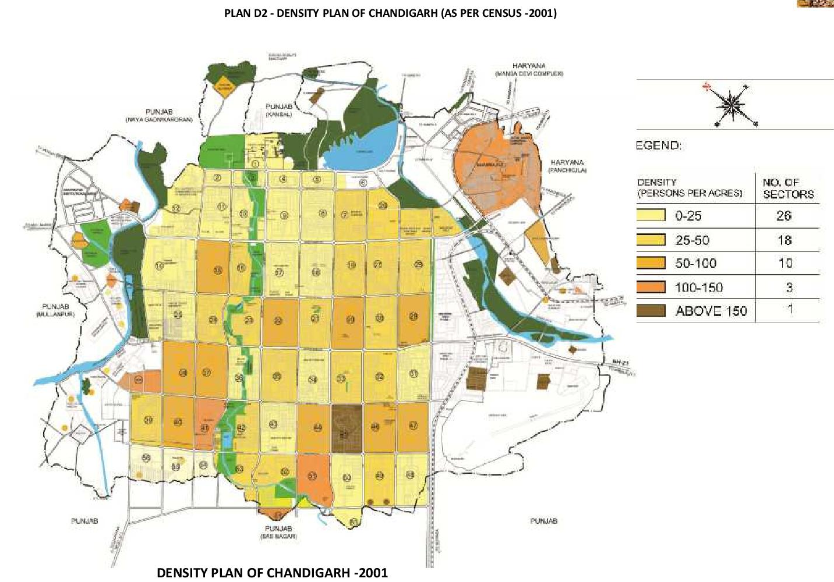

Figure 13 (b): PLAN D2 – DENSITY PLAN OF CHANDIGARH – YEAR 2001.

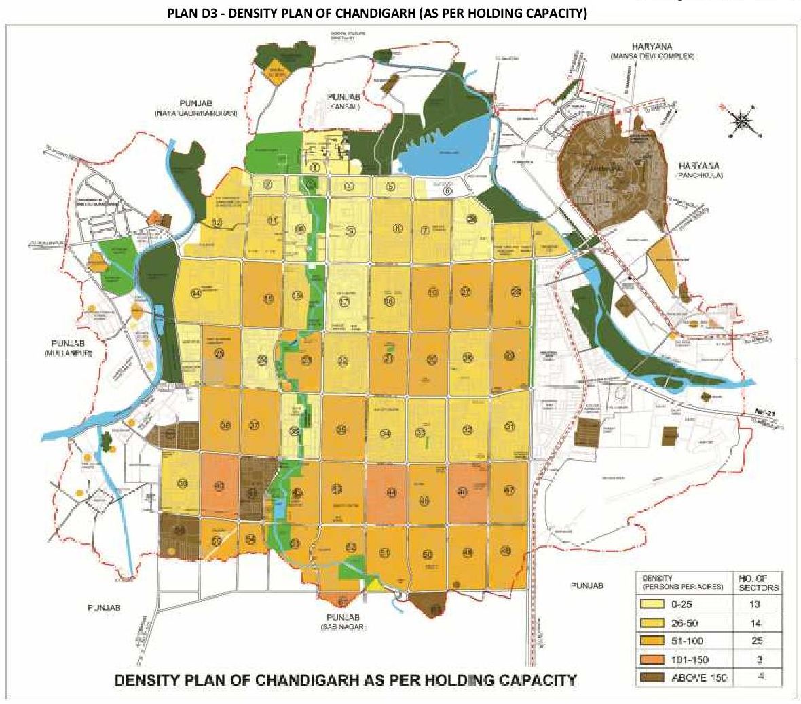

Figure 13 (c): PLAN D3 – DENSITY PLAN OF CHANDIGARH (AS PER HOLDING CAPACITY).
SEX RATIO: As per the provisional population figure of 2011, Chandigarh U. T. recorded a population of 10, 54,686 out of which 5, 80,282 are male whereas remaining 4, 74,404 are female. As per Census 2011, compared to the all India figure of 940, Chandigarh has recorded a sex ratio of 818. Chandigarh recorded a sex ratio of 777 in the year 2001 as compared to the national average of 933. The prevailing sex ratio in Chandigarh and in India during the period 1961 – 2011. The sex ratio has gradually increased over the years except in 2001, when it showed a marginal decline.

LITERACY RATE: Chandigarh has always recorded a high literacy rate since its inception due to the high quality of educational infrastructure available in the city. As per Census 2011, 8, 09,653 persons were literate in the U. T., indicating a literacy rate of 86.43%.

ECONOMIC ACTIVITY: The majority of workers in the U. T. are employed in fields other than cultivation, agriculture, household industry etc. It is observed that proportion of cultivators, agricultural labourers, household industry workers and other workers to total workers are found to be on an average 0.6%, 0.2%, 1.1% and 98.1% respectively.

FUTURE POPULATION PROJECTIONS: In order to have a realistic assessment of the future population, the population estimates have been based on the following four methods.

- Population projections made by the technical group on population projections constituted by Registrar General, Census of India;
- Population projections based on accepted methods of population projections;
- Population projections made by various agencies;
- Population projections based on the holding capacity;

POPULATION PROJECTIONS MADE BY THE CENSUS OF INDIA: The Technical Group set up by Census of India has made projections for Chandigarh’s population for the period 2011 – 2026. As per the table, Chandigarh will have a population of 14, 38,000 in the year 2011, 22, 26,000 in 2021 and 25, 18,000 in the year 2026. These projections are based on assumed growth rates of 59 .67% for the period 2001 – 11, 54.80% for 2011 – 21 and 13.12% for 2021 – 26. However, the actual population in the year 2011 is 10, 54,686 which is much lower than the projected population by the “Technical Group” (TG). The prime reason for variation is the difference in actual and projected growth rate of the Chandigarh U. T. recording the lowest decadal growth rate of 17.10% in its history as against the 59.67% projected by the technical group. Accordingly, even the future population projections for Chandigarh shall be much lower compared to the projections made by the technical group. Population projections based on four accepted methods “Population Projections” (PP) for Chandigarh U. T. have also been made by the “Arithmetic Progression Method, Exponential Method, Incremental Increase Method, and the Geometric Progression Method” as shown in Table 16. As indicated in the table, there are large variations in the projected population using different methods. In order to remove the abnormalities/ large variations, law of averages has been made applicable.

TABLE 16: POPULATION PROJECTION OF CHANDIGARH UT BY VARIOUS METHODS.

Sr. No. | Method | 2011 | 2021 | 2031
1. | Arithmetic Progression | 10,54,686 | 12,41,647 | 14,28,608
2. | Geometric Progression | 10,54,686 | 14,74,694 | 20,61,962
3. | Incremental Increase | 10,54,686 | 12,72,457 | 15,21,039
4. | Exponential | 10,54,686 | 18,82,540 | 33,60,200
 | Average | 10,54,686 | 14,67,834 | 20,92,952

POPULATION PROJECTION OF CHANDIGARH UT BY VARIOUS METHODS

POPULATION PROJECTIONS MADE BY VARIOUS AGENCIES: Taking various population projections into account, it will be realistic to assume that Chandigarh UT will have a population of 13.5 – 14.5 Lakhs by the year 2021 and 15 – 16 Lakhs by the Year 2031. Holding capacity of UT Chandigarh based on “Master Plan Recommendations’ to Population” (MPRP) for the Chandigarh U. T. has also been projected based on the holding capacity of the area. Holding capacity of the city has been worked out based on the following:

- Number of plots carved out for government housing;
- Residential plots made available to the residents for constructing houses;
- Number of plots and dwelling units made available by the “Chandigarh Housing Board” (CHB);
- Dwelling units created in re – habilitation colonies;
- Population of Manimajra in 2011;
- Housing in the villages falling in the U. T.;
- Population living in unauthorized settlements;
- Holding capacity of vacant areas in Phase – III sectors and the periphery;
- Para – military personnel housed in the area;

Based on the above, the total holding capacity of the U. T. of Chandigarh has been worked out as 15.52 Lakhs as detailed in Table 16. While it may not be possible to make an accurate forecast, the expectation is that the UT’s population will range between 15 – 16 Lakhs, by 2031 for which the provision of necessary infrastructure should be planned as per system of “Planning, Preparation and Assessment” (PPA).

In order to maintain the basic character of Chandigarh as an administrative city, unnecessary increase in the population should be avoided. With the coming up of new towns in the periphery in Punjab and Haryana, the excess population can be easily accommodated in those towns. Moreover since the land stock in Chandigarh is limited, the uses related to governance and administration should get priority in the allocation of land. It will be prudent to look at the city and the union territory based on the holding capacity indicated above with population restricted to 15.5 Lakhs. Additional population will have to be diverted to the adjoining settlements by viewing the entire context of planning in the regional framework of “Planning, Preparation and Assessment” (PPA). However, continuous monitoring of population every 5 years will be desirable in order to rationalize the distribution of population. It will be prudent to consider that population for the area falling in the sectors should not exceed one million (Tables 17 and 18).

TABLE 17: HOLDING CAPACITY OF UT CHANDIGARH BASED ON MASTER PLAN RECOMMENDATIONS.

Sr. No. | Category |  | Total Units | Existing Population | Maximum No. of Dwelling Units | Holding Capacity
1. | Government Plots |  | 24,330 | ------- | 29,925 | 1,11,116
2. | Private Plots |  | 22,788 | ------- | 22,788 × 3 = 68364 | 2,93,965
3. | Chandigarh Housing Board | Plot | 2,255 | ------- | 2,255 × 3 = 6765 | 29,090
 |  | Unit | 30,698 | ------- | 30,698 | 1,32,001
4. | Others |  | 28,963 | ------- | 28,963 | 1,24,541
5. | Rehabilitation Colonies |  | ------- | ------- | 61,525 | 2,64,558
6. | Unauthorized Colonies to be Rehabilitated |  | 20,911 | 69,047 | ------- | 69,000
7. | Villages |  | ------- | 84,235 | ------- | 1,17,929
8. | Manimajra |  | ------- | 1,17,046 | ------- | 1,36,943
9. | New Residential Areas |  | ------- | ------- | ------- | 2,00,328
10. | Paramilitary |  | ------- | ------- | ------- | 50,000
 | Total |  |  |  |  | 15,29,471
Note: | - Average family size for calculating holding capacity has been taken as 4.3;  - In case of sectors 6, 12, 17, 26 E, 53 and 54 existing population in 2001 has been included in the holding capacity;  - Private plots availing additional FAR/ DU’s;

TABLE 18: ADJUSTMENT OF PROPOSED POPULATION IN CHANDIGARH CITY.

Sr. No. | Sectoral Grid | Sectors | Projected Population
1. | Phase – I | 01 to 30 | 2,70,086
 | Phase – II | 31 to 47 | 3,45,945
 | Phase – III | 48 to 63 | 2,01,424
2. | Periphery | Pocket – 2 Near Sarangpur | 7,500
 |  | Pocket – 7 Near Maloya | 45,000
 |  | Chandigarh Armed Police Complex | 6,500
3. | Others | Rehabilitation Colonies | 2,64,558
 |  | Villages | 1,17,929
 |  | Manimajra | 1,36,943
 |  | Unauthorized Colonies to be Rehabilitated | 69,000
 |  | Paramilitary | 50,000
 | Total |  | 15,29,471 Say 16 Lac
*The Population of Sectors 48 to 63 has been calculated with a Gross Density of 100 PPA;
DECADAL GROWTH RATE OF GMADA REGION (PUNJAB): The growth in Mohali’s population and its emergence as a part of the “Tri – City” comprising “Chandigarh, Panchkula and Mohali” started in the “Seventies”. The population of Mohali (then a Village) was only 1,229 in 1971, but grew by about 39% per year during the period 1971 – 81 to reach 32,351 in 1981. Though the rate of growth in Mohali’s population has declined after 1981 due to a larger base population, it has remained high at over 9% per year during 1981 – 91 and over 4.5% per year during 1991 – 2001.

DECADAL GROWTH RATE OF HARYANA PORTION: Due to establishment of various special government projects of HMT, ACC Cement Factory, Chandimandir Cantonment, Indian Tibet Border Police Complex, CRPF Complex, Terminal Ballistic Research Laboratory and Panchkula Town, this periphery area has undergone tremendous socio – economic and physical development. Further the development of infrastructure like roads, electricity and rapid transportation facilities, induced large scale immigration from other areas to this region. The population in the periphery area of Haryana has increased manifold in the last three decades and shows the projected population of the Haryana portion of periphery controlled area upto 2021. As apparent from the above projections, the total population of the periphery controlled area would be 14, 23,000 in 2021, when projects of Panchkula Extension and Shree Mata Mansa Devi Urban Complex get completed and urbanization in the area adjoining Kalka and Pinjore take place. Accordingly, the urban population would be 65.00%, 75.00% and 85.00% of the total population in the corresponding years of 2001, 2011 and 2021 respectively. The total urban population would be 12, 09,550 in 2021.

FUTURE TRENDS OF POPULATION IN 16 KM PERIPHERY CONTROL AREA: The provisional population of U. T. according to 2011 Census is 10, 54,686 having increased by 17.1% over the decade. It is a much lower rate of population growth than projections made by different agencies. While availability of more detailed 2011 Census data has to be awaited for analysis of the factors, which have contributed to this lower growth rate, it may be conjectured that rising property values in the city, combined with limited availability of land for additional housing, has led to spill over of some of Chandigarh’s growth into cheaper alternatives available in Zirakpur, Mohali and Panchkula as well as some of the neighbouring villages such as Kansal and Naya Gaon in Punjab Province or Jurisdiction.

It is clear that future trends of the city’s growth cannot be seen in isolation from the massive urban development taking place in its periphery falling in Punjab and Haryana. With little land left for new development, and no major new developments in the pipeline combined with the decision to maintain Chandigarh as a medium rise city at best, the same low rate of population growth during the coming two decades may be assumed. The total projected population for the “Year 2031” has been estimated at “20 Lakh” as highlighted earlier to maintain the basic character, the holding capacity of city has been worked out to be 16 Lakh with a view to retain the original concept of a green and spacious town and due to environmental considerations. The additional population will have to be diverted to the adjoining settlements by viewing the entire context of planning in the regional framework of “Planning, Preparation and Assessment” (PPA).

CORONA VIRUS OR COVID – 19 Cases Update

CHANDIGARH/ SHIMLA: The North region that covers Punjab, Haryana and Himachal Pradesh reported 15 Covid – 19 deaths and 394 new cases. Punjab reported 14 deaths and 234 new positive cases. The tally of the infected is now 1, 75,252 and the death count 5,675. In the last 24 hours, five patients died in Gurdaspur, three in Jalandhar, and one each in Faridkot, Hoshiarpur, Kapurthala, Ludhiana, Patiala, and Ropar. The new cases 35 are in Ludhiana, 31 each in Jalandhar and Mohali, 20 in Nawanshahr, 19 each in Gurdaspur and Hoshiarpur, 7 in Fatehgarh Sahib, 6 in Tarn Taran, 3 each in Pathankot, Muktsar, Moga, Mansa and Bhatinda, 2 each in Sangrur, Kapurthala, Faridkot and Fazilka and one in Ropar. Haryana reported 77 new patients and 7 zero Case – Districts are also found in many parts or regions. It also vaccinated 2,966 people, including the healthcare workers and reported 107 recoveries and no deaths. The overall count is 2, 68,677 cases, 3,303 deaths, 2, 64,820 recoveries and 824 active cases. The vaccination tally is 1, 88,868 against 1.87 Lakh healthcare workers.

The “CORONA VIRUS OR COVID – 19 Figure Cases” are updated daily to provide the latest information and are based on the source data from the “Union Ministry of Health and Family Welfare Department” (UMHFWD). As on 20.02.2021 at 08: 00 AM, The people affected with Coronavirus of Punjab region is 00 persons only {Tables 19 (a) to (d)}.

Table 19 (a): CORONA VIRUS OR COVID – 19 Figure Cases Updates.

Total Cases | Active Confirmed Cases | New Cases | Deaths Total | New Deaths | Recovered | Vaccination
2, 68,677 | 824 | 77 | 3,303 | 15 | 2, 64,820 | 1, 88,868
Source: Ministry of Health and Family Welfare Coronavirus Updates, Updated Time: 20.02.2021 at 08: 00 AM;

Table 19 (b): COVID – 19 Digital Catalogue Apprise in Punjab, Haryana, Himachal Pradesh and Other States.

Sr. No. | Location | Total Cases | Confirmed | Recovered | Deaths Total
1. | Punjab | 97,689 | ------- | ------- | 2,813
2. | Haryana | 1,11,25 | ------- | ------- | 1,149
3. | Himachal Pradesh | 12,038 | ------- | ------- | 115
4. | Chandigarh | 10,082 | ------- | ------- | 120

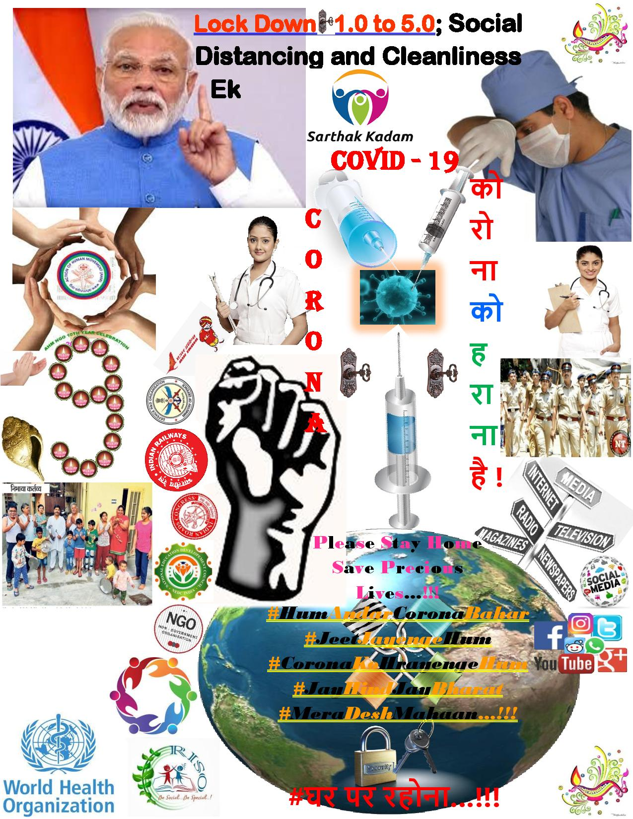

Table 19 (c): Current CORONA Virus Infected Patients Count in Rupnagar District.

Sr. No. | City Name | District Name | Total Covid Cases | Remarks
1. | Ropar District | Rupnagar | 02 | CORONA Positive Cases of COVID – 20/ 21 are under Control as Compared to COVID – 19.
2. | Rupnagar District | Rupnagar | 01

Total infected patients are 03 in Rupnagar District and total population of Rupnagar District is 6, 83,349. Total Infected Patients in Punjab State are 323.

Table 19 (d): Current CORONA Virus Infected Patients Count in Chandigarh District.

Sr. No. | City Name | District Name | Total Covid Cases | Remarks
1. | Chandigarh District | Chandigarh | 15 | CORONA Positive Cases of COVID – 20/ 21 are under Control as Compared to COVID – 19.
2. | Chandigarh | Chandigarh | 07
3. | Sector – 26 | Chandigarh | 05
4. | Chandigarh Sector – 30 | Chandigarh | 03
5. | Sector – 37 | Chandigarh | 03
6. | Sector – 12 | Chandigarh | 01
7. | Vikas Nagar | Chandigarh | 01
8. | Sector – 32 | Chandigarh | 01

Total infected patients are 36 in Chandigarh District and total population of Chandigarh District is 10, 54,686. Total Infected Patients in Chandigarh State are 427.

Connectivity Details

NHAI to Build New Link to Kurali – Chandigarh Road: Will decongest Chandigarh and Zirakpur by providing an alternate route to traffic coming from Delhi and going to Himachal Pradesh and Jammu and Kashmir. After scrapping the project to widen the 40 – Km long Kharar – Banur – Tepla Road in July 2019, the “National Highway Authority of India” (NHAI) has come up with an alternate “Green Field” (GF) alignment, a 32 Km road from IT City Chowk (PR – 7) near Airport to the Kurali – Chandigarh Road from the Villages of Nagiari and Devi Nagar (Figure 14). All major utilities follow the road alignment as the project road connects to Kurali Chandigarh. Table 20 containing details about the village specifics for this road are enclosed as below:

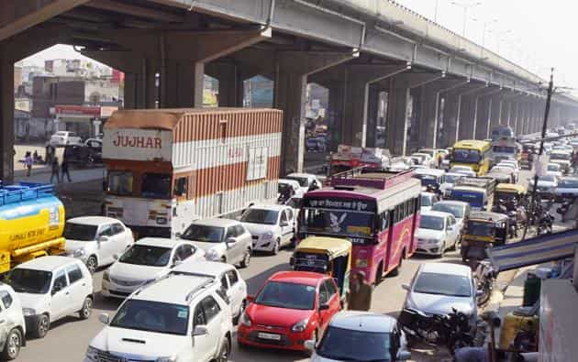

Figure 14: The Kharar – Banur – Tepla Road with an Alternate “Green Field” Alignment of 32 Km Road from IT Chowk (PR – 7) near Airport to Kurali – Chandigarh Road from Villages of Nagiari and Devi Nagar.
A Greenfield road is built in an area where there is no construction. NHAI, it is learnt, issued a notification recently asking the farmers of around 60 villages for objections and acquisition of land within 21 days. The new road will decongest Chandigarh and Zirakpur by providing an alternate route to traffic coming from Delhi and going to Himachal Pradesh and Jammu & Kashmir. “As per issued the notification and around 400 acres land will be acquired in around 60 Villages of Mohali District”. NHAI will also widen the existing road to six lanes of 40 Km from IT City chowk to Ambala via Banur and Tepla. The matter of an alternate route had been taken up in February, 2020, by Member of Parliament Manish Tiwari with Union Minister… Nitin Gadkari, following which NHAI is checking the feasibility of the “Green Field Section” (GFS).

After issuing the notification for widening 40 Km long Kharar – Banur – Tepla Road in 2018, the NHAI had scrapped the project in July 2019 owing to high costs. Inderjit Ghai, Managing Director, General Highway and Infracom Private Limited, who prepared the detailed project report for the scrapped project said, NHAI had decided to explore the possibility of a new “Green Field” (GF) alignment. “The proposed project is also viable under “Build Operate Transfer” (BOT) as traffic is huge on the road and its cost can be recovered in a decade’s time. In addition, there are other benefits like reduction in pollution level, reduction of road accidents and congestion in Chandigarh City and Zirakpur”.

Table 20: List of Village with Length and Chainages.

Sr. No. | Location and Section |  | Length (m) | Name of Village/ Town
 | From | to
A | B | C | D | E
1. | 0 + 000 | 1 + 900 | 1,900 | Nagiari
2. | 1 + 900 | 2 + 300 | 400 | Gigemajra
3. | 2 + 300 | 3 + 600 | 1,300 | Gudana
4. | 3 + 600 | 4 + 800 | 1,200 | Dhelpur
5. | 4 + 800 | 5 + 800 | 1,000 | Gobindgarh
6. | 5 + 800 | 6 + 400 | 600 | Chudiala
7. | 6 + 400 | 7 + 200 | 800 | Soey Majra
8. | 7 + 200 | 8 + 100 | 900 | Gidarpur
9. | 8 + 100 | 9 + 550 | 1,450 | Machli Khurd
10. | 9 + 550 | 10 + 900 | 1,350 | Macchli Kalan
11. | 10 + 900 | 13 + 200 | 2,300 | Jhanjhari
12. | 13 + 200 | 13 + 500 | 300 | Popna
13. | 13 + 500 | 15 + 500 | 2,000 | Rangian
14. | 15 + 500 | 17 + 000 | 1,500 | Cholta Khurd
15. | 17 + 000 | 18 + 100 | 1,100 | Deh Kalan
16. | 18 + 100 | 19 + 500 | 1,400 | Bajheri
17. | 19 + 500 | 20 + 800 | 1,300 | Pir Sohana
18. | 20 + 800 | 22 + 600 | 1,800 | Rukhi Pukhta
19. | 22 + 600 | 23 + 200 | 600 | Mamupur
20. | 23 + 200 | 24 + 200 | 1,000 | Sanauran
21. | 24 + 200 | 25 + 300 | 1,100 | Barouhli
22. | 25 + 300 | 27 + 700 | 2,400 | Padiala
23. | 27 + 700 | 28 + 200 | 500 | Kanora
24. | 28 + 200 | 28 + 500 | 300 | Jhingra
25. | 28 + 500 | 28 + 800 | 300 | Kanora
26. | 28 + 800 | 29 + 400 | 600 | Jhingra
27. | 29 + 400 | 30 + 300 | 900 | Fatehgarh
28. | 30 + 300 | 30 + 900 | 600 | Sekhpura
29. | 30 + 900 | 31 + 230 | 330 | Andheri

Geometrics

The horizontal alignment of Section – II passing through plain terrain and there are some acute curves, which is not constructed as per the norms in the IRC: SP: 48 – 1998; and IRC: SP: 87 – 2019. Approximately 5.1 Km length out of total existing length of 16.96 Km is having more than 6% gradient, which is more than exceptional and limiting gradient as per the IRC: SP: 48 – 1998; and IRC: SP: 87 – 2019. The horizontal alignment is passing through “Plain and Steep Terrain” (PST) in its entire length. There are many acute curves and hair pin curves with inadequate sight distance are present on the project road especially before urban area and approaches of structures. The vertical alignment is not smooth as it’s having hilly topography in its entire length. The horizontal alignment of the project traverses through hilly terrain in its entire length. It is essential to improve substandard geometrics at various locations on the projected road. Geometric improvements shall be made as per standard and specifications. In order to upgrade the road to the geometric requirements commensurate with the design speed, improvement has been proposed for the Projected Road. The alignment passes through several villages and habitation areas of which some have built – up sections. The improvement works, consist of the existing intermediate lane carriageway to 4 to 6 lane with paved shoulder “Carriageway” (10.0 m Width) of Rigid pavement with hard shoulder of 2.0 m on either side of rural section and intermediate lane to 2 lane with paved shoulder of 2.50 m “Carriageway” (12.0 m Width) of Rigid pavement on either side on built up section. The surface and subsurface drainage system shall be planned as per IRC: SP: 42 – 1994. A camber of 2.5% shall be provided in main carriageway and minimum longitudinal gradient of 0.05% in rural areas and 0.2% in urban shall be provided for smooth surface runoff. Longitudinal lined/ unlined drain shall be provided near “Right of Way” (ROW) in scattered built up section with outlets to cross drainage structures (Tables 21 and 22).

Table 21: As per IRC: SP: 48 – 1998; IRC: SP: 87 – 2019 Curve Detail “ROAD INVENTORY”.

Classification | As per IRC: SP: 48 – 1998; IRC: 52 – 2001 and IRC: SP: 87 – 2019 |  |  |  |  |  |  |  | As per IRC: SP: 73 – 2015 and IRC: 84 – 2014; IRC: SP: 87 – 2019
 | Flat or Plain Terrain |  |  |  | Steep Terrain |  |  |  | Flat or Plain and Steep
 | Area not Affected by Snow |  | No Snow Bound Areas |  | Area not Affected by Snow |  | No Snow Bound Areas
 | Ruling Minimum | Absolute Minimum | Ruling Minimum | Absolute Minimum | Ruling Minimum | Absolute Minimum | Ruling Minimum | Absolute Minimum | Desirable Minimum Radius | Absolute Minimum Radius
National Highways and State Highways | 80 | 50 | 90 | 60 | 50 | 30 | 60 | 33 | 150 | 75

Note: Above All Values in Meter (M);

Table 22: Classification of Design Standards for Geometrics of Highway.

Sr. No. | Element | Rural | To be Adopted for 6 – Lane
1. | Lane Width | ------- | 3.5 mts
2. | Shoulders | Paved Shoulder | 1.5 m Wide on Left Side of Carriageway
 |  | Unpaved Shoulder | 2 m Wide on Left Side of Carriageway
3. | Camber/ Cross Fall | Carriageway, Paved Shoulder, Edge Strip | 2.50%
 |  | Earthen Shoulder | 3.00%
4. | Right of Way (ROW) | Rural Section | 60
5. | Design Speed (Km/ H) | Plain | 100
6. | Super Elevation | Limited to 7% | If Radius of Curve < Desired Minimum Radius of Curve
 |  | Limited to 5% | If Radius of Curve >= Desired Minimum Radius of Curve
7. | Minimum Radii of Horizontal Curves (mts) | Absolute Minimum Radius (mts) | 470
 |  | Desirable Minimum Radius (mts) | 700
8. | Sight Distance | Safe Stopping Sight Distance (mts) | 180
 |  | Desirable Minimum Sight Distance (mts) (Intermediate Sight Distance) | 360
9. | Decision Sight Distance | Decision Sight Distance (mts) | 360
10. | Minimum Length of Transition Curves | Minimum Length of Transition Curves (mts) | 83
11. | Minimum Length of Vertical Curves | Minimum Grade Change Requiring Vertical Curve | 0.50%
12. | K – Value | Hog Curve (SSD) | 74
 |  | Hog Curve (DSD) | 295
 |  | Hog Curve (ISD) | 135
 |  | Sag Curve (SSD) | 42
 |  | Sag Curve (DSD) | 92
 |  | Sag Curve (ISD) | 92
13. | Gradient | Plain (Ruling Gradient) | 2.50%
 |  | Plain (Limiting Gradient) | 03%
14. | Vertical Clearance | Interchanges and Flyover | 6.5 mts
 |  | Vehicular Underpass | 5.5 mts
 |  | Light Vehicle Underpass | 4.5 mts
 |  | Cattle Underpass | 4.0 mts
 |  | Railway Over Bridge | 6.805 mts
Note: Above All Values are in %age and Meter (M);

8. ENVIRONMENTAL CHECKLIST (EC)

RAPID ENVIRONMENTAL ASSESSMENT CHECKLIST
ROADS AND HIGHWAYS

INSTRUCTIONS

(i) The project team as “Environmental Expert/ Specialist” completes this checklist to support the environmental classification of a project. It is to be attached to the environmental categorization form and submitted to the “Ministry of Environment and Forest and Climate Change” (MoEF & CC) for concern nodal/ zones/ regional officer or expert/ specialist.

(ii) Answer the questions assuming the “Without Mitigation” case. The purpose is to identify potential impacts on its environment and surrounding areas. Use the “Remarks” section to discuss any anticipated mitigation measures and “Rapid Environmental Assessment Checklist” (REAC)/ “Initial Environmental Examination” (IEE) Report is shown in Table 23.

Table 23: Rapid Environmental Assessment Checklist.

Country/ Project Title | India: Chandigarh UT and Punjab State  Sub – Project: Initial Environmental Examination Report for: IT City Chowk to Kurali Chandigarh, Road
Sector Division/ Section | Road and Transport Government of India (GOI)
Screening Questions | Yes | No | Remarks
A. Project Site
Is the project area adjacent to or within any of the following environmentally sensitive zones/ sites/ areas? |  | X | No environmentally sensitive zone/ site is located within the projected road;
Cultural Heritage Site; |  | X | No archaeologically protected monument or cultural heritage site/ zones is located within the road;
Protected Area; |  | X | No protected areas are located/ placed close to roads and nearby zones/ areas;
Wetland Area; |  | X | No protected or classified wet land is located close to roads and nearby surrounding areas;
Mangrove Cover/ Area; |  | X | Project road is not located in Coastal Areas;
Estuarine Locality/ Area; |  | X | No Estuarine is located in the Projected Area;
Buffer Zone of Protected Area; |  | X | No such area is located in the Projected Vicinity;
Special Area for Protecting Biodiversity; |  | X | No such area is located in the Projected Vicinity;
B. Potential Environmental Impacts
Encroachment on historical/ cultural areas; disfiguration of landscape by road embankments, cuts, fills, and quarries? |  | X | The area is no mountainous throughout the proposed alignment and there is no human settelment nor any historical/ cultural places. So there no human encroachment;
Encroachment of precious ecology (e.g., Sensitive or protected areas)? |  | X | Attempts have been made to minimizing the cutting of trees while finalizing the road widening options, but we didn't found any sensitive or procted area in the projected area;
Alteration of surface water hydrology of waterways crossed by roads, resulting in increased sediment in streams affected by increased soil erosion at construction site? |  | X | The proposed alignment is crossing only small natural drains. All drainage courses will be maintained to avoid alteration in surface water hydrology so that water courses are not affected. The temporary soil stockpiles will be designed so that runoff will not induce sedimentation of waterways. Silt fencing during construction will be provided. “To Mitigate This Problem The “Environmental Management Plan (EMP)” is Already Incorporated with their Mitigation Method”;
Deterioration of surface water quality due to silt runoff and sanitary wastes from worker – based camps and chemicals used in construction? |  | X | Adequate sanitary facilities including “Soak Pits Treatment (SPT)”, facilities will be provided at construction camps, which will be set – up away from habitat and water bodies. No harmful ingredients are likely to be used in the construction activities. Surface water quality is not impacted due to construction. Measures like embankment slope stabilization, “Reinforced Cement Concrete (RCC)”, retaining walls are proposed to prevent siltation of ponds located next to the road due to surface runoff;
Increased local/ regional areas air pollution due to rock crushing, cutting and filling works and chemicals from asphalt processing? |  |  | Regional/ local/ on site “Air Pollution Level (APL)”, will be high during construction period due to structure/ road construction work; vehicle movementsand asphalt processings etc. The “Asphalt Mixing Plant (AMP)” OR “Hot Mix Plant (HMP)” will be located away from habitat areas adequetly high stack for effective dispersion of likely Dust Emissions. Separation measures like spraying of water on unpaved vehicle movement areas are proposed to minimize the dust generation. To mitigate this problem the “Environmental Management Plans (EMPs)” are already in corporated with their mitigation methods and measures;
Risks and vulnerabilities related to occupational health and safety due to physical, chemical, biological and radiological hazards during project construction and operation? |  |  | Workers may get exposed to dust and noise during construction activities. However, the exposure levels are likely to be short and insignificant. Workers will be provided requisite “Personal Protective Equipments (PPEs)” to minimize such exposure and associated harmful occupational health effects. To mitigate this problem the “Environmental Management Plan (EMP)” is already in corporated with their mitigation methods;
Noise and vibration activities due to blasting and other civil works on site construction of roads/ bridges and valuable residential and commercial structures establishments? |  | X | No blasting is involved. No significant noise generation is expected during construction activities except normal construction equipment operational noise. These noise levels will be impulsive in nature and its impact will be confined within few Meters of either side of the road. All stationary noise making sources equipment like DG set, compressors will be installed with acoustic enclosures/ mufflers/ silencers to reduce noise level on site if specified for the region or state.

9. STATUTORY CLEARANCES REQUIRED

The “Environmental Impact Assessment/ Statement” (EIA/ S) process adopted will follow regulations of “Government of India” (GOI) and “Maharashtra and Karnataka Government”. As per current policy since the project is more not more than 100 Km in length so the MOEF notification will not apply and need no “Environmental Impact Assessment/ Statement” (EIA/ S) Clearances. Table 24 presents clearances required under the proposed project for roads network area.

Table 24: Required Statutory (EIA/ S) Clearances.

Sr. No. | Acts / Rules and Regulations | Purpose and Resolution | Applicable Yes/ No | Authority
1. | Environment Protection Act (EPA) – 1986. | To protect and improve overall environment. | No | MOEF; GOI; DOE; SPCB
2. | Environmental Impact Assessment Notification (EIAN) 14th September, 2006. | To provide environmental clearance to new development activities following environmental impact assessment. | No | MOEF; (EIAN)
3. | Notification for use of Fly Ash (NFA). | Reuse large quantity of fly ash discharged from thermal power plant to minimize land use for disposal. | Yes | NFA
4. | Coastal Regulation Zone (CRZ) Notification 1991 (2002). | Protection of fragile coastal belt. | No | CRZN
5. | National Environment Appellate Authority Act, (NEAA) 1997. | Address grievances regarding the process of Statutory Environmental Clearance (SEC). | No | NEAA; SEC
6. | The Land Acquisition Act (LAA) – NH – 1956. | Set out rule for acquisition of land by government. | Yes | Revenue Department; LAA
7. | MOEF Circular on Marginal Land Acquisition and Bypasses 1999. | Defining “Marginal Land”  Acquisition relating to the 1997 Notification (MLAN). | No | MOEF; MLAN
8. | The Forest (Conservation) Act – 1927; The Forest (Conservation) Act – 1980; Forest (Conversion) Rules –1981. | To check deforestation by restricting conversion of forested areas into non – forested areas. | Yes | Forest Department; Government of Haryana (GOH)
9. | Wild Life Protection Act – 1972. | To protect wildlife through certain of National Parks and Sanctuaries. | No | CCF; Department of Forest; (GOH)
10. | Air (Prevention and Control of Pollution) Act – 1981. | To control air pollution by and Transport Controlling Emission of Air Department (TCEPA). Pollutants as per the prescribed standards. | Yes | GO UP; SPCB; TCEPA
11. | Water Prevention and Control of Pollution) Act – 1974. | To control water pollution by controlling discharge of pollutants as per the prescribed standards. | Yes | (GOH); SPCB
12. | Noise Pollution (Regulation and Control Act) 1990. | The standards for noise for day and night have been promulgated by the MOEF for various land uses. | Yes | MOEF; (GOH); SPCB
13. | Ancient Monuments and Archaeological Sites and Remains Act – 1958. | Conservation of cultural and historical remains found in India. | No | ASI; GOI
14. | Public Liability and  Insurance Act (PLIA) – 1991. | Protection form hazardous materials and accidents. | Yes | PLIA
15. | Explosive Act – 1984. | Safe transportation, storage and use of explosive material. | Yes | Chief Controller of Explosives
16. | Minor Mineral and concession Rules (MMCR). | For opening new quarry. | Yes | District Collector; MMCR
17. | Central Motor Vehicle Act –1988 and Central Motor Vehicle Rules (CMVR) – 1989. | To check vehicular air and noise pollution. | Yes | Motor Vehicle Department; CMVR
18. | National Forest Policy 1952; National Forest Policy (Revised) 1988 (NFP). | To maintain ecological stability through preservation and restoration of biological diversity. | Yes | Forest Department; GOI; and (GOH); NFP
19. | The Mining Act (MA) – 1989. | The mining act has been notified for safe and sound mining activity. | Yes | Department of Mining (DOM); MA

Environmental Screening and Initial Social Assessment

Impact and Clearances Needed

An environmental impact study will be undertaken during the process of creating the “Detailed Project Report” (DPR) to understand impact of the project road on the surrounding ecology and environmental goals and outcomes. It will not require environmental clearances. The proposed project involves the acquisition of protected land. A summary of the environmental impact and clearances required is provided below (Table 25):

Table 25: Environmental Impact and Clearances Required.

Sr. No. | Impact Type | Description | Clearance Status
1. | Environmental Clearance | Not Applicable | Not Applicable
2. | Trees in Row | 31.23 Km in Length and 60 m ROW Proposed | To be Applied for Felling Permission

Cost of Environmental Mitigation

The “Environmental Mitigation” and “Management Costs” were developed based on the estimation of resources required to implement the mitigation measures proposed and also number of places where intervention is required.

Social Impact Assessment and Land Acquisition

Social Impact Assessment: Project highway is a “Green – Field” (GF) alignment proposed with 6 – Lane configuration accordingly land acquisition required. This will lead to the additional acquisition of 242.572 Ha with 60 m “Right of Way” (ROW) in the States of Punjab, affecting a total of 28 villages in S. A. S. Nagar District. Preliminary interactions have been held with locals to understand their issues and concerns and help communicate the project plan and its impact on them. The key concerns of title and non – title holders cantered on:

- Crossing to be given for free local movement;
- High compensation requirement;
- Grade separator structure requirement;

Key Risks Envisaged in Land Acquisition

Despite the best efforts of the consultant and various land acquisition teams working to complete land acquisition, it is envisaged that acquiring possession of the “Right of Way” (ROW) for some specific sections of the project road may prove to be difficult or be delayed inordinately. Such potential risk are highlighted below are not applicable. “Land Acquisition” (LA) Requirements and the Status of Land Acquisition is given below (Table 26):

Table 26: Land Acquisition Requirements and Status.

Sr. No. | Section/ Location/ Region/ Area | Chainage (Km) | Number of Village | Total Land Required (Ha) | 3A (Ha)
1. | (IT City Chowk) – Kharar – Kurali Chandigarh Road | 00.000 to 31.230 | 29 | 242.572 | 242.572

Widening Proposal

The proposed widening has been carried out through considering “Social and Environmental Aspects” (SEA) of the project. Concentric widening has been proposed in built – up portion to save acquisition of road side established or installed residential and commercial structures. Likewise eccentric widening (LHS or RHS) has been proposed in open areas to save tree from the other side. In other words, only one side tree requires to be felled. Out of total “Existing Length 31.230 Km” length concentric widening is “Proposed” for about “31.230 Km” mainly in built – up locations shown in Tables 27 and 28.

Table 27: Pavement Crust Thickness for Widening and New Construction.

Description | Proposed
Pavement Crust Thickness for Widening and New Construction | Rigid Pavement: PQC – 300 mm (M40); DLC – 150 mm (M15); Drainage + GSB – 225 (150+75) mm; Sub – Grade – 500 mm | Overlay: BC – 40 mm; DBM – 50 mm

Table 28: Chainage References of Village Community/ Town (IT City Chowk to Kurali Chandigarh Road).

Sr. No. | Existing Chainage (Km) @ Starting Point | Existing Chainage (Km) @ Ending Point | REMARKS  Name of Village/ Town/ Bypass/ Area
 | From | To
A | B | C | D
1. | IT City Chowk Chainage: 00 + 000 Km  E – 76°41’37”  N – 30°36’58”  Z – 1,484 M OR 4,823 Feet | Kurali Chandigarh Chainage: 31 + 230 Km  E – 76°38’57”  N – 30°49’59”  Z – 3962.4 M OR 13,000 Feet | IT City Chowk to Kurali Chandigarh Road

Major Bridge/ Minor Bridge and Cross Drainage Structures (Culverts)

There is 00 Nos. of Vented Cause Way (VCW); 00 Nos. of Flush Causeway; 00 Nos. of Hume Pipe Culvert (HPC); 53 Nos. Culverts; 06 Nos. of Arch or Minor Bridges; 02 Nos. of Major Bridges; 01 Nos. of ROB; 07 Nos. of VUP; 10 Nos. of LVUP; 02 Nos. of SVUP; 01 Nos. of VOP; and 07 Nos. of Flyovers along the Existing Road. During inventory and condition survey, the details of Culverts Wise Improvement Proposal containing Rehabilitation, Widening or Reconstruction with culverts retained generally require clearing of vent way and existing “DESIGN PARAMETERS” for Proposed Structures are shown in the Table 29 respectively. The flowing design standards have been assumed adopted and approved as per “Indian Roads Congress (IRC) Guidelines”, contained in IRC: 73, IRC: 86, IRC: 38 and IRC: SP: 23.

Table 29: Details of Existing DESIGN PARAMETERS for Proposed Structures.

Sr. No. | Item | Plain/ Rolling Terrain/ Stretch/ Normal Configuration
1. | Design Speed (Km/ Hr) | 20 Km/ Hr – 30 Km/ Hr, As per IRC: SP: 48 – 1998; IRC: SP: 87 – 2019, Sub Clause: 6.3.1
2. | Right of Way | 24: 00 m
3. | Land Width (m) Open/ Built – up Area | In Open Areas – 25 m and in Built – up Areas 3.75 m
4. | Width of Carriageway (m) | 3.75 m
5. | Paved Shoulders | Nil
6. | Unpaved Shoulders | 2 × 1.25 m
7. | Camber/ Cross Fall | -------
(i) | Carriageway and Paved Shoulders | 2.5%
(ii) | Earthen Shoulders | 3.0%
8. | Maximum Super Elevation | 7.0%
9. | Minimum Radii of Horizontal Curves (m) | 30 m Ruling/ 20 m Absolute Minimum
10. | Minimum Length of Vertical Curves (m) | 15 m for every Deflection Angle of 5°
11. | Drains | As per Design (Not Final)
12. | Sight Distance | As per IRC: 73, IRC: 86, IRC: 38 and IRC: SP: 23
13. | Gradient | -------
(i) | Ruling Gradient | 5.0%
(ii) | Limiting Gradient | 6.0%
(iii) | Exceptional Gradient | 7.0%
14. | Vertical Clearance for Power/ Telecommunication Lines  Low Voltage up to 110 V  Electric Power Line up to 650 V  Electric Power Line more than 650 V | 5.5 m  6.0 m  6.5 m

RIGHT OF WAY AND LAND PATTERN

The available “RIGHT OF WAY” (ROW) is 24 m and finished road width 8.8 m as per provision in IRC: 48 – 1998 and in Built up Area and 3.75 m in Open Area along the projected corridor. Design has been done within available ROW and the existing alignment (Table 30) is a link between IT City Chowk to Kurali Chandigarh Road. The land use pattern on both side of road is agricultural and built – up area and the details of land use pattern observed along the project road areas shown in the Figure 15:

1. | Built – up Area Land Pattern | : | 15.00%
2. | Agricultural Area Land Pattern | : | 79.00%
3. | Barren Area Land Pattern | : | 00.00%
4. | Forest Area Land Pattern | : | 06.00%
5. | Private Area Land Pattern | : | 00.00%

Figure 15: Prototype – Paradigm of Land Use Pattern of Existing Road.

Table 30: Land Use Pattern of Existing Road.

Sr. No. | Chainage @ |  | Land Use Pattern | Village/ Place Name
 | From | To
1. | 0 + 000 | 1 + 100 | Agriculture | Start from IT City Junction
2. | 1 + 100 | 1 + 400 | Agriculture | Near Nagari
3. | 1 + 400 | 2 + 700 | Agriculture | -------
4. | 2 + 700 | 3 + 000 | Agriculture | Near Gudana
5. | 3 + 000 | 3 + 400 | Agriculture | -------
6. | 3 + 400 | 3 + 700 | Agriculture | Near Dhelpur
7. | 3 + 700 | 9 + 400 | Agriculture | -------
8. | 9 + 400 | 9 + 900 | Agriculture | Near Machhli Kalan
9. | 9 + 900 | 11 + 900 | Agriculture
10. | 11 + 900 | 12 + 600 | Scattered Built – Up | Near Jhanjheri
11. | 12 + 600 | 14 + 500 | Agriculture | -------
12. | 14 + 500 | 14 + 800 | Agriculture | Near Rangian
13. | 14 + 800 | 15 + 700 | Agriculture | -------
14. | 15 + 700 | 16 + 100 | Agriculture | Near Cholta Khurd
15. | 16 + 100 | 18 + 700 | Agriculture | -------
16. | 18 + 700 | 19 + 400 | Agriculture | Near Bajheri
17. | 19 + 400 | 21 + 600 | Agriculture | -------
18. | 21 + 600 | 22 + 300 | Agriculture | Near Rurkee Pukhta
19. | 22 + 300 | 26 + 300 | Agriculture | -------
20. | 26 + 300 | 26 + 700 | Agriculture | Near Paidiala
21. | 26 + 700 | 28 + 200 | Agriculture | -------
22. | 28 + 200 | 28 + 500 | Agriculture | Near Jhingrah Kala
23. | 28 + 500 | 30 + 000 | Agriculture | -------
24. | 30 + 000 | 30 + 200 | Agriculture | Near Fhategarh
25. | 30 + 200 | 31 + 230 | Agriculture | End at Kurali Chandigarh Road

TERRAIN

The terrain is plain at most of the stretch and has normal gradient throughout the flat region but also has regular terrain in 31.230 Km. and the details of which are given in the Table 31 below:

Table 31: Plain Terrain All Most Stretch/ Normal/ Rolling Gradient.

Sr. No. | Existing Chainage @ |  | Design Chainage @ |  | Total Length (Km) | Land Use Pattern and Type of Terrain
 | Km | Km | Km | Km
1. | 00 + 000 | 31 + 230 | 00 + 000 | 31 + 230 | 31.230 | Regular Or Plain Terrain

RESERVED FOREST

Chandigarh has 3,245 Hectares under forest and most of it is “Hilly Region” (HR). The forest areas are mostly around “Sukhna Lake, Sukhna Choe and Patiala Ki Rao”. Near village Kansal on the outskirts of Chandigarh towards the hills is a “Reserved Forests” (RF), entry to which is restricted. One has to obtain an entry pass to see it. A large area of “natural Forest” is preserved intact and one can have a real feel of a forest. Inside this forest is located a rest house which is surrounded by beautiful grassy lawns and flower beds. At a short distance from Kansal forest is located another reserve forest known as Nepli. Nepli is a bit wilder than Kansal. On two sides it is surrounded by small hills and the whole area is covered by thick “Existing Forest Cover” (EFC) which is full of “Wild Life” (WL) as shown in the Figure 16. There is a small rest house amidst green and flowery lawns. A walk in these forest areas can be very rewarding as one may come across large variety of wild animals – antelopes, neelgais, hyena, jackals and hares. The “Deputy Conservator of Forest Chandigarh” (DCFC) issues permits for entry to these forests.

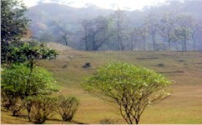 | 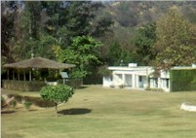

Figure 16: Existing Forest Cover along the Projected Road in Chandigarh U. T.
Forest Trek: A fire line which is laid down by the Forest Department to reduce fire hazard serves the dual purpose of a trek, has gained popularity among health conscious citizens and tourists. The trek is 8 Km long and runs over three hillocks and has a steep gradient. It originates at “Nepli Forest Lodge” and terminates at “Kansal Forest Lodge”. It is an educative trek which introduces a different kind of flora and fauna. Permission has to be sought from the “Chief Wilde Life Warden” (CWLW) before commencing on the trek. There are excellent places for trekking in the hills near Chandigarh. Most of these routes are in Himachal Pradesh and Haryana. Some of the prominent trekking routes are:

- Kalka to Kasauli (15 Km);
- Jabali to Kasauli (06 Km);
- Morni to Tikar Tal (07 Km);
- Morni to Ghagar River (04 Km);
- Kasauli to Sabathu (13 Km);

No “Trees” were allowed to be cut from the “Reserved Forests” (RF). During the first decade of the present century IT City Chowk to Kurali Chandigarh Road were the only towns of commercial importance in the erstwhile/ former/ previous State.

TRAFFIC: Projected Traffic

The daily traffic volume count has been carried out at 2 locations considering the traffic intensity and merging and diverging traffic on the project road corridor. To convert the mixed traffic into common unit, passenger car unit factor is used as given in “Indian Road Congress” (IRC) 102: 1988; Report Data. Adopted equivalent passenger car units and “Details of Reserved Forest with Existing and Design Chainage” for the study have been presented in Table 31. A summary of traffic data in terms of “Annual Average Daily Traffic” (ADT) and “Passenger Car Unit” (PCU) has been presented in Figures 17 (a) to (b) to have better appreciation. The report is concerned about IT City Chowk to Kurali Chandigarh Road and the Traffic Survey Locations and Schedules are given below:

Figure 17 (a): Daily Variations of Traffic Volume at IT City Chowk (Chainage 00 + 000) to Kurali Chandigarh (Chainage 31 + 230) on Projected Road.

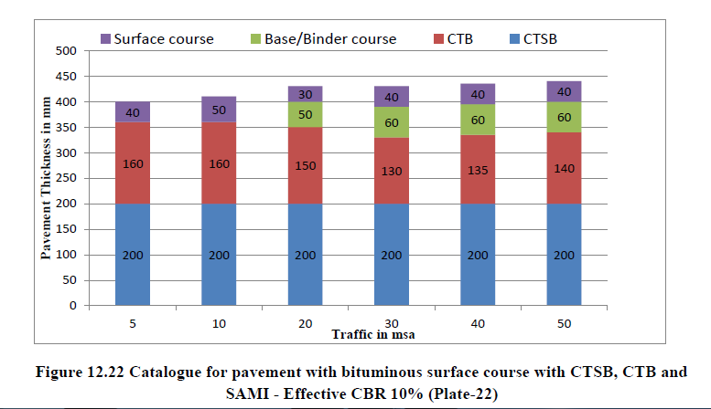

Figure 17 (b): Catalogue for Pavement with Bituminous Surface with CTSB, CTB and SAMI – Effective CBR 10% (Plate – 22).

ROAD JUNCTIONS/ INTERSECTIONS

Major Bridge/ Minor Bridge/ Submergence and Cross Drainage Work Structures

There is 00 Nos. of Vented Cause Way (VCW); 00 Nos. of Flush Causeway; 00 Nos. of Hume Pipe Culvert (HPC); 53 Nos. Culverts; 06 Nos. of Arch or Minor Bridges; 02 Nos. of Major Bridges; 01 Nos. of ROB; 07 Nos. of VUP; 10 Nos. of LVUP; 02 Nos. of SVUP; 01 Nos. of VOP; and 07 Nos. of Flyovers along the present Existing Road from Km 00.000 to Km 31.230 (IT City Chowk to Kurali Chandigarh Road). Various cross roads join the project road at different locations. Project road is having 02 Major and 06 Minor intersections. During inventory and condition survey, the details of culverts wise Improvement Proposal containing Rehabilitation, Widening or Reconstruction. Crust design has been done based on the field CBR evaluated from the samples collected from site during field survey at every 1.0 Km interval and critical CBR has been adopted for crust design in accordance with IRC – 37: 2012, using 10% CBR for sub grade and from the curves as mentioned in IRC: 37 – 2012 pavement thickness were computed for the relevant million standard axles and pavement thickness required for the above designed MSA and as per IRC guidelines is shown in following Tables 32 (a) to (e).

Table 32 (a): Crust/ Pavement Composition IT City Chowk to Kurali Chandigarh Road.

Sr. No. | Section/ Location/ Region/ Area | Adopted (MSA) | CBR (%) | Crust/ Pavement Composition (mm)
 |  |  |  | BC | DBM | WMM | GSB
A | B | C | D | E | F | G | H
1. | IT City Chowk to Kurali Chandigarh Road | 05 | 10% | 40 | 60 | 250 | 200

Table 32 (b): Soil Classification IT City Chowk to Kurali Chandigarh Road.

Chainage @ |  | Type of Soil
From | To
0,000 | 1,450 | Ordinary Rock
1,450 | 2,150 | All Kind of Soil
2,150 | 3,170 | Hard Rock
3,170 | 4,560 | All Kind of Soil
4,560 | 5,750 | Ordinary Rock
5,750 | 7,760 | Hard Rock
7,760 | 8,950 | Ordinary Rock
8,950 | 9,980 | All Kind of Soil
9,980 | 11,250 | Hard Rock
11,250 | 13,560 | Ordinary Rock
13,560 | 14,630 | All Kind of Soil
13,560 | 16,645 | Hard Rock

The project stretch is spread on a “Wide Flat Ground” (Plateau) surrounded by flat region or low level hills and it is more or less “26.9 Km” from “Kurali Chandigarh”. The remaining portion of the project stretch is traversing in plain terrain “IT City Chowk” and ends at “Kurali Chandigarh”. In this various cross roads also join the project road at different locations as shown in the Figure 17 (c). The projected road encountered with 5 Major and 26 Minor intersections.

- Via Kurali Chandigarh Road Distance around 26.9 Km (34 Minutes);
- Via Kurali Chandigarh Road and Udyog Path Distance Near About 29.7 Km (36 Minutes);
- Via Ropar – Chandigarh Road Distance Approximately 27.5 Km (37 Minutes);

Figure 17 (c): Kurali Chandigarh Road Distance around 26.9 Km (34 Minutes).

Table 32 (c): List of Junctions’/ Cross Roads Composition IT City Chowk to Kurali Chandigarh Road.

Sr. No. | @ Location/ Chainage (Km) | Type of  Destinations or Crossing Road | Type of Carriageway | Lane  Configuration | Type of Junction | Remark
A | B | C | D | E | F | G
1. | 0 + 000 | NH – 205 – A | BT | 2 Lane – Banur – Kharar Road  8 Lane Airport Side | X | IT CITY Junction (Airport Side)  L/S – Banur  R/S – Kharar
2. | 0 + 783 | Village Road | BT | 3.75 (Single Lane) | X | L/S Nagri  R/S Dairi
3. | 2 + 838 | Village Road | BT  (Under Construction) | 3.75 (Single Lane) | X | L/S – Natian  R/S – Gudana
4. | 3 + 340 | Village Road | BT | 3.0 | X | L/S Dhelpur  R/S Gudana
5. | 3 + 610 | Village Road | BT | 3.75 (Single Lane) | X | L/S - Talpur  R/S – Dhirpura
6. | 3 + 705 | Village Road | BT | 3.0 | X | L/S Dhelpur  R/S Gobindgarh
7. | 6 + 530 | Village Road | BT | 3.75 (Single Lane) | X | L/S – Patran  R/S – Chudaila
8. | 7 + 072 | Village Road | BT | 3.0 | X | L/S – Patran  R/S – Soe Majra
9. | 7 + 490 | Village Road | BT | 3.75 (Single Lane) | X | R/S Chudiala
10. | 9 + 308 | Village Road | BT | 3.75 (Single Lane) | X | L/S – Machhli Kalan R/S – Machhli Khurd
11. | 9 + 567 | Village Road | BT | 3.75 (Single Lane) | X | L/S – Machhli Kalan  R/S – Chuhar Majra
12. | 10 + 638 | Village Road | BT | 3.75 (Single Lane) | X | L/S – Machhli Kalan  R/S – Jhanjheri
13. | 11 + 234 | Village Road | BT | 3.0 | X | L/S – Makran  R/S – Jhanjheri
14. | 12 + 296 | SH – 12A | BT | 7.0 M | X | L/S – Sirhind  R/S – Mohali City
15. | 14 + 575 | Village Road | BT | 3.5 | X | L/S – Rangian  R/S – Cholta Kalan
16. | 15 + 830 | Village Road | BT | 3.5 | X | L/S – Cholta Khurd  R/S – Cholta Kalan
17. | 16 + 265 | Village Road | BT | 3.5 | X | L/S – Cholta Khurd  R/S – Madan Heri
18. | 17 + 030 | Village Road | BT | 7.0 M | X | L/S – Cholta Khurd  R/S – Chandigarh City
19. | 19 + 290 | Village Road | BT | 3.75 | X | L/S – Bajheri  R/S – Kharar
20. | 20 + 463 | Village Road | BT | 3.75 | X | L/S – Simbal Majra  R/S – Pir Sohna
21. | 20 + 605 | Railway Crossing | Broad Gauge | Single Track | X | L/S – Morinda  R/S – Chandigarh City
22. | 22 + 080 | NH – 05 | BT | 4 Lane | X | L/S – Morinda  R/S – Kharar
23. | 23 + 665 | Village Road | BT | 3.75 | X | L/S – Hasanpur  R/S – Savada
24. | 25 + 203 | Village Road | BT | 3.75 | X | L/S – Barouli  R/S – Padiala
25. | 26 + 348 | Village Road | BT | 3.75 | X | L/S – Kalewal  R/S – Padiala
26. | 26 + 668 | Village Road | BT | 3.75 | X | L/S – LNT Constuction  Workshop  R/S – Padiala
27. | 27 + 040 | Village Road | BT | 3 | X | L/S – Connect to NH – 205  R/S – Padiala
28. | 27 + 125 | NH – 205 | BT | 6 Lane | X | L/S – Khurali  R/S – Kharar
29. | 28 + 458 | Village Road | BT | 3.75 | X | L/S – Chandewala  R/S – Jhingarh Kala
30. | 30 + 840 | Village Road | BT | 3.75 | X | L/S – Connect to Kurali – Chandigarh Rd  R/S – Shekhpura
31. | 31 + 230 | NH | BT | 4 Lane | T | L/S – Kurali  R/S – Chandigarh

Table 32 (d): Existing Bridges, Cross Drainage and Culverts Structures.

Type of Structure  (TS) Section – II | Major Bridges (MB) | Minor Bridges (MB) | Slab/ Arch/ Box Culvert  (S/ A/ BC) | Vented Cause Way  (VCW) | Hume Pipe Culvert (HPC) | ROB/ VUP/ LVUP/ SVUP/ VOP | Flush Cause Way (FCW) | Flyover
A | B | C | D | E | F | G | H | I
Existing Structure 89 Nos. | 02 | 06 | 53 | 00 | 00 | 01/ 07/ 10/ 02/ 01 | 00 | 07

Table 32 (e): Details of Major Bridge Structures (Bailey Bridge).

Sr. No. | Design @ Chainage/ Location (In Km) | Proposal Type | Span Arrangement (m) | Remarks
A | B | C | D | E
1. | 18 + 456 | RCC Girder | 3 × 30.0 | -------
2. | 29 + 800 | Precast PSC Girder | 7 × 30.0 | Siswan Nadi

Table 32 (f): Details of Minor Bridge Structures (Bailey Bridge).

Sr. No. | Design @ Chainage/ Location (In Km) | Proposal Type | Span Arrangement (m) | Remarks
A | B | C | D | E
1. | 0 + 338 | BOX | 4 × 10.0 | -------
2. | 1 + 300 | BOX | 1 × 10.0 | -------
3. | 10 + 185 | RCC – Girder | 2 × 30.0 | -------
4. | 13 + 130 | RCC – Girder | 2 × 20.0 | -------
5. | 14 + 830 | BOX | 1 × 15.0 | -------
6. | 21 + 500 | BOX | 1 × 10.0 | -------

Table 32 (g): Details of Railway Over Bridge (ROB).

Sr. No. | Design @ Chainage/ Location (In Km) | Proposal Type | Span Arrangement (m) | Remarks
A | B | C | D | E
1. | 20 + 605 | Composite Steel Girder | 1 × 15.0 + 1 × 37.20 + 1 × 15.0 | -------

Table 32 (h): Details of Crossing Culverts.

Sr. No. | Design @ Chainage/ Location (In Km) | Proposal Type | Span Arrangement (m) | Remarks
A | B | C | D | E
1. | 1 + 100 | BOX | 1 × 2.0 × 2.0 | -------
2. | 1 + 445 | BOX | 1 × 4.0 × 3.0 | Crossing Culvert
3. | 1 + 735 | BOX | 1 × 6.0 × 3.0 | Crossing Culvert
4. | 2 + 150 | BOX | 1 × 2.0 × 2.0 | -------
5. | 2 + 555 | BOX | 1 × 2.0 × 2.0 | -------
6. | 3 + 400 | BOX | 1 × 6.0 × 3.0 | -------
7. | 3 + 705 | BOX | 1 × 2.0 × 2.0 | -------
8. | 4 + 605 | BOX | 1 × 6.0 × 3.0 | Crossing Culvert
9. | 5 + 055 | BOX | 1 × 4.0 × 3.0 | Crossing Culvert
10. | 5 + 500 | BOX | 1 × 2.0 × 2.0 | -------
11. | 5 + 910 | BOX | 1 × 4.0 × 3.0 | Crossing Culvert
12. | 6 + 650 | BOX | 1 × 2.0 × 2.0 | -------
13. | 7 + 072 | BOX | 1 × 4.0 × 3.0 | Crossing Culvert
14. | 7 + 590 | BOX | 1 × 2.0 × 2.0 | -------
15. | 8 + 100 | BOX | 1 × 2.0 × 2.0 | -------
16. | 8 + 700 | BOX | 1 × 6.0 × 3.0 | -------
17. | 9 + 310 | BOX | 1 × 6.0 × 3.0 | Crossing Culvert
18. | 9 + 700 | BOX | 1 × 4.0 × 3.0 | Crossing Culvert
19. | 10 + 354 | BOX | 1 × 4.0 × 3.0 | Crossing Culvert
20. | 10 + 635 | BOX | 1 × 6.0 × 3.0 | -------
21. | 11 + 355 | BOX | 1 × 2.0 × 2.0 | -------
22. | 11 + 655 | BOX | 1 × 5.0 × 5.0 | Crossing Culvert
23. | 12 + 420 | BOX | 1 × 2.0 × 2.0 | -------
24. | 13 + 550 | BOX | 1 × 2.0 × 2.0 | -------
25. | 13 + 738 | BOX | 1 × 4.0 × 3.0 | Crossing Culvert
26. | 14 + 200 | BOX | 1 × 2.0 × 2.0 | -------
27. | 15 + 048 | BOX | 1 × 4.0 × 3.0 | Crossing Culvert
28. | 15 + 535 | BOX | 1 × 2.0 × 2.0 | -------
29. | 16 + 140 | BOX | 1 × 2.0 × 2.0 | -------
30. | 16 + 680 | BOX | 1 × 2.0 × 2.0 | -------
31. | 17 + 340 | BOX | 1 × 2.0 × 2.0 | -------
32. | 18 + 070 | BOX | 1 × 2.0 × 2.0 | -------
33. | 19 + 300 | BOX | 1 × 2.0 × 2.0 | -------
34. | 20 + 069 | BOX | 1 × 4.0 × 3.0 | Crossing Culvert
35. | 21 + 165 | BOX | 1 × 4.0 × 3.0 | Crossing Culvert
36. | 21 + 750 | BOX | 1 × 4.0 × 3.0 | Crossing Culvert
37. | 22 + 540 | BOX | 1 × 2.0 × 2.0 | -------
38. | 23 + 335 | BOX | 1 × 2.0 × 2.0 | -------
39. | 24 + 070 | BOX | 1 × 4.0 × 3.0 | Crossing Culvert
40. | 24 + 426 | BOX | 1 × 4.0 × 3.0 | Crossing Culvert
41. | 24 + 968 | BOX | 1 × 4.0 × 3.0 | Crossing Culvert
42. | 25 + 450 | BOX | 1 × 2.0 × 2.0 | -------
43. | 25 + 870 | BOX | 1 × 4.0 × 3.0 | Crossing Culvert
44. | 26 + 525 | BOX | 1 × 2.0 × 2.0 | -------
45. | 27 + 035 | BOX | 1 × 2.0 × 2.0 | -------
46. | 27 + 670 | BOX | 1 × 6.0 × 3.0 | Crossing Culvert
47. | 28 + 200 | BOX | 1 × 2.0 × 2.0 | -------
48. | 28 + 770 | BOX | 1 × 2.0 × 2.0 | -------
49. | 29 + 150 | BOX | 1 × 4.0 × 3.0 | Crossing Culvert
50. | 29 + 555 | BOX | 1 × 4.0 × 3.0 | Crossing Culvert
51. | 29 + 985 | BOX | 1 × 6.0 × 3.0 | Crossing Culvert
52. | 30 + 585 | BOX | 1 × 2.0 × 2.0 | -------
53. | 31 + 100 | BOX | 1 × 2.0 × 2.0 | -------

Table 32 (i): Details of Small Vehicular Underpasses (SVUP’s).

Sr. No. | Design @ Chainage/ Location (In Km) | Proposal Type | Span Arrangement (m) | Remarks
A | B | C | D | E
1. | 12 + 735 | SVUP | RCC BOX | 1 × 7.0 × 4.0
2. | 17 + 705 | SVUP | RCC BOX | 1 × 7.0 × 4.0

Table 32 (j): Details of Light Vehicular Underpasses (LVUPs).

Sr. No. | Design @ Chainage/ Location (In Km) | Proposal Type | Span Arrangement (m) | Remarks
A | B | C | D | E
1. | 0 + 783 | L/S Nagri R/S Khrar Road (NH – 205A) | RCC Box | 1 × 12 × 4.5
2. | 3 + 610 | L/S – Talpur R/S – Dhirpura | RCC Box | 1 × 12 × 4.5
3. | 11 + 234 | L/S – Todar Majra R/S – Jhanjheri | RCC Girder | 1 × 12 × 4.5
4. | 14 + 575 | L/S – Rangian R/S – Cholta Kalan | RCC Girder | 1 × 12 × 4.5
5. | 15 + 830 | L/S – Cholta Khurd R/S – Cholta Kalan | RCC Girder | 1 × 12 × 4.5
6. | 18 + 700 | ------- | RCC Girder | 1 × 12 × 4.5
7. | 23 + 665 | L/S – Hasanpur R/S – Savada | RCC Girder | 1 × 12 × 4.5
8. | 25 + 203 | L/S – Barouli R/S – Padiala | RCC Box | 1 × 12 × 4.5
9. | 26 + 670 | L/S – Kalewal R/S – Padiala | RCC Box | 1 × 12 × 4.5
10. | 30 + 840 | L/S – Kurali R/S – Shekhpura | RCC Box | 1 × 12 × 4.5

Table 32 (k): Details of Vehicular Underpasses (VUP).

Sr. No. | Design @ Chainage/ Location (In Km) | Proposal Type | Span Arrangement (m) | Remarks
A | B | C | D | E
1. | 2 + 838 | L/S – Natian R/S – Gudana | RCC Girder | 1 × 20.0 × 5.50
2. | 6 + 530 | L/S – Patran, R/S – Chudaila | RCC Girder | 1 × 20.0 × 5.50
3. | 9 + 567 | L/S – Machhli Kalan R/S – Chuhar Majra | RCC Girder | 1 × 20.0 × 5.50
4. | 17 + 030 | L/S – Cholta Khurd R/S – Chandigarh City | RCC Girder | 1 × 20.0 × 5.50
5. | 20 + 463 | L/S – Simbal Majra R/S – Pir Sohna | RCC Girder | 1 × 20.0 × 5.50
6. | 20 + 900 | ------- | Precast PSC Girder | 1 × 30.0 × 5.50
7. | 28 + 458 | L/S – Chandewala R/S – Jhingarh Kala | RCC Girder | 1 × 20.0 × 5.50

Table 32 (l): Details of VOP at Start Point Towards Airport Side.

Sr. No. | Design @ Chainage/ Location (In Km) | Proposal Type | Span Arrangement (m) | Remarks
A | B | C | D | E
1. | 0 + 000 | Composite Steel Girder | 2 × 13.0 | At Start Point Towards Airport Side

Table 32 (m): Details of Flyover IT City Kurali Road to Banur.

Sr. No. | Design @ Chainage/ Location (In Km) | Proposal Type | Span Arrangement (m) | Remarks
A | B | C | D | E
1. | 0 + 000 | PSC Girder | 2 × 30.0 + 2 × 45.0 +  2 × 30.0 | Flyover for Right Turn (IT City Kurali Road to Banur)
2. | 12 + 296 | PSC Girder | 2 × 30.0 | -------
3. | 22 + 080 | PSC Girder | 2 × 30.0 | -------
4. | 23 + 150 | Voided Slab | 4 × 30.0 | Flyover for U – Turn
5. | 27 + 125 | PSC Girder | 2 × 30.0 | -------
6. | 27 + 125 | PSC Girder | 2 × 30.0 | At Kurali Bypass
7. | 31 + 230 | PSC Girder | 7 × 30.0 | -------

TRAFFIC Surveys: Characteristics on Projected Road

In this chapter, the report is concerned about IT City Chowk to Kurali Chandigarh Road. Traffic Survey Locations and Schedules were, the summary of all data collected from traffic volume survey for the 2 locations on the section is presented as “Average Daily Traffic” (ADT) for the month of 9th October, 2020 is summarized as given below (Table 33). In order to capture traffic and travel characteristics, speed characteristics, users’ preference regarding toll imposition of traffic passing through the existing alternative routes for Package – II – IT City Chowk to Kurali Chandigarh Road from Memmadpur (Ambala) – Banur (IT City Chowk) – Kharar – Kurali Chandigarh Road, following primary traffic surveys were conducted:

- Classified Traffic Volume Count (CTVC);
- Origin – Destination Survey (OD);
- Axel Load Survey (ALS);

The classified volume count surveys were carried out at two locations, considering the possibility of diversion of traffic from existing alternative routes to proposed NHAI. These locations are characterized by centers of heavy economic activities, population and are away from the influence of city areas in order to avoid the influence of local traffic. The surveys were conducted continuously for seven consecutive days for 24 hours. The “Average Daily Traffic” (ADT) value of base year (FY – 2020) is used for the traffic volume projection up to horizon year and projected traffic volume is used in design of pavement and for projecting the toll able traffic.

Table 33: Classified Different Average Daily Traffic (ADT) Surveys, Schedules and Dates of Commencement at Two Locations.

Sr. No. | Location/ Chainage (Km) | Start to End Date of Traffic Survey |  | Duration
 |  | From | To
IT City Chowk to Kurali Chandigarh
Classified Traffic Volume Count
1. | IT City Chowk | 09/ 10/ 2020 | 15/ 10/ 2020 | 7 Days/ 24 Hours
2. | Shahid Bhagat Singh Khalsa College Near Kurali Bypass | 09/ 10/ 2020 | 15/ 10/ 2020 | 7 Days/ 24 Hours
 | Survey Location | Average Daily Traffic (nos.) | Average daily PCUs (nos.)
1. | IT City Chowk | 19,643 | 26,019 | -------
2. | Shahid Bhagat Singh Khalsa College Near Kurali Bypass | 15,321 | 23,050 | -------
 | Type of Vehicles | Survey Location
 |  | IT City Chowk | Shahid Bhagat Singh Khalsa College Near Kurali Bypass
 | AA | BB | CC | DD
Tollable Traffic No.
1. | Car/ Jeep/ Van | 10,822 | 5,133 | -------
2. | Taxi
3. | Shared Jeep
4. | Mini Bus | 16 | 01 | -------
5. | School Bus | 168 | 215 | -------
6. | Government Bus
7. | Private Bus
8. | Max/ Pick – Up | 00 | 00 | -------
9. | LCV (4 – Tyre) | 1,185 | 1,340 | -------
10. | LCV (6 – Tyre)
11. | 2 – Axle | 1,056 | 1,533 | -------
12. | 3 – Axle | 907 | 1,203 | -------
13. | MAV (4 to 6  Axles) | 905 | 946 | -------
14. | MAV (> 6 Axles) | 00 | 00 | -------
15. | Others | 00 | 00 | -------
 | Total Tollable (Nos.) | 15,059 | 10,371 | -------
 | Total Tollable (PCUs) | 23,090 | 20,255 | -------
Non – Tollable Traffic No.
1. | 3 – Wheeler | 270 | 399 | -------
2. | 2 – Wheeler | 4,161 | 4,510 | -------
3. | Agriculture Tractor | 34 | 10 | -------
4. | Agriculture Tractor/ Trailer | 117 | 28 | -------
5. | Cycle | 00 | 00 | -------
6. | Cycle Rickshaw | 00 | 00 | -------
7. | Animal Drawn Cart | 00 | 00 | -------
8. | Others | 02 | 03 | -------
 | Total  Non – Tollable (Nos.) | 4,584 | 4,950 | -------
 | Total Non – Tollable (PCUs) | 2,929 | 2,795 | -------
 | Grand Total (Nos.) | 19,643 | 15,321 | -------
 | Grand Total (PCUs) | 26,019 | 23,055 | -------

Capacity Analysis of Project Highway

Capacity Analysis of Project Highway for section has been carried out in order to define the “Level of Service” (LOS) offered by road sections under the prevailing roadway and traffic conditions. Capacity and design service volumes for various lane configurations specified by IRC: 64 – 1990: “Capacity of Roads in Rural Areas” (CRRA) has been adopted for determining the Level of Service offered by the road sections during design period. Standards for lane width of National Highways and Road developed under Central Sector Schemes in Hilly and Mountainous Terrains in Circular No.: NH – 150/ 28/ 2018 – P and M Dated, 23rd March, 2018 (Table 34).

Table 34: Categorized Average Daily Traffic (ADT) Inventory Reviews and Periods of Instigation at Two Locations.

AVERTAGE DAILY TRAFFIC INVENTORY SURVEY
(Date: 09/ 10/ 2020 to 15/ 10/ 2020)
Road Name: IT City Chowk to Kurali Chandigarh
Section : IT City Chowk to Kurali Chandigarh From Km 00 + 000 To 31 + 230 Km. |  |  |  |  |  |  |  |  | Direction: Bothways
Location  (Km) | Motorized Traffic |  |  |  |  |  |  |  |  |  |  |  |  |  | Non – Motorized Traffic |  | Grand Total
 | Passenger Vehicles |  |  |  |  | Goods Vehicles |  |  |  | Agricultural |  | Army Vehicles |  |  | Passenger
 | Two Wheeler | Three Wheeler | Car/ Jeep | Mini Bus | Bus | Tempo/ LCV | Road Trucks |  |  | Tractor with Trailer | Tractor | Army Car | Army Bus | Army Trucks | Cycle Rickshaw | Hand Cart | ADT | PCU
 |  |  |  |  |  |  | 2 – Axle | 3 – Axle | M – Axle
PCU Factor | 0.5 | 1.0 | 1.0 | 1.5 | 3.0 | 1.5 | 3.0 | 3.0 | 4.5 | 4.5 | 1.5 | 1.0 | 4.0 | 3.0 | 2.0 | 3.0 | ----- | -----
IT City Chowk  (00 + 000) | 4,161 | 270 | 10,822 | 16 | 2.0 | 1,185 | 1,056 | 907 | 905 | 117 | 34 | 9.o | 00 | 18 | 00 | 00 | 19,643 | 26,019
Shahid Bhagat Singh Khalsa College Near Kurali Bypass  (31 + 230) | 4,510 | 399 | 5,133 | 01 | 2.0 | 1,340 | 1,533 | 1,203 | 946 | 28 | 10 | 47 | 00 | 43 | 00 | 00 | 15,321 | 23,055
Average of All Locations | 4,336 | 335 | 7,978 | 09 | 02 | 1,263 | 1,295 | 1,055 | 926 | 73 | 22 | 47 | 00 | 31 | 00 | 00 | 17,482 | 24,537

Capacity analysis for the project corridor is carried out in order to assess the “Level of Service” (LOS) offered by road sections under prevailing roadway and traffic conditions. Capacity and “Design Service Volumes” (DSV) specified in IRC: 64 – 1990, Capacity of Roads in Rural Areas have been adopted for determining the Level of Service offered by road sections during the design period. Based on the average rise and fall observed from the field surveys, the project corridor runs through Plain terrain. As there are no guidelines for capacity of 6 – Lane highway the same is estimated based on per lane hourly capacity estimated from capacity guidelines given in IRC: 64 – 1990 for 4 – Lane highway. As per the study lane capacity estimated is 2,150 PCUs/ Hour. Apply 8% peak hour factor and 60% directional distribution, capacity thus estimated for 6 – Lane Highway. The capacity and design service volumes for various lane configurations in case of plain terrain at different LOS’s are presented in Table 35 below.

Table 35: Capacity; Level of Service and Design Service Volume.

Sr. No. | Road | Shoulder Type | Plain Terrain
 |  |  | Capacity (PCU/ Day) | DSV (PCUS/ Day)
 |  |  |  | LOS – B | LOS – C | LOS – D
1. | 4 – Lane* | Earthen Shoulders | 70,000 | 35,000 | 49,000 | 59,500
 |  | Paved Shoulders | 80,500 | 40,250 | 56,350 | 68,425
 |  | With 7 m Service Road | 1,34,000 | 67,000 | 94,000 | 1,14,000
2. | 6 – Lane** | Paved Shoulders | 1,34,000 | 67,000 | 94,000 | 1,14,000
3. | 6 – Lane | Paved Shoulder with 5.5 m Service Road on Both Sides | 1,46,375 | 73,188 | 1,02,463 | 1,24,419
4. | 6 – Lane*** | Paved Shoulders | 90,000 | ------- | ------- | -------

- IT City Chowk at Km 00 + 000

Survey was carried out at IT City Chowk (Chainage 00 + 000 Km). Selected location lies between IT City Chowk to Kurali Chandigarh Road is away from urban section to avoid influence of local traffic. ADT recorded at this station is 19,643 Nos. / 26,019 PCU. Fast moving vehicles were recorded as 100% of the “Total Traffic” (in PCU). Peak hour traffic flow of 788 Nos. formed around 4.01% of the total traffic. Peak hour is identified during 02: 00 AM to 03: 00 PM. There will be variation of traffic for each day.

- Shahid Bhagat Singh Khalsa College near Kurali Bypass at Km 27 + 150

Survey was carried out at Shahid Bhagat Singh Khalsa College near Kurali Bypass (Chainage 27 + 150 Km). Selected location lies between IT City Chowk to Kurali Chandigarh Road is away from urban section to avoid influence of local traffic. ADT recorded at this station is 15,321 Nos. / 23,050 PCU. Fast moving vehicles were recorded as 100% of the “Total Traffic” (in PCU). Peak hour traffic flow of 645 Nos. formed around 4.20% of the total traffic. Peak hour is identified during 10: 00 AM to 11: 00 AM. There will be variation of traffic for each day.

Survey was carried out in “IT City Chowk to Kurali Chandigarh Road” (00 + 000 and 27 + 150) and “Average Daily Traffic” (ADT) recorded at this station is 19,643 Nos. / 26,019 PCU and 15,321 Nos. / 23,050 “Passenger Car Unit” (PCU). Fast moving vehicles were recorded as 100% and 99.05% of the “Total Traffic” (in PCU). Peak hour traffic flow of 788 Nos. and 645 Nos. formed around 4.01% and 4.20% of the total traffic and peak hour is identified during 2:00 PM to 3:00 PM and 10:00 AM to 11:00 AM respectively.

Analysis of Classified “Traffic Continuous Volume Count” (TCVC) Survey

The objective of “Traffic Continuous Volume Count” (TCVC) survey is to estimate traffic intensity on the projected road. The traffic volume count at two locations has been carried out continuously for 7 consecutive days for 24 hours on each day. 7 – Day Continuous volume counts were undertaken to obtain a realistic picture of the current volume and composition of the traffic. The analysis of traffic counts provided an estimate of the “Average Daily Traffic” (ADT). The analysis has been carried out in terms of total number of vehicles and also in respect to “Passenger Car Unit” (PCU). Location wise results of analysis are discussed below. The counts were recorded in the formats as per IRC – specifications. Classified volume count survey has been carried out at two locations the details are given above in the Table 35. Reconnaissance survey was conducted on the “Projected Road” (PR) for selection of locations for various traffic surveys. While selecting the traffic volume survey location, consultants have considered the aspect of private sector participation in this road development and accordingly, the locations were selected. The first location has been selected near “IT City Chowk” at “Chainage 00 + 000”, the second TCVC location has been chosen near “Shahid Bhagat Singh Khalsa College near Kurali Bypass” at “Chainage 27 + 150” respectively.

Axle Load Survey

The vehicle damage factor is a multiplier for converting the number of commercial vehicles of different axle loads to the number of standard axle load repetitions. Design of new pavement for additional lane or strengthening of existing pavement is based upon the cumulative number of 80 KN (IRC: 37 – 2018 Clause No.: 4.4.2) “Equivalent Standard Axles” (ESA) that will pass over during the 15 – year design period. The classes of traffic which lead to significant axle loads (or damage) to the pavement and accordingly considered for design are: LCVs, Two/ Three axle and Multi Axle Trucks. “Cumulative Standard Axles” (CSA) are calculated in accordance with the guidelines provided in IRC: 37 – 2018 and IRC: 81 – 1997. The overloaded vehicles have serious adverse impact on performance of pavement (Tables 36 and 37). It has been ascertained that the damaging effect of axles on flexible pavement is approximately proportional to the fourth power of the axle load (IRC: 37 – 2018 and Clause No.: 4.4.3).

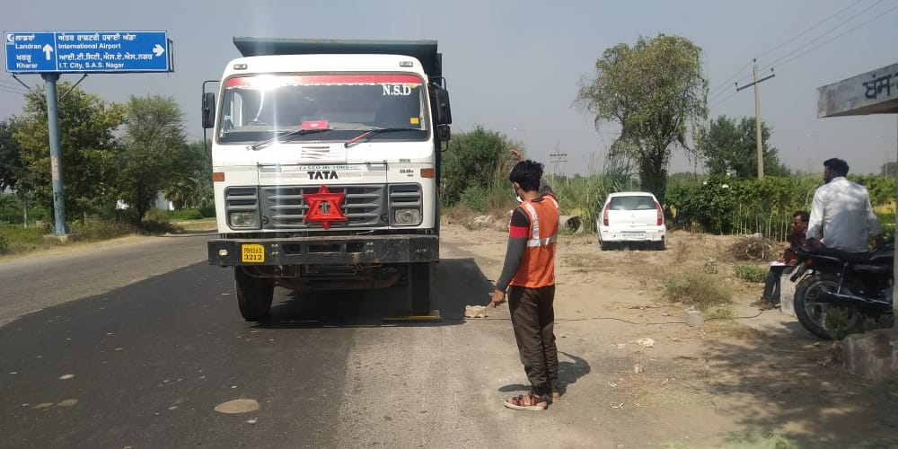
At Chainage: 00 + 000 to 27 + 150 (Axel Load Survey – 1).
The “Equivalent Single Axle Loads” (ESALs) have been Calculated Assuming that the Project Road will be Opened to Traffic in the Year 2022.

Table 36: Classified Summary “Variable Frequency Drive” (VFD) Surveys of Commencement at Two Locations.

“Variable Frequency Drive” (VFD) Surveys’ Calculation
Sr. No. | Type | IT City Chowk to Kurali |  |  | Kurali to IT City Chowk |  |  | Adopted VDF
 |  | VFD Actual | VFD with Legal Limit | VFD with 20% Legal Limit | VFD Actual | VFD with Legal Limit | VFD with 20% Legal Limit | VFD  Actual | VFD with Legal Limit | VFD with 20% Legal Limit
 | AA1 | BB1 | CC1 | DD1 | EE1 | FF1 | GG1 | HH1 | II1 | JJ1
1. | LCV | 0.024 | 0.024 | 0.024 | 0.052 | 0.052 | 0.052 | 0.052 | 0.052 | 0.052
2. | 2 – AXLE | 2.630 | 2.545 | 3.394 | 2.669 | 2.603 | 3.256 | 2.669 | 2.603 | 3.394
3. | 3 – AXLE | 4.168 | 3. 513 | 5.683 | 4.234 | 3. 541 | 5.268 | 4.234 | 3. 541 | 5.683
4. | MAV | 7.676 | 4.518 | 7.364 | 5.964 | 3.987 | 6.157 | 7.676 | 4.518 | 7.364
Note: Calculation Detail is given in Annexure – V (B) of Main Report;

Table 37: Classified Summary “Million Standard Axle” (MSA) Surveys of Commencement at Two Locations.

Name of the Road | MSA for 20th (00 + 000)
IT City Chowk to Kurali Chandigarh Road | 69.30
Note: Calculation Detail is given in Annexure – V (C) of Main Report;

Economic and Financial Analysis

Any infrastructure project, which is in terms of improving the existing facility, is subjected to economic and financial analysis to establish its viability and ensure that the investment proposed would yield appropriate return either to the national economy of the private/ public investor/ sector.

Economic Costs of vehicle and tyre are derived from the market survey in Punjab. Representative retail price for each category of vehicle have been collected. Elements of taxes and duties applicable have been removed to arrive at the economic costs. Details of derived economic costs for each vehicle category are presented in the Table 38 as summary is given below:

Table 38: Details of Vehicle Category.

Sr. No. | Category | Two Wheeler | Three Wheeler | Medium Car | Bus | LCV | 2 – Axle Truck | 3 –Axle Truck | Multi Axle Truck
1. | Vehicle | 51,002 | 60,000 | 34,6105 | 1,10,1235 | 44,0494 | 7,80,042 | 8,94,754 | 9,36,050
2. | Tyre | 328 | 328 | 1,640 | 6,725 | 4,100 | 6,725 | 8,201 | 8,201

Traffic Growth Rate

The growth rates estimates were subjected to scenario analysis and the most likely case was adopted for the purpose of the present study. The traffic growth estimates scenario is based on the likely growth of the Indian economy and its relationship to the growth in the state economy. Information presented in the study area reveals that traffic growth is more than 7% in initial years of the project. Adopted growth rate is 5% Ref. IRC – 37, 2018, Page No.: 14 Clause 4.2.2 for commercial vehicles along the Section. The growth of remain traffic moving vehicles is taken as 5% “Reference: Ministry of Shipping, Road Transport and Highways, (18th January, 2008 Reference No.: RW/ NH – 37011/ 57/ 2006 – PIC) 5% Traffic Growth Rate.” Summary of projected traffic based on adopted growth rate is provided in Table 39 given below:

Table 39: Projected Traffic Volume, Vehicle/ Day and PCU/ Day IT City Chowk – Kurali Chandigarh Road.

Project Road | Year 2019 | Year 2022 | Year 2027 | Year 2032 | Year 2037
AA2 | BB2 | CC2 | DD2 | EE2 | FF2
Projection of “Average Daily Traffic” (ADT)
Total Fast Moving Vehicle  (Motorized Traffic) | 353 | 448 | 572 | 730 | 931
Slow Moving Vehicle  (Non – Motorized Traffic) | 000 | 000 | 000 | 000 | 000
Traffic (Number) | 353 | 448 | 572 | 730 | 931
Projection (PCUs/ Day) | (520) | (659) | (841) | (1,073) | (1,370)
Note: Values in Bracket Indicate PCUs/ Day;

PAVEMENT COMPOSITIONS/ CONDITIONS

The existing project section has been constructed as per CL – 9 specifications from Km 00 + 000 to Km 31 + 230 length 31.23 Km with bituminous surface, “Carriageway Width” (CW) is generally varying from 3.60 meter to 5.20 meter and formation width 6.0 meter in general and at some location i.e., built – up area formation width up to 10.0 meter to 12 meter condition of the pavement is fair along the road and condition of shoulders is generally fair to poor. The existing alignment Section – II passes through the mountainous terrain. The flexible pavement is adopted for proposed carriageway reconstruction and Flexible Pavement design period of 15 year. That has been designed as per “IRC: SP: 37 – 2018; IRC: SP: 48 – 1998; IRC: SP: 87 – 2019”. The proposed pavement design standard is presented in table given below and hence the “Design of Proposed Better Crust Thickness for Ridge Pavement Composition” as is shown in the Table 42. The condition survey of existing pavement includes the assessment of pavement, shoulder, embankment and drainage condition. In pavement condition data regarding pavement distress like cracking, ravelling, potholes are recorded in terms of pavement affected. The edge break is measured in length and rutting is measured in mm depth. Shoulder Condition is assessed as earthen shoulder, corrugation or ruts development in mm and shoulder edge drop in mm.

Reconstruction Proposal

In order to meet future traffic requirement, the existing carriageway is proposed to upgrade to achieve high speed of travel with comfort and safety. “Concentric Widening” (CW) scheme shall be followed to minimise land acquisition issues and to ensure maximum utilisation of existing carriageway. Tables 40 to 45 given below shows relation between existing and proposed chainage and section wise improvement proposed for these section.

Table 40: Design of Existing – Proposed Chainage for Homogenous Section.

Sr. No. | Homogenous Section | Existing Chainage |  | Proposed Chainage
 |  | From | to | From | to
1. | IT City Chowk to Kurali Chandigarh Road | 00 + 000 | 31 + 230 | 00 + 000 | 31 + 230

Table 41: Design of Flexible Pavement for Homogenous Section.

Sr. No. | Homogenous Section (IT City Chowk to Kurali Chandigarh Road) | (Length = 31.230 Km)
1. | Design Period | 15 Year
2. | Design MSA | 10
3. | Design CBR (%) | 10
4. | Design CBR (%) for Hard Shoulder | 12
5. | BC (mm) | 40
6. | DBM (mm) | 75
7. | CSB (mm) | 150
8. | WMM (mm) | 250
9. | Granular/ Non Frost Substance Sub – Base (mm) | 200

Table 42: Design of Proposed Better Crust Thickness for Ridge Pavement Composition.

Sr.  No. | Section | CVPD |  |  |  | CBR | Pavement Composition (mm)
 |  | Present Year 2017 | Base Year 2020 | 15 Year | 30 Year | (%) | BC | DBM | CRM | GSB
1. | IT City Chowk to Kurali Chandigarh Road | 453 | 514 | 1,068 | 2,220 | 10% | 40 | 60 | 200 | 200

Table 43: Design of Curve Improvement Details Section.

Sr. No. | Curve Radius (m) | Curve Radius (m)
1. | 300 – 150 | 41
2. | 150 – 80 | 56
3. | 80 – 50 | 46
4. | 50 – 30 | 15
5. | Hair Pins | 04

Table 44: Summary of Flexible Pavement, Breast Wall, Hill Side Drain, Valley Side Crash Barrier for Structure Configuration.

Sr. No. | Type of Structure | Proposals | TCS
1. | Reconstruction of Flexible Pavement and Hill Side Drain Only; | 8,560 | I
2. | Reconstruction of Flexible Pavement, Hill Side Drain and Valley Side Crash Barrier; | 2,050 | I (A)
3. | Reconstruction of Flexible Pavement and Both Side Drain Only; | 2,400 | II
4. | Reconstruction of Flexible Pavement, Hill Side Drain, Breast Wall and Valley Side Crash Barrier; | 550 | III
5. | Reconstruction of Flexible Pavement, Both Side Drain and one Breast Wall; | 1,800 | IV
6. | Reconstruction of Flexible Pavement and Both Side Breast Wall | 1,050 | V
 | Total Length of TCS (m) = | 16,410
Maintenance Labour and Crew Costs

Based on the market survey and inquiries from the various organizations, the maintenance labour cost/ hour and wages/ hour has been evaluated. Rates have been compared with that adopted for the recent studies before arriving at reasonable values.

Table 45: Maintenance Labour and Crew Costs Details.

Sr. No. | Category | Two Wheeler | Three Wheeler | Medium Car | Bus | LCV | 2 – Axle Truck | 3 – Axle Truck | Multi Axle Truck
1. | Main Labour | 14 | 14 | 18 | 23 | 21 | 23 | 29 | 29
2. | Crew Wage | 00 | 30 | 00 | 60 | 32 | 40 | 48 | 48
Detailed Calculation given in Annexure – VI of Main Report;

10. ENVIRONMENTAL IMPACT ASSESSMENT OF THE PROJECT

The environmental impact assessment has been carried out and which is based on status of the environment, and impact of proposed four lanning roads/ bridges based on these findings of the “Environmental Management Plans” (EMPs) have been prepared for the implementation in the project. Following section discusses status of the environment, and its complementary impact assessment work plan assigned to “Environmental Management Plans” (EMPs) required for the project development/ implementation system and process.

11. BASELINE ENVIRONMENTAL INDEX AND STATUS

Demographic and Climatic Conditions

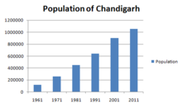

Population: Population growth in Chandigarh over the years. As of 2011 India census, Chandigarh had a population of 1,055,450, making for a density of about 9,252 (7,900 in 2001) persons per square kilometre. Males constitute 55% of the population and females 45%. The sex ratio is 818 females for every 1,000 males. The child sex ratio is 880 females per thousand males. Chandigarh has an effective literacy rate of 86.77% (based on population 7 years and above), higher than the national average; with male literacy of 90.81% and female literacy of 81.88%. 10.8% of the population is under 6 years of age. The population of Chandigarh forms 0.09% of India in 2011. There has been a substantial decline in the population growth rate in Chandigarh, with just 17.10% growth between 2001 and 2011. Since, 1951 – 1961 the rate has decreased from 394.13% to 17.10%. This is probably because of rapid urbanisation and development in neighbouring cities. The urban population constitutes as high as 97.25% of the total and the rural population makes up 2.75% as there are only a few villages within Chandigarh on its Western and South – Eastern Border and the majority of people live in the heart of Chandigarh.

Languages: English is the sole official language of Chandigarh. The majority of the population speaks Hindi (73.60%) while Punjabi is spoken by 22.03%. Government schools use English, Hindi and Punjabi Text Books. Languages of Chandigarh (2011) are given as below.

Hindi (73.60%);
Punjabi (22.03%);
Urdu (1.00%);
Nepali (0.62%);
Bengali (0.59%);
Tamil (0.53%);
Others (1.63%);

Religion: Hinduism is the predominant religion of Chandigarh followed by 80.78% of the population. Sikhism is the second most popular religion in the city, followed by 13.11% of the people. In Chandigarh city Islam is followed by 4.87%. Minorities are Christians 0.83%, Jains 0.19%, Buddhists 0.11%, those that didn't state a religion are 0.10%, and others are 0.02%. Many institutions serve minorities in the city. One such being the Roman Catholic Diocese of Simla and Chandigarh, serving the Catholics, which even has a co - cathedral in the city, Christ the King Co – Cathedral, although it never was a separate bishopric. Most of the convent schools of Chandigarh are governed by this institution. Chandigarh hosts many religious places, including Chandimandir, the temple after which it was named. The ISKCON temple in Sector 36 is one of the worship places for Hindus. Nada Sahib Gurudwara, a famous place for Sikh worship lies in its vicinity. Apart from this, there are a couple of historical mosques in Manimajra and Burail.

Religion in Chandigarh
Religion |  | Percent
Hinduism |  | 80.78%
Sikhism |  | 13.11%
Islam |  | 4.87%
Christianity |  | 0.83%
Others |  | 0.4%

Civic Utilities: The prime responsibilities of the civic body are to ensure cleanliness and sanitation in the city, illumination of street lights, maintenance of parks and sewerage disposal. The city has both brick and pipe sewers laid in four phases. In September 2020, the civic body announced that it would upgrade and renew the 50 – year – old sewerage system.

Economy: Chandigarh has been rated as one of the “Wealthiest Towns” (WT) of India. The Reserve Bank of India ranked Chandigarh as the third – largest deposit centre and seventh largest credit centre nationwide as of June 2012. With a per capita income of ₹ 99,262, Chandigarh is one of the richest cities in India. Chandigarh's gross state domestic product for 2014 – 15 is estimated at ₹ 0.29 Trillion (Short Scale) (US $ 4.3 Billion) at current prices. According to a 2014 survey, Chandigarh is Ranked 4th in the top 50 cities identified globally as “Emerging Outsourcing and IT Services Destinations” ahead of cities like Beijing.

Cultures and Festivals: Every year, in September or October during the festival of Navratri, many associations and organisations hold a Ramlila event which has been conducted for over 50 years. The “Rose Festival” in “Zakir Hussain Rose Garden” every February shows thousands of subspecies of roses. The “Mango Festival” held during the monsoons and other festivals are held at “Sukhna Lake”.

Transport and Road: CTU – AC, Bus starts/ operates outside railway station and Chandigarh has the largest number of vehicles per capita in India. Wide, well – maintained roads and parking spaces all over the city ease local transport. The “Chandigarh Transport Undertaking” (CTU) operates public transport buses from its “Inter State Bus Terminals” (ISBT) in Sectors 17 and 43 of the city. CTU also operates frequent bus services to the neighbouring states of Punjab, Haryana, and Himachal Pradesh and to Delhi.

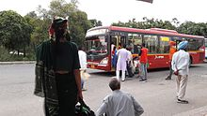

Highway Routes’ Connection: Chandigarh is well connected by road to the following nearby cities, by the following highway routes:

NH – 7 to Patiala in the South West.
NH – 152 to Ambala and Kaithal in the South (NH – 44 catches up from Ambala to Panipat – Delhi).
NH – 5 to Shimla in the Northeast, and to Ludhiana in the West.

Air: View of Chandigarh Airport new terminal Chandigarh Airport has scheduled commercial flights to major cities of India.

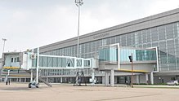
Railway Zone at Chandigarh: Chandigarh Junction Railway Station lies in the Northern Railway zone of the Indian Railway network and provides connectivity to most of the regions of India.

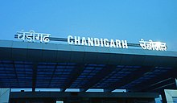

Education: Gandhi Bhavan built by Pierre Jeanneret for Panjab University. There are numerous educational institutions in Chandigarh. These range from privately and publicly operated schools to colleges. These include Panjab University, “Post Graduate Institute of Medical Education and Research” (PGIMER), Punjab Engineering College, Post Graduate Government College, Sector – 11, Chandigarh and DAV College. According to Chandigarh administration's department of education, there are a total of 115 government schools in Chandigarh, including Government Model Senior Secondary School, Sector 16, Jawahar Navodaya Vidyalaya, Bhavan Vidyalaya, Convent Schools like St. Stephen's School, St. John's High School, Chandigarh, St. Anne's Convent School, St. Kabir Public School, St. Xavier's Senior Secondary School and Carmel Convent School and other Private Schools like Delhi Public School and D. A. V. Public School etc.

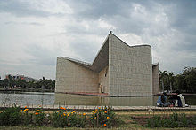
Sports: The Chandigarh Hockey Stadium is situated at Sector – 42. The Sector – 16 Stadium has been a venue of several international cricket matches, but it has lost prominence after the PCA Stadium was constructed in Mohali. It still provides a platform for cricketers in this region to practice and play inter – state matches. The Chandigarh Golf Club has a 7,202 – yard, 18 – hole course known for its challenging narrow fairways, dogleg 7th hole and flood lighting on the first nine holes.

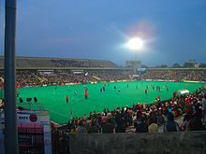

Modernism in New Town Design: Off the back of this conflation of assets Chandigarh then was well poised to serve a function as a city – building project in national identity. From a federal policy perspective, the development of the new town became a tool in India for modernisation and an intended driver of economic activity, legal reform, and regional growth as well as a significant agent for the decolonisation project. As Britain's grip on their empire began to weaken their accelerated withdrawal between the beginning of the second world war and 1947 left their former colony in states of disarray and disorganisation, and policymakers for the new Indian government were required to contend with issues such as rapid rural depopulation, urban congestion, and poverty. As well as in Chandigarh this policy tool was implemented in the creation of new capital cities in Bhubaneswar and Gandhinagar, and more broadly throughout India in the 112 planned cities created between independence and 1971, purposed to absorb migration from those regions in demise after being abandoned by the British and provide hubs for growing industries such as in steel and energy.

These examples from a genealogy of utopian urban forms developed in post – independence India as a panacea for issues related to underdevelopment as well as post – independence complications to do with separatist religious conflict and the resulting diplomatic tensions. Chandigarh is the first example of a state – funded master – planned modernisation scheme. These “Urban Utopias” attempt to enforce nation – building policies through a federalised rule of law at a regional level and diffuse postcolonial urbanism which codes justice in its design. The intent is that the economic success and progressivism of cities such as Chandigarh as a lightning rod for social change would gradually be emulated at the scale of the nation. Chandigarh was for Nehru and Le Corbusier an embodiment of the egalitarian potential offered by modernism, where the machine age would complete the liberation of the nation's citizens through the productive capacity of industrial technology and the relative ease of constructing civic facilities such as dams, hospitals, and schools; the very antithesis of the conservative and traditional legacy of colonialism. Though built as a state capital Chandigarh came to be focused in industry and higher education. The specialisation of these new towns in particular functions represents a crucial aspect of the modernisation process as a decolonising enterprise, in completing a national portfolio where each town forms a part of the utopian model for contemporary India.

The post – colonialism of Chandigarh is rooted in the transformation of the political ideas of those such as Nehru who generated a new Indian nationalism into the design of newly built forms. Scholars such as Edward Said have emphasised the sinister nature of nostalgia and the romanticisation of colonial architecture in newly independent colonies as artefacts that perpetuate the ideological legacy of the hegemony and replicate the hierarchy of power even after decolonisation. Insofar as modernism in architecture (which defined town planning under the Nehru era of rule) represents an active radical break from tradition and a colonial past even the very presence of Le Corbusier has been recognised as an indelible resistance to the British construction legacy, as he provided the first non – British influence on design thinking in India, enabling a generational shift in the contemporary cohort of architects and planners to be hired by the state throughout the rest of the century who were initiated under Modernist conditioning. As early as the 1950s the presence of the International Style could be detected in the design of houses in India, “Whether Mistri or Architect – Designed”. The development of low – cost housing was a priority for Chandigarh, and the modern forms designed by Corbusier are characterised by a dispensing with colonial forms focused on classic aesthetics and a refocusing on strategies such as using narrow frontages and orientation for minimising direct exposure to the sun and maximising natural ventilation and efficient cost while providing modern amenities in the International Style aesthetic. These developments are credited as the beginning of a “Chandigarh Architecture”, inspiring gradual experimentation with form and an “Indianising” of the International Style, which precipitated the formation of the country's new cultural identity in town design.

Sustainable Design and Life Cycle Management: More than any other human endeavour the built environment has direct, complex, and long lasting impact on the “EARTH” and its “BIOSPHERE”. Around one – tenth of global economy is devoted to “CIVIL — CONSTRUCTION” and about one half of world’s major resources are consumed by “CONSTRUCTION” and related industries. The “Three Columns of Sustainability Development – Environmental, Economic and Social” are shown in Figure 18.

Figure 18: Three Columns of Sustainability Development – Environmental, Economic and Social.

While the situation is not so acute in India at present, increasing urbanization may push us in that direction. These statistics underline the importance of changing the “CIVIL CONSTRUCTION PRACTICES” (CCP). To address these challenges, there is a need to develop effective approaches for life cycle design and management of “CONSTRUCTIONS” that will ensure their sustainability in terms of improved physical performance, cost effectiveness, and environmental compatibility. These optimized designs and management systems should provide the owners with the solutions that achieve an optimal balance between three relevant and competing criteria, namely, (i) “Engineering Performance” (e.g., Safety, Serviceability and Durability), (ii) “Economic Performance” (Minimum Life Cycle Costs and Minimum User Costs) and (iii) “Environmental Performance” (Minimum Greenhouse Gas Emissions, Reduced Materials Consumption, Energy Efficiency, etc.).

12. AIR, WATER AND NOISE LEVEL

Air Quality

The results analysis of air samplesis presented in general for all monitoring stations the PM₁₀ values were monitored in the range 110 — 112 µg/ m³. While comparing with the “National Ambient Air Quality” (NAAQ) Standard of 100 µg/ m³ by the “Central Pollution Control Board” (CPCB) all the monitored PM₁₀ values were found to be near the limit (Slightly Higher). This is because of high vehicular location and dryness of the areas. PM_{2.5} values were ranging from 35 — 38 µg/ m³. While comparing with the NAAQ Standard of 60 µg/ m³ and the monitored PM_{2.5} values were found to be well within the limit. Similarly monitored values for SO_{X}, NO₂ and CO are also found within the limits are as shown in the Table 46.

Table 46: AAQ Monitoring Result of Project Road.

Sr.  No. | Parameters | Unit | IT CITY CHOWK  Chainage  00 + 000 | KURALI CHANDIGARH  Chainage  31 + 230 | Prescribed  Limits (µg/m³) | Protocol
Date of AAQ Monitoring |  |  | 29.01.2021 | 29.02.2021
A – 01 | PM₁₀ |  | 98 | 91 | 100 | IS: 5182 (Part – 23), 2006.
A – 02 | PM_{2.5} |  | 35 | 38 | 60 | CPCB  Guidelines.
A – 03 | SO₂ |  | 17 | 17 | 80 | IS: 5182 (Part – II), 2001.
A – 04 | NO_{X} |  | 19 | 25 | 80 | IS: 5182 (Part – VI), 2007.
A – 05 | CO |  | 840 | 1,200 | 2,000 | IS: 5182 (Part – 10).

The maximum SO₂ and NO_{X} levels monitored were 23.41 µg/ m³ and 35.15 µg/ m³ respectively. While comparing with the NAAQ Standard (80 µg/ m³), the monitoring results were found to be well within the limits. The maximum CO concentration monitored was 1.8 µg/ m³ and most of the CO levels were monitored below the detectable limit of 2 µg/ m³. While comparing the NAAQ Standard, the monitored CO levels were found to be well within the limit. All Hydro — Carbon (HC) values were found to be below the detectable limit of 65 µg/ m³. All Particulate Lead values were found to be below the detectable limit of 0.01 µg/ m³ and within the NAAQ Standard of 1.0 µg/ m³ (24 — Hourly).

Noise Levels

Ambient Noise Standards

Ambient noise standards were established as per the “CPCB/ MOEF Gazette Notification Dated 26th December, 1989”. It is based on the “A” weighted equivalent noise level, Leq are given in the Table 47.

Table 47: National Ambient Noise Standards.

Area Code | Category of Zones | Day* Limits of  Leq {dB(A)} | Night* Limits of  Leq {dB (A)}
A | Industrial | 75 | 70
B | Commercial | 65 | 55
C | Residential | 55 | 45
D | Silence Zone** | 50 | 40
Sources**: GOI; CPCB, 1989;

Monitoring Locations and Results

The noise measurement work has been carried out continuously for a period of 24 Hours. At each site 2, 880 data were recorded, each taken at an interval of 30 seconds of which 1, 800 data recorded at day time (07: 00 AM to 10: 00 PM) and 1, 080 at night time (10: 00 PM – 07: 00 AM) as shown in the Table 48.

Table 48: Equivalent Noise Level Data.

Sr. No. | Name of  Locations | Date of  Monitoring | Category of  the Area | Leq dB (A),  Day | Leq dB (A),  Night
1. | IT CITY CHOWK  Chainage  00 + 000 | 22.02.2021 | Educational Area on Site | 54.3 | 37.4
2. | KURALI CHANDIGARH  Chainage  31 + 230 | 23.02.2021 | Religious Area on Site | 45.4 | 47.7

The monitored noise levels were ranging from 65.2 dB (A) to 54.2 dB (A) While comparing the MOEF Ambient Noise Norms for different categories, Leq noise levels at all locations during day time and during night time, were found to be exceeding their respective limits. This is because of regular movement of diverse vehicles. It may be noted that as the noise survey was carried out at sensitive receptors i.e., School Zones; Domestic Zones; Sensitive Zones; Old People Living Zones; Children Parks; Zoo Parks and Hospital Zones respectively, noise standards is found above the limits at almost all the location.

Water Quality

Water Quality Standard

The rivers, canal, lakes and ponds located along the proposed project road are a source of water for the local, regional inhabitants, for domestic as well as agricultural uses. An analysis of their present status and the quality of the water has been done through and with the help of state/ local/ regional agencies. They have been classified as per the CPCB standard classification norms for best optimum use of data and report used as shown in the Table 49.

Table 49: CPCB Best Use Classification for Surface Water Bodies.

Sr. No. | Parameters | Class – A | Class – B | Class – C | Class – D | Class – E
1. | pH | 6.5 – 8.5 | 6.5 – 8.5 | 6.0 – 9.0 | 6.5 – 8.5 | 6.5 – 8.5
2. | Dissolved Oxygen (as O₂),  Mg/ l, Minimum. | 6 | 5 | 4 | 4 | -------
3. | BOD, 5 Days at 20°C,  Maximum. | 2 | 3 | 3 | ------- | -------
4. | Total Coli – form Organism,  MPN/ 100 ML, Maximum. | 50 | 500 | 5,000 | ------- | -------
5. | Free Ammonia (as N),  Mg/ l, Maximum. | ------- | ------- | ------- | 1.2 | -------
6. | Electrical Conductivity,  Mhos/ Cm, Maximum. | ------- | ------- | ------- | ------- | 2,250
7. | Sodium Absorption  Ratio, Maximum. | ------- | ------- | ------- | ------- | 26
8. | Boron (as B),  Mg/ l, Maximum. | ------- | ------- | ------- | ------- | 2

Class A | : Drinking Water Source without Conventional Treatment but after Disinfection;
Class B | : Outdoor Bathing (Organized);
Class C | : Drinking Water Source after Conventional Treatment and after Disinfections;
Class D | : Propagation of Wild – Life and Fisheries;
Class E | : Irrigation, Industrial Cooling, and Controlled Waste Disposal;
Below E: Not Meeting A, B, C, D and E Criteria.

Water Quality Variation along the Projected Road

Surface Water Quality: The pH of surface water was found to be in the range 7.10 to 7.91 along the Corridors. Total hardness is found 337 – 234 ppm (parts per million). Lead contents were found to be below the detection limit. In general, surface water quality along the Corridors is good and complies with “CPCB Surface Water Quality Norms”. Details of water quality features are mentioned in Tables 50 (a) and (b) below.

Table 50 (a): Ground Water and Surface Water Quality along the Projected Road.

Sr. No. | Parameters | Units of Measurement | Surface Water Quality Monitoring  Result along the Project Road |  |  | Protocol
 |  |  | IT CITY CHOWK | KURALI CHANDIGARH | Desirable  Limit
Date of Sampling |  |  | 18.01.2021 | 19.01.2021 | < OR ≥ OR Nil
1. | Colour | Hazen  Units | <5 | <5 | 5 | IS: 3025
2. | Turbidity | NTU | 34 | 7 | <5 | IS: 3025
3. | pH | ------- | 7.91 | 7.09 | 6.5– 8.5 | IS: 3025
4. | Temperature (T) | °C | 14 | 14 | 14 | IS: 3025
5. | Dissolved Oxygen (DO) | mg/l | 3.8 | 4.2 | 4.4 | IS: 3025
6. | Conductivity | µmhos/cm | 1,250 | 674 | 976 | IS: 3025
7. | Total Suspended Solids (TSS) | mg/l | 30 | <4 | <4 | -------
8. | Total Dissolved Solids (TDS) | mg/l | 812 | 316 | 634 | IS: 3025
9. | Alkalinity as CaCO₃ | mg/l | 410 | 291 | 370 | IS: 3025
10. | Total Hardness as CaCO₃ | mg/l | 234 | 289 | 337 | 300
11. | Calcium as CaCO₃ | mg/l | 123 | 198 | 174 | IS: 3025
12. | Magnesium as CaCO₃ | mg/l | 111 | 91 | 163 | IS: 3025
13. | Sodium as Na | mg/l | 92 | 41 | 51 | APHA
14. | Potassium as K | mg/l | 86 | 13 | 10 | APHA
15. | Chloride as Cl | mg/l | 98 | 24 | 24 | IS: 3025
16. | Phosphate as PO₄ | mg/l | 0.43 | 0.03 | 0.03 | -------
17. | Sulphate as SO₄ | mg/l | 29 | 45 | 51 | IS: 3025
18. | Nitrate as NO₃ | mg/l | 0.12 | 0.06 | 0.08 | IS: 3025
19. | Oil and Grease (OG) | mg/l | Nil | Nil | Nil | IS: 3025
20. | Phenolic Compounds (PC) | mg/l | <38.0001 | <38.0001 | <38.0001 | IS: 3025
21. | Chemical Oxygen Demand (COD) | mg/l | 97 | <4 | <4 | -------
22. | Biological Oxygen Demand (BOD) | mg/l | 52 | <2 | <2 | IS: 3025

Table 50 (b): Ground Water and Surface Water Quality along the Projected Road.

Sr. No. | Parameters | Units of Measurement | Surface Water Quality Monitoring  Result along the Project Road |  |  | Protocol
 |  |  | IT CITY CHOWK | KURALI CHANDIGARH | Desirable  Limit
Date of Sampling |  |  | 21.01.2021 | 22.01.2021 | < OR ≥ OR Nil
23. | Arsenic as As | mg/l | <0.01 | <0.01 | 0.01 | IS: 3025
24. | Mercury as Hg | mg/l | <38.0001 | <38.0001 | 38.0001 | IS: 3025
25. | Lead as Pb | mg/l | <0.01 | <0.01 | 0.01 | IS: 3025
26. | Cadmium as Cd | mg/l | <0.01 | <0.01 | 38.0003 | IS: 3025
27. | Chromium as Cr⁺⁶ | mg/l | <0.05 | <0.05 | 0.05 | IS: 3025
28. | Copper as Cu | mg/l | <0.01 | <0.01 | 0.05 | IS: 3025
29. | Zinc as Zn | mg/l | <0.01 | <0.01 | 5 | IS: 3025
30. | Selenium as Se | mg/l | <38.0005 | <38.0005 | 0.01 | IS: 3025
31. | Iron as Fe | mg/l | 0.15 | 0.01 | 0.3 | IS: 3025
32. | Total Coli – form | MPN/ 100 ml | 50 | 28 | ------- | IS: 5401 – (Part – II)
33. | Faecal Coli – form | MPN/ 100 ml | 20 | 13 | ------- | IS: 5401– (Part – II)

ECOLOGICAL AND ENVIRONMENTAL TEXTURE

(Chandigarh Master Plan – 2031)

ECOLOGY AND ENVIRONMENT

As already detailed in ecological and aesthetic values of Chandigarh’s location were major considerations in selection of the site and planning of Chandigarh. While the Shivalik Hills to the North provided a visually attractive backdrop to the monumental Capitol Complex, the two Choes (Seasonal Rivulets) on either side defined the Eastern and Western boundaries of the Chandigarh Plan. The N Choe going through the middle of the site was converted into a continuous “Green Belt” (the Leisure Valley) and the North to South slope provided natural drainage. Subsequently, it was decided to dam the Sukhna Choe to provide Chandigarh with its much loved lake. Both the Chandigarh Plan and the “Edict of Chandigarh” strove to preserve the city’s proximity with nature by prohibiting any development to the North of the city, leaving the hills ecologically and visually undisturbed. The Periphery Control Act was similarly meant to maintain a clear rural urban dichotomy and prevent unregulated urban development within a radius of 16 Kms around the city.

Objectives of ecological planning for the Union Territory of Chandigarh:

- Protecting the ecological integrity of Sukhna Lake catchment and the wildlife sanctuary;
- Protection and conservation of Choes;
- Increasing the green cover and its diversity;
- Minimizing noise and air pollution;

PROTECTING SUKHNA LAKE’S CATCHMENT IN THE ECOLOGICALLY FRAGILE SHIVALIK HILLS

Realizing the grave threat posed to the Sukhna Lake by soil erosion from the degraded Shivalik Hills, in 1963, the erstwhile Punjab Government acquired 2,598.42 Ha of hilly catchment area of the lake from different villages for undertaking soil and moisture conservation works. Despite conservation measures taken, the first major ecological problem encountered by the city was the high rate of siltation of the lake. Around 63% of the lake’s storage capacity had already been eaten away by silt till 1974. After the reorganization of Punjab in 1966, the catchment got divided between the UT of Chandigarh and the states of Punjab and Haryana. Out of the lake’s total catchment area of 4,207 Hectares, 3,312 Ha (66% of the catchment area) is in the hills out of which 770 Ha now falls in Haryana. Most of the remaining 895 Ha of the catchment area in the plains is under agricultural use and habitations and falls partly in “Punjab” (Kansal Village), “Haryana” (Saketri Village) and the UT of “Chandigarh” (Kaimbwala Village, a part of the Capitol Complex and the Rock Garden).

Figure 19: Chandigarh Master Plan – 2031 (Source: Management Plan for Sukhna Wildlife Sanctuary and Survey of India Map of the Lake’s Catchment Area/ Zone).

THE CAPITOL COMPLEX AND THE AREA TO ITS NORTH. | LOCATION OF SUKHNA WILD LIFE SANCTUARY ON THE NORTH OF CHANDIGARH.
FOREST AREAS IN CHANDIGARH. | SUKHNA LAKE AND THE RESERVE FORESTS IN THE BACKDROP.
Entrance to the Sukhna Wildlife Sanctuary. | SUKHNA WILDLIFE SANCTUARY.
SUKHNA WILDLIFE SANCTUARY.

CATCHMENT AREA/ ZONE/ REGION OF THE SUKHNA LAKE.

Examination of the catchment area in the mid – 1970s revealed that the highest rate of siltation was taking place in the area adjoining “Sukhomajri Village” in Haryana due to unregulated grazing in the hills and breaking of hilly land for cultivation. This resulted in the “Central Soil and Water Conservation Research and Training Institute” taking up an operational research project in the Sukhna catchment from the mid – 1970s which led to the famous pilot project of social fencing in Sukhomajri Village. With grazing voluntarily brought under control by the villagers, combined with extensive soil and water conservation measures undertaken under the operational research project, the rate of siltation in the catchment came down dramatically. Chandigarh’s forest department has subsequently continued intensive soil and water conservation measures including effective closure, large scale plantation, construction of silt detention dams and masonry check dams supported by vegetative conservation measures. Figure 19: Chandigarh Master Plan – 2031 (Source: Management Plan for Sukhna Wildlife Sanctuary and Survey of India Map of the Lake’s Catchment Area/ Zone). These measures have further reduced the siltation rate of the lake to less than 5 Tonnes/ Hectare/ Year and the overall tree density has increased from 162 to 450 Trees per Hectare. However, this seems to have also decreased the surface water runoff into the lake. In 1998, the 2,598.42 Ha hilly area acquired in the lake’s catchment was first notified as a “Reserve Forest” (RF) and then as a wildlife sanctuary under the “Wildlife Protection Act”, 1972 with effect from 16.03.1998. This ensured a still higher level of protection to this area for which a separate “Management Plan” has been prepared. Another 456.31 Ha was notified as Reserve Forest in the UT consisting of the Sukhna choe “Reserve Forest” and “Lake Reserve Forest”. An additional 23.29 Ha of land along Patiala Ki Rao was notified as RF in 1961. With about 9 Ha having been diverted for non – forest purposes, the total RF area in the UT (excluding the sanctuary area) at present is 470.38 Ha. (Source: Working Plan, UT Forest Division and Management Plan for the Wildlife Sanctuary). Another 183.14 Ha Adjoining the Patiali – Ki – Rao, Sukhna Choe and Lake RFs is Recorded as Unclassified Forest.

SUKHNA WILDLIFE SANCTUARY

“Sukhna Wildlife Sanctuary” (SWS) spread over an area of 2,598.42 Ha is located in the North – East of the Sukhna Lake and forms part of Sukhna Lake’s catchment area falling in the “Shivalik Hills”. The Shivalik hills geologically unstable and thus are highly prone to soil erosion during rains. The soil in the Shivalik is sandy, embedded with pockets of clay which is highly susceptible to erosion by surface run off. Concerted measures taken towards prevention of erosion/ silt into the Sukhna Lake have resulted in a thick forest cover and rich biodiversity of the area. Approximately 10% of the perimeter of the sanctuary abuts the Chandigarh UT, the major part being along the states of Punjab and Haryana. 193 water bodies have been built in the Sukhna Wildlife Sanctuary which support wildlife and migratory birds that flock to this sanctuary. The first wildlife census carried out in the Sukhna Wildlife Sanctuary in December 2010 found nine species of mammals and 63 species of birds including two species of Schedule – I, two in Schedule – II, and three in Schedule – III and one in the Schedule – IV category of the Wildlife Protection Act. Nine species of mammals include Leopard, Sambar, Chitah, Wild Boar, Indian Porcupine, Indian Pangolian, Blacknaped Hare, Golden Jackal and Grey Langur. The presence of predators such as the leopard, which requires enough prey for its sustenance, suggests the importance of Sukhna and its rich biodiversity. Prominent among the birds are Peacock, Red Jungle Fowl, Grey Partridge, Cuckoo, Night Jar, Golden Oriole, Kingfisher, Swift, Hoopoe, Hornbill, Barbet, Woodpecker, Roller, Barn Owl, Parrot, Dove, Jacana, Plover, Coot, Hawk, Goose, Swan, Duck, Grebe, Black Drongo, Tree Pie, Jungle Crow, Bulbul, Hill Myna, Koel, Bee – eater, Common Myna etc.
THE CHOES (SEASONAL RIVULETS)

Both “Sukhna Choe and Patiali Ki Rao”, as well as the N – Choe flowing through the city (now converted into the Leisure Valley) perform important ecological functions which have not received the same attention as the problem of siltation of the lake. All the three choes originate in the “Shivalik Hills” and provide seasonal drainage for the surface water runoff from their catchments during the monsoons. Their sandy beds also recharge the deep sub – soil water aquifers, which provide Chandigarh about 20% of its water supply. Many of Chandigarh’s tube wells are located in the beds of these choes. Unfortunately, several insensitive developments are taking place next to and within the choe beds both in the UT and Punjab. Untreated sewerage and solid waste of Naya Gaon in Punjab and Khuda Lahora and Khuda Jassu in the UT is being thrown into Patiali Ki Rao. The same is happening in parts of the Sukhna Choe in the UT and Punjab and even the N – Choe going through Chandigarh’s Southern sectors has not been spared. Besides destroying the local ecology and becoming a public health hazard, it is likely to pollute the sub – soil water. Rampant unregulated sand mining in Patiali Ki Rao is also threatening its water recharging capacity. In Contrast, the Parts of Sukhna Choe and Patiali Ki Rao with notified Reserve Forests along their Sides are in Much Better Condition with Lush Vegetation. These Choes suffer from:

- High degree of man – made encroachments;
- High degree of water/ environment pollution;
- Discharge of untreated salvage in the choe bed;
- Mushroom development of slums along the river bed;
- Low availability of fresh water;

SECURING AND ENHANCING THE VALUE OF EXISTING GREEN COVER

Open spaces in the Chandigarh Master Plan were meant to provide a continuous stretch of green spaces for pedestrians and cyclists to walk/ cycle across the city in safety. The Forest Department has been preparing an annual “Greening Action Plan” synergizing the efforts of different stakeholders like the, Municipal Corporation, Engineering Department, NGOs etc. Due to these efforts the tree cover in the UT is placed at 8.93% (10 Sq. Km.) of the geographical area. The forest and tree cover of the UT of Chandigarh has increased consistently over the last decade and as per the State of Forest Report 2011, the total “Green Cover” (Forest Cover + Tree Cover) of UT, Chandigarh is placed at 23.65% of its geographical area. Recognizing these efforts, the Union Territory of Chandigarh was awarded the “Indira Priyadarshini Vriksha Mitra” (IPVM) Award – 2010” under the UT category.

THE FOREST AND TREE COVER OF CHANDIGARH. | PATIALI KI RAO.

ENCROACHMENTS WITHIN THE NATURAL RIVULETS. | POLLUTION INTO PATIALI KI RAO.
POLLUTION INTO PATIALI KI RAO. | ENCROACHMENT INTO THE NATURAL RIVULETS.

Air and Noise Pollution

The entire Union Territory of Chandigarh was declared an “Air Pollution Control Area” under the “Air” (Prevention and Control of Pollution) Act, 1981 on 1st February, 1988 by the Ministry of Environment and Forests. Earlier, the Central Pollution Control Board was enforcing the Environmental Acts/ Rules in Chandigarh. After 1991, the Chandigarh Pollution Control Committee became responsible for performing the functions of “State Pollution Control Board” (SPCB) in Chandigarh. The Ministry of Environment and Forests has notified “National Ambient Air Quality Standards” (NAAQS) for various pollutants and the “Chandigarh Pollution Control Committee” (CPCC) monitors ambient air quality at five different locations and implements various Environmental Acts/ Rules in Chandigarh. The ambient air quality of Chandigarh is now under pressure. Respirable suspended particulate matter in the city has started crossing permissible limits. Studies have shown that the air quality of Chandigarh is largely impacted by vehicular pollution. The other major contributors to air pollution are industries, burning of leaves from trees and gardens and the use of diesel generator sets in certain areas. In addition to the air pollution, the city is also facing problems in terms of noise pollution. Despite the care taken to minimize noise pollution during Chandigarh’s planning through measures such as restricting the movement of heavy vehicles on internal roads, separating industrial area with green belt and dense vegetation cover, etc., most of the areas now exceed the noise pollution limits. The most prominent sources of noise in the city are traffic, commercial and industrial activities, celebration of festivals, diesel generators, construction activities, etc. A road length of over 2,000 Kms and over six lakh vehicles contribute a major share of noise pollution to Chandigarh’s surrounding environment.
EMERGING THREATS TO THE NORTH OF CHANDIGARH

The Edict of Chandigarh prohibits any urban development to the North of the Capitol Complex. This was reiterated by the “Chandigarh Urban Complex Plan” (CUCP) prepared in 1977 by the Co – ordination Committee. This plan clearly indicates the area of Kansal Village (falling in Punjab) North of the Capitol complex as a “No Development Area” (NDA). Although Chandigarh itself has refrained from undertaking any development to the North of the city, both Punjab and Haryana have now planned intensive urbanization in this belt, held almost sacred by the original planners as well as the city’s residents, in total violation of earlier decisions. Besides marring the aesthetic value of the undisturbed hills crowning all Chandigarh’s North – South roads, and mocking the conceptual basis of Chandigarh’s original Plan, these contradictory developments in the pipeline will jeopardize the Capitol Complex’s sanctity and make the efforts futile to preserve the city’s unique heritage.

Chandigarh Urban Complex Plan (CUCP).

Due to large scale urban development taken up by the States of Punjab and Haryana, to the City’s North falling in the catchment of the Sukhna Lake, such development will pose a long term threat to Chandigarh’s already threatened lake. The notified Development Plan of NAC, Naya Gaon – 2021 falling in Punjab provides that one kilometer zone from the North – Eastern edge of the Secretariat building shall be a low rise zone. Beyond that, the building height can be 1.5 times the width of the road in front of the building plus the width of the front setback. Based on these norms, a group housing – cum – retail complex on a site of 53.39 acres in the vicinity of the Capitol Complex and almost adjoining the wildlife sanctuary in Kansal Village, has been designed. With a planned built up area of 7,01,370 Sq. M., the project envisions building 28 high rise towers ranging from 12 to 35 floors implying minimum heights of 120 to 350 Feet. “Besides overshadowing Le Corbusier’s Capitol Complex, enormous volume of built space generated by these tall buildings and the large increase in traffic on the road just outside the sanctuary will “Cause Serious Disturbance to Wildlife, Flora and Fauna”. Such a project will also have an adverse impact on Chandigarh’s ecology and infrastructure in terms of air and noise pollution, high extraction of ground water, lowering the ground water table, waste water and solid waste management, besides, generating high volume of traffic. In addition, the development is likely to pose a “Serious Threat to Wildlife”.

PROPOSALS OF THE CHANDIGARH MASTER PLAN – 2031

To deal with above problems, the Chandigarh Master Plan – 2031 proposes following interventions:

(a). Securing the Entire Catchment of the Sukhna Lake

In order to preserve the Sukhna Lake, it will be appropriate that entire catchment area of Sukhna Lake is brought under Regulation and Control to secure it. At present, only the hilly part of the lake’s catchment area has been notified as the wildlife sanctuary. However, area under urbanization forming lower part of the catchment has not been strictly regulated. This needs to be done on a priority basis in order to minimize its adverse impact to prevent flow of sediment or polluted water into the lake. Any change in the landuse in this area also needs to be strictly regulated in order to preserve the sanctity and basic character of the area. Development in the immediate vicinity of the Wildlife Sanctuary should not be permitted which contravenes the objectives of wildlife conservation. “The Catchment Area of Sukhna Lake consists of 4,207 hectares, out of which 3,312 Ha is hilly and forested. The remaining 895 Ha of area is comprised of Villages Kansal (Punjab) Saketri (Haryana) and the UT of Chandigarh (Kaimbwala village, part of the Capitol Complex and the Rock Garden)”.

(b). Notifying an “Eco – Sensitive Zone” (ESZ) around the Wild life Sanctuary

In order to protect the environs of “Wild Life Sanctuary” (WLS) the area around it should be identified and declared as “Eco – Sensitive Zone” (ESZ) in consultation and collaboration with the governments of Punjab and Haryana. Only ecologically compatible landuses and activities shall be permitted in this zone as per the guidelines issued by the “Ministry of Environment and Forest”. Accordingly, plans for the area falling in Kansal Village in the Development Plan of NAC, Naya Gaon – 2021 and the “Mansa Devi Urban Complex” (MDUC) in Haryana should be reviewed and revised to conform to the requirements specified for the ESZ. The Chandigarh Administration has already finalized the draft notification of Eco Sensitive Zone of “Sukhna Wild Life Sanctuary” (SWLS) for the area falling in UT, Chandigarh’s jurisdiction and submitted to the Ministry of Environment and Forests, Government of India, for notification. The Chandigarh Administration has determined a width of Eco Sensitive Zone ranging from 2.0 Km to 2.75 Km upto Uttar Marg on Southern side of the Sukhna Wild Life Sanctuary so as to include Sukhna Lake and its catchment area.

(c). Protecting the Choes

Considering the role and importance of choes in the context of overall ecology of the city and its environs, it is recommended that:

The flood plains and the beds of the two choes on either side of the sectoral grid must be demarcated and protected from any kind of construction, sand mining and dumping of sewage and solid waste in them to maintain their ecological integrity and natural drainage function.

- The “Reserve Forest Area” (RFA) along both the “Sukhna and Patiala Ki Rao Choes” should be expanded by notifying the unclassified forest land adjoining them as reserve forests. The feasibility of notifying the choe beds, consisting of revenue land as reserve or protected forests should be explored in order to protect this area from unauthorized construction. This would help in not only increasing the Union Territories’ Forest Cover, but will also provide a corridor for wildlife connecting different forest patches which are presently not integrated.

- Alternatively, the demarcated choe beds and, where available, 30 meters of land on their sides should be declared as “Eco – Sensitive Zones” (ESZ) under the Environment Protection Act for prohibiting uses/ activities considered detrimental to their ecological functions and regulated as per MOEF guidelines.

- Decentralized “Sewerage Treatment Plants” (STP) must be set up for the existing villages and other developments along the choes on priority for preventing pollution of subsoil water by untreated sewage.

- Channelizing the “Choes and Stone Facing” their sides must be reviewed and revoked. Stone facing may be undertaken only in selected/ identified patches. As choes are ecological entities cutting across state or administrative boundaries, efforts must be coordinated with the state governments of Punjab and Haryana to adopt similar measures for the parts of the choes passing through their territories.

(d) Securing and Enhancing the Value of Existing Green/ Open Spaces

- Surviving old trees and groves in the UT should be identified and protected.

- All existing Zoning Plans should be reviewed and revised in order to ensure that no future construction of community facilities in the planned open spaces are permitted, which interfere with pedestrian movement, availability of green spaces and natural drainage.

(e) Air and Noise Pollution

- For tackling the menace of air and noise pollution and to minimize the same to bring it within the prescribed norms, it is proposed that time bound switchover to use of CNG by public transport vehicles and giving priority to developing footpaths and cycle tracks to reduce the dependence on motorized vehicles should be promoted on priority. “A Comprehensive Urban Air Quality Management Strategy (CUAQMS) may be formulated based on emission inventory, dispersion models and urban policy inventory. The proposed Multi – Modal Mobility Plan with Mass Rapid Public Transport linking the city to neighbouring towns should be put in place on priority in order to reduce the air and noise pollution.

WILD LIFE CORRIDOR

The “Lake Reserve Forest” (LRF) and “Wild Life Sanctuary” (WLS) are separated by agricultural land. The growing wildlife population in the Sanctuary has often resulted in animals straying into nearby settlements in Kishangarh and Khuda Ali Sher in the Union Territory and in Kansal in Punjab leading to number of causalities. In order to overcome this problem, the UT administration has launched a massive afforestation drive of the agricultural land separating the two forests in order to create a Wildlife Corridor between the Reserve Forest area and the Regulator End of the Sukhna Lake on a stretch spanning nearly 1.4 Km. The programme is aimed at preventing unauthorized construction taking place in the area and to preserve and protect the wildlife in the Sanctuary. The proposed Wildlife Corridor will help in converting the agriculture use of land into afforestation and would act as the connector between the Sanctuary and the Lake Reserve Forest. For preserving the area under corridor, it should be declared as a “No Development Zone”.

Chandigarh Urban Complex Plan.

Plantation in the Newly Acquired Land at Village Kaimbwala

On the recently acquired 50 acre land at Village Kaimbwala, the Forest Department has carried out thematic plantation of fruit bearing tree species in approximately 48 acre area. The rest of the two acre area, which already has the vegetation is being maintained as such. A massive plantation drive was organized by the Department of Forests, UT, on the occasion of the “World Environment Day” – 2011 to take up the plantation on the newly acquired land. Tall saplings of following fruit bearing species have been planted – Mango, Jamun, Guava, Shatoot, Neem, Pipal, Pilkhan, Dhek, Kankankchampa, Arjun, Imli, Amaltas etc. Plantation of fruit bearing species will improve the Quality and Bio – Diversity of the vegetation in the Lake Reserve Forest behind Sukhna Lake. Availability of the food to the wildlife and monkeys will be ensured by this plantation.

THEMATIC PLANTATION IN THE NEWLY ACQUIRED LAND FOR THE WILD LIFE AT VILLAGE KAIMBWALA.

Archaeological and Historical Sites

There is no archeologically protected monument or historical sites along the project route or roadways network of construction site.

Environmental Impacts

Impact on Topography

During the construction of the proposed project, the topography will change due to excavation of borrow areas, fills for project road, especially construction of project related cross drainage structures and intersections etc. Provision of construction camp/ yard for material handling will also alter the existing topography. There will be change in topography at re – alignments as these re – alignments have been proposed through agriculture farming fields. The change in topography will also be due to the probable induced developments of the project. With adequate planning, all topographical impacts or signature could be made to enhance the local aesthetics. Similarly, it will invite benefits in the form of land leveling and “Tree Plantations” (TPs) in the vicinity/ region/ area/ site of the projected road.

Impact on Climate

The widening and strengthening of project is not going to have impact on micro as well and macro – climate of the region on the site or area/ region.
Impact on Air Quality

Operation Phase

Vehicular emission will be the principle source of pollution during operation stage. Quantitative assessment for predicted level of pollutants concentration has been done using “ISC – AERMOD”, a recommended model by USEPA for prediction of air quality from point, area and volume sources. AERMOD is a long range dispersion model based on “Gaussian Dispersion Model” (GDM), which incorporates the “Pasquile – Gifford (P – G) Dispersion Parameters” for estimating horizontal cross wind and vertical dispersion. In “ISC – AERMOD Software”, the line sources are characterized either are area source or volume sources. After drawing the road alignment of particular traffic segment and putting the information related to carriageway width, vertical dimension, source elevation, base elevation and release height, the model converts the road alignment to volume source. The model simulates the effect of emissions from continuous/ variable volume sources on neighborhood air quality. The model is an hour – by – hour steady state “Gaussian Model” (GM) which takes into account special features like Terrain Adjustments, “Gradual Plume Rise” (GPR), Buoyancy – induced dispersion, Complex terrain treatment etc.

Emission Rate: Composite Emission factors were calculated to assess the contribution of the vehicles in air emission based on the emission factors developed for Indian road conditions by “The Automotive Research Association of India” (ARAI), Pune in its study for “Emission Factor Development for Indian Vehicles” as a part of “Ambient Air Quality Monitoring” and “Emission Source Apportionment Studies” (ESAS) under “Air Quality Monitoring Project” (AQMP) – “Indian Clean Air Program” (ICAP). “Composite Emission Factor” (CEF) represents the various vehicular emission pollutants for different types of Vehicles (viz. Two Wheelers, Three Wheelers, Cars, Commercial Vehicle, Buses etc.) are used in India as requirement of “AERMOD – MODEL”.

“Meteorological Data: The primary factors affecting transport and dispersion of pollutants are wind and stability. The winds are caused by differences in pressure between areas of the atmosphere. Differences in pressure cause air to move from “High – Pressure Areas” (HPA) to “Low – Pressure Areas” (LPA). Wind speed can affect the pollutant concentration in a selected area. In general, the higher the wind speeds, the lower the pollutant concentration. The winds dilute pollutants and rapidly disperse them throughout the near areas. In the present case, meteorological data of winter season (December and January 2018) generated through primary survey has been used for prediction of the impacts”.

Homogeneous Traffic Sections: Based on the traffic study the entire project road was divided into 3 – homogenous sections, as detailed under:

Predicted Ground Level Concentrations (GLC): The prediction of maximum “Ground Level Concentrations” (GLC) on each traffic sections for CO, NO_{X} and particulate matters have been carried out using “ISC – AERMOD”, software for the base year 2018, start year of operation 2020 and which is designed life ending year 2040. The predicted levels are plotted in isopleths and superimposed on a gridded topographical sheet within 10 Km radius of the volume source to simulate the dispersion of pollutants. The predicted concentration range is shown in colour scale on the right of each isopleths, which are presented in Figures 20 to 21 and Table 51.

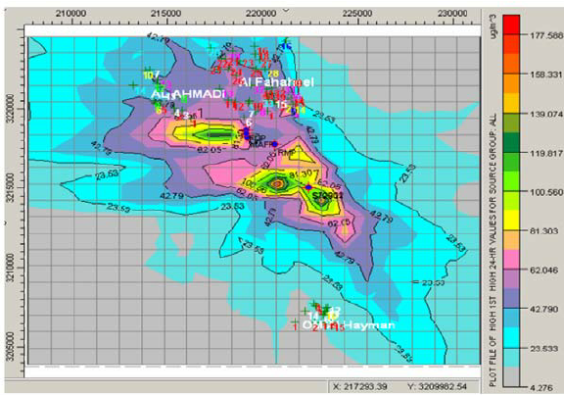
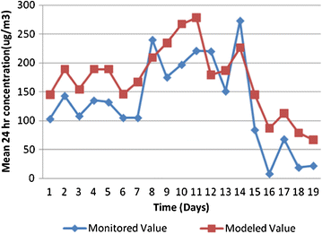

Figure 20: Isopleths/ Graphics of Dispersed Pollutants from Volume Source.
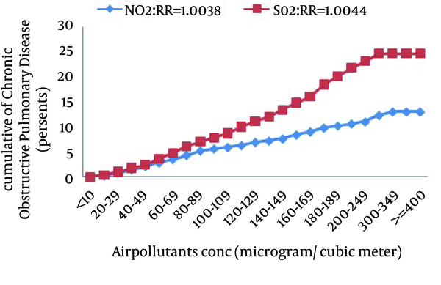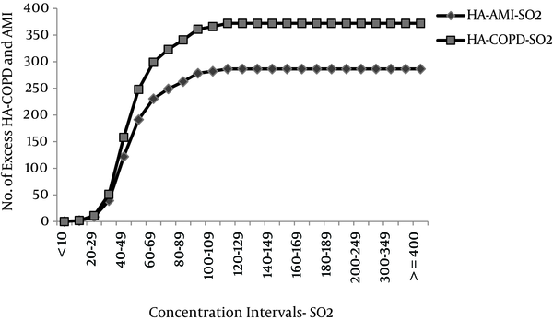

Figure 21: Graphical Representation of Air Pollutants from Volume Source.

Table 51: Frequency of Sulphur Dioxide in Air.

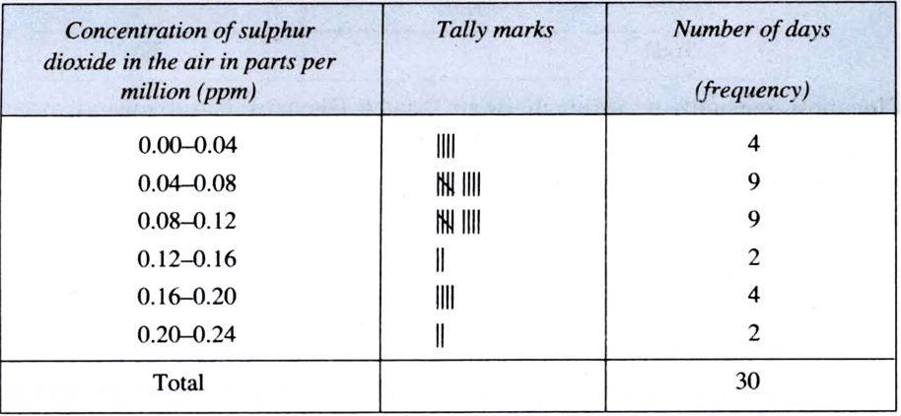
Prediction Results: Analyses of modeling results ascertain that the predicted level of concentrations for all parameters along the project road in three homogeneous sections are within the prescribed range. However, the pollutant concentrations and its spread (dispersion) increase consistently with the increase in traffic volume. It can be observed from the isopleths that dispersion of gaseous pollutants have wide geo-graphical spread in comparison to the particulate matters, as it tends to settle down owing to gravitational forces. It may be inferred from the above isopleths that the predicted concentration of pollutants is expected to decrease in the year of operation (2020) due to construction of 4 – lane road. Thereafter, the concentration will gradually increase with the increase in the traffic flow.

Caline – 4 Model: Caline – 4 has high applicability in Indian Scenario and is a recommended model by US – EPA for prediction of air quality from line sources like “Highway Projects”. Quantitative assessment for predicted level of pollutants concentration has been done using Caline – 4 Model, Version – 2011.

“CALINE – 4” (Caltrans, 1989) is a “Fourth – Generation Line Source Gaussian Plume Dispersion Model” (GPDM) that predicts carbon monoxide (CO) impacts near roadways. Its purpose is to help planners protect public health from the adverse effects of excessive CO exposure. The Caltrans publication, Transportation Project – Level Carbon Monoxide – Protocol (CO – Protocol) recommends the use of CALINE – 4 when a proposed transportation project requires a more detailed analysis than initial screening analysis. The 2011 – Version of CALINE – 4 can also be used for prediction of NO_{X} and PM₁₀. Pollution Control Authorities/ Regulatory Agencies in India are using CALINE – 4 to predict the future air quality trends along highways/ roads from vehicular traffic for regulatory purposes.

“CALINE – 4 Model” employs a mixing zone concept to characterize pollutant dispersion in the proximity of roadways. The model employs source strength, meteorology, and site geometry and site characteristics as input parameters and predicts pollutant concentrations for receptors located within 150 meters either side of the roadways. The CALINE – 4 Model allows roadways to be broken into multiple links that can vary in traffic volume, emission rates, height, width, etc. CALINE – 4 is capable of specifying links at heights above grade (z = 0), links as bridges (allowing air to flow above and below the link) and links as parking lots (which should be defined by the user as having a height of zero). Also, unlike CAL3QHCR, CALINE – 4 is capable of analyzing the dispersion of pollutants in wind speeds of less than 1 m/ sec. in CALINE – 4 the concentration at a point with co – ordinates (x, y, and z) is calculated based on the following Equation (2):

$$C\left(x, y, z,H\right)= \frac{Q}{2πuσzσy}* \left[\exp{-\left(\frac{y^{2}}{2σy^{2}}\right)}\right]\left[\exp{\frac{- \left(z- H^{2}\right)}{2σz^{2}}}\right]+\exp\left[\frac{- \left(z+ H^{2}\right)}{2σz^{2}}\right]$$ | …Equation (2)
Where:

C | = | Concentration of the Pollutant in Air [m/ L³];
Q | = | Rate of Chemical Emission [m/ T];
U | = | Wind Speed in X – Direction [L/ T];
σ_{y} | = | Standard Deviation in y – Direction [L];
σ_{z} | = | Standard Deviation in z – Direction [L];
y | = | Distance along a Horizontal Axis Perpendicular to the Wind [L];
z | = | Distance along a Vertical Axis;
[L] H | = | Effective Stack Height [L];

Emission Rate, Meteorological Data and “Homogeneous Traffic Sections” (HTS) are same with that of “ISC = AERMOD Model”.

Receptors: The complete road alignment has been drawn with respect to UTM Co – ordinates. A set of link receptors were taken at various receptor locations within each section at a distance of 10 m, 30 m, 50 m, 100 m, 150 and 200 m both sides from edge of the carriageway to know the dispersion of pollutant from the road.

Predicted Ground Level Concentrations (PGLC): The prediction of “Maximum Ground Level Concentration” (MGLC) is as on each road side/ section have been found near about negligible in the region. And network has been carried out to study and analyze specific region, while completing projected road network. The prediction for CO was conducted for 8 – Hourly concentrations, whereas for NO_{X}, SO₂ and PM₁₀, it was conducted for 24 – Hourly concentrations. Predicted concentrations on four “Homogenous Sections” (HS) of the Project for CO, NO_{X}, SO₂ and PM₁₀ and their spread around the road sections have been worked out and found well below the standard.

Prediction Results: Analyses of modeling results ascertain that the predicted levels of concentrations for all parameters along the project road in three “Homogeneous Section” (HS) are within the prescribed range. However, the pollutant concentrations are estimated to increase after 2030 within 30 m from the road edge. The tree plantation and habitat improvement activities included in the project scope will help to check air pollution. Road signage at regular intervals to remind motorists to maintain their vehicles and minimize fuel consumption may be posted. Raising awareness amongst drivers on good driving practices to reduce fuel consumption and promote road safety may also be carried out. As part of the routine maintenance works good riding conditions of the road surface will be maintained to reduce dust and vehicular pollution.

Conclusions: “In the existing scenario, due to lesser carriageway width, the average vehicle speed is low, which results in traffic congestions causing more exhaust gas emissions. In the post – project scenario, improved road conditions and congestion free traffic movement will reduce emissions. It is also expected that over the period, the fleet/ fuel type will improve significantly contributing in emission reduction processes in the projected study area/ region”.

Mitigation Measures:

- Vehicular emission will be controlled through enforcement of laws and public awareness. It will be ensured that all the vehicles have vehicular emission within the permissible limits;
- Truck parking lay – bays and bus lay – bays will be provided at required locations to facilitate smooth traffic flow vis a vis reduce air pollution;
- Regular monitoring of ambient air quality at specified representative locations will be conducted at fixed interval;
- Road side plantation along the road will act as sink of air pollutants. Pollution resistant species, which can grow in high pollutants concentrations and absorb pollutants will be planted as proposed under “Green Belt Development Plans” (GBDP);
- The designed road surface will generate lesser dust due to the paved shoulders in settlement areas;
- Improvement in road surface condition and traffic capacity will reduce the local congestion in the built up areas and provide a smooth traffic flow;
- The net air quality impacts during the operation phase would be reduced after widening and improvement of the project.

There will be rise in “Suspended Particulate Matter” (SPM) levels due to the construction activities, because the project runs entirely in plain areas. Since the emission will be fugitive in nature and it is difficult to quantify the SPM standards even expected to be violated, as the background values are not alarming rate at many places. “Affected Persons” (APs) should be completely well – versed even; if it is exceeded then it will be for very short time period. There will be some increase in levels of gaseous pollutant also, which are highly harmful to all or whole ecosystem surviving/ sustaining on this “Precious Planet Earth”. The impact on ambient air quality has been assessed using “AERMOD – Lakes Environmental Software” and “CALINE4 – A Dispersion Model for Predicting Air Pollution Concentrations near Roadways or Road Network”. The air quality predictions have been done for the horizon years 2010, 2020 and 2030. The results of various or numerous types of mathematical modelling applications shows that CO, SO₂, NO_{X}, HC, “Respirable Particulate Matter” (RPM) stuff concentration will remain within the limits of CPCB tills the end of project life. The SPM levels are well within limit at present also. But significant contribution of SPM is expected from vehicular emissions; transportation; industrial as well as domestic activities in future as given in Figure 22.

“Affected Persons” (APs) should be fully informed of their rights and responsibilities from the very beginning of the process to achieve transparency and understanding between the APs and the project implementers.

Primary stakeholders include the APs, the beneficiaries of the project, the host population, the “Project Partner Agencies” (PPAs) such as “Urban Development Authority” (UDA), and more importantly the project proponent and the “Ministry of Defence and Urban Development” (MOD and UD), Ministry of Finance and Ministry of Land and Land Development. The secondary stakeholders are those who have an interest in the project such as the National Government, the political authority, policy – makers, advocacy groups, NGOs and other private and public sectors which have indirect involvements with the project.
Therefore, PPA need to be assisted more closely in explaining and guiding them in resolving the issues in a more productive manner more favourable to the APs, as per involuntary resettlement principles and guidelines. This nature of consultation with the project APs and their profiling are mandatory as per the requirements of preparing the “Resettlement Action Plans” (RAP), which needs to be carried out as socio – economic and census surveys as an integral part of detailed designing.

Implementation Stage | Involve APs in decision – making committees;
 | Involve APs in monitoring and evaluation;
 | Establish “Grievance Redress Committee” (GRC) procedures, representatives of APs;
 | Arrange APs inputs to entitlements, income restoration and resettlement options;
 | Consultations with APs on alternatives;
 | Involve APs in assessing project impacts.

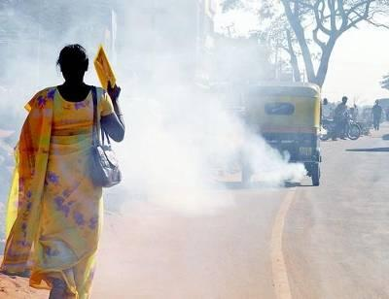
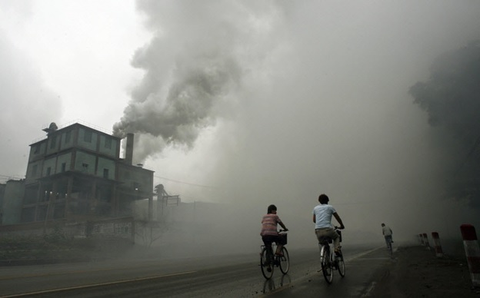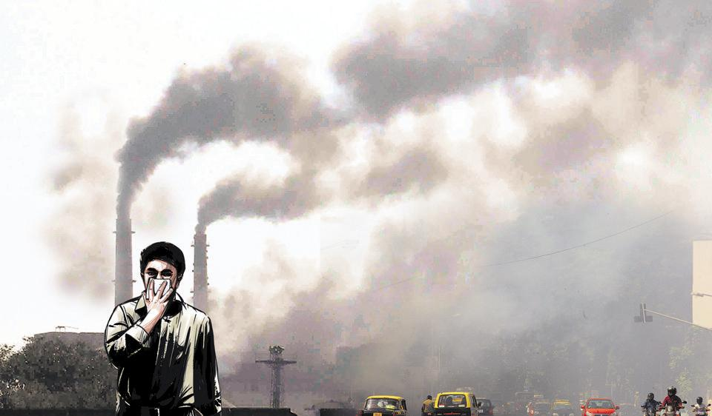
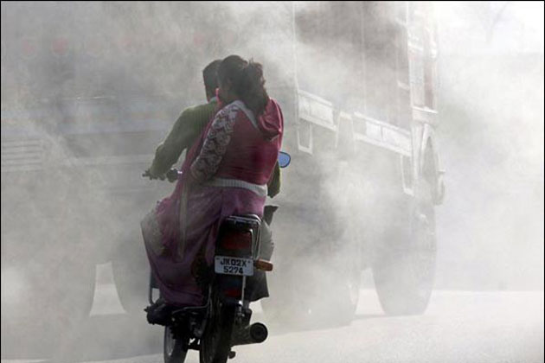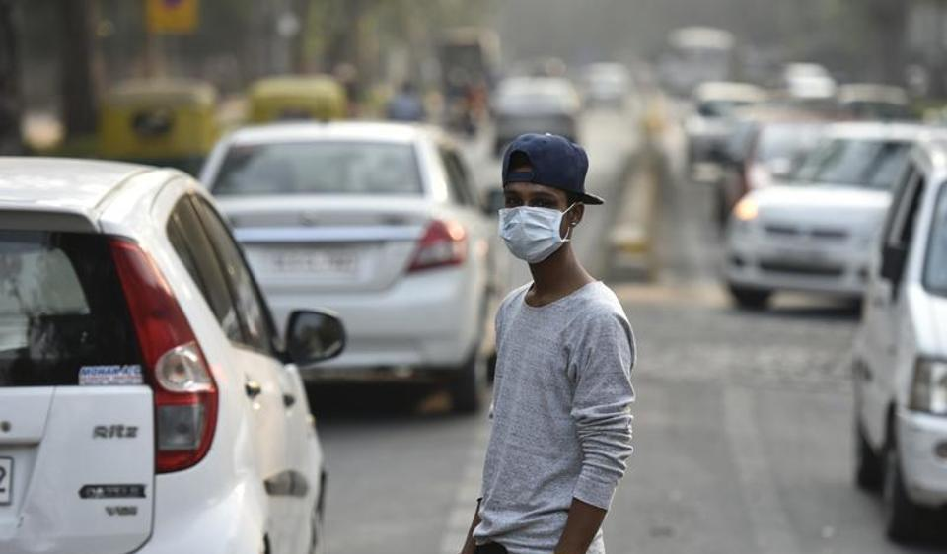
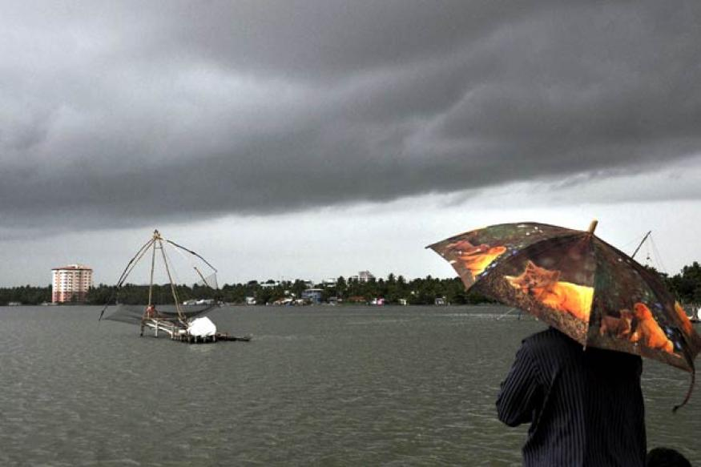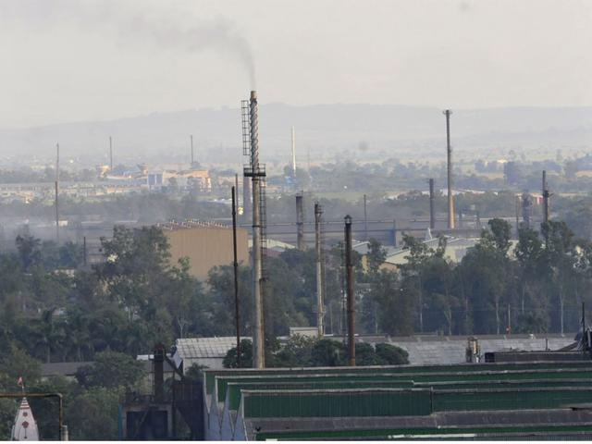

Figure 22: Increase in Levels of Pollutant – Emissions – Impact on Future Generated Aspects/ Prospects from Various Sources.

Impact on Noise Levels

Construction Phase

During the construction phase, noise will be generated due to movement of vehicles, and operation of light and heavy construction machineries including pneumatic tools (hot – mixer, dozer, tipper, loader, excavator, grader, scraper, roller, concrete mixer, generator, pump, vibrator, crane, compressor etc.) that are known to emit sounds with moderate to high decibel value.

Noise generated from sources mentioned above will be intermittent and mostly during daytime. Moreover, villages/ settlements being mostly away from the road, no significant impact on local people is apprehended, as the noise will generally die down by the time it reaches them. However, the workers are likely to be exposed to high noise levels that may affect them.

Impacts: Increase in noise level due to construction activities like operation of construction equipment and vehicular traffic.

Operation of construction machinery will lead to rise in noise level to the range between 80 to 95 dB (A). The magnitude of impact from noise will depend upon types of equipment to be used, construction methods and also on work scheduling. Typical noise level of various activities associated with highway projects is already presented.

General conclusion can be based on the types of construction work anticipated, the likely equipment required and their associated range of noise levels. The construction noise is generally intermittent and depends on the type of operations, location and function of the equipment and the equipment usage cycle, it attenuates quickly with increases in distance. The noise level generated from a source will decrease with distance as per the following “Empirical Formula” (Inverse Square Law) Equation (3).

SPL₂ = SPL₁ – 20 Log 10 (r₂/ r₁) | …Equation (3)

Where, SPL₁ and SPL₂ are the sound pressure levels at distance r₁ and r₂ respectively.

Noise standards for automobiles, domestic appliances and construction equipments have been notified for “Environment (Protection) Rules”, 1986, as amended on “19th May, 1993”. Considering the stationary construction equipment as a point source generating 90 dB (A) at a reference distance of 2 m, computed minimum distance required from the stationery source to meet the permissible noise limits during day time for different land use categories or patterns are as given below in the Tables 52 and 53.

Table 52: Frequency of Permissible Noise Limit in the Environment.

Category of Vehicle | Noise Limit in dB (A)
(a) Motorcycle, Scooters and Three Wheelers; | 80
(b) Passenger Cars; | 82
(c) Passenger or Commercial Vehicles up to 4 – MT; | 85
(d) Passenger or Commercial Vehicles above 4 – MT and up to 12 – MT; | 89
(e) Passenger or Commercial Vehicles Exceeding 12 – MT; | 91
Table 53: Category of Domestic Appliances/ Construction Equipments in the Environment.

Category of Domestic Appliances/ Construction Equipments | Noise Limit in dB (A)
(a) Window Air Conditioners of 1 Tone to 1.5 Tone; | 68
(b) Air Coolers; | 60
(c) Refrigerators; | 46
(d) Diesel Generator for Domestic Purposes; | 85 – 90
(e) Compactors (Rollers), Front Loaders, Concrete Mixers, Cranes (Movable), Vibrators and Saws; | 75

The permissible levels for noise exposure for work zone area have been prescribed under the “Model Rules” of the “Factories Act”, 1948, as given in the Tables 54 and 55 below.

Table 54: Peak Sound Pressure Level (PSPL) in the Environment.

Peak Sound Pressure Level in dB (A) | Permitted Number of Impulses or Impact/ Day
140 | 100
135 | 315
130 | 1,000
125 | 3,160
120 | 10,000

Notes:
1. No exposure in excess of 140 – dB (A) “Peak Sound Pressure Level” (PSPL) is permitted;
2. For any “Peak Sound Pressure Level” (PSPL) falling in between any figure and the next higher or lower figure as indicated in Column – 1, the permitted number of impulses or impacts per day is to be determined by extrapolation on a proportionate basis.

Table 55: Total Time Exposure of Peak Sound Pressure Level in the Environment.

Total Time of Exposure (Continuous or a Number of Short Term Exposures) per Day, in Hour | Sound Pressure Level (SPL) in dB (A)
8 | 90
6 | 92
4 | 95
3 | 97
2 | 100
1 – 1/ 2 | 102
1 | 105
1/ 2 | 107
1/ 4 | 110
1/ 8 | 115

Notes:
1. No exposure in excess of 115 – dB (A) is to be permitted;
2. For any period of exposure falling in between any figure and the next higher or lower figure as indicated in Column – 1, the permissible “Sound Pressure Level” (SPL) is to be determined by extrapolation on a proportionate basis.

From the above table it may be noted that residence within 113 m from the road will be exposed to a noise higher than the permissible limit. The impacts will be significant on construction workers, working close to the machinery.

Mitigation Measures:

- Construction camp and temporary labour sheds will be located away from the immediate vicinity of the construction sites and major road traffic;
- Protective gears such as ear plugs or ear muffs will be provided to construction personnel exposed to high noise levels as preventive measure;
- Low noise construction equipment will be used;
- It will be ensured that all the construction equipment and vehicles used are in good working condition, properly lubricated and maintained to keep noise within the permissible limits and engines turned off when not in use to reduce noise;
- Stationary construction equipment will be placed 113 m away from inhabited areas;
- Stationary construction equipment will be placed 200 m away from the silence zones i.e., educational institutions, medical amenities and religious places;
- Construction activities carried out near residential area will be scheduled to the daytime only so that minimum disturbances are caused to people;
- “Silence Zones” will be demarcated and road signs prohibiting the use of “Horns” (No Honk Zone) will be displayed at residential areas, sensitive locations and silence zones;
- “Noise barrier will be constructed in all educational institutions to minimize the impact of traffic noise”.

Noise Monitoring: The effectiveness of mitigation measures and further improvement in designs to reduce the noise level due to construction and operation activity shall be monitored. The frequency, duration and monitoring plan shall be functional in construction as well as in operation stages as per the “Environmental Monitoring Plan” (EMP). “Ambient Air Quality Standards” (AAQS) with respect of Noise are given and the monitored values should correspond with the table. All deviated results shall be reported to IE, for remedial measures.

Operation Phase

The significance of operational noise impacts commensurate with the number of sensitive structures and sensitive areas that exist along the project roads. As stated in the project road is mainly passes through agricultural land (67.9%) followed by residential and commercial area (24.9%) and only residential area (7.3%). After removal and shifting of the directly impacted sensitive structures, the sensitive structures that will be remaining on either side of the road, which will be exposed to noise generated by future traffic plying on the improved road.

Source of Noise: During the operational phase, movement of traffic, traffic congestion, pedestrian interferences and increase in use of horns will be the prime source of noise. The noise levels at nearby schools, religious place may cause nuisance and irritation in the surrounding environment.

Vehicle Noise and Road Surface Influence on Tire/ Road Noise*: There are many sources of noise when a vehicle travels down a roadway. Vehicle manufactures have made efforts to reduce tire/ road noise and drive train noise. If a vehicle is in a good operating condition and has a reasonably good exhaust system, then the effect that power and drive train noise has on the overall noise level will be negligible at moderate to high speeds. There is a “Cross – Over Speed” where tire/ road noise begins to dominate the overall noise level of a vehicle. This speed lies in the range of 30 – 50 Km/ Hr for automobiles and 40 – 70 Km/ Hr for trucks. It has been found that the noise level increases with the increase in the speed (Figure 23).

There are several pavement parameters, which affect the amount that the road surface contributes to the generation of tire/ road noise. These parameters include the texture, age, thickness, and binder material of the pavement. The overall texture of the pavement has a significant impact on tire/ road noise levels. Studies performed by the “Washington State Department of Transportation” (WSDT) to evaluate how tire/ road noise changes with pavement age. These studies have shown that asphalt pavements start out quieter than cement concrete pavements, but the asphalt pavements exhibit an increase in noise levels over time. Another reason for the increase in noise levels is due to an increase in stiffness from traffic loading. Finally, as the asphalt surface wears over time, the coarse aggregate becomes exposed, which causes an increase in noise level in the specific region/ area/ place.

*
U.S. Department of Transportation, “Federal Highway Administration” (FHA);

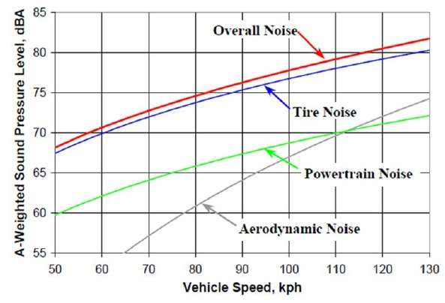

Figure 23: Comparison of Noise Level Separated by Component.

Prediction of Impacts: Long – term noise level increase was assessed with respect to the sensitive receptors for the years 2015, 2020 and 2040 using the “7 – CRTN Model”. Noise barrier has been proposed in 16 educational institutions. List of sensitive receptors where noise barrier has been worked out and found less than the desirable. The “7 – CRTN Model” predicts noise in terms of the L – index, for the 18 – Hours between 06: 00 and 24: 00. The Equation (4) is as given below:
10

L_{Aeq}, 1h = 0.94 × L_{A10}, 1h + 0.77 dB was used to convert L₁₀ to L_{Aeq} | …Equation (4)

(Abbot, P. G. and Nelson, P. M. Converting the UK Traffic Noise Index L_{A10}, 18 H to EU Noise Indices for Noise Mapping, Project Report PR/ SE/ 451/ 02).

Input Parameters: Total vehicle flow for the projected period is obtained from the traffic projections. Minimum design speed of 80 Km/ Hr is considered for operation phase. Apart from that, year – wise %age of heavy vehicle, gradient, road surface, absorbent ground cover, distance from edge of the carriageway and source/ receiver height difference are at the other input parameters.

Output: To reduce traffic induced noise, noise barrier in the form of solid boundary wall is proposed. Height and length of the noise barrier and estimated reduction in noise level after construction of the noise barrier and results of “7 – CRTN Model” is graphically presented (Figure 23) and Noise Contours near the sensitive receptors is for 5 sensitive receptors for the years 2015, 2020 and 2040 respectively.

Height of noise barrier has been proposed 3 m. It has been observed that, in the year 2030, the value of noise at the receptor will increase substantially from the base year (2015). However, to maintain the noise level at the receptors, the barrier height should be increased by 0.5 m in the year 2030 (Height 3.5 m) and further 0.5 m in 2040 (Height 4.0 m). It is recommended that the foundation of the noise barrier should be made in such a way that it can bear the load of incremental heights in future, if required.

Noise Barrier

“To reduce traffic induced noise, noise barrier in the form of solid boundary wall is proposed for sensitive receptors. The noise barrier wall shall be constructed by excavation of foundation, lying of brick masonry wall, plastering and painting. It is also proposed to plant shade and flowering trees within the boundary of the sensitive receptors, between the building line and the compound wall (Figure 23). Creepers may be planted in consultation with the local forest officials to give an aesthetic look”.

Various Noise Barrier Materials: Noise barriers are a necessary structure along the highway to protect the sensitive receptors from excessive road noise. There are many different materials from which noise barriers can be constructed such as brick, concrete, plastic, wood, mixed type (existing wall, top up with dense fiber/ polyethylene wall) high density fiber/ polyethylene etc. Each of the materials used to construct noise barrier has advantages and disadvantages both acoustically and aesthetically. Several studies have been conducted to identify the noise barrier material that produced the greatest noise reduction. It can be concluded from literature review that:

- Absorptive wall materials absorbed more sound energy than a standard reflective material;
- Concrete noise abatement walls yields a mean insertion loss of 18.54 dB, which is maximum in comparison to the other materials such as Fiberglass (17.35 dB), Wood (13.60 dB) Acoustic Fabric Fence Materials (11.62 dB), Earthen Berms (12.93 dB) etc.

However, keeping in view the policy of NHAI and cost effectiveness, brick has been proposed as a material for construction of noise barrier. In NHAI – VIII, brick wall has been constructed as noise barrier and effectiveness of the barrier is discussed in the study and projected areas. In the year 2035, the noise level at the receptor will increase more than 4 dB (A) from the base year 2015. Therefore, to maintain the noise level at the receptors, construction of concrete wall may be considered in the year 2035.

Mitigation Measures:

- Vehicular noise and use of horns will be controlled through enforcement of laws and public awareness. It will be ensured that all the vehicles are using proper horn as per norms to keep noise within the permissible limits;
- Silence zones will be demarcated and road signs prohibiting the use of horns will be displayed at residential areas, sensitive locations and silence zones;
- Regular monitoring of noise level at specified representative locations will be conducted at fixed interval;
- Roadside plantation with suitable species near sensitive receptors and inhabited areas will result in partial noise attenuation;
- Maintenance of noise barrier.

Noise Barrier Installation under NHAI Projects

As part of the road up – gradation/ improvements, NHAI will construct noise barriers at selected sensitive receptor locations like schools, colleges, hospitals, temples among others at various chainage along roads under EPC – Packages.

A study will be conducted by NHAI to assess the effectiveness of such constructed noise barriers and accordingly selected sensitive receptor locations, which are either on almost road side or very close to road and have maximum exposure to traffic of the road for most hours of the day, were selected among various chain – ages.

The impact of noise levels from the proposed project on the neighbouring communities is addressed by carrying out Noise Modelling using “FHWA Model” developed by “Federal High Way Administration” (FHWA). It has been concluded after Mathematical Modelling that both day time and night time equivalent noise levels are within the permissible limits as right from start of project life. Noise sensitive receptors have been identified along the projected road site/ area. The noise sensitive receptors include school, hospitals, colleges; old orphan people’s sensitive house zones (Ashrams) and other nearby housing transportation activities along the road side etc. The predicted levels indicate that the noise levels in future years will not exceed permissible limits right from start of project life as given in Figure 24. Hence there is no need to protect these noise sensitive receptors.

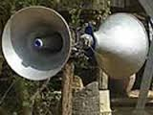
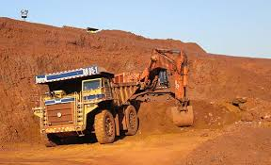
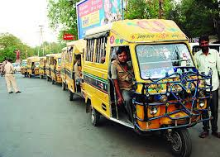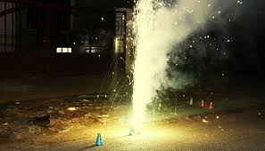
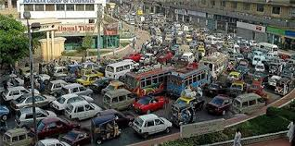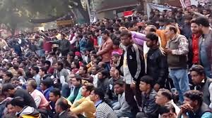

Figure 24: Noise Levels Impact Must Not Exceed the Permissible Limits in Sensitive Zones along Road Side.

Impact on Water Resources and Quality

The construction and operation of the proposed project roads will not have any major impacts on the surface water and the ground water quality in the area projected site/ region. Contamination to water bodies may results due to spilling of construction materials, oil, grease, fuel and paint in the equipment yards and “Asphalt Crusher Plants” (ACP) or “Hot Mixing Plants” (HMP). This will be more prominent in case of locations where the project road crosses water streams; major canals distributaries, minor/ major ponds and minor/ major small lakes etc. Mitigatory measures have been planned; generated; Initialized and finalized to avoid contamination of these water bodies are given in Figure 25.
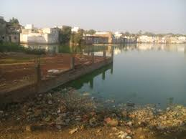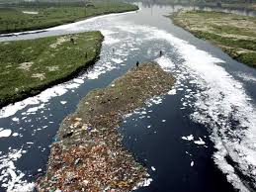
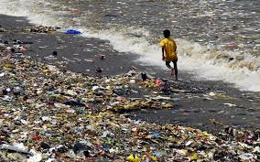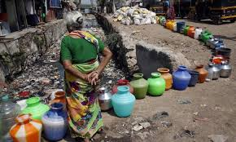
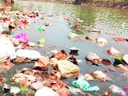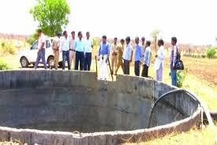
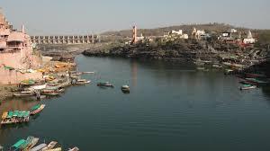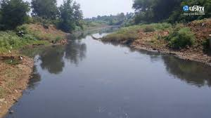

Figure 25: Mitigatory Measures Plans Generated; Initialized and Finalized to Avoid Contamination Impact on Water Resources and Quality.

Impact on Ecological Resources and Soil Quality

There is no wildlife sanctuary in the close vicinity of the projected road. The study area passes primarily through agricultural land in plain areas. There will be temporary impact on terrestrial ecology, as trees will be cut. But after construction no impact is anticipated as compensatory a forestation is planned. There are no endangered species or rare species of flora and fauna in the projected area. There is no major loss of vegetation; hence adverse impact in terms of availability of nesting sites for the bird doesn’t arise in the region. Furthermore; there is no sensitive Environmental/ Natural/ Ecological area near the existing projected roads, so the impact will be insignificant or inconsequential. Brief potential impacts are shown in Figure 26 and are presented in matrix below in the Table 56.
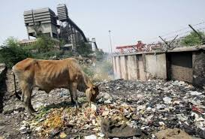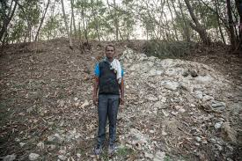
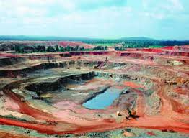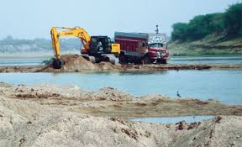
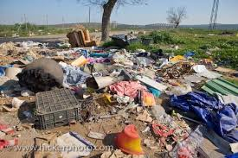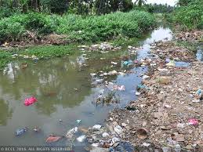
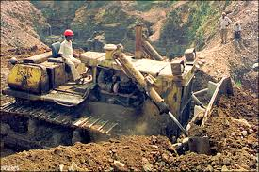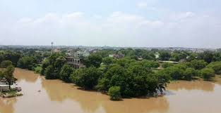

Figure 26: Plan Mitigatory Measures to Avoid Soil Contamination Impact on Agricultural Land and Other Sensitive Zones in Environmental/ Natural/ Ecological Vicinity/ Area/ Site.

Table 56: Potential Environmental Impacts.

Project Activity | Pre –Construction | Construction Phase |  |  |  |  |  | Operation Phase
Component Affected | Land Acquisition | Site Clearance | Earth Moving (Borrow Pits) | Contractor Camps | Quarries Areas | Construction of Highway | Asphalt Crusher Plants | Operation
Soil | Loss of productive agricultural land | Loss of crops, and increase in soil erosion | Loss of top soil and erosion | ------- | Increase in erosion, siltation and slope instability | Soil pollution | Pollution due to spills | Soil contamination due to surface runoff
Ground  Water | ------- | ------- | ------- | Water  Extraction for drinking | ------- | Exploitation of water for construction | ------- | Maintenance of trees/ shrubs
Surface Water | ------- | Change in water quality and siltation | Water logging and mosquito breeding | Water pollution from sanitary and other wastes | Water logging problems | Change in water quality | Water pollution due to spill into water bodies | Degradation due to spill – over sand road run off
Drainage | ------- | Change in natural drainage pattern | Change in drainage pattern | ------- | Modification in natural drainage | Interference with natural drainage, water logging | ------- | Cleaning and maintenance
Air Quality | ------- | Increase in air pollution | Particulate matter pollution | Atmospheric pollution due to fuel burning | Dust pollution | Dust pollution | SPM, SO₂ | Increase in SPM, NO_{X}, CO
Noise Quality | ------- | Reduced buffering of noise | Increase in  noise levels due to machinery | ------- | Vibration from blasting operations | Vibrators, concrete batching plants noise etc. | Increase in noise | Increase in noise levels due to increased traffic
Forest | ------- | Habitat loss, and vegetation | Loss of forest | Encroachment into forest areas | Loss of habitat/ cover | Loss of forest | ------- | -------
Trees | Tree cutting clearance | Loss of trees | Loss of trees | Cutting of  trees | Tree cutting | Loss of trees | ------- | -------
Temples/ Mosques | Clearance | Removal/ rehabilitation | ------- | ------- | ------- | ------- | ------- | -------

Flora

Construction Phase Impacts:

- Loss of flora due to felling of trees along the ROW;
- No threatened species of flora is falling in the ROW of the project road;
- Deposition of fugitive dust on pubescent leaves of nearby vegetation may lead to temporary reduction of photosynthesis. Such impacts will, however, be confined mostly to the initial periods of the construction phase and in the immediate vicinity of the construction area;
- In the long term, compensatory afforestation and “Green Belt Development” (GBD) will enhance environment of the project area.

Felling of Roadside Trees: Efforts were made to minimize the number of trees to be felled and considering the need to minimize, concentric widening of existing carriageway (4 – lane divided carriageway with paved shoulder), which is adopted for majority of the section. Approximately number of trees is counted required to be felled for the improvement of the road. However, this number may reduce and actual number of trees to be felled can be determined only after the completion of joint inspection with the “Forest Department” (FD). Trees species abutting the project road mainly comprise of Ficus Benghalensis (Banyan), Ficus Religiosa (Peepal), Azadirachta Indica (Neem), Pongammia Pinnata (Karanj), Syzigium Cumini (Jamun), Eucalyptus Teriticornis (Eucalyptus), Tamarindus Iindica (Tamarind) etc. Girth – Size wise distribution of trees to be felled along both side of the road is worked out.

Mitigation Measures:

- Avoid cutting the giant trees to the extent possible;
- It shall be ensured that trees located outside ROW shall not be felled;
- The trees required to be felled shall be identified, marked and verified by “Forest Department” (FD). Felling of trees shall be done only after obtaining “Tree Felling Permission” (TFP) from competent authority. No threatened species of flora is reported in the ROW. The trees planted along the roads are common in distribution and found throughout the region;
- Roadside Plantations: To mitigate the adverse impact due to the felling of the roadside trees plantations shall be done. One row of tree shall be planted on both sides of the project road outside drain line where space is available. In urban sections, 23 m to 25 m ROW has been proposed to minimize social impact, where no space is available for plantation.

“Total length of the project road is 252.78 Km and effective length available for plantation will be worked out by “PIU – NHAI” has an arrangement with the Forest Department to plant the trees. In NHAI per Km “200 Trees” (10 m interval on either side) will be planted and the same system will be followed in NHAI”.

The “Punjab Preservation of Trees Act”, 1976 shall be abided. Trees in non – forest/ agriculture land shall be felled only after obtaining permission from competent authority.

* I – Insects, B – Birds, M – Mammals;

- The plantation shall be maintained for 5 years. Dead saplings shall be replaced to maintain the survival percentage of 90%;
- Horticultural trees such as Mango, Custard Apple, Papaya, Pomegranate etc. may be distributed to farmers in affected villages freely as part of “Corporate Social Responsibility” (CSR) to compensate the loss of horticultural trees in the area;
- To enhance the visual and landscape near water bodies, plantation is suggested. Species such Terminalia Arjuna, Syzigium Cumini etc. and flowering plants such as Champa, Jasmine, Rose etc. can be planted;
- Oil seed species/ Bio – fuel trees species such as Pongamia Pinnata, Azadirachta Indica, Simarouba Glauca, Madhuca Indica/ Latifolia, Calophyllum Inophyllum also suggested for Plantation;
- Native indigenous trees species shall be used as far as practicable, strictly avoiding any exotic (but popular) species like Eucalyptus sp. that can have far – reaching adverse effects on the ecology and water regime of the area. Soil erosion shall be checked by adopting bio – engineering measures;
- Construction camps shall be located away from Forest Areas and movement of labours shall be monitored by Independent Engineer and Contractor (IE/ C);
- LPG/ Kerosene shall be provided by the Contractor for cooking;
- The impact on flora will be concentrated within the ROW of the road and cutting of trees or clearing of vegetation outside ROW shall be strictly prohibited.

Operation Phase

Impacts: Illegal felling of road side plantation.

Mitigation Measures:

- Plantation along the ROW will be maintained properly;
- Plantation along the ROW will be protected from illegal felling.

Fauna

Construction Phase

Impacts:

- Wildlife can survive if the landscapes they live in remain intact. The clearing of land and felling of trees will directly cause loss of habitat to avifauna and wildlife dwelling in the area;
- There are no National Parks or Wildlife Sanctuaries within 10 Km radius of the proposed road. There will be no direct impact on “Protected Areas or Wildlife Habitat” due to the project;
- The proposed project does not involve diversion of forest land;
- The domestic fauna in the area will also face problem in movement due to construction activity.

Mitigation Measures:

- The Contractor shall ensure that all the people at construction site abide by the law prohibiting hunting of wildlife. Poaching will be strictly banned and any incidence of poaching of wildlife by workforce shall be reported to the “Forest/ Wildlife Department” (F/ WD);
- All staff/ workers will be instructed not to chase or disturb, if any wildlife seen near the project area. The incidence of sighting wildlife near project site should be reported to “Forest Department” (FD);
- Noise will be kept under control by regular maintenance of equipment and vehicles. Noisy activity shall be prohibited during night time;
- Trees located outside ROW will not be felled;
- Implementing sediment and erosion controls during construction will minimize adverse impacts of water bodies. Construction activity will be avoided near water bodies during rainy season;
- Existing and proposed culverts and minor bridges along the project stretch will facilitate the movement/ crossing of wildlife in the area;
- Plantation of fruit bearing species will support the future demand of the fauna dwelling in the projected area. It will provide additional habitats to avifauna dwelling in the area;
- Impact on availability of fodder due to loss of trees and agricultural area shall be negligible on domestic fauna;
- Overall the impact will be insignificant on fauna of the project area.

Operation Phase

Impacts:

- Effect on aquatic fauna in case of accidental oil spill and toxic chemical release find its way into the water bodies;
- Illegal felling of road side plantation etc.

Mitigation Measures:

- Contingent actions will be taken for speedy cleaning up of oil spills, fuel and toxic chemicals in the event of accidents;
- Plantation along the ROW will be protected from illegal felling.

Protected Area

The project road “NHAI Roads” does not pass through any Wildlife Sanctuary/ National Park/ Bio – sphere Reserve. No protected area is located within 10 Km radius of the project area. Hence, there will be no impact on protected area.

Reserved Forest

The proposed project does not involve diversion of reserved forest land. Hence, there will be no impact on reserved forest.

Induced and Cumulative Impact

“According to the ADB Environment Safeguards Sourcebook Cumulative Impact is Described as: “The combination of multiple impacts from existing projects, the proposed project and anticipated future projects that may result in significant adverse and/ or beneficial impacts that cannot be expected in the case of a stand – alone project”. The Sourcebook also Describes Induced Impacts as: “Adverse and/ or beneficial impacts on areas and communities from un-intended, but predictable developments caused by a project, which may occur at later or at a different location”.

Economic activities supporting transport like fuel stations, automotive repair shops, lodging, and restaurants are expected to increase with increase of traffic and induce development in the project area. Increase in agro – industrial activities are also expected to take advantage of improved access to urban centers, where there are higher demand and better prices for agricultural products. The project area has good infrastructure for industrialization. Hence the project will accelerate industrial activities and induce development significantly.

Climate Change Impacts and Risks

Further the increased industrial activities will significantly reduce migration. The improved road will provide better connectivity and result in (i) Reduction in travel time (ii) Better mode and frequency of transport (iii) Access to quality health care facilities, educational and other infrastructural facilities (iv) Enhanced tourism activities in the area and state, which in many terms will boost the local economy (v) Better investment climate for industries creating more employment opportunities to local people.

In terms of environment safeguard issues the improved road surface is expected to result in less dust and noise due to traffic plying on the damaged roads. However, the increased traffic due to the improved road will generate more air pollution due to vehicle exhaust and noise. The smoother road conditions will also result in increase of traffic speeds, hence creating more risks for accidents amongst traffic users as well as the local communities in the project area. Improvement in local economic conditions can also result in un – organized and illegal establishment of settlements and businesses along the roads creating new problems of waste and pollution. To address these potential problems relevant local authorities will have to monitor developments and strictly enforce rules.

“For addressing the impacts of air pollution and noise, regular maintenance of the road surface, maintenance and monitoring of newly planted trees, noise barriers have been included in the “Environmental Management Plan” (EMP) for implementation during operation stage. For addressing safety related impacts, regular maintenance of the road furniture including safety related furniture, has been included in the “Environmental Management Plan” (EMP) for implementation during operation stage. Relevant local authorities will need to monitor developments locally and strict enforce rules on location for establishment of new business and houses along the improved road. Information on other development projects in and around the project area was not available. “Hence, it is difficult to assess cumulative impacts from other projects, which may get implemented in the projected area/ state/ region accord to space and time”.

Social Impacts

Educational, Medical and Religious Properties

Impacts: Roadside amenities, religious and cultural properties generally include:

- Educational Institutions (Schools and Colleges);
- Medical Amenities (Hospitals and Health Centers);
- Religious Properties (Temples, Mosques, Church etc.).

In few cases the impacts will be total (e.g., the main structure has to be demolished), and in few cases the impacts will be partial (e.g., only boundary wall and/ or part of the structure has to be demolished) depending on the distance of the structure from the road.

Mitigation Measures:

- Fully affected structures will be relocated;
- Affected utilities like electrical transmission lines, telephone lines, water pipelines, petrol pumps etc. will be suitably shifted by the concerned departments.

Steps for Minimizing Adverse Impacts

Social impacts were minimized to the extent possible. The following steps were followed to minimize social impacts and in particular impacts on very congested areas and sensitive structures (i.e., clusters, community and religious structures). The social team working in the field weighed up the alternative alignment options proposed by the “Survey and Engineering Team” (SET) and this field information were shared and discussed with engineering design team, to avoid or minimize adverse impact on large number of households. Moreover, local level consultations regarding the impact of widening of the road and in particular its impacts on sensitive sites were conducted and alternative suggestions offered by road residents were considered. In response, the engineering team considered various options.

These minimization efforts resulted in:

- Potential displacement avoided by modifying the alignment;
- Fixing the speed in the built up areas including schools and hospitals as per local needs and problems of the people;
- Deciding the rural and settlement location road cross – sections based on field surveys and likely impact on the people; and
- “Evolving Community” (EC) consensus on shifting the existing community properties and religious structures.

Rehabilitation and Resettlement

The resettlement cost estimate for the compensation for structure at replacement cost without depreciation, compensation for livelihood loss, resettlement assistances and cost of implementation. The total resettlement cost for the project is in INR 346.43 Crores. The “Environmental Authority” (EA) will provide the necessary funds for compensation for land and structures and R&R assistance. The EA will ensure timely availability of funds for smooth implementation of the project.

Employment and Trading Opportunities

It is estimated that a substantial construction personnel including skilled, semi – skilled and un – skilled labourers employed by various contractors will work at site during the peak period of construction phase. Since most of sizeable labour force will be drawn from neighborhood, no change in demographic profile is anticipated. Only for a few skilled personnel, brought to site from outside the locality, proper housing/ accommodation would be provided in the construction camps. Due to employment opportunities, some competition for workers during construction phase is therefore anticipated.

The construction materials like stone chips and sand will be procured locally from identified quarry sites. The other important materials like cement, steel will be procured through various local sources. Thus there is a possibility of generation of local trading opportunities, though temporary and provisional.

Migration

Mitigation Measures:

- Most of the un – skilled construction labourers will be recruited from the local areas to create some employment opportunities and sense of well – being among local people. This will also reduce social tension of migration;
- Some of the construction materials like stone chips and sand will be procured locally. Thus there is a possibility of generation of local trading opportunities, though temporary/ provisional.

From the view point of employment of migrant skilled workers the project is small. Therefore no social tension is expected due to very small number of migrant skilled workers. As the construction phase has a very short time span in comparison to the operation phase, it would not have any long term effect. Moreover the different groups of people engaged in different construction activities will leave the place after specified time span.
Construction Camp

Impacts:

- Influx of construction work – force and supplier, who are likely to construct temporary tents in the vicinity;
- Likely sanitation and health hazards and other impacts on the surrounding environment due to inflow of construction labourers;
- Generation of solid and liquid waste from construction camp.

Mitigation Measures:

- Temporary construction camps at designated and demarcated sites with adequate sanitation, drinking water supply and primary health facilities;
- Proper accommodation will be provided in the locality for the migrant construction engineers and officers;
- Most of the construction works is labour intensive. As most of the job will be done by contractors, it will be ensured that the contractor's workers are provided with adequate amenities, health and sanitation facilities in the camp by the contractor. Such facilities shall include potable water supply, sanitary facilities, solid waste collection and disposal system, primary health facilities, day care facilities and temporary electrification (if possible);
- It will be ensured through contract agreement that the construction workers are provided fuel for cooking to avoid cutting of trees for fuel wood from the adjoining areas;
- Domestic as well as the sanitary wastes from construction camp will be cleared regularly.

Waste Management System/ Structure Coordination

- The Contractor should provide separate garbage bins in the camps for bio – degradable, non – biodegradable “Waste Management System/ Structure Coordination” and ensure that these are regularly emptied and disposed – off in safe and scientific manner;
- The disposal of kitchen waste and other bio – degradable matter will be disposed in approved “Landfills Sites” through arrangement with local civic bodies;
- Non – biodegradable waste like discarded plastic bags, paper and paper products, bottles, packaging material, gunny bags, metal containers, strips and scraps of metal etc. and other such materials will be sold/ given out for recycling or disposed in approved “Landfills Sites” through arrangement with local civic bodies;
- No incineration or burning of wastes should be carried out on “Landfills Sites”;
- “Effluent Treatment System” (ETS) like septic tank with “Soak Pits” provided for toilets should be sited, designed, built and operated in such a way that no health hazard occurs and no pollution to the air, soil properties or characteristics, land area, ground or adjacent watercourses takes place and Area Method of Land Filing Solid Wastes along with Trench Method of Land Filing Solid Wastes for Small Landfills must be applied f0r “Waste Management System/ Structure Coordination” at Projected Site (Figures 27 and 28);
- Soak pits must be provided to collect waste water from bathrooms and kitchen sideways through Pit Method of Land Filing Solid Wastes for Large Landfills at Projected Site (Figure 29);
- “Septic tank must be provided for toilets and the sludge should/ must be cleaned by municipal exhausters”.

Chandigarh Municipal Corporation's (CMC) “Swachhata Warriors” are carrying out regular cleanliness and sanitization drives to keep the surroundings clean and citizens safe from the menace of “ Horrifying COVID – 19 to 21 Pandemic Viral Disease ”.
Chandigarh (Union Territory) Municipal Corporation {C (UT) MC}: To Preserve City as Neat, Clean, Green, Pollution and Horrifying COVID – 19 to 21 Virus Free Zone … With Eco – Friendly Environment, Civilized and Inhabitable… Region/ Area of Union Territory and Punjab State…!!!
To Be A Good Citizen and Make Chandigarh City, An Ideal City Persistently By Enthusiastic Efforts, Determinations... and Temperament…!!!

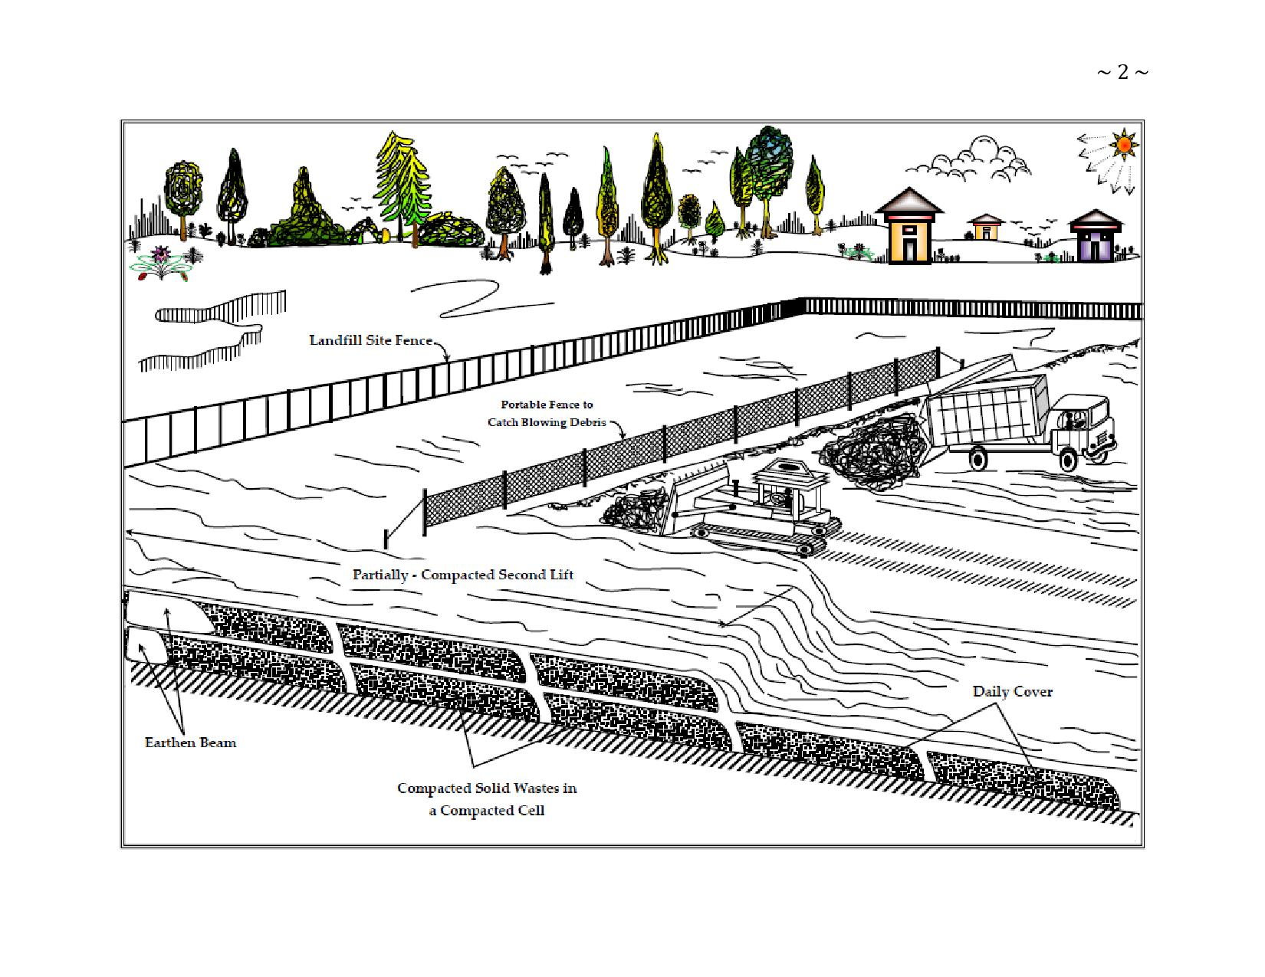

Figure 27: Proposed/ Recommended/ Optional/ Suggested Area Method of Land Filing Solid Wastes at Projected Site.
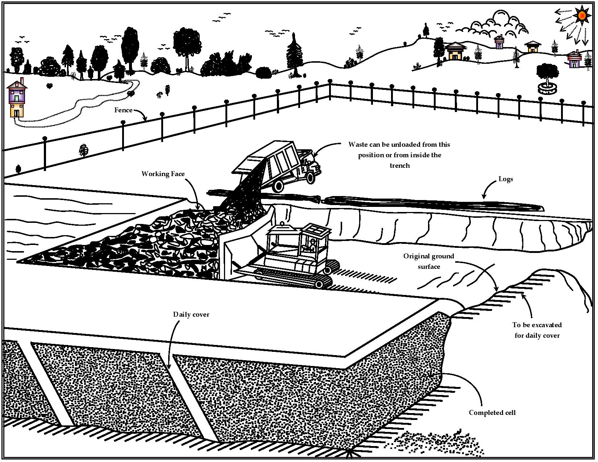

Figure 28: Proposed/ Recommended/ Optional/ Suggested Trench Method of Land Filing Solid Wastes for Small Landfills at Projected Site.
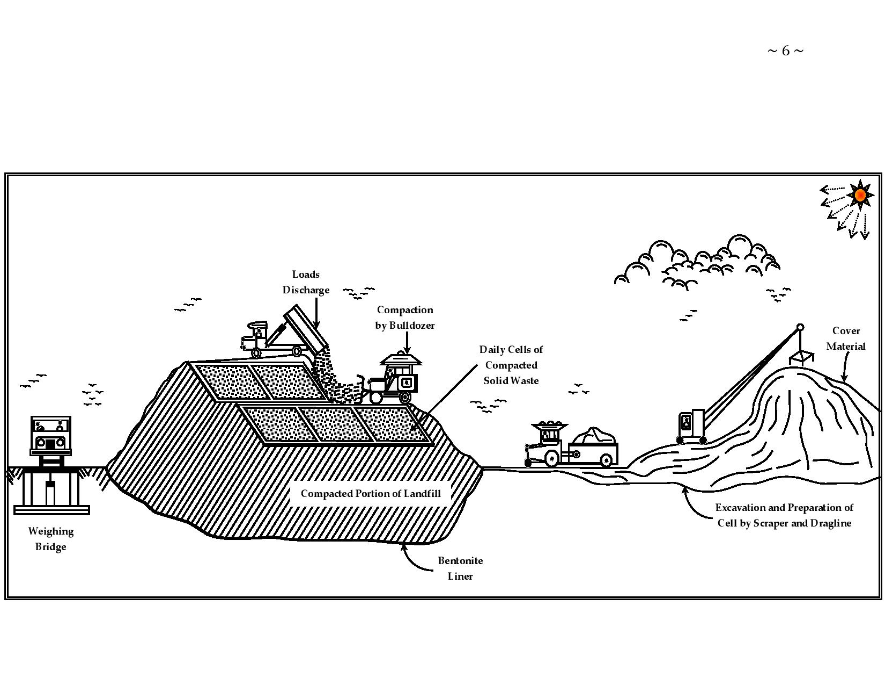

Figure 29: Proposed/ Recommended/ Optional/ Suggested Pit Method of Land Filing Solid Wastes for Large Landfills at Projected Site.

Occupational Health and Safety

Impacts: Health and safety related problems to construction workers due to inadequate health and safety measures.

Mitigation Measures:

- Adequate safety measures complying with the occupational safety manuals will be adopted by the contractor to prevent accidents/ hazards to the construction workers;
- A road safety, traffic management and accident management plan is to be prepared by the Contractor prior to the start of the construction activity;
- Periodic health check – up of construction workers will be done by the contractor;
- Personal protective equipment will be provided to the construction workers.

Road Safety

About 63.9% participants opined that the project road at the present condition is accident prone and requested for its improvement. Further, about 39% of the participants feared that construction period may lead to further increase of accidents and adequate safety measures must be enforced.

Around 83% of the respondents wanted pedestrian crossings at important junctions and popular movement locations like schools, hospitals and temples etc. while 90% of them felt speed breakers are required at these locations to avoid accidents. The respondents shared their concern that the present road signage is insufficient and the proposed improvement proposal should provide proper road signage (86%). Many of the participants viewed that the dumped municipal waste and construction debris on the road shoulders at a few locations are also a threat to the road safety, especially during the night time.

About 78% respondents viewed regular police patrol can also curb the accident rate while another 83% were of the opinion that speed cameras should be installed at important junctions and considered it as the most effective tool to nab the offenders responsible for over speeding causing fatal accidents. About 75% of the respondents opined that regular road safety education camps and “Driver Awareness Programs” (DAP) can also bring down accident rates Overall; the respondents were unanimous over the requirement of road safety features and demanded for its implementation at the earliest.

Positive and Beneficial Impacts

Construction

Phase Impacts: Increase on incidence of road accidents due to disruptions caused in existing traffic movements.

Mitigation Measures:

- Proper traffic diversion and management will be ensured during construction at the intersections and construction areas. Proper warning signs will be displayed at the construction sites;
- Reduction of speed through construction zones.

Operation

Phase Impacts:

- Impacts on human health due to accidents;
- Damage of road due to wear and tear.

Mitigation Measures:

- Bus shelters shall be provided along the project road conforming to design standards;
- Semi – rigid type/ rigid type/ flexible type safety barriers shall be provided on the high Embankment Section (where the height of embankment is more than 3.0 m) and along the horizontal curve having radius up to 450 m for complete length including transition and 20 m further before and after;
- Rigid Type such as “Concrete Crash Barriers” (CCB) shall be provided on the bridges, isolated structures and its approaches;
- Three types of “Road Signs” (RS) shall generally be provided (such as Mandatory/ Regulatory, Cautionary/ Warnings, and Informatory Signs);
- Locations of signs shall conform to IRC: 67 – 2012 and Section – 800 of MORT and H specifications;
- Periodical inspection of the road will be conducted to detect anomalies in pavement;
- Disposal of solid waste/ municipal waste along the side of the road should be avoided. The accumulated wastes should be disposed at approved landfill sites. Where such sites are not available within reasonable lead distance, NHAI should encourage the local municipal/ Panchayat authorities to identify and develop new landfill sites away from the project for disposal of solid wastes;
- The ambulance services to transport serious cases to the district hospital will be introduced and maintained so that serious accident cases can be transported immediately to the nearest district hospital.

Construction

Phase Impacts:

- Employment opportunities due to recruitment of local labourers;
- Trading opportunities due to procurement of some construction materials locally;
- Clean up operations, landscaping and plantations.

Operation

Phase Impacts:

- Increase in road traffic and transportation activities due to faster accessibility;
- Time saving due to faster movement of traffic playing on road;
- Fuel saving due to faster movement of traffic;
- Reduction of air pollution;
- Reduction of number of accidents;
- Reduction of vehicle operating cost;
- Better facilities to road users e.g., bus lay – bays, truck lay – bays etc.

Impact on Drainage Pattern

The proposed widening and strengthening will not alter drainage pattern of the area as adequate cross drainage structures have been planned along the new alignments and existing culverts along the project road are planned for “Rehabilitation and Resettlement” (R and R). Construction of bridges across water streams may result in siltation of water body, which can affect aquatic life and fauna in the region/ area or proposed site. Proper mitigatory measures have been recommended in “Environmental Management Plans” (EMPs).

Impact on Human Use Values

Impact on human use values are including “Precious Planet Earth’s”, common property resources such as temples, mosques, wells, hand pumps, stream channels, stream fountains and tube well etc. Impact on these has been minimized through proper planning of the alignments along roadside/ location site. The environmental impacts have been summarized as in Figures 30 (a) to (d) and Table 57 given below.

Mitigation Avoidance and Enhancement Measures

The mitigation measures have been planned for identified adverse environmental impacts alignment enhancement design phase is being applied along roadside to reduce tree cuttings as compensatory plantation process or relevance. These mitigation measures have been identified as “Environmental Management Plans” (EMPs) during “Planning, Construction and Operation Phase”.

Design Phase

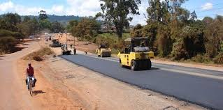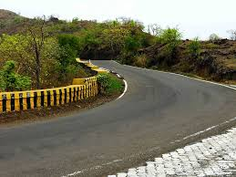
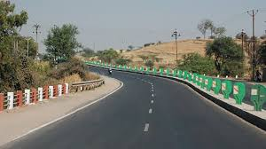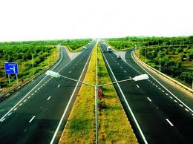
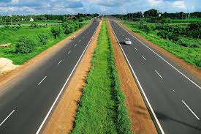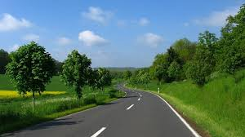

Figure 30 (a): Mitigation Enhancement as per Alignment Design Phase to Reduce Tree Cutting and Compensatory Plantation Relevance.

Anticipated; Recommended and Refined Enhancement Measures of Road Design Phase for ZERO Pollution Level…!!!
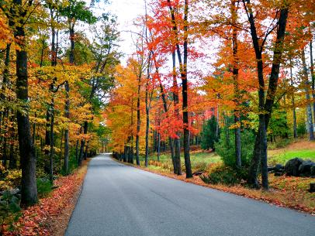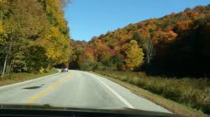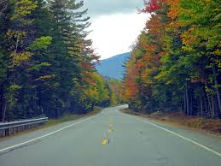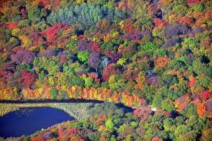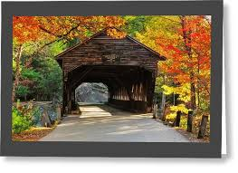
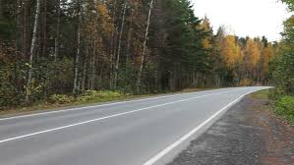

Figure 30 (b): Anticipated Refined Enhancement Measures of Road Design Phase as per Alignment to Reduce Tree Cutting and Compensatory Plantation Relevance for ZERO Pollution Level.

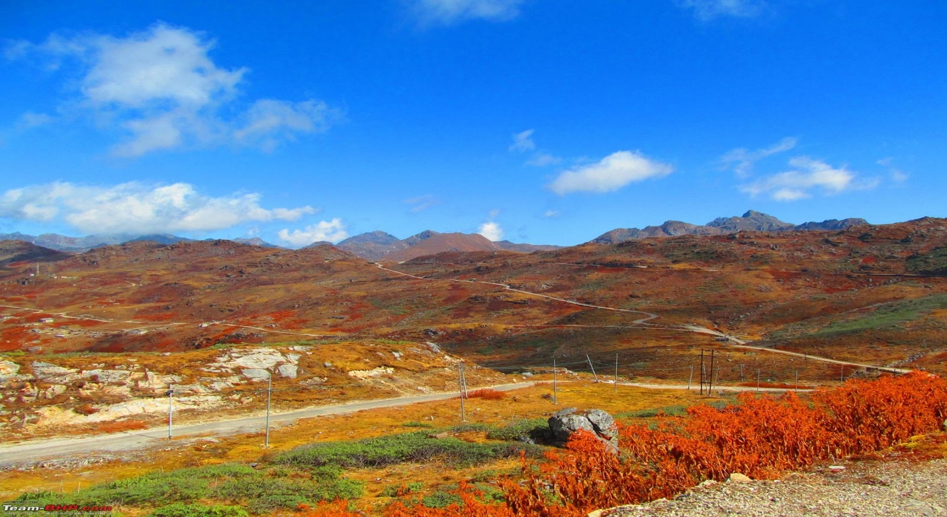
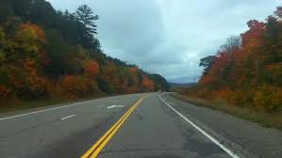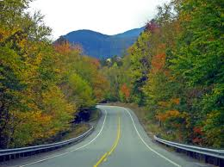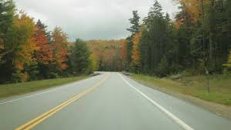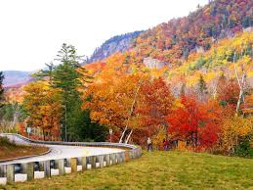
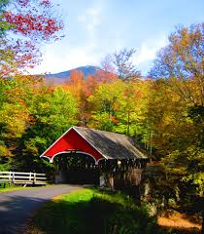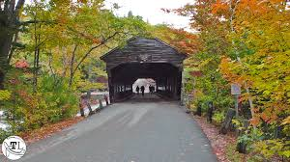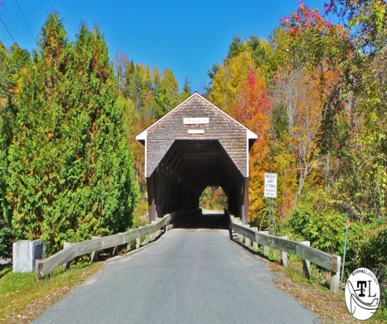

Figure 30 (c): Recommended Refined Enhancement Measures of Road Design Phase as per Alignment to Reduce Tree Cutting and Compensatory Plantation Relevance for ZERO Pollution Level.

Road Designing Phase for ZERO Pollution Level

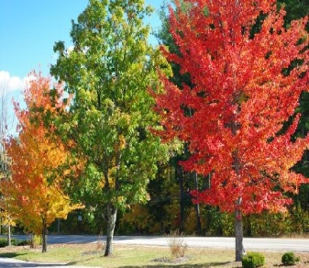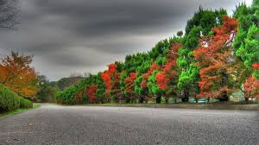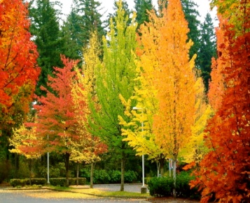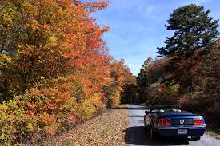
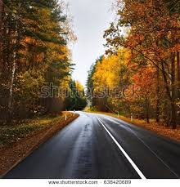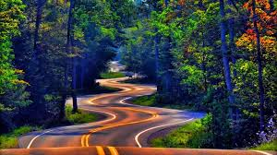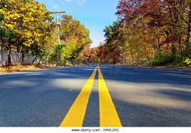
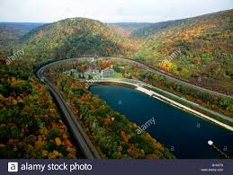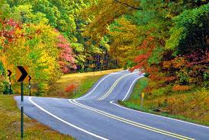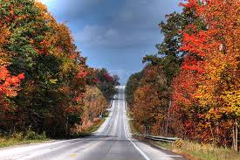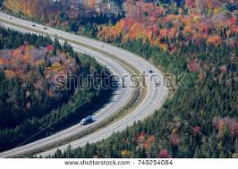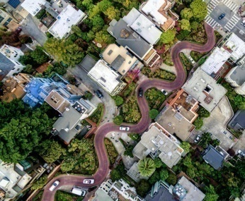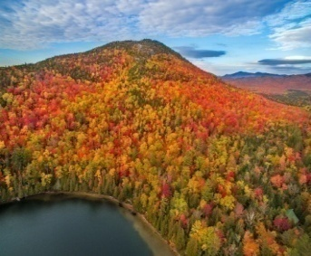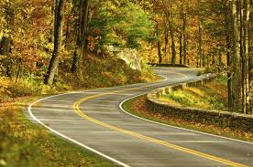

Figure 30 (d): Road Designing Phase as per Alignment to Reduce Tree Cutting and Compensatory Plantation Relevance for ZERO Pollution Level.

ANTICIPATED ENVIRONMENTAL IMPACTS AND MITIGATION MEASURES

Table 1 Impact on Project Road due to Consideration of Alternative

Introduction

This chapter presents key environmental issues associated with various aspects of the proposed sub-projects. The environmental impacts caused due to the development of the sub – project road sections can be categorized as primary (direct) and secondary (indirect) impacts. Primary impacts are those, which are induced directly by the project whereas the secondary impacts are those, which are indirectly induced and typically include the associated investment and changing patterns of social and economic activities due to the proposed action. Interaction of the project activities with environmental attributes is presented as Activity – Impact Identification Matrix in Table 57.

Table 57: Activity – Impact Identification Matrix.
Sr. No. | Activities | Type of Impact
 |  | Air | Water | Noise | Flora | Fauna | Drainage | Soil | Topography
1. | Labour Camp Activities | ------- | -ve/ t | ------- | ------- | ------- | ------- | ------- | -------
2. | Quarrying | -ve/ t | ------- | -ve/ t | -ve/ t |  | -ve/ t |  | -ve/ p
3. | Material Transport and Storage | -ve/ t | ------- | -ve/ t | ------- | ------- | ------- | ------- | -------
4. | Drilling, Blasting and Hill Cutting | -ve/ t | ------- | -ve/ t | -ve/ t | -ve/ t | ------- | ------- | -------
5. | Earthwork | ------- | ------- | ------- | ------- | ------- | -ve/ p | -ve/ t | -ve/ t
6. | Payment Works | -ve/ t | -ve/ t | -ve/ t | -ve/ t | ------- | ------- | -ve/ t | -ve/ p
7. | Use of Construction Equipments | -ve/ t | -ve/ t | -ve/ t | ------- | -ve/ t | ------- | ------- | -------
8. | Plantation | -ve/ p | ------- | -ve/ p | -ve/ p | ------- | ------- | ------- | -------
9. | Drainage Work | ------- | ------- | ------- | ------- | ------- | -ve/ p | ------- | -------
10. | Culvert and Bridge Construction | ------- | -ve/ t | -ve/ t | ------- | ------- | -ve/p | ------- | -------
11. | Stripping of Top Soil | ------- | ------- | ------- | ------- | ------- | ------- | -ve/ p | -------
12. | Debris Generation | ------- | ------- | ------- | ------- | ------- | -ve/ t | -ve/ t | -------
13. | Oil and Grease | ------- | ------- | ------- | ------- | ------- | ------- | -ve/ t | -------
14. | Construction in Forest and Sensitive Areas | -ve/ t | -ve/ t | -ve/ t | -ve/ t | -ve/ t | -ve/ p | -ve/ p | -ve/ p
Notes: t – temporary, p – permanent. Impact indicated in bold letters indicates significant impacts:

Identification and assessment of the potential environmental impacts are based on secondary information supplemented by field visits.

Impacts on various environmental components have been assessed at four different stages, namely:

- The Project Location;
- Design and Pre – Construction;
- Construction; and
- Operation Stages.

A few permanent as well as short – term and long – term adverse effects, mainly at the construction and operation stages, are, nonetheless, anticipated. Temporary short – term impacts can be kept in check through proper planning and adopting environment friendly road construction methods and the appropriate regulatory measures.

The Proposed Project will have Impacts on the Environment in Two Distinct Phases: During the construction phase, which may be regarded as temporary or short – term; the other during the operation stage, which will have long term effects. The negative impacts can be reduced or minimized only if proper safeguards are put in place during the design and construction stage itself. These can include reducing pollutant discharge from the harmful activities at source or protecting the sensitive receptor. “An effective mitigation strategy will utilize a combination of both options to arrive at practically implementable measures. Conscious efforts have been worked out to minimize any adverse impacts on the various environmental and social components. Where the impacts on various environmental components have been unavoidable, mitigation measures have been worked out”.

Positive Environmental Impacts due to Improvement of Project Road Sections

The positive impacts expected from the improvement of the sub – project road section include:

- Improved quality of life for the rural population in the projects influence area: this as a result of better access to markets, health, education and other facilities; and the derived stimulus for local economic activity;
- A more efficient and safe road transport system: through reduced travel times, reduced road accidents, reduced vehicle operating and maintenance costs and reduced transportation costs for goods;
- The facilitation of tourism;
- Inter – district connectivity within District Bhopal;
- Better connectivity to the “State Highway” (SH) and “National Highway” (NH) Network;

Environmental Impacts due to Improvement of Project Road Sections

The adverse environmental impacts anticipated from the improvement of the project road section are:

- Loss of productive soil and agriculture land, cutting of road side trees that falls within formation width i.e., 10 m (for intermediate lane and 11 m for 2 – lane roads) may reduce the ecological balance of the area and also increase soil erosion problem. Noise, air and water pollution and disposal of construction waste, during construction, will adversely impact both local residents. These latter effects should, however, only be temporary/ reversible.
- A number of quarries and other sources will be established, which will change the landscape. However, the operation of quarries is an independent and already regulated activity. Adverse impacts on water quality of rivers crossing or running parallel to the proposed alignments in the form of silt deposition and runoff during construction are expected. However, this is short term and will be taken care of by controlled construction activities.
- Improvement on existing road and construction of new road and bridges, although limited, may enhance soil erosion, landslips and reduce the micro – level ecological balance of the area. Construction may also disturb the habitation of fauna living in this area. These should, however, be only temporarily reversible effects. The improvement will also require the cutting of about “Total Trees”.
- Minor impacts of noise and air quality for those now living and workings close to the sub – project roads (mainly at urban centers) will deteriorate during the construction period and afterwards during operation.

Impacts Related to Project Location, Preliminary Planning and Design

Forest Clearing and Tree Felling

Most of the project roads are passing through plain terrain with land use being agriculture. Although diversion of forest land is not envisaged adverse impacts are anticipated due to land clearing, which will involve cutting of about “Total Trees”. Problem of soil erosion is expected in some locations. To minimize loss of trees, the following mitigation measures have been adopted. During the detailed design and these will be implemented during construction stage of the sub – project roads:

- Widening proposal considered option with minimal tree cutting;
- Widening is restricted to minimum width in the length passing through forest areas;
- Adequate measures are included in the design to minimize any un – foreseen impacts on flora and fauna in the forest areas;
- Land stabilization measures were included in identified areas prone to erosion;
- Strictly enforce the environmental conditions put as part of the forest clearance and no objection certificates issued by the “Forest Department” (FD) and “State Pollution Control Board” (SPCB);
- Adopting “Environmental Friendly Road Construction” (EFRC) methods.

Based on the tree inventory carried out during the field surveys in second quarter of 2018, the total number of trees has to be cleared along sub – project road sections. The main species of trees to be cut are local species namely Mahua (Madhuca Longifalia), Pipal (Ficus Religiosa), Jamun (Syzygium Cumin), Sarai (Sharea Robusta), Chola (Cicer Arietinum), Babool (Acacia Arabica, Wi/ ld), Aam (Mangifera Indica), Sagon (Tectana Grandis Linn), Chirol (Ho/ Apte/ Ea Integrifalia) and Neem (Azadirachta Indica).

As per compensatory afforestation requirement, the tree plantation will be done ten times of “Tree Cutting” (1: 10 of Tree Cutting). At sensitive locations such as schools and temples along the project roads suitable noise barrier shall need to be provided. The compensatory plan will be developed in consultation with local forest department.

Construction Camps, Borrow Pits and Quarries

The impacts on existing topographical setting originate primarily from embankment preparation and opening up borrow pits to fulfill the requirement of huge quantity of earth material. Disfiguration of land may result from unplanned opening of borrow pits/ quarry sites. Aggregate and sand will be procured from the authorized suppliers and prevalent rules will be followed for borrowing of soil. Hence the impact on geology of the region is insignificant.

Impacts:

- Disfiguration and change in existing profile of the land due to realignment;
- Disfiguration of topography due to indiscriminate digging of borrow pits;
- Uncontrolled digging of borrow pits resulting in water accumulation and breeding of vector disease;
- Disturbance on geological setting due to quarrying;
- Establishment of Construction Camp.

There is a need to establish construction. Camps and related facilities, such as borrow pits and quarries. These must be located in environmentally sound and socially safe areas. It is expected that construction materials for the road works will be mined mostly from approved quarries. The following criteria are applied for locating the borrow areas:

- Borrow areas are not established in ecologically sensitive areas;
- Villagers are consulted in regard to the design and location of all borrow areas these should ensure the safety of local communities and, if possible, should incorporate beneficial post construction features for the villages;
- Located away from the road and hill slopes as well as settlements facing the road, so as to minimize visual impacts;
- In case of protected areas/ reserve forest areas, construction facilities such as temporary workers camp, hot mix plants, and concrete batching plant and stone crushers should not be established in stretches that passes through reserve/ protected forests. Local forest department/ village forest management committees should be consulted before locating these temporary sub – project facilities;
- Construction camps for labourers should be located at least 500 m away from settlements and 1 Km away from forest/ protected areas;
- Living accommodation and ancillary facilities should be erected and maintained to standards and scales approved by the “Engineer – in – Charge” (EC); and
- “Toilets and urinals should be provided in accessible places away from the asphalt plant and mixing yard”.

Cultural Heritage

There are no adverse impacts anticipated on historical places/ monuments. However, there are few temples and small shrines along the roads. Care must be taken to avoid any damage to these structures. Earthworks, as associated with the road construction/ improvement works, or deriving from secondary sites such as quarries or borrow pits, may reveal sites or artifacts of cultural/ archaeological significance. In the event of such discovery, the concerned authorities should be informed and the requirement to take such action should be incorporated in contract documents.

Other Impacts deriving from the Project Planning and Design Process

During preliminary planning and design of the sub – project roads, the Consultant has taken into account the need for:

- Optimum sitting and control of borrow areas;
- Reduced incidence of slope failures due to inadequate drainage;
- Providing adequate culverts/ drains;
- Providing side – drainage structures;
- Mechanized construction methods and thereby, for example, reduced use of firewood for heating bitumen;
- Maximizing safety and thereby reducing traffic accidents;
- Reducing travel times and, thereby, fuel consumption and emissions;
- Adequate signage for biodiversity and wildlife protections,
- Increased accessibility for residents to education and health facilities, markets etc., and for others who might come for tourist or other purposes; and
- Improving the socio – economic conditions of residents in the project areas of influence.

As part of the engineering works for this work, the following guiding principles have been used in determining the alignments (Table 58).

Table 58: Environmental Issues and Measurements.

Environmental Issue | Measures Taken
Alignment | Final alignment has been determined so as to minimize land take, tree removal, air pollution and the impact on people and animals and to avoid un – favourable geological condition and cultural relics;
Balancing Cut and Fill | The design attempted to equalize cut and fill. The centerline has been aligned so that on all slopes below 60 degrees, half cut and half fill is achieved;
Soil Erosion | Temporary and permanent drainage system has been designed to minimize the soil erosion;
Dust and Air Pollution | Borrow sites, waste disposal sites and asphalt mixing sites have been identified – keeping in mind environmental issues such as dust;
Cultural Heritage | Any archaeological sites identified along the alignment should be excavated prior to construction;
Wildlife Habitat | Care has been taken in preservation of wildlife and construction workers should be educated on wildlife protection.

Seismological Characteristics of the Area: The project road is in “Zone – II” (having Low Seismic Intensity) of the seismic map of India (as per IS: 1893, Part – 1, 2002), and therefore it will have a low risk of potential damage due to earthquake.

Road Building Materials: During road construction, mainly stone aggregates and bitumen will be required for pavement, while stone aggregates, sand and cement will be required for concrete making for rigid pavement, bridges, culverts, urban drains etc. Diesel will be required to run construction equipment. Stone aggregates and sand will be brought from the pre – identified quarry areas. The contractors usually depend on the local commercial suppliers for obtaining various construction materials. Active existing sources are most likely to be used with cost and the quality considerations.

Construction of Borrow Areas: About lacs cubic meter of earth materials is to be used for the project road. This will be obtained from earth generated through cutting of the road or from the existing borrow areas. Quantity of earth material likely to be generated through cutting operation is more than the quantity of earth required for construction. Additional quantity of earth may be utilized for plantation, in bitumen disposal pit, re – development of quarry area etc.

Establishment of Crushers: Contractor will be required to establish crushers along the project road. It is the responsibility of the contractor to obtain statutory clearance {such as “No Objection Certificate” (NOC) from “SPCB” etc.} from concerned authorities before start of stone crushing operation. The maintenance and management of access road/ haul road could be a major impact. “It is appropriate to consider the environmental implications in the selection of crusher areas since poor maintenance may create dust pollution, contribute to noise pollution, water pollution as well as loss of “Natural or Ecological” resources”.

Mitigation Measures: “All Construction Works are Directly Interrelated to the Land/ Air/ Water/ Soil Environment”. Therefore, contractor needs to prepare/ follow several mitigation/ management plan/ guidelines for various construction activities. These guidelines are listed below and detailed out in “IEE, EIA and EMP”.

- Guidelines for Sitting and Layout of Construction Camp;
- Guidelines for Sitting, Operation and Re – Development of Borrow Areas;
- Guidelines for Sitting, Operation and Re – development of Quarrying and Stone Crushing Operations;
- Guidelines for Sitting and Management of Debris Disposal Site;
- Guidelines for Preparing Comprehensive Waste Management Plan.

Some of the important provisions are given below:

- Earthquake resistance structures with seismic restrainers are being planned to be constructed under the project. Design of all structures like bridges and CD structures have taken the area’s seismic characteristics into account.
- Opening up new borrows pits will be in accordance with the IRC: 10 – 1961 specifications. Topsoil from the new borrow pits should be preserved and reused in restoring the pits to the satisfaction of the “Independent Engineer” (IE). Opening up of new borrow pits will be restricted to 1 m depth followed by resurfacing of pits with top soil (15 cm).
- No borrow pits will be allowed in the forest land.
- Uncontrolled digging of borrow pits will be avoided to prevent water accumulation in abandoned pits, which results in breeding ground of vector disease.
- Road building materials will be procured from existing approved and licensed quarries only where crusher is already operating. Therefore, mitigate measure for the environmental impacts due to quarrying and rehabilitation plan of the quarries is the responsibility and scope of the license holder of the quarry.
- On owner’s choice, borrow pits will be converted to water bodies (pond) with proper landscaping (i.e., rectangular in shape, proper sloping and plantation on the bank), which will add scenic beauty in those localities.

Land Environment

Operation Phase

During operation phase of the project road, no impact is anticipated on the topography and geology of the area.

Soil

Impacts on Soil Erosion: Erosion of topsoil can be considered a moderate, direct and long term negative impact resulting from construction and maintenance of the road. Erosion problems may occur on newly constructed slops and fills depending on the soil type, angle of slope, height of slope and climatic factors like wind (direction, speed and frequency) and rain (intensity and duration). In the project road, embankment will be raised at many places slope protection measures (stone pitching or turfing with Coir Geo – Textile and Vetiver Grasses) may form part of “Good Engineering Practice” (GEP) and therefore, it has been incorporated into the “Environmental Management Plan” (EMP).

Construction of Bridges and Culverts: Along the corridor reconstruction/ widening of a number of bridges (both major bridges, other minor bridges) and culverts are planned. Construction of bridges involves excavation for construction of the foundation and piers. If the residual spoil is not properly disposed of, increased sedimentation may take place during the monsoon. During the construction period, some amount of drainage alteration and downstream.

Soil Contamination: Contamination of the soil may take place from the following activities at the construction zones, construction labour camps and other auxiliary facilities required for the construction. Details of the activities from which contamination may occur are given below:

- Scarified bitumen wastes, excess production of bituminous product;
- Debris generation due to dismantling of structures;
- Maintenance of the machinery and operation of the diesel pumps, diesel generator sets, diesel storage and during transportation;
- Operation of “Hot Mix Plant” (HMP);
- Storage; “Bitumen Disposal Pit” and Stock Yards of Bitumen; and
- Form various activities in the labour camps.

Mitigation Measures for Top Soil Conservation: The top soil from all sites including road side widening and working area, cutting areas, quarry sites, borrow areas, construction camps, haul roads in agricultural fields (if any) and areas to be permanently covered shall be stripped to a specified depth of 15 cm and stored in stock piles for reuse. At least 10% of the temporary acquired area shall be earmarked for storing top soil. Contractor has to strictly follow the “Guidelines for Top Soil Conservation and Reuse” as given in Figure 31.

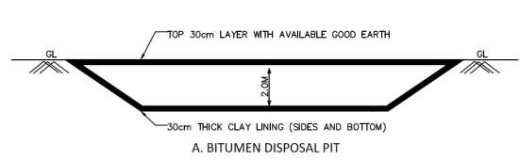
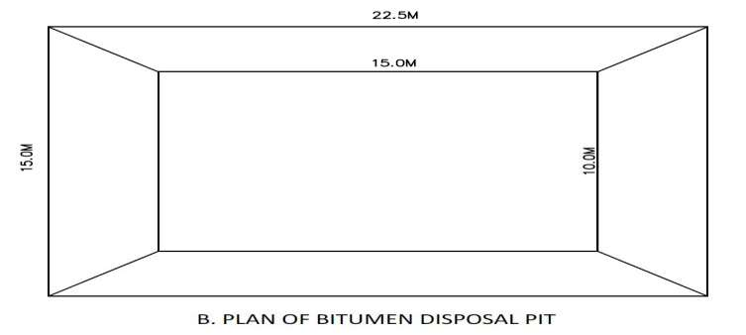

Figure 31: Proposed/ Recommended/ Optional/ Suggested Plant of Bitumen Disposal Pit.

Slope Stabilization: Adequate measures like adequate drainage, embankment consolidation and slope stabilization will be taken along the road to avoid soil erosion. The slopes have been restricted to 1 vertical: 2 horizontal for most of the sections. Soil erosion through embankments will be prevented and controlled by stone pitching or turfing with Coir Geo – Textile and Vetiver grasses. Bio – engineering is the technique of utilizing vegetation in addressing geo-technical problems. Environmental uncertainties are prompting engineers to favour bio – engineering measures. Vegetation as an aid to artificial methods in controlling surficial soil erosion is gaining larger acceptability among engineers all over the world. Growth of appropriate vegetation on exposed soil surface is facilitated by use of natural Geo – Textiles such as Coir Geo-Textiles. Properly designed Coir Geo – Textiles lay on slopes or any other exposed soil surface provides a cover over exposed soil lessening the probability of soil detachment and at the same time reduces the velocity of surface runoff, the main agent of soil dissociation. Natural Geo – Textiles Bios – Degrade quicker than man – made counterpart, but facilitate growth of vegetation quicker and better due to its inherent characteristics. Road slope stabilization can range from allowing Native Grass (Vetiver Grass) to re – establish on a disturbed slope to building an engineered wall.

Disposal of Bituminous Waste: Non reusable bituminous waste to be dumped in 30 cm thick clay lined pits with the top 30 cm layer covered with good earth for supporting vegetation growth over a period only after obtaining permission of IE. Details of bituminous waste generated from the proposed project road, number of “Bitumen Disposal Pits” (BDP) required for the disposal and typical drawing of disposal pit are given below and cost of the pit is covered in the EMP budget.

- Accidental spills of lubricants/ oil and molten asphalt will be avoided by following the “Guideline for Storage, Handling, Use and Emergency Response for Hazardous Substances”;
- Oil interceptor shall be provided for wash down, refueling areas and accidental spill of oil and diesel;
- Vehicle parking area of the construction camp will be made impervious using 75 mm thick P.C.C. bed over 150 mm thick rammed brick bats. The ground will be uniformly slopped towards to adjacent edges towards the road. A drain will take all the spilled material to the oil interceptor.

Land Use

Construction Phase: Widening of existing road 252.78 Km. will lead to change in land use pattern of areas adjacent to the road that comes under the proposed ROW. The land use pattern in most of the stretch along the project road is agricultural (80.1%) followed by residential cum commercial area (16.1%) and forest (3.8%). Within ROW the land use is mainly open land with trees by the side of the earthen shoulder.

Preparatory activities like clearing of ROW, construction of temporary construction camps and go – downs, storage of construction materials etc. will be confined within the camp and ROW. This will not hamper the land use aspects outside ROW. However, indirectly there may be some change in the land use pattern of the proximate area due to influx of construction work – force and supplier, who are likely to construct temporary tents in the vicinity.

Impact:

- Changes in existing land use pattern of the ROW for construction of the road.

Mitigation Measures:

- Earth material generated from excavation of roadways and drainage will be reused to the maximum possible extent as filling material during site development;
- The small amount of construction debris and surplus excavated material will be disposed of by mechanical transport in suitable pre – identified (jointly by project proponent and local administration) dumping areas in tune with the local condition to avoid land degradation and water logging due to indiscriminate dumping;
- Identification, operation and redevelopment of dumping areas will be as per the Guideline provided in the study;
- Construction camp will be provided for construction personnel to avoid indiscriminate settlement of construction workers and labourers;
- Regular inspection of haul roads and construction site will be carried out to ensure regular and timely removal of construction debris to the designated dumping sites;
- Construction activities will be kept confined to ROW only.

Operation Phase: In the operation phase, the temporarily modified land use pattern such as temporary construction camps/ tents would be dismantled. The road, after completion of its development, would consist of neat landscape to lead to a pleasing outlook. The existing road passes through mainly agricultural field and some congested stretches of residential/ commercial areas. The safe and quicker accessibility would result in increased scope of commercial, industrial and residential development along the project corridor/ alignment. Squatter settlement and encroachment along the project road is very likely to take place unless proper controlled measures are adopted.

Impacts:

- Likely change of land use pattern due to squatter/ encroachment within ROW;
- Likely change of land use pattern due to induced roadside development outside the ROW.

Mitigation Measures:

- Immediately after the construction phase, it is necessary to ensure that no further deterioration or major land use changes such as ribbon development takes place in a manner that will jeopardize the interests of the state;
- Squatter development along the project shall be strictly avoided by proper regulation and vigilance;
- Land use control measures will be prepared and administered to avoid occurrence of induced development as far as possible;
- Planning agencies and Collector/ Revenue Officer will be made involved for controlled development and prohibiting squatter/ encroachment within ROW.

Water Environment

Drainage and Hydrological Flow

The project road runs through plain and rolling terrain. It crosses two Small River and Natural Drainage Channel/ Local Stream at Six Locations. During heavy rainfall these natural drainage channels carry swift flow. As the existing CD structures and bridges will be suitably augmented and additional CD structures will be constructed, it will not obstruct the water flow in the channels. Therefore, no impact on drainage is envisaged.

Impacts:

- Change in drainage pattern of the land around realignment;
- Increased incidence and duration of floods due to obstruction of natural drainage courses by the road embankment;
- Chances of filling of existing drainage courses during earth filling;
- There may be potential drainage impacts relating to the establishments of construction camps and various plants such as hot mix plant, batching and asphalt mixing plants etc. drainage impacts at these locations may result in loss of top soil.

Mitigation Measures:

- Adequate roadside drains will be provided along the road to facilitate its better maintenance and increase in the life of the carriageway. This will also help in avoiding soil erosion and land degradation due to water stagnation on the either side of the road. Length of lined drain along the project road is 44,778 m (22,389 m on either side) and the length of unlined drain is 55,760 m (27,880 m on either side);
- Detailed drainage survey and hydrological investigations have been carried out and accordingly capacity of existing drainage works and “Cross Drainage” (CD) structures have been duly augmented, wherever necessary, to accommodate high discharges to avoid flooding and formation of water pool;
- All bridges have been designed for a return period of 100 years;
- Structures which fail against 100 years flood have been recommended for replacement with a new one;
- Adequate new drainage works and “Cross Drainage” (CD) structures have been provided for smooth passage of runoff to avoid flooding;
- Filling of existing drainage courses will be strictly avoided;
- Construction works of culverts and bridge (cross drainage structures) are taken up during the lean flow periods in summer to minimize the impacts on drainage;
- Construction work near natural drainage channels/ low lying areas have to be carried out in such a way that flow of water is not blocked and even if it has to be blocked then the contractor must ensure that the local communities are informed about the same in advance;
- Suitable drainage at construction site and camp will be provided to eliminate the chances of formation of stagnant water pools that leads to soil erosion and breeding of mosquitoes.

Drinking Water Sources

Impacts: Minimum Number of Water Sources will be affected.

Mitigation Measures:

- Affected hand pump, bore well and open well shall be relocated in such a manner that it should not hamper the access to drinking water;
- Construction will not be started until all drinking water sources are replaced with new ones;
- Supply water is the main sources of drinking water in the project area. Therefore, no major impact is envisaged on the user.

Water Use

Impacts: During construction period water is required for compaction of embankment, dust suppression, concrete making and domestic use in construction camp.

Mitigation Measures:

- Minimum use of water from existing sources for construction purpose will be ensured to minimize likely impacts on other users;
- The contractor will arrange water required for construction in such a way that the water availability and supply to nearby communities remain un – affected;
- If new tube – wells are to be bored, due to the non – availability of water required for construction, prior sanctions and approvals by the “Ground Water Department” (GWD) has to be obtained by the Contractor;
- “Wastage of water during the construction should be minimized”.

Water Quality

Impacts: Construction Phase

- During construction phase, leakage of “Point of Leakage” (POL) could lead to an increase in water pollution level of the region. Anticipated potential impacts are due to spillage of construction materials, such as, cement, POL, bitumen etc. Falling in to the drainage channels from workshops, construction camps quarry/ borrow areas etc. of the Contractor;
- Accident involving hazardous materials (bitumen) may cause pollution, but the occurrence of large scale spillage of bitumen is extremely rare;
- Increase of sediment load in the runoff from construction sites and increase in turbidity in receiving streams/ water bodies;
- Water pollution due to sewage from construction camps.

Mitigation Measures:

- Quality of construction wastewater emanating from the construction site will be controlled through suitable drainage system with silt traps for arresting the silt/ sediment load before its disposal into the main natural drainage system around the site;
- Proper sanitation facilities will be provided at the construction site to prevent health related problems due to water contamination;
- An effective traffic management plan is to be implemented to avoid any accidental spillage of hazardous materials;
- All the construction and preparatory activities including construction of culverts and bridges will be carried out during dry seasons only;
- The CD structures should not be drained to the agricultural and horticultural farms or to the immediate vicinity of houses of the villagers;
- The fuel storage and vehicle cleaning area shall be stationed at least 500 m away from the nearest drain/ water body;
- Provision for oil interceptors shall be made at all the construction camps/ workshop areas to separate the oil and grease waste generated from servicing of equipment and vehicles used in the construction works;
- The un – lined roadside drains in rural stretches carrying storm water will be connected to the nearest natural drainage channel, water bodies with silt traps.

Water Quality Monitoring: Apart from provision of the mitigation measures, water quality shall be monitored to understand the effectiveness and further improvement in designs in reducing the concentration of pollutants. The monitoring plan shall be functional in construction as well as in operation stages. The frequency, duration and responsibility will be as per the “Environmental Monitoring Plan” (EMP). The maximum desirable limits as per the water quality standards and the monitored values should correspond with the table. All deviated results shall be reported to “Environmental Specialist” of “Independent Engineer” (IE) for “Remedial Measures” (RM). It should be ensured that no construction camps or stockyards are set up near rivers, irrigation canals and water bodies to prevent oil spills.

Silt Fencing: Silt fencing will be provided to prevent sediments from the construction site entering into the nearby watercourses. The silt fencing consists of Geo – Textile with extremely small size supported by a wire mesh mounted on a panel made up of angle/ wooden frame and post. The frame will be installed at the edge of the water body, near river crossing along which construction is in progress. It is proposed to install silt trap at the edge of all water bodies located along the project road, major and minor bridge locations. Further, silt fence will be mounted in guiding drains at a distance of 3 to 5 m in the up – stream direction depending on the gradient of the guiding drains. However location of silt traps will depend on contractor’s proposal for site facilities and work sites should be provided in the contractor’s proposals. This will be checked by “Sr. Environmental Specialist” (SES) of the “Independent Engineer” (IE) and monitored by PIU.

Oil Interceptor (OI): Oil and grease from road run-off is another major concern during construction as well as operation. During construction, discharge of oil and grease is most likely from workshops, oil and waste oil storage locations, vehicle parking areas of the contractor and the concessionaires' camps. Therefore, location of Oil Interceptors has been considered such that each construction camp having refueling stations, oil and lubricants storage places will have one oil interceptor to stop and separate the floating oils. The arrested products shall be disposed as per MOEF and CC and CPCB guidelines. However the number of interceptors shall increase as the situation demands or during the accidental spillages. Actual number will be decided by the Contractor with the consent of “Sr. Environmental Specialist” (SES) of the “Independent Engineer” (EI).

Ground Water Recharge (GWR): “Pit/ Rainwater Harvesting Structures” (P/ RHS) and silt fences have been proposed near river and local stream crossings to improve the water table in this region and conserve water bodies. It has been observed from the past meteorological data of IMD, total number of “Rainy Days” (RD) in the project area is “59.8 Days” and total “Annual Rainfall is 970 mm”. Ground Water Recharge Pit has been proposed at “10 Locations”. However, the locations of proposed ground water recharge will be reviewed by the “Sr. Environmental Specialist” of the “Independent Engineer” (EI) and finalized in consultation with EM – PIU. These locations should be permanent, which shall be handed over to the local civic bodies at the end of the project so that the water shortages can be reduced to a certain extent. Lump sum cost provision has been provided in the EMP. Typical drawing of ground water recharge pit is given in the Figure 32.

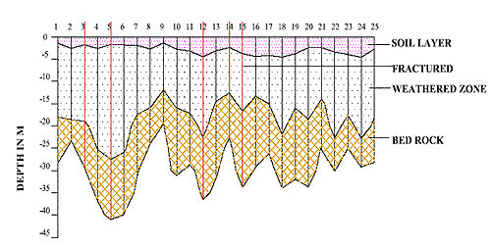

Figure 32: Proposed/ Recommended/ Optional/ Suggested Ground Water Recharge Pit.

Operation Phase: Widening will result in increase of surface run – off due to more paved road surface. It will have adverse impact on ground water recharging if measures are not taken during the design stage.

Impacts:

- Increase of surface run – off due to more paved road surface;
- Filthy environment due to improper maintenance of drainage;
- Chances of contamination of water bodies from road surface run off containing oil spills due to traffic movement and accidents.

Mitigation Measures:

- Longitudinal roadside drains of sufficient capacity will be provided on both sides of the road to accommodate increased run – off. The out fall for these drains will be the nearby culverts/ bridges or natural drainage channel. Silt fencing will be provided to sediment entering into the water courses;
- Contingent actions will be taken for speedy cleaning up of oil spills, fuel and toxic chemicals in the event of accidents;
- Regular maintenance of rainwater harvesting structures shall be done during the operation stage to prevent choking of these structures;
- Regular monitoring of water quality at specified representative locations will be conducted at fixed interval.

Water Bodies

- “Corridor of Impact” (COI) is the proposed construction width, which is varying from 23 to 25 m in built – up areas and 38 to 40 m in rural/ open country area. There are 11 water bodies, which are located within the COI;
- All 11 water bodies have been saved by providing toe wall/ change in engineering design or through re – alignment. Therefore, there will be no impact on surface water bodies.

Enhancement of Water Body

Enhancement measures have been proposed for roadside pond located left hand side of project road. The pond water is utilized for irrigation purpose. The pond is located 30 m away from the project road. Followings have been proposed as a part of enhancement:

- Earth excavation along the boundary (excluding the portion where retaining wall has been proposed);
- Stabilization of the slope using Vetiver Grass;
- Phyco – Remediation of water using “NUALGI Technology” (NT);
- Turfing of surrounding area of the water body;
- Sitting arrangement with RCC – Precast Benches with back support;
- Pathway with Interlocking Paver Blocks and Sand Filling;
- Approach Road.

Phyco – Remediation using NUALGI: During the site visit, algal growth is observed in various ponds along the project road and local villagers also informed that the quality of water of these ponds is very poor. Therefore, Phyco – Remediation using “NUALGI Technology” (NT) is proposed to improve the water quality of the following ponds, which also include the pond proposed for enhancement.

Phyco – Remediation is the use of algae to remediate polluted waters. Among all the algae, diatoms are the most prolific photosynthesizes because of their silica shells, which are translucent. This helps the diatoms to photo – synthesize even in low light conditions. The “NUALGI Technology” (NT) is based on providing micro nutrients required for diatom algae growth to speed up the nutrient removal in stagnant water and converting these nutrients to fish bio – mass. “NUALGI Technology” (NT) contains micro – nutrients along with silica which is required for diatom growth. During photosynthesis, diatoms consume Nitrates and Phosphorous, as also uses up CO₂ from the atmosphere. In the process, they release oxygen (pure oxygen in water) to almost saturation levels, which will help the water body regain its original levels of “Dissolved Oxygen” (DO). The absorption of CO₂ will also mitigate the water acidification and pH levels would move towards more basic levels. The high levels of DO would set up a chain of benefits, primarily it promotes aerobic bacteria, which would digest the excess nutrients in water and convert them into the base constituents. Such high levels of DO would also oxidize the heavy metals, which would precipitate out of water, where other bacterial strains would consume them.

Air Environment

Construction Phase

Particulate matter would be the predominant pollutant affecting the air quality during the construction phase as it is likely to generate considerable quantities of dust, especially during dry condition. Dust will be generated mainly during excavation, backfilling, hauling and transportation activities through un – paved haul roads, loading/ un – loading and transportation of construction materials, spilling of material during transportation, and open storage of fine construction materials.

Un – desirable gaseous pollutants will be generated mostly by the automobile traffic and construction machineries. Pollutants of primary concern include PM_{2.5} and PM₁₀. However, suspended dust particles may be coarse and will be settled within a short distance of construction area. Therefore, impact will be temporary and restricted within the closed vicinity along the road only. Further, this would not lead to any tangible effect, as the expected traffic volume is low. Operation of “Hot Mix Plants” (HMP) and “Asphalt Plants” (AP) will cause emission of fumes and gases.

Impacts:

- Deterioration of air quality due to fugitive dusts emission from construction activities like excavation, backfilling and concreting, and hauling and dumping of earth materials and construction spoils, and vehicular movement along un – paved roads;
- Deterioration of air quality due to gaseous emissions from construction equipment and vehicular traffic;
- Deterioration of air quality due to emission from asphalt and hot mix plants;
- Emission of “Carbon Monoxide” (CO), “Sulfur – Dioxide” (SO₂), “Nitrogen Oxides” (NO_{X}) etc. will be generated from the “Hot Mix Plants” (HMP).

Mitigation Measures:

- Dust Control:

- Proper and prior planning and appropriate sequencing and scheduling of all major construction activities will be done, and timely availability of infrastructural supports needed for construction will be ensured to shorten the construction period vis a vis reduce pollution;
- Construction materials will be stored in covered go – downs or enclosed spaces to prevent the windblown fugitive emissions;
- Truck carrying soil, sand and stone will be duly covered to avoid spilling;
- Adequate dust suppression measures such as regular water sprinkling on un – paved haul roads and vulnerable areas of the construction sites from trucks or other suitable means will be undertaken to control fugitive dust during material handling and hauling activities particularly near habitation especially in the dry seasons.

- Emission Control:

- Use of Recycled Asphalt Cold Mix Technology: Most bituminous mixes are produced at a very high temperature (nearly 160°C), mainly because bitumen is very viscous at low temperatures and cannot coat the aggregates, unless heated to high temperatures. Technologies are available, which can facilitate the coating at low temperatures by increasing the surface area of bitumen or by reducing the surface tension at the aggregate bitumen interface with use of certain additives, thereby making the mixing possible at much lower temperature, saving energy and releasing less pollutants in the atmosphere. It is proposed to follow IRC Guidelines on the subject;
- During construction period, all activities are to adhere to the contractual obligations and all clearances and approvals such as “Consent to Establish” (CTE) and “Consent to Operate” (CTO) shall be obtained from the Punjab Pollution Control Board under Air Act. All vehicles operating for the Contractor, Supervision Consultants and PIU shall obtain “Pollution Under Control” (PUC) certificate.
- All required clearances are to be obtained from the Punjab Pollution Control Board and the Mining Department for establishing quarries, borrow areas and crushers. Contractor should submit copy of such clearances to EM – PIU and IE before start of activities;
- Asphalt and hot mix plants will be located at least 500 m away from inhabited areas and sensitive receptors such as school, hospital, temple etc. as well as 300 m from the road. A written agreement with the land owner clearly specifying the terms and conditions of opening, operation and closing activities of the Contractor must be part of the management plan;
- Pollution control devices such as cyclone separators/ scrubbers shall be installed to control emissions from hot mix plants, crushing units and concrete batching plants. Height of the stacks shall be as per the statutory requirements;
- It will be ensured that all the construction equipment and vehicles are in good working condition, properly tuned and maintained to keep emissions within the permissible limits and engines turned off when not in use to reduce pollution at all circumstances/ conditions.

Air Quality Monitoring: Apart from provision of the mitigation measures, air quality shall be monitored. The monitoring plan shall be functional in construction as well as in operation stages. The frequency, duration and responsibility will be as per the “Environmental Monitoring Plan” (EMoP). The maximum desirable limits as per the “National Ambient Air Quality Standards” (NAAQS) and the monitored values should correspond with the table. All deviated results shall be reported to “Independent Engineer” (EI), for remedial measures with “NABL Accreditation, TESTING and Calibration”.

NABL Accreditation, TESTING and Calibration Laboratories Sample Format.
(Laboratory Monitoring Results are under Practice)
Impacts during design phase is limited to removal of trees, acquisition of land and structures, relocation of water ways, water parks, water bodies, water locations, water streams or channels identification and management of borrow pits are as mentioned in Table 59.
Table 59: Impacts during Design Phase.

Impacts | Mitigation Measures
Land Acquisition | Alignment design to minimize the land acquisition whenever applicable;
Major Displacement | Bypasses and detours to be considered preciously;
Removal of Trees | Alignment design to reduce the number, widening on the side of the road where less trees are required to be cut. Compensatory plantation to be planned;
Impact on Public Utilities e.g., Community Wells etc. | Alignment design to be considered. In case of removal alternate arrangement to be done before;
Impact on Cultural Sites | Alignment design to be considered. Public consultation may be needed if impact cannot be avoided;
Relocation of Waterways | Hydrology to be considered. Public consultation will be needed, wherever applicable;
Access Restriction | Required alternatives, underpasses, proper signposts for people should be included in design all types of roads constructions;
Congestion in Settlement Areas | Service road to be provided everywhere all over the road network;
Borrow Pits | Locations to be selected considering minimum loss of productive land and redevelopment and resettlement;
Environmental Specifications for Contractors | Environmental qualifications specification should be included in pre – qualification packages for the contractors and structure designers.

Construction Phase

“Environmental Management during Construction” phase is more crucial, because major impacts during construction like earthworks road network, movement of heavy machineries etc. causes lot of disturbances and management becomes essential at this stage during construction work. The construction workers camp will be located at least 500 Meters away from habitations. The construction yard, “Hot Mix Plants” (HMPs) and crushers like “Asphalt Crusher Plants” (ACP) etc. will be located at 500 Meters away from habitations and in downwind directions. The minimum distance of these will be kept 3.0 Km. from reserve forest areas. Adequate cross drainage structures have been planned to maintain proper cross drainage. “In order to compensate negative impacts on floral species due to cutting of trees the project plans compensatory plantation in the ratio of 1: 3 i.e., for everyone has to be applied… if one tree is cut…!!! Then three or more trees will be planted”. The acquisition of forest area will be minimal and will be compensated through compensatory afforestation. The noise barriers have been planned closed to educational institute so that post project noise levels are within the specified limits. The project will take an opportunity to provide “Environmental Enhancement Measures” (EEM) to improve aesthetic activities in the projected area. The planned “Environmental Enhancement Measures” (EEM) include ponds enhancement, plantation in median and in available clear space in “Right of Way” (ROW), seating arrangements around trees must be installed or placed in the specific region. The pond “Enhancement Measures” (EM) will include such as stepped access; washing platforms and seating arrangements ought to be applied etc. Some of ditches will be filled up due to embankment construction in the “Right of Way” (ROW). In order to avoid contamination of water bodies during construction sedimentation chambers, oils and grease separators, oil interceptors at storage areas and at construction yard have been planned. The bill of quantities for mitigation and enhancement measures has been given in respective “Environmental Management Plans” (EMPs) of construction packages. Table 60 below summarizes impacts and its Environmental Management Plan during Construction Period.

Table 60: Environmental Management Plan during Construction Period.

Impacts | Mitigation Measures
Soil Erosion | Proper planning for slope stabilization, topsoil storage, plantation and turf on slopes;
Loss of Topsoil | Arable lands will be avoided for earth borrowing network. If needed, topsoil will be separated and refilled after excavation on operational site/ region/ area;
Borrowing of Fill Materials | Excavation from pre – selected locations. After excavation the borrow pits will be dressed to match with the surroundings. In specific cases borrow pits can be excavated in consultation with local people to use those pits as water harvesting point locations in particular areas/ sites;
Disposal of Construction Waste | No haphazard dumping of construction waste. Only pre – selected location maintaining local environmental regulations activities/ performance will be used for operational site;
Disposal of Human Waste by Construction Workers | Specific landfill sites should be identified to manage solid waste generated from habitation of construction workers on operational site/ area/ specified region;
Generation of Dust | Water will be sprayed during construction phase, in earth handling sites, asphalt mixing or crushing sites and other excavation areas for suppression of dust on operational site;  In case fly ash is used, dust emission during its unloading, storage at open place and handling for road construction should be suppressed by water sprinkling at regular interval and operation with space and time;  Dust emission from piles of excavated material should also be controlled by spraying water on the piles located areas/ sites/ regions;  Special care should be taken when working near schools and medical facilities and other sensitive zones.

Environmental issues change during operation phase and its mitigation plans are also related with vehicular movement, road safety and management of ecological as well as natural/ environmental/ ordinary issues. Environmental aspects are thus more or less related to vehicular emission; domestic; industrial or anthropogenic activities in the surrounding areas. The mitigation measures for different environmental aspects are discussed in Table 61 below.

Table 61: Environmental Management during Operation Phase.

Impacts | Mitigation Measures
Dust | Bad road maintenance of road gives high rise to dust pollution. Road Surface will be maintained properly and constantly;
Gaseous Pollution | All vehicles should be checked for “Pollution Under Control (PUC)”, certificates and occasional spot testing of emission from vehicles will be carried out in specified regions;
Noise | Noise level for different automobiles has been prescribed in Environment (Protection) Rules, 1986. Signs will be posted to restrict blowing of horns with high tons in front of highly sensitive locations or zones;
Surface Runoff | Surface runoff from the road will not be disposed directly in the water – bodies or surfaces used by people for bathing and washings purposes etc. It should also not be disposed directly in to any watercourse with good water quality;
Wild Life | There should be speed restrictions through specific forest area in the night and day time to prevent accident with wild animals. There will be proper signs and indications for the drivers to inform about these activities happening in the region/ area or site;
Flora | Tree plantations will be monitored continuously on regularly basis;
Safety | Safety signs and signals should be kept always clean and updated on regular basis;
Public Amenities | Bus stops, underpasses etc. should be kept in order for specified zones on the site/ region or area.

Waste Water and Solid Treatment Process

Current treatment strategies are directed towards reducing the amount of solid waste that needs to be land filled, as well as recovering and utilizing the materials present in the discarded wastes as a resource to the largest possible extent. Different methods are used for treatment of solid as well as waste water and the choice of proper method depends upon refuse characteristics, land area available and “Disposal of Human Waste by Construction Workers” with disposal cost as they are given below in pyrolysis process as shown in the Figure 33:

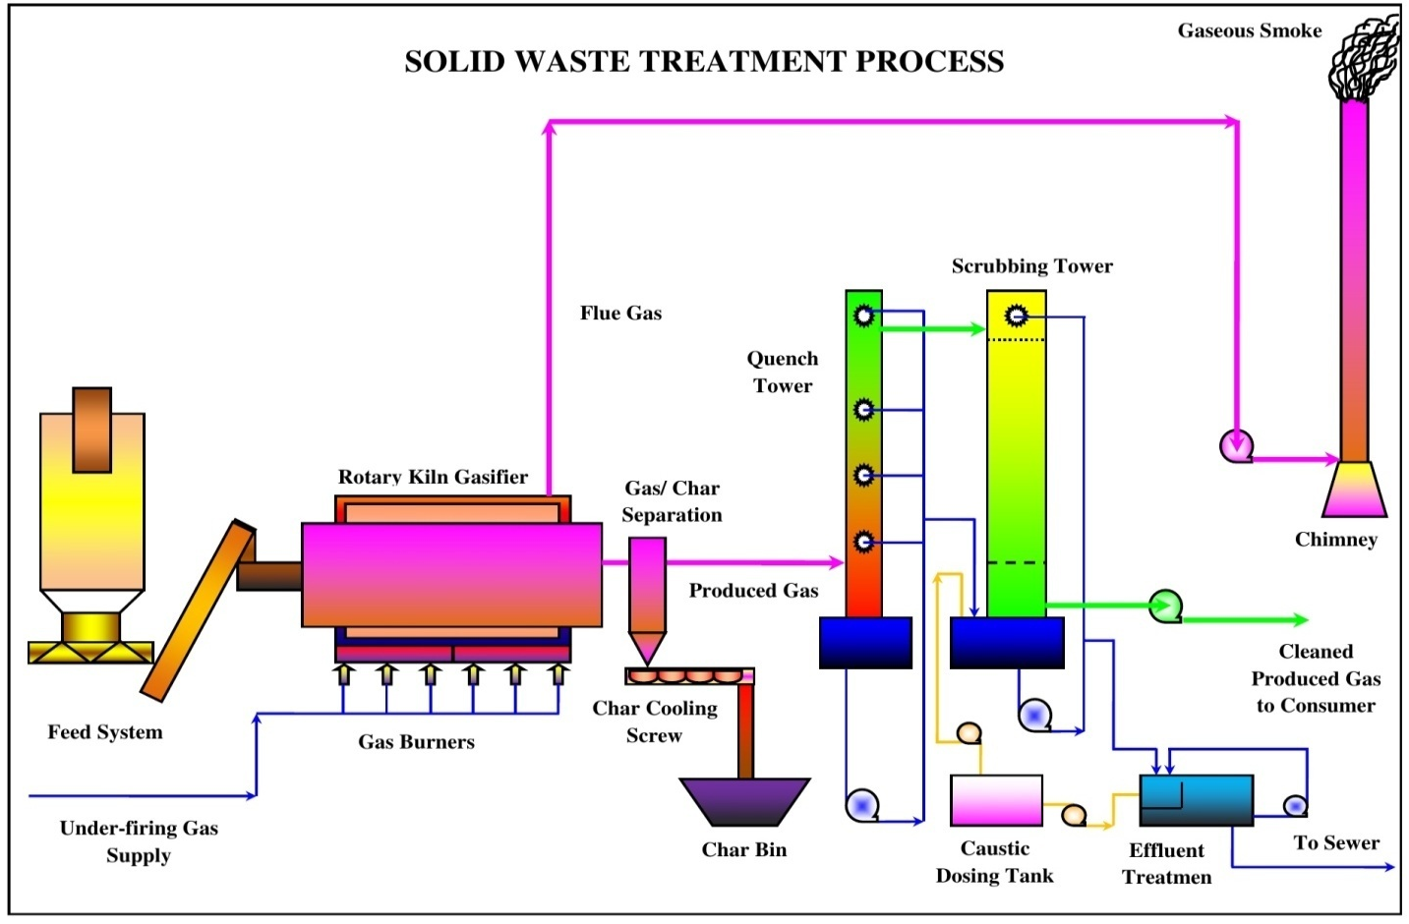

Figure 33: Process of Pyrolysis in Solid and Waste Water Treatment.

Pyrolysis: Pyrolysis is defined as thermal degradation of waste in terms of may be water or solid in the absence of air to produce char, pyrolysis oil and syngas, e.g., the conversion of wood to charcoal also it is defined as destructive distillation of waste in the absence of oxygen. External source of heat is employed in this process. Because most organic substances are thermally unstable they can upon heating in an oxygen – free atmosphere be split through a combination of thermal cracking and condensation reactions into gaseous, liquid and solid fraction.

- Incineration process;
- Compaction process;
- Pyrolysis process;
- Gasification process;
- Composting process.

Solid Waste Handling Practice

Proper method should be adopted for management of solid waste disposal in a soil. Industrial wastes can be treated physically, chemically and biologically until they are less hazardous. Acidic and alkaline wastes should be first neutralized; the insoluble material, if biodegradable should be allowed to degrade under controlled conditions before being disposed off into the soil. As a last resort, new areas for storage of hazardous waste should be investigated such as deep well injection and more secure landfills. Burying the waste in locations situated away from residential areas is the simplest and most widely used technique of solid waste management.

Environmental and aesthetic considerations must be taken into consideration before selecting the dumping site’s soil condition and quality. Incineration of other wastes is expensive and leaves a huge residue and adds to air, water and soil as major pollutant in terms of residue as well. “Pyrolysis Practice or Technique” (PP/ T) is a process of combustion in absence of oxygen or the material burnt under controlled atmosphere of oxygen as Solid Waste Handling Pyrolysis Technique shown Figure 34. It is an alternative to incineration. The gas and liquid thus obtained can be used as fuels. Pyrolysis of carbonaceous wastes like firewood, coconut, palm waste, corn combs, wheat pod, cashew shell, rice husk, paddy straw, barley pod, maize husk and saw dust, yields charcoal along with products like tar, methyl alcohol, acetic acid, and acetone and fuel gases.

Figure 34: Solid Waste Handling Pyrolysis Technique.

Environment Baseline: Environmental, ecological and societal profile of the study region/ vicinity of project location are based on secondary data of Physiographic, Topology, Climate, Water Quality, Biological outline of town. The study has to be incorporated regarding “Sewage Treatment Plant” (STP) both in terms of theoretically and technically applicability for the specific region. The working model of Sewage Treatment Plant or principal subject matter has to be applied in the town so that it must play significant role for the people and its cultural civilization of the society as shown in the Figure 35. The flora and fauna recognized in the study spot are commonly found and not precise to the province due to the deficiency of forest in the study zone.

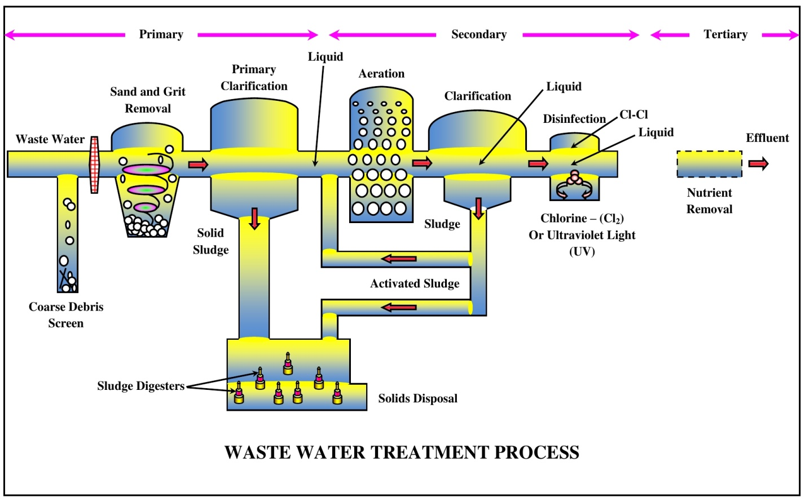

Figure 35: Sewage Treatment Process (STP) of Wastewater Layout.

13. INSTITUTIONAL REQUIREMENTS AND ENVIRONMENTAL MONITORING PLANS

“National Highway Authority of India” (NHAI) has a well – established “Environmental Management Unit” (EMU), Head by a Senior Officer “Indian Forest Services” (IFS) from “Ministry of Environment and Forest” (MOEF), who is supported by an officer of Dy. G. M. rank from “State Pollution Control Board” (SPCB). Main responsibility of EMU will be established to monitor the progress regarding “Environmental Management Plan” (EMP). “Environmental Management Plan” will be the responsibility of contractors and will be closely coordinated by the “Engineer” (Supervision Consultant). Table 62 as given below discusses about the remedial measures components, locations/ regions/ areas, time frame work and institutional responsibility with applicable criteria.

Table 62: Institutional Responsibility of Remedial Measures.

Environmental  Components | Remedial Measures  Components | Locations/ Regions/ Areas | Time Frame Work | Applicable Responsibility Criteria
Design – Phase
Major Resources (Alignment, Public Amenities and Public Utilities)
Alignment | Avoid impacting school, health facilities, water bodies and residential quarters. | Throughout the Project Corridor. | During Design | Design Consultant
Public Amenities | Provision of service roads, underpasses, safety signs, bus stops, lay bees, parking spaces etc. | Throughout the Project Corridor as Mentioned in  EIA Report. | During Design | Design Consultant
Closure of Public Utilities e.g., Tube – Wells, Wells, Bus Stops etc. | Alternative arrangement. | Throughout the  Project Corridor as Mentioned in  Social Impact Assessment (SIA). | At the Beginning of Construction Activities. | Contractor, Supervising Engineer
Construction – Phase
Water Resources and Pollution (Water Bodies, Rivers, Drinking and Wastewater Water)
Water Bodies | Construction of embankments, de – siltation and environmental enhancement as mentioned in EIA report. | Water Bodies  As Mentioned in EIA Report. | Throughout Construction Phase | Contractor, Supervising Engineer
Rivers/ Nallahs | Prevention of pollution of water. | Rivers/ Nallahs Mentioned in EIA Report. | Throughout Construction  Phase | Consultant,  Contractor,  Supervising  Engineer
Water Requirement for Construction | Arrange water without affecting local requirement. Do not use local water bodies. Drill boreholes with required permission. No water collection within forest area. | Throughout the Project Corridor. | Throughout Construction Phase. | Contractor, Supervising Engineer
Drinking Water Requirement | Arrange water without affecting local requirement. | Workers’ Camps Working Site. | Throughout Construction Phase. | Contractor, Supervising Engineer
Wastewater from Workers’ Camp | Ensure proper sanitation and drainage. No direct wastewater discharge in water bodies or the rivers/ Nallahs. | Workers’ Camps | Throughout Construction Phase | Contractor, Supervising Engineer
Air and Noise
Dust Generation | Spraying of water, proper handling of fly ash. | Throughout the Project Corridor. | Throughout Construction Phase. | Contractor, Supervising Engineer
Dust Generation near Sensitive Locations | Spraying of water, work during scheduled period only. | Schools, PHCs as Mentioned in EIA Report. | During Construction Near the Vulnerable Sites. | Contractor, Supervising Engineer
Asphalt Plant | Location away from sensitive areas. | Throughout the Project Corridor. | Throughout Construction Phase. | Contractor, Supervising Engineer
Stone Crushers | Implementing proper air pollution control measure as per law. | Stone Crushers. | Throughout Construction Phase. | Contractor, Supervising Engineer
Gaseous Emission from Construction Work Vehicles | Ensure checking of vehicular emission and obtaining Pollution Under Control (PUC) certificate. | Throughout the Project Corridor. | Throughout Construction Phase. | Contractor, Supervising Engineer
Noise from Machineries and Construction | Ensure machineries meeting noise level standards. Blasting to be done with required caution. | Throughout Projected Locality/ Region | Throughout Construction Phase | Contractor, Supervising Engineer
Noise at Sensitive Locations | Work only at scheduled period. Construct noise barrier if suggested. No work during night in forest areas. | At Schools, PHCs as Mentioned in EIA Report. In Forest Areas. | During Construction Near the Vulnerable Sites. | Contractor, Supervising Engineer
Land and Soil
Storage of Construction Materials, Debris. Fly Ash, etc. | Prevent siltation from washing of construction materials. | Throughout the Project Corridor. | During Rainy Seasons. | Contractor,  Supervising Engineer
Soil Erosion | Proper planning for slope stabilization, topsoil storage, plantation and turf on slopes. | Throughout the Project Corridor. | Throughout Construction Phase. | Contractor, Supervising Engineer
Borrow Pits and Queries | Excavation from pre – selected locations. After excavation the borrow pits will be dressed to match with the surroundings. | Selected Borrow Pits and Quarries as given in EIA Report. | Throughout Construction Phase. | Contractor, Supervising Engineer
Solid Waste from Construction Work | Ensure dumping outside city area with permission from local authority or used as landfill material. | Throughout Project Area/ Site/ Region | Throughout Construction Phase. | Contractor, Supervising Engineer
Flora (Plants’ Life)
Tree Felling | Ensure plantation of trees on both sides of road and around in consultation with forest department. | Throughout the Project Corridor and Beyond. | Throughout Construction Phase. | Design Consultant, Contractor, Supervising Engineer
Fauna (Plants’ Life)
Forest Area | No work after evening. No use of water bodies, safety regulations, no workers’ camp. | In the Forest Area. | Throughout Construction Phase | Contractor, Supervising Engineer
Others (Public, Religious and Aesthetics)
Workers’ Camp | Ensure providing camp of proper dimension and environmental quality as given in EIA report. | Workers’ Camps. | Throughout Construction Phase. | Contractor, Supervising Engineer
Public Facilities | Ensure access to all important locations. | Throughout the Project Corridor. | Throughout Construction Phase. | Contractor, Supervising Engineer
Religious Places | Ensure minimum disturbance during festival time. | Throughout the Project Corridor. | Religious Festivals. | Contractor, Supervising Engineer
Aesthetics | Planting flowering creepers on medians, slope vegetations, suitable design of restaurants etc. | Throughout the Project Corridor. | Throughout Construction Phase. | Contractor, Supervising Engineer
Operation – Phase
Sources (Dust, Gaseous Pollution, Forest, Safety and Public Amenities)
Dust | Road maintenance. | Throughout the Project Corridor. | Throughout Operation Phase. | Contractor, Supervising Engineer
Gaseous Pollution | Check the vehicles for pollution control. | Throughout the Project Corridor. | Throughout Operation Phase. | Contractor, Supervising Engineer, Traffic Department
Forest | Speed restriction safety signs underpass maintenance. | In Forest Areas. | Throughout Operation Phase. | Contractor, Supervising Engineer, Traffic Department
Safety | Maintain all safety provisions. | Throughout the Project Corridor. | Throughout Operation Phase. | Contractor, Supervising Engineer, Traffic Department
Public Amenities | Bus stop and other amenities to be properly kept. | Throughout the Project Corridor. | Throughout Operation Phase. | Contractor, Supervising Engineer, Traffic Department

14. Principal Component Analysis (PCA) Indicators

Significant Indicators as “Principal Component Analysis” (PCA) performed also indicates that indicators, which play significant role in explaining vulnerability among the districts states. Amongst all the indicators considered in particular sector indicators with weights greater than the average weight of all indicators are considered as important in explaining vulnerability study applications. Table 63 gives the list of significant indicators in order of their importance for each sector. These indicators can play important role in decision making process/ system/ methodology in a goal to reduce vulnerability.

Table 63: Principal Component Analysis as Significant Indicators of Remedial Measures.

Sr. No. | Principal Indicators Analysis/ Aspects | Conceptual Basis
(A) | Social Aspects/ Analysis
1. | Population Served Per Health Centre (Community, Primary and Sub Health Centers); | Adaptive Capacity
2. | Percentage of Households With Access To Sanitation Facilities; | Adaptive Capacity
3. | Level of Urbanization; | Adaptive Capacity
4. | Percentage of Households With Access to Safe Drinking Water; | Adaptive Capacity
5. | Density of Population; | Sensitivity
6. | Number of Slum Dwellers Per Slum; | Sensitivity
7. | Percentage of Households Owning Radio, Transistor, Television and Telephones; | Adaptive Capacity
8. | Proportion of Elderly Population Aged 65 and Above; | Sensitivity
9. | Proportion of Child Population in The Age Group 0 – 6; | Sensitivity
10. | Literacy Rate and Growth; | Adaptive Capacity
(B) | Economic Aspects/ Analysis
11. | Agricultural Credit Societies Per Lakhs of Population; | Adaptive Capacity
12. | Loan Disbursed by Agricultural Credit Societies Per Cultivator; | Adaptive Capacity
13. | Scheduled Commercial Banks Per Lakhs of Population; | Adaptive Capacity
(C) | Agricultural Aspects/ Analysis
14. | Percentage of Land Holdings Below 1 Hectare; | Sensitivity
15. | Fertilizer Consumption and Utilization; | Adaptive Capacity
16. | Percentage of Net Irrigated Area to Geographical/ Physical/ Environmental Area By Surface Water; | Adaptive Capacity
17. | Percentage of Bio – Farming Villages in Total Villages; | Adaptive Capacity
18. | Percentage Share and Contribution of Agricultural And Cultivators Main Workers; | Sensitivity
19. | Yield and Capitulate of All Crops; | Adaptive Capacity
(D) | Water Aspects/ Analysis
20. | Crop Water Stress, Strain and Sprain (Evapo – transpiration/ Potential Evapo – transpiration); | Sensitivity
21. | Surface Water Availability and Accessibility; | Adaptive Capacity
(E) | Climate Aspects/ Analysis
22. | Warm Nights – Days, When Minimum Temperature > 90th Percentile; | Exposure
23. | Warm Days – Cool Nights – Days, When Maximum Temperature > 90th Percentile; | Exposure
24. | Warm Spell Duration Indicator (Annual count of days with at least 6 consecutive days when maximum temperature > 90th percentile); | Exposure
25. | Cool Days – Cool Nights – Days, When Maximum Temperature < 10th Percentile; | Exposure
26. | Cool Nights – Days, When Minimum Temperature < 10th Percentile; | Exposure
27. | Flood Discharge; | Exposure
28. | Extremely Wet Days – Annual Total Rainfall, When Rainfall > 99th Percentile; | Exposure
(F) | Health Aspects/ Analysis
29. | Percentage of People Having Diarrhea and Other Dieses; | Sensitivity
30. | Index, Directory, Catalog, Guide, Manifestation or Indicator of Malaria; | Sensitivity
(G) | Pollution Aspects/ Analysis
31. | Pollution of Rivers/ Wetlands, Degradation of Forests and Biodiversity Loss is Being Observed; | Exposure
32. | Effective Industrial Waste Management and Pollution Control; | Exposure
33. | With Increasing Pollution Increase in Respiratory Diseases and Allergies is Also Predicted to Increase on the Site; | Exposure
34. | Water Pollution is another Big Concern for the State. Depletion of Water Resources and Deterioration of Water Quality is Big Concern for the State; | Exposure
35. | Use of More Efficient Technology to Reduce Pollution. Effective Industrial Waste Management and Pollution Control; | Exposure
36. | Climate Change (CC) could Increase Air Pollution Levels by Accelerating the Atmospheric Chemical Reactions that Produce Photochemical Oxidants due to a Rise in Temperature; | Exposure
37. | Long Term Targets – By achieving renewable sources of environmental factors/ parameters through agriculture – ecosystem management, implementation of main schemes as soil carbon storage and metering, enhancing soil health, reducing ground water pollution specially harmful chemicals and enhancing biodiversity modifications; | Exposure
38. | The other serious issues of groundwater quality are high concentration of fluorides (mainly in granitic terrain), agricultural, municipal and industrial or anthropogenic pollutions; | Exposure
(H) | Forest Aspects/ Analysis
39. | Percentage of High Density Forest Area to Geographical Area; | Adaptive Capacity
40. | Non – Timber Forest Products (NTFPs) Diversity (Number of Varieties); | Adaptive Capacity
41. | Number of Joint Forest Management (JFM) Communities, Neighbourhood – Area – District – Groups of People; | Adaptive Capacity
(I) | Soil Aspects/ Analysis
42. | Dependence on natural resources is the way of life but unsustainable practices of harvesting, irrigation, elimination of crop residue, forest degradation, deteriorating soil and water quality are augmenting the problems besides other impacts of Climate Change (CC) occur in the state; | Adaptive Capacity
43. | Mono – cropping reduces the crop diversity and adversely affects the soil health in the state or region; | Sensitivity
44. | Soil and water conservation innovative ideas must be applied through demonstration of best engineering practices; | Sensitivity
45. | Set up a knowledge management network to avail information on land – use pattern, soil types, weather or climatic conditions, genotypes of crops, water availability, pasture, off – season crops and agro – forestry practices etc. | Adaptive Capacity
46. | Develop capacity to run agriculture related climate models, decipher their projections, to understand the impact on crops, soils and water like precious and important factors etc. in the region/ area or state; | Adaptive Capacity
47. | Soil testing – practice and packages must be applied during civil construction work (soil kit to the farmers); | Exposure
48. | Undertake and revise soil resource mapping at village/ local/ regional or state level; | Exposure
49. | Promote use of water and soil conservation techniques, namely dry land farming, drip irrigation, intermittent flooding, drying sowing use of high yielding drought resistant cultivars as appropriate etc. in different areas or states; | Adaptive Capacity
50. | Promote agro – forestry and agro – climatic or weather conditions to increase forest biomass and hence soil moisture; | Exposure
51. | Identify critical unspecified areas within forests for soil and water conservation; | Exposure
52. | This effort would not only provide fodder to the animals, but also would curb or reduce further land degradation and soil erosion; | Exposure
53. | Soil moisture stress to the crops leading to their stunted growth in the region or state; | Exposure
54. | Soil and water conservation technologies will need to be strongly adopted after observing or seeing the rising temperatures and decreasing water conditions in the state; | Adaptive Capacity
55. | Soil and water conservation through demonstration of best practices: Application of mulching techniques, drip irrigation, and micro/ macro irrigation practices, techniques and methodologies etc. should be encouraged; | Adaptive Capacity
56. | Soil conditions may pose threat problems with an expected increase in acidity, alkalinity and salinity; | Sensitivity
57. | Soil temperature may increase in spring hence the planting time may also vary accord to space and time; | Sensitivity
58. | Further, it would be worthwhile to build and strengthen capacity in the state to run climate models, interpret their projections, and use the same to run the various bio physical models to understand the impact of “Climate Change” (CC) on crops, soils, water etc. and then to design appropriate adaptation strategies during construction of civil work or human made or designed, but not natural process; | Adaptive Capacity
59. | In some regions mono – cropping of soybean wheat is rendering the soil infertile, sterile, unproductive, barren, unfruitful, arid, uncultivable and may lead to over use of artificial fertilizer which may be detrimental in the long run; | Sensitivity
60. | Promoting and managing agro – forestry, agro – climatic specific crops farming practices and management including that of water, soil, pests, crops, cropping cycle and practices for harnessing the full productivity potential of the different zones should be done on high priority basis for regional areas or site locations; | Adaptive Capacity
61. | This would mean promoting measures for soil moisture conservation through development of watersheds and small catchments that would also increase biomass production and increase the fertility of the “Precious Soil” as well on “Precious Planet Earth”; | Adaptive Capacity
62. | Also as the evapo – transpiration rate increases with increase in temperature, it will lead to depletion in moisture retention capacity of the different soil types and can pose a threat to agricultural activities; | Sensitivity
63. | Expansion of area of cultivation under mono – cropping of profitable crops without nutrition management is leading to rapid decline in soil fertility of these farms and agricultural fields; | Adaptive Capacity
64. | Simple soil and water conservation techniques, methodologies, applications, processes and overall watershed development including the rejuvenation of tanks is proposed to be the focus; | Adaptive Capacity
65. | Low capacity of natural water recharge and resources system in the sub – soil in most of the areas of “Chandigarh and Punjab State” is also a major concern; | Sensitivity
66. | Water logging in canal command areas leads to soil salinity and needs immediate attention towards conjunctive use of surface streams, channels and ground water; | Sensitivity
67. | The state is characterized by a great diversity of parent rocks and minerals, which have weathered under different climatic conditions, vegetative covers and topographic situations to form soils with different characteristics in different zones; | Exposure
68. | Shifting of rainfall pattern affects cropping and farming patterns. Mono – cropping reduces the crop diversity and adversely affects the precious and significant soil health conditions. | Sensitivity

Aspects of Transparent Skeleton – Flowers in Rainy Season, Diphylleia Grayi Rare – Plants.

Typical Cross Sections: The proposed TCS developed for the project corridor are for 3 $×$ 3 lane divided carriageway and the details are provided in this report and project highway is a Green – Field alignment proposed to be developed with a design speed of 100 Kmph. All design parameters are as per IRC: SP 87: 2019 are to be followed; the median width adopted is 5 m. The geometric design of the Project Highway shall conform to the standards set out in the Manual for Project (IRC: SP: 87 – 2019). The project highway is to be developed as six lane divided carriageway. The various typical cross sections used for the project road sections are given in Table 64 below and Figures 36 (a) to (h):

Table 64: Proposed Typical Cross Section Lengthwise for Projected Road Sections.

Sr. No. | Type of Cross Section | Proposed Typical Cross Sections (TCS) Description | Length (m)
1. | TCS – 1 | New Construction of 6 – Lane with Service Road and Flyover For Right Turn (Towards Banur) and 4 – Lane Under Pass (Towards Airport Road); | 400
2. | TCS – 1A | New Construction of 6 – Lane with Service Road and Flyover For Right Turn (Towards Banur); | 200
3. | TCS – 2 | New Construction of 6 – Lane with Paved Shoulder and Raised Median; | 8,730
4. | TCS – 3 | New Construction of 6 – Lane with Paved Shoulder, RHS Service Road and Raised Median; | 2,340
5. | TCS – 4 | New Construction of 6 – Lane with Paved Shoulder, LHS Service Road and Raised Median; | 640
6. | TCS – 5 | New Construction of 6 – Lane with Paved Shoulder and Raised Median; | 650
7. | TCS – 6 | New Construction of 6 – Lane With Paved Shoulder VUP/ LVUP/ SVUP/ FLYOVER Approach; | 7,620
8. | TCS – 7 | New Construction of 6 – Lane With Paved Shoulder VUP/ LVUP/ SVUP/ FLYOVER Approach and BHS Service Road; | 4,390
9. | TCS – 8 | New Construction of 6 – Lane With Paved Shoulder VUP/ LVUP/ SVUP/ FLYOVER Approach and LHS Service Road; | 880
10. | TCS – 9 | New Construction of 6 – Lane With Paved Shoulder VUP/ LVUP/ SVUP/ FLYOVER Approach and RHS Service Road; | 1,560
11. | TCS – 10 | New Construction of 6 – Lane for Major Bridge without Services Road; | 210
12. | TCS – 10A | New Construction of 6 – Lane for Railway Over Bridge; | 70
13. | TCS – 11 | New Construction of 6 – Lane With Paved Shoulder VUP/ LVUP/ SVUP/ FLYOVER Approach and BHS Slip Road; | 1,910
14. | TCS – 12 | New Construction of 8 – Lane For Interchange; | 590
15. | TCS – 13 | New Construction of 6 – Lane With Service Road and Raised Median for Right Turn (Towards Baddi Road); | 390
 |  | Toll | 650
 |  | Total Length (Km) | 31.230

Figure 36 (a): TCS: TYPICAL CROSS SECTION: FOR 6 AND 4 – LANE TOWARDS BANUR AND AIR PORT ROAD.
TYPICAL CROSS SECTION – I AND I (A)

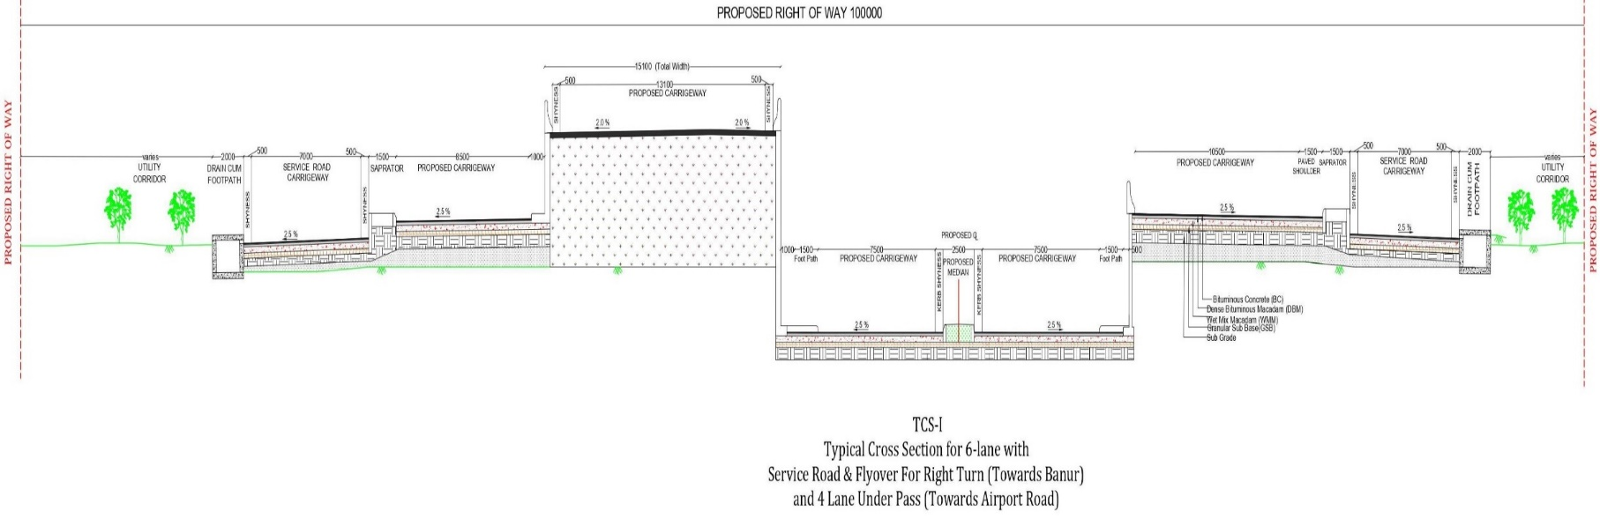

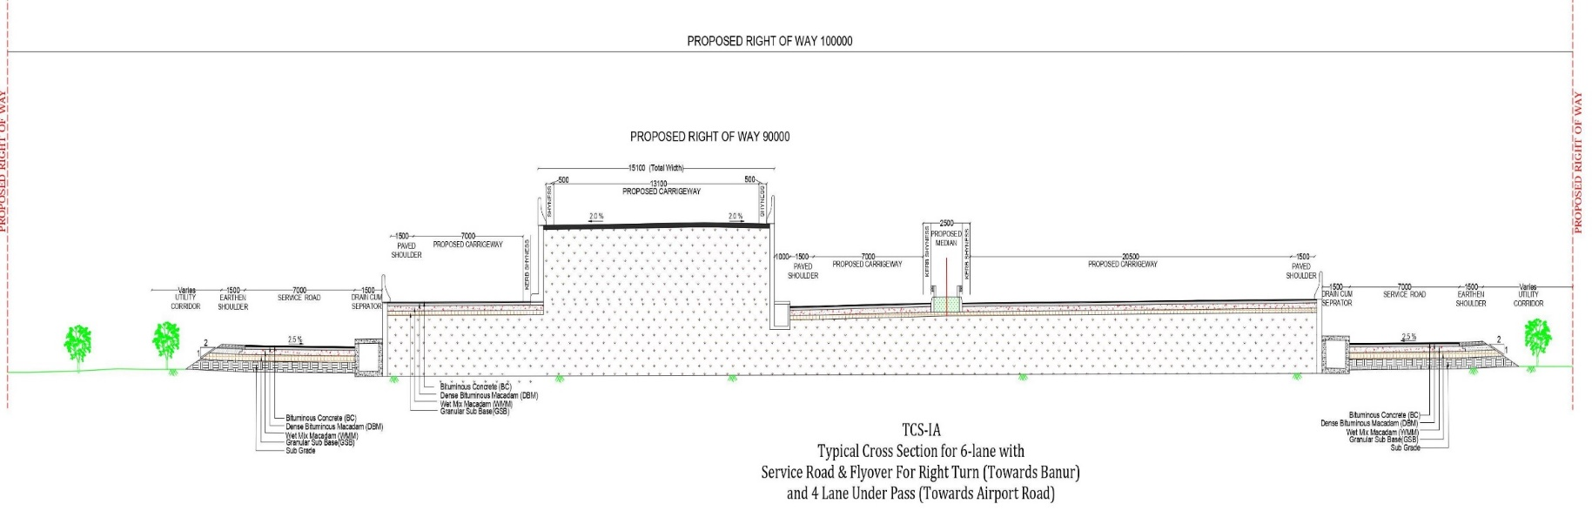
Figure 36 (b): TCS: TYPICAL CROSS SECTION: FOR 6 – LANE WITH PAVED SHOULDER & RAISED MEDIAN.
TYPICAL CROSS SECTION – II AND III (RHS)

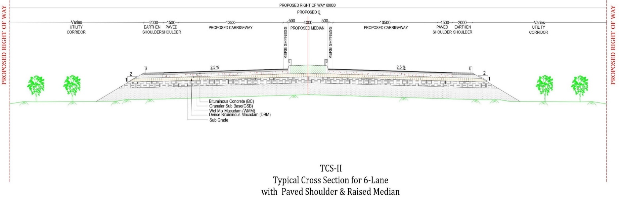

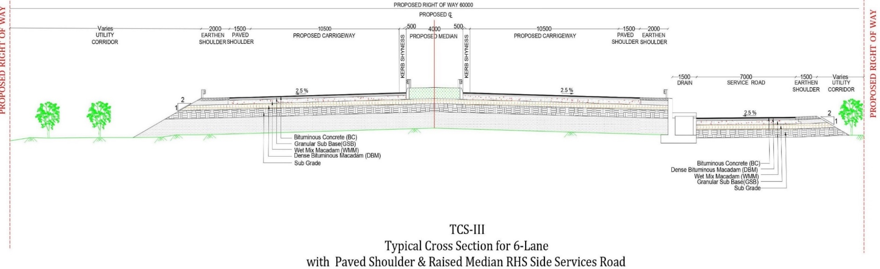
Figure 36 (c): TCS: TYPICAL CROSS SECTION: FOR 6 – LANE WITH PAVED SHOULDER & RAISED MEDIAN.
TYPICAL CROSS SECTION – IV (LHS) AND V

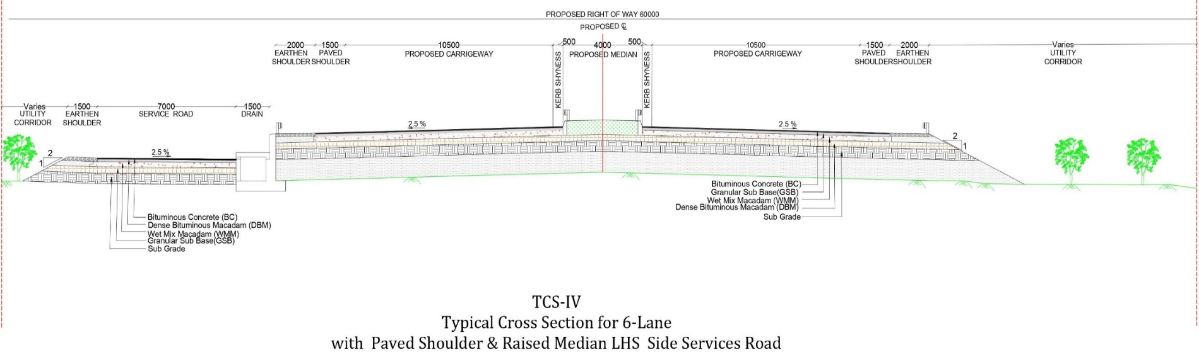

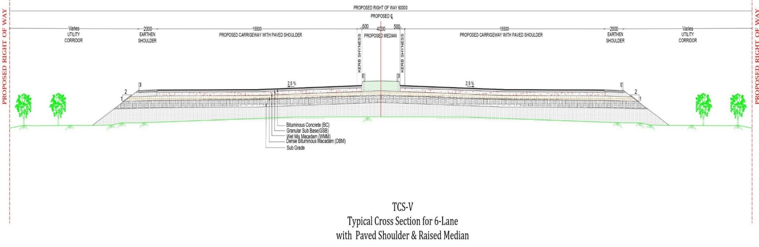
Figure 36 (d): TCS: TYPICAL CROSS SECTION: FOR 6 – LANE WITH PAVED SHOULDER VUP/ LVUP/ SVUP/ FLYOVER.
TYPICAL CROSS SECTION – VI AND VII (BHS)

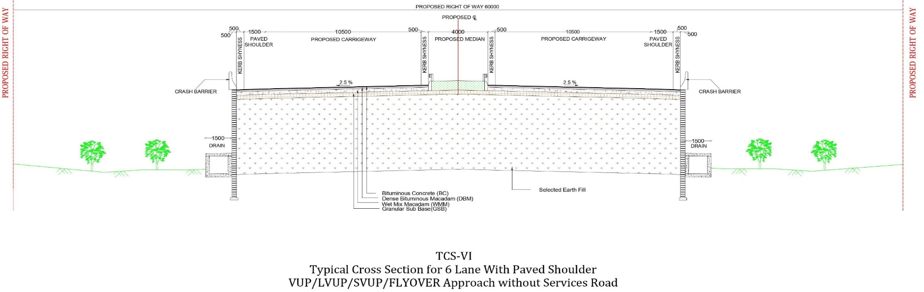

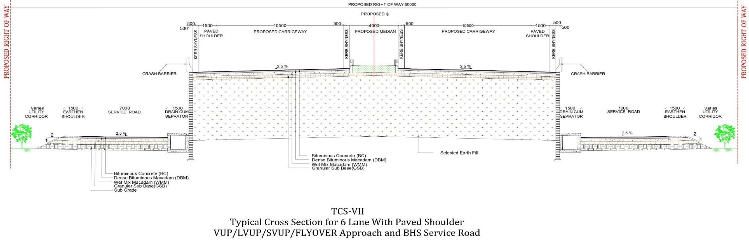
Figure 36 (e): TCS: TYPICAL CROSS SECTION: FOR 6 – LANE WITH PAVED SHOULDER VUP/ LVUP/ SVUP/ FLYOVER.
TYPICAL CROSS SECTION – VIII (LHS) AND IX (RHS)

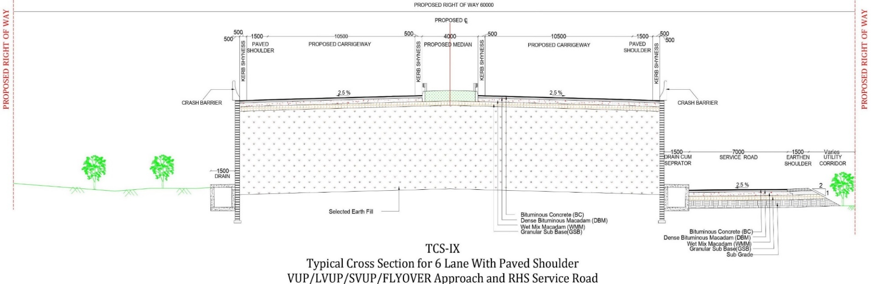
Figure 36 (f): TCS: TYPICAL CROSS SECTION: FOR 6 – LANE BY MAJOR BRIDGE AND RAILWAY OVER BRIDGE.
TYPICAL CROSS SECTION – X AND X (A)

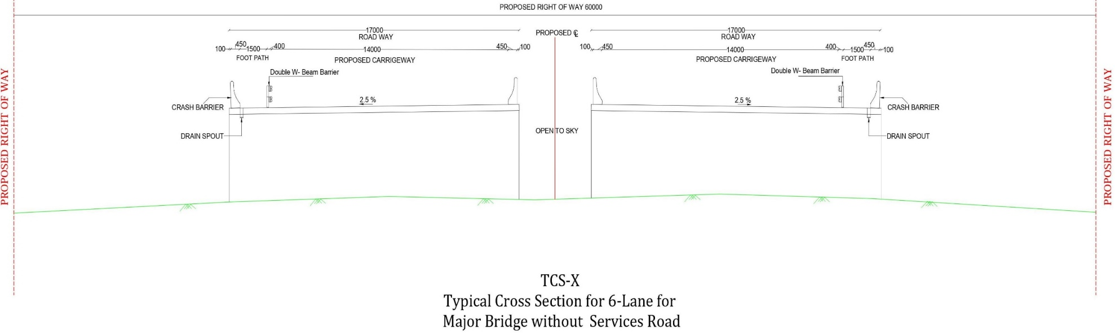

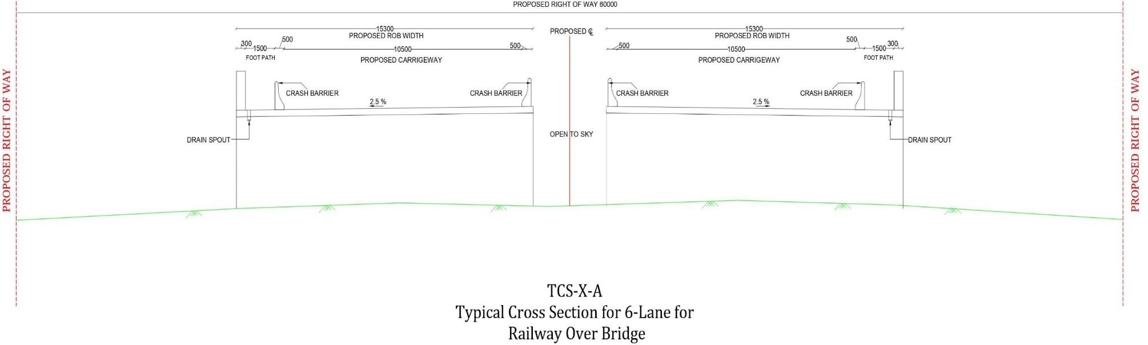
Figure 36 (g): TCS: TYPICAL CROSS SECTION: FOR 6, 8 – LANE WITH PAVED SHOULDER VUP/ LVUP/ SVUP/ FLYOVER.
TYPICAL CROSS SECTION – XI (BHS) AND XII

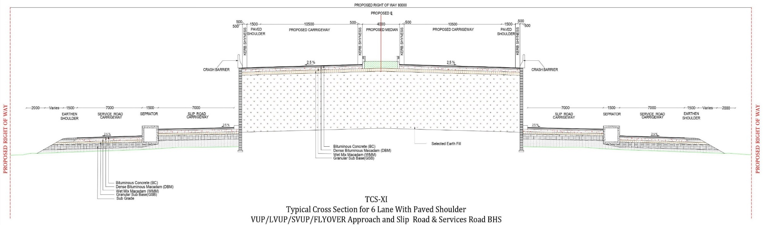

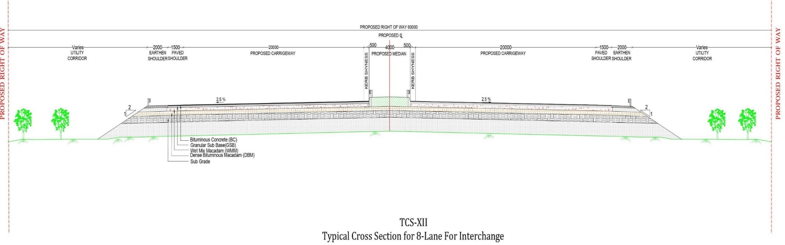
Figure 36 (h): TCS: TYPICAL CROSS SECTION: FOR 6 – LANE WITH SERVICE ROAD & RAISED MEDIAN (TOWARDS BADDI ROAD).
TYPICAL CROSS SECTION – XIII

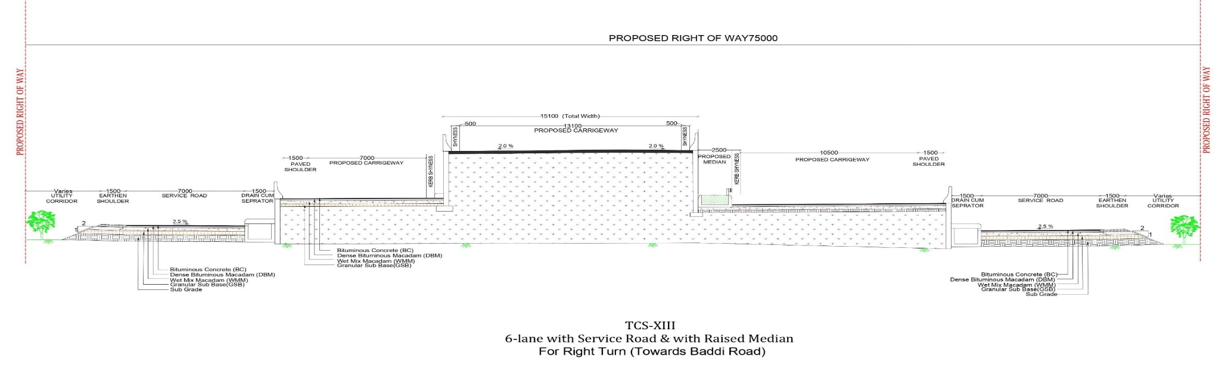

Figure 37: BOTHER... SAFEGUARD; PROTECT; CONSERVE AND PRESERVE OUR PLANET EARTH’S NATURAL – MOTHER... (ECO – NATURAL – GREEN – ENVIRONMENT)...!!!

***************************
*********************

Chapter – 2: ENVIRONMENT SCREENING REPORT

2.1 GENERAL DESCRIPTION

The “Initial Environmental Examination” (IEE) is carried out to assess the potential environmental impacts likely to be triggered by the project road. The project road will be reconstructed without any land acquisition and displacement of people. The project road belongs to Category C projects as per NHAI's recent Environmental Assessment Guidelines and requires an IEE to be carried out. IEE report will be prepared based on the IEE format of “Advanced Data or Design Systems” (ADS) with due consideration to environmental legislation e.g., “Environmental (Protection) Rules, 1986 of Government of India” (GOI). The Project Road for IT City Chowk to Kurali Chandigarh Road is situated in Punjab. The alignment of the project road connects IT City Chowk to Kurali Chandigarh Road respectively.

The objectives of IEE are as following:

- To provide information about the general environmental settings around the sub project area as baseline data;

- To provide information on potential impacts of the project and characteristic of impacts, magnitude, distribution and their duration;

- To provide information on potential mitigation measures to minimize the impact;

- To provide information on the basis of “Environmental Management Plans” (EMPs);

- The field visits were made to collect the requisite information from various government departments and from other secondary sources (including limited public consultation in the form of focused group discussions).

In the “IEE Activities Proposed” to be undertaken as part of this project will be considered and the potential impacts will be analyzed.

2.2 DESCRIPTION OF THE PROJECT

The Project Road for “IT City Chowk to Kurali Chandigarh Road” is situated in Punjab. The proposed project road at present has single lane carriageway. The road will be widened for intermediate lane. It is planned to reconstruct the existing road with provisions for side drains, bridges, culverts etc. The project road will be implemented within the existing “Right of Way” (ROW) without any land acquisition. The terrain is flat with very minor changes in elevation, and the landscape is open and devoid of forest cover. The only noticeable changes from the flat terrain occur in the few places, where the road briefly descends through ravines carved out by streams and then climbs back to the level plain. Settlements are sparse; the road runs largely through open fields/ barren lands. Many hand pumps are placed alongside the roadways or roadside for obtaining drinking water.

2.3 NHAI REQUIREMENTS

The NHAI classifies projects such as “Scientific Research and Experimental Development” (SRED) into one of three categories based on a screening of their expected environmental impacts:

- Category “A”: Category “A” Projects are defined by the NHAI as "Projects expected to have significant adverse environmental impacts as shown in the Flow Diagram 38 (a). An “Environmental Impact Statement/ Assessment” (EIS/ A) (as defined by the NHAI regulations) is required to address significant impacts."

- Category “B”: Category “B” Projects are defined as "Projects judged to have some adverse environmental impacts, but of a lesser degree and/ or significance than those for Category A projects as shown in the Flow Diagram 38 (b). An “Initial Environmental Examination” (IEE) is required to determine whether or not significant environmental impacts warranting an EIA are likely. If an EIA is not needed, the IEE is regarded as the “Final Environmental Assessment Report” (FEAR)."

- Category “C”: Category “C” projects are defined as "Projects unlikely to have adverse environmental impacts. No EIA or IEE is required, although environmental implications are still reviewed."

2.4 GOVERNMENT OF INDIA REQUIREMENTS

The following is provided for informational purposes. The “IEE OR FEAR” in hand has not been prepared to meet the specific criteria/ strategies/ goals/ objectives in actual on priority basis, and does not support to meet “Government of India” (GOI) requirements that may ultimately be determined to be applicable to certain “Scientific Research and Experimental Development” (SRED) activities. As of this writing, it is not anticipated that any GOI’s process/ system concerning EIAs will be required. Careful planning of those activities that of necessity occur outside the existing “Right of Way” (for example: placement of labour camps, extraction of fill from borrows areas, placement of temporary approaches to river crossings during bridge replacement), combined with proper contracting and procurement measures should keep all SRED activities below the thresh – hold limit that would trigger or activate the mechanism, which is in actual practice the need for an EIA OR EIS.

2.4.1 Central Government Requirements

- Primary responsibility for administration and implementation of the GOI policy with respect to conservation, ecologically or environmentally sustainable development and pollution control rests with the “Ministry of Environment and Forest” (MOEF) and the regulations established pursuant to the National Conservation Strategy; National Forest Policy; the Policy for Abatement or Mitigation Strategies of Pollution (1992); and the Indian Environmental Protection Act – 1986 (29th of 1986), revised in the year 1997.

- Guidance for the preparation of “Environmental Impact Assessments/ Statements” (EIA/ S) within this overall framework for environmental clearance of new development proposals is provided and suggested by the GOI's Handbook of Environmental Procedures and Guidelines (1994).

- Additional guidelines for road projects are provided by the “Ministry of Road Transport and Highways” (MORTH) in its publication entitled Environmental Guidelines for Rail/ Road and Highway Projects. The Guidelines include the summary questionnaire to be submitted to MOEF for the preparation and planning of EIAs for domestic road projects requiring EIA as noted above in the paragraphs.

- MOEF Circular No. 21012/ 26 – 99 – la – 111 dated 22nd August, 2013 exempts linear projects with ROWs of less than 40 metros (including the existing “Right of Way” (ROW) and land acquisition as may be required by the project) from most review processes. Projects entirely contained within the existing “Right of Way” (ROW) are considered as maintenance, which is generally not subject to MOEF review.

- Thus, road projects limited to actions as per instructions such as those are proposed and implemented by “Scientific Research and Experimental Development” (SRED) are generally exempted from GOI/ EIA requirements. The Project will not include construction of any new high level bridges and thus will not require significant changes and variations to the existing roadsides/ ways alignment or grade level quality construction of civil work.

2.4.2 State Forest Department Requirements

Removal of Trees along the Right of Way (ROW): Trees will have to be removed within the existing “Right of Way” (ROW) in some places to allow for widening of the carriageway, construction of shoulders, or to meet and follow current road safety standards. It should be noted that trees within the Right of Way are considered to be within the purview of the “State Forest Department” (SFD). Therefore, an application will be required pursuant to MOEF Letter Ref. No. 4 – 1/97' – FC, dated 18th February, 1998, which provides revised guidelines for applicability of the Forest Conservation Act (1980) to linear infrastructure projects such as rail and road projects. Clearance by the “State Forest Department” is assumed to have been granted/ decided/ approved/ fixed and established unless there is an indication to the contrary within 30 days.

Impacts to Reserved Forests: In the event of potential impacts to Reserved Forests, a “Notice of Compliance” (NOC) is required from the “State Forest Department” (SFD). In the event that a submission to MOEF is required, the NOC must be obtained prior to action by MOEF as an esteemed organization.

2.4.3 State Pollution Control Board Requirements (SPCB)

- Certain actions to be included in SRED (e.g., the locations and operations of asphalt crushing or mixing plants) will require submission of an application to the SPCB pursuant to the water (Prevention and Control of Pollution) Act of 1974, Cass Act of 1977, and Air (Prevention and Control of Pollution) Act of 1981.

- The SPCB generally establishes a review panel or board/ section/ group/ jury members and circulates the application for public review and comment in each affected district. At least one public hearing is held in each affected district following not less than 30 days’ notice in local and regional newspapers/ media network/ news channels etc.

- A state – level hearing is also required, taking all comments received from the districts into account and assuming acceptability of the SPCB issues as per NOC status and standard maintained for civil construction road network.

- The SPCB's NOC, as well as the Forest Department's NOC is required before MOEF action on any required EIA can be considered complete or whole comprehensive and inclusive report work.

2.5 DESCRIPTION OF THE ENVIRONMENT

Data and information required for preparation of the “Initial Environmental Examination” (IEE) report have been collected from various government departments or agencies/ well established organizations, secondary sources and through actual field visits/ tours/ on site/ area/ location fieldworks etc. Environmental conditions for applicability index of the area are discussed below one by one in detail:
- Physical Resources

- Weather and Climate Index

IT City Chowk – Kurali Chandigarh (आईटी सिटी चौक – कुराली: ਕੁਰਾਲੀ, चंडीगढ़: ਚੰਡੀਗੜ੍ਹ)

    - Weather for the week in Kurali, India: Looking at the weather in Kurali, India over the week, the maximum temperature will be 40℃ (or 103℉) on Sunday 28th March at around 2 pm. In the same week the minimum temperature will be 14℃ or 58℉ on Wednesday 24th March at around 5 am. The national weather service for Kurali, India is reporting Monday 22nd March to be the wettest day in the coming week with around 1.70 mm or 0.1 inches of rainfall. Make sure to carry an umbrella if you are out and about in Kurali, India. The windiest of all days will be Tuesday 23rd March as wind will reach 17 mph or 27 kmph at around 5 pm. Kurali is a Town in Kurali Tehsil in Rupnagar District of Punjab State. It is located 18 Km towards South from District headquarters Rupnagar. It is a Tehsil head quarter and Kurali Pin code is 140103 and postal head office is Kurali. Ward No. 6 (1 Km), Ward No. 7 (1 Km), Ward No. 8 (1 Km), Charheri (2 Km), Dhianpura (2 Km) are the nearby Villages to Kurali. Kurali is surrounded by Morinda Tehsil towards West, Majri Tehsil towards East, Rupnagar Tehsil towards North, and Kharar Tehsil towards South. Kurali, Morinda, Kharar, Mohali are the nearby Cities to Kurali. This Place is in the border of the Rupnagar District and S. A. S. Nagar District. S. A. S. Nagar District Kharar is South towards this place.

    - Climate for Chandigarh has a humid subtropical climate (Köppen: Cwa) characterized by a seasonal rhythm: very hot summers, mild winters, unreliable rainfall and great variation in temperature (−1°C to 46°C OR 30.2°F to 114°F). The average annual rainfall is 1110.7 mm and the minimum temperature is around 6°C. Chandigarh District is one among 1 Districts of Chandigarh State, India and Chandigarh District Administrative head quarter is Chandigarh. Chandigarh District population is 10, 54,686 and it is Biggest district in Chandigarh State by population. It is smallest district in Chandigarh State by population and it is Located at Latitude 30.7333° N, Longitude 76.7794° E. Chandigarh District is sharing border with S. A. S. Nagar District to the West.

    - It is sharing Border with Punjab State to the West and Chandigarh District occupies an area of approximately 114 square kilometres. It’s in the 334 meters extraordinary elevation range and this District belongs to Hindi Belt of India. Punjabi is the Local Language here and also People Speaks Hindi. Chandigarh District is divided into 2 Tehsils, 109 Panchayats and 107 Villages. Chandigarh Tehsil is the Smallest Tehsil by population with 9, 00,635 population and Chandigarh Tehsil is the Biggest Tehsil by population with 9, 00,635 population. Chandigarh district total population is 10, 54,686 according to census 2011. Males are 5, 80,135 and Females are 4, 74,551. Literate people are 6, 97,780 among total. Its total area is 114 Sq. Km and it is the 1st largest district in the State by Population. But 1st Largest District in the State by Area. Moreover it is 427th Largest District in the Country by Population and 1st highest District in the State by Literacy Rate. And 59th highest District in the Country by literacy rate and its Literacy Rate is 86.43%.

- Climate and Temperature Index

    - There is no meteorological observatory in the district and on the basis of records of the observatories in the districts where similar climatic conditions prevail. Temperature varies with altitude and slope of plain/ flat/ mountainous/ hilly region and the maximum temperature is recorded usually during July and August and minimum during December and January. Fog is a common feature in the entire Punjab from May to September. Biting cold is experienced at high altitude places in the winter months and snowfall is also not uncommon during this period. Humidity varies from 80 to 90% and wind flows at 16 KPH from West to East on an average. “Transmission Windows” (TWs) for malaria i.e., the appropriate conditions of temperature and humidity in which a vector thrives, is projected to increase (temperature ranges between 14 – 40°C, and RH > 50%) with “Climate Change” (CC).

- Rainfall and Temperature Index

    - PHYSICAL ASPECTS: With an annual average rainfall of 2,068 mm, it is one of the highest rainfall receiving regions on the planet, which makes it an important site from a meteorological perspective. Analysis of rainfall data plays an important role for any water resource planning as well as for hydrological modeling. The mean monthly rainfall data for all districts of Punjab for 102 years (1901 – 2002) were used for the present study displays the annual rainfall behavior recorded for whole Punjab for the duration 1901 – 2002. The average annual rainfall recorded is 1069 mm for the whole duration. During this period, the highest amount of rainfall was about 1982.15 mm in 1936, whereas the lowest amount of rainfall recorded was about 559.98 mm during 1987. The dark line in the figure represents the annual average rainfall. If the annual rainfall in a year departs from the average annual rainfall by greater than or equal to 25%, then it is declared as a drought (meteorological drought) year. On the basis of 25% departure from the average annual rainfall, 30.4% times there were dry years. There was sufficient rainfall from July to September to meet evapotranspiration demand and vice versa from the October to June.

      - (i) Moderate rainfall (more than 800 mm) receiving region in the Northern and South – Eastern parts of the district/ region/ locality;

      - (ii) Low rainfall (700 mm to 800 mm) in the extensive Eastern and Southern parts of the district/ region/ locality;

      - (iii) Very low rainfall (less than 700 mm) in the Western part of the district/ region/ locality.

    - Climate projections for 2030s (2021 – 2050) and 2080s (2071 – 2098) have been derived from “PRECIS” (Providing Regional Climate for Impact Studies), which is a desktop version of the HadRM³ model with a grid resolution of 0.44°×0.44° Angles. PRECIS simulation dataset is provided by the “Indian Institute of Tropical Meteorology” (IITM), Pune. The “Climate Change Scenarios” (CCS) are driven by the “Green House Gases” (GHG) Emission Scenario, which assumes a future world of very rapid economic growth, a global population that peaks in midcentury and declines thereafter and assumes rapid introduction of new and more efficient technologies/ innovations in this scenario or field. Change in precipitation and temperature in 2030s and end of the century 2080s have been derived with respect to 1970s (1961 – 1990).

- Humidity Index

    - Kurali Live Weather: Humidity is found to be 87% along with North Eest (NE) wind flow at 00 to 2.57 mt/ sec. Kurali’ current Weather and Temperature on an average is 19.4°C to 37.2°C and Weather Forecast for next 5 days may varies between 15.9°C to 30.1°C and temperatures seldom exceeding (11.0°C × 9/ 5) + 32 = 51.8°F in summer. Elevation/ Altitude/ Ceiling are found to be 303 Meters above the “Mean Sea Level” (MSL) in the State of Punjab.

    - Chandigarh Live Weather: Humidity is found to be 41% along with South Eest (SE) Wind Flow at 00 to 18 Km/ Hr. Chandigarh’ current Weather and Temperature on an average is 20.0°C to 37.1°C and Weather Forecast for next 5 days may varies between 15.7°C to 29.0°C and temperatures seldom exceeding (26.0°C × 9/ 5) + 32 = 78.8°F in summer. Elevation/ Altitude/ Ceiling are found to be 321 Meters above the “Mean Sea Level” (MSL) in the State of Punjab.

    - Since the study region lies far away from the sea coast area/ region, it experiences continental type of climate zone. It has the Tropical monsoon climate with five distinct/ dissimilar/ divergent seasons namely…!!!

      - i. Monsoon season extending from June to September month;

      - ii. Retreating monsoon season extending from October to November month;

      - iii. Winter season – December to February month;

      - iv. Summer season – March to May month.

      - v. The temperature during spring season ranges between 6°C at night to 17°C during day in the month of December the sky generally remains clear in Punjab;

      - vi. Autumn season falls on the months of September and October in Punjab;

    - Other minor effects are increased incidences of skin disorders, such as prickly heat and fungal skin disorders such as ringworm and athlete's foot as a result of increased temperature and humidity. Some of the viral diseases like “Peste des Petits Ruminants” (PPR) are an acute or sub – acute viral disease of goats and sheep characterized by fever, necrotic stomatitis, gastroenteritis, pneumonia etc. may also re – appear affecting small ruminant population as well. “Temperature Humidity Index” (THI), representing the combined stress of temperature and humidity, affects the productivity of livestock. In addition to these inherent problems increasing temperature and humidity are also affecting the quality of these produce. For value addition, processing units and marketing of products need to be developed for rural clusters in different “Agro – Climatic Zones” (ACZ). This would also help in reducing the wastage of the produce. Beside the vector borne diseases that could expand its occurrences, other infections that are related to varying temperature and humidity indices are also imminent threats to human health and its well beings.

- Ambient Air Quality Index

    - The air quality along the roadsides/ ways is good as there is less flow of traffic. No major source of emission of exhaust gases exist along the roadways or roadsides except some commercial and residential establishments concerns, enterprises, shops etc., which burn wood as a fuel for commercial and domestic purposes/ reasons or functions.

    - As existing road is in narrow condition, dust due to wind – blown and movement of vehicles on earthen shoulder portion is observed experimentally, physically and practically along the roadside. However, such dust particles are settled or mend or resolved within short distances from the road.

- Noise Levels Index

    - In the area along the projected road, noise levels are moderate as there is less traffic flow. Therefore, the contribution of traffic, an increase of ambient noise levels can be considered insignificant or unimportant and immaterial.

- Seismological Index

    - As per seismic zonal map of India, the sub project area is located in seismic zone – II. The bridges, culverts and other structures, therefore, need to be designed accordingly as per specific record of civil construction work.

(ii) Ecological Resources Index

- Terrestrial Ecology

    - Impacts to flora will be minimal throughout most of the projected areas. Most of the length of the “Right of Way” (ROW) lies in rural areas as well as some parts of urban areas also. Insofar as can be determined, no threatened or endangered plant species are located within or adjacent to the affected ROWS and no adverse impacts to special status of species/ varieties/ groups are likely to occur due to these activities. Virtually all rehabilitation and resettlement applicable processes or activities will be confined to the existing ROWS, and both direct and indirect impacts to threatened or endangered plant species are unlikely. Plant species present within the “Right of Way” (ROW) are either introduced species or ubiquitous native species, which are highly tolerant of grazing, compaction, and other physical disturbances. Construction activities will have direct impact only in a narrow band of vegetation adjacent to the existing roadways. Potential impacts to flora, in both the forested and non – forested land areas will be avoided by ensuring that roadside activities such as asphalt crushing and hot mixing plants, construction camps and other ancillary features are properly sited. Right of Way, both inside and outside of forested areas is lined by mature trees overarching the roadways/ roadside. In some portion trees will have to be cut to permit rehabilitation and resettlement of the roads to current/ recent applicable safety measure standards.

- Wildlife

    - The road does pass through any wildlife area in the projected region. And wildlife zone occurs in the region/ area or state.

- Fisheries

    - No fishing activity is observed in the drains of sub – projected area. And no fisheries zone occurs in the region/ area or state.

(iii) Economic Development

- Industries

    - No major/ minor industrial activity is observed along the projected roadside. Therefore no industrial zone occurs in the region/ area or state.

- Commercial Activities

    - Commercial activities observed mostly near the inhabitation portion, along the projected road. These commercial activities are in the form of shops/ malls or complexes in the region/ area or site.

- Infrastructure Facilities

    - Infrastructure facilities are adequate/ sufficient and satisfactory in the area along the projected roadside.

- Agricultural Development

    - The climate of the area is more suitable for growing agricultural i.e., wheat, soya bean, Zwaar (Heavy), Bazra or Pearl Millet (Pennisetum Glaucum) is the most widely grown type of millet as a part of plants and vegetables. There exists huge potential as far as the agriculture development is concerned. Soils are Medium to Deep – Black with relatively high clay content. The major agricultural crops are wheat, gram soybeans and cotton seeds for cotton generation/ production etc.

2.6 Social Impact Assessment (SIA): GENERAL DESCRIPTION

As part of the project, to ascertain the Resettlement and “Social Development and Improvement Component” (SDIC) of the project, the scopes of the present study as defined by the “Terms of References” (TORs) are involved with several elements, parameters and factors, which are in order as below:

- To examine and assess the overall social and poverty profile of the project area on the basis of the primary and secondary data sources such as statistical handbooks, poverty data, land use patterns and prototype models and sample areas/ site visits/ field visits are key stakeholder’s interviews and preparation of a socio – economic profile of the state of “Punjab” and the project districts.

- Preparation of social and poverty or scarcity and deficiency index analysis, taking into account socio – economic and poverty status of the projected area of influence, including the nature, extent and determinants of poverty in the project area including assessment of the risk of human trafficking and HIV/ AIDS due to the project. In addition, estimation/ judgment/ inference/ evaluation/ assessment of the likely socio – economic and poverty or deficiency index reduction impacts of the project also constituted an important as well as significant aspect of the study.

- Consultations with relevant officials from the governments, NGOs and other relevant officials, including consultation with “Affected Persons” (APs) and affected communities to assess responses to the project and ascertain the nature and scope of local participation in project planning and implementation stage.

- To identify, analyze and where appropriate, quantify the potential resettlement impacts of the proposed project on the area and the population.

- To suggest measures to enhance benefits and mitigate adverse impact on socio – economic profile in the region.
The report is based on the findings of the socio – economic surveys, field visits or site/ area visits and small group meetings/ discussions with the project populations in the projected area.

2.7 METHODOLOGY

The study will be conducted with a participatory approach that aimed at putting the community at the center with a collective process of reflection, discussion and consultation with all major stakeholders in the Project. The primary stakeholders, such as farmers, shopkeepers, daily wage labourers, Panchayat members, women and other socio – economically deprived groups like Scheduled Caste (SC), Scheduled Tribes (ST), Other Backward Classes (OBC), health workers, school teachers, General Category (GC) people and Non – Government Organizations (NGOs) will be consulted individually, in homogenous sub – groups and mixed groups to understand the local needs and responses to the proposed sub – projects and also to ascertain the impact or contact of the proposed project on the communities, the area and the overall regional state.

Site or field visits will be made by the team to the respective projects and all the villages getting affected by the proposed project intervention, in order to ascertain the socio – economic profile of the area, “Participatory Rural Appraisal” (PRA) Methodologies and Techniques like social mapping, resource mapping, transect walk and mobility maps etc. will be used during the course of the field investigation work.

Community meetings shall be initiated to obtain, acquire and achieve the views, responses and possible solutions from the local people.

“Focus Group Discussions” (FGD's) will be organized at the village level with different potential affected groups of people, more importantly, women, indigenous/ native/ local/ original and other socio – economically deprived people to ascertain the impact of the project on them.
Meetings with village Panchayats, Non – Government Organizations, health workers, and school teachers, social workers will also be held during the course of field/ site and area visits with emphasis on project impact, poverty, road safety and related issues.

“A Socio – Economic Survey” (SES) covering 20% of the total households/ businesses along the alignments of each of the sub – projects shall be conducted and carried out and accomplished by means of a detailed questionnaire as opinion poll.

A detailed analysis of secondary data sources shall be carried out and accomplished to understand the social, economic and demographic situation in the projected area and will be submitted along with “Initial Environmental Examination” (IEE) OR “Final Environmental Assessment Report” (FEAR) as shown in the columns with the Flow Diagrams 40 (a, b, c and d respectively).

2.8 SOCIO – ECONOMIC CHARACTERISTICS

On the basis of socio – economic data collected from the “District – Handbooks” and other departmental publications and brochures relevant to the project roads, as stated earlier, a “Project Road Influence Area Profile” (PRIA) has been prepared. The profile consists of demographic features, land utilization, occupation structure, agriculture production, acreage intensity irrigation facilities, and concentration of infrastructure facilities, such as, availability of banks, hospital beds, primary schools, electrified villages, drinking water facilities, status of accessibility (paved/ unpaved road), number of hat/ bazaar, primary health centers, government public distribution shops, post offices and family planning center etc. The compiled data have been used in the present project for several analyses during the study. A summary with salient features are presented in and Flow Diagrams 40 (a, b, c and d respectively) as given below.

Since the time series data are not available for the above socio – economic parameters, it is difficult to establish any trend analysis report work. However, the data available reveal the salient features of the “Project Road Influence Area Profile” (PRIA) as well as the concentration of different activities occurs in the projected area/ region. The status of a “Project Road Influence Area” (PRIA), thus identified, in a specific activity would be useful to appreciate the relative importance of that particular projected road. The information collected and compiled for all the projected roads has been utilized for establishing, launching, ascertaining the relative potential, possible, probable, prospective for future development and growth and in turn an increase in traffic of the state or region.

2.9 IMPACT ON THE INDIGENOUS PEOPLE

The indigenous/ local/ native/ original people who are presently confined to local area only shall look – after the development of road and thus transportation infrastructure will get more exposure to education, health, markets and other informative and innovative activities etc. The area is not vulnerable to migration settlements from external people. Since the major occupation of people in local area is agricultural based and there are no proper warehousing facilities for storage of agricultural product in the area the indigenous people will be benefited by road development projects. The Column 15 of Table 65: “ENVIRONMENTAL MANAGEMENT PLAN” (EMP) for “IT City Chowk to Kurali Chandigarh Road” in the State of Punjab.

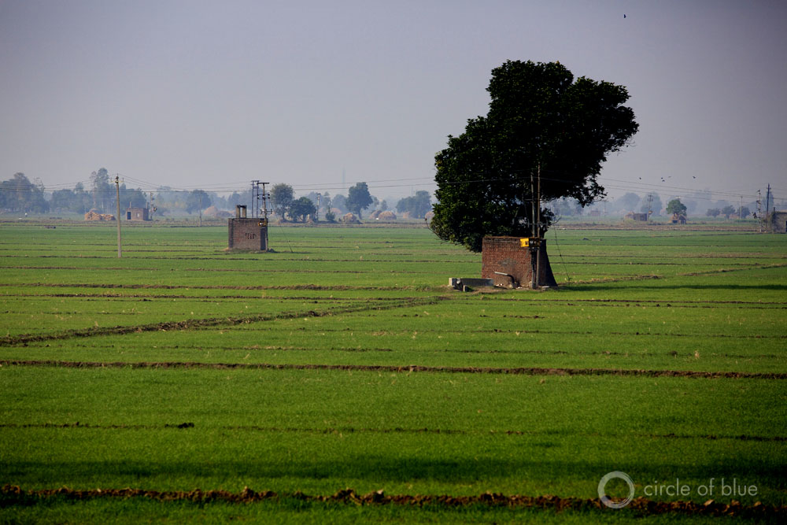
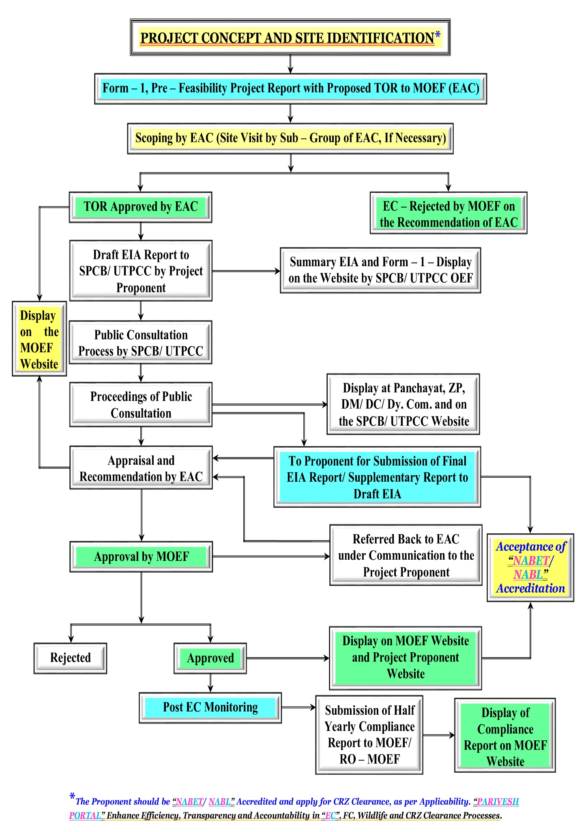
Figure 38 (a): Stream Illustration of Prior Environmental Clearance Process for Category “A” Projects.
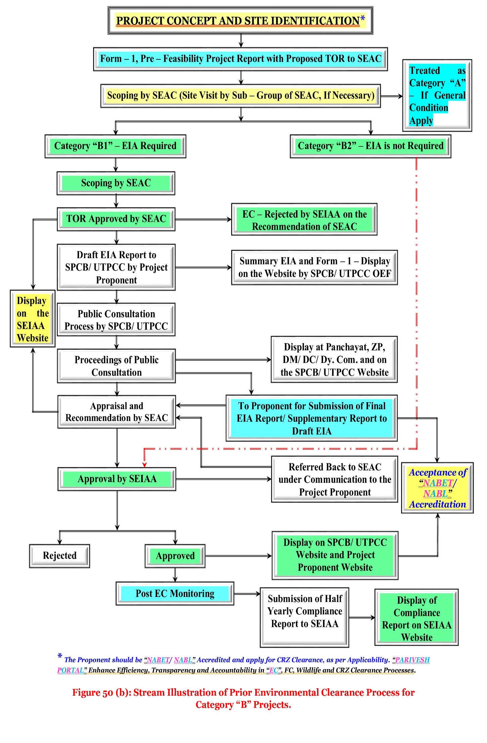
Figure 38 (b): Stream Illustration of Prior Environmental Clearance Process for Category “B” Projects.
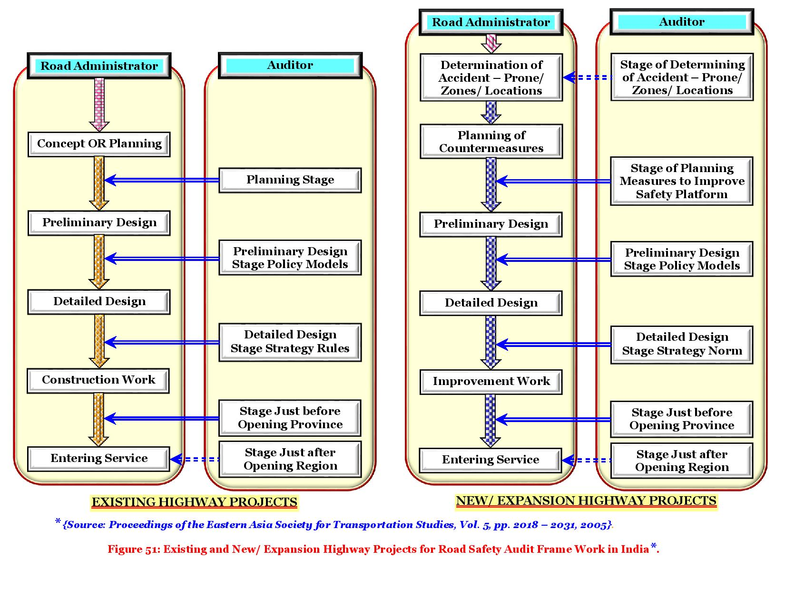
Figure 39: Existing and New/ Expansion Highway Projects are an Integral Part during Planning, Construction and Operational Stage for Road Safety Management System Audit Frame Work in India*.

Figure 40 (a): Overview of the Environment and Social Framework.

ENVIRONMENTAL OVERVIEWS AND SOCIAL FRAMEWORKS

Figure 40 (b): Core Principles of the Environmental and Social Framework.
Core Principles
NHAI’s core principles which governs operations on environment and social management; “Environmental and Social Standards” (ESS) w. r. to “Environment, Involuntary Resettlement and Indigenous or Originated People” (EIRIOP);
Objectives
“Purposes” of the Articles of Agreement of the “National Highway Authority of India” (NHAI);
Aim of this Environment and Social Framework is to: Manage environmental; social risks; impacts in projects; manage operational; reputational risks of NHAI and its stakeholders;
- Mainstream environmental and social considerations into decision – making processes of all parties;
- Encourage international – good – environmental and social practices; operations; strengthen country systems;
- Policy seeks to ensure environmental social soundness and sustainability of projects;
- Enable clients to identify, manage environmental and social risks and impacts in NHAI’s projects;
- Improve development effectiveness and impact to increase results on the ground, and facilitate cooperation on environmental and social matters with development partners;
- Its operations, NHAI seeks to balance economic, social, and environmental interests while fostering ownership and accountability of member countries.
Introduction

ENVIRONMENTAL Core Principles

Figure 40 (c): The Environmental Objectives; Application Scope; Policy Approach of the Environmental and Social Framework.
A. Environment Objective;
B. Application Scope;
C. Policy Approach;
D. Environmental Policy Requirements;
E. Roles and Responsibilities;
g) Precautionary Measures/ Approaches/ Applications/ Evaluations in Precious Environmental Goals
h) Co – operative Functioning and Knowledge Dissemination Regarding Policies and Responsibilities
f) Gender Equality and Overall Impact on Environment

e) Conservation of Natural Resources in Environmental Field

c) Environmental and Social Aspects/ Interests/ Achievements
a) Inclusive and Environmental Sustainable Development

b) Environmental Study and Country Systems

d) Climatic Changes/ Conditions/ Observations

A. Environmental Objectives;
B. Application Scope;
C. Policy Approach;

Figure 40 (d): The Policy Requirements; Roles and Responsibilities of the Environment and Social Framework.
- Further, if NHAI determines relevant requirements of the country in which the project is located are more stringent than the requirements of its “Environmental Policies and Goals” (EPG);
- NHAI may require the customer to comply environment with more stringent requirements.
- NHAI will apply on project by project basis, an appropriate risk – based framework grounded on NHAI experience with BRICS and other “International Good Engineering Practices” (IGEP) in the Environment;
- The implementation of the “Environmental Policies” (EP) are the responsibility of the client or costumer, including way of assessments, consultations, plans, implementation, complaint redressal, dispute resolution, and disclosure and monitoring. However, NHAI seeks to play a proactive role by (i) Ensuring stricter compliance with applicable national standards (ii) Working with client to strengthen country capacity and systems (iii) Facts sharing with clients on “International/ Global Good Practices” (I/ GGP). NHAI provide support to clients during project processing, monitoring supervision where and whenever essential in the field of “Environmental Goals” (EG).
- Environmental involuntary resettlement; indigenous or native peoples standards; preparation and implementation of NHAI projects;
- NHAI addresses gaps, if any, engaging client or customer to take adequate actions to ensure full success of “Environmental Objectives of Framework” (EOF).
- Including investment projects on environment and their components regardless of financing sources;
- NHAI agree to apply additional needs relating to the environmental or social affairs with the “Articles of Agreement and its Policies Applicability” (AAPA).
NHAI believes:
- Environmental;
- Social sustainability are crucial while addressing infrastructure gaps;
- “Environmental Sustainable Development” (ESD) needs consistent with national laws; regulations, and its mandatory policies.
A. Environmental Objective:
To combine the achievement of this it is very important with project decision making process of the client and NHAI and the overall operations of NHAI;
B. Application Scope:
Policy applies to all NHAI financed; NHAI administered projects with or without sovereign guarantee;
C. Policy Approach:
Under Framework, NHAI requires clients to meet key requirements for environmental and social assessment;

D. Environmental Policy Requirements;
E. Roles and Responsibilities;

D. Environmental Policy Requirements:
- The screening covers three types of concerns of ESS, i.e., environmental, involuntary resettlement and indigenous or originated or native people;
- “Environmental and Social Management Framework” (ESMF).

- (d) Monitoring and supervising the Client’s compliance with its environmental and social obligations under the legal agreement between NHAI and the Client;
- (e) Establish and maintain a fair and effective grievance redress mechanism for “Environmental and Social Safeguards” (ESS).
E. Roles and Responsibilities:
- (a) Screening each project to assign a category to it;
- (b) Undertaking due diligence review of the “Client’s or Customer’s Environmental and Social Assessment Reports” (CESAR);
- (c) Determining the feasibility or practicability of NHAI financing for the project.

15. ENVIRONMENTAL MANAGEMENT PLAN (EMP) for IT City Chowk to Kurali Chandigarh Road in the State of Punjab

Table 65: Environmental Management Plan (EMP).

Environmental Issues/ Components | Remedial Measure Statements | Reference to Laws/ Guidelines | Locations/ Areas | Monitoring Indicators | Monitoring Methods | Mitigation Coast | Institutional Responsibility and Requirement
 |  |  |  |  |  |  | Implementation | Supervision
- Pre – Construction and Design Stage
1. Alignment
1.1: Pavement Damage and Inadequate Drainage Provisions in Habitat Areas. | - Construction of concrete pavement in habitat areas considering alignment level and drainage.  - Raise road level above the nearby areas with provision of adequate side drains to evacuate the rain water and domestic discharges (drained by habitats occasionally) to prevent damage to road and rain water entry to habitats’ houses.  - Provision of adequate no. of cross drainage structures based on drainage pattern around the alignment. | Design Requirement. | All habitat areas throughout the alignment. | Design of both cross and side drains no. 57 of slab/ box culverts, Hume pipes. | Review of detail design documents and drawings. | Included in construction cost. | Design Consultant. | NHAI/ (CSC)
1.2: Loss of Tree and Vegetation. | - Restricting tree cutting within construction limit.  - Avoid tree cutting at ancillary site.  - Martian compensatory tree plantation of 8,480 trees @ 1: 10. | Design Requirement. | Throughout the alignment. | 848 No. of tree will be cut. | Observation | Included in construction cost | Design Consultant. | NHAI/ (CSC)
1.3: Protection of Sensitive Receptors. | - Careful selection of alignment to the sensitive receptor.  - Timely schedule ling of construction activity  - Provision of noise suitable barriers. | Project Requirement. | Location of sensitive receptors (Refer Table). | Design and alignment plan | Review of design | Included in construction cost | Contractor. | NHAI/ (CSC)
1.4: Safety along the Proposed Alignment. | - Make provisions of crash barriers at accident prone areas as identified in the road safety studies.  - Provision of rumble strips in habitat areas to regulate speed.  - Provision of retro – reflective warning sign boards nears school, hospital, and religious places and forests areas.  - Provision of proper sidewalks/ pedestrian zone along the road near habitat areas, school, hospital, religious places and forests.  - Compliance with norms specified in IRC codes for state highway for curvature and grading.  - Provision of safety curve at all bridges.  - The design should attempt to equalize cut and fill.  - Minimize the cutting in hill areas. Incorporate slope stabilization measures to prevent any land slide situation.  - Incorporate slope stabilization measures to prevent any land slide situation. | Design Requirement. | Places where height of embankment is more than 3.0 m. | No. of accident and vehicle collision. | Field observation, interview of locals. | Included in construction cost. | Design Consultant. | NHAI/ (CSC)
2. Natural Hazards
2.1: Protection for Damage from Earthquake. | - Design considering relevant seismic standard in the clause under IRC 6 – 2014 for earthquakes in bridges. |  | Throughout the stretch. | Incorporation of IRC 6 – 2014 guidelines for earthquake in bridge design. | Review of bridge design. | Project preparation cost. | Design Consultant. | NHAI
2.2: Protection of Road Embankment in Flood Prone Areas. | - Raise embankment height above the HFL levels in the flood prone areas.  - Provision of adequate balancing culverts.  - Improvement in existing culverts/ bridges to increase their carrying capacity. | IRC: 34 Recommendations for road construction in waterlogged area and IRC: 75 and MORT and H guidelines for Design of High Embankments (DHE). | All the existing culverts/ bridges. | Design of both cross and side drains, no. of slab/ box culverts, no. and size of Hume pipes. | ------- | Included in construction cost. | Design Consultant. | NHAI
3. Shifting of Utility Structures
3.1: Disruption of Utility Services to Local Community. | - All telephone and electrical poles/ wires and underground cables should be shifted before start of construction.  - Necessary permission and payments should be made to relevant utility service agencies to allow quick shifting and restoration of utility services.  - Local people must be informed through appropriate means about the time of shifting of utility structures and potential disruption of services if any. | Project Requirement. | Throughout the corridor. | Utility shifting plan.  Complaints from local people.  Status of local utility services. | Interaction with concerned utility authorities and local public. | Included in construction cost. | Contractor. | NHAI/ CSC
- Construction Stage
1. Air Quality
1.1: Dust Generation due to Construction Activities and Transport, Storage and Handling of Construction Materials. | - Transport, loading and unloading of loose and fine materials through covered vehicles.  - Paved approach roads.  - Storage areas to be located downwind of the habitation area.  - Water spraying on earthworks, unpaved haulage roads and other dust prone areas. | MORT and H Specifications for Road and Bridge Works Air (P and CP) Act – 1981 and Central Motor and Vehicle Act – 1988. | Throughout Project corridor. | PM₁₀ level measurements dust pollution or complain of locals. | Standards CPCB methods observations public consultation. | Included in project cost. | Contractor. | NHAI/ CSC
1.2: Emission of Air Pollutants (HC, SO₂, NO_{X}, CO etc.) from Vehicles due to Traffic Congestion and use of Equipment and Machinery. | - Regular maintenance of machinery and equipment.  - Batching, asphalt mixing plants and crushers at downwind (1 Km) direction from the nearest settlement.  - Only crushers licensed by the PCB shall be used.  - DG sets with stacks of adequate height and use of low sulphur diesel as fuel.  - Ambient air quality monitoring.  - Follow traffic management plan as given in Section – 8. | The Air (Prevention and Control of Pollution) Act, 1981 (Amended 1987) and Rules1982. | Asphalt mixing plants, crushers, DG sets locations. | Monitoring of ambient air quality and checking PUC certificates. | Standards CPCB methods. | Included in project cost. | Contractor. | NHAI/ CSC
2. Noise
2.1: Noise from Construction Vehicle, Equipment and Machinery. | - All equipment to be timely serviced and properly maintained.  - Bottlenecks to be removed.  - Construction equipment and machinery to be fitted with silencers and maintained properly.  - Only IS approved equipment shall be used for construction activities.  - The regulation near residential, built up and forest area construction shall be restricted to daylight hours.  - Timing of noisy construction activities shall be done during night time and weekends near schools and selected suitable times near temples when there are no visitors, concurrent noisy operations may be separated to reduce the total noise generated, and if possible re – route traffic during construction to avoid the accumulation of noise beyond standards. Else provision of temporary noise barrier at sensitive locations or near sources. | Legal requirement noise Pollution (Regulation and Control) Rules, 2000 and amendments there of + Clause No. 501.8.6. MORT and Highway Specifications for Road and Bridge Works. | Throughout project section especially at construction sites, residential and identified sensitive locations. | Noise levels measurements.  Complaints from local people. | As per noise rule, 2000.  Consultation with local people. | Included in Project Cost Plantation Cost is Separate. | Contractor. | NHAI/ CSC
3. Land and Soil
3.1: Land use Change and Loss of Productive/ Top Soil. | - Non – agricultural areas to be used as borrow areas to the extent possible.  - If using agricultural land, top soil to be preserved and laid over either on the embankment slope for growing vegetation to protect soil erosion. | Project Requirement. | Throughout the project section and borrow areas. | Borrow pit locations.  Top soil storage area. | Review borrow area plan, site visits. | Included in Construction Cost. | Contractor. | NHAI/ CSC
3.2: Slope Failure and Soil Erosion due to Construction Activities, Earthwork, and Cut and Fill, Stockpiles etc. | - Bio – turfing of embankments to protect slopes.  - Slope protection by providing frames, dry stone pitching, masonry retaining walls, planting of grass and trees.  - The side slopes of all cut and fill areas will be graded and covered with stone pitching, grass and shrub as per design specifications. Care should be taken that the slope gradient shall not be greater than 2:1.  - The earth stockpiles to be provided with gentle slopes to prevent soil erosion. | IRC: 56 – 1974 recommended practice for treatment of embankment slopes for erosion control Clause No. 306 and 305.2.2 MORT and Highway Specifications for Road and Bridge Works Guidelines IX for Soil Erosion. | Throughout the entire project road  Especially along hilly areas. | Occurrence of slope failure or erosion issues. | Review of design documents and site observation. | Included in Construction Cost. | Design Consultant and Contractor. | NHAI/ CSC
3.3: Borrow Area Management. | - Non – productive, barren lands, upland shall be used for borrowing earth with the necessary permissions/ consents.  - Depths of borrow pits to be regulated and sides not steeper than 25%.  - Topsoil to be stockpiled and protected for use at the rehabilitation stage.  - Transportation of earth materials through covered vehicles.  - IRC recommended practice for borrow pits (IRC – 10: 1961).  - Borrow areas not to be dug continuously.  - To the extent borrow areas shall be sited away from habituated areas. Borrow areas shall be levelled with salvaged material or other filling materials which do not pose contamination of soil. Else, it shall be converted into fishpond in consultation with fishery department and land owner/ community.  - Rehabilitation of the borrow areas as per guidelines for redevelopment of borrow areas. | IRC Guidelines on borrow areas and for quarries (Environmental Protection Act And Rules – 1986; Water Act, Air Act) + Clause No. 305.2.2 MORT and Highway Specifications for Road and Bridge Works Guidelines V for Borrow Areas Management. | Borrow sites location. | Existence of borrow areas in inappropriate unauthorized locations.  Poor borrow area management practices.  Incidents of accidents.  Complaints from local people. | Review of design documents and site observation. | Included in Construction Cost. | Design Consultant and Contractor. | NHAI/ CSC
3.4: Quarry Operations. | - Aggregates will be sourced from existing licensed quarries.  - Copies of consent/ approval/ rehabilitation plan for a new quarry or use of existing source will be submitted to Environmental Officer (EO), NHAI.  - The contractor will develop a Quarry redevelopment plan, as per the mining rules of the state and submit a copy of approval to Executing Agency (EA). | Clause No. 111.3 MORT and Highway Specifications for Road and Bridge Work Guidelines VI for Quarry Areas Management. | Quarry area locations. | Existence of licenses for all quarry areas from which materials are being sourced existence of a quarry redevelopment plan. | Review of design documents, contractor documents and site observation. | Included in Construction Cost. | Contractor. | NHAI/ CSC
3.5: Compaction of Soil and Impact on Quarry Haul Roads due to Movement of Vehicles and Equipment. | - Construction vehicles, machinery, and equipment to be stationed in the designated Right of Way (ROW) to avoid compaction.  - Approach roads/ haulage roads shall be designed along the barren and hard soil area to reduce the compaction.  - Transportation of quarry material to the dumping site through heavy vehicles shall be done through existing major roads to the extent possible to restrict wear and tear to the village/ minor roads.  - Load of haulage trucks will be monitored to ensure they do not exceed the standard limits to avoid safety issues and excessive damage on the roads.  - Land taken for construction camp and other temporary facility shall be restored to its original conditions. | Design Requirement. | Parking areas, haulage roads and construction yards. | Location of approach and haulage roads presence of destroyed/ compact ted agricultural land or land which has not be restored to its original condition. | Site observation. | Included in Construction Cost. | Contractor. | NHAI/ CSC
3.6: Contamination of Soil due to Leakage/ Spillage of Oil, Bituminous and Non–Bituminous Debris Generated from Demolition and Road Construction. | - Construction vehicles and equipment will be maintained and refuelled in such a fashion that oil/ diesel spillage does not contaminate the soil.  - Fuel storage and refuelling sites to be kept away from drainage channels.  - Unusable debris shall be dumped in ditches and low lying areas.  - To avoid soil contamination Oil – Interceptors shall be provided at wash down and refuelling areas.  - Waste oil and oil soaked cotton/ cloth shall be stored in containers labelled “Waste Oil” and “Hazardous” sold off to MoEF/ SPCB authorized vendors.  - Non–bituminous wastes to be dumped in approved borrow pits with the concurrence of landowner and covered with a layer of topsoil conserved from opening the pit.  - Bituminous wastes will be disposed off in an identified dumping site approved, appropriately designed, compliant waste management facilities (land–fills). | Design Requirement. | Fuelling station, construction sites, and construction camps and disposal location. | Quality of soil near storage area.  Presence of spilled oil or bitumen in project area. | Site observation. | Included in Construction Cost. | Contractor. | NHAI/ CSC
4. Water Resources
4.1: Sourcing of Water during Construction. | - Requisite permission shall be obtained for abstraction of groundwater from Central Groundwater Authority (CGA).  - Arrangements shall be made by contractor that the water availability and supply to nearby communities remain unaffected. | ------- | Throughout the project section. | Approval from competent  Authority.  Complaints from local people on water availability. | Checking of documentation on.  Talk to local people. | Included in Construction Cost. | Contractor. | NHAI/ CSC
4.2: Disposal of Water during Construction. | - Provisions shall be made to connect road side drains with exiting nearby ponds otherwise make provision of water harvesting pits intermittently. | Clause No. 1010 EP Act – 1986 MORT and Highway Specifications for Road and Bridge Works. | Throughout the project section. | Design of road side drains existence of proper drainage system for disposal of waste water. | Standards methods site observation and review of documents. | Included in Construction Cost. | Contractor. | NHAI/ CSC
4.3: Alteration in Surface Water Hydrology due to Embankment. | - Existing drainage system to be maintained and further enhanced.  - Provision shall be made for adequate size and number of cross drainage structures especially in the areas where land is sloping towards road alignment.  - Road level shall be raised above High Flood Level (HFL); level wherever road level is lesser than HFL. | Design Requirement, Clause No. 501.8.6. MORT and Highway Specifications. | Near all drainage  channels, river crossings etc. | Design of road side drains. | Review of design documents.  Site observation. | Included in  Construction Cost. | Contractor. | NHAI/ CSC
4.4: Siltation in Water Bodies due to Construction Activities/ Earthwork. | - Embankment slopes to be modified suitably to restrict the soil debris entering water bodies.  - Provision of silt fencing shall be made at water bodies.  - Silt/ sediment should be collected and stockpiled for possible reuse as surfacing of slopes where they have to be re – vegetated.  - Earthworks and stone works to be prevented from impeding natural flow of rivers, streams and water canals or existing drainage system. | Design Requirement, Clause No. 501.8.6. MORT and Highway Specifications for Road and Bridge Works (CP and CP) and Worldwide Best Practices. | Near all water bodies, river embankment slopes. | Siltation of rivers, streams, ponds and other water bodies in project area. | Field observation. | Included in Construction Cost. | Contractor. | NHAI/ CSC
4.5: Deterioration in Surface Water Quality due to Leakage from Vehicles and Equipments and Waste from Construction Camps. | - No vehicles or equipment should be parked or refuelled near water – bodies, so as to avoid contamination from fuel and lubricants.  - Oil and grease traps and fuelling platforms to be provided at re – fuelling locations.  - All chemicals and oil shall be stored away from water and concreted platform with catchment pit for spills collection.  - All equipment operators, drivers, and warehouse personnel will be trained in immediate response for spill containment and eventual clean – up. Readily available, simple to understand and preferably written in the local language emergency response procedure, including reporting, will be provided by the contractors.  - Construction camp to be sited away from water bodies.  - Solid wastes shall be collected, strong and taken to the approved, appropriately designed, compliant waste management facility (landfills) only.  - Water quality shall be monitored periodically.  - All equipments operators, divers, and ware house personal will be trained in immediate response for spill containment and eventual cleanup. Readily available, simple to understand and preferably retain in the local language emergency response procedure, including reporting, will be provided by the contractor. | The Water (Prevention and Control of Pollution) Act – 1974 and Amendments Thereof. | Water bodies, refueling stations, construction camps. | Water quality of ponds, streams, rivers and other water bodies in project.  Presence of oil floating in water bodies in project area. | Conduction of water quality tests as per the monitoring plan.  Field observation. | Included in Construction Cost. | Contractor. | NHAI/ CSC
5. Flora and Fauna
5.1: Vegetation Loss due to Site Preparation and Construction Activities and Structure Development. | - Minimize tree cutting to the extent possible.  - Roadside 848 trees to be removed with prior approval of competent authority.  - Compensatory plantation at 1: 10 basis and additional plantation as per the IRC: guidelines in consultation with Forest Department (FD).  - Regular maintenance of all trees planted.  - Provision of LPG in construction camp as fuel source to avoid tree cutting, wherever possible.  - Plantation of trees on both sides of the road. Integrate Vegetation Management (IVM) with the carriage way completely clear of vegetation. From the edge of the road to the boundary of Right of Way (ROW), vegetation structured with smaller plants near the line and larger trees further away to avoid costly and provide habitats for a wide variety of plants and animals. Additional plantation near river banks to check erosion as part of compensatory plantation.  - In the event of design changes during the construction stages additional assessments including the possibility to save trees shall be made by the Executing Agency (EA).  - Road side Plantation Strategy as per IRC specifications including manuring. | Forest Conservation Act – 1980 and IRC: SP: 21 and IRC: SP: 66. | Throughout project corridor. | Right of Way (ROW) width 848 number of trees for felling.  Compensatory plantation plan 8,480 number of trees replanted. | Review of relevant documents – tree cutting permit, compensatory plantation plan.  Field observations. | Road side Plantation Cost is Included in Project Costs. | Relevant agency specialized in a forestation. | NHAI/ CSC
6. Construction Camps
6.1: Impact Associated with Location. | - All camps should maintain minimum distance from following:  - 500 m from habitation;  - 500 m from forest areas where possible;  - 500 m from water bodies where possible;  - 500 m from through traffic route where possible;  - The average distance between two camps should be 50 Km. | Design Requirement. | All construction camps. | Location of campsites and distance from habitation, forest areas, water bodies, through traffic route and other construction camps. | On site observation.  Interaction with workers and local community. | Included in Construction Costs. | Contractor and Environmental Officer (EO). | NHAI/ CSC
6.2: Worker’s Health in Construction Camp. | - The location, layout and basic facility provision of each labour camp will be submitted to SQC prior to their construction. The construction shall commence only after approval of SQC.  - The contractor will maintain necessary living accommodation and ancillary facilities in functional and hygienic manner as approved by the Executing Agency (EA).  - Adequate water and sanitary latrines with septic tanks attached to soak pits shall be provided.  - Preventive medical care to be provided to workers including a First – Aid – Kit (FAK) that must be available in the camp.  - Waste disposal facilities such as dust bins must be provided in the camps and regular disposal of waste must be carried out.  - The contractor will take all precautions to protect the workers from insect and pest to reduce the risk to health. This includes the use of insecticides, which should comply with local regulations.  - No alcoholic liquor or prohibited drugs will be imported to, sell, give, and barter to the workers of host community.  - Awareness rising, to immigrant workers/ local community on communicable and sexually transmitted diseases. | The Building and Other Construction Workers (Regulation of Employment and Conditions of Service) Act – 1996 and The Water (Prevention and Control of Pollution) Act – 1974 and Amendments Thereof. | All construction camps. | Camp health records.  Existence of proper First – Aid – Kit (FAK) in camp site.  Complaints from local people. | Camp records.  Site observation.  Consultation with local people living nearby. | Part of the Contractors Cost. | Contractor. | NHAI/ CSC
7. Management of Construction Waste/ Debris
7.1: Selection of Dumping Sites. | - Unproductive/wastelands shall be selected for dumping sites.  - Away from residential areas and water bodies.  - Dumping sites have adequate capacity equal to the amount of debris generated.  - Public perception and consent from the village Panchayats has to be obtained before finalizing the location. | Design Requirement and MORT and Highway Guidelines. | At all dumping sites. | Location of dumping sites.  Public complaints. | Field survey and interaction with local people. | Included in Construction Costs. | Contractor. | NHAI/ CSC
7.2: Reuse and Disposal of Construction and Dismantled Waste. | - The existing bitumen surface shall be utilized for paving of cross roads, access roads, and paving works in construction sites and camps, temporary traffic diversions, and haulage routes.  - Unusable and non – bituminous debris materials should be suitably disposed off at pre – designated disposal locations, with approval of the concerned authority. The bituminous wastes shall be disposed in secure landfill sites only in environmentally accepted manner. For removal of debris, wastes and its disposal MORT and Highway guidelines should be followed.  - Unusable and surplus materials, as determined by the Project Engineer (PE), will be removed and disposed off – site.  - All excavated materials from roadway, shoulders, verges, drains, cross drainage will be used for backfilling embankments, filling pits, and landscaping. | MORT and Highway Guidelines. | Throughout the project corridor. | Percentage of reuse of existing surface material.  Method and location of disposal site of construction debris. | Contractor records.  Field observation.  Interaction with local people. | Included in Construction Costs. | Contractor. | NHAI/ CSC
8. Traffic Management and Safety
8.1: Management of Existing Traffic and Safety. | - Temporary traffic diversion shall be planned by the contractor and approved by the “Engineer”.  - The traffic control plans shall contain details of diversions; traffic safety arrangements during construction; safety measures for night time traffic and precautions for transportation of hazardous materials. Traffic control plans shall be prepared in line with requirements of “IRC’s: SP: 55 – Document”.  - The Contractor will ensure that the diversion/ detour are always maintained in running condition, particularly during the monsoon to avoid disruption to traffic flow.  - On stretches where it is not possible to pass the traffic on the part width of existing carriageway, temporary paved diversions will be constructed.  - Restriction of construction activity to only one side of the existing road.  - The contractor shall inform local community of changes to traffic routes, and pedestrian access arrangements with assistance from “Engineer”. | Design Requirement and IRC: SP: 55. | Throughout the project corridor especially at intersections. | Traffic management plan.  Safety signs on site.  Number of traffic accidents. | Review traffic management plan field observation of traffic management and safety system.  Interaction with people in vehicles using the road. | Included in Construction Cost. | Contractor. | NHAI/ CSC
8.2: Pedestrians, Animal Movement. | - Temporary access and diversion, with proper drainage facilities.  - Access to the schools, temples and other public places must be maintained when construction takes place near them.  - Fencing wherever cattle movement is expected.  - To avoid the need for cattle underpasses, some of the proposed culverts `near habitations may be widened to facilitate cattle movement. | Design requirement And IRC: SP: 27 – 1984; IRC: SP: 32-1988; Road Safety for Children (5 – 12 Years Old) IRC: SP: 44 – 1994 Highway Safety Code IRC: SP: 55 – 2001; Guidelines for The Building and other Construction Workers Act – 1996 and Cess Act of 1996 Factories Act – 1948. | Near habitation on both sides of schools, temples, hospitals, graveyards, construction sites, haulage roads, diversion sites. | Road signage and drainage as per IRC – guideline.  Complaints from local people. | Field observation interaction with local people. | Included in Construction Cost. | Contractor. | NHAI/ CSC
8.3: Safety of Workers and Accident Risk from Construction Activities. | - Contractors to adopt and maintain safe working practices.  - Usage of fluorescent and retro – flectory signage, in local language at the construction sites.  - Training to workers on safety procedures and precautions.  - Mandatory appointment of safety officer.  - All regulations regarding safe scaffolding, ladders, working platforms, gangway, stairwells, excavations, trenches and safe means of entry and egress shall be complied with.  - Provision of PPEs to workers.  - Provision of a readily available first aid unit including an adequate supply of dressing materials.  - The contractor will not employ any person below the age of 18 years for any work.  - Use of hazardous material should be minimized and/ or restricted.  - Emergency plan (to be approved by engineer) shall be prepared to respond to any accidents or emergencies.  - Accident Prevention Officer (APO) must be appointed by the contractor. | ------- | Construction sites. | Availability of safety gears to workers.  Safety signage training records on safety.  Number of safety related accidents. | Site observation.  Review records on safety training and accidents.  Interact with construction workers. | Included in Construction Cost. | Obligation of Contractor. | NHAI/ CSC
8.4: Accident Risk to Local Community. | - Restrict access to construction sites to authorized personnel.  - Physical separation must be provided for movement of vehicular and human traffic.  - Adequate signage must be provided for safe traffic movement. | ------- | Construction sites. | Safety signs and their location.  Incidents of accidents.  Complaints from local people. | Site Inspection.  Consultation with local people. | Included in Construction Cost. | Contractor. | NHAI/ CSC
9. Site Restoration and Rehabilitation
9.1: Clean–up Operations, Restoration and Rehabilitation. | - Contractor will prepare site restoration plans, which will be approved by the “Engineer”.  - The clean – up and restoration operations are to be implemented by the contractor prior to demobilization.  - All construction zones including river-beds, culverts, road – side areas, camps, hot mix plant sites, crushers, batching plant sites and any other area used/ affected by the project will be left clean and tidy, at the contractor's expense, to the satisfaction of the Environmental Officer (EO).  - All the opened borrow areas will be rehabilitated and “Engineer” will certify in this regard. | Project Requirement. | Throughout the project corridor, construction; camp sites and borrow areas. | Clean and restored camp sites.  Presence/ absence of construction material/ debris after completion of construction works on construction site. | Site observation.  Interaction with locals.  Issue completion certificate after restoration of all sites are found satisfactory. | Included in Construction Cost. | Contractor. | NHAI/ CSC
- Operation Stage
1. Air Quality
1.1: Air Pollution due to Vehicular Movement or Vehicles Playing on the Road. | - Roadside tree plantations shall be maintained.  - Regular maintenance of the road will be done to ensure good surface condition.  - Vehicular air pollution will be managed and monitored.  - Ambient air quality monitoring. If monitored parameters are above the prescribed limit, suitable control measures must be taken.  - Technological and behavioural changes.  - Road signs shall be provided reminding the motorist to properly maintain their vehicles to economize on fuel consumption and unprotect the environment. | Environmental Protection Act – 1986; The Air (Prevention and Control of Pollution) Act – 1981. | Throughout the corridor. | Ambient air quality (PM₁₀, CO, NO_{X}) survival rate of trees planted. | As per CPCB requirements site inspection. | Included in Operation/ Maintenance Cost. | Contractor. | NHAI/ CSC
2. Noise
2.1: Noise Pollution due to Movement of Traffic. | - Effective traffic management and good riding conditions shall be maintained to reduce the noise level throughout the stretch and speed limitation and honking restrictions may be enforced near sensitive locations.  - The effectiveness of the multi – layered plantation should be monitored and if needed solid noise barrier shall be placed.  - Create awareness amongst the residents about likely noise levels from road operation at different distances, the safe ambient noise limits and easy to implement noise reduction measures while constructing a building close to the road. | Noise Pollution (Regulation and Control) Rules, 2000 and amendments thereof. | Sensitive receptors. | Noise levels. | Noise monitoring as per noise rules, 2000.  Discussion with people in sensitive receptor sites. | Included in Operation/ Maintenance Cost. | Contractor. | NHAI/ CSC
3. Land and Soil
3.1: Soil Erosion at Embankment during Heavy Rainfall. | - Periodic checking to be carried to assess the effectiveness of the stabilization measures viz. turfing, stone pitching, river training structures etc.  - Necessary measures to be followed wherever there are failures. | Project Requirement. | At bridge locations and embankment slopes and other probable soil erosion areas. | Existence of soil erosion sites.  Number of soil erosion sites. | On site observation. | Included in Construction Cost. | Contractor. | NHAI/ CSC
4. Water Resources/ Flooding and Inundation
4.1: Siltation. | - Regular checks shall be made for soil erosion and turfing conditions of river training structures for its effective maintenance. | Project Requirement. | Near surface water bodies. | Water quality. | Site observation. | Included in Operation/ Maintenance Cost. | Contractor. | NHAI/ CSC
4.2: Water Logging due to Blockage of Drains, Culverts or Streams. | - Regular visual checks and cleaning of drains shall be done along the alignment to ensure that flow of water is maintained through cross drains and other channels/ streams.  - Monitoring of water borne diseases due to stagnant water bodies. | Project Requirement. | Near surface water bodies. | Presence of flooded areas or areas with water stagnation. | Site observation. | Included in Operation/ Maintenance Cost. | Contractor. | NHAI/ CSC
4.3: Road Inundation due to Choking of Drainage Channels. | - NHAI will ensure that all drains (side drains and all cross drainages) are periodically cleared especially before monsoon season to facilitate the quick passage of rainwater and avoid flooding. | Project Requirement. | Flood prone sections. | Incidents of flooding and road inundation with details on change. | Field observation  Interaction with local community. | Included in Operation/ Maintenance Cost. | Contractor. | NHAI/ CSC
5. Flora
5.1: Vegetation. | - Planted trees, shrubs, and grasses to be properly maintained.  - The tree survivalist audit to be conducted at least once in a year to assess the effectiveness. | Forest Conservation Act – 1980. | Project tree plantation sites. | Minimum of 70% of tree survival. | Records and fields observations. | Operation and Maintenance Cost. | Contractor. | NHAI/ CSC
6. Maintenance of Right of Way and Safety
6.1: Accident Risk due to Uncontrolled Growth of Vegetation. | - Efforts shall be made to make shoulder completely clear of vegetation.  - Regular maintenance of plantation along the road side.  - Invasive plant not to be planted near the road. | Project Requirement. | Throughout the project route. | Presence of and extent of vegetation growth on either side of road.  Accident data. | Visual inspection.  Accident records. | Included in Operation/ Maintenance Cost. | Contractor. | NHAI/ CSC
6.2: Accident Risks Associated with Traffic Movement. | - Traffic control measures, including speed limits, will be enforced strictly.  - Further encroachment of squatters within the Right of Way (ROW) will be prevented.  - No school or hospital will be allowed to be established beyond the stipulated planning line as per relevant local law.  - Monitor/ ensure that all safety provisions included in design and construction phase are properly maintained.  - Highway patrol unit(s) for round the clock patrolling. Phone booths for accidental reporting and ambulance services with minimum response time for rescue of any accident victims, if possible.  - Tow – away facility for the break down vehicles if possible. | IRC: SP: 55 | Throughout the project route. | Police records on accident.  Condition and existence of safety signs, rumble strips etc. on the road.  Presence/absence of sensitive receptor structures inside the stipulated planning line as per relevant local law. | Review accident records.  Site observation. | Included in Operation/ Maintenance Cost. | Contractor. | NHAI/ CSC
6.3: Transport of Dangerous Goods. | - Existence of spill prevention and control and emergency responsive system.  - Emergency plan for vehicles carrying hazardous material. | ------- | Throughout the project stretch. | Status of emergency system – whether operational or not. | Review of spill prevention and emergency response system. | Included in Operation/ Maintenance Cost. | Contractor. | NHAI/ CSC

Note: EA: Executing Agency, NHAI: National Highway Authority of India, EO: Environmental Officer, IRC: Indian Road Congress.

- The “Project Engineer” or “The Engineer” is the team of “Construction Supervision Consultants” (CSC) responsible for approving the plans, engineering drawing, release of payments to contractor etc. on behalf of the employer (NHAI). It is usually the team leader of the CSC that takes the responsibility of signing approval documents on behalf of the “CSC – Team Members/ Jury Members” (CSE – TM/ JM).

- The “Environmental Officer” (EO) is the “Environmental Specialist or Expert” (ES/ E) under the CSC who is responsible for providing recommendations to the “CSC – Team Leader” for approving activities specific to “Environment Safeguards” (ES) on behalf of “The Engineer” (TE) or “Project Engineer” (PE).

Chandigarh 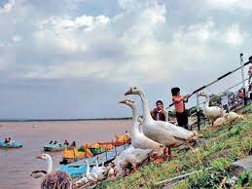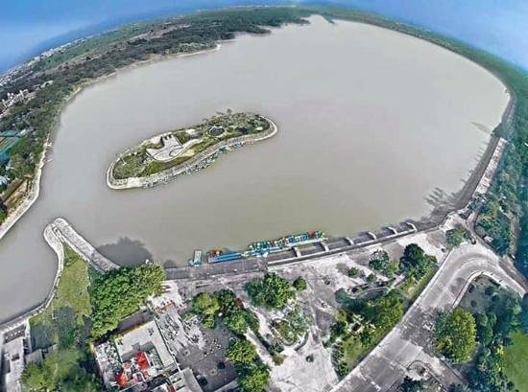and Punjab State
EA: Executing Agency, NHAI: “National Highway Authority of India” (NHAI); Government of India (GOI), EO: Environmental Officer, IRC: Indian Road Congress, CSC: Construction Supervision Consultant, JFM: Joint Forest Management Committee, CPCB: Central Pollution Control Board.

The “Project Engineer” (PE) or “The Engineer” (TE) is the team of “Construction Supervision Consultants” (CSC) responsible for approving the plans, engineering drawing, release of payments to contractor etc. on behalf of the employer (NHAI). It is usually the team leader of the CSC that takes the responsibility of signing approval documents on behalf of the CSC team. The “Environmental Officer” (EO) is the “Environmental Specialist or Expert” (ES/ E) under the CSC who is responsible for providing recommendations to the “CSC – Team Leader” (CSE – TL) for approving activities specific to “Environment Safeguards” (ES) on behalf of “The Engineer” (TE) or “Project Engineer” (PE).

“Joint Forest Management” (JFM) Committee’s exist at the village level. Each “Joint Forest Management” (JFM) committee has 15 members of which 3 to 5 members are mandated to be women. The member secretary of each committee is the local Forester or Beat Officer, who oversees the accounts and activities of the “Joint Forest Management” (JFM) committee. Respective “Joint Forest Management” (JFM) committee’s will be identified and confirmed by the contractor under the guidance of the “Environmental Specialist or Expert” (ES/ E) of the CSC during construction IT City Chowk to Kurali Chandigarh Road in the State of Punjab.

16. CONCLUSIONS AND BUDGET

ENVIRONMENTAL MONITORING PLAN AND COST (EMPC): {IT City Chowk to Kurali Chandigarh Road in the State of Punjab}

Based on the field survey and data available from secondary sources, it can be concluded that the project will not have significant negative environmental impacts. The issues of concern in the project are construction of bypasses, re – alignments, and bridges and acquisition of private land and forest land etc. Proper “Environmental Management Plans” (EMPs) compliance needs to be ensured. The issues related to land acquisition and re – settlement has been evaluated and adequate compensation has been suggested in “Resource Allocation Program” (RAP) document. The Environmental Mitigation and Monitoring Requirements are given in the Table 66.

Table 66: Environmental Mitigation and Monitoring Requirements.

Particulars | Estimated Rate | Total Cost (₹ in Lakhs)
Environmental Monitoring during Construction and Implementation Phase | Lump Sum | 5.0
Environmental Training Programs | Lump Sum | 2.0
Plantation of 12,150 Trees Including Maintenance Cost for 3 Years | ₹ 1,000/- per Tree Including Maintenance | 260
Water Sprinkling for Dust Emission Suppression | 80,000 per Km. | 54.4
Solid Noise Barrier Installation by Trees in Places | Lump Sum | -------
Enhancement of Water Bodies Sources and Resources | ₹ 1.0/- Lakh Each | -------
Safety Signs and Provisions at Different Locations/ Sites/ Areas | ------- | Provided in Civil Works Contract
Cost to be Included in Engineering | ------- | -------
All Underpasses OR Bypasses/ Roads/ Ways | Included in Civil Works | -------
Dust Emission Suppression by Watering | Incidental to Work with in Contractor | -------
Environmental Measures at Workers’ Camps during Site Visit | Incidental to Work with in Contractor | -------
Vegetation Turf at Slopes along Roadsides/ Roadways | Civil Works | -------
Operation Phase
Environmental Monitoring and Evaluation Plans | ------- | 1.0 per Annum
Tree Maintenance and Monitoring Plans | Included Above | -------
Training for Segregation; Mitigation and Monitoring etc. | ------- | 2.0 per Annum
Road Maintenance Cost not Considered as Per Specific Targets OR Proposed Work | ------- | -------
Sub Total | For Contract Period = (3.0 × 3) | 9 for 3 Years
Total | Twenty Seven Lakhs | 27.00 Lakhs
Grand Total = | ------- | 425.4 Lakhs

Based on the environmental assessment and surveys or visits conducted for the project, associated potential or prospective adverse environmental impacts can be mitigated to an acceptable/ satisfactory level by adequate implementation of the measures/ methods/ ways/ processes as stated in the “Environmental Impact Assessment” (EIA) Report. Adequate provisions have been made to cover the environmental mitigation and monitoring requirements (including a forestation cost), which is approximately ₹ 4.25 Crores or ₹ 425.4 Lakhs.

Cost Estimate

Cost estimate for the projected road is finalized based on the improvement proposals are summarized/ recapitalized/ reviewed/ abridged/ précised respectively. The existing “Right of Way” (ROW) along the project road varies from 8 m to 10 m. Therefore, land acquisition is required for widening of the project road, Improving and black spots. Hence the project will have social impact in terms of loss of livelihood or shelter, which will have to be studied and a suitable mitigation/ alleviation/ easing/ improvement plans has to be prepared.

Construction of project is proposed in Two Phases. Phase – I include intermediate lane/ two lanes of existing road from Existing Length = 00 + 000 Km. and Proposed Length = 31 + 230 Km. Cost estimate for the project Road is finalized/ finished/ concluding/ ending with ultimate approach based on the improvement proposals in Table 67 (a) and (b).

Table 67 (a): Details of IT City Chowk to Kurali Chandigarh Road.

Description |  | Existing | Proposed
Terrain | : | Hilly Mountainous and has Steep Gradients. | Hilly Mountainous and has Steep Gradients.
Designed Length | : | Existing Length = 00 + 000 Km. | Proposed Length = 31 + 230 Km.
Alignment | : | The Existing Alignment is almost Poor Except at few Locations. | The New Alignment with Geometric Improvements.
Design Speed | : | Average = 20 – 30 Km/ Hr. | 20 Km/ Hr to 30 Km/ Hr, As per IRC: SP: 48 – 1998, Sub Clause: 6.3.1.
Cross – Section | : | C/ W Width – Varying = b/ w 7 m.  Shoulder = 0.9 m. | Flexible Pavement  Two – Lane (Class – 9: Road)  0.6 m Drain + 0.9 m Shoulder + 7 m C/W + 0.9 m Shoulder + 0.6 m Extra Widening.  Sr. No. From To Length (Km)  1. 38.000 31.230 31.230  Total 31.230
CBR Considered | : | ------- | 10%.
Traffic (2017) | : | Nil. | On Basis of Projected Traffic* From Km. 38.000 to Km 31.230.
Pavement Design Life | : | Nil. | 15 Years, As per IRC: SP: 48 – 1998, Clause: 10.6, Sub Clause: 10.6.1.
Design MSA | : | ------- | MSA – 5.
Pavement Crust Thickness for Widening and New Construction | : | Existing Structure = 89 Nos. | Flexible Pavement  Sr. No. Type of Structure Length (mm)  1. Bituminous Concrete 40 mm  2. Dense Bituminous Concrete 60 mm  3. Crusher Run Macadam 200 mm  4. Granular Sub Base 200 mm  Total 500 mm
Bridges | : | Major Bridge = 02 Nos. | 00 Nos. of Major Bridge is at IT City Chowk to Kurali Chandigarh Road Bypasses and Newly Proposed Parallel To Existing Bridge.
 |  | Minor Bridges = 06 Nos. on Project Road. | Widening = 00 Nos.  Reconstruction = 00 Nos.  Retained = 00 Nos.  New Proposed = 00 Nos.
Culverts | : | Total Culvert = 53 Nos.  HPC = 00 Nos.  Slab Culvert = 00 Nos.  Box Culvert = 00 Nos.  FCW = 00 Nos. | Retained = 00 Nos.  Widening = 00 Nos.  Reconstruction = 00 Nos.  New Proposed = 00 Nos.  See Proposals in Table 67 (b).
Forest Reserves | : | Approximately 31.230 Km (100%) Forest Area Existing in the IT City Chowk to Kurali Chandigarh Road Regions. | Not Applicable.
“Right of Way” (ROW) | : | ------- | Proposed ROW in Open Area – 24.0 m.  Proposed ROW in Built – up Area – 15.0 m.
Land to be Acquired | : | ------- | 07.49 Hectare Private and 15.54 Hectare Government.
Tentative Total Civil Cost (₹) Project: |  |  | ₹ 870.73
Tentative Total Cost Including Land Acquisition: |  |  | ₹ 4,987.254
Tentative Total Civil Construction Cost: |  |  | ₹ 17.77 Crores Per Km

Table 67 (b): Tentative Cost of IT City Chowk to Kurali Chandigarh Road.

Section | Proposed Length (km) | Base Cost Per KM (₹) | Base Cost Per KM (Crore)
IT City Chowk to Kurali Chandigarh Road | 31.230 | ₹ 870.73 | 17.77

17. CONCLUSIONS AND RECOMMONDATIONS

The project corridor is from Km 70/ 00 to Kurali Chandigarh. The total length of project road passes through mountainous terrain. The following are the “Conclusions and Recommendations” for construction of this “Segment of Project Road”.

- Widening has been proposed in general on hillside for this stretch from single lane carriageway to two lane carriageway configuration with 0.9 m wide shoulder each side. But in order to use cut volume in filling some widening have been in valley side.

- There are geometric deficiencies in the existing road. These deficiencies have been corrected to improve the widened road alignment at least to minimum standard specified in the IRC: 52 – 2001 for hill road as far as possible.

- At few stretches in hill the minimum provision as per codal requirement could not be maintained due to the site constraints so far as it relates transition curves.

- Out of existing Culverts in the Project Road, most of the culverts are to be dismantled and constructed a new to 4, 6, and 8 – lane width. Provision of additional culverts have been proposed on the basis of hydrological study.

Following cross section is proposed for the widening:

- Moreover 4, 6, 8 – lane carriageway width will be 7 m;
- Shoulder width will be 2 × 0.90 m;
- Parapet and drains of 0.60 m wide each are to be provided within soft shoulder;
- The formation width is proposed as 10.00 m;

- The details of proposed new pavement composition on the basis of pavement design as per Clause No.: 10.22.3.5.1 (a) IRC: SP – 48: 1998 have been furnished in Draft DPR. The assessed 15 – Years traffic is 7.1 MSA. But pavement design has been done considering 10 MSA.

- Adequate provision for sign ages and markings are proposed and the provision has been made in the overall estimate.

- Provision has been made for Crash Barrier.

- Drains have been provided on the hillside of the project road. Catch water drains will be provided where necessary.

- Provisions of stone masonry/ concrete parapet wall have been made and included in cost estimate.

- Provision of adequate length of Breast Walls of matching height have been made and included in cost estimate.

The “Remote Sensing Technology” (Stereo Photogrammetric) OR “Geographical Information System” (GIS) has been proven a fastest method of carrying out the topographical survey within the hilly terrain areas, thus considering the same advantages the RS technology has been used in NHAI Road DPR projects. Even though the areas are of very complex geography and terrain, the RS technology was able to provide fast and reliable DEM – Digital Elevation Model, Topographical features and base data to prepare such complex geography road DPR projects. In the project, 50 cm Very High Resolution Multispectral Satellite Imagery (World View – 2) from Digital Globe – USA has been used. This imagery was procured through National Remote Sensing Agency – INDIA. The processing of the above imagery was undertaken in software’s such as SOCETSET, ERDAS, and Global Mapped. After satellite image processing the products delivered are DTM/ DEM, 3D – Topographical Features, Ortho – photo, which has further been used in finalization of road alignment as per IRC guidelines. The products from RS has also been played a very critical role in identifying the water bodies crossing the alignments in order to provide cross drainage works to cater for the runoff. Details of the structures for the same are mentioned above in Project details. As per contract agreement the current stage of corridor comprises preparation of “Final Feasibility Report” (FFR) for re – habilitation and upgrading of existing road to 4, 6, and 8 – lane with paved shoulder. We have conducted Classified Traffic Volume counts at 2 No. locations for analyzing the capacity. As per analysis of the traffic surveys total number of PCUs at all two locations has crossed the threshold limit (15,000 PCU) of design service volume for 4, 6, and 8 lane roads with paved shoulder configuration as per the IRC in year 2041. The project road is not only an important transport link for en – route habitations within “Punjab/ Region”, but it is also an important inter – state link. The existing road has stretches whose geometrics do not conform to “Indian Road Congress” (IRC) standards will need to be improved by means of re – alignments and by re – construction. The road passes through ribbon development at 5 Nos. locations, where travel speed does not meet “National Highway” (NH) Standards, hence bypasses have been proposed for them. The soil conditions along the projected road are generally good and the construction materials like soil and aggregates are available nearby area/ region of the state.

The existing “Right of Way” (ROW) along the projected road varies from 8 m to 10 m and also we proposed IT City Chowk to Kurali Chandigarh Road. Therefore, land acquisition is required for widening of the project road, improving and black spot points. Hence the project will have social impact in terms of loss of livelihood or shelter, which will have to be studied and a suitable mitigation plan must be prepared thoroughly for Survey, Investigation and Preparation of Detailed Project Report for improvement of Road and Bridges etc. for construction of Roads in the state of Punjab using Satellite Imagery of Existing Length = 00 + 000 Km. and Proposed Length = 31 + 230 Km. It is recommended that the project to be undertaken with paved in the immediate future. The project can be constructed within 24 months’ period with strategic planning and through two construction packages.

One ROB is Proposed at IT City Chowk to Kurali Chandigarh Road, where track project road is to be designed for 20 Km/ Hr to 30 Km/ Hr speed in project road length, but two locations (Km 38.000 to Km 31.230) designed for 30 Km/ Hr. It is recommended that the project be undertaken for Foot Track/ Two Laning with Paved in the immediate future. The estimated total capital cost of Projected Road is ₹ 870.73 OR ₹ 17.77 Crores per Km for IT City Chowk to Kurali Chandigarh Road in the State of Punjab.

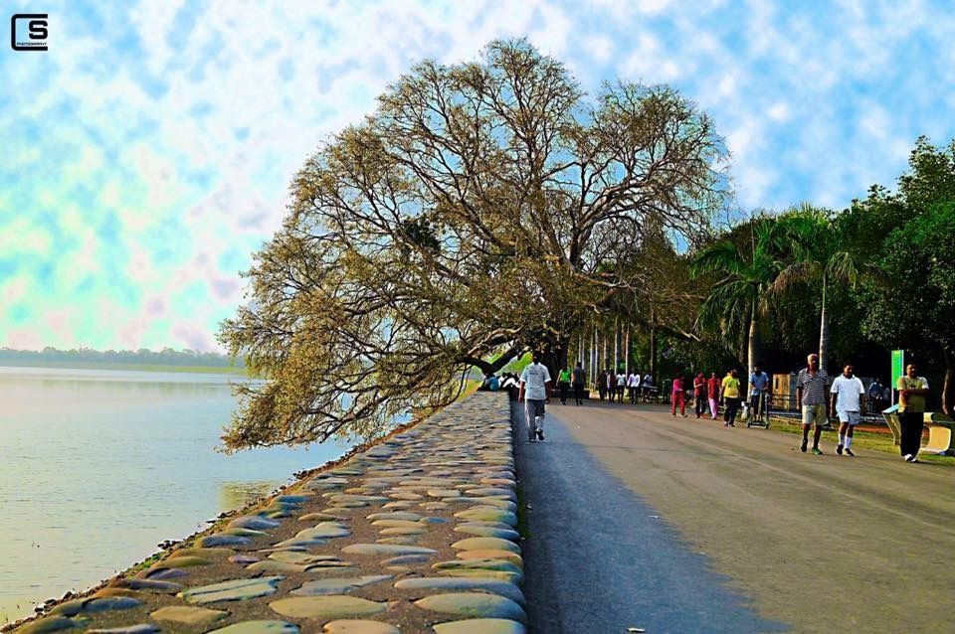

Chandigarh Lake View (Sukhna Lake)
- 18. Environmentally Expected Natural Resources and Policies for Chandigarh and Punjab State…!!!

Environmental policies refers to the commitment of an organization to the laws, regulations, and other policy mechanisms concerning environmental issues and sustainability. These issues generally include air and water pollution, solid waste management, biodiversity, ecosystem management, maintenance of biodiversity, the protection of natural resources, wildlife and endangered species.

Policies concerning energy or regulation of toxic substances including pesticides and many types of industrial waste are part of the topic of environmental policy. This policy can be deliberately taken to directly or indirectly and oversee human activities and thereby prevent harmful effects on the biophysical environment and natural resources, as well as to make sure that changes in the environment do not have harmful effects on human beings;

It is beneficial to contemplate that environmental policies to comprise two major terms: “Environment and Policy”. “Environment” refers to the physical ecosystems, but can also take into consideration the social dimension (quality of life, health) and an economic dimension (resource management, biodiversity). “Policy” can be defined as a “Course of action or principle adopted or proposed by a government, party, business or individual concern”. Thus, environmental policy focuses on problems arising from human impact on the environment, which retroacts onto human society by having a (negative) impact on human values such as “Good Health” or the “Clean and Green” environmental surroundings for regional people of Chandigarh and Punjab State;

To be Monitored Policies/ Strategies/ Guidelines/ Procedures/ Rules:

(a) Mandatory scheduling and planning of inclusive programme for the prevention, control or abatement of pollution of streams, ponds (i.e., Punjab Pollution Control Board, Government of Punjab – Sukhna Lake) and wells in the state and to secure the execution there of;

(b) To recommend the State Government on any matter concerning the prevention, control or abatement of air, land, soil, ground water table and water pollution etc.;

(c) To assemble and disseminate information relating to water pollution and the prevention, control or abatement of air, land, soil, ground water table and water pollution etc. there of;

(d) To inspire, conduct and participate in investigations and research relating to problems of water pollution and prevention, control or abatement of air, land, soil, ground water table and water pollution etc.;

(e) To cooperate with the “Punjab Pollution Control Board” (PPCB) in organizing the training of persons engaged or to be engaged in programmes relating to prevention, control or abatement of air, land, soil, ground water table and water pollution etc. and to organize mass education/ training programmes relating thereto;

(f) To examine sewage or trade effluents, works and plants for the treatment of sewage and trade effluents and to review plans, specifications or other data relating to plants set up for the treatment of water, works for the purification thereof and the system for the disposal of sewage or trade, industry effluents or in connection with the grant of any consent as mandatory by this Act;

(g) Lay down and carry out, modify or annul effluent standards plans for the sewage and trade, industry effluents and for the quality of receiving waters (not being water in an inter – state stream, pond, water bodies and river) resulting from the discharge of effluents and to classify waters of the state;

(h) To progress economical, beneficial and reliable methods of treatment of sewage and trade, industry effluents, with regard to the peculiar conditions of soils, weather, climate and water resources of different regions and more especially the prevailing flow characteristic of water in streams, channels and wells, which render it impossible to attain even the minimum degree of dilution of pollution proceedings;

(i) To develop methods and approaches of utilization/ consumption/ application of sewage and suitable trade or industry effluents in agricultural and green field areas located in the region or state;

(j) To grow resourceful methods/ techniques of disposal of sewage and trade or industry effluents on land areas, as are necessary on account of the predominant conditions of scant stream flows that do not provide for major part of the year the minimum degree of dilution or reduction in pollution;

(k) To lay down standards of treatment of sewage and trade/ industry effluents to be discharged into any particular stream taking into account the minimum fair weather dilution available in that stream and the tolerance limits of pollution permissible in the water of the stream, pond, channel after the discharge/ expulsion of such effluents;

(l) To assistance the State Government with respect to the location of any industry or trade or locality about to carrying on of which is likely to pollute a stream or well or pond or waterway or treasurable water bodies.

***************************
*********************

