‘‘HERBAL FORMULATIONS FOR MANAGEMENT OF DIABETES MELLITUS’’

Herbal products: Herbal products comprise of herbal formulations made from one or more herbs.
Herbal medications: Ayurvedic herbal medications are defined as extracts from combination of herbs, single herbs, ayurvedic proprietary medicines or a compound of herbs in any form (tablets, capsules, powder, crude extract or decoction).¹ The various part of herbs like roots, leaves, stems, barks are utilised for the preparation of the herbal medications.
Herbal formulations are the basis for finished herbal products and may include milled or pulvarised herbal materials, or extracts, tinctures and fatty oils of herbal materials.² Herbal preparations are produced by extraction, fractionation, purification or concentration or by other physical or biological processes.³
Herbal materials include, in addition to herbs, fresh juices, gums, fixed oils, essential oils, resins and dry powders of herbs.⁴
Herbs
Herbs include crude plant material such as leaves, flowers, fruit, seed, stems, wood, bark, roots, rhizomes or other plant parts, which may be entire, fragmented or powdered.⁵
Diabetes mellitus
Diabetes is a chronic, metabolic disease indicated by elevated levels of blood glucose (or blood sugar), which leads over time to serious damage to the heart, blood vessels, eyes, kidneys and nerves.
Diabetes is an illness where the insulin processing functions aberrantly due to pancreas not being able to secrete the hormone in adequate amounts. This in turn leads to uncontrollable levels of glucose or sugars in blood circulation and affects energy metabolism and kidney function in the affected individual.⁶
Types of diabetes
Type 1 diabetes mellitus (T1D) is an autoimmune disease that leads to the destruction of insulin-producing pancreatic beta cells. ⁷
Type 2 Diabetes Mellitus (T2DM) is one of the most common metabolic illness worldwide and its development is primarily caused by a combination of two main factors: faulty insulin release by pancreatic β-cells and the incapability of insulin-sensitive tissues to respond to insulin ⁸
Gestational diabetes
Gestational diabetes (GD) is a type of diabetes that develops in gestation when blood sugar magnitude gets too high. Gestational diabetes usually appears during the middle of pregnancy, between 24 and 28 weeks. Developing Gestational diabetes doesn't mean you already had diabetes before you got pregnant. This condition in fact appears because of the high blood sugar elevation during pregnancy.
Prediabetes
A condition in which blood sugar level has spiked, but is not sufficiently high enough to be type 2 diabetes. Without intervention, it's likely to lead to type 2 diabetes.
Diabetes mellitus can be managed by maintaining a healthy diet, avoiding junk food, following good sleep patterns, regular exercises etc.
Nowadays, diabetes mellitus can be managed by including nutraceutical substances in the diet.
Some of these nutraceutical substances are sugar apple, curry leaves, amla, banana stem, bitter gourd etc.
How is diabetes diagnosed?¹⁴
• The detection of diabetes mellitus should be as extensive as possible. It is verified by the presence of chronic hyperactive glycemia, and by the presence of other factors, such as associated symptoms, clinical laboratory findings, a family history of diabetes, and body weight history of the patient. ⁹⁻¹³

For the diagnosis of diabetes, either of the following approaches shall be followed:
- Two assessments of the diabetic type in each patient (one blood glucose test is obligatory).
- One assessment of the diabetic type (with obligatory blood glucose testing) along with the presence of chronic hyperactive glycemic symptoms*. (*typical symptoms of chronic hyper-glycemia (e.g., dry mouth, polyposis, polyuria, body weight loss, or diabetic retinopathy).
- Substantiation of a prior diagnosis of ‘diabetes’.

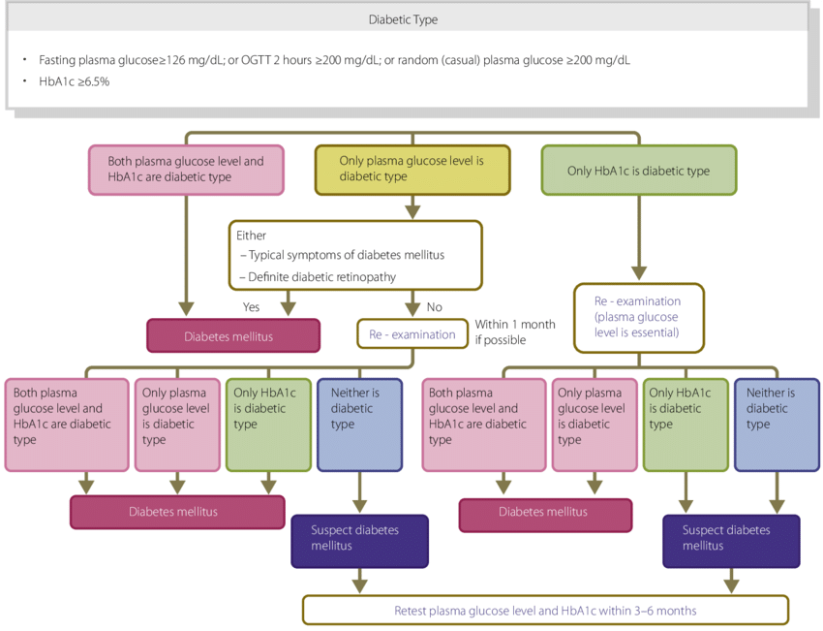
Flow chart outlining the steps in the clinical diagnosis of diabetes mellitus. OGTT, Oral glucose tolerance test.¹⁴
How is hyper-glycemia assessed?
• The cases are to be classified into the normal type, borderline type, or diabetic type, according to the combination of fasting and 2-h post-75 g oral glucose tolerance test (OGTT) glucose values.
• The cases where fasting glucose values are 100–109 mg/dL (5.6–6.1 mmol/L) are classified into the ‘high - normal’ category as part of the normal type¹⁵.
• The OGTT is to be proactively considered in high-risk individuals (i.e., those who are suspected to have diabetes or the borderline type, those whose fasting glucose values are indicated to be ‘high-normal’, those with HbA1c values of ≥5.6%, cases with obesity or dyslipidemia, and those with strong family history of diabetes¹³).
• At present, HbA1c values are calculated by point-of-care testing (POCT) and devices are not to be used for the diagnosis¹³.

GOALS AND STRATEGIES FOR DIABETES
MANAGEMENT
Q2-1 What are the objectives of diabetes management?
•The objectives of diabetes management are to improve meta-
bolic dysfunctions resulting from hyperglycemia, to prevent
the development or progression of diabetic complications and
conditions associated with diabetes, and to enable affected
individuals to maintain their quality of life (QOL) and life
expectancy comparable to those of healthy individuals
GOALS AND STRATEGIES FOR DIABETES
MANAGEMENT
Q2-1 What are the objectives of diabetes management?
•The objectives of diabetes management are to improve meta-
bolic dysfunctions resulting from hyperglycemia, to prevent
the development or progression of diabetic complications and
conditions associated with diabetes, and to enable affected
individuals to maintain their quality of life (QOL) and life
expectancy comparable to those of healthy individuals
GOALS AND STRATEGIES FOR DIABETES MANAGEMENT

What are the objectives of diabetes management?
• The objectives of diabetes management are to ameliorate metabolic dysfunctions rising from hyper-glycemia, to arrest the evolution or advancement of diabetic problems and conditions associated with diabetes, and to enable affected persons to maintain their quality of life (QOL) and life probability similar to those of healthy individuals.

How is a basic treatment strategy developed for each diabetic patient?

• The treatment strategy for diabetes may vary depending on the type, complaint condition, age, metabolic abnormality, and status of diabetic complications.
• Insulin remedy is to be given not only to cases who are insulin-dependent but also to pregnant cases, cases witnessing surgery that involves whole- body operation, and cases with severe infection, indeed if they aren't insulin-dependent. In addition, insulin remedy is to be given to those in whom glycemic pretensions aren't attainable with oral hypo- glycemic agents (OHAs) or glucagon- such as peptide 1 (GLP- 1) receptor agonists.
• OHA and/ or GLP- 1 agonist remedy is to be given to noninsulin-dependent cases in whom favourable glycemic control isn't attainable with acceptable medical nutrition therapy (MNT) and physical exertion/ exercise continued for 2 – 3 months. OHA and/ or GLP- 1 agonist remedy or insulin remedy may be given to these cases from the onset depending on the inflexibility of the metabolic complaint involved.
• Continued remedy is essential for cases with diabetes to help the onset or progression of complications. Team care- grounded diabetes education for these cases forms the foundation of their diabetes treatment.

MEDICAL NUTRITION THERAPY (MNT)

What is the part of MNT and the optimal nutritive balance in MNT for patients with diabetes?

• Carbohydrates, proteins and fats should account for 50–60%, ≤20%, and 20–30%, respectively, of the total energy intake in MNT for patients with diabetes.
• The ratios of macronutrients may vary depending on physical activities and the severity of diabetic complications, as well as on the food preferences of each patient with diabetes.¹⁴

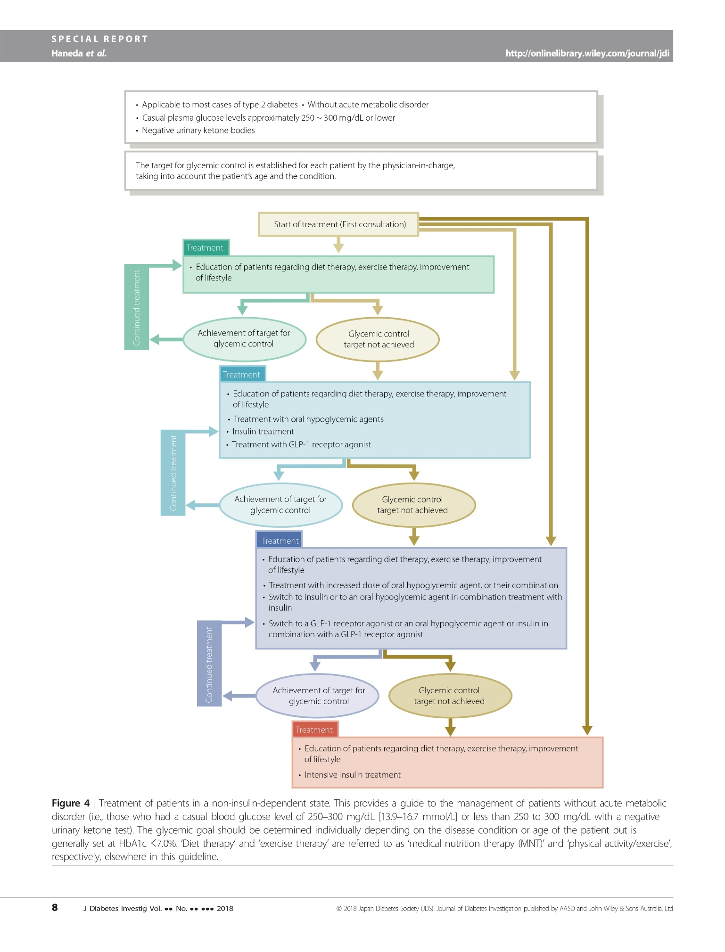

Treatment of patients in a non-insulin-dependent state. This provides a guide to the management of patients without acute metabolic disorder¹⁴

Sl no | Scientific name | Common name | Family | Parts utilized | Activity | Ref  no
1 | Annona squamosa Linn | Custard apple | Annonaceae | Leaves, fruit | Leaf extracts show antidiabetic, cytotoxic, antimalarial, and immunosuppressive activities. | 16
2 | Murraya koenigii Linn | Curry leaves | Rutaceae | Leaves | Boost insulin activity | 17
3 | Momordica charantia Linn | Bitter gourd | Cucurbitaceae | Fruit, vegetable | Mimics insulin and aids in glucose utilization | 19
4 | Phyllanthus emblica Linn | Amla | Phyllanthaceae | Fruits, leaves | stimulates pancreatic insulin secretion, and restores and regenerates β-cells | 20
5 | Musa sapientum Linn. | Banana | Musaceae | Plant stem, fruit, flower | induced blood sugar reduction may be due to possible inhibition of free radicals and subsequent inhibition of tissue damage induced by alloxan | 18
6 | Punica granatum Linn. | Pomegranate | Lythraceae | Fruit, leaves | action on β-cells of pancreas that stimulates insulin release and decreases glucose unacceptance. | 21
7 | Beta vulgaris Linn. | Beetroot | Amaranthaceae | Tap root | It is a good source of fibre which helps to increase satiety and slow down the absorption of carbohydrates preventing sudden spikes in blood sugar levels | 22
8 | Withania somnifera Linn. | Ashwagandha | Solanaceae | Root | Reduce blood sugar to normal levels by boosting insulin synthesis and sensitivity | 23
9 | Acacia Arabica Linn. | Babul | Fabaceae | Bark, pulp | slow down any glucose absorption and support a keto diet by keeping insulin spikes at bay | 24
10 | Allium cepa Linn. | Onion | Amaryllidaceae | Bulb | improve insulin sensitivity and regulate blood glucose level | 25
11 | Allium sativum Linn. | Garlic | Amaryllidaceae | Bulb | Lower blood glucose level, stimulate insulin activity | 26
12 | Aloe vera (L.) Burm.f. | Aloe vera | Asphodelaceae | leaves | lowers blood glucose levels in diabetic patients. improves the responsiveness of the body tissues towards insulin | 27
13 | Syzygium cumini Linn | Jamun | Myrtaceae | Leaves, fruits, seeds | slow down the rate of sugar released into the blood and increase the insulin levels in the body | 28
14 | Butea monosperma (Lam.) Taub. | Palasa | Fabaceae | Flowers, leaves | It might reduce blood sugar levels by improving glucose tolerance and regulation of excessive blood sugar levels | 29
15 | Bombax diffusa | semul | Malvaceae | Flowers | lower the hyperlipidemic problems associated with diabetes mellitus., enhance the insulin release | 30
16 | Areca catechu Linn | supari | Arecaceae | Nut | Reduce the blood sugar level | 26
17 | Artemisia pallens Wall. ex DC. | Davana | Asteraceae | Leaves and flowers | significant blood glucose lowering effect | 26
18 | Trigonella foenum graceum Linn | Fenugreek | Fabaceae | Seeds and leaves | activating of insulin synthesis and promote its release from the pancreatic β-cells | 31
19 | Gymnema sylvestre R. Br. | Gurmar | Apocynaceae | Leaves | delaying the glucose absorption in the blood. | 32
20 | Chamaecostus cuspidatus  (Nees & Mart.) C.Specht & D.W.Stev. | Insulin plant | Costaceae | Whole plant | Reduce the blood sugar level | 33
21 | Abroma agustum Linn | Abroma agusta | Steruliaceae | Root | Hypoglycemic and antilipidemic effect | 34
22 | Acer saccharum Marshall | Sugar Maple | Sapindaceae | Juice | Hhypoglycemic and antioxidant effect | 35
23 | Coccinia indica (L.) Voigt | Ivy gourd | Cucurbitaceae | Leaves | Antioxidant, antihyperglycemic and antilipidemic | 36
24 | Acalypha wilkesiana Müll.Arg. | Copperleaf | Euphorpiaceae | Leaves | Hypoglycemic and antioxidant | 37
25 | Acorus calamus Linn. | Sweet flag | Acoraceae | Leaves/bark | α-Glucosidase inhibition and hypolipidemic | 38
26 | Aegle marmelos (L.) Corrêa | Bael | Rutaceae | Leaves/bark/root | Antidiabetic, Antioxidant and anti cataract activity | 39
27 | Afzelia Africana Sm. | African mahogany | Fabaceae | Stem bark | Antidiabetic and hematological effect | 40
28 | Eriobotrya japonica (Thunb.) Lindl. | Japanese Loquat | Rosaceae | Leaves | Antihyperglycemic | 41
29 | Prosopis glandulosa Torr. | Honey mesquite | Fabaceae | Leaves | Increase insulin secretion | 42
30 | Amaranthus spinosus Linn. | Spine amaranth | Amaranthaceae | Leaves | α-Amylase inhibition, antioxidant and anticholesrolemic | 43
31 | Anogeissus acuminate  (Van Heurck & Müll.Arg.) Gere & Boatwr  (terminalia phillyreifolia) | Button tree | Combretaceae | Whole plant | Antioxidant | 44
32 | Artemisia Linn. | Artemisia sphaerocephala krasch | Compositae | Gum/seed powder | Antidiabetic | 45
33 | Artemisia dracunculus Linn. | Tarragon | Asteraceae | Aerial part | Antidiabetic | 46
34 | Artemisia herba-alba Asso. | White wormwood | Asteraceae | Whole plant | Antihyperglycemic and antihyperlipidemic | 47
35 | Lonicera japonica Thunb. | Japanese honeysuckle | Caprifoliaceae | Whole plant | α-Glucosidase inhibition | 48
36 | Ascophyllum nodosum Linn. | Rockweed | Algae | Young tips | α-Glucosidase inhibition and α-amylase | 49
37 | Aspidosperma macrocarpon Mart. | Guatambu | Apocynaceae | Steam/Bark Root wood | α-Amylase inhibition | 50
38 | Atractylodes macrocephala Koidz. | Bai Zhu | Asteraceae | Whole plant | α-Glucosidase inhibition | 48
39 | Azadirachta indica A.Juss. | Neem | Meliaceae | Leaves, flower and seed | Antidiabetic and antihypertension | 51,52
40 | Barringtonia racemose Linn. | Common Putat | Lecythidaceae | Seed | α-Glucosidase and α-amylase inhibition | 53
41 | Bauhinia forficate | Brazilian orchid tree | Leguminosae | Leaves | Antidiabetic | 26
42 | Belamcanda chinensis Linn. | Blackberry lily | Irdaceae | Leaves | Hypoglycemic | 54
43 | Benincasa hispida (Thunb.) | Wax gourd | Cucurbitaceae | Fruit | Antidiabetic, ameliorate the derangement in lipid metabolism in diabetics. | 55
44 | Nervilia plicata | Pleated Leaf Nervillia | Orchiaceae | Stem | Antidiabetic | 56
45 | Berberis vulgaris Linn. | Barberry | Berberidaceae | Leaves | Hypoglycemic | 57
46 | Psoralea corlifolia Linn. | Purple Fleabane | Fabaceae | Leaves | Antioxidant | 39
47 | Rauwolfia serpentinum Linn. | Indian snakeroot | Apocyanaceae | Leaves | Hypoglycemic | 58
48 | Silybum marianum Linn. | milk thistle | Asteraceae | Whole plant | Antihyperglycemic | 59
49 | Argyreia cuneate Ker Gawl. | purple morning glory | Convolvulaceae | Whole plant | Antihyperglycemic | 60
50 | Desmodium gangeticum Linn. | salparni | Fabaceae | Whole plant | Antidiabetic | 61

These are commonly available from the plants, in the market etc which can be used directly, or can be processed at home, and can be used in form of decoction, powder, etc

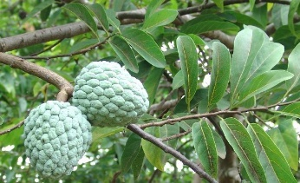
- Annona squamosa Linn.¹⁶

Synonym: Sweetsop, Custard Apple
Biological source: It comprises of dried leaves of Annona squamosa Linn. belonging to family Annonaceae
Phytochemical constituents: anonaine, annonacin, squamocin, asimicin, phytochemical assessments have emphasised that numerous active compounds, such as acetogenins and flavonoids.
Description: Annona squamosa Linn. is a small tree, which is well branched belonging to the family Annonaceae that bears edible fruits called sugar-apples or sweetsops. It tolerates a tropical flat climate and it is the most widely cultivated of its species. Annona squamosa Linn. is a small, semi-deciduous, branched shrub or small tree 3 to 8 metres (10 to 26 feet) tall.
Formulation: decoction
- Decoction preparation
- Chop the leaves into small pieces
- boil the leaves in water for about 5-10 min
- consume the freshly prepared decoction

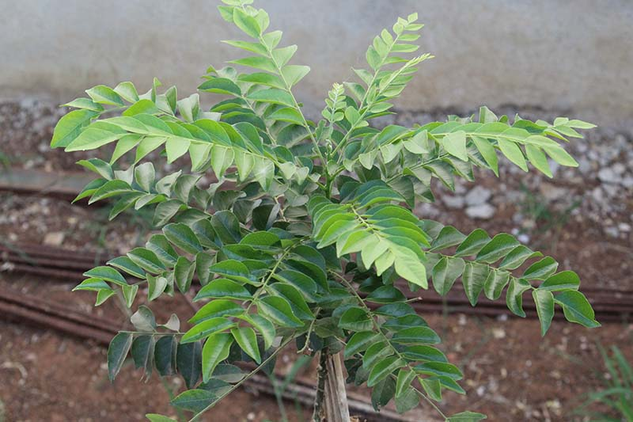
- Murraya koenigii Linn.¹⁷
Synonym: karivepaaku, karibevu kadi patta
Biological source: It comprises of dried leaves of Murraya koenigii Linn belonging to family Rutaceae
Phytochemical constituents: alkaloids, glycosides, steroids, tannins and terpenoids monoterpenes. linalool, elemol, geranyl acetate, myrcene, α-terpinene (E)-β-ocimene.
Description: It’s a small tree, growing 4–6 metres (13–20 ft) in height, with the trunk up to 40 cm (16 in) in width. The leaves are pinnate, aromatic, with 11–21 leaflets, each leaflet 2–4 cm (³⁄₄–1+¹⁄₂ in) long and 1–2 cm (¹⁄₂–³⁄₄ in) broad

Consumption:
- the leaves can be directly be consumed orally
- the leaves can be included in diet in the dishes
- the leaves can be dried, crushed into powder and can be consumed with water.
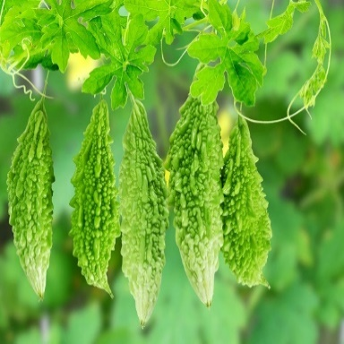
- Momordica charantia Linn.¹⁹

Synonym: bitter apple, bitter gourd, karela,
Biological source: It comprises of the fruits and leaves of Momordica charantia Linn. belonging to family Cucurbitaceae
Phytochemical constituents: polysaccharides, saponins, and phenolics cucurbitane-type triterpenoids, cucurbitane-type triterpene glycosides, phenolic acids, flavonoids, essential oils, fatty acids, amino acids, sterols, saponins and protein
Description: The tree is medium in size, reaching 1–8 m (3 ft 3 in – 26 ft 3 in) in height. The branches are finely pubescent (not glabrous), 10–20 cm (3.9–7.9 in) long, usually deciduous. The leaves are simple, subsessile and are present close along branchlets, light green in colour, exhibit pinnate leaves. The flowers are greenish-yellow. The fruit is nearly spherical, light greenish-yellow, fairly smooth and hard on appearance.
Juice preparation:
- Take a fresh bitter gourd, chop into pieces
- Combine the bitter gourd and half cup of water in a mixer
- Prepare a blend
- Strain by adding little water
- And consume immediately

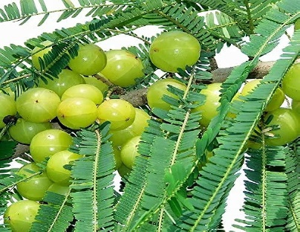
- Phyllanthus emblica Linn.²⁰

Synonym: Indian gooseberry, āmalakī, emblic myrobalan
Biological source: It comprises of the fruits and leaves of Phyllanthus emblica Linn. belonging to the family phyllanthaceae.
Phytochemical constituents: ellagic acid, emblicanine A, emblacani B, Gallic acid, phyllantine, quercetin and phyllantidine
Description: the tree is medium in size, reaching 1–8 m (3 ft 3 in – 26 ft 3 in) in height. The branches are finely pubescent (not glabrous), 10–20 cm (3.9–7.9 in) long, usually deciduous. The leaves are simple, subsessile and set nearly along the branches, resembling pinnate leaves, and are light green in appearance. The flowers are greenish-yellow. The fruit is nearly globular, light greenish-yellow, quite smooth and hard on appearance, with six vertical stripes or furrows
Consumption
Eat the fruit fresh:
This is the greatest and the efficient method for the consumption of amla
Amla juice:
- first remove the seed
- crush the pulp
- extract the juice by blending and straining with water
Amla powder:
- Take fresh amla fruits
- Cut into pieces
- Sun-dry the amla pulp
- grind it into a fine powder.

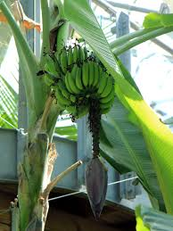
- Musa sapientum Linn.¹⁸

Synonym: Common banana
Biological source: It comprises of the fruit, stem of Musa sapientum Linn. belonging to family
Musaceae
Phytochemical constituents: phenolics, carotenoids, biogenic amines and phytosterols
Description: The banana plant is among the largest blossomy flowering plant. All aerial parts of the plant grow from a structure usually called a "corm". Plants normally have a good height and are fairly sturdy with a treelike appearance, but what appears to be the trunk is actually a "false stem" or pseudo-stem. Bananas grow in a wide variety of soils, as long as the soil is at least 60 centimetres (2.0 ft) deep, has good water supply and isn’t compacted. Banana plants are one of the rapidly growing of all plants, with diurnal surface growth rates recorded of 1.4 square metres (15 sq ft) to 1.6 square metres (17 sq ft).
Consumption
- Blend chopped banana stem with water
- Untill it becomes a smooth paste.
- Add some plant-based buttermilk and salt.
- Mix well and drink it immediately.

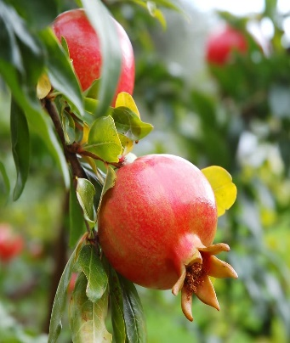
- Punica granatum Linn.²¹

Synonym: Malum granatum, Punica granatum, anar
Biological source: It comprises of fruits and leaves of Punica granatum Linn belonging to family Lythraceae
Phytochemical constituents: Punicalagin, Ellagic acid, Cyanidin. Liteolin, organic acids, phenolic acids, sterols, terpenoids, fatty acids, triglycerides, alkaloids and some other compounds.
Description: Punica granatum Linn. is a shrub growing 5 to 10 m (16 to 33 ft) in height, and has multiple spiny branches and is long-lived, with some species in France have survived for 200 years. Punica granatum Linn. leaves are opposite or subopposite, glossy, narrow oblong, entire, 3–7 cm (1+¹⁄₄–2+³⁄₄ in) long and 2 cm (³⁄₄ in) broad. The flowers are bright red and 3 cm (1+¹⁄₄ in) in diameter, with three to seven petals. Some fruitless species of Punica granatum Linn. are grown only for obtaining the flowers.
Consumption:
Pomegranate tea:
- Add 3 mugs of pomegranate seeds to a blender.
- Store the juice in a vessel after straining.
- Combine three-fourth mug of piping hot water with one-quarter mug of pomegranate juice.
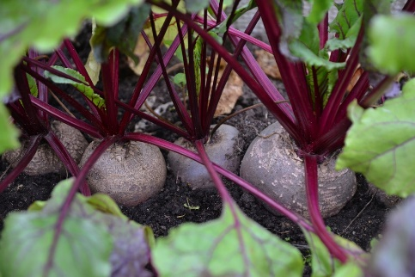
- Beta vulgaris Linn.²²

Synonym: Beetroot, common beet, or garden beet
Biological source: It comprises of taproot portion of a Beta vulgaris Linn. belonging to family Amaranthaceae
Phytochemical constituents: betalains (e.g., betacyanins and betaxanthins), flavonoids, polyphenols, Saponins and inorganic Nitrate (NO₃)
Description: Beets, Beta vulgaris Linn. are blossoming root vegetables in the family Chenopodiaceae grown for their consumable root. The plant leaves are seen growing on stems and is usually upright with a long main root. The leaves are arranged alternately on the stem, ovoid shaped and grow 20–40 cm (7.9–15.7 in) in length. The roots are usually red in colour. The plant produces stalkless green flowers that can grow 1–2 m (3.3–6.6 ft) in height. Beets are usually grown as yearly plants, harvested after one growing season. Beets may also be referred to as beetroot, garden beet or spinach beet and originated from the Mediterranean.
Juice preparation:
- Take a fresh beetroot, chop into pieces
- Combine the beetroot and half cup of water in a mixer
- Prepare a blend
- Strain by adding little water
- And consume immediately

- Withania somnifera Linn²³
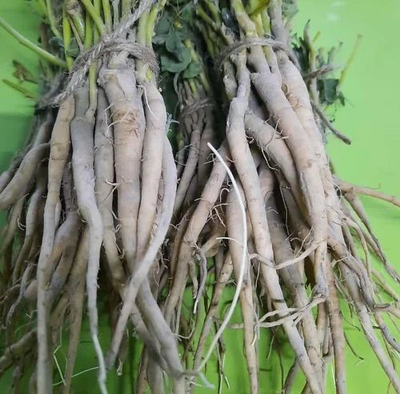
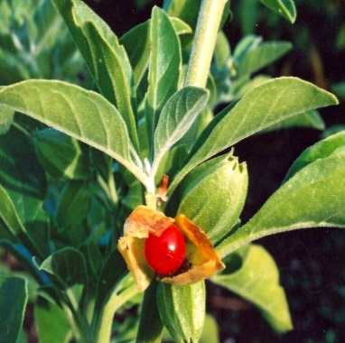

Synonym: Ashwagandha or winter cherry,
Biological source: Ashwagandha is derived from the root of the Withania somnifera Linn plants belonging to family Solanaceae
Phytochemical constituents: steroidal lactones, alkaloids, saponin, flavonoids, tannin, starch, phenolic content, carbohydrate, withanolides, sitoindosides, anaferine, anahygrine, β-sitosterol, chlorogenic acid, cysteine, cuscohygrine, pseudotropine, withanine, scopoletin
Description: This species is a 35–75 cm (14–30 in) tall growing shrub. The branches expand spirally from the central stem. Leaves appear to be dull green, elliptic, usually up to 10–12 cm (3.9–4.7 in) long. The flowers are small in size, green coloured and bell-shaped. The fruit becomes orange-red on ripening.
Usage
- Take one glass of milk and upto its half volume water in a pan and bring it to boil.
- Introduce Ashwagandha root powder, upto 1/2 teaspoon and boil for additional 5 minutes.
- To the admixture add around (2 teaspoons) crushed walnut and almonds
- Drink this admixture to maintain blood sugar level.

References
- Gyawali D, Vohra R, Orme-Johnson D, Ramaratnam S, Schneider RH. A systematic review and meta-analysis of ayurvedic herbal preparations for hypercholesterolemia. Medicina. 2021 May 28;57(6):546.
- Alamgir AN, Alamgir AN. Herbal drugs: their collection, preservation, and preparation; evaluation, quality control, and standardization of herbal drugs. Therapeutic Use of Medicinal Plants and Their Extracts: Volume 1: Pharmacognosy. 2017:453-95.
- Abubakar AR, Haque M. Preparation of medicinal plants: Basic extraction and fractionation procedures for experimental purposes. Journal of pharmacy & bioallied sciences. 2020 Jan;12(1):1.
- Bijauliya RK, Alok S, Kumar M, Chanchal DK, Yadav S. A comprehensive review on herbal cosmetics. International Journal of Pharmaceutical Sciences and Research. 2017 Dec 1;8(12):4930-49.
- Evans WC. Trease and Evans' pharmacognosy. Elsevier Health Sciences; 2009 May 27.
- de Matos AM, de Macedo MP, Rauter AP. Bridging type 2 diabetes and Alzheimer's disease: assembling the puzzle pieces in the quest for the molecules with therapeutic and preventive potential. Medicinal Research Reviews. 2018 Jan;38(1):261-324.
- Ehrmann D, Kulzer B, Roos T, Haak T, Al-Khatib M, Hermanns N. Risk factors and prevention strategies for diabetic ketoacidosis in people with established type 1 diabetes. Lancet Diabetes Endocrinol. 2020 May;8(5):436-446.
- Roden, M.; Shulman, G.I. The integrative biology of type 2 diabetes. Nature 2019, 576, 51–60.
- Bonovas S, Filioussi K, Tsantes A. Diabetes mellitus and risk of prostate cancer: a meta-analysis. Diabetologia 2004; 47:1071–1078.
- Friberg E, Orsini N, Mantzoros CS, et al. Diabetes mellitus and risk of endometrial cancer: a meta-analysis. Diabetologia 2007; 50: 1365–1374.
- Huxley R, Ansary-Moghaddam A, de Gonzalez AB, et al. Type-II diabetes and pancreatic cancer: a meta-analysis of 36 studies. Br J Cancer 2005; 92: 2076–2083.
- Kasper JS, Giovannucci E. A meta-analysis of diabetes mellitus and the risk of prostate cancer. Cancer Epidemiol Biomarkers Prev 2006; 15: 2056–2062.
- Larsson SC, Orsini N, Wolk A. Diabetes mellitus and risk of colorectal cancer: a meta-analysis. J Natl Cancer Inst 2005; 97: 1679–1687.
- Haneda M, Noda M, Origasa H, Noto H, Yabe D, Fujita Y, Goto A, Kondo T, Araki E. Japanese clinical practice guideline for diabetes 2016. Diabetology international. 2018 Feb;9:1-45.
- Larsson SC, Orsini N, Brismar K, et al. Diabetes mellitus and risk of bladder cancer: a meta-analysis. Diabetologia 2006; 49: 2819–2823.
- Kaleem M., Asif M., Ahmed Q.U., Bano B. Antidiabetic and antioxidant activity of Annona squamosa extract in streptozotocin-induced diabetic rats. Singapore Med. J. 2006;47:670–675.
- Khan B.A., Abraham A., Leelamma S. Hypoglycemic action of Murraya koenigii (curry leaf) and Brassica juncea (mustard) mechanism of action. Ind. J. Biochem. Biophys. 1995;32:106–108.
- Dhanabal S.P., Sureshkumar M., Ramanathan M., Suresh B. Hypoglycemic effect of ethanolic extract of Musa sapientum on alloxan induced diabetes mellitus in rats and its relation with antioxidant potential. J. Herb. Pharmacother. 2005;5:7–19
- Rajapaksha U. Traditional food plants in Sri Lanka. Colombo, Sri Lanka: Hector Kobbekaduwa Agrarian Research and Training Institute; 1998.
- Barwant M, Lavhate N. Evaluation of Physico-Chemical, Phytochemical, Minerals and Antimicrobial Properties from Selected Edible Fruits.
- Kaur R, Malik CP. Punica granatum: Cultivation and medicinal importances. The Journal of Plant Science Research. 2016 Jul 1;32(2):149.
- Kalia P. Root vegetable crops. Journal of New Seeds. 2004 Jul 1;6(2-3):247-75.
- Scartezzini P, Speroni E. Review on some plants of Indian traditional medicine with antioxidant activity. Journal of ethnopharmacology. 2000 Jul 1;71(1-2):23-43.
- Patil RN, Patil RY, Ahirwar B, Ahirwar D. Evaluation of antidiabetic and related actions of some Indian medicinal plants in diabetic rats. Asian Pacific Journal of Tropical Medicine. 2011 Jan 1;4(1):20-3.
- Srinivasan K. Plant foods in the management of diabetes mellitus: spices as beneficial antidiabetic food adjuncts. International journal of food sciences and nutrition. 2005 Jan 1;56(6):399-414.
- M. U. Rao, M. Sreenivasulu, B. Chengaiah, K. J. Reddy and C. M. Chetty, “Herbal Medicines for Diabetes Melli- tus: A Review,” International Journal of PharmTech Re- search, Vol. 2, No. 3, 2010, pp. 1883-1892.
- A. Okyar, A. Can, N. Akev, G. Baktir and N. Sutlupinar, “Effect of Aloe Vera Leaves on Blood Glucose Level in Type I and Type II Diabetic Rat Models,” Phytotherapy Research, Vol. 15, 2001, pp. 157-161.
- A. Singh and T. Marar, “Inhibitory Effect of Extracts of Syzygium cumini and Psidium guajava on Glycosidases,” Journal of Cell and Tissue Research, Vol. 11, No. 1, 2011, pp. 2535-2539.
- Somani R, Kasture S, Singhai AK. Antidiabetic potential of Butea monosperma in rats. Fitoterapia. 2006 Feb 1;77(2):86-90.
- Rajpoot K, Mishra RN. Boerhaavia diffusa roots (Punarnava mool)–review as rasayan (rejuvenator/antiaging). Int J Res Pharm Biomed Sci. 2011 Oct;2:1451-60.
- Geberemeskel GA, Debebe YG, Nguse NA. Antidiabetic effect of fenugreek seed powder solution (Trigonella foenum-graecum L.) on hyperlipidemia in diabetic patients. Journal of diabetes research. 2019 Sep 5;2019.
- Ahmed AB, Rao AS, Rao MV. In vitro callus and in vivo leaf extract of Gymnema sylvestre stimulate β-cells regeneration and anti-diabetic activity in Wistar rats. Phytomedicine. 2010 Nov 1;17(13):1033-9.
- Ponnanikajamideen M, Rajeshkumar S, Annadurai G. In vivo antidiabetic and in vitro antioxidant and antimicrobial activity of aqueous leaves extract of Chamaecostus cuspidatus. Research Journal of Pharmacy and Technology. 2016;9(8):1204-10.
- Eshrat MH. Effect of Coccinia indica (L.) and Abroma augusta (L.) on glycemia, lipid profile and on indicators of end-organ damage in streptozotocin induced diabetic rats. Indian Journal of Clinical Biochemistry. 2003 Jul;18:54-63.
- Apostolidis E, Li L, Lee C, Seeram NP. In vitro evaluation of phenolic-enriched maple syrup extracts for inhibition of carbohydrate hydrolyzing enzymes relevant to type 2 diabetes management. Journal of Functional Foods. 2011 Apr 1;3(2):100-6.
- S. Venkateswaran and L. Pari, “Effect of Coccinia indica Leaves on Antioxidant Status in Streptozotocin-Induced Diabetic Rats,” Journal of Ethnopharmacology, Vol. 84, No. 2-3, 2003, pp. 163-168. doi:10.1016/S0378-8741(02)00294-5
- Ikewuchi JC, Onyeike EN, Uwakwe AA, Ikewuchi CC. Effect of aqueous extract of the leaves of Acalypha wilkesiana ‘Godseffiana’Muell Arg (Euphorbiaceae) on the hematology, plasma biochemistry and ocular indices of oxidative stress in alloxan induced diabetic rats. Journal of Ethnopharmacology. 2011 Oct 11;137(3):1415-24.
- Si MM, Lou JS, Zhou CX, Shen JN, Wu HH, Yang B, He QJ, Wu HS. Insulin releasing and alpha-glucosidase inhibitory activity of ethyl acetate fraction of Acorus calamus in vitro and in vivo. Journal of ethnopharmacology. 2010 Mar 2;128(1):154-9.
- Gacche RN, Dhole NA. Profile of aldose reductase inhibition, anti-cataract and free radical scavenging activity of selected medicinal plants: an attempt to standardize the botanicals for amelioration of diabetes complications. Food and Chemical Toxicology. 2011 Aug 1;49(8):1806-13.
- S. O. Oyedemi, E. A. Adewusi, O. A. Aiyegoro and D. A. Akinpelu, “Antidiabetic and Haematological Effect of Aqueous Extract of Stem Bark of Afzelia africana (Smith) on Streptozotocin-Induced Diabetic Wistar Rats,” Asian Pacific Journal of Tropical Biomedicine, Vol. 1, No. 5, 2011, pp. 353-358. doi:10.1016/S2221-1691(11)60079-8
- A. Toshima, T. Matsui, M. Noguchi, J. Qiu, K. Tamaya, Y. Miyata and T. Tanaka, “Identification of Alpha-Glu- cosidase Inhibitors from a New Fermented Tea Obtained by Tea-Rolling Processing of Loquat (Eriobotrya japon- ica) and Green Tea Leaves,” Journal of the Science of Food and Agriculture, Vol. 90, No. 9, 2010, pp. 1545- 1550. doi:10.1002/jsfa.3983
- C. George, A. Lochner and B. Huisamen, “The Efficacy of Prosopis glandulosa as Antidiabetic Treatment in Rat Models of Diabetes and Insulin Resistance,” Journal of Ethnopharmacology, Vol. 137, No. 1, 2011, pp. 298-304. doi:10.1016/j.jep.2011.05.023
- B. S. Ashok Kumar, K. Lakshman, R. Nandeesh, P. A. Arun Kumar, B. Manoj, V. Kumar and D. S. Shekar, “In Vitro Alpha-Amylase Inhibition and in Vivo Antioxidant Potential of Amaranthus spinosus in Alloxan-Induced Oxidative Stress in Diabetic Rats,” Saudi Journal of Bio- logical Sciences, Vol. 18, No. 1, 2011, pp. 1-5. doi:10.1016/j.sjbs.2010.08.002
- Manosroi J, Moses ZZ, Manosroi W, Manosroi A. Hypoglycemic activity of Thai medicinal plants selected from the Thai/Lanna Medicinal Recipe Database MANOSROI II. Journal of Ethnopharmacology. 2011 Oct 31;138(1):92-8.
- X.-Z. Hu, X.-H. Xing, Z.-M. Zhang, R.-Q. Wu, Q. B. Guo, S. W. Cui and Q. Wang, “Antioxidant Effects of Artemis sphaerocephala Krasch. Gum, on Streptozoto- cin-Induced Type 2 Diabetic Rats,” Food Hydrocolloids, Vol. 25, No. 2, 2011, pp. 207-213. doi:10.1016/j.foodhyd.2009.12.006
- S. W. Eisenman, A. Poulev, L. Struwe, I. Raskin and D. M. Ribnicky, “Qualitative Variation of Anti-Diabetic Compounds in Different Tarragon (Artemisia dracuncu- lus L.) Cytotypes,” Fitoterapia, Vol. 82, No. 7, 2011, pp. 1062-1074. doi:10.1016/j.fitote.2011.07.003
- N. Hamza, B. Berke, C. Cheze, R. Le Garrec, R. Lassalle, A.-N. Agli, P. Robinson, H. Gin and N. Moore, “Treat- ment of High Fat Diet Induced Type 2 Diabetes in C57BL/6J Mice by Two Medicinal Plants Used in Tradi- tional Treatment of Diabetes in the East of Algeria,” Journal of Ethnopharmacology, Vol. 133, No. 2, 2011, pp. 931-933. doi:10.1016/j.jep.2010.11.019
- K. He, X. G. Li, X. Chen, X. L. Ye, J. Huang, Y. N. Jin, P. P. Li, Y. F. Deng, Q. Jin, Q. Shi and H. J. Shu, “Evalua- tion of Antidiabetic Potential of Selected Traditional Chi- nese Medicines in STZ-Induced Diabetic Mice,” Journal of Ethnopharmacology, Vol. 137, No. 3, 2011, pp. 1135- 1142. doi:10.1016/j.jep.2011.07.033
- F. Nwosu, J. Morris, V. A. Lund, D. Stewart, H. A. Ross and G. J. McDougall, “Anti-Proliferative and Potential Anti-Diabetic Effects of Phenolic-Rich Extracts from Edible Marine Algae,” Food Chemistry, Vol. 126, No. 3, 2011, pp. 1006-1012. doi:10.1016/j.foodchem.2010.11.111
- E. M. Silva, A. Valencia, M. F. Grossi-de-Sá, T. L. Rocha, É. Freire, J. E. de Paula and L. S. Espindola, “Inhibitory Action of Cerrado Plants against Mammalian and Insect α-Amylases,” Pesticide Biochemistry and Physiology, Vol. 95, No. 3, 2009, pp. 141-146. doi:10.1016/j.pestbp.2009.08.003
- A. B. Shori and A. S. Baba, “Antioxidant Activity and Inhibition of Key Enzymes Linked to Type-2 Diabetes and Hypertension by Azadirachta indica-Yogurt,” Jour- nal of Saudi Chemical Society, 2013 (in press).
- K. Biswas, I. Chattopadhyay, R. K. Banerjee and U. Bandyopadhyay, “Biological Activities and Medicinal Poperties of Neem (Azadirachta indica),” Current Sci- ence, Vol. 82, No. 11, 2002, pp. 1336-1345.
- P. Mangala Gowri, A. K. Tiwari, A. Z. Ali and J. M. Rao, “Inhibition of α-Glucosidase and Amylase by Bartogenic Acid Isolated from Barringtonia racemosa Roxb. Seeds,” Phytotherapy Research, Vol. 21, No. 8, 2007, pp. 796- 799. doi:10.1002/ptr.2176
- C. M. Wu, Y. Li, Y. Chen, X. Y. Lao, L. H/ Sheng, R. J. Dai, W. W. Meng and Y. L. Deng, “Hypoglycemic Effect of Belamcanda chinensis Leaf Extract in Normal and STZ-Induced Diabetic Rats and Its Potential Active Frac- tion,” Phytomedicine, Vol. 18, No. 4, 2011, pp. 292-297. doi:10.1016/j.phymed.2010.07.005
- B. V. Shetty, A. Arjuman, A. Jorapur, R. Samanth, S. K. Yadav, V. N. Anna Deephy Tharian, S. K. and G. M. Rao, “Effect of Extract of Benincasa hispida on Oxidative Stress in Rats with Indomethacin Induced Gastric Ul- cers,” Indian Journal of Pharmacology, Vol. 52, No. 2, 2008, pp. 178-182.
- E. K. Dilip Kumar and G. R. Janardhana, “Antidiabetic Activity of Alcoholic Stem Extract of Nervilia plicata in Streptozotocin-Nicotinamide Induced Type 2 Diabetic Rats,” Journal of Ethnopharmacology, Vol. 133, No. 2, 2011, pp. 480-483. doi:10.1016/j.jep.2010.10.025
- N. Meliani, M. El Amine Dib, H. Allali and B. Tabti, “Hypoglycemic Effect of Berberis vulgaris L. in Normal and Streptozotocin-Induced Diabetic Rats,” Asian Pacific Journal of Tropical Biomedicine, Vol. 1, No. 6, 2011, pp. 468-471. doi:10.1016/S2221-1691(11)60102-0
- Qureshi SA, Nawaz A, Udani SK, Azmi B. Hypoglycaemic and hypolipidemic activities of Rauwolfia serpentina in alloxan-induced diabetic rats. IJP-International Journal of Pharmacology. 2009;5(5):323-6.
- N. Suksomboon, N. Poolsup, S. Boonkaew and C. C. Suthisisang, “Meta-Analysis of the Effect of Herbal Sup- plement on Glycemic Control in Type 2 Diabetes,” Jour- nal of Ethnopharmacology, Vol. 137, No. 3, 2011, pp. 1328-1333. doi:10.1016/j.jep.2011.07.059
- Biradar SM, Rangani AT, Kulkarni VH, Hanumanthachar J, Habbu PV, Smita DM. Prevention of onset of hyperglycemia by extracts of Argyriea cuneata on alloxan-induced diabetic rats. Journal of Pharmacy Research. 2010;3(9):2186-7.
- Hanumanthachar J. Antidiabetic activity of Desmodium gangeticum in albino rats. Planta Indica. 2005;1:4-8.

