Fault and Condition Monitoring Of Three Phase Induction Drive Based On Internet of Things
Y. Mohamed Shuaib¹, V. Bharanigha², R. Ranjith Kumar³, S. Suresh⁴
¹Professor, Electrical and Electronics Engineering, B. S. Abdur Rahman Crescent Institute of Technology, Vandalur, Tamil Nadu. ymohamedshuaib@gmail.com
²Assistant Professor (Senior Grade), Electrical and Electronics Engineering, B.S. Abdur Rahman Crescent Institute of Technology, Vandalur, Tamil Nadu. bharanigha@gmail.com
³Assistant Professor (Senior Grade), Electrical and Electronics Engineering, Kongu Engineering College, Tamil Nadu, India. ranjithsat8@gmail.com
⁴Assistant Professor (Selection Grade), Electrical and Electronics Engineering, B.S. Abdur Rahman Crescent Institute of Technology, Vandalur, Tamil Nadu. ssureshavy@gmail.com
ABSTRACT
Due to the expanding trend of the Internet of Things (IoT), there are ever more sensors being used internationally. A wireless IOT based control and monitoring system for induction motor (IM) failure and condition detection is provided in this study. A sensor module has been used to monitor the numerous parameters, such as current, voltage, temperature, and speed, and a microcontroller has been used to analyse and display the data. Additionally, data has been transferred to a cloud database using the Ethernet module of the microcontroller, allowing for wireless remote monitoring and control of an IM. Because the current, voltage, temperature, and speed levels have been wildly confined, the system's capacity to monitor and control a wide range of parameters in real-time has been improved. The proposed method has a lot of potential for monitoring machine status safely and affordably in an industrial setting with complicated systems. Wi-Fi networks are so simple, dependable, and adaptable for remote IM control.A temperature of 32.5℃ has been recorded. The motor's speed is 1230 rpm and a voltage of 230V has been observed.
Keywords: IOT, IR Sensor, IM, Speed Sensor, Temperature sensor
1. INTRODUCTION
The Internet of devices (IoT) is a group of quickly developing techniques that can be used to connect, oversee, and manage smart devices that are linked to the Internet via an IP address. IoT devices could be found in commonplace goods like furniture, food packaging, and paper documents [1]. Currently, IM control is automated through the Internet of Things (IoT), which is mostly employed to improve everyday existence with the use of technologically advanced equipment. As a result, conventional industries will become "smart industries" [2]. It is more advantageous to establish a wireless communication network than a wired one. The IoT system's flexibility can be increased while its complexity and expense can be reduced by using a Wi-Fi network [3].
An asynchronous motor, usually referred to as a three-phase IM, is frequently used in industrial applications. A three-phase IM's rotational speed can be controlled using a variety of techniques [4]. The rotor refusal or voltage on the terminal can be changed to cause a slip. Any kind of IM can be done using this technique. For regulating the frequency power in production applications, a 3-phase inverter is high frequently employed than a 1-phase inverter [5]. When evaluating the motion of an electric machine, additional considerations must be made. Some of these qualities are capacitance, sound, pressure, temperature, current, humidity, and insulating resistance. [6].
The NodeMCU board has a number of benefits, including simplicity of use, affordability, and power efficiency [7, 8].With an IP stack and additional peripherals required for data processing, the NodeMCU board is able to carry out its tasks. The IP protocol is used to wirelessly transfer sensor data to a cloud server. End users can then quickly allows the data stored in the cloud server inside the Internet by utilising an Android mobile app [9]. In the event that an abnormality is found when reviewing the sensed data, the client can remotely disable IM [10].Inadvertent shutdowns may result from failing to maintain motors on a regular basis. On the other hand, condition monitoring will give information on both the type of maintenance needed as well as the status and performance of the motor. In order to determine the induction motor's state of health, numerous sensors are used to measure parameters such as vibration, bearing and winding temperatures, and current.
The electrical and mechanical characteristics define the output of the induction motor. Continuous monitoring of industrial induction motors is necessary for their safe and dependable functioning. The electrical and environmental characteristics of the motor, such as the current, voltage, humidity, and temperature, have an effect on its performance. The output of the motor is also influenced by mechanical factors like vibration and unusual speed. There are a few mechanical and electrical elements that can seriously hurt an induction motor and cause problems in the applications in which it is used. The industry is currently working as swiftly as it can to accomplish the operation. In several industries, induction motors are frequently utilized to move products.
This project suggests real-time induction motor fault and condition detection via the Internet of Things. The temperature of the windings and the bearings is tracked using temperature sensors. Induction motor condition monitoring is achieved by continuously recording the critical parameters with a range of sensors. The voltage level of the IM is measured using voltage sensors. An infrared sensor measures the IM's speed. An ESP8266 microcontroller board, which will be mounted where the motor is, is connected to all of the sensors. All characteristics will be detected by the sensors and transmitted to the microcontroller board. The smart Wi-Fi enabled Arduino microcontroller with ESP8266 processor is used by the Blynk application to communicate and upload data to the cloud platform. The outputs of the induction motor are tracked using the Blynk app.
The structure of this work is as follows: In the second section, similar works are suggested .In the third section of the current work, the suggested system is explored in greater detail. The study's results are summarized in Section fourth.
2. RELATED WORKS
Michał Markiewicz et al [2019] suggested a compressed recurrent neural networks for conditional monitoring of induction motors could be performed on ultra-low power sensors as a platform for artificial intelligence. High levels of confidentiality of failure prediction that were previously provided by more potent mains-powered computer platforms are maintained. Low compression ratios with hardly any accuracy loss.
Jennifer F. Dos Santos et al [2022] developed a method that uses sensors and an inexpensive collection module to wirelessly transmit readings of the motor current and temperature to a database. The obtained results are sufficient because the employed sensors had acceptable errors that did not compromise the reliability of the data. Only the serial monitor of the Arduino IDE allows users to view the data collected by various sensors.
Minh-Quang Tran et al [2021] proposed infrastructure verifies the motor state via internet connection while requiring less money and effort to link various networks. Once the signal for a cyber-attack has been discovered, the suggested. The outcomes demonstrate that the proposed machine learning-based IoT architecture is capable of precisely visualising all motor status concerns. Future approaches that could be used to numerous pieces of equipment include IoT architecture.
Qingyun Zhuet al [2022] developed a system for the quick evaluation of rotor faults in order to achieve the goals of timely and superior rotor fabrication. An inexpensive edge computing node with a Raspberry Pi microcontroller and a signal acquisition circuit is used to implement the developed approach. This implementation is capable of attaining an iteration duration of under 200 ms and precision of above 99%, according to the completed experimental experiments. It has been shown that the devised system performs better than conventional methods. Under low load situations, the motor's power factor falls to an extremely low level.
Mehdi Gheisariet al [2019] suggests a novel architecture for IoT gadgets in the smart city that protects privacy by utilising ontology. First, put forth an ontology that includes of device privacy data. Based on the results of simulations performed using Protege and Visual Studio on a fictitious dataset, we have discovered that our solution offers privacy in real-time while resolving the heterogeneity issue, allowing for its use by a large number of IoT devices. As a result, smart cities can employ our suggested solution widely. Only Protege and Visual Studio have been used to test the system's functionality.

3. PROPOSED SYSTEM
In this project, an IoT based Condition and fault detection in induction motor is proposed. The induction motor condition monitoring is accomplished by continuously capturing the important parameters with a variety of sensors. The IM's speed is measured via an IR sensor. An ESP8266 will be put where the motor is and will be connected to all of the sensors. The sensors will pick up every characteristic and send it to the microcontroller board. The Blynk application uses the Wi-Fi enabled, smart Arduino microcontroller with the ESP8266 processor to communicate and upload data to the cloud platform.
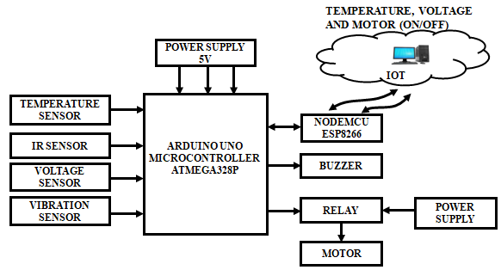
Figure 1: Three phase induction detection based on IOT
Temperature sensors are used to monitor winding and bearing temperature. Voltage sensors are used to gauge the IM's voltage level. IR sensor is used to monitor the speed of the induction motor. All the sensors are connected to ESP8266 microcontroller board which is to be installed at the motor site. All parameters will be sensed by the sensors and sent to the microcontroller board. The Blynk app is used for monitoring the outputs of the induction motors.
- Power Supply
For all electronic circuits, the power supply portion is crucial. The step-down transformer is provided the AC supply main in this instance. The transformer that has various voltages. Transformation X1 steps down the 230V, 50Hz AC mains to provide a secondary output of 12V, 500 mA. It is filtered by capacitor $C_{1}$ and controlled by ICs 7812 and 7805. The regulated supply's waves are avoided using capacitor$C_{2}$.
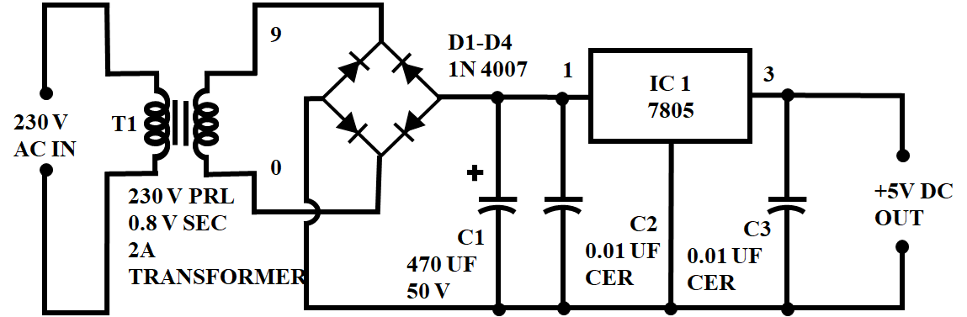
Figure 2: Power Supply
The rectifier circuit receives the transformer's output. The rectifier circuit converts the AC voltage into DC voltages, which are then provided to the regulator circuit. The regulator's output is dependent on the regulator IC used in the circuit.
- Node MCU
The hardware design for NodeMCU is open for modifying, evolving, and development. The Node MCU's primary component is the ESP8266 wifi chip. Additional details are accessible in the ESP8266 Documentation.
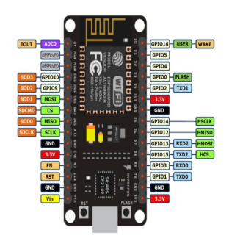
Figure 3: Node MCU
The ESP8266 Node MCU's active voltage ranges from 2.5 to 3.6 volts. The ESP8266 NodeMCU is powered using a Micro USB port on the device's PCB. 200 KB of flash memory, and 32 KB of RAM are all available on the ESP8266 NodeMCU. It has five grounding pins, three 3.3-volt pins, and one $v_{in}$ pin is used to connect a separate +5V power source from the Pc.
It is a IoT development board that handles the system's five most important tasks. The ESP8266 Wi-Fi module powers the device's firmware. In order to do computations and deliver the results in real time to the IoT cloud interface, it receives data on average load consumption from a database located in the cloud, registers an estimated bill, and keeps track of how long each relay module is turned on.
The peripheral functions that can be assigned to these pins include one 10-bit ADC channel, two UART interfaces for serial code loading, four PWM pins for dimming LEDs or controlling motors, SPI and I2C interfaces for connecting various sensors and peripherals, and an I2S interface for adding sound to projects. Numerous peripherals can be multiplexed on a single GPIO pin using the ESP8266's pin multiplexing feature. The ESP8266 chip can be reset using the Node MCU's RST button.
- Cloud Database
The system's simple design, which omits the need of any electric energy measurement chips or current and voltage sensors, was made possible by the hosted database. The final estimated cost of the monthly bill is likewise stored in the database. This database contains entries that detail the average power consumption of various loads in Watts. It was chosen because NodeMCU maintains an internet connection.
- IR Sensors
An IR sensor is a component of an electrical device that uses heat produced by an object alone to detect specific changes in that object. An IR sensor might be animated or impassive. A functional IR sensor keeps emitting IR beams, and when it doesn't receive back the same number of beams that it has reflected, it recognizes an object. An inactive infrared sensor just determines the object's temperature to identify the object without emitting any infrared beams.
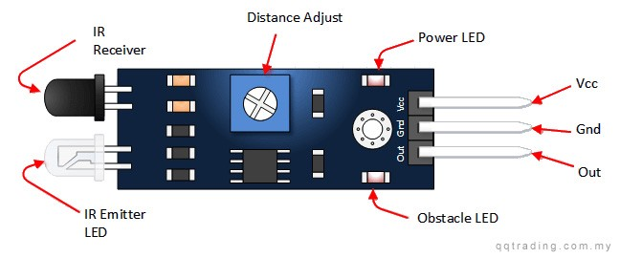
Figure 4: IR Sensor
Infrared radiation are emitted by the transmitter and travel over space. When there is an item present, the waves from the transmitter are reflected back and picked up by the receiver. The receiver notifies additional electronic circuitry via a command that there is an object nearby. IR-equipped automobiles can alert the driver to other nearby vehicles so that a collision can be avoided.
- Temperature Sensor DHT11
The most popular method of checking the temperature in motors is via temperature sensors, which are used to track changes in engine temperature. If the temperature climbs beyond the motor's maximum standard temperature level, the motor will notify or transmit a warning to the user or manual controller.
The DHT11 sensor module measures temperature in combination and generates a calibrated digital output signal. It has an output for a temperature intricate and calibrated digital signal. This sensor contains an intolerant type measurement element, an 8-bit microprocessor, and a 4-pin single row packaging with a short reaction time.
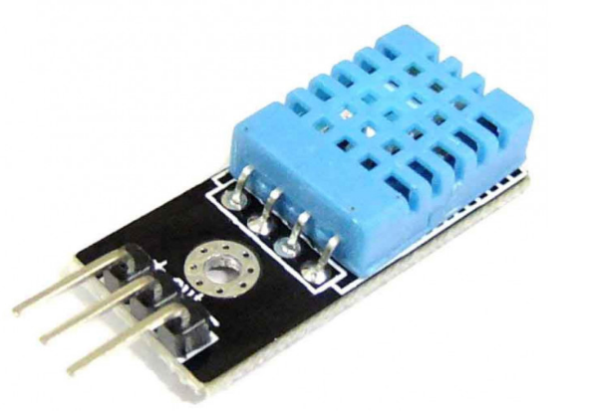
Figure 5: DHT11
This module transmits data in the form of pulse trains at regular intervals. Some start up commands with a time delay are required before delivering data to the Arduino. Even the most demanding applications can benefit from its small size, low power consumption. The packaging of the component is made up of a single row of four pins. Specific packages can be requested by users, and connecting is simple.
- Voltage sensor
The voltage sensor, which is used to measure and calculate the amount of voltage obtained in an item, is depicted in Figure 6.Detecting and measuring AC or DC voltage levels are its main uses. This sensor receives voltage as an input, and its outputs can include switches, analogue voltage signals, current signals, etc.
The three-phase is more efficient and produces very little torque. The 3-phase offers extremely strong control precision despite some cost concerns. And in terms of the stator current, this is necessary.
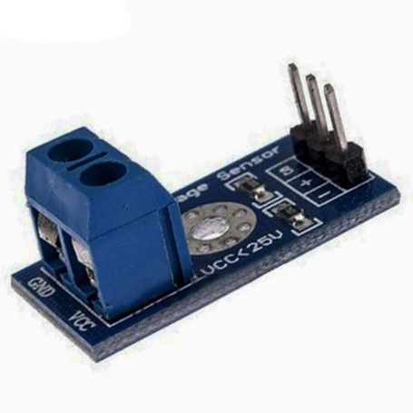
Figure 6: Voltage Sensor
- Vibration Sensor
The Vibration Switch SW-420 detects vibrations that are louder than the threshold. Threshold adjustments can be made using the on-board potentiometer. This module's output is LOW when there is no vibration, meaning the LED is off, and HIGH when there is vibration. It is used to find out if the motor is vibrating in an unexpected way. The motor's misalignment could be to blame for the vibrations.
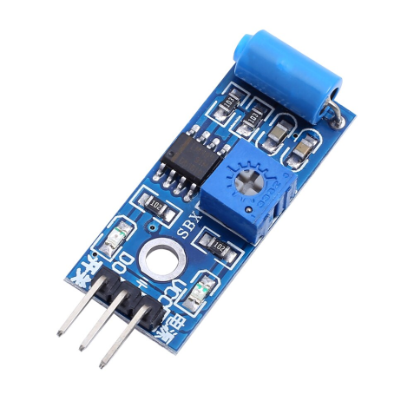
Figure 7: Vibration Sensor
- Wi-Fi Module
Arduino UNO connects at the output with Wi-Fi module ESP8266 in order to post sensor readings from DHT11 to the cloud. It is a cheap Wi-Fi microchip that has a complete IP stack. It operates on the 5V that our system's Arduino UNO supplies. The module is set up using AT commands, and using it as a client requires the necessary steps to be followed. The module has client and server functionality.
When connected to Wi-Fi, the module receives an IP and uses that address to communicate online. We attached our ESP8266 module to an Arduino UNO once we had tested it, and we then programmed the Arduino UNO to set up the ESP8266 Wi-Fi module as a TCP client and send data to the Thing Speak server, an open IoT platform for visualising and analysing real-time sensor data. The ESP8266 has the option of running a software or offloading every Wi-Fi networking job to a different CPU. However, you can load different firmwares to create your own programme on the module's memory and CPU. This module features a built-in, 80 MHz, 32-bit low-power CPU that can be used for custom firmware.
- IOT Module
The IOT is a system of interconnected devices and items that have been given intelligence through the addition of sensors, actuators, and network connectivity. This allows for data collection and exchange between the devices and objects as well as human participation in the network.
The IoT platform, which permits the connection between the physical and virtual worlds and hence enables communication between items, is the key component of the Internet of Things architecture.
- Relay Module
The relay module is utilized to turn the IM ON or OFF. In the event that the ESP8266 module's signal is strong (1), IM is turned ON. If the control signal is low (0), on the other hand, the IM is turned off. The three-phase IM's fear of remote control can be reduced by the relay module.
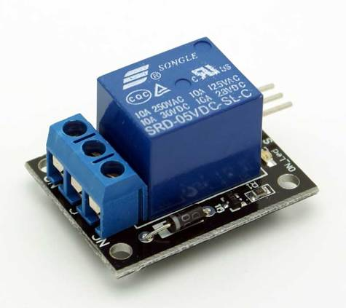
Figure 8: Relay Module
The suggested solution makes use of a 5V relay that is wired directly to an Arduino board. The contactor's input is the relay's output, which receives a pulse from the Arduino. If the Arduino notices an anomaly in the data being collected, it instructs the relay to open the contactor. In this work, a single pole, one throw switch relay is used.
The relay has 5 pins, including a common pin, 5V, GND, NO (usually open), and NC (normally closed). The relay operates according to the electromagnetic principle; when power is applied, it acts like an electromagnet and modifies the switch's state. The Arduino supply is independent of the supply's ON and OFF status.
- Arduino UNO
The ATmega328 serves as the foundation for the Arduino Uno microcontroller board. It includes a 16 MHz ceramic resonator, 6 analogue inputs, 14 digital input/output, a USB connectivity option, and a reset button. The microcontroller is supported in every manner by its designs, which include aids.
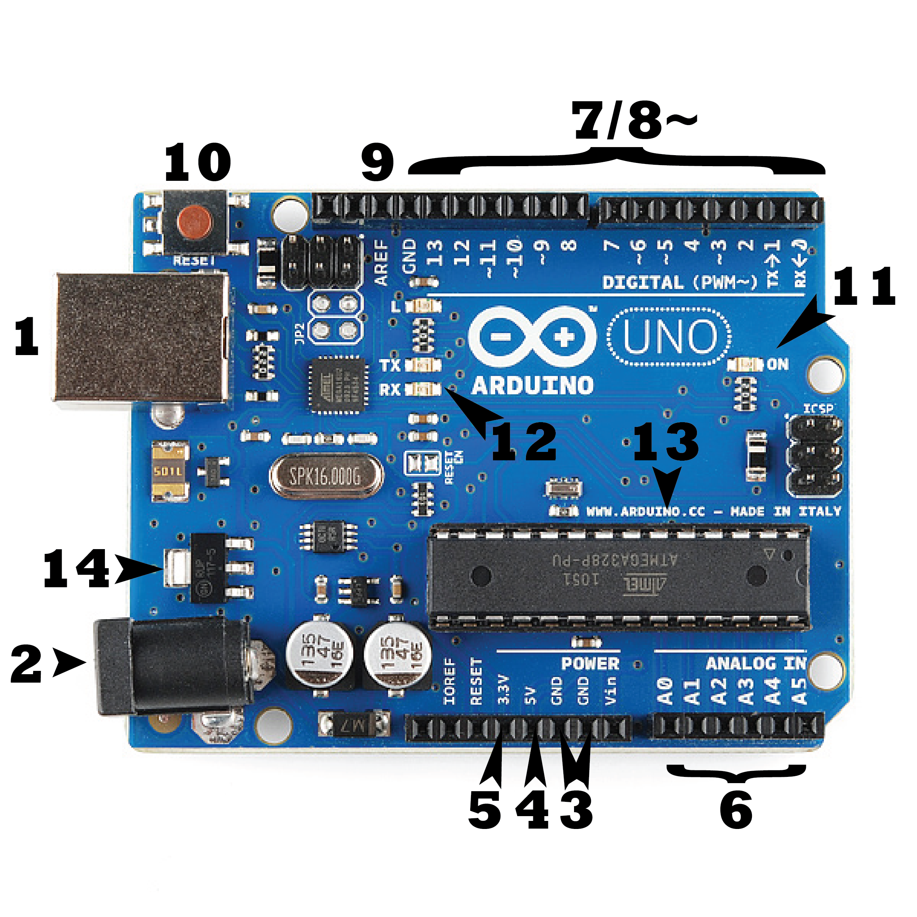
Figure 9: Arduino UNO
Every board requires a method of power supply connection. An Arduino UNO can be powered by a USB cable from the machine itself or an electric outlet with a barrel jack. In the figure above, the USB connection is indicated (1).The FTDI USB-to-serial driver chip is not used by the Uno, making it different from all of its predecessor boards.
The term "Uno" is an Italian word that meaning "one," and it was chosen to represent the imminent release of Arduino 1.0. The baseline for the system is the Uno, the most modern in a family of USB Arduino boards.
- Induction Motor
IM is one of the most widely used types of electrical motors. Always slower than synchronous, it runs. The magnetic field generated by the rotating stator creates flux in the rotor, which in turn causes rotation. The rotor can never spin faster than its synchronous speed because of the lag between the rotor and stator flux current. There are two broad categories of induction motors, and the types vary depending on the input source. In contrast to single-phase induction motors, three-phase IMs can self-start.
Three-phase AC induction motors are extensively used in industrial and commercial environments. They either belong to the wound-rotor motor category or the squirrel cage motor category. These motors can start themselves without the need of a capacitor, start winding, or switch.
From moderate to high starting torque is produced by them. These motors have capacity for medium to high power and efficiency in comparison to their single-phase versions. Printing equipment, electronic cooling, and other mechanically demanding goods are examples of common applications.
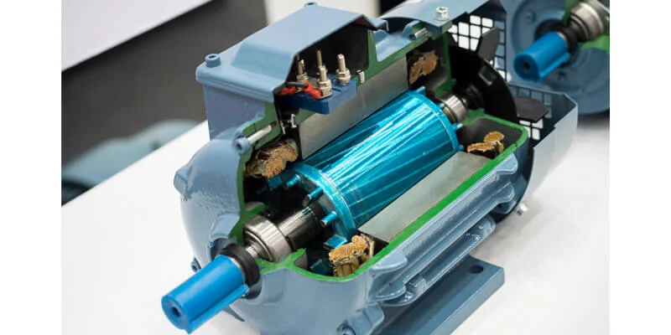
Figure 10: Induction Motor

4. RESULTS AND DISCUSSION
Temperature, voltage and speed of the induction motor are detected by the stimulated result utilising IOT and numerous sensors. Figure 11 depicts the output of Blynk app. A temperature of 32.5℃ has been recorded. The motor's speed is 1230 rpm and a voltage of 230V has been observed.
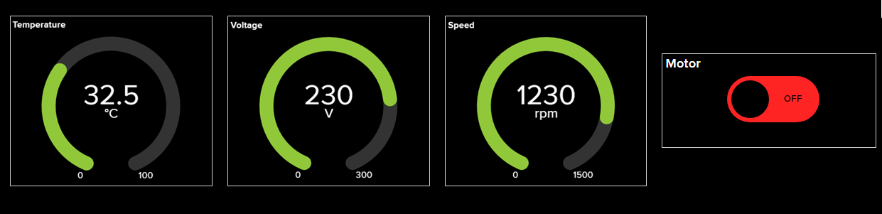
Figure 11: Output of Blynk app
5. CONCLUSION
An IoT-based controller that regulates and keeps an eye on the temperature, movement, and speed of a 3-phase IM is employed. Utilising DHT22 and SW-420 sensors, it is possible to control the temperature, humidity, and movement of the IM concurrently. Real-time online transmission of the observing information to the cloud server. Therefore, the web-based application can access and keep track of the IM's state. Inside a Wi-Fi network, all the designed functionalities are remotely tested and confirmed. Wi-Fi networks are so simple, dependable, and adaptable for remote IM control. As a result, the mobile app can access the IM and determine its state. If an anomaly is found in the data after analysis, the IM may be turned off. Through a Wi-Fi network, all the designed functionalities are remotely tested and confirmed. The experimental findings show that the IM's speed can be properly managed. Wi-Fi networks are so simple, dependable, and adaptable for remote IM control. A temperature of 32.5℃ has been recorded. The motor's speed is 1230rpm and a voltage of 230V has been observed.
REFERENCES
- Mohamed, Ahmed T., Mahmoud F. Mahmoud, R. A. Swief, Lobna A. Said, and Ahmed G. Radwan. "Optimal fractional-order PI with DC-DC converter and PV system." Ain Shams Engineering Journal, Vol .12, no. 2, pp: 1895-1906, 2021.
- N. M. Haegel and S. R. Kurtz, "Global Progress Toward Renewable Electricity: Tracking the Role of Solar," in IEEE Journal of Photovoltaics, vol. 11, no. 6, pp. 1335-1342, Nov. 2021.
- Z. Wu, Y. Hu, J. X. Wen, F. Zhou and X. Ye, "A Review for Solar Panel Fire Accident Prevention in Large-Scale PV Applications," in IEEE Access, vol. 8, pp. 132466-132480, 2020.
- S. Bouguerra, M. R. Yaiche, O. Gassab, A. Sangwongwanich and F. Blaabjerg, "The Impact of PV Panel Positioning and Degradation on the PV Inverter Lifetime and Reliability," in IEEE Journal of Emerging and Selected Topics in Power Electronics, vol. 9, no. 3, pp. 3114-3126, June 2021.
- S. K. Dash and P. K. Ray, "Power quality improvement utilizing PV fed unified power quality conditioner based on UV-PI and PR-R controller," in CPSS Transactions on Power Electronics and Applications, vol. 3, no. 3, pp. 243-253, Sept. 2018.
- L. Li et al., "Robust position anti-interference control for PMSM servo system with uncertain disturbance," in CES Transactions on Electrical Machines and Systems, vol. 4, no. 2, pp. 151-160, June 2020.
- M. Muhammad, Z. Rasin, A. Jidin, A. M. Razali and N. A. Yusoff, "Investigation on quasi-Z-source inverter with hybrid energy storage for PMSM drive system," 5th IET International Conference on Clean Energy and Technology (CEAT2018), Kuala Lumpur, pp. 1-7,2018.
- S. M. Suhel and R. Maurya, "A new switching sequences of SVPWM for six-phase induction motor with features of reduced switching losses," in CES Transactions on Electrical Machines and Systems, vol. 5, no. 2, pp. 100-107, June 2021.
- G. Sun, G. Yang, J. Su and M. Wang, "A Hybrid Random SVPWM Method with Full Modulation Ratio of Five Phase VSI," 2018 IEEE International Power Electronics and Application Conference and Exposition (PEAC), Shenzhen, China, pp. 1-6, 2018.
- H. Yao, Y. Yan, T. Shi, G. Zhang, Z. Wang and C. Xia, "A Novel SVPWM Scheme for Field-Oriented Vector-Controlled PMSM Drive System Fed by Cascaded H-Bridge Inverter," in IEEE Transactions on Power Electronics, vol. 36, no. 8, pp. 8988-9000, Aug. 2021..
- Michał Markiewicz; Maciej Wielgosz; Mikołlaj Bocheński; Waldemar Tabaczyński; Tomasz Konieczny; Liliana Kowalczyk,2019, “Predictive Maintenance of Induction Motors Using Ultra-Low Power Wireless Sensors and Compressed Recurrent Neural Networks”, IEEE Access, vol: 7,pp. 178891 – 178902.
- J. F. D. Santos et al., "Digital Twin-Based Monitoring System of Induction Motors Using IoT Sensors and Thermo-Magnetic Finite Element Analysis," in IEEE Access, vol. 11, pp. 1682-1693, 2023.
- M. -Q. Tran, M. Elsisi, K. Mahmoud, M. -K. Liu, M. Lehtonen and M. M. F. Darwish, "Experimental Setup for Online Fault Diagnosis of Induction Machines via Promising IoT and Machine Learning: Towards Industry 4.0 Empowerment," in IEEE Access, vol. 9, pp. 115429-115441, 2021.
- Q. Zhu et al., "Real-Time Quality Inspection of Motor Rotor Using Cost-Effective Intelligent Edge System," in IEEE Internet of Things Journal, vol. 10, no. 8, pp. 7393-7404, 15 April15, 2023.
- M. Gheisari, Q. -V. Pham, M. Alazab, X. Zhang, C. Fernández-Campusano and G. Srivastava, "ECA: An Edge Computing Architecture for Privacy-Preserving in IoT-Based Smart City," in IEEE Access, vol. 7, pp. 155779-155786, 2019.

