CORPORATE SOCIAL RESPONSIBILITY IN INDIA
By
Dr. Geetha Bai.B.
Professor
Department of Commerce
Karpagam academy of Higher Education
drgeethabai.b@kahedu.edu.in

Introduction
Corporate Social Responsibility is a voluntary business approach aimed at making companies accountable to themselves, stakeholders, and the public. By practicing CSR, businesses consider their impact on various aspects of society, such as the economy, social aspects, and the environment. Engaging in CSR means that a company operates in a way that benefits society and the environment, rather than causing harm. CSR programs can take different forms depending on the company and industry, including philanthropy and volunteer efforts, to benefit society and enhance the company's reputation.

CSR is not only beneficial to the community but also valuable for the company itself. It can strengthen the bond between employees and the company, boosting morale and fostering a sense of connection to the world around them. Starbucks is an example of a company that is a leader in CSR initiatives across its business. CSR programs are not limited to large corporations; smaller businesses also engage in social responsibility activities, although they may not be as well-publicized. ISO 26000 is a set of voluntary standards developed by the International Organization for Standardization to guide companies in implementing CSR. It helps organizations understand social responsibility and translate CSR principles into practical actions.
Corporate citizenship
Corporate citizenship another term for CSR, refers to a company's responsibility toward society. Embracing CSR can lead to improved customer relations, employee motivation, and brand reputation. It can also attract investors and open up new opportunities and markets.
However, there are arguments against CSR, with some claiming that businesses should focus solely on profits and let government or non profit organizations handle social and environmental issues. Critics also argue that CSR may lead to higher costs for smaller businesses and that businesses lack the social skills to effectively address social problems.
CSR is an evolving concept that can benefit both society and businesses. It helps build a positive reputation, attracts customers, motivates employees, and opens new opportunities. However, there are differing opinions on its implementation and impact, and businesses should carefully consider their CSR initiatives based on their capacity and values.

Corporate Social responsibility programs
Corporate responsibility programs can indeed raise morale in the workplace. When employees see that their company is actively involved in making a positive impact on society and the environment, it can create a sense of pride and purpose among the workforce. Knowing that they are working for an organization that cares about more than just profits can foster a stronger sense of loyalty and commitment among employees. Additionally, employee engagement in corporate responsibility initiatives can also boost morale. Many companies encourage their employees to participate in volunteer efforts or support philanthropic causes, which can be fulfilling and rewarding for employees. This kind of engagement can also lead to increased teamwork and a sense of camaraderie among colleagues, further enhancing the overall work environment.Corporate social responsibility can create a positive and inspiring workplace culture that motivates employees and fosters a greater sense of satisfaction and connection with the company's mission and values.
Types of corporate social responsibility
Corporate Social Responsibility activities are often categorized into four main pillars: environmental responsibility, ethical responsibility, philanthropic responsibility, and financial responsibility. Each pillar addresses different aspects of a company's impact on society and the environment. By integrating these pillars into their business practices, companies can demonstrate their commitment to being socially responsible and contribute positively to the world around them.

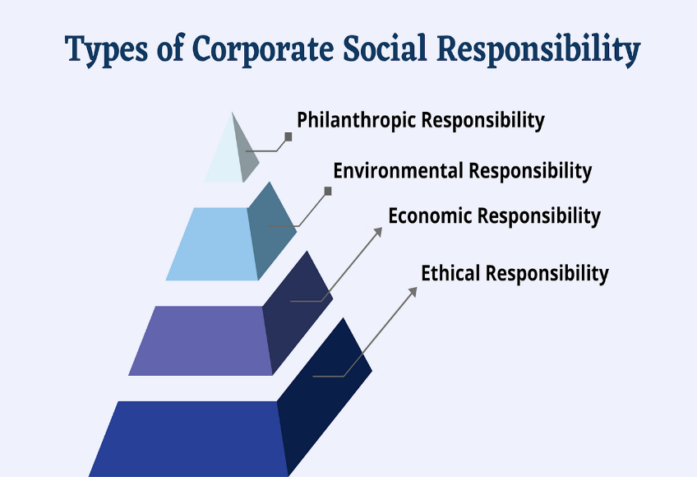

Examples of companies that strive to be leaders in corporate social responsibility include Starbucks and Ben & Jerry's. These companies have demonstrated their commitment to sustainability, community welfare, and ethical business practices, which has earned them a positive reputation and strong brand recognition among consumers. They serve as examples of how corporate social responsibility can benefit both society and the businesses themselves.
Corporate social responsibility is an essential aspect of modern business practices. It not only benefits society and the environment but also contributes to a positive workplace culture and brand reputation for companies. By embracing CSR initiatives, businesses can create a better world while also reaping the rewards of employee engagement, customer loyalty, and investor support.

Corporate Social Responsibility initiatives in India
Corporate social responsibility initiatives were undertaken by companies to contribute to social, environmental, and community welfare while also aligning with the company's business objectives. In India, the Companies Act of 2013 mandates CSR expenditure for qualifying companies meeting specific financial criteria. Companies with a net worth of Rs. 500 crores or more, annual turnover of Rs. 1000 crores or more, or profit of Rs. 5 crores or more are required to form a CSR committee and spend at least 2% of their average net profit for the previous three financial years on CSR initiatives.
CSR activities in India can cover a wide range of areas, as defined in Schedule VII of the Companies Act 2013. Some of the types of CSR activities include:
- Eradicating Hunger, Poverty, and Malnutrition: Companies can support healthcare and sanitation in rural areas, contribute to the Swachh Bharat Kosh (Clean India Fund), and organize blood donation camps.
- Promoting Education: Initiatives can include providing education to children, vocational skill training, and special education for women, elderly, and differently-abled individuals.
- Promoting Gender Equality: Activities may involve women empowerment programs, establishing affordable hostels for women, and setting up orphanages.
- Environmental Sustainability: Contributions can be made towards maintaining ecological balance, protecting flora and fauna, promoting animal welfare, and conserving natural resources.
- Protection of National Heritage, Art, and Culture: Companies can be involved in the restoration of heritage sites, historical buildings, and supporting works of art.
- Support for Armed Forces Veterans, War Widows, and Families: Contributions can be made to benefit and support armed forces personnel and their families.
- Welfare and Development of Scheduled Castes, Tribes, Other Backward Classes, Women, and Minorities: Companies can contribute to funds set up by the government for the welfare and development of marginalized communities.
- Development of Technology in Academic Institutions: Contributions can be made to support technology development in government-approved academic institutions.
- Rural Development Projects and Slum Area Development: Companies can undertake initiatives for the development of rural areas and improvement of slum areas Legal Framework of CSR in India:
Section 135 of the Companies Act 2013 mandates that certain companies must allocate at least 2% of their average net profits from the preceding three financial years towards CSR activities.
The provision applies to companies with a net worth of Rs. 500 crores or more, a turnover of Rs. 1000 crores or more, or a net profit of Rs. 5 crores or more during the immediately preceding financial year.Such companies are required to constitute a CSR Committee of the Board consisting of three or more directors, with at least one director being an independent director. If a company is not required to appoint an independent director, then the CSR committee shall consist of two or more directors.
The role of the CSR Committee is to formulate and recommend to the board a CSR policy, which should indicate the activities to be undertaken by the company in areas specified in Schedule VII of the Act, and monitor the implementation of the CSR policy.
The company's CSR activities must be undertaken in areas such as promoting education, eradicating hunger, poverty, promoting gender equality, protecting the environment, and other areas specified in Schedule VII.
Recent Developments in CSR in India
Digitalization of CSR:
The government has launched an online portal for companies to register and report their CSR activities, making it easier for companies to track and manage their CSR spending.

Inclusion of COVID-19 relief measures under CSR:
The Ministry of Corporate Affairs allowed companies to undertake COVID-19 relief measures under CSR, such as providing healthcare facilities or contributing to the PM CARES Fund.

National Voluntary Guidelines on Social, Environmental, and Economic Responsibilities of Business (NVGs):
Introduced by the Ministry of Corporate Affairs, the NVGs provide guidance to companies on integrating CSR into their business operations.

Emphasis on Education:
CSR activities in India have focused on funding education programs, building school infrastructure, training teachers, and providing scholarships.

Partnership with Non-Profits:
Companies are increasingly collaborating with charitable institutions to carry out their CSR programs.

Promotion of Social Entrepreneurship:
Companies can now contribute to incubators and research organizations supporting social entrepreneurship under the CSR Rules.

Focus on Impact Assessment:
There is a greater emphasis on the need for companies to assess the impact of their CSR activities, with higher spending allowed for impact assessments of major CSR projects.

Transparency and Accountability:
Recent amendments require companies to provide detailed information in their annual CSR reports, promoting transparency and accountability in CSR reporting.

International Corporate Social Responsibility has evolved into a mandatory obligation for certain companies having international operations in India, with the legal framework and recent developments promoting sustainable development and social responsibility. Companies are increasingly expanding their CSR activities, recognizing the importance of contributing positively to society and promoting their reputation and brand image

Conclusion
CSR activities in India have had a significant impact on various social and developmental areas. Many companies have actively participated in CSR initiatives, leading to substantial contributions in education, health, rural development, and other critical sectors. Companies such as ITC, Tata Group, Infosys, and others have been actively involved in meaningful CSR activities, addressing the needs of society and making a positive impact on communities.
Overall, CSR activities in India play a crucial role in promoting sustainable and inclusive development and contribute to the betterment of society and the environment

1.UNIDO (2007) UNIDO Initiative Aims to Develop CSR Awareness Among European SMEs. http://www.ethicsworld.org/corporatesocialresponsibility/ngoinitiatives.php
2.Ethics World (2014) CSR around the World: A Seven Country Study, Study from the Society for Human Resource Management Shows Brazil Leads in Prevalence of CSR Practices. http://www.ethicsworld.org/corporatesocialresponsibility/surveysandtrends.php
3. Legal Framework for CSR in India(2014)
https://www.researchgate.net › ... › Philosophy › CSR

4.Types of corporate social responsibility to be aware of(2021)https://online.hbs.edu/blog/post/types-of-corporate-social-responsibility

5.Corporate Social Responsibility Explained With Examples(2023) https://www.investopedia.com/terms/c/corp-social-responsibility.asp (CS)

