“Synthesis of silver nanoparticles from bacteria and fungi to check their efficiency against human pathogen”

Nirali Kathiriya¹, Dushyant Dudhagara² and Rasik Sojitra^{3*}
Department of Life Sciences, Bhakta Kavi Narsinh Mehta University, Junagadh, Gujarat, India^{1, 2, 3*}.
E-mail: nnirali996@gmail.com¹, dushyant.373@gmail.com², sojitrark13@gmail.com^{3*}

*Corresponding author: sojitrark13@gmail.com
Abstract
Currently, using microorganisms in order to develop reliable and ecofriendly methods for the synthesis of silver nanoparticles. In this study, we have investigated extracellular biosynthesis of silver nanoparticles using bacteria Bacillus subtilis and fungi Aspergillus niger. The formation of silver nanoparticles in the cell filtrates was confirmed by change in the color of cell filtrates, absorption peak at 420 nm for Bacillus subtilis and 430 nm for Aspergillus niger in UV-Vis spectra. The antibacterial efficacy of the produced nanoparticles was investigated against Staphylococcus aureus and Escherichia coli. The antifungal efficacy of the produced nanoparticles was investigated against Aspergillus niger. The biosynthesized AgNPs could be utilized as antimicrobial agents for effective disease management.
Key words: Bacillus subtilis, Aspergillus niger, silver nanoparticles, Green biosynthesis of silver nanoparticles, Antibacterial activity, Antifungal activity.

- Introduction
The old-style chemical Nanotechnology could be a multidisciplinary science of chemistry, biology, physics, engineering and technology conduct at nanoscale from 1nm until 100nm of dimensional size where practiced widely in various areas like in food processing industry, innovative fabric, agriculture production similarly in sophisticated medicinal techniques. nanoparticles have unique characteristics that change from their bulk particle and their properties changed thanks to decreasing in their dimension size which resulted in high total expanse area (Ahmad A. et al., 2003).
Nanoparticles are at the foremost important fringe of the speedily increasing field of nanotechnology. the synthesis of nanoparticles of specific composition and size is vital in science research. the properties of those particles in applications as diverse as catalysis, biochemical sensors, equipment, stimulants, biopsy, tumor imaging, drug making and pharmaceutical preparation methods and medicine depend critically on the dimension and composition of the nanoparticles (Gahlawat et al., 2016). AgNPs has been referred to as excellent antimicrobial and anti-inflammatory agents, and thus were accustomed to improve wound healing. the preparation of these particles extends the choice of properties that may be obtained. nanoparticles are the dispersion of particles from solid particles measured between 1 to 100 nanometers. nanoparticles contributed to opening different fronts to style new materials and assessing their properties by adjusting the dimensions, shape, and distribution of their molecules (El-Gamal et al., 2018). pure nanoparticles are widely used due to their unique properties such as being anti- bacterial, anti-fungal, anti-inflammatory, anti-cancer and medical purpose. the synthesized nanoparticles are excellent anti-bacterial activity against forms of gram- negative and gram-positive pathogenic microorganisms. the silver nanoparticles showed the potential application of antibacterial agent against multidrug-resistant bacteria (Kim et al., 2006).
The AgNPs are attractive option because they are not poisonous to the human body at low concentrations and furthermore they have wide range antibacterial actions. the antibacterial activity of silver ions is well known, moreover, the bactericidal activity of elementary silver, in the form of NPs has been developed. the antimicrobial activity of Ag-NPs was investigated against yeast, E. coli and S. aureus etc., (Fangfei et al., 2015). silver nanoparticles have proven to exert antiviral activity against HIV-1 at non-cytotoxic concentrations, but the mechanism underlying their HIV-inhibitory activity has not been fully illustrated. these silver nanoparticles were evaluated to elucidate their mode of antiviral action against HIV-1 using a panel of different in-vitro assays (Lara et al., 2010). silver has been used as disinfectant since from the ancient time in different forms (metallic silver, silver nitrate, silver sulfadiazine) for the treatment of wounds, burns and microbial infections. Silver has long been recognized as antimicrobial agent on numerous pathogenic and microbes commonly present in medical and industrial processes (Khan et al., 2018). silver is a safe inorganic antibacterial agent and is capable of killing about 650 types of pathogens (Jeong et al., 2005). it is highly toxic to bacteria such as Escherichia coli and Staphylococcus aureus.
The procedures of synthesis silver nanoparticles include the employment chemical solvents (Iravani S. et al., 2014). the chemicals utilized in these methodologies are often toxic and very reactive posing cause a risk to the humans and environment, and therefore the procedures are too costly to be realistic at a built-up scale. for that reason, there has been a look for affordable for cheap, dependable, harmless, and “green” style to the synthesis of stable metal nanoparticles with precise size and shape.
There are two methodologies which are included with in the syntheses of silver nanoparticles, will be from ''bottom up'' method or a ''top down'' method. in bottom up method, nanoparticles can be integrated utilizing substance and biological approaches by independent-assemble of atoms to new nuclei which become develop into a particle of nanoscale. in top down method nanoparticles are normally synthesized by evaporation and condensation and bulk material breakdown into fine particles by size reduction with various lithographic techniques e.g. grinding and milling. all One of the foremost benefits of this method is that an expansive amount of nanoparticles will be synthesized in a short span of your time and one amongst the main limitations during this procedure is during this sort of syntheses; chemicals utilized are harmful and prompted to non-ecofriendly by-items. the advancement of green syntheses over chemical and physical methods is environment friendly, cost effective and simply scaled up for giant scale syntheses of nanoparticles (Ahmed S et al., 2016). AgNPs are also known for their antimicrobial potential against several viruses, including hepatitis B, respiratory syncytial virus, herpes simplex virus type, and monkey pox virus. AgNPs and ions have been shown to possess intrinsic cytotoxic activity (Sriram et al., 2012).
The physical methods used to produce nanoparticles include several methods, including grinding and thermal fusion. physical synthesis of silver NPs have some disadvantages prefer it might involve huge space, expends a rare measure of vitality while raising the ecological temperature round the source material, requires an excellent deal of your time to accomplish thermal stability, devour more power than some kilowatts and a preheating time of a some several minutes to realize stable working temperature (Jung JH et al., 2008). these assemblies are exceptionally costly It’d deliver concentrated slime and high cost of power is required (Mishra A et al., 2011).
The chemical methods include electrochemical synthesis, chemical reduction, and optical chemical reduction technique (Gahlawat and Choudhury , 2019). the production of sludge, which contains the concentrated polluting influences, still requires disposal. corrosive, coordinate, vat, stringent and responsive dyes typically coagulate, yet the next floc is of caliber and does not settle well, yielding unremarkable outcomes which are hazardous to any or all and environment and these techniques are additionally cost- effective (Alsukaibi A.K. 2022). some Chemical synthesis techniques have short half- life, normally being 20 min. This point may be further abbreviated if dyes are available, with stability being influenced by the nearness of salts, pH, and temperature. some innovative techniques have freshly established using biologically derived reducing agents such as plants extract, microbes, polysaccharide, fungi (Gayathiri E. et al., 2022) for synthesis of silver nanoparticles. amongst them, bacteria mediated biological method has been extensively examined because of their low-cost and easy protocol.
The microorganism, which contains the ‘‘silver resistance machinery’’, synthesizes silver nanoparticles as a product of detoxification pathway (Rezvani A et al., 2016). extracts and enzymes of microorganisms can act as both reducing and capping agents (Chugh D et al., 2011) in biosynthesis (Jain J et al., 2009). in microorganism mediated nanoparticle synthesis, the reduced metal in its elemental form can get accumulated either intracellularly or extracellularly (Ahmad et al., 2007).
The intracellular synthesis of nanoparticles requires additional steps such as ultrasound treatment or reactions with suitable detergents to release the synthesized nanoparticles (Kalimuthu et al., 2008). at the same time extracellular biosynthesis is cheap and it requires simpler downstream processing. this favors large-scale production of silver nanoparticles to explore it potential applications. since numerous studies were focused on extracellular methods for the synthesis of metal nanoparticles (Duran et al., 2005). In the extracellular biosynthesis, microorganism cells are separated from the growth medium and the cell-free supernatant is used for biosynthesis of nanoparticles (Kowshik et al., 2002). even though extracellular biosynthesis has an economical pathway for the purification process, it has a limitation. size distribution and shape of nanoparticles can’t be completely controlled in extracellular biosynthesis. Extracellularly prepared nanoparticles have a size distribution between 10 nm and 6 nm with different shapes. silver nanoparticles highly antimicrobial to many species of bacteria, including the common microbe staphylococcus aureus, Escherichia coli. consistent with to the mechanism reported, silver nanoparticles interact with the outer membrane of bacteria, and arrest the respiration and a few other metabolic pathways that ends up in to the death of the bacteria. new technology advances in reducing silver compound chemically to nano scale sized particles have enabled the combination of this valuable antimicrobial into a bigger number of materials including plastics, coatings, and foams likewise as natural and artificial fibers. nano-sized silver has already provided a more durable antimicrobial protection, often for the life time of the merchandise. current research in inorganic nonmaterial having good antimicrobial properties has opened a replacement in pharmaceutical and medical industries. silver is that the metal of choice as they hold the promise to kill microbes effectively. Silver nanoparticles are recently known to be a promising antimicrobial agent that acts on a broad range of target sites both extracellularly additionally as intracellularly. silver nanoparticles show very strong bactericidal activity against gram positive as gram negative bacteria including multi resistant strains and also it absolutely found to be in few studies (Zeng et al., 2007). silver nanoparticles are gaining much attention among the rising nano items within the yield of nano medication due to their novel properties and evident restorative potential in treating an assortment of ailments, including retinal neovascularization (Kalishwaralal K et al., 2009) nanotechnology is an developing technology which include numerous territories like chemist, cosmetics, and mechanical advances and are notable to have critical applications within the fields of electronic, magnetic, information storage and optoelectronics.(Murray et al., 2000) and numerous especially within the area of pharmaceutical and medicinal analytic, which additionally assume key part in environmental protection and vitality conversion. various methodologies for the synthesis of silver nanoparticles are accessible, as an example silver particles are produced by chemical electrochemical, radiation, photochemical strategies, Langmuir– Blodgett and biological methods (Iravani et al., 2014).
Bacteria are a prospective candidate for biogenic of nanoparticle consequent to manipulation of genetic material and also the easy handling (Faramarzi and Sadighi 2013). also, bacteria can survive in all told forms of unfavorable conditions, an example, high or low peaks of temperatures, variable degrees of alkalinity or acidity, and high salt concentrations. at the identical time, biologically formed nanoparticles have many applications, like being catalysts in chemical reactions (Li et al., 2016), optical receptors, an antimicrobial agent (Ranjan and Jadeja 2017). further as having the ability to precipitate nanoparticles due to their metabolic activity. the biological synthesis of nanoparticles by bacteria is facilitated by their ability to precipitate those molecules out of cells, as those nanoparticles can be obtained using cell filtration which is taken into account beneficial for intracellular synthesis (Alsamhary et al., 2020). the biosynthesis of nanoparticles is carried out either inside or outside the cell counting on cell metabolism within the organism. sometimes nanoparticles will be generated using fungal cell filtration, a nice factor for the biological synthesis of nanoparticles. fungi also play a very important role within the synthesis of nanoparticles so were used in the biosynthesis of silver nanoparticles because it secretes a large sized number of proteins and thus its productivity is high for NPs It’s expected that the bio- synthesis mechanism of nanoparticles is to back silver ions by enzymes within the fungal system. fungi secrete large amounts of enzymes and are easy growing on every medium in order that they are considered as a correct choice for the biosynthesis of silver nanoparticles (A. Ahmad et al., 2003). many studies are done to this point using various species of fungi for the biosynthesis of sliver nanoparticles such as Aspergillus (K. C. Bhainsa and S. F. D'Souza, 2006) among minerals, fungi require nitrogen within the largest amounts, so nitrogen are often considered because the limiting factor for their growth will be accounted. unlike bacteria, fungi cannot fix atmospheric nitrogen, but they are ready to use many other forms of nitrogen like amino acids, ammonium, and nitrate. several fungi can convert nitrate as sole nitrogen source to ammonium by the enzymes nitrate reductase and nitrite reductase (Zomorodian K et al., 2016).
The precise reaction mechanism resulting in the biosynthesis of sliver nanoparticles is yet to be clarified. previous studies proposed the probable role of the reduced sort of nicotinamide adenine dinucleotide (NADH) and NADH-dependent nitrate reductase within the reduction of silver ion to metallic silver 5within the present study, we have got investigated the extracellular biosynthesis of sliver nanoparticles using four Aspergillus species including A. fumigatus, A. clavatus, A. niger, and A. flavus. so as to work out the probable role of nitrate reductase within the formation of sliver nanoparticles, we have analyzed the relationship between the standard and quantity of biosynthesized sliver nanoparticles by the studied Aspergillus species and their nitrate reductase activity. Bacillus subtilis, known also as the hay bacillus or grass bacillus, is a commonly gram- positive, catalase-positive bacterium, found in soil and therefore the digestive track of ruminants and humans. as a member of the genus Bacillus, B. subtilis is rod- shaped, and can form tough, protective endospores, allowing it to tolerate extreme environmental conditions. B. subtilis has historically been classified as an obligate aerobe, though evidence exists that it’s a facultative anaerobe. B. subtilis is considered the best studied gram-positive bacterium and a model organism to study bacterial chromosome replication and cell differentiation. It’s one in every of the bacterial champions in secreted enzyme production and used on an industrial scale by nanotechnology companies and synthesis of nanoparticles. the cell wall of Bacillus is a structure on the outside of the cell that forms the second barrier between the bacterium and the environment and at the same time maintains triangle shape and withstanding the pressure generated by the cell's turgor.
Aspergillus niger is a major fungus and one in all of the foremost common species of the genus Aspergillus. It causes a disease called "black mold" on certain fruits and vegetables like grapes, apricots, onions, and peanuts, and is could be a common contaminant of food. it is ubiquitous in soil and is usually reported from indoor environments, where its black colonies may be confused with those of Stachybotrys Aspergillus niger have been reported to supply potent mycotoxins called ochratoxins other sources disagree, claiming this report relies upon misidentification of the fungal species. Recent evidence suggests some true A. niger strains do produce ochratoxins so fungi can easily isolate from different sources of environment and also cultivate in simple and less nutrient media like PDA in laboratory and maintenance of fungi in laboratory is very easy. fungi enzyme secreting activity is more and easy to isolate and maintain, so fungi were selected for Silver nanoparticles production. characterization studies of Silver Nanoparticles and nanoparticle-based devices are of interest in numerous industrial applications due to their unique and often advantageous properties. The high surface-to-volume ratio together with size effects (quantum effects) of nanoparticles introduces many size-dependent phenomena such as chemical, electronic, magnetic and mechanical properties.
In this study, strains of Bacillus were examined for the synthesis of silver nanoparticles. among these different Bacillus species, only Bacillus subtilis has demonstrated greater potential for synthesis of silver nanoparticles. the primary aim of this study was to develop a simple, cost-effective, biocompatible, and ecofriendly approach for the extracellular biological synthesis of silver nanoparticles using Bacillus subtilis. ultraviolet spectroscopy, analyzes were accustomed characterize the formed AgNPs. these silver nanoparticles are also studied for their check the antimicrobial activity against pathogenic bacteria Streptococcus aureus and antifungal activity against fungi Aspergillus niger. to investigate effect of time on silver nanoparticles biosynthesis in this research work. Aspergillus niger were examined for the synthesis of silver nanoparticles. the primary aim of this study was to develop an easy, cost-effective, biocompatible, and ecofriendly approach for the extracellular biological synthesis silver nanoparticles using Aspergillus niger. ultraviolet spectroscopy, analyzes were accustomed characterize the formed AgNPs. These silver nanoparticles are also studied for this check the antimicrobial activity against pathogenic bacteria Escherichia coli and antifungal activity against fungi Aspergillus niger.
- Materials and Method
2.1 Isolation of silver nanoparticles producing bacteria:
2.1.1 Collection of soil sample:
The soil samples collected from Narsinh Mehta garden, Junagadh, Gujarat, India. the soil samples up to a depth 10-15 cm were collected using sterile spatula and then packed in polythene bags.
2.1.2 Isolation of bacteria:
A quantity of 1.0 g of representative and homogenized soil was suspended in 9 ml sterile distilled water in a test tube dilution process was continued till 10⁻⁶ dilution. nutrient agar take place in autoclave. the medium was cooled and poured on to petri plates. aliquots were withdrawn and transferred to sterile selective media petri plates dilution of the samples add in nutrient agar plate and rotated in clockwise and anticlockwise directions for even spreading and allowed for solidification. the plates were inverted and incubated at room temperature 37˚C. when the bacterial colonies appeared on the plates, morphologically distinct bacterial colonies were picked up and maintained on nutrient agar slants.
2.1.3 Identification of bacterial isolates:
The morphological, physiological characterization of bacteria. cell morphology of the isolates was studied by simple staining method. the bacterial shape was observed under oil immersion objective. the gram’s reaction of the isolates was performed as per the common methods.
2.1.4. Purification of Bacillus subtilis:
Take a loop full Bacillus subtilis colony help of wire loop and striking on nutrient agar plate. this plate takes place in incubator for 37⁰ c for 24 hrs.
2.2 Production of biomass of bacterial isolates:
Purified bacterial isolates colonies were transferred into 200 ml sterilized nutrient broth containing flask and incubated on an orbital shaker at 37 °C and continuous agitation at 200 rpm for 24 hours. the microbial biomass was collected after 24 h of growing and centrifuged at 10,000 rpm for 10 minutes. the bacterial cells were separated by centrifugation. The cell free supernatant material was separated out and used for extracellular synthesis of nanoparticles.
2.3 Biogenic of silver nanoparticles from bacterial isolates:
Preparation of silver nanoparticles (Kalishwaralal et al., 2008) for the preparation of AgNPs, two solutions were prepared; the first one was: 100 ml of supernatant was mixed with one ml of silver nitrate solution (1 mM) and the second reaction mixture was prepared without AgNO3 that used as a control test. The designed solutions were incubated at 30 °C for 24 h. all solutions were preserved in dark to abolish any photochemical reversion during the experiment. then, the solutions turned from yellow into brown colure. the silver nanoparticles were purified by centrifugation at 10000 rpm for ten minutes, and collected for characterization.
2.4 Effect of time on silver nanoparticles biosynthesis:
To investigate the efficacy of time on the biosynthesis of silver nanoparticles, a fresh colony of the Bacillus subtilis produces for silver nanoparticles was selected. the culture tubes were incubated for 60 min then one ml of the growth was inoculated in new flasks containing 10ml LB broth incubated at 37 °C with continued shaking 150 rpm for 20 hrs. 1 ml of nanoparticle suspension was added to the experimental flask. The growth of the microbe was detected by determining the O.D. of culture at regular time interval (24 hrs.) by UV–Vis Spectroscope at 600 nm. an equal volume from each culture was outgoing and the optical density was calculated and draws the growth curves of microbial strains
  - isolation of silver nanoparticles producing fungi:
2.5.1 Collection of soil sample:
The soil samples collected from agriculture garden. The soil samples up to a depth 10-15 cm were collected using sterile spatula and then packed in polythene bags.
2.5.2 Isolation of fungi:
A quantity of 1.0 gm of representative and homogenized soil was suspended in 9 ml sterile distilled water in a test tube dilution process was continued till 10⁻⁶. potato dextrose agar media take place in autoclave. the medium was cooled and poured on to Petri plates. Aliquots was withdrawn and transferred to sterile selective media petri plates dilution of the samples add in potato dextrose agar plate and rotated in clockwise and anticlockwise directions for even spreading and allowed for solidification. the plates were inverted and incubated at room temperature 37˚C for 4 days. when the fungi appeared on the plates, morphologically distinct colonies were picked up and maintained on potato dextrose broth.
2.5.3 Identification of fungi:
Fungi were characterized by their morphology such as hyphae characteristics, presence or absence of spores, arrangement of conidia and reproductive structures by microscopic observation using lacto phenol Cotton Blue (LPCB) method.
2.5.4 Purification of Aspergillus niger:
A single spore was taken in an inoculation loop and streaked at potato dextrose agar plate and incubated for 4 days.
  - Production of biomass of fungi:
To prepare biomass, fungi were grown aerobically in liquid media containing (g/L) KH₂PO₄, 7.0; KH₂PO₄, 2.0; MgSO₄·7H2O, 0.1; (NH₄)₂SO₄, 1.0; yeast extract, 0.6; and glucose, 10.0. The flasks were inoculated and incubated on orbital shaker at 150 rpm at 25°C (Kamiar Zomorodian et al., 2016). The biomass was harvested after 72 hours of growth by filtering through a paper sieve, followed by substantial washing with distilled deionized water in order to remove any medium component from the biomass.
  - Biosynthesis of Silver Nanoparticles from fungi:
The biomass (25gm) wet weight was placed in individual flasks containing 100 ml water and incubated for 24 hrs. the biomass was filtered, and the cell filtrate was collected and used for biosynthesis of AgNPs. for biosynthesis of AgNPs, 50 ml of cell filtrate was mixed with 2 ml AgNO₃ solution (1mM) and reaction mixture without AgNO₃ was used as control. the prepared solutions were incubated at 28°C for 24 hrs. in abolish condition (Devi and Joshi, 2012). the color change from yellow to brown color indicates the production of silver nanoparticles in the sample. The silver nanoparticles were purified by centrifugation at 10000 rpm for ten minutes, and collected for characterization.
  - Characterization of silver nanoparticles:
The reduction of silver nitrate and formation of silver nanoparticles from microorganisms were characterized by visible color change and by UV-visible spectroscopy between 300 to 500 nm. the biosynthesized silver nanoparticles samples were periodically monitored for the bioreduction completion of Ag⁺ in aqueous solution as color change by visual inspection and subsequent scan in UV-visible spectra, the wavelength range between 420 to 440 nm were used for silver nanoparticles. (Kamiar Zomorodian et al., 2016).
  - Determination of antimicrobial activity of silver nanoparticles by well diffusion method:
The silver nanoparticles were centrifuged 10000 rpm and the silver dissolve the pellet in distilled water.
    - Antibacterial activity:
Preparation of Inoculum: The active young cultures for the study were prepared by sub-culturing a loopful of cells to the nutrient broth and incubated for 24 hours at 37˚C. agar well diffusion method: The Petri plates were prepared with 20 ml of Luria bertani agar media and the test cultures were swabbed on the surface of the solidified media and allowed to dry for 10 minutes and pour into agar and make a well. biosynthesized silver nanoparticles added in the well. silver nitrate was used as a control. the plates were incubated for 24 hrs. at 37˚C for bacterial growth. zones of inhibition were recorded in millimeters.
2.9.2 Antifungal activity:
Preparation of fungal Inoculum: The fungi cultures were grown on PDA plates at 37˚C, 4 days for fungi. spore suspensions were prepared in sterile distilled water.
Agar well diffusion method: The antifungal activity of the AgNPs was evaluated using the diffusion method. further Petri plates were prepared with 20 ml of potato dextrose agar media and the test cultures were swabbed on the surface of the solidified media and allowed to dry for 10 minutes and pour into agar and make a well. biosynthesized silver nanoparticles added in well then Silver nitrate was used as a control, after that Petri plate incubated at 37ºC for 48 hours. finally, the inhibition zones were measured.

- Result
Isolation of silver nanoparticles producing bacteria:
Soil samples taken Narsinh Mehta garden were used as source material for isolation studies. after the incubation period, about four morphologically dissimilar colonies were selected and subcultured in nutrient agar slants for further studies.
Identification of silver nanoparticles producing bacterial isolates:
The morphological, physiological characterization of bacteria by gram staining method. after use of gram staining method identification of Bacillus subtilis, Staphylococcus aureus and Escherichia coli.
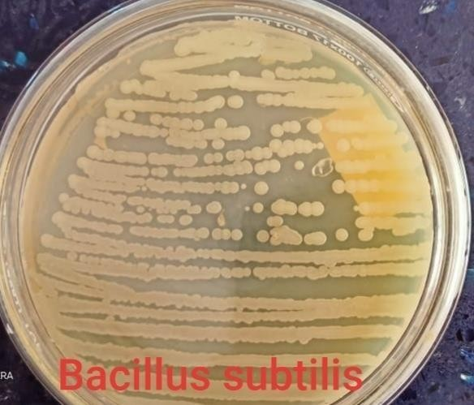
Figure-1 Bacillus subtilis pure culture on nutrient agar.
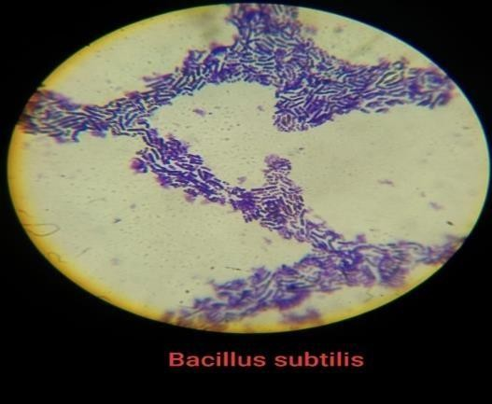
Colony characteristic (figure-1) of Bacillus subtilis on nutrient agar plate. they have irregular margin, 2-3mm size, dry and rough texture, flat elevation, white pigmentation and opaque opacity.
Figure-2 Bacillus subtilis microscopic view.
Colony characteristic of (figure-2) Bacillus subtilis in microscopic view performing gram stain. they have rod shaped, purple color and gram positive bacteria.
Identification of bacterial isolates:
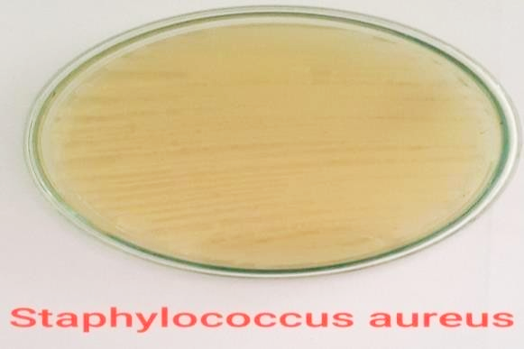
The morphological, physiological characterization of bacteria by gram staining method. after use of gram staining method identification of staphylococcus aureus and Escherichia coli.
Figure-3 Staphylococcus aureus pure culture on luria bertani agar.
Colony characteristic (figure-3) of Staphylococcus aureus on luria bertani agar medium. they have entire margin, convex elevation, 2-3mm size, smooth and shiny texture, flat elevation, yellow pigmentation and opaque opacity.
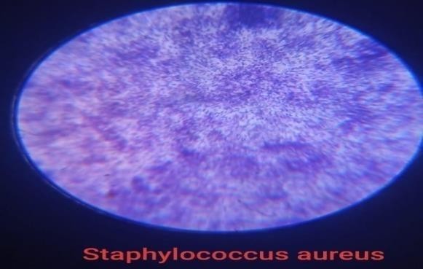
Figure-4 Staphylococcus aureus microscopic view.
Colony characteristic of (figure-4) Staphylococcus aureus in microscopic view performing gram stain. they have round shaped, purple color and gram positive bacteria.
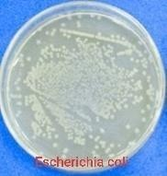
Figure-5 Escherichia coli on nutrient agar.
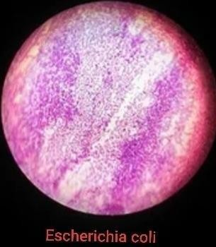
Colony characteristic (figure-5) of Escherichia coli on nutrient agar plate. they have entire margin, 1-2mm size, shiny texture, convex elevation, off-white pigmentation and opaque opacity.
Figure-6 Escherichia coli microscopic view.
Colony characteristic of (figure-6) Escherichia coli in microscopic view performing gram stain. they have rod shaped, pink color and gram negative bacteria.
Identification of silver nanoparticles producing fungal isolates:
Fungal isolates were identified up to morphological characteristics (spores, arrangement of conidia and reproductive structure) using lacto phenol cotton blue staining.

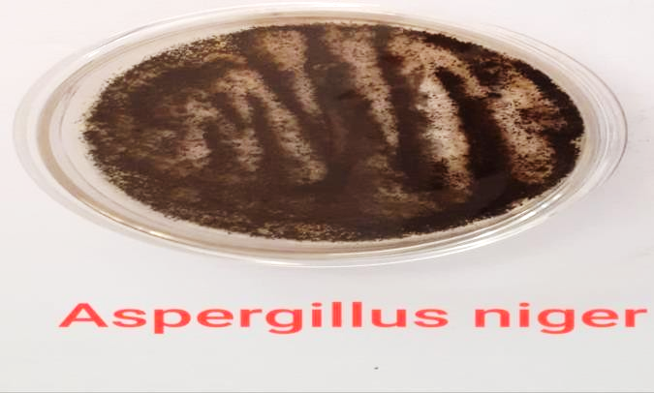
Figure-7 Aspergillus niger pure culture.
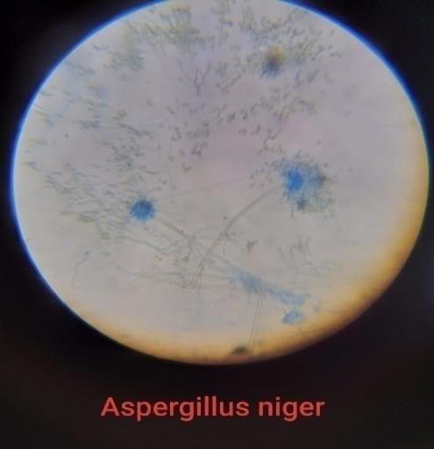
Colony characteristic of (figure-7) Aspergillus niger on potato dextrose agar plate. they have smooth structure, white surface color and reverse black color.
Figure-8 Aspergillus niger microscopic view.
Colony characteristic of (figure-8) Aspergillus niger in microscopic view performing of lacto phenol cotton blue staining. they have one celled conidia, branching septate hyphae, smooth cell walls and asexually reproductive structure.
Production of biomass from Bacteria:
After the agitation microbial biomass was collected around 24 hours after. so we observe from the (figure-9) clear biomass production and the (figure-10) cell free supernant.

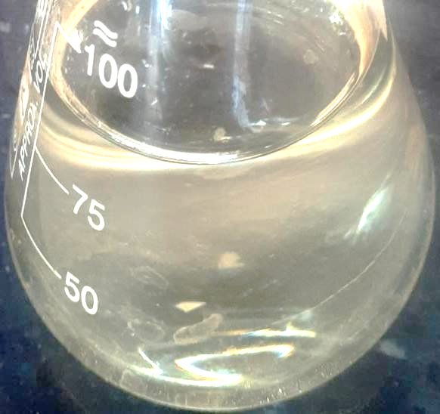
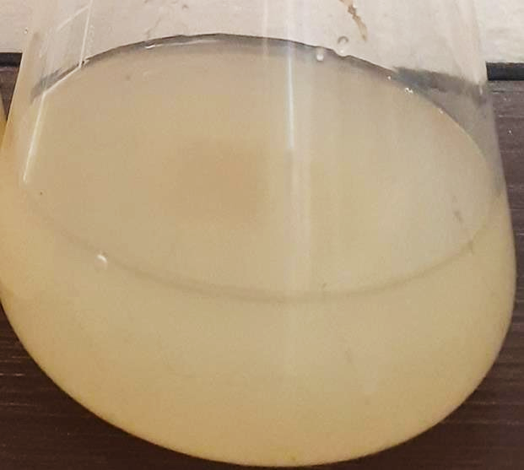

Figure-9 Biomass Production of B. subtilis. Figure-10 B. subtilis cell free supernant.
Biosynthesis of silver nanoparticles from Bacillus subtilis:
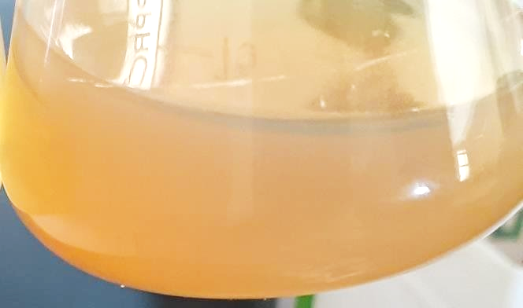
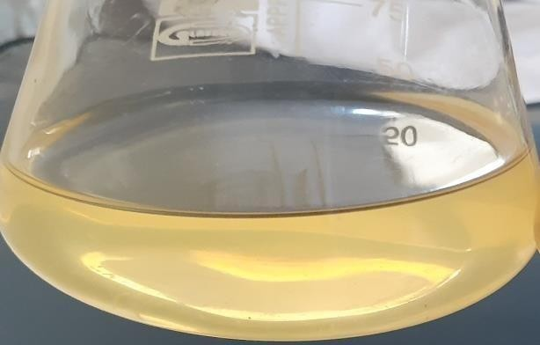

Figure-11 Control, without silver nitrate.

Figure-11 Control, without silver nitrate. Figure-12 silver nanoparticle suspension.
The biosynthesis of silver nanoparticles was initially confirmed through color change of the reaction mixture. the appearance of a pale yellow to (figure-12) brown color filtrate in the reaction vessels after incubation at room temperature confirms the formation of silver nanoparticles. in negative (figure-11) control (without silver nitrate), no color change was observed. in flask containing bacterial supernatant with silver nitrate solution color change from pale yellow to brown color was observed. The silver nanoparticles were concentrated and separated after centrifugation.

Effect of time on the biogenic silver nanoparticles:

Figure-13 Uv- visible spectrum of Effect of time on the biogenic silver nanoparticles.
As a (figure-13) function of time, the UV–Vis spectra absorbance at a concentration of 1 mM silver nitrate and cell free supernant indicates that the reaction was completed during of the incubation period. An increase in time does not affect the formation of silver nanoparticles.
Characterization of silver nanoparticles produces by Bacillus subtilis:
Figure-14 Uv- visible spectrum of synthesis for silver nanoparticles from Bacillus subtilis.
The primary characterization (figure-14) of silver nanoparticles was done with UV-Visible spectral analysis. this initial step to authenticate silver nanoparticles formation in aqueous solution is using UV- Visible spectroscopy. the absorbance pattern of the UV-Visible spectra in the range of 300-500 nm. A strong, broad peak observed at 420nm.
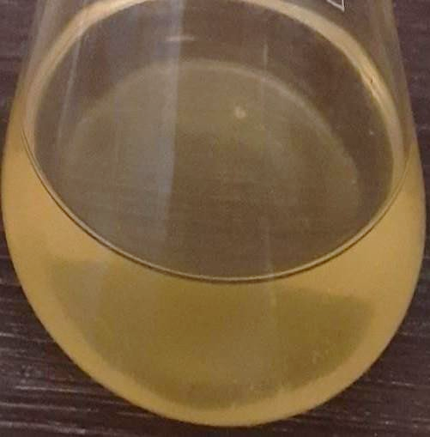
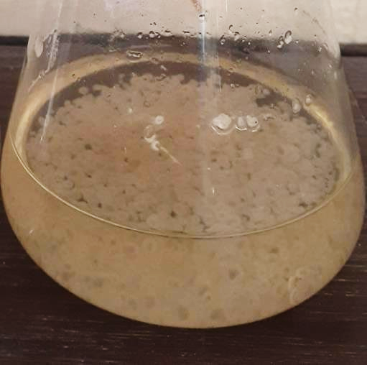
Production of biomass of fungi:

Figure-15 Mass production of A. niger. Figure-16 A. niger cell free supernant.
The biomass was harvested after 72 hours of growth by filtering through a paper sieve, followed by substantial washing with distilled water in order to remove any medium component from the biomass (figure-15). Fresh biomass was added to 200 ml of distilled water for 48 hours at 25°C in flask and agitated on orbital shaker at 150 rpm for 48 hours. After incubation, the cell filtrate was obtained by sieving the content through filter paper (figure-16).
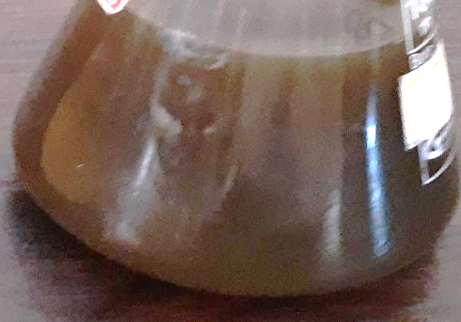
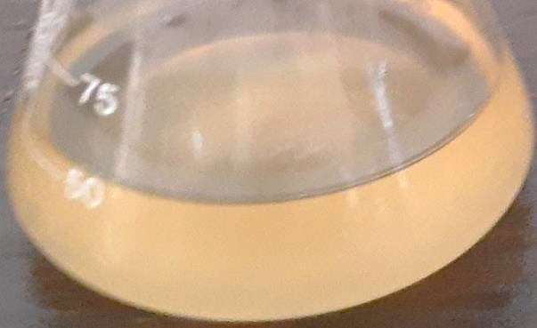
Biosynthesis of silver nanoparticles from Aspergillus Niger:

Figure-17 Control, without silver nitrate. Figure-18 Test, silver nanoparticle suspension

After incubation of the fungal cell filtrates with silver ions and maintenance in the dark, the cell filtrates showed a gradual change in color towards yellow to brown (figure-18). The color of the cell filtrates changed to intense brown after 48 h of incubation. This indicated the formation of sliver nanoparticles in the medium which was mainly. Controls (without silver ion, figure-17) exhibited no change in color of the cell filtrate in the same condition of incubation. The silver nanoparticles were concentrated and separated after centrifugation.
Characterization of silver nanoparticles produces by Aspergillus niger:

Figure-19 Uv- visible spectrum of synthesis of silver nanoparticles from Aspergillus niger.
The primary characterization of silver nanoparticles was done with Uv-Visible spectral analysis. This initial step to authenticate silver nanoparticles formation in aqueous solution is using Uv- Visible spectroscopy. the absorbance pattern of the Uv-Visible spectra in the range of 300-500 nm. a strong, broad peak observed at 430 nm (figure-19).

Antimicrobial activity of silver nanoparticles produces by Bacillus subtilis against staphylococcus aureus:
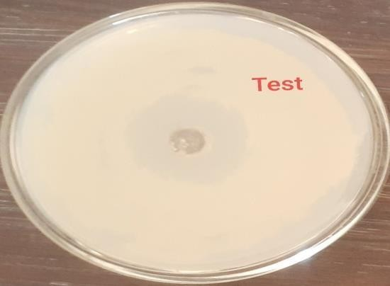
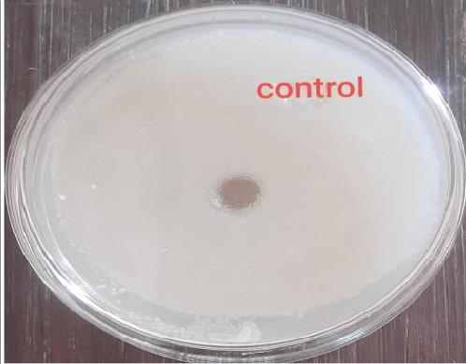

Figure-20 Control, silver nitrate. Figure-21 Test, silver nanoparticle.
After the incubated plate zone of inhibition (8mm) is observed against bacteria. Antibacterial activity of silver nanoparticles is gain best result against staphylococcus aureus. The diameters of clear area determined for staphylococcus aureus were 8 mm (figure-21). in control plate zone of inhibition is not observed (figure-20).
Antifungal activity of silver nanoparticles produces by Bacillus subtilis against Aspergillus niger:
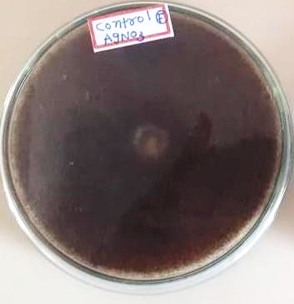
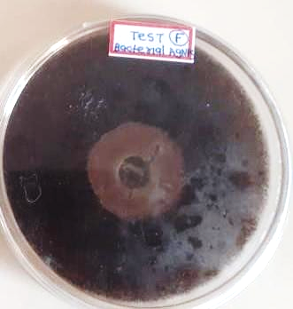

Figure-22 Control, silver nitrate Figure-23 Test, silver nanoparticles.
After the incubated plate zone of inhibition (10mm) is observed against fungi. antifungal activity of silver nanoparticles which produced by Bacillus subtilis is gain best result against Aspergillus niger. The diameters of clear area determined for Aspergillus niger were 11 mm (figure-23). in control plate zone of inhibition is not observed (figure-22).
Antimicrobial activity of silver nanoparticles produces by Aspergillus niger against Escherichia coli:
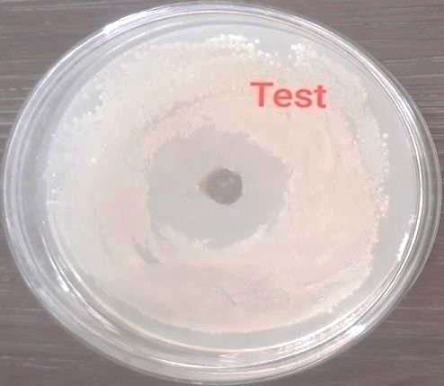
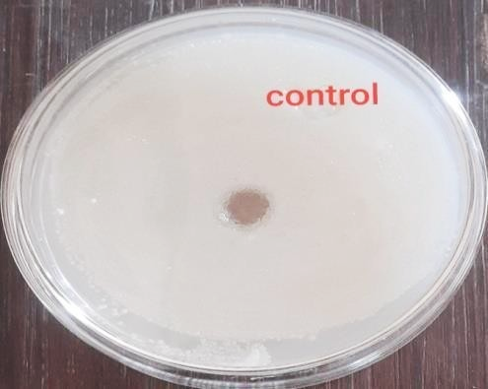
Figure-24 Control, silver nitrate. Figure-25 Test, silver nanoparticles.
After the incubated plate zone of inhibition (9.5mm) is observed against bacteria. antibacterial activity of silver nanoparticles produced by Aspergillus niger is gain best result against staphylococcus aureus. The diameters of clear area determined for Escherichia coli were 14 mm (figure-25). in control plate zone of inhibition is not observed (figure-24).
Antifungal activity of silver nanoparticles produces by Bacillus subtilis against Aspergillus niger:
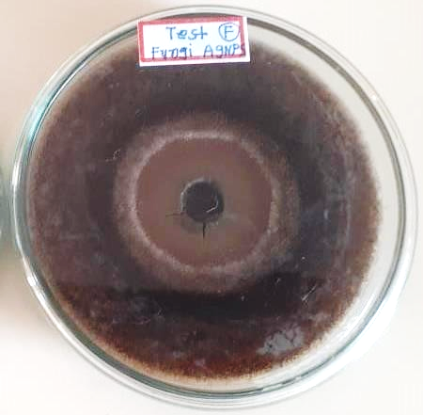
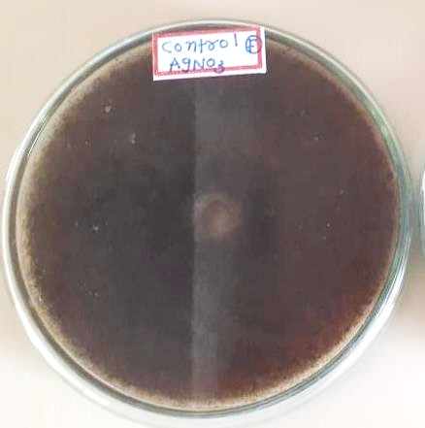

Figure-26 Control, silver nitrate. Figure-27 Test, silver nanoparticles.
After the incubated plate zone of inhibition (12mm) is observed against fungi. antifungal activity of silver nanoparticles against Aspergillus niger is better. The diameters of clear area determined for Aspergillus niger were 12 mm (figure-27). in control plate zone of inhibition is not observed (figure-26).

- Discussion
Silver nanoparticles are gaining popular nowadays because of their versatile applications in various fields of research. AgNPs are useful in treating various kinds of diseases in any forms. biosynthesis of silver nanoparticles using microbes is best alternative to accomplish the clean, economical and eco-friendly production among the microbes, prokaryotic bacteria have been most extensively used for the synthesis of nanoparticles, in the current study, soil microorganisms from Narsinh Mehta garden were screened for their ability to produce silver nanoparticles. The bacteria from this region are expected to have continuous interactions with metals, hence they could possess nanoparticle forming properties. Bacterial isolates obtained from soil samples were further screened for silver nanoparticles forming ability. The cell free supernatant of all the isolates were treated with 1mM AgNO₃ solution and observed for the color change from colorless to brown.
The change in color throughout the supernatant was occurred after 24 hour of incubation and the color was completed at 48h. in the current study, soil microorganisms from agriculture garden were screened for their ability to produce silver nanoparticles. The fungi from this region are expected to have continuous interactions with metals, hence they could possess nanoparticle forming properties. fungal isolates obtained from soil samples were further screened for silver nanoparticles forming ability. The cell free supernatant of all the isolates were treated with 1mM AgNO3 solution and observed for the color change from colorless to brown.
The production of silver nanoparticles by Bacillus subtilis characterization in Uv visible spectroscopy in a strong, broad peak observed at 420nm. It means production of silver nanoparticles capable Bacillus subtilis and gets best result. the production of silver nanoparticles by Aspergillus niger characterization in Uv visible spectroscopy in A strong, broad peak observed at 430nm. it means production of silver nanoparticles capable Aspergillus niger and gets best result. antibacterial activity of the biosynthesized silver nanoparticles against staphylococcus aureus and Escherichia coli produce the zone of inhibition. silver nanoparticles against staphylococcus aureus create zone of inhibition 8 mm and 9.5 mm respectively. it is good antibacterial activity of silver nanoparticles. antifungal activity of the biosynthesized silver nanoparticles against Aspergillus niger produce the zone of inhibition. diameter of zone against Aspergillus niger 10 mm and 12 mm.

- Conclusion
Soil samples used in the study were collected from Narsinh Mehta garden. the bacterial and fungal isolates obtained from agricultural garden soil samples were further subcultured on Nutrient agar and potato dextrose agar supplemented with 1mM concentration of sterilized AgNO3, to select silver nanoparticles producing isolates. the results indicated that among all the isolates Bacillus subtilis and Aspergillus niger showed the synthesis of AgNPs which was evidenced from the yellow color change to brown color. the UV-Vis spectral analysis showed an absorbance peak of Bacillus subtilis and Aspergillus niger at 420 nm and 430 nm.
Antibacterial activity of silver nanoparticles was performed by well diffusion method against staphylococcus aureus and Escherichia coli. antibacterial potential of AgNPs was assessed by measuring diameter of zone of inhibition against the pathogens. zone of inhibition against staphylococcus aureus 8 mm and Escherichia coli 9 mm. antifungal activity of silver nanoparticles was performed by well diffusion method against Aspergillus niger. the antifungal potential of AgNPs was assessed by measuring diameter of zone of inhibition against the pathogens. the zone of inhibition against Aspergillus niger is 10 mm and 12 mm.
this data suggests green and eco-friendly method to formation of silver bio-nanoparticles by Bacillus subtilis and Aspergillus niger. silver nanoparticles used as antimicrobial agent against pathogenic microorganism. silver nanoparticles also useful in the treatment of the many diseases. silver nanoparticles give best antimicrobial activity against fungi and bacteria. silver nanoparticles broadly used in medical field.

- References
- Ahmad, A., Mukherjee, P., Senapati, S., Mandal, D., Khan, M. I., Kumar, R., & Sastry, M. (2003). Extracellular biosynthesis of silver nanoparticles using the fungus Fusarium oxysporum. Colloids and surfaces B: Biointerfaces, 28(4), 313-318.
- Gahlawat, G., Shikha, S., Chaddha, B. S., Chaudhuri, S. R., Mayilraj, S., & Choudhury, A. R. (2016). Microbial glycolipoprotein-capped silver nanoparticles as emerging antibacterial agents against cholera. Microbial Cell Factories, 15, 1-14.
- El-Gamal, M. S., Salem, S. S., & Abdo, A. M. (2018). Biosynthesis, characterization, and antimicrobial activities of silver nanoparticles synthesized by endophytic Streptomyces sp. J. Biotechnol, 56, 69-85.
- Kim, J., Grate, J. W., & Wang, P. (2006). Nanostructures for enzyme stabilization. Chemical engineering science, 61(3), 1017-1026.
- Li, F., Collins, J. G., & Keene, F. R. (2015). Ruthenium complexes as antimicrobial agents. Chemical Society Reviews, 44(8), 2529-2542.
- Lara, H. H., Ayala-Núñez, N. V., Ixtepan Turrent, L. D. C., & Rodríguez Padilla, C. (2010). Bactericidal effect of silver nanoparticles against multidrug-resistant bacteria. World Journal of Microbiology and Biotechnology, 26, 615-621.
- Khan, A. U., Malik, N., Khan, M., Cho, M. H., & Khan, M. M. (2018). Fungi-assisted silver nanoparticle synthesis and their applications. Bioprocess and biosystems engineering, 41, 1-20.
- Jeong, S. H., Hwang, Y. H., & Yi, S. C. (2005). Antibacterial properties of padded PP/PE nonwovens incorporating nano-sized silver colloids. Journal of materials science, 40, 5413-5418.
- Iravani, S., Korbekandi, H., Mirmohammadi, S. V., & Zolfaghari, B. (2014). Synthesis of silver nanoparticles: chemical, physical and biological methods. Research in pharmaceutical sciences, 9(6), 385.
- Ahmed, S., & Ikram, S. (2016). Biosynthesis of gold nanoparticles: a green approach. Journal of Photochemistry and Photobiology B: Biology, 161, 141-153.
- Sriram, M. I., Kalishwaralal, K., & Gurunathan, S. (2012). Biosynthesis of silver and gold nanoparticles using Bacillus licheniformis. Nanoparticles in biology and medicine: methods and protocols, 33-43.
- Jung, W. K., Koo, H. C., Kim, K. W., Shin, S., Kim, S. H., & Park, Y. H. (2008). Antibacterial activity and mechanism of action of the silver ion in Staphylococcus aureus and Escherichia coli. Applied and environmental microbiology, 74(7), 2171-2178.
- Mishra, A., Tripathy, S. K., & Yun, S. I. (2011). Bio-synthesis of gold and silver nanoparticles from Candida guilliermondii and their antimicrobial effect against pathogenic bacteria. Journal of nanoscience and nanotechnology, 11(1), 243-248.
- Gahlawat, G., & Choudhury, A. R. (2019). A review on the biosynthesis of metal and metal salt nanoparticles by microbes. RSC advances, 9(23), 12944-12967.
- Alsukaibi, A. K. (2022). Various approaches for the detoxification of toxic dyes in wastewater. Processes, 10(10), 1968.
- Gayathiri, E., Prakash, P., Karmegam, N., Varjani, S., Awasthi, M. K., & Ravindran, B. (2022). Biosurfactants: potential and eco-friendly material for sustainable agriculture and environmental safety—a review. Agronomy, 12(3), 662.
- Rezvani Amin, Z., Khashyarmanesh, Z., & Fazly Bazzaz, B. S. (2016). Different behavior of Staphylococcus epidermidis in intracellular biosynthesis of silver and cadmium sulfide nanoparticles: more stability and lower toxicity of extracted nanoparticles. World Journal of Microbiology and Biotechnology, 32, 1-11.
- Chugh, D., Viswamalya, V. S., & Das, B. (2021). Green synthesis of silver nanoparticles with algae and the importance of capping agents in the process. Journal of Genetic Engineering and Biotechnology, 19(1), 1-21.
- Jain, J., Arora, S., Rajwade, J. M., Omray, P., Khandelwal, S., & Paknikar, K. M. (2009). Silver nanoparticles in therapeutics: development of an antimicrobial gel formulation for topical use. Molecular pharmaceutics, 6(5), 1388-1401.
- Shahverdi, A. R., Minaeian, S., Shahverdi, H. R., Jamalifar, H., & Nohi, A. A. (2007). Rapid synthesis of silver nanoparticles using culture supernatants of Enterobacteria: a novel biological approach. Process Biochemistry, 42(5), 919-923.
- Kalimuthu, K., Suresh Babu, R., Venkataraman, D., Bilal, M., Gurunathan, S. (2008).Biosynthesis ofsilver nanocrystals by Bacillus licheniformis. Colloids Surf B Biointerfaces volume 65, pages 150–153.
- Kalimuthu, K., Babu, R. S., Venkataraman, D., Bilal, M., & Gurunathan, S. (2008). Biosynthesis of silver nanocrystals by Bacillus licheniformis. Colloids and surfaces B: Biointerfaces, 65(1), 150-153.
- Duran, N., Priscyla, D., Marcato, P.D., Alves, O., De Souza, G., Esposito.E. (2005). Mechanistic aspects of biosynthesis of silver nanoparticles by several Fusarium oxysporum strains.J Nanobiotechnol. Volume 2005 issue 3, pages 1– 7.
- Kowshik, M., Ashtaputre, S., Kharrazi, S., Vogel, W., Urban, J., Kulkarni, S. K., & Paknikar, K. M. (2002). Extracellular synthesis of silver nanoparticles by a silver-tolerant yeast strain MKY3. Nanotechnology, 14(1), 95.
- Zeng, H., Zhao, C., Qiu, J., Yang, Y., & Chen, G. (2007). Preparation and optical properties of silver nanoparticles induced by a femtosecond laser irradiation. Journal of Crystal Growth, 300(2), 519-522.
- Kalishwaralal, K., Deepak, V., Ramkumarpandian, S., Nellaiah, H., & Sangiliyandi, G. (2008). Extracellular biosynthesis of silver nanoparticles by the culture supernatant of Bacillus licheniformis. Materials letters, 62(29), 4411-4413.
- Murray, C. B., Kagan, C. R., & Bawendi, M. G. (2000). Synthesis and characterization of monodisperse nanocrystals and close-packed nanocrystal assemblies. Annual review of materials science, 30(1), 545-610.
- Iravani, S., Korbekandi, H., Mirmohammadi, S. V., & Zolfaghari, B. (2014). Synthesis of silver nanoparticles: chemical, physical and biological methods. Research in pharmaceutical sciences, 9(6), 385.
- Faramarzi, M. A., & Sadighi, A. (2013). Insights into biogenic and chemical production of inorganic nanomaterials and nanostructures. Advances in Colloid and Interface Science, 189, 1-20.
- Li, J., Li, Q., Ma, X., Tian, B., Li, T., Yu, J., ... & Hua, Y. (2016). Biosynthesis of gold nanoparticles by the extreme bacterium Deinococcus radiodurans and an evaluation of their antibacterial properties. International journal of nanomedicine, 5931-5944.
- Ranjan, R., & Jadeja, V. (2017). Isolation, characterization and chromatography based purification of antibacterial compound isolated from rare endophytic actinomycetes Micrococcus yunnanensis. Journal of pharmaceutical analysis, 7(5), 343-347.
- Alsamhary, K. I. (2020). Eco-friendly synthesis of silver nanoparticles by Bacillus subtilis and their antibacterial activity. Saudi Journal of Biological Sciences, 27(8), 2185-219
- Ahmad, A., Mukherjee, P., Senapati, S., Mandal, D., Khan, M. I., Kumar, R., & Sastry, M. (2003). Extracellular biosynthesis of silver nanoparticles using the fungus Fusarium oxysporum. Colloids and surfaces B: Biointerfaces, 28(4), 313-318.
- Bhainsa, K. C., & D'souza, S. F. (2006). Extracellular biosynthesis of silver nanoparticles using the fungus Aspergillus fumigatus. Colloids and surfaces B: Biointerfaces, 47(2), 160-164.
- Zomorodian, K., Pourshahid, S., Sadatsharifi, A., Mehryar, P., Pakshir, K., Rahimi, M. J., & Arabi Monfared, A. (2016). Biosynthesis and characterization of silver nanoparticles by Aspergillus species. BioMed research international, 2016.
- Kalishwaralal, K., Deepak, V., Ramkumarpandian, S., Nellaiah, H., & Sangiliyandi, G. (2008). Extracellular biosynthesis of silver nanoparticles by the culture supernatant of Bacillus licheniformis. Materials letters, 62(29), 4411-4413.
- Zomorodian, K., Pourshahid, S., Sadatsharifi, A., Mehryar, P., Pakshir, K., Rahimi, M. J., & Arabi Monfared, A. (2016). Biosynthesis and characterization of silver nanoparticles by Aspergillus species. BioMed research international, 2016.

