CRITICAL ASSESSMENT OF NEED FOR ENTREPRENEURIAL EDUCATION
(GOVERNMENT-INITIATED ENTREPRENEURIAL EDUCATION IN INDIA)

Dr G Jayanthi, Professor, School of Management, Kumaraguru College of Liberal arts and Science.
Coimbatore, Email : jayanthi.g.bba@kclas.ac.in

Abstract
Today, the majority of schools instruct their pupils in business studies, economics, and commerce. Unfortunately, despite the fact that this topic focuses on the technicalities of starting and running a business, it falls short in defining what it really means to be an entrepreneur for our future business owners—aspiring kids and teens: They lack knowledge of the challenges and triumphs faced by now-successful companies. They do not receive instruction on how to cultivate the character characteristics and abilities necessary to succeed as great entrepreneurs. Our educational system has been tasked with ensuring that kids are ready for successful adulthood. They should be prepared for the array of options that await them after they graduate from high school or college, including working for others and beginning their own businesses, and giving back to their communities.

Each of these options requires a broad knowledge base in their field of expertise, as well as creative problem-solving skills, leadership traits, teamwork experience, and adaptability in a dynamic workplace. These are the same qualities that corporations claim they seek in recent college and university graduates, so it is no coincidence. These skills are essential to entrepreneurship education because they clearly teach students how to spot opportunities and deal with challenges. As a result, in addition to teaching them traditional subjects like physics, language, and history, which lay a foundation for knowledge, it's imperative that we teach kids and students how to be entrepreneurs. The chapter discusses government initiatives, entrepreneurial education, and assessment before addressing the relationship between prevalence, effectiveness, and equal Accessibility for Entrepreneurial Education.
Key Words : Entrepreneurial Education, Entrepreneurial Mindset, Government initiatives

- INTRODUCTION - IMPORTANCE OF ENTREPRENEURSHIP
Due to the crucial role that entrepreneurship plays in promoting innovation and economic progress, the study of entrepreneurship is of utmost relevance in the modern world. With a specific focus on government-initiated entrepreneurial education programmes in India, this abstract offers a critical appraisal of the need for entrepreneurial education. The chapter goes into the many facets of entrepreneurial education, examining its importance in giving people the abilities, information, and mindset needed to start their own businesses. It looks at how entrepreneurship is changing in India and emphasises how the government is fostering it via various policies and initiatives..
The efficiency of government-sponsored entrepreneurial education projects in India is also critically examined in this study. It examines the advantages and disadvantages of current programmes, taking into account things like curriculum design, delivery methods, and results. The report assesses how well these programmes align with the shifting demands and difficulties of India's entrepreneurial ecosystem. The abstract also discusses the larger effects of entrepreneurial education in India, such as its potential to promote job creation, improve economic resilience, and alleviate socioeconomic inequities. The importance of merging various viewpoints and cutting-edge teaching techniques into entrepreneurship education is also discussed in order to address the particular issues. The Government has been taking significant steps to encourage entrepreneurship as entrepreneurship is the only solution to various problems of developing countries. Entrepreneurship caught strong waves during the last .

CAN ENTREPRENEURSHIP BE TAUGHT ?

Entrepreneurship can be taught to some level, but it's critical to realise that even with the best education and skills, not everyone can succeed as an entrepreneur. Being an entrepreneur requires a variety of abilities, a growth-oriented mindset, and life experiences.
Here are several methods for teaching and developing entrepreneurship:
1. Education and Training: Numerous colleges and business schools provide entrepreneurial courses and programmes. These programmes often encompass subjects like marketing, finance, strategy, and business planning. They can impart important knowledge and abilities to budding business owners.
2. Access to mentors and coaches: Having access to mentors and coaches who have experience in the business world can be very helpful. They can offer advice, impart their knowledge, and aid aspiring businesspeople in overcoming obstacles
3. Workshops and Seminars: Individuals can learn about entrepreneurial principles, best practises, and real-world examples by attending workshops, seminars, and networking events. These activities can also contribute to the development of a community of entrepreneurs
4. Online Resources: There are a tonne of online resources that address many facets of entrepreneurship, such as blogs, podcasts, videos, and online courses. Self-learners and individuals seeking to supplement their official education may find these resources to be helpful.
5. Real-World Experience: Nothing surpasses first-hand knowledge. Even launching a modest business can teach you important things that are difficult to completely grasp in a classroom. Failure and error-learning are frequently essential components of the entrepreneurial process.
Creating an entrepreneurial attitude: Having the proper mindset is just as important as having the necessary abilities. Success requires traits like resiliency, creativity, adaptability, and a willingness to take calculated risks. Over time, one can grow and develop these qualities.
Despite the fact that entrepreneurship can be taught and studied, it's crucial to understand that not everyone will succeed as an entrepreneur. While some people may struggle despite their best efforts, others may have a natural aptitude for entrepreneurship. External elements like chance and market conditions can also have a big impact on an entrepreneur's success.
In the end, entrepreneurial education and training can offer a solid foundation and raise the chance of success, but they are only one component of the puzzle. Real-world knowledge, willpower, and the capacity
There are many people who believe that entrepreneurship is an inborn trait which can’t be taught. This is just not true. As with any skill, from maths to music, learning to be entrepreneurial is built upon inborn traits.It is possible to teach entrepreneurship can be taught by building upon a human’s natural ability to imagine:
- Imagination is about envisioning things which don’t exist.
- Creativity is employing imagination in order to address a challenge.
- Innovation is harnessing creativity in order to generate bespoke solutions.
- Entrepreneurship involves applying innovations, scaling the ideas by encouraging others’ imagination.

With the aid of this framework, educators at all levels can assist children in exploring their surroundings and imagining how things might be different, testing out creative solutions to issues they come across, honing their ability to reframe problems in order to come up with original ideas, and then putting forth great effort to scale those ideas by enlisting the aid of others.

1.1 WHY ENTREPRENEURIAL EDUCATION TO THE SCHOOL STUDENTS ?

From the words of Jim Rhon, "formal education will make you a living; self-education will make you a fortune." The entrepreneur mindset is a blend of self-learning and formal education. It prepares the child to understand to sustain in the real world”

Decoding the importance of entrepreneurship curriculum in schools

Over the past few decades, India has paid a lot of attention to the study of entrepreneurship. Because of the shifting trend, we have recently heard more about encouraging entrepreneurship among school students. It is impossible to exaggerate the value of entrepreneurship education in schools since it helps pupils succeed in the modern world. Here are some main arguments in favour of entrepreneurship education.

Beyond only preparing students to launch firms, entrepreneurship education is taught in schools. It gives them a diverse skill set, encourages an innovative and problem-solving approach, and gives them the ability to think and act with confidence and independence. Whether students opt for jobs in entrepreneurship or conventional employment, these abilities are priceless in today's world of rapid change and competition.
1.1.1 THE ENTREPRENEURIAL MINDSET TO ENTREPRENEURIAL BEHAVIOUR

The entrepreneurship programme offers a special way to cultivate an inventive attitude that will allow you to rethink and reimagine the world. The need for an entrepreneurship curriculum for pupils in schools is explained here. The rising demand for creative solutions has given education institutions new chances to launch new entrepreneurship curricula.

The ability to build consciousness in young minds so they can create possibilities that make their horizon broad is an effective practise. An entrepreneurial attitude is most needed to promote creativity and critical thinking more than that. The ability to establish consciousness in young minds so they may create opportunities that make their horizon broad, which is an effective practise, is what is most needed to enhance creativity and critical thinking.
It has been recognised that educational institutions provide knowledge rather than a promise of work once a student graduates; nonetheless, by going above and beyond after years of training, they do create an informal market by walking the extra mile after years of schooling, which questions the nature of the education offered to students in a country An entrepreneurship mindset offers more than just making them think about innovation; every year, we see around 40 percent of the incubators involved in startups for their bright future in India.

The entrepreneurship curriculum provides a unique way to develop a creative mindset to rethink and reimagine the world with innovative approaches. Here's why the entrepreneurship curriculum is needed for school students. The high demand for innovative solutions has created new opportunities for education institutes to initiate new curriculums for entrepreneurship.

1.1.2 THE RATIONALE OF THE ENTREPRENEURIAL MINDSET:
According to the All India Survey on Higher Education, AISHE-2018-19, we have 993 Universities, 39,931 colleges, and 10,725 stand-alone institutions, with total enrolment estimated to be 37.4 million with 19.2 million males and 18.2 million females in higher education. The gross enrolment ratio has increased from 25.8 in 2017-18 to 26.3 in 2018, which affects not having job opportunities or if they get a job, whether it is underpaid or not efficient according to qualifications; If they are introduced to a self-sufficient idea, they won't struggle and will be sufficient to create job opportunities. Entrepreneurs are most needed in developing countries like India.
The primary concern of the entrepreneurial mindset for school students is skill development. These abilities stem from the educational component that encourages students to participate in their country's economy by teaching and supporting them regardless of their socioeconomic level. Many students graduate without possessing advanced knowledge or creative thinking, which is a setback for a more important issue.
By introducing programmes and loans as well as skill-based learning in the curriculum for NEP 2020, the government has even begun to recognise entrepreneurs and small enterprises. Workshops and training sessions for the pupils have already begun, according to the state governments. As a result, education involves using your creativity while learning, applying what you have learnt, and practising.
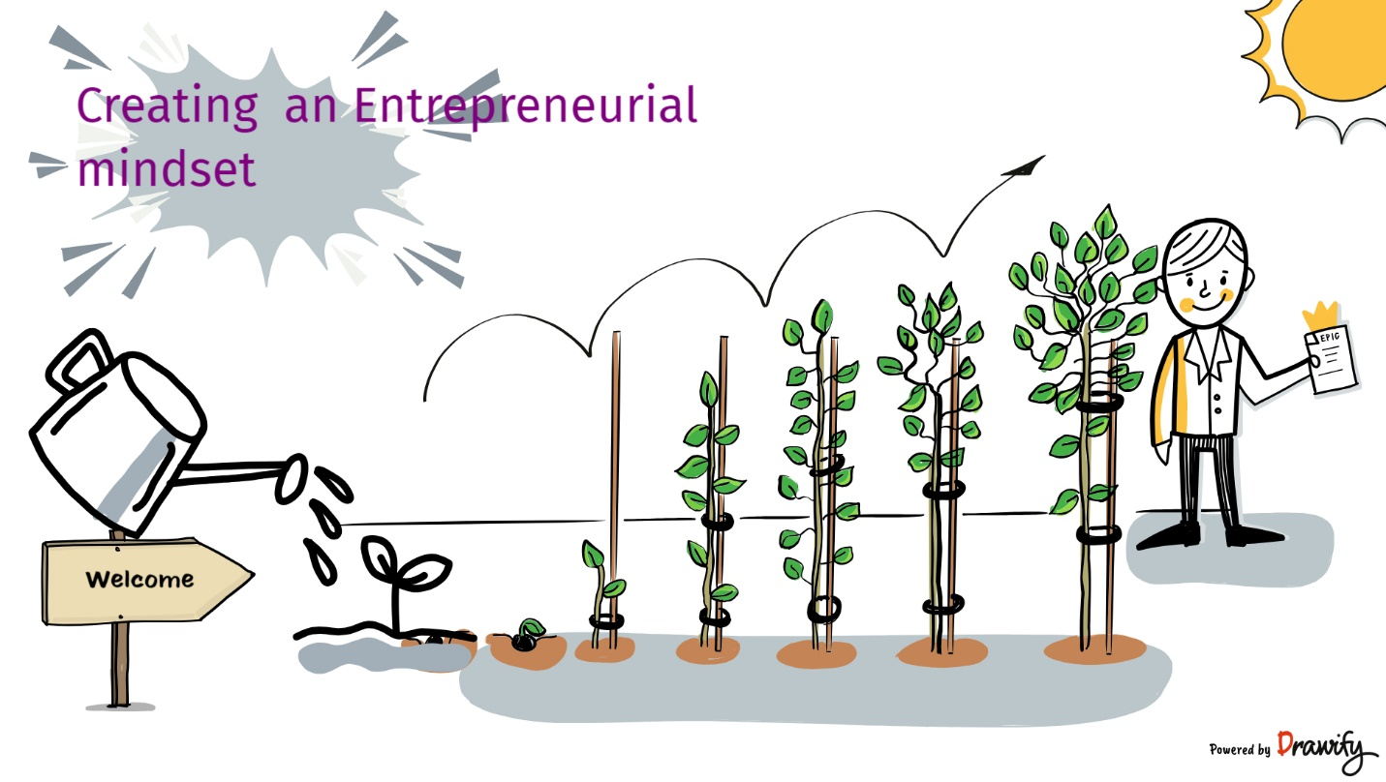

1.1.3 IMPLICATIONS OF ENTREPRENEURIAL MINDSET IN STUDENT'S LIFE:
The way in which students approach learning in an entrepreneurial curriculum can have a big impact on how successful they are as entrepreneurs and how much they learn overall. Here are some significant ramifications:
1. Mindset as a Foundation: In entrepreneurship education, the entrepreneurial mindset is frequently seen as a foundational component. It encompasses traits like inventiveness, resilience, flexibility, a readiness to take calculated risks, and a focus on problem-solving. Students are more likely to embrace and apply these entrepreneurial characteristics if they approach an entrepreneurial programme with a growth mindset, which is the belief that one's skills and intelligence can be increased via work and education.
2. Effect on Learning: Learners who have a growth mindset are typically more receptive to new information and view failures and setbacks as opportunities for improvement. Conversely, those who have a fixed mentality may make them less willing to take chances and more risk-averse, which may restrict their ability to experiment with novel business concepts or strategies. Thus, encouraging pupils to adopt a growth mentality can increase their openness to the entrepreneurial curriculum.

3. Risk Tolerance: One of the most important components of entrepreneurship is the willingness to take measured risks. Risk-averse students could find it difficult to accept the uncertainties and difficulties that come with starting and operating a business. By giving them the knowledge and abilities to successfully analyse and manage risks, an entrepreneurial curriculum can assist students in developing a balanced approach to taking risks.

4. Resilience and Persistence: Entrepreneurship frequently entails dealing with failures and disappointments. Students that have a resilient mindset are better able to overcome these difficulties and stay motivated. Students can develop this crucial skill through studying great entrepreneurs who overcame adversity or other curriculum elements that emphasise resilience problems. Students who are encouraged to think creatively tend to develop more original business concepts and strategies. Entrepreneurial curriculum frequently include tasks and activities that encourage original thought.

1.1.4 FUTURE OF ENTREPRENEURIAL MINDSET AMONG STUDENTS :
Students' future attitudes towards entrepreneurship will be influenced by a variety of sociological, technological, and economic factors. The following are some significant developments and things to think about for the future of students' entrepreneurial mindsets:

- Technology Integration
- Remote Learning and Collaboration
- Global Perspective
- Life long learning
- Sustainability and Social impact
- Resilience and mental Health.
- Data Literacy
- Interdisciplinary learning

A solid foundation in technology, global awareness, diversity, adaptability, ethical considerations, and a dedication to addressing urgent societal and environmental challenges will define the future of the entrepreneurial attitude among students. These elements will equip students to succeed in an entrepreneurial environment that is rapidly changing and to make significant societal contributions through their companies.
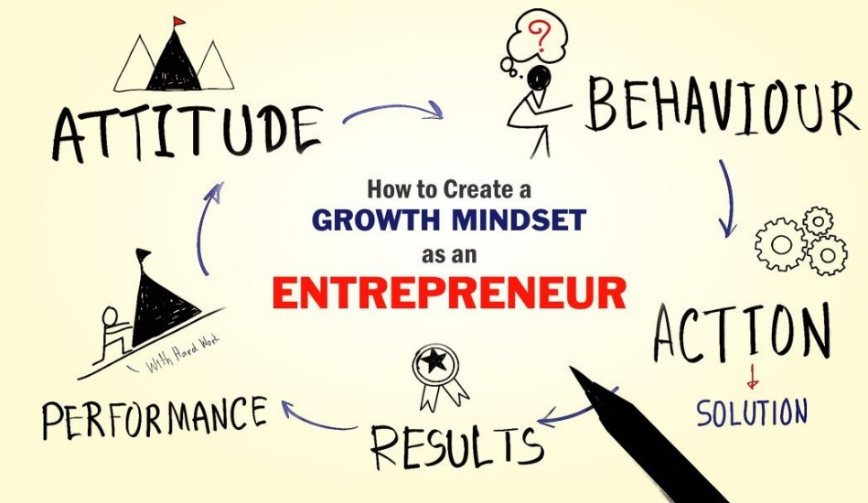

(https://businessconnectindia.in/wp-content/uploads/2019/06/How-to-Create-a-Growth-Mindset-as-an-Entrepreneur.jpg)
The following are the Entrepreneurial skills developed through creating entrepreneurial mindset among the students.
Entrepreneurial Skill Sets | Offer Venture lab Programmes
Creating Entrepreneurial Mind set | - Teach Entrepreneurial topics – instructional ppts and videos, use a printable student work book  - Provide Entrepreneurial learning to the students as a part of a class, curriculum, hybrid and remote learning  - Venture Lab : Programs and assignments include idea pitch, Knowledge on Social Entrepreneurship and career exploration
Advanced Skills and Innovative thinking
Creative thinking
Problem solving Skills
Thinking differently
Critical thinking
Idea Generation
Business Knowledge
Analytical Skills

A solid foundation in technology, global awareness, diversity, adaptability, ethical considerations, and a dedication to addressing urgent societal and environmental challenges will define the future of the entrepreneurial attitude among students. These elements will equip students to succeed in an entrepreneurial environment that is rapidly changing and to make significant societal contributions through their companies.
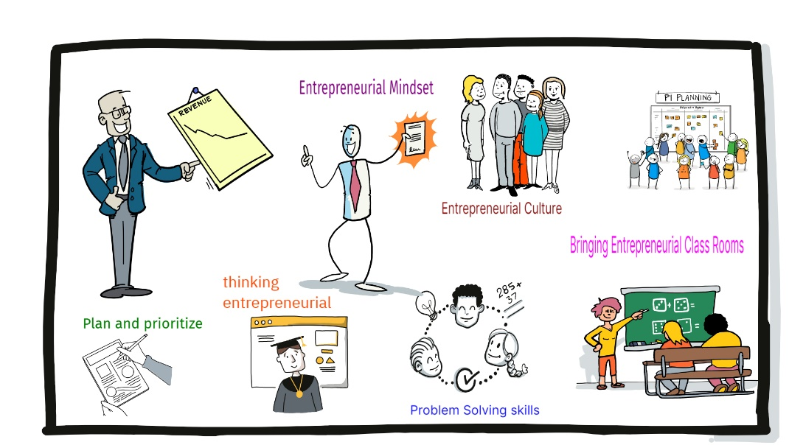
(image source : own)

- Government Initiatives - What is entrepreneurship program for students?

The objective of this chapter is to have an Understanding of the government's attempts to promote entrepreneurial empowerment is the chapter's main goal.

Students that enrol in entrepreneurship programmes learn fundamental life skills like problem-solving, creative thinking, and cooperation. These courses also focus on developing abilities relevant to modern circumstances. Students are taught, for instance, how to adjust to the rare pandemic event.
A 6-day certification programme called Young Entrepreneurs Classroom (YEC) helps students develop their business skills. This brief course introduces students to the fundamental ideas of entrepreneurship and demonstrates the path to pursuing their entrepreneurial goals.

The New Education Policy places a strong emphasis on developing pupils' sense of entrepreneurship from their earliest years in school. The future entrepreneurs should be supported from an early age in a setting where entrepreneurship is anticipated to be the economic mainstay. In this regard, Metamorphosis Edu, the first organisation in the world to teach entrepreneurship to children at the school level (Grades VI through XII), has developed short courses that are specifically designed for students to teach them the guts and bolts of launching their own enterprises. (Refer Table 1 )
Through a stronger emphasis on practical learning, the recent reforms to the National Education Policy (NEP) have the potential to have a substantial impact on entrepreneurial education in India, both at the secondary level and at the higher education level. The NEP offers a fantastic chance to improve entrepreneurship education because of its clear entrepreneurship focus. Indian students seeking postsecondary education may benefit from knowledge transfer from nations with well-established entrepreneurship education programmes and ecosystems thanks to legislation reforms allowing international universities to build campuses in India. More people might be inspired to pursue entrepreneurship education as a result of the NEP's implementation of a credit transfer system and improved freedom in switching between universities and programmes, directly promoting the expansion of the nation's entrepreneurial ecosystem. Consequently, we may witness the emergence of a more vibrant and diverse pool of Indian entrepreneurs equipped with the necessary skills and knowledge to navigate the complexities of the modern entrepreneurial landscape.

Benefits of Entrepreneurial Education
Simply said, starting your own business is the finest way to change the way you work and live. Our students may always profit from and contribute to entrepreneurship. Their entrepreneurship education compels students to begin their professional careers prior to earning their degrees. So many successful businesspeople have launched their ventures even before earning their degrees.
Our students also benefit greatly from entrepreneurship education in that they start their own businesses at a young age. Instead of putting too much emphasis on their studies and extracurricular activities, they strive to concentrate on honing their abilities and put a lot of effort into doing so in order to make them a better source of income for themselves. The term for creativity and invention is entrepreneurship. One advantage of entrepreneurship for our students is that it motivates them to take risks and develop even greater creativity and innovation in their chosen fields.
The following are the benefits of Entrepreneurial education viz.,
- Knowledge of Business at early stage
- Thinking for a better future
- Entrepreneurial education is relevant to all fields
- Personal growth and development
- Creation of Job opportunities
- Prepares for future
- Help them to identify and solve problems .

Table – 1 Entrepreneurial Initiatives by the Government of India
MSE - Metamorphosis School of Entrepreneurship | Young Entrepreneur’s Class Room- YEC | Metamorphosis Entrepreneurship Olympiad (MEO) –MEO | Jump starter
A two-year entrepreneurship programme is available to pupils at the school level from the Metamorphosis School of Entrepreneurship. Students are given an end-to-end entrepreneurial experience through the carefully crafted curriculum, which takes them on a journey from ideation to establishing a business plan to launching the finished product onto the market.  The curriculum is centred on case studies, and there are mentoring and live guest speaking sessions. Additionally, the alumni community is encouraged to take part in numerous networking opportunities and business-plan competitions. | A 6-day certification programme called Young Entrepreneurs Classroom (YEC) helps students develop their business skills. Students learn the fundamentals of entrepreneurship in this brief course, which also demonstrates the path they should take to become successful entrepreneurs. It uses both live sessions and a hybrid teaching methodology.  The students will receive certification as Young Entrepreneurs from Metamorphosis in collaboration with IIT Bhubaneswar upon successful completion of the programme. | a national competitive exam given to pupils in schools. Students might evaluate their entrepreneurial quotient and make progress towards sharpening their abilities, which are essential to have in the next age of automation, through this test (which features questions that have been professionally vetted by real-time entrepreneurs and industry professionals).  The winners would be validated by Metamorphosis in collaboration with IIT Bhubaneswar, and they would be announced at both the national and school levels. | Metamorphosis has put together a class called "Jumpstarter" to introduce students to entrepreneurship. Students will learn the what, why, and how of entrepreneurship in this course, as well as about the vast opportunities that would be made available to young businesspeople. The accessibility of schools will affect this course.  The following topics would be covered (one of the following would be chosen for a session)  The Value of Entrepreneurship from a Young Age  Entrepreneurial Skills for the 21st Century  How to start a business before age 20  How Early Startups Travel
Eligibility: Grade VI to Grade XII  Course Duration: 2 years  Fee: Rs 50,000  Link: https://www.metamorphosisedu.com/metamorphosis-school | Eligibility: Grade VI to Grade XII  Course Duration: 6 days  Session Duration: 1 hour  Fee: Rs 999 (as of now)  Link: https://www.metamorphosisedu.com/entrepreneursclassroom | Eligibility: Grade VI to Grade XII  Fee: None  Link: https://www.metamorphosisedu.com/meo | Eligibility: Grade VI to Grade XII  Course Duration: 1 Day  Session Duration: 1 hour  Fee: None

2.1 Institutionalizing the concept of a “Professor of Practice”:
By formalising the appointment, functions, responsibilities, and contributions of people in these positions, the idea of "Professor of Practise" is institutionalised inside educational institutions. An expert practitioner with real-world experience who contributes to academics is often referred to as a professor of practise. The following actions can be taken to formalise this idea:
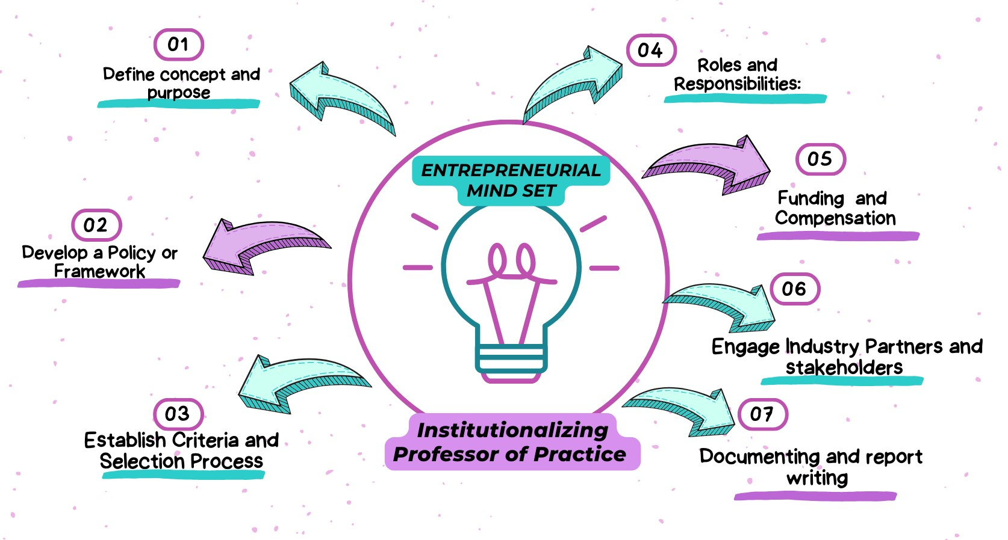
(Source : own for research)
Institutionalising the idea of professors of practice can improve industry relevance, improve the educational experience, and develop ties between academia and the working world. It necessitates careful planning, backing, and a dedication to incorporating real-world experience into the classroom.
These individuals would serve as role models and mentors, guiding bright students in creating ground breaking ventures, similar to the creation of Google on a university campus. All India Survey on Higher Education (AISHE): The main objectives of the survey are to identify and capture all the institutions of higher learning in the country; and collect the data from all the higher education institutions on various aspects of higher education.
2.2.1 Key findings of All India Survey on Higher Education (AISHE) 2020-2021
Specification | 2020-21 | Trend w.r.t 2014-15.
Total student enrolment: UP, Maharashtra, TN, MP, Karnataka and Rajasthan are top 6 States in terms of number of students enrolled. | 4.14 crore. | 21%
Female Enrolment | 2.01Crore | 28%
Percentage of female enrolment to total enrolment... | 49% | 4
Gross Enrolment Ratio (GER): Percentage of students belonging to eligible age group (18-23 years) enrolled in Higher Education. | 27.3 | 3 point raise
Gender Parity Index (GPI): Ratio of female GER to male GER | Increased from 1 in 2017-18 to 1.05 | ---
Institutes of National Importance (INIs)... |  | Almost doubled 75
Enrolment in INIs | 149 | increased
Female per 100 male faculty | 61% | Increased (63)

From the above table of comparison (Aishe), it is opined that there is a rise in enrolment and other aspects demands that the learning environment has to be changed. Female enrolment has increased to 28 % when it is compared to 2014-15 data.
2.4 Entrepreneurial Initiatives for women
In order to enable and inspire women entrepreneurs to launch and expand their enterprises, the Indian government has established a number of entrepreneurial education and assistance programmes for women. These programmes seek to give women the information, abilities, resources, and networks of support they need to succeed as business owners. The following are some significant government programmes for women's entrepreneurship education in India.
These federal initiatives, in addition to other state-specific initiatives, are essential in promoting entrepreneurial education for women in India. In order for women to start and build their enterprises, contribute to the economy, and attain financial independence, they want to foster an environment that is encouraging. These programmes offer networking opportunities, financial aid, and training for women who are interested in starting their own businesses.
Exhibit – 1
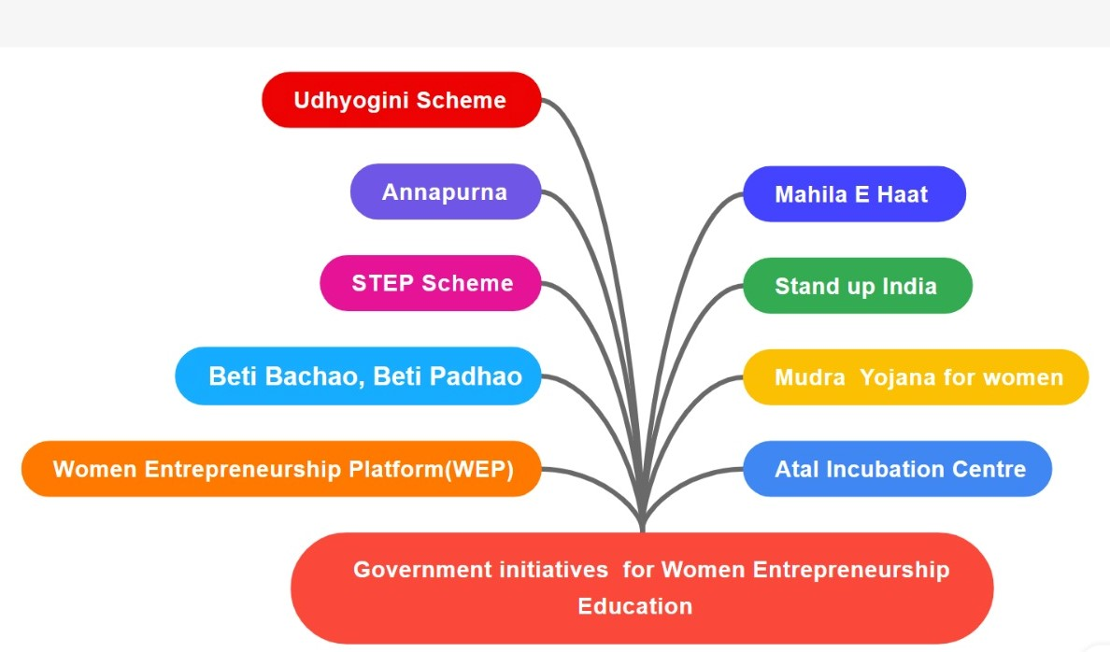
Table- 3- Government Initiatives for Women Entrepreneurial Education
S.No | Scheme | Details of the Scheme
1 | MUDRA Yojana for Women | - The Pradhan Mantri MUDRA Yojana (Micro Units Development and Refinance Agency) provides loans to women entrepreneurs at affordable interest rates.  - It offers three categories of loans: Shishu, Kishor, and Tarun, with increasing loan amounts based on the business's stage of development.
2 | Stand-Up India | - This initiative aims to promote entrepreneurship among women and marginalized communities by providing bank loans between ₹10 lakh and ₹1 crore to set up greenfield enterprises.  - At least one woman entrepreneur and one individual from a Scheduled Caste (SC) or Scheduled Tribe (ST) is eligible for this scheme.
3 | Beti Bachao, Beti Padhao: | - While not directly an entrepreneurship program, this initiative by the Indian government promotes the education and welfare of the girl child, which indirectly contributes to their empowerment and potential as future entrepreneurs.
4 | Annapurna Scheme | - This scheme offers working capital to women entrepreneurs who run food catering businesses, canteens, and food stalls.  - It helps women expand their food-related businesses.
5 | Mahila e-Haat: | - Launched by the Ministry of Women and Child Development, Mahila e-Haat is an online platform that enables women entrepreneurs to showcase and sell their products and services.  It provides a digital marketplace for women to reach a wider audience.
6 | Udyogini Scheme | This scheme by the Rajasthan government offers financial assistance and training to women entrepreneurs in the state.  It aims to encourage women to start and manage small-scale businesses.
7 | STEP Scheme | The Support to Training and Employment Program for Women (STEP) is a government initiative that provides skill development and training to women to enhance their employability and entrepreneurial abilities.
8 | Women Entrepreneurship Platform (WEP): | Although not a government initiative, the WEP was launched by NITI Aayog to promote and support women entrepreneurs in India. It offers various programs, resources, and opportunities for women to connect, learn, and grow as entrepreneurs.
9 | Atal Incubation Centres (AICs): | These centres, supported by NITI Aayog, provide incubation and mentoring support to start-ups, including those led by women. AICs help women entrepreneurs develop their business ideas and access resources.
1(Government of India Initiatives )
STEP Scheme
A Doorway to an Entrepreneurial University Background- Higher Education in India
In relation to India, the phrase "higher education" refers to the tertiary level instruction that is provided following 12 years of formal education (10 years of elementary education and 2 years of secondary education). Next to China and the United States, India has the third-largest higher education system in the world.Since India's independence, the number of universities, college-level institutions, and other higher education institutions has significantly increased.
There are 11,779 independent institutions, 42,343 colleges, and 1043 universities in India, according to the All-India Survey of Higher Education (AISHE). Only approximately 21% of them are government-run colleges, while the majority—nearly 78.6%—are in the private sector. The article discusses the value of collaborations between academia and industry in driving economic and intellectual growth.
University for Entrepreneurship :
The "entrepreneurial university" is a concept that is being discussed as the next step in the development of universities. It recognises that opinions on whether universities should concentrate only on doing original research and generating new knowledge or whether they should also try to monetize their intellectual product vary.
III. Relationship of Prevalence, Effectiveness and equal Accessibility for Entrepreneurial Education.
1. Prevalence: Recent years have seen a considerable increase in the popularity of entrepreneurship education as more people want to acquire the skills and information required to launch and run their own firms. At several levels, including elementary and secondary schools, colleges, universities, and institutions of higher learning, entrepreneurship education is provided. The prevalence of entrepreneurship education varies by region, with some places emphasising the integration of entrepreneurial concepts into their curricula more than others, while others are currently creating such programmes.
2. Effectiveness: The influence entrepreneurship education has on students' entrepreneurship-related knowledge, skills, attitudes, and behaviours can be used to assess its efficacy. Effective entrepreneurship education emphasises practical skills like ideation, company planning, market research, financial management, and networking in addition to theoretical understanding. Additionally, it ought to promote an innovative, resilient, and adaptable mindset. The success of graduates who go on to found and run prosperous enterprises, contribute to economic growth, and spur innovation demonstrates the long-term efficacy of entrepreneurship education.
3. Equal Accessibility: To ensure that people from all backgrounds have equal access to high-quality entrepreneurship education, ensure equal accessibility in the field of entrepreneurship education. This includes removing obstacles that could exclude some groups from participating:
- Gender Equality: Providing equal opportunities for both genders to access entrepreneurship education and ensuring that curriculum materials and classroom environments are inclusive.
- Socioeconomic Inclusion: Ensuring that individuals from different socioeconomic backgrounds have access to entrepreneurship education, regardless of their financial means.
- Racial and Ethnic Diversity: Creating inclusive environments that cater to the needs of diverse racial and ethnic groups, and promoting diverse role models and mentors in entrepreneurship education.
- Geographical Accessibility: Offering entrepreneurship education in both urban and rural areas to ensure that students from all geographic locations can participate.
- Accessibility for People with Disabilities: Designing education materials and physical spaces that are accessible to people with disabilities.

Offering scholarships and financial aid, collaborating with neighbourhood organisations, creating curriculum materials that are culturally relevant, and utilising online learning platforms to reach a larger audience are all ways that equal accessibility in entrepreneurship education is promoted.
In general, entrepreneurship education is essential for giving people the abilities and outlook required to thrive in an entrepreneurial setting. We can encourage a broad and dynamic ecosystem of future entrepreneurs who contribute to economic growth and innovation by assuring its ubiquity, efficacy, and equal accessibility.

Conclusion
This study has highlighted the popularity and accessibility of informal learning channels for entrepreneurship education, but further research is needed to assess their prevalence, effectiveness, and equality of access. In order to assess their influence and any potential negatives, it can be useful to comprehend the extent to which aspiring businesses in India rely on informal channels, such as networks, independent coaches, and knowledge passed down through relatives. The study should examine the factors that affect how well aspiring entrepreneurs can compensate for a lack of formal schooling options. Future research should try to identify and address these vital issues in order to comprehend entrepreneurial education in India. We can get insights into the difficulties, possibilities, and trends through rigorous research employing larger and more diverse sample sizes.
We can learn more about the difficulties, opportunities, and potential limiting factors in obtaining entrepreneurship education by doing rigorous study with larger and more diverse sample sizes. The development of a more open, accessible, and thorough entrepreneurship education will be guided by this knowledge, helping to create a strong entrepreneurial environment in India.
References
- https://www.studyiq.com/articles/a-doorway-to-an-entrepreneurial-university/
- India Today -New Delhi, UPDATED: Nov 6, 2022 14:10 IST
- https://www.forbes.com/sites/robynshulman/2018/04/08/5-ways-teachers-can-introduce-entrepreneurship-skills-in-their-classrooms/?sh=2b9ab0e67293
- Report By Jagdish Bishnoi, Founder & CEO, SAFL India Foundation Research Scholar, University of Delhi.
- https://techbaji.com/entrepreneurship/entrepreneurship-for-students/

