Role of Evidence-based practice in Nursing
In present scenario healthcare, the professionals are required to make their clinical decisions on the basis of best available evidence. Evidence based medicine (EBM) is a systematic approach to clinical problem solving. It allows the integration of the best available good quality research evidence with clinical expertise and opinions or values of the patient, family members or caregivers. This concept of EBM has been gaining popularity in the past decade.
Evidence-based practice can be defined as a problem-solving approach to clinical decision-making within a healthcare facility or organization. Or it is based on the evidence from credible studies and findings, they are engaging in what is known as evidence-based practice. It is essential in providing holistic and best quality health care in the field of nursing rather than traditional methods. In clinical decision-making, in addition to the available evidence, many other factors such as judgment, personal beliefs or experience, skills, and more importantly patient values and preferences must be considered. EBP is about bringing scientific results into practice
Nurses have massive role in the delivery and promotion of quality health care services. Nurses can expand their knowledge and improve their clinical practice experience by collecting the available research findings, processing and implementing them as per need. Evidence-based practice mainly focuses on the patient i.e. the heart of nursing. Thus, Evidence-based practice (EBP) is an important tool which should be integrated into daily practices as it influences the professional development, capabilities and responsibilities of nurses.

There may be necessary healthcare environment for evidence-based practice (EBP) supporting its practices. For the practices to be evidence-based, the practitioners must incorporate the newly generated knowledge into their daily routines. Like in the US, there is the supportive healthcare environment requiring healthcare practitioners to provide efficient and effective health care. This environment also mandates continuous improvement in health care processes and outcomes. Many healthcare organizations have created strategic initiatives for EBP.

Yet there is a well-documented delay in implementing new knowledge into practice environments. Even with the increased emphasis on EBP, the majority of healthcare practitioners and organizations have still not implemented the EBP guidelines available to them for best health care.

Why Is Evidence-Based Practice in Nursing Essential?
- It bridges the theory-to-practice gap and delivers innovative patient care using the most advanced health care finding. It offers a range of other benefits to the nurse and your patient.
- Consumer pressure and increased patient expectations place an even greater emphasis on this need for true evidence-based practice.
- EBP enable organizations to meet the healthcare aim to enhance quality of the patient care, improve overall community health, reduce healthcare burden and increase the well-being of healthcare practitioners and staff.
- There are various examples of evidence-based practice in nursing such as: Management of angina pain and measurement of blood pressure (B.P) in children.
How to use EBP : models of EBP:

Several evidence-based practice (EBP) models have been developed by the nurses and other healthcare professionals that may aid in the implementation of EBP. These models serve as organizing guides to integrate the available research to create best patient care practices. Training courses for EBP have been provided by the National Library of Medicine designed using pubmed.

THE FIVE STEP EBM MODEL :-
By following five essential steps, the nursing staff & healthcare professionals can do evidence-based practice.
1. Ask a searchable clinical question by identifying the patient population, interventions, comparisons and outcomes (PICO). ;
2. Find the best evidence to answer the question by performing a literature search
3. Appraise the evidence for its validity and usefulness in clinical practice.
4. Apply the evidence with clinical expertise, taking the patient's wants/needs into consideration;
5. Evaluate the effectiveness and efficiency of the process.
Johns Hopkins Evidence-Based Practice (JHEBP) model. (Figure.1)
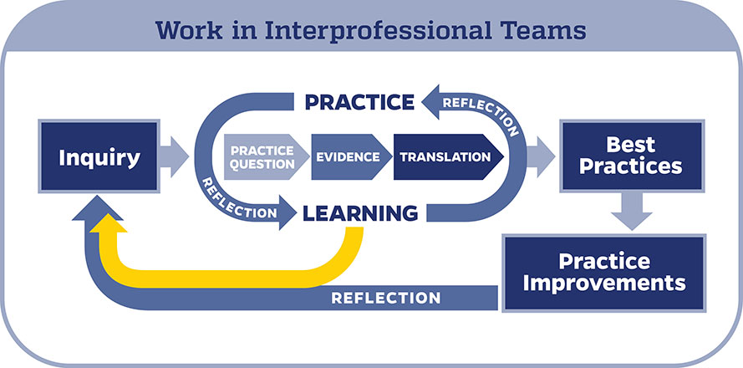One of the best examples is Johns Hopkins Evidence-Based Practice (JHEBP) model. This model is accompanied by user-friendly tools. The nurses at Johns Hopkins can access all the JHEBP tools via our Inquiry Toolkit. Inquiry Toolkit contains all the ten JHEBP tools, organizing the tools in four main categories like Evidence-based practice tools, Quality improvement tool, Research tools, and Dissemination tools with their own multiple types of applications. Some types of tools under Evidence-based practice tools category are PET Process Guide, question development tool, stakeholder analysis tool, evidence level and quality guide, research evidence appraisal tool, non-research evidence appraisal tool, individual evidence summary tool, synthesis and recommendations tool, Translation and action planning tool, and EBP publication guide tool.
JHEBP Dissemination Tool is used to prepare and share the outcomes of EBP project with the community i.e. for publication after the completion of the project.
The tools are available to individuals from other institutions via the Institute for Johns Hopkins Nursing (IJHN).Johns Hopkins nurses have access to a free online course entitled JHH Nursing | Central | Evidence-Based Practice Series. The course follows the JHEBP process from beginning to end and provides guidance to the learner on how to use the JHEBP tools. 5 steps of EBM are shown in Figure 2.

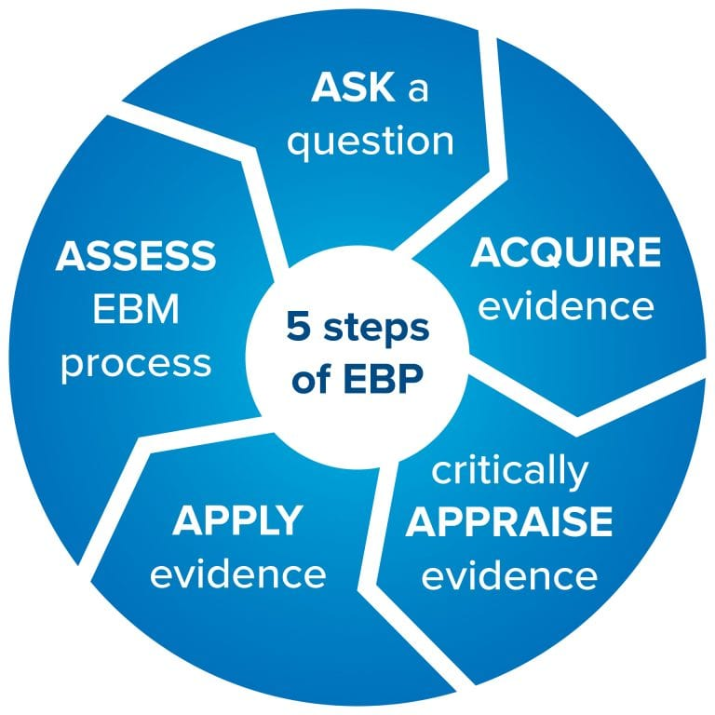
Figure 2: Five steps of EBM (Strauss, S. E. Evidence-Based Medicine: How to Practice and Teach EBM. New York: Churchill Livingstone, 2005)

The healthcare professionals need to be developing the competences to apply their new knowledge & skill into practice, for the distinction between decision-making for a single patient or a group of patients (Figure 3).
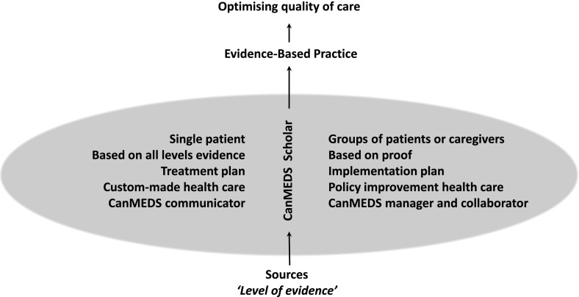

Figure 3: Schematic overview of the differences in evidence-based practice for a single patient as opposed to a group of patients or caregivers

Advantages of EBP:-
- foster shared decision-making about the patient's care
- better outcomes,
- higher satisfaction,
- continuous quality improvement in clinical care
- better patient outcomes and nursing practice .
- reduces the health care costs by preventing complications
Knowledgeable healthcare professionals make decisions based on the best available evidence, not conclusive and up to date information only. As for the practitioners, their professional judgment and expertise to determine whether the evidence is applicable, is required.
As the trend has been shifting from classic practices, nurses new and experienced face few limitations to adjust to the new environment of evidence based practices.
Barriers /Limitations in impelemattaion of evidence based practice in the field of nursing:
These may be organizational barriers or individual in healthcare professionals, as studied.
- Non-availability of best evidence
- Lack of resources& limited support
- Current management environment changes
- Lack of new knowledge, skills and awareness in seeking and appraising evidence, nurses’
- Lack of personal attitude professional experience and characteristics
- language barrier
- Time constraints
- Hiring of young and inexpensive practitioners and equiping them with an evidence-based protocol in some organizations to cut off the treatment costs.
(https://cebma.org/faq/limitations-evidence-based-practice/)
These identified barriers can be overcome by facilitating the implementation of evidence-based practice among healthcare professionals with the help of Nursing administrators and educators. Training and education must be provided to them to enhance knowledge, skills and awareness to use evidence based practice. Providing the adequate resources, time management and adequate supervision can facilitate the implementation of evidence-based practice which influence the quality of health care positively.
REFERENCES:-
- Evidence-Based Practice: Context, Concerns, and Challenges. In: Dang D, Dearholt SL, Bissett K, Ascenzi J, Whalen M. eds. Johns Hopkins Evidence-Based Practice for Nurses and Healthcare Professionals Model and Guidelines, 4e. McGraw Hill; 2022. Accessed July 24, 2023. https://apn.mhmedical.com/content.aspx?bookid=3144&sectionid=264685308.
- https://study.com/academy/lesson/critical-care-nursing-scenarios-case-studies.html
- Strauss, S. E. Evidence-Based Medicine: How to Practice and Teach EBM. New York: Churchill Livingstone, 2005.
- Akobeng AK. Principles of evidence based medicine. Archives of Disease in Childhood 2005;90:837-840.
- https://cebma.org/faq/limitations-evidence-based-practice/)
- Banakar M, Alatawi M, Aljuhani E, Alsufiany F, Aleid K, et al. (2019) Barriers of Implementing Evidence-Based Practice in Nursing Profession: A Literature Review. J Nurs Care 8: 496.

