EMPOWERING RURAL WOMEN IN INDIA: SELF-HELP GROUPS AS CATALYSTS FOR DEVELOPMENT
Ananya Ghosh^{1*}, Arindam Ghosh
Assistant Professor, Department of Agronomy, School of Agricultural Sciences, Sister Nivedita University
Assistant Professor, Department of Agricultural Extension, School of Agricultural Sciences, Sister Nivedita University
Corresponding author email id- ananya.ghosh0193@gmail.com
1. Introduction
Self-Help Groups (SHGs) are voluntary associations of individuals who share similar socio-economic backgrounds and unite to address common challenges through self-help and mutual support. The primary aim of SHGs is to empower their members both economically and socially. These groups are known by various names across different regions of India, such as Sangha, Samooh, Mandal, Dangham, and Samiti (Kumar, 2006).
SHGs are primarily formed to promote the economic empowerment of women and communities. They engage in activities related to savings, credit, and establishing links with banks to access larger financial resources (Gugerty et al., 2019). While savings and credit activities are the main focus, SHGs also undertake initiatives to empower women, improve health and education, and enhance overall well-being. It is widely recognized in the field of development that women's involvement in economic activities, such as savings and credit, can lead to their empowerment.
The concept of SHGs has gained widespread popularity because it enables individuals to collectively address shared challenges and create opportunities for socio-economic progress. By fostering self-reliance and encouraging mutual assistance, SHGs contribute to the empowerment of women and communities, enabling them to actively participate in decision-making processes and improve their overall standing within families and communities.
2. Purpose of SHGs
2.1. Economic Empowerment: The primary purpose of SHGs is to empower their members economically. They aim to enhance their income-generating capacity, savings habits, and access to credit and financial resources. By pooling their savings, members can accumulate funds and provide loans to each other, promoting entrepreneurship and economic self-reliance.
2.2. Social Empowerment: SHGs also focus on social empowerment, particularly the empowerment of women. They provide a platform for women to come together, voice their concerns, and collectively address gender-based issues. SHGs often undertake activities to improve women's health, education, and overall well-being, thus enhancing their social status and decision-making power.
2.3. Mutual Support and Solidarity: SHGs foster a sense of mutual support and solidarity among their members. By working together and sharing experiences, knowledge, and resources, group members can tackle challenges more effectively. SHGs provide a support system that helps individuals overcome social and economic obstacles and build resilience.
2.4. Community Development: SHGs play a vital role in community development. They often undertake initiatives that benefit the broader community, such as implementing environmental conservation projects, organizing awareness campaigns, and promoting social cohesion. SHGs contribute to the overall development and upliftment of their communities.
2.5. Capacity Building: SHGs provide opportunities for capacity building and skill development among their members. Training programs, workshops, and educational sessions are conducted to enhance members' knowledge, technical skills, and entrepreneurial capabilities. These capacity-building efforts enable individuals to explore new livelihood opportunities and improve their overall well-being.
3. History of SHGs
The history of SHGs dates back to 1985, from the actions undertaken by the Mysore Resettlement and Area Development Agency (MYRADA). The SHG movement, under the leadership of MYRADA, first started in the southern states. There is a general awareness in these states, especially amongst women, regarding thrift and importance of cheap credit. By 1986-87, there were around 300 SHGs in MYRADA's projects. MYRADA imparted training to these groups on several grounds like organizing meetings, setting agendas, keeping minutes and accounts etc (Gouranga, 2018).
Over time several agencies like the National Bank for Agricultural and Rural Development (NABARD), the Reserve Bank of India (RBI), leading NGOs, as well as multilateral agencies like International Fund for Agricultural Development (IFAD) helped in the growth of the SHGs. The history of SHGs can be broadly studied in two phases:
Phase 1(1987-1992)
In this phase, NABARD was the main agency for helping out SHGs. NABARD undertook measures to assist MYRADA through a grant of INR 1 million in 1987. It then helped other NGOs involved in promoting SHGs. In 1992, the RBI accepted the SHG model as an alternative credit option.
Phase 2(1992-present)
In this second phase, the linkage of SHGs and banks was done, with the unstinting support of RBI as well as IFAD. By March 2005, credit had been extended to about 1,628,456 SHGs with a cumulative membership of about 24 million families.
Since 2011, the Indian government has actively promoted SHGs through the National Rural Livelihood Mission (NRLM) (Nichols, 2021). The NRLM aims to include at least one woman from every impoverished household in an SHG. By May 2019, the program had successfully mobilized around 60 million women, resulting in the formation of nearly 6 million SHGs (GOI 2019). The government, in collaboration with non-governmental organizations (NGOs) and funding agencies, has expanded the scope of SHGs and introduced targeted interventions to further support development initiatives.
4. Importance and relevance of SHGs in community development
Recent analyses have conceptualized how SHGs might impact various economic, social, and health related outcomes (Gugerty et al., 2019, Kumar et al., 2018, Kumar et al., 2019, Raghunathan et al., 2019). Kumar et al. (2018) chart four pathways by which different types of SHGs might impact MCHN. The pathways include (i.) income generation, (ii.) agriculture, (iii.) behaviour-change communication (BCC), and (iv.) rights awareness. Social capital generation, collective action, and women’s empowerment are identified as cross-cutting pathways that enable impacts on health (Fig. 1).
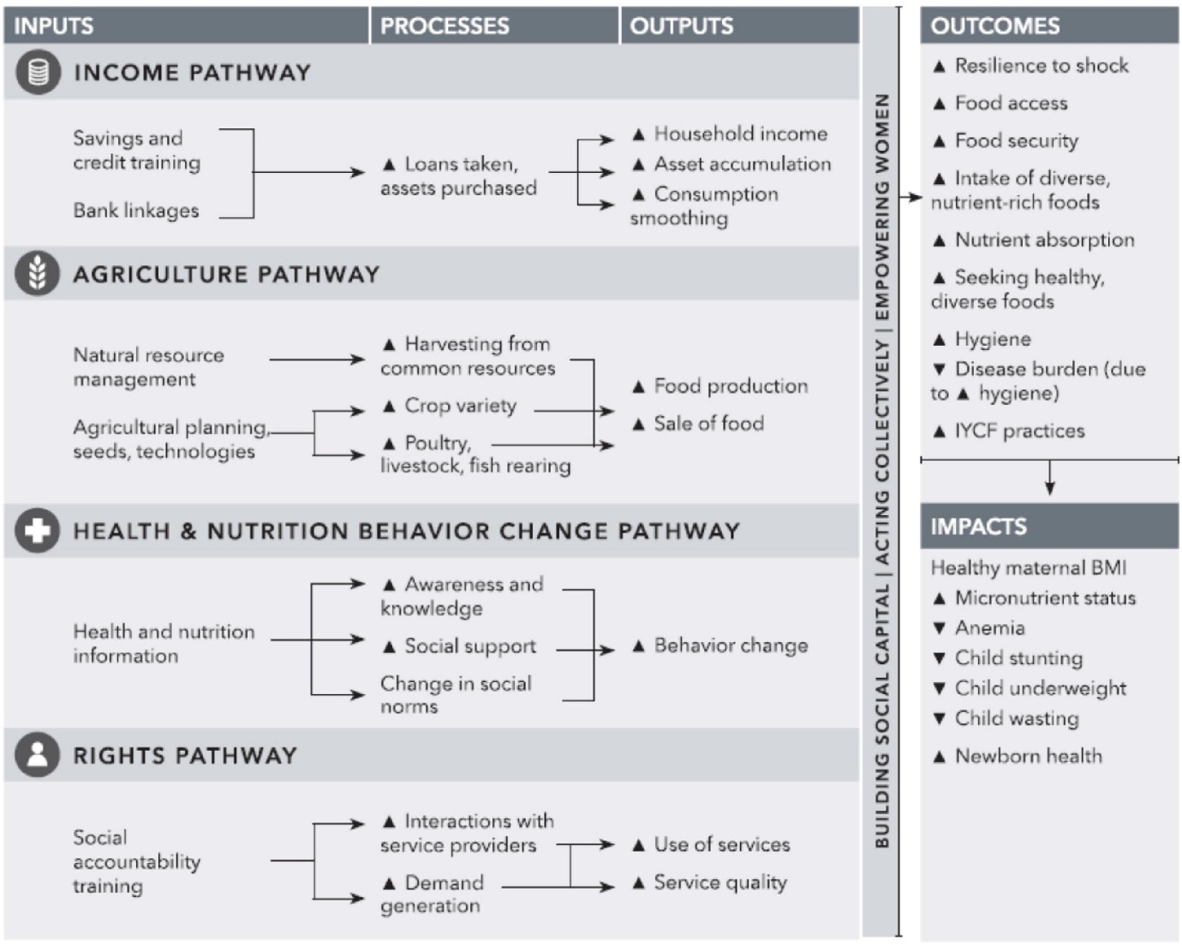
Fig.1. Importance and relevance of SHGs in community development
Conceptual pathways from women's groups to maternal and child nutrition (from Kumar et al., 2018).
5. Process of forming an SHG
The model depicts the implementation processes necessary to layer interventions onto SHGs, which include: (i.) SHG group establishment, (ii.) selecting and training SHG members to disseminate information (iii.) discussing information in weekly SHG meetings, and (iv.) women implementing this information in their lives or troubleshooting problems in subsequent meetings (Fig. 2).
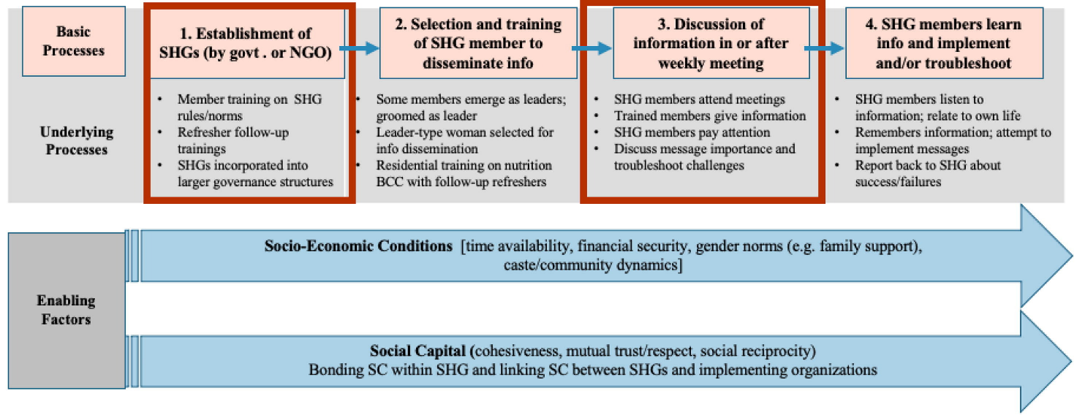
Fig. 2. Implementation framework (Nichols, 2021).
6. Governance and Decision Making of SHG
Governance and decision-making in Self-Help Groups (SHGs) involve the active participation of members. Key aspects of SHG governance and decision-making include:
6.1. Democratic Structure: SHGs typically follow a democratic structure where decisions are collectively made by all members, ensuring equal participation irrespective of socio-economic status.
6.2. Group Meetings: Regular meetings provide a platform for members to discuss and make decisions on various aspects of the SHG's functioning, allowing them to share their opinions, ideas, and concerns.
6.3. Consensus Building: SHGs strive to achieve consensus among members when making decisions. This involves open discussions, active listening, and finding common ground that satisfies the majority.
6.4. Agenda Setting: Prior to meetings, an agenda is established to ensure that all relevant topics and decisions are addressed, maintaining focus and productivity.
6.5. Decision-Making Process: SHGs employ participatory approaches to decision-making. Members present their proposals, concerns, or ideas, which are collectively deliberated upon, leading to a final decision based on the consensus reached.
6.6. Leadership Roles: SHGs may have elected or appointed leaders who facilitate decision-making, ensure inclusivity, and represent the group in external interactions.
6.7. Transparency and Accountability: SHGs emphasize transparency by sharing decisions, financial transactions, and pertinent information with members, fostering accountability within the group.
6.8. Conflict Resolution: SHGs have mechanisms in place to address conflicts and disagreements among members. These may involve further discussions, seeking mediation, or referencing the group's constitution or guidelines.
6.9. Inclusion and Gender Equality: SHGs prioritize inclusion and gender equality in decision-making processes, striving for the active involvement of all members, including marginalized individuals, and addressing any gender-based disparities.
6.10. External Support: Some SHGs receive external support from facilitators, NGOs, or government agencies. These entities offer guidance and capacity-building assistance to strengthen governance and decision-making within the SHG.
It is important to acknowledge that the specific governance and decision-making processes may vary across SHGs due to contextual factors, cultural norms, and the structure of each group. Additional mechanisms may be in place to ensure effective governance and decision-making within specific SHGs.
7. Objectives of SHGs
- Economic empowerment through savings and credit activities
- Linkages with banks and financial institutions
- Income-generating activities and entrepreneurship development
- Social and community development initiatives undertaken by SHGs
8. Activities of SHGs
8.1. Regular Meetings: SHGs conduct regular group meetings where members gather to discuss various issues, share experiences, and make collective decisions. These meetings provide a platform for interaction, learning, and planning.
8.2. Savings Mobilization: SHGs encourage members to save a portion of their income regularly. Members contribute to a common savings fund, which is used for lending purposes within the group.
8.3. Internal Lending: SHGs facilitate internal lending by providing loans to their members from the pooled savings. Loans are typically given for income-generating activities, education, healthcare, emergencies, or other specific needs of the members.
8.4. Income-Generating Activities: SHGs support members in identifying and engaging in income-generating activities. This may involve providing training, technical assistance, and market linkages to help members start or expand their businesses or agricultural ventures.
8.5. Skill Development and Training: SHGs organize skill development programs and training sessions to enhance the capabilities of their members. This includes imparting vocational skills, entrepreneurship training, financial literacy, and other relevant skills to improve income-generating abilities.
8.6. Social Support and Networking: SHGs provide a platform for members to support and assist each other beyond financial matters. Members offer emotional support, share experiences, and provide guidance to fellow members. SHGs also encourage networking with external stakeholders, community organizations, and government agencies for collaboration and resource mobilization.
8.7. Advocacy and Awareness: SHGs may engage in advocacy and awareness activities to address social issues, promote gender equality, and raise awareness about rights and entitlements. This can include awareness campaigns, community outreach programs, and participation in community development initiatives.
8.8. Monitoring and Evaluation: SHGs undertake monitoring and evaluation of their activities to assess the impact, identify areas for improvement, and ensure accountability. This may involve assessing the effectiveness of credit utilization, tracking savings, and evaluating the overall progress of the group.
It's important to note that the specific objectives and activities of SHGs can vary based on their local context, community needs, and the focus areas determined by the members.
9. Impact of SHGs
9.1. Economic impact on individual members and communities
Self-Help Groups (SHGs) have a significant economic impact, especially in developing countries. SHGs are community-based organizations where individuals, typically women, come together to pool resources, save money, and provide mutual support. The economic impacts of SHGs include:
9.1.1. Poverty Alleviation: SHGs aim to alleviate poverty by pooling savings. Members can access capital for income-generating activities like starting businesses or investing in agriculture. This boosts income and economic empowerment, helping members and their families escape poverty.
9.1.2. Financial Inclusion: SHGs provide marginalized individuals, who often lack access to formal financial services, a platform for financial inclusion. Regular savings and credit activities enable members to develop financial literacy and savings habits. They can access small loans from their group's savings, reducing reliance on costly informal moneylenders.
9.1.3. Employment Generation: SHGs engage in income-generating activities such as handicrafts, agriculture, and microenterprises. These activities create employment opportunities for SHG members and others in the community, contributing to local economic development.
9.1.4. Women Empowerment: SHGs predominantly consist of women, fostering women's empowerment. SHGs enhance decision-making skills, self-confidence, and leadership abilities. Women gain control over financial resources, contribute to household income, and experience improved social status and bargaining power within the family and community.
9.1.5. Community Development: SHGs undertake social and community development initiatives beyond economic activities. They engage in collective initiatives like building infrastructure, promoting education, healthcare, sanitation, and addressing social issues. These efforts contribute to the overall development and well-being of the community.
9.1.6. Financial Sustainability: SHGs promote a culture of savings and self-reliance. As groups mature and accumulate savings, they become financially sustainable entities. SHGs can leverage their accumulated capital to access formal financial institutions for larger loans, expanding their economic activities and impact.
The economic impact of SHGs may vary based on factors like the socio-economic context, government policies, market access, and the level of support and training provided. Nevertheless, studies consistently demonstrate that SHGs significantly contribute to poverty reduction, women's empowerment, and local economic development.
9.2. Empowerment and enhanced decision-making abilities of women
Self-Help Groups (SHGs) play a vital role in empowering women and enhancing their decision-making abilities. Here are the key ways in which SHGs contribute to women's empowerment:
9.2.1. Enhanced Financial Control: SHGs provide women with opportunities to save money, access credit, and engage in income-generating activities. Through active participation in savings and financial management within the group, women gain control over their financial resources. This autonomy enables them to make independent decisions regarding household expenses, investments, and savings.
9.2.2. Increased Economic Opportunities: SHGs enable women to participate in income-generating activities and develop entrepreneurial skills. By pooling resources and accessing credit, women can start small businesses or invest in agricultural activities. This opens up economic opportunities, enhances their financial status, and boosts their self-esteem.
9.2.3. Development of Leadership Skills: SHGs create a supportive environment for women to develop leadership skills and engage in decision-making processes. Women often hold key positions within the SHG, such as president or treasurer, which provides practical experience in managing group affairs. These leadership roles foster confidence, assertiveness, and effective articulation of their views.
9.2.4. Capacity Building and Training: Many SHGs offer training programs and capacity-building activities. These initiatives cover areas such as financial literacy, entrepreneurship, vocational skills, and leadership development. Acquiring new skills and knowledge empowers women to actively participate in decision-making at the individual, family, and community levels.
9.2.5. Social Empowerment: SHGs foster a supportive network where women can share experiences, discuss common issues, and provide mutual support. This sense of solidarity helps women overcome social barriers and challenges they face in their communities. SHGs promote gender equality, challenge traditional gender norms, and create a more inclusive and supportive environment for women.
9.2.6. Improved Social Status and Recognition: Active participation in SHGs and contributions to household income often result in improved social status and recognition for women within their families and communities. They gain respect and acknowledgment for their economic contributions and decision-making abilities, positively impacting their self-esteem. This recognition empowers them to take on more leadership roles and responsibilities.
9.2.7. Influence on Family Decision-Making: Economic independence and enhanced decision-making skills enable women to exert influence on family decisions related to education, healthcare, and other significant matters. Their contributions contribute to more equitable and informed choices within the family.
Overall, SHGs provide a platform for women to build their capacities, develop leadership skills, and achieve economic independence. These factors contribute to women's empowerment by enhancing their decision-making abilities and enabling them to actively shape their lives, families, and communities.
9.3. Socio-cultural changes resulting from SHG participation
Participation in Self-Help Groups (SHGs) can bring about several socio-cultural changes in communities. Here are some of the key socio-cultural changes that can occur through SHG participation:
9.3.1. Empowerment of Women: SHGs predominantly consist of women, and their participation leads to the empowerment of women. By engaging in income-generating activities, accessing credit, and gaining decision-making abilities, women challenge traditional gender roles and norms. This empowers them to assert their rights, challenge social inequalities, and demand equal treatment and opportunities.
9.3.2. Increased Social Cohesion: SHGs create a sense of community and belonging among their members. Through regular meetings, mutual support, and collaborative activities, SHG members develop strong social bonds. This increased social cohesion fosters trust, solidarity, and collective action within the community, promoting a sense of shared responsibility and cooperation.
9.3.3. Attitude Shift towards Women: SHG participation challenges societal attitudes towards women. As women become more visible in public spaces, engage in income-generating activities, and take on leadership roles within the SHGs, it challenges traditional gender stereotypes. This can lead to a shift in societal attitudes, where women are seen as capable, equal partners, and their contributions are recognized and valued.
9.3.4. Enhanced Decision-Making and Voice: SHG participation provides women with opportunities to voice their opinions, ideas, and concerns. As women gain confidence and assertiveness through their involvement in the SHGs, they become more active participants in family and community decision-making processes. This leads to a more inclusive decision-making culture and increased recognition of women's perspectives.
9.3.5. Social Awareness and Collective Action: SHGs often engage in social awareness campaigns and collective action initiatives. They address issues such as education, health, hygiene, and other social concerns through community-led initiatives. This fosters a culture of social responsibility and encourages community members to work together for the betterment of their society.
9.3.6. Role Modelling and Leadership: Through their active participation in SHGs, women become role models for others in the community. Their achievements, confidence, and leadership qualities inspire other women and girls to follow suit. This can lead to a ripple effect, where more women are motivated to join SHGs, participate in community activities, and take on leadership roles.
9.3.7. Breaking Social Barriers: SHGs often cut across social divisions such as caste, religion, and ethnicity. They provide a platform for women from diverse backgrounds to come together and collaborate. This interaction breaks down social barriers, promotes understanding, and fosters social cohesion among community members.
Overall, SHG participation can bring about significant socio-cultural changes by empowering women, challenging traditional norms, fostering social cohesion, promoting inclusivity, and encouraging collective action. These changes contribute to more equitable and progressive communities.
10. Case studies and success stories showcasing the positive impact of SHGs
10.1. In India
SEWA (Self-Employed Women's Association), India:
SEWA is a prominent SHG-based organization that has transformed the lives of countless women in India. It started as a small collective of women in 1972 and has now grown into a powerful movement with over 2 million members. SEWA has played a pivotal role in organizing women into SHGs, providing them with access to credit, skill development training, and market linkages. By promoting entrepreneurship and financial inclusion, SEWA has empowered women to become self-reliant and improve their socio-economic conditions.
Kudumbashree, Kerala, India:
Kudumbashree is a unique community-driven poverty eradication program implemented in the state of Kerala, India. It focuses on organizing women into neighbourhood groups, known as Neighbourhood Groups (NHGs). These NHGs are then federated at various levels, creating a robust structure for collective action and empowerment. Kudumbashree has been successful in addressing poverty, promoting women's leadership, and facilitating sustainable livelihoods. It has played a crucial role in poverty reduction, entrepreneurship, and social development, making it a globally recognized model.
Hand in Hand, India:
Hand in Hand is an organization that focuses on job creation, entrepreneurship, and skill development. It has established SHGs in rural areas to train and support women in starting their businesses. By providing vocational training, access to credit, and mentoring, Hand in Hand has enabled women to establish micro-enterprises and increase their income. This has not only improved the economic conditions of the women but has also had a positive impact on their families and communities.
Deccan Development Society (DDS), Telangana:
The Deccan Development Society is an organization working in rural Telangana. Through SHGs, DDS has empowered women by promoting sustainable agriculture and organic farming practices. The SHGs enable women to pool their resources, access credit, and receive training in organic farming techniques. As a result, women have increased their agricultural productivity, diversified their income sources, and improved their livelihoods. The initiative has also led to enhanced food security, preservation of indigenous seeds, and environmental conservation in the region.
Swayam Shikshan Prayog (SSP), Maharashtra:
SSP is a non-governmental organization that has transformed the lives of women in rural Maharashtra through SHGs. SSP focuses on building women's entrepreneurial skills and promoting micro-enterprises. Women in the SHGs receive training in various income-generating activities such as organic farming, dairy farming, and handicrafts. They also gain access to credit facilities and market linkages. Through these initiatives, SSP has empowered thousands of women to become successful entrepreneurs, uplifted their socio-economic status, and contributed to the overall development of their communities.
Mahila Arthik Vikas Mahamandal (MAVIM), Maharashtra:
MAVIM is a state-level nodal agency in Maharashtra that promotes women's empowerment through SHGs. MAVIM has been instrumental in organizing women into SHGs, providing them with financial assistance, and facilitating skill development and capacity building. By supporting income-generating activities such as dairy farming, agriculture, and tailoring, MAVIM has enabled women to generate sustainable livelihoods. The SHGs have also played a vital role in fostering women's leadership, social cohesion, and community development.
Janalakshmi Financial Services, Karnataka:
Janalakshmi Financial Services (JFS) is a microfinance institution that has effectively utilized the SHG model to empower women in Karnataka. JFS provides financial services and support to SHGs, enabling them to access credit and establish their businesses. Through the formation of SHGs, JFS has facilitated women's financial inclusion, improved their financial literacy, and promoted entrepreneurship. The initiative has resulted in enhanced income levels, increased savings, and improved living standards for women and their families.
Tamil Nadu Women's Development Corporation (TNWDC), Tamil Nadu:
TNWDC is a government agency that has been instrumental in empowering women through SHGs in Tamil Nadu. The corporation facilitates the formation of SHGs and provides them with capacity-building training, credit facilities, and market support. SHGs engage in various income-generating activities such as handicrafts, food processing, and small-scale enterprises. TNWDC's efforts have resulted in economic self-sufficiency for women, improved access to education and healthcare, and women's active participation in decision-making processes.
10.2. In West Bengal
Annapurna SHG, Nadia District
Annapurna SHG in Nadia district of West Bengal has made a significant impact on the lives of its members. The group consists of women engaged in agriculture and animal husbandry. With the support of local NGOs and government agencies, the SHG members received training in organic farming techniques and livestock management. They also gained access to credit facilities and market linkages. As a result, the women were able to increase their agricultural productivity, improve the quality of their produce, and secure better prices in the market. The increased income has uplifted their socio-economic status, enabling them to provide better education and healthcare for their families.
Bandhan-Konnagar, Kolkata
Bandhan-Konnagar is an organization based in Kolkata, West Bengal, that has effectively utilized the SHG model to empower women and promote entrepreneurship. The organization provides skill development training and financial support to women through SHGs. One success story involves a group of women who started a small-scale garment manufacturing unit. With the assistance of Bandhan-Konnagar, they received training in sewing and tailoring, access to credit, and marketing support. The SHG members were able to establish a profitable business, generate income for their families, and create employment opportunities for other women in their community.
Women's Interlink Foundation (WIF), North 24 Parganas
WIF is an NGO working in the North 24 Parganas district of West Bengal, focusing on empowering women through SHGs. One notable success story involves a group of women who were victims of trafficking. WIF organized them into an SHG and provided vocational training in handicrafts and sewing. The women were able to develop their skills and create beautiful handmade products. With the help of WIF, they gained access to markets and were able to sell their products at fair prices. This not only enabled the women to earn a sustainable income but also restored their confidence and provided them with a support system.
National Rural Livelihood Mission (NRLM), West Bengal
NRLM is a government program implemented in West Bengal to alleviate poverty and empower rural communities through SHGs. NRLM has formed thousands of SHGs in the state and provided them with training, credit facilities, and livelihood support. Through the SHGs, women have been able to start and expand various income-generating activities such as agriculture, livestock rearing, and handicrafts. The SHG members have experienced improved socio-economic conditions, increased income, and enhanced decision-making abilities within their families and communities.
Ujjivan Financial Services, West Bengal
Ujjivan Financial Services is a microfinance institution that has successfully implemented the SHG model in West Bengal. The organization provides financial services, credit facilities, and capacity-building support to SHGs, primarily comprising women. Through Ujjivan's initiatives, women in SHGs have been able to start and expand small businesses, such as grocery stores, tailoring units, and poultry farms. The increased income and financial inclusion have helped the women overcome poverty, improve their standard of living, and gain social recognition.
11. Challenges of Implementation of SHGs
Implementation of SHGs is a challenging task to do. SHG can provide livelihood security to the rural people and can improve their family income through employment generation. But establishment of SHG requires an amount of funding, allocation of resources and manpower. In India, we belong to that society where most of the people belong to village community and orthodox in nature. In every village society there are existence of different cultures, customs, taboos which have to be followed by rural people. And another important factor is gender inequality so, participation of women is very less. Some of the challenges are as follows:
11.1. Limited Financial Resources: SHGs often face challenges in accessing adequate financial resources to support their activities. Limited savings and limited access to formal credit can hinder their ability to invest in income-generating ventures, expand their businesses, or meet the financial needs of their members.
11.2. Lack of Skill Development: Many SHG members may lack the necessary skills and knowledge to effectively manage their group activities and enterprises. This includes financial management, bookkeeping, marketing, and entrepreneurship skills. The lack of skill development opportunities can limit their ability to make informed decisions and maximize their economic potential.
11.3. Group Dynamics and Internal Conflicts: SHGs are comprised of individuals with diverse backgrounds, interests, and aspirations. Group dynamics and conflicts can arise due to differences in decision-making, leadership roles, distribution of benefits, or conflicting personal agendas. Managing and resolving internal conflicts can be a significant challenge that affects the overall functioning and sustainability of the SHGs.
11.4. Inadequate Institutional Support: SHGs often require external support and linkages to financial institutions, government programs, and market opportunities. However, the lack of proper institutional support and collaboration can impede their progress. Limited access to technical assistance, mentoring, and networking opportunities can hinder their growth and development.
11.5. Social and Cultural Barriers: Socio-cultural norms and practices prevalent in certain communities can pose challenges to the formation and functioning of SHGs. Gender disparities, discrimination, and restrictions on women's mobility and participation can limit their ability to actively engage in SHG activities and decision-making processes.
11.6. External Market Challenges: SHGs that engage in income-generating activities may face challenges in accessing markets for their products. Lack of market linkages, limited market information, and competition from larger enterprises can hinder their ability to sell their products and generate sustainable income.
11.7. Limited Awareness and Participation: Lack of awareness about the concept and potential benefits of SHGs can lead to low participation and limited community support. It can be challenging to generate enthusiasm and convince individuals to actively participate and contribute to the SHG's goals.
12. Policy Recommendation of SHG
A policy recommendation for Self-Help Groups (SHGs) involves proposing a course of action or set of guidelines to support and improve the functioning and impact of SHGs. These recommendations are typically developed by policymakers, government agencies, or development organizations with the aim of addressing specific needs and challenges faced by SHGs, while enhancing their effectiveness in achieving their objectives. Policy recommendations for SHGs can cover a range of areas, including financial inclusion, capacity building, access to credit, market linkages, social and institutional support, monitoring and evaluation, collaboration and partnerships, and policy continuity. These recommendations provide practical steps and strategies to strengthen SHGs, enabling them to effectively contribute to poverty alleviation, women empowerment, rural development, and other desired socio-economic outcomes.
Implementing policy recommendations for SHGs involves formulating and adopting policies, programs, and initiatives that align with the identified needs and priorities of SHGs. This often requires coordination among various stakeholders, such as government entities, financial institutions, non-governmental organizations, and community members, to ensure comprehensive support and sustainable development of SHGs.
In summary, policy recommendations for SHGs aim to create an enabling environment, establish supportive frameworks, and provide targeted interventions that enhance the functioning, impact, and sustainability of SHGs. This fosters inclusive and participatory development at the grassroots level, facilitating positive socio-economic change.
12.1 Steps of Policy Recommendation
11.1.1. Financial Inclusion: Ensure greater financial inclusion for SHGs by providing them with easy access to formal banking services. This can be achieved by encouraging banks to set up dedicated branches or counters in rural areas, simplifying the account opening process, and offering tailored financial products and services for SHGs.
12.1.2. Capacity Building and Skill Development: Promote capacity building and skill development programs for SHG members. This can include training on entrepreneurship, financial management, bookkeeping, marketing, and other relevant skills. Such programs will enhance the members' ability to manage their group effectively and improve their livelihoods.
12.1.3. Access to Credit: Facilitate access to credit for SHGs through various means. Governments can establish revolving funds specifically targeted at SHGs, which can provide them with low-interest loans for income-generating activities. Additionally, link SHGs with microfinance institutions and encourage banks to prioritize lending to SHGs with a good repayment track record.
12.1.4. Market Linkages: Support SHGs in establishing market linkages for their products or services. This can be done by organizing exhibitions, trade fairs, or facilitating tie-ups with larger enterprises or retailers. Access to markets will help SHGs generate sustainable incomes and expand their businesses.
12.1.5. Social and Institutional Support: Provide social and institutional support to SHGs by creating an enabling environment. This includes ensuring legal recognition and protection of SHGs, promoting social cohesion and networking among SHGs, and facilitating the formation of federations or associations of SHGs to amplify their collective voices and enhance their bargaining power.
12.1.6. Monitoring and Evaluation: Establish a robust monitoring and evaluation framework to assess the impact of SHG programs and policies. Regular monitoring will help identify challenges, refine interventions, and ensure accountability. It is important to collect data on the socio-economic outcomes of SHGs, such as income levels, employment generation, women empowerment, and overall poverty reduction.
12.1.7. Collaboration and Partnerships: Foster collaboration and partnerships between government agencies, non-governmental organizations, financial institutions, and other stakeholders to strengthen support for SHGs. This can involve sharing resources, knowledge, and best practices, as well as coordinating efforts to avoid duplication and maximize impact.
12.1.8. Policy Continuity and Long-term Sustainability: Ensure policy continuity and long-term sustainability of SHG programs by incorporating them into national development plans and budgets. Sustainable funding mechanisms should be established to provide ongoing support for SHGs beyond short-term projects.
By implementing these policy recommendations, governments can enhance the effectiveness of SHGs in promoting socio-economic development, poverty reduction, and women empowerment. It is important to adapt these recommendations to the local context and engage stakeholders in the design and implementation process for better outcomes".
13. Conclusion
In conclusion, Self-Help Groups (SHGs) have emerged as effective tools for promoting women's empowerment and social security. These voluntary associations bring together women from similar socioeconomic backgrounds, providing them with a platform to address shared social and economic needs while uplifting themselves and their communities. SHGs play a crucial role in empowering women by offering opportunities for skill development, capacity building, and entrepreneurship. Through collective efforts, SHGs enable women to access financial services, achieve economic independence, and enhance their decision-making abilities. Additionally, SHGs foster solidarity, support, and networking among women, creating a supportive social structure that empowers them to challenge societal norms and advocate for their rights. One of the significant impacts of SHGs is the promotion of social security for women. By facilitating access to financial resources and establishing a platform for collective bargaining, SHGs contribute to the economic well-being of their members. This financial stability, combined with the mutual support within the group, acts as a safety net for women, particularly during times of crisis or emergencies. Furthermore, SHGs serve as platforms for women to voice their concerns, participate in decision-making processes, and advocate for their rights at the individual and community levels. The collective strength of SHGs enables women to challenge gender inequalities, address social issues, and contribute to the overall development of their communities. To maximize the impact of SHGs and ensure sustainable women's empowerment and social security, it is crucial for governments, policymakers, and development organizations to provide the necessary support. This includes creating an enabling environment through policy measures, establishing robust financial inclusion mechanisms, offering capacity building programs, promoting gender-responsive social protection measures, and fostering collaboration among stakeholders. In conclusion, Self-Help Groups have the potential to transform the lives of women, promoting their empowerment and providing them with social security. By recognizing and supporting the role of SHGs in women's development, societies can create a more inclusive and equitable future, where women actively participate in shaping their destinies and contribute to social progress.
Reference
GOI 2019. Deendayal Antyodaya Yojana - NRLM - Genesis. Government of India. Available at: https://aajeevika.gov.in/en/content/genesis. Accessed 28 May 2021.
Nichols, C., 2021. Self-help groups as platforms for development: The role of social capital. World Development, 146, p.105575.
Kumar, A., 2006. Self-help groups, women's health and empowerment: Global thinking and contextual issues. Women's Health and Empowerment: Global Thinking and Contextual Issues (January 21, 2009). Jharkhand Journal of Development and Management Studies, 4(3), pp.2061-2079.
Gugerty, M.K., Biscaye, P. and Leigh Anderson, C., 2019. Delivering development? Evidence on self‐help groups as development intermediaries in South Asia and Africa. Development Policy Review, 37(1), pp.129-151.
Kumar, N., Scott, S., Menon, P., Kannan, S., Cunningham, K., Tyagi, P., Wable, G., Raghunathan, K. and Quisumbing, A., 2018. Pathways from women's group-based programs to nutrition change in South Asia: a conceptual framework and literature review. Global food security, 17, pp.172-185.
Kumar, N., Raghunathan, K., Arrieta, A., Jilani, A., Chakrabarti, S., Menon, P. and Quisumbing, A.R., 2019. Social networks, mobility, and political participation: The potential for women’s self-help groups to improve access and use of public entitlement schemes in India. World development, 114, pp.28-41.
Raghunathan, K., Kannan, S. and Quisumbing, A.R., 2019. Can women's self‐help groups improve access to information, decision‐making, and agricultural practices? The Indian case. Agricultural Economics, 50(5), pp.567-580.
Gouranga K. B., 2018, India study channel, Posted Date: 16 May 2018, https://www.indiastudychannel.com/resources/173964-Self-Help-Groups-SHGs-Their- History-Working-and-Criticism.aspx.

