APPLICATION OF NANOTECHNOLOGY IN THE FIELD OF MEDICAL SCIENCE

MR. KHOTE GAURAV TULSHIRAM, MR. SHAIKH SOHAIL ALLIBABA
K.T. PATIL COLLEGE OF PHARMACY, OSMANABAD.

ABSTRACT:
In a world full of technologies and inventions, the medical field has also achieved its way over the period of time in developing more and more technologies in order to make therapy and diagnosing much more, easier with the help of nanotechnology and nanoparticles. With the help of nanotechnology and nanoparticles such as nanobubbles, nanosomes, liposomes, nanotubes, nanopores, respirocytes and microbivores drug delivery at target and specific sites has been much more, easier than the conventional preparations. The use of nanotechnology in major diseases like Cancer, Respiratory diseases, etc has been very useful for effective therapy and instant improvement of signs and symptoms for particular diseases.
KEYWORDS:
Nanopores, Liposomes, Nanotubes, Nanobubbles, Nanosomes, Respirocytes, Microbivores.
INTRODUCTION:
Nanotechnology is a branch that deals with manipulation at molecular and atomic levels to introduce the world to new structures, materials and devices. Nowadays nanotechnology is gaining tremendous demand in the field of medical sciences in terms of diagnosing, imaging and treatment of diseases. Introduction of new devices called nanodevices (at cellular and tissue level these nanoparticles interact with specific tissue or cell and perform specific functions). The transformation in the world of nanotechnology is very much essential for human civilisation. The use of nanotools for diagnosing such as nanowires, cantilevers, quantum dots and nanoshells for treatment applications too. Treatment of certain diseases such as cancer, gastrointestinal disorders, etc has achieved an eye-capturing image in the field of nanoworld. The introduction of nano doctors which have a huge hand in the focus of the treatment of the diseases with help of nanodevices for the productivity of the patients. The use of nanotechnology in various fields of science and therapeutics has brought tremendous changes in the field of medicine where nanoparticles of various dimensions ranging between 1-100nm are designed and used for diagnostics, treatment and as bio-engineering devices for research[1]. Today, in the era of technology and the highly developed medical field it is very much possible for providing treatment to diseases at the molecular level in order to produce with correct pathogenesis of a particular disease.

MATERIAL | PROPERTY | APPLICABILITY
Gold nanoparticles | It has optical, thermal and electronic properties. | Diagnosis and perception of biotic particles in the body which is at low concentrations
Quantum dots | Cd/Zn selenides | In-vitro diagnostic imaging at the cellular level.
Magnetic nanoparticles | Magnetic properties | Immuno assay, drug delivery, tissue repair, cell suppression and purification
Polylactic acid | Biodegradable and biocompatible | Drug and gene delivery system

Table 1.1: Similarity of various materials of nanodevices exhibiting their properties and their importance[2].

NANOTECHNOLOGY AND ITS APPLICATION IN MEDICINE:

1. NANOPORES:
Nanopores were mapping out in 1997 by Desai and Ferrari, and consist of wafers with a high density of pores (20 nm in diameter). These pores allow the entry of specific substances such as glucose, oxygen and other products such as hormones(insulin) to pass through and permeable substances only[1].
Nanopores do not allow to pass any type of cells and antibodies through it. This application can be used in the transplantation of any tissue or organ transplantation as they protect the transplanted tissues from the immune cells of the host body and helps in the survival of tissue or an organ from being rejected.
For example, the transplantation of beta cells with nanopores benefits as they get unidentified and rejection of these cells is majorly not possible. DNA sequencing can be also done with the help of nanopores for medical therapy. Branton’s team at Harvard University has been working on modified nanopores that can differentiate DNA strands based on differences in base pair sequences[1].
Many favourable biomedical applicability of nano-porous materials have been invented and several are currently being surveyed. In implantable devices, nanoporous materials act as the semipermeable membrane as they allow the entry of desired molecules in a controlled way.

2. LIPOSOMES:
Liposomes were first discovered in mid of the 1960s. Generally, used in nanoscale drug delivery. These are small round-shaped vesicles generally made from cholesterol and non-toxic phospholipids. As they are smaller in size with hydrophobic and hydrophilic characteristics, they have a promising character of delivering the drug. Many cancer therapy drugs which have adverse effects on the body and many other toxic drugs such as Amphotericin B, hanamycin can be given through a liposomal drug delivery system to avoid the adverse effects of conventional preparations of these drugs[1].

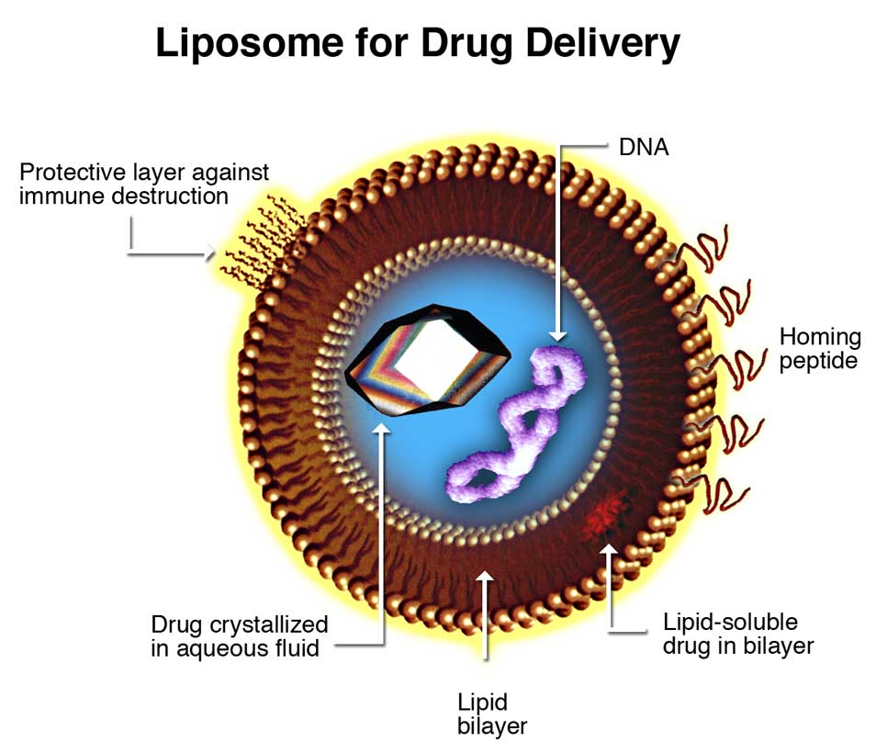
Fig 1.1: Liposomes for Drug Delivery[3].

Liposomes can be incorporated as anti-infective agents for drug delivery in diseases like leishmaniasis, candidiasis, aspergelosis, histoplasmosis, erythrococosis, gerardiasis, malaria and tuberculosis. Pathogens aside near or in the hepatic and spleen(intracellularly) can be bacterial, fungal and protozoal. Targeted sites with therapeutic agents in liposomes carrying drug delivery are as follows:

ACTIVE CONSTITUENTS | APPLICATION
Pentamidine | Leishmaniasis
Antisense oligo-nucleotides | Leishmaniasis
Anamycin | Leishmaniasis
Asiaticoside | Tuberculosis/Leprosy
Rifampicin | Tuberculosis
Table 1.2: Some liposomal preparations for infective diseases[4].
The use of Amphotericin B (Polyene antibiotic) for systemic fungal infections has severe renal toxicity. They act by the mechanism of, they bind to the ergosterol membrane of sensitive fungi and forming pores which cause cellular damage to the fungal cell and ultimately cause death. This binding may be non-specific which causes toxicity. Such drugs can be given through the liposomal drug delivery system which acts on targeted sites in the body.

3. NANOTUBES:
Carbon nanotubes were discovered in 1991 by Sumio Lijima and Ichihashi. Carbon nanotubes are tubular structures in which the sheet of graphite is rolled in the shape of a cylinder. Which is covered by one end or both ends by a buckyball.

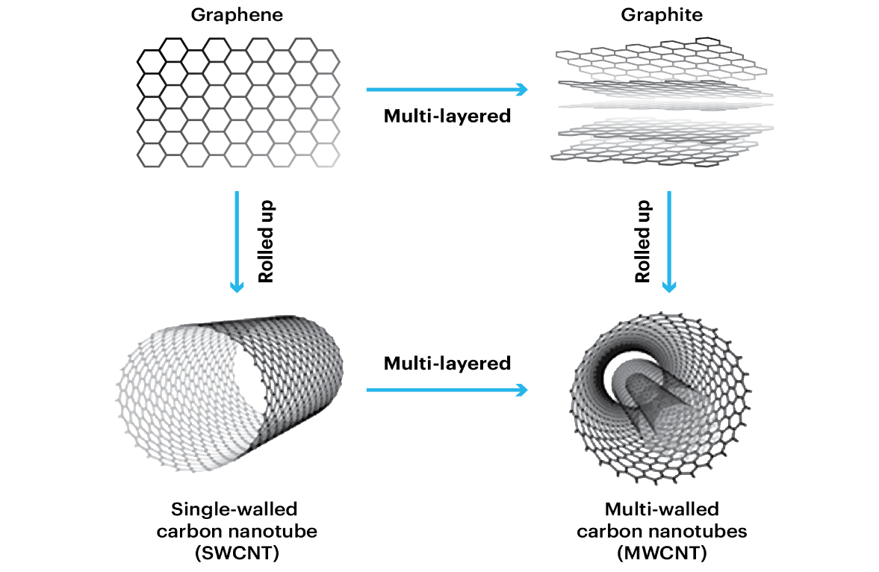
Fig 1.2: Single-walled and doubled-walled carbon nanotubes[5].

Carbon nanotubes are broadly classified into two main classes:
1.Single walled carbon nanotubes (SWCNT)
2.Multi walled carbon nanotubes (MWCNT)
Single-walled nanotubes have an internal diameter of 1-2nm while multi-walled carbon nanotubes have an internal diameter of 2-25nm diameter. In multi-walled layered carbon, tubes have approximately 0.36 nm distance between the two layers. The passage of nanotubes within the cell can be provided by the action of endocytosis and insertion of nanotubes within the cell. As these nanotubes are less insoluble, nanotubes can be made easily soluble in the body by the addition of carboxylic groups or ammonium groups to their structure. These nanotubes can be utilized in the transport of peptides, nucleic acid and other drug molecules.
The tremendous use of nanotubes can be utilized in the administration of Amphotericin B (Anti-fungal) via help of nanotubes for drug delivery. The efficacy and potential of Amphotericin B with the addition of nanotubes can be enhanced by comparing without nanotubes. And this activity of Amphotericin B with nanotubes is very useful and helpful against the resistant bacteria which are resistant to Amphotericin alone.
Here is the demonstration through the figure of Amphotericin with nanotubes.
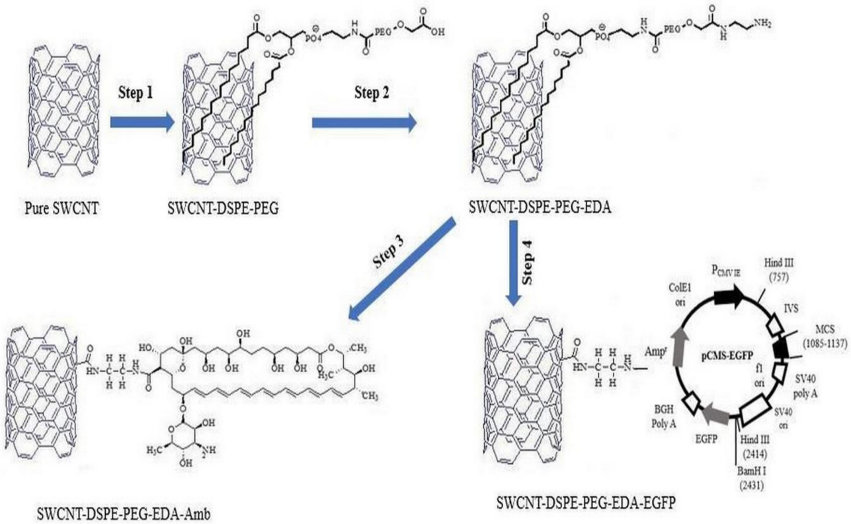
Fig 1.3: Nanotube with Amphotericin B[6].

4. NANOBUBBLES:

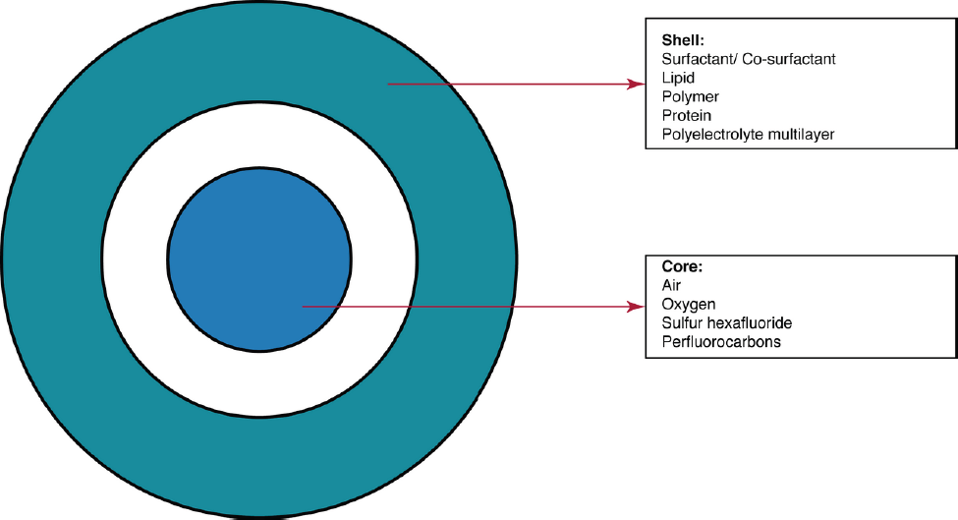
Fig 1.4: Schematic representation of nanobubble structure[7].

Nanobubbles are gas-carrying concurrent cavities in aqueous solutions having a size of less than 1µm (these particles are round globular and consist of a shell and gas-filled core structure) [7]. Generally, nanobubbles are less than 1µm. Nanobubbles are often used to deliver cancer therapeutic agents. These are generally steady at room temperature but combine to form microbubbles in the body under physiological temperatures. Nanobubbles have a special advantage as this target the specific target cancer tissue and deliver the drug under the influence of ultrasound exposure which results in high intracellular uptake of the drug by the tumour tissue. Rapaport et al. has shown the importance of nanobubbles in the delivery of drugs like doxorubicin on the basis of in vitro and in vivo experiments using mice breast cancer cells (MDA MB231) breast cancer xenograft respectively[1]. Nanobubbles combined with ultrasound exposure have shown improved transfer of genes in both in vitro and in vivo studies respectively[1]. Through nanobubbles, ultrasound imaging has been much useful in diagnosing and for clinical decision-making. Ultrasound beam majorly decreases the toxic side effects of Anti-cancer drugs used in the pharmacotherapy of cancer[7].
Nanobubbles can be also utilized in the therapy of Parkinson's disorder. The authors denoted that nanobubbles can be utilized to deliver apomorphine, an especially favourable but unreliable drug for treating Parkinson's disease, through the blood barrier[1]. Nanobubbles can be also used as supersaturated fluids for oxygen delivery. Liposome-based nanobubbles and microbubbles are under development for gene-based drug delivery for various diseases.
Various studies suggest that nanobubbles can be utilized for the removal of clots from any vessel of blood in various vascular diseases of tissues with the induction of ultrasound[1].

5. NANOSOMES:
Group of Raoul Kopelman’s was working on nanosomes at the University of Michigan, USA, also named PEBBLEs (Probes Encapsulated by Biologically Localised embedding) which coalesce different various applications such as targeting, diagnosis and therapy[1]. There are many nanosomes which have been evolved for the therapy of tumour-causing cancer particularly central nervous applications such as in targeting, diagnosing and treatment of Central Nervous system tumours. Iron oxide nanoparticles having silica layers coated with polyethylene glycol and appended with targeting with antibodies and distinct elements like gadolinium are utilized to access certain areas of the brain having tumour cells. The heat produced by the iron oxide particles can destroy the tumour cells. Nanosomes when combined with a photocatalyst produce reactive oxygen species which destroy the target tissue. This method of nanosomes of drug transportation system is very advantageous and is safer unaccompanied by any adverse reactions resulting due to chemotherapy along with the absence of developing drug resistance of chemotherapeutic anticancer drugs over the conventional preparations.

6. RESPIROCYTES AND MICROBIVORES:
Respirocytes are considered as an accessory approved by FDA and is synchronized under the amenities of the Medical Device Amendments 1976, the Safe Medical Devices Act 1990 and the Medical Device Amendments 1992[1]. Respirocytes are man-made Red Blood Cells (RBCs) or nanodevices used for carrying or functioning as RBCs with high potency. These respirocytes deliver oxygen to the various cells in a higher capacity than that of normal Red Blood Cells. These supply oxygen to tissues 236 times more per unit volume[1]. Respirocytes consist of sensors on their outer surface which reveal the alteration in the external surroundings and on the onboard nanocomputer which maintains the exchange of oxygen and carbon dioxide output. An infusion of volume one-litre having a dose of 50 per cent respirocytes (saline suspension) in a human can actually keep the subject oxygenated for almost four hours followed by cardiac failure[1].
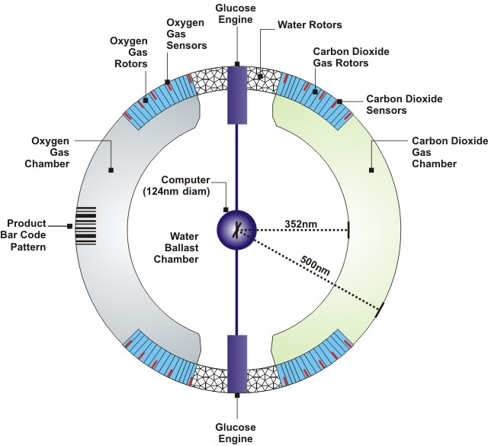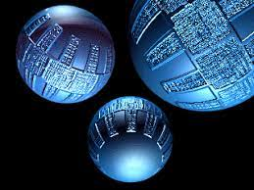
Fig 1.5: Internal structure of Respirocytes[8]. Fig 1.6: Artificial respirocytes by
Robert A. Frcitas Jr.[8].

Microbivores are the type of micro devices which mimics the function of natural White Blood Cells (WBC) in the human bloodstream to engulf the microorganisms in the body. They perform phagocytosis on another level as their efficacy is much more than the natural ones. The microbivores have four fundamental components in which the microbe binds to the reversible binding site and trap the microorganisms. Once trapped, the morcellation chamber of the microbivore minces the microbe into fine, easily breakdown into segments and further chemically digested. The use of microbivores in septicaemia thoroughly clears the infection in the bloodstream of humans at a much-enhanced rate as compared to the natural defence mechanism along with antibiotics [1].
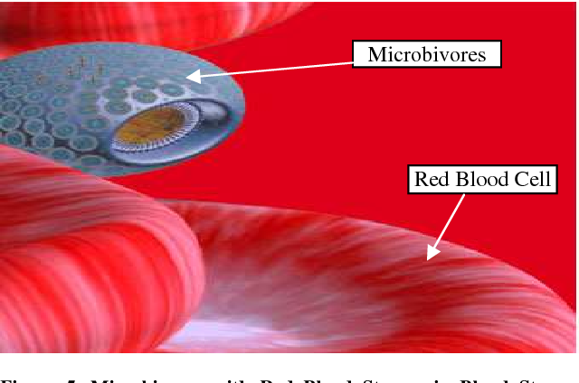
Fig 1.7: Microbivores in Bloodstream[9].
APPLICATIONS OF NANOTECHNOLOGY IN DIAGNOSING AND IMAGING:

- NANOWIRES:
Devices which work on the basis of nanowires provide integrated general platforms for ultrasensitive direct electrical examination for the presence of the biological and chemical species[2]. Nanowires can be arranged across small-sized fluid channels the nanowire sensors get the molecular impulses of these particles and transfer the details to a signal analyser.

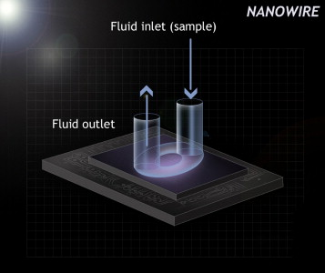
Fig 1.8: Schematic representation of regular planner planar nanowire sensor with integrated microfluid sample delivery[2].

A device named silicon nanowire field effective device was discovered in which well-defined nanowires and outside receptors of cells were included in the arrangement[2].

- CANTILEVERS:
The nanocantilevers are used for the assessable measurement of minute concentrations of specific molecules within the body. For example, the cantilever coated with antibodies binds discriminatorily to the secreted products of cancer cells.

- QUANTUM DOTS:
Quantum dots (QDs) are the type of semiconductor device or nanodots which are synthetic in nature. The fluorescence property of quantum dots specifically can be utilized in the detection and imaging of cancer cells. Generally, the diameter of these quantum dots is between 2-10 nm.

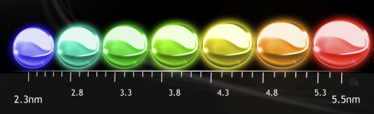
Fig1.9: Quantum dots[2].
The targeted site at which the accumulation of Quantum dots has been experimentally performed and demonstrated in vivo experiment in a transplant(xenograft) replica involving human prostate cancer cells in nude mice[2].
Many, cancer-causing agents can be detected through the specialized Quantum dots.

And many more nanotools can be utilized for diagnosing and imaging such as:
- DENDRIMERS
- LIPOSOMES
- NANOPYRAMIDS
- NANOGELS
- NANOSHELLS

As we know and we have covered in this review the applications and advantages of nanotechnology in our day-to-day life and in upcoming future generations. There is vast and huge scope in future for the nanotechnology but there will be newly coming and hazardous diseases via nanotechnology which is its dark side.

SOME HAZARDS OF NANOPARTICLES ARE AS FOLLOWS:
1. These particles tend to cause some pathologic disorders of the cardiovascular system, respiratory system, central nervous system and gastrointestinal system.
2. Intracranial implantation of carbon nanotubes particles in mice has manifested that carbon nanotubes have the potency to cause varied lung symptomologies like epitheloid granuloma, interstitial inflammatory response, peribronchial inflammation and sphacelus of the lungs[1].
3. Nanoparticles as a whole, or the degraded products of these nanoparticles can cause symptoms such as dermal or skin changes, neurotoxicity, hypersensitivity, developmental toxicity and cardiac toxicity[10].
4. As these nanoparticles are foreign bodies for the human body the immune cells tend to remove these nanoparticles from the body through processes like phagocytosis which harm the human body only.
5. The American Heart Association detected that even exposure to elevated particulate matter concentrations in outdoor air for the short term was accompanied by a significant increase in acute cardiovascular mortality, particularly in specific subsets of the population[11].
6. Even it is very difficult to eliminate these nanoparticles from the body through the urine as kidneys face an extra workload to eliminate them.

CONCLUSION:
In the end, nanotechnology has exerted or played a major character in the life of human beings. The role of nanotechnology in the area of therapeutics and diagnosing has led to tremendous growth in enhancing and quality of patient’s life productivity and the quality of life of patients.
However, in a few more years nanomedicine will achieve a great peak in the area of medicine and drug delivery system in sequence to enhance the efficacy of the treatment.

ACKNOWLEDGEMENT:
The authors are thankful to the Principal, ASPM's K.T. Patil College of Pharmacy for providing the necessary facilities for studying and providing new opportunities.

REFERENCES:

- Surendiran A, Sandhiya S, Pradhan SC, Adithan C. Novel applications of nanotechnology in medicine. Indian Journal of Medical Research. 2009 Dec 1;130(6):689-701.

- Laroui H, Rakhya P, Xiao B, Viennois E, Merlin D. Nanotechnology in diagnostics and therapeutics for gastrointestinal disorders. Digestive and Liver Disease. 2013 Dec 1;45(12):995-1002.

- Fazal-ur-Rehman M. Novel applications of nanomaterials and nanotechnology in medical sciences-a review. J. Basic Appl. Sci. Res. 2018;8(4):1.

- Samad A, Sultana Y, Aqil M. Liposomal drug delivery systems: an update review. Current drug delivery. 2007 Oct 1;4(4):297-305.

- Filchakova M, Saik V. Single-walled carbon nanotubes: structure, properties, applications, and health & safety. Tuball. 2021 May.

- Yazdani S, Mozaffarian M, Pazuki G, Hadidi N, Gallego I, Puras G, Pedraz JL. Design of double functionalized carbon nanotube for amphotericin B and genetic material delivery. Scientific Reports. 2022 Dec 7;12(1):21114.

- Pasupathy R, Pandian P, Selvamuthukumar S. Nanobubbles: A Novel Targeted Drug Delivery System. Brazilian Journal of Pharmaceutical Sciences. 2022 Jul 8;58.

- Muhammad, Yahaya & Bk, Muh'd & Muhammad,. (2020). Nanotechnology and Artificial Blood; Future Revolution in Modern Transfusion Medicine. 3. 23-27.

- Mishra J, Dash AK, Kumar R. Nanotechnology Challenges; Nanomedicine: Nanorobots. International Research Journal of Pharmaceuticals. 2012;2(4):112-9.

- Abdussalam-Mohammed WJ. Review of therapeutic applications of nanotechnology in medicine field and its side effects. Journal of Chemical Reviews. 2019;1(3):243-51.

- Sotropa¹ RM. The advantages and disadvantages of nanotechnology. Romanian Journal of Oral Rehabilitation. 2018 Apr;10(2).

- Bamrungsap S, Zhao Z, Chen T, Wang L, Li C, Fu T, Tan W. Nanotechnology in therapeutics: a focus on nanoparticles as a drug delivery system. Nanomedicine. 2012 Aug;7(8):1253-71.

- Khan I, Saeed K, Khan I. Nanoparticles: Properties, applications and toxicities. Arabian journal of chemistry. 2019 Nov 1;12(7):908-31.

- Bodunde OP, Ikumapayi OM, Akinlabi ET, Oladapo BI, Adeoye AO, Fatoba SO. A futuristic insight into a “nano-doctor”: a clinical review on medical diagnosis and devices using nanotechnology. Materials Today: Proceedings. 2021 Jan 1;44:1144-53.

- Gwinn MR, Vallyathan V. Nanoparticles: health effects—pros and cons. Environmental health perspectives. 2006 Dec;114(12):1818-25..

- Singh R, Nalwa HS. Medical applications of nanoparticles in biological imaging, cell labeling, antimicrobial agents, and anticancer nanodrugs. Journal of biomedical nanotechnology. 2011 Aug 1;7(4):489-503.

- Chakraborty M, Jain S, Rani V. Nanotechnology: emerging tool for diagnostics and therapeutics. Applied biochemistry and biotechnology. 2011 Nov;165:1178-87.

