Artificial intelligence in drug discovery and development

Introduction

Artificial intelligence and machine learning have significantly influenced the pharmaceutical and consumer healthcare industries. Artificial intelligence is a computer technology discipline that analyses enormous amounts of data in the medical field. Their ability to leverage meaningful correlations within a data collection can be helpful in diagnosis, therapy, selecting individuals for clinical trials, pharmaceutical production, and making predictions. The main advantages of artificial intelligence include cheaper costs for medication research, better returns on investment, and perhaps even lower end-user costs.¹ This article describes the use of artificial intelligence and machine learning to augment drug discovery and development to make them more efficient and accurate. AI is currently used in the pharmaceutical industry in four main ways. The first is in the assessment of the severity of disease and the prediction of whether treatment will be successful for an individual patient, even prior to its administration. Secondly, it is used to prevent or solve complications during treatment. Its third main use is as an assistive technology during treatment procedures or operations on patients. Lastly, it is used to determine the reasons behind the use of particular instruments or chemicals during treatment, and to develop or extrapolate new uses for instruments or chemicals to improve safety and efficacy. Enhanced computational power and the development of innovative techniques in the field of AI could be used to reform drug discovery and development processes.

AI: networks and tools

AI comprises a number of approach domains, including machine learning (ML), a fundamental paradigm, reasoning, knowledge representation, and solution search. In machine learning (ML), algorithms are used to find patterns in a set of data that has been further categorised. Deep learning (DL), a branch of machine learning that uses artificial neural networks (ANNs), is one such branch. These comprise a set of interconnected sophisticated computing elements involving ‘perceptons’ analogous to human biological neurons, mimicking the transmission of electrical impulses in the human brain.² ANNs constitute a set of nodes, each receiving a separate input, ultimately converting them to output, either singly or multi-linked using algorithms to solve problems.³ ANNs involve various types, including multilayer perceptron (MLP) networks, recurrent neural networks (RNNs), and convolutional neural networks (CNNs), which utilize either supervised or unsupervised training procedures.^{4,5}
The MLP network has applications including pattern recognition, optimization aids, process identification, and controls, are usually trained by supervised training procedures operating in a single direction only, and can be used as universal pattern classifiers. RNNs are networks with a closed-loop, having the capability to memorize and store information, such as Boltzmann constants and Hopfield networks.⁶ CNNs are a series of dynamic systems with local connections, characterized by its topology, and have use in image and video processing, biological system modeling, processing complex brain functions, pattern recognition, and sophisticated signal processing.⁷ The more complex forms include Kohonen networks, RBF networks, LVQ networks, counter-propagation networks, and ADALINE networks.⁶ Examples of method domains of AI are summarized in Figure 1 .
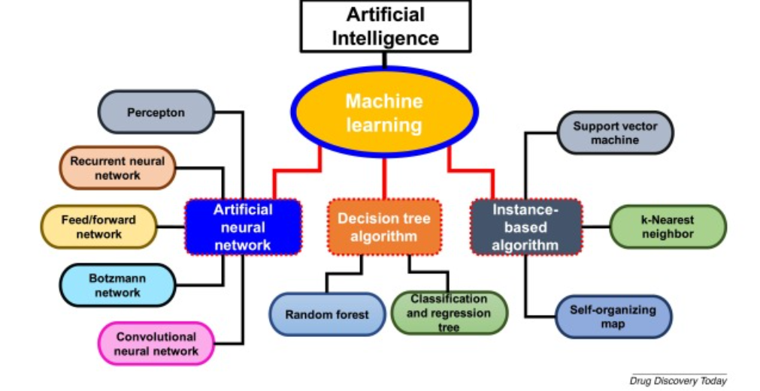
Figure 1. Method domains of artificial intelligence (AI). This figure shows different AI method domains along with their subfields that can be implemented in different fields drug discovery and development.
Several tools have been developed based on the networks that form the core architecture of AI systems. One such tool developed using AI technology is the International Business Machine (IBM) Watson supercomputer (IBM, New York, USA). It was designed to assist in the analysis of a patient’s medical information and its correlation with a vast database, resulting in suggesting treatment strategies for cancer. This system can also be used for the rapid detection of diseases. This was demonstrated by its ability to detect breast cancer in only 60 s.^{8, 9}

Present scenario of AI in pharma

According to some experts, by 2025, over half of all global healthcare corporations will have implemented AI plans, and it will be critical for how businesses operate in the future. Top pharmaceutical corporations partner with AI vendors for research & development and overall drug discovery and incorporate AI technology into their production processes. According to surveys, 62% of healthcare organizations plan to invest in AI shortly, and 72% of companies believe AI will be indispensable to their operations in the future.^{10, 11}
Researchers claim that the use of AI and ML technologies improves decision-making, maximizes innovation, boosts the effectiveness of research and clinical trials, and develops helpful new tools for doctors, patients, insurers, and regulators. Roche, Pfizer, Merck, AstraZeneca, GSK, Sanofi, AbbVie, Bristol-Myers Squibb, and Johnson & Johnson are among the top pharmaceutical corporations that have already partnered with or purchased AI technologies. The Massachusetts Institute of Technology has launched a Machine Learning based on Pharmaceutical Research and Synthesis program teamed with Novartis and Pfizer in 2018 to change medication design and production. The consortium intends to bridge the gap between MIT's machine learning research and drug discovery research by bringing together researchers and industry to identify and solve the most pressing issues.¹²
GSK also collaborated with Cloud Pharmaceuticals to accelerate the development of novel drug candidates. In April 2020, GSK and Vir Biotechnology announced a collaboration to boost COVID-19 drug discovery using CRISPR and AI. Roche has partnered with Owkin, a medical research machine learning platform, to speed pharmaceutical discovery, development, and clinical trials. Abbott also just introduced an artificial intelligence powered coronary imaging technology. To facilitate better decision-making during coronary stenting procedures, AI platforms can assess channel diameter and determine the severity of calcium-based obstructions.¹³

AI based- drug discovery
More than >10⁶⁰ molecules make up the enormous chemical space, which encourages the creation of many different pharmacological compounds.¹⁴ However, the lack of advanced technologies limits the drug development process, making it a time-consuming and expensive task, which can be addressed by using AI.¹⁵ AI can identify hit and lead compounds, as well as expedite therapeutic target validation and structural design optimization.^{14, 16} Different applications of AI in drug discovery are depicted in Figure 2.

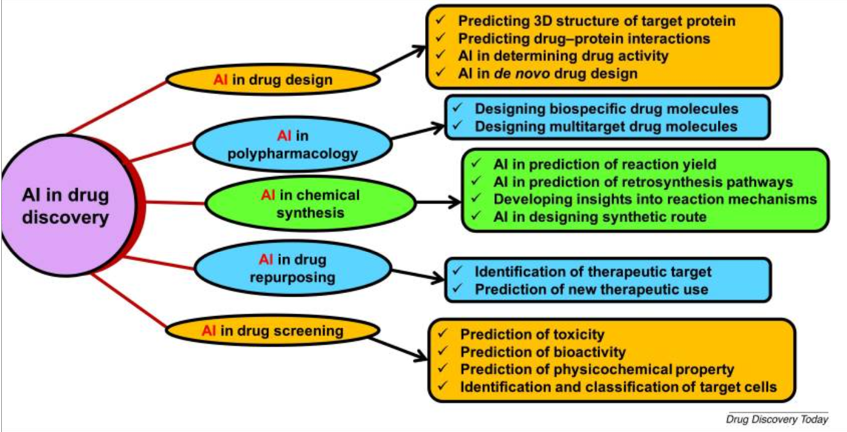
Figure 2: Role of artificial intelligence (AI) in drug discovery. AI can be used effectively in different parts of drug discovery, including drug design, chemical synthesis, drug screening, polypharmacology, and drug repurposing.
Despite its advantages, AI faces some significant data challenges, such as the scale, growth, diversity, and uncertainty of the data. The data sets available for drug development in pharmaceutical companies can involve millions of compounds, and traditional ML tools might not be able to deal with these types of data. Quantitative structure-activity relationship (QSAR)-based computational model can quickly predict large numbers of compounds or simple physicochemical parameters, such as log P or log D. However, these models are some way from the predictions of complex biological properties, such as the efficacy and adverse effects of compounds. In addition, QSAR-based models also face problems such as small training sets, experimental data error in training sets, and lack of experimental validations. To overcome these challenges, recently developed AI approaches, such as DL and relevant modeling studies, can be implemented for safety and efficacy evaluations of drug molecules based on big data modeling and analysis. In 2012, Merck supported a QSAR ML challenge to observe the advantages of DL in the drug discovery process in the pharmaceutical industry. DL models showed significant predictivity compared with traditional ML approaches for 15 absorption, distribution, metabolism, excretion, and toxicity (ADMET) data sets of drug candidates.^{17, 18}
Biological testing of pharmaceutical compounds consumes enormous time in the drug development process. Novartis researchers employ ML algorithms on photographs to determine which chemicals are worth further investigating to speed up the screening process. Algorithms are significantly faster at revealing new data sets than traditional human analysis and laboratory tests. Unique and effective medications can be available sooner while simultaneously lowering the operating expenses associated with each compound's manual examination. The following are some of the top biopharmaceutical companies' current AI initiatives:
[a] mobile platform to improve health outcomes - the ability to refer patients based on real-time data, improving patient outcomes.
[b] drug development- pharmaceutical corporations collaborate with software businesses to employ cutting-edge technologies in the costly and time-consuming drug discovery process.¹³
Table 1. Comparison between traditional and AI-based drug discovery.¹²
Traditional drug discovery | AI tools based drug discovery
Target driven | Data-driven
Work well for easy targeting | Machine learning with complex algorithms  extracts valuable insights from a given dataset
They have limitations as the complexity of cellular connections and a lack of understanding of complicated cellular pathways | Find chemicals that attach "undruggable targets" or proteins with undefined structures

AI support antibiotic study

Antibiotic discovery has become more complicated in recent years with the rise of antibiotic resistance. Earlier, antibiotics were discovered by screening soil swelling microbes for secondary compounds prohibited bacterial growth. However, antibiotic development is currently hampered by the discovery of the same molecules repeatedly. Recently, a study showcasing machine learning to find new antibiotics was released, where researchers employ machine learning to anticipate antibacterial chemicals in silico from a database of over 107 million molecules. This antibiotic, known as "Halicin," is effective against various bacteria, including tuberculosis and difficultto-treat types. Other medications could benefit from this strategy, such as those used to treat cancer or neurological illnesses.¹

AI in diagnosis and treatment

Physicians can collect data using powerful machine learning techniques and analyze and evaluate patient healthcare data. Deep learning and machine learning are being used by healthcare practitioners worldwide to store patient data in a cloud securely, or a centralized storage mechanism Electronic Medical Records (EMRs) are the term for this. Physicians can use these health records to determine how a specific genetic trait affects a patient's health. Machine Learning algorithms can use data contained in EMRs to provide real-time estimates for diagnostic purposes and suggest appropriate treatment for the patient. Verge Genomics is tackling the major issues in drug discovery by employing automated data collection and analysis. In other words, they're using an algorithm to map out hundreds of genes involved in brain disorders such as Alzheimer's, Parkinson's, and ALS (Amyotrophic lateral sclerosis). Medications could benefit from this strategy, such as those used to treat cancer or neurological illnesses.¹⁹
They believe collecting and interpreting gene data will positively impact the drug discovery phase, beginning with preclinical trials. Starting in the preclinical stage, utilize AI to track the effects of various pharmacological treatments on the human brain. As a result, drug companies can better understand a medicine's impact on human cells earlier in the development process. Verge genomics, in particular, use artificial intelligence to track the effects of various drugs on the human brain with a specific focus on the preclinical phase.¹⁹

AI in clinical trial design

Clinical trials are directed toward establishing the safety and efficacy of a drug product in humans for a particular disease condition and require 6–7 years along with a substantial financial investment. However, only one out of ten molecules entering these trials gain successful clearance, which is a massive loss for the industry.²⁰ These failures can result from inappropriate patient selection, shortage of technical requirements, and poor infrastructure. However, with the vast digital medical data available, these failures can be reduced with the implementation of AI.²¹
The enrolment of patients takes one-third of the clinical trial timeline. The success of a clinical trial can be ensured by the recruitment of suitable patients, which otherwise leads to ∼86% of failure cases.²² AI can assist in selecting only a specific diseased population for recruitment in Phase II and III of clinical trials by using patient-specific genome–exposome profile analysis, which can help in early prediction of the available drug targets in the patients selected. Preclinical discovery of molecules as well as predicting lead compounds before the start of clinical trials by using other aspects of AI, such as predictive ML and other reasoning techniques, help in the early prediction of lead molecules that would pass clinical trials with consideration of the selected patient population.²¹
Drop out of patients from clinical trials accounts for the failure of 30% of the clinical trials, creating additional recruiting requirements for the completion of the trial, leading to a wastage of time and money. This can be avoided by close monitoring of the patients and helping them follow the desired protocol of the clinical trial.²² Mobile software was developed by AiCure that monitored regular medication intake by patients with schizophrenia in a Phase II trial, which increased the adherence rate of patients by 25%, ensuring successful completion of the clinical trial.¹⁴

AI-based advanced applications

AI-based nanorobots for drug delivery

Nanorobots comprise mainly integrated circuits, sensors, power supply, and secure backup of data, which are maintained via computational technologies, such as AI.^{23, 24} They are programmed to avoid the collision, target identification, detect and attach, and finally excretion from the body. Advances in nano/microrobots give them the ability to navigate to the targeted site based on physiological conditions, such as pH, thus improving the efficacy and reducing systemic adverse effects.²⁴ Development of implantable nanorobots developed for controlled delivery of drugs and genes requires consideration of parameters such as dose adjustment, sustained release, and control release, and the release of the drugs requires automation controlled by AI tools, such as NNs, fuzzy logic, and integrators.²⁵ Microchip implants are used for programmed release as well as to detect the location of the implant in the body.

AI in combination drug delivery and synergism/antagonism prediction

Several combinations of drugs are approved and marketed to treat complex diseases, such as TB and cancer, because they can provide a synergistic effect for quick recovery. ^{26, 27} The selection of precise and potential drugs for combination requires high-throughput screening of a considerable number of drugs, making the process tedious; for example, cancer therapy requires six or seven drugs as a combination therapy. ANNs, logistic regression, and network-based modeling can screen drug combinations and improve overall dose regimen. ^{26, 28} Rashid et al. developed a quadratic phenotype optimization platform for the detection of optimal combination therapy for the treatment of bortezomib-resistant multiple myeloma using a collection of 114 FDA-approved drugs. This model recommended the combination of decitabine (Dec) and mitomycin C (MitoC) as the best two-drug combination and Dec, MitoC, and mechlorethamine as the superior three-drug combination.
Combination drug delivery can be more efficient if backed up by data on the synergism or antagonism of drugs administered together. The Master Regulator Inference Algorithm used ‘Mater regulator genes’ to efficiently predict 56% synergism. Other methods, such as Network-based Laplacian regularized least square synergistic drug combination, and RF, can also be used for the same. ²⁸
Li et al. developed a synergistic drug combination model using RF for the prediction of synergistic anticancer drug combinations. This model was formed based on gene expression profiles and various networks, and the authors successfully predicted 28 synergistic anticancer combinations. They have reported three such combinations, although the remainder might also prove to be important.²⁹ Similarly, Mason et al. applied an ML approach, called the Combination Synergy Estimation, to predict potential synergistic antimalarial combinations based on a data set of 1540 antimalarial drug compounds. ³⁰

AI emergence in nanomedicine

Nanomedicines use nanotechnology and medicines for the diagnosis, treatment, and monitoring of complex diseases, such as HIV, cancer, malaria, asthma, and various inflammatory diseases. In recent years, nanoparticle-modified drug delivery has become important in the field of therapeutics and diagnostics because they have enhanced efficacy and treatment.³¹ A combination of nanotechnology and AI could provide solutions to many problems in formulation development.³²
A methotrexate nanosuspension was computationally formulated by studying the energy generated on the interaction between the drug molecules, monitoring the conditions that could lead to the aggregation of the formulation.³³ Coarse-grained simulation, along with chemical calculation, can aid the determination of drug–dendrimer interactions and evaluation of drug encapsulation within the dendrimer. In addition, software such as LAMMPS and GROMACS 4 can be used to examine the impact of surface chemistry on the internalization of nanoparticles into cells.³²
AI assisted the preparation of silicasomes, which is a combination of iRGD, a tumor-penetrating peptide, and irinotecan-loaded multifunctional mesoporous silica nanoparticles. This increased the uptake of silicasomes three–fourfold because iRGD improves the transcytosis of silicasomes, with improved treatment outcome and enhanced overall survival.³¹

Concluding remarks and prospects

The advancement of AI, along with its remarkable tools, continuously aims to reduce challenges faced by pharmaceutical companies, impacting the drug development process along with the overall lifecycle of the product, which could explain the increase in the number of start-ups in this sector.³⁴ The current healthcare sector is facing several complex challenges, such as the increased cost of drugs and therapies, and society needs specific significant changes in this area. With the inclusion of AI in the manufacturing of pharmaceutical products, personalized medications with the desired dose, release parameters, and other required aspects can be manufactured according to individual patient need.³⁵ Using the latest AI-based technologies will not only speed up the time needed for the products to come to the market, but will also improve the quality of products and the overall safety of the production process, and provide better utilization of available resources along with being cost-effective, thereby increasing the importance of automation.³⁶
Automation of certain tasks in drug development, manufacturing, and supply chains, clinical trials, and sales will take place with time, but these all fall under the category of ‘narrow AI’; where AI has to be trained using a large volume of data and, thus, makes it suitable for a particular task. Therefore, human intervention is mandatory for the successful implementation, development, and operation of the AI platform. However, the fear of unemployment could be a myth given that AI is currently is taking over repetitive jobs, while leaving scope for human intelligence to be used for developing more complicated insights and creativity.
Nevertheless, AI has been adopted by several pharmaceutical companies, and it is expected that a revenue of US$2.199 billion will be created by 2022 through AI-based solutions in the pharmaceutical sector, with an investment exceeding US$7.20 billion across 300+ deals between 2013 and 2018 by the pharmaceutical industry.³⁷ Pharmaceutical organizations need clarity about the potential of AI technology in finding solutions to problems once it has been implemented, along with understanding the reasonable goals that can be achieved. Skilled data scientists, software engineers with a sound knowledge of AI technology, and a clear understanding of the company business target and its R&D goal can be developed to utilize the full potential of the AI platform.

REFERENCES

- Patel, J., Patel, D., & Meshram, D. (2021). Artificial Intelligence in Pharma Industry - A Rising Concept. Journal of Advancement in Pharmacognosy, 1(2)

- Beneke F., Mackenrodt M.-O. Artificial intelligence and collusion. IIC Int. Rev. Intellectual Property Competition Law. 2019;50:109–134

- Steels L., Brooks R. Routledge; 2018. The Artificial Life Route to Artificial Intelligence: Building Embodied, Situated Agents.

- Bielecki A., Bielecki A. Foundations of artificial neural networks. In: Kacprzyk Janusz., editor. Models of Neurons and Perceptrons: Selected Problems and Challenges. Springer International Publishing; 2019. pp. 15–28. Polish academy of sciences, Warsaw, Poland.

- Kalyane D. Artificial intelligence in the pharmaceutical sector: current scene and future prospect. In: Tekade Rakesh K., editor. The Future of Pharmaceutical Product Development and Research. Elsevier; 2020. pp. 73–107.

- Da Silva I.N. Springer; 2017. Artificial Neural Networks.

- Hänggi M., Moschytz G.S. Springer Science & Business Media; 2000. Cellular Neural Networks: Analysis, Design and Optimization.

- Rouse M. 2017. IBM Watson Supercomputer.https://searchenterpriseai.techtarget.com/definition/IBM-Watson-supercomputer . Accessed 13 October 2020

- Vyas M. Artificial intelligence: the beginning of a new era in pharmacy profession. Asian J. Pharm. 2018;12:72–76.

- Patrusheva, E. (2019). MONITORING OF REGIONAL INDUSTRIAL CLUSTER OPERATING CONDITIONS. 6th SWS International Scientific Conference on Social Sciences ISCSS 2019, 2

- Arvapalli, S., Ch. Krishnaveni, Divya. K, & J. V. C. Sharma. (2019). ARTIFICIAL INTELLIGENCE IN PHARMA INDUSTRY- A Review. International Journal of Innovative Pharmaceutical Sciences and Research, 7(10).

- Babu, K. A., MS, S., & AS, M. D. (2021). Artificial Intelligence in Pharma. International Journal of Current Research in Physiology and Pharmacology (IJCRPP).

- Arinez, J. F., Chang, Q., Gao, R. X., Xu, C., & Zhang, J. (2020). Artificial Intelligence in Advanced Manufacturing: Current Status and Future Outlook. Journal of Manufacturing Science and Engineering, Transactions of the ASME, 142(11).

- Mak K.-K., Pichika M.R. Artificial intelligence in drug development: present status and future prospects. Drug Discovery Today. 2019;24:773–780.

- Vyas M. Artificial intelligence: the beginning of a new era in pharmacy profession. Asian J. Pharm. 2018;12:72–76.

- Sellwood M.A. Artificial intelligence in drug discovery. Fut. Sci. 2018;10:2025–2028.

- Zhu H. Big data and artificial intelligence modeling for drug discovery. Annu. Rev. Pharmacol. Toxicol. 2020;60:573–589.

- Ciallella H.L., Zhu H. Advancing computational toxicology in the big data era by artificial intelligence: data-driven and mechanism-driven modeling for chemical toxicity. Chem. Res. Toxicol. 2019;32:536–547.

- Monath TP, Teuwen D, Cetron MS. Yellow fever vaccine. In: Plotkin S, Orenstein WA, Offit PA, editors. Vaccines. 5th ed. Philadelphia: WB Saunders; 2008. p. 959-1055.

- Hay M. Clinical development success rates for investigational drugs. Nat. Biotechnol. 2014;32:40–51.

- Harrer S. Artificial intelligence for clinical trial design. Trends Pharmacol. Sci. 2019;40:577–591.

- Fogel D.B. Factors associated with clinical trials that fail and opportunities for improving the likelihood of success: a review. Contemp. Clin. Trials Commun. 2018;11:156–164.

- Hassanzadeh P. The significance of artificial intelligence in drug delivery system design. Adv. Drug Delivery Rev. 2019;151:169–190.

- Luo M. Micro‐/nanorobots at work in active drug delivery. Adv. Funct. Mater. 2018;28:1706100.

- Fu J., Yan H. Controlled drug release by a nanorobot. Nat. Biotechnol. 2012;30:407–408.

- Calzolari D. Search algorithms as a framework for the optimization of drug combinations. PLoS Comput. Biol. 2008;4:e1000249.

- Wilson B., KM G. Artificial intelligence and related technologies enabled nanomedicine for advanced cancer treatment. Future Med. 2020;15:433–435.

- Tsigelny I.F. Artificial intelligence in drug combination therapy. Brief. Bioinform. 2019;20:1434–1448.

- Li X. Prediction of synergistic anticancer drug combinations based on drug target network and drug induced gene expression profiles. Artif. Intell. Med. 2017;83:35–43.

- Mason D.J. Using machine learning to predict synergistic antimalarial compound combinations with novel structures. Front. Pharmacol. 2018;9:1096.

- Ho D. Artificial intelligence in nanomedicine. Nanoscale Horiz. 2019;4:365–377.

- Sacha G.M., Varona P. Artificial intelligence in nanotechnology. Nanotechnology. 2013;24:452002.

- Mehta C.H. Computational modeling for formulation design. Drug Discovery Today. 2019;24:781–788.

- Chan H.S. Advancing drug discovery via artificial intelligence. Trends Pharmacol. Sci. 2019;40(8):592–604.

- Rantanen J., Khinast J. The future of pharmaceutical manufacturing sciences. J. Pharm. Sci. 2015;104:3612–3638.

- Jämsä-Jounela S.-L. Future trends in process automation. Annu. Rev. Control. 2007;31:211–220.

- Research and Markets . Research and Markets; 2019. Global Growth Insight - Role of AI in the Pharmaceutical Industry 2018-2022: Exploring Key Investment Trends, Companies-to-Action, and Growth Opportunities for AI in the Pharmaceutical Industry.

