Life cycle, Nature of damage and Present methods to control Heliothis armigera
Agriculture is the main source of Indian Economy and currently the second largest producer of several agricultural products including dry fruits, roots and tuber crops, pulses, sugarcane, cotton, vegetables etc. Agriculture is provided employment opportunities in India. Near about 65-70% population in India is engaged in agricultural activities and nearly 60% of populations are depends directly or indirectly on agriculture. It is also the backbone of India’s economy because it providing food security to the population.
In India there are 3 species of Heliothis studied i.e. Heliothis armigera (Hubner), Heliothis assulta (Guenee) and Heliothis peltigera (schiff).
All are widely worldwide distributed and out of these three species Heliothis armigera is the most destructive species with country-wide distribution. Host range are relatively less economic importance. It is also a most abundant of the three species of Heliothis that occur in India (CIBC, 1974). In late 1980s the genus was known as 'Heliothis', as a scientific as well as common name. This name is widely used but taxonomists split this name into Helicoverpa and Heliothis.
Systematic Position:-
Kingdom : Animalia
Phylum : Arthropoda
Class : Insecta
Order : Lepidoptera
Family : Noctuidae
Sub-family : Heliothinae
Genus : Heliothis/Helicoverpa
Species : armigera
Heliothis armigera remains a highly dreaded pest of several agricultural crops. It belongs to order- Lepidoptera and family- Noctuidae. Generally, it is also called as cotton bollworm, gram pod borer, corn earworm and tomato fruit worm. They feeds on wide variety of crops of economic importance such as Cicer arietinum, Cajanus cajan, Lycopersicon esculentum, Abelmoschus esculentus, Gossypium species and Zea mays commonly called as chickpea, pigeonpea, tomato, okra, cotton and maize respectively. It feeds on more than 170 species of plants belonging 41 families most notably in cotton (King, 1994). Near about 150 pests have been reported feeding on cotton out of these Helicoverpa armigera is a major pest of cotton in Pakistan (Shabbier, 1973) and all West African cotton producing countries (Youm et. al., 2005). The larvae of H. armigera feed on the green leaves, buds, pods and fruits of their host plants. One larva of H. armigera can be damage 10-12 fruiting bodies in its life span (Nyambo, 1988). Helicoverpa armigera (Hübner) is a serious pest causing 14-56 per cent damage suggested by Kaushik et. al., 1969; Manjunath et. al., 1989; Jayaraj, 1990. Ignacimuthu and Jayaraj, 2003 reported an annual loss of about Rs. 2,000 crores in India by Helicoverpa armigera. Heliothis armigera is also a serious pest of chickpea, pigeonpea, maize etc. in tropic and sub tropic regions. They are polyphagous, fruit feeding, voracious, highly mobile, highly fecund, multi volatine with facultative diapauses. Bhatnagar et. al., 1982, Nyambo, 1988 reported the ability to feed on various plants enables H. armigera populations to develop continuously during the entire cropping season as they exploit a succession of different hosts. At the ICRISAT research station near Hyderabad in India, H. armigera occurs on groundnut in July and feeds on sorghum and millet in August and September, and moves to pigeonpea and chickpea from October to March reported by Bhatnagar et. al., 1982.
Life cycle of Heliothis armigera:-
H. armigera shows complete metamorphosis and the life cycle stages includes egg, larva i.e. caterpillar, pupa and adult i.e. moth. Lifecycle of H. armigera takes near about 6-10 weeks which depends on the environmental conditions probably temperature.
1. Eggs:-
Fertile eggs hatched in about 4-6 days at the 25 °C average temperature. High temperatures were dehydrating the eggs and also juvenile larvae. During the development of eggs, it changes its colour from white to brown as well as to a black-head stage before hatching. All the eggs are not fertile i.e. non fertile eggs are also lay by the insect.
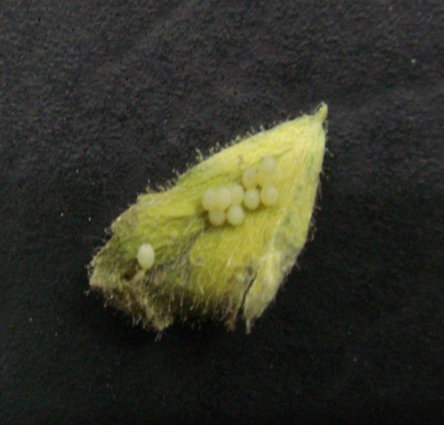
Eggs of H.armigera

2. Larvae:-
Larvae can develop in six instars. The newly hatching larva feeds on the egg shell and make a hole for exit and emerges into neonate larvae. The first instar larva is very small and about 1-3 mm long, which is white or yellowish-white in colour with brown-black head and dark-spotted body. About 1-2 days newly hatched larvae was feed on tender young foliage and then move to feed on buds, flowers, fruits etc. Second instar larva is smaller in size and about 4-7 mm in length while third instar larva is small medium in size with 8-13 mm in length. The medium large larva is about 14-23 mm in length and it is voraciously feeders i.e. fourth instar as well as the fifth instar can 24-28 mm in length and it is also voraciously feeding stage. Sixth instar larvae can stop feeding and enter in to a pre-pupal stage. It is about 29-32 mm in length.
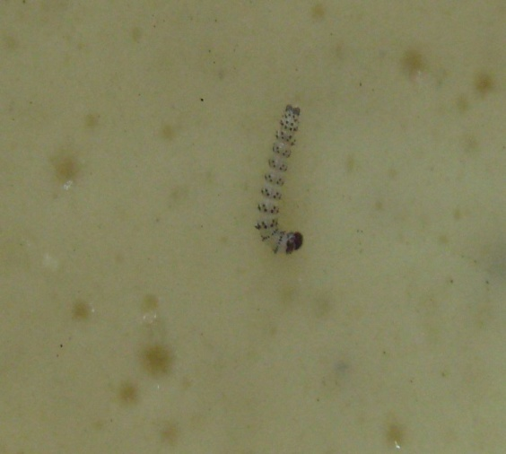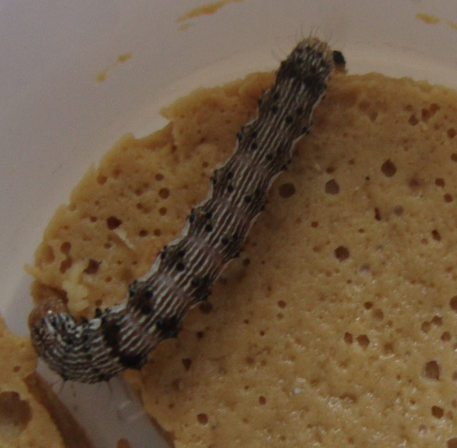
First Instar Larva Third Instar Larva
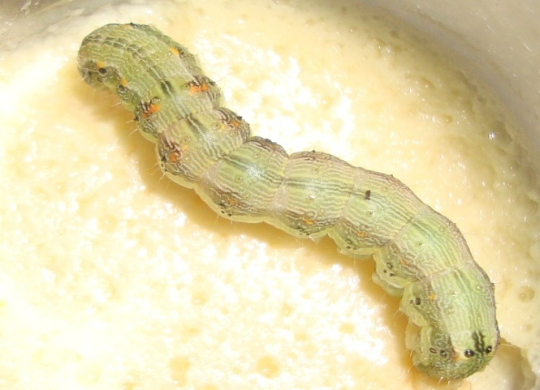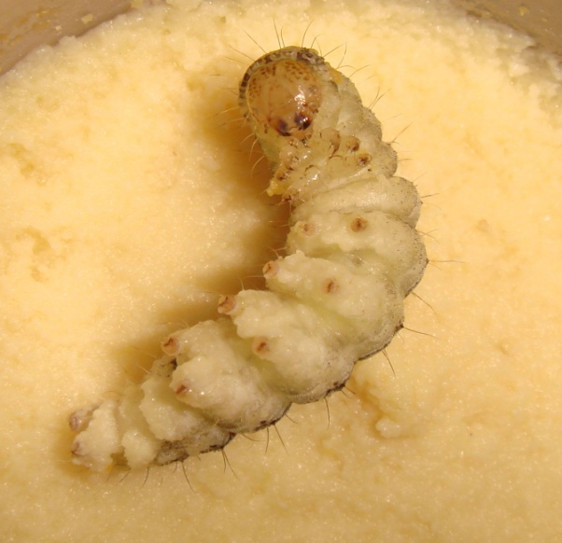
Fourth Instar Larva Sixth Instar Larva

3. Pupa:-
Fully grown larvae are crawl to the base of the plant and tunnel up to 10 cm into the soil for the pupation. Firstly, the fully grown larvae enters into pre-pupa which is somewhat transparent to light green in colour and it is lasts for 2-4 days. After the pre-pupa the pupation period is start which is dark brown in colour and lasts for 10-14 days before the emergence of adult.
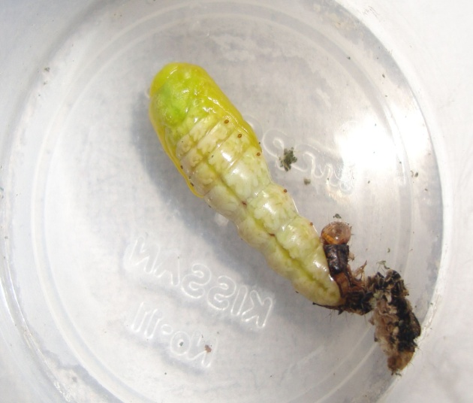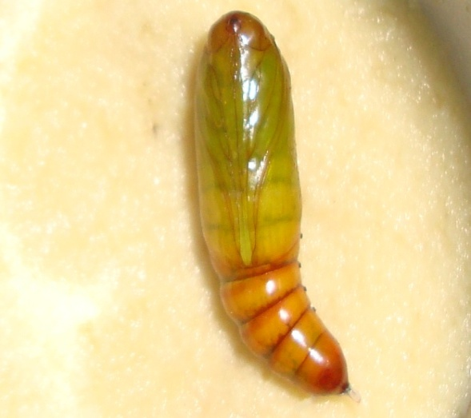
Pre-Pupa Pupa
4. Adult:-
Adults i.e. moth are stout-bodied with a 35 to 40 mm wingspan and body length is about 18 to 19 mm. Colour are varies from dull greenish-yellow to olive-grey with light brown to blackish markings on the wings. Heliothis armigera is a polyphagous insect causing serious damage to cultivated crops in India i.e. cotton, tomato, chickpea, pigeonpea, maize and sorghum etc. It is cosmopolitan and distributed throughout India i.e. Maharashtra, Meghalaya, New Delhi, Madhya Pradesh, Orissa, Punjab, Rajasthan, Tamil Nadu, Uttar Pradesh, West Bengal, Andhra Pradesh, Kerala, etc.
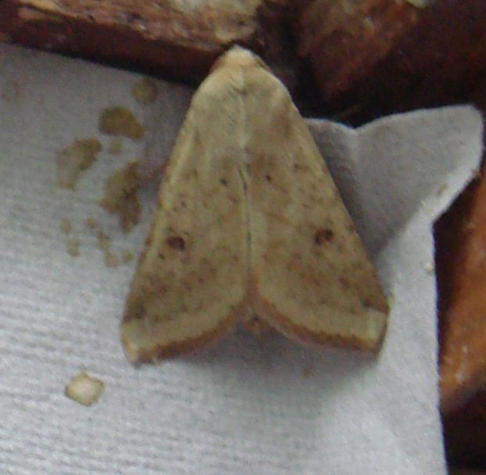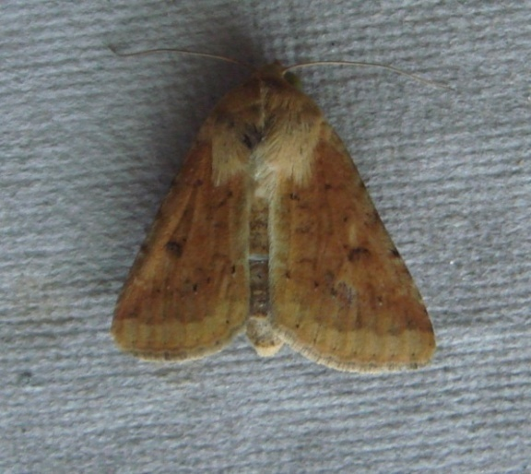
Male Female
Damage of crops by H. armigera:-
Heliothis armigera causes severe damage to a wide variety of crops. Annual yield loss of 300 million US dollars on chick pea and pigeon pea due to Heliothis armigera occur in India (Reed and Pawar, 1982). Contributing factors for loss include crop mono cultures and lack of crop rotation. The extent of crop damage in Motipur (Bihar) 21% Heliothis armigera infestation was recorded on maize while in Madhya Pradesh, Kaushik et. al., (1969) reported 41.56% infestation to the same crop. In Andhra Pradesh 25-65 % pigeon pea and 7.6% chick pea pods were infested (Bhatnagar et. al., 1981, 1982). Heavy damage to tomato fruit 40-50% in Tamil nadu and 80% in Karnataka (Anonymous, 1984) has been recorded. Heliothis armigera attack on reproductive parts of plants i.e. flower buds and flower heads, capsules, berries, and maize inflorescence. Juvenile caterpillars cause high rate of commercial losses by burrowing deep into tomatoes and are overlooked in peeled fruits intended for canning etc. Caterpillars feed on the head when the grains are in the milky stage in sorghum. In Pigeon pea, the eggs are laid on leaves, flowers, flower buds, young pods etc. Flower buds and flowers are damaged by small larvae and may drop down to the ground. Larger larvae bore into pod lobules, and consume the developing grain. The larvae damage flowers and young fruits in tomato. Due to insect attack the larvae are fall down. The larger larvae are bore into the maturing fruits and secondary infections by other organisms lead to contaminated of the fruits. In Maize, the larvae damage the developing grain by laying the eggs on the silks. In cotton, round holes are made on flower buds, flowers and the bolls by the larvae which is visible and bracteoles become spread out and curled downwards. Leaves and shoots may also be damaged. Larger larvae bore into maturing green bolls of cotton and young bolls drop down following larval damage. Eggs are laid on shoot tips, squares, flowers or young bolls. In Chickpea, Eggs are laid on leaves and young pods after egg laying the juvenile larvae initially feed on the foliage (young leaves) and the young seedlings may be completely destroyed. Larger larvae bore into pods and consume the developing seed.
Nature of damage:-
Newly hatched or juvenile larvae feed on surface tissues of the host plant. Due to voracious feeding it cause most damage on the buds and fruiting parts of the plants. Mature larvae can bore completely into the fruit. Agriculture plays a greater role in the economic status of developing countries as it provides livelihood to vast majority of people. The most pressing problem today in agriculture is the need to reduce the loss of crops and their products from the attack or destruction by insects. Insects, the most abundant inhabits of all corners of earth and major pest to restrict man’s endeavours and also interact with other animal and plants species. Hussain et. al., 1991; Khan et. al., 1993 reported that, due to wider host range, multiple generations, migratory behavior, high fecundity and existing insecticide resistance, this became a difficult pest to tackle.
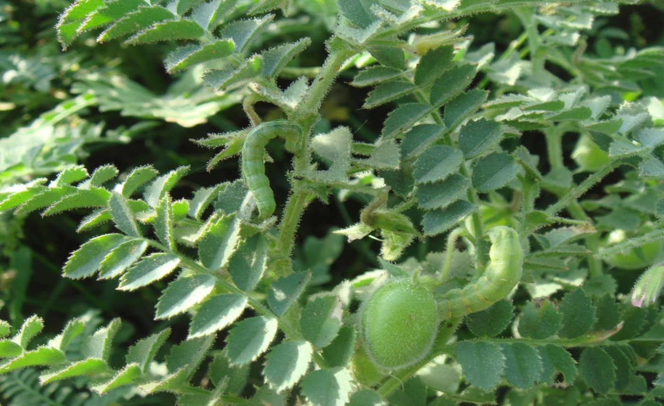
Larvae of H. armigera feeding on leaves and pods of gram (Cicer arientum)
Present methods of the control of pest:-
Chemical pesticides are commonly used to control the propogation and multiplication of injurious pests and thus certainly increased the yield of many crops. But simultaneously this had many side effects, viz,
1) Chemical pesticides may cause physical or physiological changes in the soil.
2) Repeated application of chemicals may lead to air and water pollution.
3) Sprayed chemicals may bring about deleterious effects on beneficial insects like parasitoids and predators.
4) Chemical pesticides have high residual value for long period and hence they reach to human stomach through food and water and causes health problems.
5) Natural balance & ecological cycle may be disturbed
6) Repeated applications of pesticides may lead to the development of resistant varieties of pests which enforced in multiplying the concentration of the powerful chemicals.
Integrated pest management is the result of such efforts. For the effective control, a thorough knowledge of their life cycle, 9 pest status, distribution, periodicity, host complex and behaviour is a pre requisite factor. Resistant to DDT and HCH Pesticide in agriculture was first noticed in India in 1963 when a number of serious pests were reported. The most serious problem of resistance is witnessed in cotton, for which American bollworm is a serious pest. The bollworm has developed resistance to almost all pesticides in a number of regions, and is particularly serious in parts of Punjab, Haryana, Andhra Pradesh, Karnataka and Maharashtra. Other important pests of cotton, white fly and jassid, have also developed pesticide resistance in some places. All methods described are insufficient to control the pest, Heliothis armigera.
References:-
CIBC (Commonwealth Institute of Biological Control). (1974): Biology and breeding techniques for parasites and predators of Ostrinia spp. And Heliothis spp. U.S. PI-480 Project final technical report, 21 june 1967-20 june 1973, Bangalore, Karnataka, India.
King A. B. S. (1994): Heliothis/Helicoverpa (Lepidoptera: Noctuidae). In Insect Pests of Cotton, ed. GA Matthews, JP Tunstall, pp. 39–106. Wallingford: CAB Int. 593 pp.
Shabbier S.G. (1973): Cotton pests, their distribution and seasonal prevalences. Seminar on insect pests of cotton, April 1973. Pakistan Central Cotton Committee, pp.49-61.
Youm O., Sithanantham S., Vaissayre M., Nibouche S., Martin T., Ochou G.O. and Momanyi G. (2005): Bioecology and management of Helicoverpa for sustainable crop production in Africa. Pages 63–90 in Heliothis/Helicoverpa management: emerging trends and strategies for future research (Sharma HC, ed.). New Delhi, India: Oxford & IBH Publishing Co Pvt Ltd.
Nyambo B. T. (1988): Significance of hostplant phenology in the dynamics and pest incidence of the cotton bollworm, Heliothis armigera H¨ubner (Lepidoptera: Noctuidae), in western Tanzania. Crop Prot.7:161–67.
Kaushik V. K., Rathore V. S. and Sood N. K. (1969): Incidence of Bollworms and Losses Caused to Cotton in Madhya Pradesh. Indian J. Entomol. 31: 175-177.
Manjunath T. M., Bhatnagar V. S., Pawan C. S. and Sithanantham S. (1989): Economic Importance of Heliothis spp. in India and an Assessment of Their Natural Enemies and Host Plants. In "Proc. Workshop on Biol. Control Heliothis: Increasing the Effectiveness of Natural Enemies", King, E. G. And Jackson, R. D. (Eds.), New Delhi, 143 India: For East Region Research Office, US Department of Agriculture, PP. 197-228.
Jayaraj S. (1990): The Problem of the Helicoverpa armigera in India and Its Integrated Pest Management. Proc. National Workshop at Centre for Plant Protection Studies, Tamil Nadu Agricultural University, Coimbatore, Tamil Nadu, India.
Ignacimuthu S. and Jayaraj S. (2003): Ecofriendly approaches for sustainable pest management. Current Science, 84: 10-25.
Lal O.P. (1996): An outbreak of pod borer, H. Armigera (Hubner) on chickpea in Eastern Uttar Pradesh, India. J. Ent. Res., 20: 179–81.
Bhatnagar V. S., Lateef S. S., Sithanantham S., Pawar C. S., Reed W. (1982): Research on Heliothis at ICRISAT. Proc. Int.Workshop Heliothis Manage., ed. W Reed, V Kumble, pp. 385–96. Patancheru, Andhra Pradesh, India: Int. Crops Res. Inst. Semi-Arid Trop. 418.
Nyambo B. T. (1988): Significance of hostplant phenology in the dynamics and pest incidence of the cotton bollworm, Heliothis armigera H¨ubner (Lepidoptera: Noctuidae), in western Tanzania. Crop Prot.7:161–67.
Reed W. and Pawar C.S. (1982): Heliothis: a global problem. pp. 9–14 in Reed, W. & Kumble, V. (Eds) Proceedings of the International Workshop on Heliothis Management. Pantanchera, India, ICRISAT.
Kaushik V. K., Rathore V. S. and Sood N. K. (1969): Incidence of Bollworms and Losses Caused to Cotton in Madhya Pradesh. Indian J. Entomol. 31: 175-177.
Bhatnagar V. S. and Davies J. C. (1981): Pest management in intercrop subsistence farming. Proc. Int. Workshop Intercropping. pp. 249–57. Patancheru, Andhra Pradesh, India: Int. Crops Res. Inst. Semi-Arid Trop. 401 pp.
Anonymous (2000): Utilization of Solanum viarum as a trap crop for controlling tomato fruitworm. Asian Veg. Res. Develop. Center Report, Shanhua, Taiwan. pp. 113-114.
Hussain T., Talpur M. A. and Tunio G. D. (1991): Relative toxicity of pyrethroid insecticidwes to gram pod borer. Proc. 11th Pakistan Cong. Zool., 11: 119–22.
Khan M. M., M. A. Rustamani, M.A. Talpur, H.B. Baloch and A.B. Chutto (1993): Efficacy of different insecticides against Helicoverpa armigera on gram. Pakistan J. Zool., 25: 117–9.

