Cutaneous Tuberculosis:Clinicopathological spectrum and diagnostic challenges

Authors: Dr. Abhishek Yadav, Dr. C.P. Baveja, Dr. Tanisha Bharara, Dr.Vasim Ahmad
INTRODUCTION
In 2021, eight countries accounted for more than two thirds of global tuberculosis cases namely India (28%) Indonesia (9.2%), China (7.4%), the Philippines (7.0%), Pakistan (5.8%), Nigeria (4.4%), Bangladesh (3.6%) and Democratic Republic of the Congo (2.9%).1Tuberculosis causes ill–health in millions of people each year and is one of the top 10 causes of death worldwide, ranking above HIV/AIDS as one of the leading causes of death from an infectious disease2.
Though pulmonary TB is the most common form, extra–pulmonary Tuberculosis (EPTB) also contributes to significant morbidity and mortality. The various extra–pulmonary sites are lymph nodes, intestines, bone, joints, meninges, skin, genitourinary tract3.
The incidence of cutaneous tuberculosis (CTB) is around 0.7% and median duration of disease is 1.25 years4,5. The diagnosis of CTB is a difficult task. Most of the time, this entity is diagnosed by its clinical presentation in combination with corroborative histopathological evidence. CTB presents with a wide range of clinical manifestations, varying from warty, nodules and papulonecrotic lesions, to ulcerations and abscesses6. The clinical presentation of different types of CTB varies and is determined by factors such as route of infection and cellular immune status of the host7. In association with clinical findings, histopathology is a useful diagnostic test. However, epithelioid cell granulomas may also be seen in other conditions such as sarcoidosis, leprosy, deep fungal infection, etc. which sometimes clinically also resemble CTB.
CTB may remain localized to the skin alone, but frequently involves regional lymph nodes. Disease is considered to be disseminated if there is presence of generalized lymphadenopathy and/or involvement of other organ systems8.
The direct demonstration of M. tuberculosis has very low sensitivity because most lesions are paucibacillary9. Culture of the organism from lesion of CTB is again highly specific but is usually tedious and unrewarding.
The challenge increases because of the pathogenic status and minor damage to the affected skin compared to other EPTB forms. TB must be considered a cause of cutaneous infections in developing countries due to the high prevalence of the disease in those regions. The conclusive results generally cannot be achieved with bacteriological methods; however, molecular diagnostic methods are considered more sensitive10.
Polymerase chain reaction (PCR) has emerged as a promising tool in which IS6110, a conserved sequence, is mostly targeted11.
TB is the ninth leading cause of death worldwide and the leading cause from a single infectious agent, ranking above HIV/AIDS. This is despite the fact that, with a timely diagnosis and correct treatment, most people who develop TB disease can be cured. It is currently a worldwide threat with 9–10 million new active disease cases being reported every year1. Cutaneous tuberculosis (CTB), though accounts for only 1–2% of extra–pulmonary TB (EPTB) cases12, it is important cause of mortality and morbidity in developing countries because of high prevalence. It may be acquired through exogenous inoculation or endogenous spread13.
HISTORY OF TUBERCULOSIS
Tubercle bacilli have likely lived in symbiosis with mankind since the ascent of homo sapiens on Earth. Greco–Roman civilization recognized the disease as “phthisis” or consumption. In the western world, the clinical features and communicability of TB were known before 1000 BC. Paleopathological evidence of TB in prehistoric humans has also been recorded. A team from the University of Tubingen believe that humans acquired the disease in Africa about 5,000 years ago14. Their domesticated animals, such as goats and cows, contracted it from them. Seals acquired it when coming up on African beaches for breeding, and carried it across the Atlantic. In addition, TB spread via humans on the trade routes of the old World.
ETIOLOGICAL AGENT
Mycobacterium tuberculosis, is a transitional form between actinomycetes and eubacteria. It belongs to class Schizomycetes, order Actinomycetales, family Mycobacteriaceae and genus Mycobacterium. Robert Koch first described it on March 24, 1882. It is an aerobic, nonmotile, nonencapsulated, nonspore–forming bacillus that grows most successfully in tissues with high oxygen content. It is an obligate intracellular pathogen that infects human beings as principal hosts. It has an extended growth period and doubling time (18 to 48 hours). These bacilli present acid–alcohol–resistant staining properties – i.e., they stain red by Carbol fuchsin and will not discolour by the actions of specific concentration of alcohol and acid for specific time, hence the name AFB – Acid–Fast Bacilli. Its genome has already been sequenced15,16,17.
A very slow rate of cell division and the ability to circumvent host immune responses by the bacteria results in persistence and latency. These two properties mandate the need for prolonged drug therapy in patients with established disease, and prophylactic chemotherapy in susceptible population, most commonly household contacts of active disease. Although it may cause illness in men, M. bovisis considered a zoonotic disease that usually affects tonsils, lymph nodes and intestine. It may rarely be the cause of the cutaneous form of TB. When causing lung disease, M. bovisis not easily transmitted and therefore, there is a tendency for its disappearance18.
The probability of developing active clinical TB after inhalation of M. tuberculosis aerosol from an infectious patient has an estimated lifetime risk of about 10%, the risk being highest within the first few years of the infection. Most infected immunocompetent individuals either eliminate M. tuberculosis or develop latent infection. Latent TB, a hallmark of mycobacterial infection in immunocompetent individuals is characterized by persistence of bacilli in the host’s system, with suspended ability to replicate or cause tissue damage and/or clinical symptoms. The clinical presentation of tubercular infection progressing to established disease depends on the interplay of mycobacterial virulence and host immune response.
MODE OF TRANSMISSION – EXOGENOUS V/S ENDOGENOUS CTB
CTB may be acquired by exogenous or endogenous mechanisms. Exogenous infection resultsfrom direct inoculation of bacilli from another infected individual onto the skin of susceptible individuals, resulting in tubercular chancre (when host immunity is poor) or tuberculosis verrucosa cutis (TBVC) (when host immunity is good). Endogenous infection is secondary to a pre–existing primary focus. It may present as scrofuloderma (SFD) or orificial TB resulting from locoregional spread from a contiguously infected site, most commonly an infected lymph node. Haematogenous or lymphatic dissemination of a primary systemic focus results in occurrence of lupus Vulgaris (LV), tuberculous gumma or miliary TB. Tuberculids, a separate class of CTB occurs in an individual with concurrent TB elsewhere, as an immune hypersensitivity reaction to M. tuberculosis antigens.
Although Bacillus Calmette–Guerin (BCG) is generally safe vaccine, however reactions such as skin complications are well known and can include local hypersensitivity reactions, cutaneous granulomas, fixed drug eruption and Cutaneous Tuberculosis (CTB). The interval between vaccination and the development of skin lesions may be of several months or years, with an average duration of 1 year19,20.
EPIDEMIOLOGY
In 2021, there were an estimated 1.4 million TB deaths among HIV-negative people and 187 000 among HIV-positive people, for a combined total of 1.6 million; this was up from best estimates of 1.5 million in 2020 and 1.4 million in 2019, and back to the level of 2017. In 2021, 82% of global TB deaths among HIV-negative people occurred in the WHO African and South-East Asia regions; India alone accounted for 36%. The African and South-East Asia regions accounted for 82% of the combined total of TB deaths in HIV-negative and HIV-positive people; India accounted for 32%.2
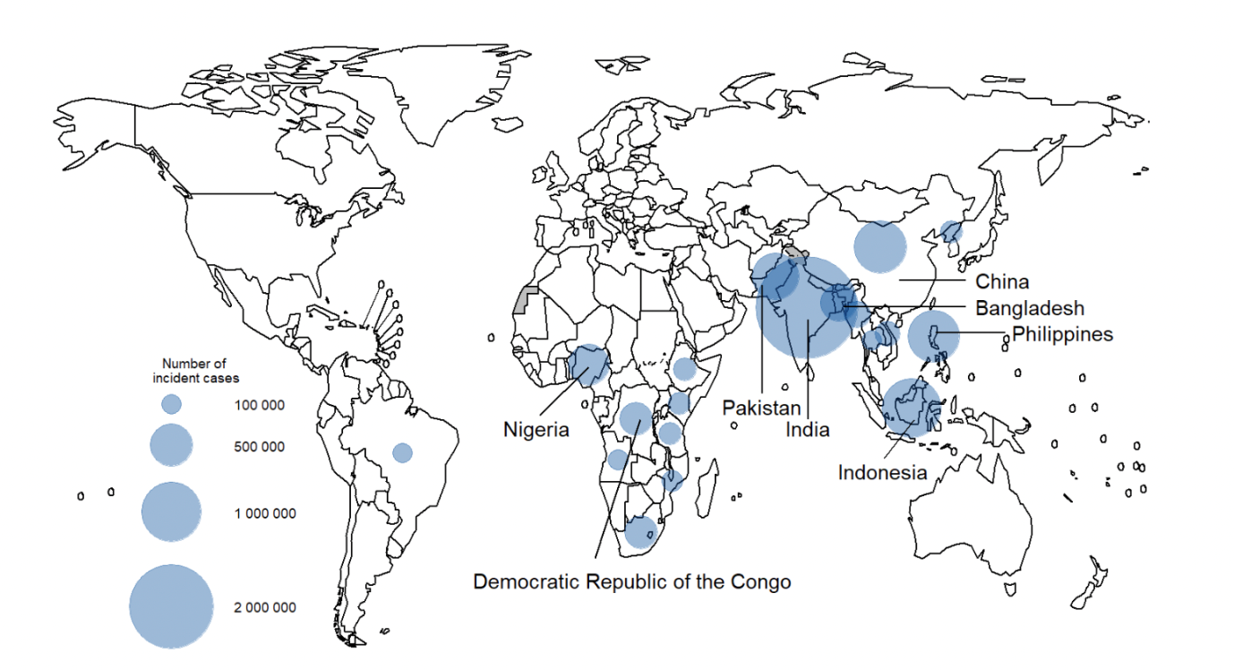
Figure 1: Tuberculosis incidence rates around the world - image by WHO 2021 https://www.who.int/teams/global-tuberculosis-programme/tb-reports/global-tuberculosis-report-2022/tb-disease-burden/2-1-tb-incidence#:~:text=An%20estimated %20global%20total%20of,among%20people%20living%20with%20HIV²
Globally, the proportion of people who develop TB and die from the disease (the case fatality ratio or CFR) was 16% in 2016. Between 2000 and 2016, TB treatment averted an estimated 44 million deaths among HIV–negative people. Among HIV–positive people, TB treatment supported by anti–retroviral therapy (ART) averted an additional 9 million deaths.
Pulmonary TB has been the most common form in children but there has been a steady increase in the number of EPTB cases, especially tuberculous lymphadenitis. During the last few years, EPTB cases have outnumbered cases of pulmonary TB in children21.
EPIDEMIOLOGY OF CUTANEOUS TUBERCULOSIS

CTB is one of the less common clinical forms of TB accounting for approximately 1–2% of the total number of extra–pulmonary cases but contributing to significant morbidity22,23. Its global resurgence parallels the increasing incidence of pulmonary TB and emergence of multidrug resistance24. The prevalence of CTB among Indian dermatology outpatients has ranged from 0.1– 0.9% over the last few decades8,12,23. Kumar et al in their 20–year retrospective survey of patients attending dermatology outpatient department of a tertiary care hospital in India, reported 280 patients suffering from CTB of the total 2,67,420; giving a prevalence rate of 0.1% among dermatology patients23. Parallel to the increase in the overall incidence of EPTB with the HIV epidemic, increase in the incidence of CTB is expected.
EPIDEMIOLOGY OF CHILDHOOD CUTANEOUS TUBERCULOSIS ACROSS THE GLOBE AND IN INDIA
Most published studies in childhood CTB are from developing countries, mainly Southeast Asia. The reported prevalence of CTB in children has varied in different studies depending on the geographical region25. It has ranged from 82% of all CTB cases in Pakistan, 24.3% in Ethiopia, and up to 50% in older surveys from Hong Kong with a downward trend over time6,26. In India, the prevalence of childhood skin TB has ranged from 18% to 54%, 18.7% in Chandigarh, 20.4% in Varanasi, 24.41% in Chennai and a higher prevalence ranging from 31.7% to 53.9% in recent case series from Delhi7,8,25,27,28,29. CTB is usually seen in children aged 10 –14 years, although no age group is resistant. Sex distribution is variable in different studies, but a significant gender predilection is inapparent. The clinical spectrum of CTB in children is comparable to that in adults, except for a higher likelihood of disseminated and systemic involvement21. Childhood CTB has been often reported to develop following BCG vaccination30.
While lupus vulgaris (LV) has traditionally been considered to be the commonest form of CTB seen in most countries, tuberculids especially lichen scrofulosorum (LS), have recently emerged as the commonest variant in many regions like Hong Kong6. Tuberculids are also rapidly becoming one of the most common manifestations of CTB in India. Scrofuloderma(SFD), once reported to be the commonest form in certain populations (e.g., in mexicans), is relatively less frequently encountered now12.
IMMUNOLOGY IN CUTANEOUS TUBERCULOSIS
Just as in leprosy and pulmonary TB, there is a concept of spectrum in CTB. Based on bacteriological, histopathological and immunological parameters, Sehgal et al proposed a continuous spectrum extending from the greater cellular immunity pole, observed in LV, with
active cellular immunity and apparently normal levels of immunoglobulins, to SFD and cutaneous miliary TB, which present a relatively less active cellular immunity and high humoral response, as evidenced by elevated immunoglobulin serum levels and low levels of C331.
The introduction of more specific and sensitive diagnostic methods, as well as a greater understanding of the molecular and cellular mechanisms that regulate the parasite–host interaction may contribute to an efficient fight against TB. Immunosuppression, either due to a poor state of health, HIV infection or due to the use of immunosuppressive drugs, represents the main trigger for active disease development, caused by M. tuberculosis32.
TABLE 1: Types of Cutaneous Tuberculosis
 | Exogenous Cutaneous TB |  | Endogenous Cutaneous TB
 | Tuberculosis Verrucosa Cutis (TBVC) | Tuberculous Chancre | Lupus Vulgaris | Scrofuloderma | Orificial TB | Tuberculous Gumma | Acute Miliary TB
Prevalence | Common | Rare | Most common form in adults, 2nd most common in children | Most common form in children | Relatively rare | Rare | Rare and severe
Mode of Infection | Inoculation | Inoculation/  trauma | Hematogenous/  Lymphatic spread | Contiguous spread from underlying focus | Self-inoculation | Hematogenous spread | Hematogenous spread
Prior sensitisation | Present | Absent | - | - | - | - | -
Immunity against MTB | Moderate – High | Initially none | Moderate | Weak | Immuno-compromised | Immuno-compromised | Poor immune status
Location | Foot, buttocks | Local trauma | Head and Neck | Skin over cervical lymph nodes | Mucocutaneous junctions of orifices | Single multiple lesions on limbs | Generalised
PPD | Strongly positive | Initially negative | Positive | Positive | Negative | Negative | Negative
HPE General | Epidermal hypertrophic changes: pseudo epitheliomatous hyperplasia | Acute neutrophilic inflammation | Typical Epithelioid granulomas+ Langhans Giant cell without caseous necrosis | Non Specific  Poorly formed granulomas with intense caseous necrosis | Necrosis and ulceration | Widespread caseation necrosis | Necrosis and ulceration
Tuberculoid  Granulomas | Sparse | Granulomas + | Granulomas ++++ | Granulomas + | Granulomas ++ | Granulomas ++ | Granulomas ++
Bacillary load | Paucibacillary | - | Paucibacillary | Multibacillary | Multibacillary | Multibacillary | Multibacillary
AFB | Rarely detected | - | Rarely detected | Detected | Detected | Detected | Detected
Course | Slow | Chancre heals within 3-12 months | Deep tissue destruction | May heal spontaneously over months-years | Resistant to ATT | Widespread involvement | Poor prognosis
Complication | Elephantiasis, Secondary bacterial infection | LV, Scrofuloderma or miliary TB | Small cell carcinoma | Scars | Fatal | - | -

CLASSIFICATION OF CUTANEOUS TUBERCULOSIS
(A) EXOGENOUS CTB
1. Tuberculosis verrucosa cutis (TBVC)
Pathogenesis: TBVC, the most common form of inoculation CTB, is the result of primary inoculation in previously sensitized individuals who maintain moderate to high immunity against M. tuberculosis. In tropical zones, TBVC often occurs over the foot and buttocks of children, on account of their habit of walking barefoot on soil contaminated with tuberculous sputum33,34. Extremities and other trauma prone sites are typically involved. It can also be considered an occupational disease, due to self–inoculation possibilities, such as may occur to a dentist treating the mouth of a patient with pulmonary TB or to a butcher handling contaminated meat (in the latter case it is usually due to infection by M. bovis). Purified Protein Derivative (PPD) test is strongly positive35,36,37.
Clinical features: Lesions are usually solitary and painless verrucous papules or plaques, with the surface showing fissures or clefts that may extrude pus and, often, perilesional erythema or purplish inflammatory halo25,38. Peripheral extension results in gradual expansion of the lesion that may lead to a serpiginous outline with involution at the center. Sometimes exuberant, extensive form of the disease may result in deformity of the limbs. In contrast to SFD and LV, lymphadenopathy is relatively less common.
Laboratory diagnosis: On histology, it shows striking epidermal hypertrophic changes like pseudo epitheliomatous hyperplasia, the presence of acute neutrophilic abscess formation in the upper dermis and characteristic but sparse tuberculoid granulomas in the mid dermis7. TBVC is a paucibacillary form of CTB, with AFB being rarely detected35,39.
Course: Without treatment, extension is extremely slow and the lesions tend to persist indefinitely, although spontaneous resolution might occur rarely40. Secondary bacterial infection and elephantiasis are possible complications of extensive lesions affecting extremities41.
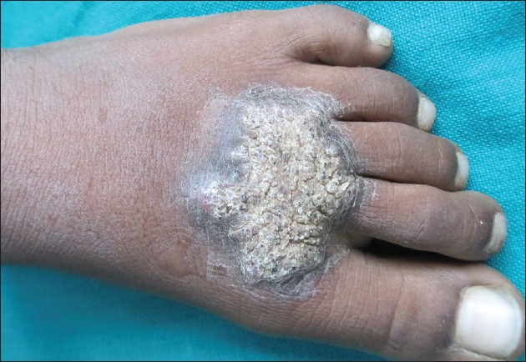

Figure 2: Tuberculosis verrucosa cutis - image by Rao AG via “https://ijdvl.com/scrofuloderma-associated-with-tuberculosis-verrucosa-cutis/”
2. Tuberculous chancre (Primary inoculation tuberculosis)
Pathogenesis: It is rare form of inoculation CTB that develops in adults without previous sensitization to the bacillus21. It is rare in children but more frequent in those who were not vaccinated and have contact with patients with pulmonary TB35,42. Inoculation occurs during local trauma, which may be trivial (often unnoticed by the patient), may occur during tattooing, ear–piercing or ritual circumcision, or may result from exposure to unsterilized material during surgical procedures38,43. The combination of the chancre and regional lymphadenopathy is equivalent to the Ghon focus in pulmonary TB.
Clinical features: After 2–4 weeks of inoculation, a firm more than 1 cm sized painless, reddish–brown papule or nodule arises, which soon evolves into an ulcer which is shallow and friable with undermined bluish margins and coarse granular base. It is typically painless but tends to bleed. Trauma prone sites like face and extremities are the most frequently involved. Lymphatic dissemination ensues 3–8 weeks after the onset of chancre, resulting in regional lymphadenopathy which may break down to form a discharging sinus39,40. Any painless nonhealing ulcer with regional lymphadenopathy (primary complex) in an adult or child should arouse suspicion of tuberculous chancre.
Laboratory diagnosis: On histopathology, early changes show acute neutrophilic inflammation. After 3–6 weeks, caseating granulomas develop and the bacilli disappear. Course: The chancre tends to heal with atrophic scarring between 3 and 12 months. Spontaneous regression with scarring and regional lymph node calcification may occur or the patient may develop LV lesions and TBVC17.
PPD is initially negative but becomes positive during the course of the disease (usually after 15 days)17. However, ATT is strongly recommended, since untreated chancre may become complicated with development of LV or SFD or may disseminate resulting in acute miliary TB.
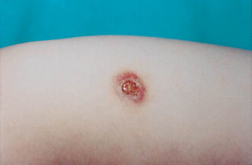
Figure 3: Tuberculous chancre – image by Mariano A “https://www.sciencedirect.com/science/article/abs/pii/S0190962200762189”
(B)ENDOGENOUS CTB
1. Lupus Vulgaris (LV)
Pathogenesis: LV is the most common clinical type of cutaneous TB in adults, and the second most common type seen in children25. LV is a chronic, progressive form of CTB occurring in individuals previously sensitized to M. tuberculosis with moderate immunity against the bacillus. Women are affected 2–3 times more often than men. Although the most common mode of infection is hematogenous or lymphatic dissemination from an endogenous source, it may also develop from direct inoculation, at site of BCG vaccination, or over the drainage scar of SFD30,44. The most common sites of involvement are the head and neck (disseminating disease), and lower extremities and gluteal region (inoculation–induced LV).
Clinical features: The clinical presentation of LV is highly variable with diverse morphology. Typical lesions (also called “classical plaque”) consist of papules and well–defined reddish– brown plaques. The plaque expands peripherally, with serpiginous or verrucous borders, often reaching over 10 cm in diameter with central discolouration and atrophy. Presence of
involution and scarring in one area of the lesion and progression in another area resulting in a
geographic or gyrate appearance is characteristic of classical LV21,25. Diascopy of
the lesion has classically been described to reveal soft reddish–brown “apple jelly” nodules
that represent the microgranulomatous papules that coalesce to form plaques of LV. However,
the ‘apple jelly’ appearance on diascopy is not specific for LV; it may be encountered in other
granulomatous diseases such as sarcoidosis and leprosy34,40. Other morphological variants of
LV include hypertrophic, ulcerative and mutilating, vegetative and tumour like, atrophic and
planar. Although regional lymphadenopathy is commonly encountered in LV, systemic
involvement is seen less often compared to SFD25. Systemic tubercular foci have been reported
in the lymph nodes, lungs, and liver. LV may also present with nodules, vegetating lesions,
psoriasiform lesions, sporotrichoid lesions, kissing lesions around the gluteal cleft, and those
mimicking diseases such as discoid lupus erythematous, actinomycosis and mycetoma12,21,25,45,46.
Laboratory Diagnosis: Histopathology of LV lesions reveals typical epithelioid granulomas in the upper dermis, with lymphocytes and langhans giant cells in up to 80% of the cases, with the remainder showing nonspecific changes7,8,23. The hypertrophic form additionally shows the presence of epidermal hyperkeratosis, papillomatosis and acanthosis. Necrosis is absent and fibrosis is evident in areas of healing and scarring. AFB is scanty and difficult to detect by staining methods or mycobacterial culture; thus, LV is considered a paucibacillary form of CTB.
The usefulness of dermatoscopy in the diagnosis of LV has been recently suggested, since it revealed peculiar characteristics consisting of linear telangiectasias on a yellow–golden background and whitish reticular streaks. Although none of the observed characteristics are specific enough alone, their combination may increase the diagnostic sensitivity47.
Course: Untreated LV lesions may grow to become gigantic and often lead to deep tissue destruction with significant aesthetic alterations33,34,40. Malignant transformation into squamous cell carcinoma, a dreaded long–term complication of untreated LV, has ranged from 0.5–10.5%48,49.
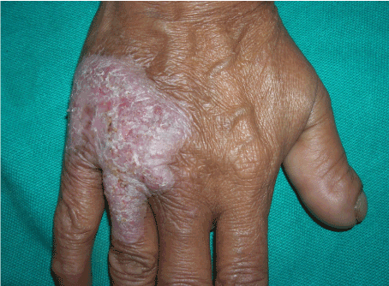
Figure 4 :Lupus Vulgaris- Image by Thomas M “https://www.oatext.com/Cutaneous-lupus-vulgaris-Bringing-the-wolf-out-of-the-darkness.php”
2. Scrofuloderma (SFD)
Pathogenesis: Also known as tuberculosis colliquativa cutis, SFD was the most commonly observed form of CTB before the advent of ATT and still remains common in developing countries such as Brazil and India, particularly in children. Though SFD can occur in any age group, extremes of age are more commonly affected, owing to relatively weaker immune responses7. SFD occurs as a result of contiguous spread from an underlying primary tubercular focus, usually a lymph nodes or bone, and sometimes joints or testicles39. SFD is due to reactivation of dormant TB. There is contiguous involvement of overlying skin from an underlying tuberculous focus such as tuberculous lymphadenitis or tuberculous bone disease. Tuberculin test is usually positive. A cold abscess is formed and the overlying skin is eroded. SFD from tuberculous lymphadenitis often affects the parotid, submandibular, supraclavicular and both sides of the neck. The cervical group of lymph nodes constitutes the most common source of SFD lesions. This may possibly be due to the prevalent habit of drinking unboiled or unpasteurized milk in many parts of the country, with subsequent infection of the cervical lymph nodes8. Inguinal, axillary, parasternal, preauricular, postauricular, occipital, submandibular, epitrochlear and supraclavicular are the other groups of lymph nodes that can be involved. In addition, tuberculous affliction of bones, joints, testes, and breasts may also give rise to SFD8,23,50.
Clinical features: SFD is characterized by the formation of painless, gradually expanding cold abscesses overlying lymph nodes or bone/joint, followed by the formation of ulcerated plaques and fistula that may discharge caseous material. Ulcers are usually shallow with undermined edges and bluish boggy margins. In children and immunosuppressed patients, the lesions can be multiple and widespread. Often, a patient presents with active draining lesions of SFD over a background of puckered scarring, reminiscent of previous healed lesions. Uncommon variants of SFD include multifocal lesions, linear sporotrichoid lesions, scrofulous gumma and SFD at the site of BCG vaccination27,45,50. Scrofulous gumma is characterized by multiple swellings and sinuses with irregular finger–like extensions involving larger areas. Other variants of CTB, most commonly LV, have been reported to develop over and adjacent to the sinuses and scars of SFD38. PPD is strongly positive17,51.
SFD is more often than not, associated with an underlying systemic tuberculous focus, most commonly pulmonary, followed by bone, and abdominal TB23.
Laboratory Diagnosis: Diagnosis is usually evident on clinical examination. While biopsy from the periphery of the lesion may show granulomas suggestive of tubercular etiology, the histopathology is non–specific in many cases8,23. Caseation necrosis, ulceration and abscess formation are commonly encountered. Compared to other forms of CTB, SFD shows granulomatous involvement of the entire dermis, with giant cells as the predominant cell infiltrate. SFD is a multibacillary form of CTB with high likelihood of detection of AFB from stained cytology smears or biopsy samples as well as positive mycobacterial culture compared to other types of CTB7,23,27. The tuberculin test is usually positive.
Course: SFD runs a very protracted course, though it tends to heal spontaneously over months and years, leaving behind cerebriform or bridging scars and pockets of retraction.
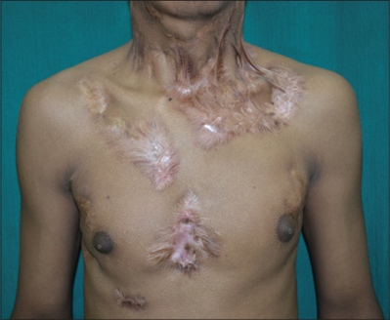
Figure 5 : Image by Rambhia KD “https://ijdvl.com/multifocal-tuberculous-gummas-and-bilateral-scrofuloderma-followed-by-papulonecrotic-tuberculids-developing-during-anti-tubercular-therapy/”
3. Orificial Tuberculosis
Pathogenesis: It results from the propagation of TB infection at the mucocutaneous junction of natural orifices (mouth, anus, vulva, urethra and palate), due to self–inoculation from an active focus on deep tissues, in patients with severe TB on the corresponding area (intestine, urogenital tract). This form of CTB is rare and usually affects immunocompromised patients. Clinical features: Lesions consist of 1–3 cm sized erythematous–to–yellowish, friable and painful papules and nodules developing more commonly in or around mouth and less commonly surrounding genital or anal mucosa21. They evolve into painful ulcers with undermined bluish edges and perilesional edema and inflammation. Severe pain may interfere with eating, micturition, or defaecation.
Laboratory diagnosis: On histopathology, it is characterized by the presence of tuberculoid granulomas with necrosis and ulceration, with abundant AFB. Pain is the cardinal feature and there is usually an evidence of advanced TB elsewhere. It is a multibacillary form of CTB so the culture is generally positive, even with a negative tuberculin response (PPD)17.
Course: The severity of the underlying visceral disease renders a poor prognosis. Resistance to ATT has been reported in few cases. Unimpeded progression of the disease may result in fatality34.
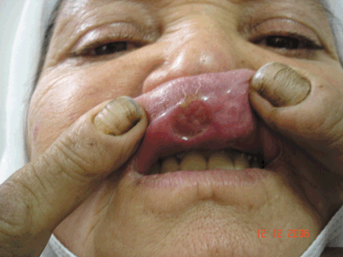
Figure 6 : Orificial Tuberculosis – image by ArzuKilic “https://onlinelibrary.wiley.com/doi/abs/10.1111/j.1365-4632.2009.03942.x”
4. Tuberculous Gumma
Pathogenesis: Tuberculous gumma, results from hematogenous dissemination of TB infection during periods of lowered immunity resulting in single or multiple lesions21,34. It typically affects malnourished children and immunocompromised adults. Tuberculous abscesses have also been described in individuals with acute miliary TB52.
Clinical features: Lesions involve both trunk and extremities and are characterized by non– tender subcutaneous nodules that may later break down to form sinuses or undermined ulcers. Nodules may ulcerate and drain caseous material. Lesions with overlapping features of SFD and gumma have been called scrofulous gumma. In fact, TB gumma is considered by some to be a severe variant of SFD21. Regional lymphadenopathy is usually not present. Laboratory diagnosis: Presence of tubercles with widespread caseation necrosis and copious amounts of AFB is seen on histopathology.
Course: In immunocompetent individuals, abscesses may persist for years without treatment followed by spontaneous resolution with scarring. Patients with compromised immunity tend to have a poor prognosis.
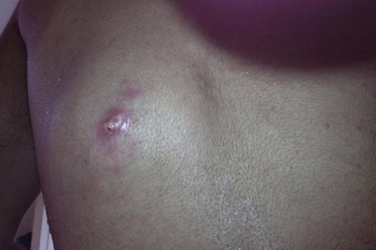
Figure 7 : Tuberculous gumma – image by Parker Louise “https://casereports.bmj.com/content/2013/bcr-2013-010462”
5. Acute Miliary Tuberculosis

Pathogenesis: Miliary TB of skin develops in association with generalized miliary TB due to haematogenousdisseminationofmycobacteriaintotheskin.Itisarareandsevereform ofTB
and affects children with poor immune status25. Disseminated miliary TB of the skin has been
reported in patients with AIDS, and this presentation may become more common owing to the TB–HIVco–epidemic53.
Clinical features: Widespread erythematous to purplish papules, pustules, or vesicles develop that subsequently break down resulting in umbilication and crust formation. Lesions tend to regress in 1– 4 weeks, leaving depressed and hypopigmented scars. Affected individuals are seriously ill with severe constitutional symptoms like fever, anorexia, asthenia, and weight loss. Affection of internal organs is common, especially the lungs and meninges. The tuberculin skin test is almost always negative, demonstrating energy resulting from severe immunosuppression.
Laboratory diagnosis: It is characterized by the presence of tuberculoid granulomas with necrosis and ulceration, with numerous AFB on histopathology17,54.
Course: The overall prognosis is poor but may respond to treatment.
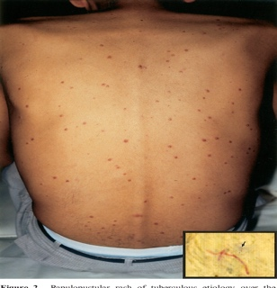
Figure 8 : Acute miliary TB – image by Daikos G “https://www.semanticscholar.org/paper/Disseminated-miliary-tuberculosis-of-the-skin-in-of-Daikos-Uttamchandani/282cacd268131e9e17f1d470a15b41e8e64aa46e”
TUBERCULIDS
Tuberculids represent cutaneous immunologic reaction to the presence of M. tuberculosis or their products in a patient with significant immunity. Their development and presentation may fluctuate based on the underlying host immune status. There are certain diagnostic features of tuberculids21,25,38:
• Tuberculoid histology on skin biopsy,
• Absence of organism in smears,
• Negative mycobacterial culture,
• Evidence of tubercular focus elsewhere (concurrent or past),
• Strongly positive tuberculin test and
• Swift resolution of the lesions with ATT.
Types of tuberculids – 1) Papulonecrotictuberculid (PNT), 2) Erythema induratum of Bazin (EIB), 3) Lichen scrofulosorum (LS) and 4) Phlebitictuberculid.
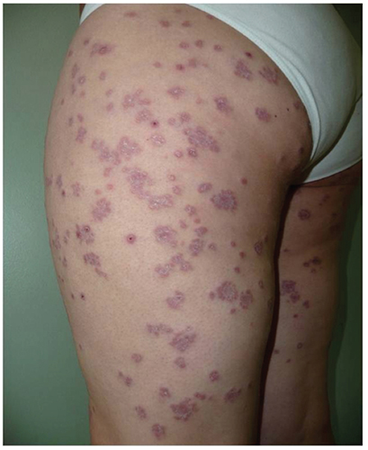
Figure 8 : Tuberculid – image by Brinca A “https://www.pagepress.org/journals/index.php/dr/article/view/dr.2011.e29/4865”
HIV AND CUTANEOUS TUBERCULOSIS
Concomitant HIV infection has been found to be a predisposing factor for acquiring severe pulmonary and extra–pulmonary forms of TB. However, the relationship of HIV infection and cutaneous TB is not very clear. Cutaneous TB, including tubercular ulcers, PNT and disseminated miliary forms may be more severe in HIV positive patients43. In various Indian series, none of the children with cutaneous TB tested positive for HIV by enzyme–linked immunosorbent assay (ELISA)7,23,27. A single case series of 231 patients from South India reported only two HIV positive cases28. Thus, larger studies are required to assess the impact of HIV seropositivity on cutaneous TB.
LABORATORY DIAGNOSIS OF CUTANEOUS TUBERCULOSIS
Diagnosis of CTB is primarily based on the characteristic clinical appearance of the skin lesions supported by various lab tests. The diagnostic accuracy of any single lab test in confirming the diagnosis of CTB is low, therefore it becomes mandatory for the physician to order different tests in order to summate positive evidence for the diagnosis and avoid empirical treatment.
MANTOUX TEST
Mantoux test, also known as tuberculin skin test (TST), is a widely used screening test performed to identify sensitized individuals to M. tuberculosis. The test involves injection of 5 tuberculin units (0.1 mL) of PPD derived from M. tuberculosis, using 26 or 27 gauze needle, on the volar aspect of left forearm about 2 inches below the elbow crease. The reaction, a classical delayed hypersensitivity reaction, results in induration that is read after 48–72 hours.
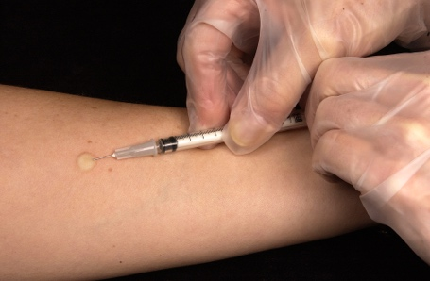
Figure 9 : Mantoux test
An induration measuring 10 mm or more is considered significant and indicates infection (i.e. previous sensitization) but not necessarily the disease. Occasionally vesicle or bulla formation or necrosis occurs, indicating high degree of tuberculin sensitivity and presence of active infection. A false–positive result may be caused by nontuberculous mycobacteria or previous administration of BCG vaccine78.
For cutaneous tuberculosis, TST has sensitivity between 33% to 96%, specificity of 62.50% with a cut–off of 10 mm and thus has low accuracy in doubtful cases of CTB. It has also been suggested that for patients with clear evidence of immunosuppression, a lower cut–off of 5 mm may be more suitable. The impact of BCG vaccination on TST positivity in endemic populations cannot be ignored. In unvaccinated populations, the sensitivity is much higher, close to 97%55. A high mantoux positivity ranging from 91.8% to 97% has been reported in patients with localized CTB in contrast to 50% in those with disseminated disease8,23. Tuberculin test shows highest positivity in tuberculids, with common occurrence of exaggerated reactions, as reported by Singal et al in 100% cases of lichen scrofulosorum56.
HISTOPATHOLOGY
The hall mark of histology of classic CTB lesion is the presence of characteristic granuloma composed of epithelioid cells, lymphocytes and langhans giant cells. Other features like distribution of granuloma in the dermis, their compactness, and presence of caseation necrosis, cellular infiltrate, and epidermal changes varies with different clinical types of CTB. Based on the host immune response, histology of CTB may be grouped into three groups38: (1) Well– formed granulomas with absence of caseous necrosis: LV and LS, (2) Granulomas with caseousnecrosis: TBVC, tubercular chancre, acute military TB, tuberculosis orificialis and PNT (3) Presence of poorly formed granulomas with intense caseous necrosis: SFD and tubercular gumma. The most common histological feature is the presence of tuberculoid granuloma in the dermis observed in 57 to 96% of biopsy samples followed by epithelial hyperplasia in 57 to 86% and caseation necrosis in 11.8 to 57%28,56,57. Classical tubercular histology is seen more often in lesions of LV compared with SFD. A clinico–histological concordance was observed in 64 to 85.6% of the cases of childhood cutaneous TB7,23,29. Histopathology is especially useful for diagnosis of tuberculid where bacilli cannot be isolated by culture or demonstrated by AFB staining.
In early lesions, there is non–specific inflammation consisting of polymorphs and macrophages. Tubercles appear after three to six weeks as immunity develops. The tubercle consists of a collection of epithelioid cells at the centre with a variable number of langhans giant cells surrounded by a rim of lymphocytes. As the inflammation progresses, the centre of the granuloma undergoes caseation necrosis, which is a distinctive feature of tuberculous infection.
In patients with adequate cell mediated immunity (CMI), the granuloma is able to contain the infection with progressive fibrosis and finally calcification. In 10% cases, TB infection will lead to active disease58.In LV, there is effective CMI in the host. Granulomas are formed with little caseation and AFB are infrequently found. There are tuberculoid granulomas in the upper dermis.
In SFD, there is moderate cell–mediated immunity in the host. The granulomas are less well formed and are located at the periphery of the lesion with more caseation necrosis at the centre. In addition, some AFBs can be found.In TBVC, there are often epidermal changes such as warty hyperkeratosis or pseudoepitheliomatous hyperplasia with epithelioid and giant cells in the mid–dermis.
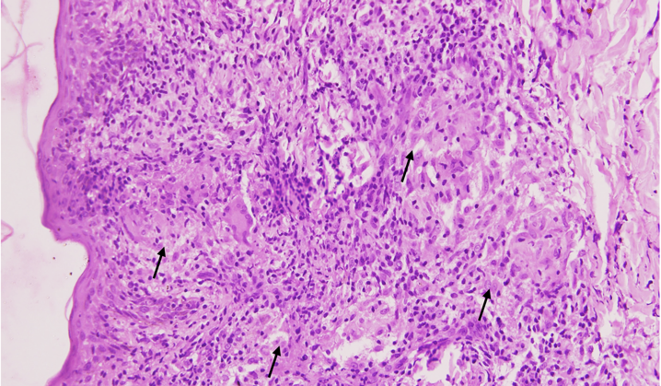 | 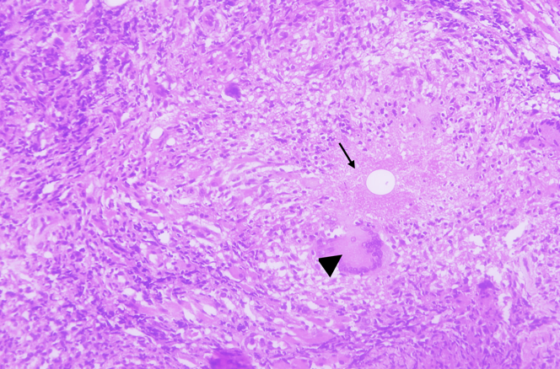

Figure10 A (Left) : Intact epidermis with mild irregular acanthosis. Multiple epithelioid cell granulomas (arrows) in the upper and mid dermis on Haematoxylin & Eosin staining (x 200).

Figure 10B (Right): Deeper dermis showing epithelioid cell granuloma with caseation (arrow) and langhan’s giant cell (arrow head) on Haematoxylin & Eosin staining (x 400).
Tubercles are less common and AFBs are occasionally seen. At the other end of the immunological spectrum, there is miliary TB with poor or absent granuloma formation and marked tissue necrosis. Numerous AFBs are present. The histological picture is similar in primary tuberculous chancre, but as CMI develops, tuberculoid granulomas are formed.
In patients with poor CMI such as in acute disseminated miliary TB, mycobacteria are present. There is massive necrosis and non–specific inflammation.Differentiation from other types of mycobacteria can only be achieved by cultures. Sarcoidosis may be distinguished from mycobacterial infection by the paucity of lymphocytes around the granuloma; called naked granulomas. Tertiary syphilis is characterised by plasma cell infiltration and vascular changes. In tuberculoid leprosy, the granulomas tend to be located around cutaneous nerves.
MICROBIOLOGICALTESTS
1. Demonstration of Acid–Fast Bacillus (AFB) in the Stained Smear
Direct demonstration of AFB, on Ziehl–Neelsen staining, in the tissue smear from exudative skin lesions, lymph node aspirates or biopsy specimens, gives faster results than culture although sensitivity gets compromised. The diagnostic yield of smears is higher for exudative lesions of CTB, especially the multibacillary forms because of the obvious higher bacterial load, as in the cases of primary inoculation, SFD, tuberculosis orificialis, or metastatic tuberculous abscess. A higher AFB positivity has been reported in SFD cases (36.8%) as compared to LV lesions (13.6%). In the same study, cytology smears showed 18.44% AFB positivity, with most of them being SFD7. Pandhi et al in addition, observed that the identification of AFB was higher in cytology smears from lymph nodes compared with detection on biopsy specimens (10.3% vs. 2.9%)23.
2. Mycobacterial culture:
As for any infection, the definitive diagnosis of TB continues to depend on the culture ofmicroorganism. Another advantage of culture is that it can distinguish mycobacterium subspecies and allow drug susceptibility testing. CTB in general is regarded as a paucibacillary infection, therefore mycobacterial isolation from smears and lesion biopsy, on the conventional Lowenstein– Jensen (LJ) medium is reported to be as low as 8.8% and 10.7% in two different studies involving CTB cases exclusively7,23. In addition, the time for declaring negative growth on LJ medium is 6–8 weeks.
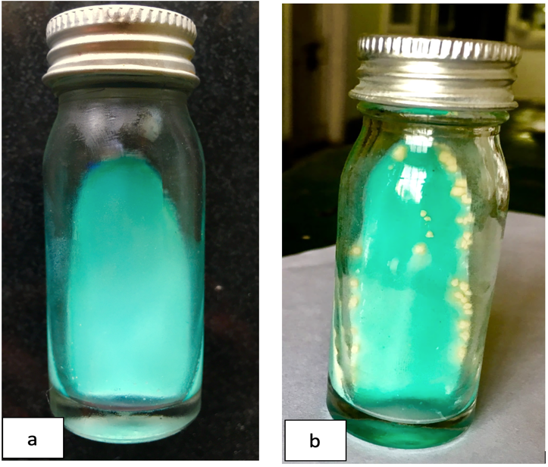  Figure 11 : Lowenstein-Jensen medium showing: a) No growth,b) Colonies of Mycobacteriumtuberculosis. | 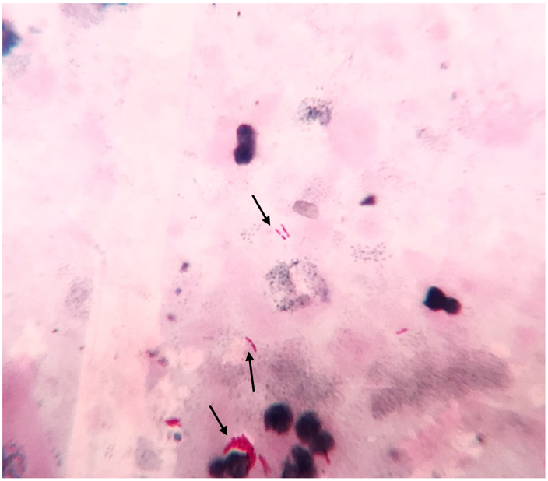  Figure 12 : Acid fast bacilli (arrows) seen on the direct smear made from processed skin biopsy sample on Ziehl-Neelsenstaining (x 1000).
The culture methods are more sensitive than AFB staining and can be positive even when bacterial load is low (10–100 bacilli/mL) with sensitivity of 80–85% and specificity of 98%, required for precise identification of causative organisms. Growth is slow and takes 6–8 weeks. There after the same length of time is required for sensitivity testing. Most commonly used solid culture medium is LJ medium. Other solid media that can be used are Petragnini (egg based) medium, Dorset’s medium (egg based), Pawlowsky (potato based), Middlebrook 7H10 and 7H11medium (agar based).
The inoculated LJ media are incubated at 37oC. The bacilli grow very slowly and colonies appear in about 2 weeks and sometimes upto 6–8 weeks. In positive culture, characteristic colonies appear dry, rough, buff coloured, raised, with a wrinkled surface. They are tenacious and not easily emulsified. M. tuberculosis has a luxuriant growth (eugonic growth)59.
Liquid culture media – The use of liquid culture media reduces the turnaround time for isolation of tubercular bacilli to approximately 10 days. Growth of mycobacterium in liquid medium requires 5 % 10% CO2.Besides solid media, liquid media available are Middlebrook 7H9, Dubo’s medium, Sula’s medium, Proskauer and Becks’s medium.
Mycobacteria growth indicator tube (MGIT)
MGIT is a type of liquid culture method. It is a rapid method which consists of round bottom tubes containing 4 mL of modified Middlebrook 7H9 broth which has an oxygen sensitivefluorescent sensor at the bottom60. When mycobacteria grow, they deplete the dissolved oxygen in the broth and allow the indicator to fluoresce brightly in a 365 nm UV light. Positive signals are obtained in 10–12 days. MGIT can also be used as a rapid method for the detection of drug resistant strains of M. tuberculosis directly from acid–fast smear positive samples as well as for indirect drug susceptibility studies. An advantage over BACTEC is its lower cost and has no problem of radioactive waste disposal61.
In a study conducted in South Africa, among 1267 specimens, MGIT versus LJ medium gave a higher yield of mycobacteria (29.7% vs. 22.8%), higher contamination (16.7% vs. 9.3%) and shorter time to positive culture (median 14 vs 25 days for smear–negative specimens). Among smear–negative samples that were culture–positive on MGIT but negative/contaminated on LJ, 77.3% were non–tuberculous mycobacteria (NTM). MGIT gives higher yield and faster results at relatively high cost62.
3. Serological tests:
Most of the serological tests have low turnaround time and high negative predictive value. However, the value of antibody detection frequently appears compromised, firstly due to BCG vaccination and secondly due to high frequencies of immunological sensitization by environmental mycobacteria.
i) Antigen Detection
Quantitative tests and dipstick method (semiquantitative) to detect lipoarabinomannan (LAM) in pulmonary and extra–pulmonary specimens have been developed. Their utility in the diagnosis of CTB remains to be explored.
ii) Interferon Gamma Release Assays (IGRA’S) – Quantiferon TB Gold and T–SPOT TB These two tests are commercially available, FDA approved, in vitro serological assays that quantify the release of interferon–gamma by blood monocytes consequent to their stimulation by highly specific M. tuberculosis antigen. Both these assays have higher sensitivity and specificity compared to mantoux test. However, previous exposure to atypical mycobacterial infections such as M. marinum and M. kansasimay give false positive results. The likelihood of indeterminate results is higher (to the tune of 30%) in elderly population (>65 years old), compared to other age groups (3.1%)38.
Other groups with high rates of indeterminate results are patients with immunosuppression, low CD4 counts, severe systemic diseases, malnourishment with low serum proteins, and increased C–reactive serum proteins. The utility of these assays lies as a screening tests for latent TB especially in patients with kidney disease, planned transplant, under treatment with anti–TNF–alpha therapies, contacts of AIDS patients38.
4. Molecular tests:
i) Polymerase Chain Reaction (PCR)
A large number of organisms required by all the above methods were the major limitation in detection of M. tuberculosis. A single test, which would amplify the genome, even if a single organism was present, was thought to be ideal for detection of paucibacillary TB cases. PCR is mainly used to complement clinical and histological examination in CTB, especially for undefined cases. In this test, M. tuberculosis DNA (most commonly targeting the IS 6110 gene specific for the MTC) present in the fresh tissue sample or paraffin block is amplified and then can be identified to detect mycobacterial infection. The DNA can be amplified by several techniques such as: conventional or in–house PCR, real–time PCR or PCR with hybridization. Though mRNA PCR has been used to monitor therapeutic efficacy and/or susceptibility to antibacterial agents in sputum samples, it has not found to be useful in diagnosing CTB. The sensitivity of DNA PCR has varied from 25% to 100%, and specificity from 73.7% to 100% in CTB10,38,63,64. Tan et al in their largest series of 105 cases, observed PCR to be 100% sensitive and specific in immunocompromised patients with multibacillary forms and 55–60% in paucibacillary forms with overall positivity of 73%10. In a recent prospective study comparing PCR with other diagnostic methods, though a higher sensitivity (88%) and specificity (83%) rates were attributed to PCR, authors advocated clinical presentation to be the main key in diagnosing CTB65.
ii) Ligase chain reaction (LCR)
It is a variant of PCR, in which a pair of oligonucleotides is made to bind to one of the DNA target strands, so that they are adjacent to each other. A second pair of oligonucleotides is designed to hybridize to the same regions on the complementary DNA. The action of DNA polymerase and ligase in the presence of nucleotides results in the gap between adjacent primers being filled with appropriate nucleotides and ligation of primers. It is mainly used for respiratory samples, and its use in paucibacillary forms such as cutaneous TB is underway.
iii) Cartridge Based Nucleic Acid Amplification Test (CBNAAT)
The new, rapid and fully automated CBNAAT Xpert MTB/RIF test is a real–time cartridge–based automated DNA amplification test. It was co–developed by the laboratory of Professor David Alland at the University of Medicine and dentistry of New Jersey, Cepheid, Inc. and Foundation for Innovative New Diagnostics, with additional financial support from the US National Institutes of Health66. GeneXpert NAAT test has 100% sensitivity and 91.6% specificity for extra–pulmonary specimens67. It is highly sensitive for smear negative samples also. It uses three specific primers and five unique molecular probes to ensure a high degree of specificity. Assay targets rpoBgene in M. tuberculosis. In addition to detecting TB this test also detects rifampicin resistance. The results of the GeneXpert test in a study on EPTB are available within 48 hours compared with a median of 35 days (interquartile range i.e IQR 15 to 43) for cultures. In a study by Held et al, all cases of multi–drug resistant TB (MDR–TB) were diagnosed accurately with the GeneXpert test68. The MDR–TB rate was calculated to be 5.8%.
Similarily, in the study on rapid molecular detection of TB and rifampicin resistance by Boehme et al, among culture–positive patients, a single, direct MTB/RIF test identified 551 of 561 patients with smear–positive TB (98.2%) and 124 of 171 with smear–negative TB (72.5%). The test was specific in 604 of 609 patients without TB (99.2%)68.
A study done on evaluation of GeneXpert MTB/RIF assay (CBNAAT) for rapid diagnosis of TB by Zeka et al with extra–pulmonary specimens, reported 100% sensitivity for smear– positive specimens69.
iv) Loop–mediated isothermal amplification (LAMP) test
LAMP is a novel nucleic acid amplification method in which reagents react under isothermal conditions with high specificity, efficiency, and rapidity. LAMP is used for detection of MTC, M. avium, and M. intracellularedirectly from sputum specimens as well as for detection of culture isolates. Species–specific primers were designed by targeting the gyrBgene, and their specificities were validated on twenty–four mycobacterial species and seven non– mycobacterialspecies.The whole procedure is quite simple, starting with the mixing of all reagents in a single tube, followed by an isothermal reaction during which the reaction mixture is held at 63°C. The resulting amplicons are visualized by adding SYBR Green I to the reaction tube. The only equipment needed for the amplification reaction is a regular laboratory water bath or heat block that furnishes a constant temperature of 63°C. The assay has a detection limit of 5 to 50 copies of purified DNA with a 60–min incubation time. The reaction time can be shortened to 35 min for the species identification of MTC, M. avium, and M. intracellularefrom a solid–medium culture70.
v) Line probe assay (LPA)
WHO recommended the use of molecular line probe assays (LPA) for rapid screening of MDR– TB in low and middle–income settings71. LPA uses multiplex polymerase chain reaction (PCR) amplification and reverse hybridization to identify MTC and mutations to genes associated with rifampicin and isoniazid resistance. LPA can be performed directly from AFB smear– positive sputum, or from culture isolates, and provide results in 1–2 days. A recent systematic review concluded that line probe assays are highly sensitive and specific for detection of rifampicin resistance (≥97% and ≥99%) and isoniazid resistance (≥90% and ≥99%) on culture isolates and smear–positive sputum. It has been shown that the overall agreement of LPA with conventional drug susceptibility testing (DST) for detection of MDR–TB was 99%72.
Antitubercular Drug Trial (Therapeutic Trial):
When the clinical picture is uncertain, and laboratory results are equivocal but the suspicion of diagnosis of CTB is high, the concept of therapeutic challenge as a valid diagnostic method has been advocated73. Four–drug ATT (consisting of isoniazid, rifampicin, pyrazinamide and ethambutol) is initiated and the clinical response is assessed in 4–6 weeks. It has been suggested that 5 weeks appears to be an adequate duration of a therapeutic trial in patients suspected to have cutaneous TB. If there is no significant response by 5 weeks, it is unlikely that further treatment may be beneficial5. So, either the diagnosis should be reviewed or possibility of MDR–TB should be considered.
However, patients with tuberculids and those with minimally active disease may take longer; around 8–9 weeks to respond, and thus it may be worthwhile to prolong the therapeutic trial in such cases before considering alternative diagnosis56.
Systemic Screening for Tubercular Focus
Coexistent systemic focus of TB has been observed in about one fourth of all patients with cutaneous lesions12. The range is reportedly higher in paediatric population (21.3–53.4%)7,8,23,29. Thus, it becomes mandatory to screen all patients of CTB carefully. Associated TB focus elsewhere in the body is a guide to the duration of ATT. A clinical assessment of lymph nodes, pulmonary and gastrointestinal system, nervous system, eyes and musculoskeletal system should be performed.

References:

- Global tuberculosis report: Epidemiology, strategy, financing: WHO report 2022. Geneva, World Health Organization, 2022.
- Global tuberculosis report: Epidemiology, strategy, financing: WHO report 2022. Geneva, World Health Organization, 2022.
- Fitzgerald DW, Sterling TR, Haas DW. Mycobacterium tuberculosis. In: Mandell GL, Bennett JE, Dolin R, editors. Principle and practice of infectious diseases. 8th ed. USA, Philadelphia: Churchill Livingstone;2015.p.2787–818.
- Varshney A, Goyal T. Incidence of various clinico–morphological variants of cutaneous tuberculosis and HIV concurrence: a study from the Indian subcontinent. Annals of Saudi Medicine. 2011 Mar 1;31(2):134–9.
- Ramam M, Tejasvi T, Manchanda Y, Sharma S, Mittal R. What is the appropriate duration of a therapeutic trial in cutaneous tuberculosis? Further observations. Indian J Dermatol VenereolLeprol. 2007 Jul 1;73(4):243–6.
- Chong LY, LO KK. Cutaneous tuberculosis in Hong Kong: a 10–year retrospective study. Int J Dermatol 1995 Jan 1;34(1):26–9.
- Vashisht P, Sahoo B, Khurana N, Reddy BS. Cutaneous tuberculosis in children and adolescents: A clinicohistological study. J EurAcad Dermatol Venereol. 2007 Jan 1;21(1): 40–7.
- Kumar B, Rai R, Kaur I, Sahoo B, Muralidhar S, Radotra BD. Childhood cutaneous tuberculosis: A study over 25 years from northern India. Int J Dermatol. 2001 Jan 1;40(1):26–
- Sehgal VN, Srivastava G, Khurana VK, Shanma CK, Bhalla P, Beohar PC. An appraisal of epidemiologic, clinical, bacteriologic, histopsthologic, and immunologic parameters in cutaneous tuberculosis. Int J Dermatol. 1987 Oct 1;26(8):521–6.
- Tan SH, Tan HH, Sun YJ, Goh CL. Clinical utility of PCR in the detection of Mycobacterium tuberculosis in different types of cutaneous tuberculosis and tuberculids. Ann Acad Med Singapore 2001 Jan;30(1):3–10
- Ogusku MM, Sadahiro A, Hirata MH, Hirata RD, Zaitz C, Salem JI. PCR in the diagnosis of cutaneous tuberculosis.Braz J Microbiol. 2003 Jun;34(2):165-70
- Kumar B, Muralidhar S. Cutaneous tuberculosis: A twenty–year prospective study. Int J Tuberc Lung Dis. 1999;3(6):494–500.
- Iftikhar U, Nadeem M, Aman S, Kazmi AH. Scrofuloderma: A common type of cutaneous tuberculosis. A case report. J Pak Assoc Dermatol 2011;21:61–5.
- Boire NA, Riedel VA, Parrish NM, et al Tuberculosis: from an untreatable disease in antiquity to an untreatable disease in modern times. J Anc Dis Prev Rem 2013;1(2):1–11.
- Kakakhel KU, Fritsch P. Cutaneous tuberculosis. Int J Dermatol. 1989 Jul 1;28(6):355–62.
- Tappeiner G. Tuberculosis and infections with atypical Mycobacteria. In: Fitzpatrick TB, Eisen AZ, Wolff K, Freedberg IM, Austen KF, editors. Dermatology in general medicine. 7th ed. New York: McGraw–Hill;2008.p.1768–78.
- Ramos–E–Silva M, Castro MCR. Cutaneous tuberculosis. In: Bolognia JL, Jorizzo JL, Rapini RP, editors. Dermatology. 2nd ed. New York: Mosby Elsevier;2008.p.1114–9.
- Ara M, Seral C, Baselga C, Navarro M, del Pilar Grasa M, Carapeto FJ. Primary tuberculous chancre caused by Mycobacterium bovis after goring with a bull's horn. J Am Acad Dermatol. 2000 Sep 1;43(3):535–7.
- Bricks LF. Percutaneous or intradermal BCG vaccine?. J Pediatr (Rio J).2004 Apr;80(2):93–8.
- McShane H. Tuberculosis vaccines: beyond bacille Calmette–Guerin. Philos Trans R Soc Lond B Biol Sci. 2011 Oct 12;366(1579):2782–9.
- Sethuraman G, Ramesh V. Cutaneous tuberculosis in children. Pediatr Dermatol. 2013 Jan 1;30(1):7–16.
- Zouhair K, Akhdari N, Nejjam F, Ouazzani T, Lakhdar H. Cutaneous tuberculosis in Morocco. Int J Infect Dis. 2007 May 1;11(3):209–12.
- Pandhi D, Reddy BS, Chowdhary S, Khurana N. Cutaneous tuberculosis in Indian children: the importance of screening for involvement of internal organs. J EurAcad Dermatol Venereol. 2004 Sep 1;18(5):546–51.
- Hamada M, Urabe K, Moroi Y, Miyazaki M, Furue M. Epidemiology of cutaneous tuberculosis in Japan: a retrospective study from 1906 to 2002. Int J Dermatol. 2004 Oct 1;43(10):727–31.
- Singal A, Sonthalia S. Cutaneous tuberculosis in children: the Indian perspective. Indian J Dermatol VenereolLeprol. 2010 Sep 1;76(5):494–503.
- Wong KO, Lee KP, Chiu SF. Tuberculosis of the skin in Hong Kong: a review of 160 cases. Br J Dermatol. 1968 Jul 1;80(7):424–9.
- Ramesh V, Misra RS, Beena KR, Mukherjee A. A study of cutaneous tuberculosis in children. Pediatr Dermatol. 1999 Jul 1;16(4):264–9.
- Umapathy KC, Begum R, Ravichandran G, Rahman F, Paramasivan CN, Ramanathan VD. Comprehensive findings on clinical, bacteriological, histopathological and therapeutic aspects of cutaneous tuberculosis. Trop Med Int Health. 2006 Oct 1;11(10):1521–8.
- Singal A, Mohanty S, Gandhi V, Bhattacharya S. Cutaneous tuberculosis in paediatric age group. In: Proceedings, 7th Congress of European Society for Paediatric Dermatology; 2002.p.33–4.
- Singal A, Sonthalia S, Pandhi D. Ulcerated lupus vulgaris at the site of Bacille Calmette–Guérin vaccination. Pediatr Dermatol. 2013 Jan 1;30(1):147–8.
- Sehgal VN, Wagh SA. Cutaneous tuberculosis. Current concepts. Int J Dermatol. 1990 May;29(4):237–52.
- Teixeira HC, Abramo C, Munk ME. Immunological diagnosis of tuberculosis: problems and strategies for success. J Bras Pneumol. 2007 Jun;33(3):323–34.
- Lai–Cheong JE, Perez A, Tang V, Martinez A, Hill V, Menagé HD. Cutaneous manifestations of tuberculosis. Clin Exp Dermatol. 2007 Jul 1;32(4): 461–6.
- Abebe F, Bjune G. The protective role of antibody responses during Mycobacterium tuberculosis infection. Clin Exp Immunol. 2009 Aug 1;157(2): 235–43.
- Bravo FG, Gotuzzo E. Cutaneous tuberculosis. Clin Dermatol. 2007 March 1;25(2):173–80.
- Rajan J, Mathai AT, Prasad PV, Kaviarasan PK. Multifocal tuberculosis verrucosa cutis. Indian J Dermatol. 2011 May;56(3):332–4.
- Kakakhel K. Simultaneous occurrence of tuberculous gumma, tuberculosis verrucosa cutis, and lichen scrofulosorum. Int J Dermatol. 1998 Nov 1;37(11):867–9.
- Santos JB, Figueiredo AR, Ferraz CE, Oliveira MH, Silva PG, Medeiros PG. Cutaneous tuberculosis: epidemiologic, etiopathogenic and clinical aspects: part I. An Bras Dermatol. 2014 Apr;89(2):219–28.
- Frankel A, Penrose C, Emer J. Cutaneous tuberculosis: a practical case report and review for the dermatologist. J Clin Aesthet Dermatol. 2009 Oct;2(10):19–27.
- MacGregor RR. Cutaneous tuberculosis. Clin Dermatol. 1995 May 1;13(3):245–55.
- Arnadottir T, Rieder HL, Trébucq A, Waaler HT. Guidelines for conducting tuberculin skin test surveys in high prevalence countries. Tuber Lung Dis. 1996 Jun 1;77 Suppl1:1–19.
- Liang MG, Rooney JA, Rhodes KH, Calobrisi SD. Cutaneous inoculation tuberculosis in a child. J Am Acad Dermatol. 1999 Nov 1;41(5):860–2.
- Wong HW, Tay YK, Sim CS. Papular eruption on a tattoo: a case of primary inoculation tuberculosis. Australas J Dermatol. 2005 May 1;46(2):84–7.
- Motta A, Feliciani C, Toto P, De Benedetto A, Morelli F, Tulli A. Lupus vulgaris developing at the site of misdiagnosed scrofuloderma. J EurAcad Dermatol Venereol. 2003 May 1;17(3):313–5.
- Ramesh V. Sporotrichoid tuberculosis. Clin Exp Dermatol. 2007 Nov 1;32(6):680–2.
- Saritha M, Parveen BA, Anandan V, Priyavathani MR, Tharini KG. Atypical forms of lupus vulgaris: a case series. Int J Dermatol. 2009 Feb 1;48(2):150–3.
- Micali G, Lacarrubba F, Massimino D, Schwartz RA. Dermatoscopy: alternative uses in daily clinical practice. J Am Acad Dermatol. 2011 Jun 1;64(6):1135–46.
- Zawirska A, Adamski Z, Stawicka E, Schwartz RA. Cutaneous squamous cell carcinoma developing in lupus vulgaris exfoliativus persistent for 40 years. Int J Dermatol. 2009 Feb 1;48(2):125–7.
- Gooptu C, Marks N, Thomas J, James MP. Squamous cell carcinoma associated with lupus vulgaris. Clin Exp Dermatol. 1998 May 1;23(3):99–102.
- Singal A, Pandhi D, Agrawal SK. Multifocal scrofuloderma with disseminated tuberculosis in a severely malnourished child. Pediatr Dermatol. 2005 Sep 1;22(5):440–3.
- Angel DI, Alfonso R, Faizal M, Ricaurte O, Baez JA, Rojas A, et al Cutaneous tuberculosis diagnosis in an inhospitable Amazonian region by means of telemedicine and molecular biology. J Am Acad Dermatol. 2005 May 1;52(5):S65–8.
- Almagro M, Del Pozo J, Rodriguez–Lozano J, Silva JG, Yebra–Pimentel MT, Fonseca E. Metastatic tuberculous abscesses in an immunocompetent patient. Clin Exp Dermatol. 2005 May 1;30(3):247–9.
- Daikos GL, Uttamchandani RB, Tuda C, Fischl MA, Miller N, Cleary T, Saldana MJ. Disseminated miliary tuberculosis of the skin in patients with AIDS. Clin Infect Dis. 1998 Jul 1;27(1):205–8.
- High WA, Evans CC, Hoang MP. Cutaneous miliary tuberculosis in two patients with HIV infection. J Am Acad Dermatol. 2004 May 1;50(5):S110–3.
- Ramam M, Malhotra A, Tejasvi T, Manchanda Y, Sharma S, Mittal R, et al How useful is the Mantoux test in the diagnosis of doubtful cases of cutaneous tuberculosis. Int J Dermatol. 2011 Nov 1;50(11):1379–82.
- Singal A, Bhattacharya SN. Lichen scrofulosorum: a prospective study of 39 patients. Int J Dermatol. 2005 Jun 1;44(6):489–93.
- Thakur BK, Verma S, Hazarika D. A clinicopathological study of cutaneous tuberculosis at Dibrugarh district, Assam. Indian J Dermatol. 2012 Jan;57(1): 63–5.
- Barnes PF, Bloch AB, Davidson PT, Snider DE Jr. Tuberculosis in patients with human immunodeficiency virus infection. N Engl J Med. 1991 Jun 6;324(23):1644–50.
- Baveja CP, Mycobacterium Tuberculosis. In: Textbook of Microbiology. 4thed.Arya publication;2014.p.334–7.
- Hanna BA, Ebrahimzadeh A, Elliott LB, et al Multicenter evaluation of the BACTEC MGIT 960 system for recovery of mycobacteria. J Clin Microbiol. 1999 Mar 1;37(3):748–52.
- Gerdes SR, Domehl C, Nardi G, et al Multicenter evaluation of the mycobacteria growth indicator tube for testing susceptibility of Mycobacterium tuberculosis to first–line drugs. J Clin Microbiol. 1999 Jan 1;37(1):45–8.
- Chihota VN, Grant AD, Fielding K, Ndibongo B, van Zyl A, Muirhead D, Churchyard GJ. Liquid vs. solid culture for tuberculosis: performance and cost in a resource–constrained setting. Int J Tuberc Lung Dis. 2010 Aug 1;14(8):1024–31
- Margall N, Baselga E, Coll P, Barnadas M, Sánchez F, de Moragas JM, et al. Usefulness of polymerase chain reaction for the diagnosis of Bazin erythema induratum. Med Clin (Barc). 1996 Nov;107(19):730–4.
- Suthar C, Rana T, Singh UB, Singh M, Ramesh V, Sharma VK, et al. mRNA and DNA PCR tests in cutaneous tuberculosis. Indian J Dermatol VenereolLeprol. 2013 Jan 1;79(1):65–9.
- Abdalla CM, de Oliveira ZN, Sotto MN. Polymerase chain reaction compared to other laboratory findings and to clinical evaluation in the diagnosis of cutaneous tuberculosis and atypical mycobacteria skin infection. Int J Dermatol. 2009 Jan 1;48(1):27–35.
- “Two hour detection of MTB and resistance to Rifampicin”, Cepheid International, 2016 http://www.cepheid.com/en/cepheid–solutions–uk/clinical–ivd–tests/critical–infectious–diseases/xpert–mtb–rif.
- Ioannidis, P., Papaventsis, D., Karabela, S., Nikolaou, S., Panagi, M., Raftopoulou, E., Kanavaki, S. (2011). Cepheid GeneXpert MTB/RIF Assay for Mycobacterium tuberculosis Detection and Rifampin Resistance Identification in Patients with Substantial Clinical Indications of Tuberculosis and Smear–Negative Microscopy Results. J Clin Microbiol. 49(8), 3068–70.
- Held M, Laubscher M, Zar HJ, Dunn RN. GeneXpert polymerase chain reaction for spinal tuberculosis: an accurate and rapid diagnostic test. Bone Joint J. 2014 Oct 1; 9(10):1366–9.
- Zeka AN, Tasbakan S, Cavusoglu C. Evaluation of the GeneXpert MTB/RIF Assay for Rapid Diagnosis of Tuberculosis and Detection of Rifampin Resistance in Pulmonary and Extra–pulmonary Specimens .J Clin Microbiol. 2011 Dec 1; 49(12):4138–41.
- Iwamoto T, Sonobe T, Hayashi K. Loop–Mediated Isothermal Amplification for Direct Detection of Mycobacterium tuberculosis Complex, M. avium, and M. Intracellulare in Sputum Samples. J Clin Microbiol. 2003; 41(6):2616–22.
- World Health Organisation. Policy Statement. Molecular Line Probe Assays for Rapid Screening of patients at risk of multidrug resistant tuberculosis (MDR–TB). Geneva,WHO,2008.
- Ling D, Zwerling A, Pai M. GenoType MTBDR assays for the diagnosis of multidrug–resistant tuberculosis: a meta–analysis. Eur Respir J. 2008 Nov 1;32(5):1165–74
- Sehgal VN, Sardana K, Bajaj P, Bhattacharya SN. Tuberculosis verrucosa cutis: antitubercular therapy, a well–conceived diagnostic criterion. Int J Dermatol. 2005 Mar 1;44(3):230–2.

