PROMOTING SUSTAINABLE AGRICULTURE IN SEMI-ARID VERTISOLS: SYNERGISTIC INTEGRATION OF MANURE AND FERTILIZER PRACTICES FOR ENHANCING SOIL FERTILITY AND CROP PRODUCTION

Sindhu R Rathod*, S.D. Jadhao, Pratik Ramteke
Department of Soil Science and Agricultural Chemistry, Dr. Panjabrao Deshmukh Krishi Vidyapeeth, Akola, 444104, Maharashtra, India *Corresponding author Email: sindhurrathod9@gmail.com
Abstract
Enhancing soil nutrients is crucial for sustainable farming. Manure is a great way to provide nutrients, like organic matter, that can support increased output. Manure increases the amount of organic matter in the soil, which has an effect on the soil's quality. It has been demonstrated that adding organic manures to soil enhances soil properties and increases nutrient availability. By influencing soil fertility, fertilization is a key management method for crop production. Fertilization altered the chemical, physical, and biological processes of the soil, which had significant effects on soil health. Utilizing organic and inorganic fertilizers in a balanced and integrated manner may promote the buildup of soil organic matter and increase the physical characteristics of the soil.
Keywords: Manuring, fertilization, INM, soil physico-chemical properties, crop productivity.
I. INTRODUCTION
Over the past six decades, India has witnessed a remarkable surge in food production, primarily attributed to the adoption of modern agricultural technologies. Among these advancements, fertilizers stand out as a pivotal component contributing to this transformative progress. Nutrient inputs, particularly Nitrogen (N) and Phosphorus (P), have emerged as critical determinants in unlocking the productivity potential of high-yielding crop varieties [1].
Modern agricultural practices have witnessed widespread utilization of chemical fertilizers, which, unfortunately, has brought about adverse consequences for the environment and land quality. In order to mitigate these repercussions and ensure a more harmonious coexistence between agricultural productivity and environmental well-being, a paradigm shift towards balanced fertilization strategies is imperative. This entails the application of carefully calibrated fertilizers that not only foster enhanced crop yields but also uphold the integrity of the soil ecosystem.
The paramount significance of balanced fertilization becomes evident in its twofold impact: augmenting agricultural output and safeguarding soil health. The intricate interplay between nutrient availability and crop productivity is mediated by the judicious use of fertilizers. Achieving an optimal equilibrium in nutrient supply not only leads to increased crop productivity but also acts as a safeguard against soil degradation. Sustainable agriculture hinges upon the preservation and enhancement of soil quality, a feat that hinges on the integration of various nutrient sources.
Organic manure emerges as a cornerstone of this integrated approach. Laden with organic matter and essential nutrients, manure contributes significantly to soil fertility enhancement and crop yield amplification. Manure application has a significant impact on soil structure and quality by enhancing the soil with organic matter. Additionally, the addition of organic manures increases the availability of nutrients, fostering a soil environment favorable to healthy plant growth.
However, the continuous application of imbalanced fertilizers, especially within The Indo-Gangetic Plains' intense rice-wheat cultivation method has a negative impact on the soil's health. Integrated nutrient management, which has the capacity to restore the physical makeup and chemical fertility of soil, appears as a workable countermeasure. In turn, this helps to increase the amount of organic carbon in the soil, which eventually promotes sustainable productivity within the agricultural system. Although the impact of organic matter on soil structure and other aspects is well examined in the literature already in existence, the bulk soil level is frequently the main emphasis. Unfortunately, understanding soil mechanical properties at the scale of aggregates has received less focus, despite the fact that these manifestations can have a significant impact on bulk soil characteristics [3].
Applying organic manures results in improvements to soil quality, manifesting in enhanced air capacity, potential root extension, and exploitation of a larger soil volume. Additionally, it bolsters water retention within the soil profile [4], [5]. This augmentation in water retention subsequently translates to increased moisture availability for crops [6]; [7]; [8]. solidifying the acknowledged significance proportion of organic materials to the physical fertility of soil [9]; [10]. Remarkably, organic materials being incorporated into soil induces positive effects on aggregation [11].
Concurrently, the judicious incorporation of inorganic fertilizers complements the organic facet of nutrient management. Fertilization regimes, when properly tailored, exert transformative through modifying its chemical, physical, and biological characteristics, consequences on soil health. It is possible to encourage the buildup of enriched soil organic matter and improve important soil physical qualities by strategically combining organic and inorganic fertilizers.
Conversely, inorganic fertilizers have been documented to stimulate root proliferation and depth in cereal crops [12]; [13]. with their impact on soil aggregation also observed [14]. Furthermore, the application of composted manure has been linked to the improvement of soil with water-stable aggregates [15].
An exciting opportunity for maintaining increased production and improving yield stability is the combination of organic manures and fertilizers. [2].
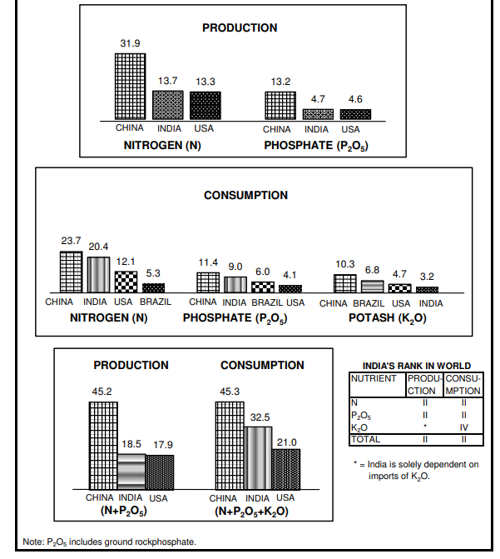
Fig. 1: Rank of India in world production and consumption of fertilizer nutrients
2020 (million tonnes)
(Source: Fertiliser-Stat-Book-2021-22)

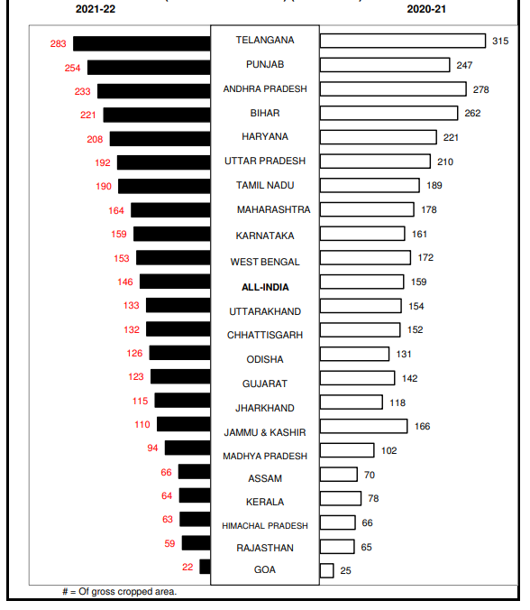
Fig.2: Consumption of plant nutrients in major states (kg ha⁻¹) (N+P₂O₅+K₂O) (Source: Fertiliser-Stat-Book-2021-22).
Consumption of plant nutrients (N+P₂O₅+K₂O kg ha⁻¹) in important Indian states in 2021–22:
In India Telangana states recorded highest consumption of plant nutrient i.e., 283 followed by Punjab (254), Andhra Pradesh (233), Bihar (221), Haryana(208), Uttar Pradesh(192), Tamil Nadu (190), Maharashtra (164), Karnataka (159), West Bengal (153), Uttarakhand (133), Chhattisgarh (132), Odisha (126), Gujrat (123), Jharkhand (115), Jammu And Kashmir (110), Madhya Pradesh (94), Assam (66), Kerala (64), Himachal Pradesh (63), Rajasthan (59), & Goa (22) is the state with the lowest intake of plant nutrients. (Source: Fertiliser-Stat-Book-2021-22).
Total fertilizer nutrient consumption (N+P₂O₅+K₂O) was estimated at 29.80 million metric tonnes (million MT) as against 32.54 million MT in the previous year registering a negative growth of 8.4%. N, P₂O₅, and K₂O usage fell by 4.7%, 12.8%, and 19.8%, respectively, over 2020–21 at 19.44 million MT, 7.83 million MT, and 2.53 million MT, respectively, during 2021–22. Urea consumption, at 34.18 million MT, DAP consumption, at 9.27 million MT, MOP consumption, at 2.46 million MT, and NP/NPK complex fertilizers, at 11.48 million MT, all saw decreases over 2020-21 of 2.5%, 22.2%, 28.3%, and 2.8%, respectively. The use of SSP, however, increased significantly by 26.6% during the time, reaching 5.68 million MT. The total consumption of fertilizer products, which totalled 63.94 million MT in 2021–22, was down 5.4% from 2020–21. All-India NPK use ratio widened from 6.5:2.8:1 during 2020-21 to 7.7:3.1:1 during 2021-22. Per hectare use of total nutrients (N+P₂O₅+K₂O) reduced from 160.1 kg in 2020-21 to 146.7 kg in 2021- 22 (Annual review of fertilizer production and consumption 2021-22).
Impact of various treatments on soil characteristics:
Reference | Location and soil texture | Cropping system | Impact on soil fertility
 |  |  | Soil properties |  | control | Only fertilization | Only manuring | INM
Gabhane et al., 2022 | Central India Clayey | Cotton + greengram intercropping | pH |  | 8.10 | 8.05-8.02 | 7.98-8.0 | 7.98-7.99
 |  |  | OC (g kg-1) |  | 4.50 | 6-5.10 | 6.10-5.90 | 6.90-6.90
Kharche et al., 2013 | Central India Clayey | Sorghum+  wheat | Nutrient availability (kg ha⁻¹) | N | 117 | 153-271 | 152-235 | 246-283
 |  |  |  | P | 6.4 | 15.2-20.5 | 15-17.7 | 16.5-24.6
 |  |  |  | K | 484 | 513-579 | 515-575 | 586-606
KATKAR et al., 2011 | Central India Clayey | Sorghum+  wheat | Available S (mg kg⁻¹) |  | 28.67 | 34.05-58.08 | 31.58 | 63.39
 |  |  | Total N (%) |  | 0.0331 | 0.0428- 0.0516 | 0.0512 | 0.0594

Reference | Location and soil texture | Cropping system | Impact on soil physical properties
 |  |  | Soil properties | control | Only fertilization | Only manuring | INM
Nandapure et al., 2011 | Central India Clayey | Sorghum+  wheat | Bulk Density (Mg m⁻³) | 1.38 | 1.24- 1.36 | 1.24 | 1.22
 |  |  | HC (cm hr⁻¹) | 0.23 | 0.28-0.60 | 0.60 | 0.71
Ramteke et al., 2022 | Central India Clayey | Cotton + greengram intercropping | WSA (%) | 78.76 | 81.00-85.37 | 80.80-83.37 | 90.88- 91.10`
Katkar et at.,2012 | Central India Clayey | Sorghum+  wheat | AWC (cm m⁻¹) | 15.86 | 17.48-21.31 | 21.59 | 21.95
 |  |  | MWD (mm) | 0.737 | 0.772- 1.169 | 1.254 | 1.412
Dhamak et al., 2020 | Central India Clayey | Sorghum+  wheat | Porosity (%) | 56.32 | 56.51- 56.89 | 58.32- 58.35 | 58.12 -58.48

Reference | Location and soil texture | Cropping system | Impact on biological properties
 |  |  | properties | control | Only fertilization | Only manuring | INM
Meshram et al., 2016 | Central India Clayey | soybean-safflower | Bacteria (CFU X 107 g ⁻¹ soil) | 95.26 | 124.62- 175.20 | 198.69 | 211.06
 |  |  | Fungi i (CFU X 104 g ⁻¹ soil) | 5.06 | 5.33-8.19 | 11.17 | 8.22
 |  |  | Actinomycetes (CFU X 106 g ⁻¹ soil); | 30.05 | 32.53-  45.87 | 51.36 | 53.16
KATKAR et al., 2012 | Central India Clayey | Sorghum+  wheat | SMBC (mg kg⁻¹) | 139 | 179- 227 | 222 | 247
 |  |  | SMBN (mg kg⁻¹) | 8.86 | 11.98-16.03 | 15.18 | 17.53
 |  |  | DHA ug gm⁻¹ 24hr⁻¹ | 32.51 | 36.97-45.69 | 45.08 | 49.78

Reference | Location and soil texture | Cropping system | Impact on crop productivity
 |  |  |  | control | Only fertilization | Only manuring | INM
Jadhao et al., 2020 | Central India Clayey | Sorghum+  wheat | Wheat Grain yield (q ha⁻¹) | 5.6 | 8.2-32.4 | 10.9 | 34.0
Jadhao et al., 2019 | Central India Clayey | Sorghum+  wheat | Sorghum grain yield (t ha⁻¹) | 0.38 | 1.76-4.22 | 3.61 | 4.60
 |  |  | Sorghum fodder yield (t ha⁻¹) | 0.83 | 4.18-10.14 | 5.82 | 8.48-11.05
Chauhan et al., 2014 | Central India Clayey | Soybeans-wheat | Sustainability yield index of soybean | 0.131 | 0.145- 0.369 | 0.326 | 0.394
Meshram et al., 2017 | Central India Clayey | soybean-safflower | Soybean grain yield (quintal per hector) | 11.62 | 14.20-26.30 | 19.62 | 26.58
 |  |  | yield of Safflower grain (quintal per hector) | 10.78 | 11.81-18.36 | 13.15 | 18.52

II. MANURES AND FERTILIZATION MANAGEMENT'S IMPACT ON THE QUALITY AND PRODUCTIVITY OF THE SOIL:
- IMPACT ON SOIL PHYSICAL PROPERTIES:
When chemical fertilizers and organics are combined, the physical qualities of the soil, such as bulk density, aggregate stability, hydraulic conductivity, mean weight diameter, and water retention, are greatly improved compared to when chemical fertilizers are used alone [16].
1. Impact on the distribution of water-stable aggregates and soil structure:
Soil bulk density (BD) was considerably influenced by both the depth by rotation interaction and fertilizer N management. Compared to the other N fertilizer managements, 75 kg N/ha had a considerably reduced BD (p 0.05). Mono-cropping BD was not substantially different between 0 and 10 cm and 10-20 cm depths in the depth by rotation interaction, while rotation BD was considerably lower for 10-20 cm than for 0-10 cm (p 0.05). The depth by rotation interaction and fertilizer N management had a big impact on MWD and GMD. N fertilizer management, rotation, depth, and their interactions all had a considerable impact on aggregate size fractions, but to varied degrees. In general, at 10–20 cm of soil depth, the proportion of large and small macroaggregates grew, whereas silt-clay size fractions and microaggregates declined. Other aggregates had a lower proportion than in the treatments with chemical fertilizers, with manure application having the largest proportion of large macroaggregates [19].
Fertilization extensively improved soil aggregation and combination balance in each surface and subsurface soil over manage [26]. By influencing plant growth, fertilization promoted aggregation and, ultimately, biomass was recycled into the soil [14].
2. Effect on Aggregate associated Carbon and Nitrogen.
By increasing the relative abundance of macroaggregates at the expense of other fractions, organic material incorporation also raises the carbon content of the macroaggregate fractions. C content is similar throughout aggregate fractions even though the effect of fertilizer treatment on increasing soil aggregation is less significant [17]. When a fertilizer was applied over an extended period of time and combined with organic manures, the soil's level of organic carbon significantly increased. The stability and aggregate qualities were very evident indicators of this. In comparison to the three chemical N fertilization treatments, manure amendment significantly raised SOC concentration (p 0.05). Except for the 0 kg N/ha treatment, tobacco-rice rotation nevertheless showed higher SOC content at the 10–20 cm depth than monocropping. With the exception of the total soil, all aggregate-associated TSN concentrations were significantly impacted by soil depth (p 0.05). The related TSN concentrations for big and small macroaggregates and microaggregates were numerically greater at 0–10 cm than at 10–20 cm depth. With the exception of big macroaggregates, nitrogen fertilizer management significantly impacted whole-soil, small macroaggregates, microaggregates, and silt-clay fraction associated SOC (p 0.05) [19].
Manure provides soil organic addition [20]. Using the aggregate-SOM models given by this SOM, soil can be aggregated around it [21]. Additionally, earlier research demonstrates that manure encourages the diversity of soil microbes and the activity of enzymes [22]; [23], This would also result in the production of fungus hyphae, causing the creation of coarse aggregate [24]; [25]. Tobacco-rice rotation and manure amendment techniques may enhance SOC and TSN and improve soil structure and quality [19].
Additionally, increased aggregate-N concentration as a result of fertilizer application was noted by [27]. N levels in all aggregate fractions of paddy soil fell as a result of ongoing cropping without nitrogen control [28].
3. Effect on soil bulk density and hydraulic conductivity:
When compared to the control treatment, the OM application considerably reduced soil BD and increased SOC. Because applying OM to the soil enhances soil organic matter, the OM treatment generally improved soil organic concentration, decreasing soil BD and increasing soil organic carbon content [31]. Under integrated nutrient management, soil bulk density decreases due to improved aggregation, enhanced porosity, and improved soil structure brought on by an increase in soil organic matter. [16]. [29] additionally noted that FYM application reduces soil BD when combined with fertilizers.
Due to enhanced organic matter content, which boosted biological activity, better soil aggregation, and optimal pore volume as well as the effective connection of the pores, balanced fertilization with FYM significantly improved the hydraulic conductivity [30].
4. Effect on Soil water content:
In addition to local climate and soil type characteristics, fertilization techniques exhibited substantial (p 0.05) influence on SWC. At all soil levels, OM treatment had a larger effect on SWC than NPK and NPK + S (p 0.05) [31]. [32] regardless of soil depths, it was discovered that OM plots reported more SWC than the inorganic fertilizer. The trends in soil water retention were further validated by SWC, which showed that at most sampling dates, the OM treatment soil had considerably greater water contents than CK at depths of 0–10 cm but not at depths of 10–20 cm.
B) EFFECT ON SOIL FERTILITY:
1. Soil pH and EC:
Even after 46 years of growing soybeans and wheat and continuing to utilize chemical fertilizers and/or organic manure, soil pH readings did not alter considerably. Even though urea has a net residual acidity, using it as fertilizer won't significantly change the pH levels of the soil. The presence of calcium carbonate seems to have regulated this outcome. With values ranging from 0.16 to 0.19 dSm⁻¹, it has been noticed that the electrical conductivity has not significantly changed as a result of the treatments that were imposed [33]. Similar, results on soil pH and EC have been earlier reported by [34], and [35].
2. Effect on soil organic carbon (SOC):
Manure or straw application on the farmyard considerably enhanced the concentration of SOC in depths of 0-20, 20-40, and 40-60 cm. SOC was highest in NP+FKM treatments at soil depths of 0–20 cm and 20–40 cm, followed by treatments with NP+S and FYM, and lowest in CK treatments [36]. Due to the greater accumulation of organic residues and external additions of organic matter at the surface layer, fertilizer and/or FYM applications increased C sequestration and SOC accumulation [37]. [38] demonstrated that increasing SOC concentrations by mixing farmyard manure (FYM) with nitrogen (N) or NPK fertilizers. [39] It was noted that the topsoil SOC content of the plots with 50% NPK fertilizers + 50% farmyard manure (FYM) was significantly greater than that of the plots with 50% NPK fertilizers + 50% green manure (GM).
[40] revealed that treatments that received organic manure had significantly greater SOC concentrations than the mineral and control treatments, with the CK treatment having the highest SOC concentrations (up to 35.39 Mg ha⁻¹) in the top 20 cm. Additionally, with rising manure input rates, SOC concentrations considerably rose. As it is also noticed that with increasing levels of fertilizer application, crop yields had improved, increasing levels of fertilizer application have contributed to raising the organic carbon content, which is attributable to an increased contribution from the biomass [33]. It was advantageous to apply organic manure alongside NPK fertilizer because it supplemented NPK, contributed some secondary and micronutrients, and enhanced the soil's biological and physical properties. These results show that organic carbon is crucial for sustaining and enhancing soil health [41].
3. Relationships between the physical characteristics and soil organic carbon:
The soil BD had a negative association with SOC, indicating that the addition of organic matter resulted in a drop in BD. Additionally, there was a decline in soil penetration resistance (PR) with the addition of organic matter, as indicated by a negative connection between SOC and PR. A drop in BD enhanced the soil structure, as evidenced by the BD's negative connection with the SWC and positive association with PR [31]. Due to various factors, including reduced or no tillage in organic treatments and an increase in the labile fraction of organic carbon released through microbial decomposition of organic matter deposited on the soil mineral fraction as a surface coating, soil aggregation, as reported by is the cause of the high negative correlation between the SOC, the BD, and the PR (p 0.01) [42].
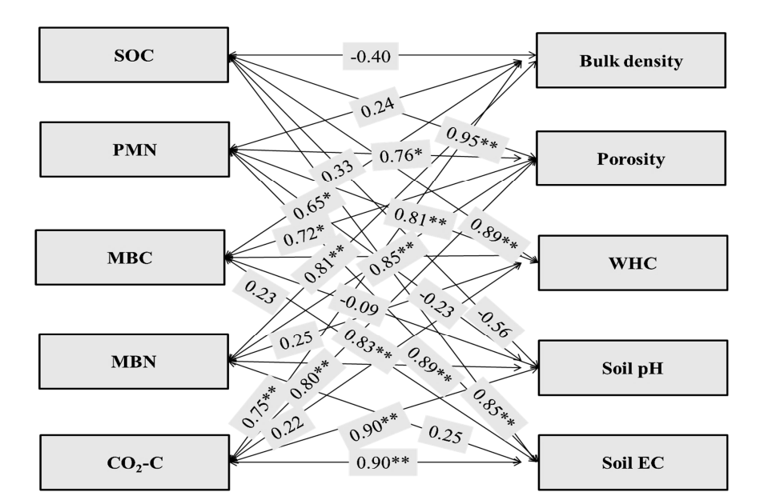
Fig. 3: The soil OC and microbiological community's correlation coefficient with soil characteristics (**-correlation is significant at the 0.01 level; *-correlation is significant at the 0.05 level), (Source: Dhaliwal et. al., 2021).
4. Effect on nutrient status of soil:
- The nitrogen content of the soil:
Using nitrogenous fertilizers continuously for 46 years tended to raise the soil's available nitrogen status [33]. [43] who discovered that adding manure to the required fertilizer dose greatly improved the amount of accessible N in the soil. [44] also reported a rise in accessible nitrogen levels as a result of grading NPK fertilizer applications.
- Soil available Phosphorous:
Due to the P addition from FYM, the concentration of P in the pool that was available further rose. Along with providing nutrients directly, the FYM may have also helped the soil's insoluble phosphate by releasing a variety of organic acids [34].
- Soil available Potassium:
Following 100% NPK + FYM treatments, 150% NPK treatments were found to have the soil's highest available K status [33]. In addition to adding K directly to the soil, the application of organic manure may have decreased K fixation and thus raised K content by interacting with clay [45].
- Available Sulphur:
After 46 years of testing, the use of NPK with FYM led to a much greater accessible S content (38.6 kg ha⁻¹) than the starting value (15.6 kg ha⁻¹) as a result of the application of a single super phosphate and sulphur-containing FYM [33]. Crop yields have decreased as a result of 100% NPK-S being deficient in S due to the ongoing use of diammonium phosphate as a source of P [34].
C) SUSTAINABLE CROP PRODUCTIVITY
Using just chemical fertilizers continuously was observed to be responsible for decline in yields which is also reflected in terms of deterioration in soil quality attributes while enhanced soil quality attributes observed under INM practices encouraged increase in crop yields [16]. In the long run, integrated application of organic manure and inorganic fertilizers increased soil quality and sustained crop yield in the sorghum-wheat cropping sequence produced on Vertisol [46]. It has been noted that increasing the amount of fertilizer used has enhanced crop output in addition to helping to increase OC content, which is attributable to increased biomass contribution [48]. [49] found that a considerable correlation exists between agronomic production and the SOC stock, especially in low-input agriculture (no or low rate of fertilizer input). An ideal level of SOC stock is a key predictor of soil quality to maintain relatively high crop yield.
- CONCLUSION
The physical characteristics of a soil were improved by the addition of organic and mineral fertilizers. Generally speaking, the use of organic fertilizers resulted in a notable rise in SWRC at maximum potential and plant-available water contents. With organic fertilizers specifically, SWC was elevated during both dry and wet periods at all soil depths. Additionally, organic fertilizers significantly reduced hydraulic conductivity (both saturated and unsaturated), soil BD, and PR compared to other treatments.
Utilizing fertilizers wisely led to large increases in the amount of accessible N, P, and K as well as the amount of organic carbon in the soil. Additionally, improper application of inorganic fertilizers decreased agricultural yields and worsened soil fertility. As a result, it is advised that a balanced application of fertilizers that integrates with FYM is required to maintain the fertility and productivity of the soil.
REFERENCES
- Randhawa, N.S. and Tandon, H.L.S. (1982) Advances in soil fertility and fertilizer use research in India. Fertiliser News 27, 11-26.
- Nambiar, K.M.M. and Abrol, I.P. (1989) Long Term Fertilizer Experiment in India (1972-82). Indian Agriculture Research Bulletin, New Delhi, 101p.
- Bappa Das, Debashis Chakraborty, V.K. Singh, P. Aggarwal, R. Singh, B.S. Dwivedi, R.P. Mishra (2014) Effect of integrated nutrient management practice on soil aggregate properties, its stability and aggregate-associated carbon content in an intensive rice–wheat system. Soil and tillage research 136 (2014)-9-18.
- Sarkar, S., Singh, S.R., Singh, R.P., 2003. The effect of organic and inorganic fertilizers on soil physical condition and the productivity of a rice–wheat cropping sequence in India. J. Agric. Sci. 140, 419–425.
- Pernes-Debuyser, A., Tessier, D., 2004. Soil physical properties affected by long-term fertilization. Eur. J. Soil Sci. 55, 505–512.
- Dexter, A.R., 1988. Advances in characterization of soil structure. Soil Till. Res. 11, 199–238.
- Ekwue, E.I., 1992. Effect of organic and fertilizer treatments on soil physical properties and erodibility. Soil Till Res. 22, 199–209.
- El-Shakweer, M.H.A., El-Sayad, E.A., Ewees, M.S.A., 1998. Soil and plant analysis as a guide for interpretation of the improvement efficiency of organic conditioners added to different soil in Egypt. Comm. Soil Sci. Plant Anal. 29, 2067–2088.
- Mokwunge, A.U., deJager, A., Smaling, E.M.A., 1996. Pestoring and maintaining the productivity of west African soil: key to sustainable development. In: Miscellaneous Fertilizers Studies No.
- Barzegar, A.R., Yousefi, A., Daryashenas, A., 2002. The effect of addition of different amounts and types of organic materials on soil physical properties and yield of wheat. Plant Soil 247, 295– 301.
- Rose, D.A., 1991. The effect of longcontinued organic manuring on some physical properties of soils. In: Wilson, W.S. (Ed.), Advances in Soil Organic Matter Research. Special Publication no. 90. Royal Society of Chemistry, Cambridge, pp. 197–205.
- Belford, R.K., Klepper, B., Rickman, R.W., 1987. Studies of intact shoot root systems of field grown winter wheat. II. Root and shoot developmental patterns as related to nitrogen fertilizer. Agron. J. 79, 310–319.
- Brown, S.C., Keatinge, J.D.H., Gregory, P.J., Cooper, P.J.M., 1987. Effect of fertilizer, variety and location on barley production under rainfed condition in northern Syria. I. Root and shoot growth. Field Crops Res. 16, 53–66.
- Campell, C.A., Selles, F., Lafond, G.P., Biederbeck, V.Q. and Zenter, R.P. 2001. Tillage-Fertilizer changes: effect on soil quality attributes under longterm crop rotations in a thin Black Chernozem. Can J. Soil Sci. 81(10):157–165.
- Whalen, J.K., Hu, Q. and Liu, A. 2003. Manure applications improve aggregate stability in conventional and no tillage systems. Soil Sci. Soc Am J 67:1842– 1847.
- Kharche V.K., S.R. Patil, A.A. Kulkarni, V.S. Patil and R.N. Katkar 2013. Long-term Integrated Nutrient Management for Enhancing Soil Quality and Crop Productivity under Intensive Cropping System on Vertisols. Journal of the Indian Society of Soil Science, Vol. 61, No. 4, pp 323-332 (2013).
- Yu, H., Ding, W., Lue, J., Geng, R., Cai, Z., 2012. Long-term application of organic manure and mineral fertilizers on aggregation and aggregates associated carbon in as sandy loam soil. Soil Till. Res. 124, 170–177.
- Bappa Das, Debashis Chakraborty, Vinod K. Singh, Pramila Aggarwal, Ravender Singh, and Brahm S. Dwivedi 2014 Effect of organic inputs on strength and stability of soil aggregates under rice-wheat rotation Int. Agrophys., 2014, 28, 163-168 doi: 10.2478/intag-2014-0004.
- Congming Zoua, Yan Lia, Wei Huanga, Gaokun. Zhaoa, Guorui Pua, Jiaen Sua, Mark S. Coynec , Yi Chena, Longchang Wangb, Xiaodong Hua, Yan Jina, 2018 Rotation and manure amendment increase soil macro-aggregates and associated carbon and nitrogen stocks in flue-cured tobacco production. Geoderma 325 (2018) 49-58.
- Spaccini R, Piccolo A. 2013. Effects of field managements for soil organic matter stabilization on water-stable aggregate distribution and aggregate stability in three agricultural soils. Journal of Geochemical Exploration, 129, 45–51.
- Tisdall JM, Oades JM (1982) Organic matter and water stable aggregate in soils. J Soil Sci 33:141–163. doi:10.1111/ j.1365-2389. 1982.tb01755.
- Duan, Y.Q., Chen, D.M., Jin, Y., Wang, H.B., Yang, Y.H., You, C.H., Tian, W.X., Lin, W.X., 2012. Effect of different fertilizers on continuous tobacco cropping rhizospheric soil microorganisms and enzyme activities. J. Agric. Sci. Technol. 14 (03), 122–126.
- Govaerts, B., Mezzalama, M., Unno, Y., Sayre, K.D., Luna-Guido, M., Vanherck, K., Dendooven, L., Deckers, J., 2007. Influence of tillage, residue management, and crop rotation on soil microbial biomass and catabolic diversity. Appl. Soil Ecol. 37 (1), 18–30.
- Jin, Y., Yang, Y.H., Duan, Y.Q., Yuan, L., 2012. Influence of the long-term fertilization on organic matter and N,P,K nutrients in aggregates of flue-cured tobacco grown red soil. Guizhou. Agric. Sci. 40 (3), 142–146.
- Zhang, S., Wang, R., Yang, X., Sun, B., Li, Q., 2016. Soil aggregation and aggregating agents as affected by long term contrasting management of an Anthrosol. Sci. Rep. 6, 3910.
- Joshi, S.K., R.K. Bajpai, Prahalad Kumar, Alok Tiwari and Vinay Bachkaiya. 2017. LongTerm Effect of Fertilization and Algalization on Aggregate Stability, Aggregate Associated Carbon and Nitrogen Under Rice-Wheat Cropping System. Int.J.Curr.Microbiol.App.Sci. 6(8): 3289-3295. doi: https://doi.org/10.20546/ijcmas.2017.608.392.
- Manna, M.C., Bhattacharyya, P., Adhya, T.K., Singh, M., Wanjari, R.H., Ramana, S., Tripathi, A.K., Singh, K.N., Reddy, K.S., SubbaRao, A., Sisodia, R.S., Dongre, M., Jha, P., Neogi, S., Roy, K.S. Rao, K.S. Sawarkar, S.D. and Rao, V.R. 2013. Carbon fractions and productivity under changed climate scenario in soybean– wheat system. Field Crops Research 145: 10–20.
- Wei, W., Wei-cai, C., Kai-rong, W., Xiao-li, X., Chun-mei, Y. and An-lei, C. 2011. Effects of long-term fertilization on the distribution of carbon, nitrogen and phosphorus in water soluble aggregates in paddy soils. Agricultural Science in China, 10(12): 1932-1940.
- Pant, P.K., Ram, S. and Singh, V. 2017. Yield and soil organic matter dynamics as affected by the long-term use of organic and inorganic fertilizers under rice– wheat cropping system in subtropical mollisols. Agric Res. 6(4):399–409.
- Pawan Kumar Pant and Shri Ram. 2018. Long-Term Manuring and Fertilization Effects on Soil Physical Properties after Forty Two Cycles under Rice-Wheat System in North Indian Mollisols. Int.J.Curr.Microbiol.App.Sci. 7(07): 232-240. doi: https://doi.org/10.20546/ijcmas.2018.707.028
- Mohamed Bassouny & Jiazhou Chen (2016) Effect of long-term organic and mineral fertilizer on physical properties in root zone of a clayey Ultisol, Archives of Agronomy and Soil Science, 62:6, 819-828, DOI: 10.1080/03650340.2015.1085649.
- Subramanian S, Rajeswari M, Chitdeswari T. 2000. Effect of organic fertilizers on soil moisture conservation in rainfed vertisol. Madras Agric J. 87:345–347.
- Nilesh Patidar, A. K. Dwivedi, B. S. Dwivedi, R. K. Thakur, Jalendra Bairwa and Abhishek Sharma 2021 Impact of Long-Term Application of Inorganic Fertilizers and Organic Manure on Soil Fertility and Crop Productivity under Soybean-Wheat Cropping System in a Vertisol. International Journal of Environment and Climate Change 11(8): 24-30, 2021; Article no. IJECC.73943 ISSN: 2581-8627.
- Thakur Risikesh, DL Kauraw, Singh Muneshwar. Effect of continuous applications of nutrient inputs on spatial changes of soil physicochemical properties of a medium black soil. Journal of Soils and Crops. 2009;19(1):14 – 20.
- Panwar S, Dwivedi AK, Dwivedi BS, Nagwanshi Anil. Distribution of zinc pools as influenced by long-term application of fertilizers and manure in a Vertisol. International Journal of Chemical Studies. 2017;5(6):1931-1934.
- Liu E, Yan C, Mei X, Zhang Y, Fan T. Long-term effect of manure and fertilizer on soil organic carbon pools in Dryland Farming in Northwest China. PLoS One. 2013;8(2):e56536.
- Sharath Chandra M, Naresh RK, Chandra Sheker B, Mahajan NC, Vijay J. Aggregate associated carbon, aggregation and storage of soil organic carbon respond to organic and synthetic fertilizers in cereal systems: A Review. Current Journal of Applied Science and Technology. 2020; 39(12):86-99.
- Bhattacharyya Ranjan, Kundu S, Ved Prakash, Gupta HS. Sustainability under combined application of mineral and organic fertilizers in a rainfed soybean- wheat system of the Indian Himalyas. Eur J Agron. 2008;28(1):33–46.
- Ghosh BN, et al. Effects of fertilization on soil aggregation, carbon distribution and carbon management index of maize-wheat rotation in the north-western Indian Himalayas. Ecological Indicators; 2018. Available:https://doi.org/10.1016/j.ecolind.2 018.02.050
- Li J, Wen Y, Li X, Li Y, Yang X, Zhian Lin Z, et al. Soil labile organic carbon fractions and soil organic carbon stocks as affected by long-term organic and mineral fertilization regimes in the North China Plain. Soil Tillage Res. 2018;175:281-290.
- Thakur RK, Sawarkar SD, Vaishya UK and Singh. Impact of continuous use of inorganic fertilizers and organic manure on soil properties and productivity under soybean-wheat intensive cropping of a Vertisol. J. Indian Soc. Soil Sci. 2011;59(1):74-81.
- Herencia F, Garcia-Galavis A, Maqueda C. 2011. Long-term effect of organic and mineral fertilization on soil physical properties under greenhouse and outdoor management practices. Pedosphere. 21:443–453.
- Dwivedi AK and Dwivedi BS. Impact of long-term fertilizer management for sustainable soil health and crop productivity: Issues and challenges. JNKVV Res Journal. 2015;49(3):387-399.
- Khandagle A, Dwivedi BS, Dwivedi AK, Panwar S, Thakur RK. Nitrogen fractions under long-term fertilizer and manure applications in soybean – wheat rotation in a Vertisol. Journal of the Indian Society of Soil Science. 2020;68(2):186-193.
- Sawarkar SD, Khamparia NK, Thakur R, Dewda MS, Singh M. Effect of long-term application of inorganic fertilizers and organic manure on yield, potassium uptake and profile distribution of potassium fractions in Vertisol under soybean-wheat cropping system. Journal of the Indian Society of Soil Science. 2013;61:94-98.
- KATKAR R. N., V. K. KHARCHE, B. A. SONUNE, R. H. WANJARI2 AND MUNESHWAR SINGH. Long term effect of nutrient management on soil quality and sustainable productivity under sorghum-wheat crop sequence in Vertisol of Akola, Maharashtra. Agropedology 2012,22 (2), J03-JJ4.
- Dhaliwal, S.S.; Sharma, S.; Sharma, V.; Shukla, A.K.; Walia, S.S.; Alhomrani, M.; Gaber, A.; Toor, A.S.; Verma, V.; Randhawa, M.K.; et al. Long-Term Integrated Nutrient Management in the Maize–Wheat Cropping System in Alluvial Soils of North-Western India: Influence on Soil Organic Carbon, Microbial Activity and Nutrient Status. Agronomy 2021, 11, 2258. https:// doi.org/10.3390/agronomy11112258.
- Jadhao S.D., Mali D.V., Kharche V.K., Muneshwar Singh , S.M. Bhoyar, P.R. Kadu, R.H. Wanjari and B.A. Sonune. Impact of Continuous Manuring and Fertilization on Changes in Soil Quality under Sorghum-Wheat Sequence on a Vertisols. Journal of the Indian Society of Soil Science, Vol. 67, No. 1, pp 55-64 (2019) DOI: 10.5958/0974-0228.2019.00006.9
- Lal, R. (2010) Beyond Copenhagen: mitigating climate change and achieving food security through soil carbon sequestration. Food Security 2, 169-177.
- KATKAR R N, B A SONUNE and P R KADU 2011. Long-term effect of fertilization on soil chemical and biological characteristics and productivity under sorghum (Sorghum bicolor)– wheat (Triticum aestivum) system in Vertisol. Indian Journal of Agricultural Sciences 81 (8): 734–9, August 2011.
- Nandapure S.P., B.A. Sonune, V.V. Gabhane, R.N. Katkar and R.T. Patil 2011. LONG TERM EFFECTS OF INTEGRATED NUTRIENT MANAGEMENT ON SOIL PHYSICAL PROPERTIES AND CROP PRODUCTIVITY IN SORGHUM-WHEAT CROPPING SEQUENCE IN A VERTISOL. Indian J. Agric. Res.., 45 (4) : 336 - 340, 2011.
- Annual review of fertilizer production and consumption 2021-22.
- Ramteke Pratik and Gabhane V. V. 2022. Long-term nutrient management effects on soil aggregation and C stabilization in Vertisols of Central India. Vegetos https://doi.org/10.1007/s42535-022-00539-4.
- Dhamak AL, Waikar SL and Shilewant SS. Long – term effect of integrated nutrient management on soil organic carbon fractions in vertisol under sorghum wheat cropping system. International Journal of Chemical Studies 2020; 8(4): 1971-1974.
- Meshram N.A., Syed Ismail and V.D. Patil 2016. Long-Term Effect of Organic Manuring and Inorganic Fertilization on Humus Fractionation, Microbial Community and Enzymes Assay in Vertisol. JOURNAL OF PURE AND APPLIED MICROBIOLOGY, March 2016. Vol. 10(1) 139-150.
- Jadhao S.D., Rahul J. Patil, B.A. Sonune, S.M. Bhoyar, Muneshwar Singh1 , V.K. Kharche2 , R.N. Katkar, P.R. Kadu, N.M. Konde and D.V. Mali. 2020.Effect of Long-term Nutrient Management on Root Chemical Properties and Morphology, Grain Yield and Phosphorus Use Efficiency of Wheat under Sorghum-Wheat Sequence. Journal of the Indian Society of Soil Science, Vol. 68, No. 1, pp 54-61 (2020) DOI: 10.5958/0974-0228.2020.00006.7
- CHAUHAN S.S. AND BHATNAGAR , 2014. Influence of long term use of organic and inorganic manures on soil fertility and sustainable productivity of wheat in Vertisols of Madhya Pradesh. Volume 9 | Issue 1 | June, 2014 | 113-116 | α e ISSN–0976–7231 | Open Access | www.researchjournal.co.in
- Meshram N.A., Syed Ismail and P.K Rathod, 2017. Effect of organic manuring and fertilization on soil fertility, yield attributes and productivity of soybean-safflower cropping system in vertisol. Vol.12/TECHSEAR-10/2017/0000-0000.

