Protocol Standardization for generating invitro Punica granatum improved callus cells through advanced tissue culture techniques.
Dr. Manasa P.
Abstract
In recent years, plant cell culture-based nutritional supplements and cosmetics have extensively gained potential in nutraceuticals and cosmetology as they are pesticide-free sources of plant extracts. Any stress on plant tissue results in the creation of a callus, an unorganized cell mass. Not only did remarkable innovations and new methods in tissue culture improve pluripotent cells, but they also enhanced callus cells, which are grown from meristematic cells found in shoot tips, cambial cells, and root tips. Improved plant callus cells enable a large increase in the generation of secondary metabolites. One such fruit with a high natural phytochemical content and three times as many antioxidants as green tea is Punica granatum. Due to its high concentration of polyphenols and anti-ageing qualities, the current health and cosmetic markets have found that this nutrient-dense fruit may treat a wide range of difficult ailments. For effective scaling up of phytochemical extraction from improved callus cells, this paper has standardized the procedure for pomegranate-enhanced callus cell synthesis. The pomegranate node explant worked best for inducing calluses. The most effective medium for callus development was Murashige and Skoog media supplemented with 3% sucrose and 1 mg 2,4 D. It had the greatest induction rate (96%), the best callus growth, and the lowest contamination detected following sterilization treatment at 5 min with mercuric chloride. The sixth day of the culture cycle saw the observation of the ideal growth index. The use of elicitors in the suspension culture of P. granatum-improved callus cells was discovered to be a simple method for creating pomegranate-improved callus cells and enhancing the production of beneficial phytochemicals.
Keywords: Improved callus cell, Callus, Cell suspension culture, Polyphenols, Punica granatum

Introduction
Mankind has long been aware of the healing properties of pomegranates. The pomegranate fruit is valued for its benefits to health, including inducing good cell communication, decreasing stress, curing illnesses, raising hemoglobin levels, and scavenging free radicals (1). Originally from the Middle East, the pomegranate spread across East Asia (2). The culturing of plant cultures obtained from non-improved callus plant tissues from an explant is often constrained, resulting in mutations. As opposed to this, plant-improved callus cells that are immortal were created from specific improved callus cells that have anti-ageing capabilities, superior genes for gene transfer, high levels of phytochemical production, and no passage restrictions (3). Pomegranates are popular for their antibacterial and anticancer effects (4). Condensed tannins and hydrolysable tannins are also present in greater concentrations in pomegranate. Anthocyanins, which make up about 30% of phenolics, are among the other phytochemicals that are said to be present (5). The presence of several phytonutrients in pomegranates that are good for human health has been found (6).
Despite the benefits of manufacturing important phytochemicals via controlled production using regulated batches, plant cell culture has a relatively low success rate (7). This work is the first to document standardization for producing Punica granatum-enhanced callus cells in vitro using cutting-edge tissue culture methods. Depending on whether better callus activity resumes in fully differentiated cells or in callus tissue that is disorganized, organ genic processes take place via dedifferentiation and cellular dedifferentiation. The in vitro organogenesis process is complex, including a number of internal and external elements that are controlled by the genotype, explant type, culture medium composition, and cultivation environment. Given the impact of the explant, it is advised to choose explants that have a larger percentage of enhanced callus tissue or that have a greater potential to express totipotency (George 2008). Elution is a powerful method for enhancing the phytochemical synthesis in enhanced callus cells. Elicitors promote the protection of the cell against biotic and abiotic stress by boosting any sort of plant defense (8). In enhanced plant callus cells, salicylic acid (SA) and jasmonic acid (JA) are extensively investigated as possible elicitors. By improving antioxidant defense, SA plays a role in controlling how plants react to heavy metal-induced toxicity (9). SA interacts with the signaling system for reactive oxygen species (ROS). It has also been shown that NO and ROS control SA biosynthesis. It is well known that salicylic acid (SA), a tiny molecule with a crucial function in the regulation of plant defense-enhanced callus, causes better callus acquired resistance (SAR) to numerous infections (10). Rapid SA buildup at the infection site during plant-pathogen contact sets off a hypersensitive reaction. After that, the signal travels to other areas of the plant, inducing a variety of defensive reactions.
Methyl jasmonate (MeJa), in particular, has been revealed to play a significant role in signal transduction mechanisms that control the expression of defense genes in plants [11]. MeJa (100–200 M) activates secondary biosynthetic pathways favourably when administered exogenously to plant cell cultures of many species, increasing the synthesis of a range of PSM, including terpenoids, flavonoids, alkaloids, and phenylpropanoids. Empirical research is needed to determine the best supplement dosage and timing for MeJa use.
There is no information on P. granatum, and among the Punica species, the development of better callus cells has not yet been recorded. We sought to use this method to develop and enhance callus cell suspension cultures of P. granatum, functioning as a source for the synthesis of important phytochemicals and realising the significance of P. granatum and its extract in medicine and cosmetics. The beginning of Punica granatum callus and cell suspension cultures, as well as their characteristics, are detailed in the current work. This gives researchers a tool for future scale-up and exploration of the phytochemical production process.
Materials and Methods
Plant Material
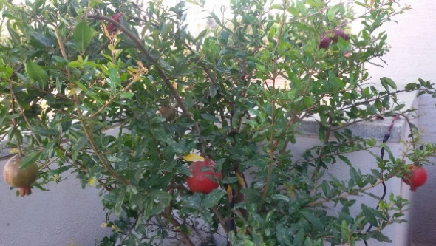
Bhagwa, a Punica granatum plant that is actively developing, was purchased from IIHR in Bangalore. The donor plants were kept in a protected environment (Fig. 1) and treated every 15 days with a 0.2% antifungal and antibacterial spray. The plant was then used as a mother plant to produce explants.

Fig.1. Punica granatum mother plant

Culture Medium
The first medium, known as the induction medium, consists of MS medium (Murashige and Skoog, 1962), supplemented with 3% sucrose, 2,4-D-1 mg/l to produce excellent callus growth, and PVP (Polyvinyl pyrollidone)-300 mg/l solidified with 5.6 g/litre of agar. PVP is added to prevent the medium from becoming brown when phenolic chemicals build up in it. MS media without a gelling agent are included in the suspension cell culture medium used to transfer induced calluses.
Selection and Processing of explants
As an explant, a nodal section of the improved callus from the terminal bud of a pomegranate was used. The explant was treated with 0.1% antifungal and antibacterial agents for 10 minutes in an aseptic environment. The surface must next be sterilised with 70% ethanol for 30 seconds and mercuric chloride for 3 to 4 minutes, depending on the size of the explant, after 15 minutes of washing with Tween 20.
Prior to being transferred to media, the sterilised explant underwent excision in order to isolate the cambium tissue from other cells and improve callus induction. Figure 2c makes it easy to see how cambial tissue separates from the xylem and phloem tissue.

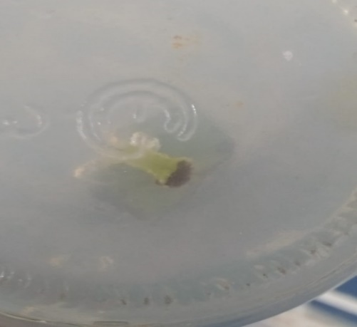

Fig 2.a Fig 2.b

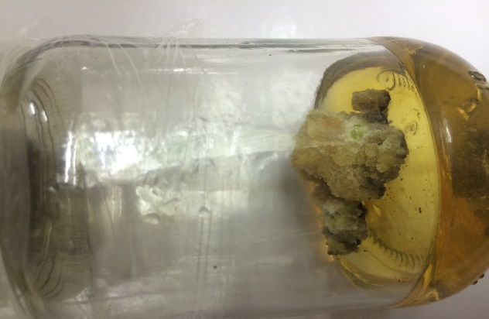
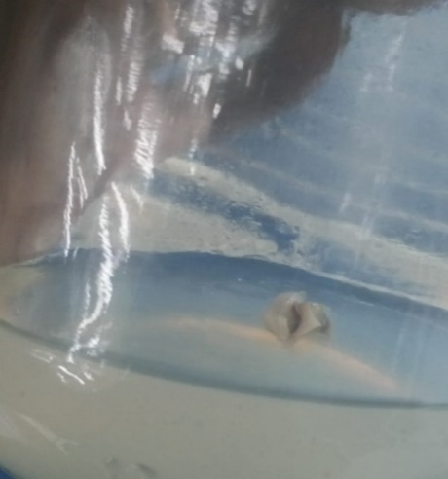
Fig 2.c Fig 2.d
Fig. 2. Stages of Callus Initiation 2a: Selection of Nodal Segments 2b: Explant processed in medium; 2c: Cambial tissue being separated from other cells; and 2d: Callus prepared to enter suspension cell medium.
Culture Conditions
The medium was sterilised in an autoclave for 20 minutes at 121ºC with the pH adjusted to 5.8. The medium was sterilised before being put into jam tissue bottles in a laminar flow hood. A culture environment with constant darkness, a temperature of 24ºC, and a relative humidity of 70% was used to incubate the inoculated cultures. The original medium was cultivated for 28 days at 28 ºC with 5000 lux of light.
Sub-culturing
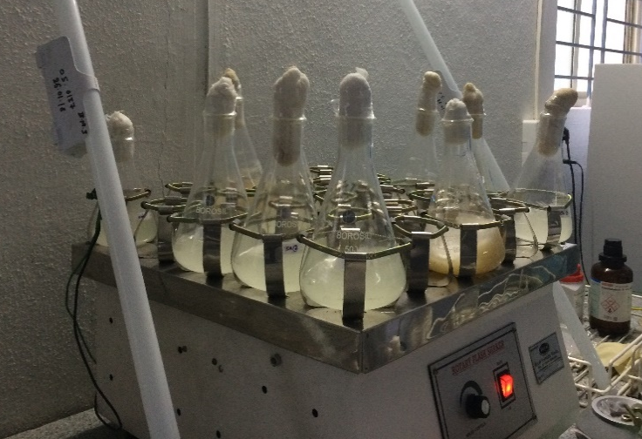
A callus that had been induced was weighed at 1-2 g/100 ml of liquid medium. This was then added to a liquid medium for developing calluses that included MS-Salts with a pH of 5.8, 1 mg/L of 2,4-D, 3% sucrose as a carbon source, 100 mg/L of inositol, 200 mg/L of PVP, and 5 mg/L of citric acid. The cells were cultivated for 28 days at a temperature of 242 °C and 120–140 RPM in a shaker without light. Renewing the medium once after cell decantation every 28 days allows for the creation of subcultures. A steady agitation was used to maintain viable cells in free form throughout each passage of the well-established suspension cultures that had no cellular clumps.
Fig 3. Pomegranate Cell suspensions in shaker
Determination of Growth and Viable cells
The culture was ultimately transferred to a conical flask and put in the shaker. Its growth and viability were checked every day. The numerous techniques listed below were used to determine the growth. To increase the synthesis of the secondary metabolite when it reaches the stationary phase, it is incubated in the presence of light. The fresh and dried cell weights were used to calculate the growth index, which is a relative estimate (11). This is crucial in figuring out the theoretical upper limit of cell concentration in plant cell suspension cultures at large densities. A 45-mm filter paper was used to filter 10 ml of the culture after centrifuging it at 5000 rpm for 10 minutes. To determine the fresh cell weight, this was weighed. Following an overnight drying period at 370 °C in a hot air oven, this was weighed to determine the dry cell weight. The growth index (GI) was calculated using the following formula (11.b):
$GI=\frac{Wf-Wi}{Wi}$ ………………………………………………… (1)
Where,
GI is growth index

W_{i} is the initial cell mass.
Both W_{f} and W_{i} are taken either as fresh or dry weight

Measure of Conductivity
According to Loyola-Vargas et al. (2006) (12), a conductivity metre was used to test the conductivity of the cell culture. This method is used to assess the growth kinetics of plant cell lines because it is affordable, practical, dependable, and accurate. It is often used in applications involving plant cell cultures in bioprocess engineering. The plant cells are unaffected by it.
Measure of Growth Curve (Calorimeter and UV-Vis Spectrophotometer)
The UV-Vis spectrophotometer's measurement of cell density as optical density served as the foundation for the growth curve's construction (13). A broad variety of wavelengths were used for the first phases of the viability assessment, with 630 nm being the most effective. Thus, a UV-Vis spectrophotometer at 630 nm detected the plant's increased callus cell density.
Viability and selection of the Improved Callus Cells
To ensure appropriate development of the suspended enhanced callus cells, Evan's blue staining was used to determine the viability of the improved callus cells. Using a phase contrast microscope, the cells were seen (14). Up to 95% of viable cells and plant cells with vacuoles in the suspension culture are in a viable condition. The cells begin the dying phase when that proportion is reached. The following formula was used to determine the viability percentage:

$\% Viability=[1-(No. of Blue Cells÷Total No. of Cells)×100]$……………. (2)
Elicitors in suspension cells
Elicitors are used in conjunction with subculture media to encourage the accumulation of greater levels of phytochemicals. In addition to the basal medium, jasmonic acid (200 g/l) and salicylic acid (20 mg/l) are utilised since they have been shown to be efficient earlier (15). It is examined after a 28-day incubation period.
Harvesting
The suspension cultures were centrifuged at 5000 RPM for 10 minutes to remove the callus. The supernatant was thrown away. The phenolic acid contents in both the control enhanced callus cells and the elicitor-induced improved callus cell pellets were compared using the growth index of the cell pellets.
Estimation of phenolic contents
The Folin Ciocalteu calorimetric technique was used to determine the aloe vera extract's total phenolic content [16]. 4 ml of sodium carbonate (5%) and 1 ml of the extract were combined with 5 ml of the Folin-Ciocalteu reagent. The mixture was then violently agitated and incubated for 30 minutes at 50 °C. Gallic acid solutions with concentrations of 50, 100, 150, 200, 250, 300, 350, 400, and 450 mg/ml were used to evaluate the absorbance of the reference solution (1 mg/ml). After 90 minutes in darkness, the mixture's absorbance measured 765 nm. Using the procedure, the value of the total phenolic content was determined and represented as mg gallic acid equivalent (GAE) per gramme of extract.
C=C₁ x V/M--------------------------------------------------------------------------------(3)

Where,
C - Total phenolic content in mg/g in Gallic acid equivalent (GAE),
C₁- Concentration of Gallic acid established from the calibration curve in mg/ml,
V- Volume of extract in ml, and
M- The weight of plant extract in g.

Statistical Analysis
The mean and standard deviation (SD) of the sample means were used to represent the experimental findings. Microsoft Excel was used to analyse every piece of data in duplicate, with three independent replicates, and to express standard errors.

Results and Discussion
Table 1: Callus induction percentage in relation to explant treatment time.
Medium constituents | Sterilization Agents | Concentrations (%) | Time (Minutes) | Total Contamination | Callus induction percentage
MS medium + 2,4 D- 1 mg /l+ | Hgcl₂ (Mercuric chloride) | 0.1% | 3 | 62% | 98%
 |  |  | 4 | 30% | 94%
 |  |  | 5 | 2% | 95%

According to Hoque A. et al. (2006), the callus proliferation started from the cut surface of the explant and eventually covered the entire explant. In the initial stages, the calli was colourless to yellowish, and over time, it turned light green. After two weeks of incubation, it turned dark green. Dark green calli were observed in basal medium MS+ sucrose 3%+ 2,4-D-1 mg-1l+ PVP-300 mg-1l. Calli with hyperhydric exudates induced necrosis soon after and started to turn brown. The growth of some calli showed high lignification, including their hard texture, whereas others were embryogenic and separated easily into small fragments. The success rate of explant treatment is shown in Table 1. The pomegranate callus growth curve was of the sigmoid type, and four growth phases can be distinguished in different days (15, 25, 35, 45, and 55 days). In the lag phase (15–25 days), callus initiation and proliferation were observed by profound cell division, as also described by previous studies (18). At 25–35 days (the exponential phase), the biomass of the callus was significantly increased. The high level of callus biomass in the stationary phase (45 days) of the callus growth curve suggests cellular membrane stabilisation. It has been previously reported that the stationary phase callus evidently demonstrated an increase in the accumulation of gagaminine in the callus of Cynanchum wilfordii (19). At the decline phase (55 days), the callus biomass was drastically reduced as compared to other phases. Explants treated for 5 minutes with surface sterilizant had the maximum success rate and less contamination. This response increased to 83.33% when 2,4-D (2 mg/L) was used in combination with BA at 0.75 mg/L or with IBA at 0.25 mg/L, as reported by Savita et al. (2011) (20). The calluses induced were green, fragile, and suitable for the subculture.

Table 2: Estimation of growth index, conductivity and viability of improved callus cells with respect to days after subculture
S.No | Time (Days) | Growth Index | Conductivity | UV-Vis Spectroscopy | Viability
 |  | (no unit) | (mS/cm) | (600nm) | (%)
1 | 0 | 0 | 4.08±0.02 | 0 | 92.14±0.04
2 | 1 | 0.028±0.004 | 3.83±0.03 | 0.091±0.007 | 93.72±0.05
3 | 2 | 0.084±0.023 | 3.84±0.05 | 0.459±0.013 | 94.97±0.01
4 | 3 | 0.088±0.024 | 3.58±0.01 | 0.845±0.021 | 95.32±0.15
5 | 4 | 0.774±0.086 | 3.20±0.02 | 1.640±0.014 | 96.78±0.04
6 | 5 | 0.948±0.024 | 2.97±0.01 | 1.621±0.020 | 97.92±0.06
7 | 6 | 0.863±0.078 | 2.72±0.01 | 1.654±0.009 | 98.99±0.04
8 | 7 | 0.669±0.075 | 2.69±0.02 | 1.647±0.011 | 99.47±0.03
9 | 8 | 0.629±0.018 | 2.38±0.01 | 1.662±0.007 | 98.72±0.02
10 | 9 | 0.644±0.034 | 2.21±0.02 | 2.349±0.005 | 97.40±0.09
11 | 10 | 0.844±0.057 | 2.14±0.02 | 2.534±0.010 | 94.54±0.10
12 | 11 | 0.612±0.041 | 2.34±0.03 | 2.864±0.834 | 96.47±0.03
13 | 12 | 0.744±0.041 | 2.11±0.03 | 3.012±0.005 | 97.33±0.05
14 | 13 | 0.680±0.097 | 2.56±0.04 | 3.249±0.834 | 96.23±0.04
15 | 14 | 0.612±0.034 | 2.62±0.06 | 3.746±0.832 | 98.43±0.02
16 | 15 | 0.600±0.043 | 2.78±0.01 | 3.993±0.034 | 97.77±0.07
17 | 16 | 0.480±0.021 | 3.04±0.03 | 4.274±0.002 | 96.21±0.09
18 | 17 | 0.507±0.054 | 3.17±0.02 | 4.431±0.832 | 97.83±0.06
19 | 18 | 0.495±0.092 | 3.01±0.02 | 4.624±0.021 | 98.73±0.07
20 | 19 | 0.470±0.036 | 3.22±0.04 | 4.743±0.469 | 97.62±0.06
21 | 20 | 0.410±0.065 | 3.05±0.05 | 4.925±0.487 | 96.32±0.21
22 | 21 | 0.367±0.054 | 3.19±0.03 | 5.120±0.049 | 95.49±0.16
23 | 22 | 0.378±0.092 | 3.24±0.09 | 5.359±0.972 | 95.89±0.03
24 | 23 | 0.348±0.036 | 3.25±0.06 | 5.534±0.486 | 96.93±0.05
25 | 24 | 0.306±0.065 | 3.06±0.03 | 5.439±0.756 | 95.02±0.25
26 | 25 | 0.237±0.041 | 3.19±0.04 | 5.692±0.040 | 96.48±0.17
27 | 26 | 0.278±0.054 | 3.23±0.05 | 5.934±0.488 | 95.75±0.03
28 | 27 | 0.254±0.092 | 3.58±0.03 | 6.046±0.546 | 94.91±0.04
29 | 28 | 0.267±0.064 | 3.47±0.03 | 6.172±0.856 | 93.64±0.03
30 | 29 | 0.241±0.041 | 3.69±0.07 | 6.210±0.573 | 91.38±0.04
31 | 30 | 0.222±0.045 | 3.58±0.04 | 6.184±0.814 | 83.99±0.07
32 | 31 | 0.187±0.018 | 3.79±0.04 | 6.298±0.783 | 76.83±0.09
33 | 32 | 0.210±0.034 | 3.76±0.05 | 6.234±0.435 | 71.33±0.07
34 | 33 | 0.197±0.057 | 3.81±0.04 | 6.338±0.567 | 67.54±0.08
35 | 34 | 0.201±0.004 | 3.69±0.07 | 6.438±0.543 | 67.34±0.05
36 | 35 | 0.191±0.057 | 3.74±0.09 | 6.359±0.326 | 67.29±0.06
37 | 36 | 0.218±0.082 | 3.86±0.08 | 6.254±0.356 | 65.83±0.02
38 | 37 | 0.207±0.074 | 3.90±0.10 | 6.435±0.364 | 64.32±0.01
39 | 38 | 0.195±0.064 | 3.87±0.02 | 6.234±0.872 | 63.75±0.05
40 | 39 | 0.187±0.075 | 3.92±0.01 | 6.432±0.573 | 60.19±0.07
41 | 40 | 0.285±0.067 | 3.95±0.03 | 6.298±0.457 | 57.72±0.05
42 | 41 | 0.283±0.025 | 3.71±0.07 | 6.473±0.922 | 50.32±0.08
43 | 42 | 0.286±0.034 | 3.74±0.05 | 6.542±0.487 | 47.17±0.06
44 | 43 | 0.290±0.034 | 3.58±0.06 | 6.234±0.457 | 46.38±0.08
45 | 44 | 0.271±0.057 | 3.72±0.03 | 6.487±0.547 | 45.19±0.12

The thumb rule for the industrial exploitation of plant cells for phytochemicals is the stability of their growth in bioreactors (22). We therefore monitored the growth curve, conductivity, and stability of these cells to analyse the lag phase for subculturing. Based on the growth curve, the need for subculturing to fresh media was between days 24 and 28 of incubation, the end of the exponential growth phase. At this stage, the viability of cells started to decline by less than 95%, which is not good for a steady yield of phytochemicals.
After the linear growth stage, the medium became depleted of nutrients, and the cells started to produce toxic substances (Bhojwani and Razdan 1983). Moreover, the cell viability, as shown in Table 2, was around 95% throughout the 28 days of culture. When cell viability remains around 50%, it is considered that the suspension culture establishment has failed (Qui et al. 2009).
Table 3: Analysis of total phenolic contents in improved callus cells.
Conc. Of phenolic content in | Total Phenols µg/GAE
µg/ml | Control | SA cells | JA cells
Blank | 0 | 0 | 0
50 | 6.83 | 11.05 | 10.96
100 | 9.23 | 15.37 | 13.28
150 | 11.42 | 19.45 | 16.72
200 | 14.74 | 24.91 | 22.13
250 | 19.64 | 29.53 | 21.62

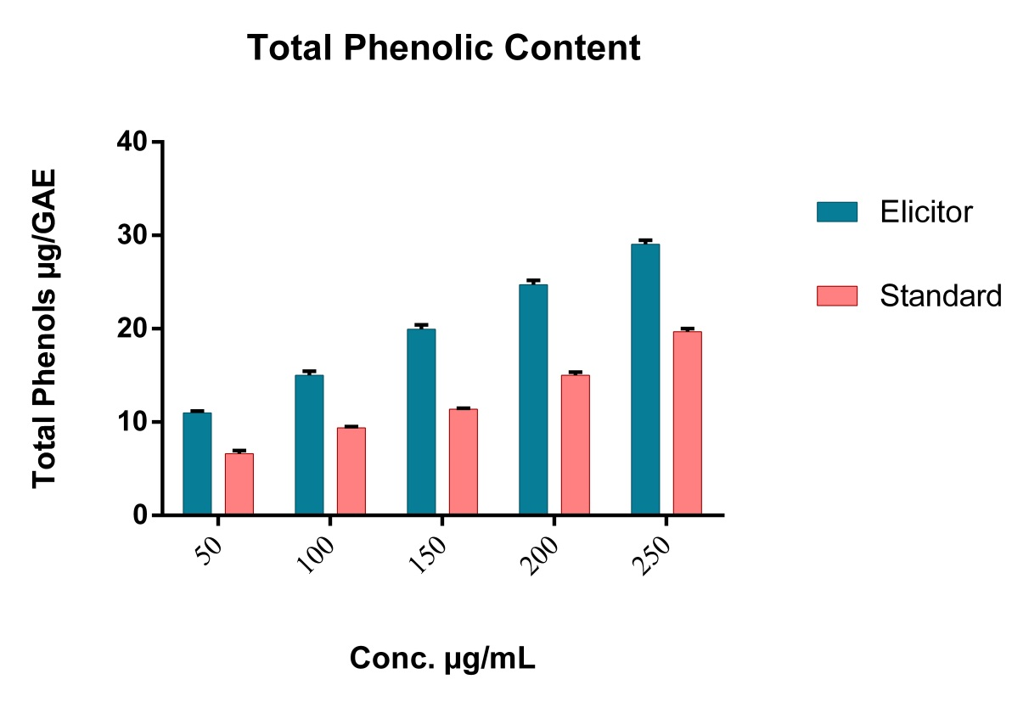
Graph1: Comparison of Phenolic content in standard as well as elicitor SA induced improved callus cells.
The growth index and phenolic acid levels of P. granatum suspension cell cultures that were exposed to elicitors (SA and JA) are shown in Table 3. Graph 1 shows that Elicitor SA generated more phenolic content overall. The range of phenolic content in our cultures throughout the elicitor-induced suspension cells' development cycle was 11.05 to 29.53 g/g of fresh weight. To obtain the maximum potential generation of bioactive substances, cell suspension culture must create as much metabolically active biomass per unit volume as feasible.
Conclusion
Nearly all of the cell culture growth patterns showed a similar pattern of constant biomass expansion beginning on day 0 and continuing until day 28. Throughout the course of the experiment, the salicylic acid concentration utilized in the medium caused the phenolic content of P. granatum suspension cells to rise. On the other hand, in all treated in vitro cultures, the overall phenolic acid content rose dramatically from day 0 to day 28. Therefore, in P. granatum suspension cells treated with elicitors, 28 days was the ideal time for phenolic acid production. The suspension culture's development was maximized. The results of the study point to the need for more research on yield-improving responses for different elictors and concentrations. These findings suggest that the current technique clearly illustrates the viability of employing cell suspension culture to increase callus for the synthesis of phytochemicals in a very short amount of time for effective scale-up of plant cell suspensions.
References:
1. Bioactive components of pomegranate fruit and their transformation by fermentation processes Małgorzata Gumienna1 · Artur Szwengiel1 · Barbara Górna1 Pomegranate (Punica granatum L.) M.OMURAl
2. M. Pavlović and K. Radotić, Animal and Plant Improved callus Cells, DOI 10.1007/978-3-319-47763-3_26
3. Silva, S., Costa, E. M., Calhau, C., Morais, R. M., & Pintado, M. E. (2017). Anthocyanin extraction from plant tissues: a review. Critical Reviews in Food Science and Nutrition, 57(14), 3072–3083.
4. Elham Azarpazhooh1 & Parvin Sharayei1 & Shahin Zomorodi2 & Hosahalli S. Ramaswamy. Received: 11 March 2018 /Accepted: 8 October 2018.
5. J.-M. Mérillon, K. G. Ramawat (eds.), Bioactive Molecules in Food, Reference Series inPhytochemistry
6. Regine Eibl1 & Philipp Meier1 & Irène Stutz 1 & David Schildberger2 & Tilo Hühn2 & Dieter Eibl1 Received: 12 June 2018 / Revised: 27 July 2018 /Accepted: 28 July 2018 /Published online: 11 August 2018
7.Cusido, R.M.; Palazon, J.; Bonfill, M.; Navia-Osorio, A.; Morales, C.; Piñol, M.T. Improved paclitaxel and baccatin III production in suspension cultures of Taxus media. Biotechnol. Prog. 2002, 18, 418–423. [Google Scholar] [CrossRef] [PubMed]
8. Zhou ZS, Guo K, Elbaz AA, Yang ZM (2009) Salicylic acid alleviates mercury toxicity by preventing oxidative stress in roots of Medicago sativa. Environ Exp Bot 65:27–34
9. Wang, Y.D.; Wu, J.C.; Yuan, Y.J. Salicylic acid-induced taxol production and isopentenyl pyrophosphate biosynthesis in suspension cultures of Taxus chinensis var. mairei. Cell Biol. Int. 2007, 31, 1179–1183. [Google Scholar] [CrossRef] [PubMed]
10. Loyola-Vargas and V á zquez-Flota (2006) plant cell culture protocols (book) pg 51-58
11.Kittipongpatana.N, Hock, R.S. Porter, J. R. Production of solasodine by hairy root callus and cell suspension cultures of Solanum aviculare forst. Plant Cell Tiss. Organ Cult. 52:133-143; 1998.
12. Wasternack, C.; Hause, B. Jasmonates: Biosynthesis, perception, signal transduction and action in plant stress response, growth and development. An update to the 2007 review in Annals of Botany. Ann. Bot. 2013, 111, 1021–1058. [Google Scholar] [CrossRef] [PubMed]
13. Al-Khayri, Jameel. (2012). Determination of the date palm cell suspension growth curve, optimum plating efficiency, and influence of liquid medium on somatic embryogenesis. Emirates Journal of Food and Agriculture. 24. 444-455.
14. Khanpour-Ardestani N, Sharifi M, Behmanesh M. Establishment of callus and cell suspension culture of Scrophularia striata Boiss.: an in vitro approach for acteoside production. Cytotechnology. 2015;67(3):475–485. doi:10.1007/s10616-014-9705-4
15. Farmer, E.E.; Ryan, C.A. Interplant communication: Airborne methyl jasmonate induces synthesis of proteinase inhibitors in plant leaves. Proc. Natl. Acad. Sci. USA 1990, 87, 7713–7716. [Google Scholar] [CrossRef] [PubMed]
16. Wintola OA, Afolayan AJ. Phytochemical constituents and antioxidant activities of the whole leaf extract of Aloe ferox Mill. Pharmacogn Mag 2011; 7:325-33.
17. Hoque A, Nahar A, Razvy MA, et al. Micropropagation of water chestnut (Trapa sp.) through local varieties of Rajshahi Division. Asian J Plant Sci. 2006;5(3):409–413. [Crossref] [Google Scholar]
18. LETICIA C.A., PAIVA P.D.O., PAIVA R., GARCIANO H.P., 2010. Growth curve and biochemical analyses of callus of IPE-BRANCO (Tabebuia roseo alba (Ridl.) Sand. Naturalia 33, 45-56.
19. SHIN G., CHIL M., LEE D., 2003. Comparative study of the effects of various culture conditions on cell growth and gagaminine synthesis in suspension culture of Cynanchum wilfordii. Biol Pharm Bull 26, 1321-1325.
20. Savita, Singh, B., Virk, G. S., & Nagpal, A. K. (2011). An efficient plant regeneration protocol from callus cultures of Citrus jambhiri Lush. Physiology and molecular biology of plants : an international journal of functional plant biology, 17(2), 161–169. doi:10.1007/s12298-011-0055-9
21. Lee, Eun-Kyong & Jin, Young-Woo & Park, Joong & Yoo, Young & Hong, Sun & Amir, Rabia & Zejun, Yan & Kwon, Eunjung & Elfick, Alistair & Tomlinson, Simon & Halbritter, Florian & Waibel, Thomas & Yun, Byung-Wook & Loake, Gary. (2010). Cultured cambial improved callus cells as a source of plant natural products. Nature biotechnology. 28. 1213-7. 10.1038/nbt.1693.
22. Roberts, S.C. Production and engineering of terpenoids in plant cell culture. Nat. Chem. Biol. 3, 387–395 (2007).
24. Yang, S.-J., Fang, J.-M. & Cheng, Y.-S. Lignans, flavonoids and phenolic derivatives from Taxus mairei. J. Chinese Chem. Soc. 46, 811–818 (1999).
25. Bhojwani SS, Razdan MK. Plant tissue culture: theory and practice. Amsterdam: Elsevier; 1983. [Google Scholar]
26. Qui JA, Castro-Concha LA, García-Sosa K, Peña-Rodríuez LM, Miranda-Ham ML. Differential effects of phytotoxic metabolites from Alternaria tageticaon Tagetes erecta cell cultures. J Gen Plant Pathol. 2009;75:331–339. doi: 10.1007/s10327-009-0184-y. [CrossRef] [Google Scholar]

