Unveiling Insights from IoT Data
- Analysis Techniques and Applications
M. Prasanna
Department of Physics and Electronics
Bhavan’s Vivekananda College of Science, Humanities and Commerce
Secunderabad, India
Prasanna.elec@bhavansvc.ac.in
Rajini A.
Department of Mathematics and Statistics
Bhavan’s Vivekananda College of Science, Humanities and Commerce
Secunderabad, India
rajinigupta.peddi@gmail.com
Chakravadhanula Naga Pranav
Bhavan’s Vivekananda College of Science, Humanities and Commerce
Secunderabad, India
chakravadhanula.pranav@gmail.com
Mummadi Sai Prasanna
Bhavan’s Vivekananda College of Science, Humanities and Commerce
Secunderabad, India
spmummadi2301@gmail.com

Abstract:
Within the sphere of data analysis in the context of the Internet of Things (IoT), this study explores its crucial function in supporting informed decision-making and acquiring valuable insights. The various advantages of analyzing IoT data, including the recognition of complex patterns, anomaly detection, optimization of operations, and enabling data-informed decision-making, are underscored. We also scrutinize the preprocessing of data and custom analytical techniques tailored for various types of IoT data. These techniques include the Chi-Square Test, Association Rule Mining, LSTM modeling, Dynamic Time Warping, Bayesian Analysis, Logistic Regression, Clustering, and Classification. They are applied to different types of data, such as categorical, numerical, time series, binary, and relational data, underscoring their adaptability and practicality. Ultimately, this study underscores the potential of these approaches to spur innovation, enhance services, and fortify the IoT infrastructure in the ever-evolving landscape of data utilization. This chapter aims to provide a comprehensive grasp of IoT data analysis methods, showcasing their applicability in dealing with specific variables derived from IoT devices.
INTRODUCTION:
Efficient data analysis plays a crucial role in facilitating informed decision-making and deriving meaningful insights. Particularly, the analysis of Internet of Things (IoT) data holds significant importance due to its multifaceted benefits. By delving into IoT data, one can unveil intricate patterns, detect irregularities, enhance operational workflows, boost resource efficiency, foster data-guided decision-making, anticipate maintenance needs, and elevate both system performance and security measures. This comprehensive analysis not only empowers businesses and organizations with valuable knowledge but also paves the way for innovation and service enhancements by harnessing the wealth of information generated by IoT devices.
In the realm of business strategy and technological advancement, the proficient analysis of IoT-generated data stands as a pivotal tool. Through meticulous examination of these data streams, enterprises gain a comprehensive understanding of trends, anomalies, and opportunities that might otherwise remain concealed. Such insights enable organizations to fine-tune processes, streamline operations, and make well-informed choices rooted in data-driven evidence. Moreover, by accurately predicting maintenance requirements and optimizing resource allocation, IoT data analysis contributes to heightened efficiency and resilience. Ultimately, this analytical endeavour not only augments service quality and innovation but also fortifies the overall infrastructure and safeguards against potential security threats, solidifying its role as a cornerstone in the modern landscape of information utilization. The examination of IoT data comprises of:
1. Data collection
2. Data preparation
3. Data analysis
4. Results interpretation

- COLLECTION OF THE DATA:
Data collection in the context of IoT means gathering the data from various devices, sensors, and sources. It typically involves managing the flow of information from sensors to storage, ensuring the integrity and reliability of the collected data.

- PREPARATION OF IoT DATA:
Data pre-processing: IoT (Internet of Things) devices produce an enormous amount of data, which often contains noise and inconsistencies.
Cleaning, transforming, and preparing this data for further investigation or machine learning processes are vital steps known as data preparation or data preprocessing.

Different procedures involved in pre-processing of IoT data:
- Data cleaning: For IoT data, data cleaning entails locating and fixing problems like missing values, duplicates, outliers, sensor noise, and inconsistent data. This procedure involves filling out in missing values, getting rid of duplicates, using statistical approaches to deal with outliers, using noise reduction techniques, aligning time-series data, validating against predicted ranges, and dealing with anomalies. To ensure data correctness, reliability, and consistency for additional analysis.
- Data transformation: Data transformation in the context of IoT is turning raw data into a structured format appropriate for analysis or modeling. This includes activities like normalising numerical values to a common scale, encoding categorical characteristics into numerical representations (e.g., one-hot encoding), aggregating and summarising time-series data, and applying mathematical functions to extract new features. Furthermore, data transformation requires synchronising time intervals, dealing with temporal factors, and employing dimensionality reduction techniques to extract significant information and improve the quality and usability of IoT data for subsequent analytical operations., it is also essential to conduct domain-specific checks and document modifications.
- Feature extraction: Feature extraction for IoT data involves distilling meaningful information from raw sensor readings and transforming it into a compact set of relevant features. This process encompasses statistical measures like mean, variance, and percentile values, as well as frequency domain features such as spectral entropy or dominant frequency components. Temporal aspects are considered through features like rolling averages or trend slopes. Additionally, domain-specific knowledge may guide the selection of pertinent features that capture the distinctive patterns and characteristics of IoT data, facilitating improved analysis, classification, or predictive modeling.
- Time-Series Alignment: Time-series alignment in IoT data synchronizes time-stamped readings from sensors or devices, ensuring accurate comparisons and analyses. Resampling techniques, interpolation, and interpolation fill gaps enhance the coherency of IoT data, enabling meaningful insights and facilitating reliable trend identification, anomaly detection, and pattern recognition in time-dependent datasets.
- Data aggregation and summarization: Data aggregation and summarization for IoT data involve condensing large volumes of detailed information into more manageable and insightful representations. This process includes grouping time-stamped readings into larger time intervals (e.g., hourly or daily) and computing summary statistics such as averages, maxima, minima, or totals within those intervals Aggregating data reduces noise and granularity, revealing overarching trends and patterns while conserving essential information. This streamlined representation aids in efficient analysis, visualization, and decision-making, particularly when dealing with extensive and high-frequency IoT data streams.
- Noise reduction: Noise reduction in IoT data entails minimizing unwanted variations or irregularities caused by factors like sensor inaccuracies or environmental interference. Techniques such as moving average, exponential smoothing, or low-pass filtering are applied to smooth out high-frequency fluctuations while preserving relevant trends and patterns. By attenuating excessive noise, these methods enhance data quality and enable clearer insights during analysis or modeling, ultimately improving the reliability of interpretations and predictions made using the IoT data.
- Normalization and Scaling: Normalization and scaling of IoT data involve adjusting the range and scale of numerical features to ensure fair treatment among different variables and compatibility with various algorithms. Normalization transforms data to a common range, often between 0 and 1, by subtracting the minimum and dividing by the range. Scaling standardizes data to have a mean of 0 and a standard deviation of 1, mitigating the influence of variables with larger magnitudes. These processes prevent features with higher values from dominating analysis or modeling, fostering improved convergence and performance while enhancing the effectiveness of machine learning algorithms on IoT datasets.
- Data Splitting: Data splitting for IoT data involves partitioning the dataset into distinct subsets to facilitate model development, validation, and testing. Typically, the dataset is divided into training, validation, and test sets. The training set is used to train the model, the validation set helps tune hyper parameters and prevent overfitting, while the test set evaluates the model’s performance on unseen data. Stratified sampling techniques can ensure representation across classes or conditions. Proper data splitting ensures the model's generalization ability and provides a robust evaluation of its effectiveness in handling real-world IoT scenarios.
- Data Formatting: Data formatting of IoT data involves preparing the preprocessed data in a structured format compatible with the specific requirements of analytical or machine learning algorithms. This process may encompass tasks like converting data into arrays, matrices, or tables to ensure consistent feature order and labeling. When dealing with time-series data, arranging information in a sequential order becomes essential. Moreover, categorical variables might require additional encoding, such as one-hot encoding, to facilitate suitable input for algorithms. Proper data formatting ensures a seamless integration with the chosen methods, thereby promoting accurate analysis and effective utilization of IoT data for generating actionable insights and predictions
- ANALYTICAL TECHNIQUES FOR DIFFERENT TYPES OF IoT DATA:
When we look at different kinds of IoT data, we need to use specific methods that match the type of data we're dealing with. Let's take a closer look at each type of data and the ways we analyse it:
- Categorical Data: These are types of data that have different categories, like colors or types of devices. We use methods like the Chi-square test and Association Rule Mining to understand the relationships between these categories.
- Numerical Data: This kind of data involves numbers, like measurements or quantities. To make sense of it, we use methods like Monte Carlo simulation, which helps us estimate different outcomes, and Optimization, which helps us find the best solution.
- Time Series Data: When data is collected over time, like temperature readings throughout the day, we use methods like LSTM (Long Short-Term Memory) models to predict future values, and Dynamic Time Warping to compare and find similarities between different time-based patterns.
- Binary Data: Binary data is all about yes or no, true or false situations. To analyze this, we use methods like Bayesian analysis, which helps us make predictions based on probabilities, and Logistic Regression, which helps us understand relationships between variables.
- Relational Data: Relational data is about how different pieces of information are connected. We use methods like Clustering to group similar data together, and Classification to categorize data into different groups.
- LSTM (long short-term memory)
Let {(x₁,y₁), (x₂,y₂), (x₃,y₃),…………, (x_{n},y_{n})} be a time series data where y_{i}(i=1 to n) be the observation and x_{i} (i=1 to n) be the time stamp corresponding to the observation. If the objective of the analysis is to forecast then, we use the LSTM model.
LSTM (long short-term memory) can be used for forecasting data, especially data that has long-term dependencies. The LSTM (Long Short-Term Memory) model is a type of recurrent neural network (RNN) architecture designed to handle sequential data and long-term dependencies. Unlike traditional RNNs, LSTMs can retain and update information over extended time intervals, making them highly effective for tasks involving time series data, natural language processing, and other sequential data analysis.
The form of data we require for time series forecasting using LSTM depends on the specific application. In general, the data should be:
      - Time stamped
- Numerical
- Clean

Apart from these, it may also depend on the following factors:
- The type of IoT device
- The frequency of data collection
Here are some examples of IoT data on which LSTM can be used:
- Temperature data
- Humidity data
- Air quality data
- Energy consumption data
- Traffic data

Implementation of LSTM using python:
import numpy as np
import pandas as pd
from sklearn.preprocessing import MinMaxScaler
from tensorflow.keras.models import Sequential
from tensorflow.keras.layers import LSTM, Dense
# Generated random data for the example
np.random.seed(42)
data = np.random.rand(100, 1)
# Convert the random data to a pandas DataFrame
df = pd.DataFrame(data, columns=['value'])
# Normalize the data to bring it within the range [0, 1]
scaler = MinMaxScaler(feature_range=(0, 1))
normalized_data = scaler.fit_transform(df)
# Split data into training and testing sets
train_size = int(len(normalized_data) * 0.8) # 80% training data
train_data = normalized_data[:train_size]
test_data = normalized_data[train_size:]
# Function to create sequences of data for LSTM training
def create_sequences(data, seq_length):
X, y = [], []
for i in range(len(data) - seq_length):
X.append(data[i:i + seq_length])
y.append(data[i + seq_length])
return np.array(X), np.array(y)
# Define the sequence length and create sequences for training and testing
sequence_length = 10
X_train, y_train = create_sequences(train_data, sequence_length)
X_test, y_test = create_sequences(test_data, sequence_length)
# Build the LSTM model
model = Sequential()
model.add(LSTM(50, activation='relu', input_shape=(sequence_length, 1)))
model.add(Dense(1))
model.compile(optimizer='adam', loss='mean_squared_error')
# Train the model
model.fit(X_train, y_train, epochs=10, batch_size=16, verbose=1)
# Make predictions on the test data
predictions = model.predict(X_test)
# Inverse transform the predictions and actual values to get the original scale
predictions = scaler.inverse_transform(predictions)
y_test = scaler.inverse_transform(y_test)
# Evaluate the model (you can use any appropriate metric here)
from sklearn.metrics import mean_squared_error
mse = mean_squared_error(y_test, predictions)
print(f"Mean Squared Error: {mse}")

Output:
Epoch 1/10
5/5 [==============================] - 1s 4ms/step - loss: 0.2711
Epoch 2/10
5/5 [==============================] - 0s 4ms/step - loss: 0.2322
Epoch 3/10
5/5 [==============================] - 0s 4ms/step - loss: 0.1934
Epoch 4/10
5/5 [==============================] - 0s 4ms/step - loss: 0.1561
Epoch 5/10
5/5 [==============================] - 0s 8ms/step - loss: 0.1166
Epoch 6/10
5/5 [==============================] - 0s 4ms/step - loss: 0.1051
Epoch 7/10
5/5 [==============================] - 0s 8ms/step - loss: 0.1097
Epoch 8/10
5/5 [==============================] - 0s 4ms/step - loss: 0.1051
Epoch 9/10
5/5 [==============================] - 0s 4ms/step - loss: 0.1014
Epoch 10/10
5/5 [==============================] - 0s 8ms/step - loss: 0.1018
1/1 [==============================] - 0s 251ms/step
Mean Squared Error: 0.07245334658136152
- Dynamic time wrapping
Let {(x₁,y₁), (x₂,y₂), (x₃,y₃),…………, (x_{n},y_{n})} be a time series data where y_{i}(i=1 to n) be the observation and x_{i} (i=1 to n) be the time stamp corresponding to the observation. Let {(u₁,v₁), (u₂,v₂), (u₃,v₃),…………, (u_{m},v_{m})} be a time series data with different rates and different lengths where v_{j}(j=1 to m) be the observation and u_{j} (j=1 to m) be the time stamp corresponding to the observation. If the interest of the study is to measure the similarity between two time series, we use “Dynamic Time Warping”.
Dynamic Time Warping (DTW) is a powerful algorithm used to measure the similarity between two time series data sequences that may vary in time or speed. It was originally developed for speech recognition but has found applications in various domains, including pattern recognition, data mining, bioinformatics, and Internet of Things (IoT) analytics. It is versatile for analysing IoT data as IoT devices can collect data at different rates and for different lengths of time.
Here are some examples of IoT data on which Dynamic time wrapping can be used:
      - Identify anomalies in the sensor data
- Detect fraud in financial data
- Heart rate data from a wearable watch
- Location data from a GPS tracker

Implementation of Dynamic time wraping using python:
!pip install fastdtw
import numpy as np
from scipy.spatial.distance import euclidean
from fastdtw import fastdtw
# Sample time series data
time_series1 = np.array([1, 2, 4, 3, 5])
time_series2 = np.array([1, 2, 2, 2, 3, 5])
# Reshape the time series data into 1-D arrays
time_series1 = time_series1.reshape(-1, 1)
time_series2 = time_series2.reshape(-1, 1)
# Compute Dynamic Time Warping distance and alignment path
distance, path = fastdtw(time_series1, time_series2, dist=euclidean)
print("Dynamic Time Warping Distance:", distance)
print("Optimal Alignment Path:", path)

Output:
Dynamic Time Warping Distance: 1.0
Optimal Alignment Path: [(0, 0), (1, 1), (1, 2), (1, 3), (2, 4), (3, 4), (4, 5)]

- Logistic Regression
Let {(x₁,y₁), (x₂,y₂), (x₃,y₃),…………, (x_{n},y_{n})} be the data where x_{i} ∈ R^{d} is the independent variable which can be categorical or numerical variable and y_{i}∈ {0,1} is the binary variable which is dependent variable. If the objective of the study is to classify then we use logistic regression.
Logistic Regression can be employed for various classification tasks that involve binary outcomes. IoT devices generate a vast amount of data, and sometimes, it's necessary to categorize or classify the data into two distinct classes based on certain criteria or thresholds. The model will learn the relationship between the independent and dependent variables. This relationship can then also be used to predict the probability of an event occurring, given the value of the independent variable.
Here are some examples of IoT data on which Logistic Regression can be used:
- Temperature data from a thermostat
- Humidity data from a hygrometer
- Motion sensor data from a PRI sensor
- Smoke detector data

Implementation of Logistic regression using python:
import numpy as np
import pandas as pd
from sklearn.model_selection import train_test_split
from sklearn.linear_model import LogisticRegression
from sklearn.metrics import accuracy_score, classification_report, confusion_matrix
# Set random seed for reproducibility
np.random.seed(42)
# Generate random IoT data
num_data_points = 100
random_data = {
'X1': np.random.uniform(0, 10, num_data_points),
'X2': np.random.normal(5, 2, num_data_points),
'y': np.random.randint(2, size=num_data_points)
}
# Create a pandas DataFrame from the random data
df = pd.DataFrame(random_data)
# Separate features (X) and target variable (y)
X = df[['X1', 'X2']]
y = df['y']
# Split the data into training and testing sets (80% training, 20% testing)
X_train, X_test, y_train, y_test = train_test_split(X, y, test_size=0.2, random_state=42)
# Create and train the Logistic Regression model
model = LogisticRegression()
model.fit(X_train, y_train)
# Make predictions on the test set
y_pred = model.predict(X_test)
# Evaluate the model
accuracy = accuracy_score(y_test, y_pred)
conf_matrix = confusion_matrix(y_test, y_pred)
class_report = classification_report(y_test, y_pred)
print("Accuracy:", accuracy)
print("Confusion Matrix:\n", conf_matrix)
print("Classification Report:\n", class_report)

Output:
Accuracy: 0.45
Confusion Matrix:
[[3 9]
[2 6]]
Classification Report:
 | precision | recall | f1-score | support
0 | 0.6 | 0.25 | 0.35 | 12
1 | 0.4 | 0.75 | 0.52 | 8
accuracy |  |  | 0.45 | 20
macro avg | 0.5 | 0.5 | 0.44 | 20
weighted avg | 0.52 | 0.45 | 0.42 | 20

- Clustering
Let{x₁,x₂,x₃,…….,x_{n}} be a set of features, which are the variables that can be used to describe the observations. R is the relationship matrix, which can be describes the relationship between the features. The data should be rational which means that it should have a relationship between the variables. If the objective of the study is to find the groups in the data, we use clustering.
Clustering is a popular unsupervised machine learning technique used to group similar data points together based on their similarities or proximity in a high-dimensional space. In the context of IoT (Internet of Things), clustering is particularly valuable for organizing and understanding large and heterogeneous datasets generated by numerous interconnected devices. By grouping IoT data into clusters, it becomes easier to identify patterns, detect anomalies, and make data-driven decisions. Popular clustering algorithms in IoT applications include k-means, hierarchical clustering, density-based clustering, and spectral clustering, each with its strengths and suitability depending on the nature of the IoT data and the specific problem at hand.
Here are some examples of IoT data on which clustering can be used:
1. Traffic sensor data from city
2. Machine health data from a factory
3. Air quality sensor data from a home

Implementation of Clustering using python:
import numpy as np
from sklearn.cluster import KMeans
import matplotlib.pyplot as plt
# Generate example IoT data
np.random.seed(0)
num_samples = 100
data = np.random.rand(num_samples, 2) * 10 # Generating random data between 0 and 10
# Perform k-means clustering
num_clusters = 2
kmeans = KMeans(n_clusters=num_clusters)
kmeans.fit(data)
# Get cluster labels and cluster centers
labels = kmeans.labels_
centers = kmeans.cluster_centers_
# Plot the data points and cluster centers
plt.scatter(data[:, 0], data[:, 1], c=labels, cmap='viridis', s=50)
plt.scatter(centers[:, 0], centers[:, 1], c='red', marker='X', s=200, label='Cluster Centers')
plt.xlabel('Temperature')
plt.ylabel('Humidity')
plt.title('Clustering of IoT Data')
plt.legend()
plt.show()

Output:
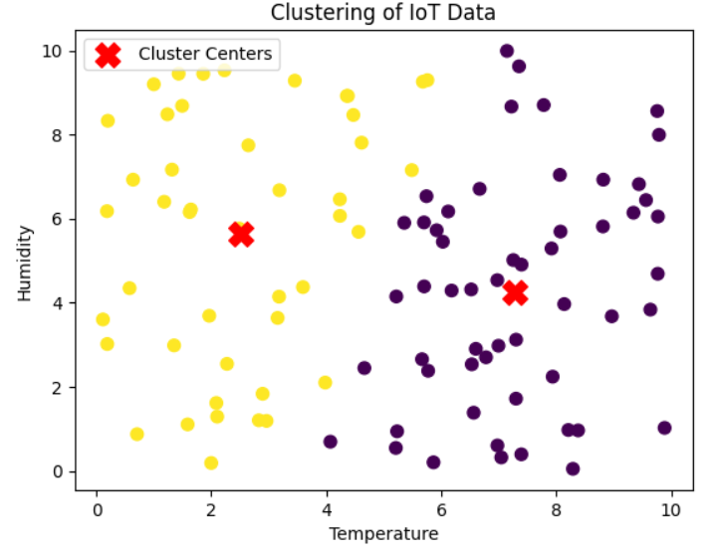

- Chi-Square Test
The Chi-Square Test can be a useful tool for analyzing IoT data and identifying potential security risks.
Let {x₁, x₂, x₃,......,x_{n}} ∈ X and {y₁, y₂, y₃,...., y_{n}} ∈ Y, where X and Y are two categorical variables and xi ∈ X where i=1 to n observations corresponding to X and yi∈ Y where i=1 to n are observations corresponding to Y. If the interested point of study is to determine whether there is a significant relation between two categorical variables then the Chi-Square Test is useful.
The chi-squared (χ²) test is a statistical test used to determine whether there is a significant association between categorical variables. It's commonly used when you have a contingency table that shows the distribution of counts for different categories of two or more variables. The test helps you to understand whether the observed frequencies in the contingency table differ significantly from what would be expected if the variables were independent.
Following are some of the types of IoT data that can be used for the Chi-Square Test:
The type of IoT device.
- The location of the IoT device.
- The time of day when the IoT device was attacked.
- The severity of the attack.
Implementation of the Chi-Square test for categorical data in Python:
import numpy as np
from scipy.stats import chi2_contingency
# Example IoT data (contingency table)
data = np.array([[50, 30, 40, 50], [20, 40, 50, 40]])
# Performing chi-square test
chi2, p, dof, expected = chi2_contingency(data)
# Output results
print("Chi-square statistic:", chi2)
print("P-value:", p)
print("Degrees of freedom:", dof)
print("Expected frequencies table:")
print(expected)
# Interpretation
alpha = 0.05 # Significance level
if p < alpha:
print("\nThe p-value is less than the significance level.")
print("There is significant evidence to reject the null hypothesis.")
print("Therefore, the two categorical variables are dependent.")
else:
print("\nThe p-value is greater than or equal to the significance level.")
print("There is not enough evidence to reject the null hypothesis.")
print("Therefore, the two categorical variables are independent.")

Output:
Chi-square statistic: 15.317771553065672
P-value: 0.001564275913128902
Degrees of freedom: 3
Expected frequencies table:
[[37.1875 37.1875 47.8125 47.8125]
[32.8125 32.8125 42.1875 42.1875]]

The p-value is less than the significance level.
There is significant evidence to reject the null hypothesis.
Therefore, the two categorical variables are dependent.

- Association Rule Mining
Let {(x₁,y₁), (x₂,y₂), (x₃,y₃),…………, (x_{n}, y_{n})} where (x, y) pair represents an item set with two items: x and y. Each item in an item set could correspond to an attribute or a feature in your dataset. If the point of interest is to discover interesting relationships or patterns in data then we use association rule mining.
Association Rule mining analyses datasets where each transaction represents a collection of events or attributes associated with IoT devices. The goal is to identify co-occurrences and correlations between these events or attributes, leading to the extraction of actionable insights. These discovered associations enable businesses and researchers to make informed decisions for optimization, anomaly detection, or resource allocation within IoT ecosystems.
To discover interesting relationships between categorical variables using techniques like Apriori algorithm and then Association Rule mining is used.
Here are some examples of how association rule mining can be applied to analyse categorical IoT data:
- Retail Market Basket Analysis
- Smart Home Automation
- Manufacturing Quality Control
- Healthcare Patient Monitoring
- Traffic Flow Optimization

Implementation of Association rule mining for categorical IoT data in python:
import pandas as pd
from mlxtend.frequent_patterns import apriori
from mlxtend.frequent_patterns import association_rules
# Example IoT dataset
data = pd.DataFrame({
'TransactionID': [1, 2, 3, 4, 5],
'Temperature': ['High', 'Low', 'Medium', 'High', 'Low'],
'Humidity': ['High', 'Low', 'Low', 'Medium', 'High'],
'Location': ['A', 'B', 'C', 'B', 'A']
})
# Convert categorical data to binary format
binary_data = pd.get_dummies(data.drop('TransactionID', axis=1))
# Apply Apriori algorithm
frequent_itemsets = apriori(binary_data, min_support=0.3, use_colnames=True)
# Generate association rules
rules = association_rules(frequent_itemsets, metric='lift', min_threshold=1.0)
# Display the generated rules
print(rules)

Output:
antecedents consequents antecedent support consequent support
0 (Location_A) (Humidity_High) 0.4 0.4 \
1 (Humidity_High) (Location_A) 0.4 0.4

support confidence lift leverage conviction zhangs_metric
0 0.4 1.0 2.5 0.24 inf 1.0
1 0.4 1.0 2.5 0.24 inf 1.0

- Bayesian Analysis
Bayesian analysis is a statistical approach that allows us to make inferences about unknown parameters in a model by combining prior knowledge or beliefs with observed data. When applied to an IoT binary dataset, Bayesian analysis can help us understand the relationships between binary outcomes and predictor variables, quantify uncertainties in the model, and make predictions based on the data.
The Bayesian logistic regression model for binary data involves a binary outcome variable (Y) and predictor variables (x₁, x₂, x₃, ......,x_{n}). The model represents the probability of the binary outcome being 1 (success) given the predictor variables, with the logit function representing the natural logarithm of the odds of the binary outcome being 1. Prior distributions are specified for the model parameters, which are combined with the likelihood function to obtain posterior distributions after observing the data. The Bernoulli likelihood function, a special case of the binomial distribution, represents the probability of observing the data given the model parameters.
Here are some applications of Bayesian analysis for binary IoT data:
- Predictive Maintenance
- Healthcare and Remote Patient Monitoring
- Agricultural Monitoring
- Smart Home Applications

Implementation of Bayesian analysis for Binary IoT data in python:
!pip install pymc3
import pymc3 as pm
import pandas as pd
import numpy as np
import matplotlib.pyplot as plt
# Example data
data = pd.DataFrame({
'Y': [0, 1, 0, 1, 1, 0, 1, 0, 1, 1],
'X1': [1, 2, 3, 4, 5, 6, 7, 8, 9, 10],
'X2': [0, 1, 1, 0, 1, 0, 0, 1, 0, 1]
})
with pm.Model() as logistic_model:
# Priors for the coefficients
beta0 = pm.Normal('beta0', mu=0, sd=10)
beta1 = pm.Normal('beta1', mu=0, sd=10)
beta2 = pm.Normal('beta2', mu=0, sd=10)
# Calculate the log-odds of the binary outcome
logit_p = beta0 + beta1 * data['X1'] + beta2 * data['X2']
# Likelihood function (Bernoulli) for the binary outcome
Y_obs = pm.Bernoulli('Y_obs', p=pm.math.sigmoid(logit_p), observed=data['Y'])
with logistic_model:
# Perform Markov Chain Monte Carlo (MCMC) sampling
trace = pm.sample(2000, tune=1000, cores=1) # You can adjust the number of samples (e.g., 2000) and tuning steps (e.g., 1000) as needed.
# Plot the posterior distributions of the coefficients
pm.plot_posterior(trace, var_names=['beta0', 'beta1', 'beta2'])
plt.show()

Output:
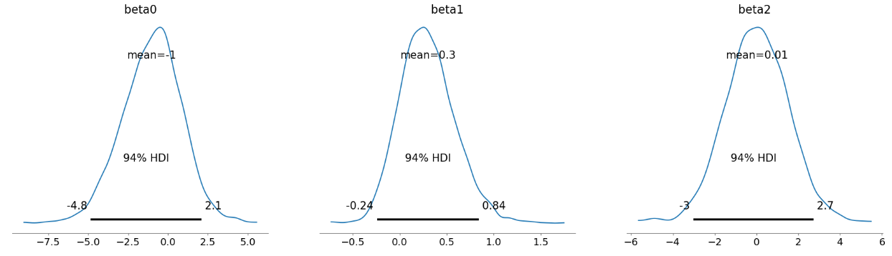

- Classification
Let {x₁, x₂, x₃, ......,x_{n} } be the set of observations of a feature X and {y₁, y₂, y₃,...., y_{n}} be the corresponding labels if the interested objective of the study is to classify the observations then we use classification.
Classification is a type of supervised machine learning that is used to assign data points to a pre-defined set of categories or classes. In the context of IoT data, Classification can be used to identify patterns and trends in data, and to make predictions about future events.
Some examples of how Classification can be used on relational IoT data:
- Machine health monitoring
- Fraud detection
- Recommendation Systems
Implementation of Classification for relational data in python:
import numpy as np
from sklearn.model_selection import train_test_split
from sklearn.ensemble import RandomForestClassifier
from sklearn.metrics import accuracy_score, classification_report
# Generating example IoT data
np.random.seed(42)
num_samples = 200
temperature = np.random.uniform(20, 30, num_samples)
humidity = np.random.uniform(40, 80, num_samples)
labels = np.where((temperature > 25) | (humidity > 70), 1, 0) # 1 for anomaly, 0 for normal
# Splitting data into training and testing sets
X_train, X_test, y_train, y_test = train_test_split(
np.column_stack((temperature, humidity)),
labels,
test_size=0.2,
random_state=42
)
# Creating and training a Random Forest classifier
classifier = RandomForestClassifier(random_state=42)
classifier.fit(X_train, y_train)
# Making predictions on the test set
y_pred = classifier.predict(X_test)
# Evaluating the model
accuracy = accuracy_score(y_test, y_pred)
print("Accuracy:", accuracy)
# Printing classification report
target_names = ["Normal", "Anomaly"]
print("\nClassification Report:\n", classification_report(y_test, y_pred, target_names=target_names))

Output:
Accuracy: 1.0
 | precision | recall |  | f1-score |  | support
normal | 1 | 1 | 1 |  | 17
Anomaly | 1 | 1 | 1 |  | 23
 |  | 1 | 1
accuracy | 1 | 1 | 1 |  | 40
macro avg | 1 | 1 | 1 |  | 40
weighted avg | 1 | 1 | 1 |  | 40

- Monte Carlo Simulation
Let us consider continuous data with mean μ, standard deviation σ and variance σ². To use Monte Carlo Simulation, in addition to statistical measures, you may also need to specify the probability distribution that you are using to represent the continuous data. This distribution will determine how you generate random values of data.
Monte Carlo Simulation is a statistical method that uses random sampling to approximate the behaviour of a system. It can be used to analyse continuous datasets from IoT devices.
The following are some of the forms of IoT data that can be used for Monte Carlo Simulation:
- Sensor data
- Financial data
- Medical data
Here are some examples of how Monte Carlo Simulation can be used on continuous IoT data:
- Industrial monitoring
- Financial risk management
- Medical research
Implementation of Monte Carlo Simulation for Continuous IoT data:
import numpy as np
import matplotlib.pyplot as plt
mean_temperature = 25.0 # Mean temperature in degrees Celsius
std_dev_temperature = 2.0 # Standard deviation of temperature
num_simulations = 1000 # Number of simulation runs
# Generate random data using Monte Carlo simulation
simulated_temperatures = np.random.normal(mean_temperature, std_dev_temperature, num_simulations)
# Analyze and visualize the results
plt.hist(simulated_temperatures, bins=20, density=True, alpha=0.7, color='b', label='Simulated Temperatures')
plt.xlabel('Temperature (°C)')
plt.ylabel('Probability Density')
plt.title('Monte Carlo Simulation of Temperature Data')
plt.legend()
plt.show()

Output:
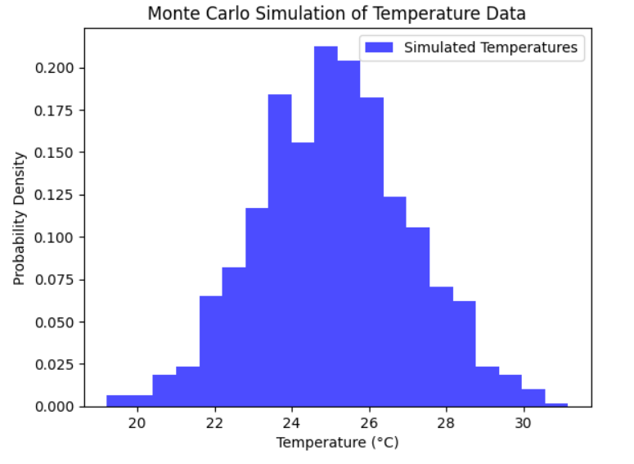

- Optimization
Let us consider x₁, x₂, x₃, ......, x_{n} are Continuous variables representing different measurements, sensor readings, or features with Y being the objective function of continuous variables i.e, y = f(x₁, x₂, x₃ ,......,x_{n})
Optimization analysis is a process of finding the best solution to a problem. It can be used to analyse continuous datasets from IoT devices in a variety of ways. Optimization analysis is a powerful tool that can be used to analyse continuous datasets from IoT devices. It can be used to improve the efficiency, performance, and profitability of systems.
Here are some examples of how Optimization can be used on continuous IoT data:
- Industrial automation
- Financial trading
- Medical treatment

Implementation of Optimization for continuous IoT data:
import numpy as np
from scipy.optimize import minimize
def objective_function(variables):
x, y = variables
return x**2 + 2*y**2 + x*y - 3*x - 4*y
initial_guess = [0.0, 0.0]
result = minimize(objective_function, initial_guess)
optimized_variables = result.x
optimized_value = result.fun
print("Optimized Variables:", optimized_variables)
print("Optimized Value:", optimized_value)

Output:
Optimized Variables: [1.14285785 0.71428548]
Optimized Value: -3.1428571428566965
- RESULTS INTERPRETATION OF IoT DATA:
The process of interpreting IoT data entails scrutinizing the gathered data from a multitude of interconnected devices to extract valuable insights. This encompasses tasks such as recognizing patterns, discerning trends, pinpointing anomalies, and establishing correlations within the dataset. Through this analysis, one can make well-informed decisions, enhance processes, predict maintenance requirements, and enhance overall efficiency across diverse sectors, ranging from manufacturing to healthcare and beyond.
CONCLUSION:
In conclusion, the assortment of analytical techniques investigated here for IoT data analysis presents a robust framework for extracting valuable insights from a wide range of data types. These methodologies, spanning from statistical tests like Chi-Square and Bayesian analysis to advanced approaches like LSTM modeling and optimization, provide decision-makers and researchers with the capability to uncover concealed patterns, foresee future trends, and enhance operational efficiency. By delving into categorical, numerical, time series, binary, and relational data, organizations acquire the means to make informed decisions, streamline processes, and foster innovation. This comprehensive toolkit transforms the extensive realm of IoT-generated data into a strategic asset, propelling industries toward enhanced performance, innovation, and data-driven excellence.

