Mycotoxicosis- A systematic review on Mycotoxin induced toxicities and Diseases
Sujatha B*ª, Dhanalakshmi G^{b}, Nethra Subramanyam^{C}
*ªDepartment of Microbiology, Padmashree Institute of Management and Sciences, Kommaghatta, Bangalore -560069. sujathabachu80@gmail.com
ªDepartment of Biochemistry,Padmashree Institute of Management and Sciences, Kommaghatta, Bangalore-560069.
^{c}Department of Biotechnology, Padmashree Institute of Management and Sciences,Kommaghatta, Bangalore-560069.
Abstract
Mycotoxins are one of the most commonly found toxins distributed in the environment everywhere. Recent investigations reveal that nearly 300 to 400 types of mycotoxins exist today. Mycotoxicosis is a severe pathological condition caused by Mycotoxins. There are several types of mycotoxins released by various fungi, and different fungi can release the same kind of Mycotoxins. Some of the best examples are aflatoxins, trichothecenes, citrinin, patulin, ergot alkaloids, fumonisins, patulin, and ochratoxins. Mycotoxins are capable of causing severe diseases ranging from allergies to acute infection in a wide variety of hosts, including humans and animals. They enter into the food chain by infecting the crops. Many intrinsic and extrinsic factors easily aid the organism in infecting the crops. The reason behind releasing the toxin is unknown, but it helps the organism to increase inside the host and compromises the host's immune system. They often colonize cereals, legumes, oilseeds, nuts, animal products, poultry, and dairy products. The main route of entry is through contaminated food products. Once they gain access to the living system, they will establish themselves in the target organ like the liver and the central nervous system through blood and lymph, exerting systemic and local toxicity. The present emphasizes the importance of mycotoxin-induced toxicity and its prevention.
Keywords: Aflatoxins, ochratoxins, mycotoxicosis, oil seed

Introduction:
Microorganisms are present here and there everywhere surrounding us. Fungi are eukaryotic organisms whose growth can be seen on suitable substrates like food, wood, walls, clothes, etc., wherever moisture is available. All the bakery foods, vegetables, and fruits show a considerable amount of this fungi. Generally, we remove and use the infected part whenever we see any contaminated food item with fungi. However, one should be careful in consuming contaminated foods, as the toxins might have also spread to the healthy part.
Mycotoxins are one of the secondary metabolites produced by the fungus. Secondary metabolites are those compounds that will not participate in the growth and metabolism of the organisms. Mycotoxins make the environment favorable for the fungi to grow. In other words, they help the fungi to increase in the target sites.
An important question arises what makes the molds infect? Their association with food substrates is considered an indication of the pathogenesis of the organisms[1]. Many of our foods act as excellent growth media for the growth of fungi.
The association of these organisms with foods is beneficial, resulting in various fermented foods.
The factors which favor the growth of fungi include:
- Hydrogen ion concentration.
- Oxidation-reduction potential.
- Nutrient composition.
- The presence of barriers like growth inhibitory substances.
A combined effect of the above factors can successfully inhibit the growth of a particular group of organisms.
The present study emphasizes the pathological condition of these mycotoxins. Mycotoxins are potentially toxic to human beings and animals. The growth of fungus in a host is termed mycoses [2]. On the other hand, the disease caused because of exposure to fungi toxins is called mycotoxicosis.
Production of Mycotoxins occurs in warm and humid conditions. Fungi that produce mycotoxins are mycotoxin fungi [3].
Mycotoxins occupy a wide variety of food like nuts, cereals, milk, meat, etc. They enter the food chain through contaminated foods [5].
History of Mycotoxins:
In 1992 a mysterious outbreak of a disease called Turkey X disease [6] resulted in the death of 100,000 poultry animals. It was because of the consumption of peanut meal. by turkey, infested with Aspergillus flavus.
Aflatoxins:
These are a group of toxins produced by A. flavus and A.parasiticus. It is one of the most investigated mycotoxins because it infects all most all staple food grains like rice, wheat sorghum, maize, groundnut, etc. Environmental factors favor or influence The organism's growth, especially temperature and humidity [7]. Major aflatoxins that impact the individual's health status are B1, B2, G1, and G2Fig : 1. These aflatoxins are identified better on the kind of fluorescence they emit under ultraviolet rays. Among these, B1 is considered the most potent toxin. These aflatoxins are present in various foods in different proportions. When animals consume this aflatoxin-contaminated food, they enter into their products like milk. The toxins found in milk are called M1 and M2.
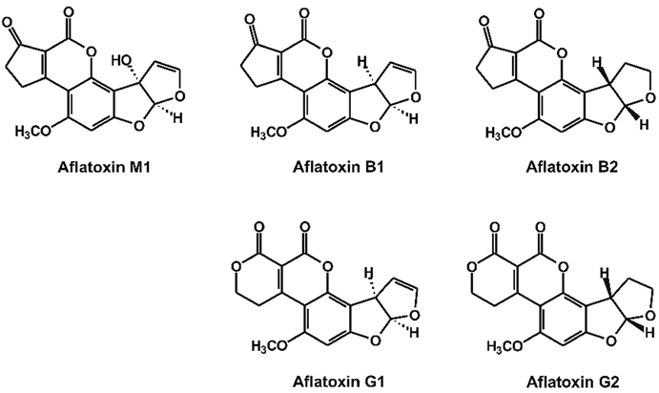
Fig: 1: Types of Aflatoxins
Source: www. Research gate.net

Ergot:
It is a kind of plant disease caused by the fungus Claviceps purpurea. It infects crops like pearl millet, wheat, sorghum, rye, etc. The fungus mainly infects the flowering stage of the crop. The infected flower turns into a dark black mass, often called Ergot. Later it fails to develop into grains. Ergot contains the alkaloids Table: 1,Fig: 2 released by the fungus.
The route of infection starts from the field itself during transportation. Also, the preservation technique followed could be more promising [8]. Many studies suggest that the disease starts from pre-harvest and persists in storage because of poor storage conditions Table 2.

Name of the organism | Stage of infection
Claviceps purpurea | Pre-harvest and early storage
Aspergillus sp. and Penicillium sp. | Storage
Aspergillus flavus | Field

Table 1: List of toxins produced by Clavicepspurpurea.

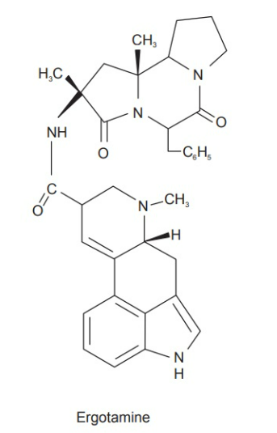
Fig 2: Structure of Ergot alkaloids.
Source: www.wikipedia.com

Name of the organism | Stage of infection
Claviceps purpurea | Pre-harvest and early storage
Aspergillus sp. and Penicillium sp. | Storage
Aspergillus flavus | Field
Table: 2:List oftoxin-producing fungi infecting the different stages of the crop.
Ochratoxin A:
It is considered one of the significant toxins causing toxic effects in the kidney[9,10]. Members of fungi belonging to Aspergillus and Penicillium sp. release Ochratoxin A Fig 3.
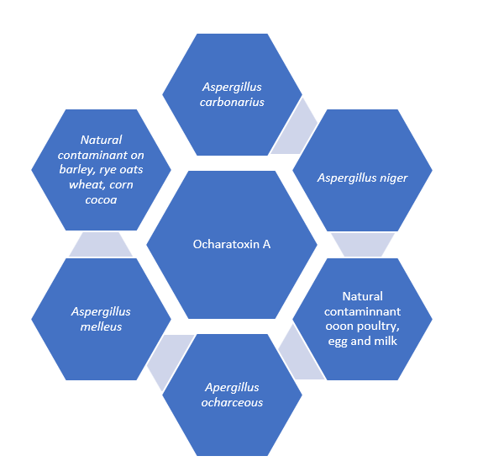
Fig 3: Different types of fungi producing Ochratoxin A

Trichothecene:
Trichothecenes are also called TCT, in short, produced by fusarium sp. They are named types A and B according to their structure. Other fungal metabolites resemble the chemical structure of the TCT. There are two types of trichothecenes, Type A and Type B. Fig 4A and Fig 4B.Consumption of Trichothecene contaminated cereals has led to severe outbreaks in many countries like Asia, Africa, Europe, North America, etc [11].
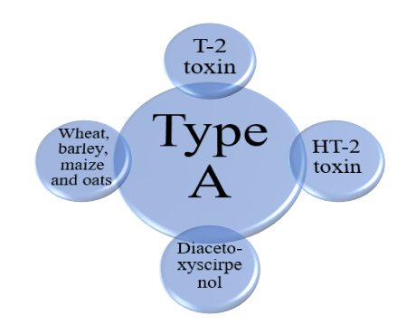
Fig: 4A. Type A-trichothecenes
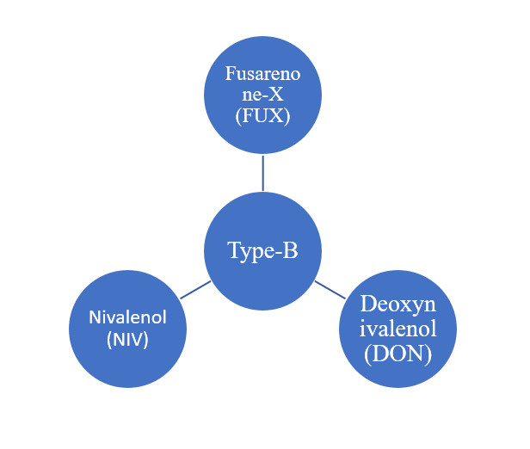
Fig: 4B. Type B- trichothecenes
Deoxynivalenol (DON):
It is also named Vomitoxin or DON fig: 5. Fusarium graminearum and Fusarium culmorum release DON when they infect cereals and grains. Environmental conditions like high humidity and temperature favor the production of the toxin [12].
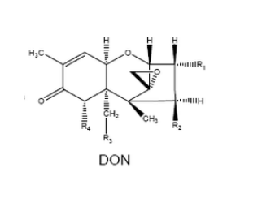
Fig: 5: Structure of DON
Source: www. Wikipedia.com

Fumonisins:
The presence of the fungus merely on the cereals and grains need not necessarily demonstrate the presence of the toxin [13,14]. Similarly, Fusarium verticillioides is a common inhabitant of corn.Among fumonisins B1 and B2, B1Fig:6is considered the most potent toxin.
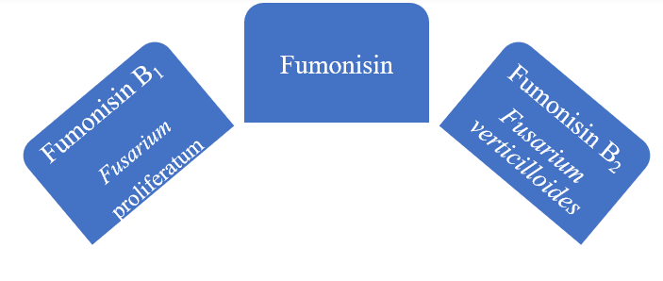
Fig: 6 Types of Fumonisins
Patulin:
Penicillium, Aspergillus, and Byssochlamys produce patulin when infested on apples, grapes, and pears. Penicillium expansum, a blue mold, makes patulin in apple juice [15]. Initially, it is considered an antibiotic; later, several investigations proved the toxic effects of the metabolite in animals.
Zearalenone:
It is another kind of mycotoxin produced by Fusarium sp.[16]. It is a non-steroidal compound that shows estrogen-like activity in certain farm animals like cattle, sheep, and pigs. The organism prefers wet and cool climates to proliferate in cereals.
Moniliformin:
It is another kind of fumonisin produced by Fusarium proliferatum found in the corn kernel. It is a reservoir pathogen found in soil and passes from one crop generation to another.
Roquefortine:
Penicillium roqueforti produces roquefortin [17] toxin in blue, Roquefort, and Stilton cheese. It is potentially toxic to mice.
Luteoskyrin:
Penicillium islandicum produces two metabolites, luteoskyrin, and cyclochlorotine. They are considered hepatotoxic to rodents.
Effect of Mycotoxins on Health
Several factors will contribute to the release of mycotoxins on several food substances. The factors are as follows
1. Physical factors: Includes temperature, relative humidity and insect infestation
2. Chemical factors: Ex: fungicides/fertilizers
3. Biological factors: Completion between the toxigenic fungi and others
Animals with single-chambered stomachs, like dogs, rats, and also humans, are more prone to the toxicity caused by fungal toxins. Animals having a complex organization of stomach-like chambers are less affected because they are microbes that may degrade the toxin.
Mycotoxins are known to cause cancer in human beings. Another toxin called citrinin released by penicillin and aspergillus species causes yellow rise disease [18]. Aflatoxicosis is a condition that results from the ingestion of aflatoxins. It causes acute liver toxicity and may lead to cancer.
Chronic toxicity develops by exposure to the toxin from low to moderate levels of toxin now, and their ergotism involves patients suffering from convulsions. It is called "St Anthony's Fire."
Symptoms of ergotism include Convulsions and Gangrene. General symptoms like nausea, vomiting, and diarrhea are associated with them. Spasms, seizures, confusion, delusions and hallucinations, itching, and paresthesia accompany convulsions [19].
Patients may lose parts of their extremities, such as toes and fingers, due to the constriction of blood vessels in gangrene conditions. Acute human mycotoxicosis includes nausea, vomiting, gastrointestinal upset, dizziness, etc.
Fumonisins are responsible for oesophageal cancer in Asia, Africa, and American maize-eating populations. Fumonisin B results in the poor update of folic acid, causing neural tube defects in human babies.
Alimentary toxic Aleukia leads to a decrease in leukocytes caused by the T2 toxin produced by Fusarium sp.
Ochratoxin A causes kidney disease. DON causes nausea, vomiting, and diarrhea in animals. Severe weight loss and reluctance to feed are observed. Because of this, it is called the food refusal factor [20].
Measures for prevention:
Mycotoxins pose adverse health effects, which may lead to cancer. Mycotoxin-contaminated food and feed have severely damaged animal livestock (farm animals). Indirectly it affected the livelihood of the farmer, who occupy the primary claim of the population, especially in India. Also, it has negatively impacted the country's economic status because of the rejection of contaminated foods that are either imported or exported.
On the other hand, it has created life-threatening conditions for human beings leading to several diseases. National and international regulatory authorities like FDA and FSSAI have issued specific guidelines for exporting and importing food materials with the threat of mycotoxin contamination. The levels of these mycotoxins need to be monitored at regular intervals to ensure the safety of the foods. According to FSSAI, the limit of aflatoxin in various foods should be between 10-15 ppb for human consumption; ochratoxin has a limit of 20 ppb in wheat, rye, and barley, etc. for patulin, it is 50 ppb in apple juice, and for DON it is 1,000 ppb in grain [21].
Processing of Foods can minimize the risk of aflatoxins:
Milling and cooking processes reduce aflatoxin levels in foods. Binding agents like bentonites andclays are added to the feeds to lessen their bioavailability.
Separation of visible mold growth in seeds or grains from healthy ones is one of the best ways to minimize risk.
Refining and filtering the nuts of the oil reduce the risk of contamination.
Control of mold in the animal feed reduces the fungus's entry into the food chain.
DON is a heat-stable and water-soluble toxin and can be removed easily by washing the grains.
Ochratoxins are removed by roasting the coffee beans
Sorting out fruits and vegetables reduces the risk of contamination. Winnowing, washing, crushing, and dehulling of grains lessen toxins. Floatation method, including salt water, 30 % potassium chloride is poured over the seeds and stirred[22].
Use of Dietary fibers:
Antioxidants like selenium, Vitamin A, E, and C fructose, phenolic compounds, chlorophyll, and coumarins reduce the toxicity of these toxins. Broccoli, Sprouts, and green tea can be detoxed to remove toxins [23].
The present study strictly emphasizes maintaining absolute cleanliness and sanitation starting from the harvesting, transportation, and finally, to the end-user, which will lessen the impact of toxins. Following good agricultural practices, preservation methods, and processing methods, all together can reduce contamination. Further selective breeding and genetic engineering offer the selection of resistant varieties of crops, which will help to prevent infestation by fungi [24].
Spread awareness about the importance of fungi, the food grains and cereals they infect, mycotoxins, and mycotoxicosis will help to achieve eradicate the risk caused by fungi.

Conclusion:
Mycotoxinsgained the attention of healthcareprofessionals because of the impact caused by them on animal and human livestock. International and national regulatory standards strictly framed the code of practice, which will limit exposureto different types of foods with respect to mycotoxins.
References:
- Ülger TG., Uçar A., Çakıroğlu FP., Yilmaz S. Genotoxic effects of Mycotoxins.Toxicon. 2020 Oct 15; 185:104-113. E pub Jul 10. 2020.
- Fletcher M.T., Blaney B.J. Mycotoxins in Reference Module in Food Science.2016.
- Bennett, J.W. and Klich M. Mycotoxins. Clinical Microbiology Reviews, 16, 497-516., 2003.
- Darina Pickova., Vladimir Ostry., Jakub Toman ., Frantisek Malir. Aflatoxins:History, Significant Milestones, Recent Data on Their Toxicity and Ways to Mitigation. Toxins (Basel). Jun 3;13(6):399, 2021.
- James W., Muthomi., Scholastica L., Musyimi., John M., Wagacha., Rama D. Narla. Occurrence of Fusarium species and associated T2-toxin in Kenyan wheat, Agricultural Sciences Vol. 3 No.1 January 5, 2012.
- Bennett, J.W. and Klich, M. Mycotoxins. In: Schaechter, M., Ed., Encyclopedia of Microbiology, 3rd Edition, Academic Press, Oxford, 559-565, 2009.
- Bhat R. V., Beedu S. R., Ramakrishna Y., and Munshi K. L. “Outbreak of Trichothecene Mycotoxicosis Associated with Consumption of Mould-Damaged Wheat Production in Kashmir Valley, India,” Lancet, Vol. 1, No. 8628, pp. 35-37 1989.
- Kensler T.W., Egner P.A., Wang J.B., Zhu Y.R, Zhang B.C, Lu PX, Chen JG, Qian GS, Kuang SY, Jackson PE, Gange SJ, Jacobson LP, Muñoz A, Groopman JD. Chemoprevention of hepatocellular carcinoma in aflatoxin endemic areas;127(5 Suppl 1): S310-8, Nov 2004.
- PE, Groopman J.D.,Baillieres. Aflatoxins and liver cancer. Best Pract. Res. Clin. Gastroenterol.;13(4):545-55, Dec1999.
- Lamichhane A., Webb P., Andrews-Trevino J., Pokharel A, Acharya S., Shrestha R., DavisD,, Baral K, Wang JS, Xue K, Paudel K, Ghosh S. Dietary determinants of Aflatoxin B₁ .Eur J Clin Nutr.;76(11):1557-1565. Nov 2022.
- Phillips TD., Wang M., Elmore S.E., Hearon S., Wang J.S.Novosil clay for the protection of human and animals from Aflatoxins and other contaminants, Clays Clay Miner. Feb;67(1):99-110. 2019.
- ArmendárizC.R., de la TorreA.H. Encyclopedia of Toxicology (Third Edition), 2014.
- Turner N.W., Subrahmanyam S., Piletsky S.A., "Analytical methods for determination of mycotoxins: a review." Anal. Chim. Acta. 632 (2): 168–80 2009.
- Jeswal P., Kumar D. "Mycobiota and Natural Incidence of Aflatoxins, Ochratoxin A, and Citrinin in Indian Spices Confirmed by LC-MS/MS". International Journal of Microbiology: 1–8. 2015.
- Yousefi., Mohammad., Mohammadi Masoud Aman., Khajavi., Maryam Zabihzadeh., Ehsani Ali., Scholtz., Vladimír. "Application of Novel Non-Thermal Physical Technologies to Degrade Mycotoxins". Journal of Fungi. 7 (5): 395 2021 2021.
- Boonen J., Malysheva S., Taevernier L., Diana Di Mavungu J., De Saeger S., De Spiegeleer B., "Human skin penetration of selected model mycotoxins". Toxicology. 301 (1–3): 21–32 2012.
- Hardin BD, Robbins CA, Fallah P, Kelman BJ (2009). "The concentration of no toxicologic concern (CONTC) and airborne mycotoxins". J. Toxicol. Environ. Health A. 72 (9): 585–98.
- Zain, M.E. (2011) Impact of Mycotoxins on Humans and Animals. Journal of Saudi Chemical Society, 15, 129-144 jscs.2010.06.006.
- Liu Yue., Yamdeu., Joseph Hubert Galani., Gong, Yun Yun., Orfila Caroline. (2020). "A review of postharvest approaches to reduce fungal and mycotoxin contamination of foods". Comprehensive Reviews in Food Science and Food Safety. 19 (4): 1521–1560.
- Jeswal P., Kumar D." International Journal of Microbiology: 1–8, 2015.
- Çimen., Duygu., Bereli., Nilay., Denizli Adil. (2022-06-01). "Patulin Imprinted Nanoparticles Decorated Surface Plasmon Resonance Chips for Patulin Detection". Photonic Sensors. 12 (2): 117–129 2022.
- A Text book on Food Safety and Quality Control by Pulkit Mathur Orient Black Swan Publications Private Ltd, Pp88-101, 2018.
- Mohammed A., Chala A., Dejene M., Fininsa C., Hoisington D.A., Sobolev V.S., Arias R.S. Aspergillus and aflatoxin in groundnut (Arachis hypogaea L.) and groundnut cake in Eastern Ethiopia, Food Addit Contam. Part B Surveil, 9(4):290-298, Dec 2016.
- Runxian Li., Yang Wen., Fenglai Wang and Pingli He. Recent advances in immunoassays and biosensors for mycotoxins detection in feedstuffs and foods Journal of Animal Science and Biotechnology 12:108, 2021.
- www.wikipedia .com
- WWW.Researchgate.com

