CHAPTER
Harnessing the power of Personalized
Medicines: Steps and Innovations

Priyanshi Singhal
Department of Biotechnology
Dr. B lal Institute of Biotechnology
Jaipur, India
E-mail: priyanshi17singhal@gmail.com

Natasha
School of Life Science, Department of Biotechnology
Jamia Hamdard University
New Delhi, India
E-mail: natashachoudhary1908@gmail.com

ABSTRACT

Personalized medicine, precision medicine, and precision health as approaches to healthcare that emphasize tailoring treatments to an individual's unique biological, behavioral, and environmental factors. These terms are sometimes used interchangeably, but personalized medicine is considered broader than precision medicine, encompassing a wide range of health factors. Precision medicine specifically focuses on genomic and physiological biomarkers. These approaches aim to prevent, diagnose, and treat diseases within the healthcare system. Precision health represents a broader framework that includes public health and consumer health management. The chapter highlights the principles and advancements of personalized and precision medicine, the shift from a "one size fits all" paradigm to individualized patient identification, diagnosis, and treatment, leveraging genomics and molecular diagnosis. The goal is to maximize therapeutic efficacy while reducing the risk of drug toxicity. The study emphasizes the potential of personalized medicine to improve target selectivity of drugs, enhance clinical trial success, and develop personalized treatment strategies. Additionally, the chapter mentions the application of personalized medicine and challenges faced during data collection, medicine development, and clinical trials. Overall, personalized medicine offers a promising approach for better healthcare, focusing on prevention, prediction, and treatment tailored to individual needs based on their genomic makeup and other factors. The emergence of genomics and translational genetics has provided powerful tools for clinical diagnosis, disease prediction, high throughput screening, and the development of personalized therapies and vaccines.

Keywords - Personalized medicine, Precision medicine, Clinical trials, Pharmacogenomics, screening, Target therapy Personalized medicine, genomics, biomarkers, epigenetics

I. HISTORY
In the early 1900s, blood types were found in the field of transfusion medicine in the early 1900s, which led to better matching of donor and recipient blood and improved transfusion results in origin of personalized medicine. Hippocrates, who often referred to as the "Father of Modern Medicine," highlighted the value of individualized therapy by putting an emphasis on patient-specific factors, such as their surroundings, nutrition, and lifestyle. The term "personalized medicine" was first introduced in a 1999 article in The Wall Street Journal, that discussed the establishment of the Single Nucleotide Polymorphisms Consortium, which aimed to target medications based on the distinctive genetic profiles of individuals. The Wall Street Journal article was republished by the Oncologist 20 years ago, became the first journal to introduce the idea of personalized medicine to the medical community, a topic that they have covered and promoted excellently ever since.[1]

II. INTRODUCTION
The healthcare industry has recently seen a paradigm change in favor of a more individualized and focused approach to patient care. This ground-breaking method, referred to as personalized and precision medicine, is changing the expression of medical practice and has the potential to completely reshape healthcare as we now know it.[2] Personalized medicine is the process of utilizing a person's genetic profile to guide decisions on avoiding illnesses, diagnosis, and treatment, according to the US National Human Genome Research Institute. Based on the patient's genetic information, this method entails choosing the suitable medicine or therapy and figuring out the right dose or regimen.[3] By understanding the individuality of people and their healthcare needs, personalized medicine moves away from a one-size-fits-all approach. To customize therapy for each patient's requirements, it takes into account a variety of variables, including genetic data, biomarkers, and medical history[3]. Precision medicine, according to the US National Cancer Institute, is defined as the use of genetic or protein information to treat, diagnose, or prevent disease. In the context of cancer, precision medicine especially makes use of data regarding a patient's tumor to help with diagnosis, therapy planning, efficacy evaluation, or outcome prediction. Precision medicine, takes ideas a step further by utilizing cutting-edge technology and data analysis to comprehend the molecular pathways behind illnesses. It strives to produce targeted medicines that focus on treating a disease's underlying causes, resulting in better results, decreased side effects, lower costs, and increased patient well-being.” (National Human Genome Research Institute, n.d.). Both personalized medicine and precision medicine center on using a patient's genetic information to inform medical decisions. Both emphasize the use of genetic information in modifying medical therapies for specific individuals and seek to provide customized medical treatments that are specifically matched to each patient's individual needs, genetic composition, and lifestyle by using the power of cutting-edge technology, genomic sequencing, and extensive data analytics. An intriguing concept advances that suggests that a true "personalized medicine and health" must take into account a person's surroundings and living conditions in addition to the biological aspects of their illness. Such a strategy implies the existence of environmental and socio-economic data, which rarely appears in medical records or are just not routinely looked for by physicians. [4]
Individuals are phenotyped at the "omics" level more frequently than the environmental levels (such as the physicochemical, behavioral, psychological, and social levels), which are rarely phenotyped.
Personalized medicine benefits in improved therapeutic results, fewer side effects, and cost effectiveness. The necessity for infrastructure and education, as well as difficulties with data interpretation, concerns about privacy, and regulations, are underlined.

III. TYPES OF TRIALS

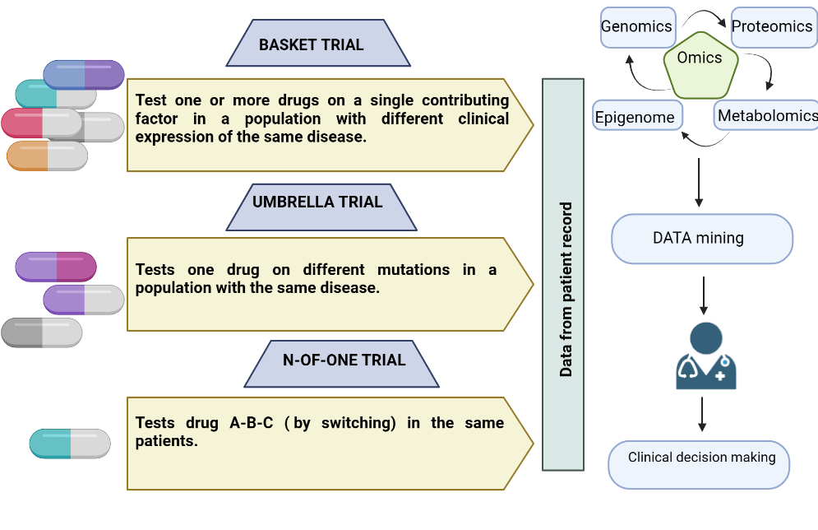
Figure 1: Types of trials depicting all three trials [5]

- Umbrella trials:
A precision medicine strategy known as umbrella trials compares several targeted treatments at once against various molecularly distinct subtypes of a given disease or condition. Patients are grouped according to certain genetic or molecular abnormalities, and then they are allocated to a particular treatment group that specifically addresses the abnormality, aiming to address inter-patient heterogeneity. Multiplex Biomarkers assays and thorough molecular profiling are used in umbrella trials to identify individuals who are more likely to react to a particular drug, improving treatment accuracy and raising the likelihood that specific patients would have positive outcomes. The prognostic and predictive functions of biomarkers can be differentiated in umbrella studies by using single or randomized arms. However, due to the difficulty in generating multiplex tests and the difficulty in admitting patients with uncommon disorders, umbrella studies encounter difficulties. Successful umbrella studies in patients with lung cancer and breast cancer include Lung Cancer Master Protocol (Lung-MAP), Adjuvant Lung Cancer Enrichment Marker Identification and Sequencing Trial (ALCHEMIST), I-SPY-2, and plasma MATCH. A more streamlined and effective method of assessing targeted drugs, real-time modifications based on new data, and the development of precision medicine are all advantages of umbrella trials.[6], [7]
- Basket trials
By segregating patients into groups according to certain molecular biomarkers rather than tumor type, basket trials are a precision medicine strategy that assesses the efficacy of targeted drugs across a variety of tumor forms.[8] The same targeted drugs is used to treat patients with various tumor types who also share a common genetic or molecular mutation. To increase the chance of a successful treatment outcome, basket trials use biomarker-driven screening to select individuals who are likely to benefit from the targeted drugs under investigation. The possibility for identifying therapeutic targets and therapies for uncommon or less frequent tumor forms, a more effective use of resources, and the growth of precision medicine are all benefits of basket trials. [9]These studies often involve patients who have had a number of treatments and have a variety of tumor types, or individuals who have tried all conventional treatments. Targeted therapeutics assessed in basket trials have showed much greater response rates than conventional treatments, despite poor response rates predicted in the following phases of treatment. For individuals whose precise tumor types may not be individually investigated, genomic biomarkers are essential in determining the best immunotherapy or gene-directed treatment. The use of pembrolizumab in tumors with high tumor mutational burden (TMB-H), Larotrectinib and Entrectinib in tumors with NTRK fusions, and pembrolizumab in tumors with mismatch repair deficiency/microsatellite instability-high (dMMR/MSI-H), are examples of successful basket trials.[6], [7]
C. N-of-1 trials
N-of-1 studies in precision medicine assess individualized treatment regimens for individuals while taking into account their distinct genetic profiles. Because cancer is a very complicated and varied disease, these studies are particularly significant in oncology. N-of-1 studies attempt to enhance outcomes for patients with a variety of tumor types by maximizing options for treatment through personalized combinations. New combinations are still being tested in ongoing N-of-1 studies on various patients. Researchers can ascertain if a patient reacts favorably or unfavorably to a certain treatment by performing well-designed N-of-1 studies. Results from several N-of-1 studies can be combined to provide important knowledge about how to treat certain groups of people or the entire community. The success of N-of-1 studies depends on overcoming practical obstacles, using health monitoring tools, creating novel biomarkers, and promoting a cultural shift in healthcare delivery systems. Additionally N-of-1 studies may also be used in early drug development, drugs repurposing, dose and safety evaluation, and illness onset detection. For treatments based on genetic make-up, biochemistry, food, and other aspects, algorithms are being created. By gathering appropriate information often, utilizing statistical protections, and utilizing control interventions, N-of-1 studies can be utilized to compare treatments. These trials have demonstrated to result in prescriptions that are more successful by analyzing the data before and after various therapies.[6], [7]

IV STEPS IN PROCESS OF PERSONALIZED MEDICINE

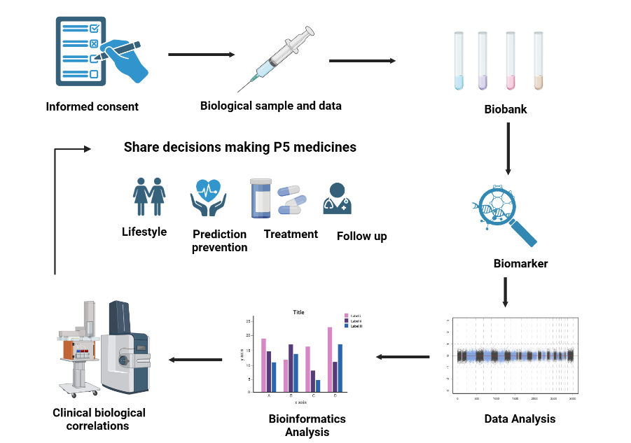

Figure 2: Major steps involved in the process of PM.
- Data Collection and Patient Profiling: the first step in the procedure is to gather detailed information on the patient, including their clinical history, genetic and genomic make-up, environmental and epigenetic influences, and other pertinent biomarkers
- Biomarker identification: Identification of the patient's particular illness or disease-related biological indicators (biomarkers) is done using the data gathered. These biomarkers can predict illness risk and prognosis and act as quantifiable indicators of the patient's biological condition.
- Risk Assessment and diagnosis: Use the biomarker profile to monitor and survey patients, determining each person's own molecular traits to determine their risk for various illnesses and ailments. Present specialized therapies that are tailored to the biomarker profiles of each patient to precisely meet their unique medical needs.
- Integrative biological marker integration: Utilize integrative (biomarkers) to treat patients who are not sick. The goal is to anticipate disease risk and categorize disease subtypes, including patient groupings with comparable molecular variances.
- Biomarker trait and analysis: Make sure that biomarkers may be independently evaluated and analyzed as indicators of typical biological processes, pathological states, or pharmacological reactions to treatment interventions.
- Individual Health State Determination: To ascertain a person's health state or illness condition, biomarkers may be utilized singly or in combination.
- Predictive Biomarkers for Biological treatments: Identify predictive biomarkers, such as genetic and immunological variables, that predict how patients will respond to biological treatments.
- Confirmation and Validation: To verify the accuracy and dependability of predictive biomarkers, thoroughly validate them through investigations and research.
- Integrating P5 medicines Integration: The digital revolution with cutting-edge medical technology to promote P5 medicine—personalized, predictive, participative, precise, and preventative. This branch of medicine strives to be participative, customized, preventative, and predictive at the population level.
- patient-centered strategy: Personalized medicine maintains a patient-centered focus throughout the process with the goal of offering the most appropriate and efficient therapies for each person based on their particular biological make-up and health situation.

Table 1: The table above includes a wide variety of FDA-approved drugs, each carefully chosen for its own target site for various death threatening diseases. The Food and Drug Administration (FDA) of the United States has placed these drugs through extensive testing and assessment to guarantee their safety and effectiveness in treating a range of medical diseases.
S.NO | DRUG NAME | TAGET SITE | REFERENCES
1. | Adotrastuzumab Emtansine | Breast cancer | [10]
2 | Atezolizumab | Urothelial carcinoma, non -small lung cancer | [10]
3. | Binimetinib | Metastatic Melanoma | [11]
4. | Burosumab -twza | X-linked hypophosphatemia | [11]
5. | Cemiplimab-rwlc | Cutaneous squamous cell carcinoma (CSCC),  Adenosine deaminase severe combined immune deficiency (ADA-SCID) | [11]
6. | Cetuximab | Metastatic Colorectal cancer | [10]
7. | Cobimetinib | Melanoma | [10]
8. | Dabrafenib | Melanoma, non- small lung cancer | [10]
9. | Dacomitinib | Advanced non- small cell lung cancer (NSCLC) | [11]
10. | Defarasirox | Thalassemia | [10]
11. | Enasidenib | Acute myeloid leukemia | [10]
12. | Ibalizumab-uiyk | HIV-1 infection | [11]
13. | Imatinib Mesylate | Aggressive systemic Mastocystosis,  Gastro intestinal stroma tumor,  Myelodysplastic syndrome | [10]
14. | Lanadelumab-flyo | Type I &II Hereditary angioedema | [11]
15. | Larotrectinib | NRTK gene fusion solid tumor | [10]
16. | Migalastal | Fabry disease | [11]
17. | Olaparib | Ovarian cancer, breast cancer | [10]
18. | Pegvaliase -pqpz | Phenylketonuria | [11]
19. | Pembrolizumab | MSI-H or DMMR solid tumor | [10]
20. | Tafenoquine | Plasmodium vivax Malaria | [11]
20. | Tezacaftor | Cystic fibrosis | [11]
21. | Trastuzumab | Metastatic breast cancer, gastric cancer | [10]
22. | Venatoclax | Chronic lymphocytic leukemia | [10]

V. Emerging technologies in precision medicine
- Biomarker discovery
Next-generation sequencing (NGS) and other technologies have played a significant role in the implementation of precision medicine. For example - single molecule array (SiMoA) and fiber microarrays, which have been used to detect changes in biomarkers for diseases like prostate cancer and cystic fibrosis. These approaches help differentiate patient subgroups and correlate well with disease severity. Microfluidic technologies have been used to detect low levels of biomarkers in small volumes of fluid. For instance, a microfluidic device was employed to detect circulating tumor cells (CTCs) associated with hepatocellular carcinoma (HCC) by depleting hematopoietic stem cells. This allowed for the development of an RNA-based signature that accurately detected HCC-derived CTCs. Single-cell analysis using techniques like Raman micro-spectroscopy and multi-plexed imaging has been utilized for biomarker discovery. Peptide arrays now enable monitoring of low-affinity protein-ligand interactions, offering novel strategies for monitoring and drug discovery.
- Precision diagnostics and biosensing
In comparison with conventional methods like imaging or blood draws, emerging technologies like microfluidics and nanofluidic provide great sensitivity and specificity for biomarker surveillance and enable more frequent outcome monitoring. Through an understanding of biological heterogeneity, single-cell analysis, which is developing quickly, promises new insights into disease, including cancer. Engineers have developed devices that can isolate rare cell populations to understand disease contributions or make diagnostic and therapeutic decisions. The use of antibody cocktails and digital pathology algorithms aids in classifying and tracking circulating tumor cells (CTCs). Technologies like CyTOF allow comprehensive interrogation of heterogeneity in driver mutations and drug resistance. Longitudinal studies are needed to understand disease progression and resolve genomic signatures. Liquid biopsies offer a promising approach for real-time disease monitoring and predictive drug action, using CTCs, exosomes, and other biological factors for analysis. These technologies have the potential to enable individualized therapy and improve treatment outcomes based on the identified biomarkers.
C. Precision therapeutics
CRISPR and zinc finger nucleases (ZFN), both methods for gene editing, offer the potential to repair damaged genes in a variety of disorders, including cancer, HIV, mucopolysaccharidosis II (Hunter Syndrome), Duchenne muscular dystrophy (DMD), and others. The efficacy of ZFN-based genome editing therapy for MPS I, severe hemophilia B, and HIV-1 infection is being examined in clinical trials. Precision medicine has also depended heavily on molecularly targeted and antibody treatments, with several approved drugs and patient-specific drug prioritization techniques based on mutation databases. The use of CRISPR to fix genetic errors in DMD and tumor profiling to predict treatment outcomes in melanoma using the expression of programmed cell death protein 1 (PD-1), PD-L1, and cytotoxic T lymphocyte-associated protein 4 (CTLA-4) are two examples of preclinical advancements. To increase the effectiveness of CRISPR-based treatments, novel delivery techniques including nanoparticles are being explored. For instance, gene editing for DMD and excessive cholesterol levels has showed potential for lipid nanoparticles and gold nanoparticles, respectively. Spherical nucleic acids (SNAs), a kind of nanocarrier used for RNA interference, have successfully proven effective gene silencing in several cell lines, suggesting possible uses in the treatment of cancer.

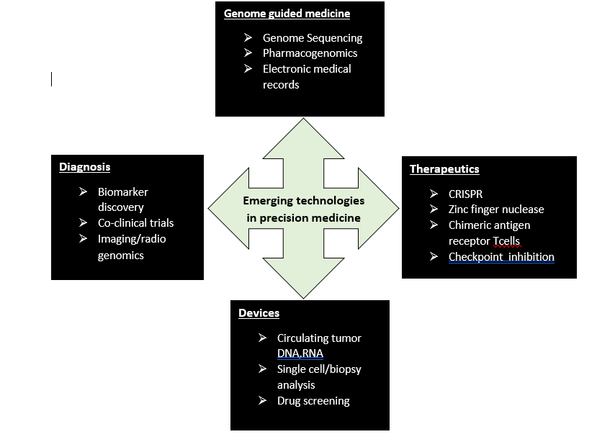
Figure: 3 List of emerging technologies on precision medicine

VI. Emerging technologies in personalized medicines
- Role of Bioengineering in personalized medicine
In order to advance personalized medicine and make patient-specific therapies more accurate and successful, bioengineering is becoming increasingly important. Since biomaterials can have a variety of impacts on cell fate and proliferation, it is important to design them with specific disease indications and organ settings in mind. By simulating organ-scale complexity, systems for organ-on-a-chip have the opportunity for individualized toxicity and drug screening research. Emerging technologies and wearables can get beyond testing frequency restrictions for rapid and accurate treatment response evaluation, enhancing personalized therapies. In order to treat a variety of diseases, the area of personalized medicine is increasingly growing to encompass digital treatment. The emphasis on using an individual's own data to customize their care and achieve continual treatment optimization is a defining characteristic of these methods. In order to advance personalized medicine and make patient-specific therapies more accurate and successful, bioengineering is essential.

B. Artificial intelligence, machine learning, and personalized treatment
The standard method of choosing the optimal therapies for specific patients involves conducting dose-escalation-based studies to determine medication dosages and drug combinations. Given the nearly endless parameter space these considerations produce, AI and ML systems provide the ability to continually determine the best medicine dosages and combinations. Additionally, AI is being used to improve diagnostic imaging and direct patient-specific therapy. New AI-based platforms show the critical link between dosages of drugs and drug choice while offering a mechanistically-neutral optimization strategy. Insights into the processes behind globally optimized results may result from this optimization, which might result in the addition of novel drug candidates to the design pools for combination therapies. Clinical trials have effectively applied AI optimization platforms to tailor post-transplant immunosuppression and improve combination treatment regimens for a variety of disorders. The potential uses of AI are growing in fields like single-cell interrogation platforms, adaptive radiotherapy, and digital therapies. The clinical validation of innovative therapeutic methods can be accelerated by integrating organ-on-a-chip systems with AI-based screening techniques that can replicate complicated organ function.
C. Wearable and implantable sensors
Wearable technologies provide individualized drugs and dosage optimization by providing rigorous, continuous monitoring of numerous health markers. Soft electronics provide glucose sensing and cystic fibrosis monitoring without fingerstick testing by analyzing sweat, tears, skin interstitial fluid, and saliva to assess analytes non-invasively. These tools may be able to recognize unique biomarker signatures. In clinical trials, wearable technology is being investigated for perioperative risk prediction, diagnosing and treating chronic obstructive pulmonary disease, and tracking cardiovascular therapy. Mobile application software can be used in neurocognitive evaluation to examine brain health for dementia, depression, and Alzheimer's disease. The limitations of traditional in-clinic testing can be solved by smartphone assessment methods, allowing for more frequent assessments and in-depth analysis of variability and practice effects. The increasing frequency and scale of data gathering made possible by wearables and mobile health technologies improve data actionability, obviating the requirement for traditional methods and enabling the development of individualized treatment plans. Wearable technology has the potential to advance both precision and personalized medicine as data troves expand, providing patients with new treatment options and ideas.
D. Personalized cell therapy and drug delivery
The acceptance of CAR-T (chimeric antigen receptor-T) cell immunotherapy is a significant development in the field of personalized cancer treatment. In order to increase CAR-T scalability and lower the danger of mutagenesis, non-viral techniques like nocturnal transposition and CRISPR/Cas9 are being investigated. Type 1 diabetes and multiple sclerosis are two diseases that are treated on an individual basis using induced pluripotent stem cells (iPSCs). Genetic disorders brought on by abnormalities in mitochondrial DNA can be treated by mitochondrial replacement therapy (MRT). Synthetic cells are intended to function as biosensors that can autonomously distribute therapeutic payloads and identify diseases. Individualized drugs delivery techniques such as personalized 3-D printing and biomaterial-mediated controlled release are promising. Nanomedicine-based combination therapy is gaining popularity, and enhanced AI is being utilized to create population-optimized combinatorial nano therapy. These developments show the promise of personalized drugs to provide personalized drugs and treatments.[12]

Artificial intelligence
- Drug discovery
- Drug development
- N-of-1 therapy
- Pathology

Emerging technologies in personalized medicine
Diagnostics
- Wearables for sweat,blood,tear analysis
- Circulating tumor cell detection
- Multiplexed biofluid analysis decive
Therapeutics
- Nanomedicine/theranostics
- Combination therapy
- Biomaterials/3D printed implants

Figure 4: List of emerging technologies in personalized medicine
CONCLUSION
The discipline of adapting medical treatment to each patient's unique genetic profile and disease characteristics is known as personalized medicine. Clinical trials are evolving to take into account patient variability and the development of biomarkers for targeted medicines. Accurate forecasts and individualized treatment suggestions are made possible by integrating various data sources and cutting-edge technology like machine learning. New technologies provide new prospects for early disease identification and better patient outcomes, such as liquid biopsies and next-generation sequencing. Despite obstacles, personalized medicine has the power to transform healthcare by enabling genuinely unique and efficient therapies for every patient, thereby enhancing overall wellbeing.

REFERENCES
[1] J. T. Jørgensen, “Twenty Years with Personalized Medicine: Past, Present, and Future of Individualized Pharmacotherapy.,” Oncologist, vol. 24, no. 7, pp. e432–e440, Jul. 2019, doi: 10.1634/theoncologist.2019-0054.
[2] K. K. Jain, “Personalized medicine.,” Curr Opin Mol Ther, vol. 4, no. 6, pp. 548–58, Dec. 2002.
[3] I. S. Chan and G. S. Ginsburg, “Personalized medicine: progress and promise.,” Annu Rev Genomics Hum Genet, vol. 12, pp. 217–44, 2011, doi: 10.1146/annurev-genom-082410-101446.
[4] M. Kesh and S. Goel, “Target-Based Screening for Lead Discovery,” 2023, pp. 141–173. doi: 10.1007/978-981-99-1316-9_7.
[5] R. Ravi and H. V Kesari, “Novel Study Designs in Precision Medicine - Basket, Umbrella and Platform Trials.,” Current reviews in clinical and experimental pharmacology, vol. 17, no. 2, pp. 114–121, 2022, doi: 10.2174/1574884716666210316114157.
[6] N. J. Schork, “Personalized medicine: Time for one-person trials.,” Nature, vol. 520, no. 7549, pp. 609–11, Apr. 2015, doi: 10.1038/520609a.
[7] E. Fountzilas, A. M. Tsimberidou, H. H. Vo, and R. Kurzrock, “Clinical trial design in the era of precision medicine.,” Genome Med, vol. 14, no. 1, p. 101, Aug. 2022, doi: 10.1186/s13073-022-01102-1.
[8] D. M. Hyman, B. S. Taylor, and J. Baselga, “Implementing Genome-Driven Oncology.,” Cell, vol. 168, no. 4, pp. 584–599, Feb. 2017, doi: 10.1016/j.cell.2016.12.015.
[9] J. Rodón et al., “Molecular prescreening to select patient population in early clinical trials.,” Nat Rev Clin Oncol, vol. 9, no. 6, pp. 359–66, Apr. 2012, doi: 10.1038/nrclinonc.2012.48.
[10] J. T. Jørgensen, “Twenty Years with Personalized Medicine: Past, Present, and Future of Individualized Pharmacotherapy.,” Oncologist, vol. 24, no. 7, pp. e432–e440, Jul. 2019, doi: 10.1634/theoncologist.2019-0054.
[11] M. S. Sarvan, A. Lakshmi, and P. Nori, “Personalized Medicine: A New Normal for Therapeutic Success.” [Online]. Available: www.ijpsonline.com
[12] D. Ho et al., “Enabling Technologies for Personalized and Precision Medicine.,” Trends Biotechnol, vol. 38, no. 5, pp. 497–518, May 2020, Doi: 10.1016/j.tibtech.2019.12.021.

