PRODRUG BASED NANOPARTICLE THERAPEUTICS: CHALLENGES AND FUTURE PROSPECTS

Sandeepa Agarwalla,¹ Dr. Pakiza Begum¹, Pimily Langthasa¹
¹Department of Botany, Gargaon College, Simaluguri, Sivasagar, Assam- 785686, India
Email: sandeepaagar94@gmail.com
¹Department of Chemistry, Gargaon College, Simaluguri, Sivasagar, Assam- 785686, India
Email: pakiza.gc20@gmail.com
¹Department of Zoology, Gargaon College, Simaluguri, Sivasagar, Assam- 785686, India
Email: langthasapimili@gmail.com

ABSTRACT

Prodrug was introduced to overcome certain problems in the drugs which consequently led the scientists to switch from the traditional methods in producing classical prodrugs to designing and invoking prodrugs. In the coming years, prodrug-based nanoparticles will be a focus for the researchers to develop drugs to cure chronic illness as it improves efficacy and lessens side effects. The current review paper tries to focus on the benefits, challenges and the future prospects of prodrug-based nanoparticles.

Keywords-Prodrug; nanoparticle; chronic illness; cancer; prodrug-based nanoparticle drug delivery.

- INTRODUCTION

Prodrugs are particles which are pharmacologically inactive but when introduced inside a host they become active due to enzymatic actions [-]. It is basically a drug coated with a safe moiety to make it inactive due to various properties of the drug which after intake becomes dissolved as depicted below (Figure 1). The prodrug approach was developed to eliminate of some of the undesirable physicochemical, biological, and organoleptic properties of some existing drugs. Some prodrugs are linked with two moieties instead of one and such prodrugs are called “Codrugs” or “Mutual prodrugs”. A few examples of codrugs are sulfasalazine, mesalazine and latanoprostene bunod, etc. Over the past few decades, it has experienced tremendous success and is now regarded as a promising and well-established method for the creation of new entities with superior efficacy, selectivity, decreased toxicity, and increased bioavailability [].
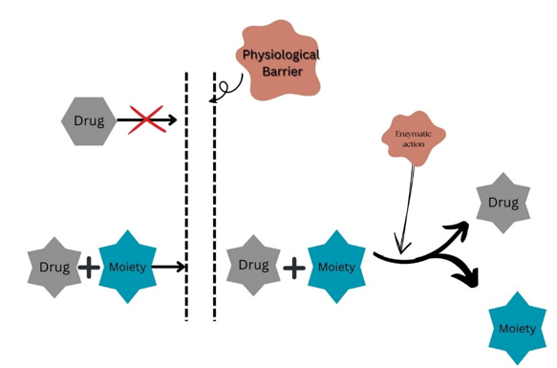

Fig 1: Concept of Prodrug.

Prodrug make use of various tactics. In order to make a prodrug more approachable it is made susceptible to various enzymes by functionalization with a group that can be cleaved to produce active form []. Prodrug have various benefits like it helps in cellular uptake, precursors in biological conversion pathways, increase duration of action of medicines, improves pharmacokinetic properties, etc.
Prodrug-based nanoparticle is the encapsulation of therapeutics within nanocarriers that helps in improving the kinetics as well as therapeutic efficacy of the drug. It is challenging at the same time has potential in the near future to overcome issues related to oncology and other areas. The development of nanotechnology has had a substantial influence on medication delivery during the past ten years. It focuses on developing nanoscale particles in order to improve the medication delivery [-].

In this chapter we will be focussing on prodrug-based nanoparticulate drug delivery strategy in combination cancer therapy as prodrug-mediated and nanomedicine-mediated treatments stand at the forefront of cancer management these days. In view of the fast development of anti-cancer strategy, this chapter focuses on the most recent advances of prodrug-based nanoparticle drug delivery systems for anti-cancer therapies resulting in enhanced chemotherapeutic efficiency, overcoming the multi drug resistance (MDR) and hindering metastasis.
Cancer is a complex disease in which some of the body’s cells grow uncontrollably and spread to other parts of the body [3]. Cancer is also one of the principal causes of death in developed countries as both the incidence and mortality of cancers are rising unceasingly. Even though a hefty amount of compelling chemotherapeutical anticancer agents has been used successfully in clinical rehearsal, no significant improvement has been seen in cancer treatment. This is due to the absence of selectivity against cancer cells as well as the toxic side effects associated with the drug []. Nanomedicine is well-defined as the therapeutic application of nanotechnology, denoting a multi-disciplinary field of nanotechnology, medicine, chemistry and material science. Though emerged recently, this field has exhibited dynamic vitality associating the hasty development of nanotechnology. A broad range of nanomedicines has been developed for various medical applications, especially for anti-cancers; cancer being one of the lethal killers to human beings [].
In the war against cancer, there has been three major concerns leading to high rate of mortality and reappearance: the severe toxic side effect of anti-cancer drugs to normal tissues due to the absence of tumour-selectivity; the multi-drug resistance to free chemotherapeutic drugs and the deadly metastases of cancer cells. The advancement of state-of-art prodrug-based nanoparticle drug delivery systems (PNDDS) is anticipated to overcome these obstacles. A distinctive characteristic of prodrug-based nanomedicines is that they need to be activated by a stimulus or multi-stimulus to produce an anti-tumour effect. A better understanding of various responsive approaches could aid researchers in perceiving the mechanism of prodrug-based nanomedicines efficiently and further improve their design strategy. In addition, the current development and future challenges of prodrug-based nanomedicines has been discussed which could helper readers to understand the structure and development of prodrug-based cancer nanomedicines to design rational and effective drugs for clinical use.

- BENEFITS OF PRODRUG

The prodrug strategy can be tailor made by fine-tuning the chemical properties of a compound, one can accomplish a diversity of properties including aiding the process of formulation, optimizing bioavailability as well as developing innovative intellectual property. Products promoted nowadays are typically envisioned to have the following advantages as (a) Improved formulation properties which aids to mask functional groups, enable formulation of nanoparticle, control solubility and modify steric properties; (b) customizable pharmacokinetic (PK) properties which aids to customize the route of administration, improve bioavailability, tune absorption profiles, increase membrane permeability, tailor uptake of cell, control binding of protein, allow blood-brain-barrier permeation as well as refine distribution, excretion and half-life; (c) optimizable pharmodynamics (PD) effects include optimizing metabolic stability, prevent metabolic activation, permit intracellular conversion as well as embrace bacteria-labile linker chemistry; (d) toxicity reduction by minimizing side-effects, controlling the release of cytokine, avoiding interactions with off-target receptor, improving liver metabolism; and (e) rationalizing the process of development by providing simplified regulatory pathway, reduction in development costs, extending intellectual property coverage and enhanced stability [, ]. A schematic diagram has been presented below (Figure 2) to show the advantages of nanoparticle-based prodrug.

Fig 2: Image showing benefits of prodrug.

- CANCER TREATMENT

The field nanomedicines have highly progressed leading to emergence of new drugs as a result of rapid development of nanotechnology, but the effective delivery of drugs to tumour sites remains a great challenge. Prodrug-based cancer nanomedicines thus developed owing to their exclusive advantages including reduced side effects, efficient targeting, high drug load efficiency and real-time controllability [].

- CHALLENGES

To act as a prodrug there are certain ideal properties like appropriate aqueous solubility, stability to reach target site in the host, passive permeability, effective conversion, minimal non-productive pathways, a safe profile to avoid inhibition of drug-metabolizing enzymes, better targeting-fewer side effects, etc. Hence it is difficult and challenging to get all these criteria in one prodrug. Despite the benefits that nanoparticle technology can provide, the rate of clinical translation that is effective is still modest []. It faces problems like unfavorable loading and leakage. The few challenges that are faced to develop a new prodrug are listed below (Figure 4).
As reported in one of the studies that the widely used chemotherapeutic agent cisplatin, and other approved platinum (II) agents have failed despite numerous attempts [11]. At different clinical trials the development of Ormaplatin (Tetraplatin, NSC 363812), a platinum (IV) complex, Iproplatin, a platinum (IV) complex structurally similar to ormaplatin and Satraplatin, a platinum-based antineoplastic agent was halted due to unpredictable neurotoxicity, failure to show activity, unfavorable PK and premature reduction to the active compound respectively [-]. There are few more examples related to this. In order to increase efficacy and lessen side effects, nanoparticle-based drug delivery systems have the ability to change the PK properties of their APIs, which may include a longer half-life and higher distribution to the site of action.
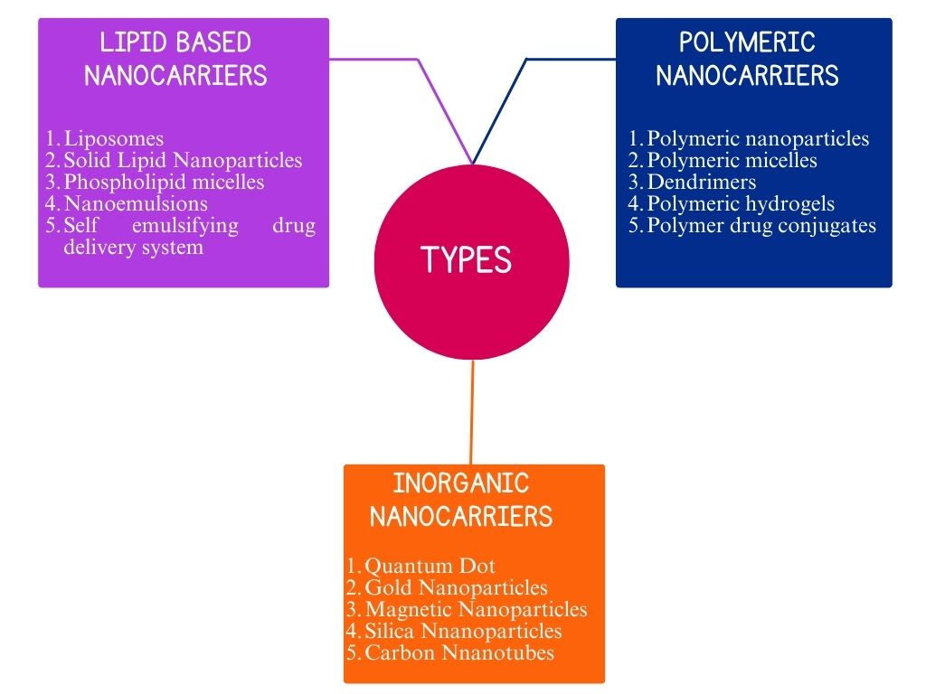

Fig 3: Summary of the types of Nanoparticles based Drug delivery system [15].

With the advancement of the use of prodrug-based nanoparticles in providing effective medications for various diseases, it still requires the crucial use of computational techniques such as ab initio, DFT, semi-empirical, and molecular mechanics approaches, as well as x-ray and spectroscopic data on enzymes and transporters, to produce drugs with high bioavailability. Also, care needs to be taken to avoid changes in both physical and biochemical properties of the prodrug.

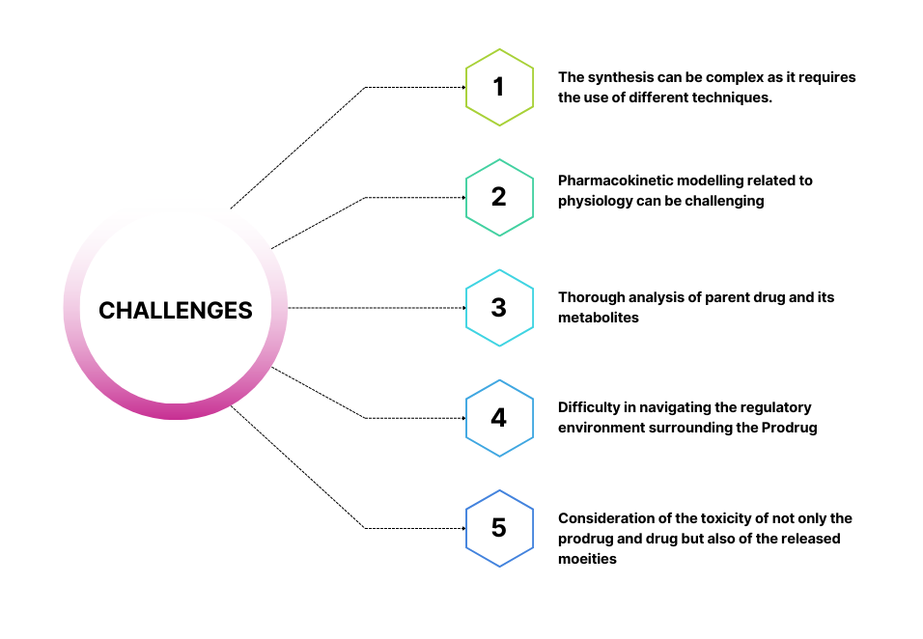
Fig 4: Mind map showing certain challenges to develop prodrug

- FUTURE PROSPECTS

To enhance nanomedicine and find novel treatments for hard-to-treat conditions, prodrug-based nanoparticle drug delivery systems (PNDDS) have been investigated []. The prodrug strategy has shown to be extremely effective over the previous few years. They were traditionally prepared as a strategy to solve problems of poor clinical outcomes like presence of certain functional groups that leads to toxicity or inappropriate bioavailability etc. but more recently, they are used as an agent to enhance the use of drugs in clinic and has great scope to play an important role in anticancer therapy []. From various studies prodrug which are thought to have future like Aldoxorubicin, Baloxavirmarboxil, Evofosfamide, Fostemsavir, Pomaglutadmethionil, etc with the therapeutics they can be used are listed in table 1. Prodrugs are thought to make up about 10% of all commercially available drugs including both small molecular weight and large molecular weight and has a scope to grow further.

Table 1: Prodrugs with future prospects

Name of the prodrug | Therapeutic for
Aldoxorubicin | Sarcoma
Baloxavirmarboxil | Influenza Type A and B
Evofosfamide | Pancreatic Cancer
Fostemsavir | HIV- 1
Pomaglumetadmethionil | Schizophrenia
Source: Najjar and Karaman []

- CONCLUSION

Prodrug modifications may now be used to get drug-like qualities, speeding up the process of obtaining clinical proof of concept. This is due to the greater understanding that drug-like features can be engineered into a molecule at an early stage. Although there are some challenges, but if researchers explore more and take advantage of computational drug discovery and design then it would lead to a larger nanoparticle-based prodrug therapeutic market in the near future. It will further help to cure certain chronic diseases. It could be able to address the problems with conventional medicine.

REFERENCES

[] J. Rautio, H. Kumpulainen, T. Heimbach, R. Oliyai, D. Oh, T. Järvinen and J. Savolainen, “Prodrugs: design and clinical applications,” Nat. Rev. Drug Discov, 2008, 7(3), 255-270.
[] P.W. Hsieh, C.F. Hung and J.Y. Fang, “Current prodrug design for drug discovery,” Curr. Pharm. Des. 2009, 15(19), 2236-50.
[] J. Rautio, N.A. Meanwell, L. Di and M.J. Hageman, “The expanding role of prodrugs in contemporary drug design and development”, Nat. Rev. Drug Discov, 2018, 17(8), 559-587.
[] N. Das, M. Dhanawat, B. Dash, R.C. Nagarwal and S.K. Shrivastava, “Codrug: An efficient approach for drug optimization,” Eur. J. Pharm. Sci., 2010, 41(5), 571-588.
[] A. Najjar and R. Karaman, “The prodrug approach in the era of drug design,” Expert Opin. Drug Deliv., 2019, 16(1), pp.1-5.
[] M.E. Davis, Z.G. Chen and D.M. Shin, “Nanoparticle therapeutics: an emerging treatment modality for cancer,” Nat. Rev. Drug Discov., 2008, 7(9), 771–782.
[] R.A. Petros and J.M. DeSimone, “Strategies in the design of nanoparticles for therapeutic applications,” Nat. Rev. Drug Discov., 2010, 9(8), 615–627
[] L. Zhang, F.X. Gu, J.M. Chan, A.Z. Wang, R.S. Langer and O.C. Farokhzad, “Nanoparticles in medicine: therapeutic applications and developments,” Clin. Pharmacol. Ther., 2008, 83(5), 761–769.
[] R. Mahato, W. Tai, K. Cheng, Prodrugs for improving tumor targetability and efficiency, Adv. Drug Deliv. Rev. 63 (2011) 659–670
[] F. Zahednezhad, P. Zakeri-Milani, J. Shahbazi Mojarrad and H. Valizadeh, “The latest advances of cisplatin liposomal formulations: essentials for preparation and analysis,” Expert Opin. Drug Deliv., 2020, 17(4), 523-541.
[] R. Karaman, Prodrugs design based on inter- and intramolecular chemical processes, Chem. Biol. Drug Des. 82 (2013) 643–668
[] K.J. Chen, A.J. Plaunt, F.G. Leifer, J.Y. Kang and D. Cipolla, “Recent advances in prodrug-based nanoparticle therapeutics,” Eur. J. Pharm. Biopharm., 2021, 165, 219-243.
[] A. Xie, S. Hanif, J. Ouyang, Z. Tang, N. Kong, N.Y. Kim, B. Qi, D. Patel, B. Shi and W. Tao, “Stimuli-responsive prodrug-based cancer nanomedicine.” EBioMedicine, 56, 2020.
[] F. Zahednezhad, P. Zakeri-Milani, J. Shahbazi Mojarrad and H. Valizadeh, “The latest advances of cisplatin liposomal formulations: essentials for preparation and analysis,” Expert Opin. Drug Deliv., 2020, 17(4), 523-541.
[] R.J. Schilder, F.P. LaCreta, R.P. Perez, S.W. Johnson, J.M. Brennan, A. Rogatko, S. Nash, C. McAleer, T.C. Hamilton, D. Roby and R.C. Young, “Phase I and pharmacokinetic study of ormaplatin (tetraplatin, NSC 363812) administered on a day 1 and day 8 schedule,” Cancer Res., 1994, 54(3), 709-717.
[] J.M. Granfortuna, N. Newman, S.J. Ginsberg, A. Louie, R.L. Comis, J.J. Gullo and B.J. Poiesz, “Phase II study of iproplatin (CHIP) in previously treated small-cell lung cancer,” Am. J. Clin. Oncol., 1989, 12(4), 355-357.
[] R.G. Kenny, S.W. Chuah, A. Crawford and C.J. Marmion, “Platinum (IV) prodrugs–a step closer to Ehrlich's vision?” Eur. J. Inorg. Chem., 2017, 2017(12), 1596-1612.
[] K.J. Chen, A.J. Plaunt, F.G. Leifer, J.Y. Kang and D. Cipolla, “Recent advances in prodrug-based nanoparticle therapeutics,” Eur. J. Pharm. Biopharm., 2021, 165, 219-243.
[] R. van der Meel, E. Sulheim, Y. Shi, F. Kiessling, W.J. Mulder and T. Lammers, “Smart cancer nanomedicine,” Nat. Nanotechnol., 2019, 14(11), 1007-1017.
[] A. Najjar and R. Karaman, “Successes, failures, and future prospects of prodrugs and their clinical impact,” Expert Opin. Drug Discov., 2019, 14(3), 199-220.

