Optimizing Wind Energy: Unleashing the Potential of AI in MPPT and Load Forecasting

Deepak Rathod
Research Scholar, Department of Renewable Energy, Rajasthan Technical University, Kota, Rajasthan Pin – 324010, India.
deepak.phd21@rtu.ac.in

Dr. Lata Gidwani
Associate Professor, Department of Electrical Engineering, Rajasthan Technical University, Kota, Rajasthan, Pin- 324010, India.
lgidwani@rtu.ac.in

Rohan Gupta
Assistant Professor, Department of Electrical and Electronics Engineering, Shri Vaishnav Vidyapeeth Vishwavidyalaya, Indore, Madhya Pradesh
Pin – 453111, India.
rohangupta@svvv.edu.in

ABSTRACT
In the contemporary global context, a significant transformative process is currently unfolding on a global scale. The ongoing revolution is causing a transformation in the lifestyles of individuals, leading to significant disruptions in traditional business structures and established processes. Like many other businesses, the power sector is currently experiencing a significant transformation. The power sector is undergoing transformation due to various factors like the adoption of distributed energy sources, the proliferation of electric vehicles, the implementation of advanced metering and communication infrastructure, the utilization of management algorithms, the implementation of energy efficiency efforts, and the integration of new digital solutions. In recent years, there has been a growing utilization of artificial intelligence approaches to tackle issues related to renewable energy due to its ability to effectively handle intricate nonlinear data structures. The prospective acceleration of worldwide renewable energy adoption in the future through technological advancements. Currently, artificial intelligence (AI) is the primary catalyst for the rapid technological revolution. To fully harness the potential of wind power, it is imperative that wind turbines exhibit optimal efficiency in converting energy. This paper provides a comprehensive examination of AI-based Maximum Power Point Tracking (MPPT) techniques in the context of wind energy systems. The impact of working conditions on yield is noteworthy due to the increasing sophistication of wind energy conversion systems (WECS) in response to unforeseen fluctuations in wind speed conditions. Attaining the optimal yield is frequently a formidable task. MPPT controllers are receiving significant interest due to this phenomenon. This article provides a comprehensive examination of both Artificial Neural Networks (ANN) and Fuzzy Logic (FL) as utilized in the context of Wind Energy Systems (WES). This study elucidates the commonly adopted ways to optimize yield under diverse scenarios. Both Artificial Neural Networks (ANN) and Fuzzy Logic (FL) can be utilized as alternatives to conventional methods for control and optimization purposes. The selection and evaluation of both approaches are dependent on the specific application at hand. Statistical data is provided regarding both the existing methodologies employed in this subject, as well as their potential future advancements. The completion of a comprehensive bibliography, the provision of proposals for further research, and the emergence of other issues have transpired. Ultimately, this platform holds potential value for future research in wind power systems, serving as a valuable resource for scholars, energy planners, and lawmakers.

Keywords— Neural Networks, Soft Computing, Intelligent Control fuzzy logic systems of types 1 and 2, respectively.

ABBREVIATIONS

AI | Artificial Intelligence
ANN | Artificial Neural Networks
FL | Fuzzy Logic
MPPT | Maximum Power Point Tracking
WECS | Wind Energy Conversion Systems

INTRODUCTION

The global energy demand is projected to experience rapid growth. Regarding the phenomena of rapid industrialization, rapid population rise, and social development [1], [2]. Indeed, electrical energy plays a crucial role in contemporary society and is intricately linked to the functioning of modern industries. There is now a competition underway to develop a new generation of power. As a result of the escalating energy demand and the consequential environmental repercussions associated with traditional energy sources, the energy sector has been urged to expedite research efforts pertaining to alternative energy sources. The wind energy sector is highly promising and profitable, yet it necessitates advancements in technology and financial resources. Efforts pertaining to technology are focused on effectively using the power of wind [3]. Hence, MPPT algorithms can be employed to extract the maximum power under different wind speed situations. The structure of an MPPT approach basically comprises two fundamental components. During the initial stage, an algorithm is employed to identify the set point that exhibits the highest power. The generation of the control signal is accomplished in the second part through the use of diverse control techniques. Hence, the enhancement of the efficiency of each component will enable the development of an effective Maximum Power Point Tracking (MPPT) technique [4]. Several scholars have documented various MPPT control techniques for wind energy systems in the literature. These methods encompass tip speed ratio [5], power-signal feedback [6], optimal torque control [7], and hill-climbing search [8], along with their respective variations [9], [10], to tackle the aforementioned issues. The efficacy of these procedures in locating the Maximum Power Point (MPP) may be compromised due to the inherent unpredictability of environmental variables. The effectiveness of wind energy conversion systems (WECS) has been enhanced in many studies by the application of soft computing and artificial intelligence (AI) techniques. Several researchers have created a variety of methods utilizing AI tools to effectively address complex systems and accurately depict increased levels of uncertainty. The maximum power point tracking (MPPT) problem can be effectively addressed through the utilization of artificial intelligence (AI) techniques, which offer adaptability and computing intensity [11], [12]. Indeed, artificial intelligence has the potential to enhance the efficiency and cost-effectiveness of WES operations. The utilization of AI technology in wind energy systems (WES) has the potential to optimize power output, reduce maintenance costs, enhance energy yield, and improve system stability and reliability. The field of artificial intelligence aims to gain an understanding of human cognition in order to create intelligent entities capable of effectively addressing complex problems [13]. Artificial intelligence finds applications in a wide range of domains, including but not limited to information retrieval, databases, medical science, business, robotics, and art. Various learning theories, including neural learning, statistical learning, and evolutionary learning, constitute the fundamental basis of artificial intelligence (AI) [14], [15]. This essay will primarily focus on the efficacy and use of artificial intelligence (AI) in the domain of wind energy system optimal control. This paper makes a significant contribution by conducting a comprehensive and detailed investigation of Maximum Power Point Tracking (MPPT) systems that are based on Artificial Intelligence (AI). Artificial Neural Networks (ANNs) and Fuzzy Logic Controllers (FLCs) are widely recognized as the two primary artificial intelligence techniques employed for Maximum Power Point Tracking (MPPT). These methods are visually represented in Figure 1. Furthermore, neural learning emerges as the predominant method employed across several industries [16].
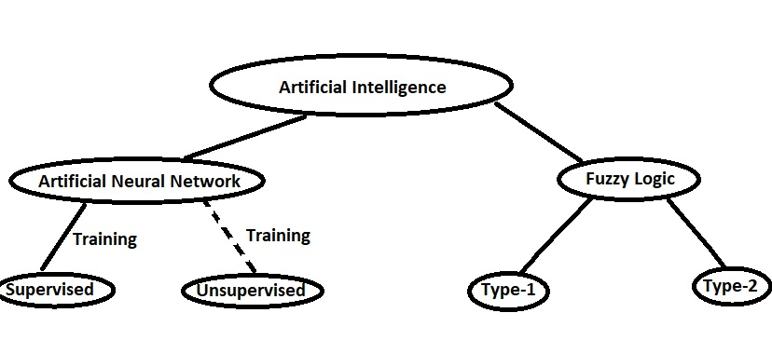
Figure 1: MPPT strategies based on artificial intelligence.

The sophisticated artificial neural networks (ANNs) are constructed using organic neurons as their foundation. These structures offer a viable resolution for issues that are not amenable to analytical solutions [3]. An artificial neural network (ANN) is comprised of individual computational units referred to as neurons, which are interconnected by weighted connections. Figure 2 presents a comprehensive depiction of the structure of the Artificial Neural Network (ANN). There are four primary attributes that can be employed to differentiate an Artificial Neural Network (ANN) from other models: the information display, input and output data linkages, training methodology, topology, and training strategy. Upon receiving a dataset and commencing the training phase, the artificial neural network (ANN) proceeds to adjust the weights associated with the connections between its constituent neurons. The training process can be classified as supervised training when the output is predetermined, whereas it is categorised as unsupervised training when the result is not known [3], [17] (see Figure 1). Furthermore, Zadeh made the inaugural introduction of fuzzy logic, also known as FL, in 1975 [18]. A Fuzzy Logic Controller (FLC) is a specific type of control system that utilizes Fuzzy Logic (FL) to determine the most suitable control action. A fuzzy logic controller (FLC) has the capability to effectively govern the operational dynamics of a wind turbine within the domain of wind energy. The controller utilizes fuzzy logic methods to determine the optimal control action, which may involve adjusting the generator torque or speed, as well as the blade pitch or yaw angle, in order to improve power generation. The controller receives data from many sensors installed on the turbine, including measurements of wind speed and direction. FLCs can also be employed for the purpose of predicting and overseeing the operations of wind farms. A Fuzzy Logic Controller (FLC) is comprised of three fundamental elements: a defuzzification module, an inference engine, and a fuzzification module (19). Figure 3 illustrates the essential construction of a Fuzzy Logic Controller (FLC). A fuzzy logic controller (FLC) utilizes a series of rules to process the input variables and generate the output of the controller. In contrast to precise numerical values, linguistic expressions such as "low," "medium," and "high" are commonly employed to delineate regulatory measures. This feature allows the controller to consider a spectrum of values instead of a singular value for each input and output. In this review, we will focus on the correct functioning and potential utility of fuzzy logic in certain domains such as classification, control, and pattern recognition. Specifically, we will explore its application in tasks such as wind turbine optimal control. Type-2 fuzzy logic, an expanded version or extension of type-1 fuzzy logic, enables the representation of imprecision to a significant extent [20]. This paper begins with a concise introduction, followed by a section that explores the application of artificial intelligence in the context of forecasting. This section presents various methodologies for forecasting in Photovoltaic (PV) systems and wind energy systems. The subsequent step involves the utilization of artificial intelligence in the process of maximum power point tracking. This section also encompasses an examination of diverse machine-learning strategies that have been put out by multiple writers. The subsequent section pertains to inverters and the many artificial intelligence systems that have been developed to tackle distinct challenges associated with inverter systems. The concluding section provides an overview of the advantages and obstacles associated with the integration of artificial intelligence into renewable energy systems.
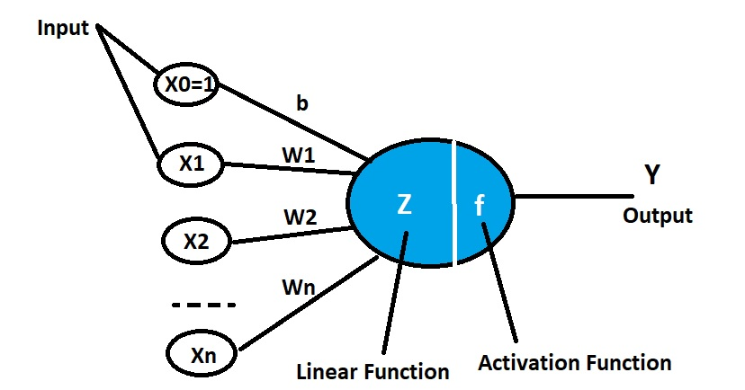

Figure 2: Structure of a biological neuron vs artificial neuron

.
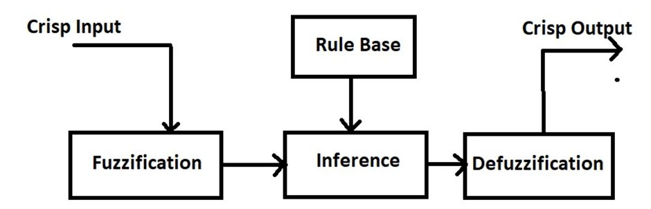

Figure 3: A basic structure of a FLC

WIND PREDICTION

The production of power in wind energy systems differs from standard thermal generation systems due to the stochastic nature of wind supply. The primary objective of forecasting in wind generation systems is to address the challenge of effectively managing the discrepancy between power generation and demand within the power system. The prevailing approach utilized in studies for wind forecasting is the neural network, namely the multi-layer perceptron. Multi-layer perceptrons are commonly advocated as the neural network designs of choice for short-term wind speed predictions. The concept of recurrent neural networks was introduced by Elman et al. To enhance their performance, a simultaneous recurrent neural network represented by particle swarm optimization was suggested [21]. The adaptive neural fuzzy system model (ANFIS) is a hybrid approach that combines two artificial intelligence techniques, namely artificial neural networks (ANN) and fuzzy logic. The utilization of fuzzy logic models is employed in cases where a significant amount of effort is required to determine the characteristics of a system and develop an accurate model. The Bayesian technique is also utilized in the prediction of wind speed. Fuzzy logic-based models are being developed at the wind farm to anticipate wind speed and power generation. Typically, the training of these models involves the utilization of genetic algorithms as a learning mechanism. The efficacy of short-term forecasting has witnessed notable advancements, progressing from minute-scale to hour-scale predictions. The primary drawbacks of these models are their substantial computational demands and the presence of multiple fuzzy rule bases.

MAXIMUM POWER POINT TRACKING

Maximum In order to provide an ideal duty cycle, maximum power point tracking (MPPT) uses a control system with an appropriate algorithm. To maximize power extraction from the photovoltaic (PV) array, the power DC-DC converter uses a duty cycle. A number of problems arise while developing the best maximum power point tracking (MPPT) method for photovoltaic (PV) systems, including issues with efficiency, an increase in overall cost, energy loss, implementation difficulties, and design-specific constraints. For solar systems, a number of MPPT techniques have been developed, including perturbation and observation (P&O) [23], hill climbing [25], and incremental conductance [24]. Fuzzy logic is a novel methodology that outperforms traditional approaches in terms of response time and reduced oscillations at the maximum power point. When faced with fluctuating irradiance data, these approaches are, nevertheless, prone to drift problems [22]. The chosen input parameters for the maximum power point tracking (MPPT) method based on artificial neural networks in photovoltaic (PV) systems take a variety of things into account. These variables include the module temperature, solar irradiance incidence on the module, wind speed, short circuit current, open circuit voltage, output current, terminal voltage, and environmental or ambient variables. These parameters enter the neural network model's input layer and then travel via the hidden layer and onto the output layer. The estimated duty cycle of the DC-DC converter, which is required for keeping track of the maximum power point, is produced by the output layer. In order to create a mapping between the input and output, neurons' weights are altered throughout training. System complexity, data accessibility, and processing requirements are just a few of the criteria that have a big impact on how many input variables and nodes are chosen. The effectiveness and accuracy of a neural network-driven method the design and implementation of the algorithm within the hidden layers will determine the maximum power point tracker [26]. Many proposed artificial neural network-based MPPT controllers use a feed-forward-back propagation technique to train their models. To make it easier to modify the weight connection, this kind of artificial neural network (ANN) transmits information in both forward and backward directions in a bidirectional manner. The hidden layer receives a variety of input sets with varying weight magnitudes, and the output layer ultimately receives the result. A backpropagation network is used, which uses a gradient descent method to alter the weights between each layer, in order to reduce the discrepancy between the observed and anticipated outcomes of the Artificial Neural Network (ANN) model [27], [28], and [29]. It has been discovered that the observed maximum power point tracking (MPPT) control system and the fuzzy logic-based perturbation both perform better in solar photovoltaic (PV) systems. A DC-DC converter is used to transmit the power produced by the photovoltaic system to the load. The recorded values of the photovoltaic (PV) panel current and voltage are used by the fuzzy logic-based maximum power point tracking (MPPT) control system to precisely track the maximum power point. Using measurements of current and voltage collected from the photovoltaic (PV) panel, a control system based on fuzzy logic determines the necessary voltage adjustment to achieve maximum power output. By altering the duty cycle of the DC-DC converter, it is possible to estimate the new operating voltage for the PV panel in the P&O maximum power point tracking (MPPT) system [30]. The assessment of the inference rule basis, which can be derived by a process of trial and error, establishes the fundamental basis of the fuzzy logic MPPT controller [31]. By using a set of rules to obtain perturbed voltage and taking power fluctuations and power variations in respect to voltage into account as input factors, fuzzy logic is developed. Fuzzy logic-based maximum power point tracking (MPPT) approaches have the advantage of not requiring perfect knowledge of the photovoltaic (PV) module parameters or accurate system modeling in order to function [32]. In contrast to the traditional fuzzy logic-based maximum power point tracking (MPPT) technique, the development of fractional order fuzzy logic (FOFLC) aims to improve control capabilities. According to earlier research [33], the FOFLC approach is intended to speed up MPPT procedures and minimize any potential deviation from the maximum power point.
A thorough summary of research studies using the Artificial Neural Network (ANN) technique for the Maximum Power Point Tracking (MPPT) unit is provided in Table I. Artificial neural networks (ANNs) have been empirically demonstrated to be advantageous in a number of fields, demonstrating its usefulness in a variety of applications. In hybrid systems, ANNs can also be successfully used with other approaches, increasing their total effectiveness and impact.

Table 1: A Brief Description of Some of The Literature’s Applicable ANN-MPPT

Reference /year | Type of Controller | Objective
copy | More table copy
[17] / 2022 | RBFNN | A RBFNN tracker provides a quick and easy way to improve WECS performance.
[9] / 2021 | ANN | A smart-sensor-free controller that uses ANN to better track the ideal torque for WECS
[36]/ 2021 | Type 2 FLC | Integrated a resilient type-2 interval FLC into WECS
[35]/ 2019 | RBFNN | Enhanced MPPT based on RBFNN using gradient descent and modified PSO algorithm
[34]/ 2012 | Type 2 FLC/GA | Designed an interval type-2 FLC using GA for DC motor velocity control

CHALLENGES AND FUTURE DIRECTIONS

The output of the wind system is substantially affected by its environment. This results in fluctuating output yield. Without an MPPT controller, wind systems cannot generate the maximum amount of energy feasible. Finding the MPPT techniques with the smallest amount of tracking error, the quickest performance, and the smallest amount of oscillation around the MMP is a crucial criterion for choosing the best MPPT techniques [11]. Therefore, the primary objectives of an MPPT are velocity, accuracy, durability, and accuracy. Consequently, artificial intelligence (AI) optimization techniques may be regarded as superior to conventional methods. Adjusting AI-based techniques, such as ANN, in order to generate the optimal MPP requires substantial effort. In addition, before ANN can be utilized in the MPPT control device, it must be properly trained with a large number of measurements to guarantee accurate results. In addition, FL controllers depend on rule-based development and membership operations. There is no accepted method for precisely defining controller parameters [11]. The AI algorithms are more complex and effective at monitoring than conventional ones. The adaptability and versatility of these technologies to address nonlinear problems are, in fact, their primary advantages [11, 17]. Neural networks have disadvantages in real-world applications, including the size of the required inputs, extrapolation errors, overtraining of the networks, and network optimization difficulties [3, 17]. Fuzzy controllers can robustly manage nonlinear situations and do not require system-specific data, but their design is typically based on trial and error [4]. Productivity and efficiency are the two most important aspects of a successful system in the Industrial Revolution, and research and investment are focused on technology and the environment. Thus, the fourth industrial revolution relies significantly on AI, and numerous machine-learning approaches have undergone substantial development. Currently, the systems will be accountable, secure, and enduring.

CONCLUSION

This study examines the utilization of machine learning in several domains of the renewable energy system, while also assessing the potential advantages and challenges associated with its implementation. Machine learning presents a robust and adaptive framework for predictive analysis, exhibiting a high degree of precision, contingent upon the absence of any inherent biases. A multitude of research has provided evidence that the utilization of a precise model can lead to the improvement of load balancing in renewable energy systems. Consequently, this enhancement contributes to the augmentation of the desired integration of renewable energy sources within power networks. Machine learning has the potential to be employed in maximum power point tracking systems, offering notable advantages such as increased resilience to input noise and improved operational efficiency. Hybrid systems that incorporate both machine learning and conventional methods have been developed to achieve optimal power point tracking. Furthermore, machine learning has the potential to address many challenges in inverters, enabling them to deliver consistent output power in the presence of intermittent renewable energy sources. The substantial concern arises from the increasing expenses associated with machine learning systems, mostly attributable to the necessity of employing specialized computational gear. The execution of operations related to data preprocessing and data purification can result in substantial additional costs. Furthermore, it is worth noting that machine learning is prone to bias, a factor that has the potential to significantly undermine the effectiveness of entire models. Therefore, it can be argued that the careful design and implementation of machine learning is necessary. It is also worth noting that by utilizing an appropriate machine learning model, several challenges related to renewable energy systems can be effectively addressed. The primary significance of this study is in its provision of a comprehensive examination of the diverse domains in which artificial intelligence has been implemented. Consequently, it facilitates a comprehensive comprehension of the manifold advantages that different domains derive from the utilization of AI. This paper serves as a first reference for individuals seeking to delve deeper into the study of artificial intelligence within the context of renewable energy systems. In subsequent investigations, further exploration can be undertaken on a diverse range of topics pertaining to renewable energy systems, including the phenomenon of battery degradation. Furthermore, further investigation is necessary to explore the diverse concerns that can be addressed by the implementation of artificial intelligence.

REFERENCES

- R.-E. Precup, T. Kamal, and S. Z. Hassan, Advanced control and optimization paradigms for wind energy systems. Springer, 2019.
- M. Farooq, A. Ramli, and A. Naeem, “Biodiesel production from low ffa waste cooking oil using heterogeneous catalyst derived from chicken bones,” Renewable Energy, vol. 76, pp. 362–368, 2015.
- A. P. Marugan, F. P. G. M ´ arquez, J. M. P. Perez, and D. Ruiz-Hern ´ andez, ´ “A survey of artificial neural network in wind energy systems,” Applied energy, vol. 228, pp. 1822–1836, 2018.
- S. Ganjefar, A. A. Ghassemi, and M. M. Ahmadi, “Improving efficiency of two-type maximum power point tracking methods of tip-speed ratio and optimum torque in wind turbine system using a quantum neural network,” Energy, vol. 67, pp. 444–453, 2014.
- S. Eriksson, J. Kjellin, and H. Bernhoff, “Tip speed ratio control of a 200 kw vawt with synchronous generator and variable dc voltage,” Energy Science & Engineering, vol. 1, no. 3, pp. 135–143, 2013.
- D. Kumar and K. Chatterjee, “A review of conventional and advanced mppt algorithms for wind energy systems,” Renewable and sustainable energy reviews, vol. 55, pp. 957–970, 2016.
- M. Yin, W. Li, C. Y. Chung, L. Zhou, Z. Chen, and Y. Zou, “Optimal torque control based on effective tracking range for maximum power point tracking of wind turbines under varying wind conditions,” IET Renewable power generation, vol. 11, no. 4, pp. 501–510, 2017.
- S. Lalouni, D. Rekioua, K. Idjdarene, and A. Tounzi, “Maximum power point tracking based hybrid hill-climb search method applied to wind energy conversion system,” Electric Power Components and Systems, vol. 43, no. 8-10, pp. 1028–1038, 2015.
- D. Belkhiri and M. R. E. M. Alaoui, “Improved tracking of optimal torque by artificial neural network for wind energy systems,” International Review on Modelling and Simulations (IREMOS), vol. 14, no. 2, 2021.
- B. Driss, S. Farhat, K. Abdelilah, and E. M. A. M. Rachid, “Adaptive control for variable-speed wind generation systems using advanced rbf neural network,” in 2020 1st International Conference on Innovative Research in Applied Science, Engineering and Technology (IRASET). IEEE, 2020, pp. 1–5.
- A. O. Baba, G. Liu, and X. Chen, “Classification and evaluation review of maximum power point tracking methods,” Sustainable Futures, vol. 2, p. 100020, 2020.
- M. Seyedmahmoudian, B. Horan, T. K. Soon, R. Rahmani, A. M. T. Oo, S. Mekhilef, and A. Stojcevski, “State of the art artificial intelligencebased mppt techniques for mitigating partial shading effects on pv systems–a review,” Renewable and Sustainable Energy Reviews, vol. 64, pp. 435–455, 2016.
- R. S. Michalski, J. G. Carbonell, and T. M. Mitchell, Machine learning: An artificial intelligence approach. Springer Science & Business Media, 2013.
- S. R. P. Norvig, “Artificial intelligence: A modern approach 3rd ed,” Harlow Pearson Education, 2016.
- D. L. Poole and A. K. Mackworth, Artificial Intelligence: foundations of computational agents. Cambridge University Press, 2010.
- S. K. Jha, J. Bilalovic, A. Jha, N. Patel, and H. Zhang, “Renewable energy: Present research and future scope of artificial intelligence,” Renewable and Sustainable Energy Reviews, vol. 77, pp. 297–317, 2017.
- D. Belkhiri, L. Elmahni, and M. R. E. M. Alaoui, “Intelligent controller for maximum power extraction of wind generation systems using ann,” International Journal of Nonlinear Sciences and Numerical Simulation, 2022. [Online]. Available: https://doi.org/10.1515/ijnsns-2021-0198.
- [18] E. H. Mamdani, “Advances in the linguistic synthesis of fuzzy controllers,” International Journal of Man-Machine Studies, vol. 8, no. 6, pp. 669–678, 1976.
- S. Subiyanto, A. Mohamed, and M. Hannan, “Intelligent maximum power point tracking for pv system using hopfield neural network optimized fuzzy logic controller,” Energy and Buildings, vol. 51, pp. 29–38, 2012.
- K. Mittal, A. Jain, K. S. Vaisla, O. Castillo, and J. Kacprzyk, “A comprehensive review on type 2 fuzzy logic applications: Past, present and future,” Engineering Applications of Artificial Intelligence, vol. 95, p. 103916, 2020.
- A. M. Foley, P. G. Leahy, A. Marvuglia, and E. J. McKeogh, “Current methods and advances in forecasting of wind power generation,” Renewable Energy. 2012.
- S. D. Al-Majidi, M. F. Abbod, and H. S. Al-Raweshidy, “A novel maximum power point tracking technique based on fuzzy logic for photovoltaic systems,” Int. J. Hydrogen Energy, 2018.
- Jaipal and T. Ramesh, “Solar Powered Based Water Pumping System Using Perturb and Observation MPPT Technique,” in 2018 IEEE International Students’ Conference on Electrical, Electronics and Computer Science, SCEECS 2018, 2018.
- N. Kumar, I. Hussain, B. Singh, and B. K. Panigrahi, “Self-Adaptive Incremental Conductance Algorithm for Swift and Ripple-Free Maximum Power Harvesting from PV Array,” IEEE Trans. Ind. Informatics, 2018.
- M. Karabacak, L. M. Fernandez-Ramirez, T. Kamal, and S. Kamal, “A new hill climbing maximum power tracking control for wind turbines with inertial effect compensation,” IEEE Trans. Ind. Electron., 2019.
- M. Seyedmahmoudian et al., “State of the art artificial intelligencebased MPPT techniques for mitigating partial shading effects on PV systems – A review,” Renewable and Sustainable Energy Reviews. 2016.
- Syafaruddin, E. Karatepe, and T. Hiyama, “Artificial neural networkpolar coordinated fuzzy controller based maximum power point tracking control under partially shaded conditions,” IET Renew. Power Gener., 2009.
- S. J. Chiang, K. T. Chang, and C. Y. Yen, “Residential photovoltaic energy storage system,” IEEE Trans. Ind. Electron., 1998.
- M. M. Atiqur Rahman and A. H. M. A. Rahim, “An efficient wind speed sensor-less MPPT controller using artificial neural network,” in 2015 International Conference on Green Energy and Technology, ICGET 2015, 2015.
- C. S. Chim, P. Neelakantan, H. P. Yoong, and K. T. K. Teo, “Fuzzy logic based MPPT for photovoltaic modules influenced by solar irradiation and cell temperature,” in Proceedings - 2011 UKSim 13th International Conference on Modelling and Simulation, UKSim 2011, 2011.
- S. Padmanaban, N. Priyadarshi, M. Sagar Bhaskar, J. B. HolmNielsen, V. K. Ramachandaramurthy, and E. Hossain, “A Hybrid ANFIS-ABC Based MPPT Controller for PV System With AntiIslanding Grid Protection: Experimental Realization,” IEEE Access, 2019.
- F. Keyrouz, “Enhanced Bayesian Based MPPT Controller for PV Systems,” IEEE Power Energy Technol. Syst. J., 2018.
- S. Tang, Y. Sun, Y. Chen, Y. Zhao, Y. Yang, and W. Szeto, “An Enhanced MPPT Method Combining Fractional-Order and Fuzzy Logic Control,” IEEE J. Photovoltaics, 2017
- Y. Maldonado and O. Castillo, “Genetic design of an interval type-2 fuzzy controller for velocity regulation in a dc motor,” International Journal of Advanced Robotic Systems, vol. 9, no. 5, p. 204, 2012.
- R. Sitharthan, T. Parthasarathy, S. Sheeba Rani, and K. Ramya, “An improved radial basis function neural network control strategy-based maximum power point tracking controller for wind power generation system,” Transactions of the Institute of Measurement and Control, vol. 41, no. 11, pp. 3158–3170, 2019.
- A. V. Hemeyine, A. Abbou, A. Bakouri, M. Mokhlis, and S. M. o. M. El Moustapha, “A robust interval type-2 fuzzy logic controller forvariable speed wind turbines based on a doubly fed induction generator,” Inventions, vol. 6, no. 2, p. 21, 2021.

