**Comparative Analysis of Mathematical Models for Non-Newtonian Stress Relaxation Flow of Blood through an Artery with Multiple Stenosis**

Goutam Dasa, Bhawna Agrawalb and Sanjeet Kumarc

*a ,b Department of Mathematics,* *Rabindranath Tagore University, Bhopal (M.P), India*

[*mailmeatgoutam@gmail.com*](mailto:mailmeatgoutam@gmail.com)*,* [*bhawnakhushiagrawal@gmail.com*](mailto:bhawnakhushiagrawal@gmail.com)

*c Department of Mathematics Lakshmi Narain College of Technology & Science, Bhopal (M.P), India*

[*sanjeetkumarmath@gmail.com*](mailto:sanjeetkumarmath@gmail.com)

**Abstract:** In this research, a mathematical model is created to investigate the stress relaxation flow of blood through a tapered artery with multiple constrictions. The study derives analytical expressions for flux and velocity, considering suitable boundary conditions. The research conducts a quantitative analysis of flux, flow velocity, resistive impedances, and temporal variations in wall shear stress. The axial velocity is graphically presented for various values of the Jeffrey parameter within the narrowed region of the artery.

**Keywords:** Stress relaxation, tapered artery, multiple constrictions, flux, wall shear stress, axial velocity, Jeffrey parameter.

**Introduction:**

Stenosis refers to the abnormal and unnatural growth inside an artery's lumen, which disrupts the flow pattern. Such constricted arteries can block 50%-90% of the area. The mathematical modeling and analysis of arteries with multiple stenoses are highly valuable for Bio-mathematicians and medical scientists, as they explore various characteristics of blood flow. The main goal of this theoretical research is to investigate the mechanics of non-Newtonian blood flow through a tapered artery with multiple stenoses. This investigation is crucial in the field of medical sciences, where precise information about various blood flow parameters is lacking.

There is compelling evidence supporting the significant role of hydrodynamic factors, such as flow resistance, wall shear stress, and apparent viscosity, in the development and progression of arterial stenosis. Recently, numerous theoretical and analytical studies have been conducted on blood flow through tapered arteries with stenosis, with a predominant focus on non-Newtonian blood behavior.

Mathur and Jain (2013) investigated the mathematical modeling of non-Newtonian blood flow through arteries with stenosis, treating blood as a power-law fluid. Their findings revealed that pressure drop and shear stress increase with the size of the stenosis in the chosen non-Newtonian model. Ramesh Babu and Savita (2019) studied the flow of Jeffrey fluid through arteries with multiple stenoses, exploring variations in velocity profiles and volumetric flow rate in different flow regions under various boundary conditions. Halder et al. (2017) conducted studies on both Newtonian and non-Newtonian pulsatile flows through arteries with stenosis. They presented three-dimensional modeling and analysis of blood flow in stenosed arteries to simulate atherosclerosis artery disease under various pulsatile flow scenarios. Sriyab (2020) analyzed the effects of stenotic geometry and non-Newtonian blood behavior in arterial stenosis. Their mathematical model considered several stenosis shapes, such as bell shape and cosine shape, and identified stenosed artery geometry, stenosis length, stenosis thickness, and power law index (in non-Newtonian behavior) as key factors affecting blood flow through the stenosed artery. Shit et al. (2012) conducted mathematical modeling of blood flow through tapered overlapping stenosed arteries with variable viscosity. They observed that hematocrit, magnetic field, and artery shape significantly influenced velocity profiles, pressure gradient, and wall shear stress. Blood's variable viscosity was treated as a porous medium, and they analytically solved the problem using the Frobenius method. Nanda and Bose (2012) investigated a mathematical model for blood flow through narrow arteries with multiple stenoses. They studied rheological parameters, stenosis height, and fluid yield stress, which strongly influenced flow characteristics both qualitatively and quantitatively. Nanda and Mallik (2012) analyzed a non-Newtonian two-phase fluid model for blood flow through arteries under stenotic conditions. They performed large-scale numerical simulations and developed computer codes to study measurable flow variables with physiological significance. Mandal et al. (2007) developed a mathematical model considering blood as a non-Newtonian fluid characterized by the generalized power-law model, blending both shear-thickening and shear-thinning properties. Their model accounted for unsteady flow in stenosed arteries subject to pulsatile pressure gradients arising from the heart's normal functioning. The arterial wall was treated as an elastic cylindrical tube with a stenosis in its lumen.

The main objective of this study is to theoretically investigate the mathematical modeling of non-Newtonian stress relaxation flow of blood through an artery with multiple stenosis. The study focuses on deriving analytical results for flow velocity and flux. These analytical expressions are then utilized to examine the variations in velocity profiles and volumetric flow rate across different flow regions.

**Mathematical model:**

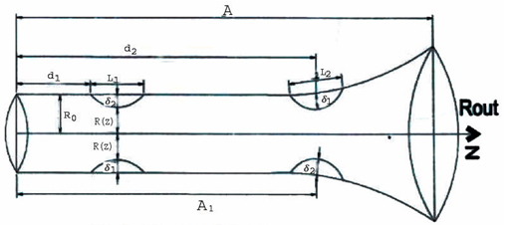

**Figure 1: Physical model of multiple stenosis**

In this scenario, we are examining the steady flow of a Jeffrey fluid through a tube with a non-uniform and cross-sectional shape containing two mild and axially symmetric stenoses. To describe the geometry of the tube, we use a cylindrical polar coordinate system (r, z), where z represents the measurement along the tube axis, and r is perpendicular to the tube's axis.

The radius of the tube is taken as:

and where 

 where 

 where 

 where 

 where 

 where  (1)

Here, lengths of the two stenoses are (where i =1,2) and the maximum thickness of two stenoses are  (where i =1,2) and the restrictions for the mild stenosis are satisfied.





Where 

The basic equation managing the flow is

 (2)

Where is Jeffrey parameter, is the pressure, is the viscosity of the fluid,  is the radius of the tube

The boundary conditions are

 where  (3)

 where  (4)

Presenting following non-dimensional variables:

 (5)

Non-dimensionalising the governing equations after dropping bars:

 (6)

The non-dimensional boundary conditions are:

 where  (7)

 where  (8)

**Solution of the problem:**

**Velocity Distribution:**

Integrating equation (1) by applying boundary conditions (7) and (8) the axial velocity can be obtained as:

 (9)

The volumetric rate of flow is obtained as:

 (10)

**Pressure Difference:**

The pressure difference $∆p$ along the total length of the tube as follows:

 (11)

**Result and Discussion:** We have evaluated the axial velocity as a function of  for various values of the Jeffrey parameterfrom equation (9) in the stenotic regions  and  and shown in the figures (2) and (3). Notably, we observed that the velocity decreases as the Jeffery parameter $μ_{1}$ increases in both stenotic regions.

Furthermore, we computed the volumetric flux in the stenotic region using equation (10) for different Jeffery parameter and its representation is illustrated in figure 4. The curve takes the shape of an inverted parabola, and it is noteworthy that the minimum flux rate occurs at that is midpoint of the stenosis.

Similarly, for the stenotic region, we calculated the volumetric flux for different Jeffery parameters and is shown in the figure (5). In this case, the flux rate decreases with an increase in the Jeffery parameterwithin the stenotic region.

The volumetric flux is calculated for different values of k and is shown in figure (6). It is assuming in the third stenotic region for numerical computation that:

 where 

and .

Here we have seen that flux increases in the value of. The variation of the flow rate for different values of Jeffery parameter in the third stenotic region is shown in the figure (7). Here it is seen that flux decreases as Jeffery parameter increases.

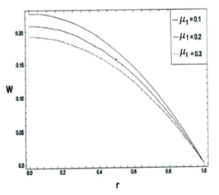

**Figure 2:** Velocity Profiles for different values of Jeffery parameter  in first stenotic region 

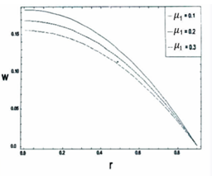

**Figure 3:** Velocity Profiles for different values of Jeffery parameter  in second stenotic region 

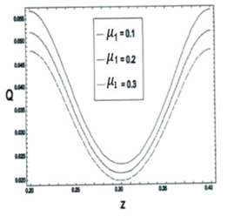

**Figure 4:** Volumetric Flux for different values of Jeffery parameter  in first stenotic region 

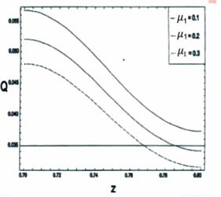

**Figure 5:** Volumetric Flux for different values of Jeffery parameter  in second stenotic region 

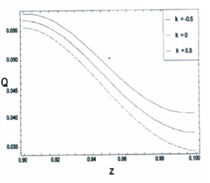

**Figure 6:** Volumetric Flux for different values of  in the third stenotic region 

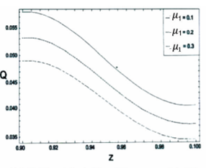

**Figure 7:** Volumetric Flux for different values of Jeffery parameter  in the third stenotic region 

**References:**

1. Chakravarty, S. and Mandal, P.K. (2000), Two-dimensional blood flow through tapered arteries under stenotic conditions, International Journal of Non-Linear Mechanics, vol. 35(5), pp. 779-793.
2. Dash, R.K., Jayaraman, G. and Mehta, K. N.(1999), Flow in a catheterized curved artery with stenosis, Journal of Biomechanics, vol. 32(1), pp. 49–61.
3. Diwakar, C. and Kumar, S. (2016), Effects of axially symmetric stenosis on the blood flow in an artery having mild stenosis, International Journal of Mathematics Trends and Technology, vol. 35(3), pp. 163-167.
4. Halder, P., Husain, A., Zunaid, M. and Samad, A. (2017), Newtonian and non-Newtonian pulsatile flows through an artery with stenosis, The Journal of Engineering Research, vol. 14(2), pp. 191-205.
5. Hye, M.A. and Paul, M.C. (2015), A computational study on spiral blood flow in stenosed arteries with and without an upstream curved section, Applied Mathematical Modelling, vol. 39(16), pp. 4746–4766.
6. Joshi, P., Pathak, A. and Joshi, B. K. (2009), Two-layered model of blood flow through composite stenosed artery, Applications and Applied Mathematics, vol. 4(2), pp. 343-354.
7. Kumar, A. and Awasthi, U. (2010), A mathematical model for blood flow in a multiple stenosis artery, International Journal of Math. Analysis, vol. 4 (50), pp. 2465 – 2472.
8. Kumar, S., Kumar, S. and Kumar, D. (2021), Comparative study of non-Newtonian physiological blood flow through elastic stenotic artery with rigid body stenotic artery, Series on Biomechanics, vol. 34 (4), pp.26-41.
9. Liu,Y. and Liu, W. (2019), Blood ﬂow analysis in tapered stenosed arteries with the inﬂuence of heat and mass transfer, Journal of Applied Mathematics and Computing, vol. 63, pp. 523-541.
10. Mathur, P. and Jain, S. (2013), Mathematical modeling of non-Newtonian blood flow through artery in the presence of stenosis, Advances in Applied Mathematical Biosciences, vol. 4(1), pp. 1-12.
11. Mekheimer, K.S., Haroun, M.H. and Elkot, M.A. (2011), Effects of magnetic ﬁeld, porosity, and wall properties for anisotropically elastic multi-stenosis arteries on blood ﬂow characteristics, Applied Mathematics and Mechanics, vol. 32(3), pp. 1047-1064.
12. Mishra, S., Siddiqui, S.U. and Madhavi, A. (2011), Blood flow through a composite stenosis in an artery with permeable wall, Applications and Applied Mathematics, vol. 6(11), pp. 1798 – 1813.
13. Misra, J.C. and Shit, G.C. (2006), Blood flow through arteries in a pathological state: A theoretical study, International Journal of Engineering Science, vol. 44(10), pp. 662-671.
14. Nanda, S.P. and Bose, R.K. (2012), A mathematical model for blood flow through a narrow artery with multiple stenoses, Journal of Applied Mathematics and Fluid Mechanics, vol. 4(2), pp. 233-242.
15. Nanda, S.P. and Mallik, B.B. (2012), A non-Newtonian two phase fluid model for blood flow through arteries under stenotic condition, International Journal of Pharmacy and Biological Sciences, vol. 2(1), pp. 237-247.
16. Ponalagusamy, R. (2007), Blood Flow through an Artery with Mild Stenosis: A two – layered model, different shapes of stenoses and slip velocity at the wall, Journal of Applied Sciences, vol. 7, pp. 1071-1077.
17. Pralhad, R.N. and Schultz, D.H. (2004), Modeling of arterial stenosis and its applications to blood diseases, Mathematical Biosciences, vol. 190(2), pp. 203-220.
18. Ramesh Babu, V. and Savita, T. (2019), Flow of Jeffrey fluid through an artery with multiple stenosis, International Journal of Engineering Development and Research, vol. 7(2), pp. 473-477.
19. Shah, S.R., Siddiqui, S.U. and Singh, A. (2016), Mathematical modeling and numerical simulation of blood Flow through tapered artery, International Journal of Innovative Science, Engineering & Technology, vol. 3 (2), pp. 710-717.
20. Shit, G. C., Roy, M. and Sinha A. (2012), Mathematical modeling of blood flow through a tapered overlapping stenosed artery with variable viscosity, Applied Bionics and Biomechanics, vol. 11 pp. 185-195.
21. Singh, B., Joshi, P. and Joshi, B.K. (2010), Blood flow through an artery having radially non-symmetric mild stenosis, Applied Mathematical Sciences, vol. 4(22), pp. 1065-1072.
22. Srivastava, V. P. (2003), Flow of a Couple Stress Fluid Representing Blood through Stenotic Vessels with a Peripheral Layer, Indian Journal of Pure and Applied Mathematics, vol. 34, pp. 1727-1740.
23. Srivastava, V. P. and Rastogi, R. (2009), Effects of hematocrit on impedance and shear stress during stenosed artery catheterization, Applications and Applied Mathematics, vol. 4(1), pp. 98-113.
24. Sriyab, S, (2020), The effect of stenotic geometry and non-Newtonian property of blood flow through arterial stenosis, Cardiovascular & Hematological Disorders-Drug Targets, vol. 20(1), pp.16-30.