Comprehensive view of isolation/detection of phytochemicals from plant extract: eco-friendly corrosion inhibitor in various corrosive media
Monisha Ravi, Sanmugapriya Ravi, Arockia Selvi J*
Department of Chemistry, SRM Institute of Science and Technology, Kattankulathur-603 203, Tamil Nadu, India.
ABSTRACT
Plants are a source of chemicals that are now being explored in diverse applications in metal deterioration prevention in most systems as a possible substitute for harmful synthetic inhibitors. Over the previous few decades, natural extracts have been used to prevent metals from corroding. The plant extracts give corrosion inhibition efficiencies above 60%. Complex phytochemicals with electron-rich sites in plant extracts interact aggressively with the metallic surface. Numerous multiple bonds and polar functional groups are typically conjugated with these phytochemicals. The presence of π electron and heteroatoms cloud in conjugation significantly reduced the degradation of metals, according to the literature. Phytochemicals are good options for green and sustainable corrosion inhibitors due to their non-toxic nature. Corrosion inhibition efficiencies shown by isolated phytochemicals are more when they are compared to the extraction of plant parts. Important electrochemical experiments are commonly performed to evaluate the efficiency of these extracts as corrosion inhibitors and to determine weight loss. The majority of components in plant extracts are adsorbed on metals according to the Langmuir adsorption model, however, a few articles also include Frumkin's equation, Flory-Huggins, El-Awady, Freundlich, and Temkin adsorption isotherms. The current review paper summarizes a body of previously published research on the issue of "Phytochemicals (active components) are isolated or detected from plant extract as corrosion inhibitors for metals and alloys in several electrolytic media."
Keywords: Plant extract, Phytochemicals, Corrosion inhibitors, Metals, Corrosive media, Corrosion Studies.

1. INTRODUCTION
Corrosion is a natural, iterative process that exists as an environmental interactive phenomenon. As a result, pure metals and their alloys decompose into sulphides, oxides, and hydroxides, among other stable forms [1]. Nowadays, metal deterioration in the form of corrosion is one of the main problems, as metals are widely used in businesses. According to an estimate, the economic loss is measured in trillions of dollars and affects a variety of worldwide industries, including gas and oil pipelines, water transport industry, automobiles, etc. Hence, inhibitors are needed to evade defects and damage to metal [2]. In a corrosive environment, the accompany of the protective layer is developed by adding a small amount of an inhibitor which is a chemical material plays a significant role in decreasing the corrosion rate. The inhibitors have a wide range of uses. They are effective corrosion inhibitors for steel structures in use, namely boilers, heat exchangers, oil, gas, and container tanks. Before being treated, metals are frequently exposed to acidic media (e.g., coating, welding, painting, or greasing). Corrosion products are also removed from damaged infrastructures such as pipelines, heat exchangers, petroleum wells, and tankers using acidification. Inhibitors are effective in preventing corrosion reactions and related metal damage in some essential procedures. The choice of inhibitors is influenced by several important factors. The toxic effects of the inhibitor are one of the most critical considerations. Hazardous chemical inhibitors, including chromates, phosphates, and nitrates, for instance, are very volatile and produce noxious fumes that are detrimental to the environment [3].
Plant extraction is an option that can be employed in an environmentally beneficial manner. According to a literature review, several plant components such as bark, seeds, fruits, roots, roots, and flowers are commonly used as corrosion inhibitors. The leaf extract has the greatest overall protection effectiveness at low concentrations. Aqueous and organic extracts are the two types of extracts that are extensively utilized as metal deterioration reducers in a wide range of electrolytic systems for various metals and alloys [4]. Numerous studies have already documented that, the numerous plant extracts as effective green corrosion inhibitors in various acidic conditions. The Asparagus racemosus leaves for MS specimens in 0.5 M H₂SO₄ showed 93.25% IE at 100 mgL⁻¹ [5]. The Allium sativa showed 100 % Inhibition Efficiency (IE) for mild steel in 0.5 M HCl and 0.5 M H₂SO₄ at 20% of its extract [6]. The Robinia pseudoacacia leaves for Mild Steel in 0.5 M HCl showed 92% IE at 2.00 gL⁻¹ at 25 ºC [7]. The Robinia pesudoacacia. L fruit for Bronze Alloy in 0.5 M NaCl Showed 93.5% IE at 1800ppm [8]. Magnolia grandiflora for Q235 steel specimen in 1 M HCl showed 85% IE at 500 mgL⁻¹ [9]. Parthenium hysterophorus for mild steel in 1 M HCl showed 84% IE at 1100 mgL⁻¹ [10]. Myristica fragrans fruit for Mild steel in 0.5 M H₂SO₄ showed 87.81% inhibition proficiency at 500 mgL⁻¹ [11]. The use of isolated active components (Phytochemicals) from the plant extract as a corrosion inhibitor is of interest, because of their more inhibitory efficiency than the direct usage of plant extract and their environmental acceptability and bio-degradable nature. Due to these benefits, isolated phytochemicals and extracts from several common plants have been tested as corrosion inhibitors for metals and alloys in various conditions. The major goal of this work is to give bibliophiles an overview of the extracted active constituents from plants that are used to prevent different metals from corroding. In addition, a brief description of the methodology employed in the corrosion inhibition study is summarized.
2. EXTRACTION PROCESS AND MEDIUM OF CORROSION INHIBITORS
2.1 Methods Used for Phytochemicals Extraction, Isolation, and Detection. Extraction is a critical step for segregating desirable natural products from raw components. The following processes are included: distillation, solvent extraction, pressing, Soxhlet extraction, and sublimation. Solvent extraction is the most common method. Modern extraction technologies are used for procuring optimal outcomes. Sublimation, expeller pressing, and enfleurage are three extraction methods that are no longer routinely used for phytochemical analysis. The following steps are taken to remove the phytochemical: (i) Solvent entry into the solid matrix (ii) solute diffusion in the solvent (iii) Solute dispersion from the solid matrix and (iv) accumulation of retrieved solutes [12]. In the identification and characterization of bioactive constituents, separating active constituents with varying polarity from plant extracts remains a significant challenge. To produce pure constituents, different separation techniques are commonly used, such as Over Pressured Layer Chromatography (OPLC), High-Performance Thin Layer Chromatography (HPTLC), Column Chromatography (CC), Thin Layer Chromatography (TLC), Paper Chromatography, Gas Chromatography-Mass Spectrometry (GC-MS), and High-Performance Liquid Chromatography (HPLC). Following that, pure and active chemicals are employed in corrosion applications [13].
The GC-MS technique combines the advantages of mass spectrometry and gas chromatography to identify each chemical constituent present in a test sample. GC separates the volatile and thermally stable substitutes in a sample, while GC-MS fragments and identifies the mass of the analyte. An analytical method is suitable for measuring the concentration of an API in a specific compound concentration form. This enables the employment of simple procedures to validate the analysis procedure and produce a consistent measurement of an active ingredient in a chemical mixture [14,15]. For instance, the GC-MS analysis of ethanolic extract of Kleinia grandiflora leaves (Figure 1) revealed that the total compounds were higher. The quinic acid (32.18%) was detected to be the major component, followed by 6-deoxy D-galactose (2.75%), hexadecanoic acid (5.89%), linolenic acid (2.44%), 2-ethoxycarbonyl-5-oxopyrrolidine (1.98%), tetradecamethylcycloheptasiloxane (1.68%), [(2-fluorophenyl) methyl]-H-purin-6-amine (2.17%), and 9-octadecenyl ester-9-hexadecenoic acid (1.82%) [16]. 38 phytochemical components were identified in the Pongamia pinnata leaves extract by the GC-MS (Figure 2). The highest concentration of the compound found in the Pongamia pinnata leaves extract are: 3,7,11,15 – tetramethyl–2–hexadecane-1-ol; N,1-dimethyl-; (Z) 6, (Z) 9-pentadecadien-1-ol; hexadecanoic acid, methyl ester; 3-hexadecene, (Z); methyl ester, (Z, Z, Z)-; n-hexadecanoic acid; 4-piperidinamine, 9,12,15-octadecatrienoic acid, 3,7,11,15-tetramethyl-2-hexadecane-1-ol; octadecanoic acid; 2H-1-benzopyran, 6,7-dimethoxy- 2,2- dimethyl [17]. The GC-MS analysis reveals that the main contributor to the extract's inhibitory effectiveness is the presence of the key organic components.
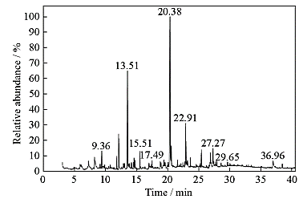

Figure 1. GC-MS spectrum of Kleinia grandiflora leaf extract [16].
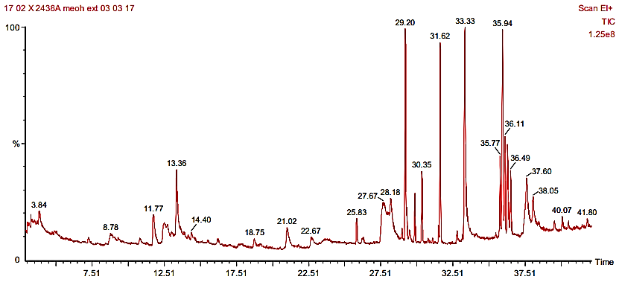
Figure 2. GC-MS spectrum of Pongamia Pinnata methanolic leaf extract [17].

2.2 Corrosive Media
2.2.1 Corrosion inhibition in Hydrochloric acid (HCl) and Sulphuric acid (H₂SO₄). Industrialists often use concentrated HCl electrolytes to remove surface impurities through descaling and cleaning methods. Because of HCl is more reactive than H₂SO₄, pickling is usually done at a lower temperature in HCl solution, whereas H₂SO₄ pickling necessitates an elevated temperature. The remaining chloride (Fe²⁺ or Fe³⁺) generated by the HCl pickling procedure is easier to rinse off than residual sulfates (Fe²⁺ or Fe³⁺) created by the H₂SO₄ pickling method. Nonetheless, all of these methods are highly corrosive and result in significant economic losses, particularly in industries. As a result, inhibitors are the most important source of corrosion protection [4,1].
Several phytochemicals from extract of plants have recently been employed as efficient HCl system inhibitors. Oxandra asbeckii extraction is done by acid-base extraction using CHCl₃ and their phytochemicals like Liridenine, azafluorenones, alkaloids, triterpenoid are isolated by CC which is used as a corrosion inhibitor in 1 M HCl on C-38 steel. Oxandra asbeckii plant extract (OAPE) is a both anodic and cathodic type of inhibitor (i.e., mixed-type inhibitor), according to polarization plots. Over a temperature range of 25 to 55 ºC, the influence of temperature on the corrosion behaviour of C38 steel in 1 M HCl with and without the plant extract was investigated. The adsorption of this plant extract on the C38 steel surface is governed by the Langmuir adsorption isotherm. By surface analysis, the ability of this plant extract to prevent corrosion in HCl solution was also verified. An electrochemical impedance study showed that the Oxandra asbeckii plant extract reduced the corrosion significantly with an IE of 92% at 100 mgL⁻¹ [18]. Dioscorea septembla extraction is done by the reflux method using 75% ethanol and their phytochemicals like Dioscin, Dioscorone, β-sitosterol, and palmitic acid are identified by ¹H NMR, ¹³C-NMR, FT-IR, which are used as a corrosion inhibitor in 1 M HCl on Carbon Steel. The electrochemical Impedance study showed that organic phase extract and water phase extract of Dioscorea septembla showed IE of 72.1% and 65.3%, respectively at 2.0 gL⁻¹. Potentiodynamic Polarization data showed that the IE of organic phase extract and water phase extract of Dioscorea septembla is 89.2% and 82.8% respectively at 2.0 gL⁻¹. Additionally, the polarisation experiments revealed that as the temperatures increased, the anodic and cathodic regions increased in more positive directions. [19].
For illustration, Aloe plant extract, extraction is done by maceration & distillation process using ethyl alcohol and their phytochemicals like Aloesin, Aloin, Aloe & Aloe Resin is used as a corrosion inhibitor for stainless steel in 1 M H₂SO₄. The Aloe extract was found to be a mixed-type corrosion inhibitor with a predominately anodic activity by polarisation plots. The Langmuir isotherm demonstrates that physical interaction was the basis for the adsorption of Aloe extract on the surface of stainless steel. Electrochemical Impedance study, Polarization study, and Electrochemical Noise revealed that 98%, 96%, and 96% corrosion IE of this plant extract at 30% v/v respectively [20]. Coptis chinensis extraction is done by maceration & distillation process using ethyl alcohol and their phytochemicals like Berberine are implemented as a corrosion inhibitor in 1 M H₂SO₄ on mild steel. For berberine concentrations greater than 5.0x10⁻³ M, IE measured by the weight loss test can reach approximately 98%. Potentiodynamic results showed that for berberine concentrations more than 1.0x10⁻⁴ M, both anodic and cathodic processes are reduced, while smaller values primarily inhibit cathodic reaction [21].

Table 1: Evaluation of plant extracts as corrosion inhibitors for several metals and alloys in different corrosive mediums: Plant name, Phytochemicals, Extraction solvent, and the Metals or alloys used for corrosion inhibition performance tests, concentration, corrosion IE, and Isotherm model

S. No. | Plant Names | Phytochemicals | Extraction  Solvents | Corrosive medium | Metal or alloy | Corrosion Inhibition  Efficiency | Concentration | Isotherm Model | Reference
 | Kleinia grandiflora | 6-deoxy D-galactose, hexadecanoic acid, linolenic acid, etc., | Ethanol | 1 M H₂SO₄ | Mild steel | 85.09% | 150 × 10⁻⁶ M | Langmuir | [16]
 | Pongamia Pinnata | 4-piperidinamine, hexadecanoic acid, N,1-dimethyl-; (Z)6, (Z)9-pentadecadien-1-ol; etc., | Methanol | 1 N H₂SO₄ | Mild steel | 94.6% | 100 ppm | Temkin | [17]
 | Oxandra asbeckii | Liriodenine, azafluorenones alkaloids, triterpenoid | Chloroform | 1 M HCl | C38 Steel | 92% (EIS) | 100 mgL⁻¹ | Langmuir | [18]
 | Dioscorea septemloba | Diosin, Diascorone A, β-sitosterol, Palmitic acid | Ethanol | 1 M HCl | Carbon Steel | 89.2% (PDS) | 2.0 gL⁻¹ | - | [19]
 | Aloe Plant extract. L | Aloesin, Aloin, Aloe, & Aloe Resin | Water | 1 M H₂SO₄ | Stainless Steel | 98% (PDS)  96% (EIS)  96% (EN) | 30% v/v | Langmuir | [20]
 | Cotis chinensis | Berberine | - | 1 M H₂SO₄ | Mild Steel | 98% | 5.0 x 10⁻³ M | Langmuir | [21]
 | Artemisia pallens | Arbutin | Aq. methanol | 0.1 Mol L⁻¹ HCl | Mild steel | 93% | 400 mgL⁻¹ | Langmuir | [23]
 | Opuntia elatior | Opuntiol | Ethanol | 1 M H₂SO₄ &  1 M HCl | Mild Steel | 73% | 50 ppm | Temkin | [24]
 | Alpinia galanga | 1’-acetochavicol acetate | n-hexane | 1M HCl | Mild Steel | 84.6% | 1000 ppm | Langmuir | [25]
 | Ochrosia oppositifolia | Isoroserpiline | Hexane, dichloromethane | 1 M HCl | Mild steel | >85% | 20-25 mgL⁻¹ | Langmuir | [26]
 | Ficus hispida L. | Stigmasterol | Ethanol | 1 M HCl | Mild Steel | 90% | 250 ppm | Langmuir | [27]
 | Valeriana willichi. R | Naptholic acid, Iridoid, Analogue | Ethanol | 0.5 M H₂SO₄ | Mild Steel | 93.47% | 500 mgL⁻¹ | Langmuir | [28]
 | Oryza sativa L. | β – sitosterol | Methanol | 1 M H₂SO₄ | Mild Steel | 95% | 500 ppm | Langmuir | [29]
 | Apple pomace | C₂₆H₅₀NO₇P, C₃₁H₄₃N₅O | Liquid Extract | 3.5% NaCl | C1010 Mild Steel | 98.8% | 3% v/v | Langmuir | [30]
 | Catharanthus roseus | Polyphenolic | Ethanol | 3.5% NaCl | Mild Steel | 70% | 3.5 wt% | - | [31]
 | Radish Leaf Extract | Folic acid,  Catechin, O-Coumaric acid, Ascorbic acid | Water, methanol | 0.5 M H₂SO₄ | Mild Steel | 93% | 300 mgL⁻¹ | Langmuir | [32]
 | Cryptocarya nigra | N-methylisococlaaurine, N-methyllaurotetanine, Atherosperminie. | Hexane, Methanol, Dichloromethane | 1 M HCl | Mild Steel | 91.05% | 500 ppm | Langmuir | [33]
 | Ficus racemosa | Hexadecanal,  Octadecanal,  Squalene,  Vitamin,  Stigmasterol, etc., | Methanol | 1 N H₂SO₄ | Mild steel | 90.5% | 2500 ppm | Langmuir | [34]
 | Pimenta dioica | Eugenol | Ethanol | 0.5 M & 1 M HCl | Mild Steel | 99.35% (PDS) | 520 mgL⁻¹ | Langmuir | [35]
 | Magnolia grandiflora | 3,7- Diemthyl-2,6-octadien-1-ol, Santamarine, Lanuginasine, Anonaine | Water | 1 M HCl | Q235 steel | 85% | 500 mgL⁻¹ | Langmuir- single layer | [36]
 | Tephrosia purpurea | n-hexadecanoic acid | Methanol | 1 N HCl | Mild Steel | 95.4% | 300 ppm | Langmuir | [37]
 | Matricaria aurea F. | Apigetrin | n-hexane, methanol, water | 1.0 M HCl | Mild Steel | 94% (PDS) | 0.464 mM | Langmuir | [38]
 | Pistacia terebinthus | α- pinene, Limonene,  α-Terpineol | - | 3% NaCl | Iron | 86.4% | 3000 ppm | - | [39]
 | Oryza sativa L. | Momilactone | Methanol, ethyl acetate, hexane | 1 M HCl | Mild Steel | 88% | 1000 ppm | - | [40]
 | Green Eucalyptus L. | Ellagic Acid, Eucalyptone, Macrocarpal A, Macrocarpal E | Water | 1M HCl | Mild Steel | 88% | 800 ppm | Langmuir | [41]
 | Brazilian Plant Extracts | 4-(methylamino)benzoic acid | Aqueous ethanol | 0.1 M HCl | Carbon Steel | 81.9% | 2700 ppm | Langmuir, Temkim | [42]
 | Rauvolfia macrophylla | Tetrahydroalastonine and Perakine | CH₂Cl₂: MeOH (1:1) | 0.5 M H₂SO₄ & 1M HCl | C38 Steel | 97% | 200 mgL⁻¹ | Langmuir | [43]
 | Mansoa alliacea | Apigenin, luteolin, scutellarein-7-glucuronide | Ethanol | 3% NaCl | Zinc | 90% | 300 mg/L | Langmuir | [44]
 | Phyllanthus amarus | Phyllantin | Ethanol | 1 M HCl | Mild Steel | 95% | 4 (v/v%) | Langmuir | [45]
 | Tiliacora accuminata | - | Ethanol | 1 M HCl | Mild Steel | 93.02 % | 320 ppm | Langmuir | [46]
 | Pomegranate | Ellagic acid | Distilled water | 1 M HCl | Carbon steel | 91% | 1 g L⁻¹ | Langmuir | [47]

3. INVESTIGATION AND THEIR CHARACTERIZATION
3.1 Weight-Loss method or Gravimetric Method. This technique considers exposing a metal specimen to a specific atmosphere within a set time, then removing the sample from the situation and calculating the difference in weight before and after exposure to that environment. This approach for calculating metal corrosion rates is simple, precise, and accurate. The metal sample is ground with emery sheets, washed with double distilled water, and degreased with acetone, and dried before the test. A balance is used to weigh the specimen that will be used for measurement. The metal is then dipped in various test media at a specified temperature for a specific period without and with various inhibitor concentrations, according to the technique. The metal sample was cleaned, dried, and weighed when the experiment was done. The inhibitor concentration for weight loss was measured [2]. Corrosion rate (CR), surface coverage (Ɵ) and IE%, were calculated from the following equation:
Surface coverage (θ) = $\frac{Wo-Wi}{Wo}$ ------------------ (1)
Inhibition Efficiency (IE %) = $\frac{w_{o} - w_{i}}{wo} × 100$-------------(2)
Corrosion rate (CR) (mm/y) = $\frac{w}{A D t} × 87.6$ ----------------------(3)
where,w₀ and w_{i} indicates a weight loss of the metal without and with an inhibitor, w represents the weight loss differences of mild steel in mg, A indicates area of the coupon in cm², t represents the exposure time in hr, D is the density of mild steel in gmL⁻¹ and 87.6 is a constant.
For illustration, weight loss measurements were used to study the inhibitory effect of different doses of Radish Leaf Extract (which contains phytochemicals such as O-Coumaric acid, Catechin, Folic acid, and Ascorbic acid) on mild steel corrosion in the 0.5M H₂SO₄ solution at 298 K. The corrosion rate was only 2.65 gm⁻²h⁻¹ when the concentration of Radish Leaf Extract was 300 mgL⁻¹ (Figure 3), and the corrosion IE was 93%. The inclusion of numerous organic components in Radish leaf extract is likely responsible for its outstanding corrosion prevention activity against mild steel. Protective coatings can be applied to the mild steel surface as a consequence of the adsorption process, increasing the surface area covered and minimizing the rate of mild steel corrosion in the H₂SO₄ medium [32]. In addition, Figure 4 shows the weight loss data of Mild Steel in 1N HCl having different concentrations of Tephrosia purpurea leaves extract (which includes n-hexadecanoic acid phytochemical) (50-400 ppm) at 303 K for a 1 hr immersion period. The corrosion rate of mild steel in 1N HCl solution with Tephrosia purpurea leaves extract decreased with an increase in inhibitor concentration, while the IE (%) increased. At 300 ppm of Tephrosia purpurea leaves extract for a 1 hr immersion period at room temperature, the maximum inhibitory efficiency of 92.4% was achieved. There is not much change in IE % above 300 ppm. The rise in IE as the concentration of leaves extract increases is attributable to the adsorption of inhibitor constituents on the Mild Steel strips surface. Figure 4b shows that as immersion duration increases, IE decreases; the IE % drops from 92.4% (for 60 minutes) to 81.6 % (for 24 hrs). This observation implies that the adsorbed inhibitor molecules desorb from the mild steel surface as the immersion time increases. Though the IE % decreases as the immersion period increases, Tephrosia purpurea demonstrates reasonable inhibition behavior, with an IE of 81.6% over 24 hrs [37].
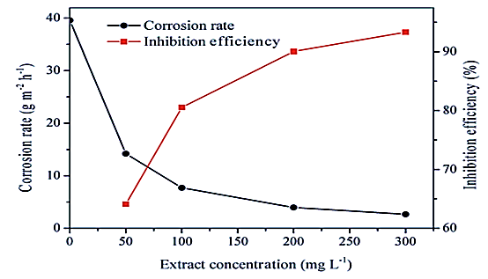
Figure 3. Corrosion rate and IE of Radish Leaf Extract at different concentrations (Which Contains phytochemicals like O-Coumaric acid, Catechin, Folic acid, and Ascorbic acid) in 0.5M H₂SO₄ solution [32].
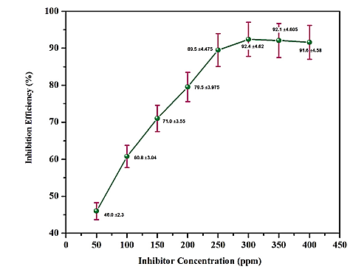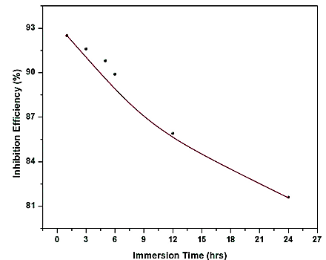
b
a
Figure 4. (a) The IE of Tephrosia purpurea leaves extract (Which contain n-hexadecenoic acid phytochemical) at different concentrations (b) Consequence of immersion time on corrosion of mild steel in 1N HCl in the presence and absence of Tephrosia purpurea leaf extract (Which contain n-hexadecenoic acid phytochemical) at 303K [37].

3.2 Electrochemical Measurements
3.2.1 Electrochemical Impedance Spectroscopy (EIS). EIS is a useful tool for determining the properties and kinetics of electrochemical reactions at metal/aggressive media contacts. On top of a DC potential, a low amplitude alternating potential (or current) wave is imposed, with the input voltage and the output current providing the impedance. The amplitude and phase angle of the variation in impedance is used to analyze the data. The frequency response analyzer examines the out-of-phase relationship between the input voltage and output current. The capacitor, resistor, and inductor are ubiquitous circuit elements. However, the impedance data for a solid electrode/electrolyte interface frequently reveal a frequency dispersion that these simple elements cannot explain. And this frequency dispersion is attributed to a “capacitance dispersion,” which is described in terms of a dispersed electrical element known as the constant-phase element (CPE). The capacitance of the adherent film was computed from the EIS data using an electric equivalent circuit and the standard deviation was obtained using equation (4).
$C_{dl}=\frac{1}{2πf_{max}R_{ct}}$ -----------(4)
where C_{dl} double layer capacitor, where f_{max} represents the frequency at the apex of the Nyquist plot, and R_{ct} is defined as charge transfer resistance.
$IE\%=\frac{R_{ct}-R_{ct}^{°}}{R_{ct}}×100$ ----------(5)
Where $R_{ct}^{°}$and$R_{ct}$ are charge transfer resistance in the absence and presence of an inhibitor respectively. To provide an additional understanding of the corrosion inhibition process, we create two types of graphical presentations using data obtained from equipment. These are the Nyquist and Bode plots [2].
For instance, the Nyquist plots of mild steel in 1 N H₂SO₄ with and without various concentrations of Pongamia pinnata leaf extract were analyzed (Figure 5). The Nyquist plot reveals that in the presence of Pongamia pinnata leaf extract, the impedance behavior of mild steel in the 1 N H₂SO₄ medium has altered dramatically. The arc curvatures demonstrate that the inhibition is because of a charge transfer mechanism with a maximum IE of 70%, as the R_{ct} values increased with increasing inhibitor molecule concentrations. The addition of an inhibitor has a slight influence on the solution resistance but does not affect the open circuit potential (OCP). The existence of a single semicircle indicates that inhibitor molecules have an impact on more than one charge transfer mechanism. The semicircle's depressing nature is typical of a solid electrode, and it is primarily owing to the mild steel electrode's micro-roughness and "inhomogeneities". The R_{ct} value is inversely proportional to the corrosion rate and measures electron transport across the electrode-solution interface. The Bode curve displays a single peak of about 125 Hz to 158 Hz, with little variation as the inhibitor concentration is improved. The presence of an inhibitor is accompanied by an increase in R_{ct} and a decrease in C_{dl}, indicating that the charge transfer process is primarily responsible for the mild steel breakdown. This is due to an intensification in the inhibitor molecules' surface coverage (θ), which increases the IE [17]. Likewise, the releasing of adsorbed intermediate products from the mild steel surface causes inductive loops in the EIS curves of a blank solution of Valeriana willichi Roots Extract (which contains phytochemicals like Naphthoic acid, Iridoid, and Analogue). They show that the inductive loop is removed at different concentrations, which is generally taken into account. In the Bode modulus curves, the semicircle width in the Nyquist plot corresponds to the changing drift of impedance values with the Valeriana willichi concentration level (Figure 6). The Nyquist plot's onetime constant is confirmed by all phase angle-frequency curvatures that reveal a single wave. According to the literature, the electrochemical behavior of the steel solution contact is capacitive or resistive depending on whether the phase angle is 90º or 0º. Naphthoic acid, Iridoid, and Analogue phytochemicals were identified in abundance in Valeriana willichi extracts. By transferring π-electrons from aromatic rings or lone-pair electrons from heteroatoms to the empty Fe orbital, these molecules can then be adsorbed onto the surface of mild steel. These substances can create a protective layer on the mild steel surface, blocking the flow of charges and ions and protecting it from corrosive media. The findings show that the Valeriana willichi inhibitor inhibits mild steel corrosion at any concentration used and that the inhibitor's efficiency increases as the concentration is increased [28].
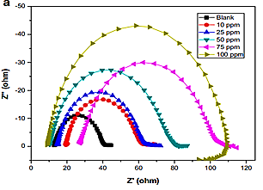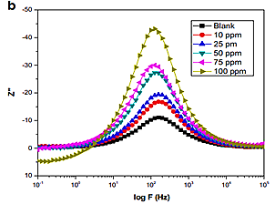
Figure 5. (a) Nyquist plot for mild steel in 1 N H₂SO₄ in the presence and absence of different concentrations of Pongamia pinnata leaf extract (contain 4-piperidinamine, N,1-dimethyl-; (Z) 6, (Z) 9-pentadecadien-1-ol; hexadecanoic acid, methyl ester; 9,12,15-octadecatrienoic acid, etc.,) (b) Bode plot for mild steel in 1N H₂SO₄ in presence and absence of different concentrations of Pongamia pinnata leaf extract [17].
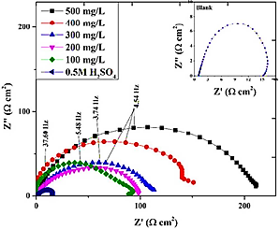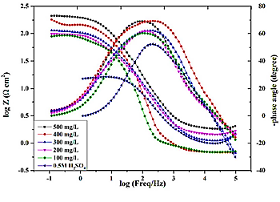
b
a
Figure 6. (a) Nyquist plots for mild steel in 0.5 M H₂SO₄ from 0 to 500 mg/L concentrations of Valeriana willichi extract (Naptholic acid, Iridoid, Analogue) (b) Bode-Z and Bode-phase plots for mild steel in 0.5 M H₂SO₄ with 0 to 500 mgL⁻¹ concentration of Valeriana willichi extract at OCP and 298K [28].
3.2.2 Potentiodynamic Polarization. It is an excellent and practical tool for investigating corrosion mechanisms. Polarization curves make it simple to understand the kinetics of anodic and cathodic reactions. Readings are taken over a predetermined range of potentials and at a predetermined scan rate. The kinetics of corrosion reactions can be measured using polarization techniques. Electrochemical parameters such as corrosion potential (E_{corr}), corrosion current density (I_{corr}), cathodic Tafel slope (c), anodic Tafel slope (a), and percentage IE (I.E %) as an indicator of inhibitor concentration level are computed with the help of the graphs using the polarisation technique. The methodology of the procedure will define the nature of the retardation as cathodic, anodic, or both. The E_{corr} values will establish the type of inhibitor utilized. When the graph's curve approaches a low current density, it indicates that the corrosion rate is reducing [2].
For instance, the Tafel graphs for varied inhibitor concentrations of the Valeriana willichi extract (which contains phytochemicals such as Naphtholic acid, Iridoid, and Analogue) on the polarization behavior of mild steel in 0.5 M H₂SO₄ were examined. The Tafel plots reveal a reduction in the current densities of the anodic as well as cathodic prolongations in the presence of inhibitors. The effects of covering mild steel surfaces with adsorbed inhibitor molecules on decreasing steel surface zone dissolution have also been investigated. At 100-500 mg/L, the increased concentration resulted in a reduced current density (i_{corr}). As the inhibitor concentration rises, so does the amount of surface covering. Once inhibitors were introduced to the corrosive medium, all anodic metal disintegration and cathodic hydrogen evolution reactions were stopped. The inhibition of these activities is maintained as inhibitor concentrations increase. Charge transfer still governs both the anodic and cathodic reaction processes, as seen by the almost unchanged anodic and cathodic Tafel slopes before and after adding Valeriana willichi extract (Figure 7). Thus, Valeriana willichi extract active components were effectively adsorbed into the steel surface and inhibited mild steel corrosion without changing the response mechanism. Valeriana willichi extract contains natural chemicals that are well-adsorbed on Mild Steel surfaces due to electrostatic contact and induce effective coordination bonds with Fe through heteroatoms. As a result of the combination of physisorption and chemisorption, the inhibitor's functional constituents are systematically adsorbed on the Mild Steel surface shielding the metal from degradation as seen by decreased corrosion current density values [28]. Also, the graph of the Potentiodynamic polarisation curvatures of Q235 MS specimens immersed in 1M HCl having and not having various levels of Magnolia grandiflora leaves concentrations that contain phytochemicals such as 3,7-Dimethyl-2,6-octadien-1-ol, Santamarine, Lanuginasine, and Anonaine is shown in Figure 8. As the concentration level increases, the i_{corr} of the mentioned specimens in the HCl metal deterioration environment reduces. This suggests that a phytochemical-rich extract extracted from Magnolia grandiflora leaves effectively inhibits Q235 steel corrosion in 1 M HCl. Furthermore, as the concentration of inhibitor increases, the cathodic branch's polarisation curve tends to drop faster than the anodic branch. This shows that the inhibitor's adsorption influence on the cathodic hydrogen suppression specimen surface is significantly stronger than that of anodic iron ion precipitation. It's worth noticing that the cathodic branch polarisation curves follow a similar pattern. The adsorption of Magnolia grandiflora leaves extract onto the specimen exterior did not affect the cathodic response procedure, indicating that it is unaffected. In comparison to the blank solution, the change values after including the MG leafage concentrate are significantly less than 85 mV, indicating that Magnolia grandiflora leaves extract is a mixed-type corrosion inhibitor. Furthermore, the corrosion IE of Magnolia grandiflora leaves extract is 88.2% when the inhibitor concentration reaches 500 mgL. As a result, they have demonstrated that the Magnolia grandiflora leaves extracts, which contain phytochemicals such as 3,7-Dimethyl-2,6-octadien-1-ol, Santamarine, Lanuginasine, and Anonaine, have retardant opposing properties for the given specimens in 1 M HCl [36].
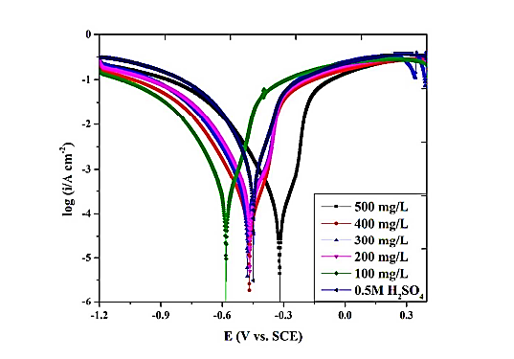
Figure 7. Potentiodynamic polarization curves for mild steel in 0.5 M H₂SO₄ with 0 to 500 mg/L concentrations of Valeriana willichi extract (Which contains phytochemicals like Naphtholic acid, Iridoid, and Analogue) [28].

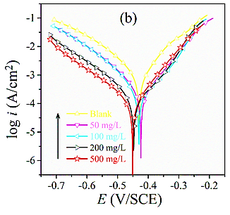
Figure 8. Polarization curve of Q235 steel immersed in 1 M HCl with and without different concentrations of Magnolia grandiflora leaves (contain phytochemicals like lanuginosine, 3,7- dimethyl-2,6-octadien-1-ol, santamarine, and anonaine) extract [36].

3.3 Surface Morphology
3.3.1 Scanning Electron Microscopy (SEM). SEM can be used to determine the surface morphology of metals with and without the presence of phytochemicals as an inhibitor extracted from plant extracts. The formation of a protective inhibitor layer on the metal surface can be approved using SEM. Due to rapid corrosion and uncontrolled dissolving without inhibitors, the metal surface becomes rough. In the presence of an inhibitor, the metal roughness is reduced, resulting in a smoother surface [2]. Phytochemicals, which are extracted from plant extracts and function as inhibitors, are frequently found on metal surfaces. Energy Dispersive X-ray Analysis (EDX) is frequently employed to assess the elemental composition of the metal surface in both the absence and presence of these inhibitors. It provides information about the element compositions present on the surface of the metals like hetero atoms. In the presence of inhibitor molecules, heteroatoms such as O, C, and Fe can give an unshared pair of electrons, resulting in the complicated formation of metal atoms during the adsorption process and preventing further metal dissolution [31]. For example, the surface morphology of Mild steel using Ficus hispida leaf extract which has phytochemical namely, Stigmasterol in 1 M HCl was studied by using SEM, and elemental composition was analysed by EDX spectra (Figure 9). In comparison to corroded rough and uneven mild steel surfaces submerged in 1 M HCl alone, SEM images of this compound showed that the metal submerged in the inhibitor contains Stigmasterol solutions and has a favourable environment with smooth surfaces. The EDX profile confirms that Ficus Hispida Leaves Extract, which contains the phytochemical Stigmasterol, adsorbed on the mild steel surface and prevented metal corrosion by blocking weak damages through its adsorption on the surface [27]. Likewise, after 24 hrs of immersion in a 3% NaCl solution, scanning electron microscope/energy dispersive x-ray methods were used to examine the interactivity of Essential Oils inhibitor with the metal surface. Figure 10 (a₁) depicts a front perspective of a scanning electron image of the blank specimen, which is rusted and depicted by an extremely coarse surface having metal deterioration indications on it. The iron surface damage was greatly decreased in the vicinity of the inhibitor as seen in Figure 10 (b₁, c₁, and d₁), and the coupons seemed smooth. After 24 hrs of exposition to a corrosive solution having 3000 ppm of Terebinth Essential Oils, this inspection validated the establishment of a protecting boundary overlay on the Fe surface. The elements present on the iron surface were shown using EDX without and with Terebinth Essential Oils. In the absence of Essential Oils inhibitors, the assortments largely featured the distinctive peaks of Iron, Carbon, Oxygen, Chlorine, and Sodium, as shown in Figure 10 (a₂). On the iron surface, this validated the production of metal oxides/hydroxides as well as chlorides as metal deterioration outcomes. The reduction in peak intensity also causes the chlorine and sodium to vanish in the presence of the Essential Oils inhibitors Figure 10 (b₂, c₂, and d₂). As a result, Terebinth Essential Oils molecules adsorb to the Fe surface, inhibiting the production of oxides/hydroxides as well as chlorides. Furthermore, the percentage of Carbon reduces as a result of the synthetic constitution of the inhibitors, demonstrating that Essential Oils inhibitors adsorb on the iron surface, forming a protective coating [39].
(i)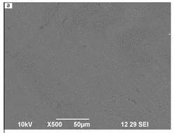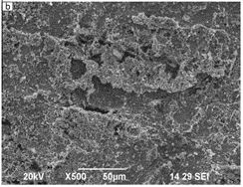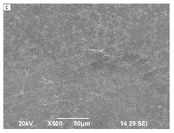
(ii)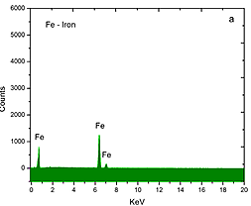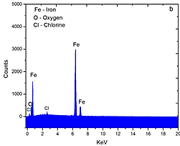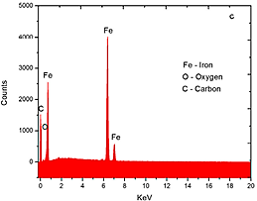
Figure 9. (i) SEM images of (a) Polished mild steel surface, (b) after 2 hrs of immersion at 308 K in 1 M HCl and (c) after 2 hrs of dipped at 308 K in 1 M HCl + Ficushispida Leaf extract (Which contain phytochemicals like stigmasterol). (ii) EDX graphs of (a) Polished mild steel surface, (b) mild steel specimens exposed in 1 M HCl and (c) mild steel exposed in 1 M HCl + Ficushispida Leaf [27].

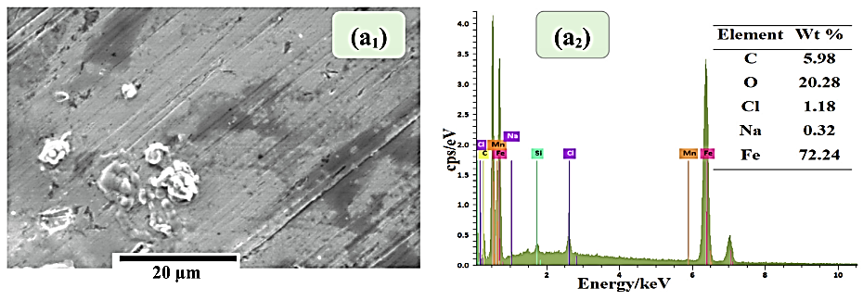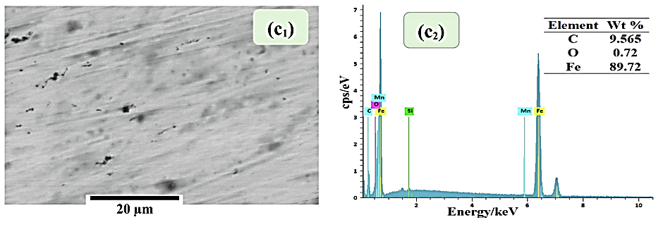
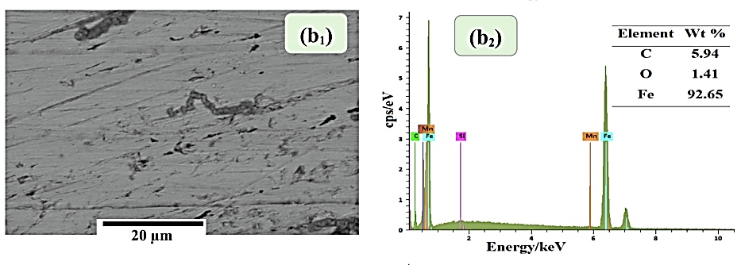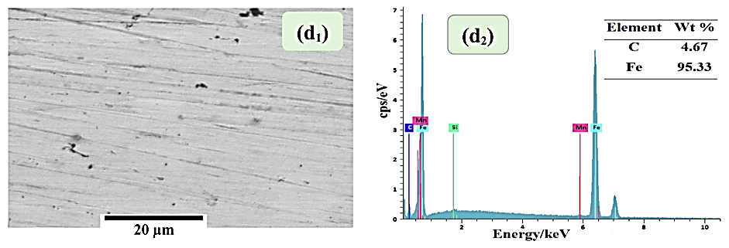
Figure 10. SEM&EDX analysis of the iron dipped in the 3% NaCl solution without ((a₁, a₂) blank) and with 3000 ppm of essential oils from (b₁, b₂) leaves, (c₁, c₂) twigs, and (d₁, d₂) fruits of Terebinth [39].

3.3.2 Atomic Force Microscopy (AFM). AFM is a valuable instrument for surface research because it may reveal the microstructure and determine whether a corrosion inhibitor has thin-film adsorption on the metal surface. AFM provides quantitative data and 3-D topography of the metal sample. Surface changes with and without phytochemicals as an inhibitor can be analyzed with this technique clarifying how adding an inhibitor to a sample reduces the average roughness of the metal specimen. Both protected and unprotected samples have their root mean square (RMS) and average roughness values computed in Nanometres (nm) and these data are then compared [2].
For instance, Magnolia grandiflora Leaves extract (Figure 11) was used to examine the AFM of Q235 steel, which contains the regular phytochemicals. In the form of a protective film layer, they operate as corrosion inhibitors. When phytochemicals from Magnolia grandiflora leaf extract are adsorbed, the culmination of the Q235 steel surface is approximately 250 nm, while the peak valley value is around 120 nm. When compared to the average roughness of Q234 steel before immersion of phytochemicals as a corrosion inhibitor, the complete Q235 steel surface was consistent as well as even, and the average roughness values (Ra) became reduced. The whole Q235 steel surface's peaks and valleys are greatly decreased. Therefore, they concluded that the surface of the Q235 steel is protected by using the leaf extracts which contain phytochemicals and reduce further corrosion [36]. Also, the surface morphology of mild steel metal was examined using an Atomic Force Microscope to see how it changed during the corrosion process without as well as with Tephrosia purpurea leaves extract (Figure 12), which contains phytochemicals such as n-hexadecanoic acid. They discovered that polished mild steel has a lower average surface roughness than mild steel that has been acid-treated which is attributable to strong metal disintegration. However, when mild steel was treated with Tephrosia purpurea extract and 1 N HCl, the phytochemical rapidly decreased. The reason is primarily due to the Mild steel producing a protective coating, which also prevents further corrosion [37].
(a)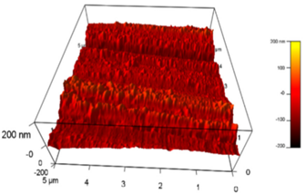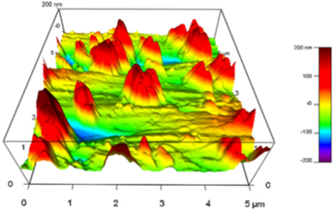(b)
Figure 11. AFM images of Q235 steel after immersion in 1 M HCl (a) with and (b) without Magnolia grandiflora leaves extract, which contains phytochemicals like Santamarine, 3,7-Dimethyl-2,6 Octadien-1-ol, Anonaine, Lanuginasine [36].

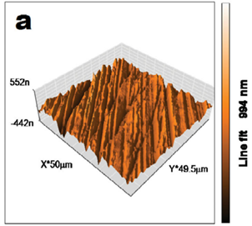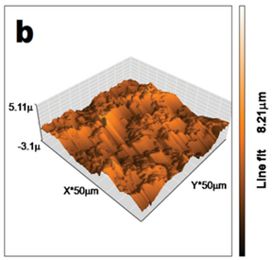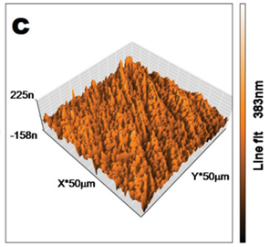
Figure 12. AFM images for (a) polished mild steel, (b) mild steel immersed in 1 N HCl, and (c) mild steel immersed in 1 N HCl with 300 ppm of Tephrosia purpurea, containing phytochemical n-hexadecanoic acid [37].

3.3.3 X-ray photoelectron spectroscopy (XPS). It was used to examine the surface to validate the assumption of physisorption and chemisorption, as well as to determine the type of the organic thin-film formed on the metal surface [23]. For instance, the x-ray photon spectroscopy reviews, as well as optimal-definition spectra from a steel surface with Brassica oleracea L. fruit extract, are shown. In surveys (Figure 13 a and d), the N peaks are observed. The reason is due to extracting constituent induction. As a result, a complex layer is produced to protect Q235 steel from corrosion [48]. Likewise, the XPS studies were carried out on the metal surface where the phytochemical act as a corrosion inhibitor is also analyzed. The phytochemicals are extracted from their plant extract. The x-ray photon spectroscopy of C 1s, O 1s, and Fe 2p_{3/2} for the Mild steel after immersion for 4 hrs in 1 molL⁻¹ HCl having 400 mgL⁻¹ methanolic extracts of Artemisia pallens (Asteraceae) and its active phytochemicals, arbutin is displayed in Figure 14. The C1s spectra of methanolic extract, as well as arbutin-processed Mild steel, were deconvoluted into 3 peaks, showing the presence of 3 synthetic variants of carbon atoms on the Mild steel surface (Figures 14a and b). O1s spectra deconvolution may be divided into three primary peaks. Three peaks emerge from the deconvolution of the high-resolution Fe 2p^{3/2} spectrum. The peak intensity of the Fe 2p spectra of crude methanolic extract processed Mild steel is lower than that of arbutin processed Mild steel, implying the formation of a thin layer on the mild steel surface due to the high adsorption of the crude methanolic extract [23].
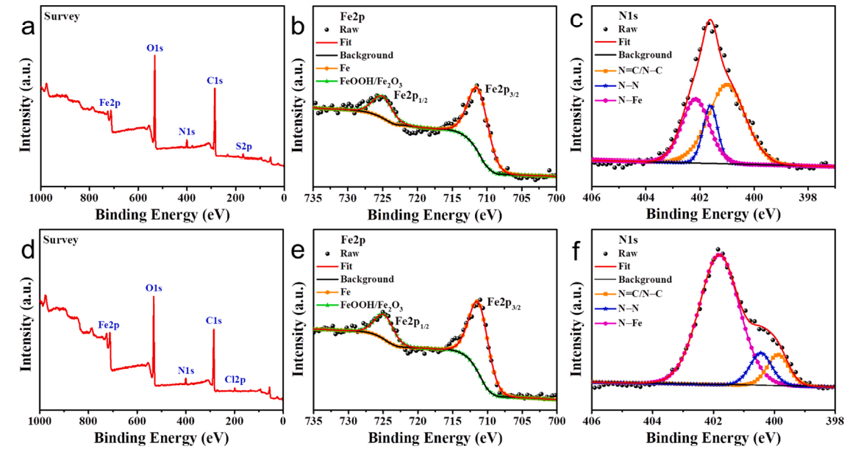
Figure 13. XPS Survey and high-resolution spectra from the steel surface with the fruit of Brassica oleracea L.extract containing Fe2p, and N1s, (a), (b), (c) in H₂SO₄, (d), (e), (f) in HCl [48].

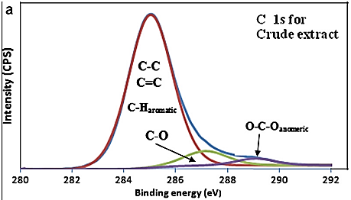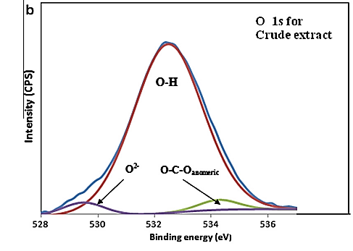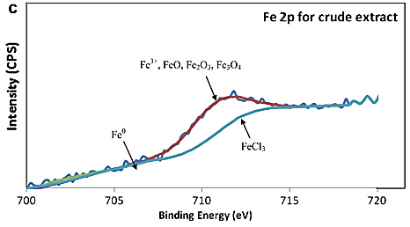
Figure 14 a, b, and c: The XPS deconvoluted profile for (a) C 1s, (b) O 1s, and (c) Fe 2p for mild steel surface after immersion for 4 hrs in 1 mol l⁻¹ HCl solution containing 400 mg l⁻¹ of the crude methanolic extract of Artemisia pallens at 30 ºC [23].
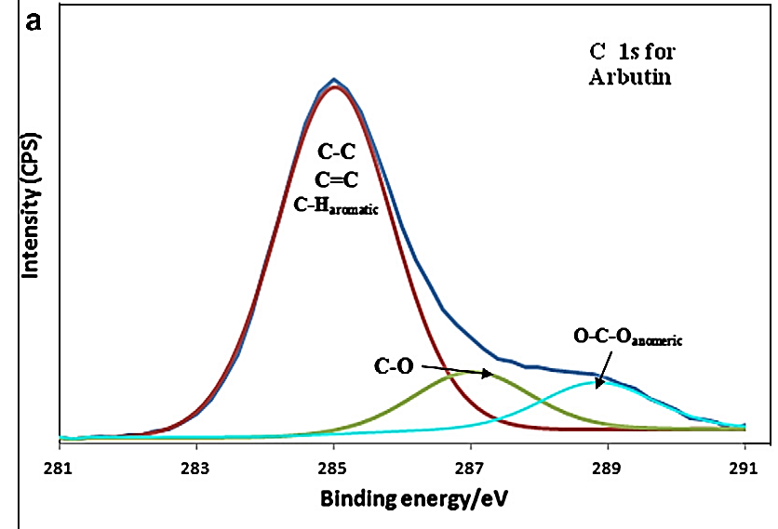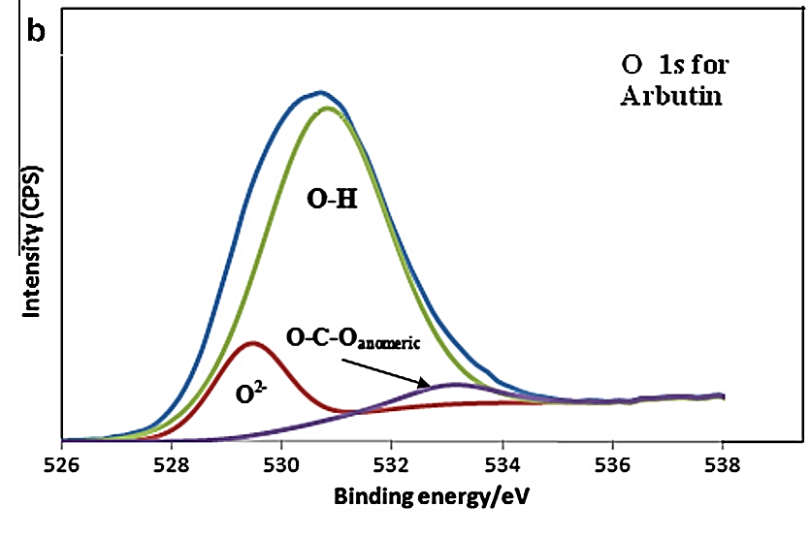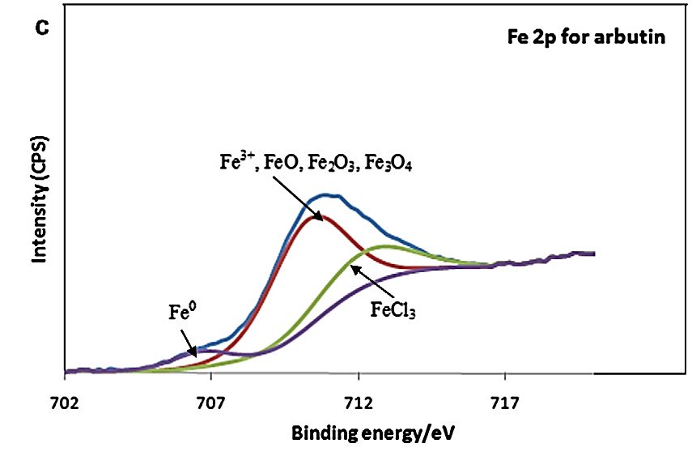
Figure 15 a, b, and c: XPS deconvoluted profile for (a) C1s, (b) O1s, and (c) Fe 2p for mild steel surface after immersion for 4 hrs in 1 mol l⁻¹ HCl solution containing 400 mg L⁻¹ of arbutin at 30ºC [23].

3.3.4 Electrochemical / Electron Frequency Modulation (EFM). Electrochemical / Electron frequency modulation (EFM) is a non-destructive electrochemical technology that may estimate the corrosion current value directly and efficiently using only a short polarising signal and no prior knowledge of Tafel slopes. This method has the advantage of combining corrosion rate, Tafel parameters, and causative factors into a single data set, making it a good choice for online corrosion monitoring. A potential perturbation signal comprised of 2 sinusoidal waves is implemented to any corroding metals to evoke an existing reaction utilizing electron frequency modulation. This method is furthermore utilized to precisely explore metal deterioration criteria for a wide range of metals & electrolytes. Noise may alter the measurement if the causality factors are not between 2 and 3. If the correlation factor's value nears the threshold, there is a link between the perturbation as well as the response signals, and the information can be acknowledged. If CF-2 and CF-3 are in the 0–2 and 0–3 ranges, respectively, the EFM results are valid. Any deviation from the anticipated value in the causation factor could be caused by a too-small perturbation amplitude, inadequate spectrum frequency resolution, or a non-functioning inhibitor [49,50]. For instance, the EFM of azelaic acid dihydrazide (Figure 16) shows that CF-2, as well as CF-3, possess conventional numbers of 2.0 and 3.0, respectively. These findings reveal that inhibitor molecules bind to the mild steel surface physically rather than chemically and that rising temperature speeds up both metal dissolving and inhibitor molecule desorption [49]. EFM Intermodulation spectrums of carbon steel in 1M HCl acid solution with various Modazar drug doses are also shown (Figure 17). Increases in the studied inhibitor concentrations increase the IE IE_{EFM} %, which can be measured as follows:
${IE}_{EFM}\%=\frac{1-i_{corr}}{i_{corr}^{°}} x 100$-------------------[6]
where iº_{corr} and i_{corr} are corrosion current densities without and with different concentrations of inhibitors, respectively [50].
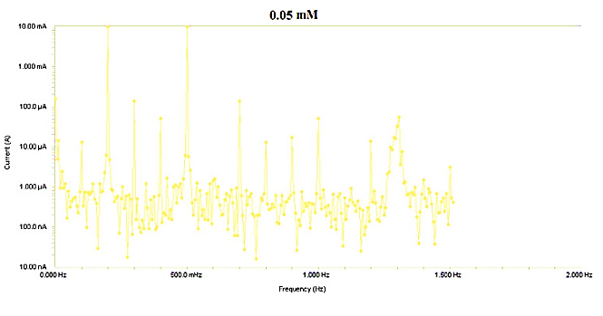
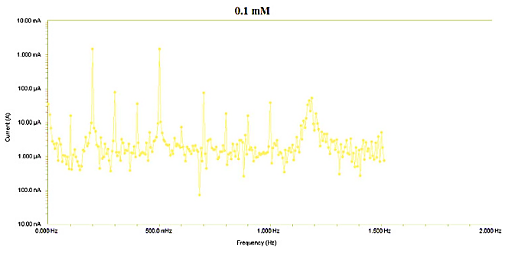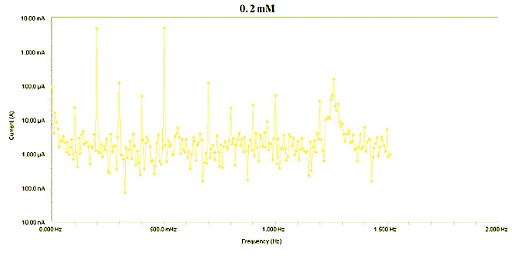
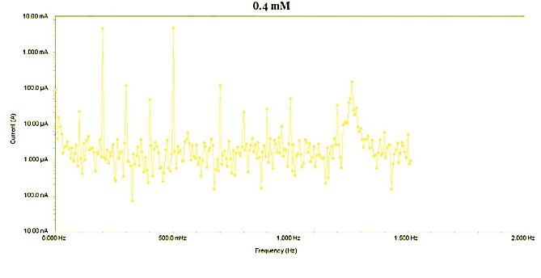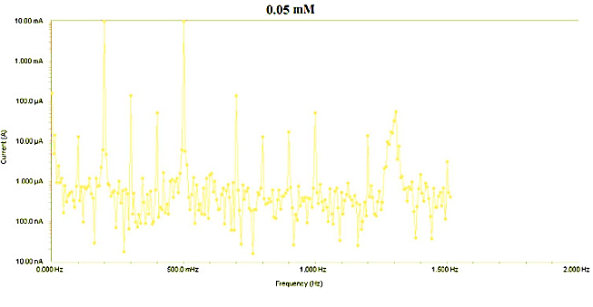
Figure 16. EFM spectra of mild steel in 1 M HCl in the absence and presence of different concentrations of the azelaic acid dihydrazide corrosion inhibitor [49].
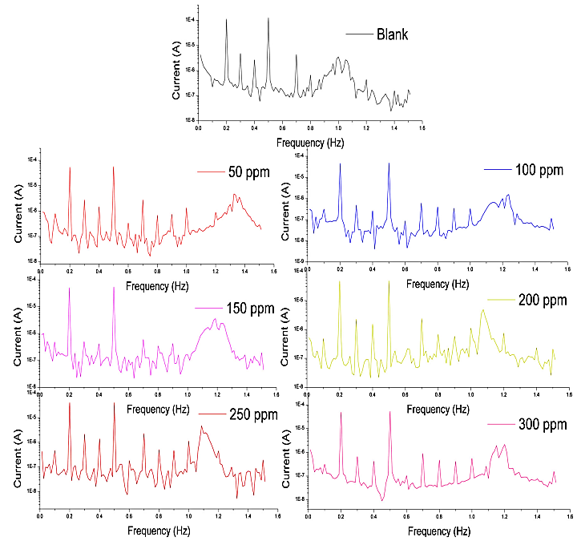
Figure 17. EFM spectra for C-steel in 1 M HCl in the absence and presence of various concentrations of Modazar drug [50].

Therefore, EFM studies are also supported for phytochemicals of the plant extracts which are used as an inhibitor for the metals for quickly determining the corrosion current value without preliminary information of Tafel slopes.
3.3.5. Fourier-transform infrared spectroscopy (FT-IR). It is an advantageous method for identifying functional groups in plant extracts. It helps with molecular identification and structural characterization. FT-IR is a high-resolution analytical approach for detecting chemical components and determining structural compounds [13]. For illustration, the Neolamarckia cadamba extract (Figure 18) as an eco-friendly corrosion inhibitor for mild steel in 1 M HCl media described the FT-IR spectra of the uncontaminated alkaloid which revealed a phytochemical like 3β-isodihydrocadambine and, a scraped shielding layer was seen over the mild steel surface. Three-isodihydrocadambine's FT-IR spectra revealed peaks that might be attributed to O-H, N-H stretches, N-H bends, the carbonyl group of a methyl ester, and aromatic C=C stretches (indole moiety). Spectra of the protective film show a shift in the carbonyl peak combined with the N-H bending peak and with the aromatic C=C peak to produce a wide absorption group. These findings revealed that the aromatic indole moiety, as well as carbonyl bands of 3β-isodihydrocadambine phytochemicals, might have a role in metal deterioration reduction [22]. The FT-IR spectrum of isoreserpiline as well as its scratched protective film formed over mild steel using the Potassium Bromide (KBr) pellet method are shown in Figure 19 for the Ochrosia oppositifolia and its phytochemical-like isoreserpiline as a green corrosion inhibition against mild steel in a 1M HCl medium. The FT-IR spectra of the phytochemical isoreserpiline and its protective layer demonstrated that the phytochemical isoreserpiline is adsorbed on the mild steel surface, protecting it from strong acid corrosion. This suggested that the lone pair electrons of the N-H group (pyrrole ring) and the π-electron clouds of the phenyl ring play a role in the isoreserpiline's coordination with the mild steel surface. As a result, the FT-IR studies have made it possible to detect the active coordination sites in multi-ring molecules [26].
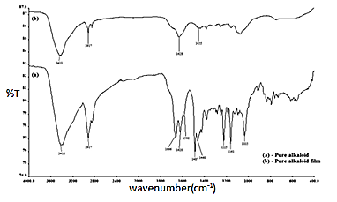
Figure 18. FT-IR absorption spectra for (a) 3b-isodihydrocadambine, and (b) protective film formed by 3b-isodihydrocadambine [22].

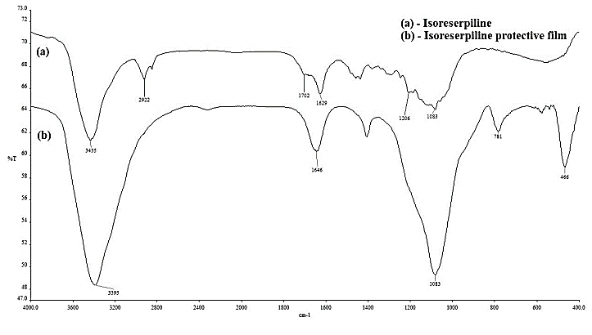
Figure 19. FT-IR absorption spectra for(a) Isoreserpiline and (b) protective film formed by Isoreserpiline [26].

3.4. Ultraviolet-Visible Spectroscopy (UV-Vis). UV-vis spectroscopy is used to analyze qualitatively and identify particular sorts of compounds in both pristine and biological mixtures. When compared to other approaches, this one takes less time and costs less money. UV–Visible absorption spectroscopy is a good tool for identifying complex ions in solution, and a shift in the absorption maximum specifies the development of a complex between two species in solution [30]. Similarly, UV-visible absorbance of Catharanthus roseus extract in 3.5% NaCl solution (Figure 20) shows the π–π* absorption due to flavonoid active species, with peaks at 380 and 350nm before immersion of mild steel. But, the absorption wavelength of Catharanthus roseus extracts reduced from 350nm to 330nm after immersion of mild steel specimen for about 24 hrs. The reason might be attributable to bisindole chemisorption on the antithetical Mild Steel surface. The strong assimilation group of the stalk segregate at 380 nm is linked to the electrical transition among the π–π* and n–π* levels. The synergy of polyphenolic blends on the Mild Steel surface causes the assimilation groups from each extract to differ significantly from those from isolated phytochemicals. The adsorption of extract molecules on the mild steel surface is supported by UV-vis absorption spectroscopy [31]. The absorption band at 200nm - 215nm was formed by the n–π* and π–π* transitions, which described the amine groups, ester, and carboxyl. Most conjugated molecules in aromatic and poly-aromatic compounds had π–π* electron transitions, which were associated with the other absorption band around 260nm–280nm. When they compared the UV-Vis spectrum of Radish Leaf Extract (which contains phytochemicals like O-Coumaric acid, Folic acid, Ascorbic acid, and Catechin) (Figure 21) to the UV-Vis spectrum of mild steel immersed solution containing radish leaf extract, they noticed a blue shift in absorbance peaks, indicating the formation of a complex between the extract molecules and Fe²⁺ ions [32].
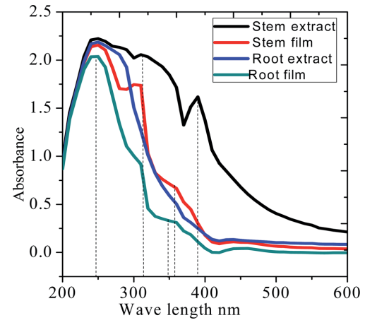
Figure 22. UV-vis absorption spectra of the Catharanthus roseus extract before and after Mild Steel immersion in 3.5% NaCl [31].
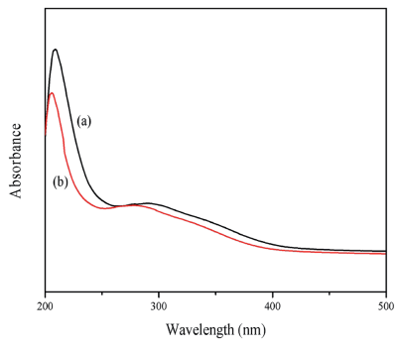
Figure 23. UV-vis spectra of Radish Leaf Extract (containing phytochemicals like O-Coumaric acid, Ascorbic acid, Folic acid, and Catechin,) (a) before and (b) after immersion of mild steel in 0.5 M H₂SO₄ [32].

4. SUMMARY AND CONCLUSION
In this review article, phytochemicals from the natural plant extracts as an eco-friendly inhibitor in the field of corrosion inhibition systems are surveyed. All types of inhibitors, such as drugs, chemical compounds, ionic liquids, Surfactants, natural polymers, natural oils, and plant extracts, have already been applied where their non-toxicity has been indirectly confirmed. All types of inhibitors utilized resulted in a reduction in corrosion rate but to various degrees.
Table 2: Comparative analysis of different types of corrosion inhibitors
Inhibitor | Inhibition efficiency (%) | Environmental effect
Chemical compounds | 80% - 98% | Comparatively higher
Lanthanide salts | 87.53% - 98.21% | Comparatively higher
Ionic liquids | 79% - 99% | Low
Drugs | 94% - 97% | Low
Plant extracts | 87% - 95% | Negligible
Phytochemicals | >90% | Negligible

Plant extracts are considered a great eco-friendly replaceable source for noxious and overpriced inhibitors. Different plant parts (bark, stem, root, seeds, fruits, and leaves) are suitable for the inhibition process. These extracts are enriched with different types of phytochemicals that protect the metal surface by forming the thin film layer after adsorption. Plant extracts contain a variety of phytochemical components, but only a few specific phytochemical components are responsible for metal protection, which may be determined by using instruments like GC-MS. According to certain research, phytochemicals derived from plant extracts are commercially accessible as corrosion inhibitors. Among the different phytochemicals that stimulate the adsorption process (e.g., organic acids, flavonoids, catechins, alkaloids, and co-enzymes), phenolic compounds are the most effective. However, because they contain varying types and quantities of phytochemicals, their inhibitory efficacy varies. Plant extracts have corrosion IE of more than 60%, with the majority of them at 80–90%. The most difficult task is to create an extract or isolate the primary component with a better than 90% inhibitory efficiency. We saw an increase in corrosion resistance when we used the phytochemicals from the plant extraction and easily know the component behind that process to take place. According to a literature review, many extracts have lately been evaluated as metal deterioration inhibitors in acidic environments. However, there are data on the non-corrosive impact of plant extracts in aqueous-oriented electrolytes. Therefore, it is necessary to research the use of extracts as inhibitors of metal degradation. When assessing a plant extract as a corrosion inhibitor, it's possible to look into factors including concentration, extraction solvent, temperature, and time of immersion. Electrochemical techniques (Electrochemical Impedance study, Potentiodynamic polarisation, and Electrochemical Frequency Modulation) and studies like Gravimetric method, Scanning Electron Microscope, X-ray Diffraction, X-ray photoelectron spectroscopy, Atomic Force Microscopy, Gas Chromatography-Mass Spectroscopy, Nuclear Magnetic Resonance spectroscopy, Fourier transfer Infrared spectroscopy, Ultraviolet-Visible Spectroscopy were evaluated.
Despite suffering from some shortcomings, specific compounds can be isolated and studied, intending to produce them in the large quantities required for the industry.
REFERENCES
[1] Chandrabhan Verma, Eno E. Ebenso, Indra Bahadur, M.A. Quraishi, An overview on plant extracts as environmental sustainable and green corrosion inhibitors for metals and alloys in aggressive corrosive media. Molliq (2018), doi: 10.1016/j.molliq.2018.06.110.
[2] S. Sharma and A. Kumar, Recent advances in metallic corrosion inhibition: A review, Journal of Molecular Liquids (2020), https://doi.org/10.1016/j.molliq.2020.114862.
[3] HongyuWei, B. Heidarshenas, L. Zhou, G. Hussain, Q. Li, K. (K.) Ostrikov, Green Inhibitors for Steel Corrosion in Acidic Environment: State-of-art, Materials Today Sustainability, https://doi.org/10.1016/j.mtsust.2020.100044.
[4] 4 S.H. Alrefaee, K.Y. Rhee, C. Verma, et al., Challenges and advantages of using plant extract as inhibitors in modern corrosion inhibition systems: Recent advancements, Journal of Molecular Liquids (2020), https://doi.org/10.1016/j.molliq.2020.114666.
[5] Saxena, Akhil, Dwarika Prasad, and Rajesh Haldhar. "Use of Asparagus racemosus extract as green corrosion inhibitor for mild steel in 0.5 MH 2 SO 4." Journal of materials science 53, no. 11 (2018): 8523-8535.
[6] Loto, Cleophas A., Roland T. Loto, and Ohwofasa J. Oshogbunu. "Corrosion inhibition effect of Allium sativum extracts on mild steel in HCl and H₂SO₄." Journal of Chemical and Pharmaceutical Research 8, no. 2 (2016): 216-230.
[7] Yüce, Ayşe Ongun. "Corrosion inhibition behavior of Robinia pseudoacacia leaves extract as a eco-friendly inhibitor on mild steel in acidic media." Metals and Materials International 26, no. 4 (2020): 456-466.
[8] Pourzarghan, Vahid, and Bahman Fazeli-Nasab. "The use of Robinia pseudoacacia L fruit extract as a green corrosion inhibitor in the protection of copper-based objects." Heritage Science 9, no. 1 (2021): 1-14.
[9] Chen, Shujun, Siyi Chen, Bin Zhu, Chibao Huang, and Wenpo Li. "Magnolia grandiflora leaves extract as a novel environmentally friendly inhibitor for Q235 steel corrosion in 1 M HCl: Combining experimental and theoretical researches." Journal of Molecular Liquids 311 (2020): 113312.
[10] Ji, Gopal, Sudhish Kumar Shukla, Priyanka Dwivedi, Shanthi Sundaram, Eno E. Ebenso, and Rajiv Prakash. "Parthenium hysterophorus plant extract as an efficient green corrosion inhibitor for mild steel in acidic environment." International Journal of Electrochemical Science 7, no. 10 (2012): 9933-9945.
[11] Rajesh Haldhar, Dwarika Prasad, Akhil Saxena, Myristica fragrans Extract as an Eco-friendly Corrosion Inhibitor for Mild Steel in 0.5x202f;M H₂SO₄ Solution, Journal of Environmental Chemical Engineering https://doi.org/10.1016/j.jece.2018.03.023.
[12] Zhang, Qing-Wen, Li-Gen Lin, and Wen-Cai Ye. "Techniques for extraction and isolation of natural products: A comprehensive review." Chinese medicine 13, no. 1 (2018): 1-26.
[13] Altemimi, Ammar, Naoufal Lakhssassi, Azam Baharlouei, Dennis G. Watson, and David A. Lightfoot. "Phytochemicals: Extraction, isolation, and identification of bioactive compounds from plant extracts." Plants 6, no. 4 (2017): 42.
[14] Chauhan, Ashish, Manish Kumar Goyal, and Priyanka Chauhan. "GC-MS technique and its analytical applications in science and technology." J. Anal. Bioanal. Tech 5, no. 6 (2014): 222.
[15] MR, Lakshmi HimaBindu, and C. Gopinath. "A review on GC-MS and method development and validation. " International Journal of Pharmaceutical Quality Assurance 4, no. 03 (2013): 42-51.
[16] Pitchaipillai, Muthukrishnan, Karthik Raj, Jeyaprabha Balasubramanian, and Prakash Periakaruppan. "Benevolent behavior of Kleinia grandiflora leaf extract as a green corrosion inhibitor for mild steel in sulfuric acid solution." International Journal of Minerals, Metallurgy, and Materials 21, no. 11 (2014): 1083-1095.
[17] Bhuvaneswari, T. K., V. S. Vasantha, and C. Jeyaprabha. "Pongamia pinnata as a green corrosion inhibitor for mild steel in 1N sulfuric acid medium." Silicon 10, no. 5 (2018): 1793-1807.
[18] Lebrini, M., F. Robert, A. Lecante, and C. Roos. "Corrosion inhibition of C38 steel in 1M HCl medium by alkaloids extract from Oxandra asbeckii plant." Corrosion science 53, no. 2 (2011): 687-695.
[19] Emori, Wilfred, Run-Hua Zhang, Peter C. Okafor, Xing-Wen Zheng, Tao He, Kun Wei, Xiu-Zhou Lin, and Chun-Ru Cheng. "Adsorption and corrosion inhibition performance of multi-phytoconstituents from Dioscorea septemloba on carbon steel in acidic media: Characterization, experimental and theoretical studies." Colloids and Surfaces A: Physicochemical and Engineering Aspects 590 (2020): 124534.
[20] Mehdipour, M., B. Ramezanzadeh, and S. Y. Arman. "Electrochemical noise investigation of Aloe plant extract as green inhibitor on the corrosion of stainless steel in 1 M H2SO4." Journal of Industrial and Engineering Chemistry 21 (2015): 318-327.
[21] Li, Yan, Peng Zhao, Qiang Liang, and Baorong Hou. "Berberine as a natural source inhibitor for mild steel in 1 M H₂SO₄." Applied Surface Science 252, no. 5 (2005): 1245-1253.
[22] Raja, Pandian Bothi, Ahmad Kaleem Qureshi, Afidah Abdul Rahim, Hasnah Osman, and Khalijah Awang. "Neolamarckia cadamba alkaloids as eco-friendly corrosion inhibitors for mild steel in 1 M HCl media." Corrosion Science 69 (2013): 292-301.
[23] Garai, Subhadra, Saraswati Garai, Parasuraman Jaisankar, J. K. Singh, and Adirajan Elango. "A comprehensive study on crude methanolic extract of Artemisia pallens (Asteraceae) and its active component as effective corrosion inhibitors of mild steel in acid solution." Corrosion Science 60 (2012): 193-204.
[24] Loganayagi, C., C. Kamal, and M. G. Sethuraman. "Opuntiol: An active principle of Opuntia elatior as an eco-friendly inhibitor of corrosion of mild steel in acid medium." ACS Sustainable Chemistry & Engineering 2, no. 4 (2014): 606-613.
[25] Ajeigbe, S. O., N. Basar, H. Maarof, A. M. Al-Fakih, M. A. Hassan, and M. Aziz. "Evaluation of Alpinia galanga and its active principle, 1'-acetochavicol acetate as eco-friendly corrosion inhibitors on mild steel in acidic medium." J. Mater. Environ. Sci 7 (2017): 2040-2049.
[26] Raja, Pandian Bothi, Mehran Fadaeinasab, Ahmad Kaleem Qureshi, Afidah Abdul Rahim, Hasnah Osman, Marc Litaudon, and Khalijah Awang. "Evaluation of green corrosion inhibition by alkaloid extracts of Ochrosia oppositifolia and isoreserpiline against mild steel in 1 M HCl medium." Industrial & Engineering Chemistry Research 52, no. 31 (2013): 10582-10593.
[27] Muthukrishnan, P., P. Prakash, B. Jeyaprabha, and K. Shankar. "Stigmasterol extracted from Ficus hispida leaves as a green inhibitor for the mild steel corrosion in 1 M HCl solution." Arabian Journal of Chemistry 12, no. 8 (2019): 3345-3356.
[28] Haldhar, Rajesh, Dwarika Prasad, Akhil Saxena, and Priyanka Singh. "Valeriana wallichii root extract as a green & sustainable corrosion inhibitor for mild steel in acidic environments: experimental and theoretical study." Materials Chemistry Frontiers 2, no. 6 (2018): 1225-1237.
[29] Prabakaran, Mayakrishnan, Seung-Hyun Kim, Asokan Sasireka, Venkatesan Hemapriya, and Ill-Min Chung. "β-Sitosterol isolated from rice hulls as an efficient corrosion inhibitor for mild steel in acidic environments." New Journal of Chemistry 41, no. 10 (2017): 3900-3907.
[30] Nazari, Mehdi Honarvar, Mehdi Salih Shihab, Eden Adele Havens, and Xianming Shi. "Mechanism of corrosion protection in chloride solution by an apple-based green inhibitor: experimental and theoretical studies." Journal of infrastructure preservation and Resilience 1, no. 1 (2020): 1-19.
[31] Palaniappan, N., Ivan Cole, F. Caballero-Briones, S. Manickam, KR Justin Thomas, and Danilo Santos. "Experimental and DFT studies on the ultrasonic energy-assisted extraction of the phytochemicals of Catharanthus roseus as green corrosion inhibitors for mild steel in NaCl medium." RSC Advances 10, no. 9 (2020): 5399-5411.
[32] Li, Dongyi, Panpan Zhang, Xinyu Guo, Xiaowei Zhao, and Ying Xu. "The inhibition of mild steel corrosion in 0.5 M H2SO4 solution by radish leaf extract." RSC Advances 9, no. 70 (2019): 40997-41009.
[33] Faiz, Mas, Azeana Zahari, Khalijah Awang, and Hazwan Hussin. "Corrosion inhibition on mild steel in 1 M HCl solution by Cryptocarya nigra extracts and three of its constituents (alkaloids)." RSC Advances 10, no. 11 (2020): 6547-6562.
[34] Manpreet Kaur Bagga, Ranu Gadi, Ompal Singh Yadav, Raman Kumar, Rashi Chopra, Gurmeet Singh, Investigation of phytochemical components and corrosion inhibition property of Ficus racemosa stem extract on Mild steel in H2SO4 medium, Journal of Environmental Chemical Engineering http://dx.doi.org/10.1016/j.jece.2016.10.022.
[35] Anupama, K. K., K. Ramya, K. M. Shainy, and Abraham Joseph. "Adsorption and electrochemical studies of Pimenta dioica leaf extracts as corrosion inhibitor for mild steel in HCl." Materials Chemistry and Physics 167 (2015): 28-41.
[36] Chen, Shujun, Siyi Chen, Bin Zhu, Chibao Huang, and Wenpo Li. "Magnolia grandiflora leaves extract as a novel environmentally friendly inhibitor for Q235 steel corrosion in 1 M HCl: Combining experimental and theoretical researches." Journal of Molecular Liquids 311 (2020): 113312.
[37] Bhuvaneswari T. K., Jeyaprabha C. & Arulmathi P. (2020): Corrosion inhibition of mild steel in HCl by leaves extract of Tephrosia purpurea, Journal of Adhesion Science and Technology, DOI: 10.1080/01694243.2020.1766395.
[38] Khan, Merajuddin, Mahmood Abdullah, Adeem Mahmood, Abdullah M. Al-Mayouf, and Hamad Z. Alkhathlan. "Evaluation of Matricaria aurea extracts as effective anti-corrosive agent for mild steel in 1.0 M HCl and isolation of their active ingredients." Sustainability 11, no. 24 (2019): 7174.
[39] Barbouchi, Mohammed, Bouchra Benzidia, Adnane Aouidate, Adib Ghaleb, and Mostafa El Idrissi. "Theoretical modeling and experimental studies of Terebinth extracts as green corrosion inhibitor for iron in 3% NaCl medium." Journal of King Saud University-Science 32, no. 7 (2020): 2995-3004.
[40] Prabakaran, Mayakrishnan, Seung-Hyun Kim, Young-Tak Oh, Vairamuthu Raj, and Ill-Min Chung. "Anticorrosion properties of momilactone A isolated from rice hulls." Journal of Industrial and Engineering Chemistry 45 (2017): 380-386.
[41] Dehghani, Ali, Ghasem Bahlakeh, and Bahram Ramezanzadeh. "Green Eucalyptus leaf extract: a potent source of bio-active corrosion inhibitors for mild steel." Bioelectrochemistry 130 (2019): 107339.
[42] Júnior, José Milton Ferreira, MG Vasconcelos Silva, Jackelyne Alve Monteiro, A. S. Barros, Maria Jose Cajazeiras Falcão, and Selene Maia de Morais. "Evaluation of antioxidant activity and inhibition of corrosion by Brazilian plant extracts and constituents." Int. J. Electrochem. Sci 11 (2016): 3862-3875.
[43] Ngouné, Bertrand, Martin Pengou, Armel Megha Nouteza, Charles Peguy Nanseu-Njiki, and Emmanuel Ngameni. "Performances of alkaloid extract from Rauvolfia macrophylla Stapf toward corrosion inhibition of C38 steel in acidic media." ACS omega 4, no. 5 (2019): 9081-9091.
[44] Suedile, Fabienne, Florent Robert, Christophe Roos, and Mounim Lebrini. "Corrosion inhibition of zinc by Mansoa alliacea plant extract in sodium chloride media: extraction, characterization and electrochemical studies." Electrochimica Acta 133 (2014): 631-638.
[45] Anupama, K. K., K. Ramya, and Abraham Joseph. "Electrochemical and computational aspects of surface interaction and corrosion inhibition of mild steel in HCl by Phyllanthus amarus leaf extract (PAE)." Journal of Molecular Liquids 216 (2016): 146-155.
[46] Karthik, R., P. Muthukrishnan, Shen-Ming Chen, B. Jeyaprabha, and P. Prakash. "Anti-corrosion inhibition of mild steel in 1M HCl solution by using Tiliacora accuminata leaves extract." Int. J. Electrochem. Sci 10 (2015): 3707-3725.
[47] Abboud, Y., O. Tanane, A. El Bouari, R. Salghi, B. Hammouti, A. Chetouani, and S. Jodeh. "Corrosion inhibition of carbon steel in HCl solution using pomegranate leave extracts." Corrosion Engineering, Science and Technology 51, no. 8 (2016): 557-565.
[48] Li, Hao, Yujie Qiang, Wenjie Zhao, and Shengtao Zhang. "A green Brassica oleracea L extract as a novel corrosion inhibitor for Q235 steel in two typical acid media." Colloids and Surfaces A: Physicochemical and Engineering Aspects 616 (2021): 126077.
[49] Al-Amiery, Ahmed A., Fatin A. Binti Kassim, Abdul Amir H. Kadhum, and Abu Bakar Mohamad. "Synthesis and characterization of a novel eco-friendly corrosion inhibition for mild steel in 1 M HCl." Scientific reports 6, no. 1 (2016): 1-13.
[50] A. S Fouda, G. El-Ewady & A. H. Ali (2017) Modazar as promising corrosion inhibitor of carbon steel in HCl solution, Green Chemistry Letters and Reviews, 10:2, 88-100, DOI: 10.1080/17518253.2017.1299228.

