IRRIGATION
By: Alisha Ray, S.B. Jasmine, Bismaya Ranjan Singh, Ankita Senapati
rayalisha683@gmail.com
C V Raman Global University, Mahura, Bhubaneswar, 752054
Abstract:

Precipitation in India has fluctuated widely throughout time and space, from 11000 millimeters to 90 millimeters. Annual per capita water availability has dropped from 1950's 5,000 cubic meters to 2011's 1,545 cubic meters, and is projected to drop even lower to 2025's 1,341 cubic meters and 2050's 1,140 cubic meters. More than 90 percent of all groundwater flow is used for irrigation, and the agriculture industry accounts for 54.6% of all jobs in a rapidly expanding population. Because of its independence and ready availability, groundwater has gradually replaced surface water as the primary source of irrigation. The water table has dropped between TE2002 and TE2016 in 64% of the country due to the excessive use of groundwater. The total amount of surface and ground water that has been irrigated has climbed to 87 Mmean thanks to the efforts of all levels of government, while the total amount of water that can be irrigated has reached 140 Mha. In 2015, the government consolidated all active irrigation programs into one program called Pradhan Mantri Krishi Sinchayee Yojana (PMKSY), of which micro irrigation is a key part.

Introduction:

Water is the most precious resource for all living things on Earth, including humans, animals, and plants. Water is essential for all forms of life on Earth. Hydrogen and oxygen combine to make water as a material in the chemical world. Water is a colorless, odorless liquid that has no taste. It is essential for photosynthesis and the movement of nutrients throughout the plant.

Definition:

Irrigation refers to the practice of artificially applying water to soil in order to provide the moisture necessary for plant growth.
Around 5,500 B.C., the ancient Sumerians, who lived in what is now Iraq, developed the first system of irrigation. The home use and the need to save crops during drought spurred the development of the irrigation system. The Nile valley in Egypt, the Indus valley in India and Pakistan, and the Huang He valley in China are just a few examples of major river valleys that were home to thriving ancient civilizations.

Scenario Worldwide: • Numerous excavations have shown evidence that barley was irrigated in Mesopotamia, Egypt, and Iran as early as the sixth millennium B.C.
Archaeologists used radiocarbon dating to determine that three irrigation canals, originally dated to the 4th millennium bc, the 3rd millennium bc, and the 9th century bc, were still in use.
• According to the International Commission on Irrigation and Drainage's Annual Report 2014–15, around 300 million hectares of land is actually being irrigated out of a total of 318 million hectares that are capable of being irrigated.

Indian Scenario:

Irrigation in India has a long and storied history that dates back to ancient times. The Vedas and other ancient Indian texts also provide a definition of irrigation.
• Many ancient cultures prospered near rivers because they figured out how to use the water there to their advantage.
Wells, canals, tanks, and dams were all useful in the ancient world to make irrigation possible.
• In India, there are three different levels of irrigation projects: major, medium, and minor.
Major projects are those with a Cultivable Command Area (CCA) of at least 10,000 ha, medium projects are those with a CCA of between 5,000 ha and 10,000 ha, and small irrigation projects are those with a CCA of 2,000 ha or less.

Types of Irrigation Technique:

In general, the goal is to supply the entire field uniformly with water, so that each plant has the amount of water it needs, neither too much nor too little. The various irrigation techniques are as under:

Surface irrigation:

  - When the water is distributed or supplied over the soil surface by gravity is known as the surface irrigation.

  - It is the most common irrigation technique which is used by most of the farmers in their field. It is also known as Flood irrigation.
  - Advantages: They have relatively low energy requirements in routine operations. This type of irrigation technique can be developed at the farm level with minimum investment.
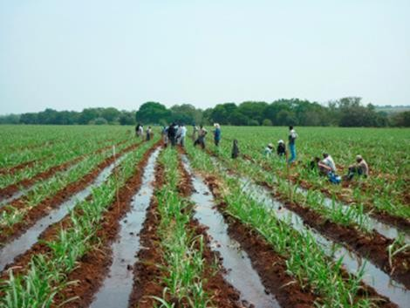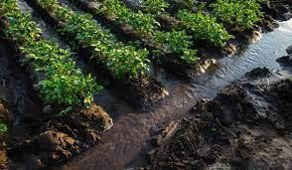

a). Border irrigation  - The land is divided into number of long parallel strips called borders.  - These borders are separated by low ridges.  - The border strip has a uniform gentle slope in the direction of irrigation.  - Each strip is irrigated independently by turning the water in the upper end.  - The water spreads and flows down the strip in a sheet confined by the border ridges. | 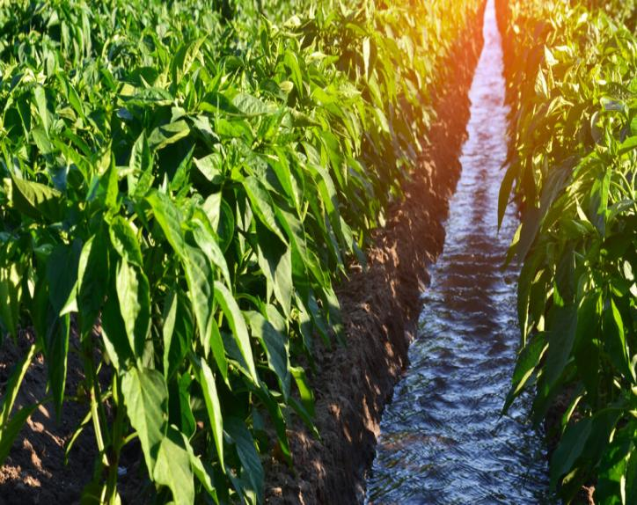

b).Check basin irrigation
  - It is the most common method.
  - Here the field is divided into smaller unit areas so that each has a nearly level surface.
  - Bunds or ridges are constructed around the area forming basins within which the irrigation water canbecontrolled.
  - The water applied to a desired depth can be retained until it infiltrates into the soil.
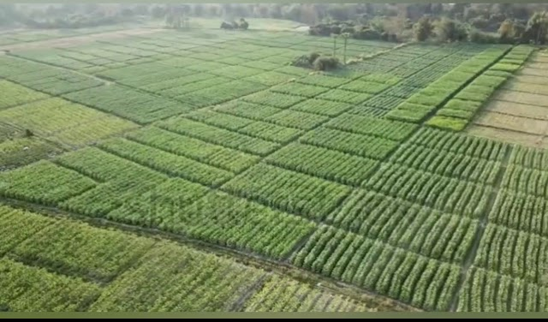
  - The size of the basin varies from 10m2 to 25 m2 depending upon soil type , topography, stream size and crop.

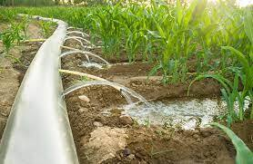
C). Furrow irrigation
  - Used in the irrigation of row crops.
  - The furrows are formed between crop rows.
  - The dimension of furrows depend on the crop grown,
equipment used and soil type.
  - Water is applied by small running streams in furrows
between the crop rows.
  - Water infiltrates into soil and spreads laterally to wet the area between the furrows.
  - In heavy soils furrows can be used to dispose the excess water.

Subsurface irrigation/Subsoil Irrigation:

  - 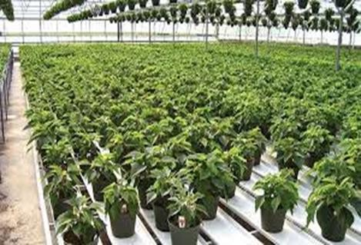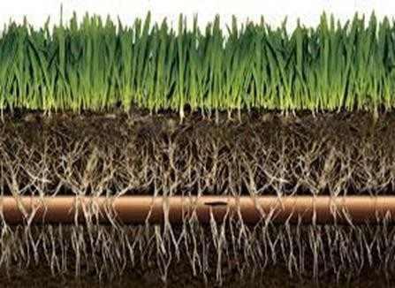Water gradually wets the root zone by capillary movement through subterranean perforated pipes and deep ditches at 15-30 m intervals.

Sprinkler irrigation:

  - Sprinkler irrigation is also known as the Overhead irrigation. Application of irrigation water is similar to natural rainfall.
  - Water is sprayed into the air through sprinklers. This type of irrigation system is mostly suitable for the row, field and tree crops.
  - Advantages : Water is applied in a consistent manner. Water savings ranging from 25% to 50% for various crops.There is no risk of runoff or erosion.
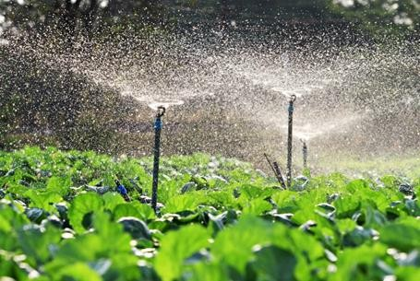
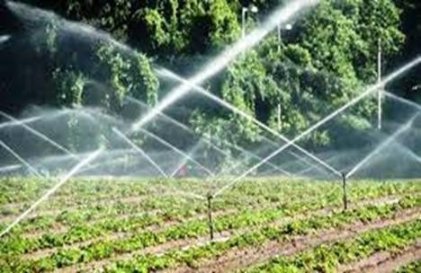

Drip irrigation:

  - Simcha Blass discovered drip irrigation in Israel, and the water flow rate per dripper is typically 1-4 lit/hr & the water diffuses through the soil due to capillary action.
  - The main pipeline, submains, laterals, and emitters are all part of it. Drip irrigation is also known as Trickle irrigation.
  - Advantages: No land levelling is required. It can save up to 70% of water and even more. Herbicides and fertilizers are applied to the crop by solublising into the irrigation water.

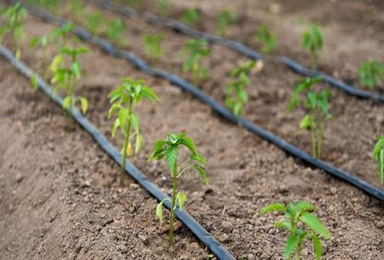
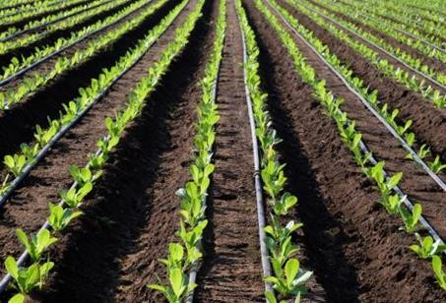

Sources of Irrigation:

  - Various sources of irrigation in India are canals, tanks , tube wells and other wells, with tube wells and canals together accounting for about 70 % of total irrigation.
  - Compared to 2001-02, irrigation during 2012-13, through tube wells has increased by about 31% whereas that through tanks has declined by about 20%.There has been 16 % increase in net irrigated area during the period.
  - Irrigation through canals hah increased by meager 3 % . Private canals accounted for only 1 % share as most of the canals are government owned.
  - Among major states, canal irrigation is more popular in Tamil Nadu, Kerala , J& K and Chhattisgarh over irrigation through Tube Wells.
  - Whereas in Northern states of Punjab, Rajasthan, Bihar , UP etc share of tube wells in irrigation is significantly higher.

Irrigated Area Under Crops (2011-12) :

  - There has been about 18% increase in total gross area under irrigation since 2001-02 with about 92.6 million hectares being irrigated in 2012-13 compared to about 78. million hectares in 2001-02.
  - During the period, Food crops have accounted for about 82-84 % of gross irrigated area under all crops.
  - Amongst about 18% gross irrigated area under non food crops, oilseeds, cotton and fodder crops accounted for 8-9 % , 3-4 % and 3 % respectively.

Conclusion:
Irrigation from groundwater has grown to become the primary form of water supply in India. On the other hand, there is a significant disparity between the total potential of surface water and how much of it is actually used. Because of the ongoing depletion of available water per person combined with the extraction of groundwater, it is now absolutely necessary to move to more water-efficient technologies and alternate sources of irrigation, such as canal water and rainwater gathering.
◆ If the current pattern of water usage is not changed, there is likely to be a water crisis in the not-too-distant future due to the rapid depletion of water tables, the inefficiency of irrigation, and the occurrence of regular droughts. In order to make use of runoff water, the infrastructure for irrigation needs to be upgraded even more so that it can collect rainwater and expand its capacity for storage. There is potential for up to a 90 percent increase in irrigation efficiency with the use of microirrigation.
◆ In addition, microirrigation and developing an optimal crop plan will each play a significant role in the nation's efforts to preserve its water resources and maintain its level of food security.
◆ The commerce of virtual water need to be balanced, rather than geared toward exporting virtual water. Farmers in states where there is a shortage of resources should be educated about the many programs offered by the government to help them realize their full potential.
References:
- Central Water Commission (CWC) 2017. Reassessment of Water Availability in India Using Space Inputs. Basin
- Dhawan, B. D. 2002. Technological change in Indian irrigated agriculture: A study of water saving methods. Commonwealth Publishers, New Delhi.
- Central Groundwater Board (CGWB) 2017. Dynamic Ground water resources of India, Ministry of Water Resources. River Development and Ganga Rejuvenation Government of India, Faridabad.

- Central Water Commission (CWC) 2015. Water and related statistics. Directorate of Information System Organisation, water planning and projects wing Report, New Delhi.

