Mechanical Behaviour of Natural Fibre Reinforced Composites with Fly-Ash Modified Matrices

Satya Ranjan Patnaik
Department Of Mechanical Engineering, ABIT, Cuttack,
Odisha.
satyaranjan.patnaik@gmail.com
Krutibash Khuntia
Dept. of Mechanical Engineering, Synergy Institute of Technology, Bhubaneswar
Odisha, krutibash4u@gmail.com

Abstract: The development of natural fibre reinforced polymer composites has gained popularity in many applications due to their environment friendly characteristics over the synthetic fibre based polymer composites. Among various fibres, jute is most widely used natural fibre due to its advantages like easy availability, low cost, low density, low production cost and satisfactory mechanical properties. The objective of the present research work is based on the study of the mechanical behaviour of jute fibre reinforced epoxy composites filled with fly-ash as the filler. The jute fibre epoxy composites were prepared by varying the fibre contents of (0, 5, 10, 15 and 20) wt% along with filler contents of 2 wt% respectively, by using simple hand lay-up technique. The jute fibres were used without any alkali treatment in the epoxy composites and length of the fibres were 6mm. The fly-ash used was of the size of 0.5 to 300 micron. The prepared composites were tested to investigate the mechanical properties of the composite such as tensile strength, impact strength, hardness and water absorption test. The results are compared with the 0% fibre reinforced composite.
Keywords: Polymer composites, jute fibre, hand lay-up, fly-ash fillers, Mechanical properties.
- INTRODUCTION
Green composite with resin matrix and natural fibres as reinforcements are used for many experiments. Natural fibres like coconut shell [1], Jute [2,4] Satin fibre [9], Wooden flour [15] are used because they are light and strong. Recent developments in composites [6] shows they have different uses like Ecological design of automobile [4], oxygen resistant materials [17], electrical insulation and thermal conductivity materials [16] and many others. Previous developments on composite shows the use of artificial fibres like cellulose blast fibre [8], carbon fibres [9,10,11,12] glass tubes[16].The use of biodegradable resin shows no negative effect on environment because the end product will be co₂ and water. To increase the strength of composite further and to fill the voids nano-fillers such as flyash [1], Zno and Tio₂ [2], graphite nano-platelets [10] are used.
The composite does not have any negative impact on environment because its main component is jute fibre extracted from natural jute after processing [2]. The wastes of jute can also be used effectively to produce composite increasing its economic value. For complicated shapes compression moulding can be used. Further-more a proper binder is required to increase the strength of the composite, water resistance, brittleness. So to solve this issue we used biodegradable resin [1-3]. For reinforced fibre we used jute fibre due to advantages like easy availability, low cost and satisfactory mechanical properties. Therefore this project is environment friendly and saves resources by utilising waste materials.
In this study, by using flyash with uniform particle size, jute fibers with uniform length and the biodegradable adhesive, several specimens were created by changing the ratio of those materials.Specimens were produced by using compression moulding at the room temperature. With regard to our natural composite, small quantities ofbiodegradable resin is used and the matrix consists of the resin with a mixture of fly-ash. The biodegradable resin is coated on jute to improve the water resistance and is also used to strengthen the adhesion of jute to improve the strength. The mechanical properties of the composite are evaluated through the effects of the biodegradable adhesive and jute fibres on the change in hardness and impact strength. Therefore Tensile strength test, Charpy impact test, Rockwell hardness test made under some conditions were examined. In addition the specimens water absorption capacity was examined. From the experimental results, the effect of adhesive and jute fibre on the total strength of the proposed composite were clarified.

II. EXPERIMENTAL INVESTIGATIONS
A. Composite Fabrication
According to Standards, we are making the mould box of 165×60×10 mm dimension. The mould box was made using plywood as a base surface and 10mm wood pieces as the side boundary. Using berger putty, the surface of the mould box was covered to prevent the leakage of the epoxy resin. The mould box is shown below.

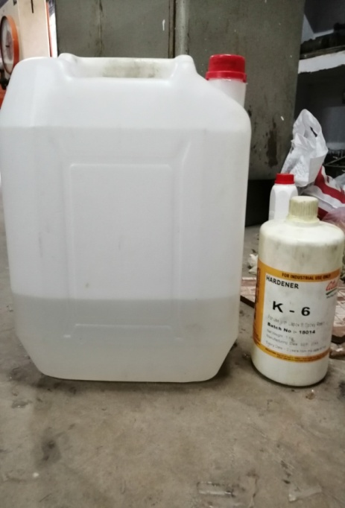
Fig.1 Mould Box Epoxy Resin and Hardener

A releasing agent or mould spray is used to facilitate easy removal of the composite from the mould after curing. Then the epoxy B11 and the corresponding hardener k6 are mixed in the ratio of 10:1 by weight as recommended by Atul Chemcials Pvt. Ltd.. After that the filler and fibres are mixed thoroughly in the epoxy resin to minimize the air entrapment. Composites of various compositions with different fibre content of (5, 10, 15 and 20) wt% were prepared along with filler content of 2 wt% respectively. The mould is then covered and 5kg of load is applied over it. The set-up is left to cure for 24 hours at room temperature. This cast is then post cured in the air for another 24 h after removing out of the mould. Finally, the specimens of suitable dimension have been prepared as per ASTM standard for different mechanical test. The detail designation and composition of composites are given in below.
Rule of mixture: The rule of mixture was used for the calculation of different fibre percentage for the composite.
$W_{f}=\frac{w_{f}}{w_{c}}$
And $ρ_{c}=\frac{1}{\frac{W_{f}}{ρ_{f}}+\frac{W_{m}}{ρ_{m}}+\frac{W_{n}}{ρ_{n}}}$

The volume fraction of fibre has been calculated by rule of mixture.

Table 1
Composition of Composites
Composites | Epoxy resin(wt%) | Fibre (wt%) | Fly ash (wt%)
C1 | Epoxy (93 wt%) | jute fiber length 6mm (5wt%) | 2%
C2 | Epoxy (88 wt%) | jute fiber length 6mm (10wt%) | 2%
C3 | Epoxy (83 wt%) | jute fiber length 6mm (15wt%) | 2%
C4 | Epoxy(78 wt%) | jute fiber length 6mm (20wt%) | 2%
C5 | Epoxy(100 wt%) | Jute Fibre(0 wt%) | 0%

B. Mechanical tests

Tensile Test (ASTM D 638):
In present investigation tensile specimens of 165 x 13 x 7 mm conforming to ASTM-D-638 were strained at a cross head speed of 50 mm per minute and gauge length 50 mm in a Universal Testing machine, UTM (INSTRON, UK 3382)

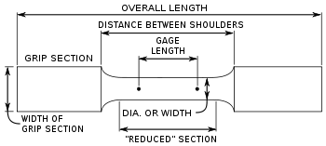
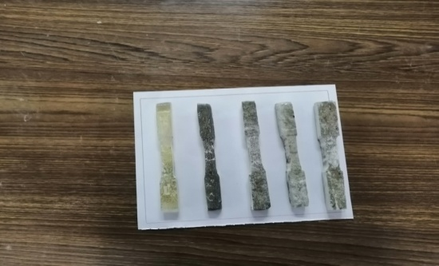
Fig.No.3 Tensile Test Specimens Fig. No.4 Tensile Test Specimen Nomenclature

Tensile strength is calculated by using following formulas:
Tensile Strength (MPa)=Force(Load)(N) / Cross Section Area (mm²)
Tensile Strength at Yield(MPa) = Max. Load recorded (N) / Cross Section Area (mm²)
Tensile modulus and elongation values are derived from the stress-strain curve. If the specimen gives a yield load larger than the load at break, percent elongation at yield is calculated; if not, percent elongation at break is calculate
Tensile strength is calculated by using following formula:
Strain = Change in Length (elongation) / Original Length (gauge length)
Elongation at yield: Δ L = ε (the value at the yield point) * L on the X-axis
Percent Elongation at yield = Δ L * 100
Tensile modulus (the modulus of elasticity) is determined by extending the initial linear portion of the load-extension curve and dividing the difference in stress obtained from any segment of section on this straight line by the corresponding difference in strain, expressing the result in the unit of Mega Pascal (MPa).

Charpy Impact test

Impact tests will be performed to understand the toughness of material. During the test, specimens will be subjected to a large amount of force for a very short interval of time. For any material, the higher amount of impact strength indicates that it can absorb a large amount of energy before failure. As the impact energy increases the toughness of material increases and its plasticity will be also large. In present investigation notched charpy impact strength of the specimens of dimensions 55x12.7x3mm was evaluated as per ASTM-E-23 with a notch depth of 2.54mm and notch angle of 45°. Minimum of three tests were performed for each composite sample average and corresponding standard deviation of these measurements is reported. The impact strength is calculated by dividing the impact values obtained from the scale by the thickness of the specimen. One point indicating the advantages of the Charpy test over an Izod test is that the specimen does not have to be clamped; therefore, it is free of variations in clamping pressures.
Rockwell hardness test

Hardness is defined as the resistance of a material to indentation, penetration, scratches, deformation and particularly, permanent deformation. Hardness is purely a relative term. Hardness of materials is impressed in number scale; so it has no unit. ASTM D 785: Standard Test Method for Rockwell Hardness of Plastic and Electrical insulating materials.
Rockwell hardness test is most commonly used for relatively hard plastics. It is defined as the resistance to indentation of the standard indenter. In Rockwell hardness A standard specimen is placed on the surface of the Rockwell Hardness tester. A minor load is applied and the gauge is set to zero. The major load is applied by tripping a lever. After 15 seconds the major load is removed. The specimen is allowed to recover for 15 seconds and then the hardness is read off the dial with the minor load still applied. Rockwell hardness is measured in R, L, M, E and K scales. The scale represents indenter size, major load and dial scale.

C. RESULT AND DISCUSSION
Mechanical characteristics of composites
In the present study, tensile, flexural impact tests and hardness were done to characterize the mechanical properties of the epoxy based treated jute fibre and fly ash powder composites. The mechanical properties of composites were compared with those of neat epoxy resin.
Tensile Strength
The universal testing machine model - INSTRON 3382
Tensile testing parameters – specimen dimensions – width 12.7mm
Total length – 165mm, Gauge width – 20 mm, Thickness – 4mm
Tensile strength = force (N)/original cross section of the sample (mm2)
Tensile speed - 50 mm/min
The tensile strength of composites increases with increase in the both the fibre and filler content up to 10 wt%. However, further increase in fibre content the strength decreases. This decrease may be due to the improper adhesion between fibre and epoxy. As the fibre content increases, instead of dispersion the gathering of fibre stakes place and the resin cannot wet the fibres due to non-entrance of resin in-between the two adjacent fibres. The other reason of the decrease in the tensile strength values may also be attributed to micro bubbles which arose during processing.

Table 2
Result of Tensile Strength Test of Specimens.
Sl. No. | Specimen Composition | Tensile Strength(MPa)
C1 | Epoxy (93%)+Fibre(5%)+Fly ash(2%) | 47
C2 | Epoxy(88%)+Fibre(10%)+Fly ash(2%) | 52
C3 | Epoxy(83%)+Fibre(15%)+Fly ash(2%) | 45
C4 | Epoxy(78%)+Fibre(20%)+Fly ash(2%) | 36
C5 | Epoxy(100%)+Fibre(0%)+Fly ash(2%) | 84

Histogram No.1 Tensile Strength Test of Specimens
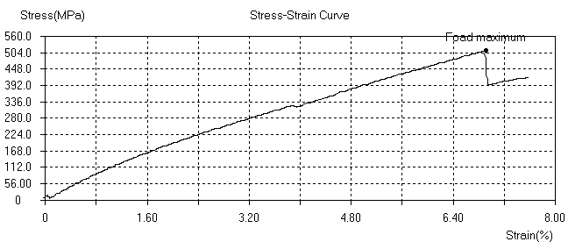
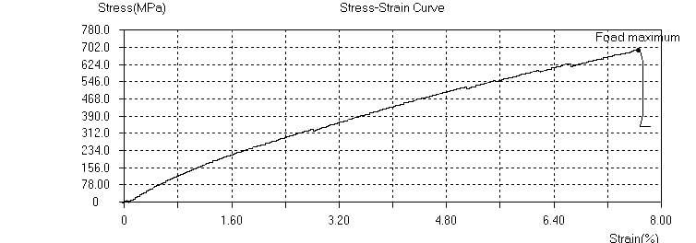
Fig.-3 Stress ~ Strain Curve with 5wt% Fibre
Impact Strength
Impact tests are carried out on composite specimens as per ASTM D 256 using an impact tester. The

Fig.-4 Stress ~ Strain Curve with 10wt% Fibre
pendulum impact testing machine as certain the notch impact strength of the material by shattering the U notched specimen with a pendulum hammer, measuring the spent energy, and relating it to the cross section of the specimen. The standard specimen for ASTM E 23 is 64.5 × 12.7 × 3.0 mm and the depth of the notch is 2.5 mm.

TABLE NO. 3
TABLE NO.- RESULT OF IMPACT STRENGTH TEST OF SPECIMEN
Sl. No. | Specimen Label | Energy Absorbed(J)
C1 | Epoxy (93%) + Fibre (5%) + Fly ash (2%) | 40
C2 | Epoxy (88%) + Fibre (10%) + Fly ash (2%) | 352
C3 | Epoxy (83%) + Fibre (15%) + Fly ash (2%) | 264
C4 | Epoxy (78%) + Fibre (20%) + Fly ash (2%) | 68
C5 | Epoxy (100%) + Fibre (0%) + Fly ash (0%) | 42

In the present investigation, an improvement in the impact strength has been observed due to addition of jute fibres and Fly ash. The impact strength gradually increases by increasing the jute fibre and fly ash contains. The composite of C2 shows the highest impact strength as compare to others. The energy absorption increases up to the 10wt% of fibre and then decreases considerably.
Rockwell Hardness
Hardness implies a resistance to indentation, penetration or plastic deformation of material. In a composite material, filler weight fraction significantly affects the hardness value of the composite material. Hardness values measured on the Rockwell R-Scale showing the effect of weight percentage of jute fibres and fly ash on the hardness values of composite are presented in below table.
All the hardness tests were conducted at 60kgf load.

TABLE 4
RESULT OF ROCKWELL HARDNESS TEST OF SPECIMEN.
Sl. No. | Specimen Label | Rockwell Hardness(R-Scale)
C1 | Epoxy (93%) + Fibre (5%) +Fly ash (2%) | 66
C2 | Epoxy (88%) + Fibre (10%) + Fly ash (2%) | 83
C3 | Epoxy (83%) + Fibre (15%) +Fly ash (2%) | 68
C4 | Epoxy (78%) + Fibre (20%) + Fly ash (2%) | 58
C5 | Epoxy (100%) + Fibre (0%) + Fly ash (2%) | 86

Conclusion
This experimental investigation of mechanical behaviour of jute fibre reinforced epoxy composites leads to the following conclusions.
This work shows that successfully fabrication of a jute fibre reinforced epoxy composites with different filler contents is possible by simple hand lay-up technique. It is observed that the mechanical properties significantly improve, due to reinforcement of jute fibre and fly ash in the epoxy resin. The tensile strength and hardness of composites increases with increase in jute fibre and fly ash contents up to 10 wt% of jute fibre. However further increase in reinforcement decreases the strength of composites. This decrease may be due to the improper adhesion between fibre and epoxy. On the other hand, Impact strength of composites increases with increase in jute fibre and fly ash contents up to 10wt%. The water absorption capacity is directly dependent upon the jute content in the composite. Following which the 5wt% jute composite showed least amount of water absorption where as the 15wt% jute composite showed highest amount of water absorption. From this study it has been concluded that better interfacial bonding resulting from better adhesion between matrix and fibre has improved the mechanical properties and fibre strength resulting in lesser fibre pullout.

REFERENCES
[1] Antaryami Mishra “Mechanical Properties of Coconut Shell Dust, Epoxy - Fly AshHybrid Composites” American Journal of Engineering Research (AJER)e-ISSN: 2320-0847 p-ISSN : 2320-0936Volume-6, Issue-9, pp-166-174
[2] Prasob P.A., Sasikumar M. “Static and dynamic behavior of jute/epoxy composites with ZnO and TiO2fillers at different temperature conditions” Polymer Testing 69 (2018) 52–62
[3] Raj B. Ladania, Shuying Wu, Anthony J. Kinloch, Kamran Ghorbania, Adrian P. Mouritz and Chun H. Wang “Enhancing fatigue resistance and damage characterisation in adhesively-bonded composite joints by 1 carbon nanofibres”
[4] Alves, C.,Ferrao,P.M.C.,Silva,A.J., et al., 2010.Ecodesignofautomotivecomponentsmakinguseofnaturaljute fiber composites.J.Clean.Prod.18,313–327. Doi:10.1016/J.JCLEPRO.2009.10.022.
[5] Nassar, .A.,Arunachalam, ,Alzebdeh, K.I., 2017. Machinability of natural fiber reinforcedcomposites:Areview.Int.J.Adv.Manuf.Technol.88,2985–3004. doi:10.1007/s00170-016-9010-9.
[6] Pickering, K.L,AruanEfendy, M.G., Le,T.M.,2016. Are view of recent developments in natural fibre compositesandtheirmechanicalperformance.Compos.PartAAppl.Sci. Manuf. 83,98–112. doi:10.1016/J.COMPOSITESA.2015.08.038.
[7] Ramesh, M.,Palanikumar,K.,Reddy,K.H.,2017.Plant fibre basedbio-composites:Sustainableandrenewablegreenmaterials.Renew.Sustain.EnergyRev.79,558–584. doi:10.1016/J.RSER.2017.05.094.
[8] Zimniewska,M.,Wladyka-Przybylak,M.,Mankowski,J.,2011.Cellulosicbastfibers, theirstructureandpropertiessuitableforcompositeapplications.InCelluloseFibers: Bio- andNano-PolymerComposites.Berlin,Heidelberg:SpringerBerlinHeidelberg,pp.97–119. doi:10.1007/978-3-642-17370-7_4.
[9] Zainab Al-Hajaj, Radovan Zdero, HabibaBougherara “Mechanical, Morphological, and Water Absorption Properties of a New HybridComposite Material made from 4 Harness Satin Woven Carbon Fibres and Flax Fibres in an Epoxy Matrix” Composites: Part A (2018)
[10] Yan Li, Han Zhang, Zhaohui Huang, Emiliano Bilotti,and Ton Peijs “Graphite Nanoplatelet Modified Epoxy Resin for Carbon FibreReinforced Plastics with Enhanced Properties” Journal of NanomaterialsVolume 2017, Article ID 5194872, 10 pages
[11] D. Carolan1,2,*, A. Ivankovic2, A. J. Kinloch1, S. Sprenger3, and A. C. Taylor1 “Toughened carbon fibre-reinforced polymeromposites with nanoparticle-modified epoxy matrices” J Mater Sci (2017) 52:1767–1788
[12] A. Garc´ıa-Carpintero · M. Herr´aez · J. Xu1 · C. S. Lopes · C. Gonz´alez1 “A Multi Material Shell Model for the Mechanical Analysis of Triaxial Braided Composites” Springer Science+Business Media Dordrecht 2017 DOI 10.1007/s10443-017-9593-9
[13] D. Carolan, A. Ivankovi, A. J. Kinloch, S. Sprenger, and A. C. Taylor “Toughened carbon fibre-reinforced polymer composites with nanoparticle-modified epoxy matrices”J Mat(2:1767–
[14] ZHANG, H “Interlaminar toughening of woven fabric carbon/epoxy compositelaminates using hybrid aramid/phenoxy interleaves” JCOMA 4688 Composites: Part A
[15] MatheusPoletto“mechanical, dynamic mechanical and morphological properties of composites based on recycled polystyrene filled with wood flour wastes” Maderas. Ciencia y tecnología 19(4): 433 - 442, 2017
[16] Li Zhang, Xingyu Li, Hua Deng, Yao Jing, Qiang Fu “Enhanced Thermal Conductivity and Electrical Insulation Properties of Polymer Composites via Constructing Pglass/CNTs Confined Hybrid Fillers” Composites: Part A , JCOMA 5178
[17] Vipin Vijay, Subramania Siva, Sreejith K. J, Prabhakaran P. V, RenjithDevasia“effect of boron inclusion in sioc polymer derived matrix onthe mechanical and oxidation resistance properties of fiber reinforced composites” Materials Chemistry and Physics, MAC 20130.

