Surfactant based nanoreactor micellar assembly: An innovative route for
synthesis of 2-thioxo-2,3-dihydroquinazolin-4(1H)-ones

Mayuri V. Patil, Pradeep M. Mhaldar, Dattaprasad M. Pore
Department of Chemistry, Shivaji University,Kolhapur 416004, India
Email: p_dattaprasad@rediffmail.com

ABSTRACT
Surfactant based nanocatalyst emerged as sustainable assembly for organic synthetic methods. Synthesis of heterocyclic scaffolds from two or multicomponent strategy is one of paramount application for researchers. In this regards, we developed a nano-micellar assembly of surfactant, 4-(dimethylamino)-1-hexadecylpyridinium hydroxide [DAHP]+ [OH]- as a nano-reactor for an innovative synthesis of 2-thioxo-2,3-dihydroquinazolin-4(1H)-ones from isatoic anhydride and phenyl isothiocyanate via in situ formation of anthranilic acid. The reaction was performed in the. The micelle concentration of surfactant is found to be 0.002 mol.dm3 using the conductivity data. The micellar particle dimensions were demonstrated from small-angle X-ray scattering (SAXS) analysis viz. micelle diameter and the interspacing between two micelles which were found to be 14.8 nm and 2.6 nm, respectively. From the TGA analysis, the surfactant is thermally stable up to 250 C with 76.01 % weight loss. The practical simplicity, atom economy, good to high yields, ease of product isolation and purification, water as eco-benign solvent and catalyst recyclability are the remarkable aspects of the present methodology.
Keywords: Anthranilic acid; Isatoic anhydride; Isothiocyanate; Micelle; Surfactant; Thioxoquinazolinone

INTRODUCTION

Heterocyclic compounds in particular nitrogen heterocycles, constitute a staggeringly diverse and an equally important class of molecules. The vast pool of heterocyclic compounds offers diverse chemical space for exploration of medicinal potential. Among them, quinazolinone is the building unit of approximately 150 naturally occurring alkaloids isolated from microorganisms, plants and animals (Fig.1).¹ It is a very important heterocycle exhibiting excellent biological properties.²⁻⁸ The first discovery of quinazolinone alkaloid is febrifugine which possesses antimalarial potential, extracted from the Chinese plant aseru (Dichroafebrifuga Lour). ⁹
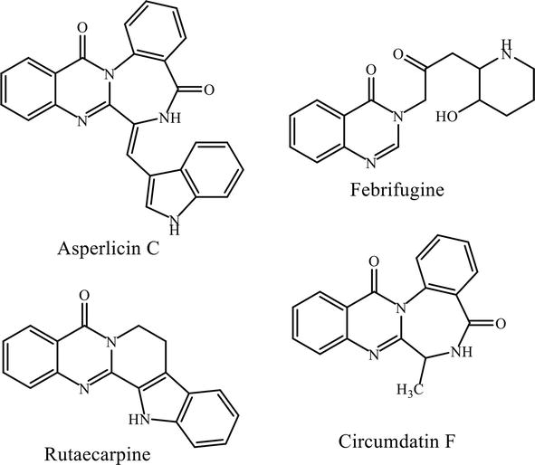
Fig. 1: Structure of different quinazolinone alkaloids
Quinazoline is a heterocyclic compound of two fused six-member simple aromatic rings - benzene and pyrimidine ring. It is a yellow-colored compound, found usually in crystalline form. Its oxo-derivative (quinazolinone) is classified into three types according to the position and number of carbonyl group: 2(1H) quinazolinones, 4(3H) quinazolinones and 2, 4(1H,3H) quinazolinedione (Fig. 2).

Fig. 2: Structure of quinazoline and quinazolinone derivatives
The synthesis of an important subclass of quinazolinone viz. thioxoquinazolinone (quinazolinthione) became the cornerstone for synthetic chemists and gained extensive importance in both medicinal and synthetic fields. Thioxoquinazolinone is a compound made up of two fused six-member simple aromatic rings, benzene and pyrimidine. The properties of the pyrimidine ring are affected by the presence of fused benzene ring (Fig. 3). The physicochemical and biological properties of quinazolinethione derivatives depend on the following three factors:
a. The nature of the substituents
b. The presence of substituent whether they are in the pyrimidine ring or in the benzene ring
c. The presence of conjugation in the pyrimidine ring

R = H, alkyl, alkoxy, halogen;
R₁ = H, alkyl, aryl;
R₂ = alkyl, phenyl, aryl, heteroaryl

Fig. 3: Structure of Thioxoquinazolinone

A) Biological importance of thioxo quinazolinone derivatives:
Different substituted thioxoquinazolinone compounds are found to possess antimicrobial (Fig. 4a),¹⁰ antifungal (Fig. 4b)¹¹ antiviral (Fig. 4c), anticonvulsant,¹² antihypertensive,¹³ anti-inflammatory,¹⁴ and phosphodiesterase inhibitor¹⁵ properties. Furthermore, they display a broad range of applications for diabetes,¹⁶ cancer¹⁷ and selective plant growth regulators.^{18,19}
Fig. 4: Bioactive compounds containing thioxoquinazolinone moiety

a) Anti-HIV activity:
Yahia and coworkers synthesized a series of dihydrobenzo[h]quinazoline derivatives using aryl methylene thiopyrimidine and 2-(4-(thiophen-2-yl)-5,6-dihydrobenzo[h]quinazolin-2-ylthio) acetic acid as a starting materials. The biological screening showed that many of these compounds have good anticancer and antiviral activities.²⁰ (Fig. 5)
Fig. 5
b) Anti-proliferative activity:

Sayed et al. studied the antiproliferative activity in vitro in addition to the theoretical calculation of the DFT theory of some novel quinazolinone(thione) derivatives which exhibited excellent potencies against two cell lines viz, Hep G2 and MCF-7 comparable to quinazolinone derivatives.²¹ (Fig. 6)

Fig. 6
c) Antimycobacterial activity:

Waisser and co-workers were synthesized a series of 3-phenyl-6,8-dichloro-2H-1,3-benzoxazine-2,4(3H)-dithiones, 3-aryl quinazoline -2,4(1H,3H)-diones as well as 3-arylquinazoline-2,4(1H,3H)-dithiones and evaluated in vitro antimycobacterial activities of the derivatives. The compounds were active against Mycobacterium tuberculosis and conditionally pathogenic mycobacteria (Mycobacterium kansasii and Mycobacterium avium). The replacement of oxygen by sulfur in 3-phenyl-6,8-dichloro-2H-1,3-benzoxazine-2,4(3H)-diones and 3-arylquinazoline-2,4(1H,3H)-diones increases antimycobacterial activity. The most active compound was 3-(3-chlorophenyl)-6,8-dichloro-2H-1,3-benzoxazine-2,4(3H)-dithione.²² (Fig. 7)
Fig. 7
d) Anticonvulsant activity:

Al-Salem reported synthesis of 4(3H)-quinazolinone bearing hydrazine carbothioamide, benzene sulfonohydrazide or phenyl acylacetohydrazide moiety. Four compounds were most potent with 100 % protection against PTZ-induced convulsions as compared with the reference drug sodium valproate.²³ (Fig. 8)
Fig. 8

e) α-Glucosidase inhibitor activity:

Saeedi et al. reported a series of anti-diabetic agents quinazolinone-1,2,3-triazole hybrids as potent α-glucosidase inhibitors that exhibited more potent inhibitory activity against yeast α-glucosidase (IC₅₀ 181.0–474.5 μM) than reference drug acarbose (IC₅₀ = 750.0).²⁴ (Fig. 9)

Fig. 9

f) Monoamine oxidase inhibitor activity (MAO):

Qhobosheane et al. reported seven quinazolinone compounds (IC₅₀ < 1 μM) as certained as potent and specific MAO-B inhibitors, among them the most potent inhibitor, 2-[(3-iodobenzyl)thio]quinazolin-4(3H)-one, with IC₅₀ value of 0.142 μM. Although these derivatives have been proved as reversible and competitive MAO-B inhibitor (Ki = 0.068 μM).²⁵ (Fig. 10)
Fig. 10

B) Methods of Synthesis:

The synthesis of thioxoquinazoline derivatives is carried out in several ways. A comprehensive account for the most common methods for the synthesis of thioxoquinazoline derivatives are as following:

1) From isothiocyanates:

Various 3-substituted 2-thioxo-2,3-dihydroquinazolin-4(1H)-ones were prepared from reactions of anthranilic acid or methyl anthranilate with alkyl or aryl isothiocyanates in different solvents under reflux conditions.
Butler and co-workers synthesized 3-methyl-2-thioxo-2,3-dihydroquinazolin-4(1H)-one by reaction of anthranilic acid with methylisothiocyanate using acetic acid in a sealed tube at 150º C for 1.5 h afford product in 39% yield after crystallization.²⁶ (Scheme 1)
Scheme 1
` Castro et al. explored the synthesis of various substituted 2-thioxo-2-3-dihydroquinazolin-4(1H)-ones from methyl anthranilate and isothiocyanates in dry toluene. The process provided low to moderate yields (18–67 %), involved longer reaction time (up to 14 days in some cases) and has been applied only on a very small scale.²⁷ (Scheme 2)
Scheme 2
Buckley et al. reported the reaction of methyl 4-methoxy-5-(oxazol-5-yl)anthranilate with thiophosgene in dichloromethane (DCM) in the presence of triethylamine (TEA) furnished corresponding isothiocyanate, which was reacted with a number of primary amines to give the corresponding thioxoquinazoline derivative.²⁸ (Scheme 3)
Scheme 3
The synthesis of 3-substituted 2-thioxo-2,3-dihydroquinazolin-4(1H)-ones was reported by Smith’s group. The method involved the preparation of isothiocyanates in situ from reaction of anthranilic acids with primary amines in the presence of carbon disulfide and KOH in methanol under reflux. Various aromatic amines were used under the general reaction conditions to provide the corresponding product in reasonable yield.²⁹ (Scheme 4)
Scheme 4
Dou and co-workers efficiently synthesized quinazoline-2-thioxo-4-ones from the reductive cyclization of ethyl 2-nitrobenzoates with isothiocyanates in tetrahydrofuran (THF) in the presence of titanium(IV) chloride and zinc with high yield.^{30,31} (Scheme 5)
Scheme 5
Wang et al. demonstrated copper-catalyzed tandem reaction of 2-bromobenzamides and aryl isothiocyanates for the synthesis of 2-thioxo-2,3-dihydroquinazolin-4(1H)-ones in high yield. The optimal condition involved the use of CuI as a precatalyst, Cs₂CO₃ as a base, N,N-dimethylethane-1,2-diamine (DMEDA) as a ligand and toluene as a solvent.³² (Scheme 6)
Scheme 6
Katritzky et al. reported reaction of benzotriazole-1-carboximidamides with potassium thiocyanate (1:2) in 1,2-dimethoxyethane (DME) using zinc bromide as a catalyst for synthesis of 4-thioxo-3,4-dihydroquinazolines.³³ (Scheme 7)

Scheme 7
2) From benzoamides and thioamides:

Kakuta and co-workers explored a synthesis of 3-(2,6-diethylphenyl)-2-thioxoquinazolin-4(1H)-one by the reaction of 2-amino-N-(2,6-diethylphenyl) benzamide with excess carbon disulfide in the presence of 1,8-diazabicyclo[5.4.0]undec-7-ene (DBU) as a base in DMF at 50º C for 3 h under argon gave 78 % yield.³⁴ (Scheme 8)

Scheme 8
Tsuji’s research group developed a solid-phase synthesis of a series of 1,3-disubstitiuted 2-thioxoquinazolin-4(1H)-ones from N-arylbenzamides supported on resin with 1,1’-thiocarbonyldiimidazole (TCDI) in the presence of 4-dimethylaminopyridine (DMAP) in decalin for 16 h at 95º C furnished an intermediate that was treated with aqueous TFA (95 %) in DCM at room temperature for 1 h to give corresponding thioxoquinazolin derivatives in good yield (59–100 %) with high purity.³⁵ (Scheme 9)
Scheme 9
Hanusek et al. achieved synthesis of 2-aryl-4-thioxoquinazolines from reaction of 2-amino benzothioamides with benzoyl chlorides followed by treatment with sodium methoxide.³⁶ (Scheme 10)
Scheme 10
Kubicova et al. synthesized 3-aryl-2,2-dimethyl-1,2-dihydroquinazoline-4(3H)-thiones by silica gel catalyzed condensation of 2-amino-N-arylthiobenzamides with acetone at room temperature for 24 h.³⁷ (Scheme 11)
Scheme 11
4-Thioxoquinazolines were synthesized in one step from the reaction of 2-aminobenzonitriles and thioamides in presence of hydrogen bromide in various solvents (e.g. DMF, glacial acetic acid or ethanol) on a steam bath for 1–4 h. The yield of products were low to moderate due to the formation of side products such as quinazoline-4(3H)-ones.³⁸ (Scheme 12)
Scheme 12
3) From thiourea:

El-Helby et al. synthesized 4-aryl-2- thioxo-3,4,5,6,7,8-hexahydroquinazolines in two-steps. The first step involved the production of substituted benzylidenes from reaction of cyclohexanone with aromatic aldehydes in the presence of potassium hydroxide in aqueous ethanol at room temperature. The second step involved reaction of benzylidenes with thiourea to give the corresponding 2-thioxoquinazolinesin 60–82 % yield.³⁹ (Scheme 13)
Scheme 13
The process represented in Scheme 15 was modified by Gupta et al. to allow the synthesis of 2-thioxoquinazolines in high yield (72–78 %) in a one-pot reaction that involved the cyclocondensation of equimolar ratios of cyclohexanone, thiourea and aromatic aldehydes in methanol under reflux conditions for 10–12 h.⁴⁰ (Scheme 14)
Scheme 14
Kidwai and coworkers reported the one-pot synthesis of 4-aryl-2-thioxo-3,4,5,6,7,8-hexahydroquinazolines in high yield (85–90 %) by reaction of 5,5-dimethyl-1,3-cyclohexanedione (dimedone), thiourea and aromatic aldehydes under microwave irradiation in 2.2–3.5 min.⁴¹ (Scheme 15)
Scheme 15
Kaur et al. developed a reaction of tetralone, thiourea and aromatic aldehydes under microwave heating for 3–7 min in the presence of acetonitrile as the energy transfer medium and HCl as a catalyst furnished corresponding 4-phenyl-3,4,5,6-tetrahydrobenzo[h]quinazoline-2(1H)-thione in 36–53 % yield.⁴² (Scheme 16)

Scheme 16
A series of thioxoquinazolinone were synthesized by Azizian in high yield from reaction of isatoic anhydride, primary amines and thiourea in the presence of a small quantity of N,N-dimethyl acetamide (DMAC) under microwave irradiation.⁴³ (Scheme 17)
Scheme 17
4) From bis(benzotriazolyl)methanethione:

Reactions of methyl anthranilates with various amines in the presence of bis(benzotriazolyl)methanethione and DBU in DCM under reflux condition for 3–4.5 h furnished corresponding 2-thioxo-2,3-dihydroquinazolin-4(1H)-ones in good yield.⁴⁴ (Scheme 18)
Scheme 18
5) From N-(2-cyanophenyl)benzimidoyl chloride:

Fathalla et al. demonstrated the reaction of N-(2-cyanophenyl) benzimidoyl chloride with thioacetamide afforded 2-phenyl-1H-benzo[d][1,3]thiazin-4(2H)-imine in 78% yield.⁴⁵ (Scheme 19)
Scheme 19
Reactions of N-(2-cyanophenyl)benzimidoyl chloride with symmetrical 1,3-diaryl thioureas in chloroform under various reaction conditions (at 60 ºC for 6 h, at room temperature for 6 days or in the presence of TEA for 2 h) yielded corresponding 3-aryl-2-phenyl-4-thioxo-2,3-dihydroquinazolines in 48–62 % yield.⁴⁵ (Scheme 20)
Scheme 20
6) Miscellaneous syntheses:

The cyclocondensation of ethoxymethylene derivatives of 1,3-diaryl thiobarbituric acids (DTBA) with malononitrile in the presence of ammonium acetate, acetic acid and zinc chloride as a catalytic system under reflux conditions led corresponding 7-amino-2,3-dihydro-2-thioxo- 1,3-diarylquinazolin-4(1H)-ones.⁴⁶ (Scheme 21)
Scheme 21
- Result and Discussion

Concept of green chemistry has open new vista for synthetic chemists that encourage moving towards sustainable and innovative approach.⁴⁷⁻⁵⁴ Development of green methodologies in terms of choice of solvent and catalyst design to reduce the waste generation is a key step in synthetic chemistry. No doubt, water became universal green solvent due to its ample availability, easy accessibility, non-combustible and environmental compatible. In many occasions, it activates the functional groups by forming hydrogen bonds.^{.55} Due to poor solubility of organic substrates in aqueous phase most of the reactions are of ‘on water’ type.⁵⁶ The most challenging task is to convert these ‘on water’ reactions into ‘in water’ type. The use of surfactant in concentration exceeding critical micelle concentration (CMC) is one of the most convenient methods to promote the reaction in aqueous medium. The presence of surfactants definitely improves the solubility of hydrophobic compounds in water. Reactants, having high surface tension and hydrophobicity are bound to form aggregation in aqueous medium⁵⁷ to decrease the exposed organic surface area⁵⁸⁻⁶⁰ which increases the rate of reaction.
In this context, to explore eco-friendly methodologies for the synthesis of heterocyclic compounds, we have devised a novel synthetic scheme to obtain thioxoquinazolinones. (Scheme 22)

Scheme 22: Synthesis of 2-thioxo-2,3-dihydroquinazolin-4(1H)-ones
Initially, our attempts were focused towards design and synthesis of novel basic surfactant with a potential to enhance the rate of reaction by increasing solubility of organic reactants in water via formation of micelles. (Fig. 11)
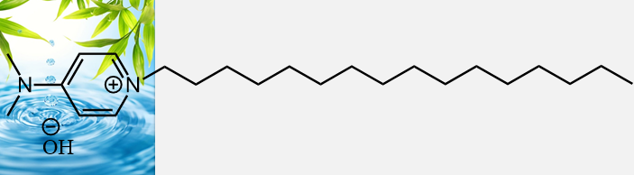
Fig. 11: Bronsted basic surfactant catalyst [DAHP]⁺ [OH]⁻
The synthesis of 4-(dimethylamino)-1-hexadecylpyridinium hydroxide, [DAHP]⁺ [OH]⁻ is outlined in Scheme 23. Initially, quaternization of 4-dimethylamino pyridine was carried out with 1-bromo hexadecane in toluene by heating reaction mixture at 80º C for 12-18 h to prepare 4-(dimethylamino)-1-hexadecylpyridinium bromide, [DAHP]⁺ [Br]⁻ followed by anion exchange with KOH in dry MeOH at room temperature for 24 h furnished 4-(dimethylamino)-1-hexadecylpyridinium hydroxide, [DAHP]⁺ [OH]⁻. The complete exchange of Br⁻ ions with OH⁻ ions was tested with AgNO₃. Structure of synthesized catalyst was confirmed by IR, ¹H, ¹³C and TGA analysis. The spectroscopic data is in full agreement with the structure of [DAHP]⁺ [OH]⁻.
Scheme 23: Synthesis of 4-(dimethylamino)-1-hexadecylpyridin-1-ium hydroxide, [DAHP]⁺ [OH]⁻
The critical micelle concentration (CMC) of a surfactant solution was estimated measuring the conductivity of a known volume of deionised water first and then successive addition of an exact volume of 0.05 M stock solution of [DAHP]⁺ [OH]⁻ surfactant into the water. Conductivity at each addition was measured. The CMC obtained from the plot of equivalent conductance (k) versus surfactant concentration is shown in fig 12. The CMC of the surfactant, [DAHP]⁺ [OH]⁻ was found to be 0.002 mol.dm⁻³.
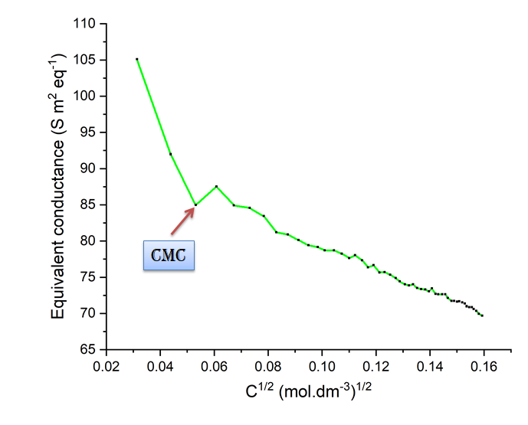
Fig.12: Equivalent conductance as a function of concentration
The thermal stability of surfactant [DAHP]⁺ [OH]⁻ was evaluated by thermogravimetric analysis (TGA), at a 10 ºC/min heating rate in air from temperature range 25- 1000 ºC. (Fig. 13) The crossing of the tangent and the baseline at the maximum slope of the TGA curves specifies the decomposition temperature of the surfactant. Initially, the weight loss of 5.066 % was observed in the temperature range of 25-100 ºC which is attributed to the loss of physically adsorbed water molecules in the catalyst. The largest weight loss of 76.01 % in the range of 250-350 ºC was due to the decomposition of organic species and finally 15.61 % weight loss of residual carbonaceous species takes place in the range of 400-550 ºC.

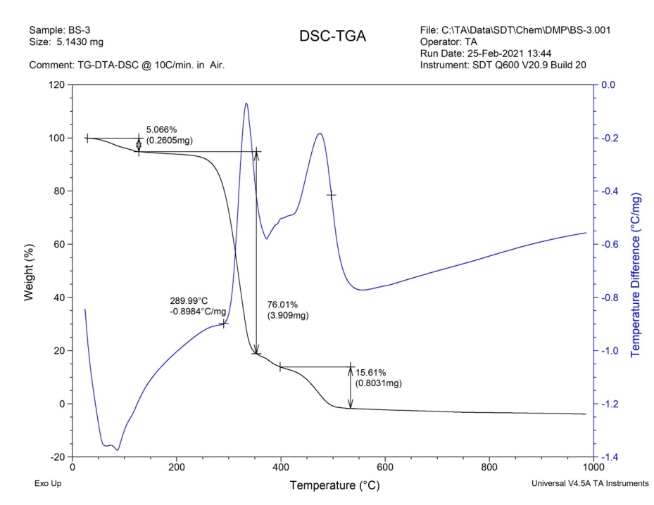
Fig. 13: TGA/DTA plot of [DAHP]⁺ [OH]⁻
After this significant accomplishment, the emphasis was switched to explore the application of [DAHP]⁺ [OH]⁻ for the synthesis of thioxoquinazolinones. Taking into consideration the importance of thioxoquinazolinone scaffolds from a pharmaceutical, industrial and synthetic point of view, comparatively few methods for their preparation are reported in the literature^{61,62}. Sayahi et al. synthesized 3-substituted 2-thioxo-2,3-dihydroquinazolin-4(1H)-one derivatives by multi component reaction of methyl 2-bromobenzoate, phenylisothiocyanate and sodium azide in the presence of copper bromide, L-proline and DMSO as catalyst, ligand and solvent, respectively.⁶³ (Scheme a) Azizi et al. demonstrated a synthesis of extremely useful 2-thioxo-2,3-dihydroquinazolin-4(1H)-one derivatives from readily available dithiocarbamates and 2-aminobenzoic acid.⁶⁴ (Scheme b) Butler and co-workers synthesized 3-methyl-2-thioxo-2,3-dihydroquinazolin-4(1H)-ones by reaction of anthranilic acid with methylisothiocyanate using acetic acid in a sealed tube at 150 ⁰C.⁶⁵ (Scheme c) Many of these processes suffer from limitations such as drastic reaction conditions, use of metal catalyst, relatively long reaction time, low yields and expensive reagents. Hence, investigation of novel routes is highly desirable.
Previous reports:
Sayahi et al.
Azizi et al.

Butler et al.

Present work:
Scheme 24: Synthesis of 2-thioxo-2,3-dihydroquinazolin-4(1H)-ones
In present experiment, the reaction of isatoic anhydride and phenyl isothiocyanate was examined as a simple model strategy which was carried out in the presence of various catalysts. Initially, we have carried out catalyst-free reaction in water but it failed to produce desirable product, (Table 1, entry 1) indicating that the catalyst should be absolutely necessary for the reaction. This inspired us to screen different acidic and basic catalysts for the said transformation. Firstly, reaction was screened by using acidic catalysts viz. NH₂-SO₃H, p-TSA, 1-methyl-3-sulfonic acid imidazolium chloride [Msim]⁺ Cl⁻ but failed to give desire product in good yield. (Table 1, entries 2-4) Next, we checked the effect of basic catalyst such as K₂CO₃, K₃PO₄, KOH, Et₃N, etc. Remarkably, these catalysts exhibited superior results. (Table 1, entries 5-8) We also tested the reaction with various surfactants viz. sodium dodecyl sulphate (SDS), Triton X-100, benzethonium tetrachloro aluminate [BZT]⁺ Cl⁻, cetyl trimethyl ammonium bromide (CTAB), sodium dioctyl sulfosuccinate (SDOSS) and synthesized [DAHP]⁺ [OH]⁻ basic surfactant. Among them, [DAHP]⁺ [OH]⁻ displayed better activity in synthesis of corresponding thioxoquinazolinone. (Table 1, entries 9-14) The effect of amount of catalyst loading was also evaluated with 10, 15, 20 and 25 mol %. The 20 mol % [DAHP]⁺ [OH]⁻ was enough to drive the reaction to completion. There was no significant effect on both yield and reaction time even after increase in amount of catalyst.

Table 1: Screening of catalysts for the formation of 3ª
Sr. no | Catalyst | Catalyst load (mol %) | Time  (h) | Yield ^{b}  (%)
1 | - | - | 12-18 | 20
2 | NH₂-SO₃H | 20 | 10 | 39
3 | p-TSA | 20 | 9 | 43
4 | [Msim]⁺ Cl⁻ | 20 | 12 | 40
5 | K₂CO₃ | 20 | 8-9 | 63
6 | K₃PO₄ | 20 | 9 | 60
7 | KOH | 20 | 5 | 70
8 | Et₃N | 20 | 6 | 71
9 | SDS | 20 | 9 | 40
10 | Triton X 100 | 20 | 10 | 35
11 | [BZT]⁺ Cl⁻ | 20 | 12 | 33
12 | CTAB | 20 | 10 | 40
13 | SDOSS | 20 | 12 | 38
14 | [DAHP]+ [OH]- | 25 | 4 | 81
15 | [DAHP]+ [OH]- | 20 | 4 | 81
16 | [DAHP]+ [OH]- | 15 | 5 | 77
17 | [DAHP]+ [OH]- | 10 | 5 | 72
ª Reaction conditions : Isatoic anhydride (1 mmol), Phenyl isothiocyanate (1mmol), Catalyst [DAHP]⁺ OH⁻ (20 %), Water (10 mL), 50º C. ^{b}Isolated yield

Next, we investigated the effect of reaction temperature on the yield of product, as shown in Table 2. It indicates that, in catalytic system of [DAHP]⁺ [OH]⁻, yield of the product increased with the increasing reaction temperature. The optimum reaction temperature is 50° C (Table 2, entry 3) and increasing the reaction temperature beyond this led no substantial improvement in the yield.
Table 2: Effect of temperature on the reaction
Sr. No. | Temperature  ºC | Yield ^{b}  (%)
1 | 30 | 25
2 | 40 | 55
3 | 50 | 80
4 | 60 | 80
5 | 70 | 79
6 | 80 | 75
7 | 90 | 73
8 | 100 | 73
ªReaction conditions: Isatoic anhydride (1 mmol), Phenyl isothiocyanate (1 mmol), Catalyst [DAHP]⁺ OH⁻ (20 %), Water (10 mL). ^{b}Isolated yield

After completion of reaction the product formed was isolated by extraction with diethyl ether and the structure of product was confirmed by various spectroscopic techniques viz IR, ¹H, ¹³C NMR and GCMS. In the IR spectrum, (Fig. 18) absorption band at 1662 and 3251 cm^{–1} corresponds to amidic carbonyl group and secondary N-H group respectively. The observed band at 1211 cm⁻¹ was consistent to C-S stretching of thiocarbonyl group. The ¹H NMR spectrum, (Fig.19) displayed doublet at δ 6.82-6.83 ppm (J = 8.5 Hz), triplet at δ 6.97-7.00, 7.14-7.17, 7.24-7.27, 7.29-7.32 ppm (J =7.5 Hz) and doublet at δ 7.48-7.49 7.65-7.66 ppm with J = 8 and 7.5 Hz respectively, specifies nine aromatic protons. A singlet at δ 12.67 ppm highlights the presence of -NH proton. In the ¹³C NMR spectrum, (Fig. 20) the presence of twelve aromatic carbons is confirmed by signals appeared at δ 116.13, 116.38, 124.43, 127.74, 128.41, 128.97, 129.20, 135.59, 139.37 and 139.97 ppm. The signals observed at δ 160.23 and 176.46 ppm due to presence of amidic carbonyl and thiocarbonyl carbon respectively. The structure was further confirmed using Mass analysis (Fig. 21) in which molecular ion peak was observed at (m/z) 254 while base peak found at (m/z) 77 due to loss of phenyl cation. Thus, the spectroscopic data is in well agreement with the structure of product 3a.
Afterwards, we focused our attention to explore the generality of present method by carrying out reactions using a substituted isatoic anhydride as well as isothiocyanate derivatives as illustrated in table 3. Isatoic anhydride and phenyl isothiocyanate with no substituent react smoothly and furnished desire product in admirable yield (Table 3, entry a). It is noteworthy that, the isatoic anhydride underwent smooth reactions with aromatic as well as aliphatic isothiocyanate derivatives and furnished corresponding products in excellent yield. (Table 3, entries b-e) Remarkably, desired product was observed in good yield by reaction of chloroisatoic anhydride with various isothiocyanate derivatives. (Table 3, entries f- i) Isatoic anhydride possessing N-methyl group afforded slightly lower yield. (Table 3, entries j-m)
Table 3: Synthesis of combinatorial library of thioxoquinazolinones

Entry | R | R₁ | R₂ | Product | Time  (h) | Yield^{b}  (%)
a | H | H | Ph |  | 2 | 84
b | H | H | 4-NO₂Ph |  | 2.3 | 81
c | H | H | CH₂-Ph |  | 2.5 | 81
d | H | H |  |  | 2.2 | 82
e | H | H |  |  | 2 | 80
f | Cl | H | Ph |  | 3 | 79
g | Cl | H | 4-NO₂Ph |  | 4.5 | 77
h | Cl | H |  |  | 6 | 74
i | Cl | H |  |  | 5.3 | 67
j | H | Me | Ph |  | 3 | 75
k | H | Me | 4-NO₂Ph |  | 7 | 69
l | H | Me |  |  | 5 | 60
m | H | Me |  |  | 6 | 57
ªReaction conditions : Isatoic anhydride (1 mmol), Isothiocyanate derivatives (1mmol), Catalyst [DAHP]⁺ OH⁻ (20 %), Water (10 mL), 50º C
^{b}Isolated yield

A probable mechanism for the formation of product (6) is illustrated in scheme 25. Initially, in water ring opening of isatoic anhydride (1) takes place by nucleophilic attack of OH⁻ of [DAHP]⁺ [OH]⁻ (2) led in situ formation of intermediate (3), anthranilic acid. Nucleophilic attack of –NH₂ of anthranilic acid (3) furnish intermediate 5 followed by intramolecular cyclization and subsequent dehydration to yield corresponding product (6).
Scheme 25: A plausible mechanism for synthesis of thioxoquinazolinones
To confirm the formation of an intermediate (3), anthranilic acid; the reaction of isatoic anhydride with catalyst, [DAHP]⁺ [OH]⁻ in aqueous medium was arrested after 45 min and product formed was isolated by extraction with diethyl ether and characterised by ¹H and ¹³C NMR analysis. In ¹H NMR, (Fig. 22) peak observed at δ 6.67-6.70 ppm due to NH₃ protons and doublet of doublet at δ 7.30-7.34 and 7.93-7.96 ppm exhibits four aromatic protons. ¹³C NMR (Fig. 23) displayed signals at δ 109.53, 116.48, 116.81, 132.15, 135.15 and 151.12 ppm exhibit presence of six aromatic carbons. Signal observed at δ 173.82 ppm confirms the –COO⁻ functionality.
Reusability of catalyst is an important aspect of green chemistry. The reusability of [DAHP]⁺ [OH]⁻ surfactant was investigated for the reaction of isatoic anhydride and phenyl isothiocyanate under optimized reaction conditions. The product formed was isolated by extraction with diethyl ether. The aqueous layer was evaporated under vacuum upto 10 mL and was reused for subsequent runs. The studies revealed that [DAHP]⁺ [OH]⁻ could be reused for four cycles without significant decrease in catalytic activity. (Fig. 14)
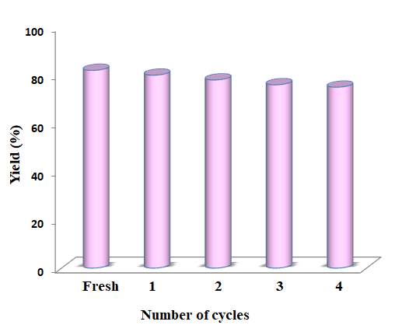
Fig.14: Recyclability study of [DAHP]⁺ [OH]⁻
- Conclusion:
In conclusion, we have designed and introduced a highly efficient novel Brønsted basic surfactant [DAHP]⁺ [OH]⁻ for the one pot synthesis of thioxoquinazolinone from reaction of isatoic anhydride and isothiocyanate derivatives. The notable advantages of present method are simple operation, use of water as a solvent, expansive substrate scope, high yield within short reaction time, easy separation of products avoiding tedious column chromatography thus making the protocol environmentally friendly.

Typical procedure:

Synthesis of surfactant [DAHP]⁺ [OH]⁻:
To a vigorously stirred solution of 4-dimethylamino pyridine (10 mmol) in toluene (25 mL), 1-bromo hexadecane (11 mmol) was slowly added at room temperature and heated reaction mixture at 80º C for 12-18 hour. After completion of reaction toluene was decanted and the remaining residue was repeatedly washed with diethyl ether to yield, 4-(dimethylamino)-1-hexadecylpyridin-1-ium bromide, [DAHP]⁺ [Br]⁻ as colourless solid product which was dried under vacuum .
The surfactant [DAHP]⁺ [Br]⁻ obtained from first step (10 mmol) was then dissolved in dichloromethane : methanol (1:1) and cooled at 0º C followed by addition of potassium hydroxide (11 mmol) and stirred it for 24 h at room temperature. The suspension was filtered to remove the precipitated potassium chloride salt and the solvent was evaporated under reduced pressure furnished 4-(dimethylamino)-1-hexadecylpyridin-1-ium hydroxide, [DAHP]⁺[OH]⁻.

Synthesis of 2-thioxo-2,3-dihydroquinazolin-4(1H)-ones:
In a 50 mL round bottom flask, isatoic anhydride (1 mmol), isothiocyanate derivative (1 mmol) and [DAHP]⁺[OH]⁻ surfactant (20 mol %) in water (10 mL) was heated at 50º C for time specified in Table 3. The progress of reaction was monitored by TLC. After completion of reaction (TLC), reaction mixture was extracted by diethyl ether (2 X 20 mL). The combined organic layer was concentrated under reduced pressure and washed with water. The product was recrystallized in ethanol to furnish corresponding pure 2-thioxo-2,3-dihydroquinazolin-4(1H)-ones. These synthesized products were characterized by IR, ¹H, ¹³C, and Mass spectroscopic techniques.

Spectral data of synthesized novel Bronsted basic surfactant catalyst 4-(dimethyl amino) -1- hexadecyl pyridin-1-ium hydroxide, [DAHP]⁺[OH]⁻

White solid; IR (Fig. 15): 3443, 2962, 2923, 2852, 2352, 1643, 1415, 1081, 1013, 957, 930, 891, 798, 681, 643, 567, 450, 394 cm⁻¹ ; ¹H NMR (400 MHz, CDCl₃) (Fig. 16) : 0.86-0.88 (t, 3H), 1.24-1.25 (m, 26H), 1.84-1.91 (m, 2H), 3.27 (s, 6H), 3.75 (bs, 1H), 4.30-4.34 (t, 2H), 7.02-7.04 (d, 2H, J = 8 Hz), 8.41-8.43 (d, 2H, J = 8 Hz) ppm; ¹³C NMR (100 MHz, CDCl₃) (Fig. 17) : δ 22.90, 26.37, 26.44, 29.26, 29.31, 29.58, 29.62, 29.73, 29.82, 29.88, 29.91, 31.11, 31.36, 32.14, 40.70, 57.31, 58.70, 76.93, 77.25, 77.57, 108.65, 142.66, 156.54 ppm.
Spectral data of 3-aryl/alkyl-2-thioxo-2,3-dihydroquinazolin-4(1H)-ones
Entry 3a, Table 3: 3-Phenyl-2-thioxo-2,3-dihydroquinazolin-4(1H)-one
White solid; Obs. m.p. 234–236 °C. IR (Fig. 18): 3251, 2962, 2914, 1612, 1544, 1469, 1367, 1211, 1096; ¹H NMR (400 MHz, DMSO-d₆) (Fig. 19): δ 6.82-6.83 (d, 1H, J = 8.5 Hz), 6.97-7.00 (t, 1H, J = 7.5 Hz), 7.14-7.17 (t, 1H, J = 7.5 Hz), 7.24-7.27 (t, 1H, J = 7.5 Hz), 7.29-7.32 (t, 2H, J = 7.5 Hz), 7.48-7.49 (d, 2H, J = 8 Hz), 7.65-7.66 (d, 1H, J = 7.5 Hz), 12.67 (s, 1H, -NH) ppm; ¹³C NMR (100 MHz, DMSO-d₆) (Fig. 20): δ 116.13, 116.38,124.43, 127.74, 128.41, 128.97, 129.20, 135.59, 139.37, 139.97, 160.23, 176.46; GCMS (Fig. 21): Mass calculated for [C₁₄H₁₀N₂OS]: 254.05 (M⁺); Obs. Mass: m/z = 254 (M⁺).
¹H NMR, zwitterion of anthranilic acid (400 MHz, CDCl₃) (Fig. 22): δ 6.67-6.70 (m, 3H), 7.30-7.34 (m, Ar-2H), 7.938-7.963 (dd, Ar-2H, J = 1.6 Hz, 8.4 Hz) ppm; ¹³C NMR (100 MHz, CDCl₃) (Fig. 23): δ 109.53, 116.48, 116.81, 132.15, 135.15, 151.12, 173.82 ppm.

Entry 3b, Table 3: 3-(4-nitrophenyl)-2-thioxo-2,3-dihydroquinazolin-4(1H)-one
Pale yellow; Obs. m.p. 288 ºC; IR (Fig. 24); 3321, 3036, 2843, 1684, 1599, 1530,1475,1437,1314, 1267, 1205, 1144,1121, 1028, 935, 796, 649 cm⁻¹ ;¹H NMR (400 MHz, DMSO-d₆) (Fig. 25): δ 7.16-7.18 (d, 1H, J = 8.4 Hz), 7.24-7.28 (m, 1H), 7.75-7.77 (m, 1H), 7.82-7.84 (d, 2H, J = 8 Hz) 7.92-7.94 (m, 1H), 8.22-8.25 (d, 2H, J = 9.2 Hz), 11.61 (s, 1H, -NH) ppm ; ¹³C NMR (100 MHz, DMSO-d₆) (Fig. 26) : δ 115.98, 116.15, 118.59, 118.77, 124.82, 126.10, 129.20, 129.79, 132.29, 140.71, 141.77, 142.72, 161.09, 175.76 ppm ; GCMS (Fig. 27): Mass calculated for [C₁₄H₉N₃O₃S]: 299.04 (M⁺) ; Obs. Mass: 299 (M⁺).

Entry 3d, Table 3 : 3-isopropyl-2-thioxo-2,3-dihydroquinazolin-4(1H)-one
white solid; Obs m.p. 176 ºC; IR (Fig. 28); 3400, 2970, 2946, 1632, 1515, 1311, 1248, 1155, 1021, 873, 842, 725, 592 cm⁻¹; ¹H NMR (400 MHz, DMSO-d₆) (Fig. 29): δ 1.47-1.49 (d, 6H), 6.01-6.08 (m, 1H), 7.29-7.37 (m, 2H), 7.69-7.73 (m, 1H), 7.91-7.94 (dd, 1H, J = 7.8 Hz, 1.2 Hz), 12.83 (s, 1H, -NH) ppm; ¹³C NMR (100 MHz, DMSO-d₆) (Fig. 30): δ 18.50, 52.43, 115.29, 116.65, 124.39, 126.89, 135.18, 138.74, 159.38, 175.92 ppm; GCMS (Fig. 31): Mass calculated for [C₁₁H₁₂N₂OS]: 220.29 (M⁺); Obs. Mass: 220 (M⁺).

Entry 3f, Table 3 : 6-chloro-3-phenyl-2-thioxo-2,3-dihydroquinazolin-4(1H)-one
White solid; Obs. m.p. 292 ºC; IR (Fig. 32); 3393, 2923, 2845, 2312, 1682, 1600, 1515, 1444, 1327, 1241, 975, 850, 709, 607 cm⁻¹; ¹H NMR (400 MHz, DMSO-d₆) (Fig. 33): δ 7.45-7.48 (m, 5H), 7.63-7.63 (d, 1H, J = 2.4 Hz), 7.82-7.84 (dd, 1H, J = 8.8 Hz, 2.4 Hz), 7.86- 7.88 (d, 1H, J = 8Hz), 11.02 (s, 1H, -NH) ppm; ¹³C NMR (100 MHz, DMSO-d₆) (Fig. 34): δ 117.67, 117.92, 118.49, 126.26, 128.14, 128.18, 128.85, 128.90 129.22, 133.74, 135.45, 138.39, 139.05, 166.28, 176.01 ppm; GCMS (Fig. 35): Mass calculated for [C₁₄H₉ClN₂OS]: 288.75 (M⁺); Obs. Mass: 288 (M⁺), 290 (M+2).

References:
1. | Mhaske S. B.; Argade N. P.; Tetrahedron 2006, 62, 9787.
2. | Patel B. N.; Patel C. J.; Sci. Pharm. 2010, 78, 171.
3. | Bartroli J.; Turmo E.; Alguero M.; Boncompte E.; Vericat M. L.; Conte L.; Ramis J.; Merlos M.; Garcia-Rafanell J.; Forn J.;J. Med. Chem. 1998, 41, 1869.
4. | Al-Obaid A. M.; Abdel-Hamide S. G.; El-Kashef H. A.; Abdel-Aziz A. A. M.; El-Azab A. S.; Al-Khamees H. A.; El-Subbagh H. I.; Eur. J. Med. Chem. 2009, 44, 2379.
5. | Kamal A.; Vijaya B. E.; Janaki Ramaiah M.; Dastagiri D.; Surendranadha R. J.; Viswanath A.; Sultana F.; Pushpavalli S. N. C. V. L.; Pal-Bhadra M.; Srivastava H. K.; Narahari S. G.; Juvekar A.; Sen S.; Zingde S.; Bioorg. Med. Chem.2010, 18, 526.
6. | Laddha S. S.; Bhatnagar P. S.; Bioorg. Med. Chem. 2009, 17, 6796.
7. | Gokhan Kelekci N.; Koyunoglu S.; Yabanoglu S.; Yelekci K.; Ozgen O.; Ucar G.; Erol K.; Kendi E.; Yes ilada A.; Bioorg. Med. Chem. 2009, 17, 675.
8. | Mohsen M. A.; Yahia A. M.; Elkhairy A. M.; Wahid M. B.; Samir Y. A.; Eur. J. Med. Chem. 2010, 45, 3365.
9. | Wattanapiromsakul C.; Forster P. I.; Waterman P. G.; Phytochemistry 2003, 64, 609.
10. | Rajasekaran A.; Rajamanickam V.; Darlinquine S.; Eur Rev Med Pharmacol Sci. 2013, 17, 95.
11. | Desh D.; Singh V. K.; Tiwari R.; Singh, Sharma G. L.; Dabur R.; bioRxiv, 2018.
12. | (a) Wenzel D. G.; J. Am. Pharm. Assoc. 1955, 44, 550. (b) Hori M.; Iemura R.; Hara H.; Ozaki A.; Sukamoto T.; Ohtaka H.; Chem. Pharm. Bull. 1990, 38, 681.
13. | (a) Hayao S.; Havera H. J.; Stryeker W. G.; Leipzig T. J.; Kulp R. A.; Hartzler H. E., J. Med. Chem.1965, 8, 807. (b) Havera H. J.; J. Med. Chem. 1979, 22, 1548.
14. | Chao Q.; Deng L.; Shih H.; Leoni L. M.; Genini D.; Carson D. A.; Cottam H. B.; J. Med. Chem.1999, 42, 3860.
15. | Witt A.; Bergman J.; Curr. Org. Chem. 2003, 7, 659.
16. | Mhaske S. B.; Argade N. P.; Tetrahedron 2006, 62, 9787.
17. | Koepfli J. B.; Brockman J. A.; Moffat J.; J. Am. Chem. Soc. 1950, 72, 3323.
18. | Choo H. Y. P.; Kim M.; Lee S. K.; Kim S.W.; Chung I. K.; Bioorg. Med. Chem. 2002, 10, 517.
19. | Panchompoo J.; Aldous L.; Kabeshov M.; New J. Chem. 2012, 36, 1265.
20. | Mohamed Y. A. ; El-galil A.; Amrb C.; Mohamed S.F.; Abdalla M. M.; Al-omar M.; Shfik S. H.; J. Chem. Sci. 2012, 124, 693.
21. | El-Sayed A. A.; Ismail M. F.; Amr A. E.-G. E.; Naglah A. M.; Molecules 2019, 24, 3787.
22. | Waisser K.; Gregor J.; Dostál H.; Kuneš J.; Kubicova L.; Klimesova V.; Kaustova J.; Il Farmaco 2001, 56, 803.
23. | El-Salem H. S.; Hegazy G. H.; ElTaher K. F.; El-Messery S. M.; AlObaid A. M.; El-Subbagh H. I.; Bioorg. Med. Chem. Lett. 2015, 25, 1490.
24. | Saeedi M.; Mohammadi Khanaposhtani M.; Pourrabia P.; Razzaghi N.; Ghadimi R.; Imanparast S.; Bioorg. Chem. 2019, 83, 161.
25. | Qhobosheane M. A.; Petzer A.; Petzer J. P.; Legoabe L. J.; Bioorg. Med. Chem. 2018, 26, 5531.
26. | Butler K.; Partridge M.W.; J. Chem. Soc. 1959, 1512.
27. | Castro A.; Jerez M.J.; Gil C.; Calderon F.; Doménech T.; Nueda A.; Martínez A.; Eur. J. Med. Chem. 2008, 43, 1349.
28. | Buckley G. M.; Davies N.; Dyke H. J.; Gilbert P. J.; Hannah D. R.; Haughan A. F.; Hunt C. A.; Pitt W. R.; Profit R. H.; Ray N. C.; Richard M. D.; Sharpe A.; Taylor A. J.; Whitworth J. M.; Williams S. C.; Bioorg. Med. Chem. Lett. 2005, 15, 751.
29. | Abdel-Mageed M. F.; Aly Y. L.; Saleh M. A.; Abdou I. M.; El-Hiti G. A.; Smith K.; Sulfur Lett. 1995, 19, 129.
30. | Dou G. L.; Wang M. M.; Huang Z. B.; Shi D. Q.; J. Heterocycl. Chem. 2009, 46, 645.
31. | Dou G.; Wang M.; Shi D.; J. Comb. Chem. 2009, 11, 151.
32. | Wang F.; Zhao P.; Xi C.; Tetrahedron Lett. 2011, 52, 231.
33. | Katritzky A. R.; Rogovoy B.; Klein C.; Insuasty H.; Vvedensky V.; Insuasty B.; J. Org. Chem. 2001, 66, 2854.
34. | Kakuta H.; Tanatani A.; Nagasawa K.; Hashimoto Y.; Chem. Pharm. Bull. 2003, 51, 1273.
35. | Makino S.; Nakanishi E.; Tsuji T.; Tetrahedron Lett. 2001, 42, 1749.
36. | Hanusek J.; Hejtmankova L.; Kubicova L.; Sedlak M.; Molecules 2001, 6, 323.
37. | Kubicova L.; Sustr M.; Kralova K.; Chobot V.; Vytlacilova J.; Jahodar L.; Vuorela P.; Machacek M.; Kaustova J.; Molecules 2003, 8, 756.
38. | Zoltewicz J. A.; Sharpless T. W.; J. Org. Chem. 1976, 32, 2681.
39. | El-Helby A. A.; Amin M. A.; El-Sawah M. M.; Bayomi A. H.; El-Azab A. S.; Sherbiny F. F.; J. Saudi Chem. Soc. 2006, 10, 77.
40. | Gupta P.; Gupta S.; Sachar A.; Kour D.; Singh J.; Sharma R. L. ; J. Heterocycl. Chem. 2010, 47, 324.
41. | Kidwai M.; Saxena S.; Khan M. K. R.; Thukral S. S.; Eur. J. Med. Chem. 2005, 40, 816.
42. | Kaur B.; Kaur R.; Arkivoc 2007, 315.
43. | Azizian J.; Mohammadi A. A.; Karimi A. R.; Synth. Commun. 2003, 33, 415.
44. | Tiwari V. K.; Singh D. D.; Hussain H. A.; Mishra B. B.; Singh A.; Monatsh. Chem. 2008, 139, 43.
45. | Fathalla W. M.; Pazdera P.; Molecules 2002, 7, 96.
46. | Moirangthem N. D.; Laitonjam W. S. ; Beilstein J. Org. Chem. 2010, 6, 1056.
47. | Anastas P. T.; Warner J. C.; Green Chemistry: Theory and Practice. Oxford University Press, Oxford, 1998.
48. | Anastas P. T.; Crit. Rev. Anal. Chem. 1999, 29, 167.
49. | Namiesnik J.; Crit. Rev. Anal. Chem, 2000, 30, 221.
50. | Armenta S.; Garrigues S.; Guardia M. D. L.; Trends Anal. Chem. 2008, 27, 497.
51 | Koel M.; Kaljurand M.; Pure Appl. Chem. 2006, 78, 1993.
52 | Tobiszewski M.; Mechlinska A.; Namiesnik J.; Chem. Soc. Rev. 2010, 39, 2869.
53. | Dichiarante V.; Ravelli D.; Albini A.; Green Chem. Lett. Rev. 2010, 3, 105.
54. | Galuszka A.; Migaszewski Z.; Namies J.; Trends Anal. Chem. 2013, 50, 78.
55. | Chanda A.; Fokin V. V.; Chem. Rev. 2009, 109, 725.
56. | Narayan S.; Muldoon J.; Finn M. G.; Fokin V. V.; Kolb H. C.; Sharpless K. B.; Angew. Chem. Int. Ed. 2005, 44, 3275.
57. | Akiya N.; Savage P. E.; Chem. Rev. 2002, 102, 2725.
58. | Gawande M. B.; Bonifacio V. D.; Luque R.; Branco P. S.; Varma R. S.; Chem. Soc. Rev. 2013, 42, 5522.
59. | Banerjee B.; J. Serb. Chem. Soc. 2017, 82, 755.
60. | Butler R. N.; Coyne A. G.; Chem. Rev. 2010, 110, 6302.
61. | Bahekar R. H.; Rao R. R.; Arzneim Forsch Drug Res. 2001, 51,284.
62. | El Azab A. S.; Al Omar M. A.; Abdel Aziz A. A. M.; Abdel Aziz N. I.; El Sayed M. A. A.; Aleisa A. M.; Sayed Ahmed M. M.; Abdel Hamide S. G.; Eur. J. Med. Chem. 2010, 45, 4188.
63. | Sayahi M. H.; Saghanezhad S. J.; Bahadorikhalili S.; Mahdavi M.; Appl. Organometal. Chem. 2019, 33, 4635.
64. | Azizi N.; Edrisi M.; Chin. Chem. Lett. 2017, 28, 109.
65. | Butler K.; Partridge M.W.; J. Chem. Soc. 1959, 1512.

