Surfactants challenges, methodology and its versatile application: A review
Bhupendra Singh Banjare and Manoj Kumar Banjare*
Department of Chemistry (MSS), MATS University, Pandri Campus, Raipur-492010 Chhattisgarh India

Graphical Abstract
Surfactant is a surface-active agent consisting of organic compounds. Surfactants' capacity to self-assemble is a highly potent function for many systems that influences the solubility of the weakly water-soluble products to boost their availability. The effective surfactant can be detected by its physicochemical behavior. Various physicochemical properties of surfactants are determined through different techniques i.e., DLS, UV-visible spectroscopy, surface tension, conductometry, viscometry etc.
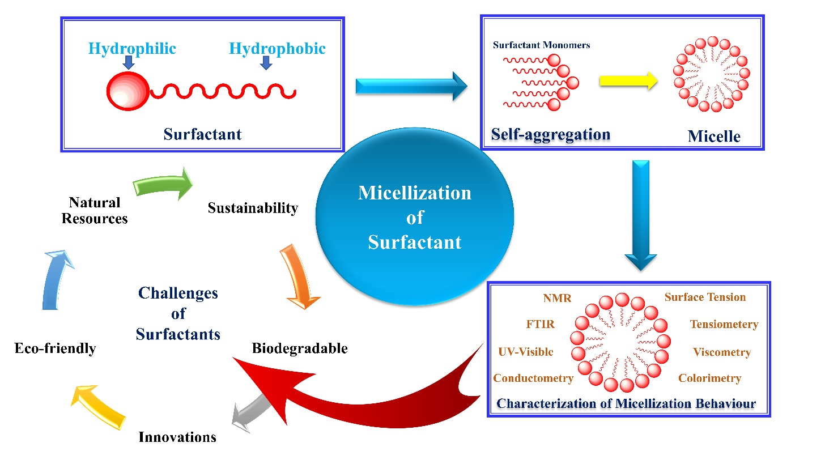

*Corresponding author
Dr. Manoj Kumar Banjare (MKB)
Tel.: +91-9827768119
E-mail address: manojbanjare7@gmail.com; manojbanjarechem111@gmail.com; rmanojkb@matsuniversity.ac.in
Surfactants challenges, methodology and its versatile application: A review
Bhupendra Singh Banjare and Manoj Kumar Banjare*
Department of Chemistry (MSS), MATS University, Pandri Campus, Raipur-492010 Chhattisgarh India
Email: bhupendra0889@gmail.com; manojbanjare7@gmail.com

Abstract
Modern science demands sustainable, effective, and natural chemicals that make human life easy and harmless, surfactant is one of them. Surfactants are the most widely used chemicals in industry such as clothing, foods, detergents, pharmaceuticals, and agriculture to modern science. Surfactant is a surface-active agent consisting of organic compounds of amphipathic character with great structural diversity. Surfactants' capacity to self-assemble is a highly potent function for many systems that influences the solubility of the weakly water-soluble products to boost their availability. The commercialization of surfactants has been going on for centuries. The effective surfactant can be detected by its physicochemical behavior. Various physicochemical properties of surfactants are determined through different techniques i.e., DLS, UV-visible spectroscopy, surface tension, conductometry, viscometry etc. The mix-micellar activity of two different types of surfactants is known by a variety of theoretical models such as Clint's, Rubing's, etc. Surfactants have a diverse variety of uses, which increases the need for future research that is more sophisticated. This review provides a detailed, well-articulated overview of surfactant classification, characteristics, applications, challenges, future aspects in various fields, and different techniques.

Keywords: Surfactant, Physicochemical, Classification, Application, Challenges.

- Introduction
The amphiphilic molecule has a tremendous role in society, nowadays mostly used in biological activities, food, personal care products, medicines, agrochemicals, and petroleum chemicals [1-2]. These features can be enhanced by producing a sugar-based amphiphilic molecule system. These deals are good renewable alternatives to the conventional production of materials [3-4]. The carbocyclic sugar-based alcohol-amphiphilic molecules respectively carbocyclic sugar alcohol, ionic liquids, and surfactants [5]. Surfactants are a type of amphiphilic components also known as surface-active agents illustrated in Fig. 1. It has several beneficial qualities, including wetting, cleaning, foaming, emulsifier splitting phases and dropping surface and interfacial tension etc. [6]. It has a unique tendency to adsorb at interfaces, that aggregate as micelles of surfactant monomers in aqueous media. The critical micelle concentration (CMC), at which this phenomenon occurs, is caused by the dual nature of the surfactant, which results in a variety of extended characteristics in the solution, such as "self-assembly," also known as micelles [7-8]. Surfactants are used in many different industries, such as anticorrosion, cosmetics, surface sciences, nanoscience, pharmaceuticals, medication delivery, agrochemicals etc. [9-10] .
Surfactant
Hydrophobic
Hydrophilic
Fig. 1 Structure of surfactant monomer

The antiquity of surfactants likely started in 1929 by German physiologist Kurt von Neergaard, (Fig. 2) who filled a swine lung with saliva solution to "reduce interfacial tension at the air-tissue part". It is amazing that independent research conducted in the 1950s by three persons involved in chemical warfare initiatives in three different nations led to identical results on the effect of nerve gases in the lungs [11]. | 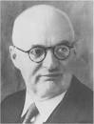  Fig. 2 K. V. Neergaard 1929
- History
- Defination
“In chemistry, surfactants are compounds that lower the surface tension or interfacial tension between the liquids-liquids, liquids-gases, and liquids-solids phases. An emulsifier, wetting agent, detergent, foaming agent, dispersant, or foaming agent are all examples of surfactants' uses. A surfactant is a component of surface-active agents.”
- Classification
A hydrophilic head is electrically charged on each surfactant. There can be a neutral charge, a negative charge, a positive charge and sometime both the charge (positive and negative) [12-13]. It is possible to identify a cationic, non-ionic, zwitterionic, and anionic surfactant based on the charge on its hydrophilic head illustrated in Fig. 3. In order to Gemini surfactants are made by joining two hydrophilic heads and two hydrophobic tails together with a spacer either in the centre of them or right next to them. One can use spacers that are either hydrophobic or hydrophilic flexible and stiff kinds exist [14]. All types of surfactants and its application shown in Fig. 10.

Non-ionic | Cationic | Anionic | Zwitterionic
Gemini
Fig. 3 A systematic representation of surfactant molecules (monomer).

Cationic surfactants
Surfactants with a positively charged head group are known as cationic surfactants. Commonly used in cosmetics, detergents, and industrial applications, these surfactants having high surface activity and ability to form micelles [15]. They are most effective at low pH values, making them ideal for use in cleaning products. These surfactants are also utilise in fabric processing and to reduce water’s surface tension. Additionally, cationic surfactants can be used to control the corrosion of metals and prevent the growth of bacteria [16]. They are excellent wetting agents and can be used to reduce foaming and stabilize emulsions. Some cationic surfactant’s structure have shown in Fig. 4.
Examples: Cetyltrimethylammonium chloride (CTAC), cetylpyridinium chloride (CPC), didecyldimethylammonium chloride (DDAC), cetyltrimethylammonium bromide (CTAB), benzalkonium chloride (BAC), tetramethylammonium hydroxide (TMAOH), etc.
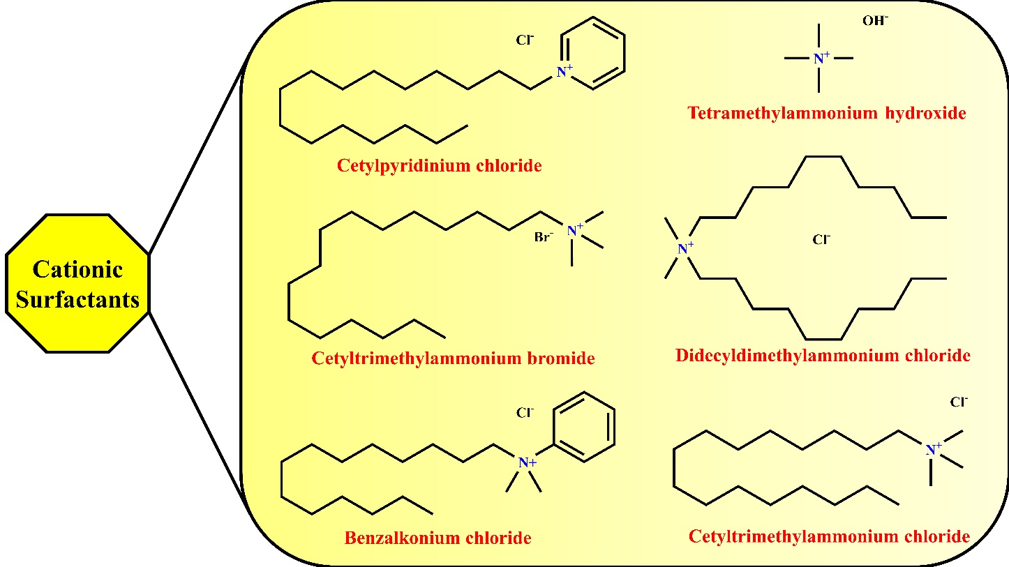
Fig. 4 Some structure of cationic surfactants.

Anionic surfactants
An negatively charged head group is present in anionic surfactants. These surfactants are utilised in a wide range of goods, including detergents and personal care items [17]. They are known for their excellent ability to remove dirt and oil from skin and surfaces. Anionic surfactants are effective, economical, and biodegradable, making them an ideal choice for many different applications. They are also known for their low foam generation and excellent solubility in water. Anionic surfactants can be used alone or in combination with other surfactants to create the desired result [18-19]. Some anionic surfactant’s structure have shown in Fig. 5.
Examples: Sodium dodecyl sulfate (SDS), ammonium dodecyl sulfate (ADS), sodium lauryl sarcosinate (SLS), sodium pareth sulfate (SPS), sodium myreth sulfate (SMS), etc.
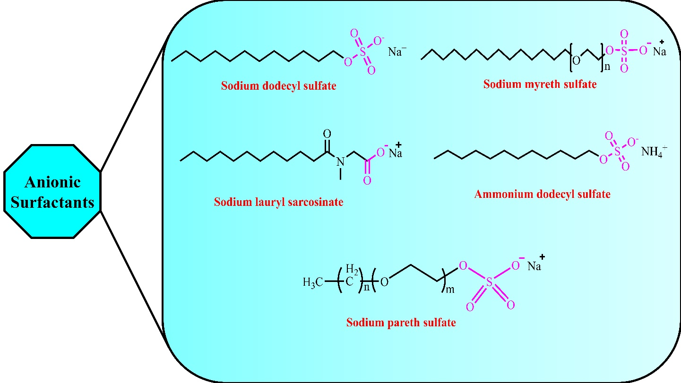
Fig. 5 Some structure of anionic surfactants.

Non-ionic surfactants
Surfactants that don't have a charge when dissolved in water are known as non-ionic surfactants. They are generally derived from fatty acids, alcohols, and amines [20]. They are often used in industrial cleaners, detergents, shampoos, and fabric softeners, as they have properties that make them effective wetting agents and emulsifiers. Non-ionic surfactants are more resistant to hard water than ionic surfactants and are often more effective [21-22]. They are also less irritating to the skin and more environmentally friendly than other surfactants. Some non-ionic surfactant’s structure have shown in Fig. 6.
Examples: Decyl polyglucose, isoceteth-20, nonoxynol-9, octyl glucoside, polysorbate-20, polysorbate-80, Triton X-100 (TX-100) etc.
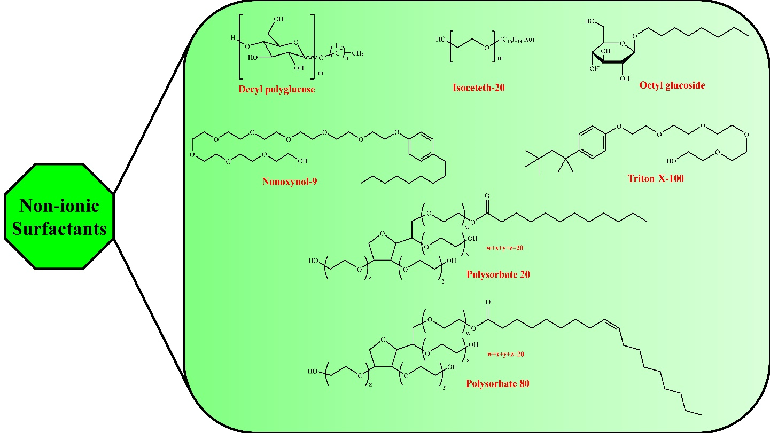
Fig. 6 Some structure of non-ionic surfactants.

Zwitterionic surfactants
Zwitterionic surfactants are a type of surface-active agent composed of both charged and uncharged molecules, also known as amphiphilic molecules [23]. They are typically composed of a hydrophilic head group, such as an amine, sulfonate, or carboxylate, and a hydrophobic tail group, such as an alkyl group. Zwitterionic surfactants are highly stable, non-toxic, and biodegradable, making them desirable industrial and consumer applications [24]. They are frequently employed in detergents, personal care items, food processing, and oil recovery. Zwitterionic surfactants have special features that make it possible for them to successfully lower surface tension, stabilise emulsions, and alter the rheology of aqueous solutions [25]. Some zwitterionic surfactant’s structure have shown in Fig. 7.
Examples: Cocamidopropyl hydroxysultaine, dipalmitoylphosphatidylcholine, lecithin, peptitergents, sodium lauroamphoacetate etc.
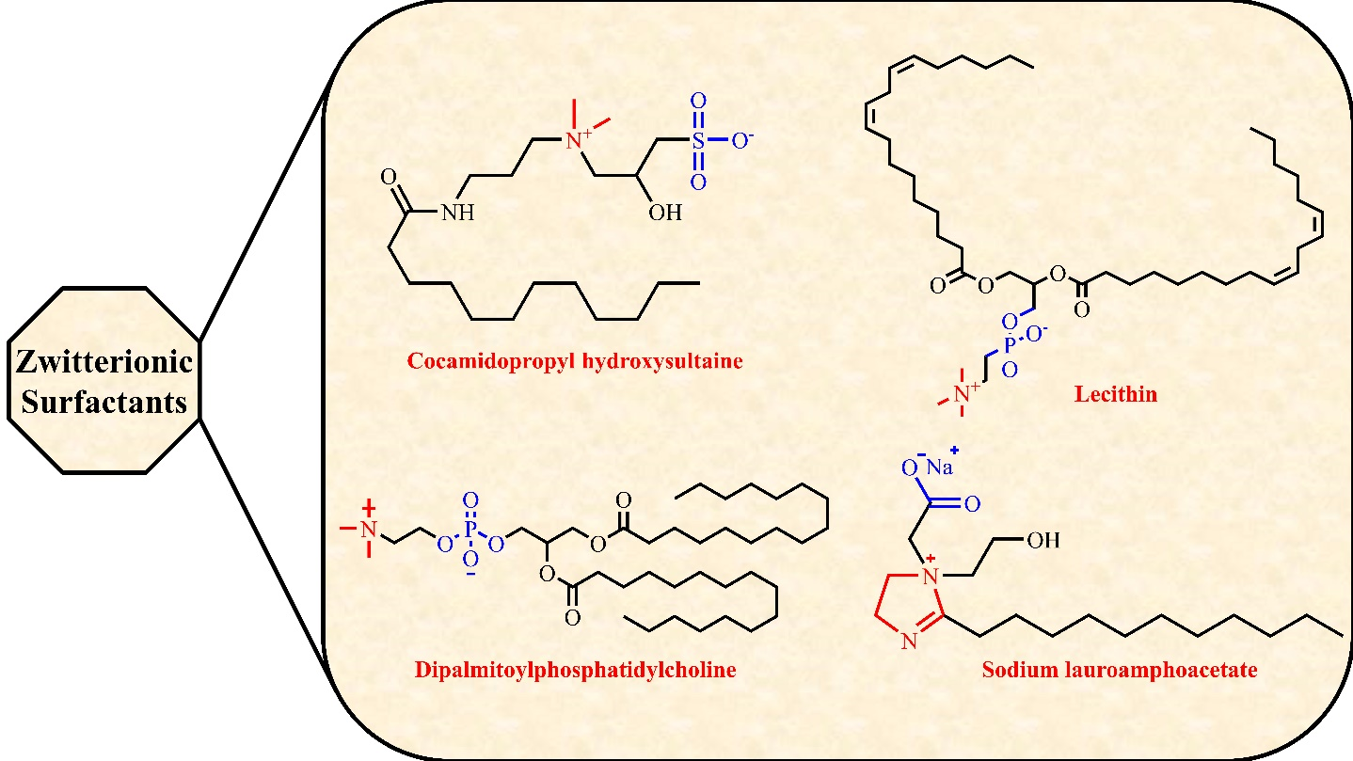
Fig. 7 Some structure of zwitterionic surfactants.

Gemini surfactants
Gemini surfactants are amphiphilic compounds made of two surfactant molecules joined by a spacer group [26]. They are employed in cleaning, detergents, emulsions, cosmetics, and personal care products as a result of their capacity to form micelles, which can aid in lowering surface tension. Gemini surfactants are more effective than traditional surfactants at low concentrations, so they can be used in eco-friendly formulations [27]. They are also more stable and less prone to oxidation and hydrolysis. Gemini surfactants are versatile and useful tools for formulators. Some gemini surfactant’s structure have shown in Fig. 8.
Examples: Pyridinium, amino acid-based Gemini surfactant etc.
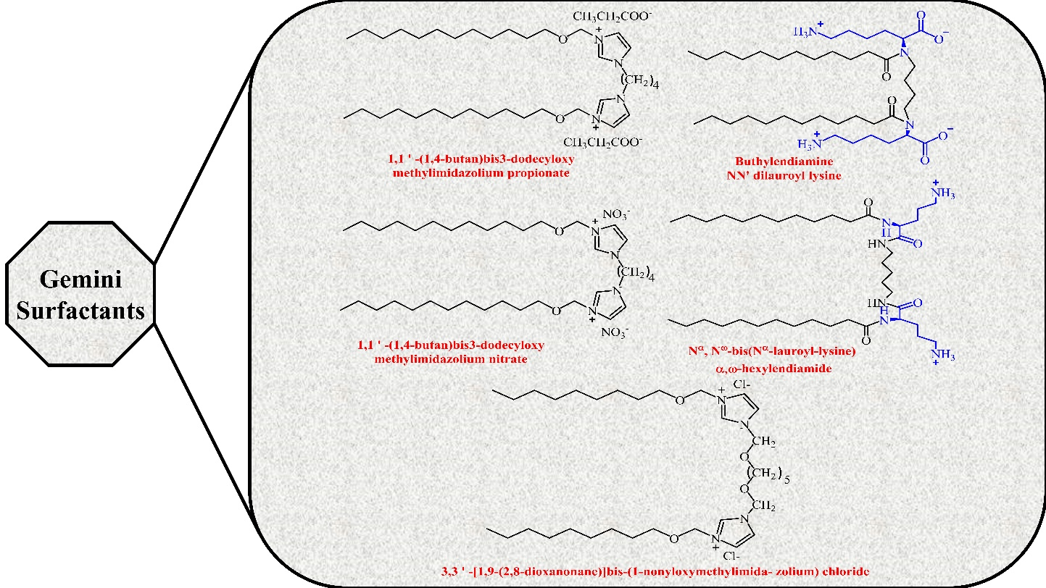
Fig. 8 Some structure of gemini surfactants.

Bio-surfactants
Bio-surfactants are special molecules that are produced naturally by bacteria, fungi, and plants. They are amphiphilic molecules, meaning they contain both hydrophilic and hydrophobic moieties [28]. This allows them to reduce surface tension and to form stable emulsions with oil and water. Bio-surfactants are biodegradable and non-toxic, making them attractive for an extensive range of industrial applications [29]. As an example, the sugar-based bio-surfactant glycolipid rhamnolipid is used to produce stable emulsions, making it useful in detergents and cosmetics. Bio-surfactants are also being explored for use in bioremediation, as they can be used to break down and remove pollutants from water and soil [30]. Some bio-surfactant’s structure have shown in Fig. 9.
Examples: Sodium deoxycholate, surfactin, rhamnolipid, and sodium cholate etc.
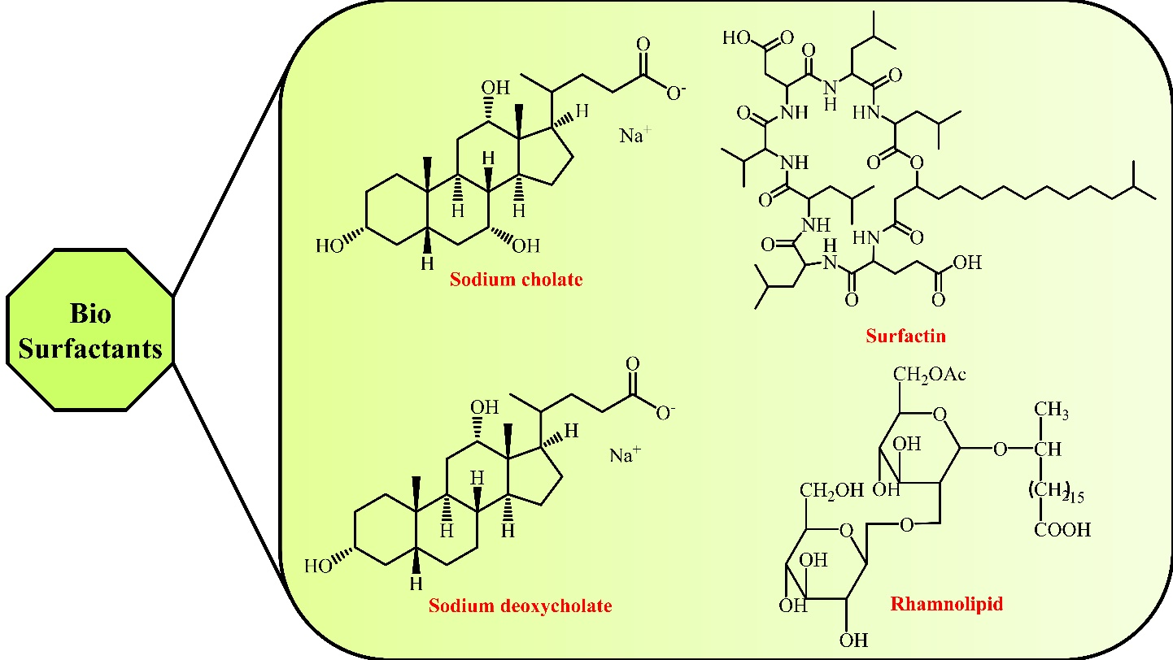
Fig. 9 Some structure of bio-surfactants.

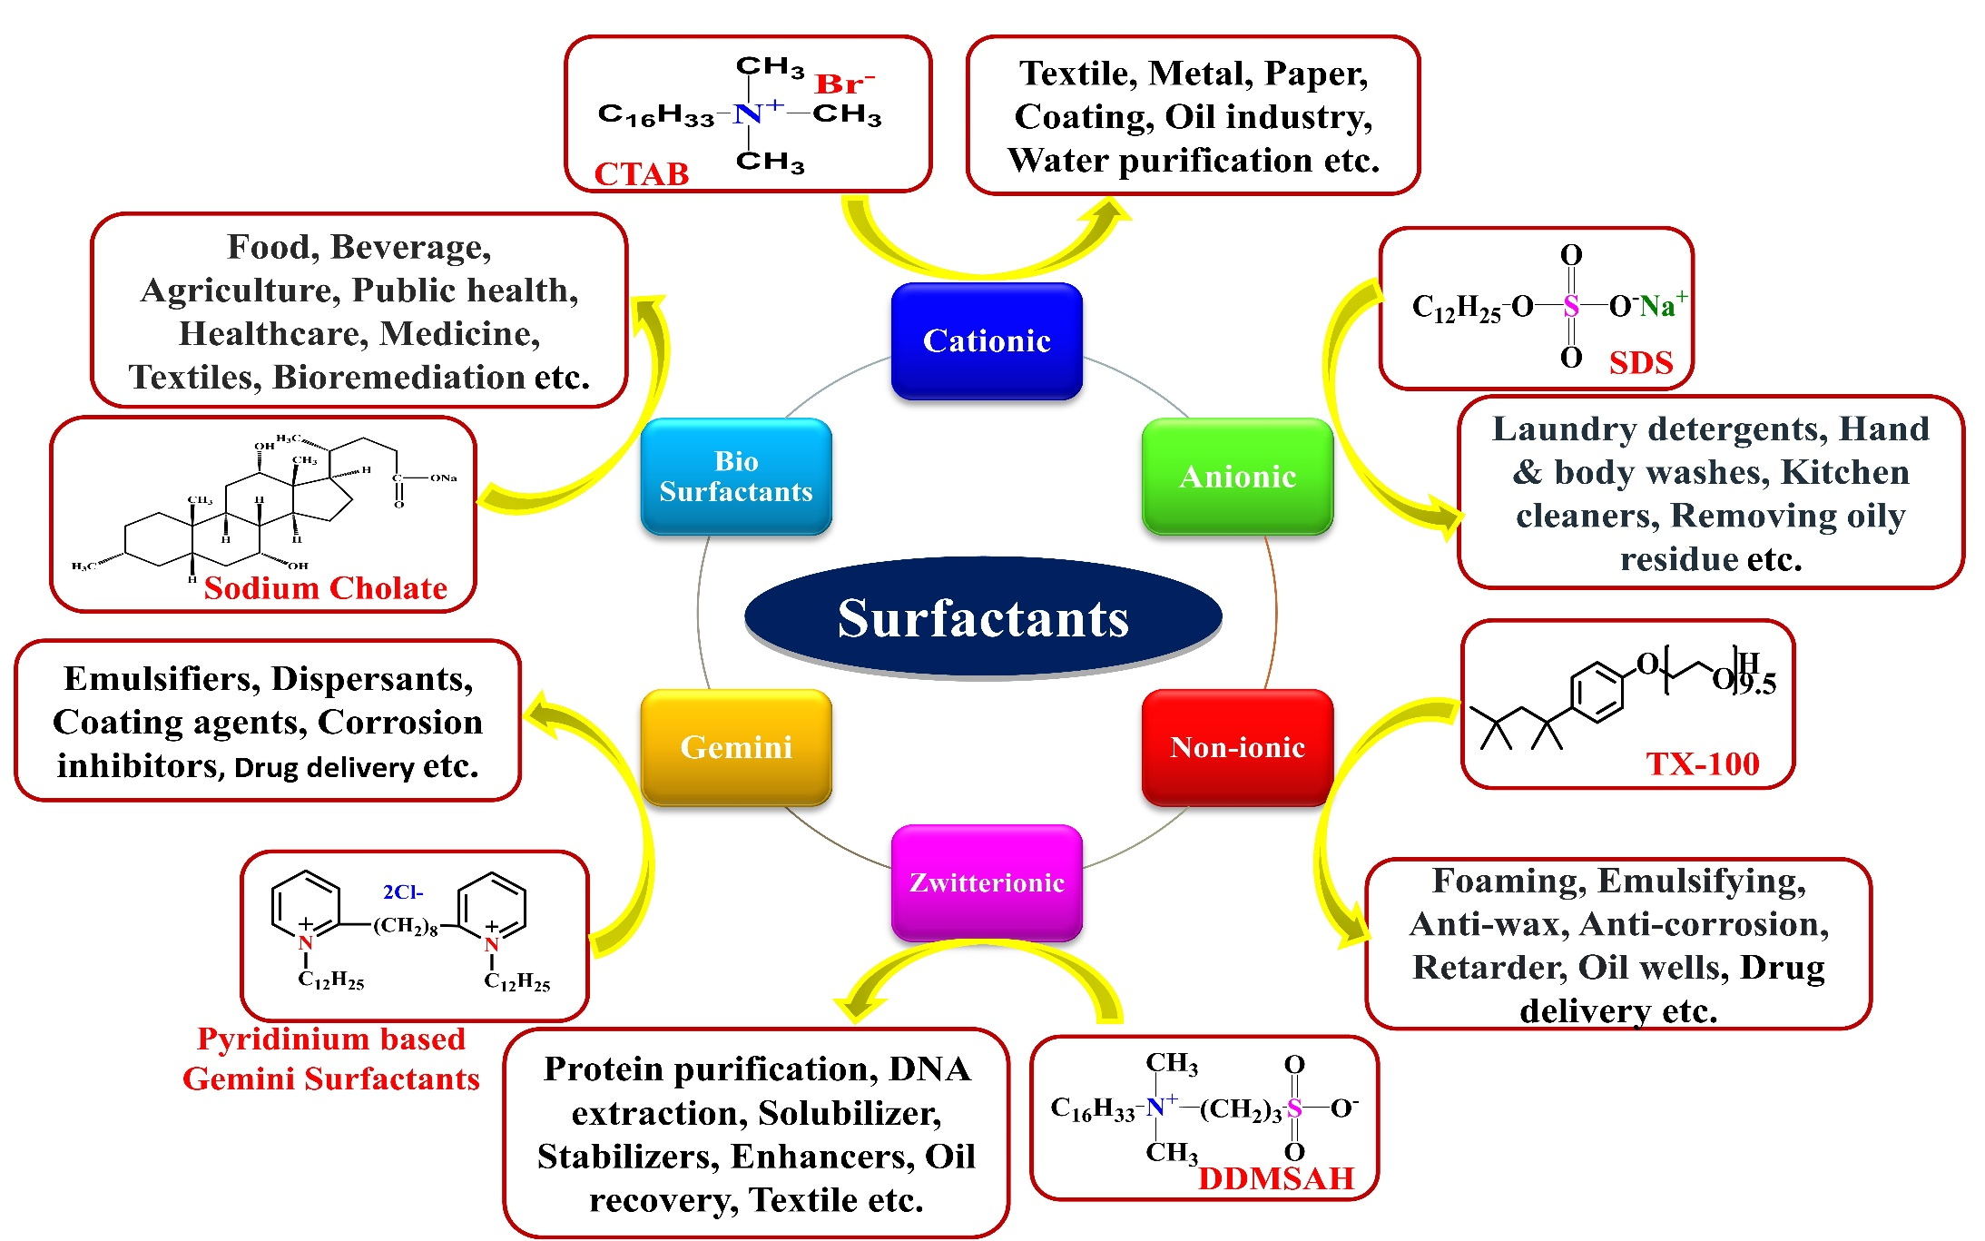
Fig. 10 A systematic representation of all types of surfactants with applications.

- Properties of surfactants
There is a component of surfactant that is insoluble in water (or oil-soluble) and a component that is soluble in water [31]. Surfactants diffuse and adsorb in water when mixed with oil, and they adsorb at the air-water interfaces or at the oil-water interface. cleaners, moisturising agents, emulsification, foaming agents, and dispersion agents [32]. All properties of surfactants have shown in Fig. 11.

Fig. 11 Systematic representation properties of surfactant.

- Application of surfactants
The excellent qualities of surfactants have led to their use in the development of a significant number of medicinal additives in recent years. They are widely used in a variety of industries as emulsifiers and wetting agents [33]. Also made from them are a number of lotions and ointments. Surfactants may improve subcutaneous absorption as well. In order to ensure protein stability during storage and purification, surfactants interact with proteins in a variety of ways, including hydrophobic and electrostatic interactions. Only hydrophobic interactions between proteins and non-ionic surfactants occur, whereas electrostatic and hydrophobic interactions between proteins and ionic surfactants occur [34-35]. Non-ionic surfactants are employed to stabilise proteins more frequently than ionic surfactants, albeit the reason for this is currently unknown [36-37]. In biopharmaceutical goods, polysorbates are the non-ionic surfactants that are most often utilised and publications year by year illustrated in Fig. 12 and Fig. 13 respectively.
.
Fig. 12 Systematic representation application of surfactants.
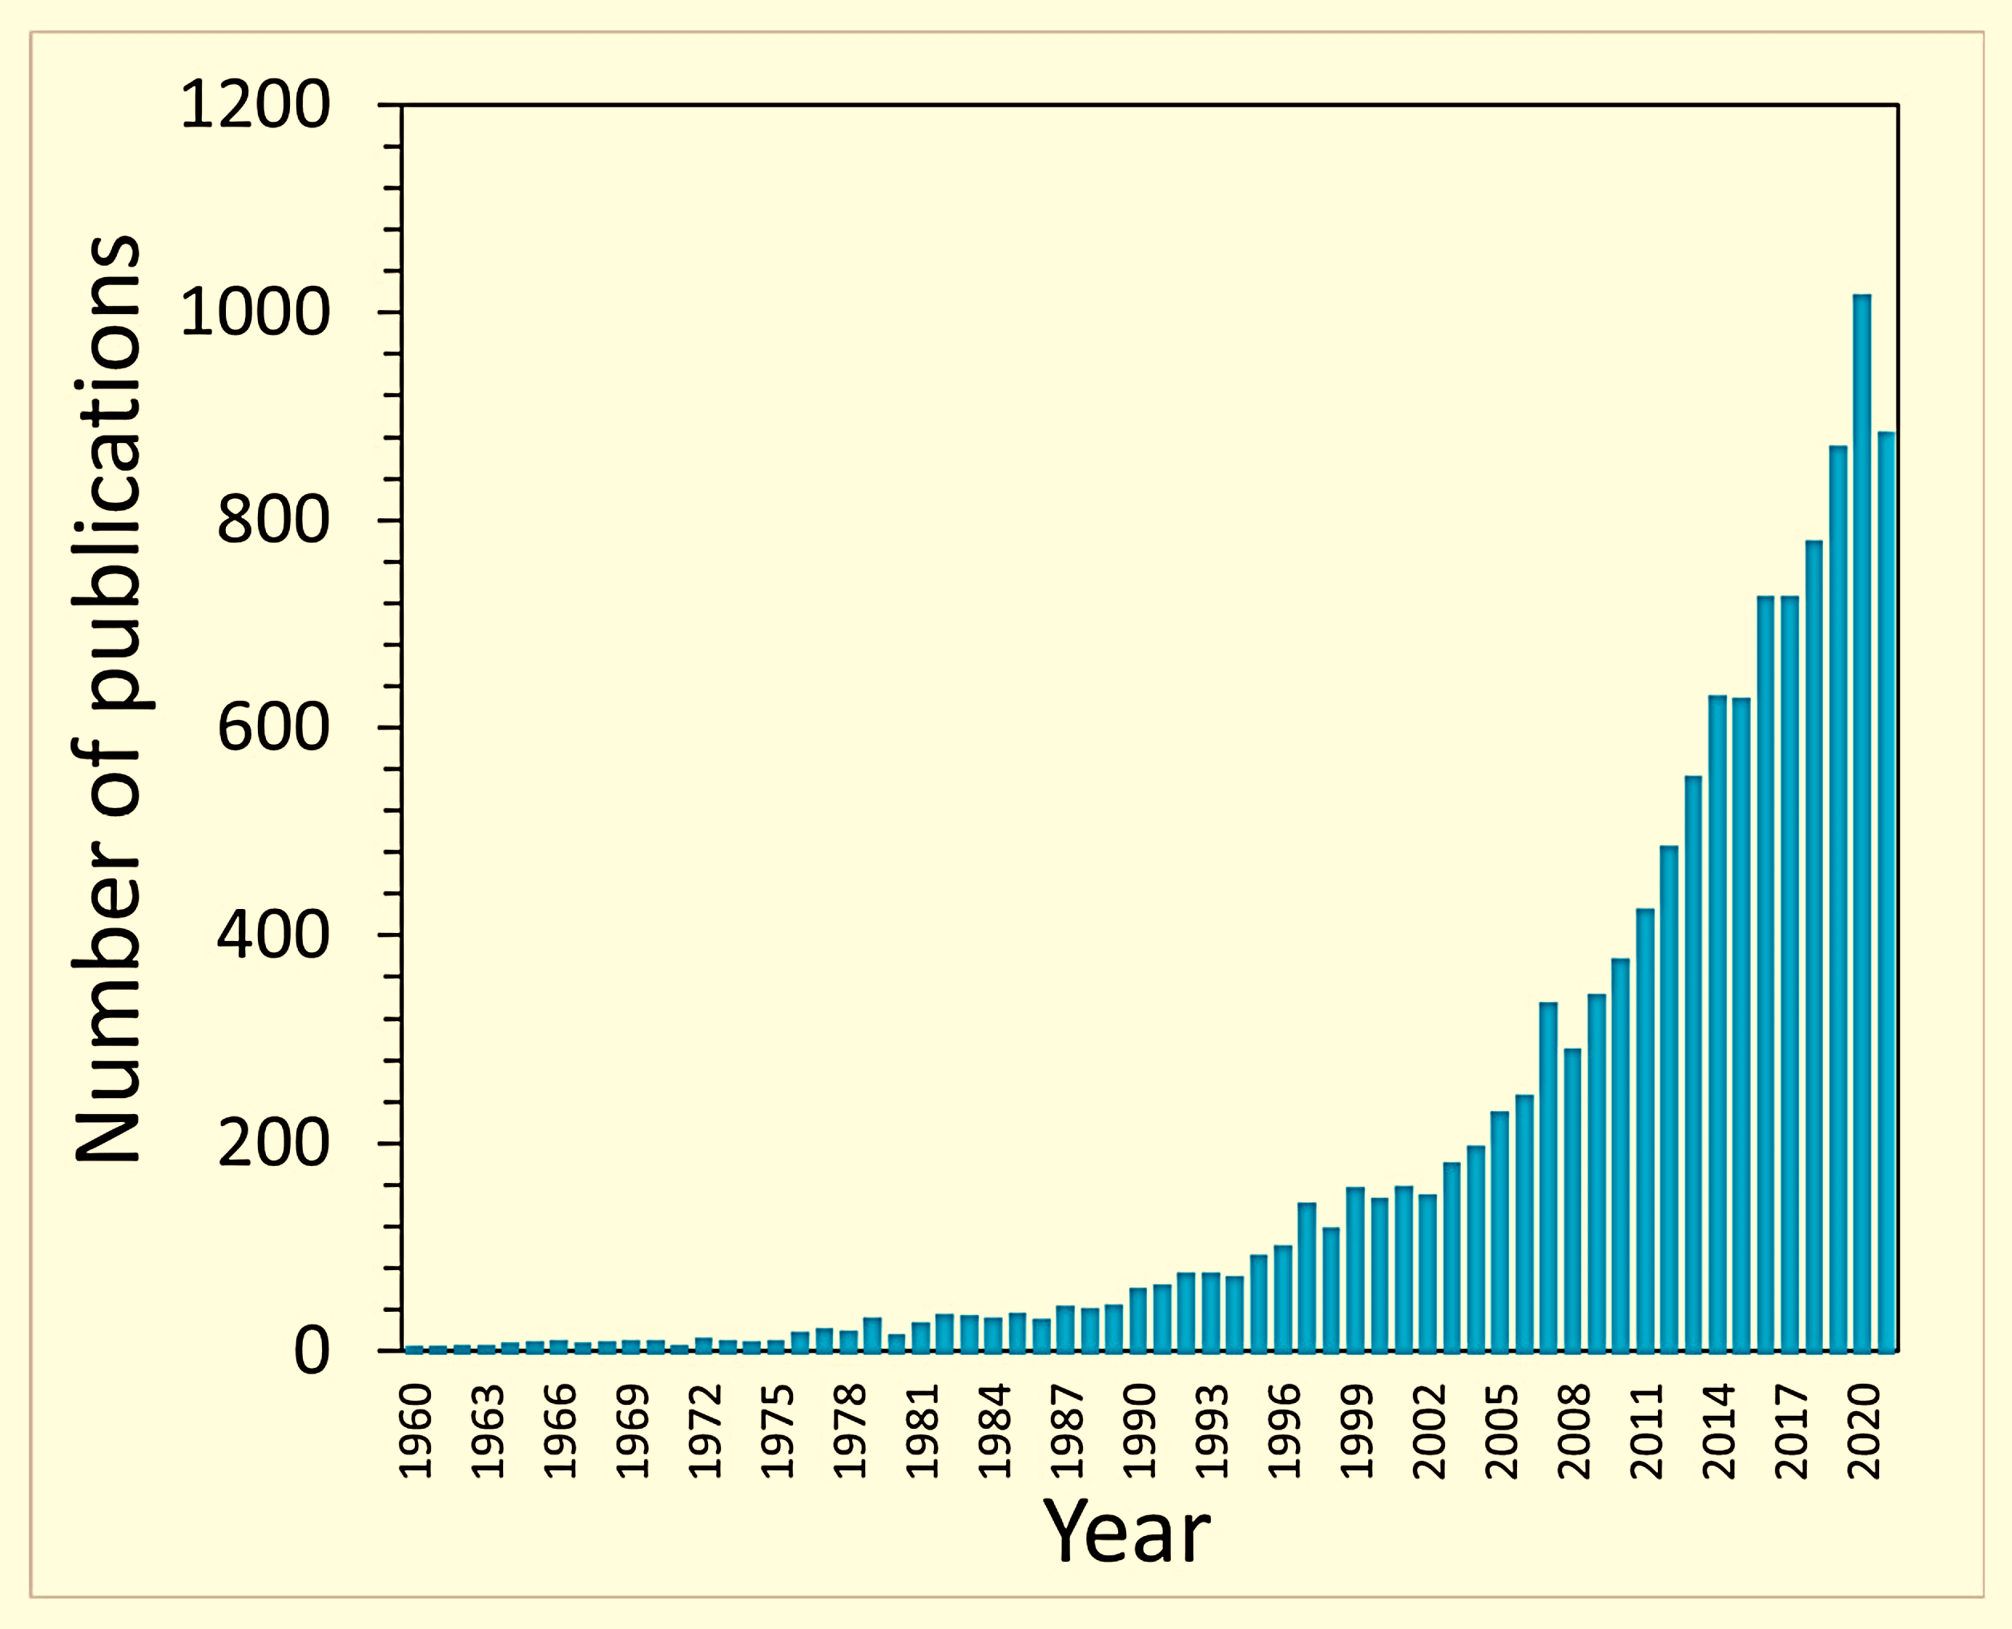
Fig. 13 Number of publications on surfactants in year between 1960 to 2020.

Critical micelle concentration (CMC)
The term critical micellar concentration (CMC) is used to describe the level of micelle formation in a surfactant molecule solution. Colloidal particles known as micelles are composed of a core of hydrophobic molecules and a shell of hydrophilic molecules [38]. The surfactant molecules exist as distinct molecules at and below the CMC. The molecules start to group together and form micelles above the CMC. The CMC is a crucial metric in the study of surfactants and has several uses. Micelles are a component of detergents that facilitate cleaning and lower the surface tension of water [39-40]. Hydrophobic compounds can be solubilized in micelles at and above the CMC to aid in their passage across membranes. Surface tension measurements, conductivity tests, DLS, TEM, SEM, fluorescence spectroscopy, and other methods may all be used to estimate the CMC. It depends on the chemical composition of the surfactant and the properties of the solution, such as its ionic strength, pH, and temperature. Typically, the CMC rises as the surfactant's hydrophobicity increases and falls as it becomes less hydrophobic [41-42].

Formation of micelle
Micelles are chemical structures in which the hydrophilic core surrounded by a hydrophobic shell of amphiphilic molecules contained in a liquid form an aggregate of spherical or cylindrical shape, such as surfactants [43-44]. This structure is important for the solubilization and stabilization of hydrophobic molecules part in aqueous solutions. The development of micelles is a complex process, driven by both hydrophobic and electrostatic interactions between amphiphilic molecules [45]. When amphiphilic molecules are added to aqueous solutions, they form aggregates known as micelles that shows in Fig. 14. These aggregates are composed of a hydrophobic core surrounded by a hydrophilic part. This hydrophobic core is composed of the hydrophobic tails part of the amphiphiles, while the hydrophilic part is composed of the hydrophilic headgroups of the amphiphiles, which interact with the aqueous environment [46-47]. The core of the micelles are formed when the amphiphiles arrange themselves in a manner that minimizes the contact between the hydrophobic tails and the aqueous environment [48-49].
Fig. 14 Micellization structure of amphiphilic molecule.

The kind and quantity of amphiphiles in the solution have an impact on the size of micelles. At low concentrations of amphiphiles, individual molecules of the amphiphiles interact with each other and form small aggregates known as primary micelles. At higher concentrations, the primary micelles can interact and form larger aggregates known as secondary micelles. The size of these micelles can range from a few nanometres to several hundred nanometres [50].
- Characterization techniques
There are several techniques for measuring the size of micelles and the CMC in aqueous solutions, comprising surface tension, fluorescence, conductometry, viscosity, light scattering, sound velocity, calorimetry, spectrophotometry, SANS, and dye solubilization etc. [51]. The most common technique is dynamic light scattering (DLS), which uses laser light to measure the Brownian motion of the micelle particles in solution. This technique allows for the measurement of the average size of the micelles and their polydispersity. Another technique that can be used is transmission electron microscopy (TEM), which allows for the direct visualization of the micelles [52-53]. This technique allows for the determination of the size, shape, and surface charge of the micelles illustrated in Fig. 15 and Table 1.

Fig. 15 Micelle formations using the surface tension, conductivity, colorimetry, florescence, and osmotic pressure methods.
Table 1 List of different technique for the characterization of surfactants CMC.
S.N. | Techniques | Characterization
1. | Scanning electron microscopy (SEM) | Morphology
2. | Transmission electron microscopy (TEM) | Morphology
3. | Nuclear magnetic resonance (NMR) | CMC/ Intramolecular interaction
4. | Fourier transform infrared spectroscopy (FTIR) | Characterization of micelle
5. | Dynamic light scattering (DLS) | Size distribution and zeta potential
6. | UV-Visible spectroscopy | Confirmed micelle formation
7. | X-ray photoelectron spectroscopy (XPS) | The elemental composition of micelle
8. | X-ray diffractometry (XRD) | Crystallinity
9. | Small angle neutron scattering | CMC
10. | Surface tension | CMC
11. | Colorimetry | CMC/CAC
12. | Conductometry | CMC
13. | Fluorescence | CMC
14. | Energy dispersive X-ray spectroscopy | Emission
15. | Loresta-GP MCT-T610 resistivity meter | Volume resistivity

Physicochemical properties of surfactants
A lot of research has been done on the physicochemical aspects of surfactant molecules because of their distinctive traits. Surfactant molecules are capable of forming self-assembling known as micelles. Additionally, they have the ability to adsorb and create a monolayer at the air-water interface, which is helpful in the creation of surfactants. Overall surfactant molecules are distinctive physicochemical features make them useful tools in a variety of disciplines. [54-55].

Interfacial Properties
Interfacial properties are characteristics of the interface between two different materials, such as an aqueous solution and an organic phase. These properties include surface tension, wettability, surface energy, wetting and spreading, adsorption, and adhesion [56-57]. The force required to move a line of water over a surface is known as surface tension, and the wettability of a liquid is how readily it spreads across a surface. Wetting and spreading define how a liquid will spread out on a surface, whereas surface energy is the amount of energy necessary to form a unit area of surface [58]. Adsorption is the process of an adsorbate being attracted to a surface, while adhesion is the force between two surfaces. Understanding interfacial properties are important for many industries, as they determine the effectiveness of interactions between materials [59].

Surface tension (γ)
According to surface tension, surface free energy is defined as the area per unit of surface tension. The intermolecular distance increases sharply at the liquid-gas interface (liquid surface) leading to anisotropic forces between molecules [60]. Surface tension is a fundamental physical property that is used in surface, interface, and colloid research and is shown by amphiphilic molecules such as ionic liquids and surfactants. An investigation of the impact of surface tension on the aggregation of amphiphilic molecules in different solvents, such as water, sugar, its derivatives, and other organic solvents. Surface tension has consistently decreased in several investigated solvents when the molar ratio of amphiphilic compounds has grown [61]. The surface tension (γ) of amphiphilic systems have calculated by using Eq. (1).
$$γ_{CMC}=\frac{Drop of Water X 72}{Drop of Solution}$$ | 1

Maximum surface excess concentration (Г_{max})
Maximum surface excess concentration is the highest concentration of a certain chemical species found at the surface of a liquid or solid. It is an important parameter in determining the stability, solubility, and reactivity of a material. It can also be used to measure the adsorption and desorption of molecules. Maximum surface excess concentration in the material, surface area, and temperature are used to calculate the maximum surface excess concentration. It may be determined using the temperature, the kind of material, and the amount of surface area available for adsorption [62]. The maximum surface excess (Γ_{max}) of amphiphilic systems have calculated from the slope (dγ/ dlog₁₀C) by using Eq. (2).
$$Γ_{max}=\left(\frac{1}{2.303nRT}\right)\left(\frac{dγ}{d\log_{10}{C}}\right)Tp$$ | 2
Where, pre-factor (n) values for non-ionic surfactant (1), cationic surfactant (2), anionic surfactant (2), molar gas constant (R = 8.314 Jmol⁻¹K⁻¹), absolute temperature (T) in Kalvin, and surfactant concentration (C) have been taken.

Minimum surface area per molecule (A_{min})
Minimum surface area per molecule is an important concept in chemistry and materials science. It refers to the smallest possible area occupied by a molecule on a surface. The smaller the surface area, the higher the potential of the molecule to interact with other molecules. This is because smaller molecules have a greater ability to form strong chemical bonds with other molecules. Therefore, minimizing the surface area per molecule have a greater potential to interact with other molecules, resulting in faster reaction times [63]. The minimum areas per molecule (A_{min}) of amphiphilic systems have calculated by using Eq. (3).
$$A_{min}=\left(\frac{1}{Γ_{max}}\right)N_{A}$$ | 3
Where, N_{A} is Avogadro’s number (6.022×10²³ mol⁻¹), A_{min} is the minimum area per molecule (m²mol⁻¹), and Г_{max} is the maximum surface excess concentration (mol.m⁻²).

Surface pressure at CMC (π_{CMC})
Surface pressure at CMC is a measure of the force exerted by a surface per unit area on a body. In addition, it can help determine the air density and airflow around an object. Surface pressure can also be affected by temperature and humidity [64]. The surface pressure at CMC (π_{CMC}) have calculated by using Eq. (4)
$π_{CMC}=γ_{0}-γ_{CMC}$ | 4
Where, γ_{CMC} and γ₀ is the surface tension at CMC and the surface tension of pure water respectively.

The efficiency of adsorption pC₂₀
The efficiency of adsorption pC₂₀ is a measure of how well a substance is adsorbed onto a surface. It is measured by the amount of material adsorbed per unit area of the surface. The higher the pC₂₀ value, the more efficient the adsorption process. Generally, adsorption is more efficient when the surface has a large surface area or when the material being adsorbed has a higher affinity for the surface. Adsorption is used in many different industries such as water treatment, food processing and the manufacture of pharmaceuticals, cosmetics, and other products [65]. The efficiency of the adsorption (pC₂₀) have calculated by Eq. (5).
${pC}_{20}=-\log_{10}{C_{20}}$ | 5

Thermodynamic Properties
The most important thermodynamic property of amphiphilic molecules is their tendency to self-assemble into ordered structures. The hydrophobic effect, which is caused by the alluring contact between hydrophobic groups in the molecules, is what propels this self-assembly. The organization of amphiphilic molecules into ordered structures can be further stabilized by hydrogen bonding and other interactions between the molecules [66].

Degree of micellization (α)
Micellization is a process where amphiphilic molecules aggregate to form micelles. The ratio of hydrophilic to hydrophobic groups in the amphiphilic molecule determines how much of the molecule micellizes. When it comes to increasing a substance's solubility and stability, micellization level is a crucial consideration. The greater the degree of micellization, the higher the solubility and stability. When the degree of micellization is low, the amphiphilic molecules remain separate and the solubility and stability is lower. Overall, the degree of micellization of an amphiphilic molecule is an important factor to consider when optimizing the solubility and stability of a substance [67]. The amount of micellar ionisation (α) has been calculated using the slopes of the pre- and post-micellar conductivity curves by Eq. (6).
$α=\frac{S_{2}}{S_{1}}$ | 6
Where, S₁ is the pre-micellar and S₂ is post-micellar slopes of the different surfactants.

The standard Gibbs free energy of micellization (ΔG°_{M})
The balance between the amphiphilic molecules' hydrophobic and hydrophilic contacts, with the hydrophobic interactions pushing micelle formation and the hydrophilic interactions opposing it, determines the standard Gibbs free energy of micellization. The standard Gibbs free energy of micellization increases with the hydrophobic and hydrophilic sections of the molecule's solubility differential. Understanding the behaviour of amphiphilic compounds depends on being able to anticipate the size and stability of micelles using the standard Gibbs free energy of micellization [68]. The standard Gibbs energy of micellization (ΔGº_{M}) of amphiphilic system have computed by Eq. (7).
$ΔG_{M}^{°}=\left(2-α\right)RTln\frac{55.4}{CMC}$ | 7
Where, T is the absolute temperature (299 K), R is the molar gas constant (8.314 Jmol⁻¹K⁻¹), is the degree of micellar ionisation (2-α) for monomeric surfactants, and 55.4 comes from 1 litre of water.

The standard Gibbs free energy of adsorption (ΔG°_{ads})
The standard Gibbs free energy of adsorption of amphiphilic molecules is an important thermodynamic parameter used to measure the affinity of the molecule to the surface of a solid. In general, the standard Gibbs free energy of adsorption is lower for molecules with greater surface area or longer chain length, as this increases the number of molecules that can adsorb onto the surface [69]. The standard Gibbs free energy of adsorption (ΔG°_{ads}) of amphiphilic have been calculated by using Eq. (8)
$∆G_{ads}^{°}={∆G}_{M}^{°}-\frac{π_{CMC}}{Γ_{max}}$ | 8
Where ∆Gº_{M} is the standard Gibbs free energy of micellization, Г_{max} is the maximum surface excess concentration, and π_{CMC} is the surface pressure at CMC.

The standard Gibbs energy of transfer (ΔG°_{trans})
The Gibbs energy of transfer (ΔG°trans) is the energy released or absorbed when an amphiphilic molecule transfers from one medium to another. ΔG°_{trans} is a valuable tool for understanding the behaviour of amphiphilic molecules in different environments and how they interact with their surroundings. By studying ΔG°_{trans}, researchers can gain insights into how amphiphilic molecules interact with their environment and how this interaction affects their stability and solubility [70]. The standard Gibbs free energy of transfer (ΔG°_{trans}) have calculated by using Eq. (9).
$∆G_{trans}^{°}={∆G}_{M(solvents mixed media)}^{°}-{∆G}_{M(pure water)}^{°}$ | 9
Where, ΔG°_{M (pure} _{water)} and ΔG°_{M (solvents mixed media)} are pure water and amphiphilic system mixed media respectively.

The standard Gibbs free energy of the given air/water interface (∆G^{(s)}_{min})
An essential factor in determining an amphiphilic molecule's capacity to form micelles and other structures is the standard Gibbs free energy of the air/water interface (ΔG^{(s)}_{min}). The interaction of the amphiphile molecule's hydrophilic and hydrophobic properties determines this free energy. The molecule's hydrophilic groups connect with water, whereas its hydrophobic groups engage with air. A measurement of the potential energy produced by the interaction of these two forces is the free energy of the interface. [71]. The standard Gibbs free energy of the given air-water interface (ΔG^{(s)}_{min}) have calculated by Eq. (10).
$∆G_{min}^{(S)}=A_{min}.Υ_{CMC}.N_{A}$ | 10
Where, A_{min} is the minimum surface area per molecule, γ_{CMC} is the surface tension of amphiphilc system at equilibrium, and N_{A} is Avogadro number (6.022×10²³ mol⁻¹).

The standard Gibbs free energy of micellization per alkyl tail (ΔG°_{m,tail})
The energy needed to create micelles from amphiphilic compounds is measured by the standard Gibbs free energy of micellization per alkyl tail (ΔGº_{m, tail}). It has to do with the harmony between the molecule's hydrophilic and hydrophobic components. This energy depends on the size, stiffness, shape, and solvent properties of the amphiphilic molecule. It is also impacted by the solution's ionic strength and temperature. [72]. The standard Gibbs free energy of micellization per alkyl tail (ΔGº_{m, tail}) of amphiphilc systems have calculated from Eq. (11).
$∆G_{m,tail}^{°}=\frac{{∆G}_{M}^{°}}{2}$ | 11

Critical packing parameter (P)
Using the following Eq. (12), the critical packing parameter (P) of amphiphilic molecules, which predicts the form of the aggregates, has been computed and is systematically shown in Fig. 16 and Table 2. Israelachvili et al. [73] revelled the relationship for determining the packing parameter (P) by using the minimum surface area of amphiphilc molecule.
$$P=\frac{V_{0}}{A_{min}l_{c}}$$ | 12
$V_{0}=(27.4+26.9C_{n})Å^{3}$ per hydrocarbon chain  $l_{c}=(1.5+1.265C_{n})Å$ per hydrocarbon chain | 13  14
Where V_{o}, l_{c} and A_{min} shows the volume long alkyl chain groups of hydrophobic part of amphiphilic molecule, the length of the long alkyl chain (hydrophobic tail) and minimum area per of amphiphilic molecule to aggregate the systems were determined by using Tanford’s formulae [74] the following Eq. (13) and (14).
 |  | 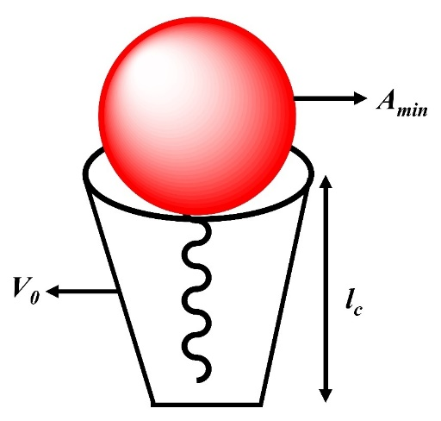
 |  | Fig. 16 Systematic representation of CPP.
Table 2 Different shape of surfactant monomers and corresponding shape of micelle.
Packing parameter | Critical packing shape |  | Name of Shape | General surfactant type | Self-assembly entities |  | Ref.  No.
P = < 0.33 | 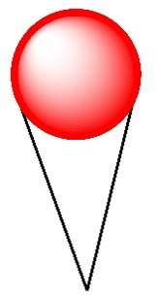 |  | Spherical Micelle | Surfactants with a single-chain and substantial head groups. |  |  | [75]
P = 0.33 - 0.5 | 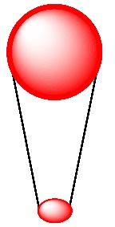 |  | Cylindrical Micelle | Surfactants with a single chain and tiny head groups. |  |  | [75]
P = 0.5 - 1.0 |  |  | Bilayer Vesicle | Surfactants having two chains, each with a big head group and flexible chains |  |  | [76]
P = 1.0 |  |  | Lamellar Phase | Small head groups on double-chain surfactants or inflexible, immovable chains |  |  | [76]
P = > 1.0 |  |  | Inverted / Revers Micelle | Surfactants having a double chain, big hydrophobic groups, and a tiny head group |  |  | [76]

Phase behaviours
Surfactants have exposed to different temperatures, pressures, and concentrations it can be used to modify the surface properties of materials. The phase behaviour of surfactants is an important factor in determining their effectiveness and applications. Surfactants are amphiphilic molecules that can form micelles, which are spherical aggregates of molecules that are held together by hydrophobic interactions. The phase behaviour of surfactants is largely determined by the degree of hydrophobicity and the molecular structure of the surfactants. At low temperatures, surfactants can form an isotropic liquid, an isotropic gel, or a lamellar phase. As the temperature increases, the surfactants can form a reverse micellar phase, a micellar cubic phase, and then a micellar hexagonal phase. At even higher temperatures, the surfactants can form a lamellar gel or an isotropic liquid [77-78].

Viscosity properties
An essential characteristic of amphiphilic compounds is viscosity. These molecules' hydrophilic and hydrophobic groups interact with one another and the medium around them. A layer of molecules is produced as a result of this contact, which might alter the medium's flow. The flow is slower the more viscous the medium is. The degree of the hydrophobicity-hydrophilicity balance of the molecule, the kind of media, the temperature, and the concentration of the molecule all have an impact on the viscosity of amphiphilic molecules. Additionally, the viscosity of amphiphilic molecules can be impacted by the presence of other molecules in the medium. varied amphiphilic systems have varied viscosity parameters, including relative, specific, decreased, and intrinsic viscosity [79].

Relative viscosity (η_{r})
Amphiphilic molecules' relative viscosity plays a crucial role in the creation of these formations. The affinity between the hydrophilic and hydrophobic components of the molecule controls it. Higher relative viscosity is exhibited by molecules whose hydrophilic and hydrophobic components are more affixed to one another. The size and shape of the molecules, as well as the size and shape of their hydrophobic and hydrophilic components, also have an impact on this relative viscosity. The relative viscosity (η_{r}) of all systems have computed from Eq. (15) is expressed as:
$$η_{r}=\frac{η_{s}}{η_{0}}$$ | 15
Where η_{r,} η_{s} and η_{ο} are relative viscosity of the system, viscosity of the solution, and viscosity of the pure solvent respectively.

Specific viscosity (η_{sp})
Specific viscosity is a measure of how much a material's viscosity increases when it is exposed to a certain concentration of an amphiphilic molecule. This increase in viscosity is due to the amphiphilic molecule's ability to interact with and increase the viscosity of the material it is exposed to [80]. The specific viscosity (η_{sp}) of all systems have computed from Eq. (16) is expressed as:
$$η_{sp}=η_{r}-1$$ | 16

Reduced viscosity (η_{red})
The reduced viscosity of amphiphilic molecules is a phenomenon that occurs when the molecules form micelles, or clusters, in an aqueous solution. These micelles are formed when one end of the molecule is attracted to water, while it repels the other end. This creates a structure in which the molecules arrange themselves in a way that reduces the overall viscosity of the solution. This is because the molecules are not interacting with each other as much, thus decreasing the amount of energy needed for the molecules to move around. Reduced viscosity can also be used to improve the performance of industrial processes [81]. The reduced viscosity (η_{Red}) of all system have calculated from Eq. (17) and (18) is expressed as:
$$η_{Red}=\frac{η_{sp}}{C}$$ | 17
$$η_{sp}=η_{r}-1$$ | 18
Where η_{sp}, η_{r}, and C are the specific viscosity, relative viscosity, and concentration of amphiphilic system respectively.

Intrinsic viscosity [η]
The intrinsic viscosity of an amphiphilic molecule is an important parameter that is used to describe the behaviour of a molecule in solution. It is a measure of the degree to which a molecule resists movement through the solution. This resistance is caused by the combination of the molecule’s hydrophobic and hydrophilic regions, which interact with the solvent [82]. It is the most important factor in determining the solubility of a molecule in a solution. The intrinsic viscosity values [η], amphiphilic system have calculated from Eq. (19) is expressed as:
$$[η]=\lim_{C→0}{\frac{η_{sp}}{C}}$$ | 19

Mixed micelle
A combination of surfactants can offer better chemical and surface-active qualities, lowering the required quantity. To improve the performance of surfactant mixtures, it is useful to comprehend the interactions between the surfactants. A mixture of two surfactants can have a CMC that is in between (or below) the CMC of its individual components in some cases. The interaction of binary surfactant systems has been predicted by several theories [83].
Mixed micelles of two amphiphilic molecule represent a unique type of self-assembled structure in which the hydrophilic and hydrophobic moieties are arranged in a distinct manner. The equilibrium of electrostatic and hydrophobic interactions between two amphiphilic molecules governs the structure of such mixed micelles. Furthermore, the size, hydrophobicity, and charge of the different components, as well as their interactions, have a significant impact on the solubilization ability of mixed micelles. A variety of applications, such as medication administration, catalysis, and separations, benefit greatly from mixed micelles [84].

Clint model
The Clint's model is employed to assess the ideal micellar mole fraction of combined surfactant systems, both of which clarify departures from ideality for researchers researching mixed systems [85]. Clint model the predicted ideal mixing CMC values are obtained from Eq. (20).
$$\frac{1}{{CMC}_{ideal}}=\frac{α_{1}}{{CMC}_{1}}+\frac{α_{2}}{{CMC}_{2}}$$ | 20
Where CMC₁ and CMC₂ are the critical micelle concentration of both amphiphilc components. CMC_{ideal} is mixture CMC, α₁ and α₂ are molar fraction of amphiphilic molecule.

Rubingh model
The Rubingh model is the phase separation model of mixed micelles. This theoretical model developed by Dutch physicist Peter Rubingh in the early 2000s. It is used to explain the properties of mixed micelles, which are aggregates of amphiphilic molecules such as lipids and surfactants. The model considers the interaction of hydrophobic and hydrophilic contacts as well as the impact of electrostatic charge interactions between the amphiphilic molecule in order to describe the behaviour of a specific system of mixed micelles. The model also considers how these interactions alter the size and structure of the mixed micelles. The Rubingh model may be used to measure these interactions and forecast the stability and solubility of mixed micelles in a given solution [86]. The Rubingh theory may be used to determine a mixture's CMC for non-ideal mixed micellization of amphiphilic components from Eq. (21).
$$\frac{1}{{CMC}_{mix}}=\frac{1}{f_{1}{CMC}_{1}}+\frac{1}{f_{2}{CMC}_{2}}$$ | 21

Where f₁ and f₂ are the activity coefficients of amphiphilic components the following Eq. (22) and (23) can calculate it.
$$f_{1}=exp\left[β{\left(1-X_{1}\right)}^{2}\right]$$ | 22
$$f_{2}=exp\left[β{\left(X_{1}\right)}^{2}\right]$$ | 23
Examining regular solution theory can help you better understand how two amphiphilic components interact in a mixed micelle. By using the Rubingh model, it is possible to calculate the micellar mole fraction of amphiphile 1:
$$\frac{{\left(X_{1}\right)}^{2}\ln\left(\frac{α_{1}{CMC}_{mix}}{X_{1}{CMC}_{1}}\right)}{{\left(1-X_{1}\right)}^{2}\ln\left[\frac{\left(1-α_{1}\right){CMC}_{mix}}{\left(1-X_{1}\right){CMC}_{2}}\right]}=1$$ | 24

where X₁ represents the mole percentage of the mixed micelle's amphiphilic component 1. Eq. (24 and 25) can be used to solve the X₁ equation.
$$X_{1}^{ideal}=\frac{α_{1}{CMC}_{2}}{α_{1}{CMC}_{2}+α_{2}{CMC}_{1}}$$ | 25

The attractive or repulsive contact between two amphiphilic components is confirmed by the Rubingh model using the regular solution theory by an interaction parameter computed by Eq. (26).
$$β=\frac{ln⁡(\frac{α_{1}C_{mix}}{X_{1}C_{1}})}{(1-X_{1})^{2}}$$ | 26
β is a sign of how much the two surfactants interact [87].
- Rosen model
The Rosen model, which was computed with the aid of Eq. (27), may be used to iteratively determine the micellar fraction of moles of the surfactant 1 (X^{α}) at the mixed adsorption layer.
$$\frac{{\left(X^{α}\right)}^{2}\ln\left(\frac{α_{1}{CMC}_{mix}}{X^{α}{CMC}_{1}}\right)}{{\left(1-X^{α}\right)}^{2}\ln\left[\frac{\left(1-α_{1}\right){CMC}_{mix}}{\left(1-X^{α}\right){CMC}_{2}}\right]}=1$$ | 27
Where C_{mix} is the concentrations of the mixture, CMC₁ and CMC₂ are pure surfactant 1 and 2 respectively. The stoichiometric mole fraction of pure surfactant 1 in solution at a fixed γ value and α₁ [88]. The evaluate interaction parameter (β ^{σ}) at the air/solution interface was used (X^{α}) value from Eq. (28).
$$β^{α}=\frac{ln⁡(\frac{α_{1}C_{mix}}{X^{α}C_{1}})}{(1-X^{α})^{2}}$$ | 28
The interaction parameter (β ^{σ}) is related to activity coefficients (f₁ and f₂) of the two surfactants in the mixed micelle system. The computing the activity coefficient with the help of the Eq. (29) and (30).
$$f_{1}=exp\left[β{\left(1-X^{α}\right)}^{2}\right]$$ | 29
$$f_{2}=exp\left[β{\left(X^{α}\right)}^{2}\right]$$ | 30
- Motomura model
Motomura's approach has been used to calculate the micellar mole fraction in the ideal state using Eq. (31).
$$X_{ideal}=\frac{α_{1}{CMC}_{2}}{α_{1}{CMC}_{2}+(1-α_{2}){CMC}_{1}}$$ | 31
Utilising the relationship between the activity coefficients and excess free energy of mixing using Eq. (32) [89].
$${∆G}_{ex}=RT\left[X_{1}.lnf_{1}+\left(1-X_{1}\right).lnf_{2}\right]$$ | 32
- Future aspects
In the personal care industry, surfactant components are rapidly growing due to the growing demand for shampoos, soaps, and body washes. Surfactants are also called surface-active agents [90]. They play an essential role in products such as detergents and cleaning agents, as well as agricultural and industrial chemicals due to their unique properties. Sustainable and eco-friendly products are one of the major drivers of the surfactant market [91]. Consumption of products that contain renewable resources and are eco-friendly is increasing due to the increased awareness of environmental issues and the need to reduce the carbon footprint. Natural surfactants, such as those obtained from vegetable oil and sugar, have become more popular due to their biodegradability, non-toxicity, and ability not to pollute water [92]. In order to meet the needs of the market, manufacturers are investing in research and development to ensure that their surfactants are sustainable and effective. The future aspect of surfactant have illustrated in Fig. 17.

- Conclusions
The development of new surfactant and bio-surfactant molecules has been relatively rapid over the past two decades. In addition to scientific curiosity, surfactant science research has focused on fabricated molecules that have interesting shapes and structures. In spite of the fact that surfactant science has become a very established discipline, new molecules are still needed for a wide range of applications. Surfactants have been viewed as a critical indication of the country's chemical technology and play a significant influence on its economy. There is no question that using too many surfactants has a negative impact on the environment. Given the substantial hazards that surfactants cause now, individuals should act fast to cut back on their usage as soon as a rapid, easy, and reliable surfactant detection technology is created. This will contribute to environmental protection and improved water quality. A number of alternatives to surfactants have taken their place, emerging as competitors of surfactants, such as ionic liquids and deep eutectic solvents. Nevertheless, eco-friendly, biodegradable, sustainable, and innovative surfactants are gaining ground today, which is creating new research opportunities.

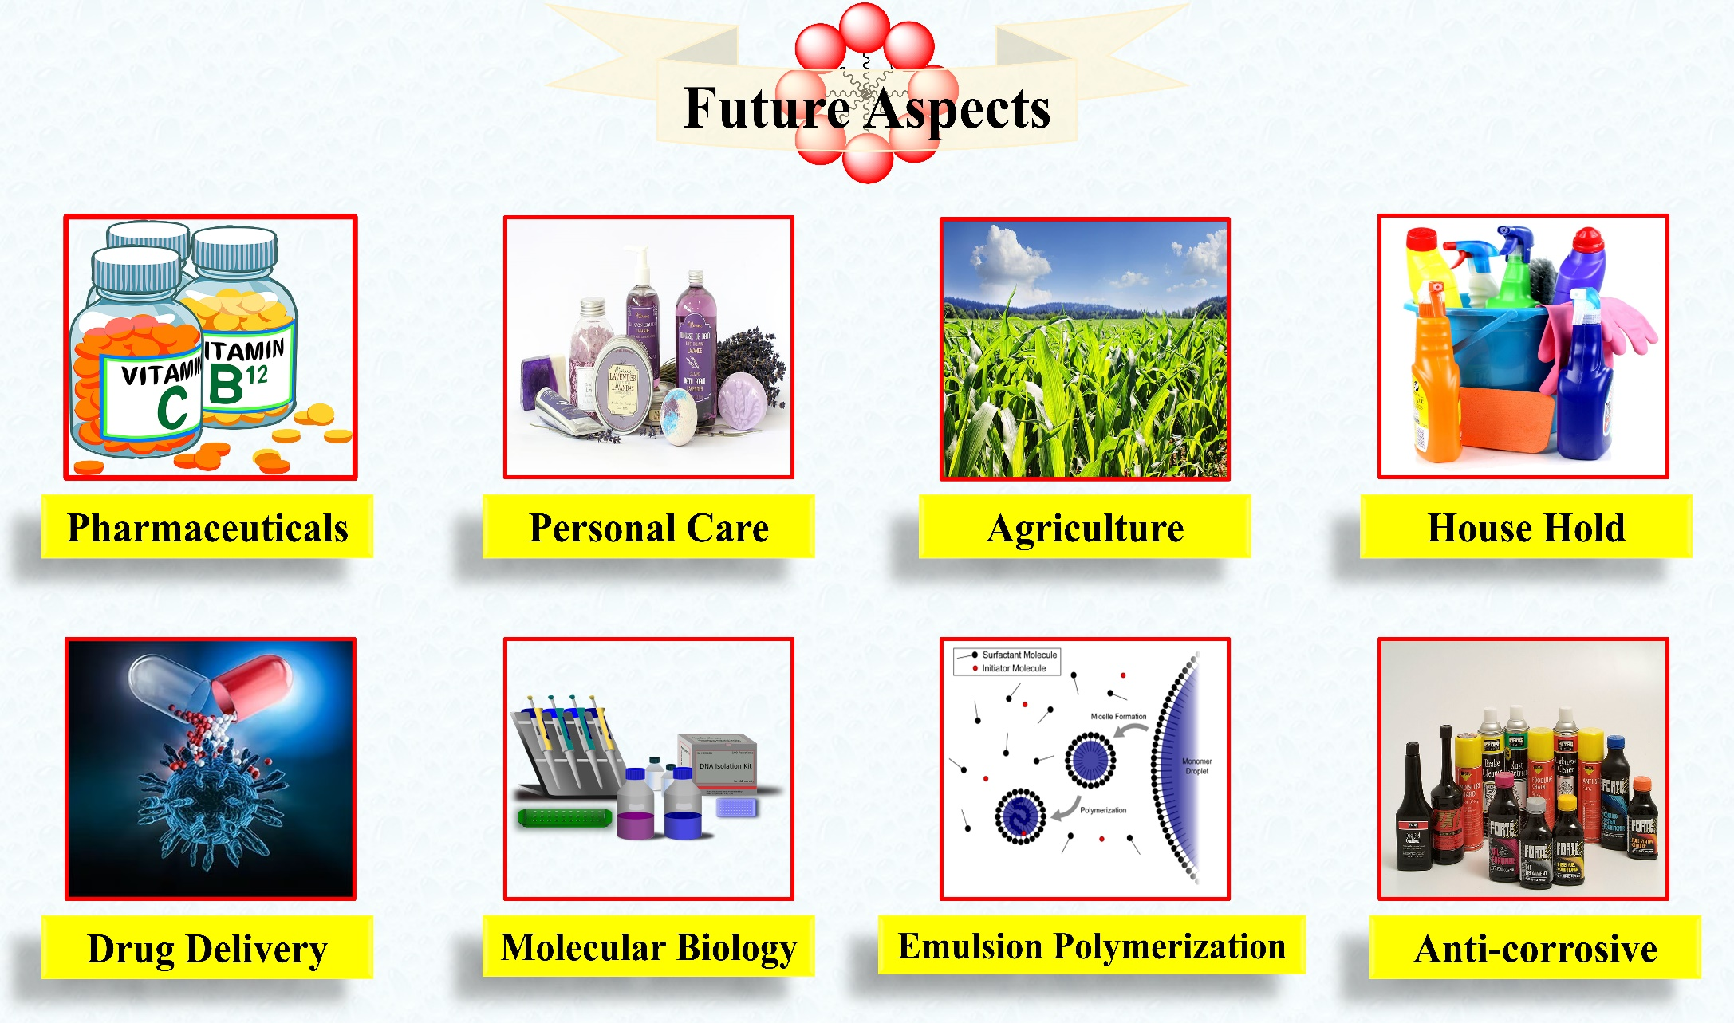
Fig. 17 Future aspect of surfactant.

- Challenges of surfactants
It is more possible that goods will be incompatible or negatively impact the value of the components if more surfactant is needed in manufacturing [93]. They are having great success substituting enzymes for chemicals in their formulations, as can be observed in the sector of household detergents. The systematically challenges of surfactants have shown in Fig. 18. Many makers of surfactants have started researching and creating systems that combine surfactants with enzymes [94]. There is also a need to find manufacturing methods and formulations that use less energy and resources overall. An example of this is crop protection in agriculture, which uses fewer active substances to get the same outcomes. Be accountable for conserving natural resources and energy at the same time. These challenges allow for an improvement in the way other substances interact with the surfactant, which subsequently creates new possibilities [95]. Solutions to reduce materials or energy consumption are also important. Examples include low-temperature cleaning, water-efficient laundry technology, and energy-efficient manufacturing. The ability to innovate closely with customers and technology providers will be essential for surfactant suppliers to take advantage of these trends [96].
Fig. 18 Systematic representation challenges of surfactants.
As a method of creating and producing our products where there is a lot of activity on both the products and the biochemical production pathways, bio-surfactants may be seen as the next step in innovation rather than as a new class of surfactants or even chemicals. The production of surfactants has mostly been driven by environmental considerations. We produce more biodegradable products, employ renewable raw resources, and so on. But it's also important to consider the other two pillars of sustainability, since it's becoming more and clearer that we need all three to meet our difficulties [97].

AUTHORS CONTRIBUTION
The manuscript was written through the contributions of both authors. All authors have approved the final version of the manuscript.

NOTES
All authors declare no competing financial interest.

CONFLICTS OF INTEREST
There are no conflicts to declare.

- References
- D. Hirpara, B. Patel, V. Chavda, A. Desai, and S. Kumar, Micellization and clouding behaviour of an ionic surfactant in a deep eutectic solvent: a case of the reline-water mixture. J. Mol. Liq., 364 (2022) 119991.
- Q. Wu, L. Zhao, R. Song, and A. Ma, Research progress of surfactant biodegradation. Conf. Ser.: Earth Environ. Sci., 227 (2019) 052023.
- N. Dave, and T. Joshi, A concise review on surfactants and its significance. Int. J. Appl. Chem., 13 (2017) 663-672.
- R. Sarkar, A. Pal, A. Rakshit, and B. Saha, Properties and applications of amphoteric surfactant: a concise review. J. Surfact. Deterg., 24 (2021) 709-730.
- H. Kumar, and G. Kaur, Scrutinizing Self-assembly, surface activity and aggregation behavior of mixtures of imidazolium based ionic liquids and surfactants: a comprehensive review. Front. Chem., 9 (2021) 667941.
- M. A. Rub, N. Azum, D. Kumar, and A. M. Asiri, Interaction of TX-100 and antidepressant imipramine hydrochloride drug mixture: surface tension, ¹H-NMR, and FTIR. Gels, 8 (2022) 159.
- X. Lu, Z. Lu, R. Zhang, L. Zhao, and H. Xie, Distribution of pigments in the aqueous two-phase system formed with piperazinium-based ionic liquid and anionic surfactant. J. Mol. Liq., 330 (2021) 115677.
- S. Riedesel, R. Kaur, and M. S. Bakshi, Distinguishing nanoparticle−nanoparticle interactions between gold and silver nanoparticles controlled by gemini surfactants: stability of nanocolloids. J. Phys. Chem. C, 125 (2021) 5399−5411.
- I. Aiad, E. M. Khalil, A. E. B. Farag, A. I. Ahmed, and A. A. Abd-Elaal, Ester-gemini and monomeric cationic surfactants; synthesis, characterization, surface parameters and biological activity. Egypt. J. Chem., 64 (2021) 5193 – 5202.
- T. Hasan, M. Abdul Rub, M. Tuhinur, R. Joy, S. Rana, F. Khan, M. Anamul Hoque, and M. Kabir, Clouding and thermodynamic behavior of the Triton X-100 + metformin hydrochloride drug mixture: Investigation of the impacts of potassium salts, J. Mol. Liq., 354 (2022) 118853.
- B. Golchin, M. O. Hamzah, S. R. Omranian, M. R. and M. Hasan, Effects of a surfactant-wax based warm additive on high temperature rheological properties of asphalt binders. Con STR Build. Mater., 183 (2018) 395-407.
- M. Jangde, S. K. Chatterjee, M. Jain, S. Ghosh, R. Jangde, and D. Sinha, The effect of temperature on the critical micelle concentration and micellar solubilization of poorly water soluble drugs. Biosci., Biotech. Res. Asia. 19 (2022) 1045-1050.
- R. Ghane-Motlagh, and P. Woias, Effect of surfactants on the growth and characterization of triglycine sulfate crystals. J. Cryst. Growth, 563 (2021) 126081.
- Md. A. Haque, T. Kurokawa, T. Nakajima, G. Kamita, Z. Fatema, and J. P. Gong, Surfactant induced bilayer-micelle transition for emergence of functions in anisotropic hydrogel. J. Mater. Chem. B, 10 (2022) 8386-8397.
- S. Chowdhury, S. Shrivastava, A. Kakati, and J. S. Sangwai, Comprehensive review on the role of surfactants in the chemical enhanced oil recovery process. Ind. Eng. Chem. Res. 61 (2022) 21–64.
- D. De Lucaa, and L. Touqui, The international week of surfactant research: increasing knowledge about surfactant and unexploited opportunities. Biomed. J., 44 (2021) 651–653.
- S. Kalam, S. A. Abu-Khamsin, M. S. Kamal, and S. Patil, Surfactant adsorption isotherms: a review, ACS Omega, 6 (2021) 32342–32348.
- M. Yang, M. Pang, J. Chen, F. Gao, H. Li, and P. Guo, Surfactant-assisted synthesis of palladium nanosheets and nanochains for the electrooxidation of ethanol. ACS Appl. Mater. Interfaces, 13 (2021) 9830–9837.
- J. Bergfreund, S. Siegenthaler, V. Lutz-Bueno, P. Bertsch, and P. Fischer, Surfactant adsorption to different fluid interfaces. Langmuir, 37 (2021) 6722–6727.
- T. Wu, and A. Firoozabadi, Surfactant-enhanced spontaneous emulsification near the crude oil–water interface. Langmuir, 37 (2021) 4736–4743.
- A. Bagheri, Interfacial and micellization properties of pure surfactants with similar hydrocarbon chain lengh (C₁₆H₃₃) and different polar head in aqueous medium. J. Appl. Chem., 15 (2021) 55-64.
- P. Müller, D. J. Bonthuis,R. Miller, and E. Schneck, Ionic surfactants at air-water and oil/water interfaces: a comparison based on molecular dynamics simulations. J. Phys. Chem. B, 125 (2021) 406−415.
- J. Park, L. H. Rader, G. B. Thomas, E. J. Danoff, D. S. English, and P. DeShong, Carbohydrate-functionalized catanionic surfactant vesicles: preparation and lectin-binding studies. Soft Matter, 4 (2008) 1916–1921.
- S. Chauhan, J. Jyoti, L. Pathania, A. Umar, and M. S. Chauhan, Carbohydrate-surfactant interactions in aqueous and mixed organic solvents at various temperatures: volumetric, compressibility and acoustical studies. J. Mol. Liq., 218 (2016) 637–648.
- H. Bao, L. Li, L. H. Gan, and H. Zhang, Interactions between ionic surfactants and polysaccharides in aqueous solutions. Macromolecules, 41 (2008) 9406-9412.
- J. Krouskáa, M. Pekařa, M. Klučáková, B. Šarac, and M. Bešter-Rogač, Study of interactions between hyaluronan and cationic surfactants by means of calorimetry, turbidimetry, potentiometry and conductometry. Carbohydr. Polym., 157 (2017) 1837-1843.
- R. S. Atri, A. Sanchez-Fernandez, O. S. Hammond, I. Manasi, J. Doutch, J. P. Tellam, and K. J. Edler, Morphology modulation of ionic surfactant micelles in ternary deep eutectic solvents, J. Phys. Chem. B, 124 (2020) 6004–6014.
- R.C. Chautmal, T.J. Patil, and V.B. Jadhav, Miceller behavior of non-ionic surfactant Triton X-100 in presence of myo-inositol at different temperatures by surface tension. Int. J. Pharm. Tech. Res., 8 (2015) 192-197.
- R. Chautmal, T. J. Patil, V. B. Jadhav, P. Patil, and D. Nikam, Miceller behaviour of non-ionic surfactant tween-20 in presence of myo-inositol at different temperatures by surface tension. Chem. Sci. Rev. Lett., 8 (2019) 104-108.
- R.C. Chautmal, and T.J. Patil, Influence of myo-inositol on thermodynamics of clouding behavior of non-ionic surfactant tween-40. Orient. J. Chem., 27 (2011) 691-695.
- R. K. Banjare, M. K. Banjare, and S. Panda, Effect of acetonitrile on the colloidal behavior of conventional cationic surfactants: a combined conductivity, surface tension, fluorescence and FTIR study. J. Solution Chem., 49 (2020) 34–51.
- W. Zhuang, C. Zhao, Y. Pan, and Q. Li, Self-assembly of an imidazolium surfactant in aprotic ionic liquids 2. more than solvents. Soft Matter, 17 (2021) 3494–3502.
- A. Kumar, M. K. Banjare, S. Sinha, T. Yadav, R. Sahu, M. L. Satnami, and K. K. Ghosh, Imidazolium-based ionic liquid as modulator of physicochemical properties of cationic, anionic, nonionic, and gemini surfactants. J. Surfactant Deterg., 21 (2018) 355–366.
- S. Ghosh, and A. Banerjee, A multitechnique approach in protein/surfactant interaction study: physicochemical aspects of sodium dodecyl sulfate in the presence of trypsin in aqueous medium. Biomacromolecules, 3 (2002) 9-16.
- W. Zhou, L. Jiang, X. Liu, Y. Hu, and Y. Yan, Molecular insights into the effect of anionic-nonionic and cationic surfactant mixtures on interfacial properties of oil-water interface. Colloids Surf. A Physicochem. Eng. Asp., 637 (2022) 128259.
- F. M. Elarbi, A. A. Janger, L. M. Abu-sen, and Z. O. Ettarhouni, Determination of cmc and interfacial properties of anionic (SDS) and cationic (CPB) surfactants in aqueous solutions. Am. J. Eng. Res., 9 (2020) 118-126.
- S. Mahbub, M. Rahman, S. Rana, M. A. Rub, Md. A. Hoque, M. A. Khan, and A. M. Asiri, Aggregation behavior of sodium dodecyl sulfate and cetyltrimethylammonium bromide mixtures in aqueous/ chitosan solution at various temperatures: an experimental and theoretical approach. J. Surfactant Deterg., 22 (2018) 137-152.
- J. L. Salager, R. Marquez, J. Bullon, and A. Forgiarini, Formulation in Surfactant Systems: From-Winsor-to-HLDN. Encyclopedia, 2 (2022) 778-842.
- R. Suryawanshi, M. K. Banjare, K. Behera, R. K. Banjare, R. Sahu, A. Saha, S. Pandey, S. Banerjee, and K. K. Ghosh, Interaction of an acid functionalized magnetic ionic liquid with gemini surfactants. J. Solution Chem., 49 (2020) 715–731.
- S. Das, S. Mondal, and S. Ghosh, Physicochemical studies on the micellization of cationic, anionic, and nonionic surfactants in water−polar organic solvent mixtures. J. Chem. Eng. Data, 58 (2013) 2586−2595.
- A. Rodrı´guez, M. M. Graciani, M. Angulo, and M. L. Moya, Effects of organic solvent addition on the aggregation and micellar growth of cationic dimeric surfactant 12-3-12,2Br⁻. Langmuir, 23 (2007) 11496-11505.
- S. K. Shah, and A. Bhattarai, Interfacial and micellization behavior of cetyltrimethylammonium bromide (CTAB) in water and methanol-water mixture at 298.15 to 323.15 K. J. Chem., 2020 (2020) 1-13.
- S. Mahbub, M. R. Molla, M. Saha, I. Shahriar, Md. A. Hoque, M. A. Halim, M. A. Rub, M. A. Khan, and N. Azum, Conductometric and molecular dynamics studies of the aggregation behavior of sodium dodecyl sulfate (SDS) and cetyltrimethylammonium bromide (CTAB) in aqueous and electrolytes solution. J. Mol. Liq., 283 (2019) 263–275.
- S. K. Shah, S. K. Chatterjee, and A. Bhattarai, Micellization of cationic surfactants in alcohol-water mixed solvent media. J. Mol. Liq., 222 (2016) 906–914.
- R. K. Banjare, M. K. Banjare, K. K Ghosh, P. Mundeja, and S. Panda, Interfacial and thermodynamic approach of surfactants with α-chymotrypsin and trypsin: a comparative study. Indian J. Chem., 59A (2020) 1128-1135.
- S. Sinha, D. Tikariha, J. Lakra, T. Yadav, S. Kumari, S. K. Saha, and K. K. Ghosh, Interaction of bovine serum albumin with cationic monomeric and dimeric surfactants: a comparative study. J. Mol. Liq., 218 (2016) 421–428.
- R. Pal, Rheological behaviour of surfactant-flocculated water-in-oil emulsions. Colloids Surfaces A: Physicochem. Eng. Aspects, 71 (1993) 173-185.
- C. Wu, N. J. Li, K. C. Chen, and H. F. Hsu, Determination of critical micelle concentrations of ionic and nonionic surfactants based on relative viscosity measurements by capillary electrophoresis. Res. Chem. Intermed., 40 (2014) 2371–2379.
- M. K. Banjare, R. Kurrey, T. Yadav, S. Sinha, M. L. Satnami, and K. K. Ghosh, A comparative study on the effect of imidazolium-based ionic liquid on self-aggregation of cationic, anionic and nonionic surfactants studied by surface tension, conductivity, fluorescence and FTIR spectroscopy. J. Mol. Liq., 241 (2017) 622–632.
- A. Goel, S. Tomar, and S. Tomar, A facile synthesis and characterization of surfactant (CTAB/TSC/TX-100) assisted Ir-Sn bimetallic nanoparticles. J. Nanostruct., 10 (2020) 846-862.
- L. K. S. Tanwar, M. K. Banjare, S. Sharma, and K. K. Ghosh, Physicochemical studies on the micellization of anionic surfactants in the presence of long alkyl chain ionic liquid. Chem. Phys. Lett., 769 (2021) 138399.
- T. Sun, S. Gao, Q. Chen, and X. Shen, Investigation on the interactions between hydrophobic anions of ionic liquids and Triton X-114 micelles in aqueous solutions. Colloids Surf. A Physicochem. Eng. Asp., 456 (2014) 18–25.
- M. Shafi, P. A. Bhat, and A. A. Dar, Solubilization capabilities of mixtures of cationic Gemini surfactant with conventional cationic, nonionic and anionic surfactants towards polycyclic aromatic hydrocarbons. J. Hazard. Mater, 167 (2009) 575–581.
- Q. Li, X. Wang, X. Yue, and X. Chen, Wormlike micelles formed using Gemini surfactants with quaternary hydroxyethyl methylammonium headgroups. Soft Matter, 9 (2013) 9667–9674.
- M. K. Banjare, K. Behera, R. Kurrey, R. K. Banjare, M. L. Satnami, S. Pandey, and K. K. Ghosh, Self-aggregation of bio-surfactants within ionic liquid 1-ethyl-3- methylimidazolium bromide: a comparative study and potential application in antidepressants drug aggregation. Spectrochim. Acta A Mol. Biomol. Spectrosc., 199 (2018) 376-386.
- Y. Geng, L. S. Romsted, and F. Menger, Specific ion pairing and interfacial hydration as controlling factors in gemini micelle morphology chemical trapping studies. J. Am. Chem. Soc., 128 (2006) 492–501.
- S. J. Pandya, I. V. Kapitanov, M. K. Banjare, K. Behera, V. Borovkov, K. K. Ghosh, and Y. Karpichev, Mixed oxime-functionalized IL/16-s-16 gemini surfactants system: physicochemical study and structural transitions in the presence of promethazine as a potential chiral pollutant. Chemosensors, 10 (2022) 46.
- I. Kralova, and J. Sjoblom, Surfactant used in food industry: a review. J. Dispers Sci Technol., 30 (2009) 1363-1383.
- X. E, Z. I. Pei, and K. A. Schmidi, Ice cream foam formation and stabilization-a review. Food Rev. Int., 26 (2010) 122-137.
- L. L. Schramm, E. N. Stasiak, and D. G. Marangoni, Surfactant and their applications. Annu. Rep. Prog. Chem. Sect. C., 99 (2003) 3-48.
- V. Zelena, and K. Veverk, Effect of surfactant and liquid utilization on transcuticular penetration of fungicides, Plant Protect. Sci., 43 (2007) 151-156.
- S. M. I. Morsy, Role of surfactants in nanotechnology and their applications. Int. J. Curr. Microbiol. Appl. Sci., 3 (2014) 237-260.
- N. Chandra, S.Mishra, B. Chandra, K. Tamta, N. D. Kandpal, and R. Joshi, Micellization of sodium lauryl sulphate in aqueous sodium malonate solution. Der. Chemica. Sinica., 5 (2014) 44-50.
- R. Singh, Solubilization of organic dyes in surfactants micelles. Div. Appl. Surfac. Chem., (2012) 1-45.
- J. Z. Manojlovic, The kraft temperature of surfactant solution. Therm. Sci., 16 (2012) 31-40.
- J. C. S. Duarte, L. L. Oliveira, M. S. Mayor, D. Y. Okada, and M. B. A. Varesche, Degradation of detergent (linear alkyl benzene sulfonate) in an anaerobic stirred sequencing- batch reactor containing granular biomass. Int. Biodeterior. Biodegradation. 64 (2010) 129-134.
- S. Mishra, and V. K. Tyagi, Ester quats: The novel class of cationics fabric softners. J. Oleo. Sci., 56 (2007) 269-276.
- D. Levitt, A. Jackson, C. Heinson, L. N. Britton, T. Malik, V. Dwarakanath, and G. A. Pope, Identification and evaluation of high-performance EOR surfactant. SPE Resrerv. Eval. Eng., 12 (2006) 243-253.
- K. M. Ko, B. H. Chon, S. B. Jang, and H. Y. Jang, Surfactant flooding characteristics of dodecyl alkyl sulfate for enhanced oil recovery. J. Ind. Eng. Chem., 20 (2014) 228-233.
- W. Lu, B. Bazin, D. Ma, Q. Liu, D. Han, and K. Wu, Static and dynamic adsorption of anionic and amphoteric surfactants with and without the presence of alkali. J. Pet. Sci. Eng., 77 (2011) 209-218.
- V.V. Ginzburg, Mesoscale Modeling of Micellization and Adsorption of Surfactants and Surfactant-Like Polymers in Solution: Challenges and Opportunities, Ind. Eng. Chem. Res., 61 (2022) 15473–15487.
- T.S. Banipal, H. Kaur, A. Kaur, and P.K. Banipal, Effect of tartarate and citrate based food additives on the micellar properties of sodium dodecylsulfate for prospective use as food emulsifier, Food Chem., 1 (2016) 599–606.
- J. N. Israelachvili, D. J. Mitchell and B. W. Ninham, Theory of selfassembly of hydrocarbon amphiphiles into micelles and bilayers, J. Chem. Soc. Faraday Trans., 2 (1976) 1525–1568.
- C. Tanford, The hydrophobic effect: formation of micelles and biological membranes, Wiley, New York, 1980.
- S. Bhattacharya, and J. Haldar, Thermodynamics of micellization of multiheaded single-chain cationic surfactants, Langmuir, 20 (2004) 7940-7947.
- Y. P. Zhu, A. Masuyama, Y. Kobata, Y. Nakatsuji, M. Okahara, and M. J. Rose, Double-chain surfactants with two carboxylate groups and their relation to similar double-chain compounds, J. Colloid Interface Sci., 158 (1993) 40-45.
- B.A. Al Jahdaly, Synthesis and characterization of a new nonionic surfactant with anticorrosive activity of aluminum in 1.0 M hydrochloric acid solution, Chem. Pap., 77 (2023) 33–45.
- P.A. Koya, and Z.A. Khan, Conductometric studies of micellization of gemini surfactant pentamethylene-1, 5-bis (tetradecyldimethylammonium bromide) in water and water–organic solvent mixed media, J. Colloid Interface Sci., 342 (2010) 340–347.
- G. Kumar, and M.S. Chauhan, Conductometric investigations of surfactant behaviour in aqueous polar aprotic organic additives, J. Mol. Liq., 1 (2018) 710–715.
- J. Wang, L. Zhang, H. Wang, and C. Wu, Aggregation behaviour modulation of 1- dodecyl-3-methylimidazolium bromide by organic solvents in aqueous solution, J. Phys. Chem. B 115 17 (2011) 4955–4962.
- V. Sharma, P. Cantero-L´opez, O. Ya˜nez-Osses, C. Rojas-Fuentes, and A. Kumar, Influence of BSA on micelle formation of SDBS and CPC: An experimental–theoretical approach of its binding properties, J. Mol. Liq., 271 (2018) 443–451.
- V. Sharma, O. Ya˜nez, M. Alegría-Arcos, A. Kumar, R.C. Thakur, and P. Cantero-L´opez, A physicochemical and conformational study of co-solvent effect on the molecular interactions between similarly charged protein surfactant (BSA-SDBS) system, J. Chem. Thermodyn., 1 (2020) 106022.
- S.K. Shah, G. Chakraborty, A. Bhattarai, R. De, Synergistic and antagonistic effects in micellization of mixed surfactants, J. Mol. Liq. 29 (2022), 120678.
- C. Wang, S. Ma, Y. Hu, and R. Wang, Hierarchical colloidal polymeric structure from surfactant-like amphiphiles in selective solvents, Langmuir, 33 (2017) 3427–3433.
- T.P. Niraula, S.K. Shah, S.K. Chatterjee, and A. Bhattarai, Effect of methanol on the surface tension and viscosity of sodiumdodecyl sulfate (SDS) in aqueous medium at 298.15–323.15 K. Karbala International Journal of Modern Science, 4 (2018) 26–34.
- Z.H. Ren, J. Huang, Y. Luo, Y.C. Zheng, P. Mei, W.C. Yu, L. Lai, Y.L. Chang, and F.X. Li, Effect of isopropanol on the micellization of binary mixture containing amino sulfonate amphoteric surfactant in aqueous solution: mixing with sodium dodecylbenzene sulfonate, J. Taiwan Inst. Chem. Eng., 1 (2016) 482–487.
- Z.H. Ren, J. Huang, Y.C. Zheng, L. Lai, and L.L. Hu, Effect of isopropanol on the micellization of binary mixture containing amino sulfonate amphoteric surfactant in aqueous solution: Mixing with octylphenol polyoxyethylene ether (7), J. Mol. Liq., 1 (2017) 101–106.
- J. Huang, and Z.H. Ren, Micellization and interactions for ternary mixtures of amino sulfonate surfactant and nonionic octylphenol polyoxyethylene ethers in aqueous solution: 1 Blending with nonionic surfactants with smaller numbers of hydrophilic unit, J. Mol. Liq., 15 (2019) 53–60.
- A.K. Tiwari, and S.K. Saha, Aggregation properties and thermodynamics of micellization of gemini surfactants with diethyl ether spacer in water and water–organic solvent mixed media, J. Chem. Thermodyn., 70 (2014) 24–32.
- R. Sheng, Q.Y. Ding, Z.H. Ren, D.N. Li, S.C. Fan, X.F. Quan, Y. Wang, M.T. Yi, Y. X. Zhang, Y.X. Cao, and H. Wang, Interfacial and micellization behavior of binary mixture of amino sulfonate amphoteric surfactant and octadecyltrimethyl ammonium bromide: Effect of short chain alcohol and its chain length, J. Mol. Liq. ,15 (2021) 116064.
- D.N. Li, Y.X. Zhang, Z.H. Ren, J. Huang, B.B. Li, Q.H. Zhang, M.T. Yi, X.F. Quan, Y. X. Wang, B.R. Wang, and Z.B. Qian, Molecular interaction for quasi-binary mixture of N-acyl amino sulfonate amphoteric surfactant from castor oil and stearyltrimethyl ammonium bromide, J. Mol. Liq., 1 (2021) 116813.
- D. Tikariha, K.K. Ghosh, N. Barbero, P. Quagliotto, and S. Ghosh, Micellization properties of mixed cationic gemini and cationic monomeric surfactants in aqueous-ethylene glycol mixture, Colloids Surf. A Physicochem. Eng. Asp., 381 (2011) 61–69.
- P.K. Banipal, S. Arti, and T.S. Banipal, Influence of polyhydroxy compounds on the micellization behaviour of cetyltrimethylammonium bromide: Conductance and microcalorimetric investigations, J. Mol. Liq., 1 (2016) 1204–1212.
- A. Dey, N. Patra, A. Mal, and S. Ghosh, Impact of organic polar solvents (DMSO and DMF) on the micellization and related behaviour of an anionic (AOT), cationic (CEM2AB) and cationic gemini surfactant (16-5-16), J. Mol. Liq., 244 (2017) 85–96.
- S. Aslanzadeh, and A. Yousefi, The effect of ethanol on nanostructures of mixed cationic and anionic surfactants, J. Surfactant Deterg., 17 (2014) 709–716.
- S. Chauhan, K. Kumar, D.S. Rana, R. Kumar, and M.S. Chauhan, A comparative study on the aggregation and thermodynamic properties of anionic sodium dodecylsulphate and cationic cetyltrimethylammonium bromide in aqueous medium: effect of the Co-solvent N-methylacetamide, J. Surfactant Deterg., 19 (2016) 193–200.
- A. Pan, B. Naskar, G.K. Prameela, B.P. Kumar, A.B. Mandal, S.C. Bhattacharya, and S. P. Moulik, Amphiphile behaviour in mixed solvent media I: self-aggregation and ion association of sodium dodecylsulfate in 1, 4-dioxane–water and methanol–water media, Langmuir, 28 (2012) 13830–13843.

*Corresponding author Dr. Manoj Kumar Banjare (MKB) Tel.: +91-9827768119 E-mail address: manojbanjare7@gmail.com; manojbanjarechem111@gmail.com; drmanojkb@matsuniversity.ac.in

