Numerical analysis of ultrathin CIGS with Si as absorber layer with SCAPS-1D simulator

Virang Shukla Gopal Panda
Sarvepalli Radhakrishnan University Sarvepalli Radhakrishnan University
Virangshukla_1983@yahoo.co.in gopal_panda007@yahoo.com

Abstract: The paper reports on the performance of ultrathin CIGS photovoltaic cells. New structure had been proposed with the help of SCAPS-1D simulator. The prime aim of this analysis is to improve device performance and reduce material cost as compared to conventional CIGS solar cells. For this purpose p Si of 1um had been inserted. CIGS thickness was ranging from 0.1 um to 1um. It could be verified with simulation result that with improvement of absorber layer thickness performance of cell also improved. The best conversion efficiency 19.56% obtained with ZnO of thickness 0.02um, CdS thickness of 0.05 um CIGS layer thickness of 1um and Si layer of thickness of 1um respectively.
Key words: CIGS, SCAPS-1D, ultrathin layer, Solar cell, simulation.
- Introduction: photovoltaic cells based on CIGS are promising materials because it has an advantage of covering wide range of solar radiation spectrum. This diminishes the material costs and shows excellent performance as compared to silicon based solar cells. CIGS is very important material for thin film solar cell because of its many advantages such as high absorption coefficient and suitable band gap. Its efficiency had been reported 20.4% previously [8]. The only demerit is high cost of gallium and indium. In order to overcome this shortcoming it is necessary to bring down thickness of CIGS layer so the use of gallium and indium can be reduced [8]. In present work alternative CIGS structure was suggested. SCAPS-1D was used to investigate the performance of new ultrathin CIGS solar cell. The performance of cell was observed by inserting new absorber layer p-Si.
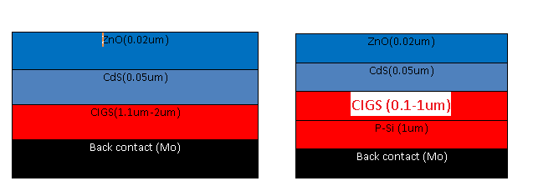
Fig.1 (a) Reference structure of CIGS solar cells (b) Proposed structure of CIGS structure.

- Device structure and simulation
SCAPS-1D was developed at University of Gent, Belgium. The program was originally designed for CdTe and CuInSe2.In proposed structure additional layer p-Si was added which has a band gap 1.12 e V. The performance of cell with new absorber layer was observed using SCAPS-1D simulator. CIGS thickness was ranging from 1.10 to 2 um to investigate performance of ultrathin CIGS solar cell. The cell contains new absorber layer and CIGS thickness of 1um set down on molybdenum with CdS layer having thickness 0.05um and window layer with 0.02um thickness. The proposed structure is shown in the figure.
Table 1. Simulation parameters[8]
Parameters | nZnO | nCdS | pCIGS | p-Si
Band gap | 3.30 eV | 2.45 eV | 1.10 eV | 1.12 eV
Electron affinity | 4.60 eV | 4.40 eV | 4.50 eV | 4.05 eV
Dielectric constant | 9 | 10 | 13.60 | 11.90
Nc(cm⁻³) | 2.2 x 10¹⁸ | 2.2 x 10¹⁸ | 2.2 x 10¹⁸ | 2.8 x 10¹⁹
Nv(cm⁻³) | 1.8x 10¹⁹ | 1.8x 10¹⁹ | 1.8x 10¹⁹ | 2.65 x 10¹⁹
Electron mobility(cm²/Vs) | 100 | 100 | 100 | 1450
Hole mobility(cm²/Vs) | 25 | 25 | 25 | 500
n,p (cm⁻³) | 1.0x 10²⁰ | 1.0x 10²⁰ | 2.0x 10⁶ | 1.0x 10²⁰
Defect density(cm⁻³) | 1.0x 10¹⁴ | 1.0x 10¹⁴ | 1.0x 10¹⁴ | 1.0x 10¹⁴

- Result and discussion:
3.1 Effect of thickness on cell performance:
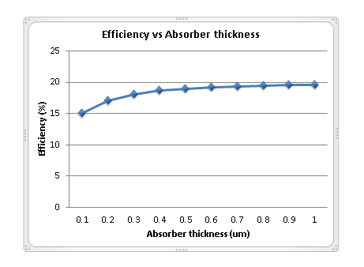
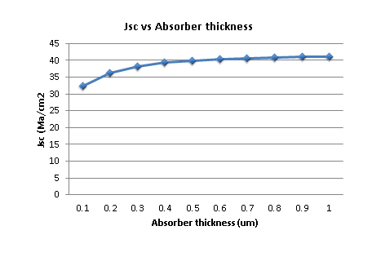
The reference structure was simulated using SCAPS-1D simulator. The thickness was varying from 1.1um to 2um using SCAPS-1D simulator. Due to excess of thickness large numbers of photons are absorbed. Due to increase of thickness in absorber layer efficiency also gain from 13.74% to 15.12% for thickness of 2um with fill factor 78.58%, open circuit voltage 0.4797V and short circuit current density 40.10mA/cm². Open circuit voltage and short circuit current density were reduced when thickness of absorber layer was reduced. This may lead to the process of recombination of electrons and holes at back contact. By adding p- Si efficiency had been increased from 14.99% to 19.56%. Thickness of CIGS for new structure was varying from 0.1 um to 1 um, while other parameters remained unchanged. The simulation result showed that 19.56% efficiency had been achieved. When thickness of absorber layer is increased more photons can be absorbed. As a result more hole- electron pairs are generated. The value of Jsc increases from 32.43 mA/cm² to 41.14 mA/cm² and enhance Voc from 0.5721 V to 0.5796 V which improve cell efficiency.
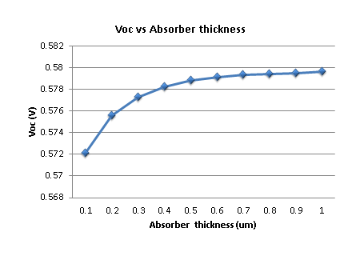
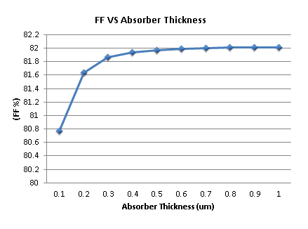
Figure 2. Absorber thickness vs. PCE, Jsc, FF, and Voc of proposed Cell

3.2 Effect of operating temperature
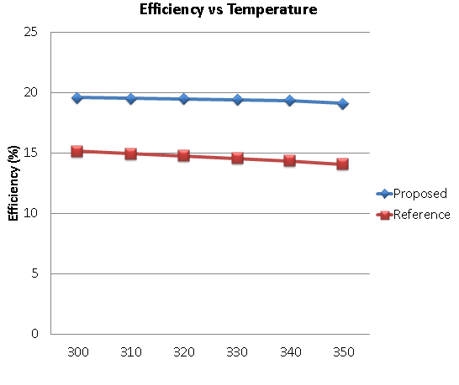
With increase in temperature cell parameters deteriorate. Short circuit current density increases with rise in temperature. The main reason behind this is the reduction of band gap at high temperature. Many photons have much more energy to create pairs of charge carriers. Open circuit voltage reduces with rise in temperature. With increase in temperature reduction of open circuit voltage shows that Voc has dependence on saturation current which decrease with increase in temperature. At very high temperature all parameters would be much more affected would result in degrade the cell performance.

Figure 3 Effect of temperature on reference and proposed structure
3.3 Effect of series resistance on cell
R_{s} had been varied between 0 and 5 Ωcm². The performances of both cells were much more affected by increasing the value of series resistance. This indicates that increase in series resistance affect significantly to efficiency of both solar cells.
Table 2. Effect of series resistance on both cell performances.
Series resistance(ῼcm²) | Solar cell efficiency without Si layer (1um) | Solar cell efficiency with Si layer(1um)
0 | 15.12% | 19.56%
1 | 13.74% | 18.04%
2 | 12.43% | 16.54%
3 | 11.14% | 15.13%
4 | 9.89% | 13.73%
5 | 8.90% | 12.37%

- Conclusion:
The reference structure was simulated and accordingly proposed structure was given with Si as absorber layer. ZnO/CdS/CIGS/Si structure shows efficiency of 19.56% with Voc 0.5796 V, Jsc 41.146218 mA/cm² and FF 82.01%. The proposed structure showed excellent performance with reduced cost as compared to conventional CIGS solar cells.

5. References:
[1] Movla H. Optimization of the CIGS based thin film solar cells: numerical simulation and analysis. Optik 2013; 124:5871e3.
[2] Wada T, Hashimoto Y, Nishiwaki S, Satoh T, Hayashi S,Negami T, et al. High-efficiency CIGS solar cells with modified CIGS surface. Sol Energy Mater Sol Cells2001; 67:305-10.
[3] Khoshsirat N, Amziah Md Yunus N, Nizar Hamidona M,Shafie S, Amin N. Analysis of absorber layer properties effect on CIGS solar cell performance using SCAPS. Optik2015; 126:681-6.
[4] Pudov AO, Kanevce A, Al-Thani H, Sites JR, Hasoon FS.Secondary barriers in CdSeCuIn1_xGaxSe2CdSeCuIn1_xGaxSe2 solar cells. J Appl Phys 2005; 97:1063-9.
[5] Huang CH, Li SS, Anderson TJ. Device modeling and simulation of CIS-based solar cells. In: 29th IEEE photovoltaic specialist conference; 2002. p. 748-51.
[6] Amin N, Chelvanathan P, Istiaque Hossain M, Sopian K.Numerical modeling of ultra-thin Cu(In,Ga)Se2 solar cells. Energy Procedia 2012; 15:291-8.
[7] Vermang B, V, Rostvall F, Edoff M,Kotipalli R, et al. Employing Si solar cell technology to increase efficiency of ultra-thin Cu(In,Ga)Se2 solar cells. ProgPhotovolt Res Appl 2014; 22:1023-9.
[8] H. Heriche, Z. Rouabah, N. Bouarissa. "Newultra thin CIGS structure solar cells using SCAPS simulation program", International Journal of Hydrogen Energy, 2017

