Leveraging Artificial intelligence in the Comparative Analysis of Medicinal
Approaches for Menstrual Disorders –
A Comprehensive Study of PCOD and PCOS Therapies
Chethana V Chalapathy ¹, Disha Maheshwari¹, Archana Nalinan¹ , Lahar Khandelwal¹, Shruti Awasthi ²*
Garden City University, Bangalore
chethana.v@gardencity.university, maheshwaridisha8@gmail.com, archnanalinan@gmail.com, laharkhandelwal@gmail.com, ,
* Corresponding author. Tel: +91 78998 49374, shruti.awasthi@gardencity.university
- Assistant Professor, Department of Life Sciences, Garden City University, Bangalore
- Department of Life Sciences, Garden City University, Bangalore
- Assistant Professor, Department of Life Sciences, Garden City University, Bangalore

INTRODUCTION
The delicate balance of menstrual cycles and fertility is orchestrated by the female reproductive system, which functions as an intricate symphony of hormones and physiological processes. However, the two common and complicated menstrual disorders polycystic ovary disease (PCOD) and polycystic ovarian syndrome frequently interfere with this natural rhythm (PCOS). Many women around the world are affected by these conditions, which have an impact on both their reproductive health and general well-being. (Naumova et al., 2021)
  - Polycystic Ovary Disease (PCOD)
Stein-Leventhal syndrome, also referred to as polycystic ovary disease (PCOD), is a complex endocrine disorder marked by the presence of numerous small cysts on the ovaries. It involves metabolic dysfunction, insulin resistance, and hormonal imbalances, particularly in the production of androgens. PCOD frequently manifests as irregular menstrual cycles, anovulation, acne, hirsutism, and obesity.
  - Polycystic Ovary Syndrome (PCOS)
Broader syndrome than a disease, including both ovarian cysts and a collection of hormonal imbalances. Menstrual irregularities, hyperandrogenism, and insulin resistance are similar to PCOD. However, among those who are affected, clinical presentation and symptom severity can differ greatly.
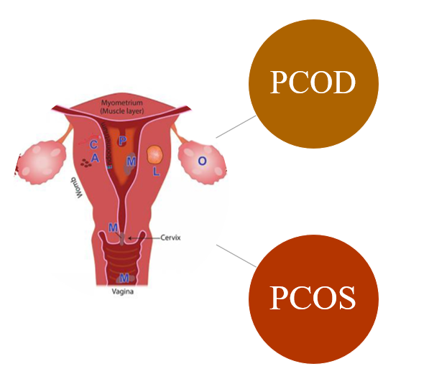

Figure 1: Diagrammatic representation of PCOS and PCOD

Concerns are raised by the widespread occurrence of PCOD and PCOS, which affect millions of women from different age groups and ethnic backgrounds. According to research, PCOS may be present in 5 to 10% of women of childbearing age, with PCOD's prevalence possibly being even higher. PCOD and PCOS negatively impact women's health, increasing the risk of type 2 diabetes, cardiovascular diseases, and endometrial cancer. They also cause emotional and psychological stress, anxiety, and depression.
Multidimensional management of PCOD and PCOS is frequently necessary for success. Specific symptoms are targeted, hormonal balance is restored, and general health is improved during treatments. A balanced diet and regular exercise are two lifestyle changes that can make a significant difference in how symptoms are managed and how the disease develops. To regulate menstrual cycles, control androgen levels, and treat related complications, pharmacological interventions, such as hormonal therapies and insulin-sensitizing drugs, are frequently prescribed. Furthermore, medical research advancements keep looking into novel treatment options to improve patient outcomes and quality of life.
This chapter analyzes drugs used to treat PCOD and PCOS, focusing on mechanisms of action, efficacy, safety profiles, and patient perspectives. The goal is to advance knowledge about these menstrual disorders, aiding affected individuals and medical professionals in improving menstrual health and overall well-being. (Senapathi et al., 2018)

2. CONTEMPORARY MEDICATIONS FOR MANAGING MENSTRUAL DISORDERS - PCOD AND PCOS TREATMENT APPROACHES.
The medications that are currently used to treat menstrual disorders like PCOD and PCOS try to target particular symptoms, control hormonal imbalances, and enhance general reproductive health. These medications are recommended in accordance with the patient's medical background, symptoms, and particular requirements. The following are some of the most popular types of medications for PCOD and PCOS: (Kim et al., 2019)

Figure 2: Contemporary Medications for Managing Menstrual Disorders

1. Hormonal therapies -For PCOD and PCOS, hormonal therapies are frequently the first line of defense, particularly for managing irregular menstrual cycles and regulating androgen levels. These drugs contain hormones that are synthetic but act like the body's own
Combined Oral Contraceptives (COCs)-For PCOD and PCOS, hormonal therapies are frequently the first line of defense, particularly for managing irregular menstrual cycles and regulating androgen levels. These drugs contain hormones that are synthetic but act like the body's own hormones.
Progestins- are manufactured forms of the progesterone hormone. To induce regular menstrual cycles and lessen abnormal bleeding, they can be used alone or in conjunction with other drugs.
2. Insulin-Sensitizing Agents: PCOD frequently exhibits insulin resistance, which raises blood insulin levels. Insulin-sensitizing drugs improve metabolic dysfunction and lower androgen production by improving how well the body reacts to insulin.
Metformin: Metformin is commonly used to treat type 2 diabetes, but it has also been found effective in managing PCOD and PCOS by improving insulin sensitivity and menstrual regularity.
3. Anti-Androgen Medications: Hirsutism, acne, and other symptoms related to androgens can result from excessive androgen production. Anti-androgen drugs aid in preventing the negative effects that androgens have on the body.
Spironolactone: Spironolactone is an anti-androgen medication commonly used to reduce hirsutism and acne in women with PCOS.
4. Gonadotropin-Releasing Hormone (GnRH) Agonists: Gonadotropin agonists function by momentarily inhibiting the production of these hormones, which are responsible for stimulating the ovaries. They are primarily used to manage symptoms temporarily or to get ready for specific medical procedures.
Leuprolide acetate- a GnRH agonist, is used to temporarily suppress ovulation and reduce androgen levels in PCOS patients. (Babu et al., 2017)
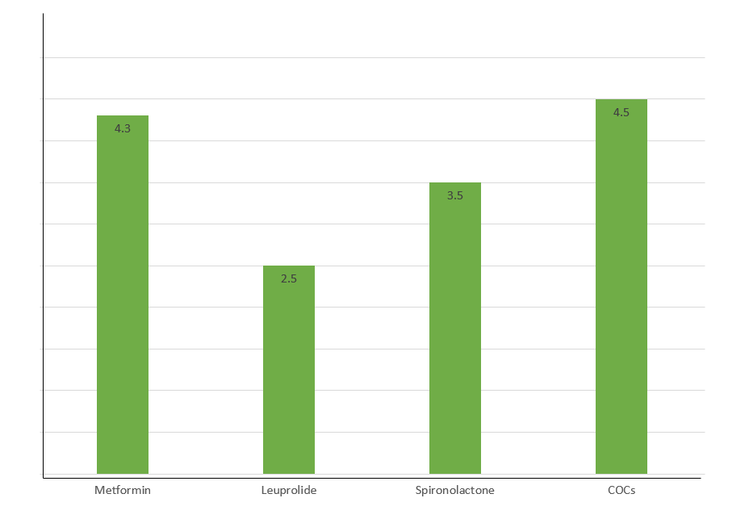
Figure 3: Comparison between medications for Menstrual Disorders
5. Oral Anti-Diabetic Medications: To increase insulin sensitivity and metabolic function in PCOD and PCOS, in addition to metformin, other oral anti-diabetic drugs may be prescribed.
Pioglitazone: Another medication that increases insulin sensitivity and lowers insulin resistance is pioglitazone, which may be used alone or in combination with other drugs.
6. Combined Hormonal Patches and Vaginal Rings: Alternative hormonal contraceptives to oral contraceptives include vaginal rings and combined hormonal patches, which release hormones steadily to control the menstrual cycle.
7. Surgical Interventions: For some specific PCOD and PCOS symptoms or complications, surgical interventions may be taken into consideration.
Ovarian Drilling: A minimally invasive surgical procedure called ovarian drilling entails using a laser or diathermy to create tiny holes in the ovaries. When other treatments are ineffective for a woman, it may be done to help her ovulate.
Laparoscopic Ovarian Cystectomy-If there are large ovarian cysts, a laparoscopic cystectomy may be done to remove the cysts and alleviate symptoms.
8. Androgen Receptor Blockers-These medications target the androgen receptors in the body to reduce the effects of androgens.
Flutamide: Women with PCOS who experience hirsutism and other androgen-related symptoms can benefit from flutamide, an androgen receptor blocker.

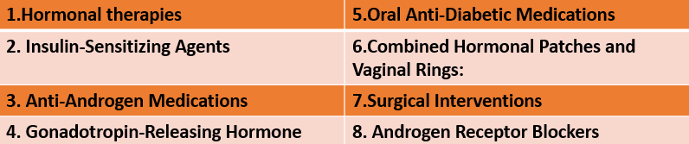
Figure 4: types of medicine for Menstrual Disorders

3. UNRAVELLING THE MECHANISM OF ACTION: UNDERSTANDING HOW TREATMENTS WORK
Combined Oral Contraceptives (COCs): Synthetic progesterone and estrogen are found in COCs. The luteinizing hormone (LH) and follicle-stimulating hormone (FSH), which are responsible for initiating ovulation, are produced too much when COCs are consumed. COCs control menstrual cycles and lessen the effects of too much androgen by preventing ovulation. Additionally, the progestin in COCs stabilizes the endometrial lining and lowers the possibility of endometrial hyperplasia (abnormal thickening of the uterine lining). (Ozturk et al., 2018)

Figure 5: Combined Oral Contraceptives

Metformin -Metformin is an insulin-sensitizing medication that mainly works by lowering the body's insulin resistance. Insulin levels are elevated as a result of insulin resistance, which is a common feature of PCOD and PCOS. High insulin levels encourage the ovaries to produce more androgen, which in turn increases the production of insulin-like growth factor 1 (IGF-1), which aggravates symptoms even more. Metformin aids in hormone regulation lowers androgen production and restores menstrual regularity by enhancing insulin sensitivity.
Anti-Androgen Medications - A drug called spironolactone that blocks androgens from binding to their receptors in the body is known as an anti-androgen. Spironolactone lessens the effects of androgens, such as reducing excessive hair growth (hirsutism) and reducing acne, by blocking androgen receptors. Spironolactone instead inhibits androgens' cellular actions rather than suppressing androgen synthesis.
Clomiphene citrate -A selective estrogen receptor modulator (SERM), clomiphene citrate affects the hypothalamus and pituitary gland. It inhibits estrogen receptors in these regions, resulting in an increase in the production of luteinizing hormone, follicle-stimulating hormone, and gonadotropin-releasing hormone (GnRH) (LH). The ovaries are stimulated by the elevated levels of these hormones to produce mature follicles, which results in ovulation.
Letrozole: Letrozole, an aromatase inhibitor, lowers the level of estrogen produced. The hypothalamus produces more GnRH after decreasing estrogen levels, which prompts the pituitary to produce FSH and LH. This results in the growth of ovarian follicles and ovulation.
Combined Hormonal Patches- The combined hormonal patches, consisting of synthetic estrogen and progestin, are worn on the skin and change every three weeks for three weeks. The synthetic estrogen component reduces the pituitary gland's production of follicle-stimulating hormone (FSH) and luteinizing hormone (LH), preventing ovulation. The progestin component suppresses LH and FSH production, preventing ovulation and acting as a barrier contraceptive by thickening cervical mucus, making it harder for sperm to reach the egg. The patch-free week is a one-week break. Thirdly, progestins also thin the uterine endometrial lining, which makes it less amenable to implantation and lowers the likelihood of pregnancy if ovulation takes place. Additionally, the patch delivers a regular and consistent hormone release over the course of the week. The menstrual cycle is controlled, and effective contraception is ensured thanks to the ongoing hormone delivery. (Bellofiore et al., 2018)

Combined Vaginal Rings- Another hormonal method of birth control is combined vaginal rings, which contain synthetic estrogen and progesterone. When the flexible ring is inserted into the vagina, the hormones are released right into the bloodstream. The combined effects of the synthetic progestin and estrogen in the vaginal ring prevent the release of LH and FSH in a manner similar to that of combined hormonal patches and oral contraceptives (COCs). This inhibition stops ovulation, preventing the release of any eggs from the ovaries. The vaginal ring's estrogen and progestin also change the cervical mucus consistency. Because of this modification, there is less chance of fertilization because it is more hostile to sperm. A barrier to sperm entry into the uterus is created by changes in cervical mucus, which contributes to the contraceptive effect.
Ovarian Drilling: Laparoscopy is used to perform the minimally invasive surgical procedure known as ovarian drilling. Small abdominal wall incisions are made during the procedure, and a laparoscope, a thin, flexible tube with a camera, is inserted into the abdomen to view the ovaries. Once the ovaries are visible, ovarian tissue is punctured with a laser or electrical device.
Ovarian drilling is used to improve ovulation in PCOD patients who are not benefiting from other therapies. Although the exact mechanism of this procedure's action is unknown, it is thought to be connected to a decrease in the amount of androgen produced by the ovaries. The excessive ovarian tissue may be broken up by ovarian drilling, which would reduce androgen production and improve hormonal balance. In turn, this might encourage more consistent ovulation and help some women resume their menstrual cycles.
Laparoscopic Ovarian Cystectomy: Ovarian cysts are large cysts that can form in some cases of PCOD and PCOS. These cysts might disrupt regular ovulation and cause pain and discomfort. A surgical procedure called a laparoscopic ovarian cystectomy uses laparoscopy to remove cysts from the ovaries.
Small abdominal wall incisions are made during the procedure, and a laparoscope is inserted to view the ovaries and cysts. In order to preserve as much healthy ovarian tissue as possible, the surgeon carefully excises the cysts from the ovarian tissue. Laparoscopic ovarian cystectomy works by reducing the symptoms and side effects brought on by large ovarian cysts. By removing the cysts, the surrounding ovarian tissue is no longer under pressure, which in some instances may help to improve fertility and restore regular ovulation.
Flutamide- works by acting as a competitive inhibitor of androgen receptors to produce its effects. Male sex hormones called androgens, such as testosterone and dihydrotestosterone (DHT) can also be found in excess in PCOD and PCOS-afflicted women. These androgens may play a role in the emergence of symptoms like acne and hirsutism.
Flutamide competes with androgens for binding to their receptors in a variety of tissues, including the skin's sebaceous glands and hair follicles. Flutamide blocks the effects of androgens on cells by interacting with androgen receptors. This successfully inhibits androgen action in these tissues, minimizing their impact on skin sebum production and hair growth. Its main therapeutic effects are the improvement of androgen-related skin manifestations like acne and the reduction of excessive hair growth (hirsutism). The body's ability to produce or circulate androgens is not significantly affected. Flutamide, on the other hand, works at the cellular level to lessen the impact of androgens in particular target tissues. (Ahmad et al., 2022)

4. ASSESSING THE EFFICACY AND EFFECTIVENESS OF MEDICATIONS FOR MENSTRUAL DISORDERS

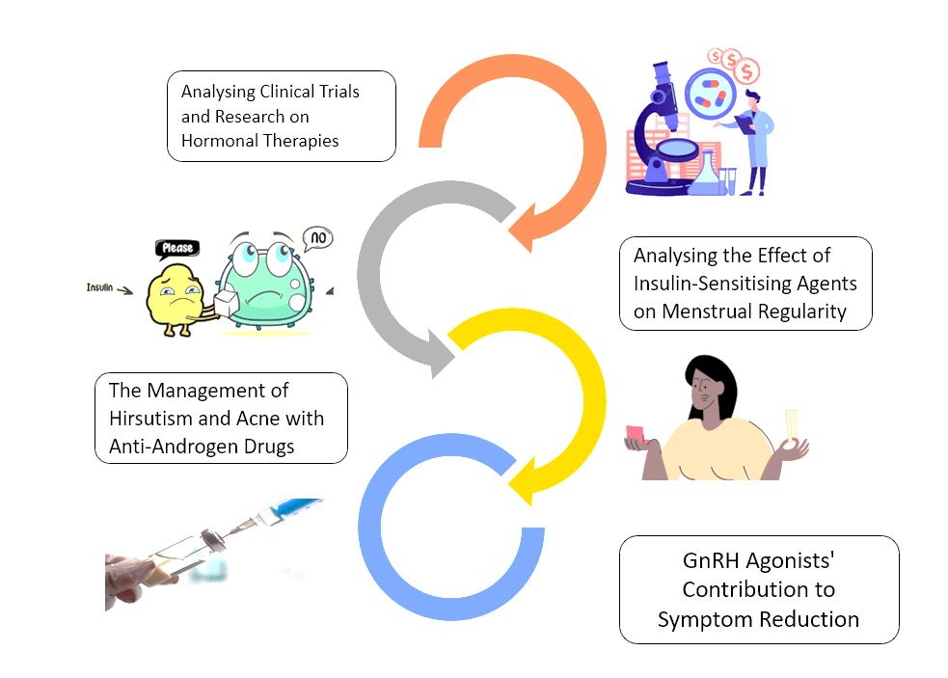

Figure 6: Mechanisms of Action: How Medications Work to Treat Menstrual Disorders
4.1 Medications for Menstrual Disorders in PCOS: A Comprehensive Assessment of Efficacy and Effectiveness
A multifaceted strategy is needed to manage the complex endocrine disorder polycystic ovary syndrome (PCOS) effectively. Its many symptoms have been addressed using a variety of treatment modalities in an effort to improve menstrual regularity and hormonal balance. Based on clinical trials and studies, we review the efficacy and effectiveness of the main treatment options in this section. (Wang et al., 2018)
Analysing Clinical Trials and Research on Hormonal Therapies
Combination oral contraceptives (COCs), which contain synthetic estrogen and progestin, have been shown in clinical trials to be effective in controlling menstrual cycles and lowering androgen levels in PCOS-affected women. COCs have been found to help many patients with their acne, hirsutism, and menstrual irregularity. Progestins alone or in combination with COCs have demonstrated efficacy in managing irregular menstrual cycles and controlling symptoms linked to androgens, among other hormonal conditions.
Analyzing the Effect of Insulin-Sensitising Agents on Menstrual Regularity:
Metformin in particular has been studied for its potential to reduce insulin resistance and restore ovulatory function in PCOS-afflicted women. Metformin may help some women with PCOS achieve normal menstrual cycles and increase fertility, according to studies. Women with PCOS who have insulin resistance or poor glucose tolerance may benefit especially from metformin.
The Management of Hirsutism and Acne with Anti-Androgen Drugs:
Anti-androgen drugs like spironolactone and flutamide have been proven to be successful in treating acne and reducing excessive hair growth (hirsutism) in women with PCOS. These drugs reduce the effects of androgens on hair follicles and sebaceous glands by blocking androgen receptors. For comprehensive symptom management, anti-androgen medications are frequently used in conjunction with hormonal therapies.
GnRH Agonists' Contribution to Symptom Reduction:
Leuprolide acetate and other gonadotropin-releasing hormone (GnRH) agonists may be used temporarily to treat symptoms in PCOS patients. In some cases, GnRH agonists can temporarily suppress ovulation and lower androgen levels, which can lessen symptoms. These drugs may also be used in certain clinical settings to treat particular symptoms or as a pre-treatment for assisted reproductive technologies (ART).
General considerations
PCOS is a complex condition that can present itself in patients in a variety of ways, the efficacy and effectiveness of treatments may differ from person to person. Combination therapies that are adapted to the patient's unique symptoms and medical background frequently produce better management outcomes for PCOS. It's crucial to regularly assess treatment progress and follow up with medical professionals in order to modify therapies as necessary. Lifestyle changes, such as eating a healthy diet and exercising frequently, can support medical treatments and enhance overall results. PCOS management addresses long-term health implications, such as lowering the risk of diabetes and cardiovascular diseases, in addition to symptom control.
4.2 Efficacy and effectiveness- PCOD
Analysing Clinical Trials and Research on Hormonal Therapies
Hormonal therapies, such as combined oral contraceptives (COCs) containing estrogen and progestin, have been shown in clinical trials to be effective in controlling menstrual cycles and lowering androgen levels in PCOD patients. COCs can help menstrual irregularities return to normal and treat hirsutism, acne, and irregular periods (excessive hair growth). Progestin and cyclic progestin therapy have both proven effective in treating menstrual irregularities in PCOD patients. (Lamba et al., 2018)
Analyzing the Effect of Insulin-Sensitising Agents on Menstrual Regularity:
Metformin in particular has been examined for its potential to help PCOD-afflicted women with their insulin resistance and metabolic dysfunction. According to studies, metformin may help some women with PCOD, particularly those who have insulin resistance, improve menstrual regularity and restore ovulatory function. Better symptom management may result from combining metformin with hormonal therapies.
The usefulness of Anti-Androgen Drugs in the Treatment of Hirsutism and Acne:
In women with PCOD, hirsutism, and acne have been shown to be reduced by anti-androgen medications like spironolactone and flutamide. By inhibiting androgen receptors, these drugs lessen the impact of androgens on sebaceous glands and hair follicles. In order to treat both menstrual irregularities and symptoms related to androgens, anti-androgens are frequently combined with hormonal therapies.
Considering GnRH Agonists' Role in Symptom Reduction
Leuprolide acetate is one gonadotropin-releasing hormone (GnRH) agonist that women with PCOD may want to take into consideration for temporary symptom relief. GnRH agonists temporarily inhibit ovulation and lower androgen levels, which can sometimes improve symptoms. These drugs may occasionally be used to treat particular symptoms in particular clinical situations or to prepare for particular medical procedures.
General considerations
PCOD is a complicated and heterogeneous condition, and each person's response to treatment will depend on their unique symptoms and overall health. Combination therapies that are adapted to the needs of the individual frequently produce better management outcomes for PCOD. It's imperative to follow up with medical professionals on a regular basis to assess treatment outcomes and make any necessary adjustments. For women with PCOD, lifestyle changes like eating well, exercising frequently, and controlling weight can complement medical therapies and enhance overall results. In addition to managing symptoms, PCOD treatment aims to address any potential long-term health effects, such as metabolic and cardiovascular risks.

5. SAFEGUARDING WELL-BEING: EXAMINING THE SAFETY PROFILE OF TREATMENT OPTIONS
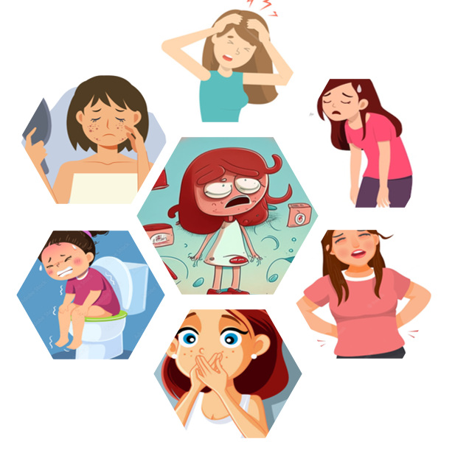
Figure 7: Effect of drugs
5.1 Ensuring Drug Safety in PCOS Treatment: A Critical Examination of Security Measures
1. Adverse Reactions to PCOS Drugs
Hormonal therapies, such as combined oral contraceptives and progestins, may cause nausea, breast tenderness, headaches, and irregular bleeding during the first few months. Insulin-sensitizing agents like Metformin may cause diarrhoea and nausea but usually subside over time. Long-term issues include vitamin B12 deficiency. Anti-androgen medications like Spironolactone and Flutamide may cause dizziness, fatigue, and gastrointestinal disturbances. Menstrual irregularities and Hyperkalemia may also occur with spironolactone. ( Moini et al., 2022)

2. Rare but Severe Adverse Reactions:
Hormonal therapies, such as combined oral contraceptives and progestins, may cause nausea, breast tenderness, headaches, and irregular bleeding during the first few months. Insulin-sensitizing agents like Metformin may cause diarrhoea and nausea but usually subside over time. Long-term issues include vitamin B12 deficiency. Anti-androgen medications like Spironolactone and Flutamide may cause dizziness, fatigue, and gastrointestinal disturbances. Menstrual irregularities and Hyperkalemia may also occur with spironolactone.

3. Risks Associated with Long-Term Use of GnRH Agonists
Leuprolide acetate, a GnRH agonist: Prolonged use of GnRH agonists can result in estrogen deficiency, which can have adverse effects like hot flashes, dry vaginal skin, and loss of bone density (osteoporosis). A decrease in bone mineral density brought on by prolonged use of GnRH agonists may also increase the risk of fractures.

5.2 AI-based Safety Data Calculation
Artificial intelligence (AI) can help analyze safety information for PCOS medication and its potential side effects. By processing large datasets like clinical trials, patient reports, and medical literature, AI can identify typical side effects, identify unforeseen adverse events, track medication safety profiles over time, predict negative effects based on patient characteristics, and assist in personalized medicine methods. This technology can help medical professionals and researchers better understand and manage PCOS medication safety. (Hoeger et al., 2021)

5.3 Ensuring Reliability of PCOD Drug Therapy: Safety and Efficacy Considerations

- Typical Side Effects of PCOD Drugs

Figure 8: Cardiovascular diseases

Hormonal therapies (combined oral contraceptives, progestins): During the first few months of use, nausea, headaches, breast tenderness, and breakthrough bleeding or spotting are possible side effects.
Insulin-Sensitizing Agents (Metformin): Gastrointestinal side effects like diarrhea, nausea, and stomach pain are frequent, particularly when the medication is first taken. Usually, these symptoms get better over time.
Anti-androgen drugs (Spironolactone, Flutamide): Typical side effects may include fatigue, drowsiness, and digestive issues. Menstrual irregularities and hyperkalemia are potential side effects of spironolactone.
2. Extremely Rare but Negative Reactions
Hormonal treatments can cause serious adverse reactions, including blood clots, strokes, heart attacks, and increased cancer risk. These reactions are more common in women with risk factors like smoking and hypertension. Insulin-sensitizing agents can cause lactic acidosis, while anti-androgen drugs may cause liver toxicity, allergic reactions, and potential adrenal gland disruption.
Perilous Effects of Long-Term GnRH Agonist Use
Long-term use of GnRH agonists (Leuprolide Acetate) can cause an initial temporary rise in androgen levels (flare-up) before they are suppressed. PCOD symptoms could temporarily worsen as a result of this. Long-term Use and Loss of Bone Density: Long-term use of GnRH agonists may result in a reduction in bone mineral density, raising the risk of osteoporosis and fractures.

5.4 Data-Driven Approaches to Menstrual Management: The Role of AI in Ensuring Safety

Figure 9: AI and medicine

The analysis of safety information pertaining to PCOD medications and the detection of potential negative effects can be aided by artificial intelligence (AI). In order to find patterns and associations between drug side effects and side effects, AI algorithms can process enormous amounts of medical literature, clinical trial data, and patient reports.
AI has a few advantages:
Safety Signal Recognition: AI can identify early safety signals and potential adverse events that may not have been immediately obvious in smaller datasets or clinical trials.
Patient Risk Profiling: Based on a patient's unique characteristics and medical history, AI can help identify which patients may be more likely to experience particular side effects.
Drug Safety Monitoring: As more data becomes available, AI can help to detect any changes or trends in adverse reactions by continuously monitoring drug safety profiles over time.

6. BALANCING HORMONES: TREATMENT GUIDELINES MENSTRUAL DISORDERS
6.1 PCOS AND PCOD Treatment Recommendations
Recognized Medical Associations and Societies' Recommendations
Reputable medical organizations and societies, like the American College of Obstetricians and Gynecologists (ACOG) or the European Society of Human Reproduction and Embryology, frequently create treatment guidelines for PCOS (ESHRE). In order to provide healthcare providers with standardized recommendations for PCOS management, these guidelines are evidence-based and incorporate the most recent research findings and expert consensus. (Witchel et al., 2021)
Adapting Treatment Plans to Meet the Needs of Each Patient
PCOS is a complicated condition with a wide range of symptoms and manifestations, and each person will present with it differently. The specific symptoms, medical background, and treatment objectives of each patient should be considered when creating a treatment plan. Menstrual irregularities, hirsutism, acne, obesity, fertility goals, and metabolic health are all factors that are taken into account in personalized approaches.
Including Lifestyle Changes in Medication Management:
Changes in lifestyle are frequently advised as the first line of treatment for PCOS because they are so important in managing the condition. Encouragement of weight loss (if overweight or obese) through a balanced diet and consistent exercise can reduce metabolic risks, improve hormonal imbalances, and enhance fertility. Alterations to one's way of life may also help with symptoms like hirsutism, acne, and irregular menstrual cycles.
Oral contraceptives that are combined:
To control menstrual cycles and treat symptoms like acne and hirsutism, doctors frequently prescribe COCs, which contain both synthetic estrogen and progestin. By inhibiting ovulation, lowering androgen levels, and regulating hormone fluctuations, COCs work.
Insulin-sensitive substances
Women with PCOS who also have insulin resistance or poor glucose tolerance may want to think about taking the insulin-sensitizing medication metformin. Menstrual cycle control, insulin sensitivity improvement, and potential help with fertility treatment are all potential benefits of metformin.
Medicines that block androgens
Spironolactone or flutamide are examples of anti-androgen medications that can be used to treat hirsutism and acne. These drugs function by preventing the effects of androgens on sebaceous glands and hair follicles.
Treatments for infertility
Fertility treatments like ovulation induction with drugs (like clomiphene citrate or letrozole) or assisted reproductive technologies (ART) may be advised for women with PCOS who are having trouble getting pregnant. Some women may require the use of ART, which includes procedures like in vitro fertilization (IVF), to become pregnant.
Long-Term Management and Monitoring:
Since PCOS is a chronic condition, it needs to be monitored and managed constantly. To evaluate the effectiveness of the treatment, change medications as necessary, and address any potential complications, regular follow-up with healthcare professionals is crucial.
Patient Support and Education
To help people with PCOS understand their condition, treatment options, and lifestyle changes, patient education is crucial. Supportive counselling can give patients the confidence they need to take an active role in their care and make knowledgeable choices regarding their health.

6.2 AI Innovations in Women's Health: Transforming Menstrual Care and Understanding
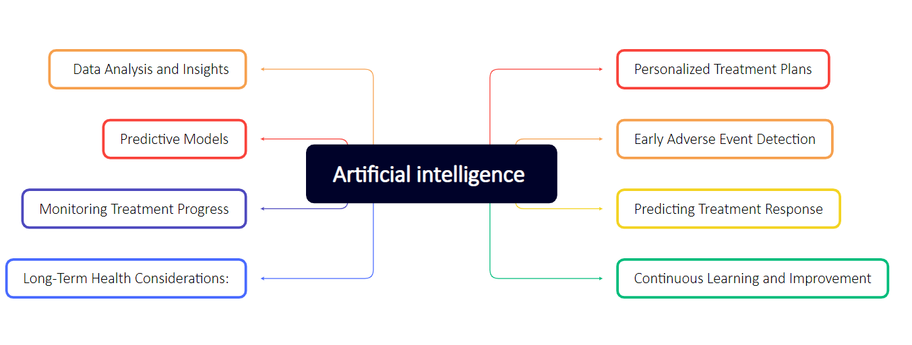
Figure 10: AI-Driven Solutions for Menstrual Disorders

Data Analysis and Insights: Artificial intelligence (AI) is able to analyze a sizable amount of patient data, including electronic health records, medical literature, and clinical trial results, to find patterns and correlations in the management of PCOD. This data-driven analysis can offer insightful information about the efficacy and security of various treatment modalities (Gade et al., 2021)
Personalized Treatment Plans: AI can assist in developing personalized treatment plans for PCOD patients based on their particular traits, medical history, and responses to various therapies. AI can suggest the best medications and lifestyle changes for each patient by taking into account their unique needs and potential risks.
Predictive Models: Using information about specific patients, AI can create predictive models that predict the likelihood that a given treatment will be successful or unsuccessful. These models can help medical professionals make better decisions and provide individualized treatment recommendations.
Continuous Learning and Optimisation AI algorithms can continuously learn from fresh data, new scientific discoveries, and patient outcomes. With time and continued learning, treatment recommendations may be improved and refined, becoming more efficient and supported by data.
Adherence and Monitoring Support- Support for Adherence and Monitoring: AI-driven tools can be created to help patients stick to their treatment regimens and medication schedules. In order to improve treatment outcomes, these tools can also track patient progress and give timely feedback to both patients and healthcare professionals.
Integration with Clinical Practice: Artificial intelligence (AI) can be incorporated into clinical decision support tools and electronic health record systems, assisting healthcare professionals in real time during patient consultations. The decision-making process could be streamlined by this integration, and recommendations for treatments could be supported by data.
Personalized Treatment Plans: AI is capable of analyzing patient information, such as medical history, symptoms, and risk factors, to produce personalized treatment plans that are catered to specific requirements. This strategy makes sure that every patient receives the interventions that are most appropriate for their unique PCOD manifestations.
Combination Therapies -AI can evaluate the efficacy of a variety of combination therapies, including hormonal treatments combined with substances that make insulin more sensitive or anti-androgen drugs. It can determine which mixtures produce the best results for various patient profiles.
Optimal Medication Dosages and Durations: AI can assist in determining the best dosages and durations of medications to manage PCOD symptoms while minimizing any potential side effects. This entails striking the ideal balance between hormonal treatments and insulin-sensitizing medications.
Early Adverse Event Detection: AI can help with the early detection of uncommon adverse reactions or safety issues linked to specific medications, enabling healthcare professionals to act quickly and ensure patient safety.
Predicting Treatment Response: Using patient characteristics and clinical data, AI can forecast the likelihood that a given intervention will be successful. These aids medical professionals in determining the best course of action for every patient.
Monitoring Treatment Progress: AI-driven algorithms are able to continuously track treatment outcomes and progress, allowing for real-time changes to treatment plans to achieve the best outcomes.
Lifestyle Changes: AI can determine how dietary and exercise changes and other lifestyle changes affect PCOD management. It can offer recommendations for modifying one's lifestyle that is supported by the latest research.
Planning for fertility and pregnancy: For PCOD-afflicted women who want to get pregnant, AI can help predict fertility potential and optimize fertility treatments. It may also provide suggestions for controlling PCOD while pregnant.
Long-Term Health Considerations: AI can analyze data to understand the effects PCOD will have on long-term health and can direct interventions to lower the risk of conditions like diabetes and cardiovascular disease that are associated with PCOD.
Continuous Learning and Improvement: AI algorithms are able to learn from fresh information and new studies over time, ensuring that treatment recommendations are current and appropriate as medical knowledge develops.

7. BEYOND THE DIAGNOSIS: PATIENT PERSPECTIVES MENSTRUAL DISORDERS

Figure 11: patient perspectives and experiences

7.1 Perspectives -from PCOS Patients
patient experience surveys for various medications:
Surveying PCOS patients and asking them about their experiences taking different medications can reveal important details about the effectiveness of the treatment, any side effects, and how satisfied they were with it overall. Healthcare professionals can learn which treatments are better tolerated and more efficient for managing particular PCOS symptoms by studying patients' actual experiences. (Ramamoorthy et al., 2021)
Obstacles to Following Treatment Regimens
Optimizing treatment outcomes depends on having a thorough understanding of the difficulties patients have sticking to their treatment plans. Adherence to prescribed therapies may be impacted by elements like medication complexity, side effects, lifestyle changes, and financial constraints.
Treatment decisions and patient satisfaction
Examining the variables affecting patients' treatment decisions can reveal their preferences and thought processes. Patients' satisfaction with their chosen therapies is influenced by a variety of variables, including accessibility to medications, prior treatment experiences, and desired outcomes.

7.2 Perspectives from PCOD Patients
Recognizing Patient Experiences and Treatment Satisfaction:
Finding the most efficient and well-tolerated interventions depends on having insight into patient experiences with various PCOD treatments. Healthcare professionals can be guided by patient feedback when modifying treatment plans to suit unique needs and preferences.
Discussing Specific Challenges PCOD Patients Face
Patients with PCOD may experience particular difficulties with fertility, menstrual irregularities, and hormonal imbalances. Understanding and addressing these issues with the help of patient perspectives can promote more patient-centered care and support. Healthcare professionals can develop more comprehensive and patient-centered treatment guidelines for PCOS and PCOD by incorporating the opinions and experiences of patients. Treatment adherence, patient satisfaction, and general well-being for those with these conditions can all be improved by having a better understanding of how treatments affect patients in real-world situations. Involving patients in decision-making also gives them the power to take an active role in their healthcare, improving both quality of life and health outcomes.

8. NEXT-GENERATION SOLUTIONS FOR MENSTRUAL DISORDERS: A VISION FOR THE FUTURE
8.1 Modernizations in PCOS Medicine
Promising Studies on New Drugs and Treatment Methods:
Novel medications that target particular facets of PCOS pathophysiology are being investigated in ongoing research. New androgen receptor modulators, selective estrogen receptor modulators (SERMs), and medications that target insulin resistance and metabolic dysfunction in PCOS are a few potential areas of interest. (Thebar et al., 2022)
Potential areas where current therapies could be improved:
Current hormonal therapies, insulin sensitizers, and anti-androgen drugs may be optimized to increase efficacy and minimize side effects. To maximize symptom management and enhance patient outcomes, combination therapies may be improved further.
8.2 Developing PCOD Treatments
Highlighting Current Clinical Trials and Research:
Clinical trials are currently being conducted to examine different PCOD treatment modalities, such as new drugs and interventions. Studies are looking into the management of PCOD and the effects of dietary adjustments, lifestyle changes, and individualized treatment plans.
Speculating on Potential Advances in PCOD Management and the Function of AI:
By analyzing huge datasets and locating potential therapeutic targets, AI can hasten the discovery of novel therapeutic options.AI algorithms can aid in the personalized treatment selection process for PCOD patients by predicting treatment responses and adverse events.
8.3 AI's Function in PCOD Precision Medicine
Artificial intelligence (AI) can help in identifying patient subgroups that might react differently to particular treatments, opening the door for individualized precision medicine methods. AI can predict the specific outcomes of each patient through predictive analytics, optimizing treatment regimens based on genetic, dietary, and environmental factors. (Harrini et al.,2021)
Potential Innovations in Fertility Therapies:
Innovative fertility treatments, such as cutting-edge reproductive technologies and ovarian rejuvenation therapies, may result from research, giving PCOD patients who are experiencing fertility issues new hope.
Nonpharmacological Interventions Have Advanced:
AI can assist in evaluating the effects of non-pharmacological interventions on PCOD management, including exercise, stress management, and complementary therapies. New evidence-based practices to assist patients in managing their condition may be discovered through research.
Digital health technology integration:
AI can make it possible to integrate digital health technologies, such as wearables and mobile health apps, to track PCOD symptoms and the effectiveness of treatment. Real-time patient-provider communication made possible by these technologies can increase patient engagement and self-management.
AI will continue to be a key influence on the future directions of PCOS and PCOD research as it changes. AI has the potential to revolutionize PCOS and PCOD management, from identifying novel therapies to enabling personalized and precision medicine approaches. Future patient-centered, evidence-based care will be facilitated by collaboration between AI-driven insights and medical knowledge. (Prathap et al., 2018)

9. CONCLUSION
Understanding these complex conditions completely is necessary for the management of polycystic ovarian disease (PCOD) and polycystic ovary syndrome (PCOS). We have examined various facets of PCOS and PCOD in this comparative analysis, shedding light on their pathophysiology, medications that are available, their mechanisms of action, their efficacy, safety profiles, and recommended therapeutic approaches. We have also examined patient viewpoints and experiences, as well as the fascinating potential future developments in the management of PCOS and PCOD.
It is clear from this analysis that both PCOS and PCOD pose particular difficulties for patients and medical professionals. The core of medical therapies, which work to restore hormonal balance and relieve symptoms, consists of hormone therapies, insulin-sensitizing agents, and anti-androgen drugs. In some circumstances, surgical interventions may be thought about to treat complications or symptoms that won't go away. Artificial intelligence (AI) is proving to be a useful tool for enhancing treatment recommendations, improving patient-centered care, and forecasting treatment outcomes. Healthcare providers can make wise decisions and create individualized treatment plans for better patient outcomes by utilizing AI to analyze large datasets and actual patient experiences.
Patient perspectives have proven instrumental in understanding the real-world impact of PCOS and PCOD treatments. AI-driven analysis of patient feedback has provided valuable insights into medication tolerability, treatment satisfaction, and adherence challenges. Acknowledging these patient experiences empowers healthcare providers to adopt patient-centered care models, taking into account individual preferences and circumstances.
Looking ahead, the future of PCOS and PCOD management holds great promise. Advancements in pharmacological and non-pharmacological interventions, as well as ongoing research and clinical trials, offer hope for novel treatment approaches. AI's role as an invaluable partner in precision medicine continues to grow, identifying patient subgroups, predicting treatment outcomes, and optimizing fertility treatments.
A comprehensive strategy for treating PCOS and PCOD requires medical expertise, patient perspectives, and AI. Healthcare professionals can improve treatment recommendations, advance personalized care, and pioneer advancements in management, enhancing the quality of life and long-term health outcomes.

10. REFERENCE
Ahmad, Ghulab Nabi, et al. "Comparative study of optimum medical diagnosis of human heart disease using machine learning technique with and without sequential feature selection." ieee access 10 (2022): 23808-23828.
Arentz, Susan, et al. "Herbal medicine for the management of polycystic ovary syndrome (PCOS) and associated oligo/amenorrhoea and hyperandrogenism; a review of the laboratory evidence for effects with corroborative clinical findings." BMC complementary and alternative medicine 14 (2014): 1-19.
Babu, Geethavani, et al. "Comparative study on the vaginal flora and incidence of asymptomatic vaginosis among healthy women and in women with infertility problems of reproductive age." Journal of clinical and diagnostic research: JCDR 11.8 (2017): DC18.
Bahamondes, Luis, and Moazzam Ali. "Recent advances in managing and understanding menstrual disorders." F1000prime reports 7 (2015).
Bellofiore, Nadia, et al. "Characterization of human-like menstruation in the spiny mouse: comparative studies with the human and induced mouse model." Human Reproduction 33.9 (2018): 1715-1726.
FAUSER, BART CJM, et al. "Serum bioactive and immunoreactive luteinizing hormone and follicle-stimulating hormone levels in women with cycle abnormalities, with or without polycystic ovarian disease." The Journal of Clinical Endocrinology & Metabolism 73.4 (1991): 811-817.
Firdose, Kouser Fathima, and Ismath Shameem. "An approach to the management of poly cystic ovarian disease in Unani system of medicine: A review." Int j appl res 2.6 (2016): 585-90.
Gade, Ramya, et al. "Polycystic ovarian syndrome (PCOS): Approach to traditional systems, natural and bio-chemical compounds for its management." Indian Journal of Biochemistry and Biophysics (IJBB) 59.5 (2022): 521-527.
Gayatri, Kar, Jena Saubhagya Kumar, and Behera Basanta Kumar. "Metformin and N-acetyl Cysteine in Polycystic Ovarian Syndrome–-A Comparative Study." Indian Journal of clinical medicine 1 (2010): 117739361000100002.
Gupta, R., et al. "A comparative study of pregnancy outcomes and menstrual irregularities in northern Indian patients with systemic lupus erythematosus and rheumatoid arthritis." Rheumatology international 30 (2010): 1581-1585.
Harrini, K., et al. "Prevalence of PCOD in Patients Visiting OPD of Karuna Medical College." Journal of Evolution of Medical and Dental Sciences 9.20 (2020): 1590-1594.
Hoeger, Kathleen M., Anuja Dokras, and Terhi Piltonen. "Update on PCOS: consequences, challenges, and guiding treatment." The Journal of Clinical Endocrinology & Metabolism 106.3 (2021): e1071-e1083.
Kim, Jihye, et al. "A comparative study of the radial pulse between primary dysmenorrhea patients and healthy subjects during the menstrual phase." Scientific reports 9.1 (2019): 9716.
Kleinstäuber, Maria, et al. "Psychosocial profile of women with premenstrual syndrome and healthy controls: a comparative study." International journal of behavioral medicine 23 (2016): 752-763.
Lamba, Chetna Deep, et al. "Evaluation of homoeopathic treatment in polycystic ovary syndrome: A single-blind, randomised, placebo-controlled pilot study." (2018).
Luef, Gerhard, et al. "Polycystic ovaries, obesity and insulin resistance in women with epilepsy: a comparative study of carbamazepine and valproic acid in 105 women." Journal of neurology 249 (2002): 835-841.
Ma, Yu-Xia, et al. "A comparative study on the immediate effects of electroacupuncture at Sanyinjiao (SP6), Xuanzhong (GB39) and a non-meridian point, on menstrual pain and uterine arterial blood flow, in primary dysmenorrhea patients." Pain Medicine 11.10 (2010): 1564-1575.
McCartney, Christopher R., and John C. Marshall. "Polycystic ovary syndrome." New England Journal of Medicine 375.1 (2016): 54-64.
Moini Jazani, Arezoo, et al. "A comprehensive review of clinical studies with herbal medicine on polycystic ovary syndrome (PCOS)." DARU Journal of Pharmaceutical Sciences 27 (2019): 863-877.
Naumova, Iuliia, et al. "Quality of life in infertile women with polycystic ovary syndrome: a comparative study." Reproductive Sciences 28.7 (2021): 1901-1909.
Ozturk, Munir, et al. "A comparative analysis of the medicinal pteridophytes in Turkey, Pakistan, and Malaysia." Plant and Human Health, Volume 1: Ethnobotany and Physiology (2018): 349-390.
Prathap, Aparna, T. P. Subhalakshmi, and P. Joseph Varghese. "A cross-sectional study on the proportion of anxiety and depression and determinants of quality of life in polycystic ovarian disease." Indian journal of psychological medicine 40.3 (2018): 257-262.
Ramamoorthy, Suganya, et al. "Enhancing intricate details of ultrasound PCOD scan images using tailored anisotropic diffusion filter (TADF)." Intelligence in Big Data Technologies—Beyond the Hype: Proceedings of ICBDCC 2019. Springer Singapore, 2021.
Senapathi, Pradeep, and Hemant Kumar. "A comparative study of menstrual hygiene management among rural and urban adolescent girls in Mangaluru, Karnataka." Int J Community Med Public Health 5.6 (2018): 2548-56.
Thebar, Jagdish, et al. "Polycystic Ovarian Disease (PCOD) successfully treated with Lachesis: An evidence based case report." Small 31 (2022): 08.
Walls, M. L., et al. "In vitro maturation as an alternative to standard in vitro fertilization for patients diagnosed with polycystic ovaries: a comparative analysis of fresh, frozen and cumulative cycle outcomes." Human Reproduction 30.1 (2015): 88-96.
Wang, Fang-fang, et al. "American, European, and Chinese practice guidelines or consensuses of polycystic ovary syndrome: a comparative analysis." Journal of Zhejiang University. Science. B 19.5 (2018): 354.
Wang, Fang-fang, et al. "American, European, and Chinese practice guidelines or consensuses of polycystic ovary syndrome: a comparative analysis." Journal of Zhejiang University. Science. B 19.5 (2018): 354.
Witchel, Selma Feldman, Helena J. Teede, and Alexia S. Peña. "Curtailing pcos." Pediatric research 87.2 (2020): 353-361.

