Controllable Synthesis and Characterization of Cu-CoZnFe₂O₄ Nano Ferrites by Auto-combustion Route

Thalari Chandrasekhar¹, Ravi Naik², Sharanappa Chapi³ and Madhukumar R^{4*}
¹Associate Professor, Department of Electronics, Government Science College, Hassan-573201, Karnataka, India
²Assistant Professor, Department of Chemistry, Mahantswamy Arts, Science and Commenrce college, Haunsbhavi-581109, Karnataka, India
³ Department of Physics, B.M.S. College of Engineering, Bull Temple Road, Basavanagudi, Bengaluru, Karnataka - 560 019, India
^{4*}Department of Physics, Art’s Science and Commerce Degree College, Ranebennur, Karnataka – 581115
Corresponding Author*: nwwton@gmail.com

ABSTRACT
The methods employed to prepare nanocrystalline mixed ferrite materials during experimentation significantly affect the resulting particle size. The quality of ferrite materials greatly influences the performance of devices. The chemical composition and microstructure of ferrites, which determine their properties, are both determined by the preparation process. The CoCuZnFe₂O₄ ferrite nanoferites were prepared by sol-gel method. The prepared samples were calcinated at 750 ºC shows sharper X-ray diffraction peaks, indicating increased crystallinity of the materials. Average crystallite sizes were obtained in the ranges 30.4-42.1 nm for the samples calcinated at 450 ℃ and 750 ℃, respectively. Images using scanning electron microscopy (SEM) showed clumps of particles. The overall acidity was reduced for the samples that were calcinated at higher temperatures. The findings highlight how the preparation circumstances affect nano ferrites’ crystallite size, shape, and magnetic characteristics.
Keywords: XRD, DSC, TGA, SEM, Nanoferites
- INTRODUCTION
Nanotechnology encompasses a wide range of disciplines, from inventing novel materials with nanoscale dimensions to examining if we can directly alter matter on the atomic scale. It ranges from extensions of standard device physics to whole new methodologies based upon molecule self-assembly. Nanotechnology holds the promise of producing a wide variety of novel materials and gadgets with a diverse range of use, including in medicine, energy production, and electronics. On the other hand, nanotechnology brings many of the same problems as when new technology is introduced, such as worries about the economy [1, 2]. When materials are scaled down to the nanoscale, they exhibit different properties than they do at the macroscale. This creates new opportunities for their use. For example, some solids that are normally opaque, such as copper, become translucent at the nanoscale. Similarly, some stable solids, like aluminium, become flammable, and some insoluble solids, like gold, become soluble. When substances like gold are reduced to nanoscales, they can display powerful chemical catalytic properties, despite being chemically inert at larger dimensions. These quantum and surface phenomena observed in matter at the nanoscale are what make nanotechnology an attractive field of study [3-5].
Ferrites, specifically spinel ferrite, possess a crystal structure that comprises two interstitial sites - tetrahedral and octahedral - capable of accommodating various cations. This feature allows for diverse properties in ferrites as other divalent metal ions can replace ferrites. Research has demonstrated that substituting Al³⁺ in cobalt ferrite nanoparticles can modify their electromagnetic properties, making them a promising option for microwave and power device applications. However, replacing Zn in MgFe₂O₄ can increase resistivity while decreasing magnetic properties. Semiconducting behaviour becomes a trend after Cr³⁺ substitution. Substituting Cr³⁺ ions in the nickel-zinc ferrite system can also increase resistivity, making the prepared samples suitable for higher frequency ranging systems. Ferrites can also improve the activation energy and thermal decomposition of propellants and can be easily separated using an external magnet [6-9]. Various methods such as sol-gel, hydrothermal, and coprecipitation are utilised to synthesise ferrite nanoparticles. This article reports on the effect of cobalt copper zinc ferrite (CoCuZnFe₂O₄) using a low-cost sol-gel method.
- MATERIALS AND METHODS
All the chemicals used were of analytical grade without further purification and available from commercial sources: cobalt(II)nitrate hexahydrate [Co-(NO₃)₂.6H₂O, 99%], copper(II)nitrate trihydrate [Cu- (NO₃)₂.3H₂O, 95%], zinc(II)nitrate hexahydrate [Zn- (NO₃)₂.6H₂O, 99%], ferric(III)nitrate nonahydrate [Fe- (NO₃)₃.9H₂O, 98%], and sodium hydroxide (NaOH), Glycine. Laboratory-setup triple distilled water was used as a solvent.
Cobalt copper zinc ferrite powder was synthesized by the auto-combustion method. The stoichiometric amounts of nitrates to the fuel are taken as 1:3. Initially, all the nitrates were mixed into the distilled water and fuel is added to the solution. These solutions are mixed using a magnetic stirrer and heated for about 45 min. The solution is continuously stirred till the temperature reaches 80 ⁰C and pH 7 is maintained by using ammonia of suitable quantity, then, the mixed solution is transferred into a heating mantel which is maintained at a temperature of about 100 ⁰C. Upon heating, the solution is turned into dried gel. The dried gel undergoes auto-combustion and forms a foam-like structure. After cooling, the obtained foam is converted into ash, poured into the mortar, and will be grinded to form a fine powder. The obtained fine powder is kept under sintered at 600 ⁰C temperature for about 6 hours using a muffle furnace. Finally, the Cobalt Copper Zinc Ferrites are obtained.
- CHARACTERIZATION:
We used the Panalytical X-Pert Pro MPD instrument to record the X-ray diffraction patterns of the samples we synthesized. The samples were analyzed in the 2θ range of 10-80º, with a scanning speed of 5º/min and step size of 0.02º. To analyze the morphology of the samples, we used the FESEM CARL ZEISS instrument. This microscope has a field emission gun and can operate with accelerating voltage variable from 0.5 to 30 kV, with 2 nm resolution. We also carried out thermal analysis of the samples using TGA/DTA.

A. X-Ray Diffraction Studies on as prepared CuZnFe₂O₄ and CoZnFe₂O₄ Nano Ferrites
Structural analysis of the CoZnFe₂O₄ and CuZnFe₂O₄ were obtained from powder XRD which is depicted in Figures 1 and 2. A single-phase spinel cubic structure can be seen in the prepared sample according to the XRD peaks (1 1 1), (0 2 2), (1 1 3), (2 2 2), (2 2 4), (3 3 3), and (0 4 4). In some of the samples, a secondary phase of hematite with a cubic spinel structure is forming partially. Previous studies have found single-phase Co-Zn ferrite nanoparticles created through the sol-gel process and annealed at temperatures below 600°C. These nanoparticles correspond with the JCPDS card numbers 52-0277 and 89-0599, which represent spinel Co-Zn ferrite and secondary hematite phase, respectively, and the diffraction peaks are in good agreement [10]. At high concentrations of cobalt doping, the secondary hematite phase's peak strength decreased. To determine the average crystallite size of all the synthesized samples, Scherer's equation [11, 12] was used, and the full-width half maximum (FWHM) of the most prominent peak (1 1 3) of the XRD patterns was analyzed.
$$D =\frac{ 0.9λ }{β cos θ}$$
where D is the average crystallite size, $β$ is the intensity FWHM in radians and $λ=1.54 Å$ is the wavelength of X-ray and $θ$ is the Bragg’s angle [13].
It is discovered that cobalt doping results in an increase in crystallite size (D) from 25 to 31 nm. Nearly the same crystallite size (D) was achieved at x=0.5% (28 nm) and x=0.5% (30 nm). Due to this slight dopant fluctuation, other estimated structural parameters at x = 0.03 and 0.09 have values that are nearly identical. The spacing (d) and lattice constant (a) [14, 15] are two structural parameters that are impacted by Co doping and have been determined by using the relation:
2d sin θ = nλ
Figure 1: XRD pattern of CoZnFe₂O₄ Nanoferrite
Figure 2: XRD pattern of CuZnFe₂O₄ Nanoferrite
B. FESEM Analysis
CuZnFe₂O₄ and CoZnFe₂O₄ Nano Ferrites were synthesized and dried at 90 ⁰C in a vacuum and calcined at 500 ⁰C for 45 min, respectively, in Figure 3. It is evident that crystal agglomeration occurs as can be seen from Figure 3 (a). It typically results from the formation of smaller crystals. There are several spherical crystals that are substantially smaller or have nanometer dimensions that are below 100 nm. This is consistent with the XRD pattern, which showed the peak broadening for these powder specimens. The grain size was assessed from a SEM micrograph, the crystal size increased (Fig. 3b). This value is consistent with the XRD data results. The extremely narrow XRD peaks show that larger grains are larger than the nanoscale area. Low-resolution micrographs clearly show the impact of heat treatment on the fine-grain size of the specimens (Fig. 3b).

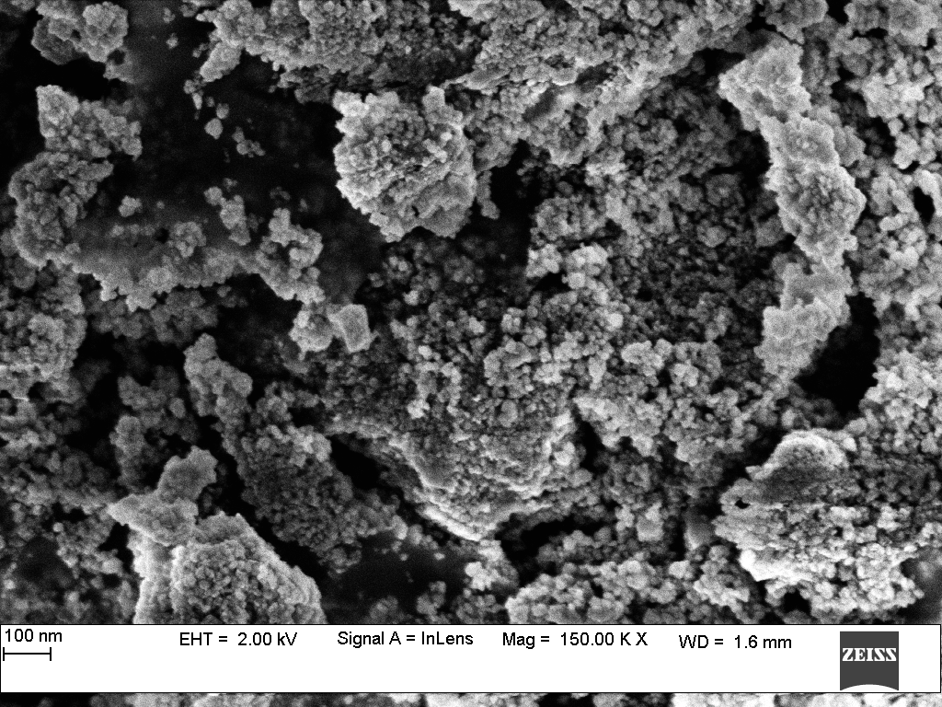
(a)

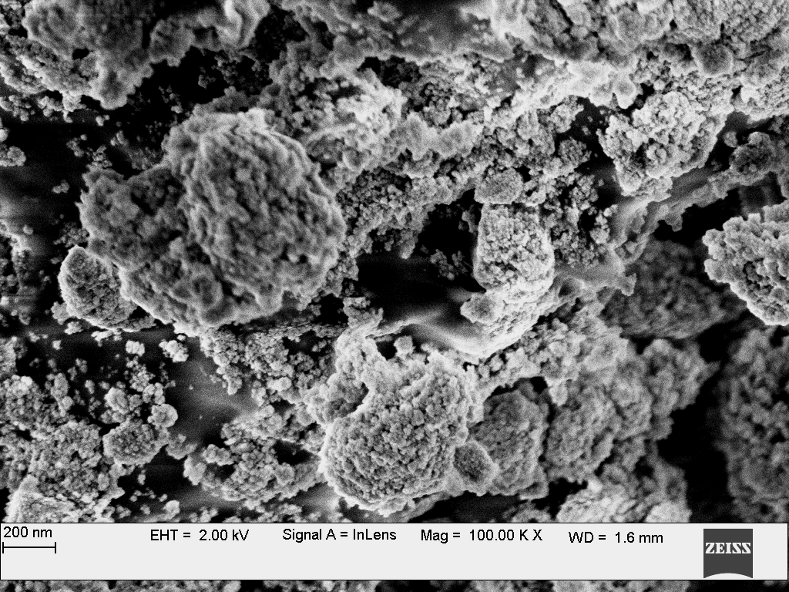
(b)

Figure 3: FESEM micrograph of (a) CuZnFe₂O₄ and (b) CoZnFe₂O₄ sintered at 500 ⁰C.

C. DSC and DTG Analysis
Figure 4. DSC/TGA Spectra of CoCuZnFe₂O₄ Nanoferrite.
The DSC/TGA curve of CoCuZnFe₂O₄ nanoferrites is shown in Figure 4. The initial weight loss in the CuZnFe₂O₄and CoZnFe₂O₄ nanoferrites was around 10% when the temperature was less than 100 ºC. The sample was thermally stable and the weight change was insignificant. Due to the degradation of the polymer chains, there is a weight loss of about 50% in the second phase in the temperature range of 100 ºC to 450 ºC and a greater weight loss (about 68%) in the temperature range of 500 ºC to 800 ºC. It was observed that the quantity of CuCoZnFe₂O₄ nanoferrites contained in the composite affected the breakdown temperature of the nanoferrites [16-18].
- CONCLUSIONS
The current work illustrated the structural, thermal and chemical characteristics of prepared CuZnFe₂O₄ and CoZnFe₂O₄ nanoferrites. XRD, FE-SEM, and DSC analysis techniques were used to investigate the prepared samples. Samples exhibit a single-phase spinel phase cubic structure according to XRD analysis. CuZnFe₂O₄ and CoZnFe₂O₄ nanoferrites create a spinel phase cubic structure with a partial secondary hematite phase (α-Fe₂O₃) development. Because Co⁺² ions have higher ionic radii than Cu⁺² ions, the crystallite size (D) increases with Co and Cu doping. FESEM gave information about the crystallinity of the prepared samples. From TGA, the thermal stability was studied.
Conflict of interest
The author declares that they have no conflict of interest.

REFERENCES:
- Nanotechnology:principles and practices, capital publishing company Sulabha K. Kulkarni Abo El A M, Attia S M and Meaz T M 2004 Solid State Sci.661.
- Amarendra singh K, goel T C, Mendiratta R G, Thakur O P and Chandra Prakash 2002 J. Appl. Phys.91 6626.
- Barbes V A M 1995 in Progress in Spinel ferrite research(ed.) H K J Buschow (Amsterdam:Elsevier)
- Brockman F G, Dowling P H and Steneck W G 1949 Phys.rev.75 1440
- Gul I H and Maqsood A 2008 J.Alloys Compds 465 227
- Mangalaraja R V, Ananthakumar S, Manohar P and Gnanamn F D 2002 J. Magn. Mater. 257 79
- Raghavender A T, Damir Pajic, Kreso Zadro, Tomislav Milekovic, Venkateshwara rao P, Jadhav K M and Ravinder D 2007 J.magn. Magn. Mater. 1 316
- Rennard R J and Khel W L 1971 J.Catal. 21 282
- Rezlescu N and Rezlescu E 1974 Phys. Status Solidi(a) 23 575
- Shitre A R, Kawade V B, Bichile G K and Jadhav K M 2002 Mater. Letts 36 188
- Sousa E C, Alves C R, Aquino R, Sousa M H, Goya G F, Rechenberg H R, Tourincho F A and Depeyrot J 2005 J. Magn. Magn. Mater.289 118
- Zaki H M 2005 Phys.B363 232 Koops C 1951 Phys. Rev.83 121
- Sharanappa Chapi, Influence of Co2+ on the Structure, Conductivity, and Electrochemical Stability of Poly(Ethylene Oxide)-Based Solid Polymer Electrolytes: Energy Storage Devices, Journal of Electronic Materials volume 50,1558–1571 (2021).
- Kwon, Y.M., Lee, M.Y., Mustaqima, M., Liu, C., Lee, B.W.: Structural and magnetic properties of Ni0.6Zn0.4Fe2O4 ferrite prepared by solid state reaction and sol-gel. J. Magn. 19, 64 (2014)
- George, M., Nair, S.S., John, A.M., Joy, P.A., Anantharaman, M.R.: Structural magnetic and electrical properties of the sol-gel prepared Ni _{0.5} Zn _{0.5} Fe₂O₄ fine particles. J. Phys. D. Appl. Phys. 39,900 (2006)
- C.H. Yan, Z.G. Xu, F.X Cheng, Z.M. Wang, L.D. Sun, C.S. Liao and J.T. Jia; Sol. Stat. Comm., 111,287 (1999)
- D.Y. Chung and E. H. Lee; J. Alloys Comp., 374, 69 (2004)
- O.A. Lopez, J. McKittrick and L.E. Shea; J. Lumin., 71, 1 (1997)

***

