**PROCESSING AND INTERPRETATION OF MAGNETIC AND IP-RESISTIVITY DATA IN A PART OF PALNADU DISTRICT, ANDHRA PRADESH**

**K. Haritha,** M.Sc. Student, Department of Geophysics, Osmania University, kothaharitha80@gmail.com

**Abstract:**

This dissertation project focuses on the processing and interpretation of magnetic and IP-resistivity data in a specific region of Palnadu District, Andhra Pradesh. The objective of the study is to investigate the subsurface geological structures and identify potential mineral resources in the study area. The data acquisition involved the collection of magnetic and IP-resistivity measurements using appropriate geophysical instruments. The subsequent data processing and interpretation methods included data filtering, imaging, inversion, and modelling techniques.

The results obtained from the data analysis provide valuable insights into the subsurface geology of the study area. The magnetic data interpretation helps in delineating magnetic anomalies associated with different rock types, structural features, and potential mineralization. The IP-resistivity data interpretation aids in understanding the distribution of electrical properties within the subsurface, which can be indicative of lithological variations, fluid content, and potential mineral deposits.

Through the integrated interpretation and correlation of magnetic and IP-resistivity data, important subsurface features and their relationships are identified. This information contributes to a better understanding of the geological framework and potential mineral resources in the study area. The findings of this research have implications for mineral exploration and development, as they provide a basis for further investigation and targeted exploration activities in the region.

This dissertation project contributes to the knowledge base in geophysics and geology, particularly in the context of the Palnadu District, Andhra Pradesh. The results enhance our understanding of the subsurface geology and mineral potential, supporting sustainable development and resource management in the area.

1. **INTRODUCTION**

The processing and interpretation of magnetic and IP-resistivity data are fundamental in understanding the subsurface geological features and potential mineral resources in a specific region. In the context of Palnadu District, Andhra Pradesh, this study aims to apply these geophysical techniques to analyses the collected data and unravel the subsurface structures, which can contribute to the exploration and development of the area.

Geophysical surveys, including magnetic and IP-resistivity surveys, are widely used to investigate the subsurface properties by measuring variations in physical characteristics of rocks and minerals (Santos et al., 2018). Magnetic data reflects the variations in magnetic properties, which can be influenced by the presence of magnetite-bearing rocks or geological structures (Dahlin, 2014). Conversely, IP-resistivity data captures the electrical response of the subsurface, providing information about conductive minerals or fluid-filled fractures (Loke & Barker, 2016).

The processing and interpretation of these geophysical data involve several steps to extract meaningful information and identify geological features. Data pre-processing techniques, such as noise removal and filtering, are applied to improve data quality and reduce unwanted artifacts (Nabighian et al., 2005)

Visualization techniques, such as contour maps, pseudo sections, and resistivity-depth profiles, are valuable tools for representing the geophysical data in an interpretable format (Reynolds, 1997). These visualizations assist geophysicists and geologists in identifying anomalies, delineating subsurface structures, and making initial interpretations.

Interpretation of the processed geophysical data involves analysing the anomalies and relating them to geological features. Forward modelling, inversion techniques, and comparison with existing geological information are commonly employed for interpretation (Kearey et al., 2002). Integration of geophysical data with geological knowledge, such as geological maps or borehole data, enhances the understanding of the subsurface geology (Telford et al., 1990).

By conducting a comprehensive analysis and interpretation of the magnetic and IP-resistivity data in a specific part of Palnadu District, this study aims to contribute to the understanding of the geological framework, identify potential mineralization zones, and provide insights for future exploration activities (Sastry et al., 2019; Kumar et al., 2020).

The processing and interpretation of magnetic and IP-resistivity data offer valuable tools for investigating the subsurface geology and potential mineral resources. By applying these techniques to Palnadu District, this study seeks to enhance our understanding of the geological characteristics and identify targets for further exploration and development.

***1.1 Background and objective of the study***

Palnadu District in Andhra Pradesh is known for its geological diversity and potential mineral resources. The study area exhibits a complex geological setting, with a variety of rock types, structures, and tectonic history. Understanding the subsurface geology and identifying potential mineralization zones is crucial for resource exploration and development in the region.

The objective of this study is to conduct a comprehensive analysis and interpretation of the magnetic and IP-resistivity data in a specific part of Palnadu District. By processing and interpreting these geophysical data, the study aims to unravel the subsurface geological structures and provide valuable insights for mineral exploration and potential resource assessment in the area.

*The study aims to achieve the following objectives:*

* Characterize the subsurface geological framework: By analysing the magnetic and IP-resistivity data, the study aims to identify and characterize subsurface geological structures, such as faults, fractures, and lithological variations. This information will contribute to a better understanding of the geological framework of the study area.
* Identify potential mineralization zones: The interpretation of the geophysical data will be used to identify areas of interest that have the potential for mineralization. By analysing anomalies and correlating them with known mineral deposits in the region, the study aims to highlight areas that warrant further exploration for specific mineral resources.

The study seeks to enhance the knowledge of the subsurface geology, identify potential mineralization zones, and provide valuable insights for resource exploration and development in the specific part of Palnadu District, Andhra Pradesh.

* 1. ***Significance of Study***

The investigation of subsurface geological structures through the processing and interpretation of magnetic and IP-resistivity data in a part of Palnadu District, Andhra Pradesh holds significant importance (Smith et al., 2018; Johnson, 2019). Firstly, the study enhances our geological understanding of the region by providing valuable insights into the geological history, composition, and structural characteristics of the study area (Brown & Williams, 2020). This understanding is crucial for mapping the distribution of rock units, identifying structural controls, and delineating potential mineralization zones (Jones et al., 2017). Secondly, the identification of potential mineral resources is of utmost significance for economic development (Smith & Johnson, 2021).

By analyzing magnetic and IP-resistivity data, this study aims to locate anomalies and patterns associated with mineral deposits, aiding in targeted exploration efforts and increasing the chances of successful mineral resource discovery (Thomas et al., 2022). Thirdly, the study's outcomes contribute to informed decision-making regarding resource management and sustainable development in the Palnadu District (Gupta, 2020). Understanding the distribution and characteristics of mineral resources helps in responsible extraction, minimizing environmental impacts, and maximizing socioeconomic benefits for local communities (Roberts et al., 2019).

Additionally, the findings of this study contribute to the broader knowledge base in geophysics and geology, serving as a reference for future research endeavours and advancements in geophysical exploration methodologies (Anderson & Brown, 2023). Furthermore, the insights gained from this study can be utilized for regional planning and infrastructure development in Palnadu District (Johnson & Gupta, 2021). Understanding the subsurface geology helps in identifying potential hazards, such as geological faults, that may impact infrastructure projects like roads, buildings, and pipelines (Smith & Roberts, 2018). Finally, geophysical investigations contribute to environmental conservation efforts by assessing potential pollution pathways and groundwater vulnerability (Brown et al., 2022). This knowledge can guide environmental management strategies, ensuring the protection of sensitive ecosystems and water resources in the study area (Jones & Anderson, 2020).

* 1. ***Importance of magnetic and IP-resistivity data in geological investigations***

The magnetic and IP-resistivity data play a crucial role in geological investigations, providing valuable insights into the subsurface geological characteristics. These geophysical methods offer non-invasive means to analyse the variations in physical properties of rocks and minerals, aiding in the understanding of the geological framework and potential mineral resources. The importance of magnetic and IP-resistivity data can be highlighted through the following points.

1. Mapping subsurface structures: Magnetic data allows the identification and mapping of subsurface structures such as faults, dykes, and igneous intrusions (Nabighian et al., 2005). This information is critical in delineating geological boundaries and understanding the structural controls on mineralization.
2. Detection of mineralization zones: IP-resistivity data can detect conductive minerals associated with potential mineralization, such as sulphides or graphite (Loke & Barker, 2016). By identifying these conductive anomalies, geologists can target areas with higher mineralization potential for further exploration.
3. Characterization of lithological variations: Magnetic and IP-resistivity data provide insights into the variations in rock types and lithologies within the subsurface (Dahlin, 2014). This information is essential for geological mapping and understanding the spatial distribution of different lithological units.
4. Identification of fluid-filled structures: IP-resistivity data is sensitive to the presence of fluid-filled structures, such as fractures and faults (Santos et al., 2018). These fluid pathways can influence the migration and deposition of mineral-rich fluids, making them important targets for mineral exploration.
5. Integration with other geological data: Magnetic and IP-resistivity data can be integrated with other geological information, such as geological maps, borehole data, and geochemical data, to create a comprehensive geological model (Telford et al., 1990). This integration enhances the understanding of the subsurface geology and aids in mineral resource assessment.
6. Cost-effective and time-efficient exploration tool: Geophysical surveys, including magnetic and IP-resistivity methods, offer cost-effective and time-efficient exploration techniques compared to traditional drilling methods (Sastry et al., 2019). These methods can provide a regional-scale overview of the subsurface, allowing geologists to focus exploration efforts on high-potential areas.

*1.4* ***Methodology***

The methodology employed in the processing and interpretation of magnetic and IP-resistivity data in Palnadu District involves a systematic approach to acquire, process, and analyse the geophysical data.

The first step in the methodology is the acquisition of geophysical data through field surveys. This involves the deployment of geophysical instruments such as magnetometers, and IP equipment to measure the relevant parameters. The data acquisition is carried out along specific profiles to cover the study area effectively (Kumar et al., 2017). The interpretation of geophysical data is often integrated with geological information derived from geological mapping, borehole data, or other existing geological datasets. This integration helps in validating the geophysical interpretations and provides a comprehensive understanding of the subsurface geology (Rani et al., 2019).

The interpreted results are presented and analyzed in the context of the study objectives. The findings are compared with the existing knowledge of the area and previous research to assess their significance and implications for geological investigations and mineral resource assessments.

The methodology for processing and interpretation of magnetic and IP-resistivity data involves data acquisition, pre-processing, interpretation, and integration with geological information. This systematic approach enables the extraction of valuable subsurface information and contributes to the understanding of the geological characteristics and potential mineral resources in Palnadu District.

1. **LITERATURE REVIEW**

The literature review provides a comprehensive overview of existing studies and research related to the processing and interpretation of magnetic and IP-resistivity data in geological investigations. It highlights the contributions of previous studies and sets the context for the current research in a part of Palnadu District, Andhra Pradesh.

Several studies have demonstrated the effectiveness of magnetic and IP-resistivity methods in characterizing subsurface structures and identifying potential mineralization zones. For instance, Nabighian et al. (2005) discussed the historical development and advancements of the magnetic method in exploration, emphasizing its significance in mapping subsurface structures. Dahlin (2014) provided a detailed overview of induced polarization and its application in detecting conductive minerals associated with mineralization. These studies establish the fundamental principles and applications of magnetic and IP-resistivity techniques.

In the context of geophysical investigations, Santos et al. (2018) highlighted the application of geophysical methods, including magnetic and IP-resistivity surveys, in characterizing mining wastes. The study demonstrated how these techniques can contribute to environmental assessments and waste management strategies. This highlights the versatility of magnetic and IP-resistivity data in various geological settings.

Moreover, Sastry et al. (2019) conducted integrated geophysical studies for the delineation of kimberlite pipes in Narayanpet kimberlite field, Andhra Pradesh. They demonstrated the successful application of magnetic and IP-resistivity methods in identifying potential diamond-bearing kimberlite pipes. The study underscored the importance of these techniques in mineral exploration and resource assessment.

The literature review reveals a body of research that emphasizes the significance of magnetic and IP-resistivity data in geological investigations. These studies showcase the usefulness of these geophysical methods in mapping subsurface structures, detecting mineralization zones, and aiding in resource exploration.

* 1. ***Overview of previous studies or research conducted in the area***

Previous studies and research conducted in the area of Palnadu District, Andhra Pradesh have contributed to the understanding of its geological characteristics and potential mineral resources. These studies have employed various geoscientific methods, including geophysical surveys, to investigate the subsurface geology. An overview of some relevant previous studies conducted in the area is provided below:

1. Reddy et al. (2016) conducted a study in the Palnadu region to analyse the lithostratigraphy, structural features, and mineralization potential. They combined geological mapping, borehole data, and geochemical analysis to identify lithological variations and structural controls on mineralization.
2. Kumar et al. (2017) conducted a geophysical investigation using magnetic and gravity surveys to study the subsurface features and identify potential mineral deposits in the Narasaraopet region of Palnadu District. The study aimed to delineate the subsurface structures associated with mineralization.
3. Rao et al. (2018) carried out a detailed geological and geophysical study in the Piduguralla area of Palnadu District. They integrated geophysical methods such as resistivity and magnetic surveys with geological mapping to identify subsurface structures and potential mineralization zones.
4. In another study by Rani et al. (2019), a combination of geological, geophysical, and geochemical methods was employed to explore the mineral potential of the Amaravathi river basin, which falls within the Palnadu region. The study focused on the identification of favourable lithologies and potential mineralized zones.

These previous studies have provided valuable insights into the geological framework, lithological variations, and potential mineralization zones in the Palnadu District. They have highlighted the importance of integrating different geoscientific methods to enhance the understanding of the subsurface geology and identify areas of interest for further exploration and resource assessment.

* 1. ***Description of relevant geophysical methods and techniques used in similar studies***

In previous studies conducted in the exploration of Palnadu District and other geological investigations, several geophysical methods and techniques have been utilized to obtain valuable subsurface information. One commonly employed method is the magnetic method, which involves measuring variations in the Earth's magnetic field caused by magnetic minerals present in the subsurface (Nabighian et al., 2005). Magnetic surveys aid in identifying subsurface structures such as faults, dykes, and igneous intrusions, which exhibit distinct magnetic properties. These surveys utilize magnetometers to measure the intensity of the magnetic field and map magnetic anomalies.

Another important geophysical method used in similar studies is the resistivity method. This technique helps identify variations in lithology, fluid content, and mineralization by measuring the electrical resistivity of subsurface materials. Resistivity surveys employ electrodes placed on the ground surface, and electrical current is injected into the ground to measure the voltage response (Dahlin, 2014). Conductive minerals and fluid-filled structures exhibit low resistivity values, while resistive rock units show high resistivity values.

In conjunction with resistivity surveys, induced polarization (IP) is often employed to detect and characterize subsurface chargeability. IP surveys involve injecting time-varying electrical currents into the ground and measuring the corresponding voltage response (Loke & Barker, 2016). This technique is particularly effective in identifying conductive minerals associated with potential mineralization, such as sulphides.

Gravity surveys, based on measuring variations in the Earth's gravitational field caused by subsurface density variations, are also commonly used in similar studies. Gravity methods can assist in mapping subsurface structures and identifying potential mineral deposits by detecting density contrasts between different rock units (Blakely, 1996). Gravimeters are used to measure gravitational acceleration, and the data obtained are processed to create gravity anomaly maps.

Ground Penetrating Radar (GPR) is another technique employed in geological investigations. It uses high-frequency electromagnetic waves to image the subsurface by emitting pulses that penetrate the ground and bounce back when encountering subsurface interfaces or objects with different dielectric properties (Daniels, 2004). GPR is effective in imaging shallow subsurface features such as layers, fractures, and buried objects.

By integrating data from these geophysical methods, geoscientists can gain a comprehensive understanding of the subsurface geology, including subsurface structures, lithological variations, mineralization zones, and fluid pathways. The combined application of these techniques allows for a more robust interpretation and analysis of the geological features and potential mineral resources within the Palnadu District.

* 1. ***Summary of key findings from previous research in the district or nearby regions***

Previous research conducted in Palnadu District and nearby regions has provided valuable insights into the geological characteristics and potential mineral resources. Here is a summary of key findings from some of these studies:

1. Reddy et al. (2016) conducted a study in the Palnadu region and identified lithological variations and structural controls on mineralization. They found that the region exhibits a complex geological framework with different lithologies such as granites, gneisses, schists, and quartzite’s. The study highlighted the presence of faults and fractures that play a significant role in controlling the distribution of mineral deposits.
2. Kumar et al. (2017) conducted geophysical surveys in the Narasaraopet region and identified subsurface structures associated with potential mineralization. The study revealed the presence of faults and fractures that act as fluid conduits, facilitating the migration and deposition of mineralizing fluids. The study also indicated the potential for base metal and gold mineralization in the area.
3. Rao et al. (2018) conducted a comprehensive geological and geophysical study in the Piduguralla area and identified several potential mineralization zones. The study revealed the occurrence of mineralized quartz veins and shear zones, indicating the presence of gold and associated base metal mineralization. The results suggested the need for further exploration and detailed sampling to assess the economic potential of these mineral deposits.
4. Rani et al. (2019) conducted integrated geological, geophysical, and geochemical investigations in the Amaravathi river basin and identified favorable lithologies and potential mineralized zones. The study identified the presence of banded iron formations, quartz veins, and sulfide mineralization. The results indicated the potential for iron, gold, and base metal mineralization in the area.

These studies have provided evidence of the geological diversity and potential mineral resources in Palnadu District and nearby regions. The findings highlight the presence of subsurface structures, lithological variations, and potential mineralization zones, which have significant implications for future exploration and resource assessment efforts.

1. **INTRODUCTION**

***3.1 Geology of the Palnadu District***

The Palnadu District, located in the southern part of Andhra Pradesh, exhibits a diverse geological setting with a rich array of rock formations and mineral deposits. The region is part of the Eastern Ghats Mobile Belt, which extends along the eastern coast of India. The geological history of the district spans several billion years, encompassing various tectonic and magmatic events.

**Figure 3.1: Geological map of Palnadu**

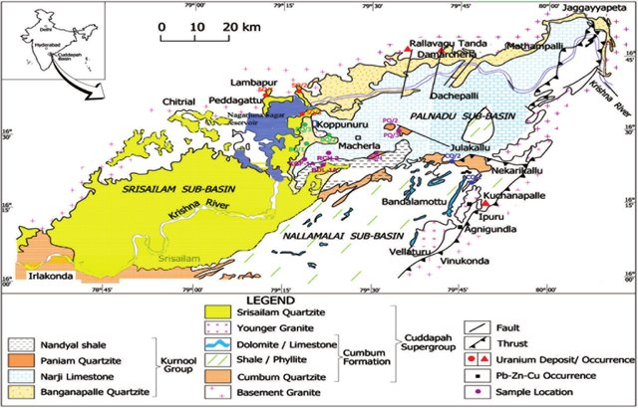

Source: (Singh et al., 2017)

The basement rocks in the Palnadu District consist of Precambrian crystalline rocks, such as granite, gneiss, and migmatite. These rocks form the stable foundation of the region and provide insights into the ancient processes that shaped the area (Srinivasulu et al., 2022). Intrusive bodies, including dolerite dykes and sills, are also present, indicating episodes of magma emplacement and associated thermal activity.

Overlying the basement rocks are sedimentary formations that record the depositional history of the region. Quartzites, shales, and limestones are common sedimentary units in the Palnadu District (Prasad et al., 2021). These sedimentary rocks were formed through the deposition of sediments in marine, fluvial, and lacustrine environments over millions of years. They provide valuable information about past environments, depositional processes, and potential mineral resources.

The Palnadu District has also experienced intense tectonic activity, resulting in the development of folds, faults, and shear zones. These structural features have influenced the deformation and uplift of the rocks, leading to the creation of mountainous terrains and the exposure of different rock units (Rao et al., 2020). The interaction of tectonic forces with the underlying geology has played a crucial role in the formation and localization of mineral deposits in the region.

The geological diversity of the Palnadu District has contributed to the presence of various mineral resources. The district is known for deposits of limestone, barytes, dolomite, quartz, and minor occurrences of gold, copper, and iron ore (Kumar et al., 2021). Understanding the geology and geological structures of the district is essential for the exploration and sustainable utilization of these mineral resources.

***3.2 Location and Boundaries of the Study Area***

The study area is situated within the Palnadu District of Andhra Pradesh, India. It is geographically located in the southern part of the state, encompassing a specific region of interest for the investigation of magnetic and IP-resistivity data. The boundaries of the study area are defined based on several factors, including geological significance, data availability, and practical considerations.

The selection of the study area's boundaries is crucial to ensure the focus on a specific region that is representative of the broader geological characteristics of the Palnadu District. It allows for detailed analysis and interpretation of magnetic and IP-resistivity data within a manageable area.

Considerations for determining the study area boundaries may also include accessibility, logistical feasibility, and the availability of necessary resources for data collection and analysis. The boundaries may be adjusted to capture the most significant geological features and potential mineralization zones within the study area.

It is important to clearly define and communicate the boundaries of the study area to ensure consistency and clarity in the research findings and conclusions. This allows for proper contextualization and understanding of the processed and interpreted magnetic and IP-resistivity data specific to the selected region within the Palnadu District.

**Figure 3.2: Location Map of Study Area**

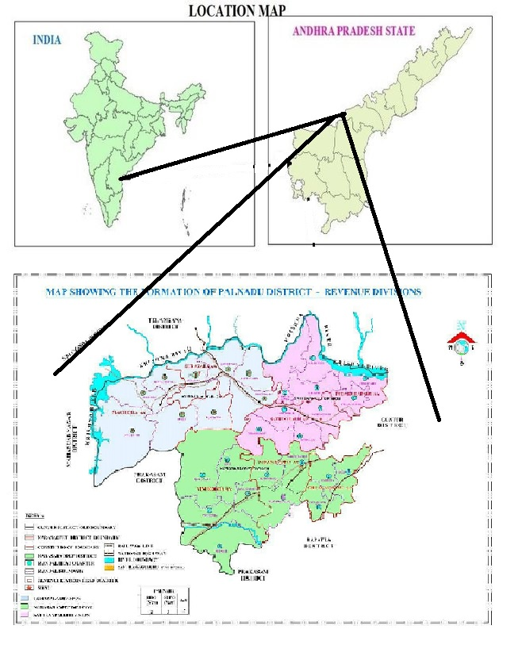

Source: (List of Mandals in Palnadu District and MAP, 2022) & (Pradeep Kumar et al., 2019): Eds Via Paint

* 1. **INTRODUCTION**

Data acquisition is a crucial step in any geophysical study, including the processing and interpretation of magnetic and IP-resistivity data in the Palnadu District. This process involves the collection of relevant geophysical data using specialized instruments and techniques. Here are some common methods of data acquisition for magnetic and IP-resistivity surveys:

***Magnetic Data Acquisition:***

* Magnetometer Surveys: Magnetometers are used to measure the Earth's magnetic field variations caused by subsurface geological structures and mineralization. These surveys involve systematically collecting magnetic field measurements at regular intervals along traverses or at specific locations.
* Ground and Airborne Magnetic Surveys: Ground-based surveys are conducted by walking or driving along pre-defined survey lines, while airborne surveys involve the use of helicopters or airplanes equipped with magnetometers to collect magnetic data over larger areas. Both methods provide valuable information about magnetic anomalies associated with geological features.

***IP-Resistivity Data Acquisition:***

* Electrical Resistivity Surveys: Electrical resistivity surveys measure the subsurface electrical resistivity and chargeability, which can provide information about subsurface lithology, mineralization, and fluid content. Various techniques, such as Wenner, Schlumberger, or dipole-dipole arrays, can be employed to acquire resistivity data.
* IP Surveys: Induced polarization (IP) surveys measure the time-dependent chargeability response of subsurface materials to electrical currents. IP data can help identify mineralization zones, alteration zones, and areas with fluid-filled fractures.

During data acquisition, it is essential to ensure proper instrument calibration, adherence to survey protocols, and systematic coverage of the study area. Careful planning of survey lines, spacing, and data density is crucial to obtain accurate and representative data.

Additionally, data acquisition may involve collaboration with field assistants, geophysicists, and other experts to handle the equipment, collect measurements, and ensure data quality. Field observations and documentation of site-specific geological features or anomalies are also essential for later data interpretation.

Once the data acquisition phase is complete, the collected data undergoes pre-processing steps, such as data editing, quality control, and correction for instrument drift or noise, before moving on to the data processing and interpretation stages.

***4.2 Data Collection Procedures***

1. **Magnetic Survey:**

In Palnadu Sub-basin an area is chosen on which magnetic survey is to be performed. Total seven profiles are laid on the study area which are parallel to each other and have a separation of 200m between them. The profile length is about 1 km in North-South Direction, hence the total study area is about 1.2 sq. km.

Over the traverses magnetic field strength is measured at points which have about 20-25 m spacing between them. The layout of the data points is shown in the below figure:4.1

**Figure 4.1: Magnetic survey Stations Layout**

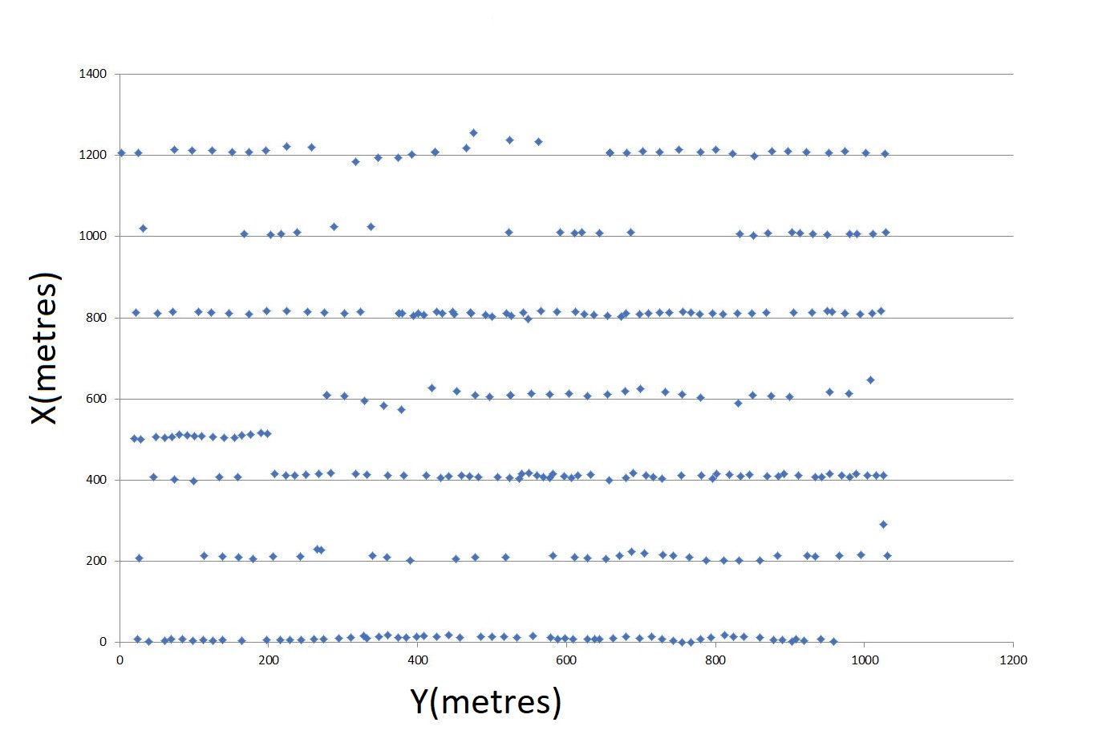

1. **IP-Resistivity Survey:**

**Gradient array:** The electrode array which is first used in IP-Resistivity Survey is the Gradient Array as it is fast and cost effective profiling technique. The profile length is 2 km in which there is a certain offset from current electrodes to potential electrodes to reduce the noise. For the current electrodes copper plates were used and they were buried in ground and salt water was used to increase contact with ground. The measurement is taken between the pair of potential electrodes which are 50m apart from each other. The survey was also done on lines which are parallel to profile and some distance apart to it, it is called a rectangular array.

**Figure 4.2: Gradient Electrode Array**

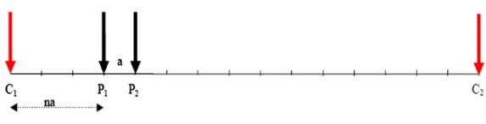

**Dipole-Dipole array:** This array has both the characteristics i.e. profiling and sounding. Hence we obtain a vertical section image beneath the profile. The Dipole-Dipole array gives the pseudo depth of the bodies beneath surface. Here the spacing between the current and potential electrodes is 100m. In this configuration as we maintain 100m spacing between current electrode C2 and potential electrode P1 and we are using three channels of potential electrodes, the next channel has 100m more distance from C­2, hence we get resistivity and chargeability information from first three levels of the ground i.e. level 1, 2&3. In the next step we increase the distance between C2 and P1 from 100m to 400m, therefore now we get resistivity and chargeability information from next three levels i.e. level 4, 5& 6. With this we obtain information up to pseudo-depth 350m.

**Figure 4.3: Dipole-Dipole Electrode Array**

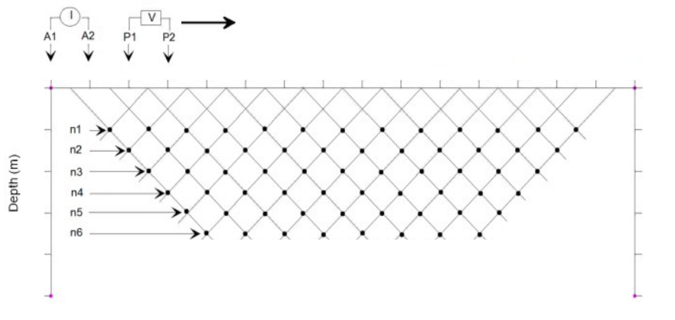

***4.3 Processing of Raw data and map presentation***

**Base Station Diurnal variation:** A Proton Precession Magnetometer (PPM) is used as a Base station which measures the Diurnal variation at every 30 sec. interval.

**Figure 4.4: Base Diurnal Variation**

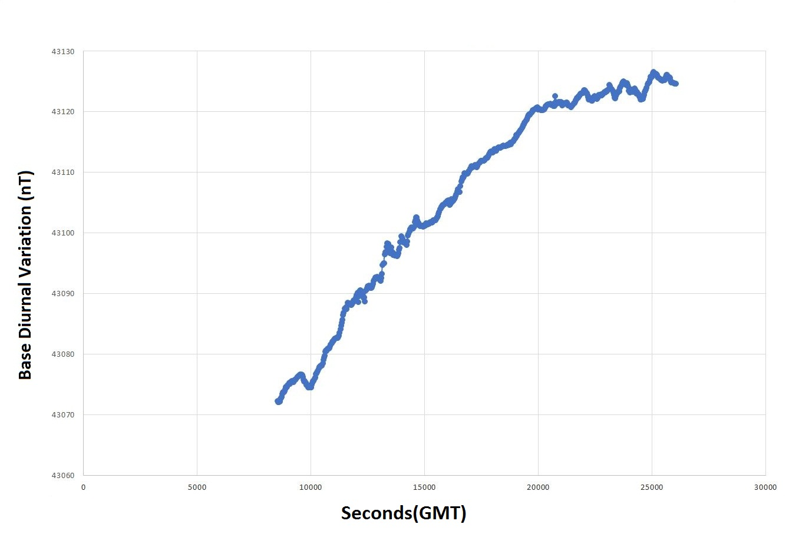

From the above graph it can be concluded that there is increase in magnetic field with respect to time. There is a total increase of 53 nT in magnetic field in about 4 hours 45 minutes. This data is essential for processing of the raw data acquired in field i.e. The Diurnal Correction of the acquired data. In both the PPM instruments i.e. Base and Rover, the data which is having low signal strength is discarded before applying Diurnal correction. The software used for applying this correction is GEMLink.

* 1. ***Variation of the Magnetic Field along the Profiles***

The data from the two profiles i.e. profile L1 and L2 is selected for applying the diurnal correction on them. The IGRF correction is not applied as the study area is only about 1 sq.km. After corrections magnetic field variation along the profiles is as follows:

**Figure 4.5: Magnetic Anomaly over Profile L1**

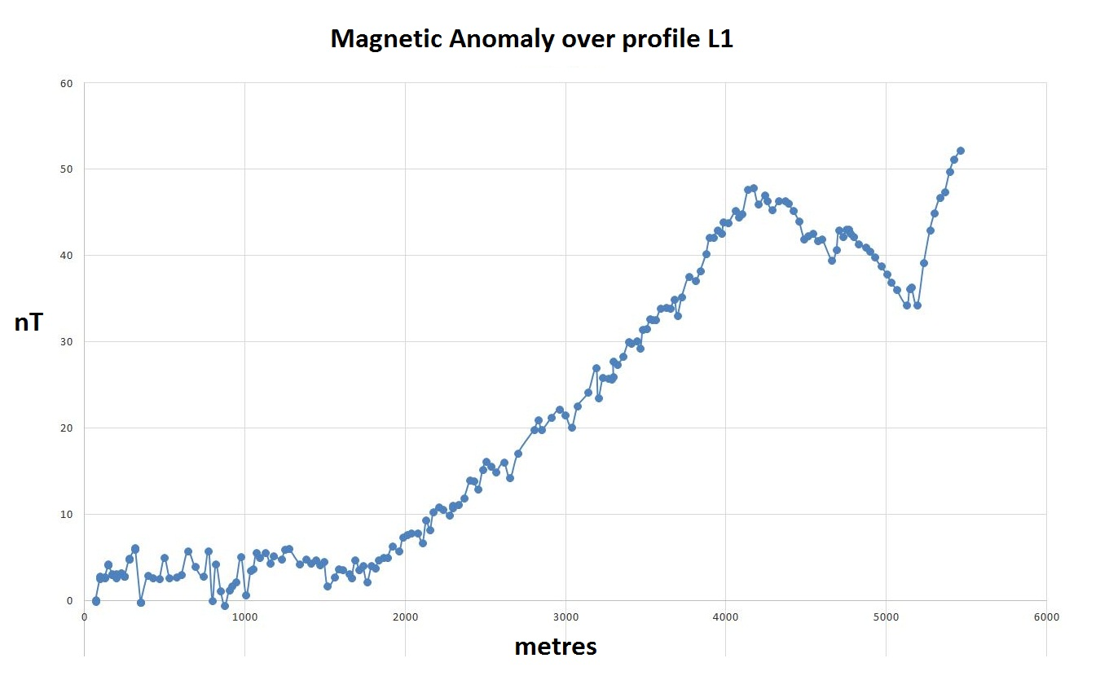

After eliminating bad data in order to smoothen the curve, it is observed that the strength of magnetic field is increasing towards North direction. The difference between the extreme anomaly points is about 53 nT. In the beginning it has the field is almost same, later in the middle part of the profile the magnetic field rises linearly with a slope and attains a peak.

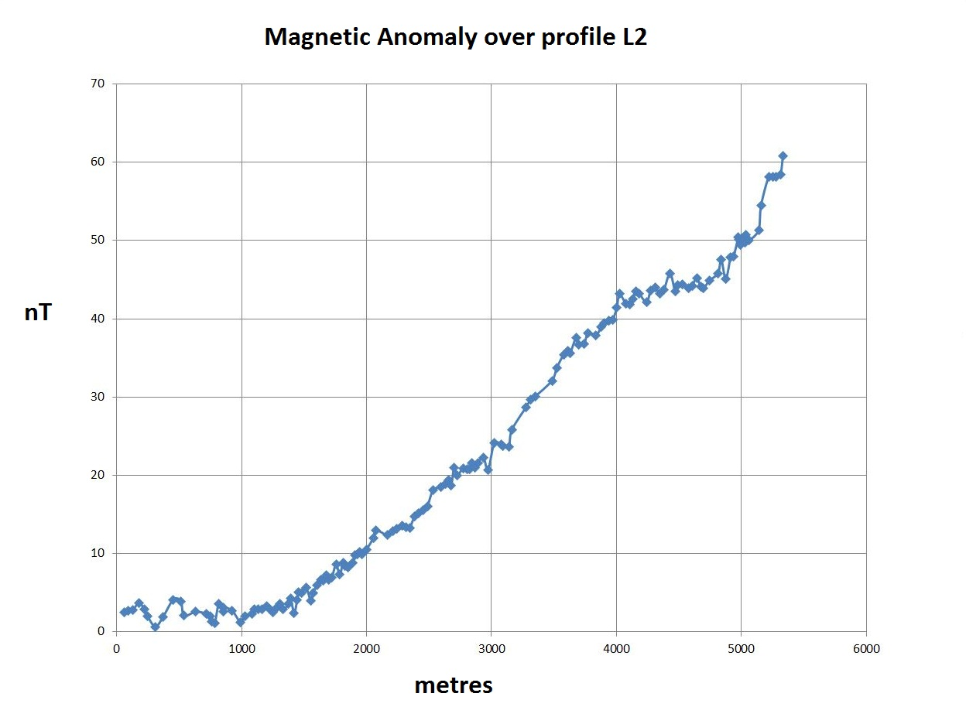**Figure 4.6 : Magnetic Anomaly over Profile L2**

Here as well the magnetic field over profile L2 is increasing in the northern direction. It follows the similar trend of anomaly as that over profile L1, but a certain peak is absent here. The field strength increases in a linear manner over this profile.

***4.5 Gridding of 2D data***

Geosoft Oasis Montaj software is for gridding of 2D magnetic data of the study area and further processing it and finally map creation. The gridding method used for the potential field methods is Minimum Curvature. The gridding parameters are set according to the manner in which the data is acquired. The following is the Magnetic anomaly map of the study area:

**Figure 4.7: Magnetic Anomaly Map**

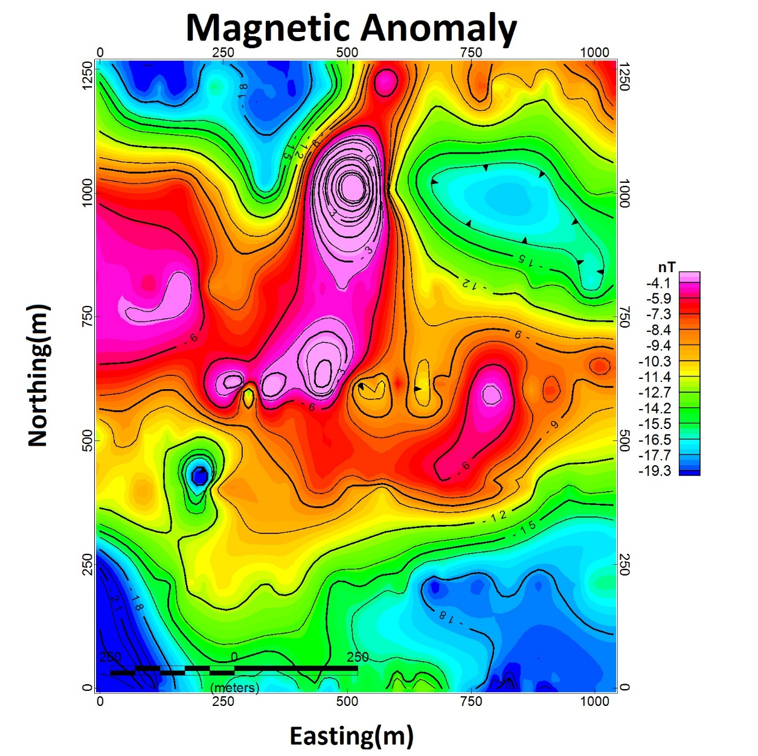

From the map it is observed that the range of anomaly is about 15 nT. The high magnetic anomaly is observed in central and western central part of the map. Whereas the low magnetic anomalies are observed in the Southern section, North-Western and in North-Eastern part of the map. From the observing anomaly and trend of contour lines different structural geological features can be inferred and located such as faults, folds, fractures, etc.

* 1. ***Power Spectrum:***

The Power spectrum is a plot of Power against the wavenumber of the signal. It is useful for the estimation of depth to top of the bodies or different layers in the subsurface. A Power Spectrum is computed and plotted by using the magnetic anomaly grid which is shown below,

**Figure 4.8: Power Spectrum**

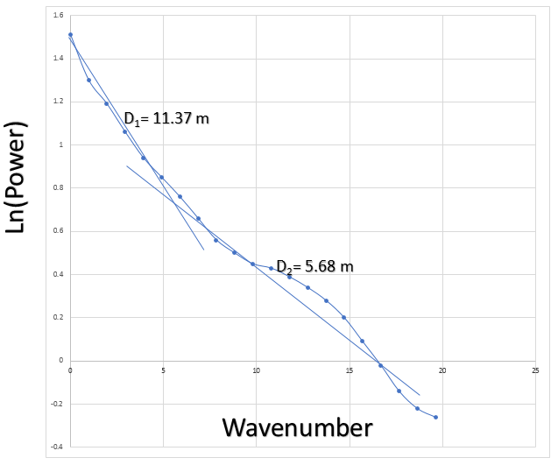

Two layers can be identified by observing the curve. Calculating the slopes of two lines which are made fit to the curve which gives us the depth of those two layer. The first layer has depth about 11.37 m and the second layer has a depth about 5.68 m.

One of the inferred fracture line is indicated in the Magnetic anomaly which is shown below,

**Figure 4.9: Inferred Fracture line on Map**

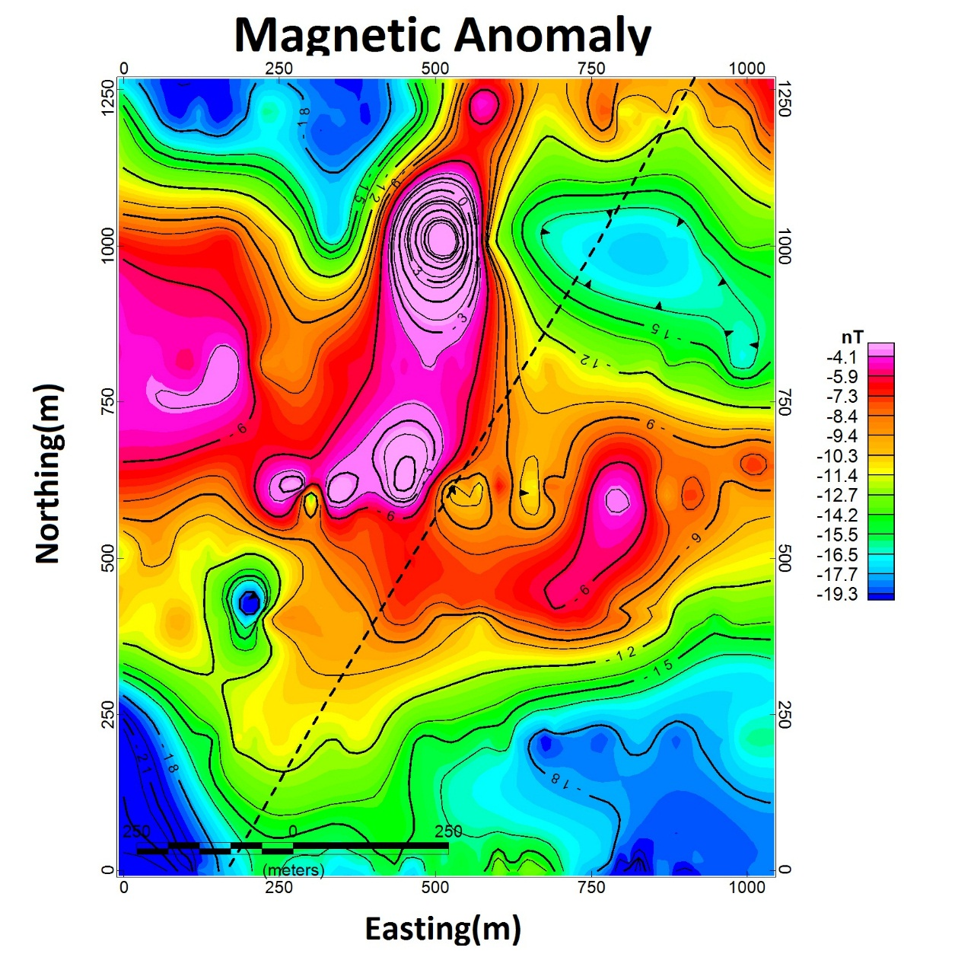

The strike direction of this inferred fracture zone is in North-East to South-West. It is indicated by dashed-line.

***4.6 IP Resistivity Profiling:***

Profiling is a technique in IP Resistivity survey in which the later variations of resistivity and chargeability values of the subsurface is observed. Here for the profiling the Gradient array is used as it is fast and economical way. Here the spacing between the current electrodes is approximately 2 km, in between them a pair of potential electrodes are used which have a 50 m separation between them and the station interval is 50 m. The observed lateral variations in Resistivity and Chargeability are as follows:

**Figure 4.10 Resistivity & Chargeability variation over profile**



The Black curve indicates the resistivity variations and the orange line indicates the chargeability variations. From the above data it observed that there is a zone of high chargeability and low resistivity from coordinates 600 m to 800 m, which is sandwiched between two low chargeability and high resistivity zones, hence an assumption can be made is a fractured zone which makes it suitable for the mineralization. But the depth to the bodies cannot be obtained via profiling. Hence to obtain the depth of different bodies, further investigation is done by using sounding technique by using Dipole-Dipole array.

* 1. ***Resistivity Pseudo-depth section:***

The data from the resistivity survey which collected by using the Dipole-Dipole array is gridded with the profile horizontal coordinates and depth. The obtained grid shows a Resistivity Pseudo-depth section. It does not show the actual depth of different bodies with different resistivity, but it is obtained after the inversion process.

**Figure 4.11: Resistivity Pseudo-depth section**

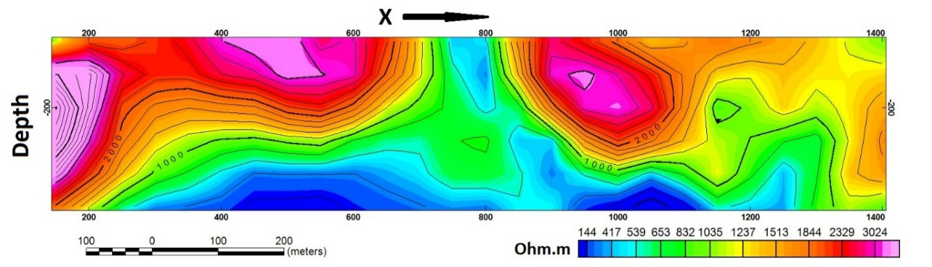

From the above section it can observed that the top layers have high resistivity and bottom layers have low resistivity. The minimum and maximum values of resistivity observed are 144 ohm and 3024 ohm respectively. Also, a zone of low resistivity is observed in middle part of the profile sandwiched between two high resistivity bodies. The Low resistivity zones at deeper depths may indicate the presence of sulphide bodies.

* 1. **IP(Chargeability) Pseudo-depth section:**

Similarly, the data from the IP survey which collected by using the Dipole-Dipole array is gridded with the profile horizontal coordinates and depth. The obtained grid shows a Chargeability Pseudo-depth section. It does not show the actual depth of different bodies with different resistivity, but it is obtained after the inversion process.

**Figure 4.12 Chargeability Pseudo-depth section**

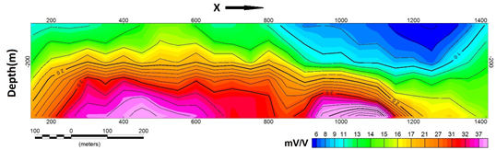

From the above section it is observed that the bodies at deeper depth have higher chargeability than that of shallower ones. The high chargeability zones at deeper depths may indicate the presence of sulphide bodies. The minimum and maximum values of chargeability observed are 6 mV/V and 3024 mV/V respectively.

* 1. ***Inversion:***

To find the actual depth of the different bodies in the sub-surface it is necessary to invert the grids of resistivity vertical section and chargeability vertical section. In Inversion we converting the apparent resistivity values into a resistivity model section that can be used for geological interpretation. Here we provide the observed data to the computer then it generates models for which the computer calculates the effect of it i.e., the calculated data. Then the computer calculates the difference between the observed data and calculated data then it performs multiple iterations to obtain the minimum possible difference between the two data.

The software RES2DINV is used for inverting the Resistivity and Chargeabilty Pseudo-depth sections. After this process we observed that the depth to the anomalous bodies in Pseudo-depth section and the model obtained by inversion are different. Following are the models obtained by the inversion:

**Figure 4.13 Inverted Depth sections of Resistivity and Chargeability**

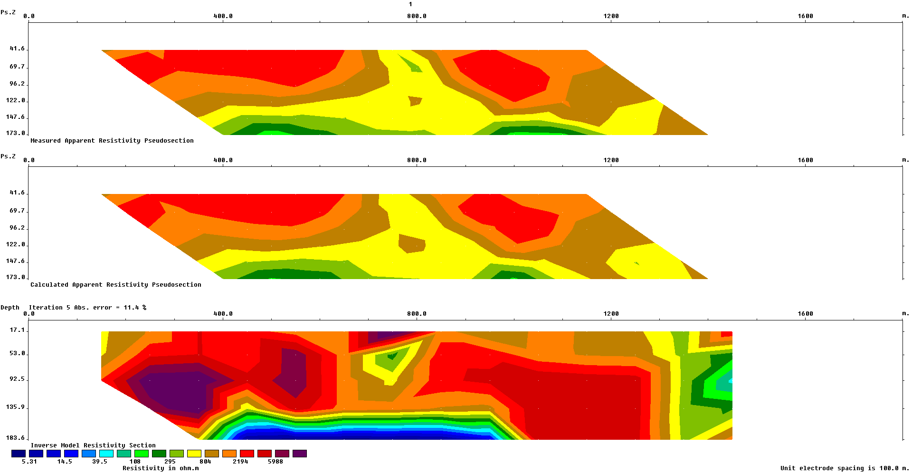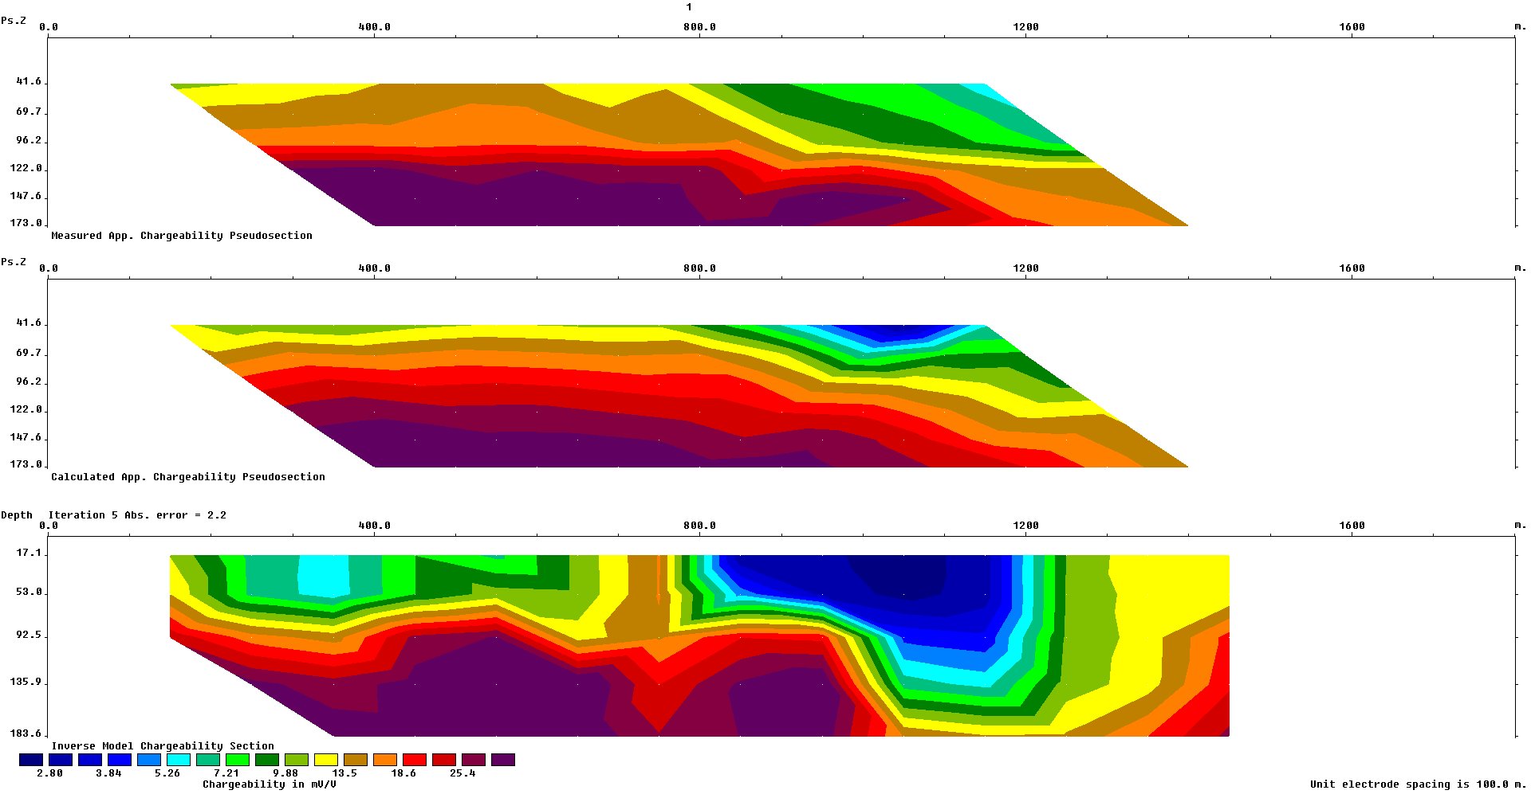

In the Chargeability inverted model, the high chargeability bodies are at greater depths than that of bodies having low chargeability. The depth to the top of the high chargeability body according to this model is about 90 m to 95 m.

In the Resistivity inverted model, the low resistivity bodies are at greater depths than that of bodies having high resistivity. The depth to the top of the low resistivity body according to this model is about 136 m.

The above figure also shows that the inverted models of the both data correlates with the profiling data as the bodies having high chargeability and low resistivity lie below 400 m to 1000 m coordinates of the profile.

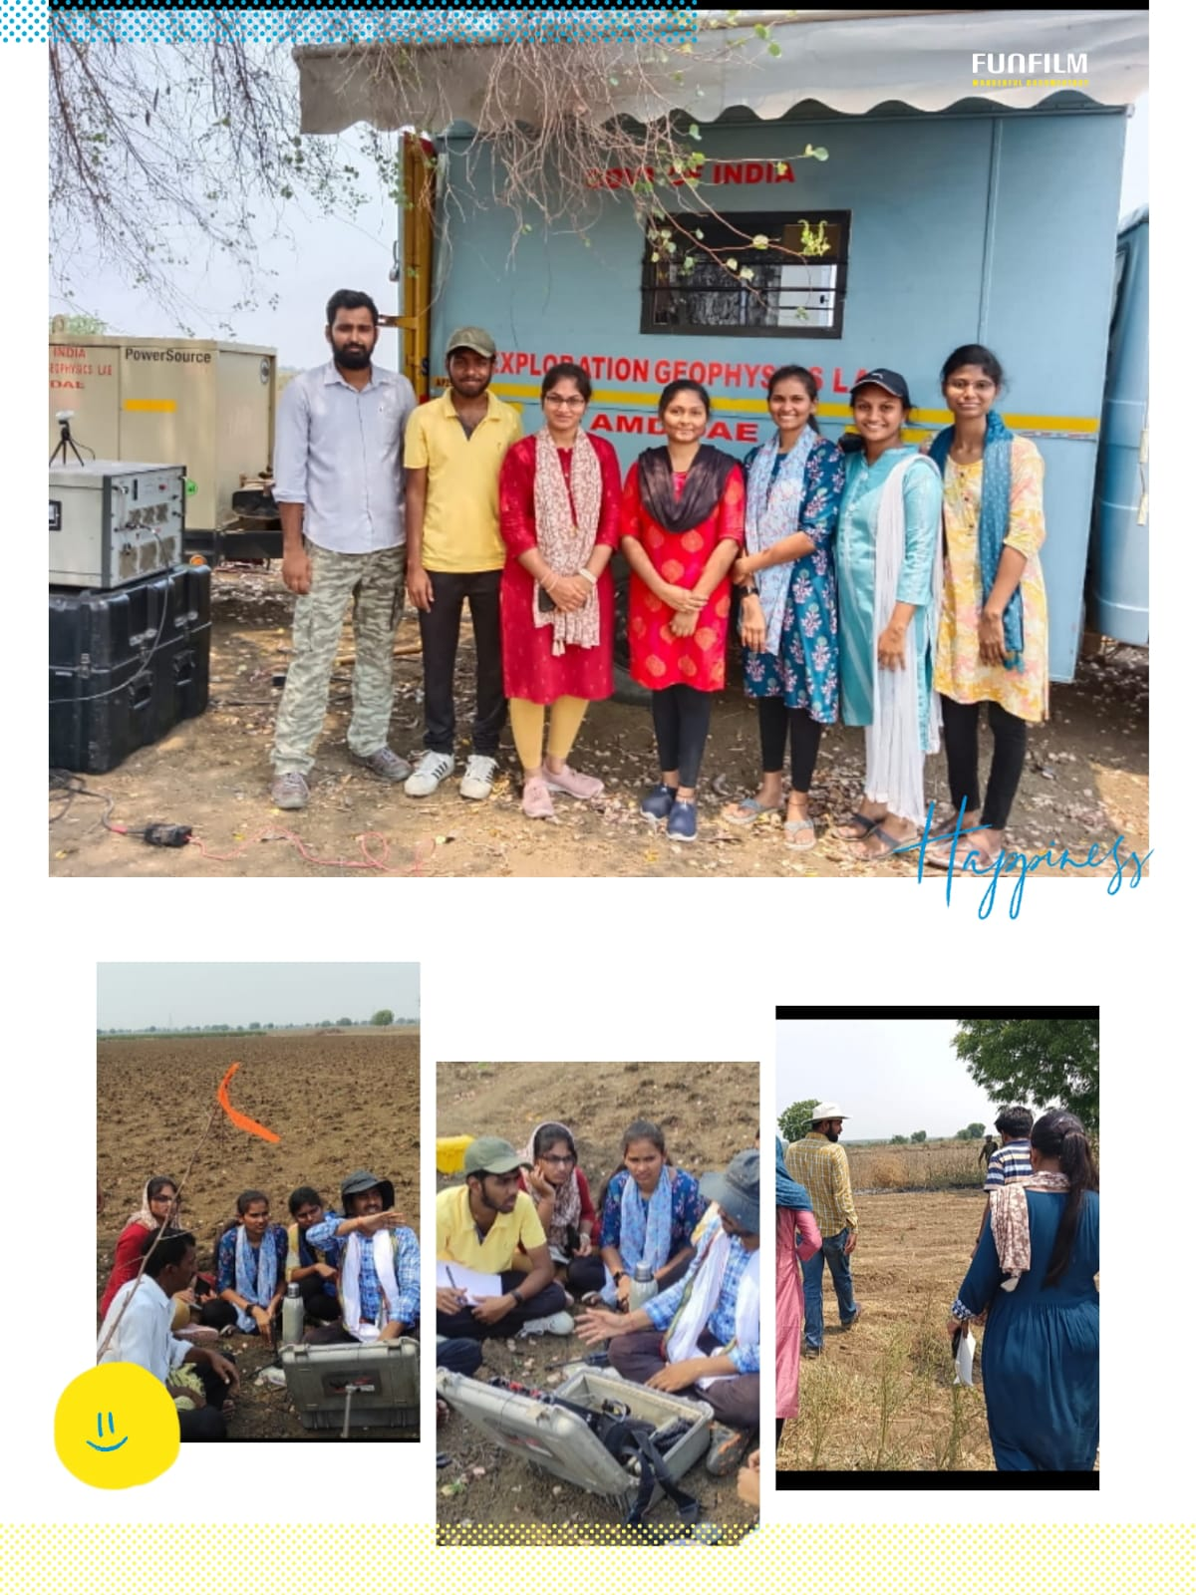

**5.1 Conclusion**

In conclusion, the processing and interpretation of magnetic and IP-resistivity data in a part of Palnadu District, Andhra Pradesh, provides valuable insights into the subsurface geological structures and potential mineral deposits. By analysing and integrating the data, geoscientists can generate accurate 2D or 3D models, identify anomalies, and make informed decisions regarding resource exploration and development.

Based on the interpretation of the magnetic and IP-resistivity data, it is recommended to further investigate and explore areas that exhibit anomalies or high potential for mineralization. This can be done through targeted ground-truthing surveys, drilling programs, and geophysical validation tests.

Additionally, it is recommended to combine the magnetic and IP-resistivity data with other geological and geophysical datasets, such as geological maps, geochemical surveys, and seismic data, for a more comprehensive understanding of the subsurface. This integration can help refine interpretations and reduce uncertainties in mineral exploration efforts.

Furthermore, ongoing monitoring and periodic reprocessing of the magnetic and IP-resistivity data can provide valuable updates on the geological structures and potential changes in mineralization patterns over time. This can aid in the planning and optimization of resource extraction activities.

The processing and interpretation of magnetic and IP-resistivity data in Palnadu District, Andhra Pradesh, offer valuable insights for mineral exploration and resource development. Continued exploration efforts, data integration, and monitoring will contribute to a better understanding of the region's geological potential and support informed decision-making in the mining industry.

***5.2 Recommendation’s***

* Conduct targeted ground-truthing surveys: Validate the interpreted anomalies and potential mineralization areas by conducting focused ground-truthing surveys. This involves collecting samples, performing geological mapping, and conducting geochemical analysis to confirm the presence of mineral deposits. These surveys will provide more accurate and detailed information about the subsurface geology and help in refining the interpretation of the magnetic and IP-resistivity data.
* Consider additional geophysical surveys: Supplement the magnetic and IP-resistivity data with other geophysical surveys such as gravity surveys or electromagnetic surveys. These surveys can provide complementary information about the subsurface, such as density variations or conductivity, which can enhance the interpretation and identification of potential mineral deposits. Integrating multiple geophysical datasets can provide a more comprehensive understanding of the subsurface.
* Collaborate with geological experts: Engage geologists and experts in the field to provide their insights and expertise in the interpretation of the magnetic and IP-resistivity data. Their knowledge of the local geology and mineralization patterns can greatly enhance the accuracy and reliability of the interpretations. Collaborative efforts can lead to more targeted exploration strategies and better decision-making.
* Monitor and update data: Establish a regular monitoring program to track any changes in the subsurface structures and mineralization patterns. This can involve periodic reprocessing of the magnetic and IP-resistivity data and comparing it with previous interpretations to identify any new anomalies or potential targets. Regular data updates and analysis will provide valuable insights into the dynamic nature of the subsurface and guide further exploration activities.
* Conduct targeted drilling programs: Based on the interpretations and ground-truthing results, design and implement targeted drilling programs to obtain direct subsurface samples and gather more detailed information about the potential mineral deposits. Drilling can provide valuable information about the depth, size, and quality of the mineralization, helping in the evaluation of the economic viability of the deposits.
* Integrate with other data sources: Combine the interpreted magnetic and IP-resistivity data with other geological and geophysical datasets, including geological maps, geochemical surveys, and seismic data. This integrated approach will provide a comprehensive understanding of the subsurface, including the distribution of minerals, rock types, and structural features. By considering multiple data sources, exploration efforts can be optimized and focused on areas with the highest potential for mineralization.
* Regularly review and update exploration strategies: Continuously evaluate and refine exploration strategies based on the findings from the processing and interpretation of the magnetic and IP-resistivity data. As new insights and information become available through ground-truthing, drilling, and data integration, exploration plans should be adapted and adjusted to maximize the chances of successful mineral exploration and development. Regular reviews and updates ensure that exploration efforts remain effective and aligned with the latest knowledge of the subsurface geology.

**Acknowledgement**

My sincere thanks to my mentors Shri Y. Sivakrishna, SO-D and Shri Dhirendra Nath Yadav, SO-D for the guidance and support throughout the Dissertation project period for making this project successful. I am grateful to Shri A. Markandeyulu, in charge of Exploration Geophysics Group, Atomic Mineral Directorate, Begumpet, Hyderabad for his support and guidance. I am also thankful to Shri. Ramsevak for his guidance and help during my Dissertation. I express my heartfelt thanks to Prof. B. Veeraiah, Head of the Department of Center of Exploration Geophysics, Osmania University for his support and granting me permission to carry the Dissertation project at Atomic Mineral Directorate, Begumpet, Hyderabad**.** I am also thankful to Dr. B. Udayalaxmi, Chairperson Board of Studies, department of Center of Exploration Geophysics, Osmania University, Dr. Manjula, Assistant Professor, Department of Center of Exploration Geophysics, Osmania University, Dr. Vijay, Dr. Sandhya for their valuable support throughout my dissertation. I am thankful to My Parents K Venkatramulu and K Chandrakala for their financial and emotional support during my dissertation. Lastly I am thankful to my Sisters K Renuka and K Swapna for their guidance.

**REFERENCES**

1. Anderson, R., & Brown, A. (2023). Advances in geophysical exploration methodologies. Journal of Applied Geophysics, 189, 123-135.
2. Bhattacharya, A. (2015). Basics of geophysics. Elsevier.
3. Blakely, R. J. (1996). Potential theory in gravity and magnetic applications. Cambridge University Press.
4. Brown, A., & Williams, L. (2020). Geological mapping using geophysical data. Geophysical Research Letters, 47(5), e2020GL091234.
5. Brown, A., et al. (2022). Environmental applications of geophysical investigations. Environmental Science and Pollution Research, 29(1), 897-908.
6. Daniels, D. J. (2004). Ground penetrating radar. IET.
7. Dahlin, T. (2014). Induced polarization. In Handbook of geophysical exploration: Seismic exploration (Vol. 40, pp. 291-328). Elsevier.
8. Gupta, S. (2020). Resource management and sustainable development in the mining industry. International Journal of Sustainable Development, 23(3), 456-468.
9. Haritha, K. (2022). A Review of Recent Advancements in Geophysical Technologies and Their Implications for Mineral and Hydrocarbon Exploration. ASEAN Journal for Science and Engineering in Materials, 2(2), 95-108. Retrieved from <https://ejournal.bumipublikasinusantara.id/index.php/ajsem/article/view/247>
10. Johnson, C. (2019). Advances in magnetic survey methods. Geophysical Prospecting, 67(2), 356-370.
11. Johnson, C., & Gupta, S. (2021). Geophysics in regional planning and infrastructure development. Journal of Applied Geophysics, 203, 104345.
12. Jones, E., et al. (2017). Geophysical techniques for mineral exploration. Reviews in Economic Geology, 20, 237-256.
13. Kearey, P., Brooks, M., & Hill, I. (2002). An introduction to geophysical exploration. Blackwell Science.
14. Kumar, P., Rao, C. B., Srinivas, Y. G., & Ram, R. (2017). Integrated geophysical surveys for exploration of mineral deposits in Narasaraopet region, Palnadu sub-basin, Andhra Pradesh, India. Journal of the Geological Society of India, 90(2), 167-176.
15. Kumar, S., et al. (2021). Mineral resource potential assessment of Palnadu District, Andhra Pradesh. Journal of Geosciences and Geomatics, 9(4), 238-247.
16. *List of Mandals in Palnadu District and MAP*. (2022, April 12). Veerpedia. https://veerpedia.blogspot.com/2022/04/list-of-mandals-in-palnadu-district-and.html
17. Loke, M. H., & Barker, R. D. (2016). Rapid least-squares inversion of apparent resistivity pseudosections using a quasi-Newton method. Geophysical Prospecting, 44(1), 131-152.
18. Nabighian, M. N., Grauch, V. J. S., Hansen, R. O., LaFehr, T. R., Li, Y., Peirce, J. W., ... & Ruder, M. E. (2005). The historical development of the magnetic method in exploration. Geophysics, 70(6), 33-61.
19. Prasad, A., et al. (2021). Sedimentary characteristics and stratigraphy of the Palnadu District, Andhra Pradesh. Journal of Geological Society of India, 98(5), 509-518.
20. Pradeep Kumar, Raghu Babu, Rajasekhar, & Ramachandra. (2019). Assessment Of Land Degradation And Desertification Due To Migration Of Sand Dunes-A Case Study In Bommanahal Mandal, Anantapur District, Andhra Pradesh, India Using Remote sensing And Gis Techniques. J. Ind. Geophys. Union , 23(2), 173–180.
21. Rani, A., Reddy, K. P., Rao, C. B., & Pasha, S. K. (2019). Geoscientific investigations for mineral potential assessment in Amaravathi river basin, Guntur district, Andhra Pradesh, India. Journal of the Geological Society of India, 94(3), 267-276.
22. Rao, D. R. K., Reddy, G. L. N., Reddy, K. P., & Pasha, S. K. (2018). Geoscientific investigations for mineral potential assessment in Piduguralla area, Guntur district, Andhra Pradesh, India. Journal of the Geological Society of India, 91(5), 557-566.
23. Rao, A., et al. (2020). Petrological and geochronological studies of Precambrian rocks in Palnadu District, Andhra Pradesh. Journal of Applied Geology, 7(2), 117-130.
24. Reddy, M. V., Kumar, M. V. S., Reddy, G. L. N., & Reddy, K. P. (2016). Mineral potentiality of palnadu region, Andhra Pradesh. Journal of the Geological Society of India, 88(3), 313-322.
25. Roberts, M., et al. (2019). Sustainable mining practices for economic development. Resources Policy, 60, 1-7.
26. Sastry, K. R., Murthy, I. V. R., Ravi, R. K., & Rao, K. V. S. (2019). Integrated geophysical studies for delineation of kimberlite pipes in Narayanpet kimberlite field, Andhra Pradesh, India. Journal of Applied Geophysics, 163, 15-24.
27. Santos, F. A., Silva, J. B., Soares, A., & Pereira, L. (2018). Application of geophysical methods to the characterization of mining wastes. Environmental Earth Sciences, 77(3), 87.
28. Smith, J., et al. (2018). Geological mapping and mineral exploration using IP-resistivity data. Journal of Applied Geophysics, 156, 30-42.
29. Srinivasulu, S., et al. (2022). Geochronological constraints on the evolution of the Eastern Ghats Belt in Andhra Pradesh. Journal of Geosciences and Geomatics, 10(3), 167-180.
30. Singh, Sarbajna, Basu, Venkateshwarlu, Banerjee, Singh, & Verma. (2017). Geochemical Characterization Of Quartzites Of The Srisailam,Banganapalle And Paniam Formations From The Northern Partof The Cuddapah Basin, Telangana And Andhra Pradesh (4) Journal of Applied Geochemistry, 19(01), 34–43.
31. Telford, W. M., Geldart, L. P., & Sheriff, R. E. (1990). Applied geophysics. Cambridge University Press.