INTEGRATED FARMING SYSTEM: NEED OF THE SCENARIO
Alok Kumar Singh, Nasam Midhun Kumar*
Department Silviculture and Agroforestry, Dr. Yashwant Singh Parmar University of Horticulture and Forestry, Solan, Himachal Pradesh- 173230
Introduction
Integrated Farming System (IFS) refers to a harmonious amalgamation of diverse farm enterprises and strategies accessible to farmers to enhance their profitability. This approach not only upholds a delicate ecological equilibrium but also preserves the synergy between ecology and socio-economics. Furthermore, IFS strives to align its objectives with national aspirations. Essentially, this approach plays a pivotal role in bolstering a nation's agricultural economy and elevating the living standards of its farming community as a cohesive unit. Various definitions shed light on the concept:
According to Lal and Miller (1990), Integrated Farming System is a prudent resource management strategy that seeks to attain sustainable and economically viable agricultural production. This strategy caters to the multifaceted requirements of farm livelihoods while safeguarding natural resources and upholding environmental quality. In the words of Sharma et al. (1991), a Farming System represents an interconnected network of diverse agricultural and economic activities within a specific agricultural context. This assemblage comprises an assortment of farm pursuits where farming families channel their resources to optimize established initiatives, enhancing both the profitability and efficiency of the farm. This assortment encompasses agriculture, dairy, aquaculture, agro-horticulture, livestock, and agro-forestry. Integrated Farming, as described by Jayanthi et al. (2002), entails the fusion of various farming components, encompassing cropping systems for horticulture, livestock, fisheries, forestry, and poultry. It encompasses diverse strategies through which farmers can augment their productivity. This integrated approach operates in symbiotic concert with nature and the environment, adeptly maintaining socio-economic and ecological equilibrium while concurrently fulfilling national objectives.
Specialized v/s Integrated Farming system
- Specialized Farming System (SFS): Specialization includes the intensification of the agricultural activities which seeks to maximize the production per unit area per unit time including the improvement of operational efficiency and upgrading the speed of operation at each level. The specialized farming systems are focused on mono-cropping system or other sequence of farming commodities like animal breeding, dairying etc., so as to attain the maximum value of precision with minimal deviation of resources or attention towards the diverse crops and commodities.
- Integrated Farming System: It is a component of Farming System which brings change in the farming practice for achieving the aim of obtaining the maximum outputs well as taking good care of natural resources. IFS, also, helps in better recycling of the waste produced in the farm. Instead of SFS’s mono-cropping approach, IFS is more focused on a few selected, inter-depending, inter-relating and inter-linking production systems which are based upon a few crops, livestock or other related subsidiary professions. IFS confront harnessing the supportive and co-operative among various agricultural sub-systems or enterprises and in the augmentation of the total productivity, sustainability and in profitable employment.
Key principles
- Cyclic
- Rational
- Ecologically sustainable
Cyclic
The farming systems are fundamentally cyclic (organic resources –> livestock –> land –> crops). Therefore, management decisions taken for one component might have an affect the other.
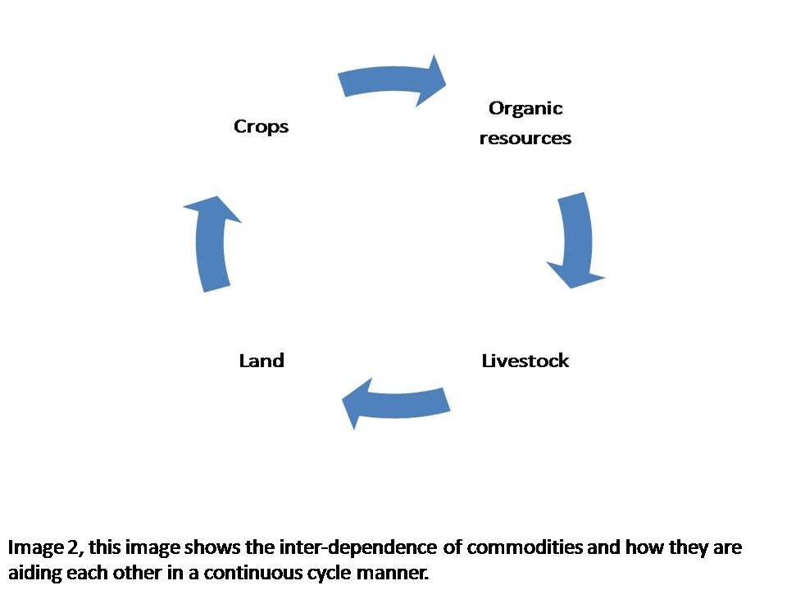
Figure 2: Inter-dependence of commodities in cyclic manner

Rational
An effective way out of poverty is to use the crop residues rationally. The poor farmers, lacking adequate capital, the fair management of crop residues along with an efficient allocation of scarce resources provide them with sustainable production.
Ecological sustainable
Integration the livestock with farming in an IFS, is economically viable and ecological sustainable. This maintains an ecological and economical balance, enhance the agricultural productivity and reduce the negative impact over environment.
Scope of Farming System
- Various farming business include crops, livestock, poultry, fisheries, sericulture etc.
- A careful planning and execution of combining one or more commodities with cropping gives a better income than a single commodity, especially to the farmers who are small and marginal.
- For a fruitful integration of the commodities which are to be integrated with cropping, farm should be considered as one single unit.
Principles of farming system
• Risk management.
• Recycling the wastes and residuals.
• Integrating two or more commodities.
• Rational utilization of resources.
• Maximizing productivity, output and profitability.
• Ecological& Economical balance.
• Generation of potential for employment.
• Improving input use efficiency.
• Usage of end products from one commodity as an input in other.
Factors influencing Integration of Farm Enterprises
- Soil and climatic conditions of the area.
- Easy and convenient availability of the resources, land, capital and handiness of labors.
- Current utilization of resources.
- Economics of the concerned IFS.
- Management skills of farmers.
Benefits or Advantages of Integrated Farming System
- High Productivity
- Highly Profitable
- Potentially sustainable
- Stabilized food
- Embracing the new technologies
- Managing and saving the energy
- Boon in fodder crises
- Solving the problems of fuel and timber
- Environmental safety
- Recycling
- Income generation round the year
- Increasing Employment potential
- Agriculture based industries
- Increased Input efficiencies
Farming System Concept
A farming system has
- INPUTS,
- PROCESSES and
- OUTPUTS
- Variability of the above said processes depends upon the variability of the commodities in the farming.
- Income, alone from the arable farming itself, is insufficient for majority of the small &marginal farmers.
- Including the other systems in the farming such as dairying, poultry, sericulture, fisheries etc. is important in augmenting the farm income of the farmers.
Time and space concept
- Time concept depicts the increase in crop intensification under such situations where there are no limited inputs.
- In the areas, that are rain fed, the possible increase in the cropping intensity is negligible. So, the modern concept i.e. space concept is applied in that areas.
- Space concept depicts the arranging of crops in tier system. In this, two or more crops with different field durations are inter-cropped by some modified panting methods.
- Income, alone from the arable farming itself, is insufficient for majority of the small & marginal farmers. Including the other systems in the farming such as dairying, poultry, sericulture, fisheries, bio-gas production etc. is important in augmenting the farm income of the farmers. It should be well fitted in with the farm infrastructure and should ensure the complete utilization of the bye-products. IFS are the solution of the various problems such as to increase in the food production, to increase the income of farm and to improve the nutritional quality and quantity for small & marginal farmers with the limited amount of resources.
Specific Objectives
- To identify the already existing farming system in specified areas and their access to relative viability.
- To delineate the models of various farming systems including main and allied commodities for varying farming situations.
- To ensure the optimum utilization and conservation of accessible resources and efficacious recycling of residues within the farm in a system.
- To maintain a system productive sustainably without causing any damage to the resources or environment.
Goals of Integrated Farming System
- Providing consistent and stable income.
- To enhance the productivity off-arming system.
- To attain agro-ecological balanceby reducing the proliferation of diseases and pests by means ofmanaging the cropping system naturally and by the reduced use of chemicals (such as herbicides, in-organic fertilizers and pesticides) (Kumar et al. 2018).

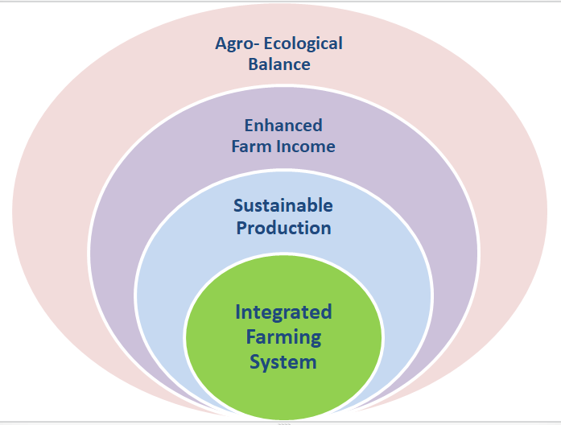
Figure 3: Goals of Integrated Farming System
Objectives of farming system
1. High Productivity – Farming system does provide opportunity to enhance economic yield per unit area per unit time through crop intensification an dallied commodities. The Crop intensification through time concept and building up the vertical dimension through space concept encourages the economic yield in crops and allied commodities.
2. Highly Profitable – Farming systems also provide an opportunity for one commodity to use the bye-product or waste produced from the other commodity as input at a very negligible cost. Therefore, due to the reduction in the cost of production, benefit cost ratio increases and leads to highly profitable system.
3. Potential of sustainability –To achieve the high sustainability, a good soil health is required. But due to the unreasonable usage of agricultural practices viz., using chemicals excessively, intensive farming practices etc., the soil health is being deteriorated and thus so sustainability. But in farming systems use of organic supplements such as manures and recycle of waste is effectively managed which provides a possibility to potentially sustain the production base relatively for a longer time.
4. Balanced & stabilized food – In farming systems, various enterprises are properly combined which leads to the production of different sources of nutritional values named proteins, carbohydrates, vitamins, fats &minerals etc., on the same unit of land, this helps to solve the malnutrition problems prevailing among the small scale and marginal farming households.
5. Environmental safety – The Primary essence of farming systems are to utilize or conserve the by-products or wastes produced in one commodity as an input for another commodity and also using bio-control measures for controlling pests & diseases. These practices are eco-friendly and lessen the application of large quantities of chemicals, which are causing soil water and environmental pollution up to afear some level. Thus, IFS greatly reduces the environmental pollution.
6. Liquid flow round the whole year-IFS, unlike the mono-cropping conventional farming, is enabling the liquid i.e. cash flow round the whole years to the farmers by providing the products for sale from various commodities like eggs from the poultry, milk & other dairy products from dairy, honey from apiculture etc. This enables the increase in power of purchasing of the farmer and also creates an opportunity for them to invest in better and improved technologies ultimately, to enhanced production.
7. Manage and Saves energy –Fossil fuels are being exploited in excess from a better time now. If the exploitation continues with the same pace, there will be a great shortage of them by 2030 AD. Only way to cut this shortage is, adoption of the IFS. In IFS, organic wastes are effectively recycled to produce energy from the bio-gas plants. This mitigates the crisis to some extent.
8. Meeting the fodder crises –Various IFS includes Alley Cropping or crop intensification with the fodder legume crops in it. This leads to the production of the fodder to the required extent and thus, the problems like non availability problems of fodder to various farming components such as livestock get reduced.
9.Aids in timber and fuel crisis –Currently the production of fuel wood and timber wood are 20mm³ and 11mm³ respectively which is very less than the estimated demand of fuel wood(360mm³) & timber wood(64.4mm³). To meet up the demand of woods the production needs to be increased several folds. Adopting agro-forestry practices, performing afforestation programmes,in an IFS, helps in meeting the demand more effectively while conserving our natural ecosystem without any deteriorating effect on the main crop production and will reduce the deforestation as well.
10. Generates Employment –Various farming system and allied commodities significantly increases the requirement of the labours. Thus, IFS aids in employment problems by creating enough potential of employment generation.
11. Scope for establishing of agriculture base industries –When IFS has reached to a potential of commercial level production, this leads to surplus value addition to the farm income which leads to the set up various agriculture based industries.
12. Enhances input use efficiency –An IFSutilizesthe resource ofdifferent components which leads toan enhanced input useefficiency and benefit-cost ratio.
Characteristics of integrated farming system
- Problem solving.
- Holistic Approach.
- Acknowledgement of the location specific solutions of technology.
- Law weight on thetechnological knowledge systems which are native to India.
- Relatedto ‘bottom- up’ research Ideology.
- Law weight on the extensive on- farm practices & it can be repetitive.
- Dynamic &have focus majorly on sustainable production.
Components of integrated farming system
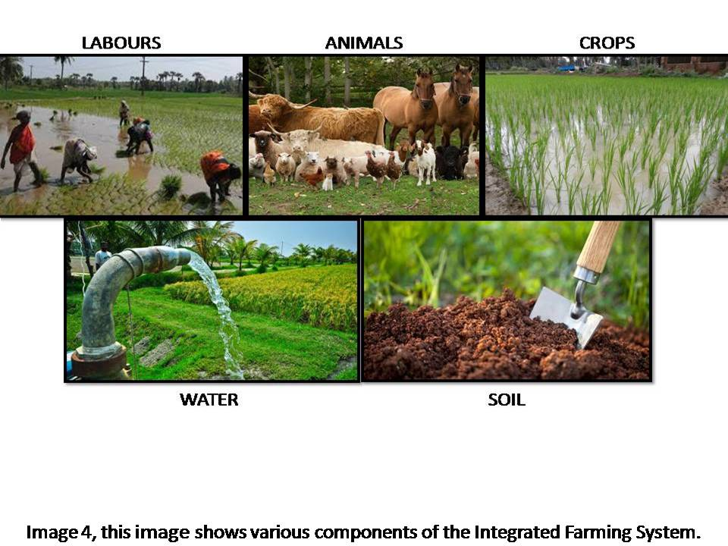
Figure 4: Various components of Integrated Farming System
- Major components are Crops, livestock, labours, birds and trees.
- Crops might have sub-systems like mono-cropping, mixed or inter-cropping, multi-tier cropping of cereals, legumes, oilseeds etc.Livestock components are milch cow, goat, apes, poultry and sheep etc.
- Tree components include timber & fuel wood, fodder trees and fruit trees etc.
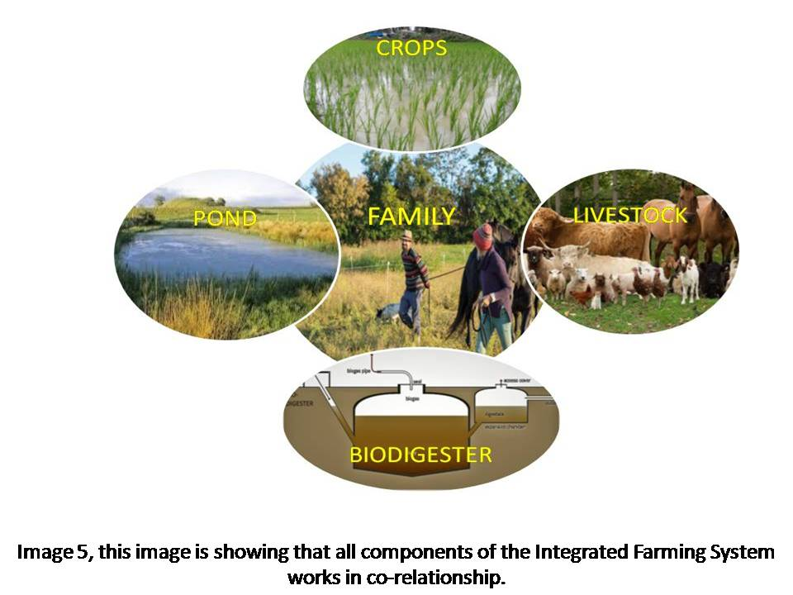
- These all components are inter-related.

Figure 5: Co-relationship between the components of IFS

Farming systems:
Table: 1, various kinds of Farming Systems and their proposed integrated components.
Sr. No | Farming systems | Proposed components
1 | Crop + livestock | Crop + livestock/poultry/apiary/mushroom cultivation/seed production/fishery/horticulture/goatry/duckery/piggery/turkey/silviculture/lac culture/floriculture/agro forestry.
2 | Vegetable +livestock + crop | Olericulture + livestock+horticulture/Silviculture/sheep/rabiatry/apiary/mushroom cultivation.
3 | Silvipasture + livestock | Silviculture + livestock + crop + water management.
4 | Crop + poultry + livestock | Crop + poultry + livestock/fishery/poultry/piggery/horticulture/floriculture/goatry/duckery/rabiatry/apiary/piggery
5 | Fishery + crop +livestock | Fishery + crop + livestock +duckery/poultry/olericulture/horticulture/piggery.
6 | Fish + livestock | Fish + crop + vegetables + livestock + aromatic and medicinal plants
7 | Crop + livestock + agro forestry | Crop + livestock + agro forestry/apiary/goatry/poultry/orchard/floriculture/horticulture/olericulture.
8 | Plantation + Spices | Plantation +poultry spices/livestock/horticulture/multitier/high density Cropping/poultry/plantation + crop/agro forestry/duckery/fishery/piggery.
9 | Agro forestry + forage | Silvipasture + crop + livestock + rain water harvesting
10 | Crop + livestock + horticulture | Crop + livestock +horticulture/goatry/poultry/olericulture/mushroom cultivation/seed production.
11 | Crop + horticulture | Crop + horticulture/goatry/mushroom cultivation/seed production.
12 | Crop + poultry + horticulture | Crop + poultry +horticulture/poultry/olericulture/crop/livestock/aromatic and medicinal plants/fishery/mushroom cultivation.
13 | Fishery + crop + horticulture | Fishery + crop + horticulture/poultry/olericulture/poultry
14 | Horticulture – based | Coconut + spices/crop/livestock/aromatic and medicinal plants.
15 | Livestock – based | Livestock + crop/poultry/olericulture/seed production/spices/goatry/horticulture/silviculture.
1. Suitable grain crops:
Crops should be selected based on the area and type of soil;
Red soil
Pulses: Greengram, Horse gram,Red gram, Cowpea, Soybean
Oilseeds: Castor, Groundnut, Sesame
Millets: Sorghum
Black soil:
Pulses: Horse gram, Red gram,Green gram, Soybean, Black gram, Chickpea
Cereals: Maize
Oilseeds: Safflower, Sunflower
Millets: Pearlmillet, Sorghum
other crops: Chilli, Coriander
2. Suitable forage crops
Red soils
Fodder Pearl millet, fodder ragi, fodder cowpea, fodder cholam, vetiver, marvel grasses, siratro, spear grass,
Black soils
Fodder Pearlmillet, fodder sorghum, desmanthus,fodder cowpea, grassMayilkondaipul, Elusine sp.
- Suitable tree species
Red soils
Hardwickia, Tamarind, Neem, Simarouba, Casuarina, Kodaivel, Ber, Silk cotton, Indian gooseberry, Vagai (Ladies tongue), Acacia tortili, A.melliferaetc.
Black soils
Casuarina, Neem,Chilbil,Hibiscus, Gamhar, Karam (Haldu), Subabool, Karuvel,Acacia albida, A.tortilis.
4. Suitable livestock
Poultry, Goat, Black cattle, White cattle, Sheep, Pigeon, Quail and Rabbit.
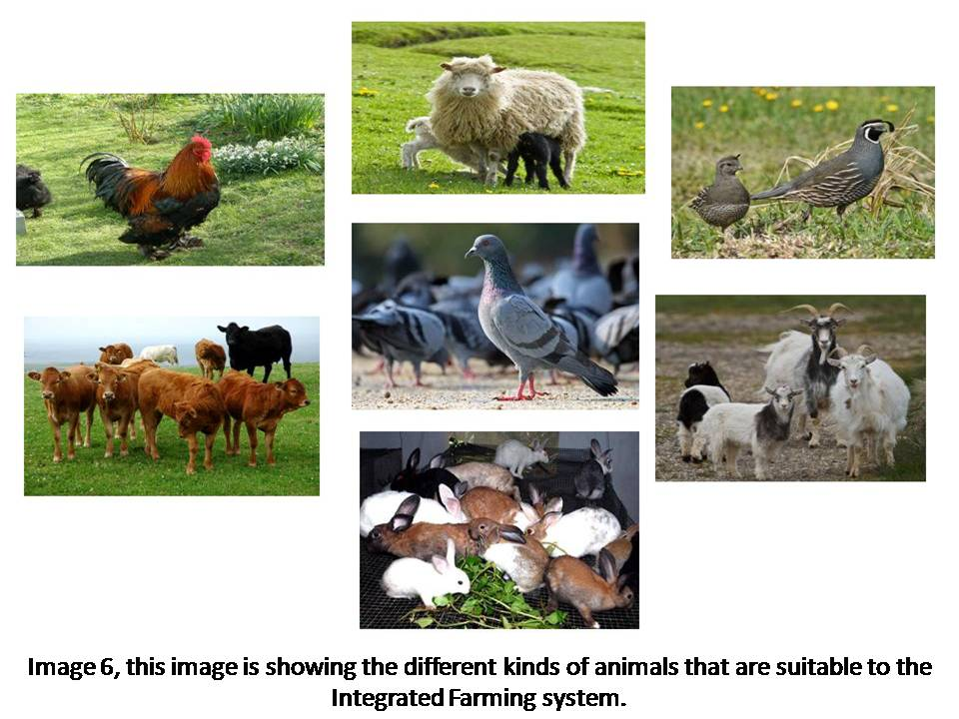
Figure 6: Different suitable livestock for Integrated Farming System
The various agronomical approaches to make IFS overall highly productive and sustainable are:
- Adopting the new & improved cropping systemsbased on the available rainfall and soil moisture.
- Selecting the suitable food grain crop species and tree species that supplies pods or leaves for a great period of time or round the whole year.
- The surfeit fodder leaves & crop residues etc. should be kept in preservation as silage or hay for summer season through the rainy season.
Country is divided in different agro-ecological zones based on the site specific resources available in the natural conditions of the different zones. IFS models are proposed with little modifications accordingly to the conditions prevalent in the different zones and are also based on various researches executed.
Difference between the mixed and integrated farming
The difference between mixed farming and Integrated Farming System is that components in the IFS are dependent and supportive to each other.Mixed farming system includes the components such as livestock and agriculture that coexistindependentof each other.In this system integrating livestock and agricultureworks to minimize the risk and not for recycling of resources whereas in an Integrated Farming Systemagriculture andlivestock deal to create a symbiotic relationship with each other like recycling allows the maximum use of availableresources. Residues from crops can be used for animal feeding whereas livestock and their production and processing of by-products can enhance the productivity of agriculture by improvingthe fertility of soil as well as reducing the use of chemical fertilizers(Csavas1992).High integration of livestock and crops is often seen as a step forward, but small farmers need adequate access to information, inputs and assets to manage the system in a manner that is long-term ecologically sustainable as well as economically balanced (FAO, 2001).Tipraqsa (2006) reported that the difference between the IFS and the commercial farming system is not absolute, but instead it is a matter of the degree to which resources are incorporated into the farming system.
Mixed farming v/s Integrated farming system
Table 2: Difference between the Mixed Farming and Integrated Farming System
Difference | Mixed farming | Integrated Farming system
Aim | Subsistence and  welfare of mankind | Highly profitability and balance the environment and resources
Emphasis | On gross output | on system
Determinants of farming system
Farming systems, to which farmers are to be engaged in, are determined majorly by the three groups of factors (A, B& C) of that specific site. These are;
Factor A: Depicts the Physical & Biological constituents. These constituents set the limit accordingly to the agricultural produce which is to be produced in the specific area. Physical constituents include topography, weather or climate, land quality & soil health, water etc. Biological constituents includes cropping types and pattern, livestock physiology etc. based on these constituents potential farm commodities are determined. These constituents can also be modified by the little mediation of farmers and scientists. For example, a new production technology evolved by the scientists can be adopted by the farmers fully or partially.
Factor B: Depicts Endogenous human constituents. Type of FS, to be adopted, in the specific areas are chosen according to these. This system mainly concerns about the farmer who works on his field with his family as labors. The whole family controls and adjusts the quality and quantity of the available production resources that are land, capital labor and their management. The adjustments are made accordingly to the family characteristics viz. size, age, education, there managerial skills, attitude and the aim of the family. The type of FS is determined mainly by the aims and attitudes of the family specifically on the region having a wide range of different practices and commodities which further leads to increase the productivity of the farm. The available resources have to use in such a combination that the maximum aims of the farmer are fulfilled.
Factor C: Illustrates the exogenous human constituents to which site specific production resources are allotted to the farmers. Farm producers are motivated to adopt the changes in their traditional farming practices and production design for moving in the better & beneficial directions.
Global trends related to Integrated Farming system
Industrialization of Agriculture
The build-up of industrialized single cropping Systems of agriculture at large scales often happens at the cost of Integrated farming system. Industrialization of single cropping system of agriculture started from the plantings by the European colonies between 1500-1800s (McMichael 2009, Perfecto et al. 2009), and went on expanding via agricultural mechanization in late 1800s till the synthetic chemical introduction in agriculture in mid of 20th century. But later with the “Green Revolution” in 1960s, new inventions were made in agricultural technologies which introduced the integrated system of using different chemicals (fertilizers, pesticides, etc.) and modified crop varieties having high yields and got promoted by the government and non-government agencies around the world (Evenson and Gollin 2003, Smil 2004). This continuous agricultural industrialization, in next 50 years, resulted in increased use of nitrogen (eightfold) and phosphorus (tri-fold) ultimately the increased global production of fertilizers and pesticides(eleven-fold) (Tilman et al. 2001). Bio-fuel production also expedited by official directives for using bio-fuel as transport fuels, and land use systems and subsidies in developed and developing countries (Borras et al. 2011). Instead of all the difficulties, an estimate of 36 Mha land under use for bio-fuel production (specifically maize, cane and oil crops) was made in 2008 by the World Bank, which was the twice of that in 2004 (Deininger 2011). Even after this much global plantations of bio-fuels, the smallholder farming generated ten times greater employment (Holt-Gimenez 2007).
Smallholder agriculture
Regardless to commercialization and industrialization of agriculture at large scale, out of approx 525 M farms around the world, 85% are smallholders. Even though they comprise most of the agricultural population yet most of the arable land is not under their possession and because of intensifying land disparities, the mean size of the farm is being decreasing. This is putting them into more poor and vulnerable conditions (Nagayets 2005). Regardless of poverty small farms contribute significantly to the food production around the globe that is integration of mixed crops and livestock produces 50% cereal, meat 60% and dairy production 75% of the world production. Much of which is provides the food to the 1 billion poor of the world (Herrero et al. 2010). A qualitative research shows that the execution of “sustainable agriculture” or conservational practices in integrated farming system (Netting 1993, Pretty et al. 2006). From IFS or such farms 60-100% more productivity can be obtained, which potentially contributes to food security (local and global) (Pretty et al. 2006, Badgley et al. 2007). Organically produced local fruits, vegetables and meat are high in demands in European countries, which encourage the small scale farms (Kristiansen et al. 2006, Pollan 2006).
SPECIAL FEATURE
Integrated farming system provides various critical inputs, while maintaining a balance with ecosystem, to farming such as soil quality, weed control, control over diseases and pests, pollination services, sequestration of carbon, mitigating climate change, production of food, and biodiversity. Kremen and Miles (2012) compared integrated farming system with the convention industrial system. This shows the significance of IFS in enhancing the ecosystem resources. He redressed the fact that the currency spent on the IFS is very small as compared to the conventional system and this gap can be filled by the investment which will result in more yield production and enhanced environmental benefits. Thus, there is a need of holistic research for integrating the various components of farming for the better management of the systems.
A crucial role of government policy, integrating the market demand and governance, in various farming system is depicted from a case study from California’s Central Valley, Mesoamerican. The findings of the study is that the IFS will provide better and quality social benefits such as enhanced food security, healthier diets and decreased exposure to the pesticides. Certain market and political framework and economic policies for agriculture are needed to assure a social sustainable expedition of IFS and to attain environmental benefits by reducing the cost.
There are certain barriers in adopting the IFS in modernized agriculture systems. Many examples have been taken into account that hastens the farmers’ choice to move toward IFS such are; wider political context for industrialized agriculture, marketing conditions and lack of knowledge in farmers. To even the odds, some new polices have to be made regarding the transformation of agricultural sciences and researches, vast and deep learning of the processes, supporting farmers by providing subsidy and recruitment, starting new conservation programs for agriculture and maintain a direct contact between the markets and the consumer. A meat industry in the U.S. was examined, in which ranching was found to be a sustainably ecological part of the industry. This illustrated the certain important characteristics of the integrated farming systems (Sayre et al. 2012). Rangelands are also seen as a best opportunity for its services such as habitat to wildlife, watershed management activity, recreation and tourism. Thus new incentives must look forward towards integrating the several components and easement of marketing programs to enhance the ranch income and to have a cooperative behavior among the rancher that will provide a great support to the diversification. This special feature enables the integration and incorporation of different fields, thus, enabling a more vast analysis of various obstacles and opportunities which will, lately, impact the sustainable farming and its multiple dimensions (Iles and Marsh 2012).

References
Badgley, C., Moghtader, J., Quintero, E., Zakem, E., Chappell, M.J., Aviles, K.-Vazquez, Samulon, A. and Perfecto, I. (2007). Organic agriculture and the global food supply. Renewable Agriculture and Food Systems, 22(02): 86-108.
Borras, S., Hall, R., Scoones, S., White, B., and Wolford, W. (2011). Towards a better understanding of global land grabbing: an editorial introduction. Journal of Peasant Studies, 38 (2): 209-216.
Csavas, I. (1992). Regional review on livestock-fish production systems in Asia. In: Mukherjee, T.K., Moi, P.S., Panandam, J.M., and Yang, Y.S. (eds.), Proceedings of the FAO/IPT Workshop on integrated livestock-fish production systems, Institute of Advance Studies, University of Malaya, Kuala Lumpur, Malaysia.
Deininger, K. (2011). Challenges posed by the new wave of farmland investment. Journal of Peasant Studies, 38(2): 217-247.
Evenson, R. E., and Gollin, D. (2003). Assessing the impact of the Green Revolution, 1960 to 2000. Science, 300(5620): 758.
Holt-Giménez, E. (2007). The biofuel myths. International Herald Tribune 10(July 10).
Herrero, M., Thornton, P. K., Notenbaert, A. M., Wood, S., Msangi, S., Freeman, H. A., Bossio, D., Dixon, J., Peters, M., van de Steeg, J., Lynam, J., Rao, P. P., Macmillan, S., Gerard, B., McDermott, J., Sere, C., and Rosegrant, M. (2010). Smart investments in sustainable food production: revisiting mixed crop-livestock systems. Science, 327(5967):822-825.
FAO. (2001). Recycling of organic wastes in agriculture. FAO Soil Bull., 40 - Rome. 13. Food and Agriculture Organization of the United Nations. Mixed Crop Livestock Farming: A Review of Traditional Technologies based on Literature and Field Experience. Animal Production and Health Papers, 152. Rome, 1977.
Iles, A., and Marsh, R. (2012). Nurturing diversified farming systems in industrialized countries: how public policy can contribute. Ecology and Society, 17(4): 42.

Jayanthi, C., Mythili, S. and Chinaasamy, C. (2002). Integrated farming system – A viable approach for sustainable productivity, profatibality and resource recycling under low land forms. Journals of Eco biology, 14(2): 143-148.
Kremen, C., and Miles, A. (2012). Ecosystem services in biologically diversified versus conventional farming systems: benefits, externalities, and trade-offs. Ecology and Society, 17(4): 40.
Kristiansen, P., Taji, A. and Reganold, J. (2006). Organic agriculture: a global perspective. CSIRO Publishing, Collingwood, Australia.
Kumar, S., Bhatt, B., Dey, A., Shivani, Kumar, U., Idris, M. and Mishra, J. S. (2018). Integrated farming system in India: Current status, scope and future prospects in changing agricultural scenario. Indian Journal of Agricultural Sciences, 88: 1661-1675.
Lal, R. and Miller, F. P. (1990). Sustainable farming system for tropics. In: Sustainable agriculture: Issues and Prospective. Vol. I (eds.) R. P. Singh., Indian Society of Agronomy, 68-89.
McMichael, P. (2009). A food regime analysis of the ‘world food crisis'. Agriculture and Human Values, 26(4): 281.
Nagayets, O. (2005). Small farms: current status and key trends. In Research workshop and information brief for future small farms. International Food Policy Research Institute and Overseas Development Institute. Pp. 355-367.
Netting, R. (1993). Smallholders, householders: farm families and the ecology of intensive, sustainable agriculture. Stanford University Press, Stanford, CA, USA.
Perfecto, I., Vandermeer J. and Wright A. (2009). Nature's matrix: linking agriculture, conservation and food sovereignty. Earthscan, London, UK.
Pollan, M. (2006). The omnivore’s dilemma: a natural history of four meals. Penguin Books, New York, USA.
Pretty, J., Noble, A., Bossio, D., Dixon, J., Hine, R., F. W. T. P. De Vries and Morison, J. (2006). Resource-conserving agriculture increases yields in developing countries. Environmental Science & Technolology, 40(4): 1114-1119.
Sayre, N. F., Carlisle, L., Huntsinger, L., Fisher, G., and Shattuck, A. (2012). The role of rangelands in diversified farming systems: innovations, obstacles, and opportunities in the USA. Ecology and Society, 17(4): 43.
Sharma, L. R., Bhati, J. P. and Singh, R. (1991). Emerging farming systems in Himachal Pradesh: Key issues in sustainability. Indian Journal of Agricultural Economics, Bombay, 46(3): 422-427.
Smil, V. (2004). Enriching the earth: Fritz Haber, Carl Bosch, and the transformation of world food production. MIT Press, Cambridge, MA, USA.
Tilman, D., Fargione J., Wolff, B., D'Antonio, C., Dobson, A., Howarth,R., Schindler, D., Schlesinger, W.H., Simberloff, D. and Swackhamer, D. (2001). Forecasting agriculturally driven global environmental change. Science, 292(5515): 281-284.
Tipraqsa, P. (2006). Opportunities and constraints of integrated farming system in Northeast Thailand.A case study of the HuaiNong Ian catchment, KhonKaen Province.Ecology Development Series No. 35. University of Bonn.CuvillierVerlag, Göttingen, Germany.

