“ Meta Analysis of Hotel Employees Balanced Score Card Effects - A Case Study”

Dr. Salla Vijay Kumar
Senior Lecturer & Academic Incharge
Institute of Hotel Management Ahmedabad, India
sallavijaykumar75@gmail.com

ABSTRACT

Background: Hospitality is the act of welcoming and meeting the basic needs of clients. The hospitality industry encompasses a wide range of enterprises that provide services to customers. Hospitality is a subset of the service industry. It essentially entails addressing client satisfaction and catering to guests' demands.

Significance: According to employee and management viewpoints, hotels that adopted Performance Management understood the system and achieved desired results, whereas other hotels were unable to successfully manage the system due to a lack of knowledge in its execution.

Method: This study employed traditional statistical methods to examine whether the observed changes were statistically significant. In addition, when making judgments based on this data to identify, encourage, measure, assess, develop, and reward, readers should exercise caution when generalizing results and take individual circumstances and experiences into account. The study includes all of the hotel's formal and informal initiatives to improve individual and team effectiveness. Employees' knowledge, skills, and competencies should be continuously developed by management and employees.

Results: The findings suggest that successful performance management systems improve continual communication between individuals and leadership teams. It enables the establishment of trusted sources of dialogue, allowing employees to share concerns, debate problems, and develop methods to improve.

Conclusion: Based on the past literature in the subject, none of the research have comprehensively studied the variables of Performance Management. Similarly, the research model established to assess how Performance Management promotes employee commitment is entirely dependent on a random selection of factors, including the moderator (i.e. firm type), with no theoretical grounding.

Keywords: Performance, Management, Consideration, Communication, Conversation, Underpinning

“ Meta Analysis of Hotel Employees Balanced Score Card Effects - A Case Study”

INTRODUCTION

The offered paper focuses on Pullman-Novotel Aerocity New Delhi and a detailed examination of how Performance Management is employed as a strategy from the perspectives of employees and management. The two hotels, which have a total inventory of 670 rooms, were launched by Ashok Gajapathi Raju, Union Minister of Civil Aviation. Both hotels are the result of a strategic collaboration between Inter Globe Enterprises Ltd, APHV India Investco Pte Ltd, and Accor Hotels. Both hotels are the perfect blend of legendary Indian and French hospitality and culture.
Performance management is gaining traction as a strategic Human Resource Management strategy that helps workers, teams, and departments accomplish their strategic goals.

The study's goal is to assess the extent to which Performance Management is practiced in hotels by reviewing relevant literature.
According to the study, hotels that practiced Performance Management from both the employee and management perspectives understand the system and are achieving expected results, whereas other hotels were unable to effectively manage the system due to a lack of understanding in its implementation. Pullman-Novotel Aerocity New Delhi has been identified as pursuing Performance Management utilizing the same approach (target setting, feedback, performance assessment, etc.) and has faced comparable issues. The variables are the system's implementation tactics, cultural diversity, and practical delivery.

Hospitality is the act of welcoming and meeting the basic needs of clients. The hospitality industry encompasses a wide range of enterprises that provide services to customers. Hospitality is a subset of the service industry. It essentially entails addressing client satisfaction and catering to guests' demands. This can be solved by addressing issues such as housing, amenities, and travel plans. Guinness World Records officially recognized Japan's Nishiyama Onsen Keiunkan, which was founded in 705, as the world's oldest hotel. Various religious organizations at monasteries and abbeys provided lodging for travelers on the road during the Middle Ages.

According to luxury hotel statistics, there are around 4,400 4 and 5-star hotels in the world. The Wyndham Hotel Group is the world's largest hotel company, with over 9157 hotels. Choice Hotels International has over 7,045 properties, and Marriott International has 7,003.According to the Federation of Hotel & Restaurant Associations of India (FHRAI), the impact of the COVID-19 epidemic cost the Indian hotel business more over Rs. 1.30 lakh crore (US$ 17.81 billion) in revenue in FY21.

Scope of the Study:

The study's major goal is to identify, encourage, measure, evaluate, improve, and reward. The study includes all of the hotel's formal and informal initiatives to improve individual and team effectiveness. Employees' knowledge, skills, and competencies should be continuously developed by management and employees.

The study's scope includes the following components:

Job performance takes into account accomplishing objectives and setting mutually agreed-upon criteria.

Maintaining professional connections with coworkers, subordinates, and managers is the focus of this element.

Need of the Study:
Human resources are the true assets of any firm. Human resources use all other resources in the organization, therefore full utilization of all resources is dependent on employee performance. Today, the globalization of the global economy, among other causes, is causing changes in how corporations organize, manage, and employ their human resources. Work is also changing as a result of technological advancements. The present working environment is defined by knowledge-intensive processes, industrial automation, and reengineering with optimal resource use. Furthermore, an employee's personal life influences his professional work, goals and desires, and decisions. As a result, consistently managing employee performance is becoming crucial to top management's policies and planning.

All organizations are interested in performance management because the information provided by PMS can be used to make important HR decisions such as Human Resource Planning, Recruitment and Selection, Training and Development, Compensation Management, Career Planning, Talent Management, Performance Based Pay, and so on.

LITERATURE REVIEW

Performance management has piqued the interest of all organizations because the information provided by PMS can be used to make various important HR decisions such as Human Resource Planning, Recruitment and Selection, Training and Development, Compensation Management, Career Planning, Talent Management, Performance Based Pay, and so on.

Employees are an organization's most important and valuable asset, according to Bhattacharjee and Sengupta (2011). If an organization wants to obtain a competitive edge, it must bridge the gap between the actual competence of its human resources and the desired competence anticipated of them. The firm can bridge the gap between real and expected performance with the help of a well-established Performance management system.

Suman Kalyan Chaudhury and Sunil Kumar Pradhan (2012), According to the findings of this study, the primary goal of a performance management system is to align individual and organizational goals in such a way that employees have the best possible platform to perform with 100% efficiency, resulting in organizational development, employee satisfaction, and increased employee retention.

OBJECTIVES OF STUDY

• To comprehend clear role definitions, expectations, and objectives

• To understand the personnel in order to reach superior work performance standards.

• To learn how to increase productivity through better performance.

RESEARCH METHODOLOGY

A random sample of hospitality professionals was chosen at Pullman and Novotel. The professionals in question were hotel personnel. In January 2023, 10 employees responded to an e-mail with a link to the Performance Management Survey, obtaining a 100% response rate. The survey was fielded for three weeks, with weekly reminders issued to sample members in an attempt to enhance response rate.
Analysis: Analyses by respondents' organization staff size, the existence of performance management initiatives, organization sector, and HR department staff size are presented and addressed throughout this research, if appropriate.
Differences: To evaluate if observed differences were statistically significant, conventional statistical methods were applied.
Results generalization: As with any research, readers should use caution when generalizing results and consider individual circumstances and experiences when making conclusions based on this data.

TABULATION AND DATA ANALYSIS
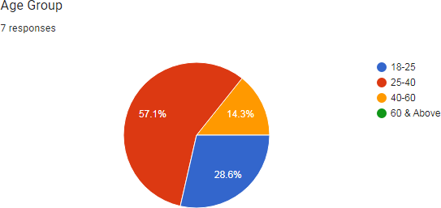
Mostly the response came from 25-40 age group which is 57.1% followed by the age group 18-25 which is approx 28.6%.
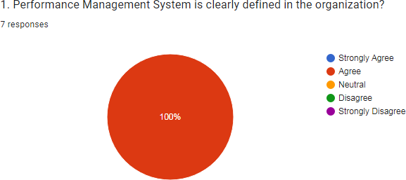
100 % respondents agreed that the performance management system is clearly defined in the organization .
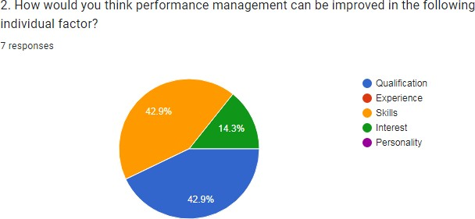
42% response believe that the performance management system can be as in thr skills of the person in the property.
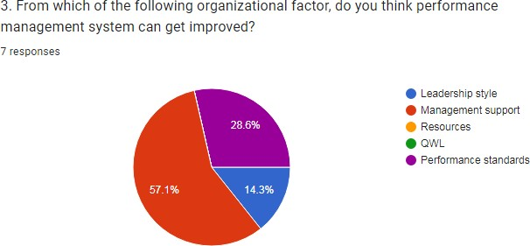
57.1% response believe that through the management support the performance management system can be improved .
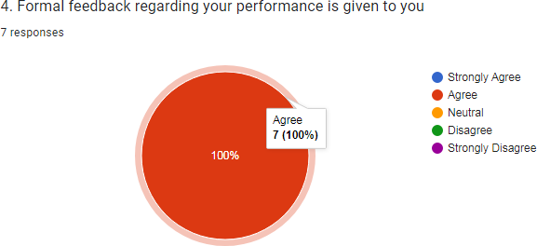
100%respondents agrees that their formal feedback is given in their organization .

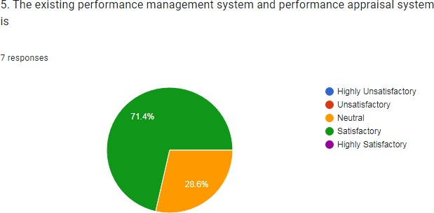
71.4% employees says that their performance management system and performance appraisal system is satisfactory and 28.6% says it is neutral
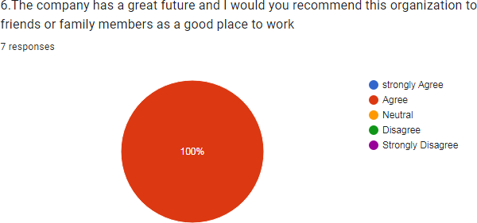

100% respondents says that their company has a great future and they would recommend the work culture and workplace to the family and friends .
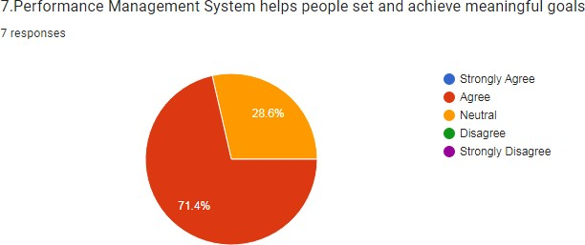

71.4 % respondents says that their performance management system helps to achieve meaningful goals followed by 28.6% who says that it is neutral they could not comment any of the thoughts
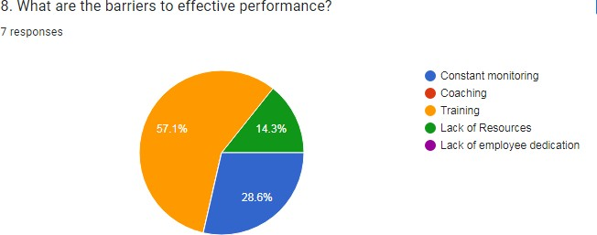

57.1 % respondents says that training is an barrier to effective performance followed by the 14.3% who says lack of resources and 28.6% says that barriers are through constant monitoring
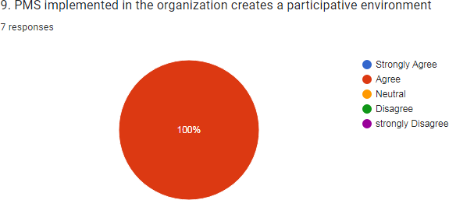
100% respondents agrees that PMS implemented in their organization creates an participative environment .

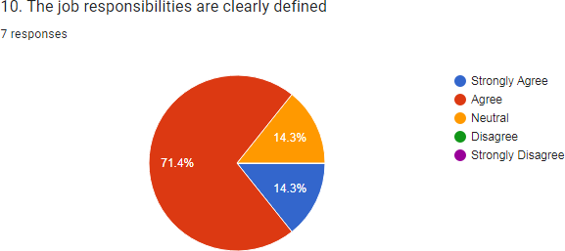
71.4 % people agrees that their job responsibilities are clearly defined whereas 14.3% have an neutral approach towards it and the mix of 14.3% strongly agrees to the given statement
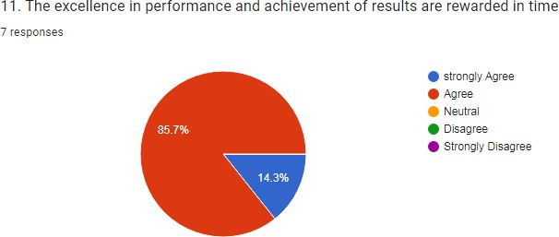
85.7 % respondents agrees that their performance and their achievements are rewarded in time followed by the 14.3% strongly agree .
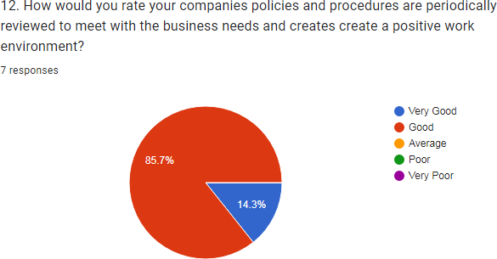

85.7% respondents says that their company policies are good in terms of business needs and positive work environment .followed by 14.3% says its very good
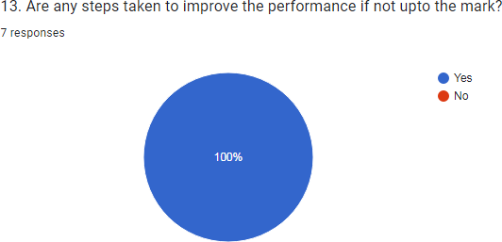

100% respondents agrees that steps are taken to improve performance management by the organization
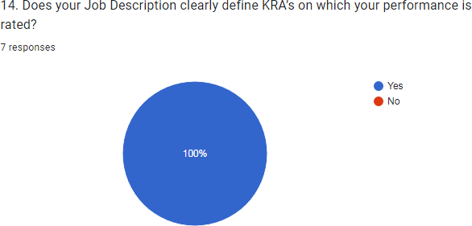
`100 % people agreed that that their job description clearly define KRA on which performance is rated
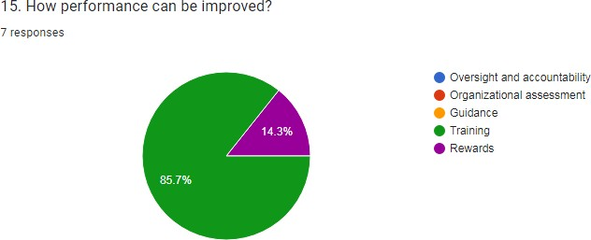
85.7% respondents says that the performance can be improve with the training factor and 14.3% says by the reward systems
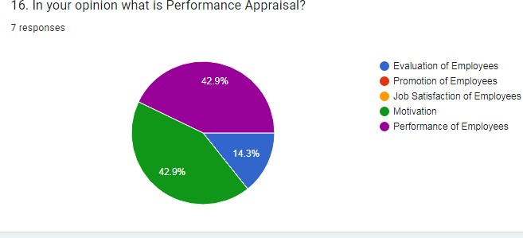
Both 42.9 % says that performance of employees and motivation are performance appraisals . and rest 14.3% says it is evaluation of employees .

Some feedback and suggestions in the given questionnaire:
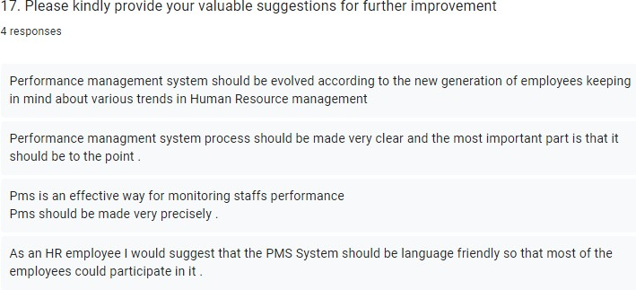

FLOWCHART OF VARIABLES
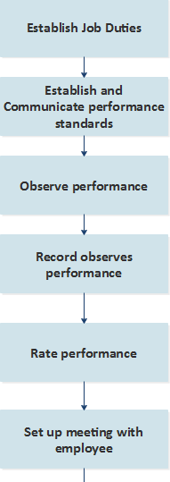
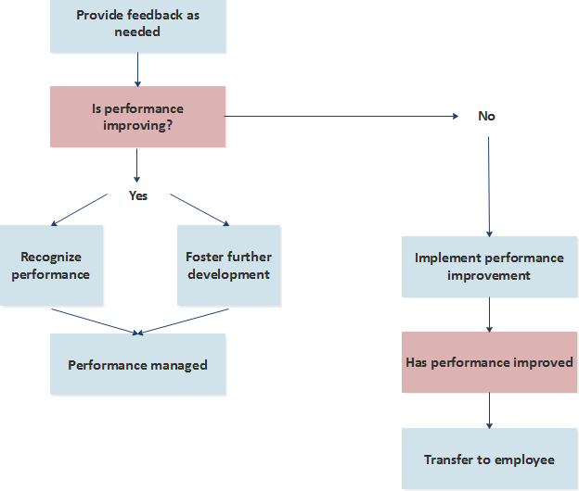

FINDINGS
- All respondents are aware of current performance management systems.
- The majority of HR professionals stated that they are comfortable doing performance reviews, however some HR professionals stated that they are not comfortable conducting performance reviews.
- All HR professionals and the majority of respondents stated that the current performance management systems work well and that there is no need for change.
- The majority of respondents stated that the checklist techniques used in organizations for accessing performance are satisfactory.
- The majority of respondents are confident in their current performance and in improving their performance.
- While some HR professionals believe that performance evaluation procedures have a greater impact on employee performance, rewards, and morale, others disagree.

CONCLUSION
According to the findings of this study, the Performance Management System is an important strategic instrument in human resource management. A well-designed PMS can assist a business in optimizing employee performance and fostering an organizational atmosphere of trust, collaboration, communication, teamwork, and so on. It is critical for a company to have a system that not only identifies great performers but also assists low performers in improving their performance through well-designed training programs and targeted counseling. The performance management system is a strategic instrument for transforming people's potential and drive into a competitive corporate advantage.

According to the survey results, all respondents are aware of existing performance management and believe that there is no need to change the current performance management system, which improves employee performance.
According to the findings of this study, performance management is a complete method to planning and sustaining changes in employee performance in order to achieve criteria.
The majority of HR professionals are uneasy about giving performance reviews. So, build trust in them. About performance evaluation procedures and keeping good relationships with employees in order to improve their performance and achieve the organization's goals and objectives.

RESULTS
Performance management methods that are effective improve ongoing communication between individuals and leadership teams. It enables the establishment of trusted sources of dialogue, allowing employees to share concerns, debate problems, and develop methods to improve.
Improved organizational performance, employee retention and loyalty, increased productivity, overcoming communication hurdles, clear accountability, and cost savings. It saves time and lowers disputes while also ensuring efficiency and consistency in performance.

LIMITATIONS
According to the findings, the majority of respondents reported that the study's findings were difficult to generalize. A sample drawn from only one or a few contexts, a small or limited sample size, a cross-sectional or snapshot approach to data collection, self-selection bias or a convenience sampling approach, a lack of empirical research, a lack of more specific variables, and exploratory or ongoing research are some of the limitations.
Future study could address constraints such as small sample size, limited empirical research, exploratory analysis, and a lack of appropriate variables.

The limited scope of empirical research can be addressed by employing quantitative analysis to determine talent turnover intentions via structural equation modeling. Furthermore, because this research is based on a thorough evaluation of the available literature on performance management, it can be stated to have solved the problem of identifying the most appropriate factors.
According to the review, none of the research carefully analyzed the variables of Performance Management based on prior literature in the field. Similarly, the research model established to assess how Performance Management promotes employee commitment is entirely dependent on a random selection of factors, including the moderator (i.e. firm type), with no theoretical grounding.

REFERENCES
- https://www.sap.com/insights/performance-management-process.html
- https://www.researchgate.net/publication/331329634_Performance_Management_Methods_ A_Case_Study_from_International_Industrial_Companies
- https://www.slideshare.net/ShaikhIrshad/project-report-on-performance-management-system
- https://www.google.com/search?q=09.+flowchart+of+variables+of+performance+manageme nt&sxsrf=AJOqlzWYByelXVIggzII6Txg5bZDcFr3w:1678797937081&source=lnms&tbm=i sch&sa=X&ved=2ahUKEwjGy8HVudv9AhVocGwGHcw_CD8Q_AUoAXoECAEQAw&bi w=1600&bih=757&dpr=1#imgrc=3yNECo3_2WvOvM
- https://support.sas.com/content/dam/SAS/support/en/books/case-studies-in-performance- management/excerpt.pdf
- https://www.researchgate.net/publication/331329634_Performance_Management_Methods_ A_Case_Study_from_International_Industrial_Companies
- https://www.studocu.com/row/document/jagannath-university/strategic-management/pdf- performance-management-system-case-study-assignment-1-converted/9027181
- https://www.scribd.com/document/352349818/Performance-Management-Case-Studies
- https://www.shrm.org/hr-today/trends-and-forecasting/special-reports-and-expert- views/documents/performance%20management.pdf
- https://www.academia.edu/38396027/Performance_Management_System_PMS_In_Indian_S mall_and_Medium_Enterprises_SMEs_A_Practical_Framework_A_Case_Study

