Metallic pollution of soil and its impact on human health
Manoj Kumar^{1*}, Dinesh Mani², Vipin Sahu³, Himanchal Vishwakarma⁴, Jeetendra Verma⁵ and Rupesh Kumar Ojha⁶
¹ Ph.D. Research Scholar, Sheila Dhar Institute of Soil Science, Department of Chemistry, University of Allahabad, Prayagraj, Uttar Pradesh-211002 India.
² Professor, Department of Chemistry, University of Allahabad, Prayagraj, Uttar Pradesh-211002 India.
³ Ph.D. Research scholar, Sheila Dhar Institute of Soil Science, Department of Chemistry, University of Allahabad, Prayagraj, Uttar Pradesh-211002 India.
⁴ Ph.D. Research scholar, Sheila Dhar Institute of Soil Science, Department of Chemistry, University of Allahabad, Prayagraj, Uttar Pradesh-211002 India.
⁵ Ph.D. Research scholar, Sheila Dhar Institute of Soil Science, Department of Chemistry, University of Allahabad, Prayagraj, Uttar Pradesh-211002 India.
⁶ Ph.D. Research scholar, Sheila Dhar Institute of Soil Science, Department of Chemistry, University of Allahabad, Prayagraj, Uttar Pradesh-211002 India.
Email: manojkumar14895@gmail.com

Abstract:
The health of people and the environment may be at risk due to the rise in soil contamination over the past few decades. Human activities including mining, agriculture, forestry, and waste disposal are the principal drivers of both natural and anthropogenic soil contamination. As a result, pollutants can build up in soils to levels that are potentially dangerous. The term “soil pollutants” refers to a broad category of contaminants, both organic and inorganic, that are present in soil either naturally or as a result of anthropogenic activity. Today, a variety of physical, chemical, and biological characteristics that are either directly or indirectly related to anthropogenic activities are exposed to soil ecosystems. Human exposure to hazardous chemical pollutants and soil-borne pathogens increased as a result of the buildup in soils, whether directly by inhalation, skin contact, or soil ingestion, or indirectly through nutritional ingestion or drinking water. Therefore, it is essential to create instruments to evaluate possible dangers associated with human exposure to contaminants.
Key words: soil, metallic pollution, contamination, food chain and human health.
Introduction
Define soil pollution as the being there of a chemical or matter that is out of place or present in a higher quantity than usual and has detrimental effects on any organism that is not the target (FAO and ITPS 2015). Soil pollution is the term used to describe the decrease in soil productivity caused by the presence of soil contaminants. Pollutants in the soil have a detrimental effect on the soil's physicochemical and biological characteristics, which lowers the productivity of the soil. The biggest contributors to soil contamination include human activities like mining, industrial processes, disposal of household and commercial waste, and drug use by both people and animals. Heavy metals and synthetic organic compounds are highlighted in numerous recent research summaries and case studies as the two primary contributors of soil pollution. The primary cause of these increases is human-caused (anthropogenic) behavior. Metallic pollutants, plastics, polycyclic fragrant hydrocarbons, and other non-biodegradable pollutants are the main causes of soil contamination that have an immediate effect on soil microorganisms and earth-worms, according to ( Keshavarzi et al. 2018). Industrial actions, farming chemicals, and inappropriate waste disposal are the main offenders. It's important to understand that all soils contain substances that are toxic or bad for humans and other living things. When applied inappropriately and regularly to protect crops from insects, fungi, and other pests, pesticides, herbicides, and fungicides change the fundamental constituents of the soil and build it poisonous designed for crops growth. Natural insecticides include Dichlorodiphenyltrichloroethane (DDT), Chlorine hexamer, aldrin, and benzene, for instance. To soil-borne pests are used. As they are broken down so slowly by water and soil bacteria, they build up in the soil. As a result, they severely impair plant growth, which in turn reduces yield, fruit size, and fruit quality. Their subpar goods may be ingested by plants, where they move up the food chain and eventually reach people and animals. Because the world's people increase, so does the demand for food, necessitating better and sustainable food production throughout intensive crop growing, consideration of public health, and prudent use of natural resources. In order to meet this need, agriculture must be enhanced by contemporary agricultural technologies while maintaining the quality of the land (Jones et al. 2013).
The main causes of soil contamination are the rising use of chemicals like insecticides, pesticides, herbicides, and chemical fertilizers, which make soil more saline’s and unsuitable for plant production, as well as the negative effects of the soil's microorganisms, which cause the soil to reduce its fertility and ultimately result in soil pollution (Tsion and Steven. 2019). Further types of soil pollution commonly result from subsurface storage tank leaks, acid rain, radioactive fallout, percolation from dirty surface water to ground-surface strata, fuel deluge from automobiles, harmful irrigation practices, leaks from hygienic sewage, discharge of waste from direct dumping of industrial trash into the ground or landfills, improper maintenance and management of septic systems (Havugimana et al. 2015).
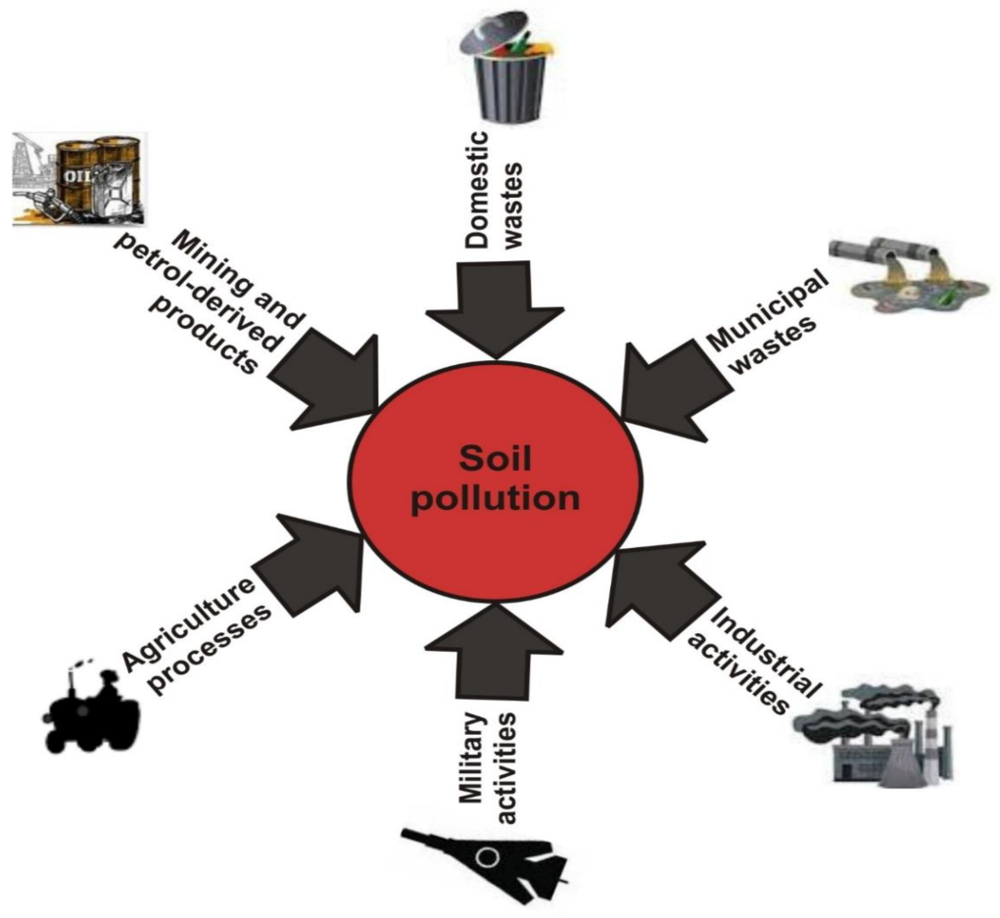
Fig. 1: Sources of Soil pollution

Today, heavy metal contamination is a significant environmental issue brought on by a number of natural and manmade processes (Jalmi et al. 2018). They are persistent and difficult to eliminate from the environment. Heavy metals or metallic pollutants having comparatively high density and toxic or fatal even at low concentration (Gill 2014). They can relocate beneficial metals from pigments or crucial enzymes by disturbing their vital functions. Metals make the environment unfavorable for the development and growth of plants. (Ghosh and Singh 2005). Metallic pollutants at high concentration can severely impact on plant growth by altering physiological and biochemical processes, including photosynthesis and respiration, even leading to the death of the plants (Shahid et al. 2015). Some of these metals like; Cobalt, Nickel, Zinc, Manganese, and copper are essential for crucial biological processes at low concentrations but display several toxic effects in plant parts beyond upper an optimal level. Other metals or metalloids such as cadmium (Cd), lead (Pb), arsenic (As) & mercury (Hg) are completely non-essential for plant growth & development (Dalcorso 2012; Kalaivanan and Ganeshamurthy 2016). To counteract heavy metal stress plants have adopted several physiological and molecular mechanisms, which are highly effective to control the uptake, accumulation, trafficking and detoxification of various metals. Some of these mechanisms are ubiquitously, i.e. part of homeostatic processes, whereas other mechanisms are activated only when a threshold level of metal toxicity is encountered. As well, increased levels of heavy metals are associated with important level of reactive oxygen species; (ROS) (Rascio and Navari-Izzo 2011). These toxic radicals cause oxidative stress which alters the homeostasis between the prooxidants and antioxidant within the intracellular system of plants. This condition imposes multiple deteriorative disorders in plants such as imbalance in redox equilibrium, electrolyte leakage and oxidation of protein as well as lipids, DNA breakage and denaturation of cellular macro molecules which altogether are often correlated with the progression of programmed cell death- (PCD); (Mourato et al. 2015). When the concentration of one or more dangerous compounds is high enough to harm living microorganisms, the soil is considered to be contaminated (Varjani et al. 2019). Define soil pollutants as compounds that contaminate soil to the point where it has poor soil quality and cannot support living species including insects, plants, and microbes. In addition, a number of pathogens and parasites, including hookworm and tetanus, are found in soil and are known to have harmful impacts on human health (Burgess, L.C., 2013). At the moment, soil quality has a big impact on farming productivity. In the modern time of chemical fertilizers, garbage, metal usage, and other issues, the significance of soil contamination concerns has grown (Gianfreda and Rao 2008).
The persistence of soil contamination is caused by anthropogenic (man-made) chemicals or other modifications to the natural soil environment. The important ecological benefits that soil provides can be drastically diminished by pollution. Due to high levels of pollutants and the fact that crops grown on contaminated soils are unsafe for consumption by humans and animals, soil pollution decreases agricultural yields and food quality. In addition to inflicting significant ecological destruction through eutrophication and having a direct impact on human health owing to contaminated drinking water, many contaminants, as well as major nutrients’ like phosphorus (P), nitrogen (N) are transferred surface waters, to the soil, and unfathomable water. Additionally, pollutants directly impair soil microbes and larger soil-dwelling microorganisms, which have an impact on soil biodiversity and the services the impacted microorganisms, perform. Through crops grown on contaminated soil, metallic pollutants (MPs) make their way into the human-binges, mammal food chain. These soils are frequently used to cultivate green leafy vegetable and tuber vegetable crops to meet the needs of the nearby metropolitan populations. It is well known that these plants' edible parts tend to acquire heavy metals more quickly than other parts of the plant. Metallic pollutants like lead, manganese, zinc, cadmium, copper, nickel, and iron are allegedly making their way into the food chain (Rattan et al. 2005).

Increased human exposure to harmful chemical contamination and soil-borne pathogens occurred either directly by inhalation, skin contact with or ingestion of the soil, or indirectly through nutritional ingestion or drinking water. Therefore, it is crucial to create instruments to evaluate possible dangers associated with pollutant exposure to humans. Human health hazards from elemental contamination, such as chromium, lead, arsenic, and cadmium are related with soil contamination. Pharmacological contaminants, including estrogen and antibiotics, as well as natural chemical contamination including Persistent organic pollutants, polycyclic aromatic hydrocarbons, and polychlorinated biphenyls. Anthrax, prions, vitamin deficiencies, and under nutrition caused by polluted soils are among other hazards from soil pathogens.
The primary objectives of this chapter are to evaluate the state of soil contamination, identify the principal contaminants and their sources that have the greatest influence on ‘human health and the food chain of the ecosystem’ with a focus on contaminants that are found in agricultural areas and that have a direct impact on people through the food chain.
Source of soil pollution
Different sorts of action, such as agricultural inputs, industrial discharge, and movement, produce more waste and new types of toxins in today's economy. All of these pollutants have traditionally been disposed of in soil, air, and water. These manures may harm adjacent rivers, lakes, and soil, as well as wash into close by streams. The primary sources of waste can be divided into two categories: anthropogenic and natural sources.
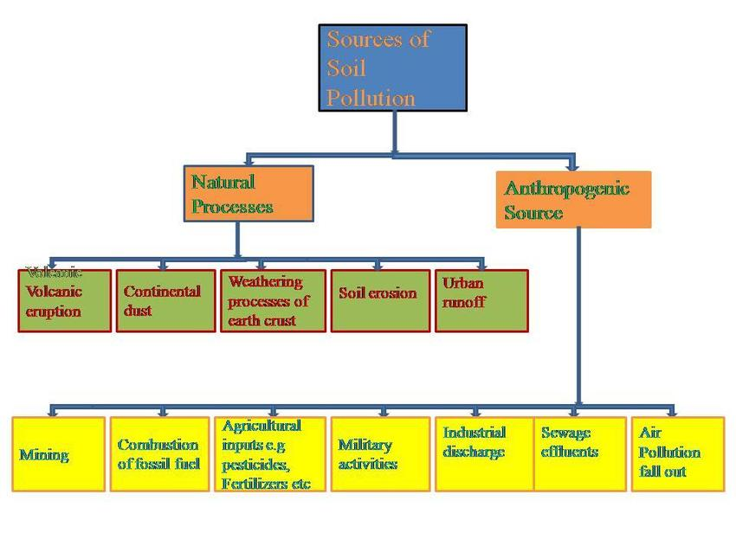 Fig. 2: Sources of soil pollution: natural and anthropogenic
- Natural sources
In addition to the natural elements like soil erosion, volcanic action, municipal run-offs, as well as aerosol particles, the human contributors include metal polishing and electroplating procedures, textile industries, nuclear power, mine removal operations, and mining removal activities. Volcanic activity, soil erosion, urban run-off, and aerosol particles are the main natural sources of metallic contaminants in the soil.
Volcanic eruptions impact the ecosystem, the climate, and the health of the populace. Natural weathering or a change in the pH of the soil or water can cause metallic pollutants in the lithosphere to become soluble, mobilized, and introduced to the biosphere. Many of these metals enter the biosphere as a result of volcanic eruptions and flooding. As, Cr, and Hg concentrations are increasing due to the many chemical processes redox reactions, acid-base reactions, pH level changes that occur in soil and water that change the types of metals and transform them into more mobile soluble forms (Wuana and Okieimen, 2011; Varalakshmi and Ganeshamurthy, 2011; Hashim et al. 2012). When abundantly contained in some soil parent constituents, certain metalloid pollutants and other elements, like radionuclides, can be hazardous to the health of the environment, animals, and people. Contamination with arsenic (As) is one of the worst environmental issues in the world. Many of these minerals exhibit high spatial variability and are disproportionately enriched in the deep-lower strata (Li et al. 2017).
Natural contamination is what happens when numerous hazardous compounds enter the ecosystem as a result of un-avoidable events like forest fires and volcanic outbursts. Polycyclic pungent hydrocarbons and substances that resemble dioxins are some of these hazardous substances (Van de Kerchove, Saint Macary, and Doelsch; 2006). High levels of metallic pollutants, particularly Mercury (Hg), have been discovered in volcanic soils. Other high levels of metallic pollutants, such as Copper (Cu), Nickel (Ni), Zinc (Zn), and Chromium (Cr) have been discovered as a result of weathering of the parent material. This natural pollution normally does not cause ecological problems because of plants' capacity for regeneration and variety (Kim, Choi, and Chang, 2011).
2. Anthropogenic sources
Chemicals used in industry or created as a byproduct of industrial activity, urban and rural misuse. The primary human-made sources of soil contamination are sewage, agricultural chemicals, and goods made from petroleum. Accidentally, as in the case of oil spills or landfill leaks, or knowingly, as in the use of fertilizers, pesticides, spreading sewage sludge on the land or utilizing un-treated wastewater for irrigation, these chemicals are released into the environment. The variety of chemicals employed in industrial processes is enormous; as is the effect they influence the environment. Pollutants are released into the air, water, and soil during industrial activities. Used for cooling in thermal power plants and many other industrial processes, former industrial land can be discharged back into rivers, lakes, and oceans, causing thermal pollutants and exhaust. Former industrial land can also be contaminated by improper management of chemical storage or direct ejection of waste into the soil, water, and other fluids. When pollutants and radionuclides are discharged into the atmosphere, they can directly affect the soil through atmospheric deposition or acid rain. Metal pollution from human (man-made) activity is widespread in industrial areas and can be brought on by fires, ash from burning fuel, dust, and releases of raw materials, waste, and finished goods (Alloway, 2013).
Industrial activities
Most chemicals are employed in industrial processes, and their impact on the environment is significant. Environmental, water, and soil pollutants are released by industrial activities. Former trade land can be contaminated by inappropriate substance storages management or direct discharge of chemicals into the soils. Gaseous pollution and radionuclide’s are released to the environment and are capable of entering the soil directly by air deposition or acid rain. Cooling fluids like water and other liquids can be released backward into rivers, lakes, and oceans several industrial processes, including those in thermal power plants, where they can produce thermal pollutants, exhausted metallic contaminants, and long term impact on aquatic life. In industrial settings, metallic pollution caused by human activity is common and can come from fires, fuel-ash spills, and fires as well as dusts and spills of raw waste materials and completed goods (Alloway, 2013).
Numerous properties near various industrial activity, primarily those involving the manufacturing of rubber, textiles, glass, animal secretion extraction, and drawing of leather, metals cleaning, medicinal, gas & oils drilling, color make up, pottery create and soap & detergent making ( Saha et al. 2017). Potential of pollution activities: can be six main categories; (A) power industries (B) manufacture and processing of metals (C) mineral manufacturing (D) Chemical industries & chemical installations (E) misuse managing and (F) Other operations include manufacturing, creating paper and boards, and fibrous material or cloth, drawing of hides & skins, butchery, exhaustive poultry or piggery, installations using chemical-free solvents, the provision of charcoal or graphite, and other measures (Garca-Pérez et al. 2007).
Mining and smelting
Along with smelting, mining is one of the main sources of metallic pollutants in soils and can have an impact on the soils above a large area. The neighboring agricultural operations may be significantly impacted by a mining plan. Mining activities continuously transform the surrounding areas by revealing prior un-disturbed earthen materials, wearing down of un-covered land, exclusion of un-refined earth, unearth, and glowing material in defile rocks plenty can effect in considerable loading of drain water-ways and groundwater with sediment. Then again reveal and discharge of harmful substance and the over-through of pollutants blown by wind dust can rich to soil pollutants. In general, there are two sorts of poisoned soils: those that have been contaminated by persistent chemical spills and wind-borne dirt. In some quarries, escaping dust could seriously harm the environment. The inherent toxicity of the dust is influenced by both the type of species mined and the presence of ecological sensors nearby. Higher levels of the metals; As, Pb, Cd and radionuclides are present in wind-blown dust. Generally facade the maximum poisonous. Soil pollutants from chemical spills and excess at mine areas may create a through contact danger when these materials are imprecise. In pursuit, poisonous wastes are piled up, mostly created by well particles with potentially various doses of metallic pollutants. These contaminated particles can be disconnected by water and wind corrosion, occasionally attainment farming soils. Example of found in higher levels of Pb, Cu and Ni, in farming land situated near a tracing weir in ‘Namibia’ (Mileusnić et al. 2014).

Agricultural & livestock actions
The various agri-sources of soil contaminants include; agro-chemical e.g. animal manure and inorganic fertilizers, herbicides and pesticides. Micronutrients among these agro-chemicals; such as lead, copper, nickel and mercury are moreover consider soil contaminants as they can injured plant growth, ingestion and reduce crop productivity. Irrigation water can also reason soil contamination but they consist of dissipate water and municipal sewage. Surfeit nitrogen and metallic pollutants are not single a cause of soil contamination, but moreover a risk to food safety “water superiority and human fitness” They are almost at the point of becoming food (FAO and ITPS, 2015).
Main sources of pollutants in farming settings including; unintentional spills of hydro-carbons (hydrogen and carbon) in farming land used as fuels for machinery or of agro-chemicals for the duration of their transportation and warehouse time. Domestic animals production can moreover be a cause of contamination, mainly if the garbage is not appropriately manage and liable of the grubby and urine may have parasites and medicinal materials so as to can residue and ‘enrichment in the soil’ (Zhang et al. 2015 a). Extreme use of chemical fertilizers and animal-manure or un-productive use of the major nutrients nitrogen & phosphorus in fertilizers are one of the main causes of ecological problem connected to farming (‘Kanter, 2018). They are a pair of nutrients, resource of spread pollutants, Excess nitrogen can also be missing to the environment throughout greenhouse gas discharge with surplus phosphorus helps to the ‘Eutrophication of nearby water sources. Extreme chemical fertilizer usage can go ahead to soil salinity (saline soil), metallic pollutants enrichment; Eutrophication of the water and nitrate buildup, which can be a cause of ecological contamination but moreover a risk the health of people. The nutrient construction is moreover considered to be a cause of metallic pollutants; such as cadmium, lead, arsenic, mercury, copper, nickel and natural radionuclide’s like Uranium-238, Thorium-232 and Polonium-210. Appropriate management and handling of chemical fertilizer is critical to avert pollutants the earth (‘Stewart et al. 2005).
Transport and municipal (urban) infrastructures
The extensive growth of transportation including; housing, roads and railways major role play in the ecological contamination. Their mostly apparent harmful possessions on soil be alive soil sealing and land utilization. Another main impact of transportation pursuit is the coming into the soil system of various contaminants. Although its creature a serious risk, land contamination from road and rail network actions has obtained very minor thought in terms of forecast and effect appraisal. Major sources of soil pollutants; Activities linked to transport in and roughly municipal centers compose, ‘release from inside burning engines that arrive at land more than hundred (100) m. expanse’ by environmental build-up and petrol leak, but moreover from the actions and the swap that effect from it as a entire (Mirsal, 2008). Soil contamination related to roads and highways are mainly imperative in municipal and semi-urban land moreover can be a foremost menace when food produce occurs in adjoining sites. Foliar accumulation and root uptake than move to upper-surface tissues of bio- available metallic pollutants are the most important process experimental in road-sides land. Battery generated by traffic at a time of rain-fall and during the runoff, which could be important but the water-way system is no good maintained, could transfer particles rich in metallic pollutants from the decompose of metal motor vehicle auto parts, tires and footpath scrape (Zhang et al. 2015; Venuti, Alfonsi, and Cavallo, 2016).
Dump of solid wastes
Generally, solid waste includes landfill waste, household waste, and unnecessary rock-solid material such as commercial, manufacturing, and farming operations. They hold a rising quantity of paper, cardboard, plastic materials, glass, old production materials, paper materials, and toxic or otherwise dangerous materials. As a higher quantity of municipal solid food waste, the most reusable or biodegradable material tends to be paper and degradable in the landfill. Similarly, the majority of harmful farming waste is reused, and mining dumps are left in place. The segments of solid waste that we need to pay carefully attention to are battery metals, oils, and scrap metals (heavy metals) from the combination (smelting) manufacturing, and natural solvents. These eventually find their way to the land of the neighboring site, changing their physical and contaminating them with chemical and biological (living) properties. They also pollute drinkable water and groundwater resources. Mostly about 90% of harmful waste is produced by chemical industries, heavy metal-related industries, petroleum, and small-scale business sectors such as gas stations and dry cleaners. As the world's population grows, so does the amount of waste produced. In underdeveloped and developing countries, high population growth rates, rising muck and garbage output, a hazardous situation is produced by the absence of urban services dealing with garbage recycling, report of world bank (Hoornweg and Bhada Tata. 2012).
Dump of oil and fuel
Soil pollution can also occur as a result of a subsurface storage tank burst or leak, the discharge of waste from hazardous waste dumps, mining of sand or land, inorganic fertilizer use, oil and fuel leakage, and many other causes of ecological imbalance.
Discharge of sewage
Extreme and un-productive apply of chemical pesticides be able to effect in severe soil contamination. Dirt bent in municipal areas can also polluted land but not ready of properly. Several carcinogenic substances may be also being by these wastes. Nuclear waste, electronic waste and coal ash are also contaminated by other forms of waste that can contaminated soils.

Digital or electronic waste
A variety of neurological and organ problem are also exposed by the contamination of soil, air and water by electronic waste. Numerous health issues can be contribute by the dioxins released by burning e- waste.
Radioactive waste
Primary causes of soil contamination brought on by improper management of nuclear or radioactive waste disposal. This type of abuse involves radioactive substances that could interact with soil components and cause to be the ground extremely poisonous and unusable. Furthermore, any plants that are developing in such soils have a probability of receiving the radiation from the soil and depositing it inside their bodies. This radiation may spread up and down the food chain as herbivores consume these plants and carnivores eat those herbivores.
Deforestation
Erosion occurs when soil fragments become loose and are carried away by water or wind. Climate change, increased agricultural production, and deforestation, this erosion is a result of precipitation, particularly acid rain, and human activity. By over-cropping, over-grazing, over-mining, destroying forests, and construction, humans hasten this process. Flooding and soil erosion are the results. Grasslands and forests are excellent soil binders that maintain healthy, clean soil. Several different habitats and ecosystems are supported by them. Which result in a countless number of food chains or feeding paths for all species? Many species' prospects of living would be at peril if they disappeared. A sizable portion of the formerly lush rural areas has become desert during the past few years. The magnificent rain forests of Southern America, Tropical Asia, and Africa are in danger as a result of population increase and development, especially in the areas of construction, agriculture, and timber.
Many scientists think these trees contain a variety of healing compounds, including anti-cancer and anti-AIDS drugs. Deforestation, which also covers significant areas of an endangered species, is slowly destroying the world's richest habitats for flora and animals. It also represents extensive tracts of an exceptionally significant carbon dioxide (CO₂) sink (Leon, P.M. 2008).
Acid rains
When contaminants the rain and particles from the air combine and return to the earth, acid rain is created. Some of the critical nutrients present in soil may dissolve away due to pollutants of the water, which may also alter the physicochemical and biological character of the soil.
Warfare and military operations
In Europe, the First and Second World Wars left behind land mines, unexploded ordnance, chemical and radioactive waste, as well as radioactive and geologically unsafe substances. These pollutants were found not just in battlegrounds, but also in locations like barracks, munitions storage facilities, and ranges. Some of these soils are regions are now unfit for any kind of service or exploitation delivery due to this legacy. Due to military operations like test-firing facilities, the nature of soils can be significantly altered by combat both during times of war and peace. It can take decades, centuries, or even longer period, for these soils to recover completely, or partially (‘Certini, Scalenghe,; and Woods, 2013).

Main pollutants in soil
Anthropogenic processes are typically the cause of pollution releases into the environment. Despite the fact that some elements and chemicals in soils occur naturally, human activities are the main contributors to soil contamination. Ahead of time the properties that make these chemicals pollutants are only briefly discussed in the sections that follow, along with a little selection of the contamination that affect farming region most frequently. Contaminants have been categorized using chemical characteristics.
Heavy metals
Heavy metals frequently have atomic numbers greater than 20 (calcium), are five times larger than water molecules, and have atomic weights larger than 40, greater than sodium's atomic weight of 22.98 (starting with scandium S- and F-block metals excluded), or more than 200 (starting with mercury).
Ahead of time Heavy metal contamination, which is mostly brought on by human actions, is the excessive deposit of dangerous the soil contains heavy metals. Arsenic (As), cadmium (Cd), chromium (Cr), lead (Pb), mercury (Hg), among others, is metallic pollutants that are geologically hazardous. There are also more metallic pollutants with varied biological toxicity present, such as vanadium (V), Among others, there are metals like copper (Cu), nickel (Ni), zinc (Zn), and sternum (Sn). Due to the expansion of the world economy and the progressive increase in the kind and concentration of heavy metals in soil brought on by human activity, the environment has recently gotten worse (‘Sayyed, M.R. and Sayadi, M.H.; 2001; Raju, K.V., Somashekar, R.K. and Prakash, K.L.; 2013; Sayadi, M.H. and Rezaei, M.R.; 2014; Zojaji, F., Hassani, A.H. and Sayadi, M.H.; 2014). Heavy metals pose a severe threat to both the atmosphere and life. As it rises up on the food chain, it can get harmful. Once metallic pollution has occurred in the soil, it is difficult to remove.

Source of heavy metal
There are two types of heavy metal sources: natural and man-made. Through the chemical and physical weathering of igneous, metamorphic rocks and soil, naturally heavy metals are released into the sediments and air. Additionally, they are frequently linked to volcanic activity, wind erosion, forest fires, and fossil fuels. Such natural processes only release a little amount of metals that are safe for both the environment and people. While several anthropogenic sources, including coal-burning power plants, foundries, smelters, electroplating, and mines, represent a risk to both people and the atmosphere (Pandey and Bagga, 2013).

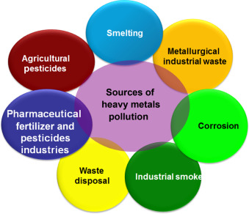
Fig. 3: Sources of heavy metals pollution (source of research Gate)
The table below listed the sources of environmental heavy metals along with their hazardous effects.
Table.1: Sources of heavy metals and their toxic effects
Heavy metals | Sources | Toxic reaction
Chromium  (Cr) | Treatment of wood, tanners for leather, insecticides, and colors | Vomiting, ulcers, diarrhea, fever, muscle cramps, changes in the genetic code. And can go into coma and sometimes mortality.
Cadmium  (Cd) | Batteries, fertilizers,  and electroplating | Lung cancer, immune system dysfunction, DNA deterioration, reduced growth, bone abnormalities, and mortality from pulmonary edema are possible side effects.
Copper  (Cu) | Wood treatment, fungicides, fertilizers, electrical products, and colors | Headaches, lightheadedness, nausea, diarrhea, irritation of the nose and mouth, as well as brain damage
Mercury  (Hg) | Mining, moving, and processing of plastic, batteries, fertilizers, and mercury ores | Headaches, sensory impairment, miscarriages, birth problems, and birth defects are some of the consequences.
Lead  (Pb) | Battery pressure and metal | Products biochemical modifications to renal function and rise of BP, as well as changes to hemoglobin production
Arsenic  (As) | Insecticides, paints, and timber treatments | DNA damage, stomach pain, infertility, and miscarriage in women who vomit
Source: (Pandey and Bagga, 2013)
Diffuse pollution or omnipresent pollution
The term "diffuse pollution" refers to contamination to facilitate is dispersed over very large areas, builds up in the soil, and lacks a single or obvious cause. Before toxins are transferred to soil, they must first be released, changed, and diluted in other media. This is known as diffuse pollution (FAO and ITPS, 2015). Pollutants are transported via systems of the soil, air, and water in diffuse pollution. Thus, in order to adequately quantify this type of contamination, complex analyses including these three compartments are required (Geissen et al.; 2015). Omnipresent pollution is therefore tough to trace and delineate its spatial range. It is also challenging to analyze. Since it is unclear how several contaminants that contribute to local pollution will behave in the ecosystem, it is possible that they will also contribute to diffuse pollution (Grathwohl and Halm, 2003). Examples of diffuse contamination include the agriculture's use of pesticides and fertilizers that also add heavy metals, persistent organic pollutants, too many surface runoff transports agrochemicals, fertilizers, and other pollutants downstream. The use of nuclear energy and the production of weapons, unrestricted polluted effluents discharged in and garbage disposal close to catchments are other causes of diffuse pollution. The environment and human health are significantly harmed by diffuse pollution, despite the fact that its intensity and scope are frequently unknown. Numerous studies have demonstrated that the topsoil is enriched with various metals and other substances related to air deposition from anthropogenic and natural sources.
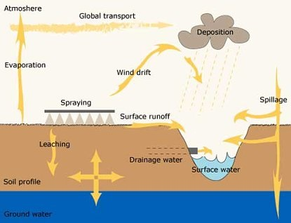Fig.4: Diffuse of Soil Pollution
Effects of soil contamination on ecology and food chain
Food production depends 95 percent on the soils, and both food quantity and nutritional value are beneficial to human fitness (Oliver and Gregory, 2015; FAO, 2015). The necessary ecology services and reliable supply of additional food and fiber can only be provided by healthy soils. Ecosystem services are "the capacity of natural processes and components to provide goods and services that satisfy human needs, directly or indirectly" (Groot, 1992). This concept has drawn a lot of attention. "Food security" is described as the supply of food and its accessibility, use, and stability. Because of the high levels of contaminants in the soil, agricultural yields are decreased and the foods produced are unfit for human utilization (FAO and ITPS, 2015).
Soil contamination of the food chain and plant uptake
Shows the food chain contamination pathways brought on by soil pollutants passing through plants.

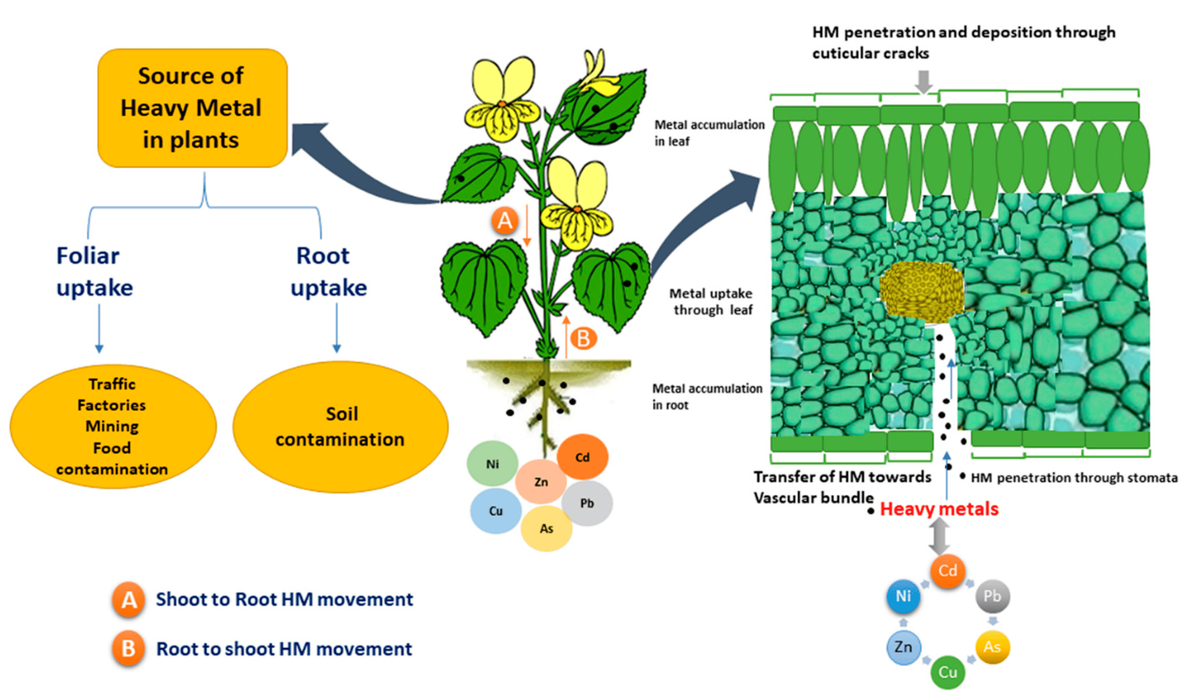 Fig. 5: contamination of the food chain, plants, and soil
If a contaminant poses a risk to animals and is extremely poisonous to plants at low concentrations and difficult to transfer to shoots, fruits, or tubers people, it is unlikely that it will reach the food chain and become a risk. About 40 years ago, Chaney gave this concept the moniker "Soil-Plant Barrier" for metals and metalloids (Chaney, 1980). In addition to affecting plant metabolism and agricultural yield, excess heavy metals in soils such as arsenic, cadmium, lead, mercury, and others can also strain arable land. When these toxins reach the food chain, they also jeopardize human health, food security, rural livelihoods, and water resources. Genetic and physiological variations in plants have an impact on the uptake and transport of metals into above-ground tissues (Chen, Li, and Shen, 2004). When metals reach plant tissues, they may interfere with a variety of metabolic functions, which can limit plant development, cause toxicity, and ultimately cause plant death. For example, high lead concentrations speed up the generation of reactive oxygen species, resulting in damage to the lipid membrane and chlorophyll, which further modifies the photosynthetic procedures and the overall growth of the plant (Najeeb et al. 2017). Reduced germination rates, oxidative damage, reduced root and shoot elongation, and changes in protein and sugar metabolism were the main consequences noted. The methods that soil contaminants are introduced into the food chain through plants. Pollutants may interfere with a number of metabolic processes once they penetrate plant tissues, decreasing plant growth, resulting in toxicity, and finally leading to plant death.
Effects of agricultural soil pollution on the environment
The introduction of pollutants, the discharge there has been reports of effluents being dumped onto land, or indirectly using dirty water to irrigate crops. Have contaminated large regions of soil resources and groundwater bodies. Through tainted food, this has reportedly had an impact on crop productivity as well as the health of people and animals (Saha et al., 2017). A major source of potential pollution in agricultural lands are agricultural inputs like antibiotics discovered in animal excrement, insecticides, or those used to treat plant diseases and infections. These inputs also present unique challenges because the chemical formulas they use are constantly changing (GSP, 2017).
Agriculture has been intensified to produce more food, fiber, and biofuels, which has led to a legacy of polluted soils. When compared to background levels in 1990, China's heavy metal over the past 30 years, with values ranging from 48 percent for zinc to over 250 percent for cadmium, concentrations has increased dramatically (Zeng, Li, and Mei, 2008). The dilemma of whether or not food grown on healthier soils has a higher nutritional value arises since it is still unclear how toxins go from the soil to plants. More scientific evidence is needed to persuade decision-makers, governments, and land users to embrace ecologically responsible practices rather than more financially oriented ones.
Human health risks associated with soil pollution
One of the main ways that heavy metals enter the food chain is through the absorption by plant roots, which varies depending on consumption. The elements that are most hazardous to humans are cadmium and lead. Humans obtain the majority of their Cd, Cr, Pb, As, and Ni consumption from food. Consuming persistent organic contaminants that have been dumped in soil can have serious health effects. Cadmium that has been consumed through food during pregnancy has the potential to cross the placenta and disrupt the fetus's membranes, DNA, and endocrine system. Among other organs, it can harm the bones, kidneys, liver, and liver. Pb is harmful to numerous organs, resulting in neurotoxicity and biochemical abnormalities in the liver, kidneys, spleen, and lungs, which mostly affects newborns and young children (Rodriguez Eugenio et al. 2018).
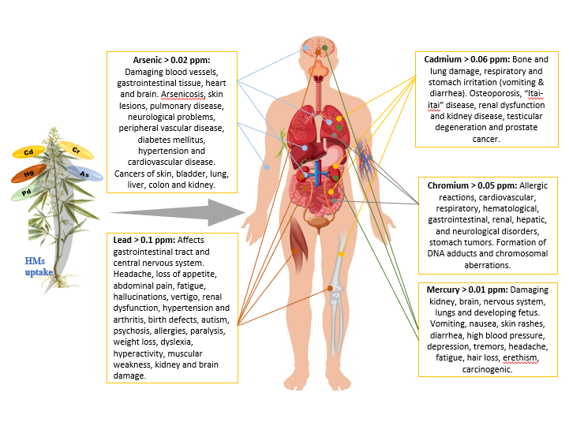
Fig. 6: Human health associated with heavy metals
Organic chemical contamination, including that involving PCBs, PAHs, and POPs; pharmaceutical contamination, including that involving estrogen and antibiotics; and elemental pollution, including that involving As, Cd, Cr, and Pb. The other three threats include nutritional inadequacies, under nutrition caused by deteriorating soils, and soil diseases like anthrax and prions. Many initiatives are being made to better understand the mechanisms underlying natural decrease of the negative consequences of hazardous contaminants on human health in the long term (Bernhardt and Gysi, 2016). However, the long-term effects of soil contamination on human health and the ecosystem are still unknown. Because human activities are concentrated on urban soils, these soils require special attention because Due to interactions with other health factors like food, air quality, and access to healthcare services for disease prevention, exposure patterns there are more complicated (WHO, 2013). The health of people, especially children, can be directly harmed by the heavy metals in urban soils because they can enter the body through skin absorption and dust inhalation, among other ways. They also contaminate the environment, including the air, water, and food, which is bad for human health (Yabe, J., and Ishizuka, M.; 2010). It was discovered that contaminated soil dust in the city played a significant role in influencing human health when it came to the Pb concentration of children's blood. The metabolism of calcium may be harmed by Cd, which will lead to calcium insufficiency, cartilage degeneration, and bone fractures. Cd is ranked as the sixth most dangerous toxin that harms human health by the ‘Agency for Dangerous Substances Management Committee’. Pb mostly enters the body of a living thing via the digestive and respiratory tracts before entering the bloodstream as soluble salts, protein complexes, or ions, among other forms. Bones store 95 percent of the insoluble phosphate lead. Pb has a powerful proorganizational effect; it harms and affects numerous bodily organs and systems, including the kidney, liver, reproductive, neurological, urinary, and immunological systems, as well as the fundamental physiological functions of cells and gene expression. Although, Zinc, Copper and Nickel are necessary trace elements for human health, they can be harmful if the body absorbs too much of them from the environment (China Chen, Y.F. 2011). Ni and Cu are factors that promote tumor growth, those who come into direct contact with Ni powder have a higher risk of developing pulmonary cancer, and environmental Ni concentrations are positively connected with nasopharyngeal cancer.
Human exposure to soil pollutants: Pathways and impacts on human health
The most important soil contaminants for human health and the dangers they pose. The method by which a human is exposed to a soil contamination will differ based on the contaminant itself as well as the surroundings and nearby activities (Shayler, McBride, and Harrison, 2009). Ingestion, eating animals or plants that have ingested significant amounts of soil contaminants, cutaneous exposure through using parks and gardens, and breathing in vaporized soil toxins are all ways that individuals might be exposed to soil contaminants (Khan et al. 2015). Science at the University of the West of England Communication Unit reported in 2013 that air pollution deposition and secondary poisoning of water supplies can both have an effect on people. In these two processes, soils can occasionally be a substantial source of pollutants.
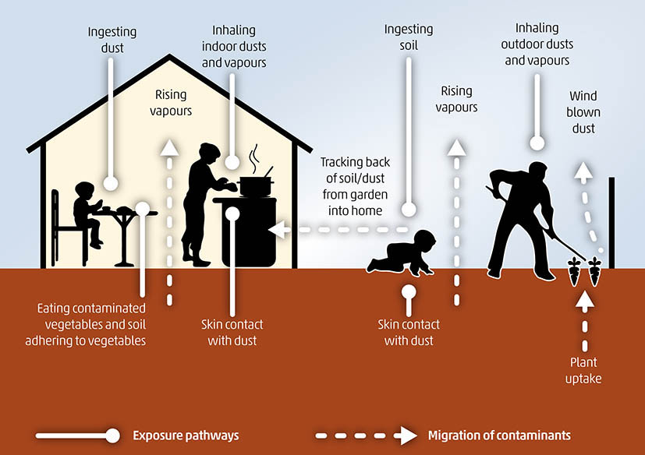
Fig.7: Routes of human exposure and the effects of soil pollutants on health
Numerous chemicals, or groups of chemicals, are transported to food and water from polluted soils sources, including highly hazardous pesticides (HHP), dioxin and dioxin-like substances, and soil pollutants like Cd, Pb, Cr, and Hg. HHPs are categorized as pesticides with extremely. According to widely acknowledged classification systems or their inclusion in significant legally binding international agreements or conventions, there are substantial levels of both acute and chronic dangers to human health and the environment. Moreover, insecticides that under the circumstances of use in a nation tend to have a negative impact on human health or the environment may be considered to be very dangerous and treated as such (FAO and WHO, 2016). The groups most at risk for long-lasting effects from pesticide exposure include children, pregnant women, and those who are undernourished. If food is contaminated by soil-borne microorganisms, there are dangers to human health. In addition, 24% of the world's population has helminthes infections, which cause nutritional imbalance and chronic anemia (WHO, 2017a). Eating contaminated food has been related to more than 200 diseases, including cancer and diarrhea (WHO, 2017b). Cd is primarily taken up by people through food. A well-known case from Japan is itai-itai, a disease brought on by consuming rice that has been polluted with Cd (Abrahams, 2002). Methyl mercury is thought to be the most harmful of the organo-mercuric compounds. Mercury exposure can have deadly effects on a person's nervous system and digestive system. Arsenic, which has been identified as carcinogenic, is absorbed into the body through ingestion or inhalation and mainly accumulates having lower amounts in the muscle and nerve tissue, in the liver, kidneys, heart, and lungs (Brevik, 2013).

Conclusion:
One of the most common types of pollution is soil contamination, which is actually brought on by human activity, such as the use of chemicals manufactured by humans. The primary reason is industrial activity, which releases hazardous compounds into the soil and contaminates or pollutes it. Additionally, agricultural pesticides are contributing to soil contamination. Additionally, one of the main causes of this is the inappropriate disposal of human waste. In fact, this kind of pollution not only impairs the fertility of the soil but also contaminates and pollutes subsurface water supplies and hastens the spread of infectious diseases. The detrimental effects of this pollution should be avoided, hence these efforts should be made to halt it. Phytoremediation is the best technique for removal of heavy metals from the contaminated soils. Phytoremediation technique is an ecological and chiefly method, through which contamination of the substrates are ameliorated by growing plants that have the capability to remove the contaminated soils.

→→ О ←←

References:
- Abrahams, P.W., (2002). Soils: their implications to human health. Science of the Total Environment, 291(1-3): 1-32.
- Ahmad, M.S. & Ashraf, M., (2011). Essential roles and hazardous effects of nickel in plants. Reviews of environmental contamination and toxicology, 214: 125-167.
- Alloway, B.J. ed., (2013). Heavy Metals in Soils: Trace Metals and Metalloids in Soils and their Bioavailability. Third edition. Environmental Pollution. Springer Netherlands.
- Bernhardt, A. & Gysi, N., (2016). World’s Worst Pollution Problems. The toxic beneath our feet. , p. 56. Green Cross Switzerland and Pure Earth Foundation.
- Brevik, E.C., (2013). Soils and human health: An overview. In E.C. Brevik & L.C. Burgess, eds. Soils and human health, pp. 29-58.
- Burgess, L.C., (2013). Organic pollutants in soil. In: Brevik, EC. And Burgess, L.C. Eds. Soil and Human Health. Boca Raton. CRC Press. pp. 83-102.
- Certini, G. Scalenghe, R. & Woods, W.I., (2013). The impact of warfare on them soil environment. Earth-Science Reviews, 127:1-15.
- Chaney, R.L., (1980). Health risks associated with toxic metals in municipal sludges. In G. Bitton, B.L. Damron, G.T. Edds & J.M. (eds) Davidson, eds. Sludge: health risks of land application. pp. 59-83. Ann Arbor, MI.
- Chen, Y. Li, X. & Shen, Z., (2004). Leaching and uptake of heavy metals by ten different species of plants during an EDTA-assisted phytoextraction process. Chemosphere, 57(3): 187-196.
- China Chen, Y.F., (2011). Review of the research on heavy metal contamination of China’s city soil and its treatment method. China Population, Resources and Environment, 21(3): 536-539.
- DalCorso, G., (2012). Heavy metal toxicity in plants. In: Furini, A. (Ed.), Plants and heavy metals, Springer: Dordrecht, 1-25.
- Doelsch, E. Saint Macary, H. & Van de Kerchove, V., (2006). Sources of very high heavy metal content in soils of volcanic island (La Réunion). Journal of Geochemical Exploration, 88(1-3): 194-197.
- FAO & ITPS. (2015). Status of the World’s Soil Resources (SWSR) - Main Report. Rome, Italy, food and Agriculture Organization of the United Nations and Intergovernmental Technical Panel on Soils.
- FAO & WHO, eds., (2016). International Code of Conduct on Pesticide Management. Guidelines on Highly Hazardous Pesticides. Health and safety guide No. 41. Rome, Italy, Food and Agriculture Organization of the United Nations. 24 pp.
- García-Pérez, J. Boldo, E. Ramis, R. Pollán, M. Pérez-Gómez, B. Aragonés, N. & López-Abente, G., (2007). Description of industrial pollution in Spain. BMC Public Health, 7(1).
- Geissen, V. Mol, H., Klumpp, E. Umlauf, G. Nadal, M. van der Ploeg, M. van de Zee, S.E.A.T.M. & Ritsema, C.J., ( 2015). Emerging pollutants in the environment: A challenge for water resource management. International Soil and Water Conservation Research, 3(1): 57-65.
- Ghosh, M. Singh, S. P., (2005). A review on phytoremediation of heavy metals and utilization of its byproducts. As J Energy Env, 6, 214-231.
- Gianfreda, L. and Rao, M.A., (2008). Interactions between xenobiotics and microbial and enzymatic soil activity. Critical Reviews. Environmental Science and Technology, 38(4): 269-310.
- Gill, M., (2014). Heavy metal stress in plants: a review. Int J Adv Res, 2, 1043-1055.
- Grathwohl, P. & Halm, D. eds., (2003). Integrated soil and water protection: risk from diffuse pollution. Cluster meeting; 2nd, Innovative management of groundwater resources in Europe - training and RTD coordination; Sustainable management of soil and groundwater resources in urban areas.
- Groot, R.S. de., (1992). Functions of nature: evaluation of nature in environmental planning. Management and decision making. Groningen, Wolters-Noordhoff. 315 pp.
- GSP. (2017). Report of the Fifth Meeting of the Plenary Assembly (PA) of the Global Soil Partnership (GSP). Rome, Italy, Food and Agriculture Organization of the United Nations.
- Hashim MA, Mukhopadhyay S, Sahu JN, Sengupta B., (2011). Remediation technologies for heavy metal contaminated groundwater. Jounal of Environmental Management, 92-10:2355-2388.
- Havugimana, E. Bhople, B.S. Kumar, A. Byiringiro, E. Mugabo, J.P. and Kumar, A., (2015). Soil pollution–major sources and types of soil pollutants. Environmental Science and Engineering, 11: 53-86.
- Hoornweg, D. & Bhada-Tata, P., (2012). What a waste. A Global review of solid waste management. Knowledge papers. The World Bank.
- Jalmi, S. K. Bhagat, P. K. Verma, D. Noryang, S. Tayyeba, S. Singh, K. Sharma, D. Sinha, A. K., (2018). Traversing the links between heavy metal stress and plant signaling. Front Plant Sci, 9, 12.
- Jones, D. L. Cross, P. Withers, P.J. DeLuca, T.H. Robinson, D.A. Quilliam, R.S. Harris, I.M. Chadwick, D.R. and Edwards‐Jones, G., (2013). Nutrient stripping: the global disparity between food security and soil nutrient stocks. Journal of Applied Ecology, 50(4): 851-862.
- Kalaivanan, D. Ganeshamurthy, A. N., (2016). Mechanisms of heavy metal toxicity in plants. In: Rao, N. Shivashankara, K., Laxman, R. (Eds.), Abiotic stress physiology of horticultural crops, Springer: New Delhi, 85-102.
- Kanter, D.R., (2018). Nitrogen pollution: a key building block for addressing climate change. Climatic Change, 147(1-2): 11-21.
- Keshavarzi, B. Abbasi, S. Moore, F. Mehravar, S. Sorooshian, A. Soltani, N. and Najmeddin, A., (2018). Contamination level, source identification and risk assessment of potentially toxic elements (PTEs) and polycyclic aromatic hydrocarbons (PAHs) in street dust of an important commercial center in Iran. Environmental management, 62(4): 803-818.
- Khan, A. Khan, S., Khan, M.A. Qamar, Z. & Waqas, M., (2015). The uptake and bioaccumulation of heavy metals by food plants, their effects on plants nutrients, and associated health risk: a review. Environmental Science and Pollution Research, 22(18): 13772-13799.
- Kim, K.-R., Owens, G. Kwon, S.-I. So, K.-H., Lee, D.-B. & Ok, Y.S., (2011). Occurrence and Environmental Fate of Veterinary Antibiotics in the Terrestrial Environment. Water, Air, & Soil Pollution, 214(1-4): 163-174.
- Leon, P.M., (2008). Invertebrate life cycle responses to PAC exposure. PhD thesis.Amsterdam: University of Amsterdam.
- Li, J.-S. Beiyuan, J. Tsang, D.C.W. Wang, L. Poon, C.S. Li, X.-D. & Fendorf, S., (2017). Arseniccontaining soil from geogenic source in Hong Kong: Leaching characteristics and stabilization/solidification. Chemosphere, 182: 31-39.
- Mileusnić, M. Mapani, B.S. Kamona, A.F. Ružičić, S. Mapaure, I. & Chimwamurombe, P.M., (2014). Assessment of agricultural soil contamination by potentially toxic metals dispersed from improperly disposed tailings, Kombat mine, Namibia. Journal of Geochemical Exploration, 144: 409-420.
- Mirsal, I., (2008). Soil Pollution: Origin, Monitoring & Remediation. Springer Science & Business Media. 310 pp.
- Mourato, M. P. Moreira, I. N. Leitao, I. Pinto, F. R. Sales, J. R. Martins, L. L., (2015). Effect of heavy metals in plants of the genus Brassica. Int J Mol Sci, 16, 17975-17998.
- Najeeb, U. Ahmad, W. Zia, M.H. Zaffar, M. & Zhou, W., (2017). Enhancing the lead phytostabilization in wetland plant Juncus effusus L. through somaclonal manipulation and EDTA enrichment. Arabian Journal of Chemistry, 10: S3310-S3317.
- Oliver, M.A. & Gregory, P.J., (2015). Soil, food security and human health: a review: Soil, food security and human health. European Journal of Soil Science, 66(2): 257-276.
- Pandey SS, Bagga D., (2013). Phytoremediation an Alternative. International Journal of Environmental Engineering and Management. 4:483 488.
- Raju, K.V. Somashekar, R.K. and Prakash, K.L. (2013). Spatio-temporal variation of heavy metals in Cauvery River basin. Proceedings of the International Academy of Ecology and Environmental Sciences, 3(1): 59-75.
- Rascio, N. Navari-Izzo, F., (2011). Heavy metal hyperaccumulating plants: how and why do they do it? And what makes them so interesting? Plant Sci, 180, 169-181.
- Rattan RK, Datta SP, Chhonkar PK, Suribabu K, Singh AK., (2005) Long-term impact of irrigation with sewage effluents on heavy metal contents in soils, crops and ground water-A case study. Agric Ecosys Env 109:210-322.
- Rodríguez-Eugenio, N. McLaughlin, M. and Pennock, D., (2018). Soil Pollution: a hidden reality. Rome, FAO. 142 pp.
- Saha, J.K. Selladurai, R. Coumar, M.V. Dotaniya, M.L. Kundu, S. & Patra, A.K., (2017). Soil Pollution - An Emerging Threat to Agriculture. Environmental Chemistry for a Sustainable World. Singapore, Springer Singapore.
- Saha, J.K. Selladurai, R. Coumar, M.V. Dotaniya, M.L. Kundu, S. & Patra, A.K., (2017). Soil Pollution - An Emerging Threat to Agriculture. Environmental Chemistry for a Sustainable World.
- Sayadi, M.H. and Rezaei, M.R. (2014). Impact of land use on the distribution of toxic metals in surface soils in Birjand city, Iran. Proceedings of the International Academy of Ecology and Environmental Sciences, 4(1): 18-29
- Sayyed, M.R. and Sayadi, M.H., (2001). Variations in the heavy metal accumulations within the surface soils from the Chitgar industrial area of Tehran. Proceedings of the International Academy of Ecology and Environmental Sciences, 1(1): 36-46
- Science Communication Unit, University of the West of England., (2013). Science for Environment Policy In-depth Report: Soil Contamination: Impacts on Human Health. Bristol, UK, European Commission DG Environment.
- Shahid, M. Khalid, S. Abbas, G. Shahid, N. Nadeem, M. Sabir, M. Aslam, M. Dumat, C. (2015). Heavy metal stress and crop productivity. In: Hakeem, K. (Ed.), Crop production and global environmental issues. Springer, Cham, 1-25.
- Shayler, H. McBride, M. & Harrison, E., (2009). Sources and Impacts of Contaminants in Soils.
- Stewart, W.M., Dibb, D.W. Johnston, A.E. & Smyth, T.J., (2005). The Contribution of Commercial Fertilizer Nutrients to Food Production. Agronomy Journal, 97(1): 1.
- Swartjes, F.A. ed., (2011). Dealing with Contaminated Sites. Dordrecht, Springer Netherlands.
- Tsion, K. and Steven, W., (2019). An overview use and impact of organic and synthetic farm inputs in developed and developing countries. African Journal of Food, Agriculture, Nutrition and Development, 19(3): 14517-14540.
- Varalakshmi LR. Ganeshamurthy AN., (2012). Heavy metal contamination of water bodies, soils and vegetables in periurban areas of Bangalore city of India. Journal of Horticultural Science, 7:62-67.
- Varjani, S. Kumar, G. and Rene, E.R.,(2019). Developments in biochar application for pesticide remediation: current knowledge and future research directions. Journal of Environmental Management, 232: 505-513.
- Venuti, A. Alfonsi, L. & Cavallo, A., (2016). Anthropogenic pollutants on top soils along a section of the Salaria state road, central Italy. Annals of Geophysics (5).
- WHO. (2013). Contaminated sites and health. Copenhagen, Denmark.
- WHO. (2017b). Food safety. In: WHO
- Wuana RA, Okieimen FE., (2011). Heavy Metals in Contaminated Soils: A Review of Sources, Chemistry, Risks and Best Available Strategies for Remediation. ISRN Ecology, 1-20.
- Yabe, J. and Ishizuka, M., (2010). Current levels of heavy metal contamination in Africa. Journal of Veterinary Medical Science, 72(10): 1257-1263.
- Zeng, X. Li, L. & Mei, X., (2008). Heavy Metal Content in Chinese Vegetable Plantation Land Soils and Related Source Analysis. Agricultural Sciences in China, 7(9): 1115-1126.
- Zhang, H. Luo, Y. Wu, L. Huang, Y. & Christie, P., (2015a). Residues and potential ecological risks of veterinary antibiotics in manures and composts associated with protected vegetable farming. Environmental Science and Pollution Research, 22(8): 5908-5918.
- Zhang, H. Wang, Z. Zhang, Y. Ding, M. & Li, L., (2015b). Identification of traffic-related metals and the effects of different environments on their enrichment in roadside soils along the Qinghai- Tibet highway. Science of the Total Environment, 521-522: 160-172.
- Zojaji, F. Hassani, A.H. and Sayadi, M.H., (2014). Bioaccumulation of chromium by Zea mays in wastewater–irrigated soil: An experimental study. Proceedings of the International Academy of Ecology and Environmental Sciences, 4(2): 62-67.

