Review of Data Science in Business Intelligence and a Future View
Dr.G.Babu
Assistant Professor
Directorate of Online Education
SRM Institute of Science and Technology (SRMIST), Kattankulathur
Mail: babug2@srmist.edu.in

Abstract:
Business Intelligence is a set of processes, architectures, and technologies that convert raw data into meaningful information that drives profitable business actions. It is a suite of software and services to transform data into actionable intelligence and knowledge.BI directly impacts the organization’s strategic, tactical and operational business decisions. BI supports fact-based decision-making using historical data rather than assumptions and gut feeling.BI tools perform data analysis and create reports, summaries, dashboards, maps, graphs, and charts to provide users with detailed intelligence about the nature of the business.. Business Intelligence has a direct impact on strategic, tactical, and operational business decisions in organizations. It allows for fact-based decision-making based on historical data rather than assumptions and gut instinct. Business Intelligence tools analyze data and generate reports, summaries, dashboards, maps, graphs, and charts to provide users with detailed business intelligence One of the primary reasons businesses invest time, money, and effort in Business Intelligence is because it allows them to better observe and analyze current customer purchasing trends. Business Intelligence involves monitoring the performance of Key Performance Indicators and therefore it is volumetric in nature. The . origin of Data Science and its requirement for a challenging mix of capability in data analytics, information technology, and business know‐how. The mission of Data Science is to provide new or revised computational theories able to extract useful information from the massive volumes of data collected at an accelerating pace and provide a multi-disciplinary overview of the research issues and achievements in the field of Business Intelligence in the data analysis.
Keywords—component;

I. Introduction and Rationale of a Business Inteligence
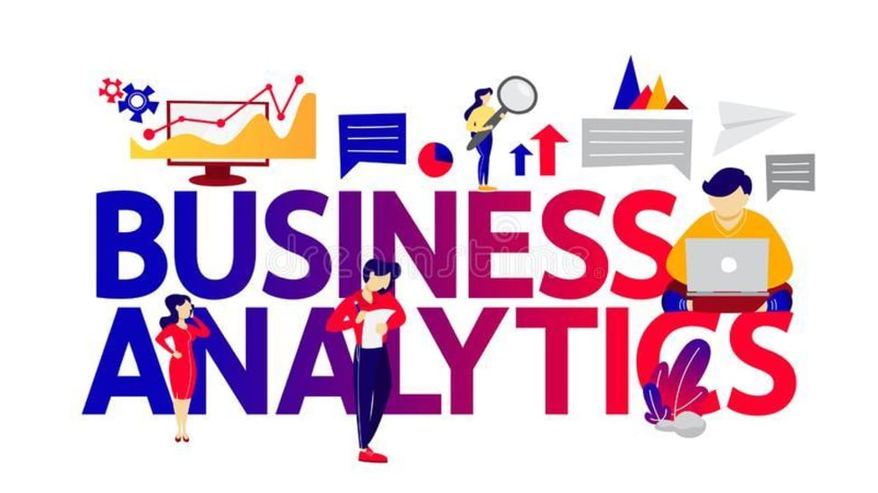
The whole history of humanity is an enormous accumulation of data. Information has been stored for thousands of years. Data has become an integral part of history, politics, science, economics and business structures, and now even social lives. This trend is clearly visible in social networks such as Facebook, Twitter and Instagram where users produce an enormous stream of different types of information daily (music, pictures, text, etc.) [1]. Now, government, scientific and technical laboratory data as well as space research information are available not only for review, but also for public use. For instance, the 1000 Genomes Project [2, 3] provides 260 terabytes of human genome data. More than 20 terabytes of data are publicly available at Internet Archive [4, 5], ClueWeb09 [6], among others. BI tools perform data analysis and create reports, summaries, dashboards, maps, graphs, and charts to provide users with detailed intelligence about the nature of the business Many companies and open-source projects see the future of Big Data Analytics via Visualization, and are establishing new interactive platforms and supporting research in this area.
BI Important
- Measu rement: creating KPI (Key Performance Indicators) based on historic data
- Identify and set benchmarks for varied processes.
- With BI systems organizations can identify market trends and spot business problems that need to be addressed.
- BI helps on data visualization that enhances the data quality and thereby the quality of decision making.
- BI systems can be used not just by enterprises but SME (Small and Medium Enterprises)
How Business Intelligence systems are implemented?
Here are the steps:
Step 1) Raw Data from corporate databases is extracted. The data could be spread across multiple systems heterogeneous systems.
Step 2) The data is cleaned and transformed into the data warehouse. The table can be linked, and data cubes are formed.
Step 3) Using BI system the user can ask quires, request ad-hoc reports or conduct any other analysis.

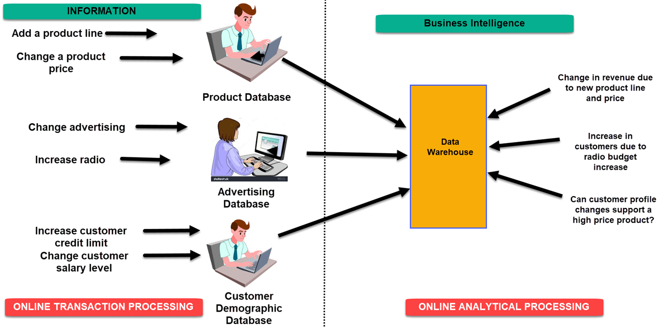

Figure 1 Examples of Business Intelligence System

Advantages of Business Intelligence
Here are some of the advantages of using Business Intelligence System:

A Boost productivity
With a BI program, It is possible for businesses to create reports with a single click thus saves lots of time and resources. It also allows employees to be more productive on their tasks.
B. To improve visibility
BI also helps to improve the visibility of these processes and make it possible to identify any areas which need attention.
C Fix Accountability
BI system assigns accountability in the organization as there must be someone who should own accountability and ownership for the organization’s performance against its set goals.[5]
D. It streamlines business processes:
BI takes out all complexity associated with business processes. It also automates analytics by offering predictive analysis, computer modeling, benchmarking and other methodologies.

II. Data Science : an overview
Businesses employ data scientists, who collect, clean, organize, and analyze large data sets, in order to solve a business problem and develop actionable insights. In their daily work, consequently, data scientists plunder big data to determine trends and predictions and form conjectures that companies use to make decisions about their operations, target audiences, or products. Data is all around us. But, how are businesses actually using data in their daily operations?In this Chapter , you'll learn more about how businesses use data science, common benefits of data science in business, and encounter the skills you'll need to become a data scientist[8].

A. Impact of data science in business
Adding data science to your business practices can make a marked difference in productivity, decision-making, and product development. It can help you minimize or eradicate the risk of fraud and error, increase efficiency, and provide better customer service. Data scientists can also help automate time-consuming functions in your business to leave more critical tasks to human hands and minds. Consider the following key benefits data science brings to companies.

Making better business decisions
Companies can use data and risk analysis practices to make informed business decisions. The collection and analysis of data collected within the company can assist higher-ups by providing objective evidence to direct difficult business choices.

Measuring performance

Data science allows businesses to measure performance through data collection to make more educated decisions across the organization by using trends and empirical evidence to help them come up with solutions.

Providing information to internal finances .The company can also use data science to make predictions, generate financial reports, and analyze economic trends so you can make informed decisions on budget, finances, and expenses. This will allow for a fully optimized revenue generation with an accurate picture of what is going on with internal finances.

Developing better products

Data analysis can use a data-driven approach to provide verifiable and evidence-based numbers that allow a company to reach its target audiences, find what its audiences enjoy, and then cater its products to that audience.

Increasing efficiency
With data collection in the workplace, a business can allow for testing and measuring different methods and feedback from workplace operations. Data can enable the company to grow and take on more load by increasing the efficiency of daily operations and work volume[12] Collecting manufacturing data can allow companies to iron out inefficiencies and optimize production. A high amount of volume collected from manufacturing machines can provide critical data to increase production efficiency and maximize output.

III Differences Between Data Science and Business Analytics
The chapter discuss Data Science and Business Analytics. Both Data Science and Business Analytics involve data gathering, modeling, and insight gathering. The difference between the two is that Business Analytics is specific to business-related problems like cost, profit, etc. In contrast, Data Science answers questions like the influence of geography, seasonal factors, and customer preferences on the business. In short, Data Science is larger or superset of the two. Data Science combines data with algorithm building and technology to answer various questions. Recently Machine Learning and Artificial Intelligence have been doing their rounds and are set to take Data Science to the next level[12]. Business Analytics, on the other hand, is the analysis of company data with statistical concepts to get solutions and insights.using statistics, algorithms, and technology, whereas Business Analytics is the Statistical study of business data.
- Data Science is a relatively recent development in the field of analytics, whereas Business Analytics has been in place ever since the late 19th century.
- Data Science involves a lot of coding skills, whereas Business Analytics does not involve much coding.
- Data Science is a superset of Business Analytics. So, a person with Data Science skills can do Business Analytics but not vice versa.
- Data Science is a step ahead of Business Analytics, which is a luxury. However, Business Analytics is mandatory for a business to understand the working and gain insights.
- Data Science analysis results cannot be used in the day-to-day decision-making of the company, whereas Business Analytics is vital in management making key decisions.
- Data Science does not answer a clear-cut question. The questions are mostly general. Business Analytics, however, answers very specific business-related questions, mostly financial.
- Data Science can answer questions that Business Analytics can but not vice versa.
- Data Science uses both structured and unstructured data, whereas Business Analytics uses mostly structured data.
- Data Science has the potential to take leaps and bounds, especially with the coming up of Machine Learning and Artificial Intelligence, whereas Business Analytics is still taking slow steps.
- Data Scientists do not come across much dirty data, unlike Business Analysts.
- Data Science depends to a large extent on the availability of data, whereas Business Analytics is not.
- The cost of investing in Data Science is high, whereas that of Business Analytics is low.
- Data Science can keep pace with the Data of today. Data has grown and branched into a variety of data. Data Scientists are equipped with the right skills to deal with this. Business Analysts, however, do not possess this.

Data science for business decision making is very much a reality. It is the cornerstone of business foundations in the information age. Its applications extend beyond just extrapolating insights. The curated findings help maximize efficiency. A prevalent case in point is the repurposing of data for charting buyer personas that can be (re)targeted for marketing campaigns and brand building.
Decision-makers have their hands full with figuring out the crossover benefits of data science which include but are not limited to the following:
- Fraud detection
- Financial risk management
- Cyberattack mitigation
- Industrial mechanization and management
- Advance warning systems for IT teams
Data is not just an asset, but an intercontinental currency. It can be used to optimize a company’s capabilities beginning from organizational supply chains, inventories, distribution networks, to customer service and marketing channels. The aim of this hands-on approach is to reduce capital expenditure with an outcome-oriented view of revenues.
Some of the immediate benefits of data science for businesses are increased ROIs, improved sales, streamlined operations, a quicker turnaround time for products, and increased customer engagement and satisfaction.
Quality data synthesis can lead to quantification of results and a better overview of what works and what doesn’t. Million-dollar campaigns shouldn’t be run based on whim. Instead, they should be guided by numerical evidence that outlines cost savings, business process optimization, and time-saving workflows.
While the aforementioned marquee characteristics are universal, specific value additions depend on the nature of the industry. In startups and enterprises that have a consumer-facing frontend, data can indicate the ideal target audience. Marketing divisions can utilize campaign performance data to churn hot leads and push up their conversion rates leading to better sales.

IV How Does Data Science and Analytics Work?
Data science isn’t any magic. The process involves various steps starting from asking the right questions to communicating the analysis results clearly and using data analytics for business decision making. This workflow is described below: 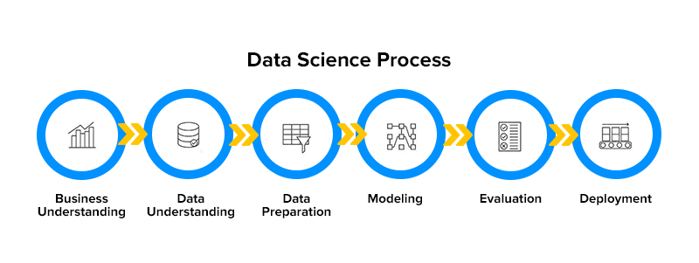

Figure 2 Data Science and Analytics Work Process

1. Asking the right questions
While this might seem obvious, asking the right questions is necessary to get insightful results using data science. For instance, if you ask a question that is too ambiguous (“what type of customers are good for our business”), you will not get the desired result. Data scientists can help you better frame questions, thereby ensuring that you get the required answers.

2. Getting the right data
Once you have the right questions, a data scientist can help determine how to collect the required data for analysis. In some cases, you will already be having the data and in others, you may need to seek out new data sources.

3. Cleaning the data
Data cleaning is one of the most important aspects of the data science process. At this step, you prepare datasets for analysis by fixing or removing the data points that are corrupted, inaccurate or incomplete.

4. Analyzing the data
The core of the data science process, at this step you finally start analyzing the prepared datasets and create models. Data analysis is an iterative process and might need different parameters to be adjusted along the way.

5. Comprehending the results
Once the process of data analysis is complete, the data scientist finally explains the analysis to the stakeholders through various data visualization techniques and determines how it can be applied to achieve improved business outcomes.

V.Industrial Applications of Data Science

Anomaly Detection
Anomalies are outliers in the data sets that disrupt the standards of a data cluster. This is an important application as even minutiae of deviation in data can lead to disastrous impacts.

Pattern Recognition
It is vital to a company’s existential interest to make a product offering that is relevant to the customer’s buying patterns. These patterns can be crafted after carefully sifting through big data and performing trend analysis. Pattern recognition is a fundamental method by which seasonal highs and lows can be deciphered. Speech recognition, stock trading, natural language processing, risk management, and computer vision are all applications of pattern recognition through data science.[3]

Predictive Modeling
Flexible and nimble is always better than rigid and non-conformist. In the same vein, predictive modeling is a top-up on formulae-driven training sets. It needs to be mentioned that predictive modeling is not new, and has been around for some time. But data science ameliorates it by incorporating machine learning and deep learning. Predictive analytics in business helps close the gaps. As an example, it is called upon to be used in industrial manufacturing to minimize equipment breakdown.

Recommendation Engines
Don’t we love personalization for our favorite products?
Recommendation engines enable brands to score high on the customer satisfaction scale. They help business analysts envision the way marketing campaigns should be designed, to extend a befitting offer to the customer at the most opportune time. This helps in customer retention. Netflix and Amazon are typical examples of companies that deliver hyper-personalized experiences for customers using data science and machine learning[9].

Classification & Categorization
Working through structured data is rather simple. But developments in deep learning and artificial neural networks have allowed teams to manage unstructured data sets be it images, text, multimedia files, or textual documents. Through this use of data science for small business applications[11] as well as legacy corporations, the macroeconomic ecosystem is benefitting at large.

Sentiment & Behavioral Analysis
Data analytics for small businesses and enterprises has come off age with sentiment and behavioral analysis. Through this approach, data is manoeuvered to determine the underlying sentiment of customers. As the behavioral patterns are identified the product usage trends can be tracked and monetized.

Conversational Systems
A data analytics guide cannot be complete without mentioning conversational AI-powered interfaces. These days, the building tools for enterprise data science applications include technologies that can automate mundane, repetitive tasks[5].
Such operations have a high dependency on human intervention. By introducing automation for such recurring KRAs, the workforce can be reallocated to more productive assignments. Intelligent agents, voice-led messenger bots, and text-to-speech interfaces are prime examples of conversational systems. Here’s an article to help you understand how bots would mold the future of work.

Autonomous Systems
Machine learning is a science that effectuates AI programs to learn and relearn from mistakes for self-correction. Such has been ML’s contribution to this industry that it has multiplied the applications of data science for business verticals. It has had a direct say in the ongoing shapeshifts in IoT and bot development.
Self-supervising robots are handling the bulk load of operations in mechanized warehouses. Self-driving cars are becoming a reality. Sooner than later, a self-sufficient world is emerging thanks to the contribution of data analytics for business owners.

VI. Data Science Use Cases
The applications of data science for enterprises as well as small businesses are only limited by our imagination. The reach and means of this technology are branching out to help industries at scale[8]
Entertainment: Over-the-Top streaming platforms such as Netflix are applying data science techniques to perform sentiment analysis of their subscribers. This helps in delivering hyper-personalization experiences and a higher customer retention rate as viewers are served content based on their preferences.
Financial Services: Customer portfolios go through a heavy-handed analysis through training models so as to squelch out imposters, fraudulent transactions, carry out risk management, and identify potential openings for upselling products.
Healthcare: This sector is trying out multiple approaches to tap into AI, some of which you’d find in this article. The impact of data science and analytics on business decision-making can be understood by the fact that there is a high-level consensus to implement computer vision in a bid to identify disease symptoms that may skip human observation.
AI and ML are lifting the hopes of medical professionals to detect life-threatening ailments at an early stage and therefore support the idea of algorithms scanning millions of patient records for relevant signs.
Manufacturing: The commercial use of data science for business leaders is evident in the fact that the tech is being widely trusted to optimize supply chains, predict equipment breakdowns and streamline distribution.
Check out this article to know how big data is used in manufacturing in detail.
Retail: Major retailers use data science and analytics to optimize inventory, manage supply chains, and architect precision-driven retargeting campaigns for outcome-oriented marketing. Check out this article to know why your retail business should up investments in data analytics.
Logistics: Shipments and delivery routes are being optimized thanks to data science applications so that customers world over get their orders on time.
Travel: From passenger loads to airplane routes and customized ticketing platforms, AI, ML, and other subsets of data science are well-ingrained within the commercial side of businesses in the travel industry.While these are some of the preliminary use cases which are visible to all, there are other industries that deserve an honorable mention such as cybersecurity, cloud computing, and business process outsourcing.

VII. Conclusion
Data science can add value to any business who can use their data well. From statistics and insights across workflows and hiring new candidates, to helping senior staff make better-informed decisions, data science is valuable to any company in any industry.. Know a day’s data science becomes as a mandatory field which coordinates between multi disciplines like mathematics, statistical approaches, mathematical methods, logical reasoning, intelligence algorithms and machine learning practical’s. All these fields correlate to access the data from various business or organizations and make use of them in effective means. These effective use of data leads to perform proper decision making to grow business further on the basis of customer chooses and satisfaction. Hence we can conclude that rise of data science field can demand more positions of data scientists to grow in each organization. At last we focus on how successful carriers can be built in the field of data science. The main beauty of this field it used to grow all businesses.
References
[1]. Russell, Stuart J., and Peter Norvig. Artificial intelligence: a modern approach. Malaysia; Pearson Education Limited,, 2016.
[2]. Nilsson, Nils J. Principles of artificial intelligence. Morgan Kaufmann, 2014. 3.
[3] Bell, Jason. Machine learning: hands-on for developers and technical professionals. John Wiley & Sons, 2020.
[4] Van Der Aalst, Wil. "Data science in action." Process mining. Springer, Berlin, Heidelberg, 2016. 3-23.
[5]. Dhar, Vasant. "Data science and prediction." Communications of the ACM 56.12 (2013): 64-73.
[6]. Hazen, Benjamin T., et al. "Data quality for data science, predictive analytics, and big data in supply chain management: An introduction to the problem and suggestions for research and applications." International Journal of Production Economics 154 (2014): 72-80.
[7]. Wimmer, Hayden, and Loreen Marie Powell. "A comparison of open source tools for data science." Journal of Information Systems Ap]plied Research 9.2 (2016): 4.
[8]. Islam, Mohaiminul. "Data Analysis: Types, Process, Methods, Techniques and Tools." International Journal on Data Science and Technology 6.1 (2020): 10.
[9]. Nicolae, Bogdan, et al. "Park, Yoonho. Leveraging Adaptive I/O to Optimize Collective Data Shuffling Patterns for Big Data Analytics. IEEE TRANSACTIONS ON PARALLEL AND DISTRIBUTED SYSTEMS. PP (99) pp: 1-13." (2020). 1
[10]. Abas, Zuraida Abal, et al. "Analytics: A Review Of Current Trends, Future Application And Challenges." Journal of Advanced Computer Technology. PP 3560 (2020): 3565.
[11] Rani, Bindu, and Shri Kant. "An Approach Toward Integration of Big Data into Decision Making Process." New Paradigm in Decision Science and Management. Springer, Singapore, 2020. 207-215.
[12]. Bejjam, Suvarnamukhi & Seshashayee, M.. (2018). Big Data Concepts and Techniques in Data Processing. International Journal of Computer Sciences and Engineering. 6. 712-714.

