EVIDENCE BASED PRACTICE
Ragni Dubey*
Assistant Professor, NRI Institute of Nursing Bhopal, Madhya Pradesh
INTRODUCTION
Evidence-based practice (EBP) is the careful use of current best evidence in making patient care choices.. EBP in nursing is a way of providing nursing care that is guided by the integration of the best. It is a problem-solving approach to clinical practice and administrative issues that integrates. A systematic search for and critical appraisal of the most relevant evidence to answer a burning clinical question One's own clinical expertise Patient preferences and values.
When compared to the original term, evidence-based medicine (EBM), evidence-based practice describes a broader, more comprehensive field. The notion of EBM was introduced into medical research in 1991, but it wasn't until 2005 that a more comprehensive approach was adopted. It was discovered that comparable ideas may be applied in domains other than medicine. The EBP process is a method that allows the practitioner to assess research, clinical guidelines, and other information resources based on high quality findings and apply the results to practice.
EBP also involves integrating the best available evidence with clinical knowledge and expertise, while considering patients’ unique needs and personal preferences. If used consistently, optimal patient outcomes are more likely to be achieved.
Using EBP means abandoning outdated care delivery practices and choosing effective, scientifically validated methods to meet individual patient needs. Health care providers who use EBP must be skilled at discerning the value of research for their specific patient population.
Evidence-based practice (EBP) is a critical concept in nursing and a fundamental component of providing great patient care. EBP in nursing is the integration of scientific evidence, clinical competence, and the preferences of the patient. This problem-solving approach to clinical practice pushes nurses to give personalized care to patients. EBP has developed over time to now integrate the best research evidence, clinical expertise, the patient's individual values and circumstances, and the characteristics of the practice in which the health professional works.³
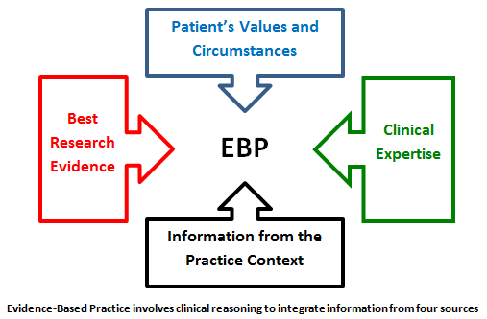
DEFINITION
- The deliberate, transparent, and prudent application of current best evidence in making decisions concerning individual patient treatment.
- Combining personal experience with the most recent external clinical data from systematic study.
- Scientific knowledge combined with nursing competence. This method necessitates nurses critically evaluating relevant scientific facts or research findings and implementing high-quality treatments in their nursing practice.
- In 2005, the Sicily Statement on Evidence-Based Practice was produced, and it defined EBP in a similar fashion, but with minor changes to make it relevant in disciplines other than medical practice. It emphasizes that choices about a patient's healthcare should always be made on the basis of relevant, recent, and confirmed evidence; however, the patient should also be presented with the same evidence before completing any treatment plan. The data and the best available treatment routes must be simplified and communicated to a patient by concerned healthcare providers so that the patient may make an educated decision.
- However, before concluding any treatment plan, the patient should be supplied with the same evidence. Concerned healthcare providers must simplify and explain the facts and the best potential treatment routes to a patient so that the patient may make an educated decision.

Need for Evidence Based Practice:
- To ensure that each client receives the best possible service.
- To keep up to date on new developments.Provide clinical judgment
- Improvement care provided and save lives.
EBP is one useful approach to improving the impact of practice in nursing.
EBP put particular emphasis on the result of experimental comparisons.

Steps in EBP Process:
The Evidence-Based Practice enables practitioners to evaluate current and previous research, clinical recommendations, and other information resources.
The stages in the EBP Process are as follows:
- Formulating a well – built question
- Finding evidence
- Appraising the evidence
- Applying the evidence/ make clinical decision
- Re – evaluation.
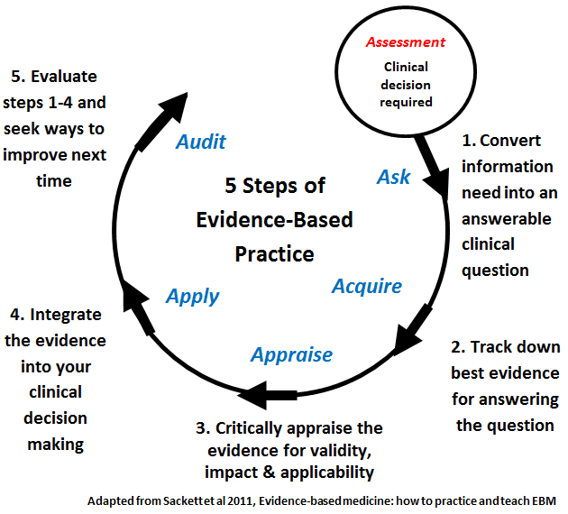

AIM OF EBP
To do the right thing, at the right time, for the right person, ensure quality care for the individual client.
Needed skills for EBP
- Observant and sensitive
- Clinical competence. Knowledge
- Communication
- Learner
- Practitioner
- Learning skills
- Research competent.
EBP PROCESS

Frame question
Select key words
Reevaluate access evidence

Evaluate evidence
Resources of EBP
- Background information/Expert opinion [Books]
- Research articles/ Studies [PubMed]
- Evidence guidelines
- Evidence summaries and abstracts
- Systematic reviews and meta analyses.

EBP IN NURSING
It should be remembered that Florence Nightingale employed similar principles to treat troops in the mid-1800s, long before evidence-based medicine became a field. Of course, EBP in nursing has gone a long way since then, but her latter work is regarded as having set the groundwork for modern nursing. Today, evidence-based nursing education and practice revolve around a few key processes, which include:
Value Establishment and Preparation – It is also referred to as Step 0 in EBP since it entails instilling in nursing students the importance, advantages, and value of implementing evidence-based practice. Step 0 is all about getting people ready to embrace the Spirit of Inquiry.centered on a few major phases such as:
Training in EBP – EBP training for nurses to learn the information and skills needed to properly apply the discipline inpatient care. PICOT - PICOT stands for the five factors of developing a patient inquiry. The letters stand for the following:
- P – Patient/patients concerned
- I – Intervention
- C – Comparison
- O – Outcome
- T – Time

EBP PRINCIPLES FOR PATIENT SAFETY
- First, assess the context and involve point-of-care health care staff in the selection and prioritization of patient safety initiatives, explicitly articulating the evidence base (strength and kind) for the patient safety practice topic(s) and the conditions or environment to which it applies. These communication messages must be thoughtfully crafted and tailored to each stakeholder user group.
- Second, demonstrate why the organization and individuals within the organization should commit to an evidence-based safety practice subject using qualitative or quantitative data (e.g., near misses, sentinel incidents, adverse events, injuries from adverse events). Clinicians are more involved in implementing patient safety programs when they understand the scientific foundation, as opposed to administrators who say, "We must do this because it is an external regulatory requirement." For example, it is critical to educate busy clinicians on the evidence-based rationale for performing fall-risk assessments and to help them understand that fall-risk assessment is an external regulatory agency expectation because the strength of the evidence supports this patient safety practice.
- Third, didactic instruction alone can never influence behavior; one-time teaching on a specific safety effort will not enough. Improving understanding may not always translate into better practice. Rather, businesses must invest in the tools and skills required to foster a culture of evidence-based patient safety practices in which inquiries are welcomed and procedures are designed to make doing the right thing simple.
- Fourth, the context of EBP patient safety improvements must be addressed at each stage of the implementation process; piloting the change in practice is critical to determining the fit between the EBP patient safety information/innovation and the setting of care delivery. There is no single method for implementation, and what works in one agency may need to be modified to meet the organizational culture of another.
- Finally, it is critical to assess the implementation methods and outcomes. Users and stakeholders must understand that efforts to increase patient safety have a beneficial influence on care quality. For example, if a new barcoding system is used to deliver blood products, it is critical to understand if the steps in the process are being followed (process indicators) and whether the change in practice is resulting in fewer blood product transfusion mistakes (outcome indicators).
Advantages of EBP
- Provide better information to practitioner
- Enable consistency of care
- Better patient outcome
- Provide client focused care
- Structured process
- Increases confidence in decision – making
- Generalize information
- Contribute to science of nursing
- Provide guidelines for further research
- Help nurses to provide high quality patient care.
Disadvantages of EBP
- Not enough evidence for EBP
- Time consuming
- Reduced client choice
- Reduced professional judgment/ autonomy
- Suppress creativity
- Influence legal proceedings
- Publication bias.

BENEFITS OF EBP
EBP is the only reasonable approach of developing a treatment plan since it is founded on medical facts rather than speculation. If we were to list the exact benefits that the discipline brought to healthcare, they would be as follows. Structure - EBP is a step-by-step approach for determining the appropriate treatment and care plans for each patient. Because the standardized protocols are evidence-based and confirmed, the final treatment plan has a better likelihood of success. Recent and Relevant - Evidence in the form of lab exam results and the most recent discoveries serve as the foundations of EBP therapy and care. Senior doctors frequently prescribe opinion-based treatment regimens, which is an obsolete practice since it may not take into consideration the most current advances in medical research.
In many cases, the senior professional will disregard the necessity for proof in favor of his or her professional opinion on the problem.
Increased Accountability – Most hospitals and clinics have now implemented a clear, step-by-step, evidence-based strategy. As a result, it is rather simple to trace accountability to the relevant healthcare practitioner. This has resulted in win-win scenarios for both the patient and the healthcare professional.
If a patient is dissatisfied with the outcome of an evidence-based treatment plan, they can contact a lawyer to look for inconsistencies between the actions that should have been taken based on the available data and the ones that were actually done. At the same time, if the practitioner followed all established EBP practices, they are far less likely to be sued by dissatisfied patients.
Improved Chances of Positive Outcomes – Treatment and care plans are significantly more likely to work when they are completely in sync with the most recent medical facts, patient preferences, and strong real-time evidence. If waiting is an option in the lack of proof, it is preferable. In most circumstances, uninformed speculation might cause more harm than benefit.
Customization – Patients had little to no input in the ultimate course of action prior to EBP since they were not given access to their own treatment plans. As we stated in the concept of evidence-based practice, including the patient is an essential component of the whole strategy.
Hierarchy of Evidence
- Systematic reviews and meta analysis
- Randomized controlled trials with definitive results
- Randomized controlled trials with non definitive results
- Cohort studies
- Case control studies
- Cross- sectional studies
- Case reports.
Models of EBP in clinical setting
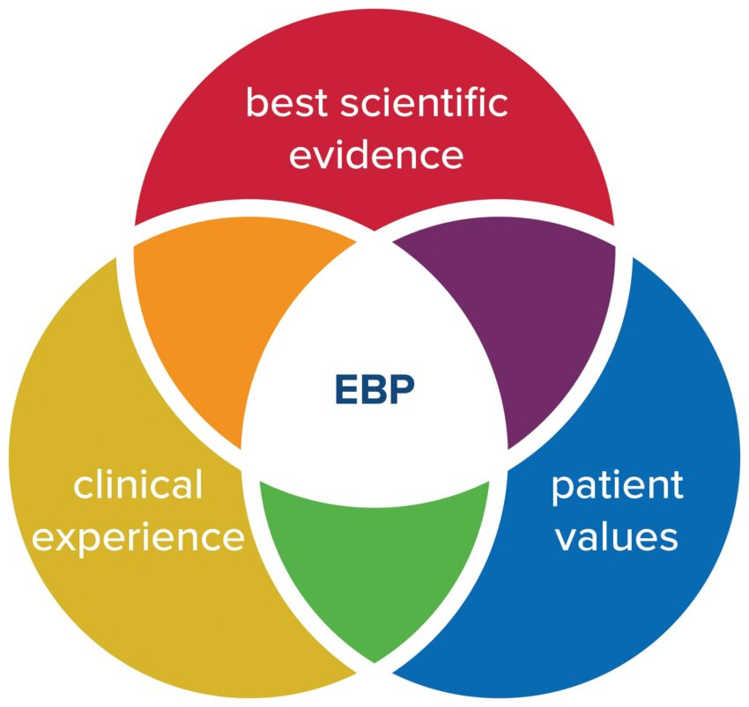
A = Clinical expertise
B= patient value
C=best evidence
John Hopkins nursing EBP model

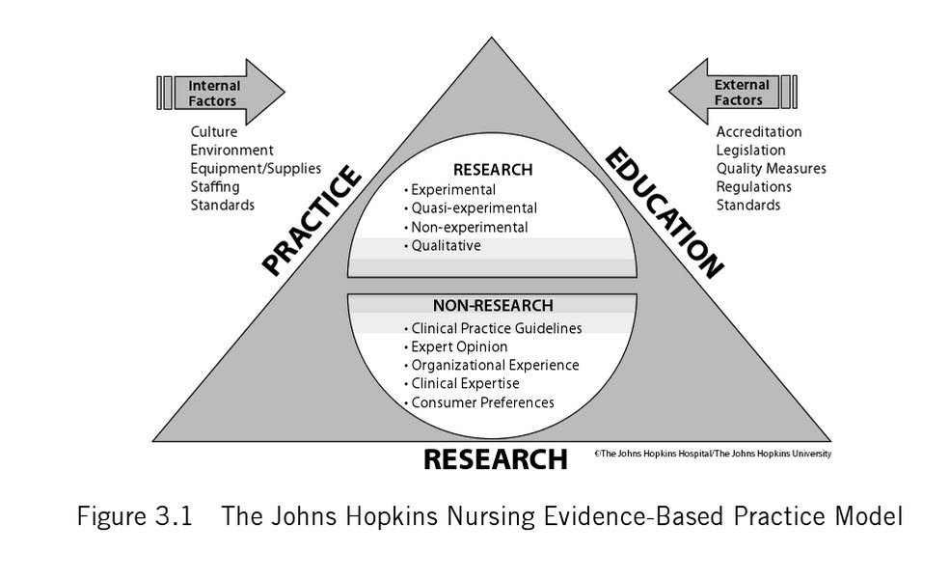
Expert opinion
- Research
- Patient experience
- Practitioner expertise
- Other evidence
Barriers in EBP
- Lack of value for research in practice
- Difficulty in bringing change
- Lack of administrative support
- Lack of knowledge mentors
- Lack of time for research
- Lack of knowledge about research
- Research reports not easily available
- Complexity of research reports
- Lack of knowledge about EBP.

Conclusion
The goal of conducting EBP is to utilize current knowledge and connect it with patient preferences and clinical expertise to standardize and improve care processes and, ultimately, patient outcomes. Regarded as key decision makers within the healthcare team. They are also expected to use the best available evidence in their judgments and decisions. The prescriptive model of evidence-based decision making and the search-appraise- implement process that accompanies it is an active process. Evidence-based practice is gaining traction in nursing, although definitions vary greatly. Research results, fundamental scientific information, clinical knowledge, and expert opinion are all regarded "evidence"; nevertheless, actions based on research findings are more likely to result in the intended patient outcomes across a variety of contexts and geographic locations. Evidence-based practice necessitates improvements in student education, more practice-relevant research, and tighter collaboration between clinicians and researchers. Evidence-based practice also allows nursing care to be more customized, effective, streamlined, and dynamic, as well as to optimize the impacts of clinical judgment. Nursing care stays up with the newest technology breakthroughs and takes use of new knowledge developments when evidence is utilized to determine best practices rather than to support existing practices.
References
- Constance 1 Milton. Evidence-based practice: Ethical question for nursing. Nursing science quarterly 2007 20 (2):123-26.
- Diane s.pravikoff, susan T pierce,annelle tanner. Evidence-based practice: readiness study supported by academy nursing informatics experts panel nursing outlook 2003; 53(1): 49-50
- Katheleen s,oman,Christine duran,Regina Fink. Evidence-based policy and procedures: An Algorithm for success. The journal of nursing administrations 200;38(1):47-51.
- Makhija Neelam. Application and utilization of Research in Practice: Evidence-based practice.Nursing Nightingale Times 2007:18-20.
- Marianne Matzo evidence for Excellence, American Journal of Nursing 2008:108(8):73-74.
- Polit Denise F,Beck Cheryl Tatano. Nursing Research principal and Methods: utilizing Research : Putting Research Evidence into Nursing practice, 7th edition. Lippincott Williams and Wilkins 2008;673-99.
- http://localhost/f: /Evidence-based practice:.mht
- http://localhost/f:/ implementing Evidence-based practice-Evidence-based practice:.mht

