An introduction to energy consumption in Wireless Sensor Node and different types of Routing for Energy conservation
Dr. Preetha P, Head of Department, Electronics and Communication Engineering, Department of Technical Education, Kerala.
Dr. N. V. Eldhose, Research Guide in Electronics, Mahatma Gandhi University, Kerala.

Introduction
In recent times, smart sensor nodes are used in most walks of life, supporting various monitoring and tracking applications [1]. A few of the possible applications are depicted in figure 1.1. The key enabler of this proliferation is the deployment of wireless sensor nodes as the last mile connection points for the Internet of Things (IoT) [2]. Several such nodes constituting a Wireless Sensor Network (WSN) assimilate data from the environment and link it up to the internet or a dedicated network.
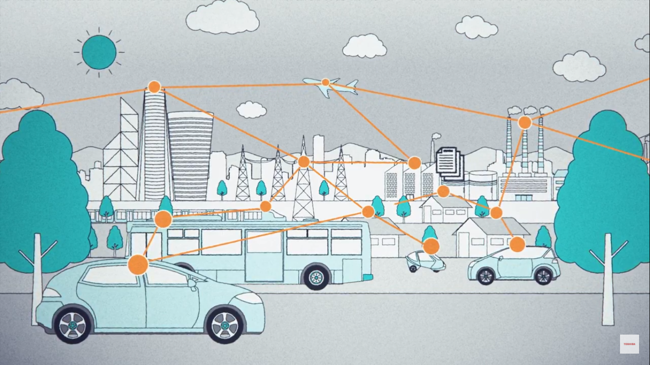
Fig. 1: The WSN world

1 Wireless Sensor Network
A typical Wireless Sensor Network will have sensor nodes deployed in the field [3]. These sensor nodes pick up data from the environment and transfer it to a centralized location for processing and display on a human machine interface. These are used in applications spanning from personnel safety monitoring in hazardous areas to defence monitoring, smart homes and weather monitoring, to name a few [4][5][6][7][8][9].
The terminologies associated with wireless sensor networks are explained below.

1.1 Wireless Sensor Node
A sensor node (SN) has the capabilities to sense, process, and communicate data to a required destination [10]. A sensor node achieves this through the use of three modules built into it, namely Sensor-Module, Processor-Module and Communication-Module as depicted in figure 1.2.
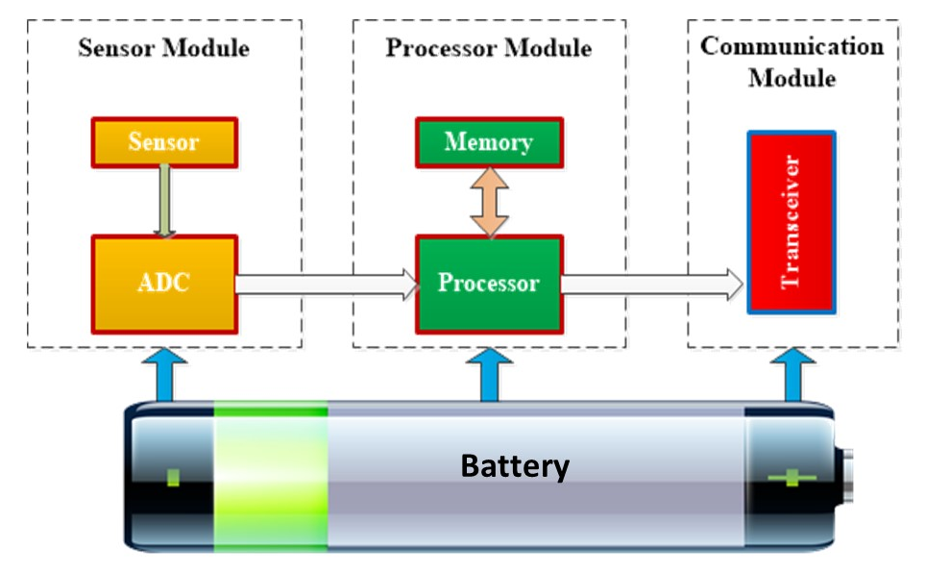
Fig. 2: Block diagram of wireless sensor node

Sensor Module
The sensor module provides a link between the real world and the virtual world [10]. It responds to stimuli from the environment like temperature, pressure or humidity and generates an electrical signal proportional to the intensity of the stimulus. The continuous analog signal is digitized using an analog to digital converter (ADC). The digital signal thus generated is sent to the processor.

Processor Module
The processor module carries out the conditioning of the raw data obtained from the sensor module before passing it on to the Communication Module [11]. It also schedules tasks, processes data and performs control functions for the whole module. For carrying out these functions, this module relies on the processor and memory sub-modules.

Communication Module
The communication module provides the connectivity between sensors and the remote processing facility. For this, the transceiver sub-module establishes a radio link for uplink/ downlink over which data transfer takes place [12].

Power Source and energy consumption
For keeping the sensor module, processing module and communication module up and running, an embedded power source, typically in the form of an inbuilt battery, is provided. Since the power that can be stored in a battery is finite, conservative use of the available energy becomes a crucial factor for the longevity of a sensor node [13].

Fig. 3: Energy consumed by various modules of a wireless sensor node
Relative power demand by various modules in a sensor node is depicted in the chart above. As can be seen in figure 1.3, the major power demand on the battery is due to the communication module. Hence any improvement in the serviceable life of a sensor node will have to focus on this area [14].

1.2 Base Station
Base Station (BS), also known alternatively as Sink or Sink node, provides the connectivity for the field-deployed sensor nodes with the remote processing center. A BS, in contrast to the sensor nodes, has access to unlimited power sources and unconstrained computational facilities [15].

1.3 Transmission Round
Transmission round is the specific time period in which data from a sensor node is transmitted to its destination. A typical transmission sequence starts with the BS initiating the request for data transfer with the sensor node. Sensor nodes in turn will carry out the required data processing and send the same over the radio interface to the BS [15].

1.4 Network Lifetime
Network lifetime is the prime factor for ensuring the widespread adoption of WSNs. The lifetime of the network is calculated as the number of transmission rounds completed from the starting time to the time where only a percentage of the initial nodes are operational [16]. The number of transmissions for which all the nodes are alive, 90% of nodes alive, 50% or half of the nodes alive (HNA) and 25% or a quarter of nodes alive (QNA) are taken according to requirements.

2 Classification of WSN
WSNs are categorized based on the network topology or type of nodes. WSNs when classified based on network-connection-topology, result in Flat and Hierarchical Networks [17]. Based on the type and characteristics of nodes, WSNs are classified as Homogeneous and Heterogenous networks.

2.1 Flat and Hierarchical Networks
In the field of WSNs, two types of network topologies are used. One is known as Flat topology and the other is Hierarchical topology [18].
Flat Topology
In flat topology, hierarchy is non-existent, as shown in figure 1.4a. All sensor nodes perform the same job of gathering and disseminating information. The network is not divided into either layers or groups. The nodes communicate with a base station or with other nodes. In every transmission round, each node collects the data and sends it to the sink or base station. The disadvantage here is that lot of energy is expended in data transmission between the sensor node and the sink node.
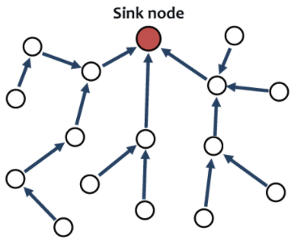
Fig. 4a: A flat wireless sensor network

Hierarchical Topology
The entire sensor network is split into smaller groups called clusters as shown in figure 1.4b. This process is known as clustering. One of the nodes will be elected as a cluster head (CH) and other nodes will be called cluster members of their respective cluster. Cluster heads are responsible for collecting data from their member sensor nodes within the clusters, aggregating them and routing it to a remote base station or sink node directly or through other CHs. Since only the cluster head communicates with the base station, the energy expenditure during this type of routing will be lesser. Therefore, hierarchical routing based on clustering becomes one of the most effective ways to conserve energy in a wireless sensor network.
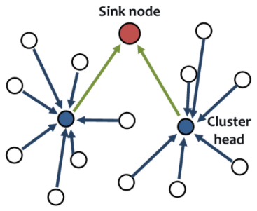
Fig. 4b: A Hierarchical wireless sensor network

2.2 Homogeneous and Heterogeneous Networks
In homogeneous networks (figure 1.5a), all sensor nodes have the same energy, processing and communication capabilities [19]. Consequently, the role of CH is assigned, in a random manner to one of the nodes in the cluster. Heterogenous networks (figure 1.5b), consist of sensor nodes having different energy and functional capabilities [20]. Hence CHs are chosen from the subgroup of nodes provided with additional capabilities.
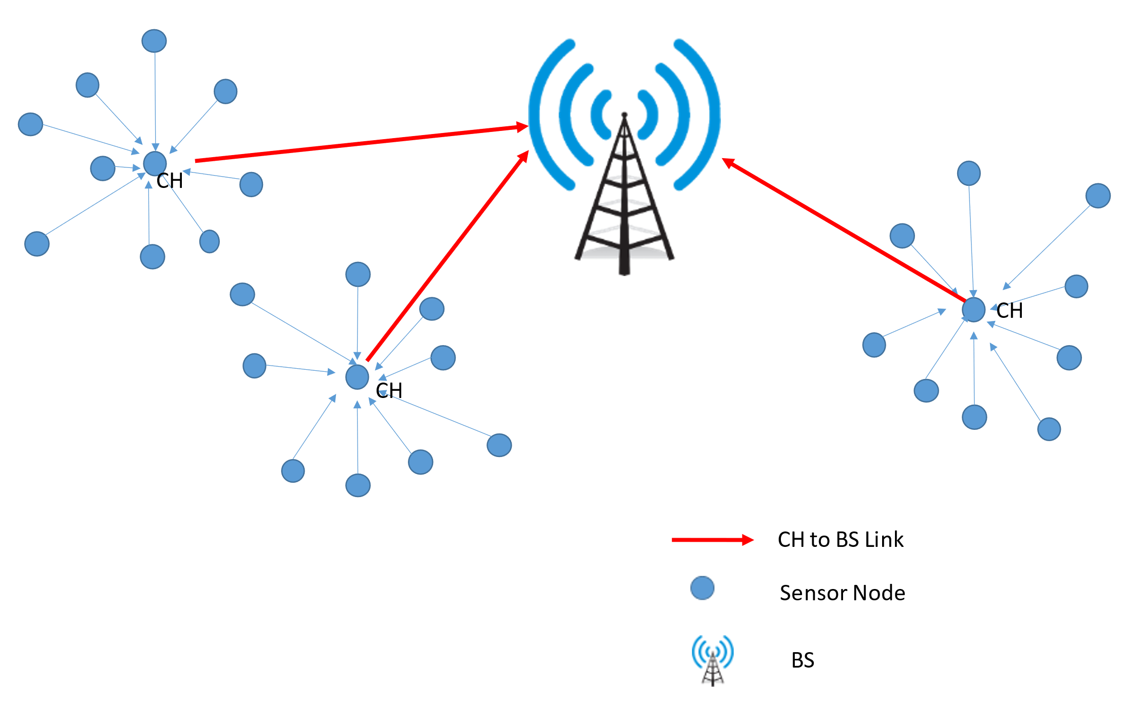
Fig. 5a: Homogeneous WSN
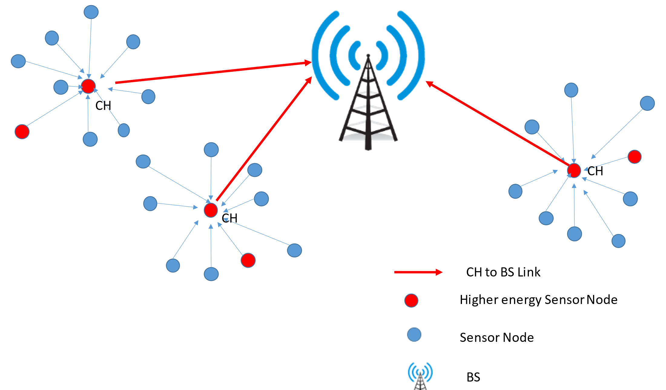
Fig. 5b: Heterogeneous WSN

3 Hierarchical Routing
Hierarchical routing is a feasible solution for reducing the energy consumption in WSN by reducing the redundant data transmission through clustering [21] [22]. Hierarchical routing aims at conserving the stored energy of the nodes leading to network lifetime enhancement. The routing approach can broadly be classified as the Classical Approach and Optimization based Approach.
Classical Routing
In classical routing, cluster head nodes are selected randomly. This might cause uneven depletion of power sources in sensor nodes [23].
Optimization-based Routing
To improve the energy efficiency, optimization algorithms such as Genetic Algorithm (GA), Ant Colony Algorithm (ACA), Particle Swarm Optimization (PSO), Artificial Bee Colony Algorithm (ABC) and Flower Pollination Algorithm (FPA) are used. This provides optimal solutions for the challenges in WSN viz, energy efficiency and consequent longevity issues [24][25][26] [27] [28].
Since the cluster heads are responsible for data fusion, data aggregation and transmission to BS, they will be depleted of stored energy faster [29]. To avoid premature failure of cluster heads, the role of the cluster head is rotated among all nodes [30] [31].
Once the cluster head is selected, the cluster is formed based on the conditions as per the scenario. In the case of fixed clustering, every network will have a fixed number of clusters. Whereas in the case of dynamic clustering, the number of clusters and members in each cluster will be varied [32].

4 Research Background
We are living in a world where everything is getting connected to everything else, whereby making every device smarter. WSNs find applications in a wide variety of sectors as shown in figure 1.6 [33]
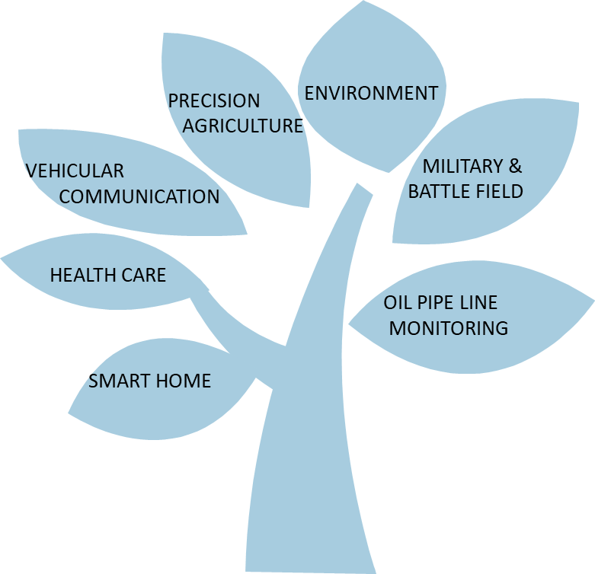
Fig. 6: WSN Applications
This is made possible only because these devices can connect without wires and cables. However, with no wires, these nodes are completely dependent on their internal energy sources for meeting their sensing and communication needs [34]. A node with a depleted battery will cease to perform its function.
Hence, among the above challenges, energy efficiency which impacts the life of nodes and consequently the acceptability of WSNs is chosen as the focus area for this research.

5 Challenges in WSN
- Energy requirement
Sensor nodes are battery operated and the amount of energy that can be packed into a battery is limited [35].
- Memory and processing limitation
Sensor nodes are designed with limited memory and processing abilities for limiting the power demand and for making them cost-effective [36].
- Scalability
Usually, in a network, nodes are deployed in large numbers and this calls for a system capable of handling large amounts of data and data generating nodes [37].
- Limited bandwidth
WSNs need to strike a balance between cost effectiveness and communication channel capabilities [38].
- Adaptability
WSNs need to evolve through accommodating mobility of sensor nodes and substitution of failed nodes [39].

6 Conclusion and Future scope
Sensor nodes are expected to operate continuously in the unattended area for long periods of time. It is extremely difficult to manually replenish the nodes because of their enormous number, maintenance costs and the inaccessibility of monitored regions.
There is a rapid growth of IoT-based wireless systems over the past few years. The battery operated IoT heterogeneous devices have to run for longer periods to fulfil their assigned tasks[40]. Moreover, the large-scale deployment leads to higher energy demand and this results in a reduced lifetime of devices. Thus, conserving battery power by minimizing energy consumption becomes very significant in extending the network lifetime.
Any research in this area strengthens the roots of IoT which is expanding into newer horizons. More and more devices can be integrated into the internet of things, without becoming overly concerned about the loss of nodes due to power exhaustion, aiding the proliferation of WSNs into hitherto unchartered domains.

References
[1] G. S. Gaba, G. Kumar, T. H. Kim, H. Monga, and P. Kumar, “Secure Device-to-Device communications for 5G enabled Internet of Things applications,” Computer Communications, vol. 169, pp. 114–128, Mar. 2021, doi: 10.1016/J.COMCOM.2021.01.010.

[2] “I. Yaqoob et al., ‘Internet of Things Architecture: Recent Advances, Taxonomy, Requirements, and Open Challenges,’ in IEEE Wireless Communications, vol. 24, no. 3, pp. 10-16, June 2017, doi: 10.1109/MWC.2017.1600421.”.
[3] M. Younis and K. Akkaya, “Strategies and techniques for node placement in wireless sensor networks: A survey,” Ad Hoc Networks, vol. 6, no. 4, pp. 621–655, Jun. 2008, doi: 10.1016/J.ADHOC.2007.05.003.
[4] “Vaiyapuri, T., Parvathy, V.S., Manikandan, V. et al. A Novel Hybrid Optimization for Cluster‐Based Routing Protocol in Information-Centric Wireless Sensor Networks for IoT Based Mobile Edge Computing. Wireless Pers Commun (2021). https://doi.org/10.1007/s”.
[5] P. Kakria, N. K. Tripathi, and P. Kitipawang, “A real-time health monitoring system for remote cardiac patients using smartphone and wearable sensors,” International Journal of Telemedicine and Applications, vol. 2015, 2015, doi: 10.1155/2015/373474.
[6] N. A. Q. Al-aboody, “Energy-Efficient Routing Protocols for Heterogeneous Wireless Sensor Networks with Smart Buildings Evacuation”.
[7] K. K. Khedo, Y. Bissessur, and D. S. Goolaub, “An inland Wireless Sensor Network system for monitoring seismic activity,” Future Generation Computer Systems, vol. 105, pp. 520–532, Apr. 2020, doi: 10.1016/J.FUTURE.2019.12.025.
[8] Y. Zhong, T. Bi, J. Wang, S. Wu, T. Jiang, and Y. Huang, “Low data regimes in extreme climates: Foliage penetration personnel detection using a wireless network-based device-free sensing approach,” Ad Hoc Networks, vol. 114, Apr. 2021, doi: 10.1016/ j.adhoc.2021.102438.
[9] M. S. Bensaleh, R. Saida, Y. H. Kacem, and M. Abid, “Wireless Sensor Network Design Methodologies: A Survey,” Journal of Sensors, vol. 2020, 2020, doi: 10.1155/2020/9592836.
[10] S. Tariq, Z. Hu, and T. Zayed, “Micro-electromechanical systems-based technologies for leak detection and localization in water supply networks: A bibliometric and systematic review,” Journal of Cleaner Production, vol. 289. Elsevier Ltd, Mar. 20, 2021. doi: 10.1016/j.jclepro.2020.125751.
[11] A. Saini, A. Kansal, and N. S. Randhawa, “Minimization of Energy Consumption in WSN using Hybrid WECRA Approach,” Procedia Computer Science, vol. 155, pp. 803–808, Jan. 2019, doi: 10.1016/J.PROCS.2019.08.118.
[12] N. K. Suryadevara, S. C. Mukhopadhyay, S. D. T. Kelly, and S. P. S. Gill, “WSN-based smart sensors and actuator for power management in intelligent buildings,” IEEE/ASME Transactions on Mechatronics, vol. 20, no. 2, pp. 564–571, Apr. 2015, doi: 10.1109/TMECH.2014.2301716.
[13] E. D. Tita, W. P. Nwadiugwu, J. M. Lee, and D. S. Kim, “Real-time optimizations in energy profiles and end-to-end delay in WSN using two-hop information,” Computer Communications, vol. 172, pp. 169–182, Apr. 2021, doi: 10.1016/j.comcom.2021.02.007.
[14] N. Sharma, B. M. Singh, and K. Singh, “QoS-based energy-efficient protocols for wireless sensor network,” Sustainable Computing: Informatics and Systems, vol. 30, Jun. 2021, doi: 10.1016/ j.suscom. 2020. 100425.
[15] V. Mhatre and C. Rosenberg, “Design guidelines for wireless sensor networks: Communication, clustering and aggregation,” Ad Hoc Networks, vol. 2, no. 1, pp. 45–63, Jan. 2004, doi: 10.1016/S1570-8705 (03) 00047-7.
[16] A. Ray and D. De, “Energy efficient clustering protocol based on K-means (EECPK-means)-midpoint algorithm for enhanced network lifetime in wireless sensor network,” IET Wireless Sensor Systems, vol. 6, no. 6, pp. 181–191, Dec. 2016, doi: 10.1049/IET-WSS.2015.0087.
[17] A. Panchal and R. K. Singh, “EEHCHR: Energy Efficient Hybrid Clustering and Hierarchical Routing for Wireless Sensor Networks,” Ad Hoc Networks, vol. 123, Dec. 2021, doi: 10.1016/j.adhoc.2021.102692.
[18] N. Sabor, S. Sasaki, M. Abo-Zahhad, and S. M. Ahmed, “A comprehensive survey on hierarchical-based routing protocols for mobile wireless sensor networks: Review, taxonomy, and future directions,” Wireless Communications and Mobile Computing, vol. 2017, 2017, doi: 10.1155/2017/2818542.
[19] I. F. Akyildiz, W. Su, Y. Sankarasubramaniam, and E. Cayirci, “Wireless sensor networks: A survey,” Computer Networks, vol. 38, no. 4, pp. 393–422, Mar. 2002, doi: 10.1016/S1389-1286(01)00302-4.
[20] L. Qing, Q. Zhu, and M. Wang, “Design of a distributed energy-efficient clustering algorithm for heterogeneous wireless sensor networks,” Computer Communications, vol. 29, no. 12, pp. 2230–2237, Aug. 2006, doi: 10.1016/j.comcom.2006.02.017.
[21] S. Kaur, R. N. Mir, A. Khamparia, P. Rani, D. Gupta, and A. Khanna, “Heterogeneous load balancing clustering protocol for Wireless Sensor Networks,” Cognitive Systems Research, vol. 70, pp. 10–17, Dec. 2021, doi: 10.1016/j.cogsys.2021.07.001.
[22] P. Rawat and S. Chauhan, “Clustering protocols in wireless sensor network: A survey, classification, issues, and future directions,” Computer Science Review, vol. 40, May 2021, doi: 10.1016/j.cosrev.2021.100396.
[23] R. C. Shah and J. M. Rabaey, “Energy aware routing for low energy ad hoc sensor networks,” IEEE Wireless Communications and Networking Conference, WCNC, vol. 1, pp. 350–355, 2002, doi: 10.1109/ WCNC.2002.993520.
[24] B. Shahi, S. Dahal, A. Mishra, S. B. V. Kumar, and C. P. Kumar, “A Review over Genetic Algorithm and Application of Wireless Network Systems,” in Physics Procedia, Jan. 2016, vol. 78, pp. 431–438. doi: 10.1016/j.procs.2016.02.085.
[25] G. Wang, Y. Wang, and X. Tao, “An Ant Colony Clustering Routing Algorithm for Wireless Sensor Networks,” in 2009 Third International Conference on Genetic and Evolutionary Computing, Oct. 2009, pp. 670–673. doi: 10.1109/WGEC.2009.22.
[26] J. Kennedy and R. Eberhart, “Particle swarm optimization,” in Proceedings of ICNN’95 - International Conference on Neural Networks, vol. 4, pp. 1942–1948. doi: 10.1109/ICNN.1995.488968.
[27] D. Karaboga and B. Basturk, “On the performance of artificial bee colony (ABC) algorithm,” Applied Soft Computing Journal, vol. 8, no. 1, pp. 687–697, Jan. 2008, doi: 10.1016/j.asoc.2007.05.007.
[28] M. Sharawi, E. Emary, A. Imane, H. Saroit, and El-Mahdy, “Flower Pollination Optimization Algorithm for Wireless Sensor Network Lifetime Global Optimization,” Applied Soft Computing, vol. ISSN, pp. 2231–2307, 2014.
[29] I. Ullah and H. Y. Youn, “Efficient data aggregation with node clustering and extreme learning machine for WSN,” Journal of Supercomputing, vol. 76, no. 12, pp. 10009–10035, 2020, doi: 10.1007/s11227-020-03236-8.
[30] X. Liu, J. Yu, W. Zhang, and H. Tian, “Low-energy dynamic clustering scheme for multi-layer wireless sensor networks,” Computers and Electrical Engineering, vol. 91, May 2021, doi: 10.1016/j.compeleceng .2021.107093.
[31] L. K. Ketshabetswe, A. M. Zungeru, M. Mangwala, J. M. Chuma, and B. Sigweni, “Communication protocols for wireless sensor networks: A survey and comparison,” Heliyon, vol. 5, no. 5, p. e01591, May 2019, doi: 10.1016/J.HELIYON.2019.E01591.

[32] P. Rawat and S. Chauhan, “Clustering protocols in wireless sensor network: A survey, classification, issues, and future directions,” Computer Science Review, vol. 40, p. 100396, May 2021, doi: 10.1016/ j.cosrev. 2021.100396.
[33] S. R. Jino Ramson and D. J. Moni, “Applications of wireless sensor networks - A survey,” pp. 325–329, 2017, doi: 10.1109/ icieeimt. 2017.8116858.
[34] N. A. Pantazis, S. A. Nikolidakis, and D. D. Vergados, “Energy-Efficient Routing Protocols in Wireless Sensor Networks: A Survey,” IEEE Communications Surveys & Tutorials, vol. 15, no. 2, pp. 551–591, 2013, doi: 10.1109/SURV.2012.062612.00084.
[35] T. Ojha, S. Misra, and N. S. Raghuwanshi, “Wireless sensor networks for agriculture: The state-of-the-art in practice and future challenges,” Computers and Electronics in Agriculture, vol. 118, pp. 66–84, Oct. 2015, doi: 10.1016/J.COMPAG.2015.08.011.
[36] A. Saini, A. Kansal, and N. S. Randhawa, “Minimization of energy consumption in WSN using hybrid WECRA approach,” Procedia Computer Science, vol. 155, pp. 803–808, 2019, doi: 10.1016/j.procs. 2019.08.118.
[37] M. A. Mahmood, W. K. G. Seah, and I. Welch, “Reliability in wireless sensor networks: A survey and challenges ahead,” Computer Networks, vol. 79, pp. 166–187, Mar. 2015, doi: 10.1016/J.COMNET.2014.12.016.
[38] I. M. Khalil, A. Khreishah, F. Ahmed, and K. Shuaib, “Dependable wireless sensor networks for reliable and secure humanitarian relief applications,” Ad Hoc Networks, vol. 13, no. PART A, pp. 94–106, Feb. 2014, doi: 10.1016/j.adhoc.2012.06.002.
[39] G. Han, X. Jiang, A. Qian, J. J. P. C. Rodrigues, and L. Cheng, “A Comparative Study of Routing Protocols of Heterogeneous Wireless Sensor Networks,” vol. 2014, 2014.
[40] F. Zantalis, G. Koulouras, S. Karabetsos, and D. Kandris, “A review of machine learning and IoT in smart transportation,” Future Internet, vol. 11, no. 4, pp. 1–23, 2019, doi: 10.3390/FI11040094.
********

