Futuristic Trends in Management: A Bibliometric Analysis
Apoorv Joshi ,Nitendra Kumar, Priyanka Agarwal

Amity Business School,
Amity University, Noida, Uttar Pradesh - India

ABSTRACT
In an era characterized by rapid technological advancement and shifting business paradigms, the study of futuristic trends in management emerges as an essential pursuit. This comprehensive exploration spans the years 2000 to 2023 and employs a systematic approach to curate relevant literature from the Scopus database. Selecting English-language articles, conference papers, book chapters, and books adhering to stringent criteria, the study delves into the intersection of management practices and transformative influences. Through the utilization of bibliometric analysis via the VOS Viewer software, co-occurrence of keywords, abstract content, citation patterns, and co-citation networks are unveiled within the curated materials. By shedding light on evolving trends, this study equips decision-makers with invaluable insights to drive innovation and adaptability in a swiftly changing business landscape.

Keywords: Futuristic trends; management practices; technological advancement; literature curation; bibliometric analysis; innovation; adaptability.

INTRODUCTION

In the rapidly evolving landscape of business and technology, the field of management has continuously adapted to embrace emerging trends and paradigms. As organizations navigate an era characterized by unprecedented technological advancements, global connectivity, and shifting consumer preferences, the study of futuristic trends in management becomes not only relevant but imperative [1]. This study embarks on a comprehensive exploration of these trends, spanning the years from 2000 to 2023, to unveil the intricate interplay between management practices and the transformative forces that have shaped them.
Employing a systematic approach, this study meticulously selected pertinent literature sources from the Scopus database, ensuring a rigorous selection process that encompasses English-language articles, conference papers, book chapters, and books. The refined search criteria encompassed considerations of publication year, subject areas such as Business, Management and Accounting, and Decision-Making, along with exclusions based on document types. Through this stringent selection process, a curated collection of materials was assembled, reflecting top-quality and contextually relevant insights into futuristic management trends within the defined temporal scope.
By harnessing the power of bibliometric analysis, the study examines the intricate web of concepts, relationships, and influences that define the landscape of futuristic management trends [3, 4]. The VOS Viewer software, renowned for its capacity to visualize and dissect bibliometric networks, was utilized to unravel the co-occurrence of keywords, the content of abstracts, citation patterns, and co-citation analyses present within the selected articles [3].
As organizations and decision-makers grapple with the complexities of an ever-evolving business environment, this study stands poised to provide a panoramic view of the key trends that have driven and will continue to drive management practices into the future [2]. By understanding the forces that have underpinned these trends, we gain valuable insights that can inform strategic decision-making, drive innovation, and foster adaptability in the face of change. Through this exploration of futuristic management trends, this study serves as a guiding light for navigating the uncharted waters of tomorrow's business landscape.

METHODS

Selecting of data:
In this study, a systematic approach was employed to select pertinent literature sources from the Scopus database, concentrating on futuristic trends in management spanning the years 2000 to 2023. The initial search formula, "Futuristic Trends" AND "Management" was refined to encompass English-language articles, conference papers, book chapters, and books. The refined formula incorporated criteria such as publication year, subject areas (Business, Management and Accounting and Decision-Making), and exclusions based on document type. This stringent selection process ensured the incorporation of top-quality and relevant materials for the study's scope, paving the way for an in-depth exploration of futuristic management trends during the specified timeframe [6,7]. The article selection process for this study is summarized in Fig. 1. As a result, 15142 papers were meticulously identified and extracted in CSV format for subsequent analysis which are demonstrated in Fig. 2 and Table 1.
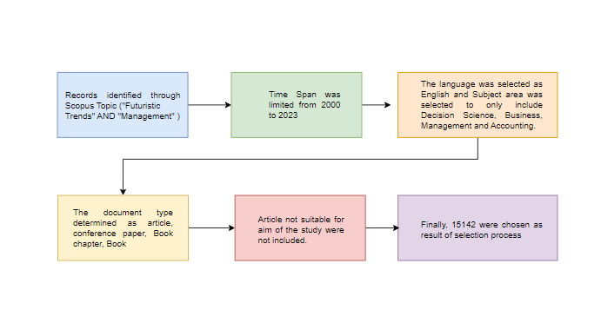
Fig. 1. Article selection process for this study.

Table 1: The top 10 countries or regions with publications related to Futuristic trends on Management.

S.no | . Distribution of Dataset by Document Type.
 | Type of Documents | Count | Percentage
1 | Articles | 8749 | 57.8 %
2 | Conference Papers | 4328 | 28.6 %
3 | Book Chapters | 1500 | 9.9 %
4 | Books | 565 | 3.7 %

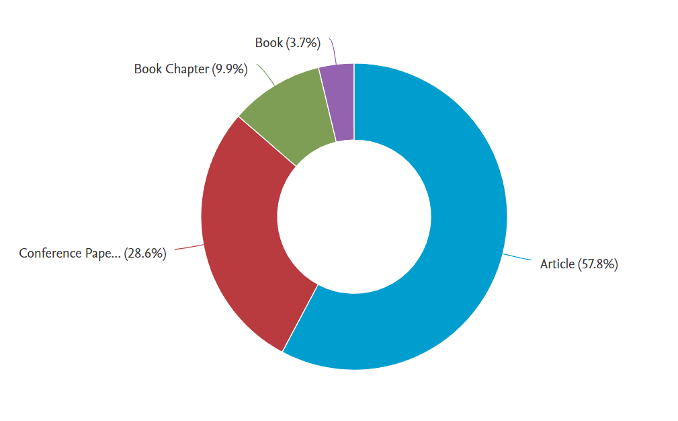

Fig. 2. Distribution of Dataset by Document Type.

Data coding and Analysis:
For bibliometric analysis, the VOS Viewer software was used to reveal network visualization of co-occurrence of the most used keywords, words used in abstracts, citation analyses and co-citation analyses in the articles [7].

FINDINGS

The result analysis provides valuable insights into the distribution of publications based on publication year, countries or regions, and top institutions. The bibliometric analysis was conducted using VOS viewer, a powerful tool for visualizing and analyzing bibliometric networks [3,4]. Let's delve into the key findings:

Distribution by publication year:
The analysis reveals a steady growth in the number of publications over the years, with the highest number of publications recorded in the year 2022 (1439 publications). The trend indicates a substantial interest and research activity in the field, which has continued over the subsequent years as shown in Fig. 3.

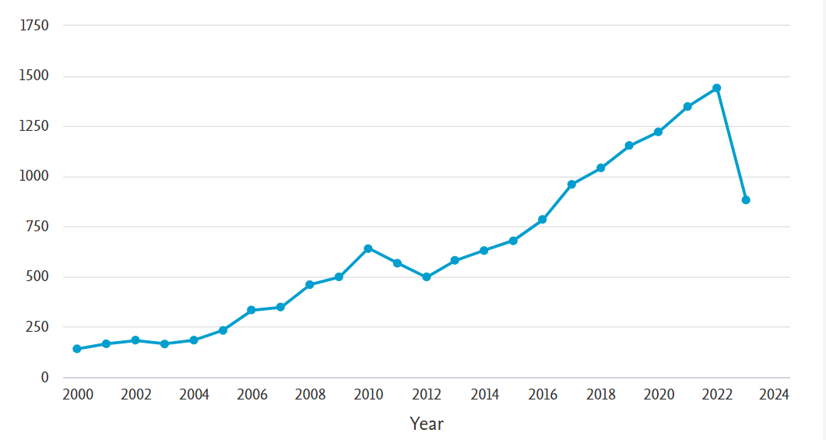
Fig. 3. Distribution of Articles by Publication Year.

Countries or Region:
The United States (USA) emerges as the leading contributor in terms of publications, with a significant count of 2800 publications. The China follows as the second highest contributor with 2361 publications, while UK, India, and Australia also demonstrate strong research output with 1330, 896, and 715 publications, respectively. The top 10 countries or regions are dominated by major global players, indicating a widespread interest in the subject matter and a diverse geographical involvement in the research as shown in Table 2 and Fig. 4.

Table 2: The top 10 countries or regions with publications related to Futuristic trends on Management.

S.no | Table Column Head
 | Countries or Region | Count
1 | United States | 2800
2 | China | 2361
3 | United Kingdom | 1330
4 | India | 896
5 | Australia | 715
6 | Germany | 700
7 | Russian Federation | 620
8 | Italy | 570
9 | Canada | 457
10 | Spain | 414

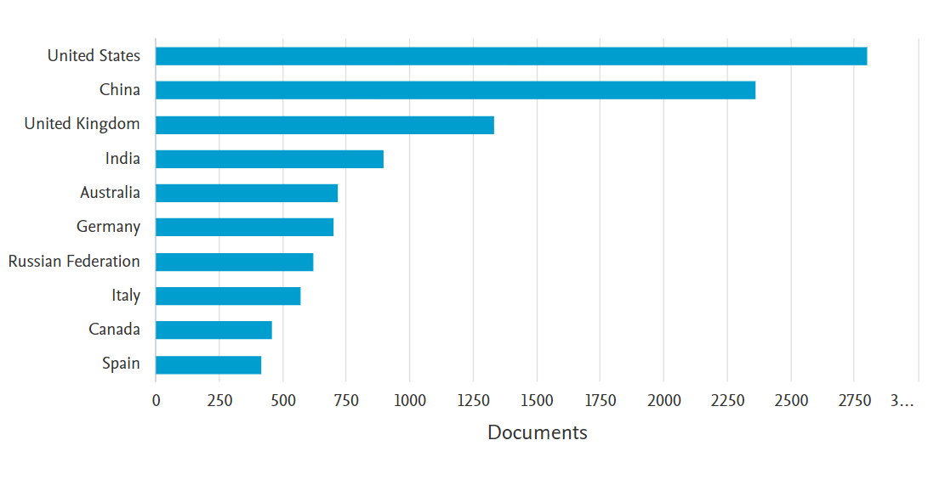
Fig. 4. Document by country or territory

Bibliometric mapping analysis findings
In order to create a map based on text data for the most used keywords, co-occurrence analysis was used, and author keywords were selected. The minimum number of occurrences of a keyword was set as 20 and the number of keywords to be selected was automatically given as 85. The map created is illustrated in Fig. 5. It shows there are Seven clusters, and the most used keyword is ‘Sustainability’ (f = 187), followed by ‘Supply chain management’ (f = 183). In addition, it is revealed for Cluster 1 ‘Sustainability’ and Cluster 2 ‘Supply chain management’ that ‘Big data’ (f = 173), ‘Industry 4.0’ (f = 146), ‘Machine Learning’ (f = 143), ‘Digitalization’ (f = 108) and ‘Internet of Things’ (f = 81) are the most used keywords as shown in Fig.6 and Fig.7.
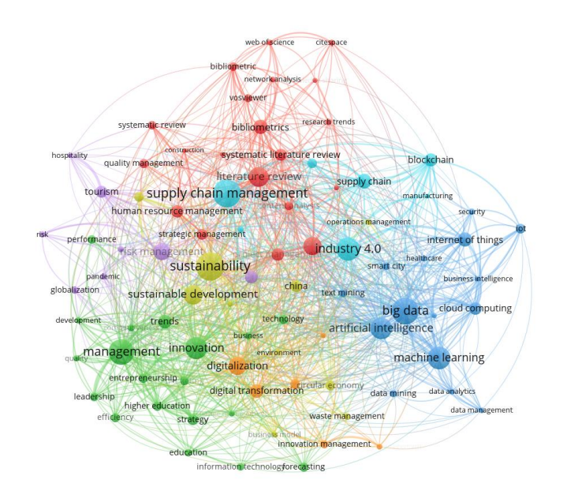
Fig. 5. A bibliometric map created based on author keywords co-occurrence.
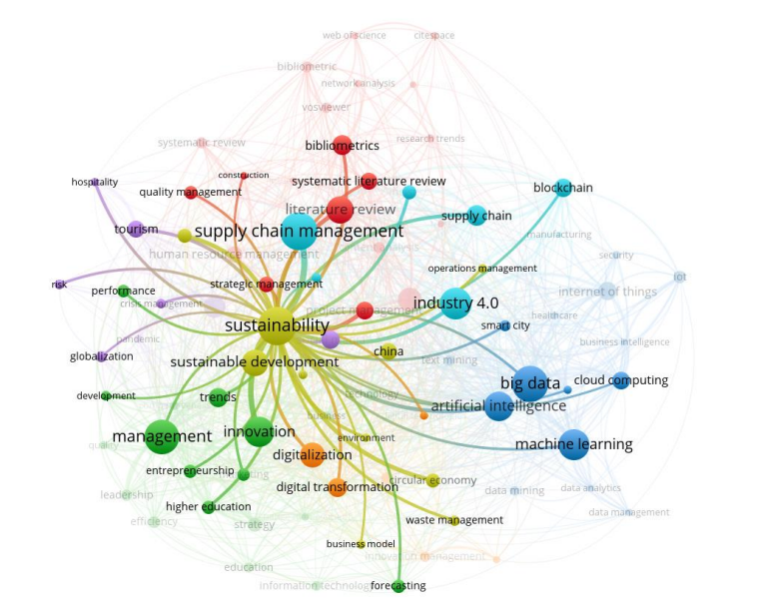
Fig. 6. Interlinked nodes with Cluster 1 ‘Sustainability’.
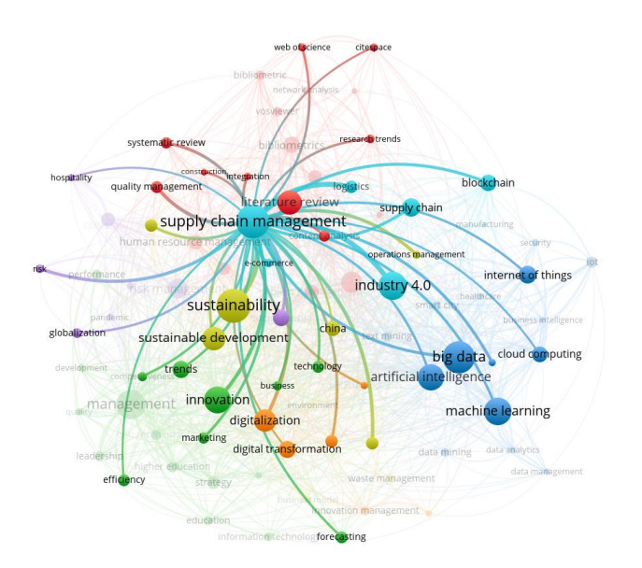
Fig. 7. Interlinked nodes with Cluster 2 ‘Supply Chain Management’.

CONCLUSION

Considering the detailed analysis presented, it is evident that the study of futuristic trends in management is a dynamic and vital area of inquiry. The analysis of publication distribution over the years reveals a consistent and substantial growth, signifying a sustained interest and research vigor within this domain. The global landscape is engaged, as reflected by the leading contributions from prominent players such as the United States, China, the United Kingdom, India, and Australia. These findings underscore the widespread interest and diverse geographic involvement in the exploration of futuristic management paradigms. Furthermore, the insights obtained through bibliometric mapping analysis shed light on the central concepts that define the landscape, with keywords like 'Sustainability,' 'Supply chain management,' 'Big data,' 'Industry 4.0,' 'Machine Learning,' 'Digitalization,' and 'Internet of Things' taking the forefront. As these trends continue to shape the trajectory of management practices, this study offers valuable guidance to decision-makers navigating the evolving business environment, ensuring that they remain equipped with the insights necessary to steer their organizations into the future [1,2].

REFERENCES

- Dron, S., STEP-HBTI, K., Mishra, R., & Saxena, R. FUTURISTIC TRENDS IN MANAGEMENT: THE IMPORTANCE OF SUSTAINABILITY IN ORGANIZATIONS.
- Bhattacharya, S., Mukhopadhyay, D., & Giri, S. (2014). Supply chain management in Indian automotive industry: Complexities, challenges and way ahead. International Journal of Managing Value and Supply Chains, 5(2), 49.
- Donthu, N., Kumar, S., Mukherjee, D., Pandey, N., & Lim, W. M. (2021). How to conduct a bibliometric analysis: An overview and guidelines. Journal of business research, 133, 285-296.
- Zupic, I., & Čater, T. (2015). Bibliometric methods in management and organization. Organizational research methods, 18(3), 429-472
- Forliano, C., De Bernardi, P., & Yahiaoui, D. (2021). Entrepreneurial universities: A bibliometric analysis within the business and management domains. Technological Forecasting and Social Change, 165, 120522.
- Forliano, C., De Bernardi, P., & Yahiaoui, D. (2021). Entrepreneurial universities: A bibliometric analysis within the business and management domains. Technological Forecasting and Social Change, 165, 120522.
- Aziminezhad, Mohamadmahdi, and Roohollah Taherkhani. "BIM for deconstruction: A review and bibliometric analysis." Journal of Building Engineering (2023): 106683.

