RECENT ADVANCEMENT IN RENAL TRANSPLANTATION WITH ABO INCOMPATIBLE PATIENTS USING IMMUNOADSORPTION

Mr. Tamilselvan L
Department of Renal Dialysis Technology,
School of Allied Health Sciences, Vinayaka Mission’s Research Foundation – DU,
AVMC & H, Puducherry, India.
E-mail: tamilselvandme333@gmail.com

ABSTRACT
ABO blood group incompatibility (ABO-I), which carries a high risk of acute antibody-mediated rejection and graft loss, was formerly thought to be a strict no-no for kidney transplantation. ABO-incompatible living donor kidney transplantation has been done due to the significant lack of deceased donors. Novel techniques developed in recent years to lower anti-donor antibodies have made it possible to successfully transplant patients across the ABO barrier. The majority of preconditioning treatments used in Europe are based on IA methods using antigen-specific columns. Commercially available antigen-specific IA columns come in two varieties: the reusable ABO Adsopak® column and the Glycosorb®-ABO column. The removal of anti-A and anti-B by using Glycosorb® ABO immunoadsorption is the frequently utilized device for desensitization therapy in ABO-incompatible living donor renal transplantation.

Keywords: ABO incompatibility, Glycosorb, Adsopak, Renal transplantation, IA columns, Immunosuppressants.

- INTRODUCTION
The most frequent difficulty to living donor kidney transplantation is blood group incompatibility (ABOi). The availability of new medications and our enhanced understanding of the immune system have led to a significant rise in the number of ABO-incompatible transplants in this century. Rituximab and plasma exchange (PLEX) have been supplanted by numerous programs to treat ABOi. ABOi live kidney transplant recipients can now be desensitized more rapidly and successfully thanks to new blood group-specific immunoadsorption (IA) columns. The elimination of ABabs via antigen-specific immunoadsorption (IA) is also gaining popularity as a substitute for nonspecific IA techniques. Currently, the only commercially viable product for this use is the Glycosorb®-ABO column.

- ABO INCOMPATIBILITY IN TRANSPLANT
The term ABO incompatibility is used to refer to the blood type compatibility between a donor and the recipient of an organ transplant, particularly when it comes to solid organ transplants, such as kidneys, liver, hearts, and lungs. ABO compatibility is a key factor in the prevention of undesirable immune reactions that could potentially lead to organ rejection.
The blood group system, also known as the ABO blood type system, is a classification system for human blood. It is based on the presence and absence of two antigens, A and B, on the surface of the red blood cells (Table.1).

Table 1: Blood group and its corresponding antigen and antibody
BLOOD GROUP | ANTIGEN | ANTIBODY
TYPE-A | A | B
TYPE-B | B | A
TYPE-AB | A&B | NIL
TYPE-O | NIL | A&B

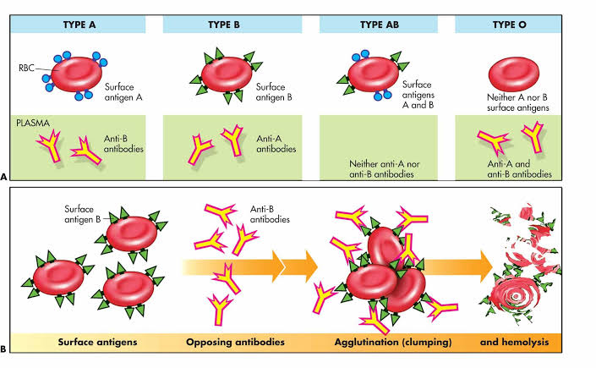
Figure 1: Blood group typing and Cross reactions

When considering organ transplantation, especially solid organ transplants (such as kidneys, liver, hearts, and lungs), ABO compatibility is important to avoid adverse immune reactions that can lead to organ rejection.
- If you're a type A donor, you can get a transplant into a type A or type AB recipient.
- If you're a type B donor, you can transplant into a type B or type AB recipient
- Type AB recipient can receive a transplant from a Type AB donor.
- Transplants from Type O donors are compatible with Type A, B, AB, or O recipients (Figure 1).

- IMMUNOADSORPTION
Immunoadsorption is a medical procedure used to selectively remove antibodies from a person's blood. It's often employed in situations where excessive or harmful antibodies are present in the bloodstream, such as in certain autoimmune diseases, ABO-incompatible organ transplantation, and some types of neurological disorders. The procedure is designed to help modulate the immune response and manage conditions related to antibody-mediated reactions.
The process of immunoadsorption involves passing the patient's blood through a specialized device or column that contains materials capable of binding to specific antibodies. These materials can include protein A or protein G, which have a strong affinity for immunoglobulins (antibodies). As the blood flows through the column, the antibodies attach to the binding sites on the materials, effectively removing them from circulation.

- GLYCOSORB
A medical device called Glycosorb®-ABO is based on biologically active carbohydrates (blood group A and B antigens), which are particularly recognized by anti-A/B antibodies and cause them to bind, removing them from the patient's plasma (Figure 2). It is primarily intended to be used in transplants from deceased donors and when blood group AB to blood group 0 transplants are performed. It is known as Immuno Adsorption because it adsorbs antibodies, removing blood group-specific antibodies from the recipient. Glycosorb dialysis involves passing the patient's blood through a device containing specially designed columns that are coated with molecules mimicking the antigens of the ABO blood group system. These columns selectively bind and remove the antibodies from the blood plasma, reducing the risk of organ rejection.
This technique aims to lower the levels of ABO antibodies in the recipient's bloodstream prior to the organ transplantation, thereby improving the chances of a successful transplant. The main advantage of glycosorb ABO is that it has little or no impact on other blood proteins or antibodies.

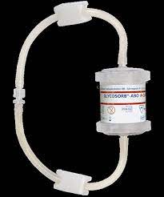

Figure 2: Glycosorb column

- ANTIBODY DEPLETION BY EXTRACORPORAL TREATMENT

Antibody removal techniques can be further divided into methods those that remove all plasma proteins, like Plasmapheresis, those that remove just a portion of the plasma proteins, like immunoglobulins, and more specialized techniques, such unselective or selective IA. The Glycosorb columns, which contain synthetic terminal trisaccharide A or B (Figure 3).

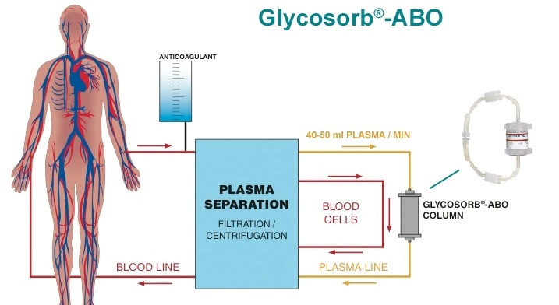

Figure 3: Removal of anti-A/B antibodies by using Glycosorb column

Blood group antigen attached to a sepharose matrix, enable the selective elimination of anti-A/B antibodies. They may also lower total IgG levels as well as IgG directed against polysaccharide antigens, such anti-Pneumococcus IgG [1]. Recent studies discovered that unselective IA was better to selective anti-A/B antibody columns for eliminating anti-A/B IgG in single treatments [2]. On the other hand, Unselective IA, performed poorly in the elimination of IgM and IgG3 subclass anti-A/B antibodies. It is also discovered that the removal of IgG and IgM antibodies as well as effector molecules such the complement C1q component was efficiently accomplished via membrane separation and unselective IA [3]. While comparing the effects of IA strategies on clinical outcomes, such as the decrease of anti-A/B antibodies, survival, renal function, episodes of rejection, or complications, there will be no significant changes [4].

- ADSOPAK COLUMN REGENERATION PROCEDURE
Over a thirty-minute period, the Adsopak column was generated in 4 phases. In the initial phase, 1 L of 0.9% NaCl was washed at a rate of 150 ml/min. With "regeneration solution 1," a 0.5–1 L solution with HCl and glycine (pH 2-3), antibody removal was accomplished in the second step at a rate of 150 ml/min. With "regeneration solution 2," a 0.5 L solution including phosphate buffer, pH restoration was carried out in the third stage at a rate of 150 ml/min. In the fourth phase, a solution comprising 2 ml of sodium nitrite and 0.5 L of phosphate buffer (a total of 502 ml) was applied to the column at a rate of 150 ml/min.

- REBOUND OF ABabs

Clinically significant rebound of ABabs in ABOi transplantation has not been uniformly defined [5-8]. Rebound of antibodies is a term used frequently in studies on autoimmune illnesses to describe an increase in antibodies that is equal to or higher than the baseline level. Japanese research has linked a postoperative antibody titre of 1:32 to a higher incidence of Anti-Microbial Resistance in ABOi transplantation. An elevated risk of Anti-Microbial Resistance could not be utilized as the only predictor of dangerously high ABab levels since we wanted to examine rebound both before and after ABOi transplantation. Therefore, when we talk about rebound, we mean when the ABabs go back to their baseline level or when they increase to 1:32 or higher. Changes in ABab titres below 1:8 were, however, thought to have of little clinical importance and ignored.

- REJECTION
Biopsies should be taken if there is any clinical suspicion of rejection. It will be assessed and graded by the transplant pathologist according to the Banff criteria. C4d-staining method will be used by either immunofluorescence or immunohistochemistry [9-10].

- ANTIBODY SYNTHESIS BLOCKING
On preoperative day 15, the day before the transplant, rituximab has to be given intravenously to the patients. Rituximab, 500 mg twice, should be administered to patients in the Glycosorb group during the initial phase of treatment. Later, participants in the Adsopak group should be given a lower dose of rituximab—200 mg once—than the other patients. The CD19 assay gets performed seven days before to transplantation.

- INDUCTION OF IMMUNOSUPPRESSION
Patients should receive an intraoperative infusion of basiliximab (Anti CD25) (20 mg) and intravenous methylprednisolone (500 mg). On the fourth postoperative day, basiliximab must be administered again. It is recommended to overlap oral prednisolone 25 mg/day with intravenous methylprednisolone 250 mg and 125 mg on postoperative days 1 and 2, respectively.

- MAINTENANCE OF IMMUNOSUPPRESSION
Tacrolimus and mycophenolate mofetil (MMF) should be administered to all patients beginning on preoperative day 7 and it is further continued throughout the posttransplant period. Tacrolimus is administered in two doses of 0.1 mg/kg/day, whereas MMF is administered in two doses of 2000 mg/day.

REFERENCES

- Valli PV, Yung GP, Fehr T, Schulz-Huotari C, Kaup N, Güngör T, Ambühl P, Weber M, Schanz U, Seebacha JD, Stussi G. Changes of circulating antibody levels induced by ABO antibody adsorption for ABO-incompatible kidney transplantation. American journal of transplantation. 2009 May 1;9(5):1072-80.
- Wahrmann M, Schiemann M, Marinova L, Körmöczi GF, Derfler K, Fehr T, Stussi G, Böhmig GA. Anti-A/B antibody depletion by semiselective versus ABO blood group-specific immunoadsorption. Nephrology Dialysis Transplantation. 2012 May 1;27(5):2122-9.
- Eskandary F, Wahrmann M, Biesenbach P, Sandurkov C, König F, Schwaiger E, Perkmann T, Künig S, Derfler K, Zlabinger GJ, Böhmig GA. ABO antibody and complement depletion by immunoadsorption combined with membrane filtration—a randomized, controlled, cross-over trial. Nephrology Dialysis Transplantation. 2014 Mar 1;29(3):706-14.
- Morath C, Becker LE, Leo A, Beimler J, Klein K, Seckinger J, Kihm LP, Schemmer P, Macher-Goeppinger S, Wahrmann M, Böhmig GA. ABO-incompatible kidney transplantation enabled by non-antigen-specific immunoadsorption. Transplantation. 2012 Apr 27;93(8):827-34.
- Ishida H, Koyama I, Sawada T, Utsumi K, Murakami T, Sannomiya A, Tsuji K, Yoshimura N, Tojimbara T, Nakajima I, Tanabe K. Anti-AB titer changes in patients with ABO incompatibility after living related kidney transplantations: survey of 101 cases to determine whether splenectomies are necessary for successful transplantation. Transplantation. 2000 Aug 27;70(4):681-5.
- Squifflet JP, De Meyer M, Malaise J, Latinne D, Pirson Y, Alexandre GP. Lessons learned from ABO-incompatible living donor kidney transplantation: 20 years later. Exp Clin Transplant. 2004 Jun 1;2(1):208-13.
- Tobian AA, Shirey RS, Montgomery RA, Cai W, Haas M, Ness PM, King KE. ABO antibody titer and risk of antibody‐mediated rejection in ABO‐incompatible renal transplantation. American Journal of Transplantation. 2010 May 1;10(5):1247-53.
- Van den Hoogen FH, Boerbooms AM, Van de Putte LB, Verheijen R, Van Venrooij W, Croockewit AJ. Rebound of anti-topoisomerase I antibody titres after plasma exchange. Annals of the rheumatic diseases. 1993 Mar;52(3):246.
- Racusen LC, Colvin RB, Solez K, Mihatsch MJ, Halloran PF, Campbell PM, Cecka MJ, Cosyns JP, Demetris AJ, Fishbein MC, Fogo A. Antibody‐mediated rejection criteria–an addition to the Banff′ 97 classification of renal allograft rejection. American Journal of Transplantation. 2003 Jun;3(6):708-14.
- Racusen LC, Solez K, Colvin RB, Bonsib SM, Castro MC, Cavallo T, Croker BP, Demetris AJ, Drachenberg CB, Fogo AB, Furness P. The Banff 97 working classification of renal allograft pathology. Kidney international. 1999 Feb 1;55(2):713-23.

