A Comprehensive Analysis of Water DEMAND - SUPPLY Management in Chennai
P. Sujatha¹, Jai Shirisha PVS², Krishna Nivash J³ and P.V.S. Janardhanam⁴
1 Asst. Professor, Dept. of Geography, Bharathi Women’s College (A), Chennai-108, TN, India
2 Final Year - MBBS, Trichy SRM Medical College Hospital & Research Centre, Irungalur, Trichy – 621 105.
3 IIIrd Year - B.E., Dept. of Electronic Communication, Sathyabama University (Deemed), Chennai.
4 Head-IT, LYCA TECH., Chennai.
sujathaj3998@rediffmail.com , jaishirisha@gmail.com, Krishnanivash.j@gmail.com, Jana_pvs@rediffmail.com
ABSTRACT
This study aims to comprehensively understand the metabolic flow of water in Chennai Metropolitan Area (CMA) for water planning and to explore the intricate interactions between different urban objectives. The research focuses on three main goals: (a) conducting a thorough assessment of water inflows and outflows, including wastewater, to establish a well-defined water mass balance; (b) illustrating how economic, policy, social, and other variables influence the metabolic flow of water and its impact on the city's background water hydrology; and (c) demonstrating the spatial diversity and variation among the drivers of water flow in the city. To achieve these objectives, the study investigates crucial aspects, such as city growth, water governance, water sources, infrastructure, potential risks in water management, and provides recommendations for sustainable water management practices. By shedding light on these critical aspects, the research aims to contribute to effective water resource management and sustainable development in the rapidly urbanizing CMA.
Key Words: Water Flows, Waster Water, Water Quality, Sustainable water management.

- INTRODUCTION
Chennai is entirely dependent on ground water resources to meet its water needs. Ground water resources in Chennai are replenished by rain water and the city's average rainfall is 1,276 mm. (Srinivasan, M. S., 2003) Chennai receives 985 mld against the required 1,200 mld, and demand is expected to reach 2,100 mld by 2031. Water sources include desalination plants, aquifers, Cauvery and Krishna rivers, Poondi reservoir, and lakes. (Mariappan, Julie, 2014). Supply of ground water to the residents and sewage management in Chennai is taken care of by the Chennai Metropolitan Water Supply and Sewage Board (Metro Water). In 2011, MetroWater served a population of 5 million in Chennai. The corporation's expansion to 426 sq km, with 200 wards and 15 zones, will add 1.7 million more customers, increasing its reach significantly. (Lakshmi, K., 2013). As of 2012, MetroWater supplies about 830 million litres of water every day to residents and commercial establishments (Lakshmi, K., 2012). Out of the 800 mld supplied to Chennai, around 710 mld is delivered through pipelines. The projected demand for the expanded city is 1,044 mld, and MetroWater must treat and dispose of an extra 219 mld of sewage in the merged areas. ( Lakshmi, K., 2013).Having evolved into a metropolis, Chennai is now known as the Chennai Metropolitan Area (CMA) for planning. CMA boasts 22 water courses, comprising three rivers, a canal, and four reservoir tanks, alongside 16 minor waterways.(Thooyavan, K, 2013),(Mariappan, Julie , 2014).
Chennai is geographically divided into north and south sections by the Cooum, Adyar, and Kosasthalaiyar rivers flowing into the Bay of Bengal. The Buckingham canal connects all three rivers. The city's four reservoirs - Red Hills, Cholavaram, Poondi, and Chembarambakkam - have a total capacity of 11,057 mcft. Each reservoir has varying capacities: Red Hills (3,300 mcft), Cholavaram (881 mcft), Poondi (3,231 mcft), and Chembarambakkam (3,645 mcft). Unfortunately, the reservoirs lose 5 mcft of water daily due to evaporation. (Lakshmi, K., 2013), ("State moves Centre for fifth reservoir in Chennai", 2013) According to the Water Resources Department, only 19 of the city's 29 major waterbodies can be restored. Nine lakes are encroached and cannot be rejuvenated, including Valasaravakkam, Virugambakkam, Mogappair, Adambakkam, Kolathur, Senneerkuppam, Thalakancheri, Ullagaram, and Maduravoyal. Once restored, the remaining lakes will store 1,000 mcft of water, and desilting the four primary reservoirs can add 500 mcft. (Lakshmi, K., 2018).
Currently, the city supplies 830 million liters of water daily, and additional 880 mld will be obtained from Minjur and Nemeli desalination plants, Krishna river, and Veeranam Tank. ("Chennai: new plant to ensure water supply", 2013). As of December 2013, the Nemmeli and Minjur desalination plants, along with the new Veeranam project, contributed over 60% of Chennai's water supply, amounting to 575 MLD. ("Nemmeli desal plant generates at full capacity", 2014). Approximately 3,600 tanks in Chennai's vicinity, when preserved and interconnected, could supply five times the city's water demand, around 80,000 million cubic feet (TMC). (Ramakrishnan, T., 2017). In 2018, 50 to 60 percent of Chennai's water supply came from private water tankers, delivering 20,000 loads daily from various areas. 80% of households consumed packaged drinking water, selling 20 million liters daily.("To tackle water crisis, Metrowater pitches in", 2018)
1.1 RESEARCH METHODOLOGY
Gather data on water demand, supply, and usage from various sources, including government records, surveys, and satellite imagery. Analyze the collected data to assess water availability, identify trends, and understand usage patterns. Study successful water management projects in other regions to draw lessons applicable to Chennai. Develop models to simulate water demand, supply, and distribution scenarios under different conditions. Formulate actionable recommendations for policymakers and stakeholders to improve water management practices.
1.2 OBJECTIVE
The general objectives are listed below:
- To Conduct an in-depth assessment of Chennai's water demand and supply dynamics to understand current water usage patterns.
- To identify key challenges and opportunities in water resource management, including groundwater depletion and water quality degradation.
- To develop effective and sustainable strategies for water demand-supply management, focusing on conservation, recharge, and wastewater treatment.
2. CITY GROWTH AND ENVIRONMENT

Geographical Characteristics
The geographical characteristics considered in this study included location, physiography and landforms, climate, forest, and biodiversity.

Location
Chennai is the capital city of the Indian state of Tamil Nadu. It is one of the metropolises in the country and serves as the cultural gateway to South India. The latitude and longitude coordinates of the city are 13.0827° N and 80.2707° E, respectively. It is located on the south-eastern coast of India and is bounded on the east by the Bay of Bengal and on the remaining three sides by Kanchipuram and Thiruvallur districts. It stretches nearly 25.6 km along the Bay of Bengal coast. Chennai urban agglomeration is classified into two broad categories: Chennai district and the CMA.
Chennai district:
It consists of the original historic center and is the Central Business District (CBD) of the CMA. Most of the settlements in early days sprawled from here, which have now gone beyond the district borders. According to Census 2011, Chennai district covered an area of 178 km2. In 2018, the city limits were expanded and reached a new area of 426 km2, which is governed by Chennai Municipal Corporation.
Chennai Metropolitan Area:
CMA is under the administration of Chennai Metropolitan Development Authority which covers an area of 1189 km2. CMA includes the Chennai district and parts of Kanchipuram and Tiruvallur districts as shown in Figure 1. The Thiruvallur district covers an area of 3427 km2, out of which approximately 637 km2 includes Ambattur, Madhavaram, Maduravoyal, Thiruvottriyur, Thiruvallur, Ponneri, and Poonamallee taluks that fall under the jurisdiction of CMA. Similarly, Kanchipuram district covers an area of 4433 km2 and out of which approximately 376 km2 of area includes Alandur, Tambaram, Sholinganallur, Sriperumbudur, and Chengalpattu talukas that come under CMA.

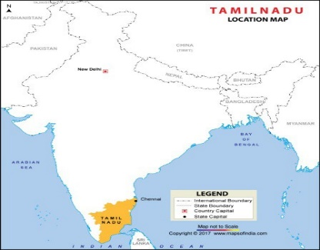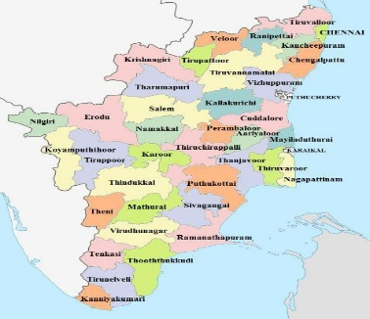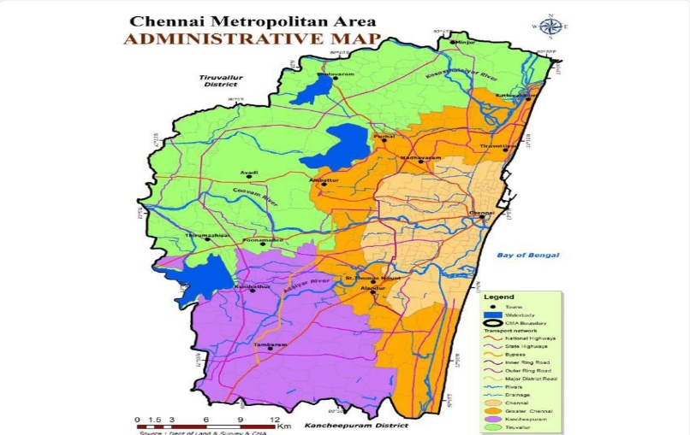
Chennai Metropolitan Area (Study Area)
India Tamil Nadu State

FIGURE 1: Geographical location of Chennai Metropolitan Area

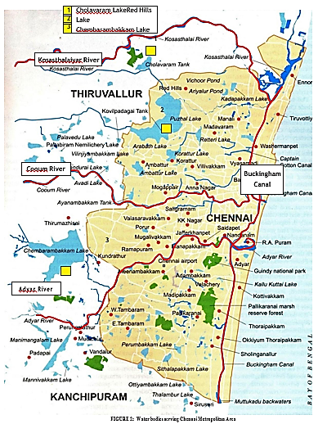

Physiography and Landform
The Chennai Metropolitan Area (CMA) is characterized by a flat coastal plain with an average elevation of 6.7 meters, making it susceptible to drainage challenges, especially in localities farther from the seacoast. The region's unique ecological diversity includes a mangrove ecosystem along the eastern coastal area and a dense forest with diverse tropical flora and fauna in the western part.
Regarding soil types, the area predominantly consists of clay, shale, and sandstone, with sandy soil along the coastline and river banks. The geological classification divides CMA into three sub-regions: sandy areas along rivers and coasts, clayey areas in most inland parts, and hard rock areas primarily in Guindy, Velachery, Adambakkam, and Saidapet. Clayey and hard rock areas retain rainwater for a longer duration due to slow percolation.
The area is intersected by three main rivers: Cooum River, Adyar River, and Kosasthalaiyar River, with the Kosasthalaiyar being significant for water usage. Unfortunately, the Cooum and Adyar rivers suffer from heavy pollution due to untreated waste and effluent discharge, while lakes in the western part serve as essential water sources along with groundwater for the region.

Climate
Chennai experiences a tropical wet and dry climate due to its equatorial location, with temperatures ranging from 19°C to 40°C throughout the year. Rainfall occurs during the southwest monsoon from June to September and the northeast monsoon from October to December. The city heavily relies on these monsoons to recharge its water reservoirs and maintain an adequate water supply for its residents. The average annual rainfall is around 1400 mm, with occasional cyclones from the Bay of Bengal bringing heavy rainfall and strong winds.

Forest and Biodiversity
The Chennai Metropolitan Area (CMA) comprises a total forest area of 943 hectares. Out of this, 320 hectares are located within the administrative boundaries of Chennai district, while the remaining 623 hectares are in Thiruvallur district. Surprisingly, there is no designated forest area in the Kancheepuram district within CMA. According to the State of Environment Report, Chennai Metropolitan Region consists of five major ecosystems, as listed in Table 1.
TABLE 1: Ecosystems in Chennai Metropolitan Area 8
S. No. | Name of the  Ecosystem | Total Area (in  hectares) | Type of Flora | Type of Fauna
1 | Guindy National Park | 270 | Dry evergreen  scrub and thorn forest  , grasslands, and waterbodies.  350 species of plants including shrubs, climbers, herbs, and grasses.  24 varieties of trees, including sugar apple, wood apple, and neem | 130 species of birds, 14 species of mammals, over 60 species  of butterflies and spiders
2 | Pallikaranai Marsh Land | 8000 | 114 species of plants, 29 species of grass | 10 species of mammals,  112 species of birds,  21 species of reptiles, 9 species of amphibians, 46 species of fish, 7 species of butterflies, 5 species of Crustaceans and 9 species of Mollusk
3 | Nanmangalam Reserve Forest | 320 | Scrubland with some rare territorial orchids | 85 species of birds like Red- wattled Lapwing, Crested Honey Buzzard, Grey Partridge, Coucal, Indian Eagle-owl, White-breasted Kingfisher, Pied Kingfisher, Southern Bush Lark, and  Red-whiskered Bulbul
4 | Adyar Estuary (Protected Wildlife Reserve) | 120 | Islands and mangrove including river, marsh, woods, backwaters, islets, sea, and open  ground | 150 species of birds and small wildlife including jackals, foxes, wild cats, snakes, and other reptiles
5 | Chennai coast between Neelankarai and Napier  Bridge stretch | - | - | Olive ridley turtles

Urban Growth and Land Use
This section focuses on the spatial growth pattern, land utilization, and land cover of the Chennai district. It analyzes the city's urban expansion and development over time, along with the various ways land is being utilized for different purposes such as residential, commercial, industrial, and recreational. The study also assesses the existing land cover, including vegetation, built-up areas, water bodies, and other land uses, providing insights into the dynamics of urbanization and land transformation in the region.

Spatial Growth Pattern
Chennai district's urban growth follows a grid pattern with wide roads and localities organized in north-south and east-west directions. The Cartesian grid layout enhances accessibility and connectivity, and radial road and rail networks facilitate city expansion and connectivity.

Spatial Growth Pattern
The core of Chennai district has witnessed urban growth following a grid pattern, with roads and localities organized in north-south and east-west directions. Over the 20th century, significant changes in the road and locality infrastructure led to the development of wide roads and the adoption of Cartesian grid layouts, systematically organizing neighborhoods and thoroughfares for enhanced accessibility and connectivity.
The road and rail network originating from the core of Chennai follows a radial pattern of urban growth across the entire metropolitan area. This radial growth model involves the expansion of residential, commercial, and industrial areas radiating outward from the central core. Chennai's CBD remains highly dense and continues to attract a growing population, while the region also experiences a sprawling pattern of urban growth, especially at the district's periphery and in the broader CMA along transit corridors to the north, south, and west.
Balancing economic growth, sustainable development, and efficient infrastructure will be crucial for Chennai's future. Addressing transportation, housing, and environmental sustainability issues will play a pivotal role in shaping Chennai as a vibrant and livable metropolis. However, the rapid growth of the Chennai Metropolitan Area poses challenges, especially in preserving agricultural lands and addressing environmental concerns while ensuring inclusive and sustainable development for both urban and rural populations. Finding equitable solutions will be essential for the future development of Chennai and its metropolitan area. (Fig. 3 & 4)
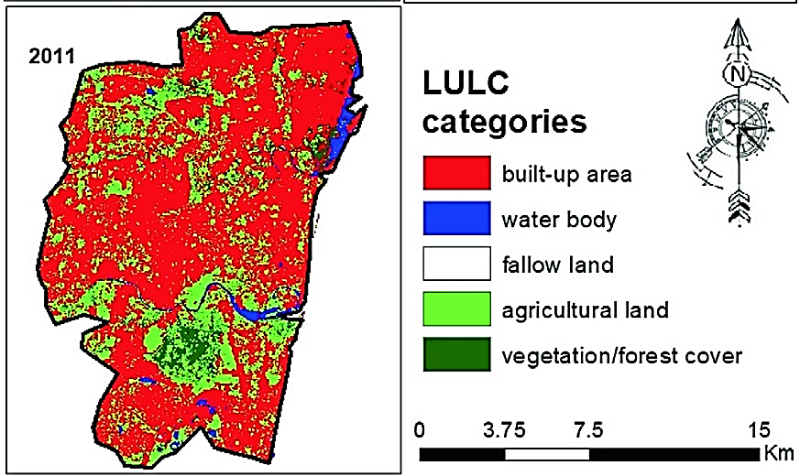
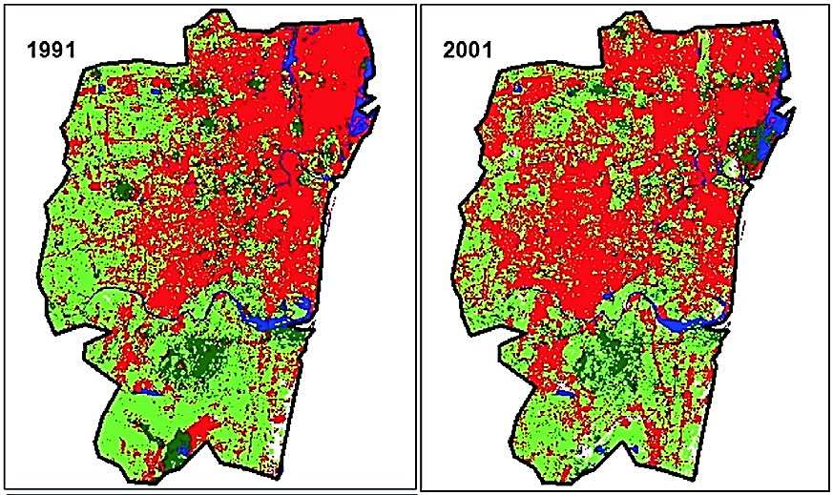
FIGURE 3: Urban sprawl pattern in Chennai district (with 178 km2 area) from 1991 to 2011
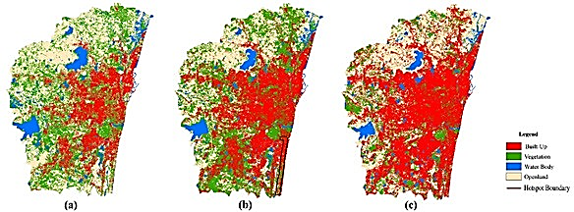
FIGURE 4: Urban sprawl pattern in Chennai Metropolitan Area from 2010 to 2017

Land Utilization and Land Cover
Over the course of three decades from 1988 to 2017, the Chennai Metropolitan Area (CMA) has experienced significant changes in its land use patterns, primarily driven by rapid urbanization and population growth. The expansion of the built-up area, which includes residential, commercial, industrial, transportation, and mixed-use zones, has been the most prominent transformation, increasing almost threefold from 211.2 km2 in 1988 to 578.3 km2 in 2017. This radial growth pattern extended westward from the core of Chennai district, fueled by domestic and foreign investments in various industries such as automobile, electronics, finance, and more. (Fig. 5)
The rise of IT and service sectors further contributed to the expansion of commercial and industrial areas, reflecting the changing economic landscape of Chennai as a major economic hub. From 1997 to 2006, scattered settlements transformed into dense urban areas with the establishment of educational institutions and industries. Post-2006, accelerated growth was observed due to the emergence of software companies, high-tech services, and medical tourism, attracting more settlers. Projections suggest the built-up area may reach 708.3 km2 by 2025.
However, this rapid urban expansion has come at the cost of agricultural land and vegetation, which decreased by half of their 1988 areas by 2017, as they were converted into built-up areas. Barren land, such as sandy regions, beaches, open spaces, and empty riverbeds, increased gradually due to soil degradation caused by the use of agrochemicals. (Fig. 6)
Water bodies and wetlands, critical for the region's water resources and ecosystems, also faced significant decline, reducing from 117 km2 in 1997 to 55 km2 in 2017. Encroachments and pollution from urbanization and waste dumping contributed to this decrease. Conservation efforts are essential to safeguard these water bodies and preserve them as vital water sources for the region.
Additionally, wasteland and dump yards increased until 2006 but declined after interventions like plantation drives. The expansion of built-up areas has implications for climate change, deforestation, and increased emissions, leading to alterations in the regional climate and elevating the risk of climate-induced disasters.
To address these challenges, sustainable urban planning and conservation measures are crucial to mitigate the adverse effects of urban growth on the region's climate and environment. Balancing urban development while preserving ecological integrity and safeguarding natural habitats is key to the resilience and well-being of the Chennai Metropolitan Area. Policymakers and stakeholders must make informed decisions to manage land use effectively, considering urbanization, population dynamics, economic growth, and environmental preservation for the sustainable development of the region.

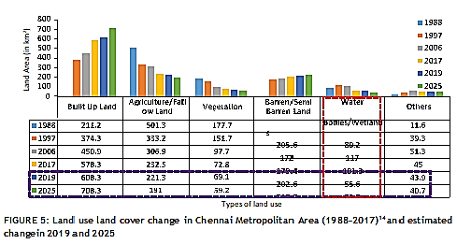

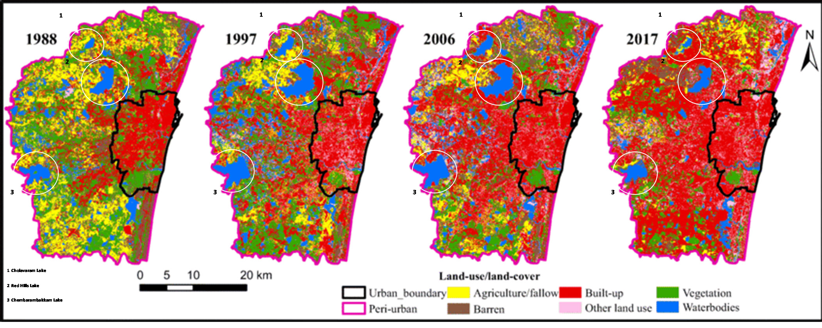
FIGURE 6: Graphical representation of land use land cover change in Chennai Metropolitan Area with highlighted change in waterbodies (1988–2017)

Demographic Description
This section delves into the population growth trend in the Chennai Metropolitan Area (CMA) and its implications on the urban system. As one of the largest cities in India, Chennai's population has seen remarkable growth, increasing from 3,505,502 lakh in 1971 to 8,653,521 lakh in 2011. This surge can be attributed to the rapid development of industries, such as hardware manufacturing, automobile, healthcare, and IT, on the outskirts of the Chennai district, attracting a significant influx of population to CMA. Projections indicate that this trend will continue, with the population estimated to reach 11,882,610 by 2025.
The population growth rate in the CMA witnessed fluctuations over the years. After a substantial decadal growth rate of 31.27% in 1981, the growth rate gradually decreased, reaching 21% by 2001, indicating a slowdown during that period. However, there was a slight increase in the decadal variation from 2001 to 2011, with the growth rate reaching 22.9%, suggesting a modest rebound in the rate of population growth during the first decade of the 21st century. (Fig 7)
The population density in the CMA has continuously risen due to robust industrial and economic development, attracting migrant populations seeking employment opportunities. The density increased from 2948 persons/km2 in 1991 to 5921 persons/km2 in 2011. Projections indicate a further increase to 7918 persons/km2 by 2025. While this indicates economic opportunities, it also poses challenges in infrastructure, housing, and resource management. (Fig 8)
To accommodate the increasing population and enhance the quality of life for CMA residents, sustainable urban planning is crucial. The blend of urban and rural areas in the CMA presents unique challenges and opportunities for planners to cater to the needs of both communities. Understanding population trends and density variations is essential for effective urban planning and sustainable development in the Chennai Metropolitan Area, ensuring a balanced approach to growth and resource management. (Fig 9)

.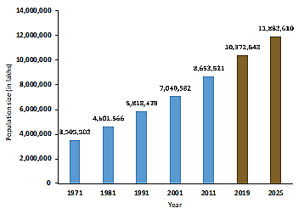
FIGURE 7: Population increase in Chennai Metropolitan Area
from 1971 to 2011 And estimated population change in 2019 and 2025
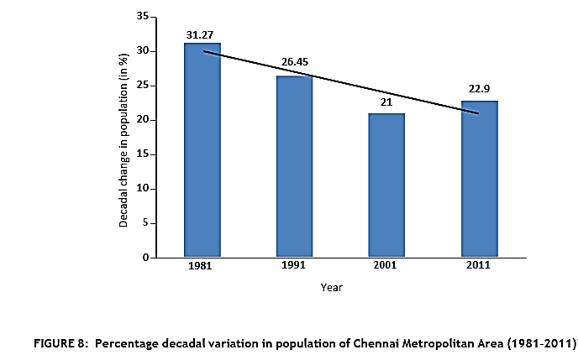

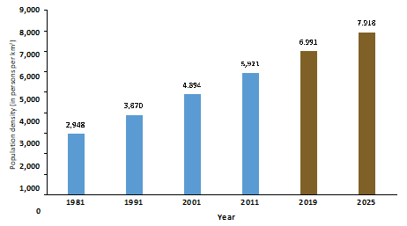
FIGURE 9: Population density change in Chennai Metropolitan Area
(1981–2011) And estimated change in 2019 and 2015

Socio-economic Description
The socio-economic analysis of the Chennai Metropolitan Area (CMA) presents a comprehensive overview of various sectors, including the economy, agriculture, industry, and housing. The region's economy has witnessed a significant shift from manufacturing to the tertiary sector, particularly the IT industry, driving economic growth and employment opportunities. The agricultural sector faces challenges due to declining groundwater levels and siltation of irrigation tanks, necessitating sustainable water management for agriculture. Rapid industrial growth in manufacturing industries, such as automobiles and IT firms, has contributed to the Gross District Domestic Product (GDDP) and employment. The housing sector has experienced substantial growth, requiring comprehensive policies to address water access for slum settlements. The analysis serves as valuable guidance for policymakers to develop integrated strategies for sustainable development, water management, and urban planning in the CMA. (Table 2,3 & 4)
TABLE 2: Employment structure in Chennai Metropolitan Area
S. No. | Occupational  Structure |  | 1971 (in %) | 1981 (in %) |  | 1991 (in %) | 2001 (in %)
1 | Primary |  | 4.01 | 3 |  | 6.5 | 2.9
2 | Secondary |  | 34.21 | 32 |  | 26.7 | 97.1
3 | Tertiary |  | 61.78 | 65 |  | 66.8
TABLE 3: Number of households in Chennai district (1991–2011)
Year |  | Total No. of Households |  |  | Percentage Change (%)
1991 |  | 798,279 |  |  | NA
2001 |  | 962,213 |  |  | 20.5
2011 |  | 1,154,982 |  |  | 20.03
TABLE 4: Slum statistics in Chennai district (1956–2011)
Year | Slum Population (in lakhs) | Number of Slums
1956 | 2.87 | 306
1961 | 4.12 | 548
1971 | 7.37 | 1202
1986 | 6.5 | 996
2001 | 8.2 | 1431
2011 | 13.2 | Not available
3. Water Governance and Administration
India's legal framework concerning water resources is multifaceted, drawing from the constitution, court rulings, central and state laws, and irrigation acts. Despite this, a comprehensive water law is absent. Water falls under the State List in the 7th Schedule of the Constitution, granting states control over planning, development, and management of water resources. The absence of a clear law defining ownership and rights over water sources has led to ambiguity, relying on court judgments and customary practices. The 'right to water' is not explicitly recognized as a fundamental right, granted case-by-case through court appeals, though central and state governments are primarily responsible for providing water for essential purposes. Various programs and policies, such as the National Water Policy, aim to address water challenges.
At the central level, the Ministry of Jal Shakti oversees water as a national resource, while the Tamil Nadu Public Works Department and the Chennai Metropolitan Water Supply and Sewerage Board handle water management in the Chennai Metropolitan Area (CMA). Coordinating various agencies and bodies is a significant challenge in water management in CMA. Establishing urban water planning and management boards in metropolitan cities nationwide could enhance water governance and sustainability. Overall, India needs an exclusive water law to address ownership and rights, and improved coordination among agencies for effective water resource management.

4. WATER SOURCE MANAGEMENT AND INFRASTRUCTURE
4.1 Water Sources
4.1.1 Historical Background
Until 1870, Chennai district relied on wells, public wells, and tanks as its primary water sources, which proved inadequate for the growing population. In 1872, the city initiated the first organized water supply system with a masonry weir across the Kosasthalaiyar River, diverting water to Cholavaram Lake, Redhills Lake, and finally distributed to Kilpauk through cast iron pipes. In 1914, the first protected water supply began with a water treatment plant at Kilpauk, using filtration and pumping techniques. From 1946 to 1966, various works were undertaken, including the Poondi reservoir construction and groundwater aquifers development, to address the city's water needs and improve water supply infrastructure.
4.1.2 Current Scenario
To meet the growing water demand in CMA, multiple sources, including surface water, rainwater, seawater, and groundwater, are utilized. Historically, groundwater aquifers have been vital for Chennai's water supply. Currently, surface water is extensively used, but groundwater remains essential during water-deficient months to fulfill the region's water requirements.
RainWater
Chennai experiences heavy rainfall during the monsoon season, with an average annual rainfall of 1400 mm. Monsoons between June-September and October-December replenish lakes, rivers, and groundwater, sustaining the city's water supply. However, inefficient rainwater management leads to severe water crises in the region during summer months. Table 5 shows rainfall and evapotranspiration statistics for Chennai city, with October being the wettest month and November having the lowest evapotranspiration rate from 2001 to 2011. FIGURE 11 provides an overview of surface, sea, and groundwater sources in the Chennai Metropolitan Area (2013).
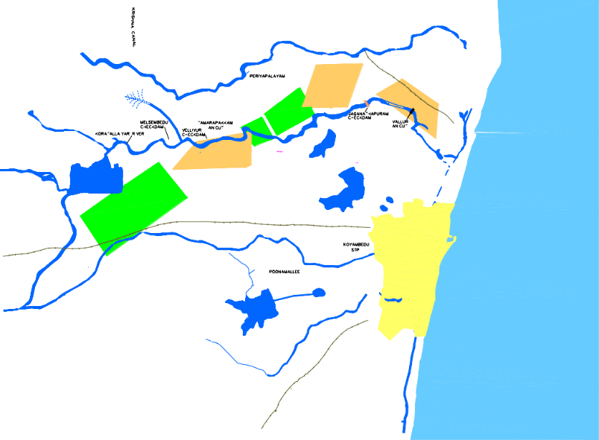
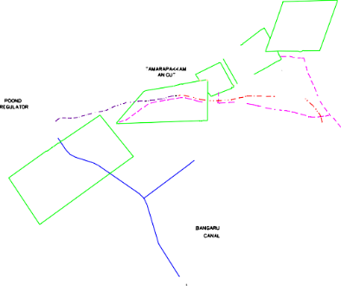
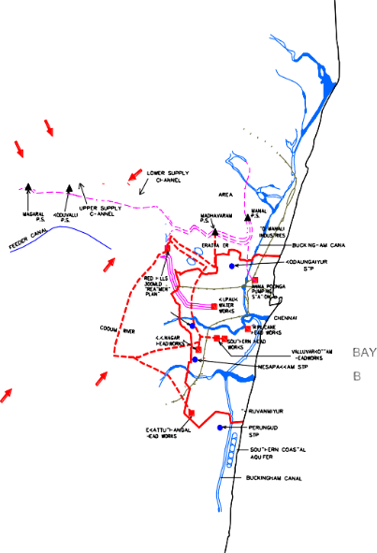
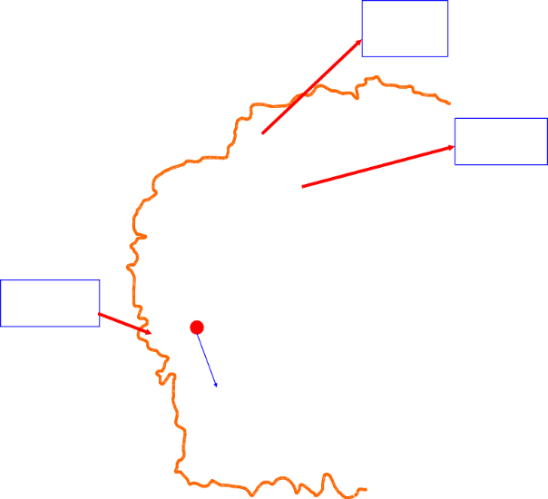
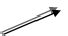
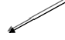
FIGURE 11: Surface, sea, and groundwater sources in Chennai Metropolitan Area (2013)
Capacity
PANJETTY WELL FIELD
881 mcft
KANNIGAIPER WELL FIELD
FLOOD PLAINS WELL FIELDS
100 mld Desalination Plant at Minjur
CHOLAVARAM TANK
MINJUR WELL FEILD
POONDI RESERVOIR
TAMARAPAKKAM WELL FEILD
Capacity
3300 mcft
POONDI WELL FEILD
REDHILLS RESERVOIR
Capacity
3645 mcft
PORUR LAKE
CHEMBARAMBAKKAM
TANK
SRIPERUMPUDUR
Surface water Ground water
TANK
CHENNAI METROPOLITAN AREA BOUNDARY
530 mld
Plant
Sea water
New Veeranam 180 mld pipe line alignment
100 mld Desalination Plant
at Nemmeli under trail run
7
Source Map (Water)
Capacity
3231 mcft

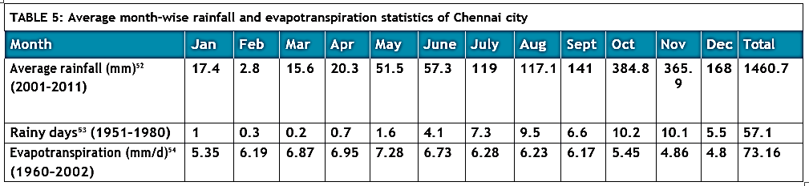
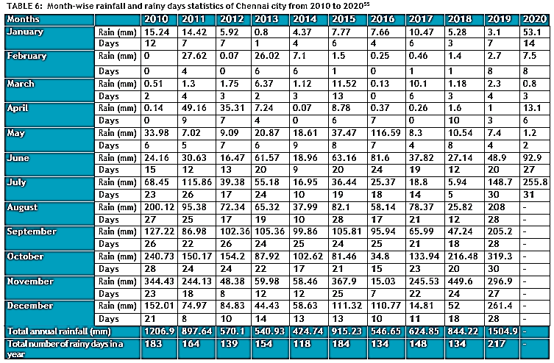
Table 6 illustrates Chennai's rainfall trends from 2010 to 2019, revealing irregular non-monsoon rainfall and increased November rainfall. Monsoon months remain the peak rainfall period, except for the anomaly in May 2016 when heavy rainfall occurred. Fluctuations in annual rainfall led to devastating floods in 2015. Global climate change, including global warming and greenhouse gas emissions, may be contributing to these unpredictable patterns. Unauthorized development and inadequate flood preparedness exacerbate the risk of flooding in CMA, necessitating proactive measures and improved flood management.

Surface Water
Chennai relies on five main surface water sources - Poondi, Cholavaram, Red Hills, Chembarambakkam, and Veeranam lakes (reservoirs) - which get replenished by the annual rainfall. Together, these lakes have a combined capacity of 360.01 MCM, as indicated in Table 7.
TABLE 7: Storage capacity at full reservoir level of surface water sources and capacity of desalination plants (seawater) supplying water to Chennai Metropolitan Area
Source of Water |  | Storage Capacity at Full Reservoir Level (MCM)57
Lakes  (Surface water) | Poondi | 91.43
 | Cholavaram | 30.59
 | Redhills | 93.39
 | Chembarabakkam | 103.15
 | Veeranam | 41.45
Total Combined Capacity |  | 360.01
Desalination Plant  (Seawater) | Minjur | 0.1
 | Nemmeli | 0.1
Chennai's water supply infrastructure includes reservoirs like Poondi (initial capacity of 72.8 MCM), Tamaraipakkam anicut, and Cholavaram Lake for water diversion. The Veeranam reservoir, commissioned in 2004, adds 0.18 MCM of water per day from Veeranam Lake through the Cauvery River system and rainwater. An interstate agreement with Andhra Pradesh provides 424.5 MCM annually (339.6 MCM after losses) of Krishna river water received in Poondi reservoir in 1996. To augment supply, desalination plants in Minjur and Nemmeli (each with a 100 MLD capacity) offer reliable water sources, enhancing water supply resilience. Figure 12 illustrates the water flow system in CMA from surface and seawater sources.
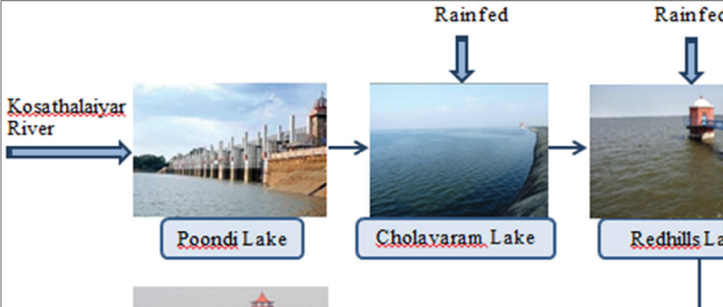
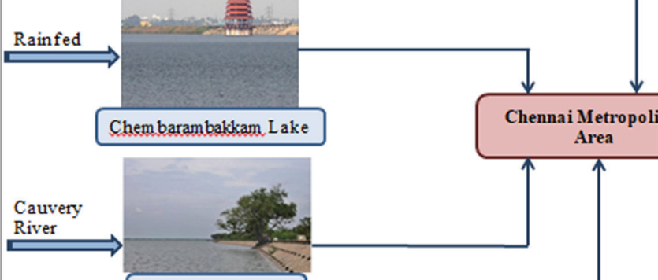
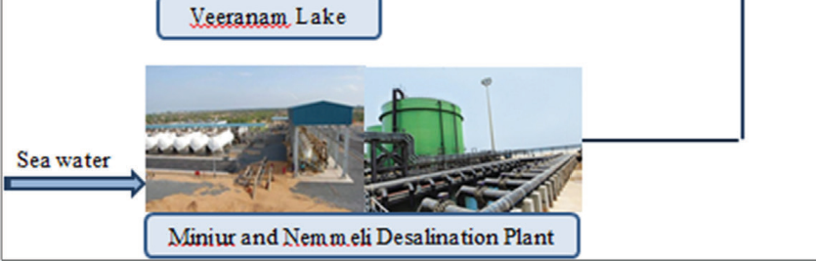
FIGURE 12: Water supply system in Chennai Metropolitan Area from surface and seawater sources
Rainfed
Rainfed
Kosathalaiyar River
Poondi Lake
Cholavaram Lake
Redhills Lake
Rainfed
Chem baram bakkam Lake
Chennai Metropolitan Area
Cauvery River
Veeranam Lake
Sea water
Miniur and Nemmeli Desalination Plant
Tables 8–11 show month-wise live water storage of the four reservoirs located in CMA, that is, Poondi, Cholavaram, Red Hills, and Chembarabakkam from 2011 to 2019.
TABLE 8: Live storage of water in Poondi reservoir in Chennai Metropolitan Area from 2011 to 2020 (in MCM)
Months | 2011 | 2012 | 2013 | 2014 | 2015 | 2016 | 2017 | 2018 | 2019 | 2020
January | 91.4 | 80.3 | 43.04 | 4.16 | 13.7 | 88.1 | 17.4 | 28.6 | 8.43 | 40.3
February | 88 | 86.3 | 38.4 | 7.19 | 6.65 | 74.3 | 20.5 | 39.2 | 5.38 | 44.8
March | 77.3 | 80.9 | 27.9 | 14.8 | 6.65 | 58 | 22.6 | 56.9 | 13.5 | 43.8
April | 71.6 | 72.9 | 11.6 | 2.63 | 2.18 | 54.1 | 4.53 | 45.6 | 9.42 | 40.7
May | 67.4 | 66.4 | 11.4 | 8.32 | 4.3 | 35 | 1.64 | 11.2 | 5.46 | 24
June | 48.1 | 58.8 | 9.54 | 12.1 | 2.7 | 30.1 | 1.104 | 5.2 | 1.58 | 10.6
July | 33.4 | 48.2 | 6.2 | 2.97 | 2.26 | 28.8 | 0.53 | 3.7 | 0.509 | -
August | 50.9 | 26.6 | 5.6 | 2.29 | 1.47 | 18.2 | 0.56 | 1.41 | 0.45 | -
September | 65.4 | 17.3 | 8.69 | 16.2 | 1.67 | 16.1 | 0.76 | 0.36 | 0.45 | -
October | 86.4 | 16.7 | 9.31 | 11.6 | 1.67 | 8 | 1.18 | 2.63 | 16.9 | -
November | 75.4 | 19.6 | 12.9 | 8.09 | 1.98 | 6.4 | 9.4 | 19.6 | 47.6 | -
December | 70.3 | 22.5 | 21.1 | 7.92 | 77.7 | 5.49 | 28.4 | 10.7 | 28 | -
Average | 68.8 | 49.7 | 17.14 | 7.8 | 10.24 | 35.21 | 9.05 | 18.75 | 11.47 | -
The above-mentioned data depicts the storage as on the first day of the month
TABLE 9: Live storage of water in Cholavaram reservoir in Chennai Metropolitan Area from 2011 to 2020 (in MCM)
Months | 2011 | 2012 | 2013 | 2014 | 2015 | 2016 | 2017 | 2018 | 2019 | 2020
January | 23.1 | 24.2 | 13.3 | 4.8 | 3.48 | 20.3 | 2.32 | 14.5 | 1.35 | 1.92
February | 23.7 | 14.01 | 11.2 | 2.6 | 3.19 | 15.09 | 1.95 | 12.7 | 1.35 | 2.03
March | 21.8 | 8.4 | 2.5 | 2.2 | 2.12 | 10.6 | 0.7 | 11.2 | 1.35 | 2.03
April | 19.1 | 2.8 | 2.1 | 1.4 | 1.81 | 7.1 | 0 | 2.8 | 1.18 | 2.03
May | 17.6 | 2.43 | 1.1 | 0.1 | 0.5 | 3.3 | 0 | 1.98 | 0.3 | 2.03
June | 6.1 | 2.3 | 0 | 0.08 | 0 | 2.3 | 0 | 1.92 | 0.02 | 2.03
July | 2.5 | 2.406 | 0 | 0 | 0 | 2.2 | 0 | 1.72 | 0 | -
August | 2.6 | 2.406 | 0 | 0 | 0 | 2.06 | 0 | 0.7 | 0 | -
September | 3.4 | 2.406 | 0 | 0 | 0 | 1.95 | 0.6 | 0.02 | 0 | -
October | 3.9 | 2.6 | 0 | 0 | 0 | 2.8 | 1.01 | 0.2 | 1.5 | -
November | 19.3 | 6.1 | 4 | 1.3 | 0 | 2.03 | 5.09 | 0.5 | 5.4 | -
December | 23.6 | 9.3 | 9.3 | 17.2 | 16.8 | 2.03 | 16.8 | 1.1 | 2.7 | -
Average | 13.89 | 6.61 | 3.62 | 2.47 | 2.32 | 5.982 | 2.37 | 4.1 | 1.26 | -
The above-mentioned data depicts the storage as on the first day of the month.
TABLE 10: Live storage of water in Red Hills reservoir in Chennai Metropolitan Area from 2011 to 2020 (in MCM)
Months | 2011 | 2012 | 2013 | 2014 | 2015 | 2016 | 2017 | 2018 | 2019 | 2020
January | 91.6 | 74.5 | 61.2 | 61.3 | 44.7 | 81 | 12.7 | 44.8 | 26.6 | 69.5
February | 92.1 | 78.4 | 62.6 | 56.4 | 49.3 | 80 | 8.6 | 38.7 | 20.3 | 82.2
March | 87.9 | 72.8 | 61.9 | 63.3 | 51.9 | 76.7 | 20.3 | 33.8 | 14.7 | 71.8
April | 76.5 | 64.8 | 48.8 | 61.6 | 42.5 | 66.4 | 18.2 | 47 | 8.5 | -
May | 64.08 | 51.5 | 35.5 | 49.4 | 38.4 | 53.2 | 11.8 | 50.3 | 3.5 | -
June | 62.4 | 37.3 | 23.2 | 42.6 | 28.5 | 45.6 | 4.7 | 40.4 | 0.08 | 78.7
July | 53.3 | 34 | 13.4 | 36.2 | 19.5 | 34 | 0.5 | 31.7 | 0 | -
August | 49.04 | 39.02 | 9.5 | 26.2 | 12.1 | 30.6 | 0 | 26 | 0 | -
September | 57.1 | 38.9 | 16.2 | 25.2 | 6.8 | 19 | 2.3 | 20.1 | 0 | -
October | 83.7 | 43.5 | 27.6 | 29.5 | 2.3 | 18.6 | 3.8 | 13.5 | 1.5 | -
November | 86.7 | 53.4 | 37.7 | 27.5 | 0.7 | 11.6 | 17.3 | 22.9 | 23.7 | -
December | 85.1 | 55.7 | 52.3 | 37.9 | 79 | 7.5 | 44 | 31.2 | 46.4 | -
Average | 74.12 | 53.65 | 37.49 | 43 | 31.3 | 43.6 | 12.01 | 33.3 | 12.1 | -
The above-mentioned data depicts the storage as on the first day of the month.
TABLE 11: Live storage of water in Chembarambakkam reservoir in Chennai Metropolitan Area from 2011 to 2020 (in MCM)
Months | 2011 | 2012 | 2013 | 2014 | 2015 | 2016 | 2017 | 2018 | 2019 | 2020
January | 88.6 | 79.9 | 35 | 24.7 | 27.4 | 89.2 | 15.2 | 52.1 | 2.8 | 47.9
February | 87.2 | 76.9 | 27.7 | 20.3 | 21.1 | 85.4 | 9.5 | 47.9 | 1.4 | 43.8
March | 77.1 | 67.6 | 40.9 | 22.3 | 20.6 | 80.8 | 4.5 | 42.6 | 0.6 | 56.1
April | 62.5 | 56.3 | 50.2 | 21.1 | 24.4 | 67.3 | 13.1 | 34.4 | 0.2 | -
May | 48.2 | 44.5 | 40.2 | 25.9 | 22.6 | 65.3 | 8.1 | 33.9 | 0.05 | -
June | 51.5 | 33.3 | 28.6 | 35.7 | 16.1 | 65.4 | 2.6 | 34.3 | 0.02 | 56.9
July | 56.1 | 21.4 | 21.4 | 31.2 | 14.4 | 55.9 | 1.3 | 25.6 | 0 | -
August | 69 | 31.7 | 15.7 | 24 | 9.1 | 44.2 | 2.3 | 17.7 | 0 | -
September | 80.5 | 39.7 | 12.6 | 17.9 | 4.6 | 32.4 | 5 | 12.6 | 0 | -
October | 79 | 33.9 | 18.9 | 20.3 | 4.1 | 27.5 | 6.2 | 9.5 | 0.3 | -
November | 77.4 | 33.7 | 21.2 | 34.2 | 6.4 | 16.1 | 17.4 | 6.6 | 2.1 | -
December | 75.6 | 32.3 | 27 | 33.6 | 88.9 | 6.7 | 49.8 | 5.2 | 21.2 | -
Average | 71 | 45.9 | 28.2 | 25.9 | 21.6 | 49.6 | 11.25 | 26.8 | 2.3 | -
The above-mentioned data depicts the storage as on the first day of the month.
Figure 13 highlights the erratic live water storage pattern in Chennai's reservoirs over the last decade, not consistently correlating with increased average annual rainfall intensity. Inconsistent rainfall resulted in extended dry periods, depleting groundwater levels and impacting reservoir storage. Mismanagement of rainwater, encroachments, and unregulated construction in reservoir catchments worsened the situation, limiting water recharge and causing water wastage. The Red Hills, Poondi, and Chembarambakkam reservoirs experienced significant declines in storage, while Cholavaram remained relatively stable. These challenges exacerbate water scarcity issues in the Chennai Metropolitan Area.
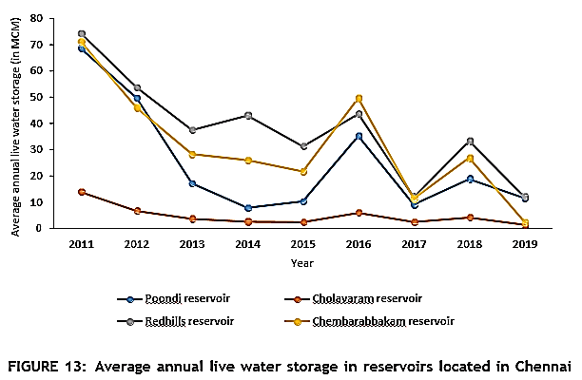
The graph shows a concerning trend of declining water storage levels in the Chennai Metropolitan Area, leading to water shortages. However, post-2015, water storage levels have shown some improvement, possibly due to desilting efforts. Table 12 presents the month-wise live water storage of Veeranam reservoir from 2011 to 2019.
TABLE 12: Live storage of water in Veeranam reservoir in Chennai Metropolitan Area from 2011 to 2020 (in MCM)
Months | 2011 | 2012 | 2013 | 2014 | 2015 | 2016 | 2017 | 2018 | 2019 | 2020
January | 27.6 | 25.8 | 14.1 | 21.6 | 33.8 | 13.8 | 7.1 | 22.8 | 41.1 | 33.1
February | 12.9 | 40 | 3.5 | 36.6 | 39 | 12.9 | 1.9 | 11.5 | 37.9 | 41.1
March | 2.1 | 38.7 | 0.7 | 30.1 | 35.6 | 0 | 0 | 3.1 | 28.6 | 39.2
April | 0 | 20.3 | 6.7 | 20.5 | 23.7 | 0 | 0 | 0 | 16.6 | -
May | 0 | 10.8 | 1.5 | 28.4 | 22.3 | 0 | 0 | 0 | 33.8 | -
June | 0 | 14.1 | 0 | 29.7 | 36.3 | 0 | 0 | 0 | 21.4 | 7.6
July | 0 | 3.1 | 0 | 22.1 | 27.3 | 0 | 0 | 0 | 10.1 | -
August | 14.3 | 2.7 | 0 | 13.2 | 18.5 | 0 | 0 | 0 | 2.7 | -
September | 19.9 | 0 | 32.8 | 17.3 | 27.3 | 0 | 0 | 38 | 35.4 | -
October | 19.4 | 0 | 13.4 | 26.4 | 26.1 | 0 | 0 | 22.8 | 35.9 | -
November | 19.4 | 24.6 | 19.9 | 29 | 27.6 | 0 | 12 | 15.9 | 33.4 | -
December | 19.4 | 12 | 28.4 | 23.7 | 16.2 | 15.7 | 20.3 | 33.4 | 38 | -
Average | 11.25 | 16 | 10 | 24.8 | 27.8 | 3.5 | 3.4 | 12.2 | 27.9 | -
The data for Veeranam reservoir in the last decade shows an undulating pattern of live water storage, influenced by inconsistent rainfall. The reservoir experienced both highs and lows in storage levels between 2011 and 2019. Notably, efforts to enhance rainwater management through desilting waterbodies have yielded positive results, with the average live water storage reaching its highest at 27.9 MCM in 2019. Such interventions are crucial in CMA to improve reservoir storage levels and ensure a sustainable water supply for the region in the face of changing rainfall patterns and water scarcity challenges.
Groundwater
The increasing population and inconsistent rainfall in CMA led to a shift towards groundwater as an alternative water source. Well fields were established, but by 2005, only 12 out of 74 wells remained active, yielding 11 MLD compared to the designed yield of 190 MLD, indicating a decline in groundwater availability.
TABLE 13: Groundwater yield information of well fields located in Chennai Metropolitan Area
Name of Well Field | Number of Wells  Yielding Water | Designed Yield  (MLD) | Average Yield from Wells in  2005 (MLD)
Tamaraipakkam | 2 out of 30 | 50 | 1.6
Panjetty | 1 out of 13 | 41 | 0.08
Minjur | 5 out of 9 | 34 | 3.1
Poondi | 4 out of 12 | 27 | 1.2
Floodplains | 0 out of 5 | 14 | 0
Kannigaipair | 0 out of 5 | 14 | 0.01
Southern coastal aquifers | - | 10 | 5
Total | 12 out of 74 | 190 | 10.99
Excessive groundwater extraction and inadequate recharge have caused a decline in the water table and reduced groundwater yielding capacity in CMA. Table 14 shows block-wise groundwater development, with Minjur classified as "over-exploited," Poonamallee as "dark area," St. Thomas Mount and Cholavaram as "grey areas," and Puzhal, Villivakkam, Sriperumbudur, Kattankulathur, and Kundrathur as "white areas" with lower water extraction.
TABLE 14: Groundwater yields in Chennai Metropolitan Area
Groundwater Source | Yield in 1996 (MLD) |  | Yield in 2006 (MLD)
Northern well fields | 148 |  | 100
Southern coastal aquifers | 10 |  | 5
Stage of Development |  | Category
Greater than 100% |  | Over exploited
85%–100% |  | Dark area
65%–85% |  | Grey area
Less than 65% |  | White area
Table 15 presents detailed information on block-wise groundwater development in CMA. For instance, Minjur exhibits high groundwater exploitation, while St. Thomas Mount and Cholavaram have moderate levels of development. Puzhal and Villivakkam show relatively lower water extraction, while Ponnamalle, Sriperumbudur, Kundrathur, and Kattankulathur fall in between.
Table 15 shows the block-wise groundwater development in CMA. Based on the development
Block | Total Area (km2 ) | Total Annual Groundwater Recharge  (Mm3 ) | Net Annual Groundwater Availability  (Mm3 ) | Existing Gross Groundwater Draft for All  Uses (Mm3 ) | Stage of Groundwater Development  (%)
Minjur | 478.30 | 123.72 | 111.35 | 147.31 | 132
Cholavaram | 193.69 | 98.40 | 88.56 | 68.43 | 77
Puzhal | 60.41 | 34.87 | 31.38 | 16.01 | 51
Villivakkam | 175.78 | 60.65 | 54.59 | 28.72 | 53
Ponnamalle | 156.13 | 72.01 | 64.81 | 57.39 | 89
Sriperumbudur | 365.69 | 134.03 | 120.62 | 23.74 | 20
Kundrathur | 270.38 | 87.66 | 78.90 | 45.26 | 57
St.Thomas  Mount | 236.51 | 41.61 | 37.45 | 23.85 | 64
Kattankulathur | 361.76 | 83.40 | 75.06 | 45.49 | 61
Table 16 highlights the net groundwater availability in the Chennai district basin for 2013, which was found to be lower than in 2011. All 20 firkas in the Chennai district were classified as "over-exploited," indicating a critical situation in groundwater availability and highlighting the urgent need for sustainable water management practices in the region.
TABLE 16: Groundwater availability and draft information of Chennai district
District | 2011 |  | 2013
 | Net Groundwater  Availability (ham) | Groundwater  Draft (ham) | Net Groundwater  Availability (ham) | Groundwater  Draft (ham)
Chennai | 1707 | 3780 | 1497 | 2768
Chennai's groundwater recharge zone is found about 3 meters below the ground near the coast, with varying depths of 4 to 23 meters in different areas. The south-eastern region, with less permeable crystalline rocks, poses challenges for recharge. Groundwater quality is heterogeneous due to diverse rock formations, leading to alkaline water with high chloride and sulfate levels, rendering it unsuitable for drinking. Artificial recharge techniques can help improve groundwater quality and ensure sustainable management of this crucial resource in Chennai.
4.2 Water and Wastewater Treatment Infrastructure
The Chennai Metropolitan Water Supply and Sewerage Board manages the city's water supply infrastructure. Water is sourced from Poondi and Cholavaram reservoirs and treated at Kilpauk, Puzhal, and Surapet Water Treatment Plants before distribution in CMA.4.2.1 Water Treatment Plants
Current Scenario
Two new lakes, Chembarambakkam and Veeranam, were identified for water supply in the early 2000s. Water from these lakes is treated at Chembarambakkam and Vadakuthu WTPs to meet growing demands. Dedicated wastewater treatment plants effectively treat and discharge wastewater back into the rivers.
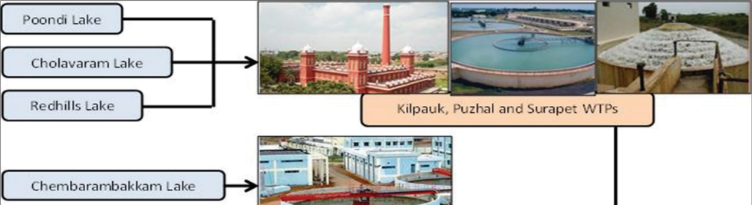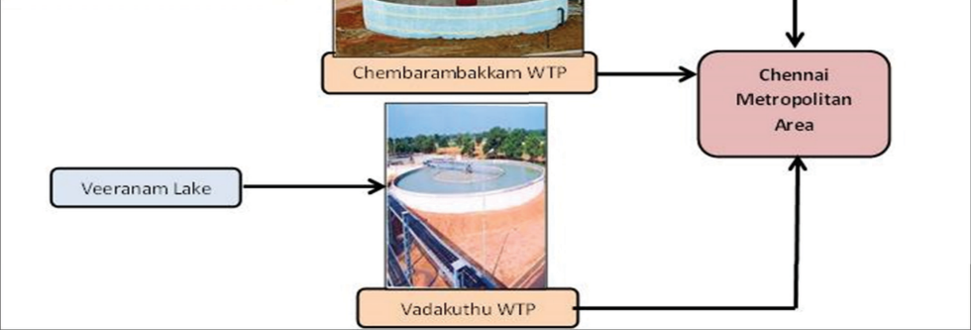
Poondi Lake
Cholavaram Lake Redhills Lake
Kilpauk, Puzhal and Surapet WTPs
Chembarambakkam Lake
Chembarambakkam WTP
Veeranam Lake
Vadakuthu WTP
Chennai metropolitan Area

There are five WTPs in CMA with combined water treatment capacity of 1294 MLD, as given in Table 17.
TABLE 17: Water treatment plants in Chennai Metropolitan Area with their treatment capacities
S. No. | Water Treatment Plant | Capacity (MLD)
1 | Kilpauk | 270
2 | Puzhal | 300
3 | Surapet | 14
4 | Chembarambakkam | 530
5 | Vadakuthu | 180
 | Total | 1294
4.2.2 Sewage Treatment Plants
Historical Background
The sewage system in Chennai has a long history, dating back to 1910, designed for a population of 6.6 lakhs by 1961. It underwent upgrades over the years, serving the growing population of 27.2 lakhs by 1991. Managed by CMWSSB, it includes sewer lines covering 5200 km and open drains spanning 1894 km. The city's sewage network divides into five zones, each with its collection, conveyance, treatment, and disposal system. Chennai has 12 STPs, generating bio-gas utilized for operations, leading to energy cost savings and reduced greenhouse gas emissions through Clean Development Mechanism adoption.
4.2.4 Water Quality of Waterways Carrying Wastewater
Chennai's major waterways, including Cooum, Adayar, Buckingham Canal, and Otteri Nullah, face degradation due to untreated sewage discharge, population growth, waste disposal, and encroachments. The drainage system consists of rivers, waterways, and drains that serve as flood carriers but also carry sewage. This leads to sludge accumulation, sandbars, and challenges for flood protection, stormwater drains, and public health. Urgent interventions are needed to improve the sewage disposal network and restore water quality, necessitating a comprehensive study to identify gaps and develop effective solutions for the health of these vital water bodies.
5. SUMMARY AND CONCLUSION
The analysis of water resources in the Chennai Metropolitan Area (CMA) reveals several critical challenges and potential opportunities. Rapid urban growth and economic development are increasing the demand for housing and civic amenities, including water supply. However, this growth is leading to the development of slums, posing a challenge in providing adequate water connections to lower-income areas. Industrialization and urban expansion are exerting pressure on land and water resources, affecting the ecological balance. Shrinking water bodies due to encroachments and waste disposal contribute to intensify flooding during monsoons. Significant water consumption by residential, commercial, and industrial sectors, coupled with declining agriculture, demands alternative water sources like reclaimed water. Unpredictable rainfall patterns affect water storage in reservoirs, necessitating strategies to address water scarcity, including treated sewage water utilization and water-efficient technologies. Groundwater depletion is concerning, and the lack of up-to-date data hampers understanding of water usage. Improved water meter coverage through initiatives like the Smart Cities Mission will enhance monitoring. Water quality in rivers and lakes is deteriorating due to untreated sewage and industrial wastewater discharge. Rejuvenating these water bodies can serve as potential alternative sources if pollution is addressed. Addressing these challenges and exploring opportunities is vital for building a water-secure and sustainable future for the CMA.
6. REFERENCES
- Lakshmi, K. "The vanishing waterbodies of Chennai". The Hindu. Chennai: Kasturi & Sons. p. 2. Retrieved 21 October 2018.
- Srinivasan, M. S."Desalination: Answer to Chennai's water woes". Business Line. Chennai: Kasturi & Sons. Retrieved 21 July 2013.
- Mariappan, Julie."As population surges, Chennai's water needs to double in 3 years". The Times of India. Chennai: The Times Group. Retrieved 9 August 2014.
- Lakshmi, K. "Metrowater to fathom needs of merged areas". The Hindu. Chennai: Kasturi & Sons. Retrieved 21 July 2013.
- Lakshmi, K."Water level in reservoirs goes up over past ten days". The Hindu. Chennai: Kasturi & Sons. Retrieved 15 December 2012.
- Thooyavan, Kr. "River basins, not stretches, should be looked at". XX (4). Retrieved 14 July 2013.
- Mariappan, Julie"Public consultation for Adyar river restoration to be held in Chennai on Wednesday". The Times of India. Chennai: The Times Group. Retrieved 18 February 2014.
- Lakshmi, K."Rains replenish city's reservoirs". The Hindu. Chennai: Kasturi & Sons. Retrieved 14 July 2013.
- Jump up to:ª ^{b} "State moves Centre for fifth reservoir in Chennai". The Times of India. Chennai: The Times Group. 21 November 2012. Retrieved 14 July 2013.
- "Chennai: new plant to ensure water supply". IBN Live. Chennai: The New Indian Express. 12 June 2012. Archived from the original on 14 July 2013. Retrieved 14 July 2013.
- "Nemmeli desal plant generates at full capacity". The Hindu. Chennai: Kasturi & Sons. 23 December 2013. Retrieved 21 March 2014.
- Ramakrishnan, T. (11 September 2017). "Well-maintained tanks can bail out city". The Hindu. Chennai: Kasturi & Sons. Retrieved 30 September 2017.
- "To tackle water crisis, Metrowater pitches in". The Hindu. Chennai: Kasturi & Sons. 16 October 2018. Retrieved 16 October 2018.
- The Energy and Resources Institute (TERI) 2013. Water Sustainability Assessment of Chennai Metropolitan Area.
- Narmada K and B Govindarajan. 2017. Multi-temporal analysis and quantification of the carbon stocks in the urban forests of Chennai Metropolitan Area using geoinformatics techniques to identify their role in climate change mitigation. Geoinformatics & Geostatistics: An Overview. doi: 05.10.4172/2327-4581.1000172
- Geographical and physical features. Chennai District. Archived from the original on 30 July 2013. Retrieved 28 December 2012
- Department of Economics and Statistics, Government of Tamil Nadu. District Statistical Handbook Chennai District 2016-17
- ENVIS Centre, Department of Environment, Government of Tamil Nadu. State of Environment Report of Chennai Metropolitan Area, 2013.
- Prof. Dr. S.P. Sekar and S. Kanchanamala. 2011. An analysis of growth dynamics in Chennai Metropolitan Area. Institute of Town Planners, India Journal 8–4, October–December, 31–57
- Sikarwar, A and A Chattopadhyay. 2016. Change in land use-land cover and population dynamics: A town-level Study of Ahmedabad city sub-District of Gujarat. International Journal of Geomatics and Geosciences. 7
- Devendran, A A and G Lakshmanan. 2019. Comparison of urban growth modeling using deep belief and neural network based cellular automata model—a case study of Chennai Metropolitan Area, Tamil Nadu, India. Journal of Geographic Information System. 11: 1–16
- Mathan, M and M Krishnaveni. 2019. Monitoring spatio-temporal dynamics of urban and peri-urban land transitions using ensemble of remote sensing spectral indices: A case study of Chennai Metropolitan Area, India. Environmental Monitoring and Assessment
- Mathan, M and M Krishnaveni. 2019. Monitoring spatio-temporal dynamics of urban and peri-urban land transitions using ensemble of remote sensing spectral indices—a case study of Chennai Metropolitan Area, India. Environmental Monitoring and Assessment
- District Statistical Handbook Chennai District 2016-17 & 2011, Department of Economics and Statistics, Government of Tamil Nadu
- An analysis of growth dynamics in Chennai Metropolitan Area, 2020, Institute of Town Planners. India Journal 8-4.
- An analysis of growth dynamics in Chennai Metropolitan Area, ., 2021. Institute of Town Planners, India Journal 8-4
- State of Environment Report of Chennai Metropolitan Area, 2013, Envis Centre, Department of Environment, Government of Tamil Nadu
- Sikarwar, A and A Chattopadhyay. 2016. Change in land use-land cover and population dynamics: A town-level Study of Ahmedabad city sub-District of Gujarat. International Journal of Geomatics and Geosciences.
- Resettlement and rehabilitation of objectionable slums on waterways – Role of TNSCB report. Thiru T.K. Ramachandran, TNSCB
- District Statistical Handbook Chennai District 2016-17, Department of Economics and Statistics, Government of Tamil Nadu
- State of Environment Report of Chennai Metropolitan Area 2013, ENVIS Centre, Department of Environment, Government of Tamil Nadu.
- Climatological Table of observations in India, IMD.
- Boyaj, A, K Ashok, S Ghosh, A Devanand, and G Dandu.2018. The Chennai extreme rainfall event in 2015: The Bay of Bengal connection. Clim Dyn 50: 2867–2879
- Excreta Matters Vol. 2, State of India’s Environment, A Citizen’s Report, Centre for Science and Environment, 2012.
- K.R.Sivaraman and Dr. S. Thillaigovindarajan, Chennai River Basin Micro Level Report, 2020
- State Ground and Surface Water Resources Data Centre 2003
- Report on AQUIFER MAPPING AND GROUND WATER MANAGEMENT, Chennai Aquifer System, Tamil Nadu, CGWB, March 2017.

