Performance of Fuzzy Inference System Model to predict the Effect of Steel Fibre on Compressive Strength of Concrete
Daha S. Aliyu¹ Mahmoud M. Farouq²
School of Engineer School of Architecture,
University of Newcastle Upon Tyne, NE1 7RU, University of Nottingham
United Kingdom United Kingdom
engrshanono@gmail.com mahmoudmurtala@gmail.com

Haruna Ibrahim³ Abdullahi G. Usman⁴
Department of Civil Engineering, Department of Analytical Chemistry,
Cerge ParisUniversity, Faculty of Pharmacy, Near East University,
Neuville-sur-Oise, France TRNC, Mersin 10, Nicosia 99138, Turkey
hibrarogo@gmail.com abdullahigusman@gmail.com

Sani I. Abba⁵
Interdisciplinary Research Centre for Membrane and Water Security,
King Fahad University of Petroleum and Mineral,
Dhahran31261, Saudi Arabia
saniisaabba86@gmail.com

Abstract
This research article investigates the effects of different combinations of high-performance steel fibre-reinforced concrete (HP-SFRC) on its mechanical properties. The parameters analysed consist of a water-to-binder ratio (w/b) of 0.35, 0.40, and 0.45, replacement of 10% and 15% of cement with silica fume, and fibre volume fractions (Vf) of 0, 0.5, 1.0, and 1.5% with aspect ratios of 80 and 40. The study's findings indicate that including silica fume and steel, fibres leads to a moderate increase in the compressive strength of HP-SFRC at Vf = 1.5%. Moreover, a machine learning framework based on an adaptive neuro-fuzzy inference system (ANFIS) was devised to enhance the accuracy of these predictions. Lastly, the effectiveness of multiple linear regression (MLR) models was assessed in predicting the strength of HP-SFRC mixes and compared with existing data.
Keywords: Empirical equation, High-performance concrete, Micro-silica, multiple linear regression, Neuro-fuzzy inference system, Steel fibre Fibre reinforced concrete.

1. Introduction
Concrete is a widely used and robust construction material for various infrastructure applications such as building structures, bridges, and sewage pipes due to its durability. Despite its high compressive strength, concrete's ability to resist tension and flexural loads are often restricted [1], [2]. However, a new approach is replacing the conventional approach of using mild steel reinforcement as the sole method to address these weaknesses. Researchers like [1], [3] have explored other types of fibres, such as steel, glass, polypropylene, and their combinations, as potential alternatives to enhance concrete's tensile and flexural strength.
Numerous investigations have been carried out to examine steel fibres' impact on test samples' compressive strength [4], [5]. They found that the inclusion of steel fibres did not significantly elevate the compressive strength of concrete. For instance, the compressive strength results for samples with a reinforcement ratio of 1.5% were 201 MPa for the control specimen and 211 MPa for the test specimen. [6], [7] noted that the addition of steel fibres had only a minor influence on the compressive strength of concrete specimens. [7] a mere 12% enhancement in compressive strength was observed by adding 0.9% steel fibres.
The findings of experiments conducted by [7], [8] demonstrate that incorporating steel fibres significantly positively impacts the flexural strength of test samples. [8] a 20% increase in flexural strength and a ductile failure mode was observed due to the crack-bridging effect of steel fibres. [7] discovered that the equivalent flexural strength ratio, representing the ratio of the first peak strength to the energy absorption capacity, improved by 22% with the addition of steel fibres. These outcomes indicate that steel fibres enhance the samples' flexural strength and energy absorption capacity.

Research has shown that fuzzy logic is an easy-to-use tool that allows rules to be created based on experience, and fuzzy logic models can explain the relationship between input and output in simple language, which is especially useful when the connection between them is not straightforward. Several researchers, including [9], have employed fuzzy logic and neural networks to investigate the impact of additives (e.g., low lime concrete and fly ash) on various properties of concrete, including compressive and flexural strength. The study's findings demonstrated that fuzzy logic could accurately predict the compressive strength of concrete test specimens, and the statistical analysis revealed an RMS value of 0.28. Moreover, neural networking also successfully generated an RMS value of 1.79.
Furthermore, the Fuzzy model exhibited slope and intercept values of 0.9764 and 0.5842, respectively. In a study by [10], gene expression programming was employed to accurately forecast the compressive strength of cement mortar, yielding an RMS value of 1.4956. Similarly, [11] utilised fuzzy logic and artificial neural networking to predict the compressive strength of concrete, achieving an RMS value of 2.02. The linear fit of the equation provided a slope value of 0.9824 and an intercept value of 0.6354. Based on the statistical analysis, both models demonstrated satisfactory and reliable outputs.
A research project was conducted to investigate the mechanical behaviour of HP-SFRC with different w/b ratios ranging from 0.45 to 0.35 and steel fibre volume fractions ranging from 0 to 1.5% (RI = 0 - 3.88), along with 10 and 15% silica fume replacements. Equations were formulated to predict compressive and flexural strength, accounting for the variations in size, shape, and length of the specimens. Furthermore, a power relationship between compressive and flexural strength was developed and compared to previous research and the American Concrete Institute model [12]. Finally, experimental data from earlier studies verified the proposed model's accuracy.
To ensure the safety and advancement of construction projects, a computational analysis was conducted to simulate the compressive strength of High-Performance Steel Fiber Reinforced Concrete (HP-SFRC). This analysis considered eight input parameters related to the mixture proportions. A machine learning framework was incorporated to develop a predictive model for the compressive strength to address the challenge of determining the strength of HP-SFRC in situ, which is influenced by site-specific and ambient conditions. The model utilises the known mixture proportions as inputs to estimate the compressive strength of HP-SFRC. This approach was adopted due to the complexities of accurately determining on-site strength, as [13] indicated.
2. Materials and methods
2.1 Materials and mixture proportions
The research utilised 53-grade Ordinary Portland cement, which exhibited a compressive strength of 54.5 MPa after 28 days and had a specific gravity of 3.15. In conjunction with this cement, silica fume was incorporated as an additional cementitious material. The silica fume possessed a particular surface area of 23000 m²/kg, a specific gravity of 2.25, and a fineness of 2% based on residue on a 45 μm sieve. The composition of the micro-silica was found to be 88.7% silicon dioxide, 0.9% carbon, and 1.8% loss on ignition. Furthermore, the micro-silica met the standards outlined in ACI 234R-1996 [14].
The study employed river sand as the fine aggregate, which could pass through a 4.75 mm sieve and met the grading zone II requirements outlined in IS: 383-1978 (Standard, 2003). As for the coarse aggregate, crushed blue granite stones with a maximum size of 12.5 mm were utilised. A high-range water reducer admixture was added to enhance the mixes' properties. This admixture comprised locally available sulfonated naphthalene formaldehyde condensate with a specific gravity of 1.20. Additionally, crimped steel fibres with the specified physical characteristics provided in Table 1 were incorporated into the mixtures.

Table 1: Physical properties of round crimped steel fibre
Fibre | Fibre diameter | Fibre length | fibre wavelength | Aspect ratio l/d | Ultimate tensile strength fu | Elastic tensile strength Ef
Crimped round fibre | 0.9mm | 35 and 26mm | 0.8mm | 80 and 40 | 1200Mpa | 200Gpa

Per the specifications outlined in [14], sixteen series of high-performance steel fibre-reinforced concrete (HP-SFRC) formulations were developed. The mixture proportions utilised in this study are detailed in Table 2. Each formulation maintained a constant water-to-binder ratio (w/b) and incorporated a fibre volume fraction (Vf) of either 0.5%, 1.0%, or 1.5% relative to the concrete's volume. Additionally, a superplasticiser was introduced to the mixtures, with dosage varying within the range of 1.75% to 2.5% by weight of the binder. To assess the performance of these HP-SFRC mixtures, sets of three cylinders measuring 150 mm in diameter and 300 mm in height and three prisms measuring 100 mm × 100 mm × 500 mm were manufactured for each formulation. Subsequently, these specimens were cured in water at a temperature of 27 ± 2°C
2.2. Methods of testing
A minimum of three specimens were tested to determine the average compressive strength. The evaluation of compressive strength adhered to the ASTM C 39–92 guidelines. It was carried out utilising a servo-controlled compression testing apparatus, which applied a loading rate of 14 MPa per minute. Likewise, flexural strength (also referred to as Modulus of Rupture) was assessed according to the ASTM C 78–92 standards as described by [15]. The specimens were positioned on a 400 mm simply supported span and subjected to third-point loading using a 100 kN closed-loop hydraulically operated Universal Testing Machine for this test. The loading was applied at a rate of 0.1 mm per minute. All specimens underwent a curing process within a laboratory environment before testing. Subsequently, they were retrieved and conditioned immediately before the commencement of the tests.
3. Results and discussion
3.1. Mechanical properties
The study's findings revealed that introducing steel fibres into High-Performance Concrete (HPC) led to a 12% enhancement in compressive strength at a fibre volume fraction of 1.5%. For regular concrete with water-to-binder (w/b) ratios of 0.45, 0.40, and 0.35, the corresponding compressive strengths were 58.4 MPa, 63.84 MPa, and 69.67 MPa, respectively. When HPC had a w/b ratio of 0.45 and a silica fume content of 19%, its compressive strength increased by 28.4% compared to the control samples. Incorporating more supplementary cementitious materials (SCMs), like micro-silica, led to improved mechanical properties. The joint impact of silica fume and steel fibres on the compressive strength of High-Performance Steel Fiber-Reinforced Concrete (HP-SFRC) can be observed in Table 3 and Figure 1. As the fibre volume fraction increased, the strength of HP-SFRC also rose, as evident in Table 3 and Figure 2. An empirical equation was formulated to predict the compressive strength (f'cf) of HP-SFRC as a function of fibre volume fraction, Vf (%), for a w/b ratio of 0.4, achieving an R² value of 0.9233, as depicted in Figure 3. This trend was found to be consistent across other variations of HP-SFRC.

Figure 1: Effect of fibre reinforcing index (RI) on compressive strength of HPSFRC (5% micro silica replacement)
The stress-strain behaviour of High-Performance Steel Fiber Reinforced Concrete (HP-SFRC) with a water-to-binder ratio (w/b) of 0.45 and a steel fibre (SF) content of 10% was investigated, as shown in Figure 2. In general, the stress-strain relationship of concrete comprises two distinct phases: an initial increasing portion leading up to the peak stress, followed by a subsequent decreasing phase characterised by cracking and softening.
Key parameters commonly used to describe the ascending portion of the stress-strain curve include the initial tangent modulus, the peak compressive strength, and the strain at which the peak stress occurs. Figure 2 illustrates the typical stress-strain (σ–ε) curves for High-Performance Concrete (HPC) without fibres and for SFRC. Notably, the stress-strain curves derived from this study reveal certain trends. For HPC, a higher concrete strength results in a more pronounced curvature in the ascending branch and a more abrupt drop in the descending phase. In contrast, SFRC exhibits a gradually shallower decline in the post-peak region.
The post-peak behaviour of SFRC displays a gradual decline, maintaining residual stress even at a strain of 0.015. This behaviour is attributed to the pull-out of fibres and the bond between fibres and the matrix. Adding Supplementary Cementitious Materials (SCM) enhances this effect due to their strength and filler properties. The toughness of HP-SFRC under compression is improved as the peak load is delayed due to the bond between the fibres and the matrix. Additionally, including fibres in the mix enhances ductility, as evidenced by the post-peak strain values.
The stress-strain curve indicates that an increase in the volume fraction of fibres or the Reinforcement Index (RI) results in a larger area under the curve. This leads to a prolonged post-peak descending phase, ultimately contributing to higher toughness and ductility, as exemplified by the post-peak stress-strain behaviour of SFRC.

Figure 2: Stress-strain curves for HPC and steel fibre reinforced concrete (w/cm = 0.45, SF content = 5%).
Incorporating steel fibres into High-Performance Concrete (HPC) at a volume fraction of 1.5% or a Reinforcement Index (RI) of 3.88 led to a substantial 37% increase in flexural tensile strength. This rise in strength is a significant indication, primarily associated with the effect of fibres being pulled out from the matrix. Experimental testing of prism specimens revealed an extended failure state beyond the point of reaching the ultimate load. This prolonged failure behaviour suggests a noteworthy enhancement in both ductility and flexural toughness of the High-Performance Steel Fiber Reinforced Concrete (HP-SFRC). These findings align with the results observed in earlier research studies conducted by [16]–[18].

Figure 3: Effect of fibre volume fraction on compressive strength of HPSFRC (w/cm = 0.40)
Table 2: Mix proportion design of HPFRC
Mix | w/b | FA, kg | CA, kg | SF, kg | B, kg | W, kg | SP(%) | SF V_{f} (%)
M1  M1  M1  M1  M1*  M2  M2  M2  M2  M2*  M3  M3  M3  M3  M3* | 0.45  0.45  0.45  0.45  0.45  0.40  0.40  0.40  0.40  0.40  0.35  0.35  0.35  0.35  0.35 | 640  638  625  622  640  636  627  625  623  636  611  603  595  587  635 | 1090  1087  1079  1075  1090  1090  1086  1084  1073  1090  1090  1077  1073  1068  1068 | 44.5  44.5  44.5  44.5  67.4  49.7  49.7  49.7  49.7  74.9  56  56  56  56  56 | 435  435  435  435  435  483  483  483  483  483  547  547  547  547  547 | 196  196  196  196  196  193  193  193  193  193  191  191  191  191  191 | 1.65  1.65  1.65  1.65  1.65  2  2  2  2  2  2.7  2.7  2.7  2.7  2.7 | 0  0.5  1.0  1.5  0  0  0.5  1.0  1.5  0  0  0.5  1.0  1.5  0
M1 to M3 and M1 to M3 is Silica fume replacement at 10% and 15%, respectively,
SP (%) Superplasticiser in percentage by the weight of binder material
Vf (%) is the steel fibre in the percentage of the total volume of concrete.

Table 3: Mechanical properties result of HPSFRC of fibre =80
 |  | Steel fibre
Mix | w/b | Vf | RI | f'cf (Mpa)
M1 | 0.45 | 0 | 0 | 53.56
M1 | 0.45 | 0.5 | 1.39 | 55.77
M1 | 0.45 | 1 | 2.68 | 57.01
M1 | 0.45 | 1.5 | 3.98 | 58.4
M2 | 0.40 | 0 | 0 | 56.85
M2 | 0.40 | 0.5 | 1.39 | 60.65
M2 | 0.40 | 1 | 2.68 | 63.05
M2 | 0.40 | 1.5 | 3.98 | 63.84
M3 | 0.35 | 0 | 0 | 64.86
M3 | 0.35 | 0.5 | 1.39 | 68.12
M3 | 0.35 | 1 | 2.68 | 69.91
M3 | 0.35 | 1.5 | 3.98 | 69.67
M1* | 0.45 | 0 | 0 | 57.7
M1* | 0.45 | 1 | 2.68 | 62.21
M1* | 0.45 | 1.5 | 3.98 | 62.17
M2* | 0.40 | 0 | 0 | 60.42
M2* | 0.40 | 1 | 2.68 | 64.41
M2* | 0.40 | 1.5 | 3.98 | 65.59
M3* | 0.35 | 0 | 0 | 65.28
M3* | 0.35 | 1 | 2.68 | 71.04
M3* | 0.35 | 1.5 | 3.98 | 73.12
Fibre reinforcing index (RI) = wf *(l/d) and average density of HSFRC = 2425 kg/m.3.
Weight fraction (wf) = (density of fibre/density of fibrous concrete) *Vf.
Aspect ratio = (l/d).
f'cf = 150 Ø x 300 mm cylinder compressive strength of HPSFRC (MPa).

4. Correlation between compressive strength ratio and fibre volume fraction (%)
Figure 4 illustrates a direct correlation between the compressive strength ratio of high-performance steel fiber-reinforced concrete (HP-SFRC) and the volume fraction of fibres (Vf, %). Through empirical analysis, precise equations were developed to predict the strength ratio (f'cf/f'c) of HP-SFRC, considering a water-to-binder ratio (w/b) range of 0.35 to 0.45. These equations were derived with high accuracy (R² = 0.8699) using regression analysis employing the least-squares method.
f’cf/f’c = 1+ 0.067Vf…………………………………………………………………1
The value of the coefficient of determination, denoted as R² = 0.8699, quantifies the extent to which the fluctuations in compressive strength observed in high-performance concrete (HPC) and high-performance steel fibre-reinforced concrete (HP-SFRC) can be elucidated by the reinforcement parameter. This parameter encompasses factors such as the sample size and several independent variables. Notably, the analysis reveals that approximately 84% of the variance in strength can be accounted for by variations in the fibre volume fraction (Vf) within the concrete mixture.
Where f'c = compressive strength of HPC (Mpa), f'cf = compressive strength of HP-SFRC (Mpa) and Vf = fibre volume fraction, %.

Figure 4: HPSFRC Vs Fiber volume fraction compressive strength ratios, Vf (%).
Equation (1) was extended to analyse the compressive strength of High-Performance Steel Fiber Reinforced Concrete (HP-SFRC), where the second term of the equation represents the influence of the interaction between the matrix and the fibres on the overall strength. This interaction relies on the characteristics of fibre bond strength and pull-out within the matrix. It was applied to cylindrical specimens of HP-SFRC with a fibre aspect ratio (l/d) 40, covering a Reinforcement Index (RI) range from 0 to 2.10 to validate the proposed model. The outcome of this testing indicated an average absolute deviation of merely 0.36% between predicted and observed values. Additionally, the correlation coefficient (R) yielded a value of 0.92, while the integral absolute error (IAE) was 0.97. For reference, the predicted values are tabulated in Table 4.
Table 4: Compressive strength of HPSFRC and absolute variation by the model of (Eq. (1)) - aspect ratio of fibre (l/d) = 40.
Mix design | w/b | Steel fibre content |  | Compressive strength (Mpa) |  | Absolute % error
 |  | Vf (%) | RI | Experimental | Predicted
M2 | 0.4 | 0 | 0 | 56.85 | 56.74 | 0.11
M2 | 0.4 | 0.5 | 1.39 | 60.65 | 60.84 | 0.19
M2 | 0.4 | 1 | 2.68 | 63.05 | 63.34 | 0.29
M2 | 0.4 | 1.5 | 3.98 | 63.84 | 64.47 | 0.63
M2* | 0.4 | 0 | 0 | 60.42 | 60.73 | 0.31
M2* | 0.4 | 1 | 2.68 | 64.41 | 64.86 | 0.45
M2* | 0.4 | 1.5 | 3.98 | 65.59 | 66.1 | 0.51

5. Numerical simulation of strength
This study employed a numerical simulation to investigate the relationship between the composition of the mixture and the 28-day compressive strength of High-Performance Steel Fiber Reinforced Concrete (HP-SFRC) incorporating micro-silica. The analysis included eight distinct input factors to evaluate the compressive strength of the concrete. The findings of the statistical analysis, derived from gathered data available in published sources, are detailed in this particular section of the research.
- Cement content (kg) | 5) Superplasticiser (kg)
- Coarse aggregate (kg) | 6) Silica fume (kg)
- Fine aggregate (kg) | 7) Water (kg)
- Water/Cement ratio | 8) Fibre volume fraction (kg)
The authors gathered data from 40 different sources to assess the accuracy of the strength model for high-performance concrete (HPC) and high-performance steel fibre-reinforced concrete (HP-SFRC). A total of 250 mixtures from the research studies were assessed. Some samples were removed due to their large aggregate size, special curing conditions, and other factors that were not pertinent to the current research. Consequently, a data set of 241 records, each with eight distinct variables, was compiled from the experimental research of this study as well as from Liao et al. [17], [19]–[21]. The ranges of components of the data set can be seen in Table 5.
The study collected data from 40 different sources to evaluate the accuracy of the strength model applied to high-performance concrete (HPC) and high-performance steel fibre-reinforced concrete (HP-SFRC). In total, 250 concrete mixtures from various research studies were examined. Some samples were excluded from the analysis due to factors such as large aggregate size, specialised curing conditions, and other criteria irrelevant to the present investigation.
As a result, a dataset consisting of 241 records, each characterised by eight distinct variables, was compiled. This dataset comprised experimental data from the current study and the works of [17], [19]–[21]. The specific ranges of components within this dataset can be observed in Table 5.
Table 5: Range of data set for HPFRC
Component | Minimum | Maximum
Cement (kg) | 385.3 | 679
Coarse aggregate | 903 | 1295
Fine aggregate | 365 | 902
Water (kg) | 119.2 | 221
Water/binder ratio | 0.35 | 0.45
Superplasticiser (kg) | 0 | 30.08
Fibre volume fraction | 0 | 0.02
Fibre (kg) | 0 | 120
Compr. strength (MPa) | 43.6 | 100

6. Machine learning: prediction of strength
The machine learning (ML) algorithm discussed in this study is tailored to predict the compressive strength of High-Performance Steel Fiber Reinforced Concrete (HP-SFRC) based on eight distinct factors. Unlike conventional techniques such as multiple linear regression, ML has the capacity to analyse both linear and nonlinear correlations within the data, offering a more straightforward interpretation of physical relationships [22]. Moreover, ML demonstrates higher accuracy during testing compared to traditional methods. Another advantage is its ability to capture intricate associations between strength properties and the mix design of HP-SFRC, enabling adjustments with new data. Consequently, the primary objective is to determine HP-SFRC's compressive strength by considering the composition and quantities of its constituents.
To prevent a situation where the number of parameters to be learned exceeds the available training samples, it is essential to restrict the number of ML inputs [23]. To achieve this input control, the eight elements (referred to as attributes in Figure 5) are divided into four groups. These attributes are normalised within the 0 to 1 range and aggregated within each group to establish distinct features: cement and water, aggregate, superplasticiser content, and fibre volume fraction. For example, when calculating each concrete sample's cement and water feature, individual attributes like the w/c ratio, cement, silica fume, and concrete water are normalised between 0 and 1 using equation (2). Subsequently, these normalised values for w/c ratio, cement, silica fume, and concrete water are combined to form the cement and water feature.
$zi=\frac{di-min⁡(d)}{\max\left(d\right)-min⁡(d)}$…………………………………………………...………2
The normalised and actual values for each attribute in a given sample (i) are denoted by zi and di, respectively; the maximum and minimum d for all samples is represented by max(d) and min(d).

Cement, Water, Silica fume
Coarse aggregate, Fine aggregate
Superplasticizer
Fibre volume fraction
Cement and water content
Aggregate content
Superplasticizer content
Fibre volume fraction content
ANFIS (First order Sugeno fuzzy model)
Compressive Strength
Attribute
ML input
ML training
Output

Figure 5: Determination of Compressive strength Using ML algorism
[24] applied comparable data processing methodologies and outlined the normalisation procedure in their work. The grouping of attributes is also depicted in Figure 5. For the machine learning process aimed at predicting the compressive strength of HP-SFRC, inputs such as cement, water, aggregate, superplasticiser content, and fibre volume fraction were employed.
Given its widespread applicability in this domain, an Adaptive Neuro-Fuzzy Inference System (ANFIS) was selected to investigate the nonlinear system. ANFIS employs a hybrid learning approach to optimise weights, minimising the disparity between predicted and actual outputs. This process governs the parameter adjustments and assembly of the fuzzy inference system (FIS). The foundational Sugeno fuzzy model, which underpins ANFIS, is illustrated in Figure 6.
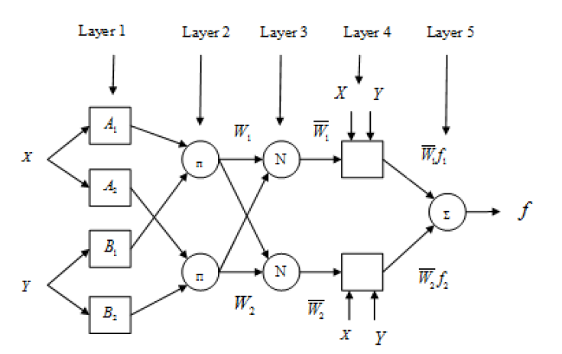
Figure 6: ANFIS structure
For example, assume the FIS has two inputs, x and y, and one output, f. A typical set of two fuzzy "if-then" rules might look like this:
Rule 1: if x is A₁ and y is B₁, then $f_{1}=p_{1}x+q_{1}y+r_{1}$
Rule 2: if x is A₂ and y is B₂ , then $f_{2}=p_{2}x+q_{2}y+r_{2}$
where,$A_{i},$ $B_{i}$ Refer to the membership functions of the inputs and $p_{i, }q_{i}, r_{i}$ Are parameters which can be adjusted during the learning process. The architecture of ANFIS, depicted in Figure 2, consists of layers and nodes; the square nodes, which are adaptable, hold the adjustable parameters, while the round nodes are fixed with certain functions, for example:
Layer 1: In this layer, every node $ⅈ$ is an adaptive node having a node function.
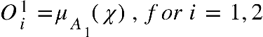………………………………………………………….3
Or
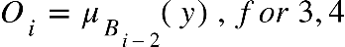……………………………………………………………4
Where 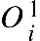 is the membership grade for input . The membership function could include Gaussian, Triangular, Trapezoidal, and Gbell membership.
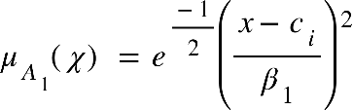……………………………………………………….….5
Where 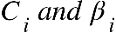 are the premise parameters to be optimised using gradient descent?
Layer 2: Every node in this layer is a fixed node, which multiplies the incoming signal and sends the product out given.
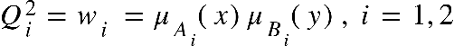…………………………………….…………6
Layer 3: This layer contains circular nodes, which compute the ratio of the firing strengths of the rules.
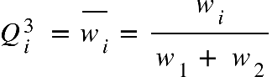…………………………………………………..…………7
Layer 4: Every node in this layer is an adaptive node and performs the consequent of the rules.
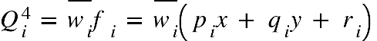………………………………………………...8
The parameters 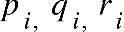 are consequent parameters to be determined.
Layer 5: The single node in this layer computes the overall output
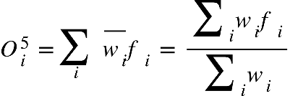………………………………………………………..9
The Adaptive Neuro-Fuzzy Inference System (ANFIS), introduced by [25], integrates two techniques, gradient descent and least squares, to adjust the parameters of the initial and fourth layers within the neural network structure. With fixed premise parameters, the output is computed during the forward pass, as demonstrated by [26], [27]. The input vector is propagated through the network during this process, and parameter adjustments are executed via the least squares method. This outcome is expressed as follows:
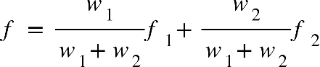
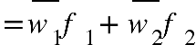
……………………………10
where 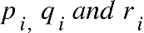 and are the consequent parameters
………………………………………………………………………….....11
For invertible X Matrix
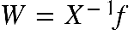………………………………………………………………………….12
Otherwise, pseudo-inverse is applied to obtain
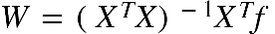……………………………………………………...…………13
In the backward pass, the error propagates back through the network, and the premise parameters 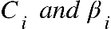 are optimised by gradient descent.
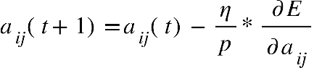……………………………………………………14
where is the learning epoch, is the learning rate for 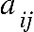 and is the number of input patterns.
The parameters are updated using the expression
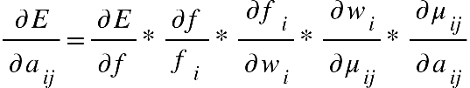…………………………………………….15
The function is expressed as
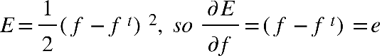…………………………………………….16
Where is the expected output and depicts the fuzzy system output.
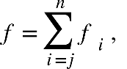 considering 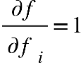………………………………………………….17
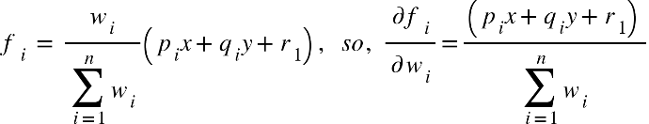……………………………….18
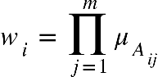 , therefore, 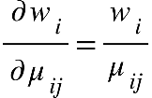…………………………………………….19
Hence, the gradient can now be expressed as:
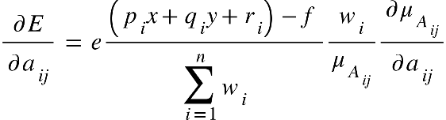……………………………………...….20
Or
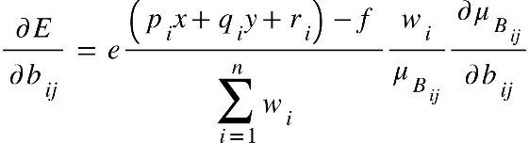……………………….……………….…21
ANFIS serves as a learning system that employs input-output data to establish a model mapping. Upon obtaining a set of parameters for the model, a comparison between the model's output for each training data pair and the corresponding measured values is performed to calculate the discrepancy between the actual and observed values. The finalisation of the model occurs once the defined stopping criterion is met.
In this study, the model configuration depicted in Figure 7 was devised using the MATLAB toolbox. The model is structured with four distinct inputs connected to a pair of bell-shaped membership functions. Following a training phase comprising one hundred iterations, the ANFIS was evaluated using testing data. This process led to the formulation of sixteen if-then rules and a total of one hundred and four parameters requiring optimisation.

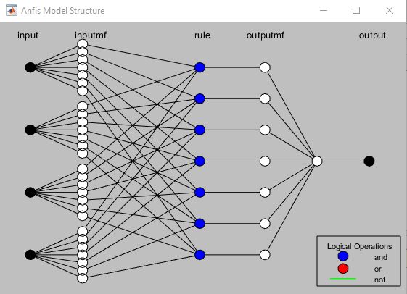
Figure 7: ANFIS Model structure for compression strength prediction of HP-SFRC.
Figure 8 portrays the correlation between forecasted values and real compressive strengths for the training and testing datasets. The high coefficient of determination (R²) is evident in both cases, signifying the model's aptitude in accurately predicting concrete compressive strength, consistent with the findings of [28]. Furthermore, the root mean squared error (RMSE) calculated through equation (22) is 0.17 for the training dataset and 0.56 for the testing dataset. This outcome reinforces the precision of the machine learning model.
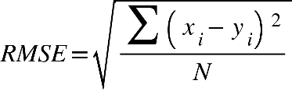…………………………………………………….22
Where is the measured value, is the predicted value and refers to the number of samples.
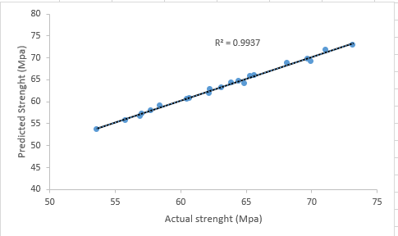 | 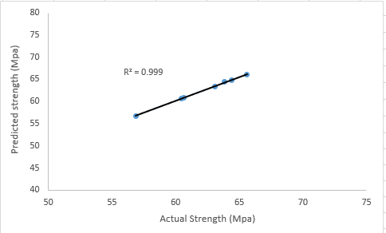

a) Training data b) Testing data
Figure 8: Correlation between actual compressive strength and predicted compressive strength by the ANFIS
Utilising the XLSTAT software, a multiple linear regression model was created after examining a dataset comprising eight distinct parameters. The generated model (Equation 23) exhibited a coefficient of determination of 0.87 and was employed to predict the 28-day compressive strength of High-Performance Steel Fiber Reinforced Concrete (HP-SFRC). The formulation of the multiple linear regression model is as follows:
y=106.1751 - 65.9815 /cm + 0.06052 C - 0.0049 FA - 0.00782 CA + 0.21315 SF - 0.23387 W - 0.3603 SP + 0.04146 Fiber (R=0.982) ……………………………………………………………23
7. Parametric study of the ANFIS model
The primary objective of this research was to assess how the inclusion of steel fibres, among other variables, impacts the compressive strength of High-Performance Steel Fiber Reinforced Concrete (HP-SFRC) as determined by the ANFIS model. The findings of this analysis were visualised through a three-dimensional plot, depicted in Figure 9. This plot illustrates the influence of an additional variable on the compressive strength of HP-SFRC. Based on the plot, introducing steel fibres to High-Performance Concrete (HPC) led to a notable 12% enhancement in compressive strength.
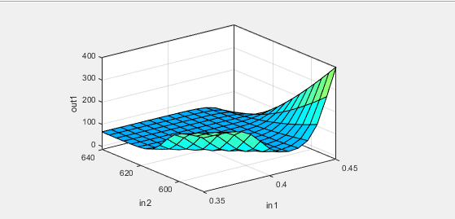
Figure 9: 3D surface plot for HP-SFRC
8. Conclusion
Drawing upon both experimental and numerical investigations of High-Performance Steel Fiber Reinforced Concrete (HP-SFRC) incorporating micro-silica as a Supplementary Cementitious Material (SCM), the study concludes that the inclusion of steel fibres into High-Performance Concrete (HPC) yields a moderate enhancement in compressive strength. Additionally, elevating the substitution of micro-silica in the concrete matrix contributes to improved mechanical performance.
The research has yielded empirical equations that predict compressive strength based on the fibre volume fraction. The associated Integral Absolute Error (IAE) values were computed as 0.92. Notably, these equations remain independent of specimen parameters, encompass non-dimensional variables, and prove suitable for a broad spectrum of water-to-binder (w/b) ratios.
A comprehensive machine learning framework was also established, employing an Adaptive Neuro-Fuzzy Inference System (ANFIS). After undergoing training, this framework exhibited a high accuracy in predicting the compressive strength of HP-SFRC. Specifically, the Root Mean Squared Error (RMSE) values were 0.17 and 0.56 for the training and testing datasets.
Furthermore, a comparative analysis established that the strength predictions of the Multiple Linear Regression (MLR) models were more precise than those of the machine learning (ML) predictions. The coefficient of determination stood at 0.87 for ML and 0.982 for MLR, underlining the superior accuracy of the MLR model in this context.
References
[1] H. Fathi, T. Lameie, M. Maleki, and R. Yazdani, “Simultaneous effects of fiber and glass on the mechanical properties of self-compacting concrete,” Constr. Build. Mater., vol. 133, pp. 443–449, 2017, doi: 10.1016/j.conbuildmat.2016.12.097.
[2] D. Falliano, D. De Domenico, G. Ricciardi, and E. Gugliandolo, “Compressive and flexural strength of fiber-reinforced foamed concrete: Effect of fiber content, curing conditions and dry density,” Constr. Build. Mater., vol. 198, pp. 479–493, 2019, doi: 10.1016/j.conbuildmat.2018.11.197.
[3] W. Abbass, M. I. Khan, and S. Mourad, “Evaluation of mechanical properties of steel fiber reinforced concrete with different strengths of concrete,” Constr. Build. Mater., vol. 168, pp. 556–569, 2018, doi: 10.1016/j.conbuildmat.2018.02.164.
[4] Y. Qin, H. Wu, Y. Zheng, W. Wang, and Z. Yi, “Microscopic Texture of Polypropylene Fiber-Reinforced Concrete with X-Ray Computed Tomography,” Adv. Civ. Eng., vol. 2019, pp. 1–9, 2019, doi: 10.1155/2019/2386590.
[5] D. Y. Yoo and Y. S. Yoon, “Structural performance of ultra-high-performance concrete beams with different steel fibers,” Eng. Struct., vol. 102, pp. 409–423, 2015, doi: 10.1016/j.engstruct.2015.08.029.
[6] T. Wu, X. Yang, H. Wei, and X. Liu, “Mechanical properties and microstructure of lightweight aggregate concrete with and without fibers,” Constr. Build. Mater., vol. 199, pp. 526–539, 2019, doi: 10.1016/j.conbuildmat.2018.12.037.
[7] J. H. Lee, B. Cho, and E. Choi, “Flexural capacity of fiber reinforced concrete with a consideration of concrete strength and fiber content,” Constr. Build. Mater., vol. 138, pp. 222–231, 2017, doi: 10.1016/j.conbuildmat.2017.01.096.
[8] D. Y. Yoo, S. Kim, G. J. Park, J. J. Park, and S. W. Kim, “Effects of fiber shape, aspect ratio, and volume fraction on flexural behavior of ultra-high-performance fiber-reinforced cement composites,” Compos. Struct., vol. 174, pp. 375–388, 2017, doi: 10.1016/j.compstruct.2017.04.069.
[9] M. Saridemir, “Predicting the compressive strength of mortars containing metakaolin by artificial neural networks and fuzzy logic,” Adv. Eng. Softw., vol. 40, no. 9, pp. 920–927, 2009, doi: 10.1016/j.advengsoft.2008.12.008.
[10] B. S. Thamma P, Application of soft computing. 2009.
[11] I. B. Topçu and M. Saridemir, “Prediction of compressive strength of concrete containing fly ash using artificial neural networks and fuzzy logic,” Comput. Mater. Sci., vol. 41, no. 3, pp. 305–311, 2008, doi: 10.1016/j.commatsci.2007.04.009.
[12] G. Arslan and E. Cihanli, “Curvature ductility prediction of reinforced High-strength concrete beam sections,” J. Civ. Eng. Manag., vol. 16, no. 4, pp. 462–470, 2010, doi: 10.3846/jcem.2010.52.
[13] M. Sofi, E. Lumantarna, P. Mendis, and A. Zhong, “Thermal Stresses of Concrete at Early Ages,” J. Mater. Civ. Eng., vol. 31, no. 6, pp. 1–9, 2019, doi: 10.1061/(asce)mt.1943-5533.0002684.
[14] ACI 211, “Standard Practice for Selecting Proportions for Normal,” ACI Mater. J., vol. 90, no. 3, 2009.
[15] Y. Choi and R. L. Yuan, “Experimental relationship between splitting tensile strength and compressive strength of GFRC and PFRC,” Cem. Concr. Res., vol. 35, no. 8, pp. 1587–1591, 2005, doi: 10.1016/j.cemconres.2004.09.010.
[16] F. Bencardino, L. Rizzuti, G. Spadea, and R. N. Swamy, “Stress-Strain Behavior of Steel Fiber-Reinforced Concrete in Compression,” J. Mater. Civ. Eng., vol. 20, no. 3, pp. 255–263, 2008, doi: 10.1061/(asce)0899-1561(2008)20:3(255).
[17] W. C. Liao, W. Perceka, and E. J. Liu, “Compressive stress-strain relationship of high strength steel fiber reinforced concrete,” J. Adv. Concr. Technol., vol. 13, no. 8, pp. 379–392, 2015, doi: 10.3151/jact.13.379.
[18] F. Köksal, F. Altun, I. Yiǧit, and Y. Şahin, “Combined effect of silica fume and steel fiber on the mechanical properties of high strength concretes,” Constr. Build. Mater., vol. 22, no. 8, pp. 1874–1880, 2008, doi: 10.1016/j.conbuildmat.2007.04.017.
[19] C. S. Poon, Z. H. Shui, and L. Lam, “Compressive behavior of fiber reinforced high-performance concrete subjected to elevated temperatures,” Cem. Concr. Res., vol. 34, no. 12, pp. 2215–2222, 2004, doi: 10.1016/j.cemconres.2004.02.011.
[20] M. Nili and V. Afroughsabet, “Combined effect of silica fume and steel fibers on the impact resistance and mechanical properties of concrete,” Int. J. Impact Eng., vol. 37, no. 8, pp. 879–886, 2010, doi: 10.1016/j.ijimpeng.2010.03.004.
[21] W. T. Lin, R. Huang, C. L. Lee, and H. M. Hsu, “Effect of steel fiber on the mechanical properties of cement-based composites containing silica fume,” J. Mar. Sci. Technol., vol. 16, no. 3, pp. 214–221, 2008, doi: 10.51400/2709-6998.2010.
[22] Z. Keshavarz and H. Torkian, “Application of ANN and ANFIS Models in Determining Compressive Strength of Concrete,” J. Soft Comput. Civ. Eng., vol. 2, no. 1, pp. 62–70, 2018, doi: 10.22115/SCCE.2018.51114.
[23] Y. M. Wang and T. M. S. Elhag, “An adaptive neuro-fuzzy inference system for bridge risk assessment,” Expert Syst. Appl., vol. 34, no. 4, pp. 3099–3106, 2008, doi: 10.1016/j.eswa.2007.06.026.
[24] D. K. Sinha, R. Satavalekar, and S. Kasilingam, “Application of Adaptive Neuro-Fuzzy Inference System for Evaluating Compressive Strength of Concrete,” Int. J. Fuzzy Log. Intell. Syst., vol. 21, no. 2, pp. 176–188, 2021, doi: 10.5391/IJFIS.2021.21.2.176.
[25] J. R. Jang, “ANFIS : Adap tive-Ne twork-Based Fuzzy Inference System,” vol. 23, no. 3, 1993.
[26] M. A. Denaï, F. Palis, and A. Zeghbib, “ANFIS based modelling and control of non-linear systems: A tutorial,” Conf. Proc. - IEEE Int. Conf. Syst. Man Cybern., vol. 4, pp. 3433–3438, 2004, doi: 10.1109/ICSMC.2004.1400873.
[27] J. S. R. Jang, C. T. Sun, and E. Mizutani, “Neuro-Fuzzy and Soft Computing-A Computational Approach to Learning and Machine Intelligence [Book Review],” IEEE Trans. Automat. Contr., vol. 42, no. 10, pp. 1482–1484, 2005, doi: 10.1109/tac.1997.633847.
[28] O. Ünal, F. Demir, and T. Uygunoǧlu, “Fuzzy logic approach to predict stress-strain curves of steel fiber-reinforced concretes in compression,” Build. Environ., vol. 42, no. 10, pp. 3589–3595, 2007, doi: 10.1016/j.buildenv.2006.10.023.

