By Dr Vishwanathan Jayaraman, Learning Scientist at IBBRF & Pipaltree
Title: Neuroteaching Techniques: An Innovative pedagogy to engage New Age Learners in the Digital & AI Era

Abstract:
This research paper explores the concept of neuroteaching and its role in effectively engaging new age learners in the digital and AI era. With the rapid advancement of technology and changing learning preferences, educators face the challenge of adapting their instructional approaches to meet the needs of today's learners. Neuroteaching, a multidisciplinary field that integrates neuroscience principles with teaching practices, offers valuable insights into how the brain learns and suggests innovative strategies to enhance engagement and learning outcomes. This paper examines the process of neuroteaching techniques, their theoretical foundations, and empirical evidence supporting their effectiveness. It further discusses the implications of neuroteaching for educators and provides recommendations for implementing these techniques in educational settings.

Keywords: neuroteaching, new age learners, engagement, digital & AI era, neuroscience, learning outcomes

Engaging new age learners and their background

The significance of engaging new age learners in education is paramount as it directly impacts their motivation, learning outcomes, and overall educational experience. New age learners, often referred to as digital natives or Generation Z, are characterized by their familiarity and comfort with technology, their diverse learning styles, and their preference for interactive and experiential learning.

Motivation and Active Participation: Engaging new age learners is crucial to spark their motivation and active participation in the learning process. Traditional passive learning approaches may not resonate with their expectations and may lead to disengagement. By incorporating interactive and technology-driven strategies, educators can tap into their natural curiosity and desire for active involvement, fostering a positive attitude towards learning.

Learning Preferences: New age learners exhibit diverse learning preferences and styles. They thrive in dynamic and interactive learning environments where they can explore, experiment, and collaborate with their peers. Engaging them through multimedia, gamification, virtual simulations, and interactive platforms caters to their preference for hands-on and experiential learning, enhancing their understanding and retention of information.

Purpose and objectives of the paper

The purpose of this research paper on neuroteaching techniques is to explore the intersection of neuroscience and education, specifically focusing on how neuroteaching can effectively engage new age learners in the digital era. The paper aims to provide a comprehensive understanding of neuroteaching, its theoretical foundations, and its practical implications for educators. By examining this neuroteaching techniques and their empirical evidence, the paper seeks to highlight the potential of the techniques in enhancing learner engagement and improving learning outcomes. Ultimately, the purpose is to contribute to the body of knowledge in the field of education and provide valuable insights for educators, researchers, and educational policymakers.

Objectives:
- The significance of engaging new age learners changing landscape of education in the digital era
- To explore the theoretical foundations of neuroteaching, drawing on neuroscience principles and cognitive theories relevant to learning and engagement.
- To identify and analyze a range of neuroteaching techniques that can effectively engage new age learners in the digital era.

By accomplishing these objectives, this research paper aims to provide a comprehensive and evidence-based resource for educators and researchers interested in understanding and implementing neuroteaching techniques to effectively engage new age learners in the digital era.

Process of Neuroteaching

Overview of neuroscience principles relevant to learning and engagement and Cognitive and affective aspects of learning

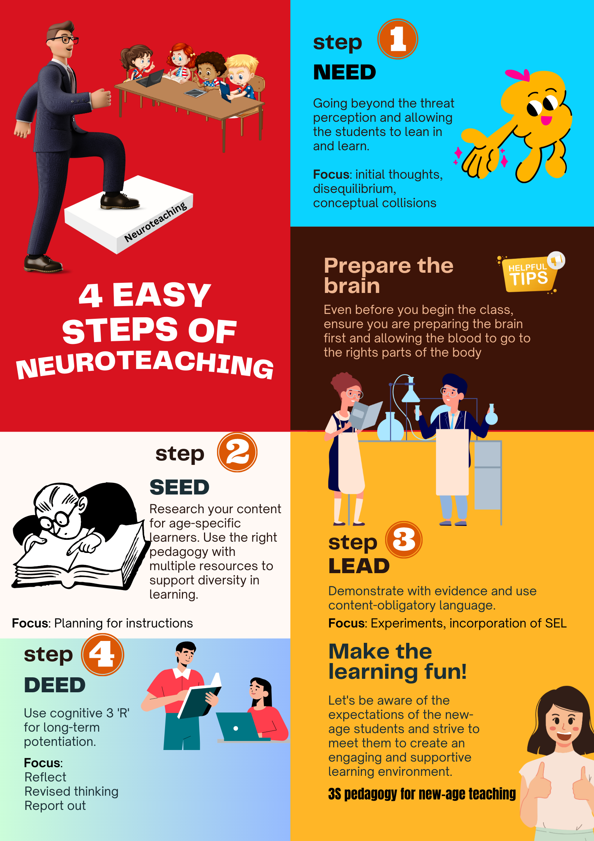
Step-1

NEED
So the first thing we do in the 3S Game board is we ask the children to write down their initial thoughts. It is worth spending about 30 seconds to 1 minute on this. We have to do this because; we want students to lean in. Think about this, if you ask the students what is 2x2, they would immediately come up with the answer 4. They would say it’s so easy and no cognitive load at all. However, if you asked them to multiply 744x826, and that’s going to cause them stress. They would say, I can’t do that unless you give me permission to use a calculator or pen and paper. In other words there’s a mental blockage, a kind of neural challenge that’s causing a stress response.
So the idea to give initial thoughts is give something simple where they can pick up a pen, lean in and start to write. The minute they do that, they go beyond the threat response.
So as a teacher, if we make the topic heading look complicated or tough, the threat response is going to challenge the students, but a few other students, will actually shut them down.

So need is about helping students move away from the threat response and help them to lean in to participate in the learning process.

Step-2

SEED
Once you got the student into the learning space, you got to give them some material that has multiple perspectives. This should take care of the diversity in the learning and help all the students to pick and choose the content in the manner they like to reach the same learning outcome. This is where the use of digital and AI technology can come in hand to enrich the learning experiences.

Step-3

LEAD
This is where understanding of the diversity in learner characteristics and learning patterns arises and the ability to explain different topics of the subject using appropriate real-life examples with evidence (demonstration / to show evidence) is important. Educators to use new –age learning preferences to engage the audience effectively. This is where the use of digital and AI technology can come in hand to enrich the learning experiences.

Step-4

DEED
This is where you help students’ scaffold in the learning of the different topics of your subject, in a conceptually clear and understandable manner, using a cognitive three 'R's. Reflect, Revised thinking and Reporting out. And each of these 'R's are accompanied by a very carefully scripted questions to readjust the learning. This scaffold approach naturally helps in understanding of the subject and topics and pushes it for long term Potentiation or for long term memory.

Therefore the process of NEED, SEED, LEAD and DEED has all the ingredients of different approaches already built into this model. For example
- Personalized and adaptive learning approaches
- Gamification and game-based learning
- Blended learning and flipped classroom models
- Multimedia and interactive learning materials
- Collaborative and project-based learning
- Incorporating digital tools and technologies

Implications for Educators

Incorporating neuroteaching techniques into instructional design

Incorporating neuroteaching techniques into instructional design can significantly enhance the learning experience and optimize learner engagement. By adopting the neuroteaching technique, a teacher can easily achieve the following.

- Personalized Learning
- Active Learning
- Multisensory Instruction & Learning
- Emotionally Supportive Environment
- Regular Brain Breaks
- Feedback and Assessment
- Reflection and Metacognition
- Collaborative Learning

Professional development and training for educators

Professional development and training play a crucial role in equipping educators with the knowledge, skills, and strategies necessary to effectively incorporate neuroteaching techniques into their instructional practices.

We provide comprehensive and sustained professional development and training; teachers and educators can enhance their understanding, implementation, and mastery of neuroteaching techniques, ultimately benefiting their students' learning experiences.

Conclusion

In conclusion, the use of neuroteaching techniques holds immense potential to enhance the learning experience and optimize engagement for students in the digital era. By incorporating principles from neuroscience and cognitive psychology into instructional practices, educators can tap into the way the brain learns best and create effective learning environments.
Neuroteaching techniques emphasize personalized learning, active engagement, multisensory experiences, and the integration of technology to support cognitive processes and optimize learning outcomes. These approaches promote deeper understanding, improved retention, and the development of critical thinking and problem-solving skills.
Through professional development and training, educators can gain the knowledge and skills necessary to implement neuroteaching techniques effectively.
In embracing neuroteaching, educators are positioned to create engaging and effective learning experiences that meet the needs of new age learners. By leveraging insights from neuroscience, instructional practices can be optimized to foster curiosity, critical thinking, and lifelong learning skills. As educational landscapes continue to evolve, the integration of neuroteaching techniques will play a vital role in preparing students for success in the digital era and beyond.

References

Bransford, J. D., Brophy, S., & Williams, S. (2000). When computer technologies meet the learning sciences: Issues and opportunities. Journal of Applied Developmental Psychology, 21(1), 59–84.
Brophy, S. P. (2000). Guidelines for modular design. Unpublished manuscript, Vanderbilt University.

By Dr Vishwanathan Jayaraman, Learning Scientist at IBBRF & Pipaltree

Biography:
Dr. Vishwanathan Jayaraman is a leading expert in the field of Educational Neuroscience, specializing in Neuroteaching—a novel approach that combines neuroscience and education to optimize teaching methodologies and enhance learning outcomes. With a passion for fostering a deeper understanding of the brain's learning processes, Dr. Vishwanathan Jayaraman has dedicated his career to bridging the gap between neuroscience research and its practical implementation in educational settings.

