NEW INTEGRATIVE APPROACHES OF RHEUMATOID ARTHRITIS
Puja Kumari*, Ankit Rai, Alok Soni, Raghvendra Dubey, Nirmal Dongre, Shashi Alok
The word “arthritis” is derived from Greek words: arthron, meaning a joint, and –itis, significant inflammation Involves redness, heat, swelling, and tenderness. So, discipline arthritis describes a joint that is red, hot, swollen, and tender. Arthritis is a precondition in which joints are painful and stiff. If the joints are actually red, heat, swelling.
1.1 Types of arthritis
(Warhadpande, 2019)
- Rheumatoid arthritis
- Osteoarthritis
- Juvenile arthritis
- Psoriasis arthritis
A. Rheumatoid arthritis
Rheumatoid arthritis chronic inflammatory disease that affects primarily the joints but may involve other tissue such as the blood vessels, skin, lungs and heart. Several evidence supports the autoimmune nature of the disease. Because the principal manifestations of the disease.
Normal immune system has inbuilt capacity to distinguish ‘self’ from ‘non self’ or foreign tissues; when confronted with a foreign invading agent, the host normally inflammatory response without causing norm to self-tissues.
Autoimmune disease on the other hand are essentially due to failure of such distinction between ‘self’and nonself’ instead the body reacts by immunologic refers to presence of either auto antibodies t cells pre activity against own tissues both of which may on not cause tissue damage and thus not always pathogenic
In other words loss of tolerance to one and own tissue autoimmunity i.e. autoimmunity is the opposite autoimmunity tolerance RA often progress to destruction of the articular and alkylosis of the joints extraarticular lesions may be involve skin heart blood vessel and lungs and therefore the clinical manifestation can reassemble other systemic autoimmune disorder such as systemic lupes erythromattosis scleroderma .
B. Osteoarthritis
Osteoarthritis is first the ongoing destruction of the articular cartilages of joints. Hence, the extracellular matrix and the cells of the articular cartilages are the primary targets of osteoarthritis therapy.
C. Juvenile arthritis
Juvenile idiopathic arthritis (JIA), also known as juvenile rheumatoid arthritis (JRA), is the most common form of arthritis in children and adolescents. (Juvenile in this context refers to an onset before age 16, idiopathic think of to a stipulation with no defined cause, and arthritis is the inflammation of the synovium of a joint.)
D. Infectious arthritis (Septic arthritis)
Septic, or infectious, arthritis is an infection of one or more joints by a microorganism. Normally, the joint is greased with a small amount of fluid that is referred to as synovial fluid or joint fluid.
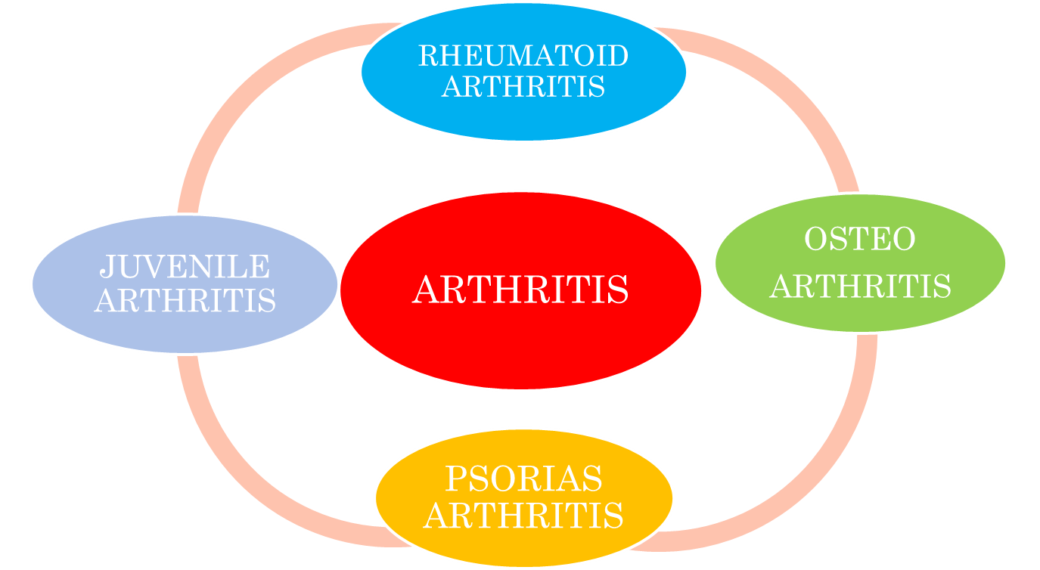

1.2 Prevalence /Population
Statistics show that RA and related musculoskeletal disorders affect greater than 0.5–1% of the population worldwide, and it is predicted that one out of every five Americans will suffer from one of these disorders by 2020. Female’s area affected by RA three times more often than males, and the disease can start at any age, with a peak incidence at 50–60 years of age. The pre valence in the second to fourth decades and is the three times more common in women than men.

1.3 Pathophysiology of Rheumatoid arthritis
The synovitis, swelling and joint damage that characterize active RA are the end results of complex autoimmune and inflammatory processes that involve components of both the innate and adaptive immune systems.
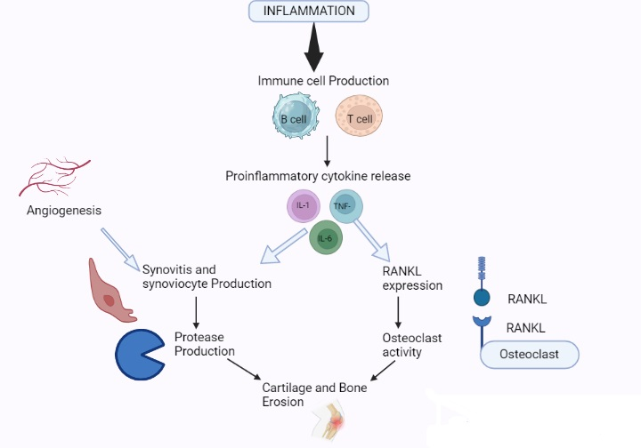
The inflammatory cytokine tnf-α interleukin 1 (IL-1) and interleukin 6 (IL -6) has been shown to be a key mediator in the autoimmune disease rheumatoid arthritis (RA). Interleukin 1 mediates bone resorption and cartilage destruction, but may not play as dominant a part in joint swelling and inflammation. Pathogenesis as in other autoimmune disease genetic pre deposition and environmental factor contribute to the development progression and chronicity of the disease. It result from complex interaction between genes and environment leading to a breakdown of immune tolerance and to synovial inflammation in a characteristics symmetric pattern. Pathophysiology is the study of abnormality of normal mechanical physical and biochemical function either caused by resulting from a disease abnormal syndrome or condition that may know qualified to be called a disease .
Several stages of rheumatoid arthiritis are known as synovitis pannus fibrous and ankyloses and bony and alkylosis several stages in pathophysiology rheumathoid arthritis.
Stage (i) Synovities during stage one including joint pain and stiffness.
Stage(ii) Pannus formation
Stage (iii) Fibrous alkyosis
Syage (iv) Bonny alkyosis
Causative factor and risk factor-Most types of arthritis are caused by many factors acting together. (Barbour KE, 2013)
- Genetic make-up had the possibility likely to develop a certain disorder.
- Obesity
- Female gender
- secondary arthritis
- Greater bone density
- Joint laxity
- Repetitive joint overuse
- Joint injury
- Posttraumatic joint in congruity
- Instability or malalignment
- Joint dysplasia
- Repetitive, excessive joint torsion
- Crystal deposition
- Neuromuscular dysfunction
- Abnormalities of the articular cartilage may contribute to the degeneration of the joint by causing stress or parts of the articular surface and joint instability.
- Penetration of sub-chondral bone
- Joint abrasion
Symptoms and signs
There are many types of arthritis, the common symptoms for all disorders include varied levels of pain, swelling, joint stiffness, and sometimes a constant pain around joints, Pain on acting is more than one joints , Stiffness is more than one joints. Tenderness and swelling in more than one joints, Weight loss, Fever, Fatigue and tiredness and Weakness. Arthritic disorders like lupus and rheumatoid can also affect other organs in the body with a variety of symptoms. (Daily, 2016).
1.4 Biomarker of RA:-
Biological makers commonly termed biomarkers are biologic characteristics that can be objectively measured and serve as indicator of normal or pathologic processes measures of the response to therapy the main clinical rheumatoid factors -
- Anti-cyclic citrullinated peptides antibody.
- Anti CCP antibodies
- Anti CCP assay.
- Positive anti CCP in other disease.
- Anti nuclear anti body test
- Anti CCP band RA prognosis
- Anti MCV Antibody
- Other Anti-cyclic citrullinated peptides antibody.
1. Disease acting and prognosis
Erythrocytic seddmentation value
2. Activity and prognosis
C –reactive protein
Multiple protein biomarkers algorithms
3. Investigation and other biomarkers
Immune abnormalities and auto antibodies.
4. Genetic factors
Other acute phase markers
Tissue specific marker
Rheumatoid arthritis susceptibility genes in RA
The association of particular human leukocytes antigen HLA alleles with RA This particular senotype represented a set of alleles at the HLA DRB genes locus
Non coding RNA (NCRNA) molecules are composed of long non coding RNA’S small nucleolar RNA’s microRNA and circular RNA’S which play an essential role in disease meet and progression and can be used in the early diagnosis and prognostic approaches to RA diease and the current knowledge on the subject focusing on recent advances in RNA MCRNA and as diagnpstric and prognostic biomarkers from the bio fliud to the tissue level .
With all the test and biomarkers high specificity presence eearly in the disease process and ability to identify patient who are likely to have severe disease and irreversible damage .
RA with an emphasis and diagnostic performance prognostic capability and relevance to pathogens and new treatment para diagnose in RA
1.5 Future Prospectus of Rheumatoid Arthritis-
Despite all improvement in Rheumatoid Arthritis. We are still not able to present or, cure the disease. Thus RA is still the reason for disability and reduced quality of life for many patients.
Rheumatoid Arthritis recent research updates it is heterogeneous disease that based on data combining genetic risk factors and auto antibodies , can be classified into anti- citrullinated protein antibodies (ACPAs)- positive and negative RA.
Best phenomena for RA treatment prevent –to- target may become a new treatment approach by combining genetic and epigastric data for personalized treatment.
As genetic and cell based therapies are evolving the cure of RA .Researchers continue to learn each everything about the various form everything about the various form of arthritis and complexity of the many ways they can develop. Eventually, cure for specific types of the disease may be found and find to better treatments and clinical trials are key to finding safe and effective treatments.In current research on RA points to bacterial strain in the gut as a disease trigger.The strin discovered in the lining of the intestine may proud the body to attack healthy tissue in the joints.
Disease modifying Anti-rheumatoid drugs and new treatments for RA latest FDA approach Biological.
S.N. | DRUGS NAME | DRUG CLASS
1. | Golimumab  Certolizumab | Tnf – α factor blockers
2. | Tofacitinib | Janus Kinase inhibitors
3. | Toclizumab | Interleukin-6 (IL-6) receptor antagonist

1.6 References
Ahuja, S.C. Ahuja, S. Ahuja, U. Nirgundi (Vitex negundo) – Nature’s Gift to Mankind. Asian Agri-History,2015;19(1);5-32.

Danielle, E. S. Sara, W. Meghan, B. Association of Body Mass Index with Physical Function and health related quality of life in adults with Arthritis. Arthritis.2013;60; 1-10.doi: 10.1155/2013/190868

Dawei, W. Yuping, L. Wei, L. Huwei, L. Separation methods for antibacterial and antirheumatism agents in plant medicines. J Chromatogr B Analyt Technol Biomed Life Sci, 2004;812(1-2); 101-117.doi: 10.1016/j.jchromb.2004.06.049.

Derek G.WallerBSc (HONS), D. M. Rheumatoid arthritis, other inflammatory arthritides and osteoarthritis. , 2018;373-383.

Dharmendra, K. Rajesh, K. Kumari, S. Medicinal property of Nirgundi. Journal of Pharmacognosy and Phytochemistry, 2018;7(1);2147-2151.doi: 2278-4136

Harith J. M. Nurzalina Abdul K. K. Mohd, Z. B. A. Roziahanim, M. Vikneswaran, A. L. M. In vivo anti-arthritic and anti-nociceptive effects of ethanol extract of Moringa oleifera leaves on complete Freund's adjuvant (CFA)-induced arthritis in rats. Integrative Medicine Research, Integr Med Res, 2018;7(1):85-94.doi: 10.1016/j.imr.2017.11.002

James, R. O. D. Robert, L. Claire, H. et al., Treatment of Rheumatoid Arthritis with Methotrexate Alone, Sulfasalazine and Hydroxychloroquine, or a Combination of All Three Medications.Arthritis Rheum,1996;46(5):1164-1170.doi:10.1002/art.10228

James, W. D. Mini, Y. Sunmin, P. Efficacy of turmeric extracts and curcumin for alleviating the symptoms of joint arthritis: A systematic review and meta-analysis of randomized clinical trials. Journal of Medicinal Food, 201619(8);717-719. doi: 10.1089/jmf.2016.3705

