RADIOCHEMISTRY
Shuchi Jain, Dr. Ravikant Gupta, Pooja Jaiswal, Dr. Sudha Vengurlekar
University Institute of Pharmacy, Oriental University.

S.No | Topic Name
1 | Particles Classification
2 | Form of Potential release and interactions
3 | Mechanisms
4 | Ionizing radiation and matter interaction
5 | An interaction's quantitative description
 | - Alpha radiation ionization interactions.
 | - Beta radiation ionization interactions (electron/positron).
- Gamma radiationIonisation and Interaction
- Compton scattering
- Photoelectric effect
- Neutronsproduction
6. | - Nuclear reactions  - Kinetics  - Neutron Interaction  - (n,f) fission

INTRODUCTION
In radiochemistry, radioactive isotopes of elements are used to study the characteristics and chemical reactions of non-radioactive isotopes (often, in radiochemistry, the absence of radioactivity leads to a substance being described as being inactive because the isotopes are stable). Radiochemistry is the chemistry of radioactive materials. Radioactivity is frequently used in radiochemistry to analyze regular chemical reactions. In contrast, in radiation chemistry, the radiation levels are kept too low to have an impact on the chemistry. Radioisotopes created by humans and those created naturally are both studied in radiochemistry.^{[1]}
1. PARTICLES CLASSIFICATION^{[2]}
Table 01. Classification of the particles according their mass and charge
I  Mass and charge |  | II  Mass, no charge | III  No mass, no charge
A | B
May induce nuclear | No nuclear reaction
P | e+ | N | ᵧ
ᵅ | e- |  | X-ray

2. FORM OF POTENTIAL RELEASE AND INTERACTIONS^{[3]}
- Electromagnetic field
- Electron
- Field of the nucleus
- Nucleus
3. MECHANISMS ^{[4]}
Mechanism | Effect of radiation | Effect of Matter
Absorption | Intensity and energy change | Excitement and change in kinetic energy
Scattering in the direction of radiation | Intensity change | -------------
Incoherent Scattering  1.Inelastic  2. Elastic | Intensity and energy change | Excitation in kinetic energy

4. IONIZING RADIATION AND MATTER INTERACTION^{[5,6]}
Here the steps of the ionizing radiation with matters:
- Neutral excitation
A + radiation → A* + radiation’
- External ionization
A + radiation → A + + e- + radiation’
- A2 + radiation →A + + A- + radiation’
- A2 + radiation →A2 + + e- + radiation’
- A2 + radiation →2 A⋅ + radiation’
- Internal ionization
A + radiation →A*+ + e- + radiation’
A*+ → A + + Xchar
A*+ →A 2+ + e- (Auger)
Xchar is the characteristic X-ray radiation that characterizing the atom A.
5. AN INTERACTION'S QUANTITATIVE DESCRIPTION^{[7,8]}
Set-up for the finding of nuclear radiation in Figure 01.
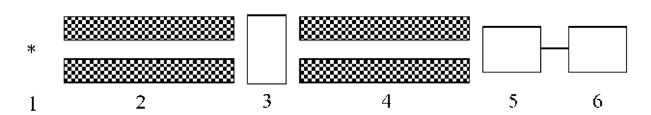
Figure:01Set-up for Identificationfor radioactive radiation.
- Here Pont 01 is for Point source
- Point 02 and point 04 for Collimators (this is for parallel radiation)
- Point 03 for absorbing material (here thickness is x, atomic density is ρA and macroscopic density is ρ)
- Point 05 is for Detector
- Point 06 for Data processor
Here the particlesnumber is absorbed in a distance can be denoted by:
-dn = σ(E)nρ_{A}dx
Here n =particles number
ρA = matters atomic density
σ=cross section of nuclear
The likelihood of a nuclear process is determined using the nuclear cross section. The latter is highly influenced by the particle's initial energy.
n₀ is the entering particles number (at x=0) so thatthe equation is:
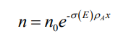
The Particles intensity is defined as:
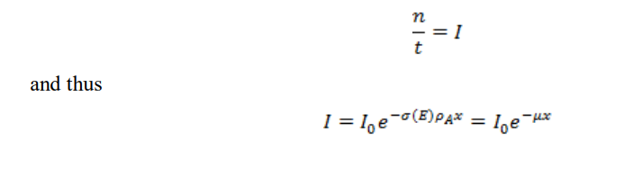
It says that the radiation's intensity will decrease from its initial value of I₀ to a value of I as it passes through a layer representing an x-thick absorbent. As a result, the linear absorption coefficient is entirely dependent on the nuclear radiation's energy.
Knowing the substance density allowed us to translate the two constants into each other:^{[9]}
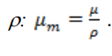
We will calculate the radioactive absorption by following equation:
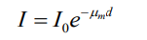
It states the radiation’s intensity decreases by the original value of I₀ to a value of I. Here the absorbent of surface mass through a layer d=ρx.
The thickness of the absorbing layercan be calculated as:
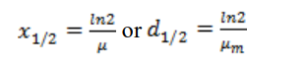
When they enter the medium, ionizing particles as well as gamma rays produce ion pairs with their path. Specific ionization refers to the number of ion-pairs per unitlength. 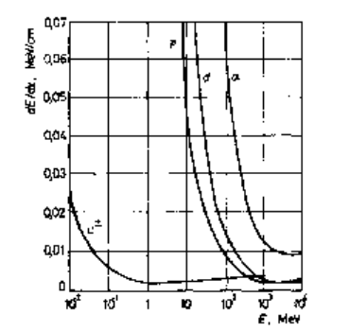
Figure 02. Various particles Linear energy transfer (LET)
The substance affects how well something absorbs. Here the Figure R03 show A qualitative comparison.
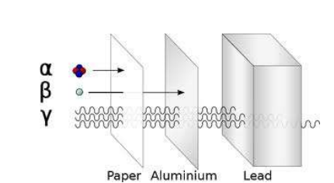

Figure R 03. Comparison of the penetration potential of the three main nuclear radiations
  - Alpha radiation ionization interactions.^{[10]}
Alpha radiation having charged (2+) and heavy (4 nucleon) particles present:
- Interactions with electrons, incoherent scattering, ionization, and excitation of the matter will cause an alpha particle's energy and direction to change by roughly 50–50%.
- With the nucleus, observe the nuclear reaction from the famous Rutherford experiment.
- Involvement of the electromagnetic field charged object: bremsstrahlung The density of the exposed material has a significant impact on the alpha radiation's short path length (Figure 04).
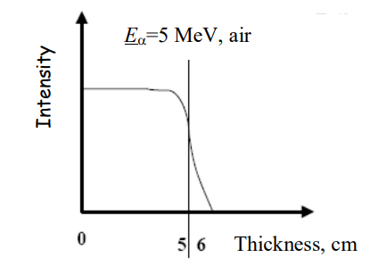
Figure R 04: The alpha particles path length
5.2 Beta radiation ionization interactions (electron/positron).^{[10]}
- charged, compact, and light
- Using electrons: scattering; external or internal ionization; excitation
- Energy and direction change
- Bremsstrahlung scattering of the charged particles in the nuclear field.
- Energy released bythe X-ray (r) and ionisation (ion) can be calculated as:
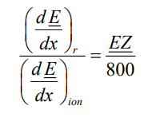
where E is the energy beta. The continuous beta-spectrum causes its intensity to exponentially decrease during the interaction across the substance.
Figure R.05 provides a comparison between beta radiation and mono-energetic electron radiation.
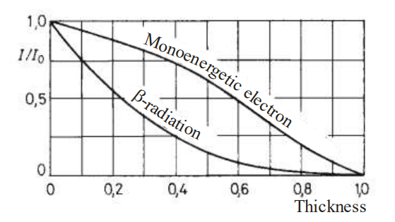
Figure R 05. Comparison of the monoenergetic electron and beta radiations' absorption characteristics
The formula for beta-radiation attenuation is 0 x I e I (more on this later).
Keep in mind that the only difference between - and + is the annihilation of the positron upon thermalization. An electron (e) and a positron (e+) collide, it results in electron-positron annihilation. Both the electron and the positron are destroyed as a result of the collision, which also produces two gamma photons:
e− + e+ → γ + γ
The process must satisfy a number of conservation laws, including the conservation of energy (mass), electric charge (the net charge before and after the annihilation is zero), etc.Consequently, each photon has an energy of 0.51 MeV.
5.3 Gamma radiation Ionisation and Interaction^{[10]}
- Having no mass,
- Having no electric charge;
- Having high energy electromagnetic radiation
The most important mechanisms
- Compton scattering
A gamma photon is scattered by an electron in an inelastic manner by Compton scattering. As a result, a portion of the photon's energy is transmitted to the scattering electron, resulting in a decrease in energy (decrease in frequency). almost independent of Z.
- Photoelectric effect
Gamma photons have the ability to absorb energy from irradiated electrons. One electron must be freed from atomic bond using all of the energy from one photon; otherwise, the energy is reemitted. In the event that the photon energy is absorbed, a portion of it releases the electron on or after the atom while the remaining portion increases the electron's free-particle kinetic energy. This causes the atom to internally ionize.
As a result, the photoelectric effect is usually followed by distinctive X-ray radiation (and on rare occasions, depending on energy and Z, the emission of an Auger electron):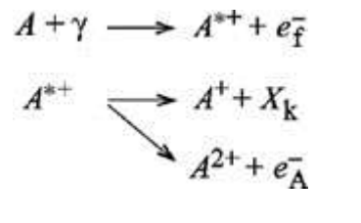

- Neutron production ^{[11]}
Once a high-energy photon interrelates with a nucleus, this process takes place. The mass of an electron and a positron can be created from the energy of this photon. To produce the mass, the photon must possess sufficient energy. An energy of 1.02 MeV is required since the remain mass of an electron is identical to 0.511 MeV, the same as a positron. dependent upon Z2. As an overall result:
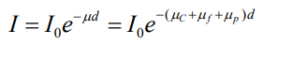
where C, f, and p stand for pair production, photoelectricity, and Compton, respectively. The energy dependence of the mass absorption coefficient is depicted in Figure R06 representation of gamma photon germanium interactions. The photoelectric effect at low energy (E 0.2 MeV) and 0.2-2MeV Compton scattering have the highest likelihood:
: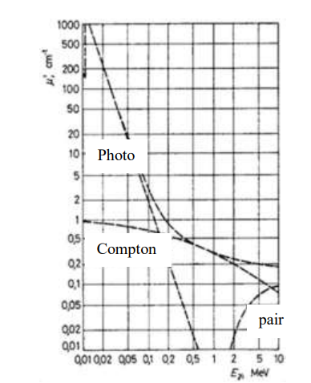
Figure 06. The interaction of gamma photons
The E and Z based on the gamma interaction that shown in Figure 07
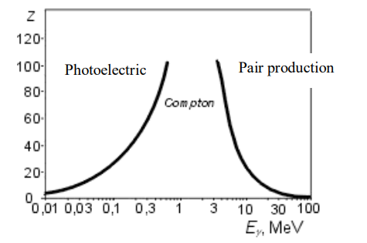
Figure 07: The gamma interactions b/w Z and energy dependence
6. NUCLEAR REACTIONS^{[13,16]}
The transient nucleus
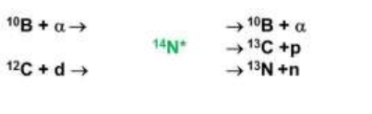
The reaction equation is given below:
X + a→ Y + b (+Q)

For the prompt particle created throughout the procedure, use the abbreviation X (a,b) Y b. These calculations do not depict the particles released since the product nucleus is radioactive. Every standard conservation law is followed. The cross section of nuclear processes is mostly dependent on one of two different forms of energy (Figure 08.)
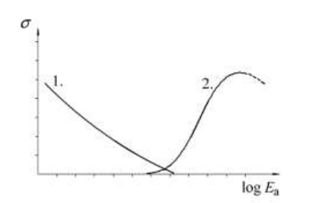
Figure 08: The two types of nuclear reactionenergy that is dependence of the probability
Neutron interactions^{[12]}
(Excited Nucleus, h) Elastic scattering against inelastic scattering. Characterization of neutron energy loss during scattering with different light elements.
Table 08. The energy absorption efficiency:
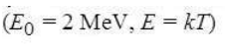
Element | ∆E, keV | N
H | 1000 | 18
D | 888 | 24
He | 640 | 41
C | 284 | 111
Be | 360 | 50
Al | 137 | 240
E =is the Energy transferred
n = number of steps need for thermalization.
Some practical importance:
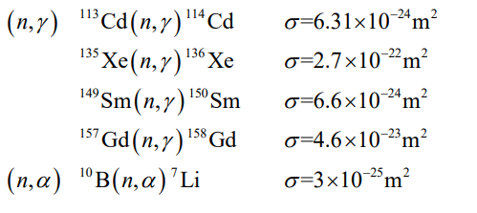
(n,f) (f=fission).
The fission reaction of 235U:
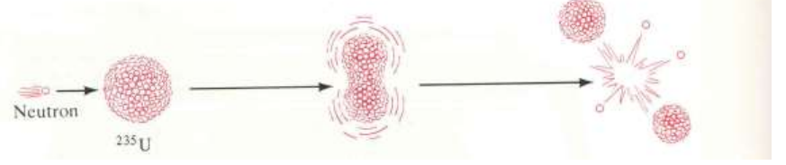
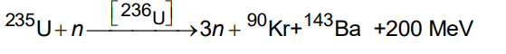
Limited number of nuclides that able to participate in the reactions (Table 02).
Table 02. Nuclides having fission reaction^{[2]}
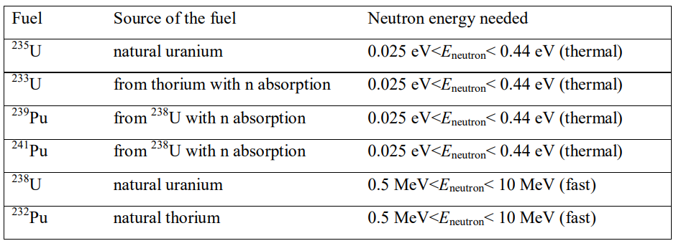
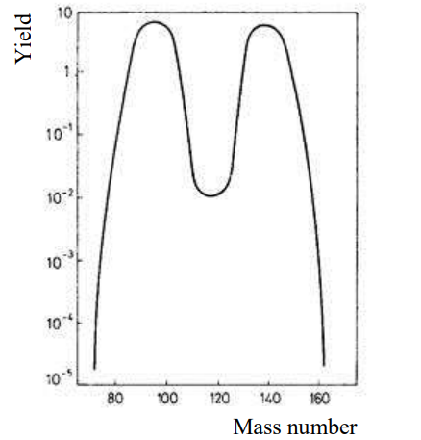
Figure 09.The distribution of the fission products of ²³⁵U
Radioactive isotopes Radioactivity:
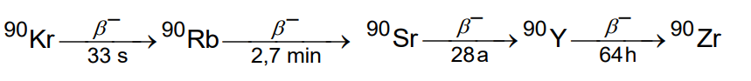
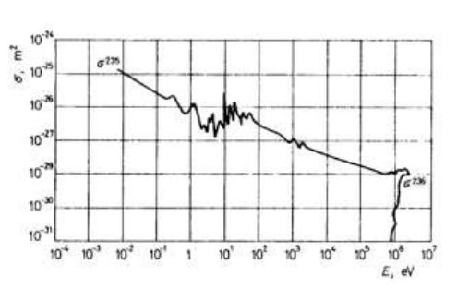
Figure10.The energy dependence of nuclear reaction
The distribution of the 200 MeV:^{[5]}
kinetic energy of the fission products | ≈ 160 MeV
kinetic energy of the neutrons | ≈ 5 MeV
energy of the γ radiation | ≈ 5 MeV
energy of the secondary radioactive decays | ≈ 20 MeV
energy from neutron absorption: | ≈ 10 MeV

Nuclear instruments and measurements ^{[14,15]}
Radiation from radioactive materials (radiation sources) is used in the industrial application of isotopes. Information concerning, for example, the qualitative and quantitative material qualities is typically gained through the impacts of materials on radiation, depending on the mode of industrial use. The detection and numerical evaluation of radiation is a crucial prerequisite for obtaining and processing the desired information about technological processes.
Although radioactive radiation cannot be directly sensed, its interaction with carefully selected media placed in its pathwayby its effective range can produce effects that can be used to estimate its intensity and, in some cases, its energy using electrical or electronic methods and the right equipment. The unit processing and storing signals of the detector is the mensuration instrument. The radiation detector is the part of the overall measuring system that detects radiation and converts it into electrical signals. Finding the integral radiation parameters or the partial parameters of the particles or photons that make up a certain type of radiation is the major objective of nuclear measurement technology.
5.1. Nuclear radiation detectors^{[15]}
There are requirements sets for radiation detectors used in instruments are;
- providing high-level electrical signals to keep the electronic equipment as simple as possible; requiring the least amount of supply voltage;
- operating without being sensitive to changes in the environment's temperature or other climatic factors;
- having a high resistance to shock and vibration.
- High-efficiency radiation sensing;
- performance independent of or proportional to radiation energy;
The detectors that are currently in widespread use do not concurrently satisfy all of the aforementioned conditions. To meet the best circumstances for a given problem, here the type of detector is with their nature will be hand. The following are the effects that are most frequently used to detect radioactive radiation:
luminescence: In some compounds, the absorption of radiation results in light flashes or scintillations.
Ionization: Atoms of gases or solids that are penetrated by radiation, such as semi-conductors, are ionized to a degree inversely correlated with the radiation's intensity.
  - In addition to the impacts mentioned above, other physical phenomena (such as track detection techniques, radiation-induced blackening of X-ray films, etc.) can also be utilized to detect radiation.
  - The functioning principles, or the type of interaction, of the nuclear radiation detectors useful for theIndustrial isotope extents can be utilized to categorize them. Table 03 provides an overview of the primary detector types and their significant characteristics that are detailed later.
Table 03. Features of the main detector types
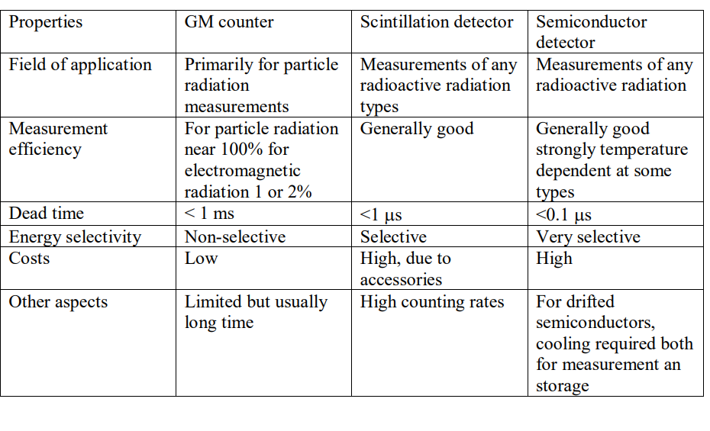
5.2 Gas ionization detectors ^{[15]}
According to the medium in which the ionization occurs, for example, gas ionization and solid state (semiconductor) detectors, two main detector types can be identified. The numerous gas ionization detectors all have the same structural layout, which consists of 2 metallic electrodes linked to a power source and a gas that may be ionized by radioactive radiation in the space between them. The incoming radiation ionizes the neutral gas molecules, producing positively charged ions pairs and electrons that is negatively charged. Positive and electrons change to the negatively and positively partial electrodes, respectively, apply the electric field amongst the electrodes. The electric field between the electrodes has a significant impact on how well gas ionization detectors operate.
5.3 Geiger-Müller (GM)-counters ^{[15]}
In order to produce large multiplication factors (108 to 109) within the detector, which is typically filled with argon, Geiger-Müller (GM)-counters utilize a high internal electric field. The voltage difference accelerates the primary ions to the point where an avalanche ionization process occurs in the gas space and quickly spreads along the anode wire to the entire length of the tube. The multiplication factor undergoes a quantitative shift that also triggers a qualitative change.
The creation of excited gas atoms, which emit photons to release their excess energy, is a result of the partial recombination of ions in addition to the ionization of the surrounding medium. The combined impact that results in a gas release. The traits depicted in Figure 11 serve as a representation of how the counter tube functions.
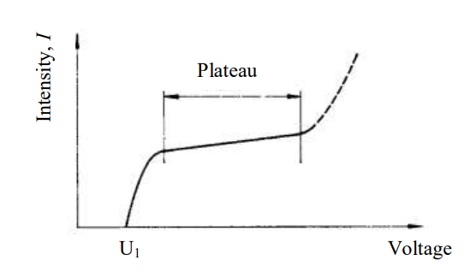
Figure 11. The characteristics of the GM tube
The numeration threshold where gas strengthening begins is represented by voltage U1. The number of detected pulses in the region U1-U2 fluctuates somewhat as voltage is increased. The plateau of the counter is the name given to this area. The better the counter, the plateau and the steeper its slope.
The parameters of a certain application should be taken into consideration when defining the operating characteristics. For and particles, the GM-counter tube's detection effectiveness is very close to 100%, but it seldom goes over 1% or 2% for electromagnetic radiation (or X-rays). For creating the most straightforward detection systems, GM-counters are best. Given that there are only a few 100 V power supplies used by these counters, their instability almost has no impact on how well the detector performs.
5.4 Semiconductor detectors ^{[15]}
The same ionization interaction technique used in gas ionization detectors serves as the fundamental basis for radiation sensing via semiconductor detectors.A planar-electrode ionization chamber with a semiconducting crystal in place of the filling gas is another way to conceptualize the semiconductor detector. The stopping power of solid-state detectors manufactured from semiconductor materials is substantially higher than that of the gas filling in ionization detectors as a result of the various specific weights of these materials.
Within 10–11 s, an elementary particle that causes ionization in a germanium or silicon single crystal semiconductor detector is stopped. Its energy will be transferred to the crystal atoms' electrons during the slowing process (ionization), which may lead to secondary ionization if the absorbed energy is high enough.
The field strength has an inverse relationship with the carrier collecting time when the detector geometry and carrier mobility are taken into account. A rather high detector voltage of several hundred volts is used to strengthen the field. Generally, liquid air or nitrogen is used to cool detectors below -190 °C in order to lessen noise effects that come with their operation.
Utilizing recent advancements in semiconductor device technology, semiconductor detectors have been produced quickly in recent years. It implies that their increasing use in technical applications as well as scientific research might be predicted.
Their main benefits include:
- good energy discrimination;
- pulse production;
- non-sensitivity to magnetic fields;
- low voltage supply requirement;
- vibration as well as impact resistance;
- long service life;
On the other hand, there are some drawbacks of semiconductor detectors, such as relatively high, supply voltage dependent self-capacity; disturbances in operation caused by crystal lattice defects; low signal-to-noise ratio at room temperature compared to other detector types; surface effects of atmospheric contaminations can increase the inherent noises; long-term irradiation can cause damage in the crystal structure leading to the degradation of the detector; and; Despite these limitations, semiconductor detector applications are growing, partly as a result of the technology's robust energy discrimination for the radiation's component particles or photons. In other words, semiconductor detectors have the finest "energy resolution" of any sort of counter.
5.5. Scintillation detectors ^{[16]}
Scintillation detectors' working principles are based on the unique characteristics of some organic and inorganic materials, such as the production of light-flashes or luminescence brought on by radioactive radiation. By acting as a light-to-electric signal transducer, a photomultiplier is utilized to detect and amplify the weak flashes or scintillations.
Due to the linear properties of the photomultiplier's voltage output and the fact that the scintillation is proportional to the incident particle energy, it is possible to determine the energies of the particles from the voltage output.
Nuclear measurement techniques refer to substances that have this luminous property as scintillators. The procedure of the scintillation mechanism is intricate. The energy from radiation that results in some atoms being excited or ionized is absorbed by the scintillator. They will quickly return to their ground state, accompanied by light or photon emission.
More scintillating atoms will be ignited in a material with a higher energy absorption from the traversing particle. Depending on how the radiation interacts with the detector material, energy will be transferred from individual photon particles.
Scintillator materials can be divided into three categories: inorganic single crystals, liquid scintillators, and plastic scintillators. As part of the well-known -photon interaction processes as the photoelectric effect, Compton scattering, and pair creation.
It is primarily appropriate for the detection of significantly penetrating electromagnetic radiation (Table R 10.) due to its comparatively high density. The energy transfer occurs in a very thin layer because -particles have very shallow penetration depths despite having energies that can reach several MeV. They powerfully ionize the atoms along their passage, creating secondary electrons that excite the atoms. The most common scintillator material used for alpha-radiation is a thin ZnS layer.
Depending on their energy, -particles can penetrate as deep as several millimeters. They more or less strongly ionize during penetration, producing secondary electrons that then excite the atoms. For the majority of scintillators, the detection efficiency for electrons is nearly 100%. However, since electrons are capable of huge angle scatterings (and occasionally backDepending on their energy, -particles can penetrate as deep as several millimeters. They more or less strongly ionize during penetration, producing secondary electrons that then excite the atoms. For the majority of scintillators, the detection efficiency for electrons is nearly 100%.
However, since electrons are capable of huge angle scatterings (and occasionally back scatterings), they may leave the detector before putting all of their energy there. The scintillator material's atomic number Z has a fast-growing relationship with the backscattering.
The detection of a particle takes place in several steps. ^{[16]}
- The scintillator crystal should be chosen based on the type of radiation being used, whether it be gamma, x-ray, or neutron radiation.
- The radiation energy determines the crystal's size, encapsulation, and inclusion into the sensor.
- Temperature and magnetic field changes have an impact on the electron multiplication process, which has an impact on multiplier performance.
- Scintillation detectors are highly efficient, or the likelihood of counting is high. It can be as high as 100% for X- and Y-rays, but it can also be between 20% and 30% for X-radiation.
The energy of the radiation being emitted is frequently too low to reach the detector, especially in the case of soft radiation. Liquid scintillators are used in these circumstances. High efficiency is made possible by the specimen being evaluated dissolving in the liquid.
The two chemicals 2,5-diphenyloxazol (PPO) and 2-phenyl-5-(4-diphenyl) are the most significant liquid scintillator compounds.2,4'-tert-butyl-5-(4"-diphenyl)-1,3,4-ocadiazol (PBD),1,4,di(5-phenyloxazol-2-yl)benzene (POPOP), 1,4-bis-2(4-methyl-5-phenyloxazolite)benzene (dimethyl-33 POPOP), and 1,3,4-oxadiazol (butyl-PBD). They are utilized in cyclic hydrocarbon solutions, such as those containing toluene, xylene, or cyclohexane.
The solvent molecules largely absorb the energy of the soft beta radiation, and the energy they emit will excite the dissolved scintillator materials. The precise positioning of the photomultipliers in relation to the sample holder may improve the detection's effectiveness. Due to its features, including those listed below:
- a good time-resolution;
- the balancein the signal to the energy;
- the large electric signal amplitude;
- the high efficiency detection;
- lifetime, scintillation detector's tendency
References
- Földeák, G. et al: Industrial application of radio-isotopes.
- Nagy L.G. et al: Radiochemistry and isotope technique
- Cuninghame J.G. et al: Introduction to the atomic nucleus
- M. Forte, R. Rusconi, M. T. Cazzaniga and G. Sgorbati, "The measurement of radioactivity in Italian drinking waters". Microchemical Journal, 2007, 85, 98–102
- R. Pöllänen, M. E. Ketterer, S. Lehto, M. Hokkanen, T. K. Ikäheimonen, T. Siiskonen, M. Moring, M. P. Rubio Montero and A. Martín Sánchez, "Multi-technique characterization of a nuclearbomb particle from the Palomares accident", Journal of Environmental Radioactivity, 2006, 90, 15–28
- Rabideau, S.W., Journal of the American Chemical Society, 1957, 79, 6350–6353.
- Lartigue, J.; Martínez, T. Trends in Nuclear Education. J RadioanalNucl Chem 2008, 276.
- Trager, R. Warnings That Radiochemistry Is Dying. Chemistry World 2019.
- Ishino, S. Nuclear Engineering Education in the 21st Century; Department of Nuclear Engineering, Tokai University: Japan, 2016.
- Macasek, F. My Five Decades of Nuclear Chemistry in Science Education; Faculty of Natural Sciences, Comenius University: Bratislava, Slovakia, 2009; p 12. 475
- B. T. Price, C. C. Horton, K. T. Spinney, Radiation Shielding, Pergamon, Oxford, 1957
- J. C. Rockley, An Introduction to Industrial Radiology, Butterworths, London, 1964
- K. Z. Morgan, J. E. Turner (Eds.), Principles of Radiation Protection, Wiley, New York, 1967
- A. Martin, S. A. Harbisson, An Introduction to Radiation Protection, 2nd ed., Chapman and Hall, International Atomic Energy Agency, Nuclear Power, the Environment and Man, IAEA. Vienna, United Nations, Ionizing Radiation: Sources and Biological Effects, United Nations, New York,
- H. Aurand, I. Gans, H. Ruhle, Radiookologie und Strahlenschutz, Erich Schmidt Verlag, Stuttgart, E. Pochin, Nuclear Radiation; Risks and Benefits, Clarendon Press, Oxford, 1983
- 0. F. Nygaard, M. G. Simic (Eds.), Radioprotectors and Anticarcinogens, Academic Press, New E. J. Hall, Radiation and Life, 2nd ed., Pergamon, Oxford, 1984.

