PHYTOCHEMICAL SCREENING AND SPECTRAL ANALYSIS OF SESBANIA GRANDIFLORA AND AMARANTHUS VIRIDIS

P.Perumal¹, B.Vignesh Babu², S. Manimegalai³ G.Kanthimathi ⁴ ,A.Prrithiba ⁵

^{1,2 ,3} Post Graduate and Research Department of Chemistry, Arulmigu Palaniandavar College of Arts & Culture, Palani-624601, Tamilnadu, India.
⁴ Department of Chemistry, Ramco Institute of Technolgy, Rajapalayam 626117, Tamilnadu, India
⁵ Avinashilingam Institute for Home Science and Higher Education for Women, Coimbatore, Tamilnadu, India.

- Introduction:
Plant products have been part of phytomedicines since time immemorial. This can be derived from barks, leaves, flowers, roots, fruits, seeds. Knowledge of the chemical constituents of plants is desirable because such information will be value for synthesis of complex chemical substances. Sesbania grandiflora (Linn) belonging to family Leguminosae commonly known as sesbania is often planted for its edible flowers and pods in tropical countries. It is believed to have originated in either India or Southeast Asia and grows primarily in hot and humid areas of the world. Sesbania is found from Northern Luzonto Mindanao in settled areas at low and medium altitudes. It was certainly introduced into the Philippines. This tree occurs also in India to the Mascarene Islands, through Malaya to tropical Australia, and is planted in other tropical countries. Amaranthus viridis is a cosmopolitan species in the botanical family Amaranthaceae and is commonly known as slender amaranth or green amaranth .Amaranthus viridis L. (Amaranthaceae), commonly known as “Chowlai”, is a fast growing herb mainly cultivated in Asia, Africa and Latin America. Traditionally, it is eaten as a leaf vegetable in south India. Being resistant to drought, hot climate and pests, and with little requirements for its cultivation, this pseudo cereal has attracted much attention as an important food commodity. In the last decade, the use of amaranth has expanded not only in the common diet, but also in diet of people with celiac disease or allergies to typical cereals. Amaranthus viridis (Amaranthaceae) widely distributed all over the world, growing under a wide range of climatic conditions and has been utilized as a medicinal herb in traditional uses. In Ayurveda, whole plant and their preparations are used for the treatment of various
infections and diseases Sesbania grandiflora has unique medicinal properties and used as a herbal drug for its antibiotic, anthelmintic, anti-tumour and contraceptive properties.
Fig. 1 Sesbania grandiflora leaves, flower, bark and seeds contains water, carbohydrate, proteins,fats, fibres, minerals ( Iron calcium, sodium and potassium), vitamins(thiamine, riboflavin,niacin, ascorbic acid and β- carotene) and essential amino acids(Arginine, histidine,isoleucine, leucine, lysine and methionine). The roots contains isoflavonids, isovestitol,medicarpin and sativan. Leucocyanidin and cyaniding are the active ingredients of Agati seeds¹³.
Fig 2. Amaranthus viridis is eaten as a boiled green or as a vegetable in many parts of the world. The leaves are highly nutritious. The nutrients present in the leaf include protein, fiber content, Vitamin A, Vitamin C, Riboflavin(Vit-B₂), Thiamin(Vit-B₁), Iron, calcium ,magnesium, Aminoacids (arginine,histidine,lysine,methionine,cystine,phenylalanine,leucine,
isoleucine, threonine, tryptophan, tyrosine, valine).The seeds possess proteins and fats . Therefore, A.viridis received considerable attention because of the high nutritional value¹.
The leaves are diuretic, febrifuge and purgative. The leaf sap is said to act as a vermifuge, being effective against filaria, as an emmenagogue and to relieve heart troubles. The leaves are used in poultices (fresh or as dried powder) to treat inflammations, boils and abscesses, gonorrhoea, orchitis and haemorrhoids. The leaf sap is used as an eye wash to treat eye infections.
Based on the above medicinal properties, the phytocompounds obtained from the butanol and aqueous extracts of plant leaves is used in the present study for the experimentation.

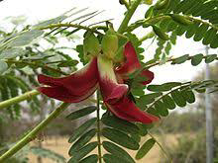
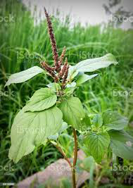
Fig.1: Sesbania grandiflora .L Fig.2: Amaranthus vidiris
2. Methodology
2.1Collection of plant material
The plants- Akathikeerai and kuppaikeerai were purchased from Ulavar Sandhai, Palani, Dindigul District. Plant specimen was authenticated in Department of Botany, Arulmigu Palaniandavar College of Arts & culture, Palani, Dindigul District, Tamilnadu.
2.2Processing of Plant material
The collected plant material was washed with tap water for 3 times and sterilized by spraying with 70% alcohol. The sterilized plant material was shade dried at room temperature to avoid chemical changes and frequently observed for any fungal contamination as the plant material rich in water content. Then the plant materials were shaded, dried, and then powdered by using mechanical blender and stored in airtight bottles. The fine powder of the plant materials were collected and used for the extraction of crude drug in different solvents by Soxhlet extraction method.
2.3Extraction of Phytoconstituents by Soxhlet method
100g of the powder of each plant material from which the extract has to be taken is packed into Soxhlet apparatus. The solvent is poured into the round bottom flask and extract condensation under reduced pressure and controlled temperature of 60-80°C is set to boil through regulated heating mantle. The collection and extraction of the materials takes place simultaneously in the main jar as seen by the coloring of the solvent as compound of material is dissolved in the solvent. Thus, the crude extract of the plant materials obtained.
All phyto constituents from plant require relatively large volume of organic solvents such as butanol and aqueous was used, it takes 7-8 hours for complete extraction. The solvent was evaporated and finally it yield dark green extract, this is stored in refrigerator for investigation of phytochemical analysis of Sesbania grandiflora (Akathikkerai) and Amaranthus viridis (Kuppaikeerai). The investigations were done in Centre for Bioscience and NanoScience Research, Eachanari, Coimbatore, Tamilnadu.
2.4Extract preparation
10% of each extract was prepared by dissolving 10 gm of them in 100ml of the distilled water and n-Butyl alcohol. These extracts were incubated at 40 ⁰C for 24 hrs in the rpm of 60 – 70 in an orbital shaker. After incubation the extracts were filtered through Whatman No.1 filter paper and used for further studies.

2.5Phytochemical Screening
(i)Test for Alkaloids
Mixed 1 ml of extract with 1 ml of Mayers reagent and few drop of Iodine solution. Formation of yellow colour precipitate was taken as an evidence for Alkaloids.
(ii)Test for Terpenoids
1 ml of crude extract was mixed with 1 ml of concentrated H₂SO₄ and heated for 2 minutes. Developed grayish colour indicates the presence of terpenoids.
(iii)Test for Phenol and Tannins
1 ml of crude extract was stirred with 1 ml of FeCl₃ solution. The formation of blue green or black precipitate was indication of tannins.
(iv)Test for reducing Sugar
To the 1 ml of extract, 1 ml of Fehling’s A solution and Fehling’s B solution was added and heated for about 2 to 4 minutes. Formation of red colour indicates to confirmed the presence of sugar.
(v)Test for Saponins
Added 1 ml of extract was shaken vigorously with 1 or 2ml of distilled water in a test tube. Shaken well and formation of 1 cm stable foam layer was taken as an indicates of saponins.
(vi)Test for Flavonoids
Few fragments of magnesium ribbon was added with 1ml of extract and added few drops of concentrated HCl drop wise in test tube. Incubate at 2 to 3 minutes. After few minutes appearance of pink scarlet colour confirmed the presence of flavonoids.
(vii)Test for Quinines
1 ml of extract was mixed with 1 ml of 1% NaOH solution and mixed well properly. Developed the blue green or red indicates the presence of Quinines.
(viii)Test for Protein
Few drops of nitric acid was added to 1 ml of extract and the test tube was allow to without disturbance for few seconds. Formation of yellow color indicates the presence of protein.
(ix)Test for Steroids
1ml of extract was mixed with equal amount of chloroform followed by added concentrated H₂SO₄ and allowed to develop red color ring. A red color was ring at the lower layer of chloroform indicates the presence of steroids²²⁻²⁴.
2.6UV-VIS spectrum analysis
The extracts of both the plants were centrifuged at 3000 rpm for 10 min and filtered through Whatmann No.1 filter paper. The samples were diluted to 1:10 with the same solvent. The extracts were scanned at wavelength ranging from 200 to 1100 nm using Perkin Elmer Spectrophotometer and the characteristic peaks were detected. The peak values of the UV-VIS were recorded²⁵.
2.6FT-IR analysis
Dried powder (butanolic extract) of test plants were used for FT-IR analysis¹⁸.1 mg of the dried powder of both the plants were encapsulated in 10 mg of KBr pellet, in order to prepare translucent sample discs. The powdered samples of the pellets were loaded in FT-IR spectroscope (Shimadzu, Japan), with a Scan range from 400 to 4000 cm⁻¹ with a resolution of 4 cm⁻¹
3.RESULTS AND DISCUSSION
3.1Qualitative phytochemical analysis of Sesbania grandiflora & Amaranthus viridis
The results of qualitative phytochemical analysis of Sesbania grandiflora & Amaranthus viridis are tabulated in Table 1.
Phytochemical screening of water and n-butyl alcohol medium extracts revealed the presence of presence of alkaloids, terpenoids, phenols, sugars, saponins, flavanoids and quinines in Sesbania grandiflora plant extracts is shown in Fig.3,4,5.
Table 1: Qualitative phytochemical analysis of the selected plant extracts
Phyto constituents | Extract used
 | Sesbania grandiflora |  | Amaranthus viridis
 | Water | n-Butyl alcohol | Water | n-Butyl alcohol
Alkaloids | + | + | - | +
Terpenoids | + | + | + | +
Phenol | + | + | + | -
Sugar | - | + | - | +
Saponins | + | - | + | -
Flavanoids | + | - | - | +
Quinines | - | + | - | +
Protein | - | - | - | +
Steroids | - | - | - | -

NOTE: ‘+’ Indicates the presence ‘-‘ Indicates the absence of phyto constituents
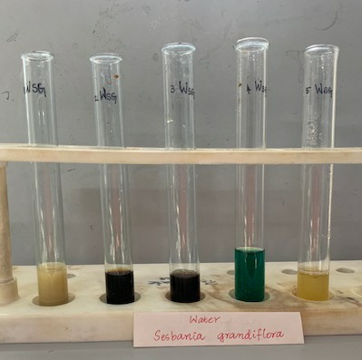

Fig.3.Aqueous extract of Sesbania grandiflora

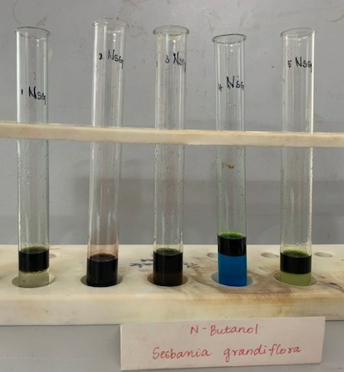

Fig.4. Butanol extract of Sesbania grandiflora
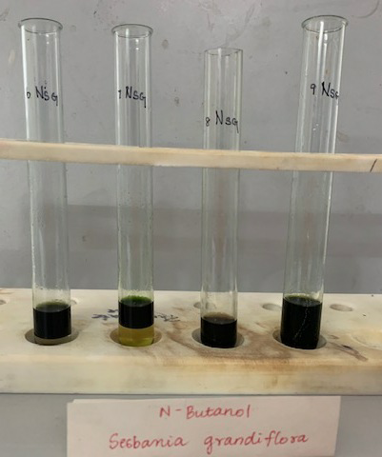
Fig.5. Butanol extract of Sesbania grandiflora
Phytochemical screening of water and n-butyl alcohol medium extracts of Amaranthus viridis revealed the presence of presence of alkaloids, terpenoids, phenols, sugars, saponins, flavanoids , quinines and proteins by positive reaction with the respective test reagent. The test specimens of the extracts are noted in Fig.6,7,8,9.

.
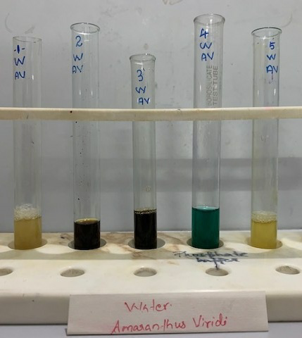

Fig.6 Test specimens of Aqueous extract of Amaranthus viridis
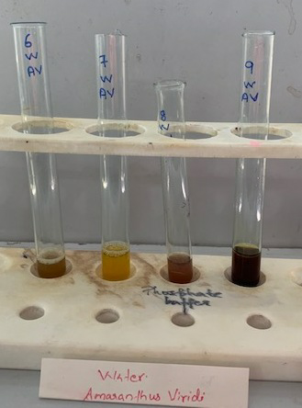
Fig.7 Test specimens of Aqueous extract of Amaranthus viridis
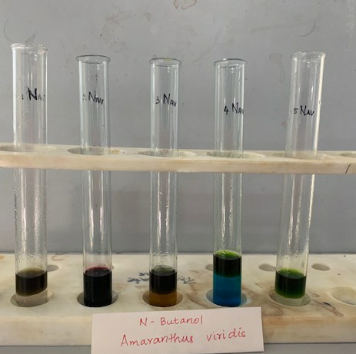
Fig.8 Test specimens of n-butanol extract of Amaranthus viridis
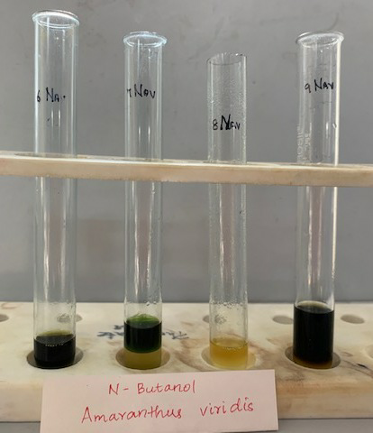
Fig.9 Test specimens of n-butanol extract of Amaranthus viridis

The Phytochemical Analysis revealed the presence of phytochemicals such as alkaloids, terpenoids, phenols, sugars, saponins, flavanoids and quinines by positive reaction with the respective test reagent in sesbania plant. However, a number of studies have shown that flavonoids and other phenolic compounds which exhibit analgesic and anti-inflammatory effects also display membrane stabilizing activity²⁶. The phytochemical results of the amaranthus plant revealed the presence of phytochemicals such as alkaloids, terpenoids, phenols, sugars, saponins, flavonoids, quinines and proteins.
Phenolic compounds represent one of the important families of antioxidants due to their free radical scavenging activity. Nevertheless, the presence of phytochemical compounds such as alkaloids, terpenoids, phenols, sugars, saponins, flavanoids, quinines and proteins has shown significant beneficial pharmacological properties, such as antiviral, anti‑inflammatory, antioxidant, antimicrobial,antimutagenic, and chemopreventive activity^{22.} An earlier report also demonstrated that the presence of phenolic compounds such as chlorogenic, acid, apigenin, kaempferol, asiaticosides, brahmic acid, asiatic acid, steroids, glycosides, and rosmarinic acid in different medicinal plants might be responsible for scavenging the free radical as well as enhanced the antioxidant activities²³⁻²⁴. Many reports also suggested that with the presence of phyto compounds in the plant extracts is responsible for their medicinal properties.²⁵⁻²⁸
3.2UV-VIS spectrum analysis of Sesbania grandiflora:
The qualitative UV-VIS spectrum profile of butanol extract of Sesbania grandiflora was selected at a wavelength from 200 to 800 nm due to the sharpness of the peaks and proper baseline. The profile showed the peaks at 240, 260 and 300nm with the absorption of 2.345,1.812 and 2.512 respectively (Table 2& Fig10). UV-VIS spectrum of this plant extracts has absorption bands at 420 and 223 nm. These absorption bands are characteristic for flavonoids and its derivatives. The flavonoids spectra typically consist of two absorption maxima in the ranges 230-285 nm (band I) and 300-350 nm (band II). The precise position and relative intensities of these maxima give valuable information on the nature of the flavonoids.

Table 2: UV-VIS Spectrum Peak values of butanolic extract of of Sesbania grandiflora

S.NO | Wavelength(nm) | Absorbance(abs)
1. | 240.00 | 2.345
2. | 260.00 | 1.812
3. | 300.00 | 2.512
4. | 325.00 | 2.503
5. | 365.00 | 2.360
6. | 430.00 | 2.600
7. | 540.00 | 1.397
8. | 615.00 | 2.192
9. | 755.00 | 0.087
10. | 785.00 | 0.077

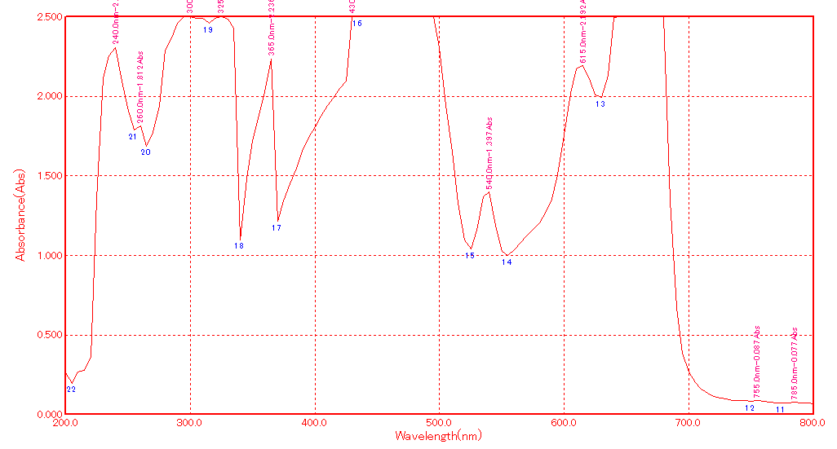

Fig.10.UV-VIS Spectrum of butanol extract of Sesbania grandiflora
3.2 UV-VIS spectrum analysis of Amaranthus viridis:
The qualitative UV-VIS spectrum profile of butanolic extract of Amaranthus viridis was selected at a wavelength from 200 to 800 nm due to the sharpness of the peaks and proper baseline. The profile showed the peaks at 223, 271 and 340nm with the absorption of 0.257,0.1973 and 0.1230 respectively in the Table 3 and Fig.11..
UV-VIS spectrum of this plant extracts has absorption bands at 420 and 223 nm. These absorption bands are characteristic for flavonoids and its derivatives. The flavonoids spectra typically consist of two absorption maxima in the ranges 230-285 nm (band I) and 300-350 nm (band II). The precise position and relative intensities of these maxima give valuable information on the nature of the flavonoids. UV-Vis absorption spectrum of Amaranthus viridis extract in butanol , indicating that all of these compounds display maximum absorption in the vicinities of 260-270 nm and 320-360 nm, which are attributed to the presence of coumarins, saponins, alkaloids, tannins, reducing sugars, catechins, epicatechins, flavonoids and polyphenolic (catechins, hydroxyl benzoicacids, hydroxyl cinnamic acids) ¹⁷⁻¹⁹.
Table3: UV-VIS Spectrum Peak values of butanolic extract of of Amaranthus viridis:

S.NO | Wavelength(nm) | Absorbance(abs)
1. | 215.0 | 0.352
2. | 235.0 | 2.264
3. | 300.0 | 2.494
4. | 315.0 | 2.395
5. | 325.0 | 2.380
6. | 540.0 | 0.342
7. | 620.0 | 0.753
8. | 665.0 | 2.500
9. | 750.0 | 0.026
10. | 785.0 | 0.022
UV-Vis study, indicates the flavonoids spectra typically consist of two absorption maxima in the ranges 230-285 nm (band I) and 300-350 nm (band II). The precise position and relative intensities of these maxima give valuable information on the nature of the flavonoids²⁵ . FT-IR techniques was employed to evaluate the IR finger print of Sesbania Grandiflora The results revealed the presence of alkaloids due to N-H stretching, polyphenols and flavonoids due to O-H stretching, terpenes due to CH group. The FTIR spectrum confirmed the presence of alcohols, phenols, alkanes, alkynes, alkyl halides, aldehydes, carboxylic acids and amines in the test plant. The presence of glycosides and alkaloids may be associated Sesbania Grandiflora with their use by traditional medicine practitioners in healthcare systems in the treatment of cough, fever and cold. These were confirmed by FTIR spectrophotometer study that predicted the presence of the groups: C-F, O-H, C-H, C=C, C=O, C≡N, N-H, C-H, carbonates and nitrates stretching. Based on the functional group analysis, Sesbania Grandiflora doesn’t contain any toxic compound.
UV-Vis absorption spectrum of Amaranthus viridis extract in butanol , indicating that all of these compounds display maximum absorption in the vicinities of 260-270 nm and 320-360 nm, which are attributed to the presence of coumarins, saponins, alkaloids, tannins, reducing sugars, catechins, epicatechins, flavonoids and polyphenols.¹⁷⁻¹⁹Then the FTIR technique was employed to evaluate the IR finger print of Amaranthus viridis The results confirmed by FTIR spectrophotometer study that the presence of the groups: C-F, O-H, C-H, C=C, C=O, C≡N, N-H, C-H, carbonates and nitrates stretching. The presence of characteristic functional groups of carboxylic acids, anhydrides, alcohols, phenols, amines, amides, esters, ethers, sulphur derivatives, glycosides, nitrates, nitriles, organic halogens and carbohydrate could be responsible for the various medicinal properties.
The different extracts of both of the leaves have clearly indicated that all the major phyto chemicals are present in the extracts and so this plant leaves can be used perfectly as a major plant for extraction of bioactive compounds. Many more experiments can be conducted in this plant where the plant can grow at different conditions and checked assayed for the phytochemicals. This experimentation is suggested because these plants grown in arid regions and also in acidic and alkaline soil regions²⁷.

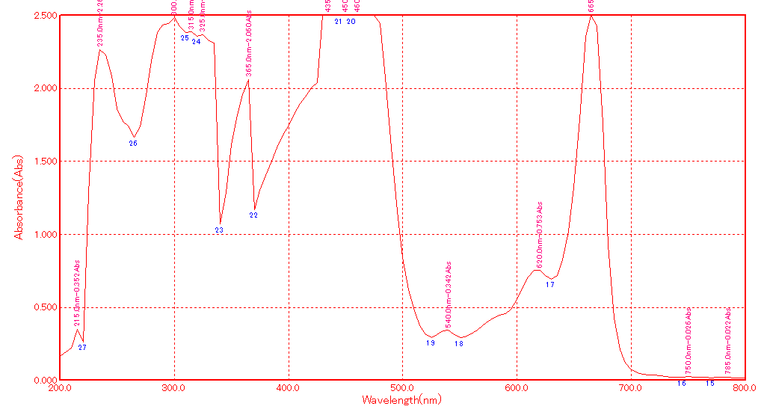
Fig.11 UV-VIS Spectrum of butanolic extract of Amaranthus viridis
3.4 FT-IR analysis of Sesbania grandiflora plant extract:
FT-IR spectrum was used to identify the functional groups of the active components present in extract based on the peaks values in the region of IR radiation. When the extract was passed into the FTIR, the functional groups of the components were separated based on its peaks ratio. The FTIR spectrum profile was illustrated in Fig.12. The FTIR gave broad peak at 3858 cm⁻¹ that indicated the presence of O-H stretching. It gave a strong peak at 2947 cm⁻¹ indicated the presence of C-H, 2839 cm⁻¹ attributed to carboxylic acid, the peak around 2361 cm⁻¹ are due to C-N , 1651 cm⁻¹ gave C=O stretching , 1450 cm⁻¹ gave alkanes, peak obtained at 1288 cm⁻¹ gave carboxylic acid and 1211 cm⁻¹ indicated the presence of alkyl amine, and the peaks at 1111 cm⁻¹ gave carboxylic acid and 1018 cm⁻¹ indicated the presence of alkyl amine and 679 cm⁻¹ gave the presence of alkyl halides, 602 cm⁻¹ gave CH stretch .FT-IR spectrum confirmed the presence of alcohols, phenols, alkanes, alkynes, alkyl halides, aldehydes, aromatics, nitro compounds and amines in powder pellet.

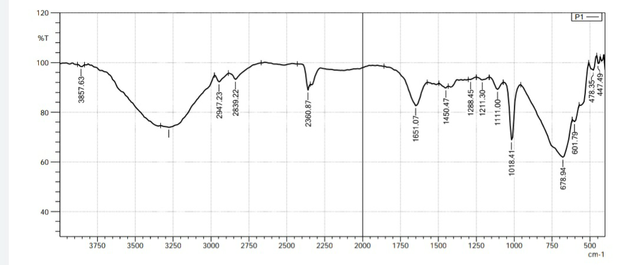

Fig. 12 FT-IR Spectrum of butanol extract of Sesbania grandiflora
3.5 FT-IR analysis of Amaranthus viridis:
The FT-IR spectrum of butanol extract of Amaranthus viridis was given in Fig.13.The broad peak at 3811 cm⁻¹ which indicated the presence of C-H stretching. It gave a strong peak at 3726 cm⁻¹ indicated the presence of O-H group, 3588 cm⁻¹ attributed to O-H stretching vibrations, the peak around 3279 cm⁻¹ are due to O-H strong peak,2978 gave CH stretching , 2901 cm⁻¹ gave CH and CH₂ stretching, peak obtained at 2361 cm⁻¹ 2337 indicated the presence of C-C conjugated and C=C, and the peaks at 1643 cm⁻¹ indicated the presence of C=O aromatic groups.1520 cm⁻¹ gave amide H - linkage,1389 cm⁻¹ gave O-H carbohydrates proteins and polyphenols, 1157 indicated the presence of C-O sretching, 949 indicated the presence of C=H stretching²⁰. The FT-IR spectrum confirmed the presence of alcohols, phenols, alkanes, alkynes, aldehydes, aromatics and amines in powder pellet.
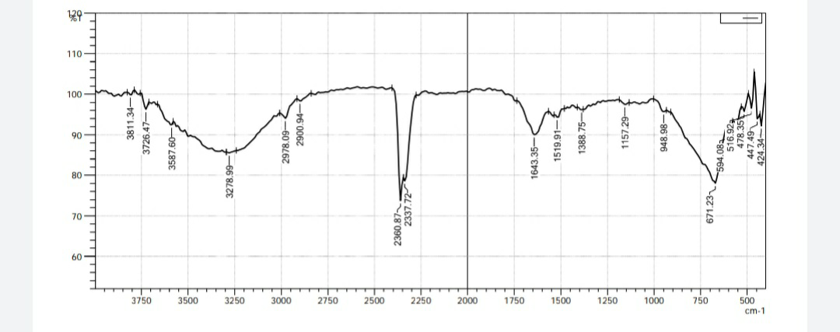

Fig. 13 FT-IR Spectrum of butanolic extract of Amaranthus viridis

CONCLUSION
Sesbania grandiflora and Amaranthus viridis plants were investigated for their phytochemical components and their therapeutic effect. The results revealed the presence of medicinally important constituents in the plants studied. Many evidences gathered in earlier studies that confirmed the identified phytochemicals to be bioactive. Qualitative phytocompounds were screened in S.gradiflora, and A.viridis according to the results alkaloids, terpenoids, phenols, sugars, saponins, flavanoids and quinines are present. Based on the results, it can be concluded that the S.grandiflora and A.viridis leaves extracts can be used in folk medicine since these compounds have antioxidants and antimicrobial activity.
In the present study UV-VIS spectrum and FTIR analysis of the plant of showed the presence of phenolic compounds and flavonoids which are responsible for various medicinal properties of test plant. Hence, more work is possible on the above plant to reveal the unknown importance that would be helpful which is the need of an hour for the present pharmaceutical world.
References:
- Abbs Fen Reji,.et.al.,Phytochemical Study on Sesbania grandiflora; Journal of chemical and Pharmaceutical Research,2013;5(2):196-201.
- Ahmed S.A, Hanif S and Iftkhar T. Phytochemical Profiling with Antioxidant and Antimicrobial Screening of Amaranthus viridis L.leaf and seed extracts. Open Journal in Medical Microbiology, 2013;3:164-71.
- Aijaz A, Sheikh, Zaferuddin Sayyed and Siddiqui A.R. Wound Healing Activity of Sesbania grandiflora Linn flower ethanolic extract using excision and incision wound model in wistar rats. International journal of Pharma Tech Research, 2011; 3(20):895-898.
- Arun.A,et al.,Phytochemical Screening of Sesbania grandiglora;International Journal of Biosciences and Nano Sciences, 2014;1(2:) 33-36.
- Bell H.C.P. The Maldive Islands; A Study of the Popular Culture of an Ancient Ocean Kingdom.2nd edition, Barcelona,1999.
- Bishen Singh and Mahendra pal singh. Allahabad, Phytochemical,Pharmacological and Phytopharmaceutics Aspects of Sesbian grandiflora; Journal of Pharmacy Research, 1995; 2:084-1087.
- Deori M,et al., Antioxidant Effect of Sericin in Brain and Peripheral Tissues of Oxidative Stress Induced Hypercholesterolemic rats. Journal in FrontPharmacology, 2016; 7 :319.
- Djordjevic T.M, Siler-Marinkovic S.S, Dimitrijevic-Brankovic S.I. Antioxidant Activity and Total Phenolic content in some Cerealsand Legumes. International Journal in Food Properties, 2011;14:175-84.
- Galeano B,et al., Application of Environmental Microbiological.Journal of Phytopharmacology,2003;69(7):4329-4331
- Gunasekaran S. UV-VIS Spectroscopic a Analysis of Blood Serum; Asian Journal of Microbiology Biotech and Environmental Science. 2003; 5(4):581–2.
- Harborne J.B. Phytochemical Methods; A Guide to Modern Techniques of Plant Analysis.2nd Edition, London New York, 1984.
- Kirtikar K.R and Basu B.D. Phytochemical,Pharmacological and Phytopharmaceutics Aspects of Sesbian grandiflora; Indian Medicinal Plants, 2nd Edition,1991.
- Larbie Christopher, et al., Anti-proliferative Effect of Amaranthus Viridis Linn on Human Leuckemic cell Lines –Preliminary Study. International Journal of Biological and Pharmaceutical Research,2015;6(3):236 – 243.
- Lipkin A,et al., An Antimicrobial Peptide Ar-AMP from Amaranth (Ama- ranthus retroflexus L.) Seeds.Journal of Science Direct, 2004; 32(1): 93 - 95.
- Maiden J.H. The Useful Native Plants of Australia : Including Tasmania. Turner and Henderson, Sydney.1889.
- Monisha M , Sowmiya M , Ragunathan R and Jesteena Johney. Extraction of Bio Active Compounds from Cassia Auriculata Pods and Leaves and its Medicinal Uses. Int.J.Curr.Microbiol.App.Sci., 2017;6(8): 425-434.
- Muhammad Javid,et al., Anti-Oxidant and Anti-Microbial Activity of Amaranthus Viridis. Journal of Medicinal Plants Research, 2012; 6(27):4450 – 4455.
- Musharaf Khan, Shahana Musharaf,Mohammad Ibrar and Farrukh Hussain. Phytochemical and Pharmacological Potential of Amaranthus viridis. Journal in Pharmaceutical Biotechnology, 2011; 3(1):11-16.
- Nadkarni A.K. Phytochemical,Pharmacological and Phytopharmaceutics Aspects of Sesbian grandiflora; Journal of Pharmacy Research ,1991;1: 52.
- Okoli C.O. and Akah P.A. Acanthus montanus: An Experimental Evaluation of the Antimicrobial, Anti-inflammatory and Immunological Properties of a Traditional Remedy for Furuncles. BMC Complement. Altern. Med.,2008;8:27-30.
- Olugbenga Oluseyi Adeoluwa,Oluwaseyi Akinyemi. Amaranthus Amaranthus viridis dry matter and soil qualities .Journal in Organic Vs Inorganic Fertilizers Research,2014;14(1):13 – 15.
- Pandhare R.B, Sangameswaran B Mohite P.B and Khanage S.G. Antidiabetic Activity of Aqueous leave extract of Sesbania grandiflora (L) Mess, in Streptozotocin induced Diabetic rats. Journal in Medicinal Biotech, 2011; 3(1): 37-43.
- Qui˜nones Islas L, Meza-M´arquez O, Osorio-Revilla G, and Gallardo-Velazquez T. Detection of Adulterants in Avocado Oil by Mid-FTIR Spectroscopy and Multivariate Analysis. Food Research International,2013; 51:148–154.
- Radhika J, Ruth Christia C and Jothi G. Effect of the aqueous extract of Sesbania grandiflora in alloxan induced diabetes in albino rats. World Journal of Pharmaceutical Research, 2014; 3(9): 677-685.
- Rajagopal P.L, Premaletha K and Sreejith K.R. Anthelmintic Activity of the Flower of Sesbania grandiflora Pers. Journal of Innovations in Applied Pharmaceutical Sciences,2016;1(2): 8-11.
- Rodr´ıguez-Carpena J.G, Morcuende D, Andrade M.J,Kylli P, and Estevez M.In Vitro Antioxidant and Antimicrobial Activities, and Inhibition of Lipid and Protein Oxidation in Porcine Patties. Journal of Agricultural and Food Chemistry,2011; 59:5625–5635,
- Sangeetha, Sriram Prasath G and Subramanian S. Anti hyperglycemic and Antioxidant Potential of Sesbania grandiflora leaves studied in STZ induced experimental diabetic rats. International Journal of Pharmaceutical Science And Research, 2015; 2266-2275.
- Sarma R,et al., Polyphenol rich extract of Garcinia pedunculata fruit attenuates the hyperlipidemia induced by high fat diet. Journal in Front Pharmacol. 2016 ; 7 :294.
- Saud Asif Ahmed,Sumaira Hanif and Tehreema Iftkhar.Phytochemical Profiling with Antioxidant and Antimicrobial Screening of Amaranthus Viridis L. Journal of Medical Microbiology,2013;3(1):164 – 171.
- Selvakumar Sivagnanam and Anoop Prakash Chandra:Preliminary Phytochemical Analysis of Amaranthus viridis. Journal of Pharmaceutical,Biological and Chemical Sciences,2016;7(1):1 -7.
- Siger A, Czubinski J, Kachlicki P, Dwiecki K,et al.,Antioxidant Activity and Phenolic content in three Lupin species. Journal in Food Compos Anal 2012; 25:190-7.
- Sima Kumari,Elancheran R and Rajlakshmi Devi. Phytochemical Screening of Amaranthus Viridis. Indian Journal of Pharmacology,2018;50(3):130 -138.
- Sofowora A. Medicinal Plant and Traditional Medicine in Africa. Wiley and Sons Limited, Chichester, 1993.
- Sowjanya Pulipati,Srinivasa Babu P and Lakshmi Narasu M. Phytochemical and Pharmacological Potential of Amaranthus viridis L. International Journal of Phytomedicine,2014:6(3):322-326.
- The Wealth of India Raw Material; Phytochemical,Pharmacological and Phytopharmaceutics Aspects of Sesbian grandiflora. Council of Scientific and Industrial Research Publication, New Delhi,1991.
- Tim Low. Wild Herbs of Australia & New Zealand. Angus & Robertson Publishers.2nd edition, 1985.
- Torres A, Mau-Lastovicka T, and Rezaaiyan R. Total Phenolics and Highperformance Liquid Chromatography of Phenolic Acids of Avocado. Journal of Agricultural and Food Chemistry, 1987; 35: 921–925.
- Townsend C.C. Phytochemical Species of Amaranthus viridis.Journal Medicinal and Biological Research, 1985;4: 20-24.
- Vijay.D,et al., Phytochemical,Pharmacological and Phytopharmaceutics aspects of Sesbian grandiflora.Journal of Pharmacy Research,2009;2(5) : 889-892.
- Zahir Hussian A.et.al.,Phytochemical Screening of Sesbania grandiflora; Journal of Chemical and Pharmaceutical Reseaech,2014;6(9):43-

