ASSESSMENT OF AIR POLLUTION AND AMBIENT AIR QUALITY IN TAMIL NADU
P. Sujatha¹, Dr. S. Srileka²
1 Asst. Professor, Dept. of Geography, Bharathi Women’s College (A), Chennai-108, TN, India
2 Asst. Professor, Dept. of Geography, Bharathi Women’s College (A), Chennai-108, TN, India.
sujathaj3998@gmail.com , srileka3330@gmail.com

ABSTRACT
Air pollution refers to the contamination of the indoor or outdoor environment by chemical, physical, or biological agents that alter the natural characteristics of the atmosphere. The depletion of stratospheric ozone caused by air pollution poses significant threats to human health and the Earth's ecosystems.
The quality of air is intricately connected to global climate and ecosystems. Many activities that contribute to air pollution, such as the burning of fossil fuels, also result in greenhouse gas emissions. Consequently, policies aimed at reducing air pollution offer a dual benefit by addressing climate change and improving public health. These policies not only reduce the burden of disease associated with air pollution but also contribute to mitigating climate change in the short and long term.
Efforts should be focused on reducing the sources and impacts of climate change, including the reduction of toxic chemical use and improved management of toxic waste. Active participation from all segments of society through environmental education, awareness campaigns, and capacity building is crucial for nature conservation and environmental protection. It is vital to integrate environmental principles into development planning, policies, and practices to ensure sustainable outcomes. Moreover, promoting environmental governance through legislation, policy implementation, and advocacy is essential.
Therefore, it is imperative to identify gaps in the current management of resource bases. The present study aims to assess the air quality and air pollution situation in Tamil Nadu, providing valuable insights into the state's environmental conditions and supporting the development of effective strategies for sustainable resource management.
Key Words: Ambient Air Quality, Air Pollution, Climate Change.

- INTRODUCTION
The Tamil Nadu Pollution Control Board (TNPCB) is actively monitoring air quality to assess the concentration of air pollutants originating from industrial emissions and the growing number of vehicles. In Chennai, multiple monitoring programs such as the National Air Quality Monitoring Programme (NAMP) and the Chennai Ambient Air Quality Monitoring Programme (CAAQM) track ambient air quality at various locations. Other cities like Thoothukudi, Coimbatore, Madurai, Salem, and Tiruchirapalli also have air quality monitoring in place. Continuous monitoring stations have been established in Cuddalore, Tuticorin, Ranipet, Manali-Chennai, Royapuram-Chennai, Kottivakkam-Chennai, and Tamil Nadu Scenario to evaluate pollution levels.
The rapid increase in the number of vehicles, driven by urbanization, economic growth, and easy access to finance, has exacerbated the issue of vehicular pollution. Not only are there new vehicles, but also older vehicles with outdated technology and non-compliance with emission norms. Additionally, the quality of fuel supplied further contributes to the problem of vehicular pollution. The TNPCB has been monitoring vehicular emissions since 1992, with three dedicated monitoring stations in Chennai at Alandur, Ambattur, and Vyasarpadi, continuously monitoring emissions from goods and transport vehicles. Vehicular emission monitoring is also conducted in other locations such as Dindigul, Palani, Ooty, Chengalpattu, and Katteri.
To effectively tackle environmental challenges, establishing a robust Pollution Database for Tamil Nadu through data collection from various sources is proposed. Striving for harmonious coexistence with nature is crucial to safeguard ecological security. This necessitates achieving objectives such as conserving biodiversity, promoting sustainable resource usage, and engaging rural communities in conservation efforts. By prioritizing these objectives, a sustainable future that benefits both humans and the environment can be achieved.
- METHODOLOGY
This study relies on secondary data from diverse sources, including the Tamil Nadu Pollution Control Board (TNPCB), National Air Quality Monitoring Program (NAMP), reviews journals, books, and periodicals. These sources have played a pivotal role in providing valuable data and insights for the study's objectives. It is crucial to highlight that the information presented in this study is derived from diligently collected and analyzed secondary data, enabling meaningful and reliable conclusions to be drawn.
- OBJECTIVE
- Assess the current status of air quality in Tamil Nadu by monitoring and evaluating air pollutant concentrations.
- Examine the number of vehicles in Tamil Nadu, including both new and old vehicles, to understand their contribution to vehicular pollution.
- Develop long-term strategies for emission control through effective measures and policies to improve air quality and promote a healthier environment in Tamil Nadu.

- LITERATURE REVIEW
The ambient air contains a wide range of potentially harmful pollutants, originating from both natural sources and human activities (1). Surprisingly, natural sources also contribute significantly to global air pollution alongside anthropogenic activities (2). Motor vehicles and industrial processes remain the primary contributors to air pollution, overshadowing other sources (3). India's rapid industrialization, urbanization, and transportation development have brought economic growth but also caused significant environmental degradation (4). Developing countries' unplanned urbanization and rapid industrialization have led to environmental deterioration and a decline in quality of life (5). Emissions from industries and vehicle exhausts, including particulate matter and gaseous pollutants, have adverse effects on respiratory health and urban environments (6). Urban air pollution is now a major concern for public health and regulatory bodies due to its detrimental impact (7).
Air pollution can be defined as the contamination of the atmosphere by gaseous, liquid, or solid waste products that pose a threat to human, plant, and animal health (Meenakshi and Elangovan, 2000). While natural sources release some pollutants, emissions from industrial activities and combustion engines contribute significantly more (Avnish and Mayank, 2010). Fuel combustion from stationary and mobile sources is the primary cause of human-induced air pollutant emissions (Avnish and Mayank, 2010). Outdoor air pollution includes various harmful substances like sulfur dioxide, carbon monoxide, nitrogen oxides, ozone, lead, and toxic particles (Barman et al., 2008). Alarming levels of air pollution in India have reduced the average life expectancy of 660 million Indians by 3.2 years (Meenakshi and Saseetharan, 2003).
The deterioration of air quality in Indian cities is primarily attributed to burning fossil fuels for industrial processes, transportation, and improper waste disposal (Meenakshi and Saseetharan, 2003). In many Indian cities with over one million populations, air pollution exceeds the recommended standards of the World Health Organization (Meenakshi and Saseetharan, 2003). The worsening air quality is amplified by factors like rapid industrialization, increasing vehicles, energy consumption, and improper waste management in urban areas.

AIR POLLUTION
Air pollution refers to the contamination of the Earth's atmosphere by the introduction of particulates, biological molecules, or other harmful substances. These pollutants have the potential to cause diseases, human fatalities, harm to food crops, and damage to both the natural and built environment. The depletion of the stratospheric ozone layer, resulting from air pollution, has been widely acknowledged as a significant threat to human health and the Earth's ecosystems. Indoor air pollution and urban air quality are recognized as two of the most severe toxic pollution problems faced globally.

Sources
There are various activities or factors which are responsible for releasing pollutants into the atmosphere. These sources can be classified into two major categories.

Anthropogenic (man-made) sources:
Anthropogenic sources of air pollution primarily stem from the combustion of various types of fuel. These sources can be categorized into stationary and mobile sources. Stationary sources encompass power plants, manufacturing factories, waste incinerators, furnaces, and other fuel-burning devices commonly found in industrial settings. In less developed countries, traditional biomass burning, including wood, crop waste, and cow-dung, represents a major contributor to air pollutants.
Mobile sources of air pollution include vehicles, marine vessels, and aircraft. Emissions from these sources are produced by the combustion of fuel, as well as the release of fumes from substances such as paint, hair spray, varnish, aerosol sprays, and solvents. Additionally, waste deposition in landfills generates methane during the decomposition process. Methane is highly flammable, capable of forming explosive mixtures with air, and can displace oxygen in enclosed spaces. It is worth noting that military resources, such as nuclear weapons and toxic gases, also play a significant role in contributing to air pollution.

Natural sources:
Air pollution can also originate from natural sources such as dust, particularly from large areas of land with limited vegetation. Another natural source of air pollution is radon gas, which is formed through the radioactive decay of radium in the Earth's crust. Radon is known to be a health hazard and can accumulate in buildings, especially in confined spaces, posing a significant risk for lung cancer.
Smoke and carbon monoxide emitted during wildfires and volcanic activity contribute to air pollution by releasing sulfur, chlorine, and ash particulates. It is important to note that pollutants can have either natural or man-made origins. They are classified as primary or secondary pollutants.

Primary pollutants are directly produced from specific processes, such as ash from a volcanic eruption or carbon monoxide gas from motor vehicle exhaust. Examples of primary pollutants also include sulfur dioxide emitted by factories.
On the other hand, secondary pollutants are not emitted directly but form in the atmosphere when primary pollutants react or interact with other substances. Ground-level ozone is a prominent example of a secondary pollutant. It is formed when primary pollutants like nitrogen oxides and volatile organic compounds react with sunlight. Some pollutants can exhibit characteristics of both primary and secondary pollutants, as they are emitted directly but can also form from the transformation of other primary pollutants.
In India, a major source of air pollution is the burning of fuel wood and biomass in both rural and urban areas. A significant portion of the population relies on fuel wood and biomass cakes for cooking and heating purposes. Biomass cook stoves are prevalent in over 100 million Indian households and are used multiple times a day. Traditional fuels such as dried cow dung, agricultural waste, and firewood are still widely used for cooking fuel in India.

Major primary pollutants produced by human activity include:
Sulphur oxides (SOx), particularly sulfur dioxide (SO2), are produced by volcanoes and various industrial processes. Coal and petroleum contain sulfur compounds, and when combusted, they release sulfur dioxide. The further oxidation of SO2, usually in the presence of a catalyst like NO2, leads to the formation of sulfuric acid (H2SO4) and contributes to the occurrence of acid rain.

Nitrogen oxides (NOx), especially nitrogen dioxide (NO2), are emitted during high-temperature combustion processes and can also be produced by electric discharge during thunderstorms. Nitrogen dioxide (NO2) is a prominent air pollutant and a chemical compound with the formula NO2.

Carbon monoxide (CO) is a toxic gas that results from the incomplete combustion of fuels such as natural gas, coal, or wood. Vehicular exhaust is a major source of carbon monoxide emissions.

Volatile organic compounds (VOCs) are well-known outdoor air pollutants. They can be categorized as either methane (CH4) or non-methane volatile organic compounds (NMVOCs). Methane is a greenhouse gas that contributes to the enhancement of global warming. Aromatic NMVOCs, such as benzene, toluene, and xylene, are suspected carcinogens and may lead to leukemia with prolonged exposure.
Another compound often associated with industrial use is 1,3-butadiene.

Particulate Matter

Particulate Matter (PM) refers to solid or liquid particles suspended in a gas, commonly found in the atmosphere. These particles can vary in size and composition and are often referred to as fine particles. They can originate from various sources, both natural and human-made.

AEROSOLS

Aerosols, on the other hand, are a combination of particles and gas. They can occur naturally from events such as volcanic eruptions, dust storms, forest fires, and sea spray. Human activities, including the burning of fossil fuels in vehicles, power plants, and industrial processes, also contribute significantly to the production of aerosols.

CHLOROFLUOROCARBONS (CFCs)

Chlorofluorocarbons (CFCs) are gases that are harmful to the ozone layer. They are commonly used in air conditioners and refrigerators. When released into the air, CFCs rise to the stratosphere where they interact with other gases and contribute to the depletion of the ozone layer. This depletion allows harmful ultraviolet rays from the sun to reach the Earth's surface, leading to skin cancer and other related health issues.

Secondary pollutants include:

Particulates that are formed from the chemical reactions of gaseous primary pollutants are known as secondary pollutants. One example of secondary air pollution is smog, which occurs as a result of extensive coal burning in an area. The combination of smoke and sulfur dioxide leads to the formation of smog. Additionally, smog is also produced by emissions from vehicles and industries, which undergo reactions in the atmosphere with sunlight to create secondary pollutants, contributing to the formation of photochemical smog.

Ground-level ozone (O3) is another secondary pollutant formed from the interaction of nitrogen oxides (NOx) and volatile organic compounds (VOCs). Ozone is a significant component of the troposphere, the lower part of the Earth's atmosphere. It also plays a crucial role in specific regions of the stratosphere, known as the Ozone layer.

Peroxyacetyl nitrate (PAN) is yet another secondary pollutant that forms from the reaction of nitrogen oxides (NOx) and volatile organic compounds (VOCs). It is a compound that contributes to air pollution and is generated through the atmospheric reactions of NOx and VOCs.

Ambient Air Quality Monitoring Results of Chennai between 2003 &2012
A. Location: Municipal Kalyanamandapam, Kathivakkam, Chennai
Category -Industrial Area
Year | Annual Average Concentration of Air  pollutants, µg/m³
 | TSPM | RSPM | NOx | SO₂
2003-2004 | 163 | 90 | 32 | 24
2004-2005 | 128 | 73 | 32 | 19
2005-2006 | 221 | 71 | 25 | 13
2006-2007 | 140 | 61 | 25 | 14
2008-2009 | 196 | 78 | 19 | 13
2009-2010 | 181 | 78 | 19 | 12
2010-2011 | 179 | 88 | 18 | 12
2011-2012 | NA | 132 | 27 | 22
Prescribed Standard
Industrial | 360 | 120 | 80 | 80
Residential, Rural & Other Areas (Mixed) | 140 | 60 | 60 | 60
NAAQS-2009 | NA | 60 | 40 | 50

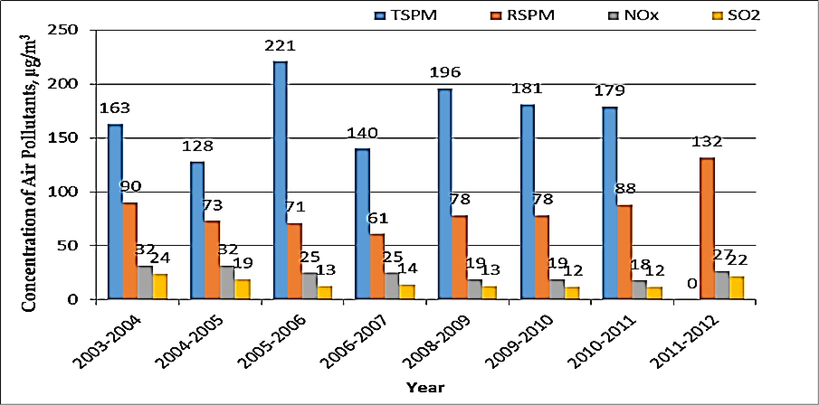
Graph showing Ambient Air Quality in Kathivakkam Chennai between 2003-201

Ambient Air Quality Monitoring Results of Chennai between 2003 &2012
B. Govt. Hr. Sec, School, Manali, Chennai
Category -Industrial Area
ear | Annual Average Concentration of Air pollutants, µg/m³
 | TSPM | RSPM | NOx | SO₂
2003-2004 | 214 | 109 | 34 | 22
2004-2005 | 181 | 95 | 34 | 20
2005-2006 | 236 | 79 | 27 | 14
2006-2007 | 151 | 81 | 25 | 14
2008-2009 | 177 | 86 | 21 | 14
2009-2010 | 174 | 83 | 20 | 13
2010-2011 | 165 | 87 | 20 | 12
2011-2012 | NA | 70 | 26 | 20
Prescribed Standard
Industrial | 360 | 120 | 80 | 80
Residential, Rural &  Other Areas (Mixed) | 140 | 60 | 60 | 60
NAAQS-2009 | NA | 60 | 40 | 50

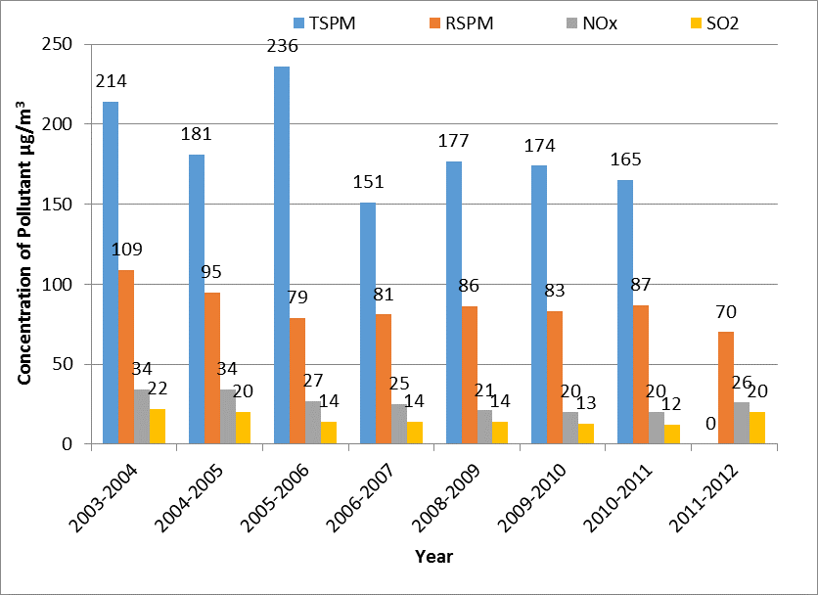
Graph showing Ambient Air Quality in Manali Chennai between 2003-2012

Ambient Air Quality Monitoring Results of Chennai between 2003 &2012
C. Municipal Office , Thiruvottiyur, Chennai
Category - Mixed Area
Year | Annual Average Concentation of Air pollutants, µg/m³
 | TSPM |  | RSPM | NOx | SO₂
2003-2004 | 151 |  | 95 | 32 | 20
2004-2005 | 133 |  | 85 | 31 | 19
2005-2006 | 207 |  | 70 | 28 | 13
2006-2007 | 128 |  | 66 | 24 | 14
2008-2009 | 196 |  | 100 | 20 | 13
2009-2010 | 218 |  | 108 | 22 | 15
2010-2011 | 167 |  | 66 | 20 | 12
2011-2012 | NA |  | 88 | 27 | 20
Prescribed Standard
Industrial | 360 | 120 | 80 | 80
Residential, Rural &  Other Areas (Mixed) | 140 | 60 | 60 | 60
NAAQS-2009 | NA | 60 | 40 | 50

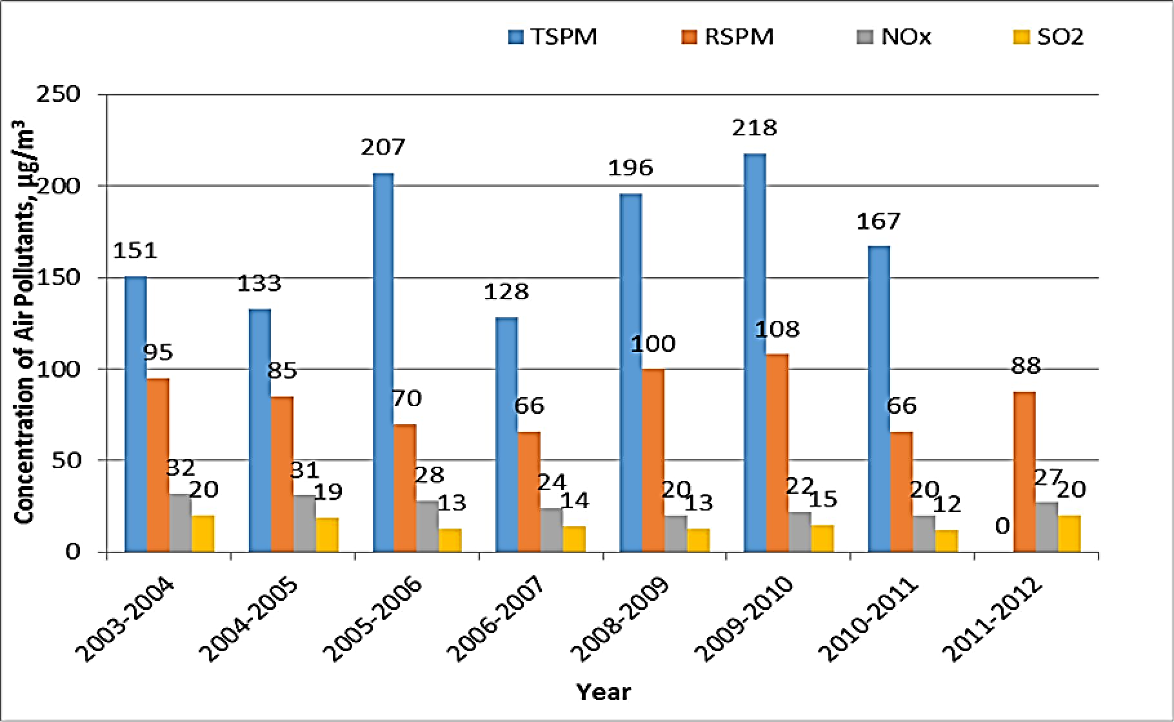
Graph showing Ambient Air Quality in Thiruvottiyur Chennai between 2003-2012

Ambient Air Quality Monitoring Results of Coimbatore between 2003&2012
A. Location: Collectorate Office Building/GD Matric School, Coimbatore
Category -Mixed Area
Year | Annual Average Concentration of Air  pollutants, µg/m³
 | TSPM | RSPM | NOx | SO₂
2003-2004 | 108 | 43 | 51 | 10
2004-2005 | 134 | 53 | 39 | 7
2005-2006 | 90 | 39 | 43 | 8
2006-2007 | 88 | 44 | 32 | 10
2008-2009 | 107 | 59 | 30 | 5
2009-2010 | 121 | 60 | 23 | 5
2010-2011 | 157 | 60 | 24 | 6
2011-2012 | NA | 68 | 30 | 5
Prescribed Standard
Industrial | 360 | 120 | 80 | 80
Residential, Rural & Other  Areas (Mixed) | 140 | 60 | 60 | 60
NAAQS-2009 | NA | 60 | 40 | 50

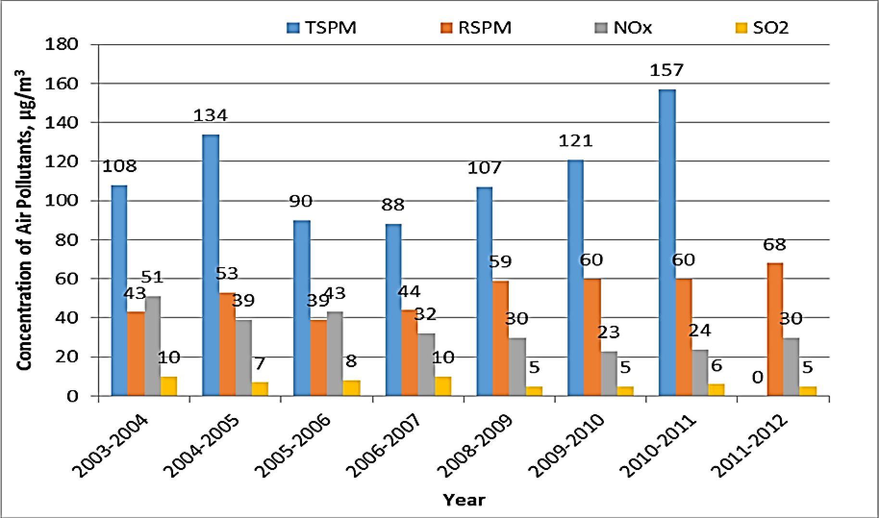
Graph showing Ambient Air Quality in GD, School Coimbatore between 2003-2012

Ambient Air Quality Monitoring Results of Coimbatore between 2003 &2012
B. Location: Ponniyarajapuram, Coimbatore
Category -Residential Area
Year | Annual Average Concentration of Air pollutants, µg/m³
 | TSPM | RSPM | NOx | SO₂
2003-2004 | 111 | 46 | 46 | 10
2004-2005 | 113 | 51 | 41 | 7
2005-2006 | 86 | 44 | 38 | 7
2006-2007 | 87 | 44 | 32 | 9
2008-2009 | 90 | 50 | 31 | 5
2009-2010 | 98 | 51 | 23 | 5
2010-2011 | 111 | 56 | 21 | 5
2011-2012 | NA | 68 | 29 | 5
Prescribed Standard
Industrial | 360 | 120 | 80 | 80
Residential, Rural &  Other Areas (Mixed) | 140 | 60 | 60 | 60
NAAQS-2009 | NA | 60 | 40 | 50

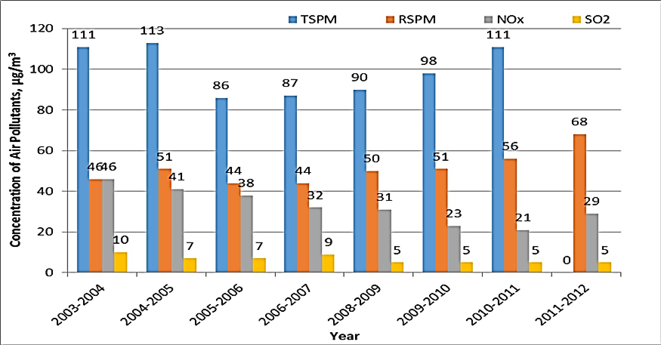
Graph showing Ambient Air Quality in Ponniyarajapuram Coimbatore between 2003-2012

Ambient Air Quality Monitoring Results of Coimbatore between 2003 &2012
C. Location: SIDCO, Coimbatore
Category -Industrial Area
Year | Annual Average Concentration of Air pollutants, µg/m³
 | TSPM | RSPM | NOx | SO₂
2003-2004 | 151 | 62 | 56 | 13
2004-2005 | 192 | 84 | 48 | 9
2005-2006 | 161 | 73 | 47 | 10
2006-2007 | 230 | 102 | 40 | 11
2008-2009 | 221 | 116 | 37 | 6
2009-2010 | 231 | 100 | 27 | 7
2010-2011 | 273 | 102 | 34 | 6
2011-2012 | NA | 205 | 35 | 5
Prescribed Standard
Industrial | 360 | 120 | 80 | 80
Residential, Rural &  Other Areas (Mixed) | 140 | 60 | 60 | 60
NAAQS-2009 | NA | 60 | 40 | 50

Graph showing Ambient Air Quality in SIDCO Coimbatore between 2003-2012
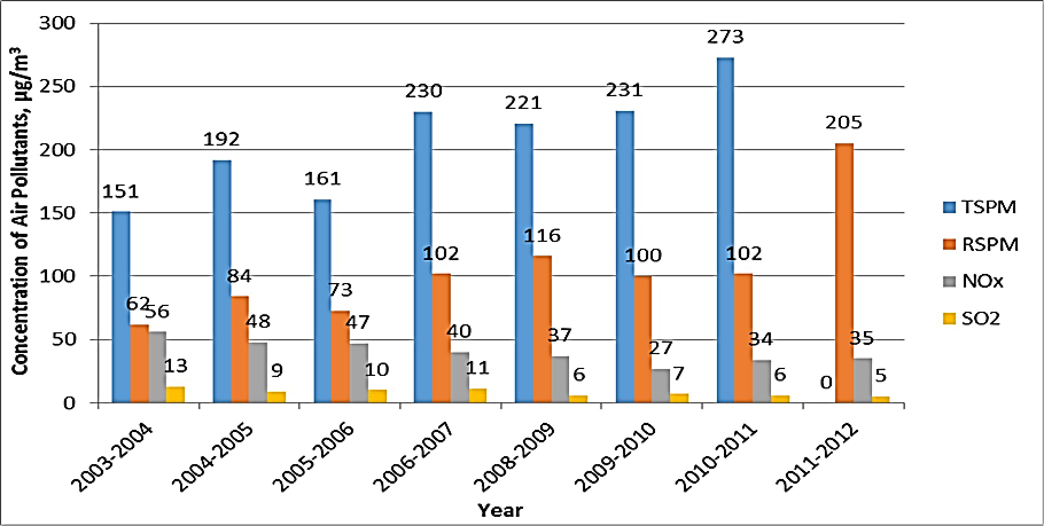

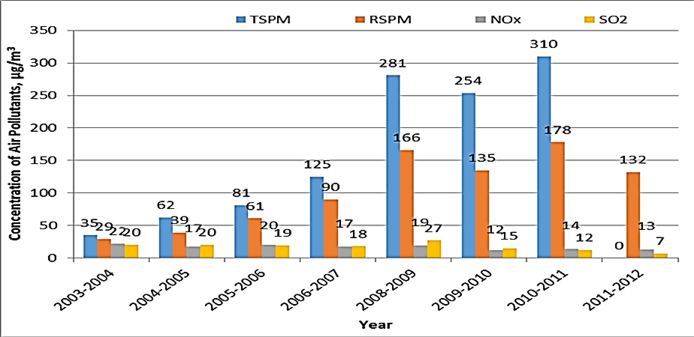

Ambient Air Quality Monitoring Results of Thoothukudi between 2003&2012
A. Location: Raja Agencies, Thoothukudi
Category -Industrial Area
Year | Annual Average Concentration of Air pollutants, µg/m³
 | TSPM | RSPM | NOx | SO₂
2003-2004 | 35 | 29 | 22 | 20
2004-2005 | 62 | 39 | 17 | 20
2005-2006 | 81 | 61 | 20 | 19
2006-2007 | 125 | 90 | 17 | 18
2008-2009 | 281 | 166 | 19 | 27
2009-2010 | 254 | 135 | 12 | 15
2010-2011 | 310 | 178 | 14 | 12
2011-2012 | NA | 132 | 13 | 7
Prescribed Standard
Industrial | 360 | 120 | 80 | 80
Residential, Rural &  Other Areas (Mixed) | 140 | 60 | 60 | 60
NAAQS-2009 | NA | 60 | 40 | 50

Graph showing Ambient Air Quality in Thoothukudi between 2003-2012

Ambient Air Quality Monitoring Results of Thoothukudi
between 2003&2012
B. Location: AVM Building, Thoothukudi
ory -Mixed Area
Year | Annual Average Concentration of Air pollutants, µg/m³
 | TSPM |  | RSPM | NOx | SO₂
2003-2004 | 41 |  | 34 | 20 | 19
2004-2005 | 71 |  | 46 | 18 | 19
2005-2006 | 105 |  | 83 | 20 | 19
2006-2007 | 116 |  | 78 | 18 | 18
2008-2009 | 152 |  | 99 | 17 | 30
2009-2010 | 97 |  | 47 | 13 | 15
2010-2011 | 90 |  | 53 | 14 | 10
2011-2012 | NA |  | 81 | 14 | 7
Prescribed Standard
Industrial |  | 360 | 120 | 80 | 80
Residential, Rural &  Other Areas (Mixed) |  | 140 | 60 | 60 | 60
NAAQS-2009 |  | NA | 60 | 40 | 50

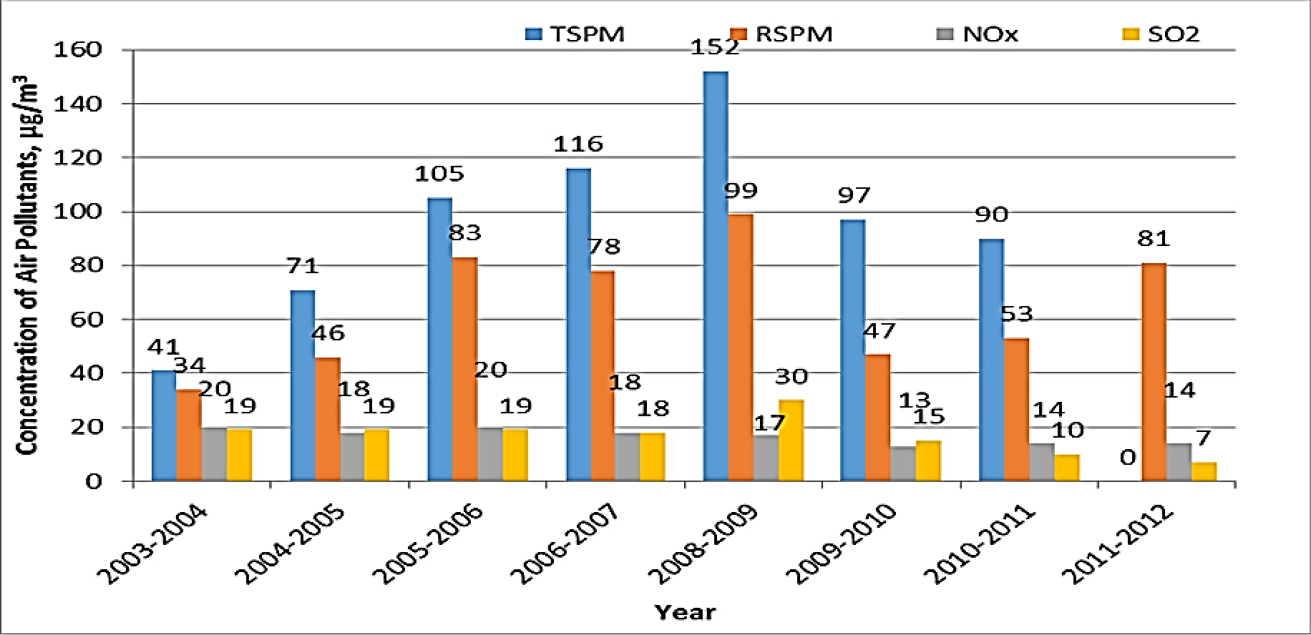
Graph showing Ambient Air Quality in Thoothukudi between 2003-2012

Ambient Air Quality Monitoring Results of Thoothukudi
between 2003&2012
C. Location: Fisheries College/ SIPCOT, Thuthookudi
Category -Industrial Area
Year | Annual Average Concentration of  Air pollutants, µg/m³
 | TSPM | RSPM | NOx | SO₂
2003-2004 | 38 | 30 | 19 | 20
2004-2005 | 60 | 38 | 18 | 19
2005-2006 | 66 | 54 | 22 | 19
2006-2007 | 90 | 63 | 17 | 17
2008-2009 | 130 | 86 | 19 | 30
2009-2010 | 138 | 70 | 11 | 17
2010-2011 | 156 | 88 | 12 | 12
2011-2012 | NA | 112 | 15 | 9
Prescribed Standard
Industrial | 360 | 120 | 80 | 80
Residential, Rural &  Other Areas (Mixed) | 140 | 60 | 60 | 60
NAAQS-2009 | NA | 60 | 40 | 50

Graph showing Ambient Air Quality in SIPCOT Thoothukudi
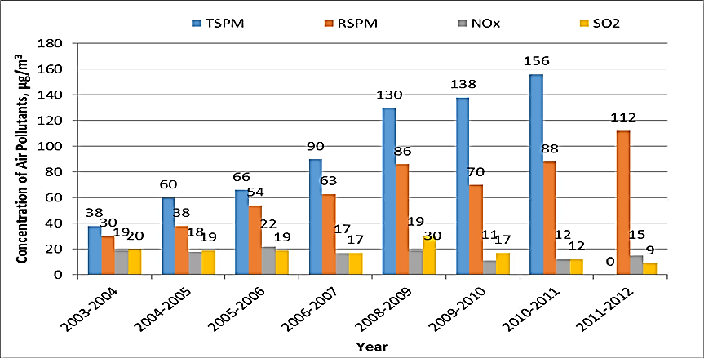
between 2003-2012

Ambient Air Quality Monitoring Results of Madurai between 2003&2012
A. Location: Fennar Ltd, M/s. Susee cars & Trucks (p)Ltd., Madurai
Category -Industrial Area
Year | Annual Average Concentration of Air pollutants, µg/m³
 | TSPM | RSPM | NOx | SO₂
2003-2004 | 163 | 72 | 29 | 22
2004-2005 | 136 | 52 | 28 | 18
2005-2006 | 117 | 37 | 29 | 17
2006-2007 | 94 | 65 | 26 | 12
2008-2009 | 91 | 45 | 24 | 11
2009-2010 | 81 | 36 | 25 | 11
2010-2011 | 111 | 42 | 25 | 11
2011-2012 | NA | 44 | 23 | 10
Prescribed Standard
Industrial | 360 | 120 | 80 | 80
Residential, Rural &  Other Areas (Mixed) | 140 | 60 | 60 | 60
NAAQS-2009 | NA | 60 | 40 | 50

Graph showing Ambient Air Quality in Madurai between 2003-2012
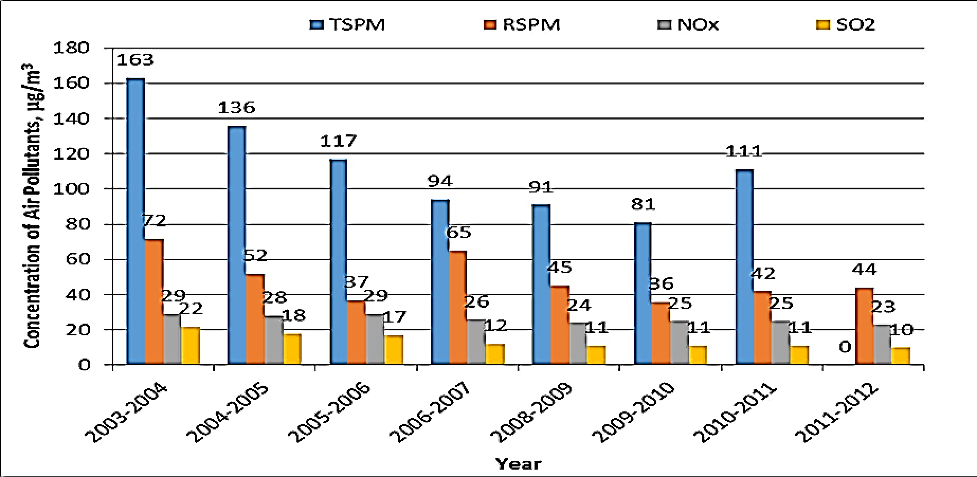

Ambient Air Quality Monitoring Results of Madurai
between 2003&2012
B. Location: Kunnathur Chatram/Avvai Girls Hr.Sec.school
Madurai
Category -Mixed Area
Year | Annual Average Concentration  of Air pollutants, µg/m³
 | TSPM | RSPM | NOx | SO₂
2003-2004 | 416 | 154 | 31 | 9
2004-2005 | 355 | 177 | 22 | 9
2005-2006 | 208 | 57 | 28 | 10
2006-2007 | 103 | 34 | 23 | 10
2008-2009 | 87 | 49 | 24 | 10
2009-2010 | 104 | 76 | 24 | 10
2010-2011 | 107 | 45 | 25 | 8
2011-2012 | NA | 46 | 24 | 11
Prescribed Standard
Industrial | 360 | 120 | 80 | 80
Residential, Rural &  Other Areas (Mixed) | 140 | 60 | 60 | 60
NAAQS-2009 | NA | 60 | 40 | 50

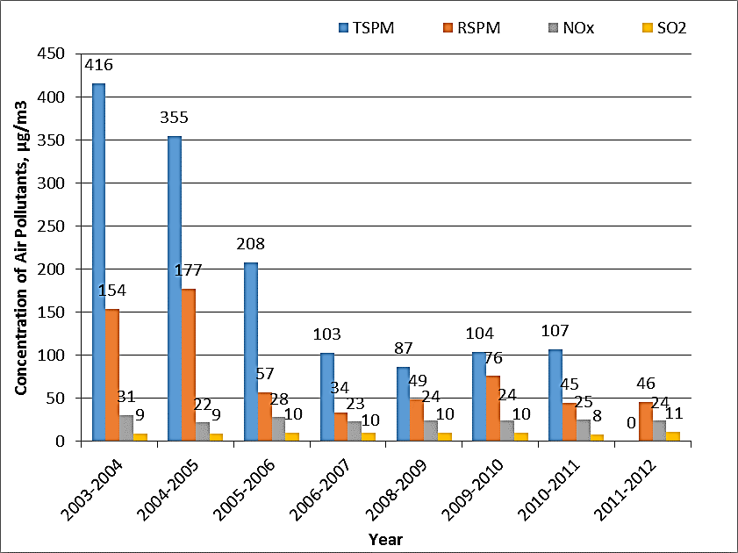
Graph showing Ambient Air Quality in Kunnathur Chatram Madurai between 2003-2012

Ambient Air Quality Monitoring Results of Madurai
between 2003&2012
C. Location: Highway Project Building, Madurai
Category -Residential Area
Year | Annual Average Concentration of  Air pollutants, µg/m³
 | TSPM | RSPM | NOx | SO₂
2003-2004 | 135 | 60 | 25 | 8
2004-2005 | 109 | 51 | 20 | 9
2005-2006 | 110 | 37 | 27 | 9
2006-2007 | 98 | 37 | 23 | 9
2008-2009 | 84 | 41 | 24 | 10
2009-2010 | 97 | 46 | 25 | 10
2010-2011 | 101 | 47 | 24 | 11
2011-2012 | NA | 47 | 24 | 10
Prescribed Standard
Industrial | 360 | 120 | 80 | 80
Residential, Rural &  Other Areas (Mixed) | 140 | 60 | 60 | 60
NAAQS-2009 | NA | 60 | 40 | 50
Graph showing Ambient Air Quality in Highway Project
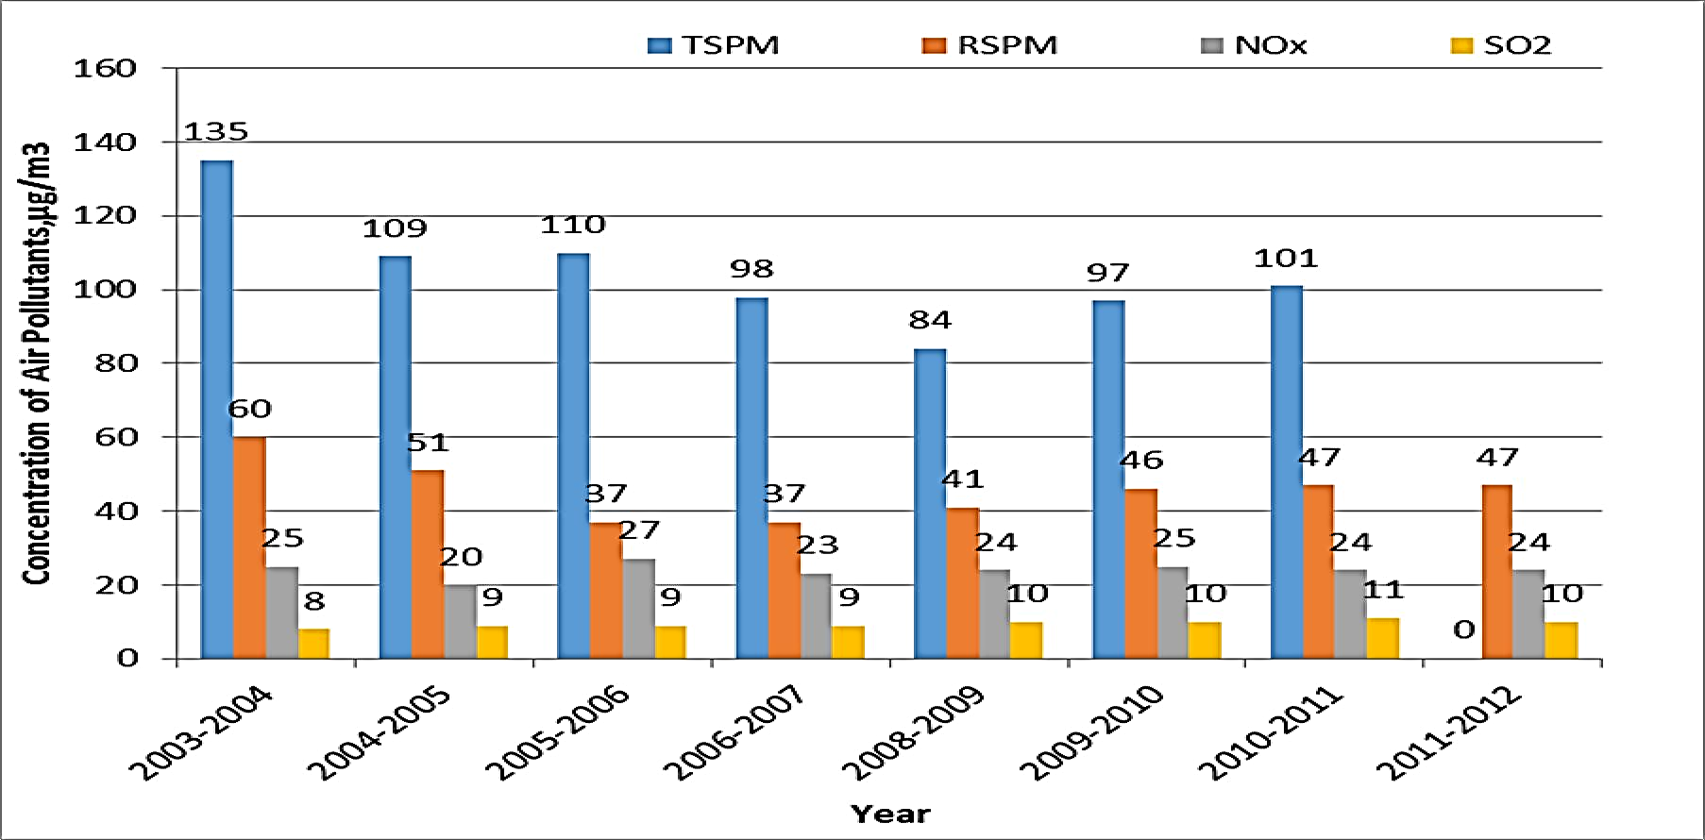
Building Maduraibetween 2003-2012

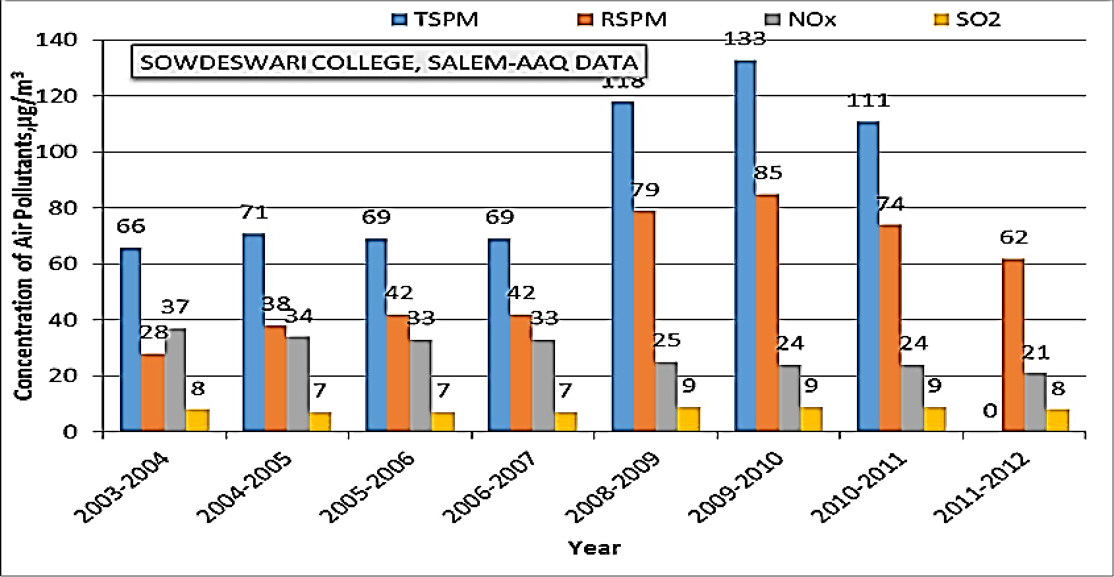
Ambient Air Quality Monitoring Results of Salem
between 2003&2012
A. Location: Sowdeswari College Building , Salem
Category -Mixed Area
Year | Annual Average Concentration of  Air pollutants, µg/m³
 | TSPM | RSPM | NOx | SO₂
2003-2004 | 66 | 28 | 37 | 8
2004-2005 | 71 | 38 | 34 | 7
2005-2006 | 69 | 42 | 33 | 7
2006-2007 | 69 | 42 | 33 | 7
2008-2009 | 118 | 79 | 25 | 9
2009-2010 | 133 | 85 | 24 | 9
2010-2011 | 111 | 74 | 24 | 9
2011-2012 | NA | 62 | 21 | 8
Prescribed Standard
Industrial | 360 | 120 | 80 | 80
Residential, Rural &  Other Areas (Mixed) | 140 | 60 | 60 | 60
NAAQS-2009 | NA | 60 | 40 | 50

Graph showing Ambient Air Quality in Salem between 2003-2012

Data collected from various organizations and departments in Tamil Nadu indicate high levels of respirable suspended particulate matter (RSPM) and total suspended particulate matter (TSPM) in industrial and urban areas. Addressing these elevated pollution levels requires comprehensive measures such as improved control equipment, effluent and sewage treatment, resource recovery, cleaner technological processes, and stricter regulations to reduce harmful emissions.

  - Status of Number of Vehicles in Tamil Nadu
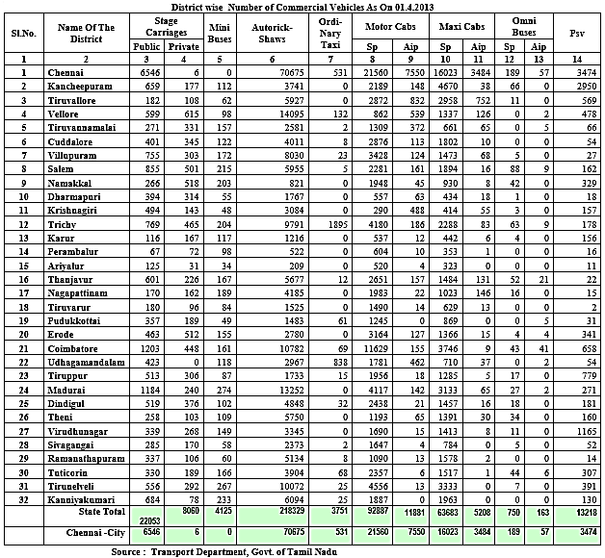

The above data provides information on the number of commercial vehicles in different districts of Tamil Nadu as of April 1, 2013. The categories of vehicles include stage carriages, mini buses, auto rickshaws, ordinary taxis, motor cabs, maxi cabs, and Omni buses. The vehicles are further classified as public or private, and whether they are operated by self-owners or associations.
In Chennai, the capital city, there were 6,546 stage carriages, 6 mini buses, and no auto rickshaws. Additionally, there were 70,675 public ordinary taxis, 531 self-owned ordinary taxis, 21,560 public motor cabs, 7,550 self-owned motor cabs, 16,023 public maxi cabs, and 3,484 self-owned maxi cabs. Chennai also had 189 self-owned Omni buses.
Other districts also had varying numbers of commercial vehicles, with different proportions of public and self-owned vehicles. For example, Kancheepuram district had 659 stage carriages, 177 mini buses, 112 auto rickshaws, 3,741 public ordinary taxis, and so on. The total number of commercial vehicles in the state was 220,053.
The data provides a comprehensive overview of the distribution of commercial vehicles across the districts of Tamil Nadu. It highlights the presence of a significant number of vehicles in Chennai, which is expected due to its status as the capital and a major urban center. The information can be useful for transportation planning, infrastructure development, and policy-making related to the management of commercial vehicles in the state.

Number of vehicles in Tamil Nadu - 2003
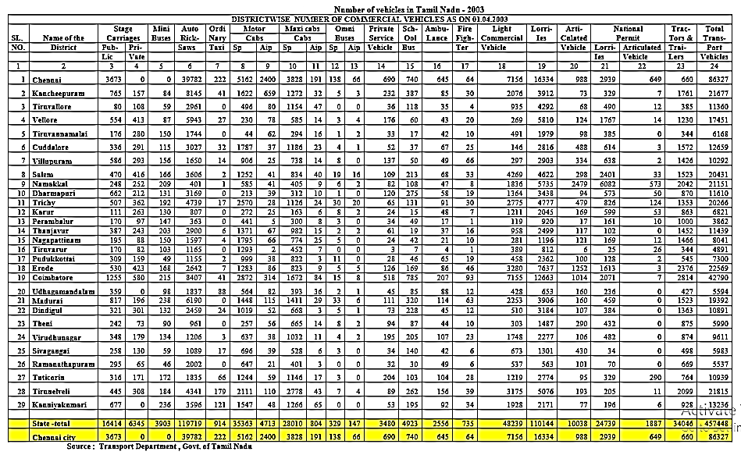
The above data provides information on the number of commercial vehicles in various districts of Tamil Nadu as of April 1, 2003. The categories of vehicles include stage carriages, mini buses, auto rickshaws, ordinary taxis, motor cabs, maxi cabs, Omni buses, private service vehicles, school vehicles, ambulances, fire-fighting vehicles, light commercial vehicles, Lorries, articulated vehicles, national permit vehicles, and tractors. The vehicles are further classified as public or private, and whether they are operated by self-owners or associations.
In Chennai, the capital city, there were 3,673 stage carriages, 6 mini buses, and no auto rickshaws. Additionally, there were 39,782 public ordinary taxis, 222 self-owned ordinary taxis, 5,162 public motor cabs, 2,400 self-owned motor cabs, 3,828 public maxi cabs, and 191 self-owned maxi cabs. Chennai also had 138 self-owned Omni buses.
Other districts also had varying numbers of commercial vehicles, with different proportions of public and self-owned vehicles. For example, Kancheepuram district had 765 stage carriages, 157 mini buses, 84 auto rickshaws, 8,145 public ordinary taxis, and so on. The total number of commercial vehicles in the state was 457,448.
The data provides a comprehensive overview of the distribution of commercial vehicles across the districts of Tamil Nadu. It highlights the presence of a significant number of vehicles in Chennai, which is expected due to its status as the capital and a major urban center. The information can be useful for transportation planning, infrastructure development, and policy-making related to the management of commercial vehicles in the state.

Number of Vehicles in the State during 2003 and 2013
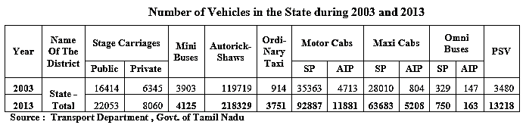

Number of Vehicles in the Chennai during 2003 and 2013
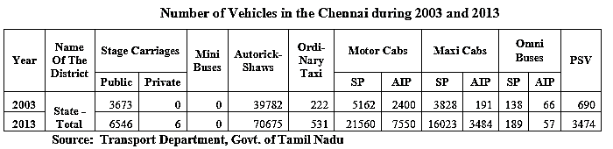
The significant number of vehicles directly contributes to air pollution in the state, with urban areas like Chennai City experiencing particularly high levels of pollutants such as CO and SO2. This can be attributed to the sheer volume of vehicles present. Moreover, inadequate fuel combustion and insufficient vehicle maintenance further exacerbate pollution levels. To address this issue, regular and thorough emissions checks are essential statewide to effectively monitor and control vehicle emissions.

Action Taken to Prevent Air Pollution in Tamil Nadu

Industrial Pollution
Several significant measures have been implemented to control industrial pollution in Tamil Nadu. Firstly, the city prohibits the establishment of new polluting units, aiming to prevent further pollution sources from emerging. Additionally, the city has also halted the construction of new incinerators, with a focus on phasing out existing ones. Instead, common facilities have been established outside the city to facilitate the safe incineration of bio-medical waste.
Industries have been mandated to develop a green belt covering a minimum of 33% of their project area. Furthermore, industries are encouraged to contribute to the creation of green belts through avenue plantations along roadsides. Compliance with this condition is a prerequisite for the renewal of industrial consent.
To ensure ongoing compliance and monitoring, industrial units are subjected to periodic inspections. These inspections involve the installation of online stack monitors, which are connected to the pollution control board's CARE Air center. This allows for real-time tracking and assessment of industrial emissions, enabling prompt corrective actions if necessary.

Vehicular Pollution
To address vehicular pollution in Tamil Nadu, several measures have been implemented to regulate vehicle emissions and promote sustainable transportation practices. Bharat Stage-II norms were introduced on July 1, 2011, mandating compliance for the registration of new passenger cars, which aim to control and reduce emissions from new vehicles.
In Chennai city, emission norms for in-use vehicles have been established in consultation with the Ministry of Road Transport and Highways (MoRTH) and the Ministry of Environment, Forest and Climate Change (MoEF). These norms have been in effect since January 1, 1997, ensuring that all vehicles in the city adhere to specified emission standards.
Since 1997, passenger cars fitted with catalytic converters have been registered, contributing to the reduction of harmful pollutants emitted by vehicles. To ensure ongoing compliance, regular inspections of in-use vehicles are conducted by officials from the Transport Department and Police Department in Chennai.
The introduction of unleaded petrol since February 2000 has played a crucial role in reducing air pollution caused by vehicular emissions. Furthermore, in Chennai City, the supply of low-sulfur diesel (0.05%) has been implemented since July 1, 2001, contributing to cleaner fuel consumption and reduced emissions.
Since April 1, 2002, the supply of pre-mixed 2T oil has been enforced, promoting the use of cleaner oils in two-stroke engines and reducing their emissions. Additionally, during peak hours, heavy vehicle entry in Chennai city is restricted on certain roads, minimizing congestion and associated pollution.
To improve overall transportation infrastructure and reduce traffic congestion, the construction of a Ring Road has been undertaken to divert intercity vehicles away from the city. The completion of the mass transport system, specifically the metro rail from Beach to Velachery, has provided an efficient and eco-friendly alternative for commuters.
Fiscal measures, such as the structuring of parking fees and road tolls, have been implemented to discourage private vehicle usage, encourage public transportation, and manage traffic flow effectively. These measures aim to mitigate vehicular pollution and promote sustainable mobility options in Tamil Nadu.

CONCLUSION
Data collected from various organizations and departments of the Government of Tamil Nadu have revealed the presence of pollution in different districts of the state, highlighting the complex environmental pollution resulting from population growth, urbanization, and industrialization. While the establishment of control equipment, effluent treatment plants, and sewage treatment plants was believed to be sufficient for controlling emissions and ensuring safe effluent discharge, it is now recognized that the real solution lies in preventing pollution at its source through measures like resource recovery and cleaner technological processes.
The adoption of long-term preventive actions, such as process development to use less polluting raw materials, proves to be an effective approach in addressing environmental issues. An example of resource conservation is the recovery of chromium from tannery effluent. The compulsion to explore alternative energy sources has led industries producing hot waste gases to generate power, resulting in a reduction in coal usage and greenhouse gas emissions. Additionally, substituting hazardous substances with eco-friendly alternatives not only reduces pollution but also minimizes raw material consumption.
Environmental concerns arising from the generation of municipal solid waste, hazardous waste, e-waste, biomedical waste, and plastic waste from various sources including residential units, industries, healthcare facilities, and commercial establishments pose significant pollution challenges affecting land, water, air, and overall ecosystem health. In major cities and towns, issues related to sewage collection, treatment, and solid waste management remain unresolved. Transportation, particularly in urban areas, contributes significantly to air pollution, necessitating the development of effective traffic management plans.
Solving environmental problems requires a collective effort involving stakeholders from industries, waste processors, communities, NGOs, government bodies, and regulatory authorities. It is crucial for all stakeholders to have a comprehensive understanding of the latest legislations, technologies, standards, and related issues to facilitate the effective implementation of environmental protection programs.
To prevent air pollution, it is essential to reduce or eliminate the use of toxic substances that contribute to air pollution. This would involve discontinuing all fossil fuel-burning processes, ranging from industrial manufacturing to residential use of air conditioners. Regulations should be designed to further reduce harmful emissions into the Earth's atmosphere, ensuring a cleaner and healthier environment for future generations.

REFERENCES
1. Junker, M., Koller, T., and Mon, C., 2000: An assessment of indoor air contaminants in building with recreational activity, Sci. Total Environ, 257: 199-211.
2. Chiras, D.D., 2001: Environmental Science: Creating a sustainable future, Six Ed. Canada: Jones and BartlettPublishers.
3. Kupchella, CE., and Hyland, M.C., 1993: Environmental science, Living within the system of nature, Ed. Ke-3, New Jersey: Prentice-Hall International, Inc.
4. Mitchell, G., et al., 2000. A disease- burden method of estimating the impact of out door air quality on human health, Sc. Total Environ., 246, 153-163
5. Sengupta, S., et al., 1996. Assessment of population exposure and risk zones due to air pollution using Geographical Information System, Compu. Environ. Urban Syst., 20, 191-199.
6. Puliafito, E., et al., 2003. Characterization of urban air quality using GIS as a management system, Environ. Pollut. 122, 105-117.
7. The World Health Reports 2002, Redusing risks, promoting health life, World Health Organization, Geneva, vol.248, ISBN 98 4 156207, ISSN 1020-3311
8. Avnish Chauhan, Mayank Pawar, 2010, “Assessment Of Ambient Air Quality status In Urbanization And Commercial Centers Of Uttarkhand (India)”., New York Science Journal;3(7).
9. Barman S.C., Singh Ramesh, Negi M.P.S., Bharghava S.K. Ambient air quality of Lucknow City (India) during use of fireworks on Diwali Festival, Environ Monit, Asses ,No 137,(2008);4954-504
10. Meenakshi, P., M. K. Saseetharan, September 2003,”Analysis of Seasonal Variation of Suspended Particulate matter and Oxides of Nitrogen with References to Wind Direction in Coimbatore City”.,IE (1) Journal, EN Vol.84
11. Meenakshi and Elangovan (2000) Assessment of Ambient Air quality Monitoring and Modelling in Coimbatore City.
***********

